Jim,

Valery and I looked at the vertical shears in the ADCP data, and the results show that A4 is a standout (see below). We’re on our way to sample another anticyclone A5 northeast of BATS, after which we will make a decision about which eddy is the fairest of the all. A4 is going to be tough to beat, but the latest altimetry indicates A4 might be spinning down, whereas A5 might be spinning up. Stay tuned…

Dennis

Vertical shear calculations from the ADCP indicate that largest shears are confined to the upper 50m (Figure 0630.1, left panel). These appear to be associated with inertial motions that are enhanced in the interior of anticyclone A4 (Figure 0630.1, right panel). Trapping or focusing of near-inertial motions may play a role in generating mixing that leads to enhanced productivity in the cores of anticyclones.

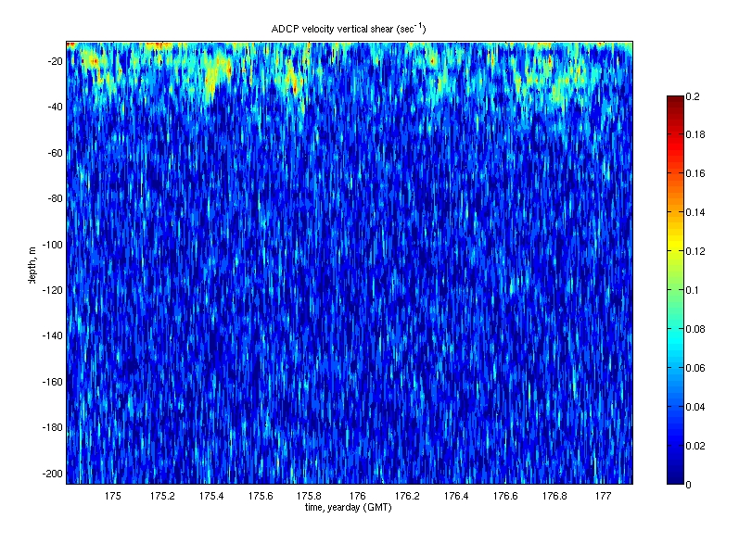 | 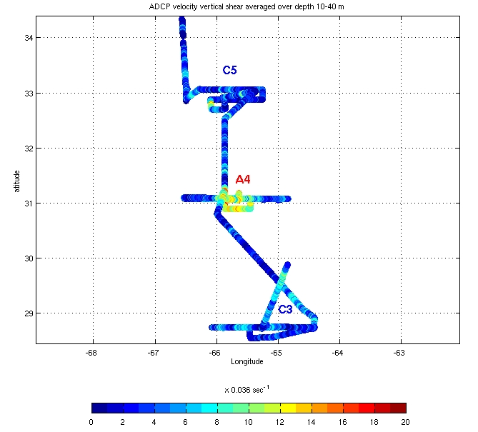
Figure 0630.1: Vertical shear computed from alongtrack ADCP measurements during the survey of anticyclone A4 (left); horizontal map of the vertical shear averaged over the upper 50m (right).

