Bridge:

To get good bottom cores:

It is most important that the ship is rolling as little as possible.

Wire angle and speed over ground as close to Zero are both important.

A near-zero Speed Over Ground is more important than a wire angle caused by speed through the water as a result of high currents.

Notify Lab when 10 min from station.

Notify Deck when situated on station.

Doghouse will request permission to deploy.

During upcast give permission to doghouse to recover. Doghouse will request

25-35kts is cutoff point for operations, depending on seas.

Winch:
Winch operator has a critical job with many things to watch: winch drum, sheaves, J-frame, deck boss’s signals, taglines, winch payout, speed, tension, etc.
If you see or hear anything wrong, STOP the winch
It is very important to watch and follow the deck boss’s signals
Do not move winch or frame without being given hand signals!!!
If the deck boss stops giving hand signals, stop the winch. He/She may be distracted by something that needs to be fixed before continuing.

The winch operator has a good overall view of operations. If you notice something isn’t right say something. Do not do something that you feel is unsafe just because a scientist says to do it. They may not realize the danger.
These next items are mentioned because accidents have happened in these cases.
NEVER move the winch if the package is strapped down or if the taglines have figure 8s on the cleats. If they need to have the package secured in the air, first have the taglines controlled, lift the package then they can secure the lines or put on straps. DO NOT MOVE the winch again until straps are removed and taglines are attended. THEN they can secure the package as normal. It takes very little movement of the winch to break a metal frame.
NEVER secure the J-frame with only the chain.

-------------------------------------------------------------------------------------------------------------------------------
Winch:

Listen for bottom depth from the lab
When ship seems situated for deployment request permission from the bridge to deploy
Follow deck boss’ signals
Be sure winch count is ZERO with BOTTOM of CORER at water’s surface. This can be done while the winch is moving and probably has to be done on the first cast and a couple times per cruise. Just check it during deployments.
After taglines are removed, Down at 30-60m/min
STOP with corer under surface for 30 seconds (for CTD pump to come on). Be sure corer is deep enough to not snap the wire in rough weather.
Alert the bridge that corer is in the water during the wait period.
Down at at 20-30m/min (speed up to 60m/min deeper than 100mwo)
Listen for Standby from Lab ~10m above bottom
Set corer onto bottom at ~20m/min

Let out wire for 3 to 5 to 9 meters after touching bottom (~10 seconds). In shallow water when the core is on the bottom, there will be no tension on the wire. The meter wheel may not spin even when letting out wire so the readout may not indicate that wire is paying out. The readout will also be off from where it was set.

STOP when signaled from Lab or deck boss
Bring wire in at 20 m/min for ~30 seconds
Corer should come out of bottom during this time
Up to surface at 30-60m/min
At 100mwo request permission to recover. DO NOT STOP AT SURFACE to request permission to recover. Do this BEFORE reaching the surface for safety & efficiency.

After the package is on deck let out a meter or two of slack. Be sure someone on deck pulls slack
Shut down the winch.
The deck boss or one of the deck workers will secure the J-frame. Do not let them secure J-frame before they pull slack on the wire. Do not move the J-frame if there is not slack in the wire.
It is very important to NOT move the J-frame if anyone is in line with the securing rod. Wait for the person to step back before moving the J-frame.
…

Main Lab:

Answer intercom when bridge gives 5-10min Time To Go. Be sure the message gets to deck crew.
Label sample containers
Watch deployment on camera/TV channel 61
Note speed over ground. Should be ~ Zero.
Note Knudsen 12 KHz bottom depth
Log CTD ON time
While taglines are being setup, notify doghouse of bottom depth
“Doghouse, Lab. Bottom depth is forty one meters, four one meters.”

Corer deployed to 10m (especially in rough wx).
wait 30sec for CTD to equilibrate then down (30m/min 10-100mwo. 60m/min 100+mwo)
Compare payout of meters wire out with the Knudsen depth. If very different there may be a large wire angle.
~10-15 meters above bottom say “STANDBY 10m above bottom slow to 30m/min” to doghouse
when tension drops on plot say to doghouse “Keep going, it’s on the BOTTOM”
count to 10 (this will equal ~5mwo at 30m/min)
Say “STOP and Come back up at 20m/min” to doghouse
Quickly press F5 & Log the time, Lat/Lon & depth
When tension increases to a peak the core has pulled out of the bottom.
Say to doghouse “IT’S OFF OF THE BOTTOM, increase speed & come up to surface”
After corer is back on deck take screen shots of Echosounder and winch tension plot (press Prnt Scrn on keyboards. Rename files w/ the core name number)
Log CTD OFF time
Be sure that Knudsen software settings are set for the entire next transit (range, min & max depth limits)

For USGS Bothner Slow Core: only give bottom depth before cast & 15m above bottom notice. No other info. USGS deck crew will communicate with doghouse from the deck.
Deck Boss:
Lots of responsibility and things to watch.
Keep the package at the surface for as short a time as possible to avoid equipment loss/damage.
It is better to have the package swinging out of the water than at the surface getting bashed by wave crests & troughs.
It is also better to have the package in the water at 5 or more meters than at the surface getting bashed by wave crests & troughs.
Use your judgment as to which option to chose.

Keep the package as low as possible while going over the rail without getting caught on it.
If it does go up high, be sure that the termination does not two-block in the over-boarding sheave.

Keep people away from the wire during casts
Be sure all personnel in the area have work vests and hardhats

Go outside ~5min prior to station arrival
Be sure taglines are set properly for deployment
Arrive on station
Unsecure the J-frame (chain first then rod) while tagliners are removing straps from corer.
Stand back from the frame when it is moving!
Signal doghouse to call bridge for permission to deploy
Be sure taglines and deck personnel are ready
Give down signal for ~1m while pulling downward tension on the wire to prime the winch
Give up signal while pulling downward tension on the wire until package takes the tension
Core center will raise in its frame
Raise core up just a few inches off the pallet
Set the liner, cotter pin and angled plate
Double check that the tagliners are ready with freed taglines
Up & over
Watch the taglines while giving signals
Signals:
Make signals deliberate so they can be seen from a distance and in the line of sight of the equipment operator.
Stop is a strong raised fist. Wave arm a bit to get attention.
Up = up index finger & arm
Up slow = up index finger & thumb pinching together, up arm
Up fast = up index finger rotating in a circular motion, up arm
Down = down index finger
Down slow = down index finger & thumb pinching together
Down = down index finger rotating in a circular motion
In sight = point at own eyes
Zero = one or both hands form a circle pointed at the operator

Tagline handlers:
Wear hardhat, work vest and rubber boots.
Keep taglines taught but not too tight
Maintain 2-3’ between your hands and the cleat or wherever the line runs along a metal object

Go outside ~5min prior to arrival on station
Be sure taglines are set properly for deployment with one end tied in a bowline to a strong stationary part of the ship
Put the line up through the outer core ring then to the cleat
Do not wrap the tagline around the cleat in a figure eight EXCEPT when using it to hold the core in place temporarily while the ratchet straps are not on.
The line should only make a 70-130 degree angle around the cleat during deployment and recovery

Arrive on station
Remove the 2 ratchet straps from the core. The pallet stays secured to the deck.
Have the taglines ready with ends unfouled
Core will lift a few inches off the pallet
Hold taglines tight while deck boss sets the corer
While core goes over the side let taglines out hand over hand
Toss the end in the water as it starts to go down
Pull in on the other end of the line to remove it from the package
YELL “STOP” if the tagline gets stuck!
Prevent your hands from getting caught between the line & the rail by pulling in on the line to the inboard side of the rail.
Coil the line leaving the end tied to the ship
Hang the coil using a clove hitch and half hitch

Get ready for recovery by attaching the hooks to the poles and putting the line around the cleat
Stay outside, ready to recover the core, but stay away from the winch wire. Stand back, towards the stern while waiting for recovery.

Aft tagline can use the longer pole and shorter lines
Forward tagline can use the shorter pole and longer lines

As the core comes up out of the surface hook the vertical outer rods which are marked with yellow tape.
After the hook is attached, let go of the line and gently pull the pole off the hook and slide / toss it towards the stern.
Go to the cleat and pick up the end of the line and pull it taught
Continue to pull the line until the core lands on the pallet
After the deck boss has pulled the slack in the wire and the winch is shut down, figure 8 the line on the cleat.
Attach the ratchet straps from the stand to the core’s side rods or bottom ring.
Snug the straps but do not tighten too much which could cause bending or breaking of the frame.
Remove the taglines. Coil and hang taglines.
Put the poles in the trough.
Take samples.

If fwd tagline misses the tagline handler should go back to the cleat and the deckboss can take the hook & line & attach it to the package when it is within reach. Then the tagline handler is ready to take up slack and proceed.
If aft tagline misses keep trying.
Corer setup before cruise:
Craib core is from Duncan & Associates, Scotland
New corer w/ ss cage ~2009
Terminate winch wire (1/4”, 0.322” or 3/8”) with poured socket or thimble & Nicopress compression sleeve
Have enough winch wire out to reach the deck. Not too much out.
Attach Chinese finger to winch wire just above termination. Install hose clamps or wire clips top & bottom.
Attach termination to swivel or directly to corer with a safety shackle & cotter pin
Attach Chinese finger to frame of core, upper section (EN486 used ½” VLS line, tied & taped)
Use canvas & gaffer’s or other tape to wrap from top half of swivel to top of Chinese fingers so hardware doesn’t fold & get caught on hole in top of cage.
2 deployment lines
2 recovery lines
2 recovery hooks
2 recovery poles

Suggestions for cage/corer:
Make it more like a teepee rather than a cylinder. It’s too difficult to reach the wire.
Large holes in cage to reach arm through.
Orient so hydraulic release hole points overboard.
Have spare parts & metric hardware especially for critical parts

Stand – larger center hole so not worried about hitting core tube
– method of aligning corer
– mechanisms to quickly secure corer
– holes for forklift/pallet jack so it can be wheeled around the deck with a pallet jack & don’t have to rely on a crane.

Change top o-ring ~1x/day
Latch
Inside – doesn’t need to be changed often but check it.
Top seal
Collar

25-35kts is cutoff point for operations, depending on seas.
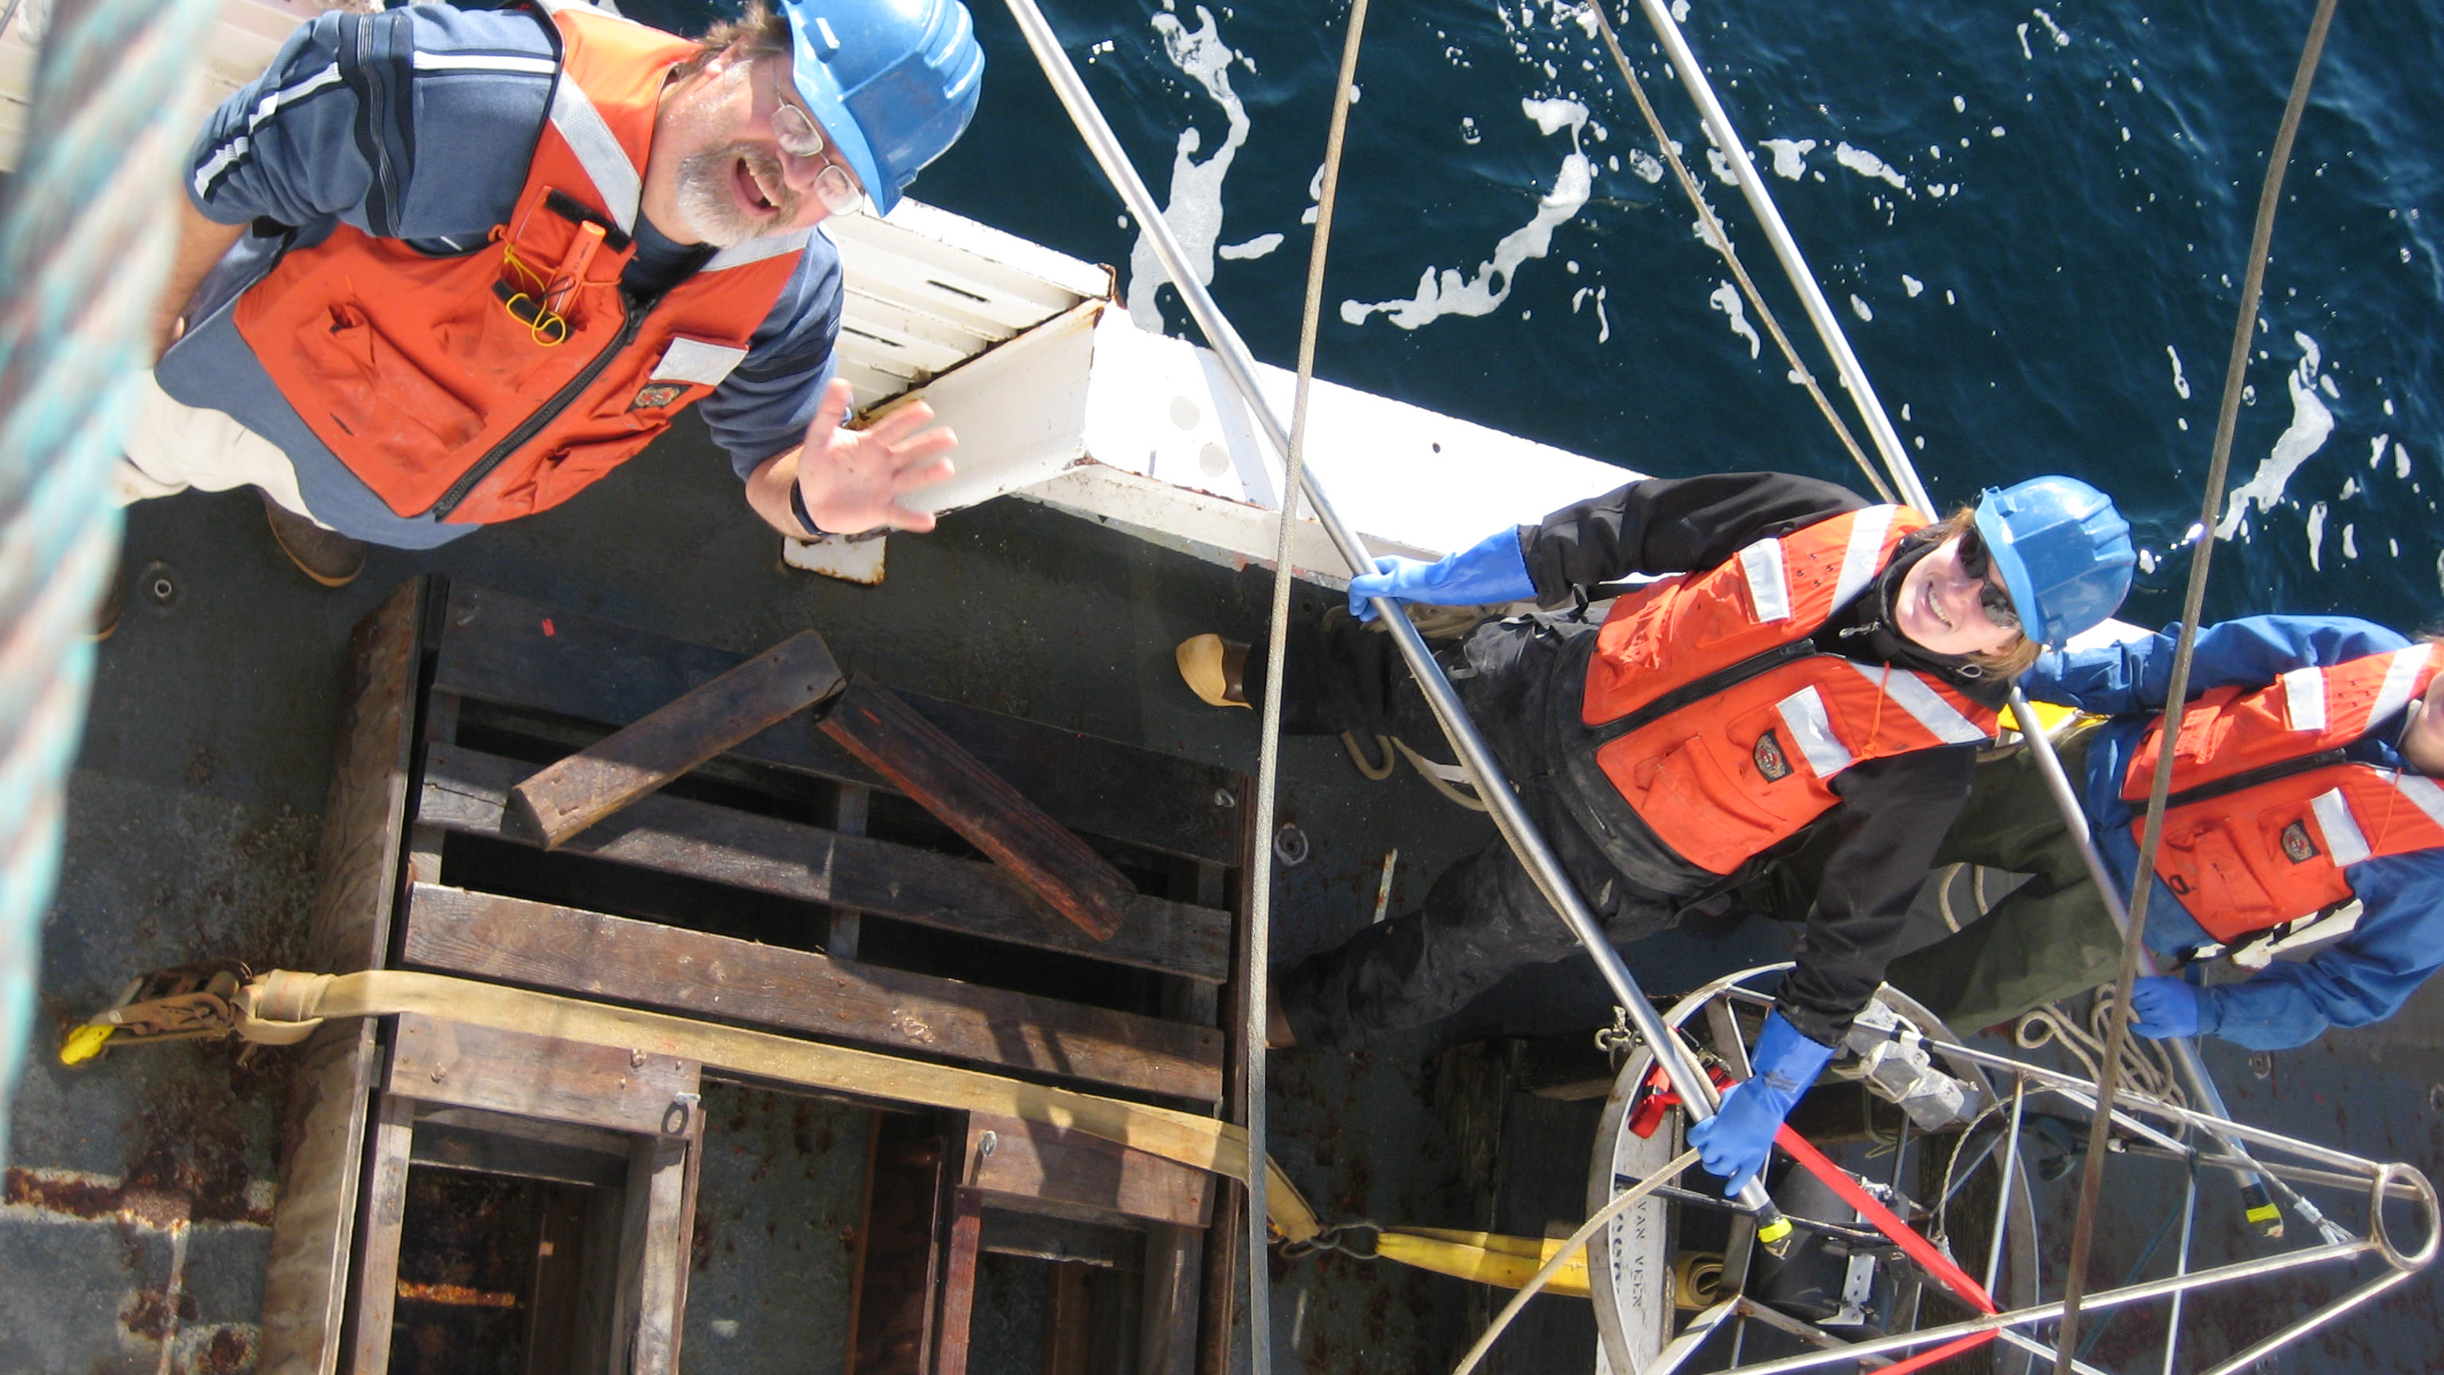

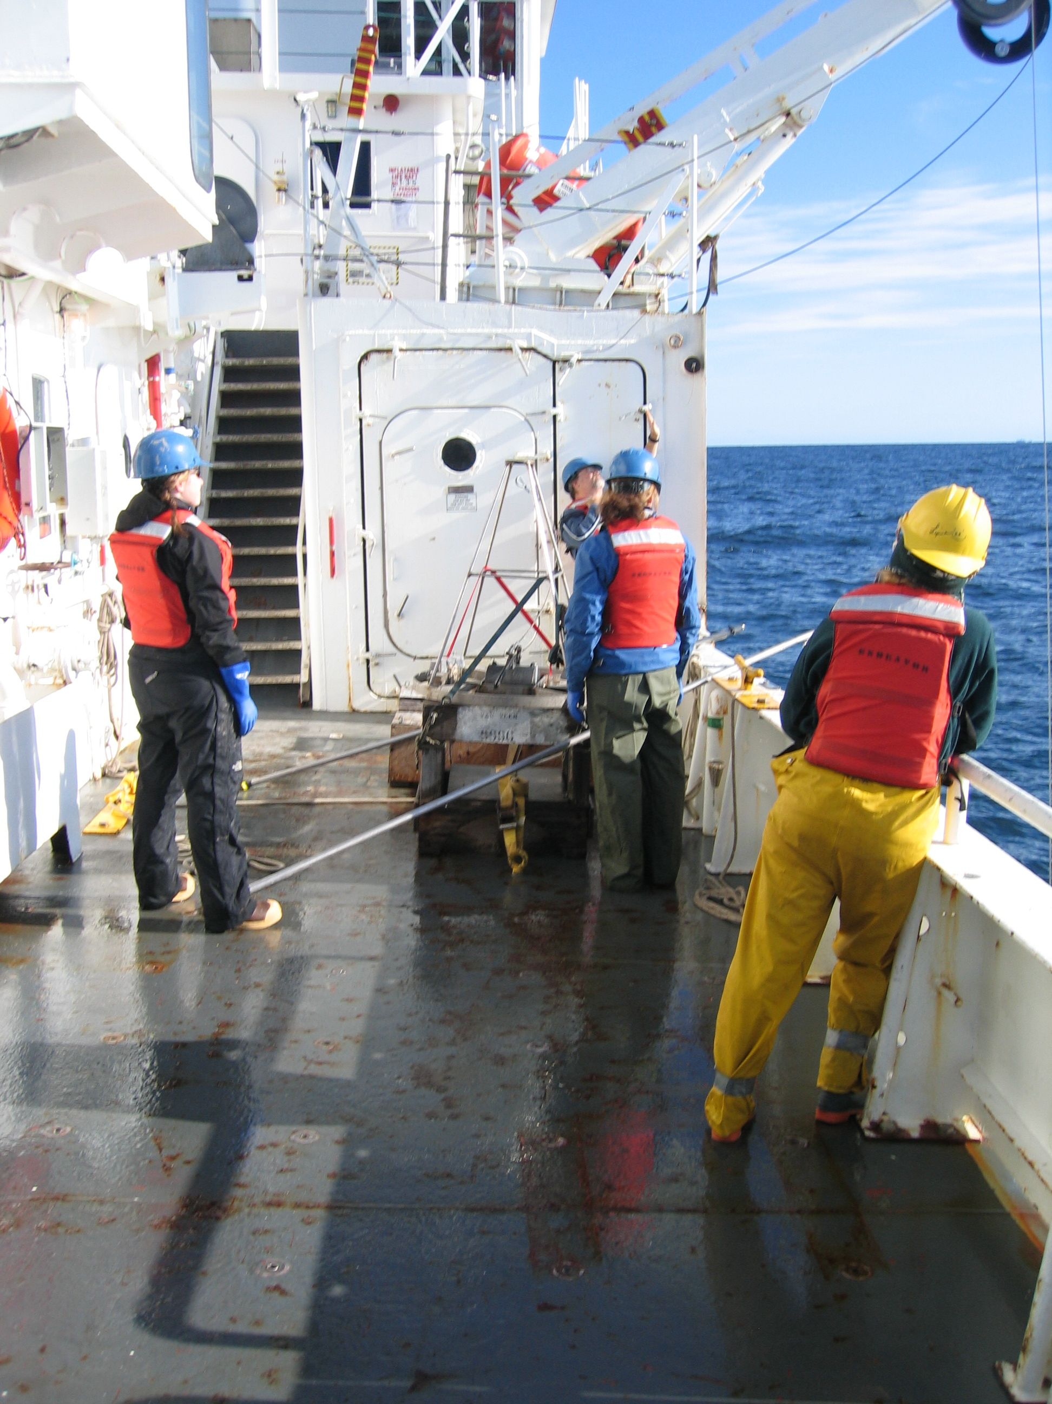
EN456 Pics of Craig core on deck w/ Bruce Keafer & handlers

