EN456 Don Anderson, Bruce Keafer=Chief Scientist
Craib Core notes

Bridge:
To get good bottom cores:
It is most important that the ship is rolling as little as possible.
Wire angle and speed over ground as close to Zero are both important.
Speed over ground is more important than a wire angle caused by speed through the water as a result of high currents.

Winch:
Winch operator has a critical job with the most things to watch: winch drum, sheaves, J-frame, deck boss’ signals, taglines, winch payout, speed, tension, etc.
If you see or hear anything wrong STOP the winch
It is very important to watch the deck boss’s signals
Do not move winch or frame without being given hand signals.
If the deck boss stops giving hand signals, stop the winch, they may be distracted by something that needs to be fixed before continuing.

Be sure winch is ZERO with BOTTOM of CORER at water’s surface. This can be done while the winch is moving.
Down at 30-60m/min
Into the bottom at 20-30m/min
Let out wire for 5 meters after touching bottom (~10 seconds)
STOP
Bring wire in at 20 m/min for ~30 seconds
Corer should come out of bottom during this time
Up to surface at 30-60m/min

Lab:
Note speed over ground. Should be ~ Zero.
Note Knudsen 12 KHz bottom depth
Notify doghouse of bottom depth “Doghouse, Lab. Bottom depth is forty one meters, four one meters.”
Watch deployment on camera/TV channel 61
Compare payout of meters wire out with the Knudsen depth
~10 meters above bottom say “STANDBY” to doghouse
when tension drops on plot say “Keep going, it’s on the BOTTOM” to doghouse
count to 10 (this will equal ~5mwo at 30m/min)
Say “STOP and Come back up” to doghouse
Quickly log the time & Lat/Lon
When tension increases to a peak the core has pulled out of the bottom
Say “IT’S OFF OF THE BOTTOM, come up to surface” to doghouse

Be sure that Knudsen software settings are set for the entire next transit (range, min & max depth limits)
Deck Boss:
Lots of responsibility and things to watch.
Keep the package at the surface for as short a time as possible to avoid equipment loss/damage.
It is better to have the package swinging out of the water than at the surface getting bashed by wave crests & troughs.
It is also better to have the package in the water at 5 or more meters than at the surface getting bashed by wave crests & troughs.
Use your judgement as to which option to chose.

Keep the package as low as possible while going over the rail without getting caught on it.
If it does go up high, be sure that the termination does not two-block in the over-boarding sheave.

Keep people away from the wire during casts
Be sure all personnel in the area have work vests and hardhats

Go outside ~5min prior to station arrival
Be sure taglines are set properly for deployment
Arrive on station
Unsecure the J-frame (chain first then rod) while tagliners are removing straps from corer.
Stand back from the frame when it is moving!
Signal doghouse to call bridge for permission to deploy
Be sure taglines and deck personnel are ready
Give down signal for ~1m while pulling downward tension on the wire to prime the winch
Give up signal while pulling downward tension on the wire until package takes the tension
Core center will raise in its frame
Raise core up just a few inches off the pallet
Set the liner, cotter pin and angled plate
Double check that the tagliners are ready with freed taglines
Up & over
Watch the taglines while giving signals
Signals:
Make signals deliberate so they can be seen from a distance and in the line of sight of the equipment operator.
Stop is a strong raised fist. Wave arm a bit to get attention.
Up = up index finger & arm
Up slow = up index finger & thumb pinching together, up arm
Up fast = up index finger rotating in a circular motion, up arm
Down = down index finger
Down slow = down index finger & thumb pinching together
Down = down index finger rotating in a circular motion
In sight = point at own eyes
Zero = one or both hands form a circle pointed at the operator

Tagline handlers:
Wear hardhat, work vest and rubber boots.
Keep taglines taught but not too tight
Maintain 2-3’ between your hands and the cleat or wherever the line runs along a metal object

Go outside ~5min prior to station arrival
Be sure taglines are set properly for deployment with one end tied in a bowline to a strong stationary part of the ship
Put the line up through the outer core ring then to the cleat
Do not wrap the tagline around the cleat in a figure eight EXCEPT when using it to hold the core in place temporarily while the ratchet straps are not on.
The line should only make a 70-130 degree angle around the cleat during deployment and recovery

Arrive on station
Remove the 2 ratchet straps from the core. The pallet stays secured to the deck.
Have the taglines ready with ends unfouled
Core will lift a few inches off the pallet
Hold taglines tight while deck boss sets the corer
While core goes over the side let taglines out hand over hand
Toss the end in the water as it starts to go down
Pull in on the other end of the line to remove it from the package
YELL “STOP” if the tagline gets stuck!
Prevent your hands from getting caught between the line & the rail by pulling in on the line to the inboard side of the rail.
Coil the line leaving the end attached to the ship
Hang the coil using a clove hitch and half hitch

Get ready for recovery by attaching the hooks to the poles and putting the line around the cleat
Stay outside, ready to recover the core, but stay away from the winch wire. Stand back, towards the stern while waiting for recovery.

Aft tagline can use the longer pole and shorter lines
Forward tagline can use the shorter pole and longer lines

As the core comes up out of the surface hook the outer ring with the hook’s opening upwards
After the hook is attached let go of the line and gently pull the pole off the hook and slide toss it towards the stern.
Go to the cleat and take the end of the line and pull it taught
Continue to pull the line until the core lands on the pallet
After the deck boss has pulled the slack in the wire and the winch is shut down, figure 8 the line on the cleat.
Attach the ratchet straps from the corner eye bolts over the core’s upper side rods
Snug the straps but do not tighten too much which could cause bending or breaking.
Remove the taglines. Coil and hang them.
Put the poles in the trough.
Take samples.
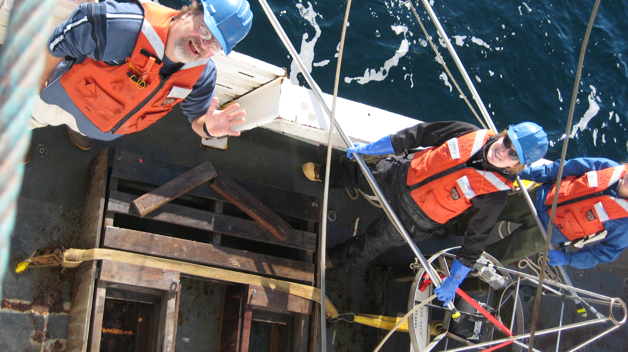

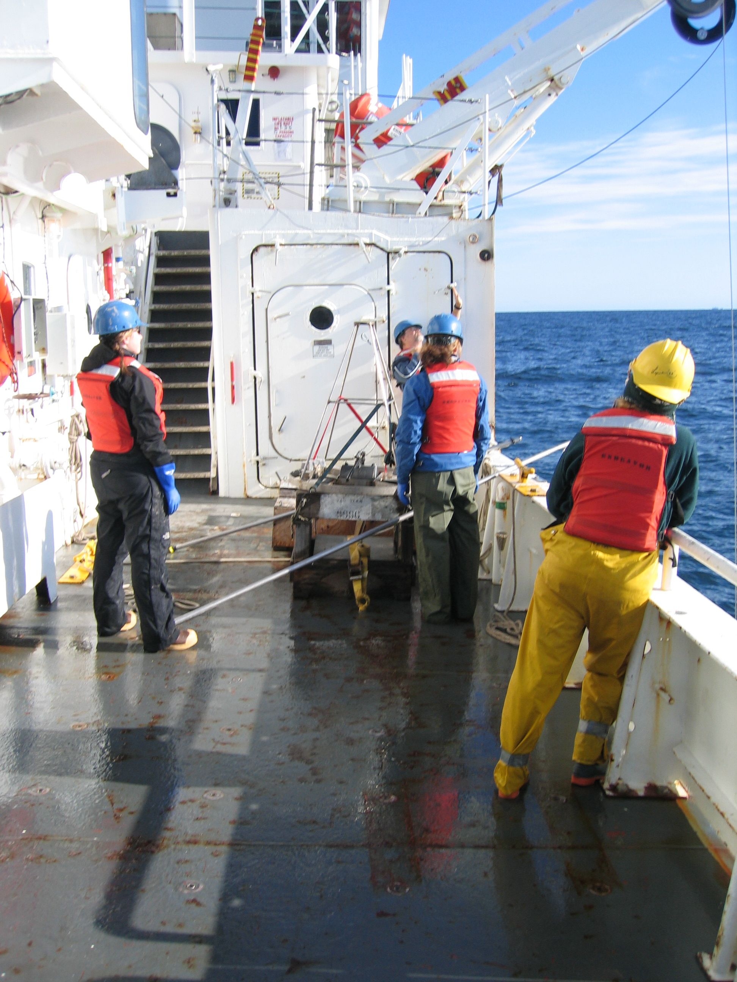
Pics of Craig core on deck w/ Bruce Keafer & handlers

