EN451 Cruise Report
Draft 8/15/08

Voyage #451 of R/V Endeavor was the fourth of four cruises in 2008 organized to serve complementary scientific objectives of two different projects. The two projects are:

Alexandrium population biology in the Gulf of Maine – Woods Hole Center for Oceans and Human Health – NSF/NIEHS

Objectives:
Sample genetic variability of Alexandrium subpopulations throughout the Gulf of Maine.

Measure changes in relative abundance of Alexandrium genotypes in space and time.

GOMTOX: Dynamics of Alexandrium fundyense distributions in the Gulf of Maine: an observational and modeling study of nearshore and offshore shellfish toxicity, vertical toxin flux, and bloom dynamics in a complex shelf sea – NOAA ECOHAB

Objectives:
Investigate A. fundyense bloom dynamics and the pathways that link this organism to toxicity in nearshore and offshore shellfish.

Investigate the vertical structure of A. fundyense blooms, vertical toxin flux, and linkage to toxicity in offshore shellfish.

Objectives common to both projects include:
Assess hydrodynamic and hydrographic context for interpretation of Alexandrium spp. measurements.

Incorporate field observations into a suite of numerical models for hindcasting and forecasting applications.

The primary domain of interest for the 2008 field season is Georges Bank, where a large bloom of A. fundyense was observed in 2007. Last year, the bloom was present on Georges Bank upon our arrival in May (EN435) and still quite conspicuous during our second cruise in June/July (EN437). The four one-week cruises in 2008 are designed to (1) resolve the seasonal variation of the Georges Bank bloom, and (2) quantify its interannual variability.

The unexpected decline in the Alexandrium population on Georges Bank observed during EN448 suggested that bloom may be winding down. In order to ascertain whether or not that was the case, a heroic effort was made on R/V Tioga to sample the two sections of Georges Bank where
we have consistently found highest Alexandrium concentrations in our prior surveys. This achievement was made possible by superb scientific operations on the part of Bruce Keafer, Kerry Norton, Bibiana Crespo, and Keston Smith, together with the outstanding seamanship of Capt. Ken Houtler and crew Ian Hanley. Alexandrium was absent from these two sections, as well as a few locations sampled by Scott Gallager on F/V Kathy Marie on the northern edge of Georges Bank and in the Great South Channel (Figure 1). All indications are that the Georges Bank bloom is over. Thus the GOMTOX objective of sampling the seasonal evolution of that bloom is complete. Therefore, EN451 was diverted to the Bay of Fundy and eastern Maine, another area that has experienced a significant bloom thus far this year.
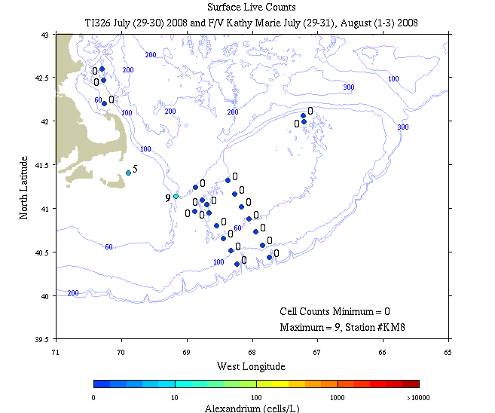
Figure 1. Alexandrium concentration (live counts; cells l⁻¹) from R/V Tioga cruise 326 (July 29-30, 2008) and F/V Kathy Marie.
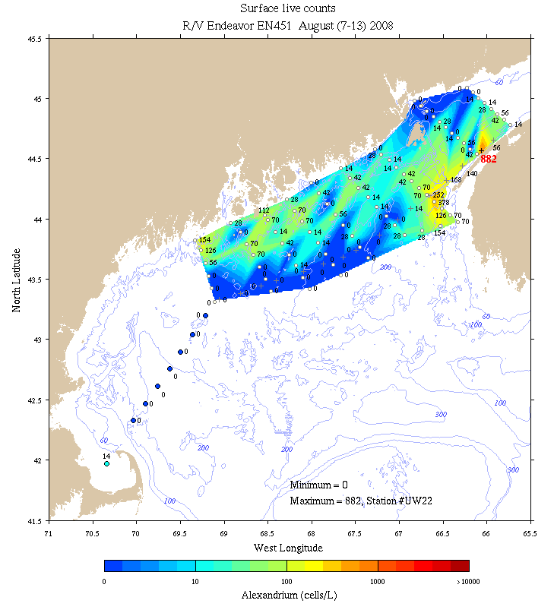
Figure 2. Alexandrium concentration (live counts; cells l⁻¹) from R/V Endeavor cruise 451 (August 7-13, 2008).
Live counts on EN451 revealed generally low concentrations overall (Figure 2). The peak concentration of 882 cells l⁻¹ was detected on an underway count just offshore of the Digby Penninsula. Otherwise concentrations in the two sections inside the Bay of Fundy itself were less than 100 cells l⁻¹. These findings are in stark contrast to those reported by Townsend et al. (2001), who documented cell concentrations of thousands of cells per liter at the mouth of the Bay of Fundy in August 1998.

A narrow tongue of ca. 100-400 cells l⁻¹ was present southwest of Digby, perhaps flowing “around the corner” from the Scotian shelf into the bay.

Cell counts offshore of Maine were also generally low, ranging from zero at the offshore boundary of the survey up to ca. 150 cells l⁻¹ near the coast.

Interannual variability in the Bay of Fundy Gyre

May 2005  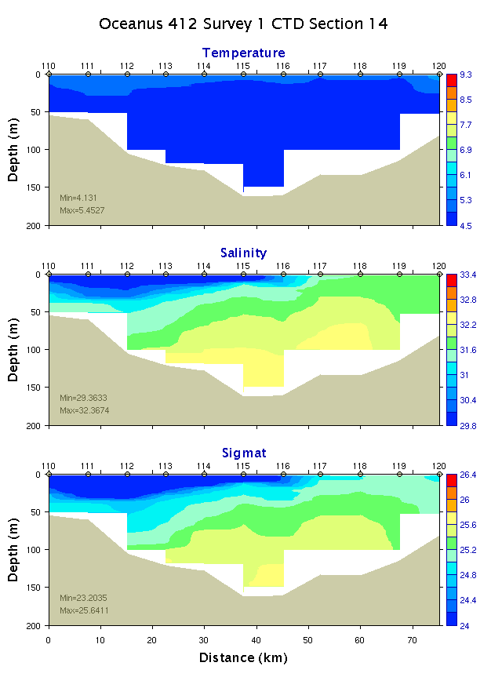 | June 2006  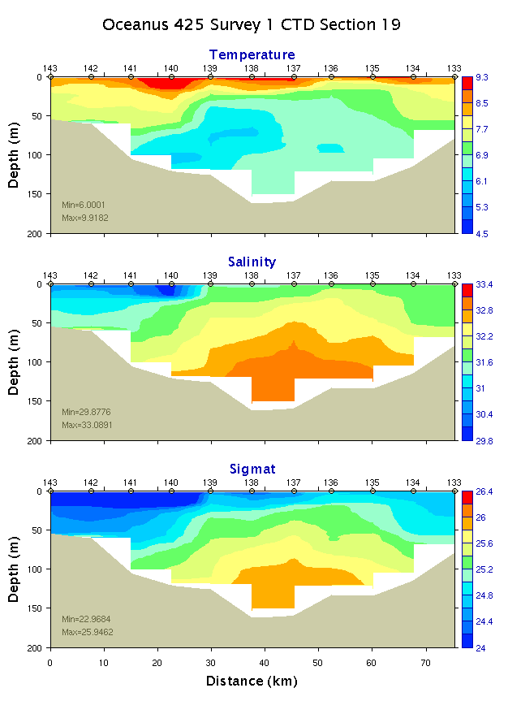 | May/June 2007  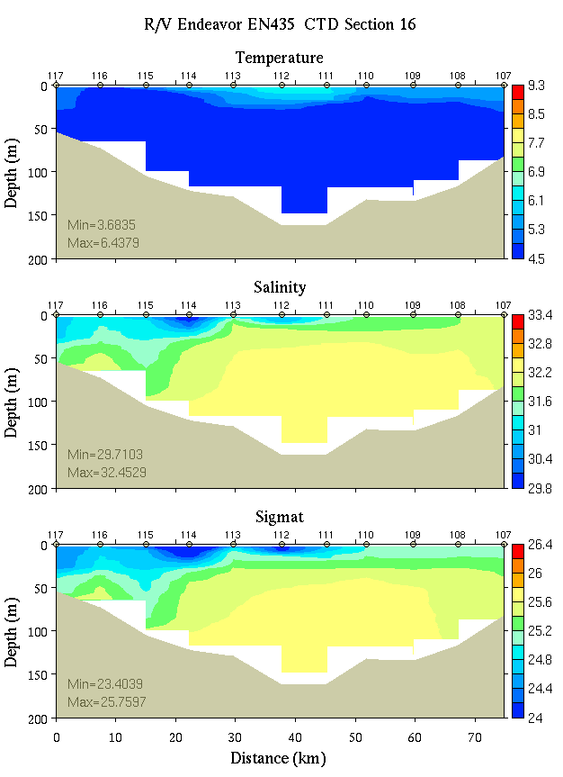
June/July 2007  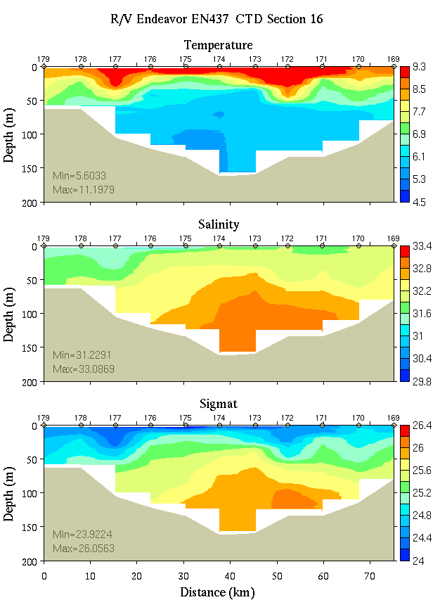 | August 2008  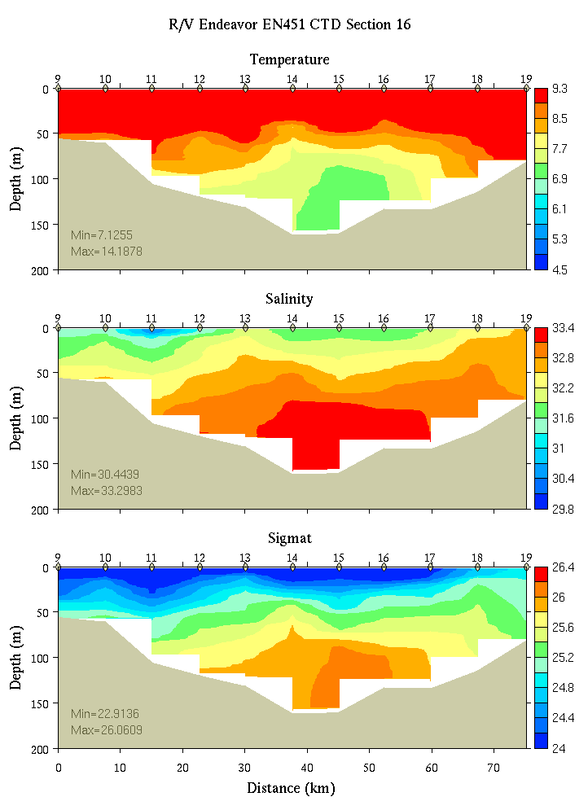
Figure 3. Interannual variability in hydrography of Grand Manan Basin, as depicted by repeat occupations of section 16 (see Appendix B, Figure B1 for location) in May 2005 (upper left), June 2006 (upper middle), May/June 2007 (upper right), June/July 2007 (lower left), and August 2008 (lower middle).

Repeat occupations of a section across Grand Manan basin reveal significant seasonal to interannual variability in hydrographic properties (Figure 3). Aretxabaleta et al. (submitted, ab) suggest that the strength of the Bay of Fundy gyre is influenced by the density-driven flow, such that denser water in Grand Manan Basin tends to augment the tidally rectified flow. Hindcast simulations for 2005-2007 presented in Aretxabaleta et al. (submitted-b) indicate July 2007 had the strongest and most retentive gyre of the years studied; May 2005 had the weakest and least retentive gyre. Results from the August 2008 hydrographic survey and initial drifter observations (see below) suggest the gyre is in a stronger and more retentive mode.

Drifters [Jim Manning]
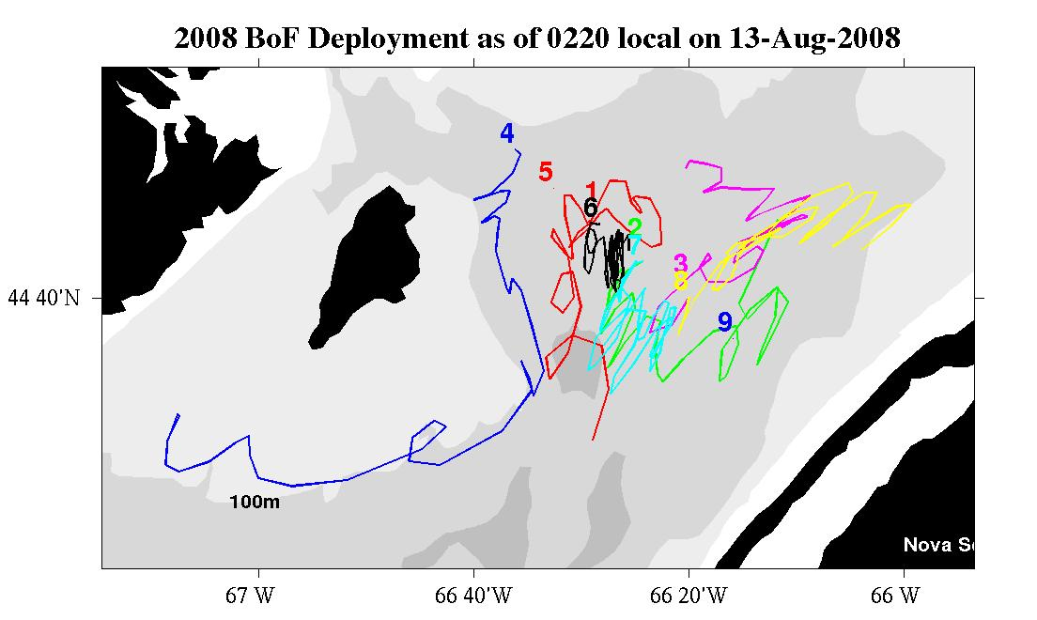
Figure 4. Surface drifters tracks from August 9 to August 13, 2008. Data courtesy of Jim Manning.

A total of nine drifters were deployed on 9 August (Figure 4; Appendix A, Table 3). Three of them were surface drifters (#’s 1-3) and six were drogued to 15 meters (#’s 4-9). They were released along a transect (similar to previous years) running north of Grand Manan towards the Digby Peninsula.

The drogues used on these deployments had various diameters and lengths. The original plan was to deploy them together in order to compare the relative water-following characteristics but that experiment was postponed in an attempt to capture another realization of the Bay of Fundy gyre. Assuming that the drogues have approximately the same drag, they were deployed at separate stations along the transect. The three surface drifters (1-3) were deployed alongside drogued units (6-8) so that some comparison can be made, at least, between surface and drogued units.

Two of the drogued units (#5 and #9) failed to transmit subsequent to being deployed. While the cause of this failure is unclear, it is possible that the units either a) had insufficient flotation or b) the vertical tether tangled with the surface units which could have submerged the transmitters below the surface. These were the larger 1.6 meter diameter drogues borrowed a few days prior to sailing.

While the units have been in the water only a short time, they are revealing expected characteristics of the Bay of Fundy gyre system (Arextabaleta et al.). The northwestern-most unit, #4, was advected down the east side of Grand Manan and exited the gyre. Five of the other six working units appear to be headed counterclockwise around the gyre. The surface-drogue pair #1 and #6 have very different paths but the other two pairs are fairly coherent with the drogued units closely following the surface units. Surface unit #1 appears to be on an exit pathway at this time.

At-sea data assimilative modeling [Keston Smith]
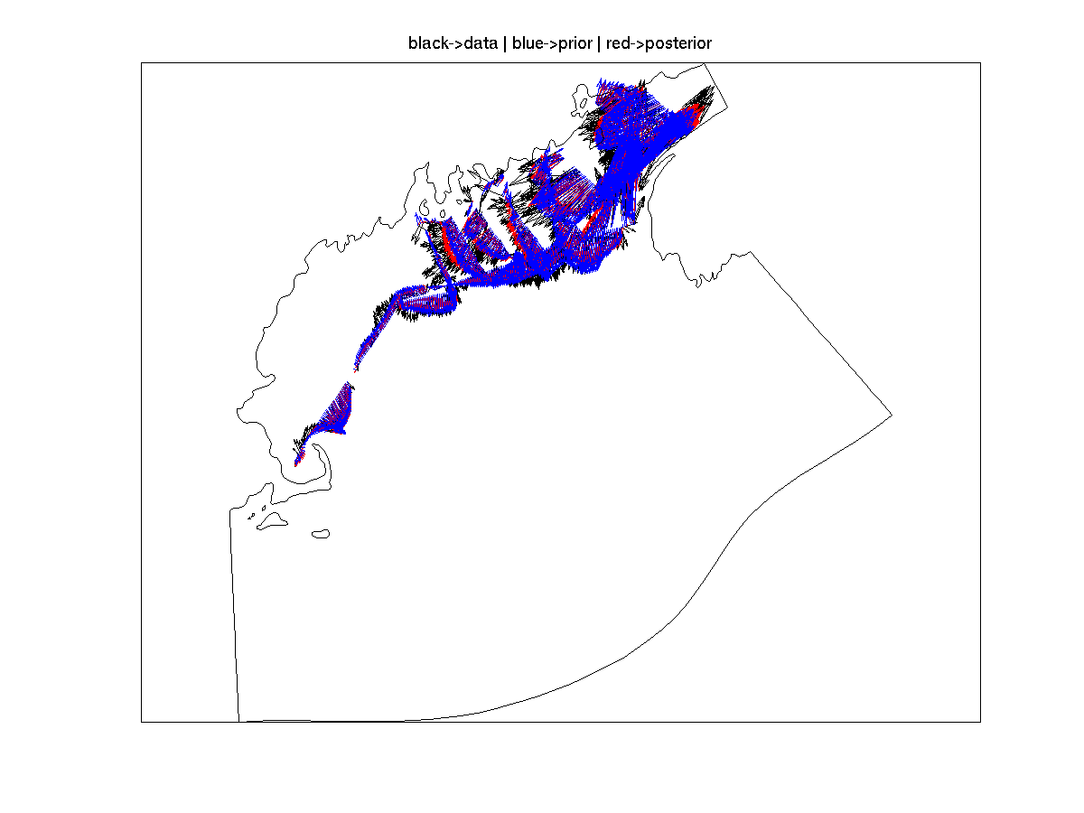
Figure 5. Example assimilation of ADCP velocity data. Observed ADCP velocity (black), prior estimate (blue), and data assimilative posterior (red).
Seven data assimilative hydrodynamic experiments were conducted aboard EN448, as described in the table below. The simulations followed the approach developed during GLOBEC and recent MERHAB, COHH and GOMTOX cruises. ADCP data were inverted to estimate barotropic boundary conditions and the hydrographic survey was used to estimate the initial conditions (Figure 5). The approach is described in detail in Arextabaleta et al. (submitted-b). The forward simulator is the finite element primitive equation model Quoddy. The data assimilation system consists of the tide band inverter, Truxton, the wind band inverter, Casco, and the hydrographic data assimilation system OACI.

The computational domain "gomtox" (Figure 6) was developed to provide moderate resolution in
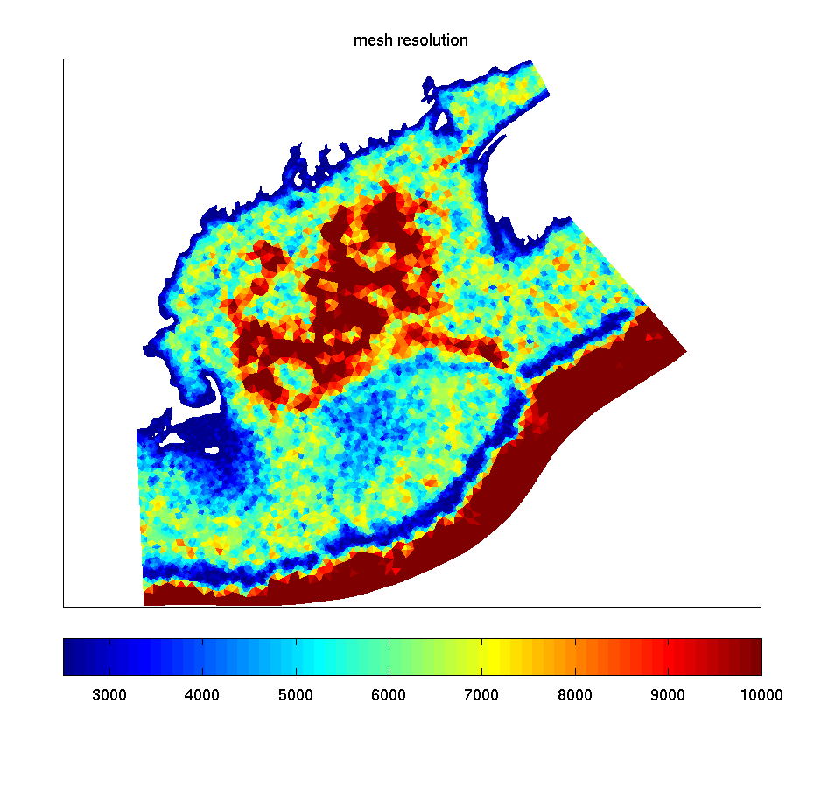
Figure 6. Resolution in meters of the finite element mesh “gomtox.”
the western, eastern gulf of Maine, and Georges bank (2000m-5000m) while extending beyond the shelf break to encompass the full survey domain. The steep topography of in the shelf break necessitates high resolution (2500m and less).

Wind data was processed by James Manning of NOAA and sent to the ship daily. The wind was spatially homogeneous taken from GOMOOS buoy A. The 3 day forecast wind was an NCEP product. Heat flux was set to climatological values. Barotropic tidal forcing with M2, N2, O1, K1, and S2 frequencies was taken from a database. Initial conditions for temperature and salinity were based on the July-August climatology described in Naimie et al. (1994).

Model skill was evaluated by comparison with unassimilated drifter data. An example is provided in Figure 7. Surface drifters such as those used in the present study are difficult to appropriately forecast with models with vertical resolution at the surface (1m) comparable to the height of the drifter sail (1m). There is strong sensitivity to mixed layer depth and windage on the drifter's transmitter and surface response to wind forcing in general. For these reasons, the model is generally more skillful in simulating the drifters with 15m drogues (Table).

To assess the effect of the currents on the synopticity of the EN451 survey, a Lagrangian calculation was carried out to track water parcels after they were sampled. After each station was occupied, the representative water parcel in the model was tracked with a particle until the end of the simulation (Figure 8). An animated presentation of these results depicts the effects of the tides, mean flow, and wind on the terminal station position.

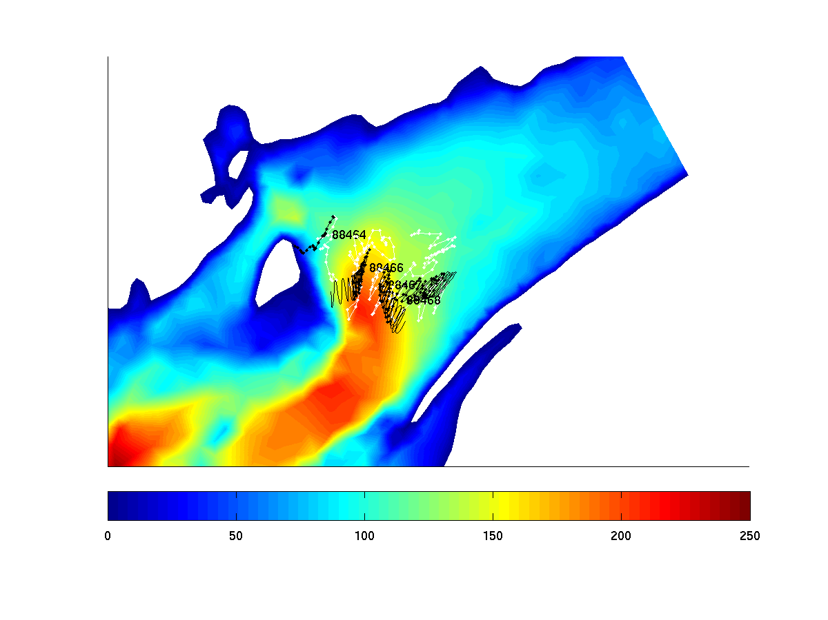 | 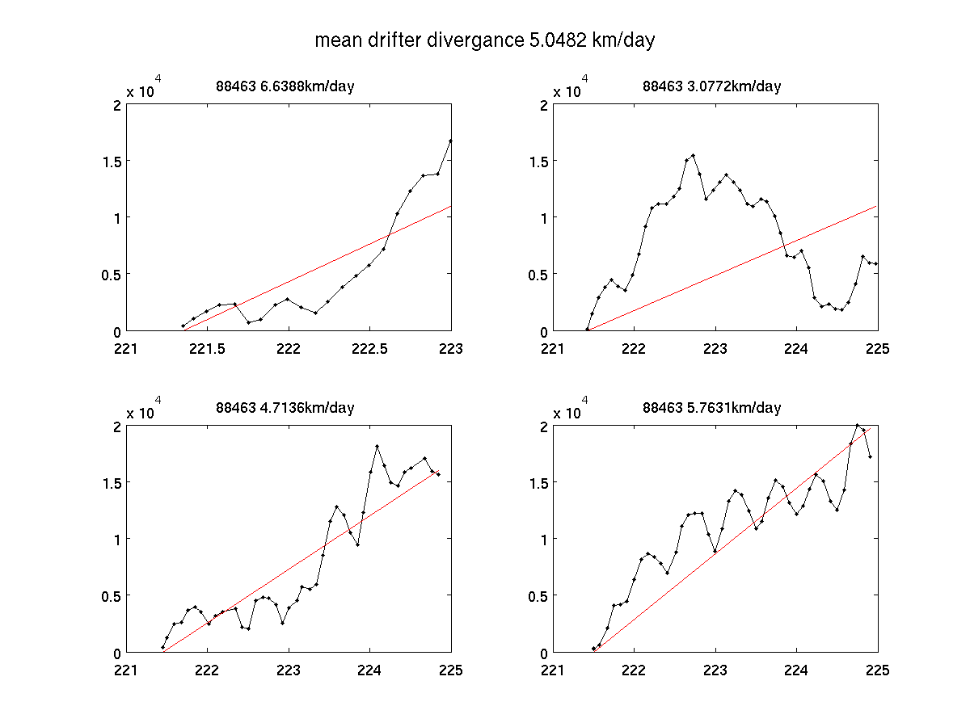
Figure 7. Left panel: Simulated (black) and observed (white) drifters from experiment 5 (15-m drogues only). Right panel: separation between modeled and observed trajectories as a function of time. The red line is the best linear approximation to the separation, its slope the basis for our skill assessment

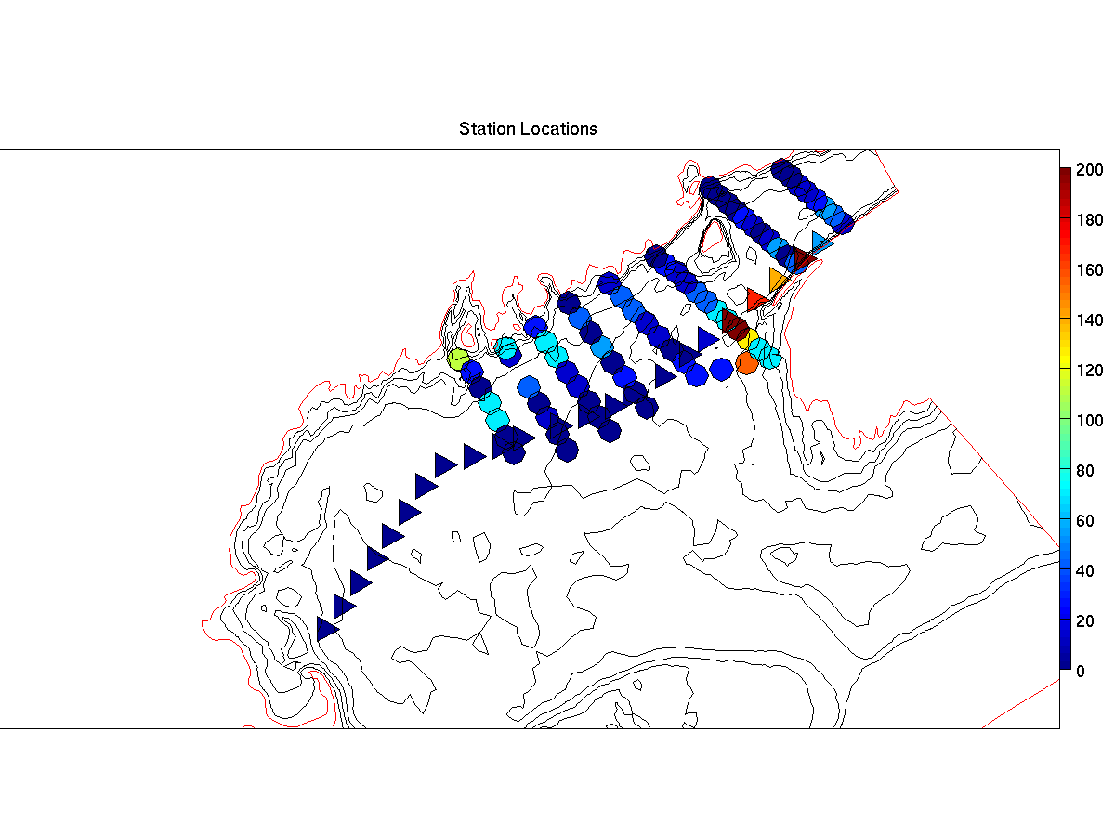 | 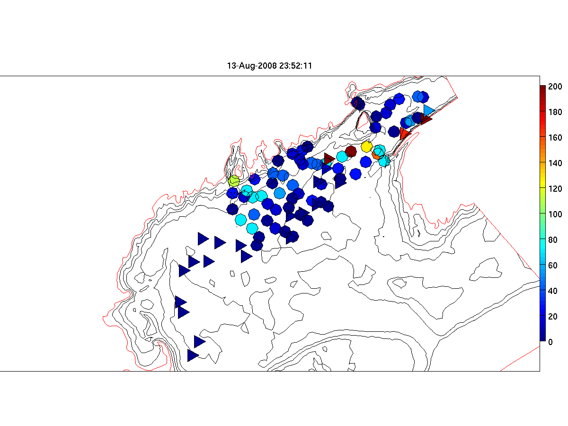
Figure 8. Left: Alexandrium concentrations at sampled positions. Right: Estimated position of water samples after accounting for advection. An animated presentation of these results is available on the web³.

Run | Start | End | Data RMS (cm/s) | Prior misfit (cm/s) | Posterior misfit (cm/s) | 15m drifter  misfit (km/d) | Surface drifter  misfit (km/d) | Hydro-DA
1* | Aug 4 | Aug 10 | 14.1 | 9.2 | 8.9 | N/A | N/A | No
2 | Aug 6 | Aug 11 | 19.7 | 8.5 | 7.7 | N/A | N/A | No
3 | Aug 6 | Aug 12 | 40.0 | 12.8 | 11.6 | 6.9 | 7.9 | No
4 | Aug 6 | Aug 13 | 38.8 | 13.4 | 11.8 | 5.1 | 6.9 | Transect 1
5 | Aug 6 | Aug 14 | 36.6 | 13.4 | 12.0 | 5.0 | 7.6 | Transect 1
6 | Aug 6 | Aug 14 | 33.5 | 12.8 | 11.4 | 5.8 | 6.8 | All data
* GoMOOS buoy data only

References

Aretxabaleta, A.L., McGillicuddy, D.J., Smith, K.W., and D.R. Lynch. Model Simulations of the Bay of Fundy Gyre: 1. Climatological Results. Submitted-a, Journal of Geophysical Research.

Aretxabaleta, A.L., McGillicuddy, D.J., Smith, K.W., Manning, J.P. and D.R. Lynch. Model Simulations of the Bay of Fundy Gyre: 2. Hindcasts for 2005-2007 Reveal Interannual Variability in retentiveness. Submitted-b, Journal of Geophysical Research.

Naimie, C.E., Loder, J.W. and Lynch, D.R., 1994. Seasonal variation in the three-dimensional residual circulation on Georges Bank. Journal of Geophysical Research, 99(C8): 15,967-15,989.

Townsend, D.W., Pettigrew, N.R. and Thomas, A.C., 2001. Offshore blooms of the red tide dinoflagellate Alexandrium sp., in the Gulf of Maine. Continental Shelf Research, 21: 347-369.
Appendix A: Measurements made on EN451

Underway measurements
a. Acoustic Doppler Current Profiler
b. Meteorological sensors

Core hydrographic measurements
a. CTD (pressure, temperature, salinity, oxygen, fluorescence, beam attenuation, PAR)
b. Alexandrium cell counts: 1, 10, 20, 30, 40, 50m plus 250/near bottom
c. Nutrients: standard depths plus 100, 150, 200, 250m

Bottle # | Depth | Live | Whole Cell | SHA | qPCR | Nuts/Chl | Pseuds | total
12 | 1 |  | 2 | 2 | 2 | 1.0 | 0.5 | 7.5
11 | 1 | 10 |  |  |  |  |  | 10
10 | 1 |  |  |  |  |  |  | spare
9 | 10 |  | 2 | 2 | 2 | 1.0 |  | 7.0
8 | 20 |  | 2 | 2 | 2 | 1.0 |  | 7.0
7 | 30 |  | 2 | 2 | 2 | 1.0 |  | 7.0
6 | 40 |  | 2 | 2 | 2 | 1.0 |  | 7.0
5 | 50 |  | 2 | 2 | 2 | 1.0 |  | 7.0
4 | 100 |  |  |  |  | 1.0 |  | 1.0
3 | 150 |  |  |  |  | 1.0 |  | 1.0
2 | 200 |  |  |  |  | 1.0 |  | 1.0
1 | 250 / near bottom |  |  |  |  | 1.0 |  | 9.0
Table 1. Water budget

Af water- one 6 hole-manifold loaded twice
6L/depth combined/split x 6 depths=6 WC tubes&12 filters/station
Pseuds – 100-500 ml whole water onto 0.65um Duropore? Frozen in Dewar; manifold 2; 6 filters/station
Additional opportunistic samples may be taken in areas of high Alexandrium abundance.

Toxin size fractionation – Turner
Pump profiles were carried out at selected locations. Sampling depths were chosen to coincide as closely as possible with hydrographic sampling and sediment trap measurements. Pump deployments are summarized in Table 2.

 | Date | Time  (UTC) | Latitude | Longitude | Station | Live Count  (cells l⁻¹)
1 | August 9 | 1425 | 44 32.3 N | 66 06.6 W | 19 Digby | 42
2 | August 10 | 1815 | 44 02.5 N | 66 25.8 W | 41 SW Nova Scotia | 70
3 | August 11 | 2020 | 44 09.5 N | 68 16.9 W | 50 Mt Desert | 28
4 | August 12 | 0701 | 43 48.96 N | 69 19.8 W | 78 Monhegan | 154
Table 2. Pump stations.

Drifters

ID | Mon | Day | Year | GMT | Lon | Lat | Drogue  depth(m) | Station Number
88464 | 8 | 9 | 2008 | 0823 | 66 36.2 | 44 50.8 | 15 | 12
88465 | 8 | 9 | 2008 | 0909 | 66 32.6 | 44 48.0 | 15 | 13
88466 | 8 | 9 | 2008 | 1002 | 66 28.4 | 44 45.4 | 15 | 14
88461 | 8 | 9 | 2008 | 1002 | 66 28.3 | 44 45.4 | 1 | 14
88467 | 8 | 9 | 2008 | 1055 | 66 24.3 | 44 42.7 | 15 | 15
88462 | 8 | 9 | 2008 | 1055 | 66 24.3 | 44 42.7 | 1 | 15
88468 | 8 | 9 | 2008 | 1158 | 66 20.0 | 44 40.1 | 15 | 16
88463 | 8 | 9 | 2008 | 1158 | 66 20.0 | 44 40.1 | 1 | 16
88469 | 8 | 9 | 2008 | 1305 | 66 15.9 | 44 37.1 | 15 | 17
Table 3: Summary of drifter release on EN448. For more information see http://nefsc.noaa.gov/drifter.

Other measurements
a. Mussel bags: Casco, Cobscook, Blue Hill, Frenchman’s – Darcy Couture
b. AVHRR, SeaWiFS, MODIS false-color imagery – Andy Thomas
c. GoMOOS moorings
d. NOAA coastal tide gauges
e. NMFS quarterly survey – March-April CTD data

Appendix B: Hydrographic maps

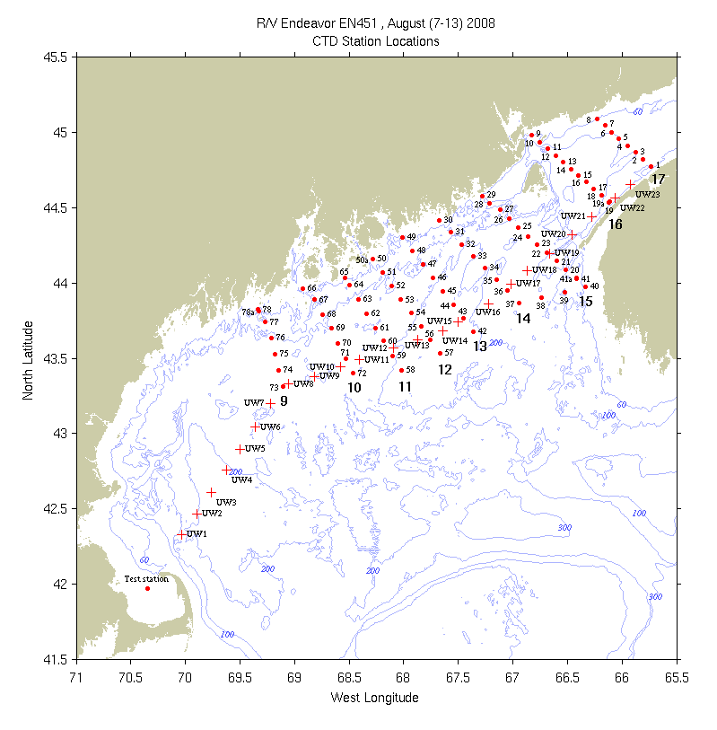
Figure B1: CTD (dots) and underway (crosses) station locations for EN451. Bold numerals indicate identifiers for the sections displayed below.

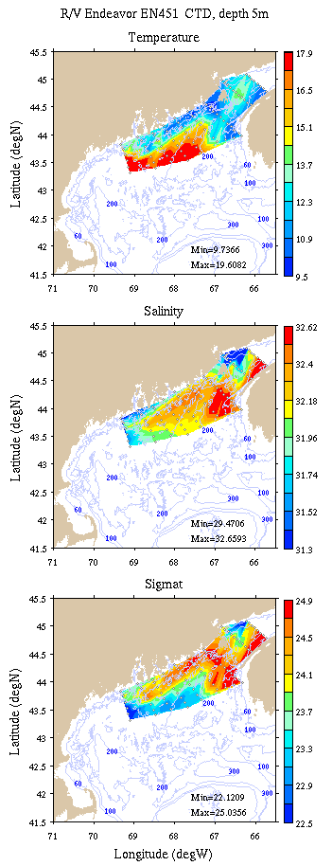 | 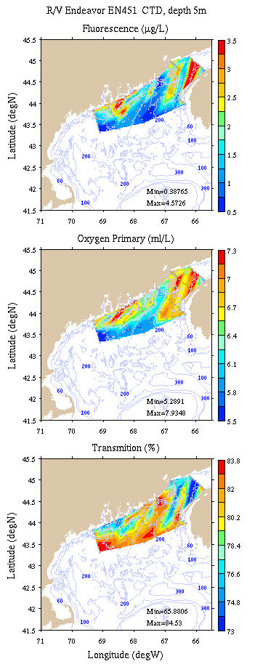
Figure B2: Survey maps at 5m depth. Left: temperature, salinity, and density; right: fluorescence, oxygen, and light transmission.

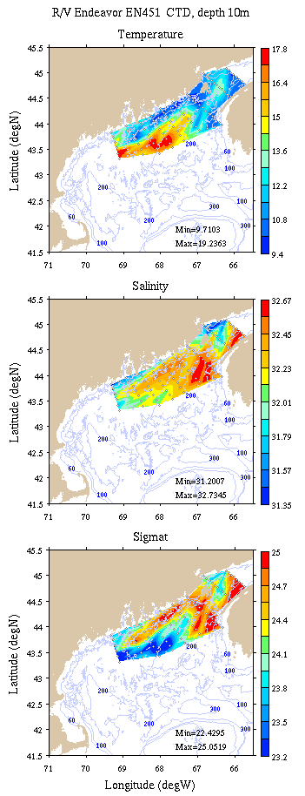 | 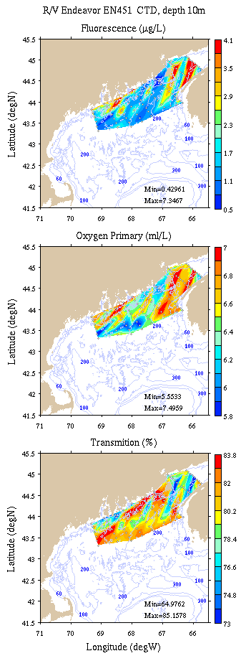
Figure B3: Survey maps at 10m depth. Left: temperature, salinity, and density; right: fluorescence, oxygen, and light transmission.

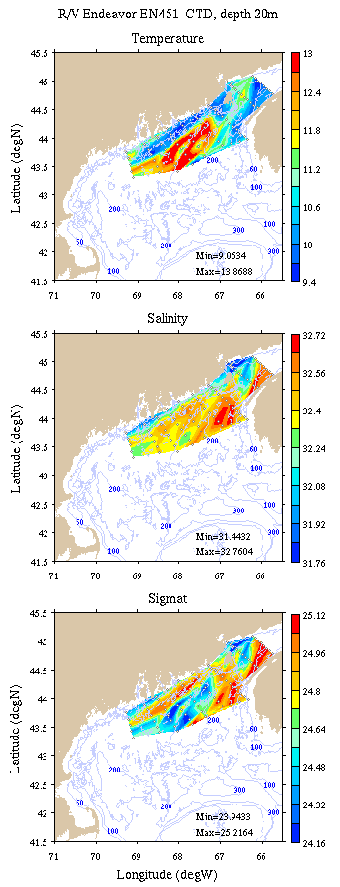 | 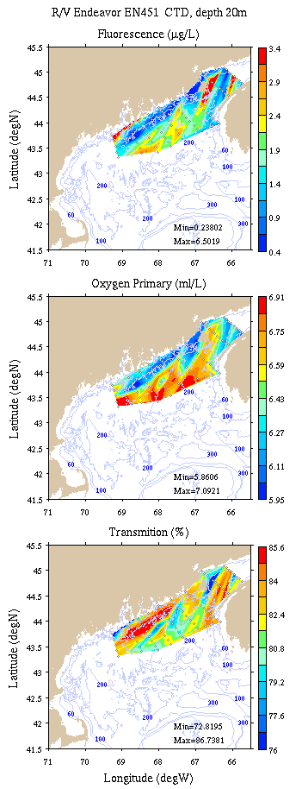
Figure B4: Survey maps at 20m depth. Left: temperature, salinity, and density; right: fluorescence, oxygen, and light transmission.

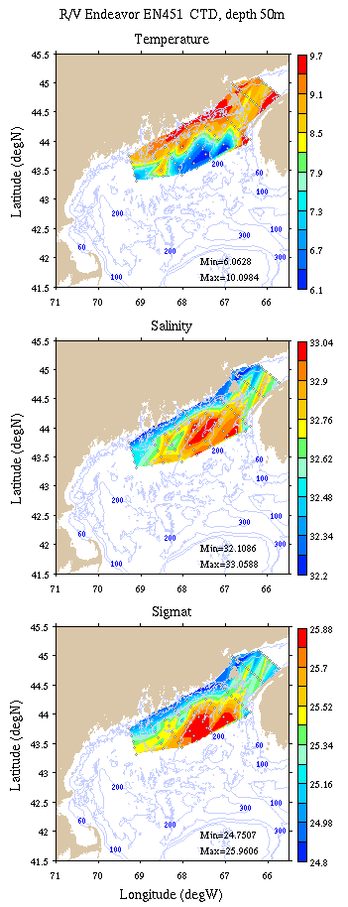 | 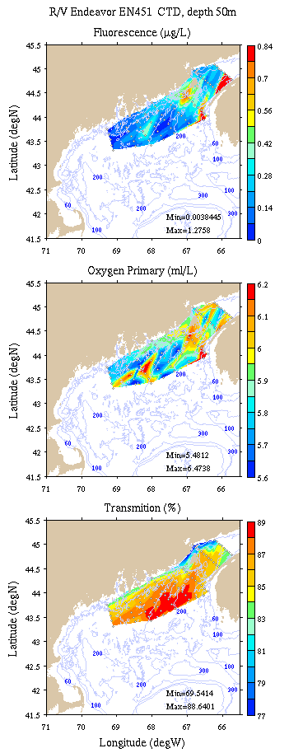
Figure B5: Survey maps at 50m depth. Left: temperature, salinity, and density; right: fluorescence, oxygen, and light transmission.

Appendix C: Vertical sections.

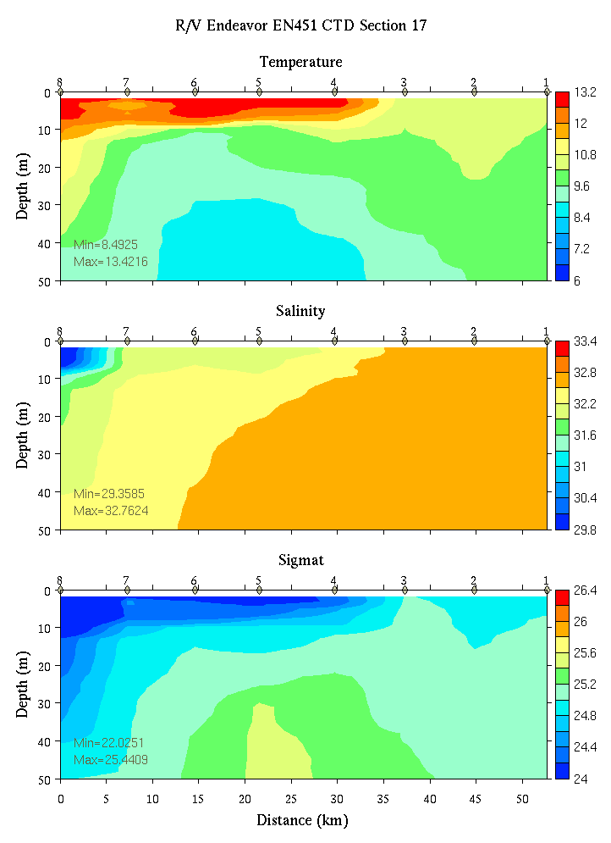 | 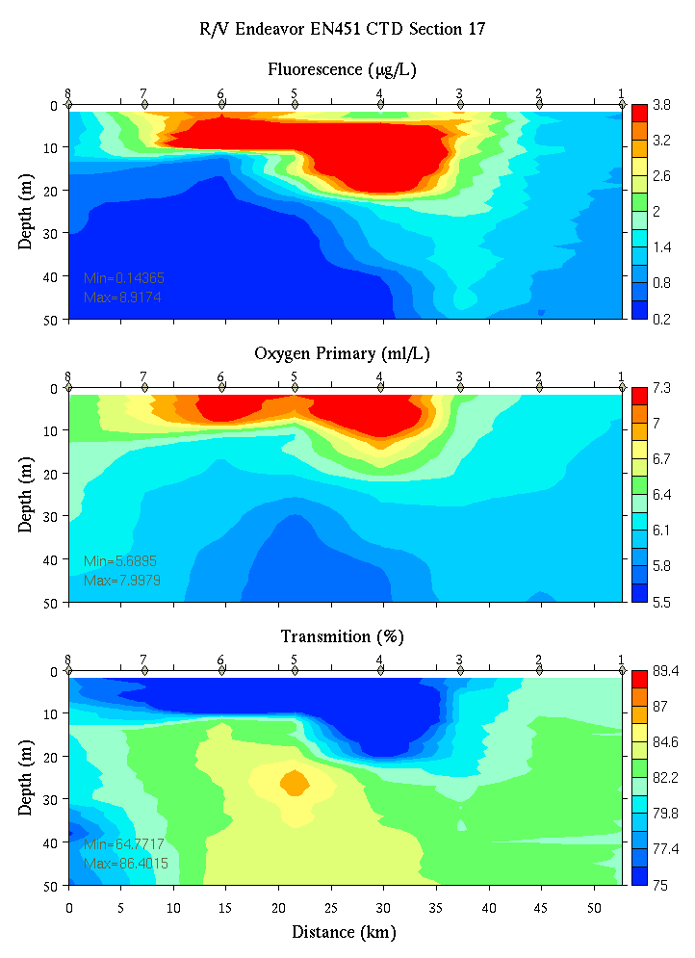
Figure C1. Section 17, 0-50m: temperature, salinity, and density (left); fluorescence, oxygen, and beam transmission (right).

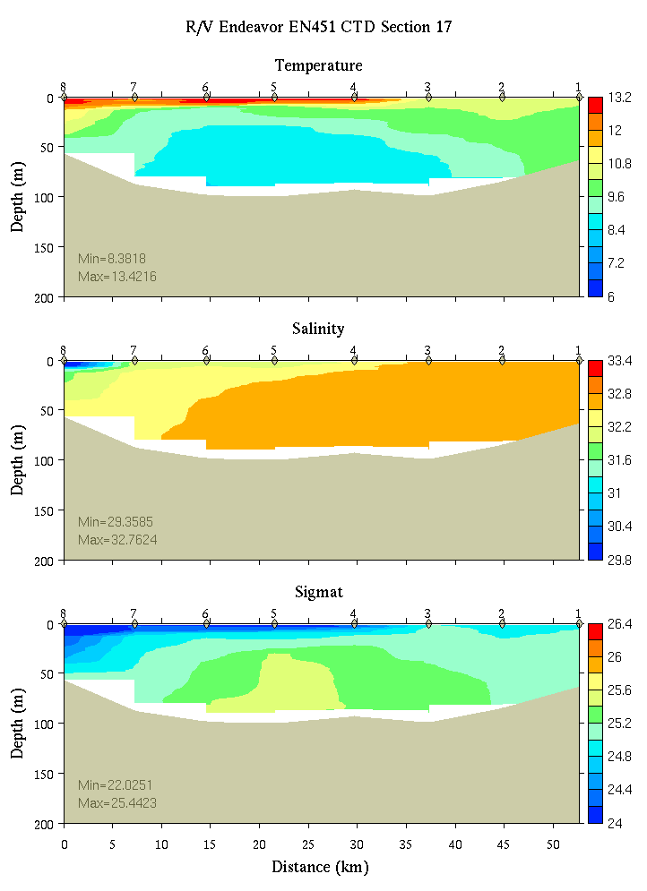 | 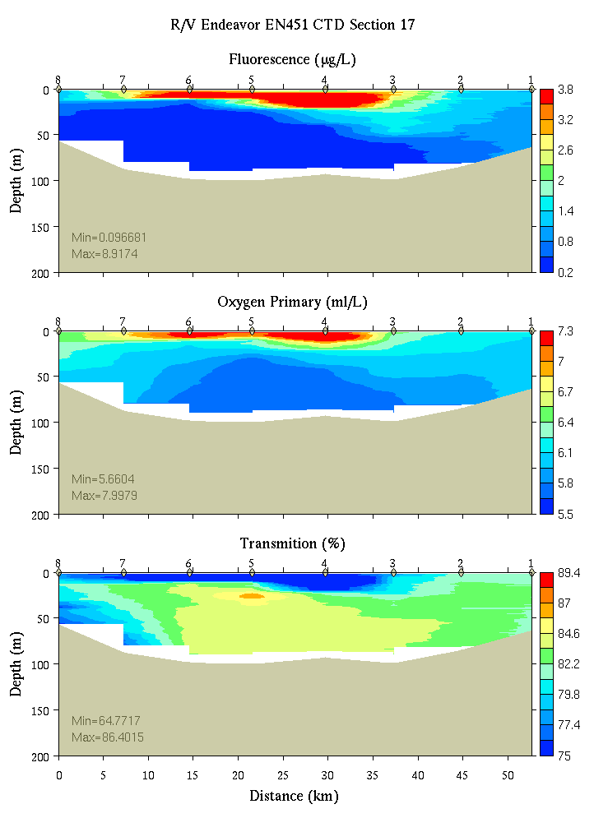
Figure C2. Section 17, 0-200m: temperature, salinity, and density (left); fluorescence, oxygen, and beam transmission (right).

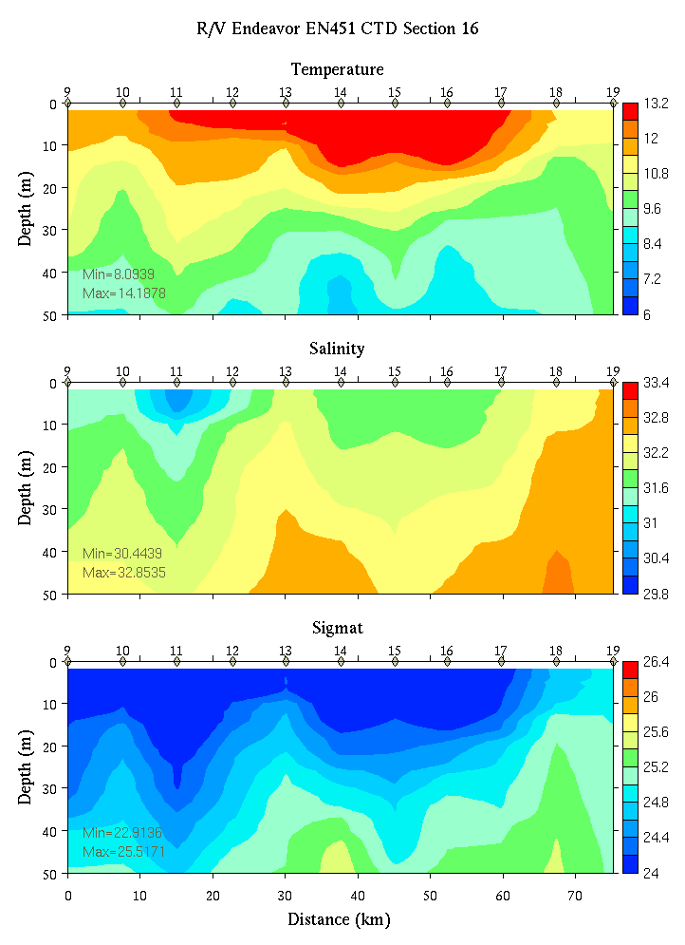 | 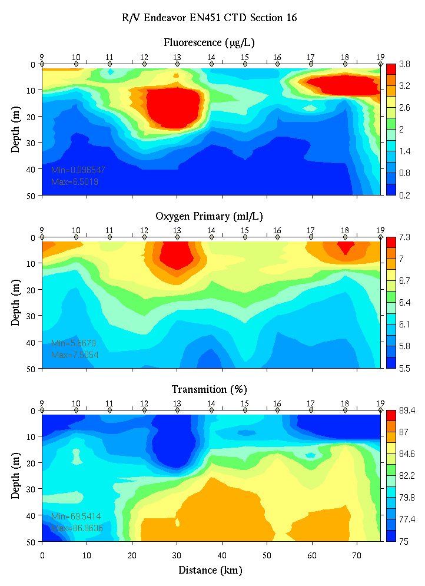
Figure C3. Section 16, 0-50m: temperature, salinity, and density (left); fluorescence, oxygen, and beam transmission (right).

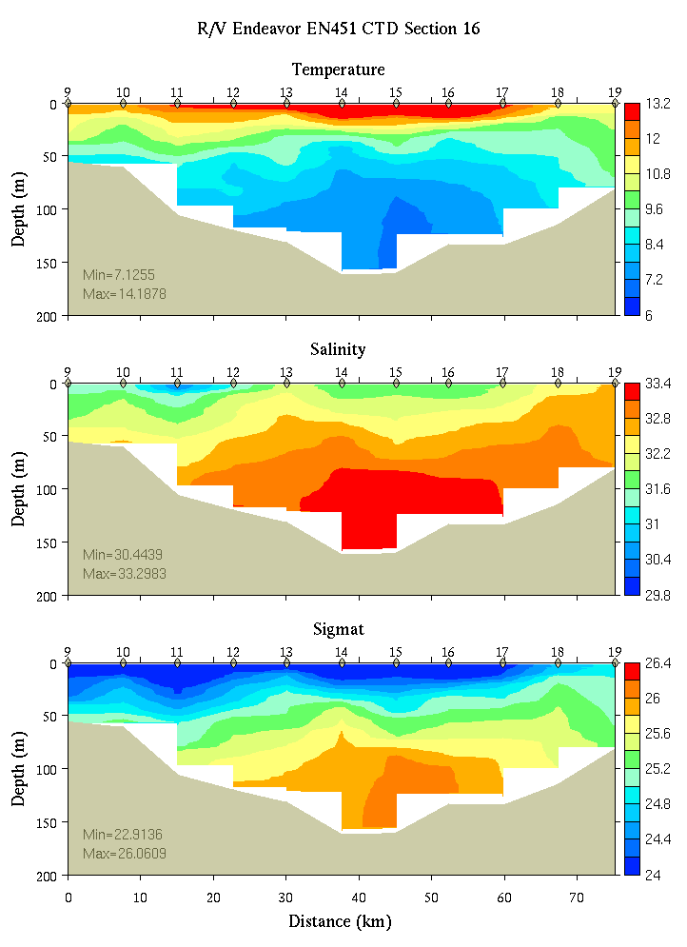 | 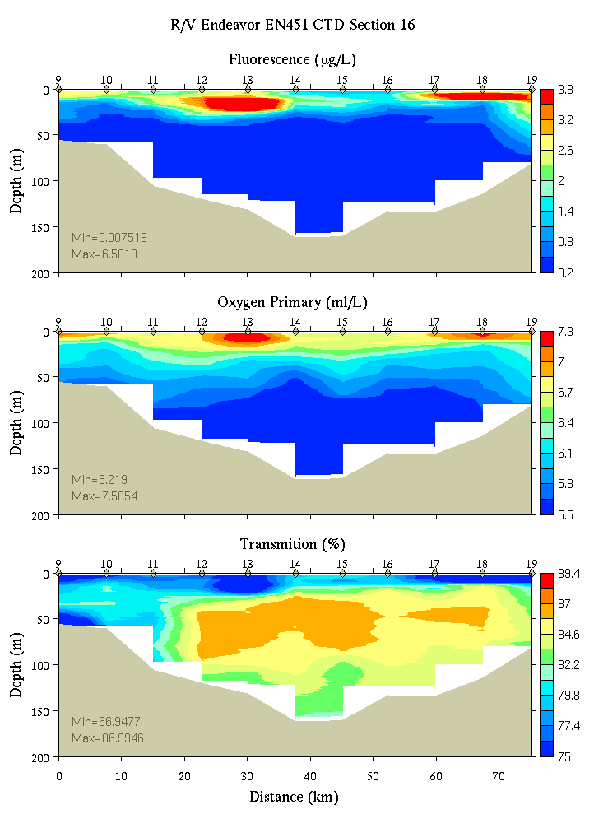
Figure C14. Section 16, 0-200m: temperature, salinity, and density (left); fluorescence, oxygen, and beam transmission (right).

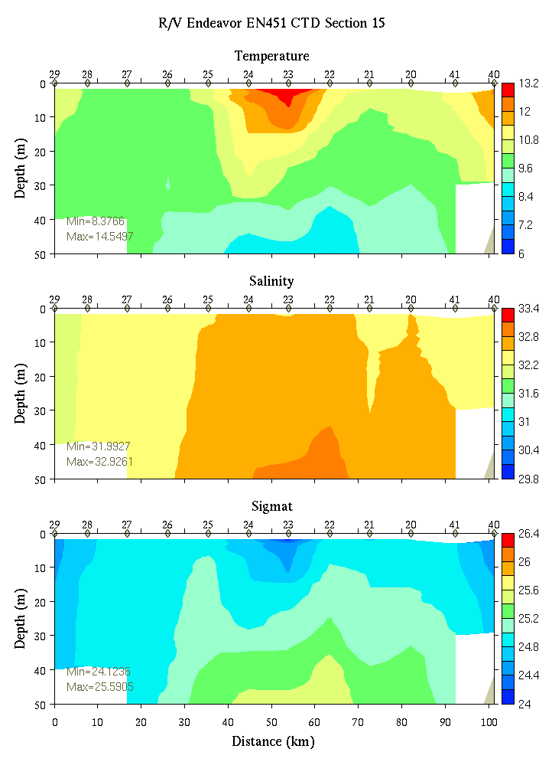 | 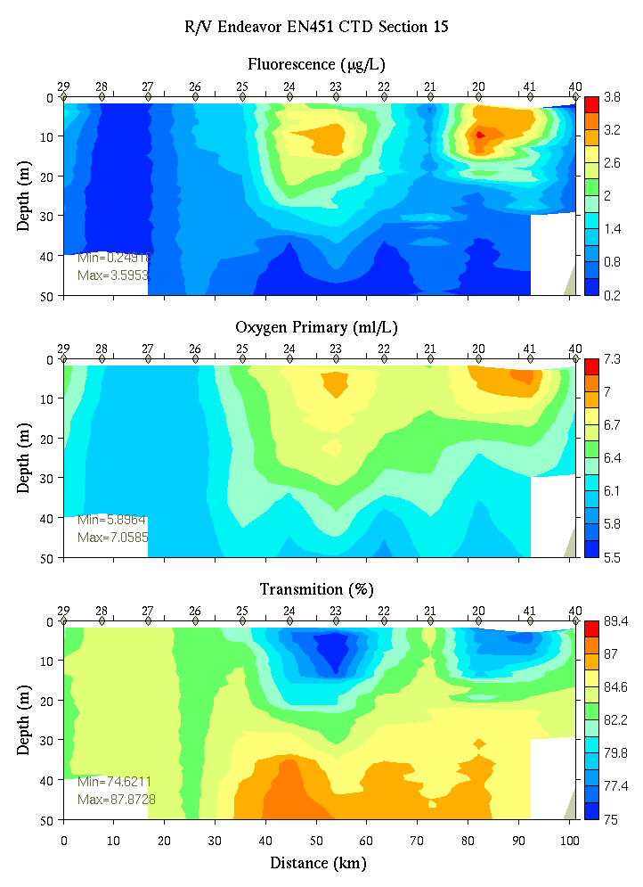
Figure C5. Section 15, 0-50m: temperature, salinity, and density (left); fluorescence, oxygen, and beam transmission (right).

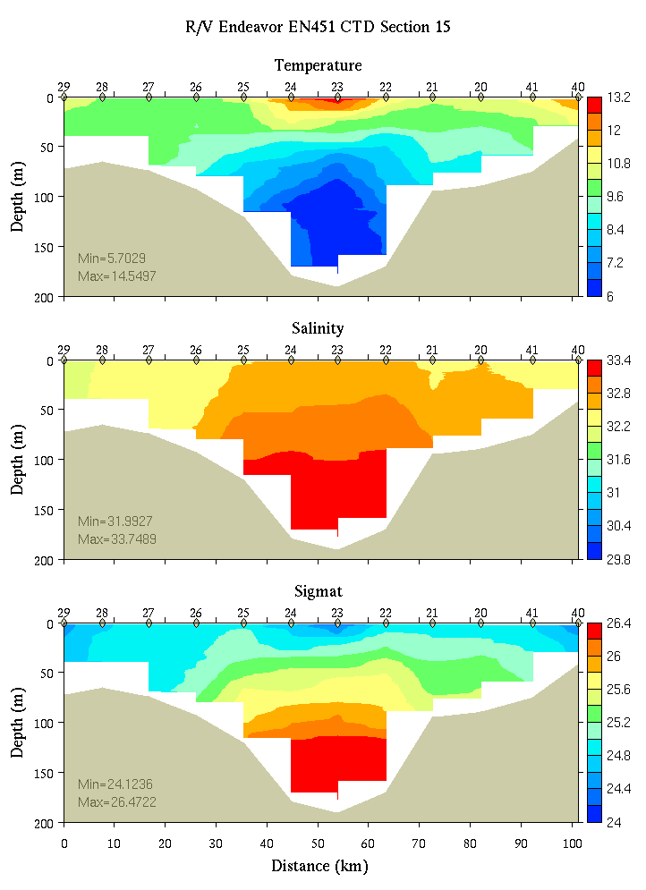 | 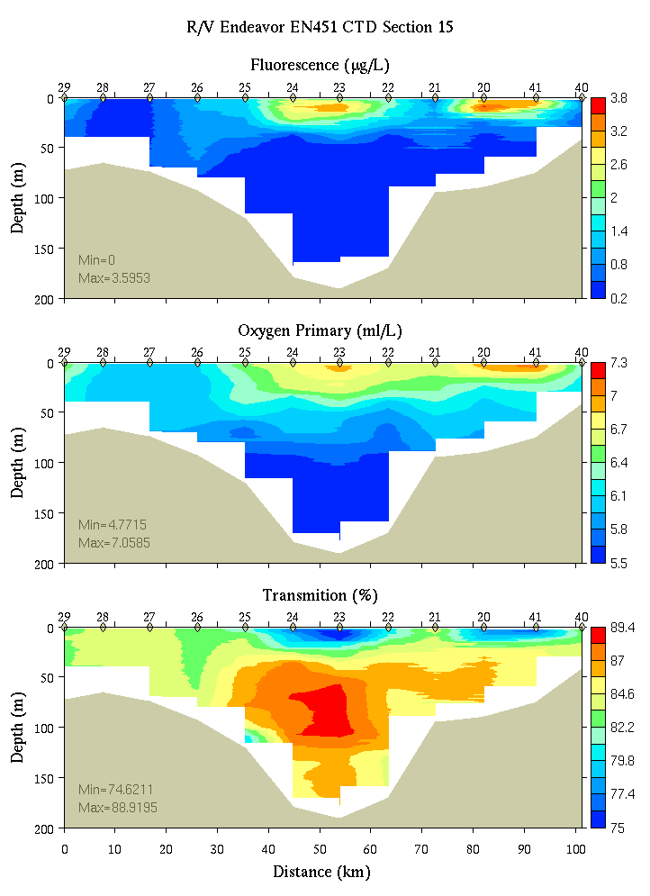
Figure C6. Section 15, 0-200m: temperature, salinity, and density (left); fluorescence, oxygen, and beam transmission (right).

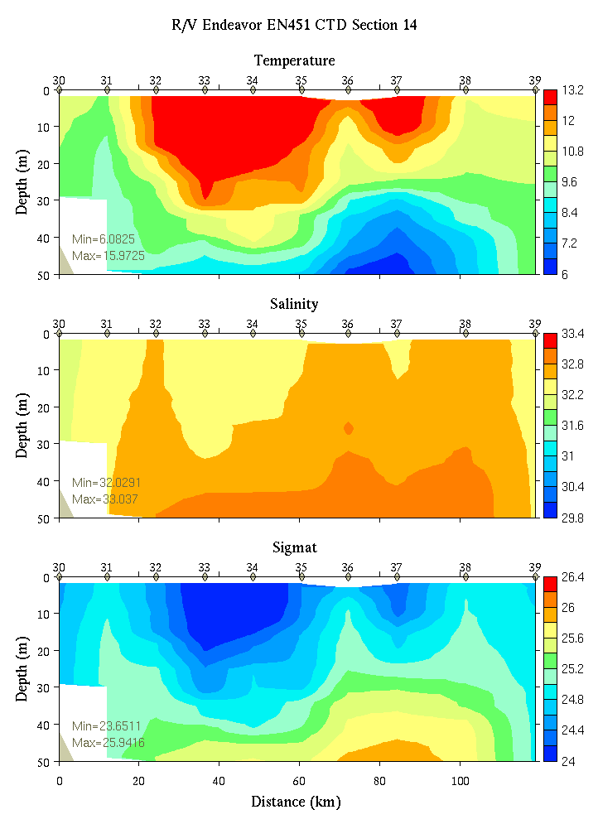 | 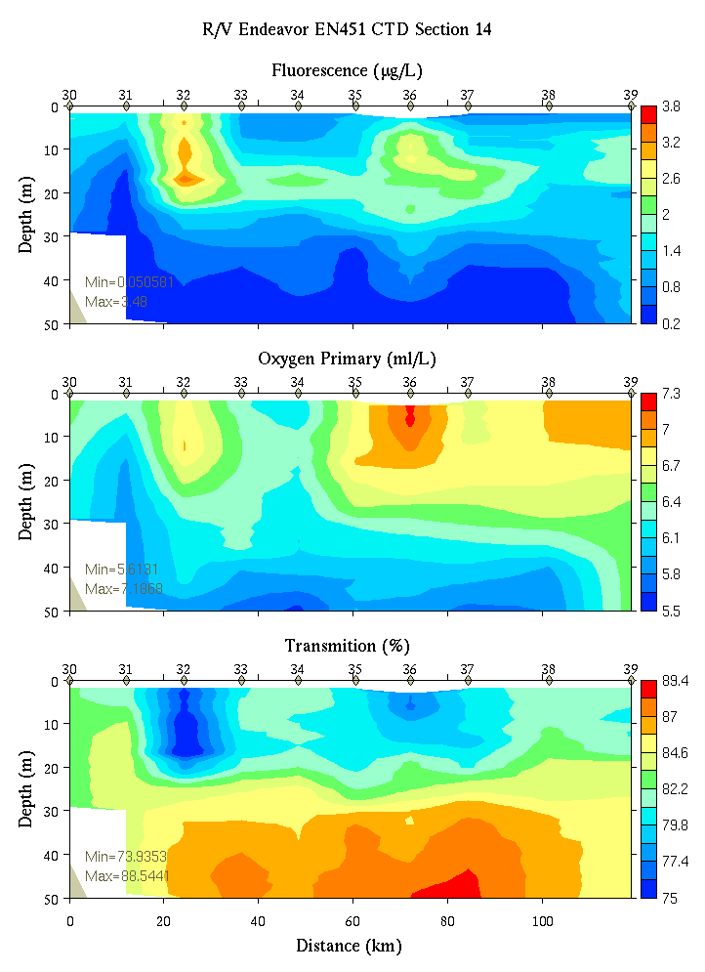
Figure C7. Section 14, 0-50m: temperature, salinity, and density (left); fluorescence, oxygen, and beam transmission (right).

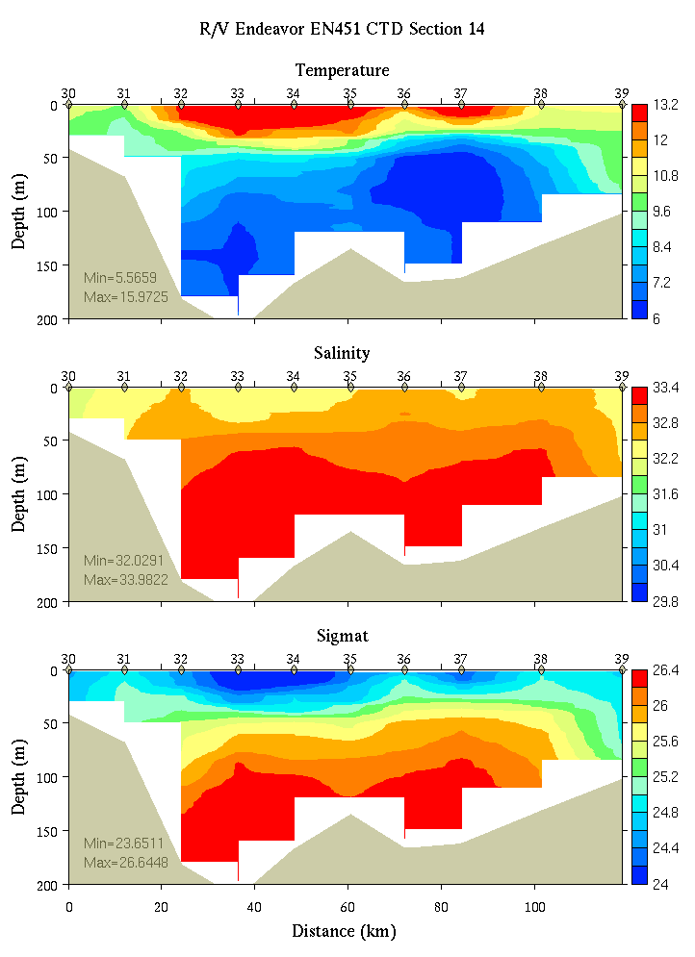 | 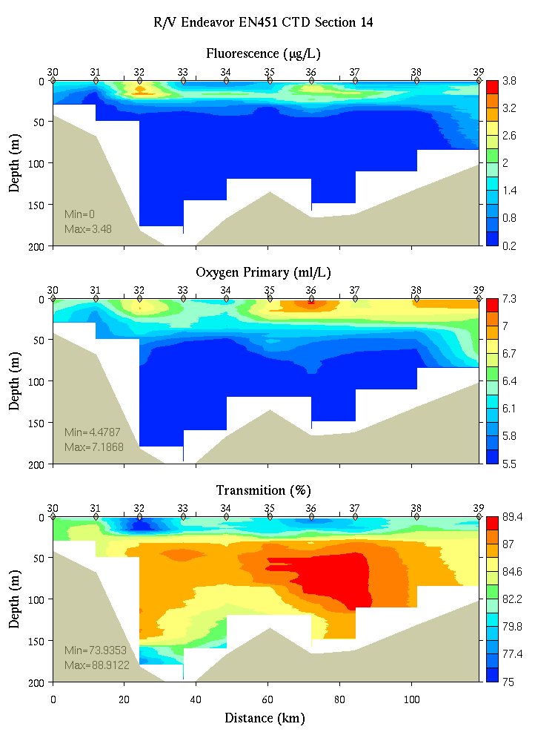
Figure C8. Section 14, 0-200m: temperature, salinity, and density (left); fluorescence, oxygen, and beam transmission (right).

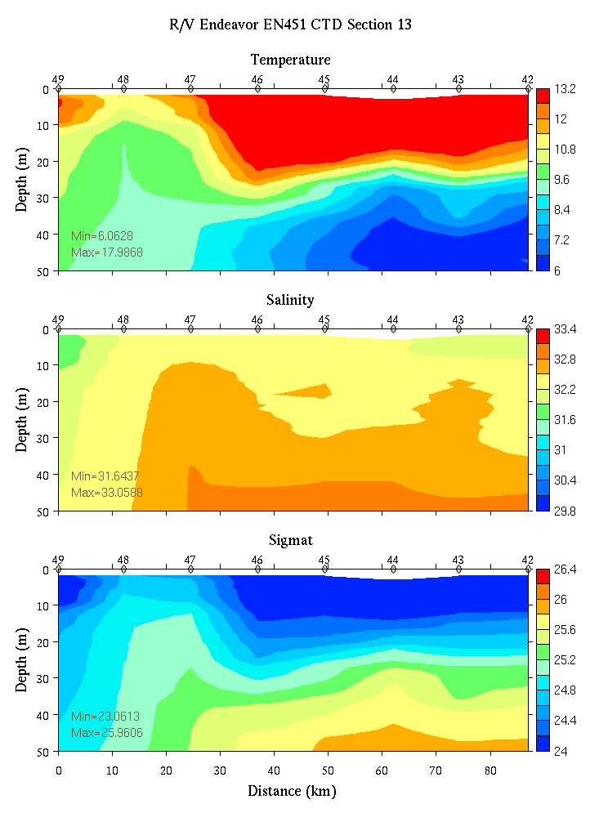 | 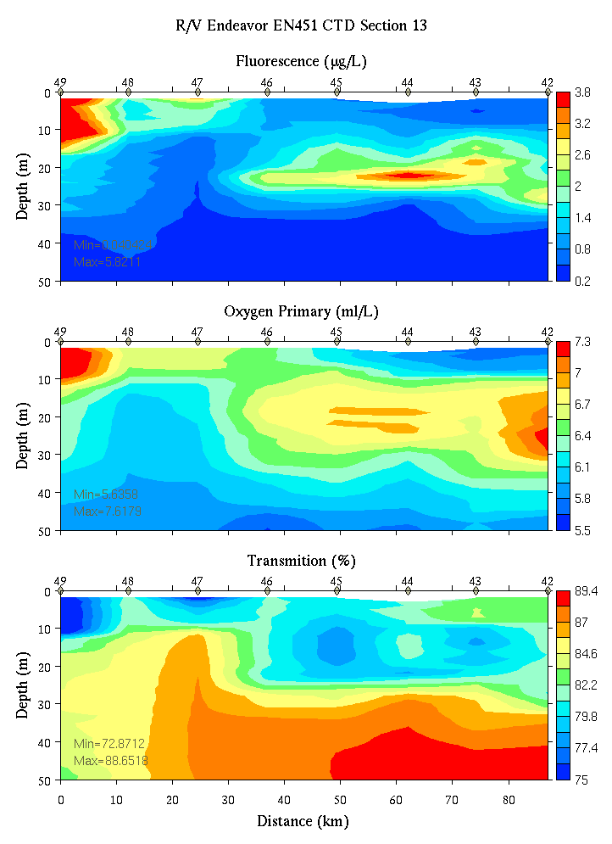
Figure C9. Section 13, 0-50m: temperature, salinity, and density (left); fluorescence, oxygen, and beam transmission (right).

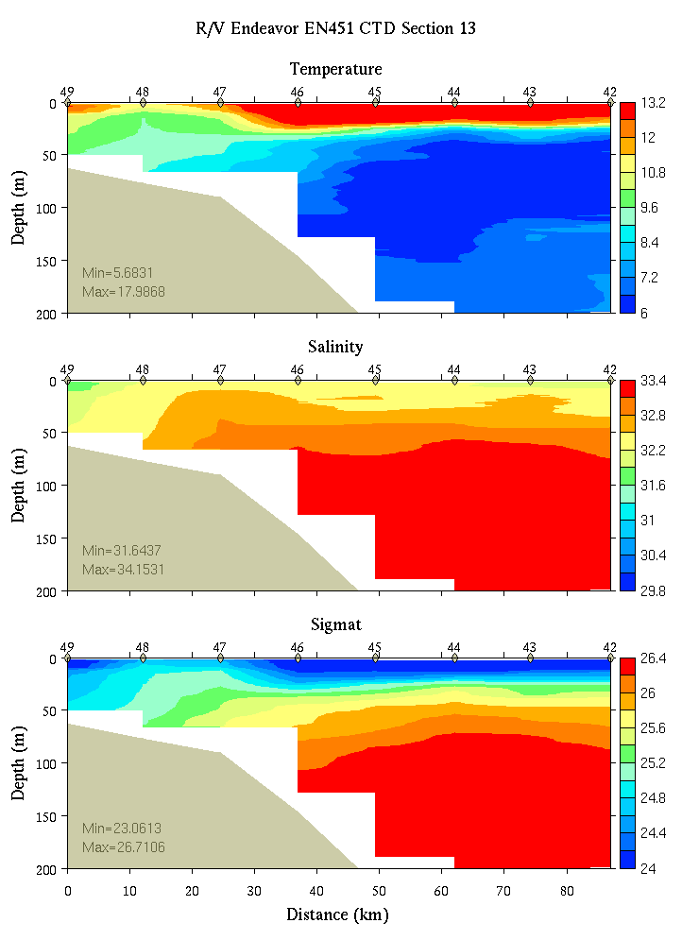 | 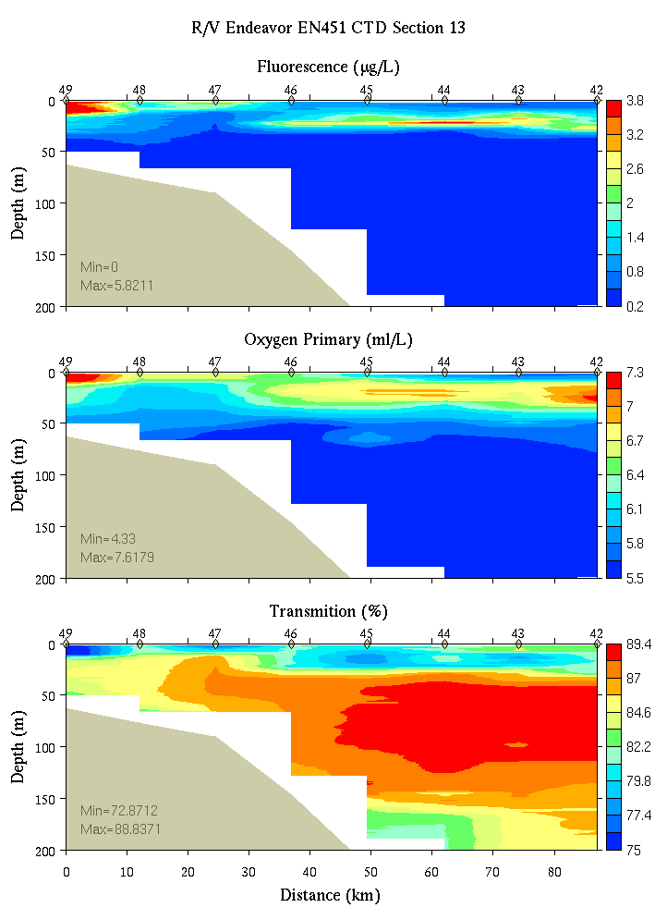
Figure C10. Section 13, 0-200m: temperature, salinity, and density (left); fluorescence, oxygen, and beam transmission (right).

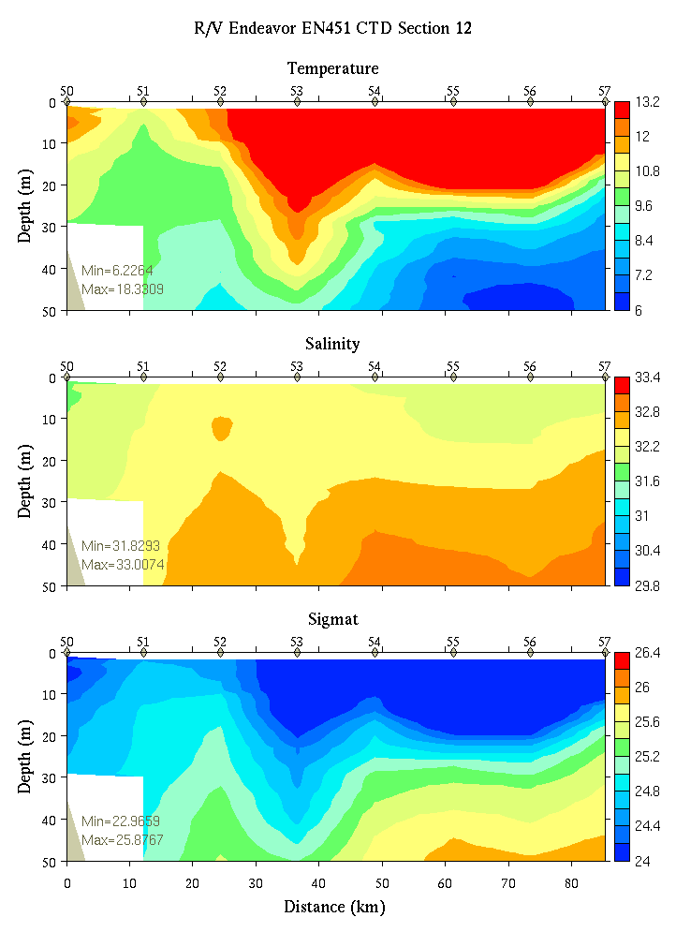 | 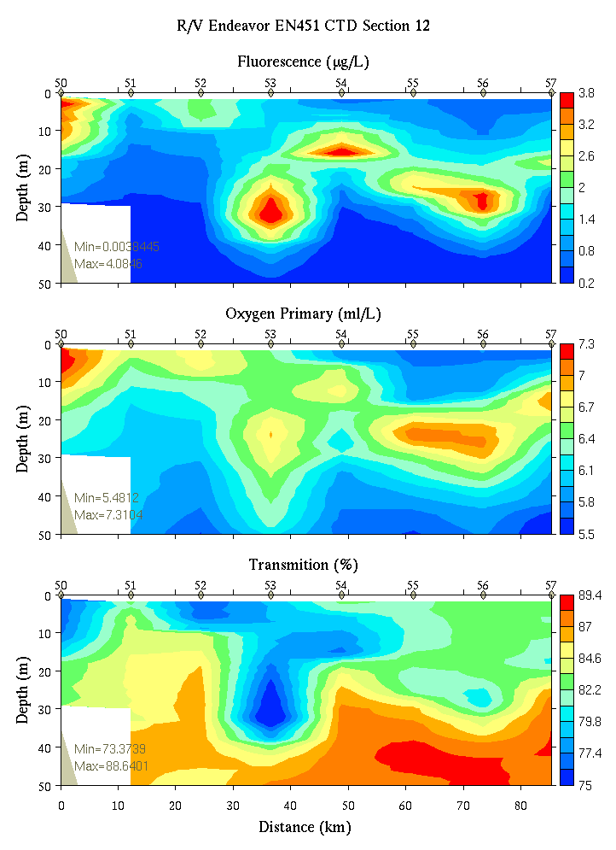
Figure C11. Section 12, 0-50m: temperature, salinity, and density (left); fluorescence, oxygen, and beam transmission (right).

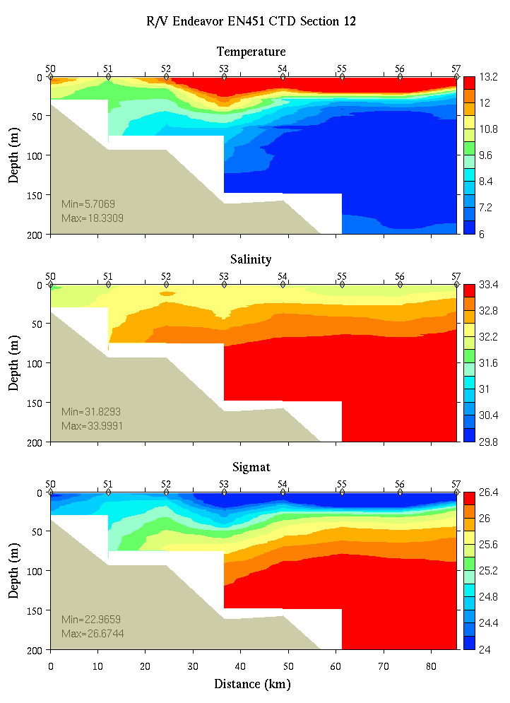 | 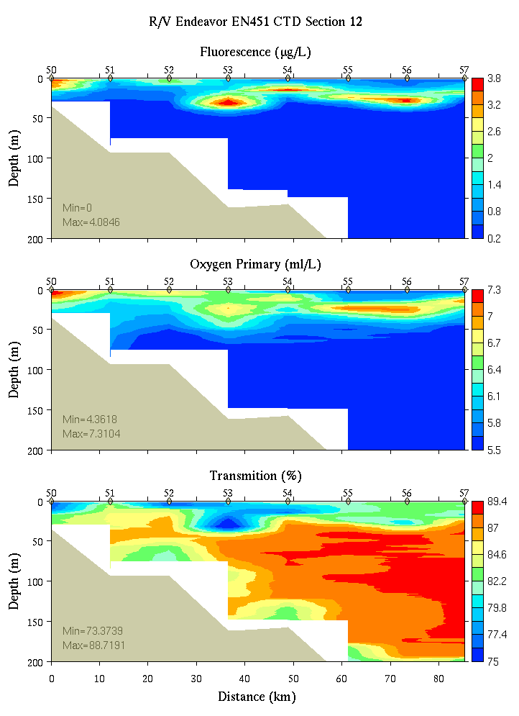
Figure C12. Section 12, 0-200m: temperature, salinity, and density (left); fluorescence, oxygen, and beam transmission (right).

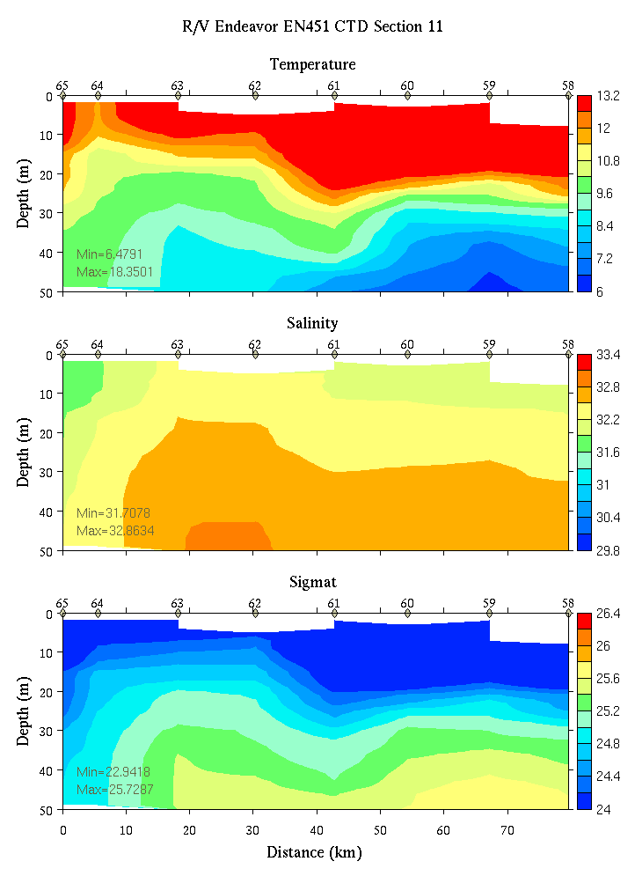 | 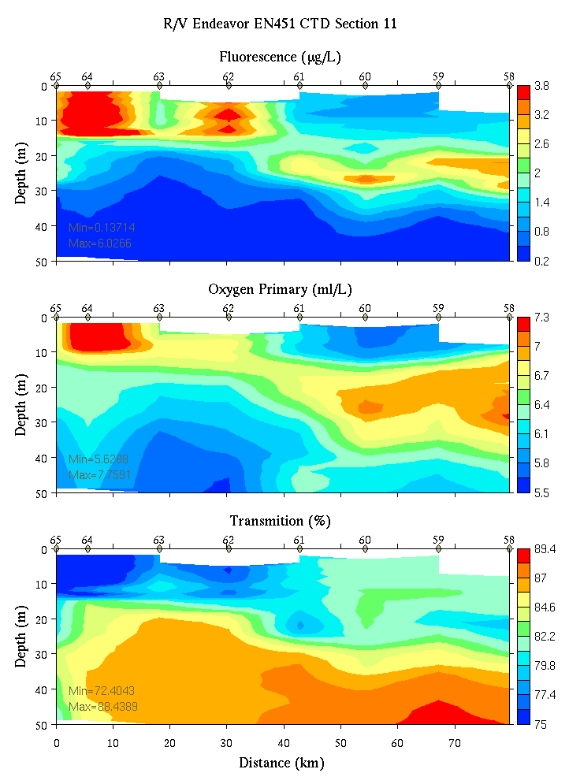
Figure C13. Section 11, 0-50m: temperature, salinity, and density (left); fluorescence, oxygen, and beam transmission (right).

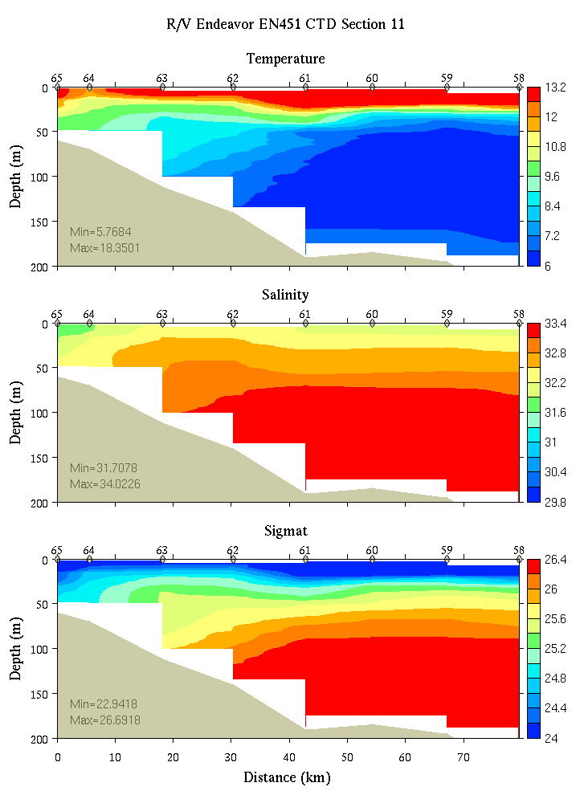 | 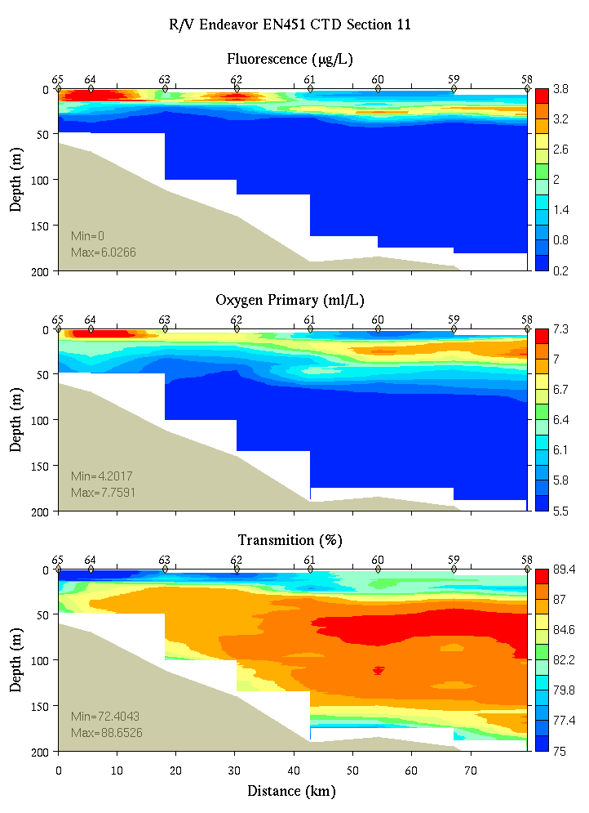
Figure C14. Section 11, 0-200m: temperature, salinity, and density (left); fluorescence, oxygen, and beam transmission (right).

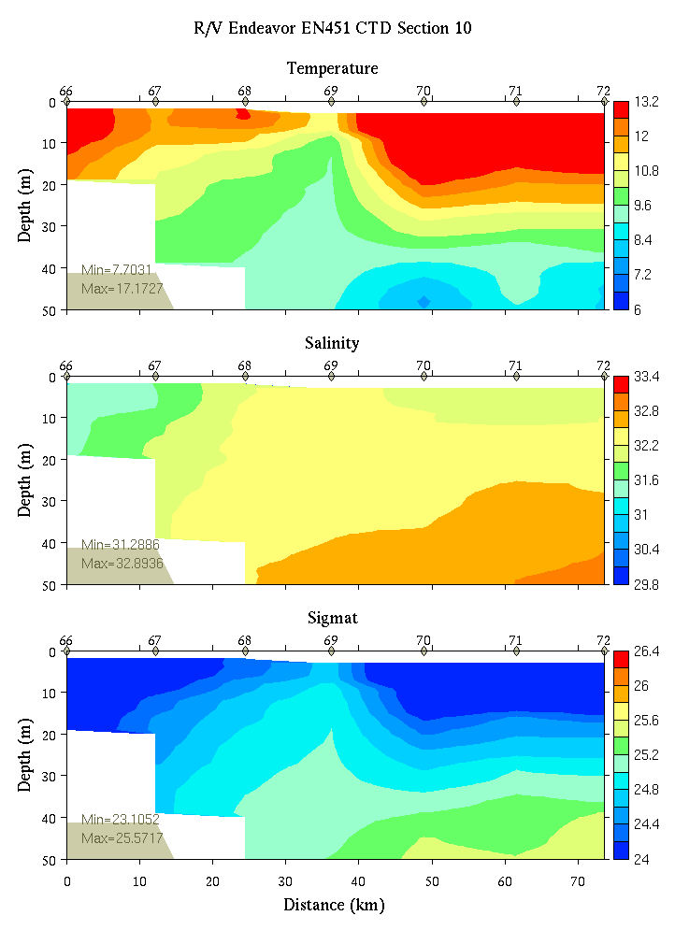 | 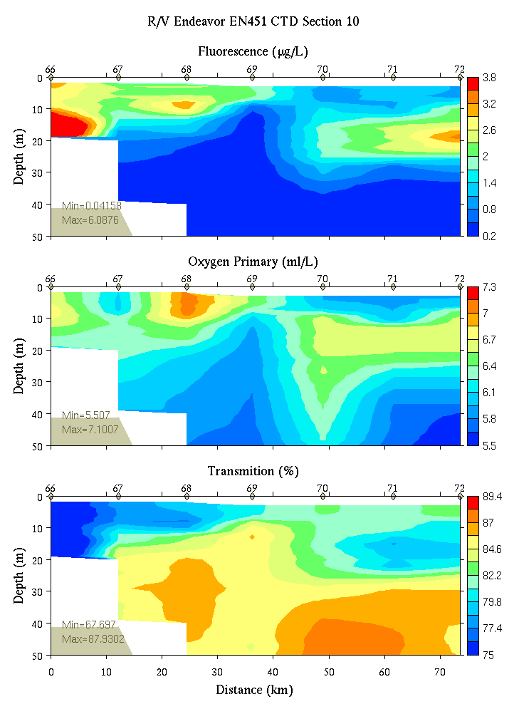
Figure C15. Section 10, 0-50m: temperature, salinity, and density (left); fluorescence, oxygen, and beam transmission (right).

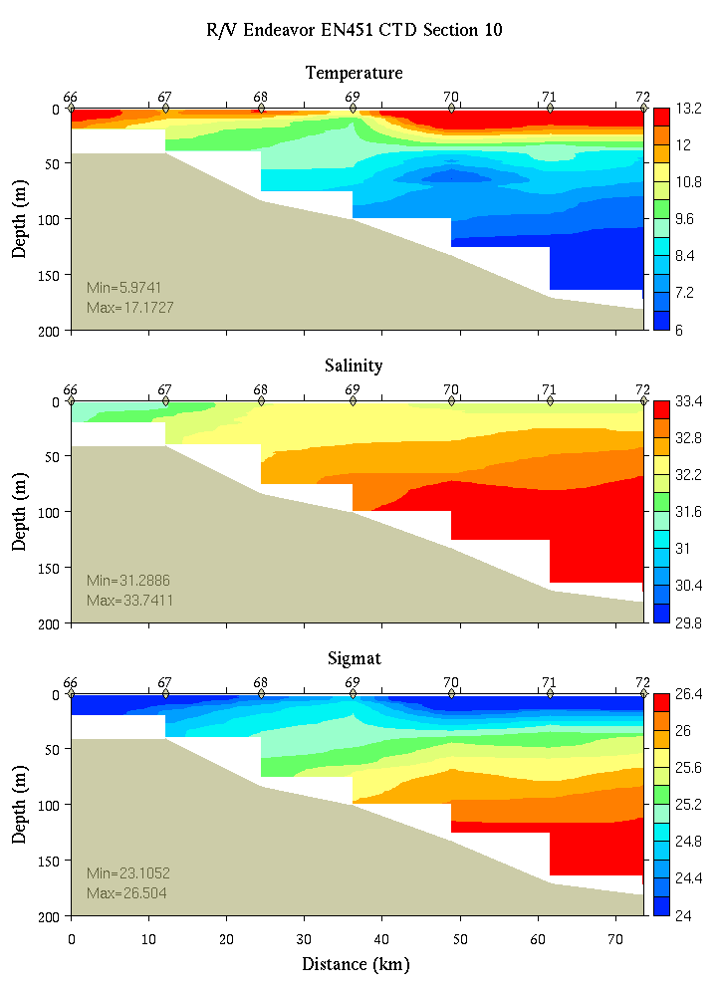 | 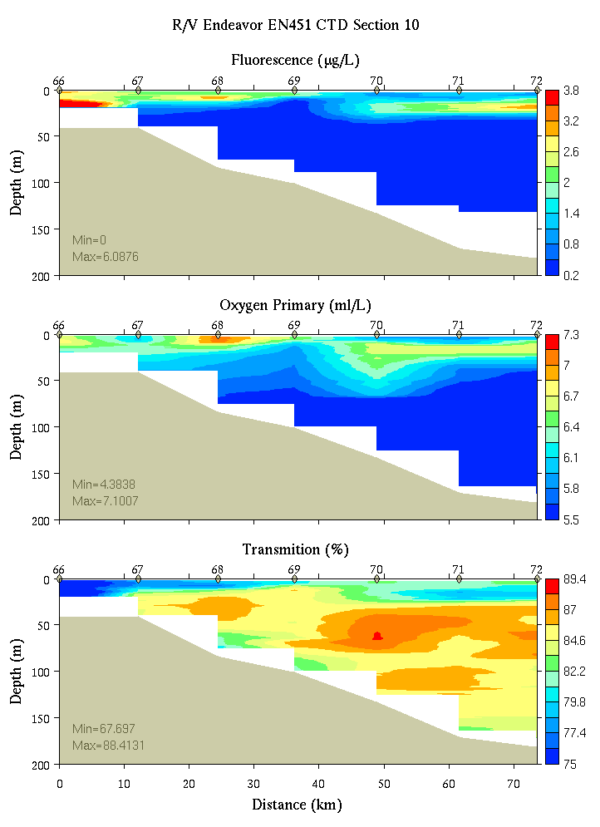
Figure C16. Section 10, 0-200m: temperature, salinity, and density (left); fluorescence, oxygen, and beam transmission (right).

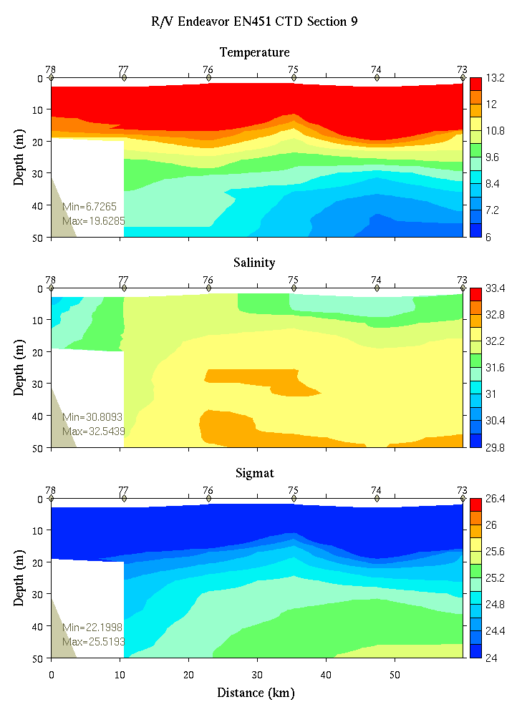 | 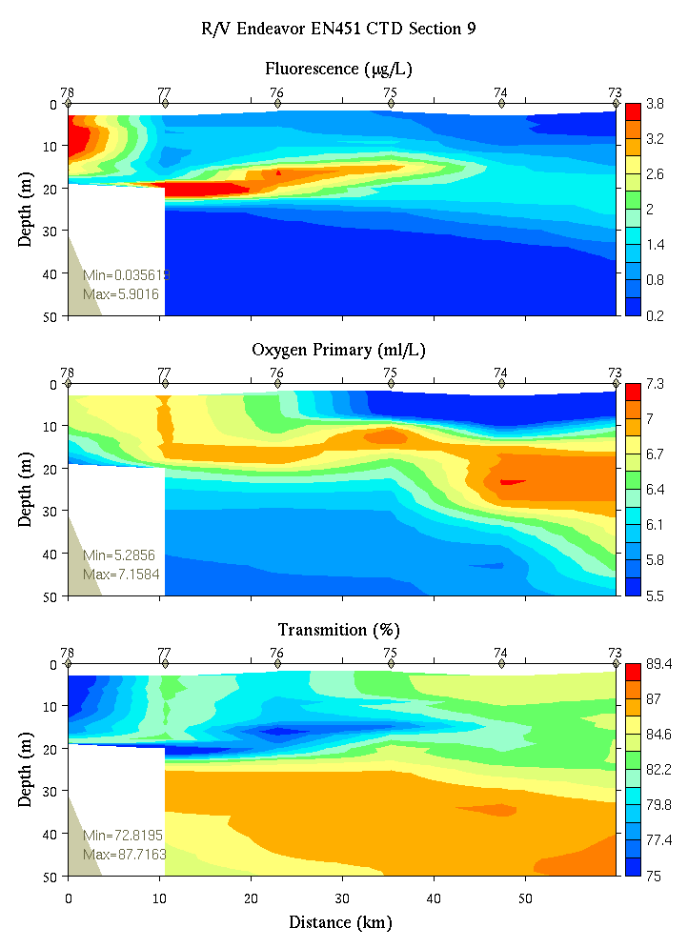
Figure C17. Section 9, 0-50m: temperature, salinity, and density (left); fluorescence, oxygen, and beam transmission (right).

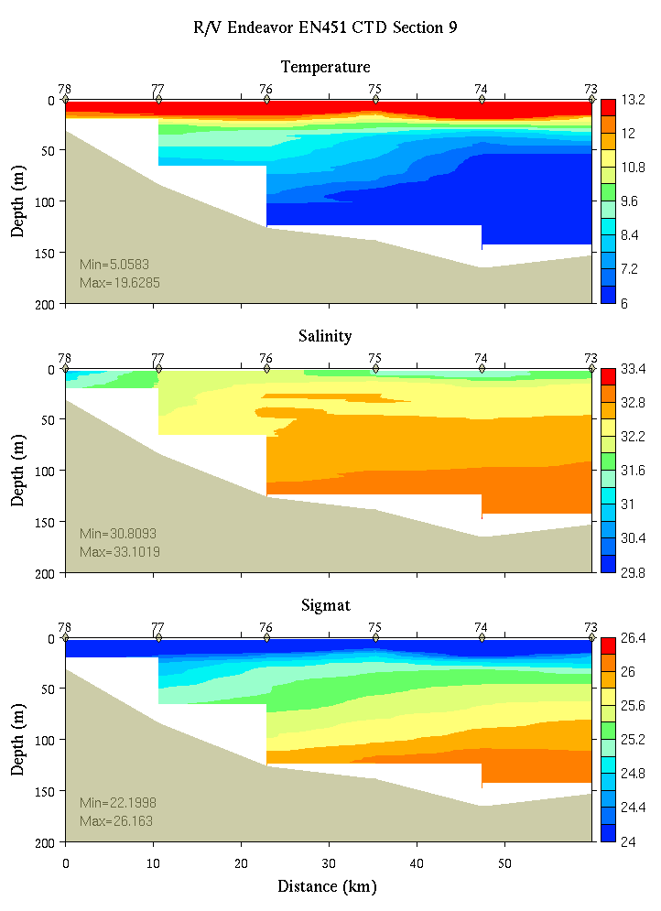 | 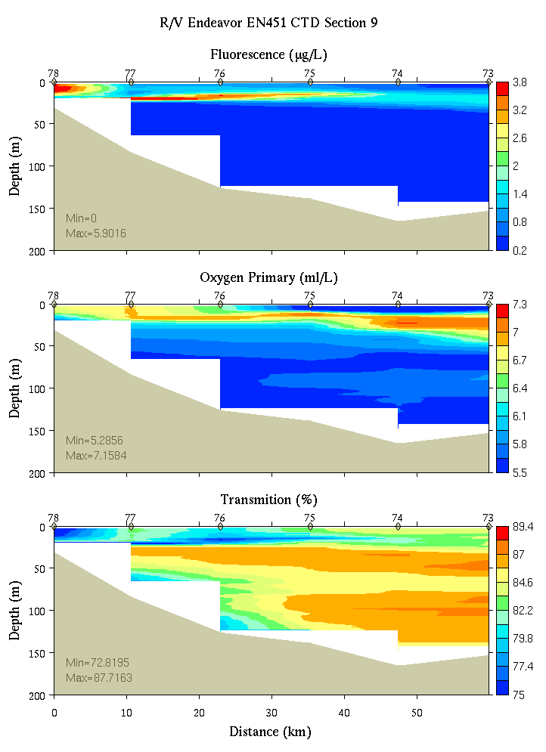
Figure C18. Section 9, 0-200m: temperature, salinity, and density (left); fluorescence, oxygen, and beam transmission (right).

Appendix D: Satellite imagery

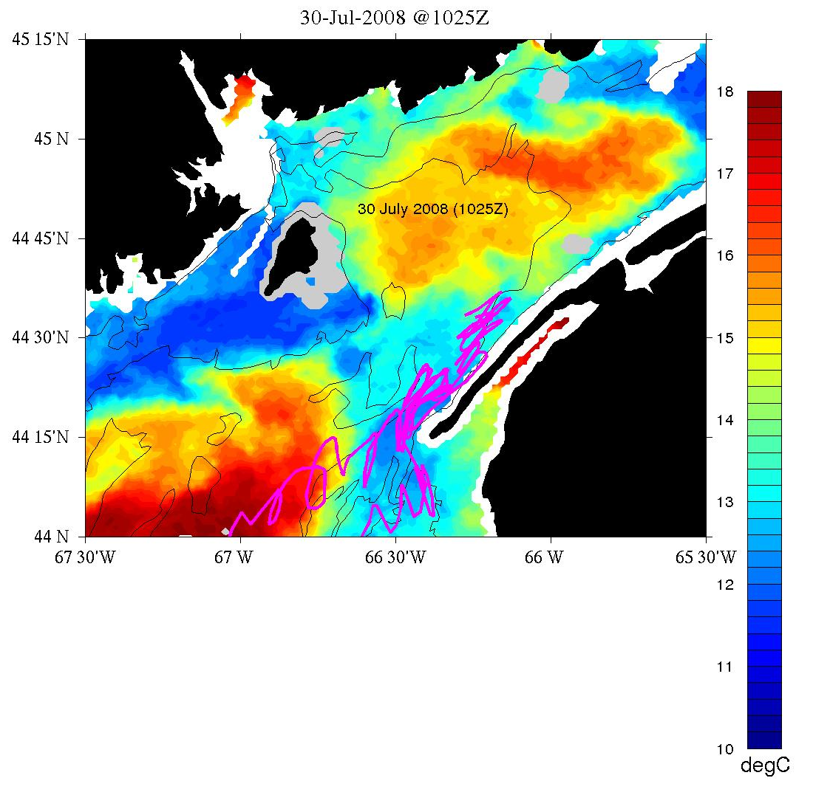
Figure D1. Satellite sea surface termperature image from July 30, 2008 courtesy of Jim Manning. Magenta line shows track of a surface drifter deployed in the coastal Gulf of Maine on an earlier GOMTOX cruise.

Appendix E: Personnel

1. Dennis McGillicuddy
2. Neal Pettigrew
3. Olga Kosnyreva
4. Keston Smith
5. Bruce Keafer
6. Kerry Norton
7. Bibiana Crespo
8. Kate Hubbard
9. Holly Taylor
10. David Townsend
11. Maura Thomas
12. Nathan Rebuck
13. Rachel Gettings
14. Croy Carlin
15. Jeff Turner
16. Peter Milligan
17. Meri Ratzel

Watch number 1 2 3
4 on / 8 off 8-12 12-4 4-8

1. CTD Operator Keston Croy Neal
2. Cell Counter Meri Kerry*## Bruce*##
3. Nutrient sampler Dave# Nathan# Maura#
4. Water sampler Bibiana*# Olga# Jeff
5. Water sampler Kate Holly Peter#
Lynne ## Rachel

* Wetlab chief
# CTD deck operations: 1 deck chief (##) and 2 slip line handlers (#)

http://www.whoi.edu/science/cohh/whcohh/projects/habs1_abstract.htm
Also see http://nefsc.noaa.gov/drifter
Available at http://science.whoi.edu/users/mcgillic/en451/at_sea_modeling

