EN448 Cruise Report
Draft 7/10/08

Voyage #448 of R/V Endeavor was the third of four cruises in 2008 organized to serve complementary scientific objectives of two different projects. The two projects are:

Alexandrium population biology in the Gulf of Maine – Woods Hole Center for Oceans and Human Health – NSF/NIEHS

Objectives:
Sample genetic variability of Alexandrium subpopulations throughout the Gulf of Maine.

Measure changes in relative abundance of Alexandrium genotypes in space and time.

GOMTOX: Dynamics of Alexandrium fundyense distributions in the Gulf of Maine: an observational and modeling study of nearshore and offshore shellfish toxicity, vertical toxin flux, and bloom dynamics in a complex shelf sea – NOAA ECOHAB

Objectives:
Investigate A. fundyense bloom dynamics and the pathways that link this organism to toxicity in nearshore and offshore shellfish.

Investigate the vertical structure of A. fundyense blooms, vertical toxin flux, and linkage to toxicity in offshore shellfish.

Objectives common to both projects include:
Assess hydrodynamic and hydrographic context for interpretation of Alexandrium spp. measurements.

Incorporate field observations into a suite of numerical models for hindcasting and forecasting applications.

The primary domain of interest is Georges Bank, where a large bloom of A. fundyense was observed in 2007. The bloom was present on Georges Bank upon our arrival in May (EN435) and still quite conspicuous during our second cruise in June/July (EN437). The four one-week cruises in 2008 are designed to (1) resolve the seasonal variation of the Georges Bank bloom, and (2) quantify its interannual variability.

Results

Surface live counts from EN448 (Figure 1) show that the Alexandrium bloom on Georges Bank have decreased dramatically since the last cruise (OC447) in late May / early June (Figure 2, right panel). The north flank and most of the crest were nearly devoid of cells. A modest tongue of cells (tens to less than 200 cells l⁻¹) emanated from the western side of the northeast peak, extending down the southern flank. The outer edge of the tongue was interrupted by an intrusion of high-salinity slope water. Peak cell concentrations of 224 and 378 cells l⁻¹ were found to the northwest of the slope water intrusion. Similar patterns were observed at 20m depth (Figure 1, bottom panel), although the cell concentrations were even lower than at the surface.
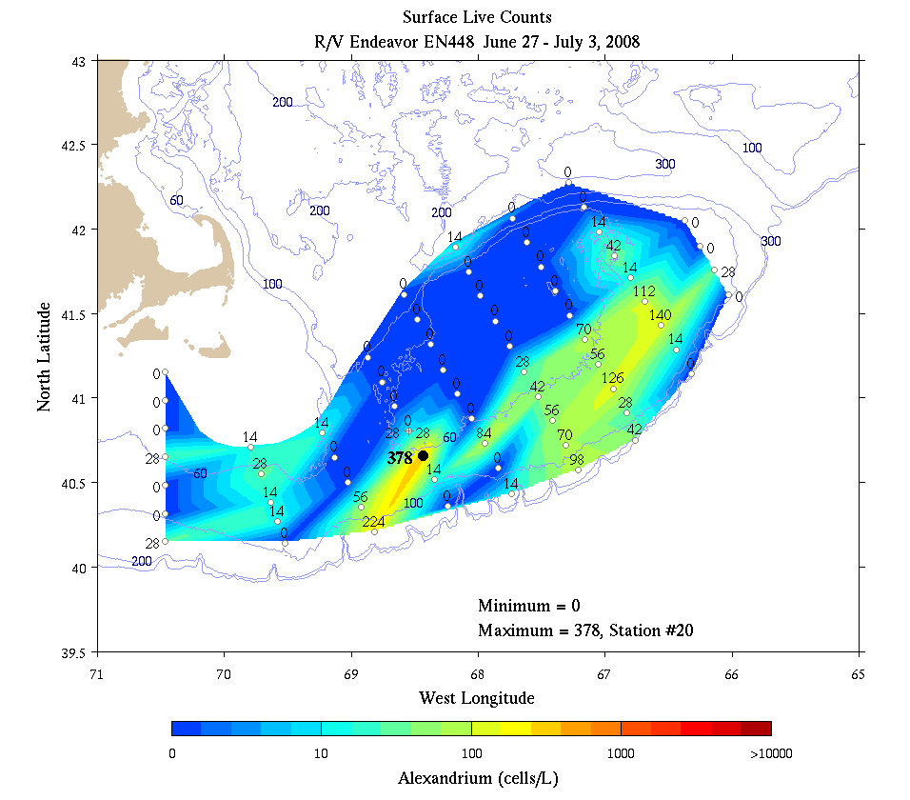
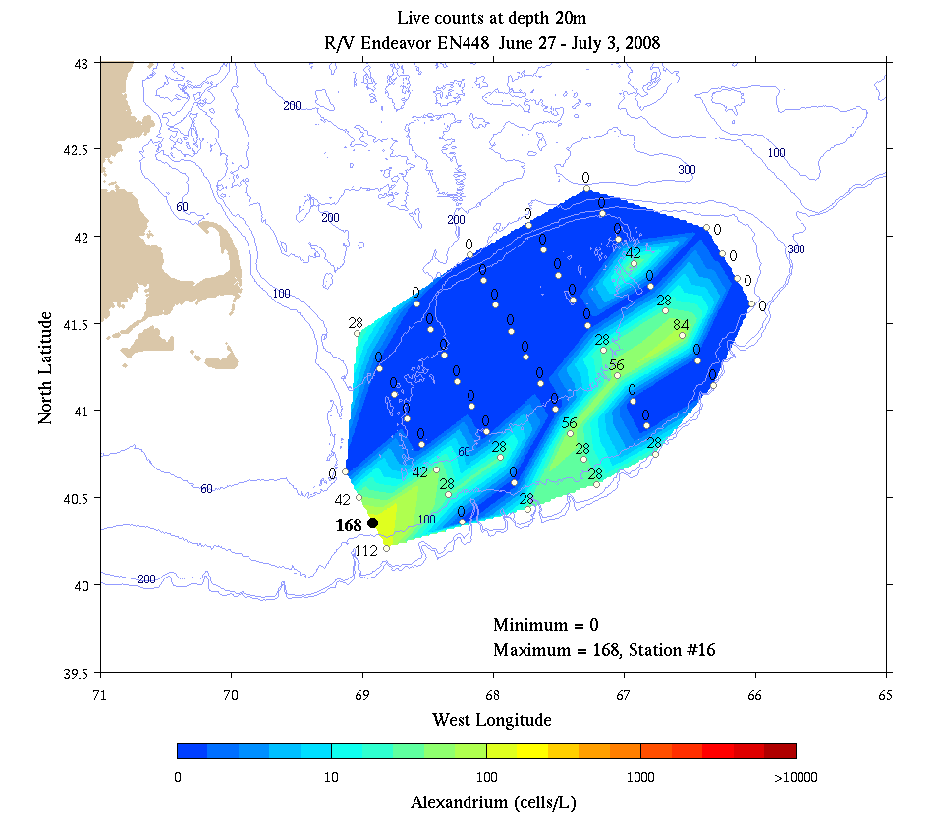
Figure 1. Alexandrium concentration (live counts; cells l⁻¹) from EN448 June 27 – July 3, 2008.

These findings are in stark contrast to the results from earlier cruises, during which large areas of the bank were covered by hundreds of cells l⁻¹ in late April / early May (OC445; Figure 2, left panel) and thousands of cells l⁻¹ in late May / early June (OC447; Figure 2, right panel). The dramatic decrease in Alexandrium abundance from OC447 to EN448 may be associated with a change in plankton community structure. A true-color satellite image provided by Andy Thomas prior to departure suggests the presence of a coccolithophore bloom on Georges Bank and in the adjacent slope waters (Figure 3). Indeed, surface waters had the characteristic “milky green” hue, especially on the southern flank. Microscopic examination of surface samples concentrated by centrifuge confirmed the presence of coccolithophores (Dave Townsend).

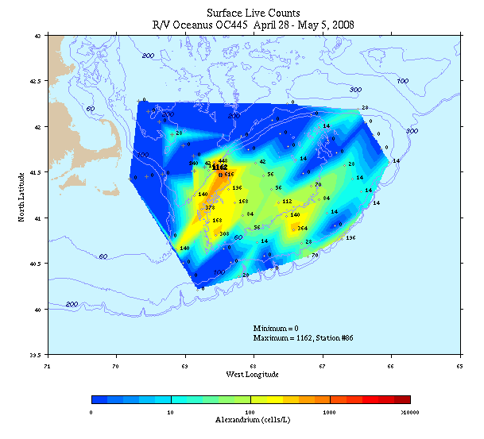 | 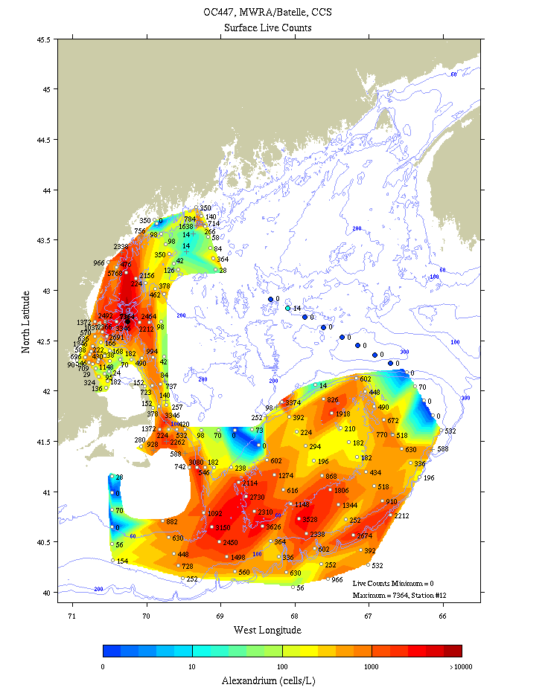
Figure 2. Alexandrium concentration (live counts; cells l⁻¹) from OC445 April 28 – May 5 (left panel) and OC447 May 27 – June 4 (right panel).

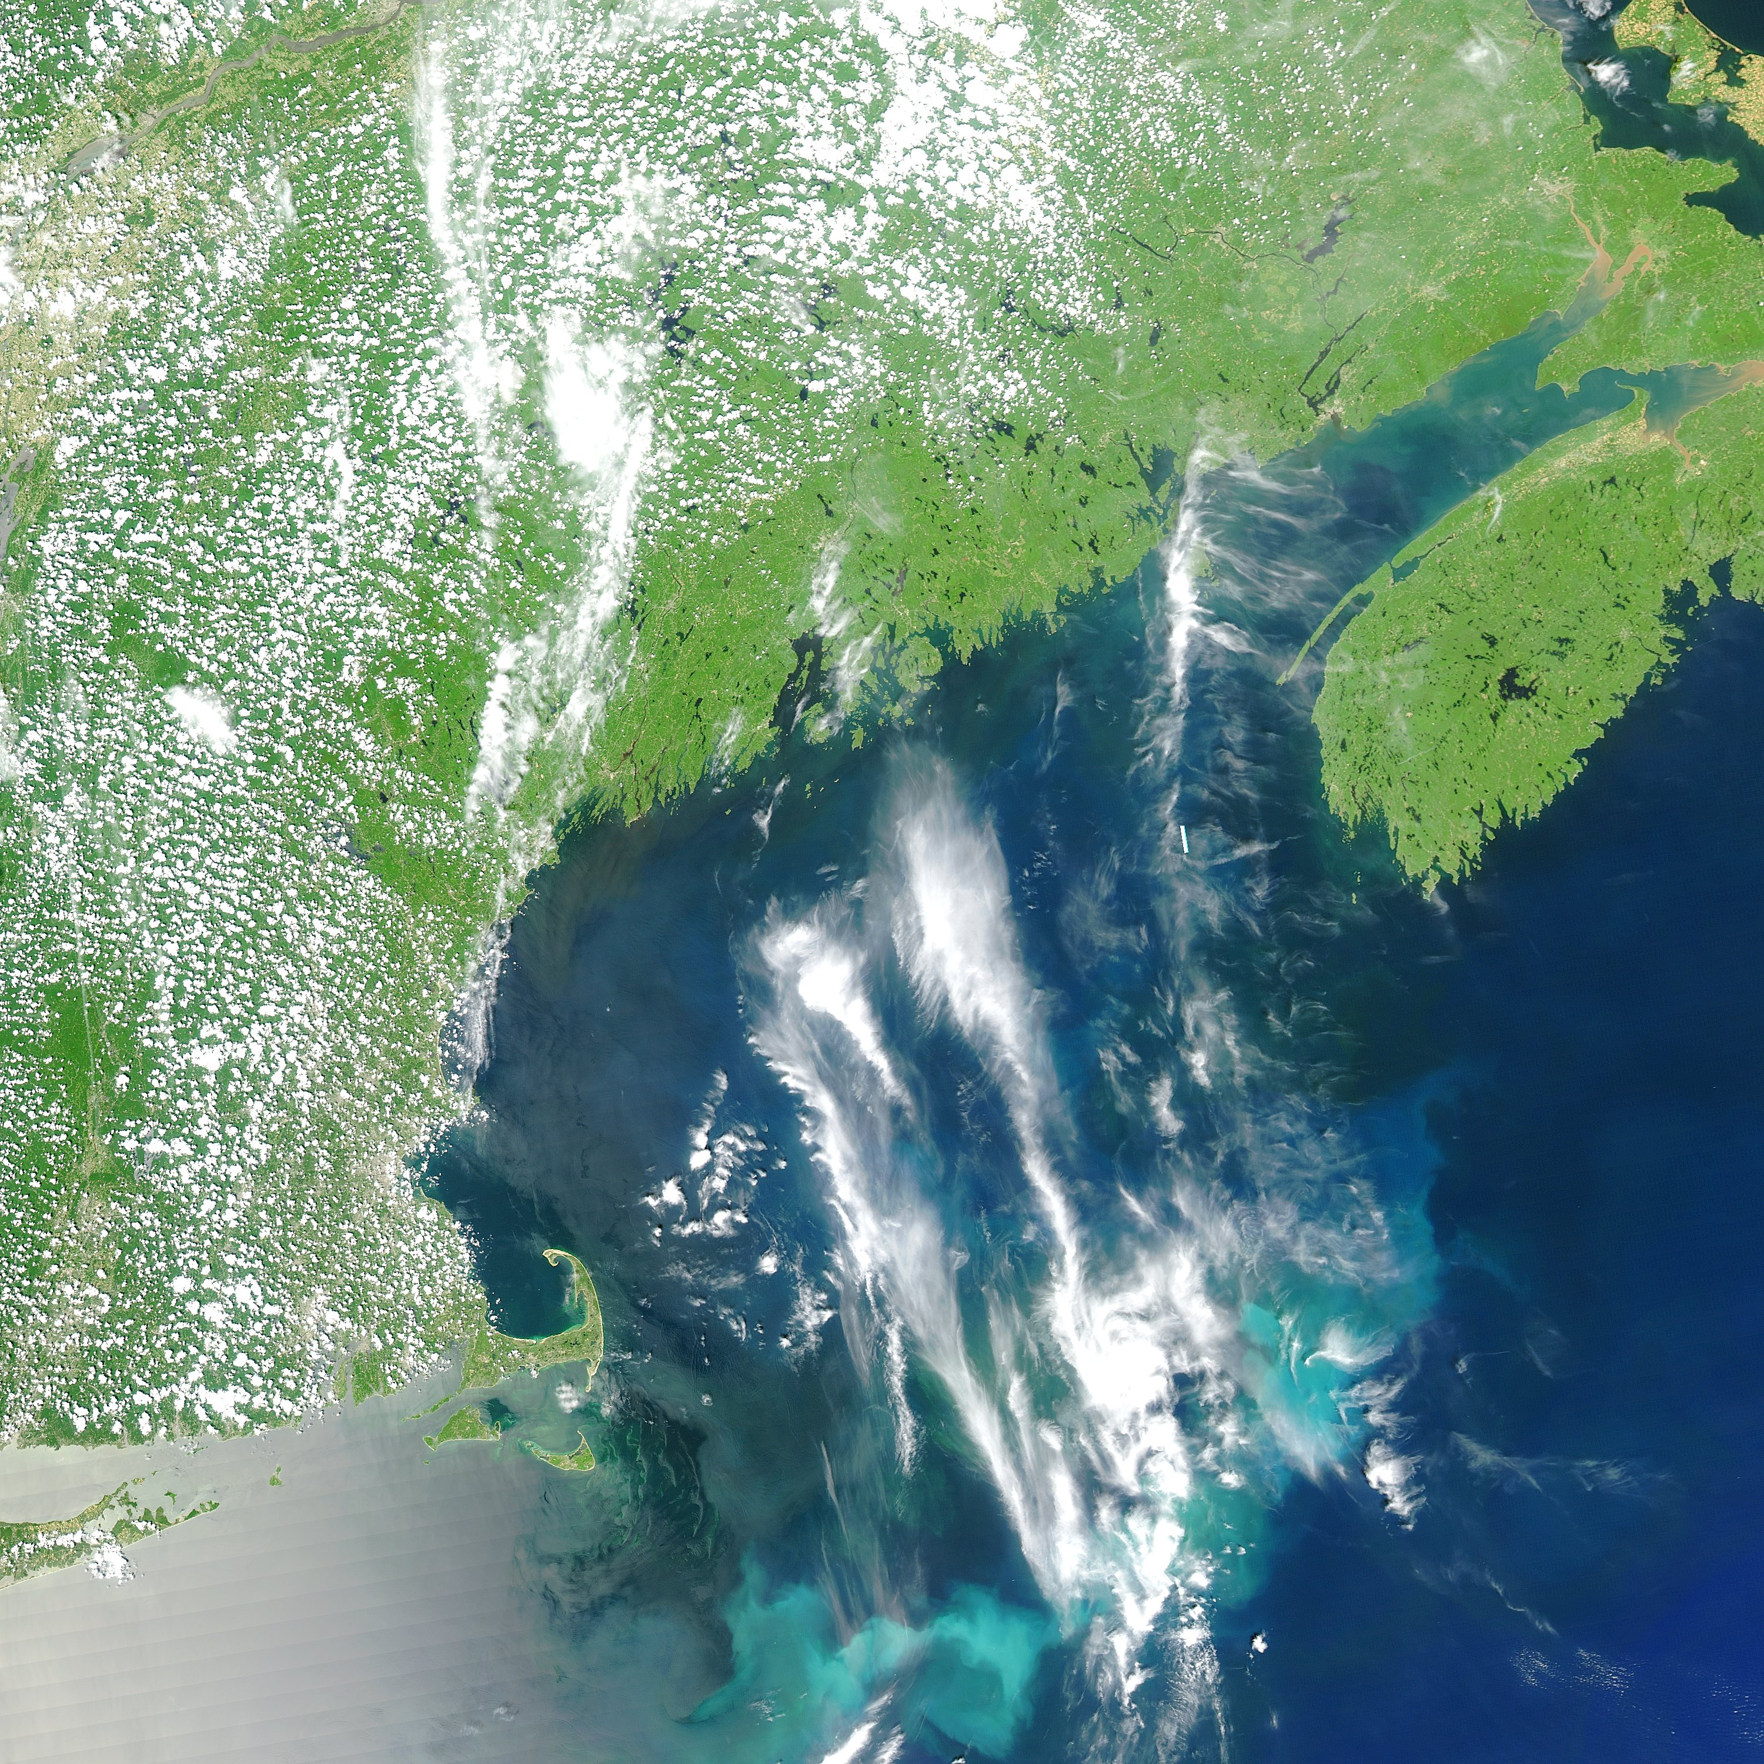
Figure 3. True-color satellite image from June 25, 2008 courtesy of Andy Thomas. Note the bright areas along the southern portions of Georges Bank, indicating a coccolithophore bloom in that area.

Interannual variability: 2007-2008

Comparison of these observations with our findings from 2007 reveals dramatic interannual variation in the seasonal evolution of the Alexandrium population on Georges Bank. In May 2007 and May 2008, concentrations of several thousand cells per liter covered large areas of the bank, and hydrographic characteristics were similar (Figure 4). In contrast, there are striking differences between June/July 2007 and June/July 2008 (Figure 5). The Alexandrium population persisted in June/July 2007, albeit at lower concentrations and a somewhat different spatial distribution than observed in May 2007. The dramatic decline in Alexandrium on Georges Bank from May to June/July 2008 was accompanied by a substantial change in water mass characteristics, with near surface waters over most of the bank being warmer and fresher than they were during the same period in 2007. The warm and fresh anomaly observed at 5m on EN448 (Figure 5, right column) was also present at 10m and 20m, but not discernible at 40m (not shown).

What processes might be responsible for the warming and freshening of Georges Bank from May to June/July 2008? The spatial structure of the water mass anomaly reflects the clockwise around-bank circulation, and is thereby suggestive of an advective phenomenon. The warm and fresh nature of the anomaly points toward the western Gulf of Maine, as waters from the Scotian shelf are relatively cold and fresh, and slope waters are relatively warm and salty. But why would Georges Bank have more water from the western Gulf of Maine than average in 2008? In May 2008, there was a large-amplitude meander of the Gulf Stream that appears to have been drawing water off the continental shelf from ca. 67-70ºW (Figure 6). A natural source for replacement of water lost from the bank would be the western Gulf of Maine, and a drifter released east of Cape Cod in May 2008 illustrates that transport pathway was active during this period. However, a single drifter is not sufficient to quantify whether the flux of water from the western Gulf of Maine to Georges Bank was stronger than average at that time.

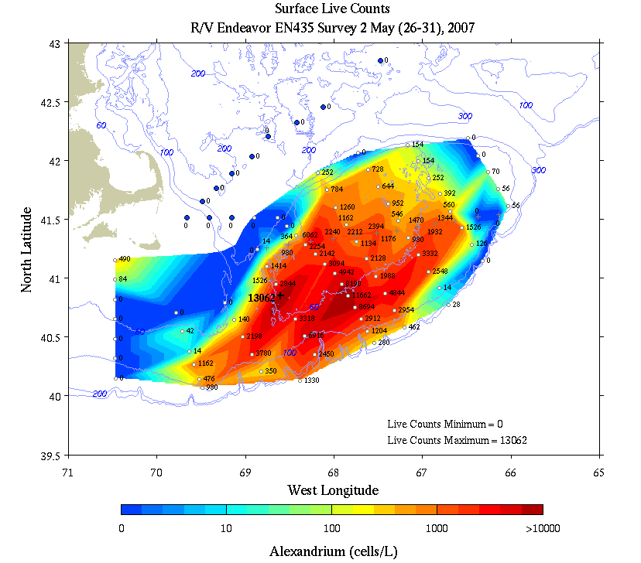 | 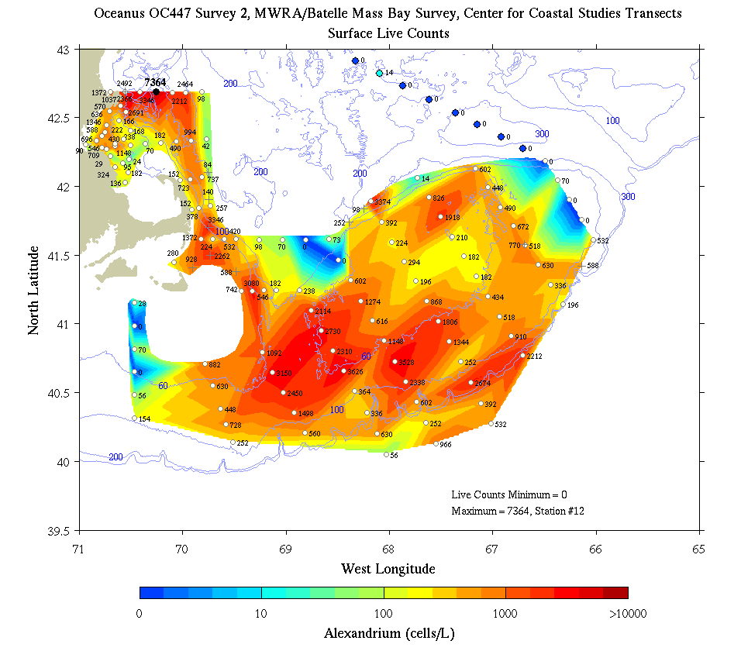
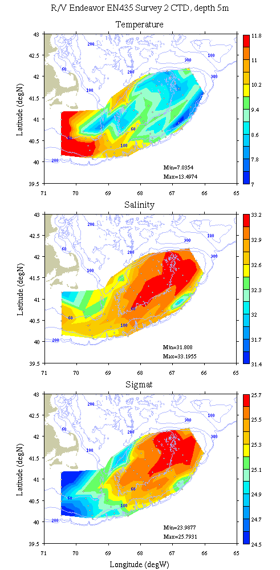 | 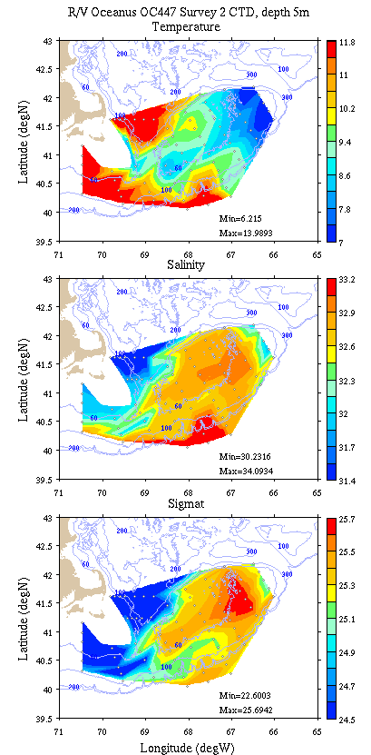
Figure 4. Alexandrium live counts and hydrography for May 2007 (EN435; left) and May 2008 (OC447; right).
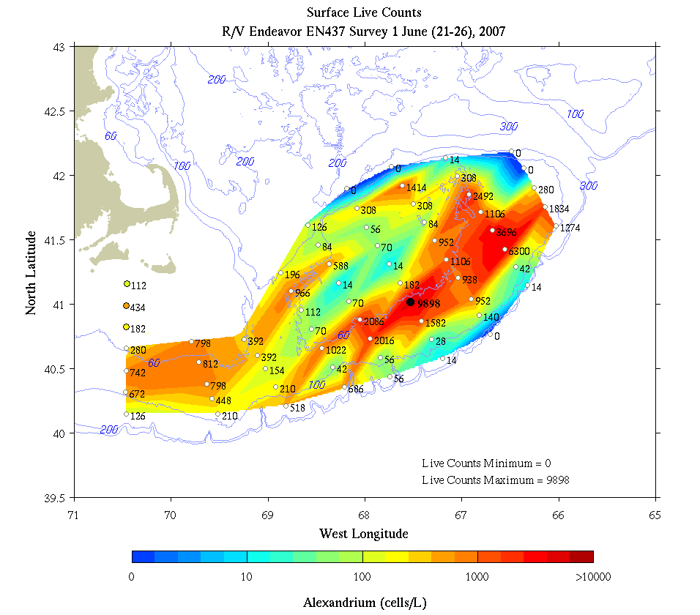 | 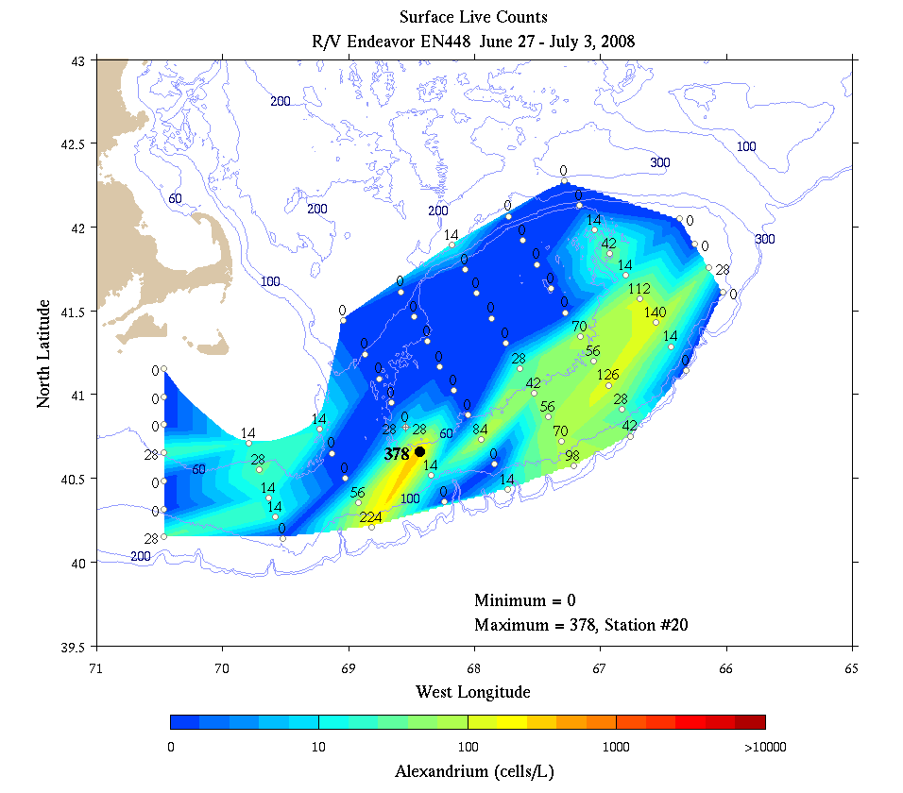
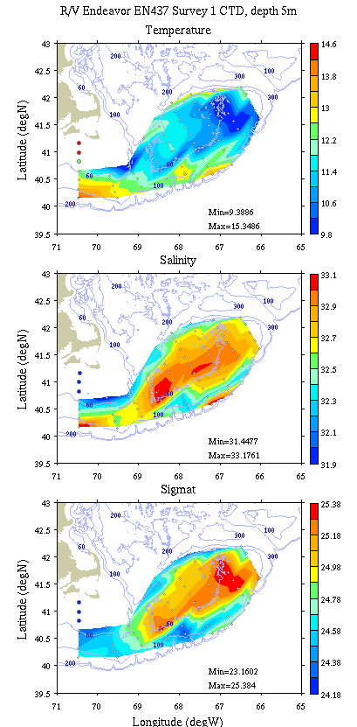 | 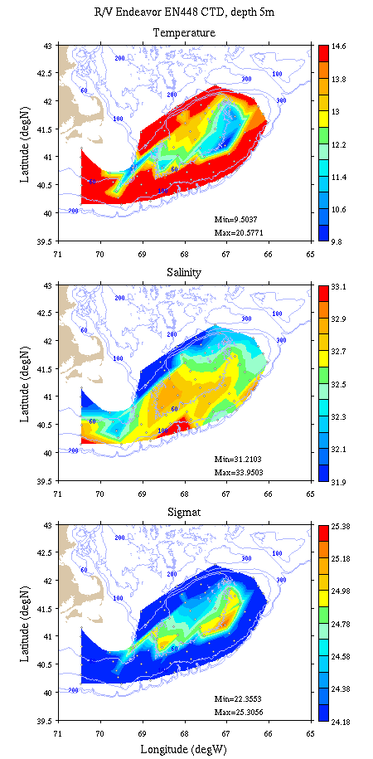
Figure 5. Alexandrium live counts and hydrography for June/July 2007 (EN437; left) and June/July 2008 (EN448; right).

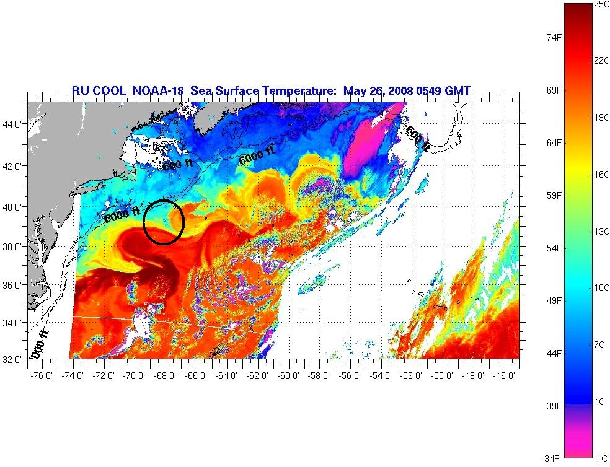
Figure 6. Sea surface temperature image for May 26, 2008 obtained from Rutgers University Coastal Ocean Observation Laboratory: http://marine.rutgers.edu/mrs/sat_data/?product=sst&nothumbs=0. The bold circle indicates the meander-driven shelf water export described in the text.

Drifters [Jim Manning]
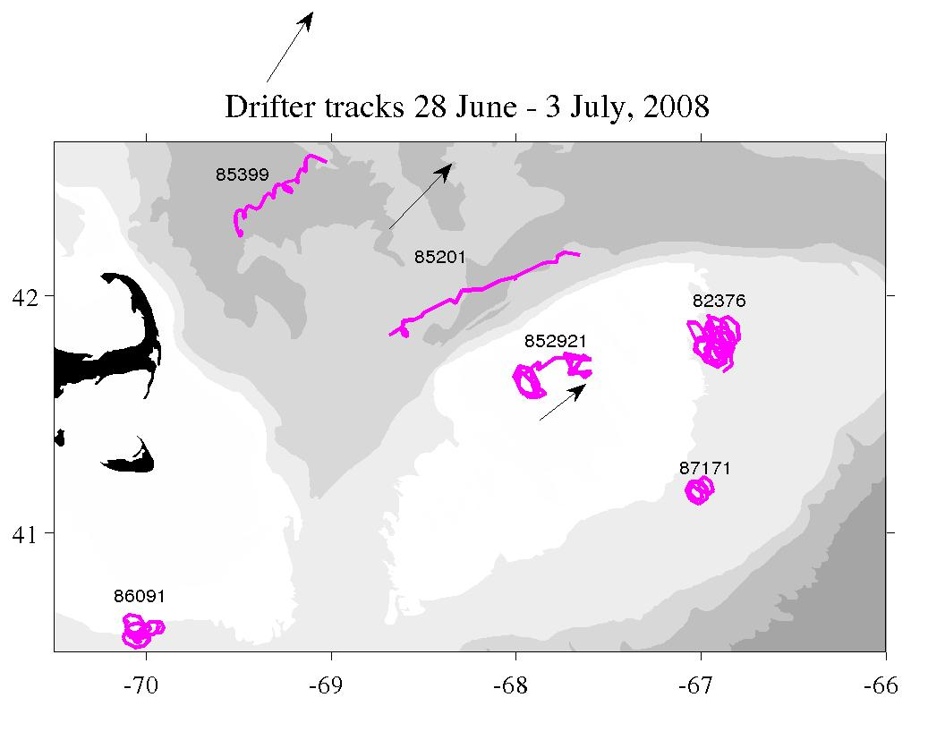
Figure 7. Surface drifters tracks from June 28 to July 3, 2008. Data courtesy of Jim Manning.

A single surface drifter (ID 87171) was deployed at station 50 on the southern flank of Georges Bank (Appendix A, Table 3). Clockwise loops of tidal motion are evident in the trajectory, as is a weak southwestward mean flow (Figure 7). This deployment complements other surface drifters already that made their way into the region from prior deployments. The drifter on the crest of the bank (#85291) and those to the northwest of the bank (#85399 and #85201) were advected towards the northeast (in the direction of the prevailing wind). The northern flank jet evidently enhanced this flow in the case of #85201. Drifters on the more southern side of the bank (#82376) and the Nantucket Shoals (#86091) where current flow is generally towards the southwest were arrested by this unusually persistent summer winds.

At-sea data assimilative modeling [Keston Smith]
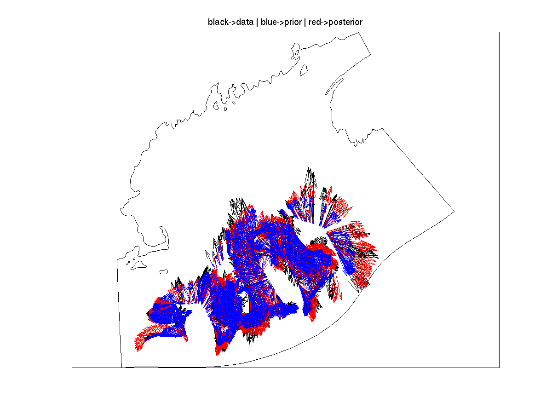
Figure 8. Example assimilation of ADCP velocity data. Observed ADCP velocity (black), prior estimate (blue), and data assimilative posterior (red).
Seven data assimilative hydrodynamic experiments were conducted aboard EN448, as described in the table below. The simulations followed the approach developed during GLOBEC and recent MERHAB, COHH and GOMTOX cruises. ADCP data were inverted to estimate barotropic boundary conditions and the hydrographic survey was used to estimate the initial conditions (Figure 8). The approach is described in detail in Arextabaleta et al. (in preparation). The forward simulator is the finite element primitive equation model Quoddy. The data assimilation system consists of the tide band inverter, Truxton, the wind band inverter, Casco, and the hydrographic data assimilation system OACI.

The computational domain "gomtox" (Figure 9) was developed to provide moderate resolution in
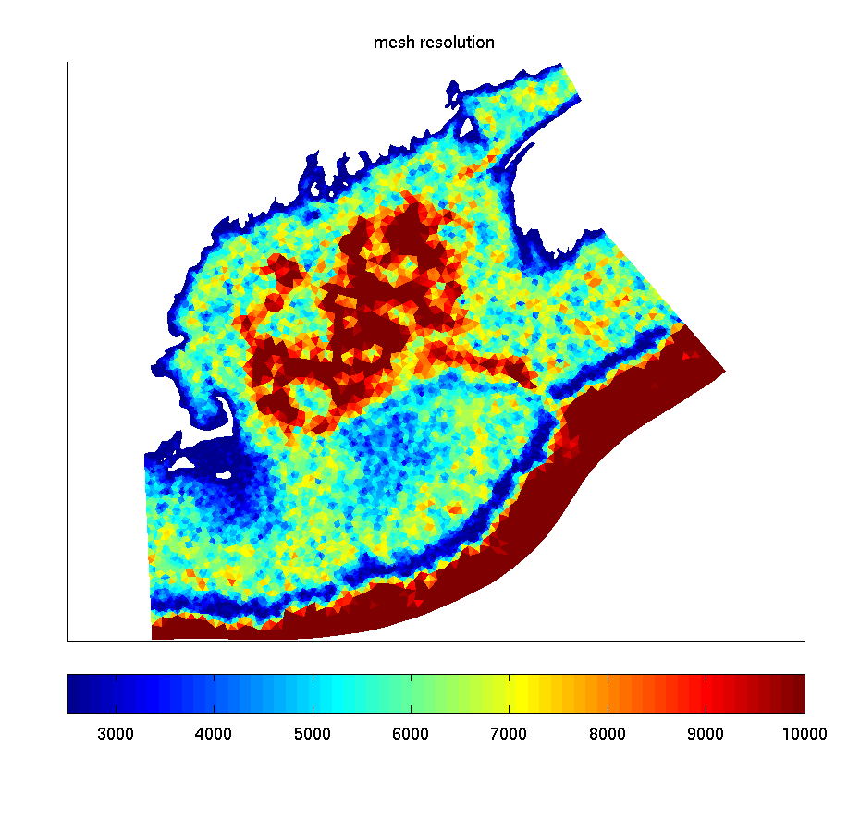
Figure 9. Resolution in meters of the finite element mesh “gomtox.”
the western, eastern gulf of Maine, and Georges bank (2000m-5000m) while extending beyond the shelf break to encompass the full survey domain. The steep topography of in the shelf break necessitates high resolution (2500m and less).

Wind data was processed by James Manning of NOAA and sent to the ship daily. The wind was spatially homogeneous taken from GOMOOS buoy A. The 3 day forecast wind was an NCEP product. Heat flux was set to climatological values. Barotropic tidal forcing with M2, N2, O1, K1, and S2 frequencies was taken from a database. Initial conditions for temperature and salinity consisted of an average between May-June and July-August climatologies from Naimie et al. (1997).

Model skill was evaluated by comparison with unassimilated drifter data (IDs 85291, 82376, 82375, 85201). An example is provided in Figure 10. Surface drifters such as those used in the present study are difficult to appropriately forecast with models with vertical resolution at the surface (1m) comparable to the height of the drifter sail (1m). There is strong sensitivity to mixed layer depth and windage on the drifter's transmitter and surface response to wind forcing in general.
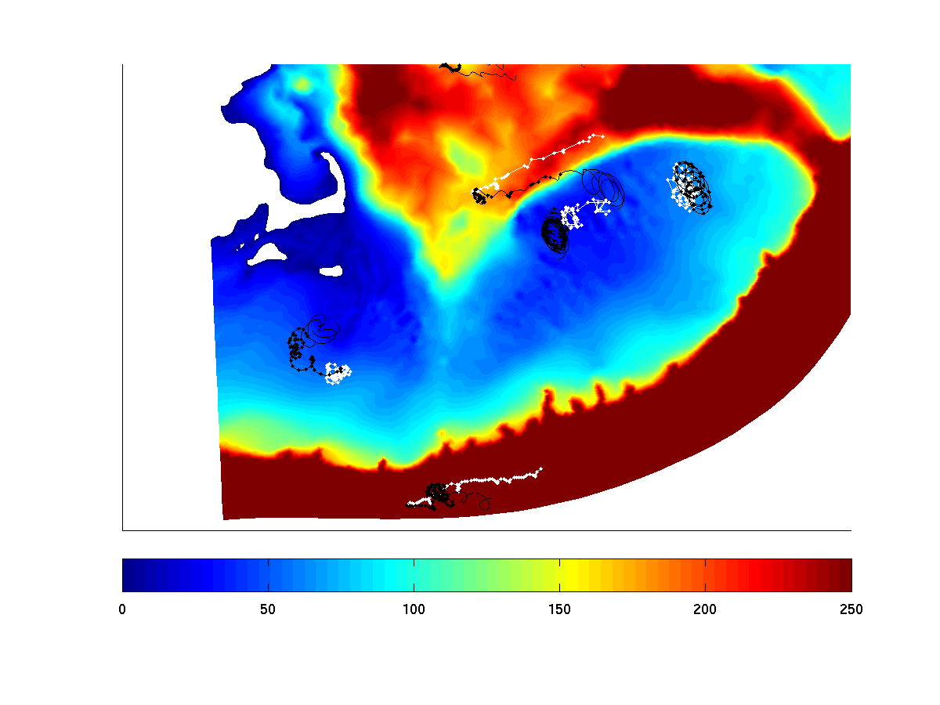
Figure 10. Simulated (black) and observed (red) drifters from experiment 5. The lines without dots indicate the predicted trajectories during the forecast period.
To assess the effect of the currents on the synopticity of the EN448 survey, a Lagrangian calculation was carried out to track water parcels after they were sampled. After each station was occupied, the representative water parcel in the model was tracked with a particle until the end of the simulation (Figure 11). An animated presentation of these results depicts the effects of the mean flow and wind on the terminal station position. In addition, tidal excursions on the order of 15km were simulated on Georges Bank during the cruise period which included the strongest spring tides of the lunar cycle.

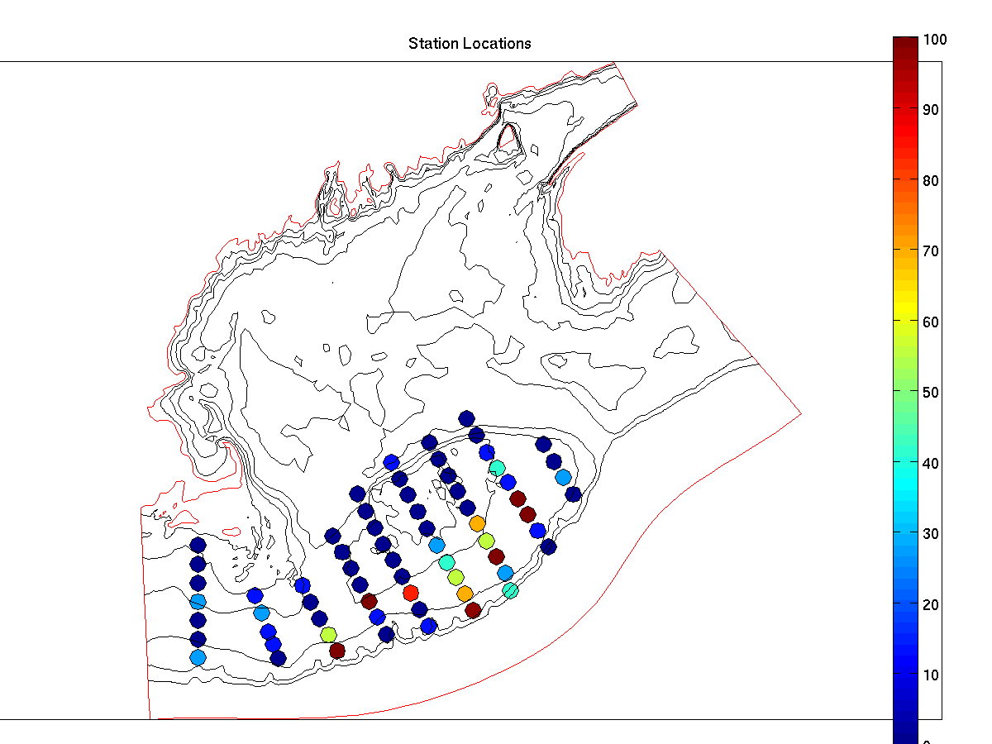 | 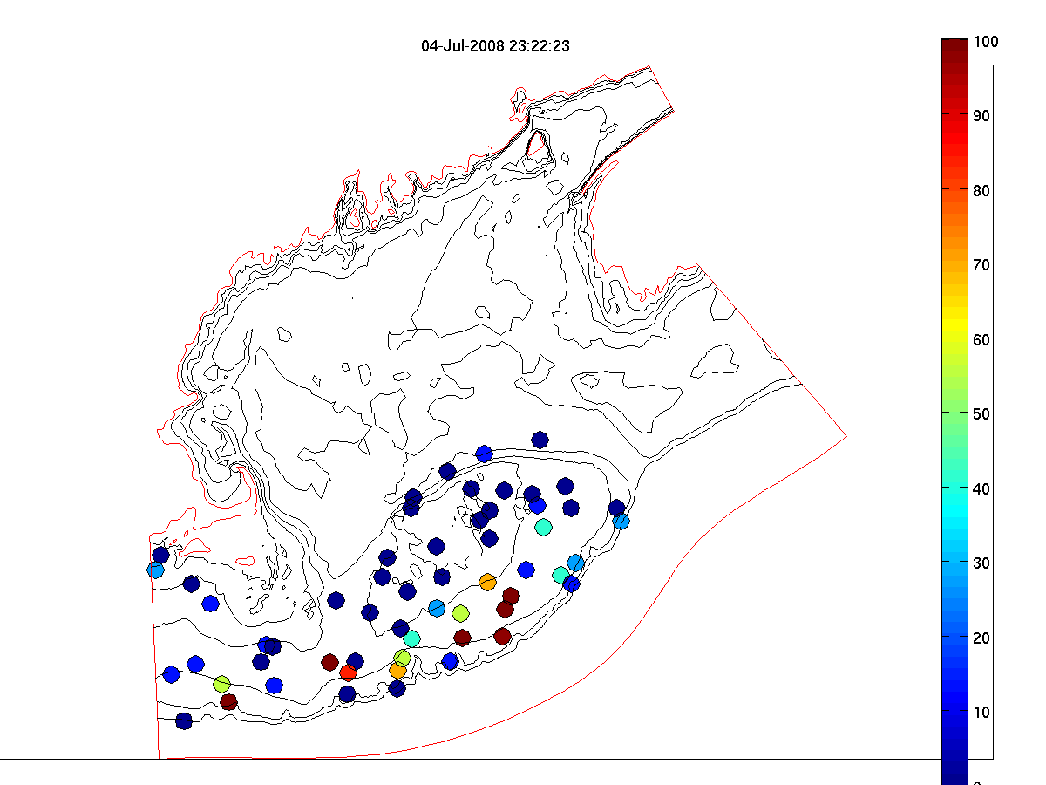
Figure 11. Left: Alexandrium concentrations at sampled positions. Right: Estimated position of water samples on July 4 after accounting for advection. In this figure the 10m sample position is shown.

Run # | Start | End | Data RMS (cm/s) | Prior misfit | Posterior misfit | Drifter misfit | Hydro-DA
1 | June 27 | July 1 | 35.1 | 16.4 | 6.5 | 10.7 | No
2 | June 27 | July 1 | 32.0 | 21.1 | 28.1 | 10.6 | No
3 | June 27 | July 3 | 42.3 | 20.5 | 15.3 | 7.1 | No
4 | June 27 | July 3 | 43.5 | 17.6 | 11.7 | 6.1 | No
5 | June 27 | July 3 | 49.3 | 17.4 | 15.0 | 5.2 | No
6 | June 27 | July 6 | 51.4 | 20.5 | 13.4 | 7.4 | No
7 | June 27 | July 6 | -- | -- | -- | -- | Yes
Appendix A: Measurements made on EN448

Underway measurements
a. Acoustic Doppler Current Profiler
b. Meteorological sensors

Core hydrographic measurements
a. CTD (pressure, temperature, salinity, oxygen, fluorescence, beam attenuation, PAR)
b. Alexandrium cell counts: 1, 10, 20, 30, 40, 50m plus 250/near bottom
c. Nutrients: standard depths plus 100, 150, 200, 250m

Bottle # | Depth | Live | Whole Cell | SHA | qPCR | Nuts/Chl | Pseuds | total
12 | 1 |  | 2 | 2 | 2 | 1.0 | 0.5 | 7.5
11 | 1 | 10 |  |  |  |  |  | 10
10 | 1 |  |  |  |  |  |  | spare
9 | 10 |  | 2 | 2 | 2 | 1.0 |  | 7.0
8 | 20 |  | 2 | 2 | 2 | 1.0 |  | 7.0
7 | 30 |  | 2 | 2 | 2 | 1.0 |  | 7.0
6 | 40 |  | 2 | 2 | 2 | 1.0 |  | 7.0
5 | 50 |  | 2 | 2 | 2 | 1.0 |  | 7.0
4 | 100 |  |  |  |  | 1.0 |  | 1.0
3 | 150 |  |  |  |  | 1.0 |  | 1.0
2 | 200 |  |  |  |  | 1.0 |  | 1.0
1 | 250 / near bottom |  |  |  |  | 1.0 |  | 9.0
Table 1. Water budget

Af water- one 6 hole-manifold loaded twice
6L/depth combined/split x 6 depths=6 WC tubes&12 filters/station
Pseuds – 100-500 ml whole water onto 0.65um Duropore? Frozen in Dewar; manifold 2; 6 filters/station
Additional opportunistic samples may be taken in areas of high Alexandrium abundance.

Toxin size fractionation – Turner
Pump profiles were carried out at selected locations. Sampling depths were chosen to coincide as closely as possible with hydrographic sampling and sediment trap measurements. Pump deployments are summarized in Table 2.

 | Date | Time  (UTC) | Latitude | Longitude | Station | Live Count  (cells l⁻¹)
1 | June 29 | 1322 | 40 56.87 N | 68 38.58 W | 22a near Cultivator Shoal | 0
2 | July 1 | 0942 | 41 29.62 N | 67 17.97 W | 48a Crest SE | 0
3 | July 2 | 2020 | 41 36.53 N | 66 01.72 W | 66 NE Peak SE | 0
4 | July 3 | 0701 | 41 26.48 N | 69 02.53 W | 67 Great South Channel | 0
Table 2. Pump stations.

Drifters

ID | Mon | Day | Year | GMT | Lon | Lat | Drogue  depth(m) | Station Number
87171 | 7 | 1 | 2008 | 1444 | 67 03.003 | 41 11.983 | 1 | 50
Table 3: Summary of drifter release on EN448. For more information see http://nefsc.noaa.gov/drifter.

Other measurements
a. Mussel bags: Casco, Cobscook, Blue Hill, Frenchman’s – Darcy Couture
b. AVHRR, SeaWiFS, MODIS false-color imagery – Andy Thomas
c. GoMOOS moorings
d. NOAA coastal tide gauges
e. NMFS quarterly survey – March-April CTD data

Appendix B: Hydrographic maps

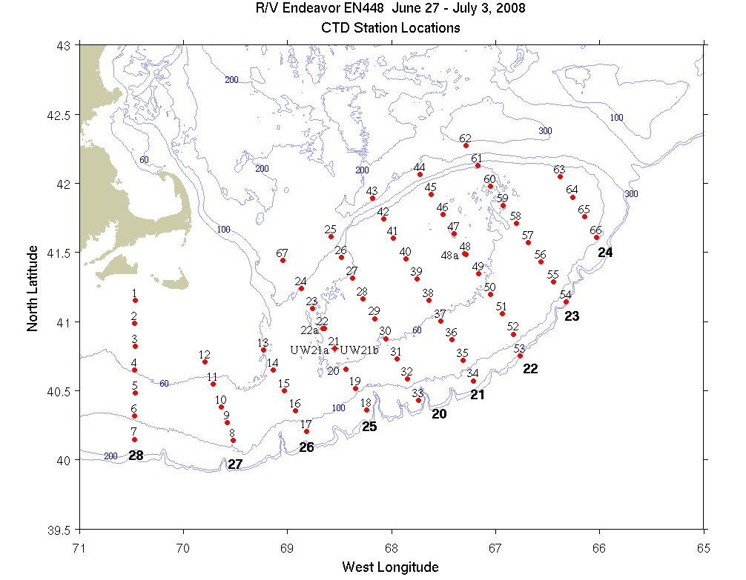
Figure B1: CTD (dots) and underway (crosses) station locations for EN448. Bold numerals indicate identifiers for the sections displayed below.

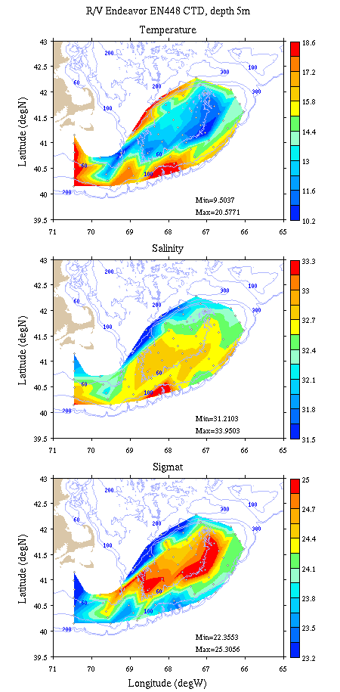 | 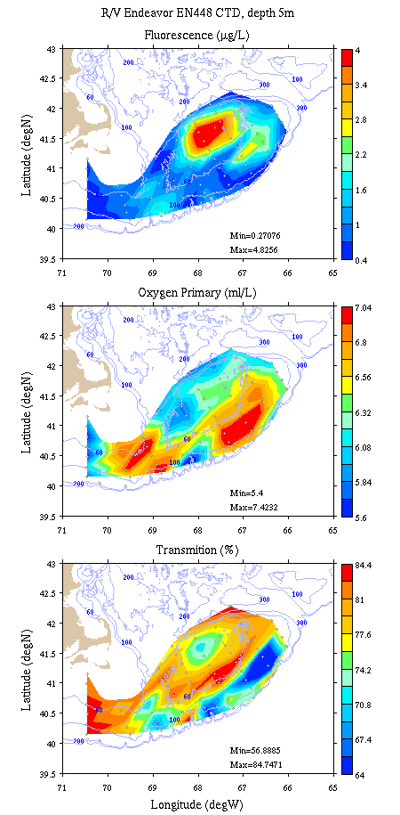
Figure B2: Georges Bank / Southern New England survey maps at 5m depth. Left: temperature, salinity, and density; right: fluorescence, oxygen, and light transmission.

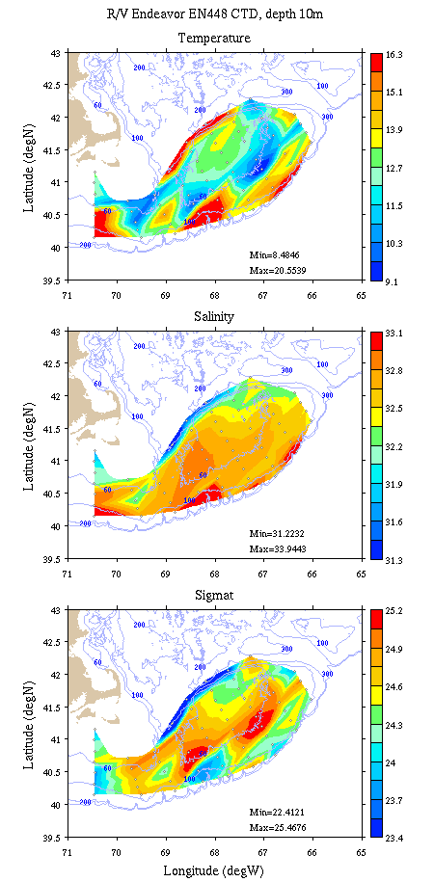 | 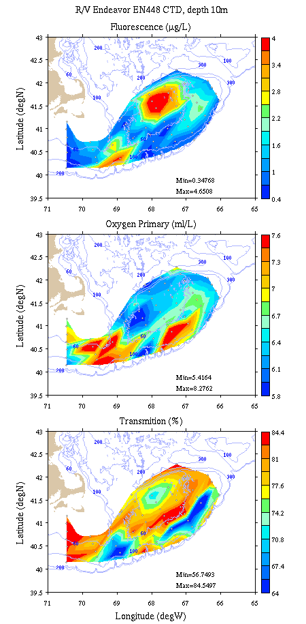
Figure B3: Georges Bank / Southern New England survey maps at 10m depth. Left: temperature, salinity, and density; right: fluorescence, oxygen, and light transmission.

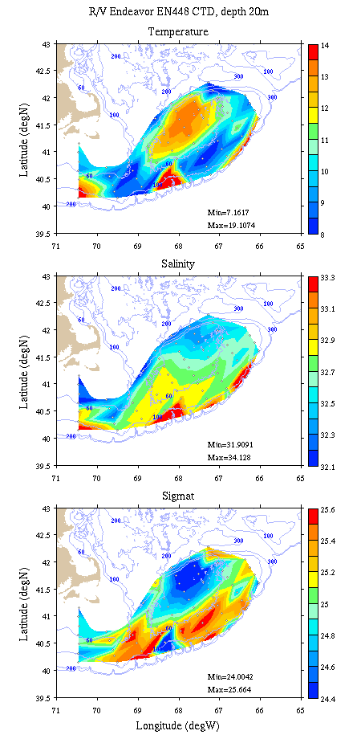 | 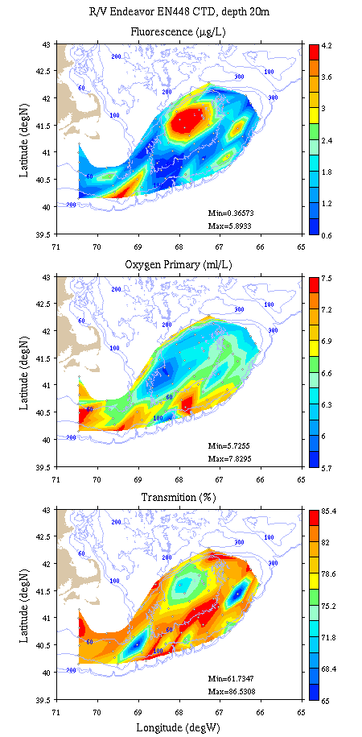
Figure B4: Georges Bank / Southern New England survey maps at 20m depth. Left: temperature, salinity, and density; right: fluorescence, oxygen, and light transmission.

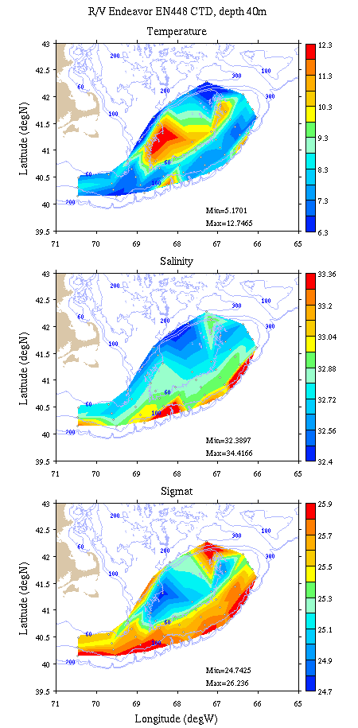 | 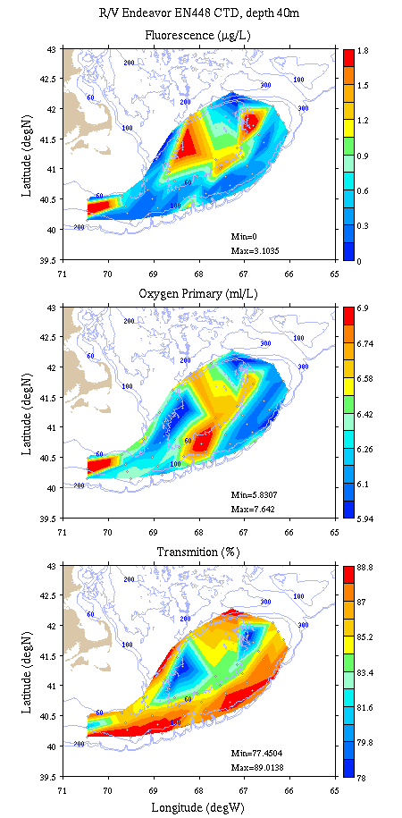
Figure B5: Georges Bank / Southern New England survey maps at 40m depth. Left: temperature, salinity, and density; right: fluorescence, oxygen, and light transmission.

Appendix C: Vertical sections.

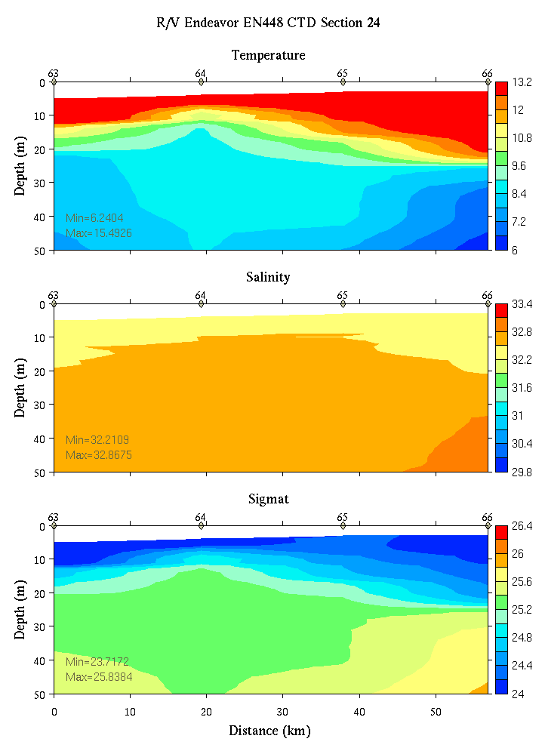 | 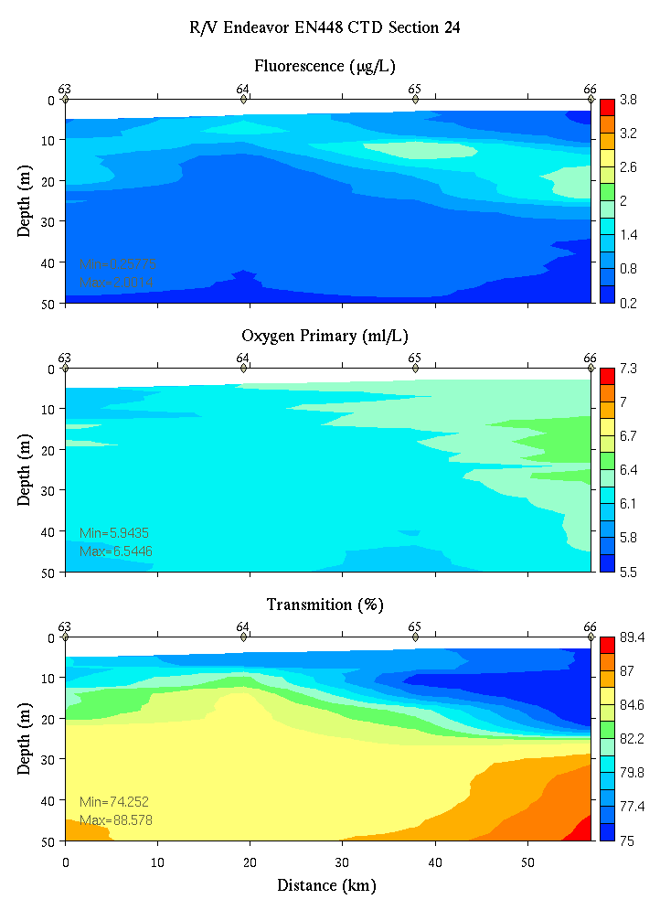
Figure C1. Section 24, 0-50m: temperature, salinity, and density (left); fluorescence, oxygen, and beam transmission (right).

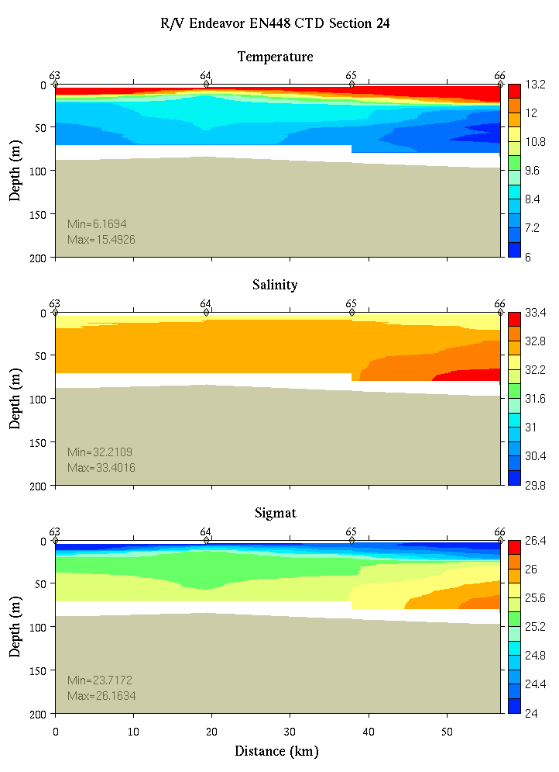 | 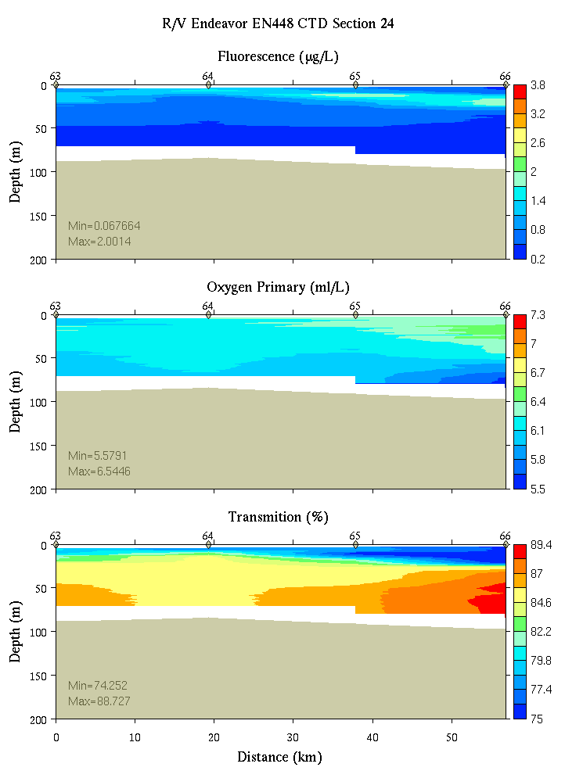
Figure C2. Section 24, 0-200m: temperature, salinity, and density (left); fluorescence, oxygen, and beam transmission (right).

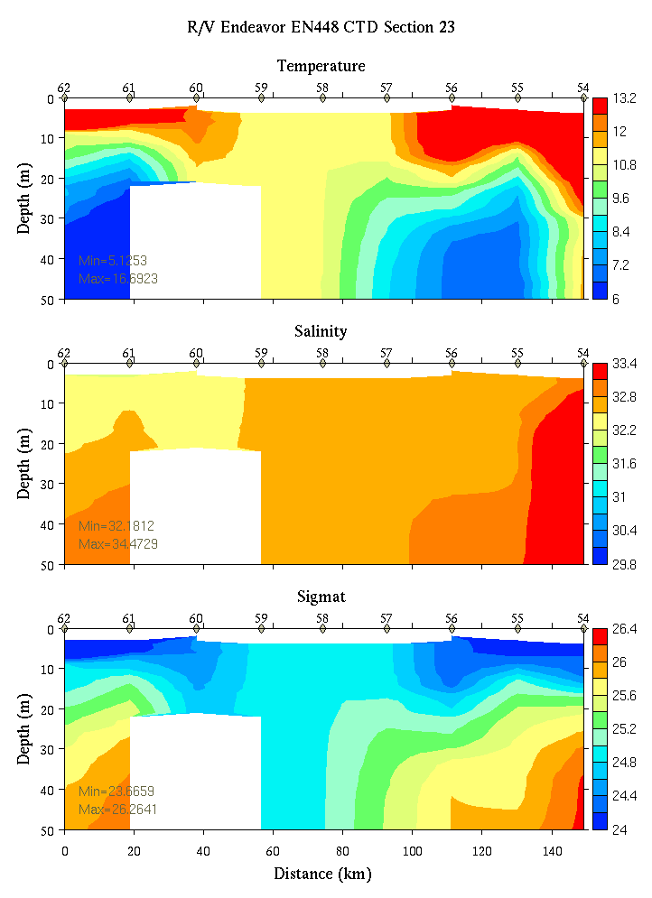 | 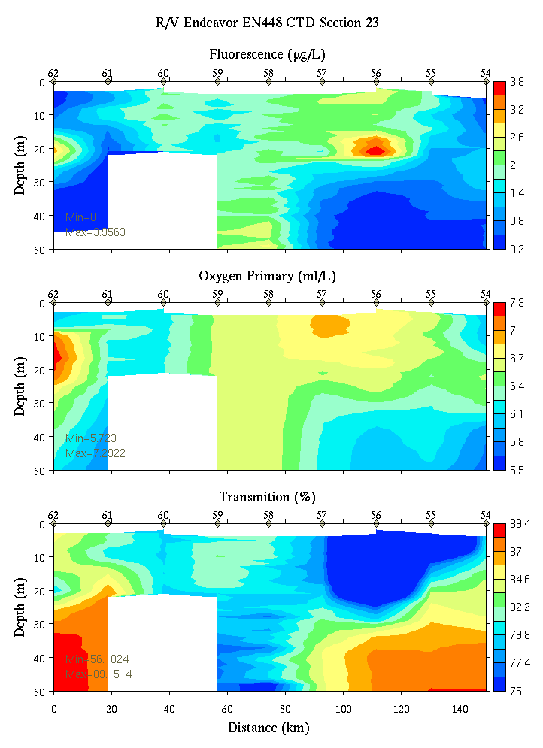
Figure C3. Section 23, 0-50m: temperature, salinity, and density (left); fluorescence, oxygen, and beam transmission (right).

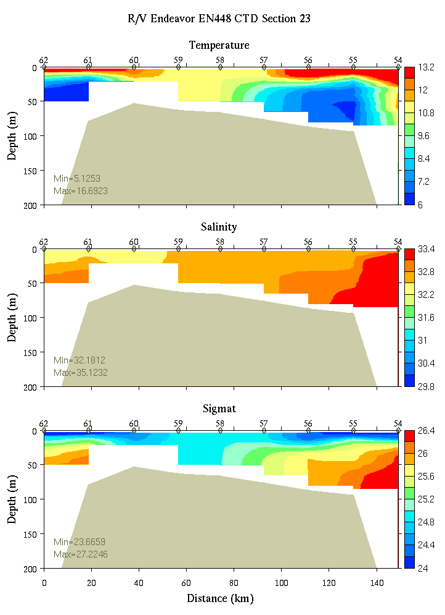 | 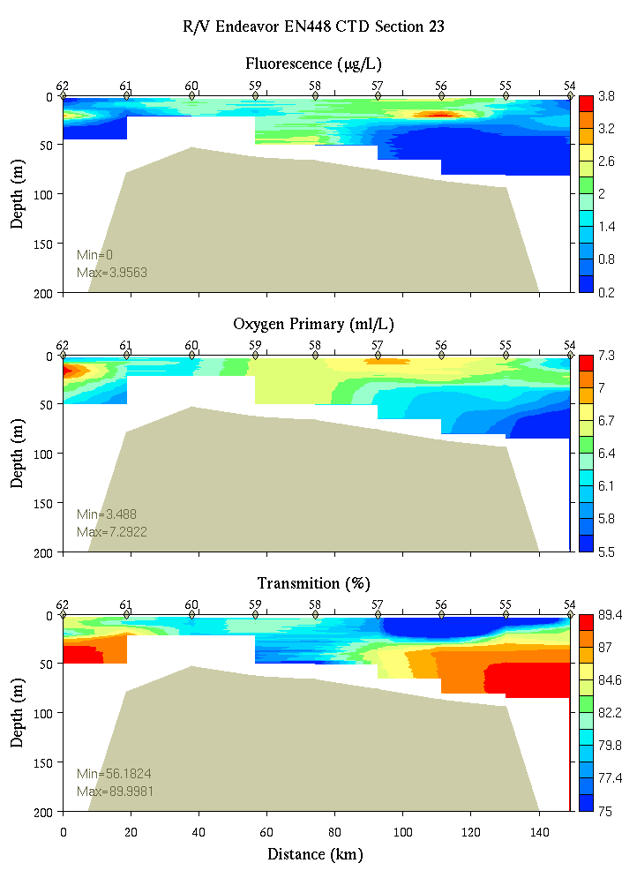
Figure C14. Section 23, 0-200m: temperature, salinity, and density (left); fluorescence, oxygen, and beam transmission (right).

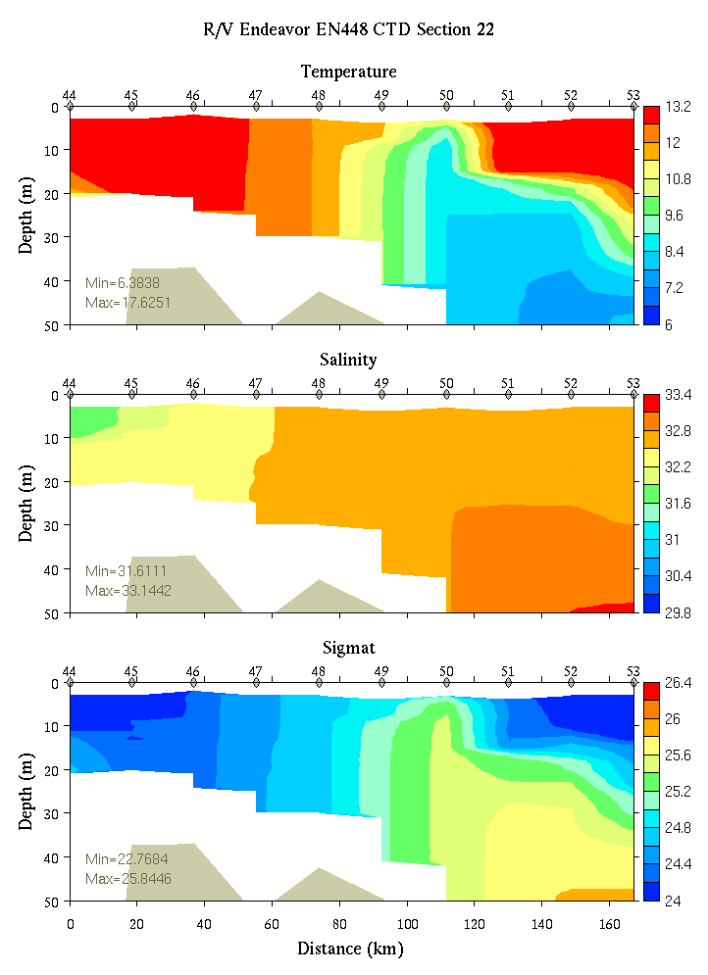 | 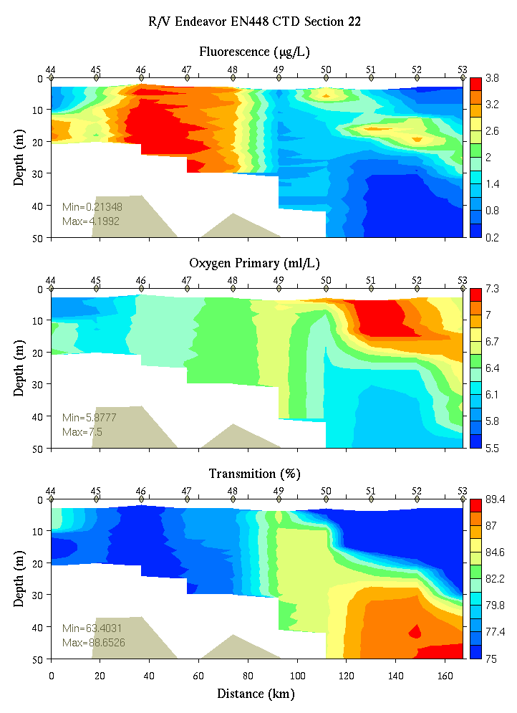
Figure C5. Section 22, 0-50m: temperature, salinity, and density (left); fluorescence, oxygen, and beam transmission (right).

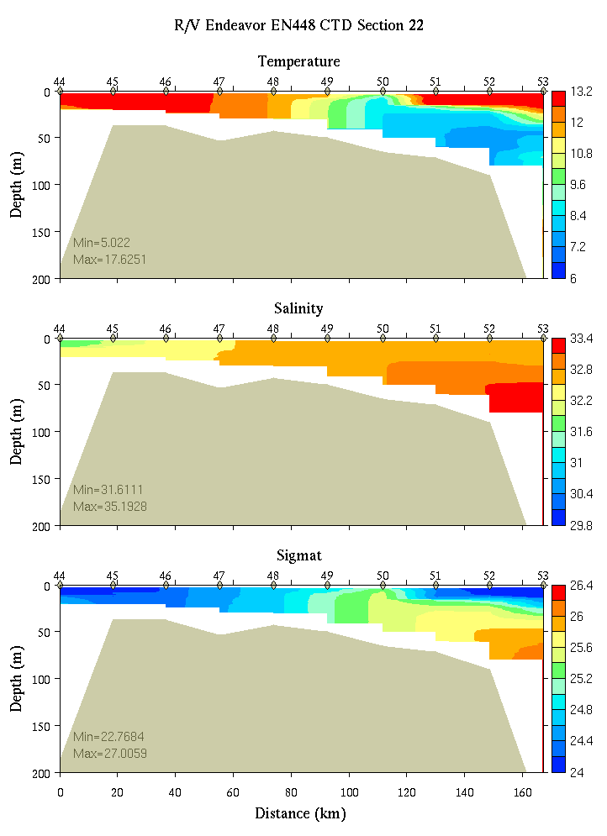 | 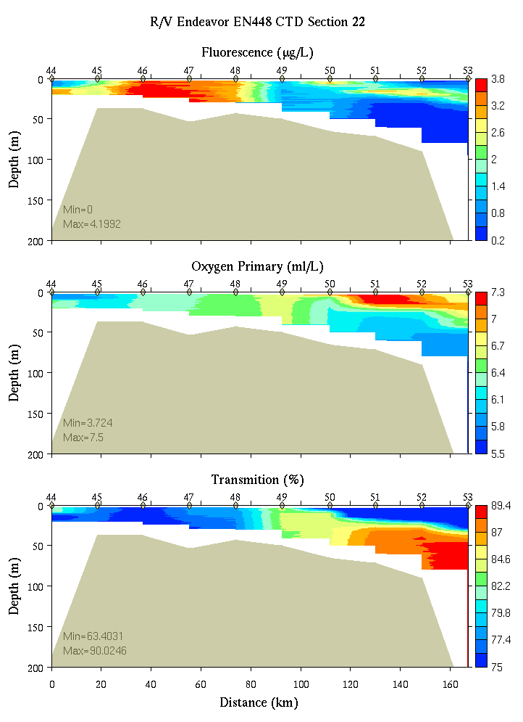
Figure C6. Section 22, 0-200m: temperature, salinity, and density (left); fluorescence, oxygen, and beam transmission (right).

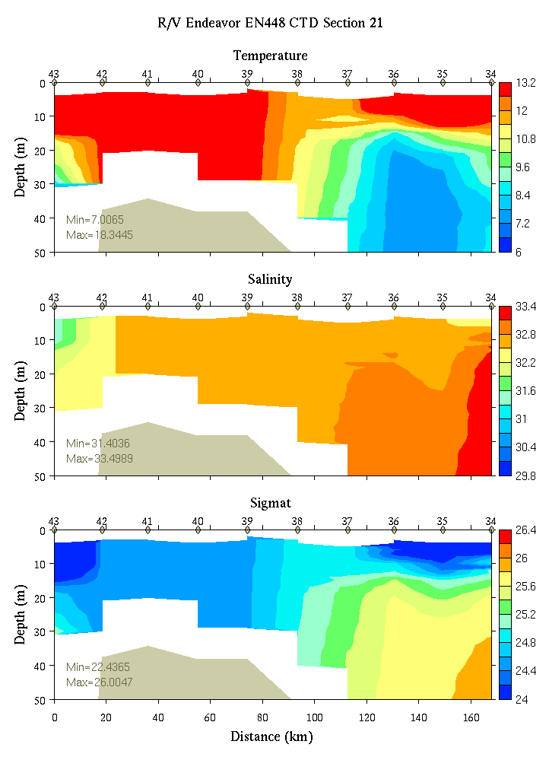 | 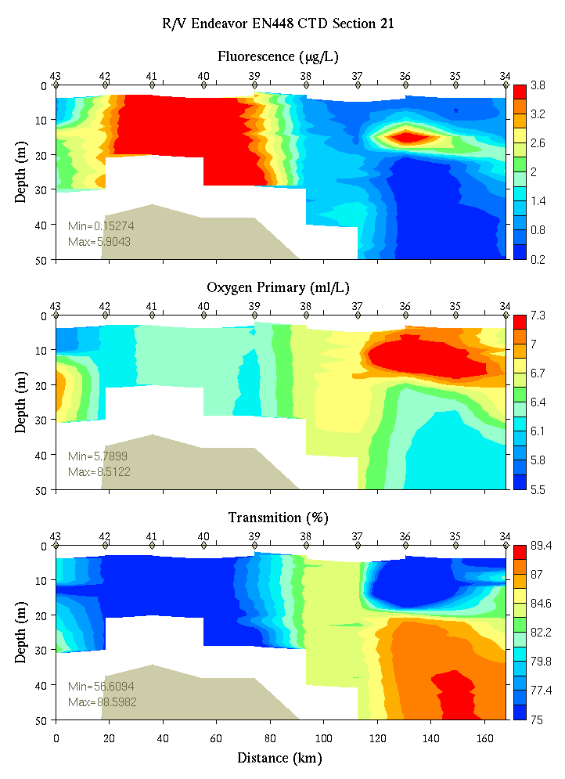
Figure C7. Section 21, 0-50m: temperature, salinity, and density (left); fluorescence, oxygen, and beam transmission (right).

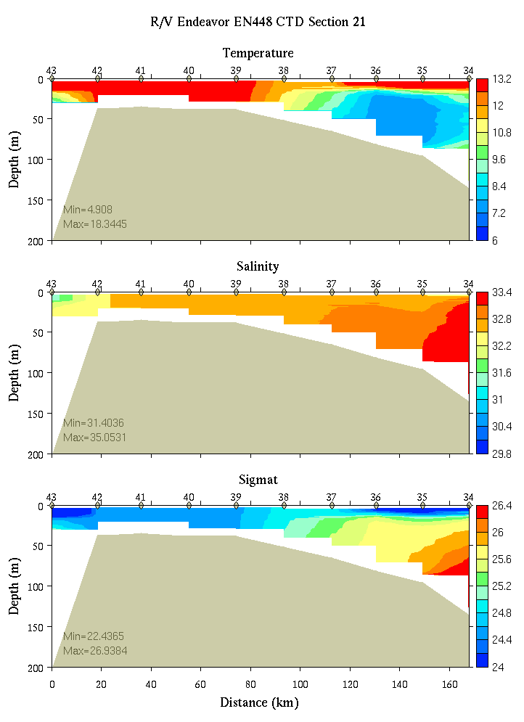 | 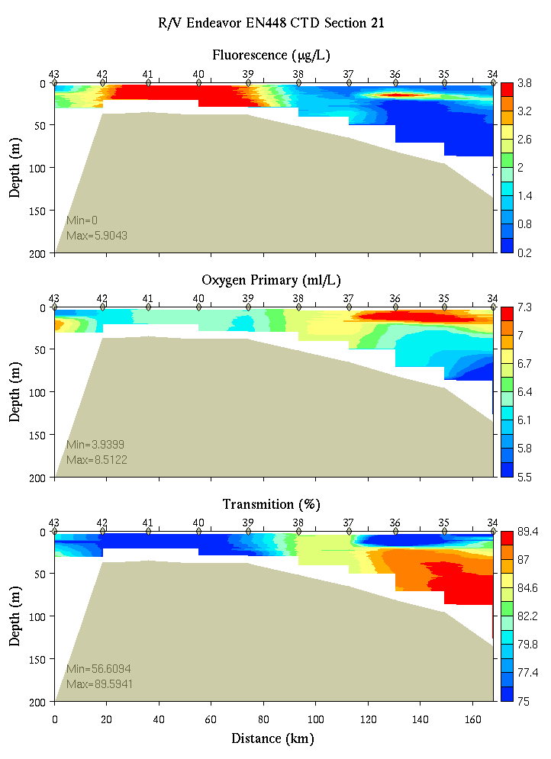
Figure C8. Section 21, 0-200m: temperature, salinity, and density (left); fluorescence, oxygen, and beam transmission (right).

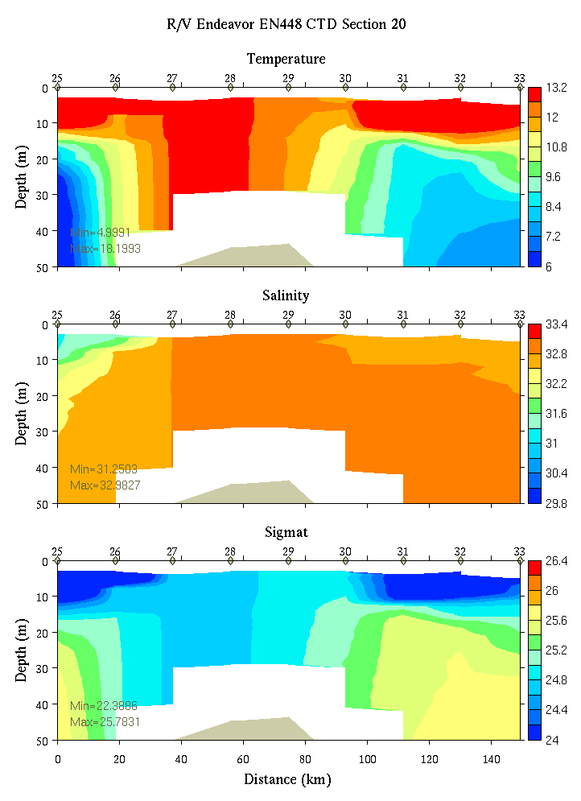 | 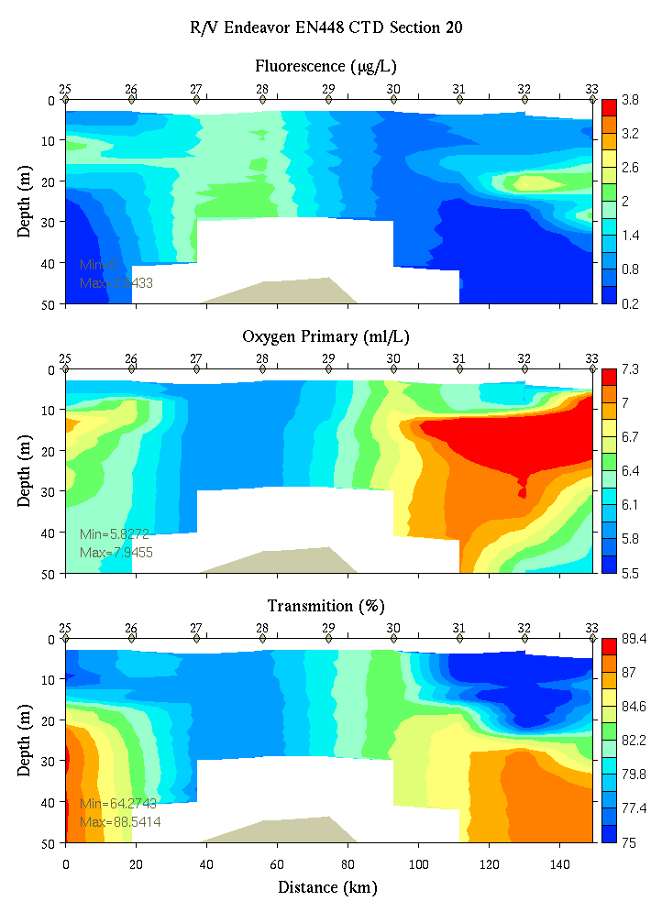
Figure C9. Section 20, 0-50m: temperature, salinity, and density (left); fluorescence, oxygen, and beam transmission (right).

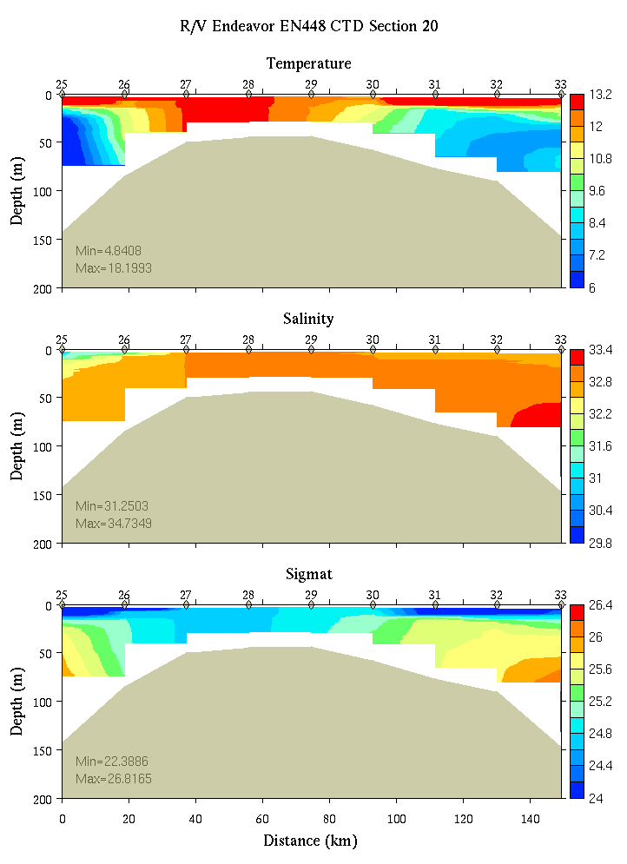 | 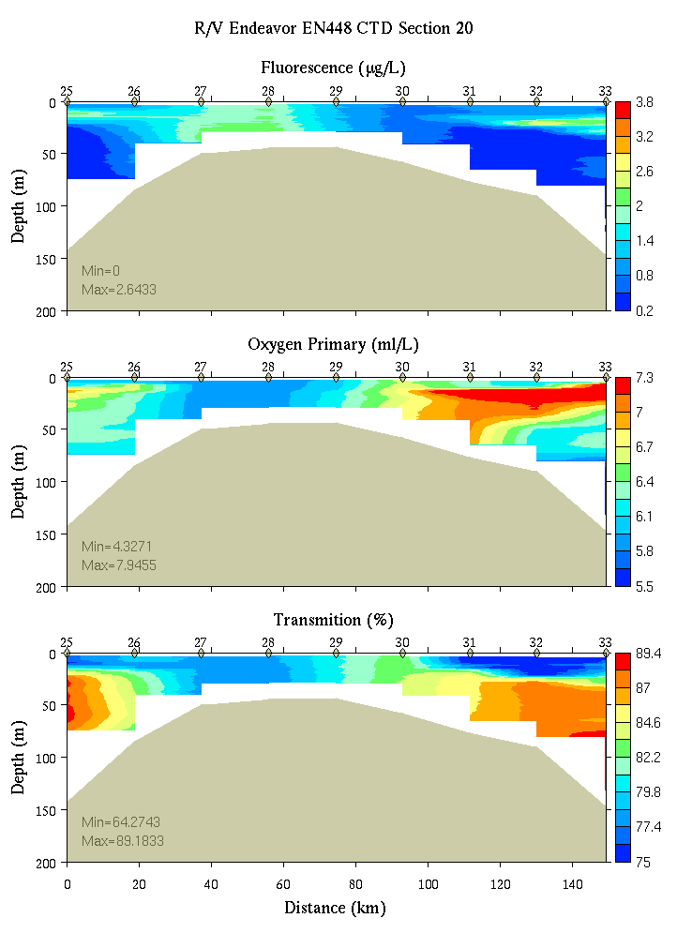
Figure C10. Section 20, 0-200m: temperature, salinity, and density (left); fluorescence, oxygen, and beam transmission (right).

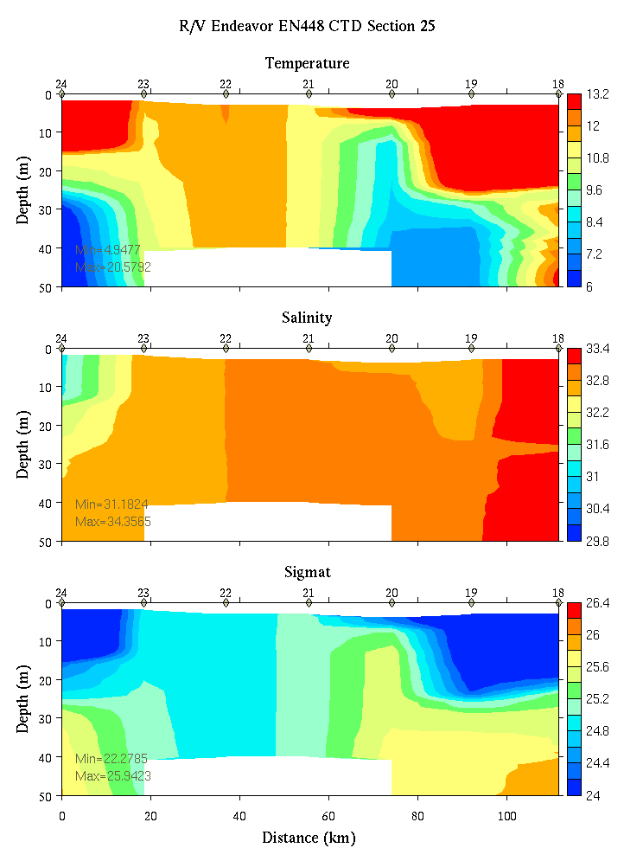 | 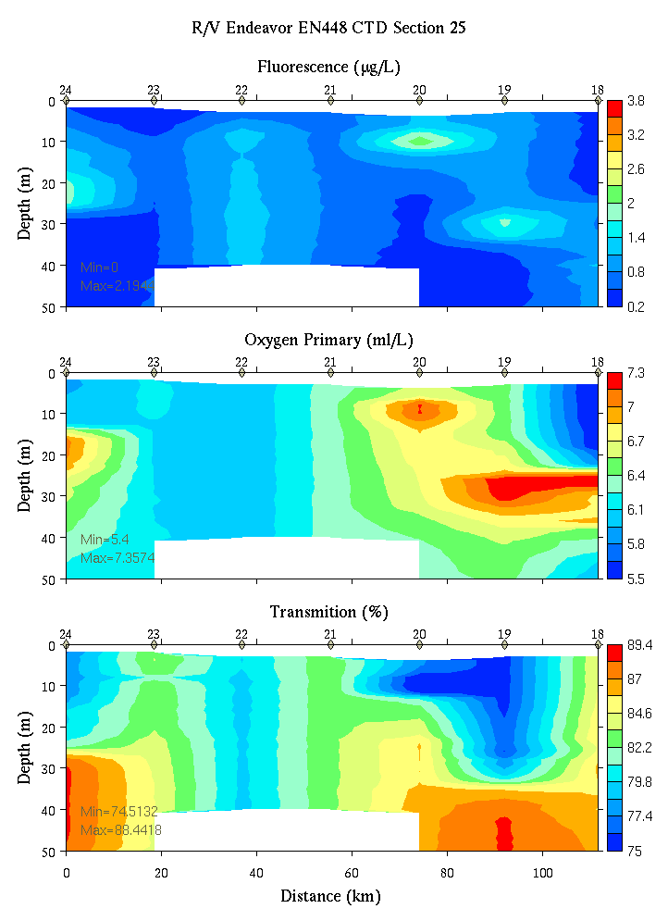
Figure C11. Section 25, 0-50m: temperature, salinity, and density (left); fluorescence, oxygen, and beam transmission (right).

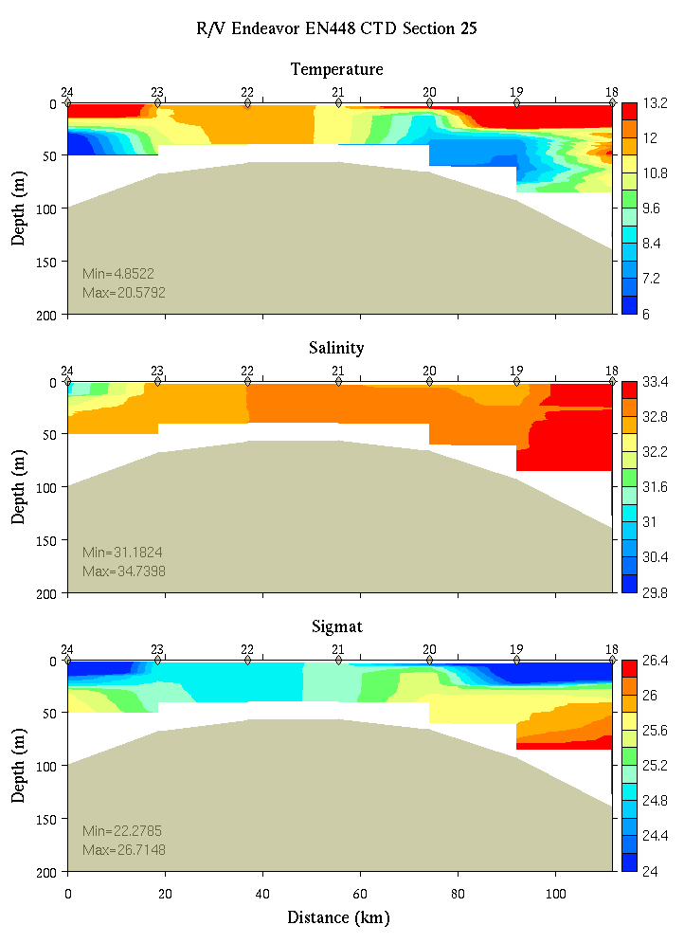 | 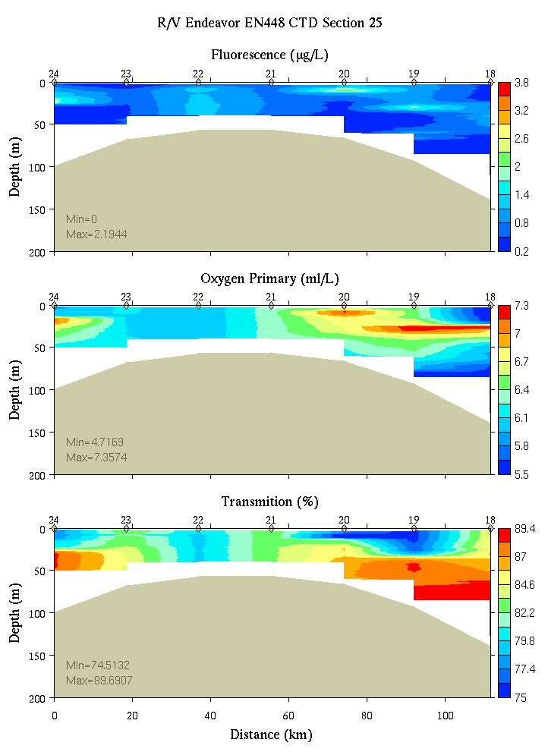
Figure C12. Section 25, 0-200m: temperature, salinity, and density (left); fluorescence, oxygen, and beam transmission (right).

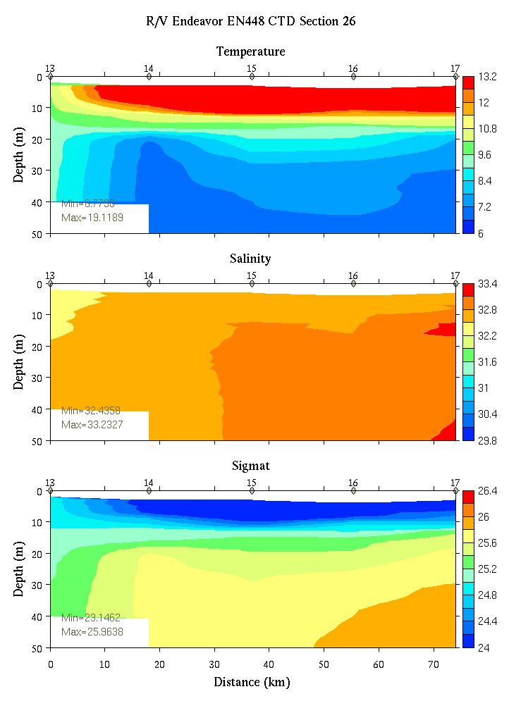 | 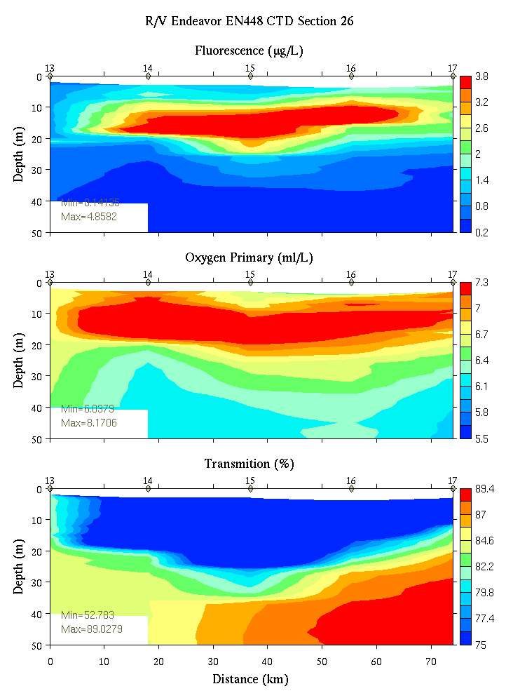
Figure C13. Section 26, 0-50m: temperature, salinity, and density (left); fluorescence, oxygen, and beam transmission (right).

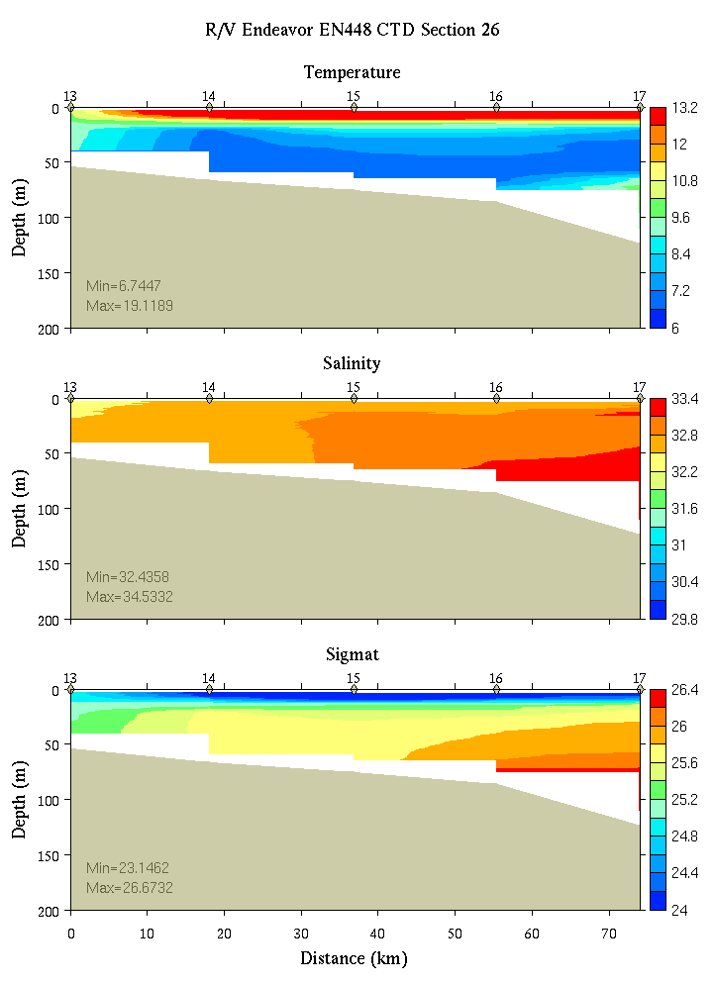 | 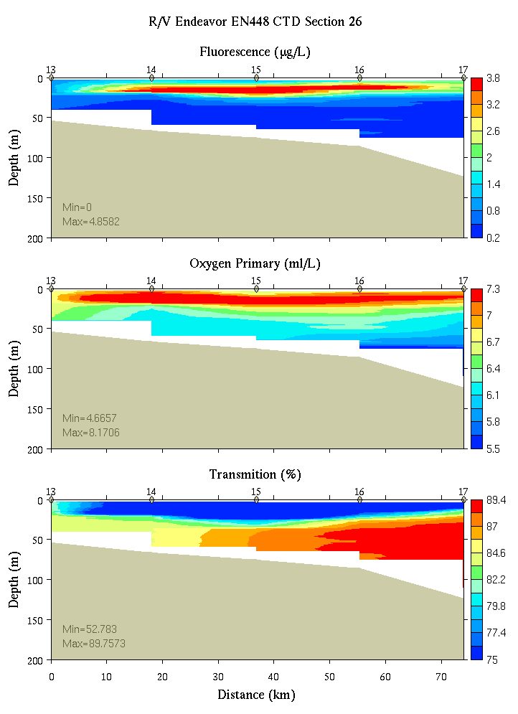
Figure C14. Section 26, 0-200m: temperature, salinity, and density (left); fluorescence, oxygen, and beam transmission (right).

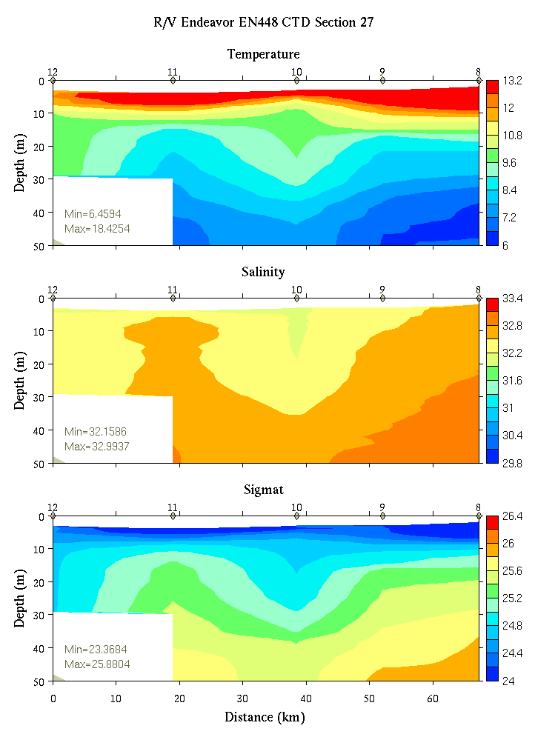 | 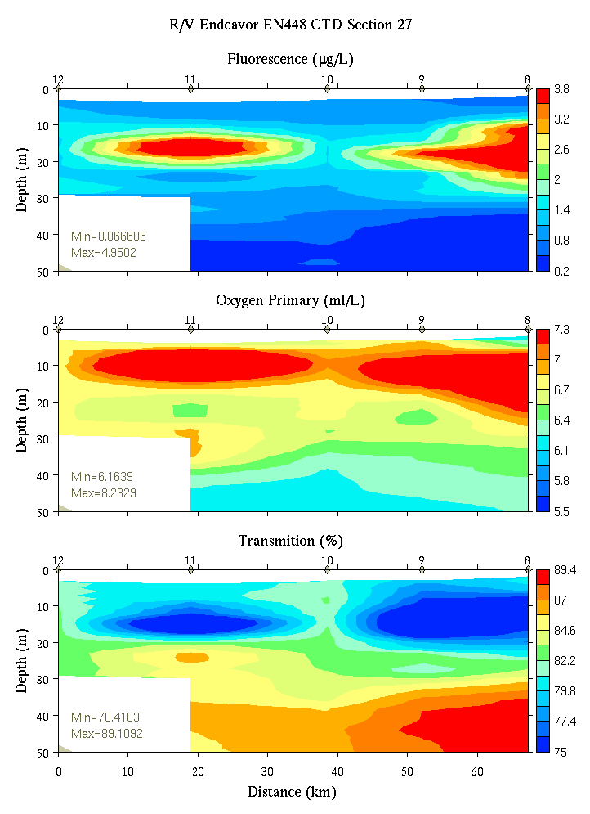
Figure C15. Section 27, 0-50m: temperature, salinity, and density (left); fluorescence, oxygen, and beam transmission (right).

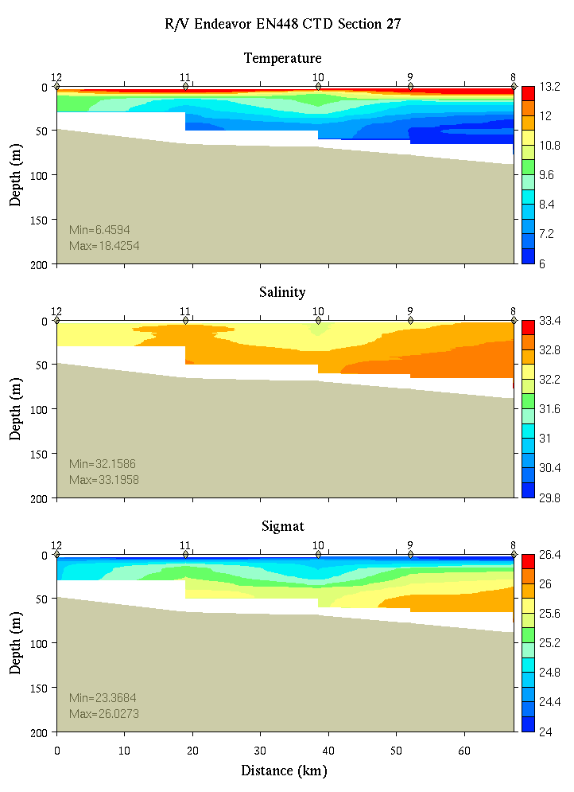 | 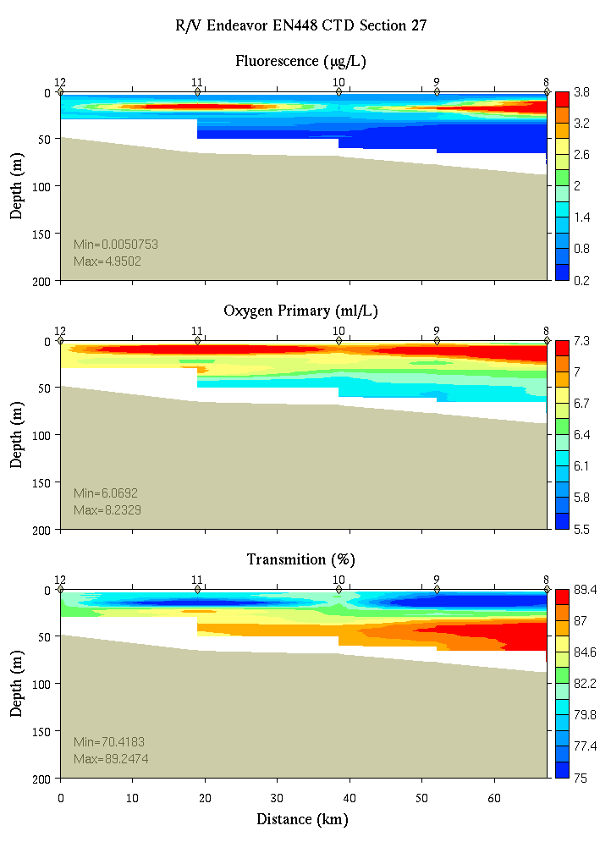
Figure C16. Section 27, 0-200m: temperature, salinity, and density (left); fluorescence, oxygen, and beam transmission (right).

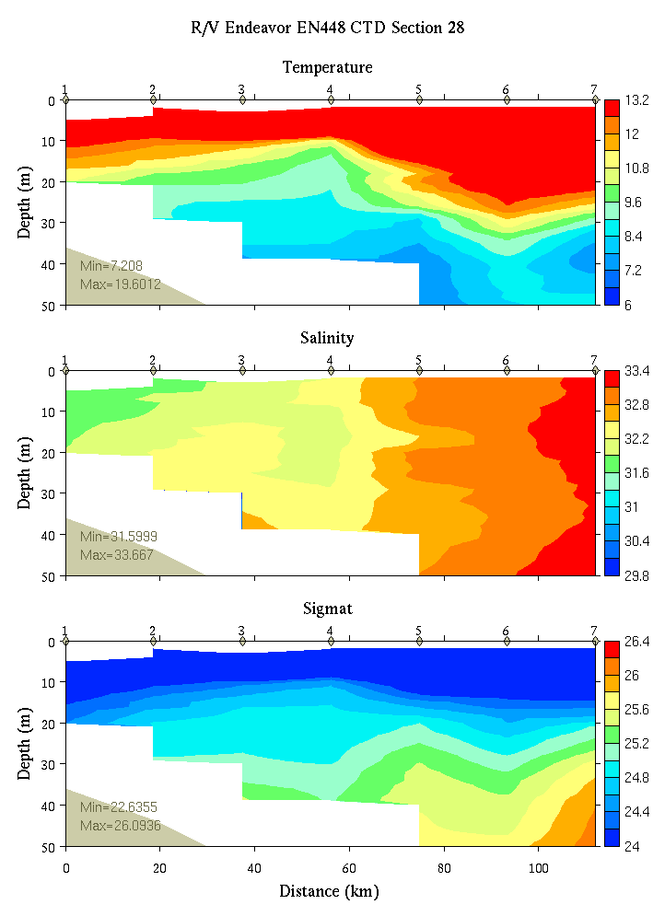 | 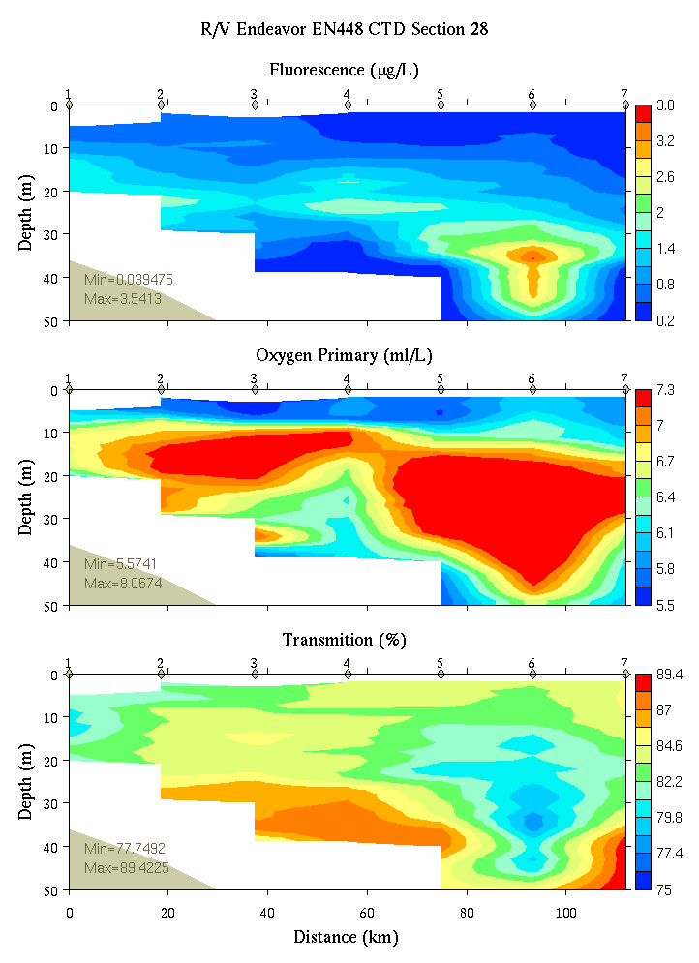
Figure C17. Section 28, 0-50m: temperature, salinity, and density (left); fluorescence, oxygen, and beam transmission (right).

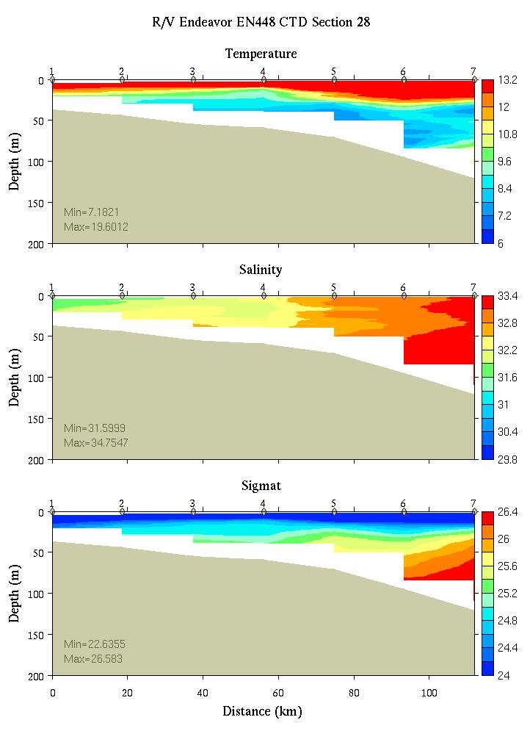 | 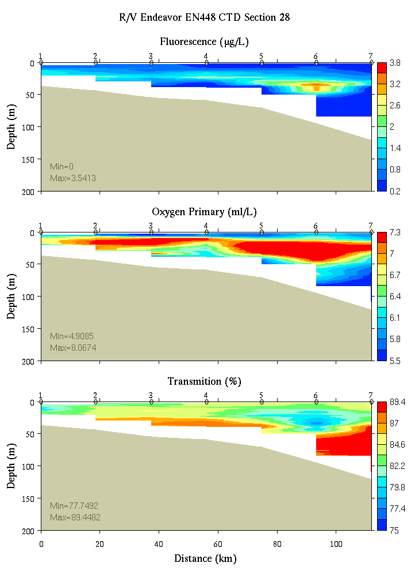
Figure C18. Section 28, 0-200m: temperature, salinity, and density (left); fluorescence, oxygen, and beam transmission (right).

Appendix D: Satellite imagery

Figure D1. True-color satellite image from June 25, 2008 courtesy of Andy Thomas. Note the bright areas along the southern portions of Georges Bank, indicating a coccolithophore bloom in that area.

Appendix E: Personnel

1. Dennis McGillicuddy (Chief Scientist)
2. Valery Kosnyrev
3. Olga Kosnyreva
4. Keston Smith
5. Bruce Keafer
6. Kerry Norton
7. Bibiana Crespo
8. Holly Taylor
9. David Townsend
10. Maura Thomas
11. Rachel Gettings
12. Morgan Brunbauer
13. Jeff Turner
14. Chrissy Petitpas
15. Meri Ratzel
16. Jonathan Breton
17. Dane Percy

Watch number 1 2 3
4 on / 8 off 8-12 12-4 4-8

1. CTD Operator Keston Morgan Dane
2. Cell Counter Meri Kerry## Bruce##
3. Nutrient sampler Dave## Rachel# Maura#
4. Deputy water sampler Bibiana# Olga# Jeff
5. Deputy water sampler Valery# Holly Jonathan#
Chrissy

* Watch chief
# CTD deck operations: 1 deck chief (##) and 2 slip line handlers (#)

http://www.whoi.edu/science/cohh/whcohh/projects/habs1_abstract.htm
http://www.nefsc.noaa.gov/drifter/pth_85291.jpg
Also see http://nefsc.noaa.gov/drifter
Available at http://science.whoi.edu/users/mcgillic/en448/at_sea_modeling

