OC412 Cruise Report
Draft 5/16/2005

Contents:
- Summary
- Narrative
- Cruise Personnel

Summary

We hypothesize that the population of Alexandrium fundyense in the Gulf of Maine consists of a set of genetically distinct subpopulations. These subpopulations may have different behavioral characteristics and physiological responses to environmental conditions, such as light, temperature, and nutrient concentration—thereby adding a genetic dimension to the mechanisms responsible for spatial and temporal variability in the organism’s abundance and distribution. We already know that different strains of A. fundyense exhibit distinct behavioral characteristics in the laboratory. It remains to be seen whether or not evidence of such variations can be gleaned from natural populations. The first step will be to ascertain whether or not the genetic characteristics of A. fundyense subpopulations can be measured. Our specific objectives for this cruise were to:

1. Measure genetic variability in A. fundyense populations.

2. Assimilate data into a hydrodynamic model to provide context for interpretation of A. fundyense measurements.

3. Deploy drifters to obtain Lagrangian velocity measurements.
a. evaluation of hydrodynamic model skill
b. measure retentive characteristics of the hypothesized
Bay of Fundy gyre

Core measurements included:
a. CTD (pressure, temperature, salinity, fluorescence, beam attenuation, PAR)
b. A. fundyense Niskin sampling (1, 10, 20m depths from 10 liter bottles – 2 bottles each)
live counts
preserved samples
oligo cell counts
microsatellite assays
sandwich hybridization analysis
c. Nutrients standard depths plus 30, 50, 100, 150, 200m
d. sediment cores for Alexandrium cysts
e. Drifters
f. ADCP

Ancillary measurements included:
a. AVHRR and SeaWiFS imagery
b. GoMOOS moorings
c. Coastal tide gauges

A large-scale survey of the Gulf of Maine was conducted to sample the ensemble of the potential A. fundyense subpopulations. The station grid consisted of a set of transects spanning from Massachusetts Bay to the Bay of Fundy (Figures 1-7).

Given the surprisingly high abundance of A. fundyense in Massachusetts Bay, that area was resurveyed at the end of the cruise (Figure 8-11).

High-resolution profiles were taken at selected stations to examine genetic structuring of the population with depth. One profile in the Bay of Fundy, one near Casco Bay, and two in Massachusetts Bay were obtained. Sampling strata was 0-30m with 3m nominal resolution. Vertical interval chosen on the basis of cell profiles from Martin et al. (ECOHAB volume), Townsend et al (ECOHAB volume) and Townsend et al. 2001 which show very few cells below 30m. Moreover, SHA profiles from the present cruise indicate comparable numbers at the surface and 10, with background levels at 20m.

Drifters were deployed along three transects (Figure 12): Cape Ann (3 surface drifters), Penobscot Bay (6 surface drifters), and the Bay of Fundy (9 drogued drifters). The Cape Ann drifters transited southeast offshore of the back side of Cape Cod. The Penobscot Bay drifters went southwest in a generally along-coast direction. The line of drifters in the Bay of Fundy behaved quite differently, with the northwest part of the line moving to the southwest and the southeast part of the line moving to the northeast. This cyclonic shear is consistent with the hypothesized gyre at the mouth of the Bay, but the drifters have not been in the water long enough to close the loop.

Hydrography, shipboard ADCP velocity measurements, GoMOOS mooring observations, and coastal tide gauges were assimilated into a numerical model to provide the hydrodynamic context in which to interpret the biological observations. Table 1 lists the numerical simulations conducted at sea.

The fidelity of the circulation fields was quantified by evaluating the ability of the model to simulate the trajectories of drifters deployed during the survey. Detailed error statistics are presented in Table 1. According to these metrics, the skill of simulation FC_13 is characteristic of the ensemble. Comparison of the simulated and observed trajectories from the Cape Ann line (Figure 13a) indicates that the model drifters generally go in the right direction, but their speed is too large. In contrast, the simulated drifters in the Penobscot Bay line(Figure 13b) move slower than observed, and do not turn offshore as much as the real drifters. The westernmost drifters in the Bay of Fundy move to the southwest as the real drifters do, but the easternmost drifters compare poorly with observations: the real drifters do northeast, whereas the simulated drifters go west (Figure 13c). The nature of these discrepancies will be investigated in a hindcasting study.

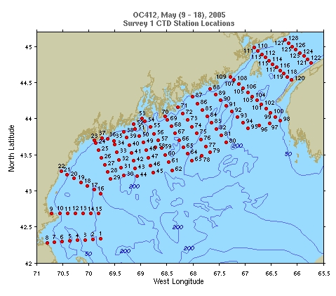
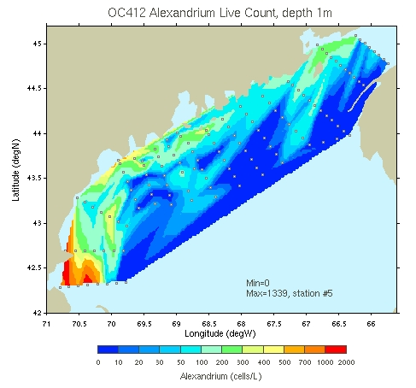
Figure 1. Large-scale survey: station identifiers (upper panel) and
Alexandrium spp. Live counts (lower panel).

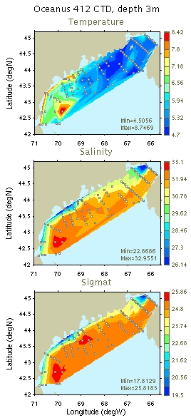 | 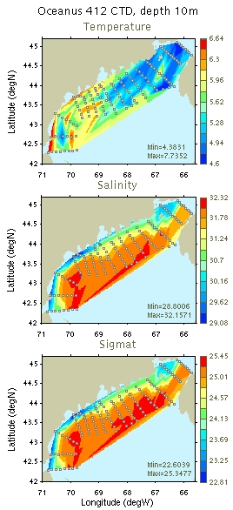
Figure 2: Temperature, salinity, and density maps for 3m and 10m.

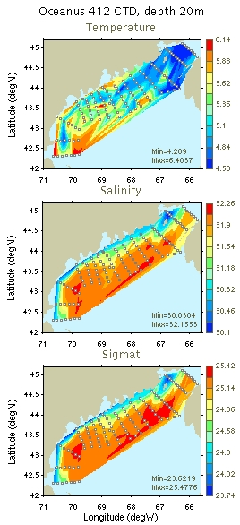 | 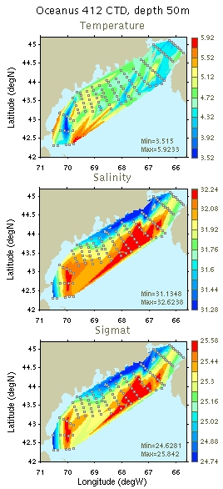
Figure 3: Temperature, salinity, and density maps for 20m and 50m.

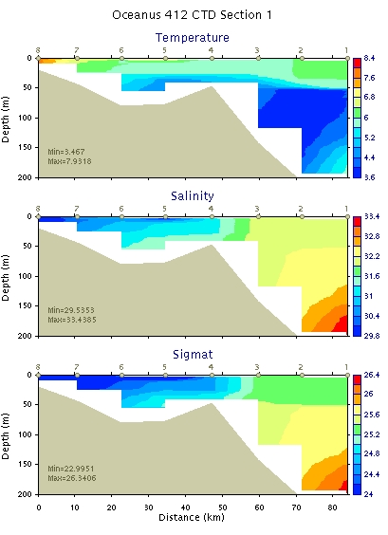 | 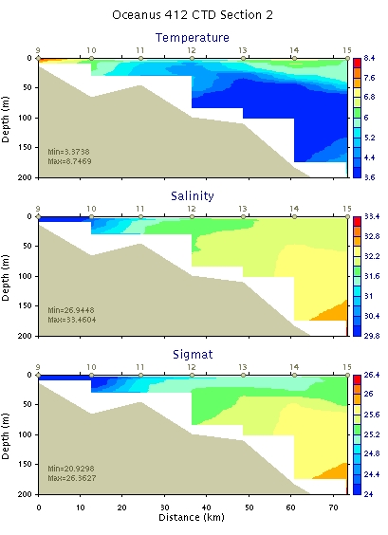
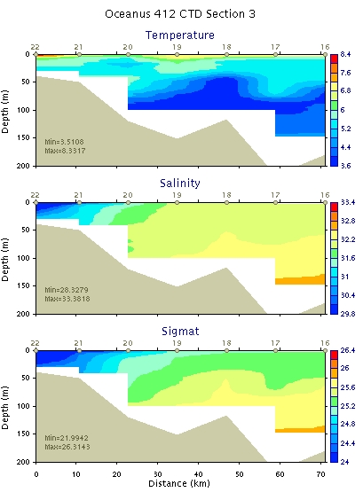 | 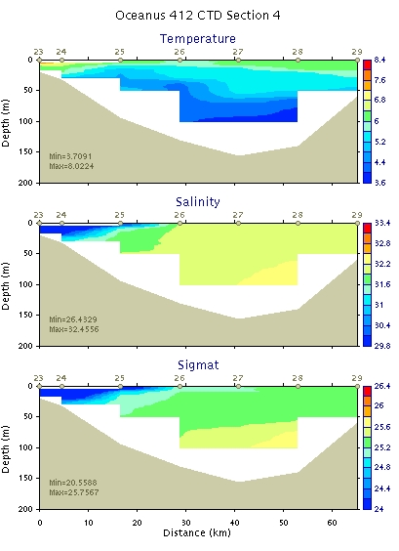
Figure 4: Hydrographic sections 1-4.

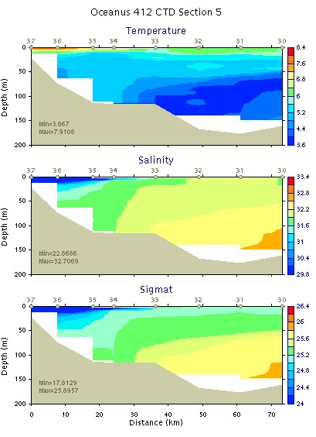 | 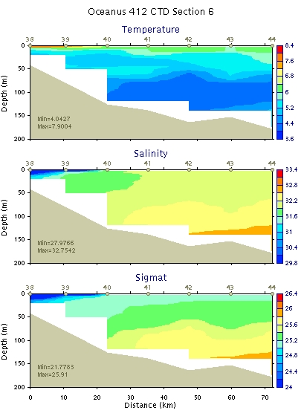
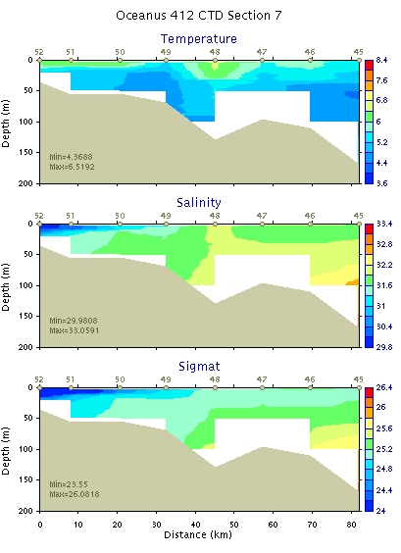 | 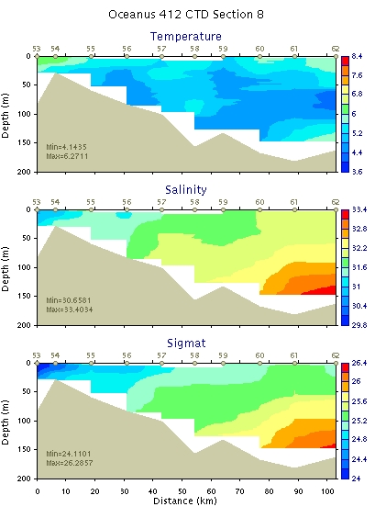
Figure 5: Hydrographic sections 5-8.

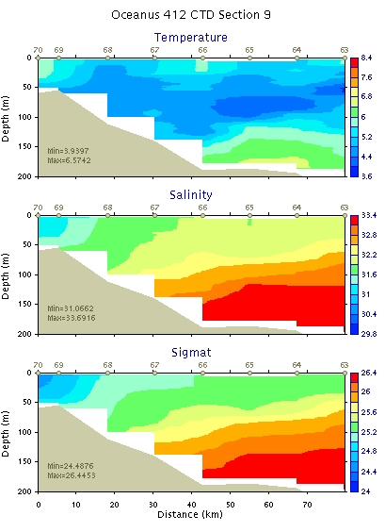 | 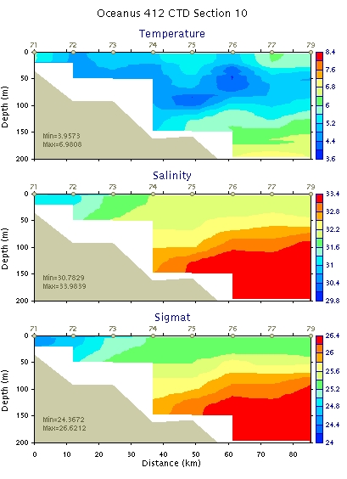
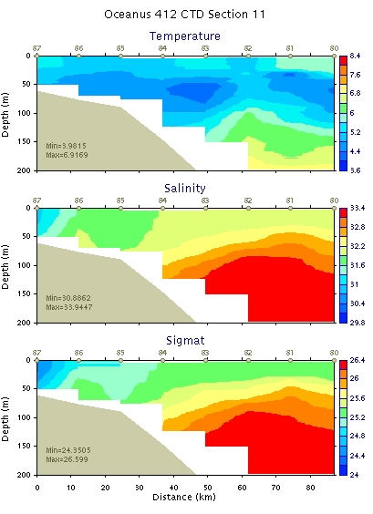 | 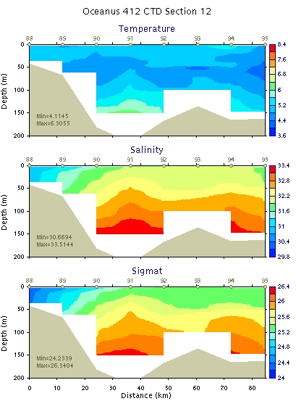
Figure 6: Hydrographic sections 9-12.

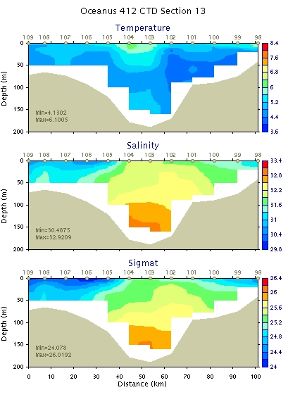 | 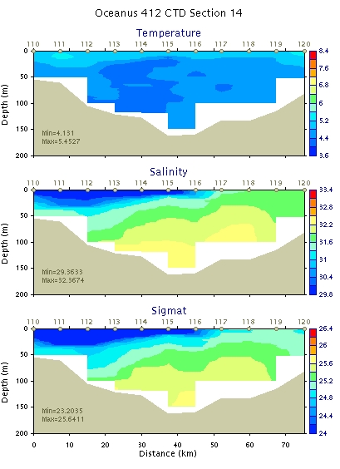
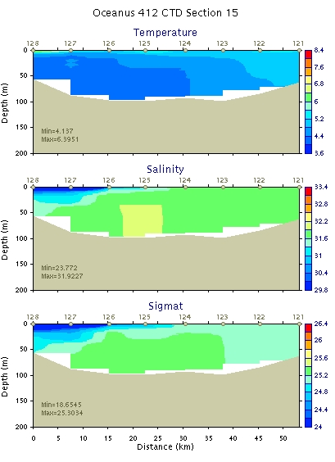
Figure 7: Hydrographic sections 13-15.

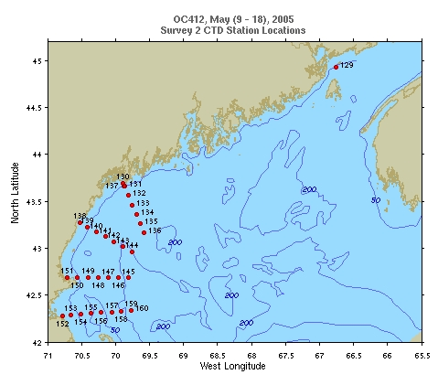
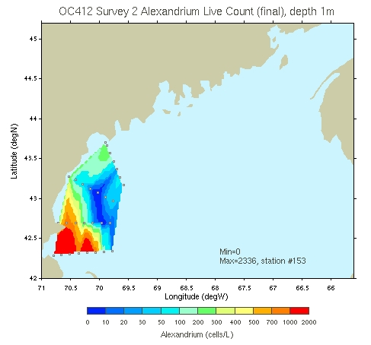
Figure 8. Repeat survey of Massachusetts Bay: station
identifiers (upper panel) and Alexandrium spp. live counts
(lower panel).

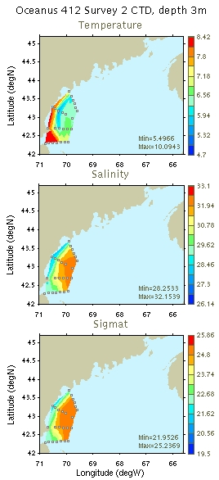 | 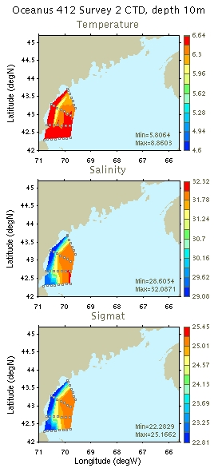
Figure 9: Temperature, salinity, and density maps for 3m and 10m.

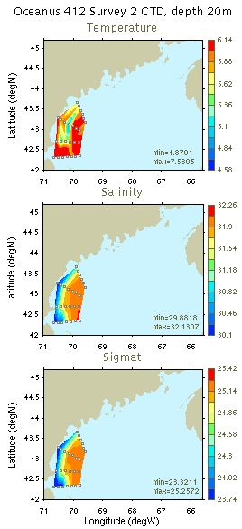 | 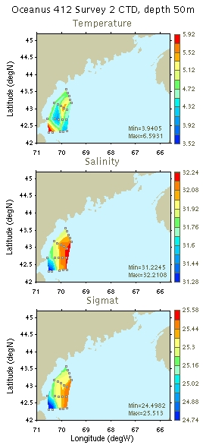
Figure 10: Temperature, salinity, and density maps for 20m and 50m.

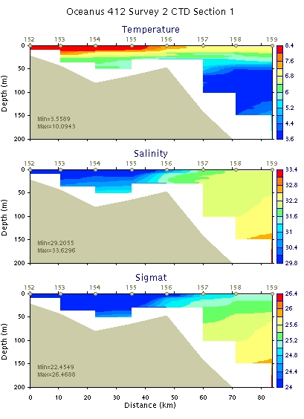 | 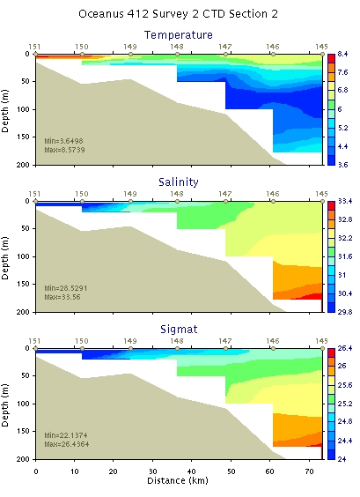
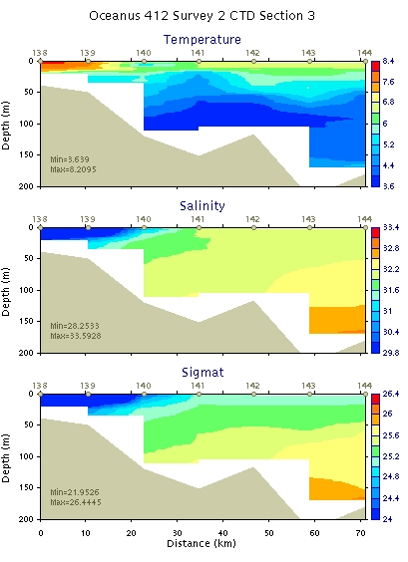 | 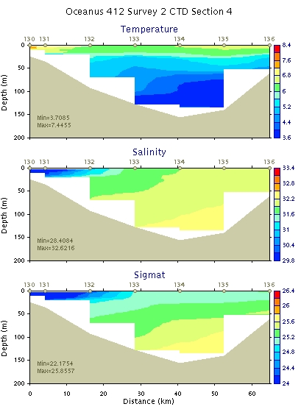
Figure 11: Repeat survey of Massachusetts Bay: hydrographic sections 1-4.

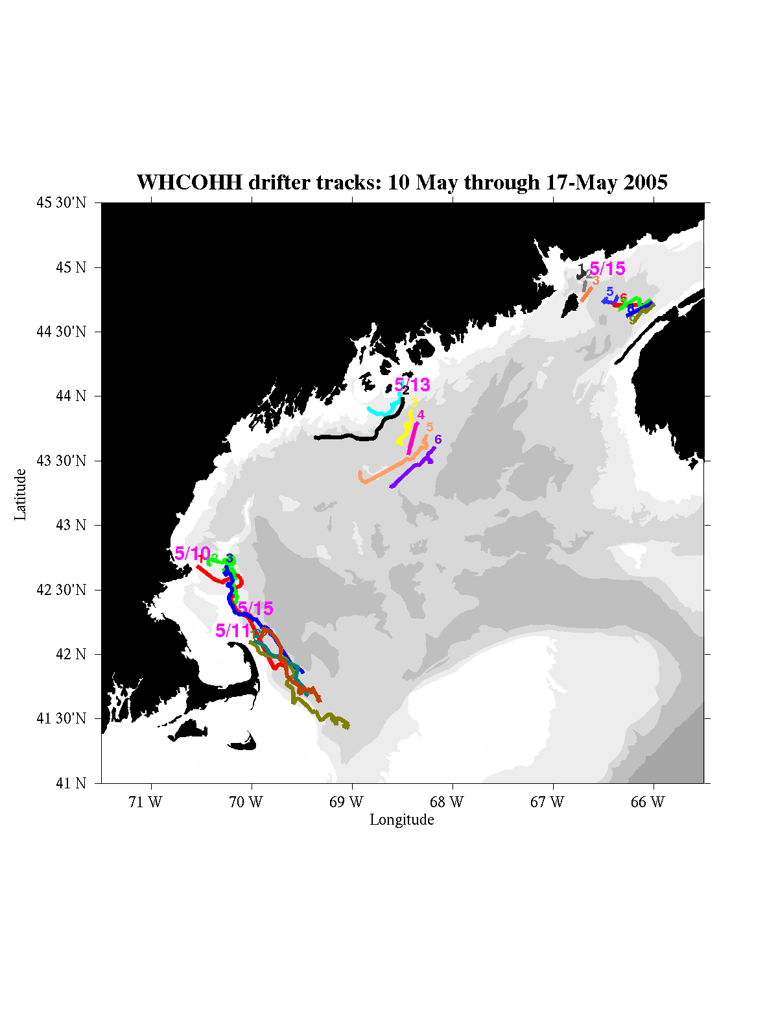
Figure 12. Drifter trajectories for OC412 plus 3 drifters deployed NE of Provincetown as part of Jim Manning’s whale project.

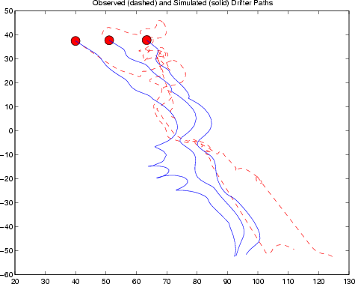 | 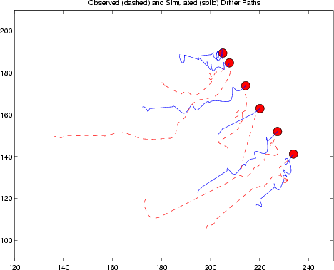
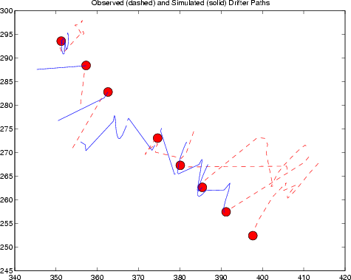
Figure 13: Simulated and observed drifter trajectories for the Cape Ann line (upper left), Penobscot Bay line (upper right), and the Bay of Fundy (lower left).

Narrative

May 9, 2005

Departed WHOI at 1000 hrs. Heavy weather persists from weekend storm, so test/training stations were occupied in Nantucket Sound. Headed out through Great Round Shoal Channel and turned north toward our sampling area.

May 10, 2005

Completed the first transect in Massachusetts Bay. Updates to CTD configuration file received from Marshall; oc412.con used to reprocess all casts to date.

Live counts across the Mass Bay transect are showing high numbers, with 500-1300 cells/L from Stellwagen Bank to Scituate, in a broad band in the <32 psu waters. We need to confirm this count with SHA

The 150kHz ADCP does not have bottom tracking due to failure of one element of the transducer. This causes data below the bottom to be mistaken for good points. The alongtrack Knudsen 12.5kHz depth data stream was merged with the ADCP to correct for this, blanking out all bins for which the bottom of the bin is greater than the bottom depth (Ruoying coding).

Cape Ann drifter deployments:

55201 1823GMT 42 41.148 070 32.602 Cape Ann inshore
55202 1918GMT 42 41.302 070 24.523 Cape Ann midpoint
55203 2015GMT 42 41.323 070 15.503 Cape Ann offshore

May 11, 2005

Live cell counts from the Cape Ann transect were highest inshore near the mouth of the Annisquam River at 1300 cells/L--that's as close as we could get to the shellfish station near there. Working offshore, the abundance declined to about 200-300 cells/L at most stations off of Cape Ann, finally declining to barely detectable (<20 cells/L) at our most offshore station (about 50km offshore) along that line.

Like Mass Bay stations reported yesterday, there is a broad band of cells across the Cape Ann line, but the numbers were consistently lower than Mass Bay, with the exception of the Annisquam station.

Live counts offshore of the Isle of Shoals near Jeffreys Ledge indicate about 400 cells/L, with another 200 cells/L at the nearshore station just south of Cape Porpoise. Seems like the population is split; a nearshore population within the river plume (28 psu) and another peak just offshore of it (31 psu).

Live counts detected about 300 cells/L at stations located near the Kennebec River plume with very few cells in the adjacent offshore waters.

The Mass Bay counts have been confirmed by positive results from the Sandwich Hybridization Analysis, so we know that our observations under the scope are in fact toxic A. fundyense cells in approximately the abundances indicated in the earlier message, certainly sufficient to cause shellfish toxicity.

Summary of forecasting activities to date: OC412_FC1 was a pre-cruise spinup of the model, assimilating GoMOOS mooring data. The model was started on April 28 with a 2.07 day ramp-up from cold start. This was followed by a 1-day burn in prior to saving hot start. Perturbation BCs are ramped up over 1 tidal cycle, followed by a 3 day burn-in of perturbation BCs.

The time window was extended in FC2, but the model crashed in the prior simulation during the period of storm force winds over the weekend (May 7-8). The storm winds were reduced to 40% of their strength in the initial attempt at FC3. However, the first posterior run crashed due to incompatibility between the reduced wind forcing and observed Coastal Sea Level (CSL). FC3 was recomputed without assimilation of CSL and it completed successfully. Forecast FC4 was the same as FC3 except the shipboard ADCP data were added. FC5 assimilated the shipboard ADCP data only so that data stream could be scrutinized by itself (note bottom tracking issue described above).

Results of FC5 do not indicate anything particularly suspicious about the ADCP data (Figure N1) with the RMS amplitude of the observations and residuals of the prior and posterior comparable to earlier modeling efforts in this region. We do note a strong southward current in the southernmost two legs of the ADCP survey that is not captured by the model (Figure N1, right panel). Perhaps this a residual response to the storm forcing over the weekend?

Successful coring station at location # 37.

May 12, 2005

Coring at location 56.

Station 58: CTD cast near Pilskaln mooring. Down to 3.8m off bottom (!).

Preparation of drifters for Penobscot line release.

Forecast FC6 included updated forcing from May 11 and constituted the central forecast for the day. Error statistics are similar to FC5, despite inclusion of the GoMOOS mooring data (Table 1). ADCP comparisons (Figure N2) are nearly indistinguishable from FC5 (Figure N1). Mooring comparisons reveal mixed results (Figure N3). Residual biases are low at moorings B, E, and I; significant discrepancy exists at mooring A, where the model does not capture the observed subtidal southeastward flow.

Based on these generally favorable results, FC6 was posted in main lab. The forecast indicates acceleration of an alongshore current in response to the forecast NW wind (Figure N4).

May 13, 2005

Penobscot Bay line drifter deployments:

55386 0643GMT 43 36.477 68 11.010 offshore
55385 0748GMT 43 42.185 68 15.755
55384 0855GMT 43 47.977 68 20.988
55383 0952GMT 43 53.724 68 25.243
55382 1051GMT 43 59.481 68 30.085
55381 1126GMT 44 01.934 68 32.061 inshore

CTD for Cindy Pilskaln at Jordan Basin mooring (near location 74).

Coring at station 79 (location 75).

May 14, 2005

Coring at location 98 (CTD 88). First core comes up fine, several tries at second sample fail.

Scrutiny of residual errors from shipboard ADCP reveals correlation with ship motion. Minimization of the RMS velocity of ADCP observations to date indicates proper angular correction is +0.6 degrees, rather than the -0.4 degrees used in all the runs to date. Runs FC_8a and FC_8b compare the same forcing with the old (-0.4 degrees) and new (+0.6 degrees) angular corrections, respectively. The new angle removes the bias in residual velocity to the right of the ship’s direction of travel (Figure N5). Statistics of the ADCP misfits are improved (Figures N6 and N7; also see Table 1). Interestingly, the overall character of the posterior solution changes very little, indicating the inversion procedure effectively distinguishes observational error from the true oceanographic signal; the frequency-specific tidal inversion of Truxton and regularization of wind-band variability in Casco are to thank for this.

May 15, 2005

Bay of Fundy Drifter Deployments

55461 0720GMT 44 56.150 66 45.206
55462 0808GMT 44 53.489 66 40.798 bungee strap
55463 0852GMT 44 50.584 66 36.918
55464 0944GMT 44 47.789 66 33.015 yellow collar
55465 1119GMT 44 45.538 66 28.134
55466 1224GMT 44 42.543 66 24.125 chain/shackle ballast on surface float
*55468 1320GMT 44 40.131 66 20.227 8’ 3/8” chain ballast on surface float
*55467 1405GMT 44 37.436 66 16.019 8’ 3/8” chain ballast on surface float
55469 1459GMT 44 34.821 66 11.290 8’ 3/8” chain ballast on surface float
*Note reversal of order in series.

Survey grid completed.

Three high vertical resolution profiles are planned: Grand Manaan, Pen Bay, and Mass Bay. Profile consists of 20 bottles, 2 bottles per depth, 0-30m (3m resolution). Vertical interval chosen on the basis of cell profiles from Martin et al. (ECOHAB volume), Townsend et al (ECOHAB volume) and Townsend et al. 2001 which show very few cells below 30m. Moreover, SHA profiles from the present cruise indicate comparable numbers at the surface and 10, with background levels at 20m.

Arrival at location 121; bucket sample indicates high cell abundance; high-resolution profile conducted.

Transit to Casco Bay (location 36) for high resolution profile.

Monday May 16, 2005

Bruce’s SHA runs during the night indicate very few cells below the surface layer. Casco Bay high resolution profile postponed pending results of reoccupation of that transect; live counts to be conducted for 1,10,20m during that transect only.

Live counts indicate measurable cells at depth at location 29. Backtracked to that location for high resolution profile.

Tuesday May 17, 2005

Completion of Massachusetts Bay snapshot. High resolution profiles at locations 4 and 6. Coring at locations 5, 7, and 9 to fill in holes in the recent cyst survey last fall.

Summary of recent forecasting activities:

Forecasts FC_9a and FC_9b assess the impact of coastal sea level assimilation. Subsequently it was discovered that the Casco input parameter providing the expected elevation error was erroneously set to an unrealistically small number (1mm). Forecasts FC_10 and FC_11 repeat the FC_9a / FC_9b pair with updated winds and observed currents, with the expected elevation error set to 5cm in FC_10. Forecast FC_12 is a repeat of FC_11 with updated winds and currents (no CSL assimilation). FC_13 is the same as FC_12 except that the observed density field is blended into the initial condition using OACI. FC_14 is the same as FC_13 except that a slip model is applied to the surface drifters.
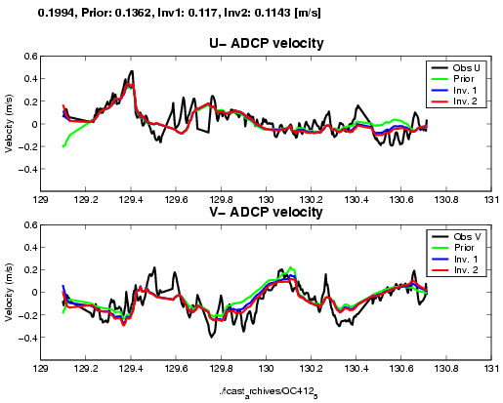 | 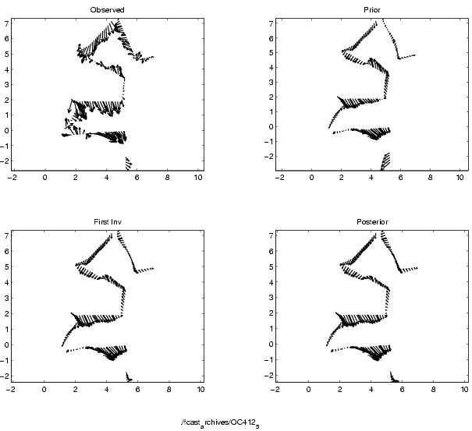
Figure N1: Observed (shipboard ADCP) and predicted velocities for FC_5: alongtrack (left) and spatial comparisons (right).

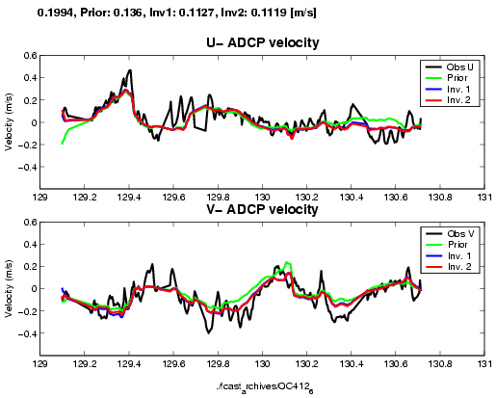 | 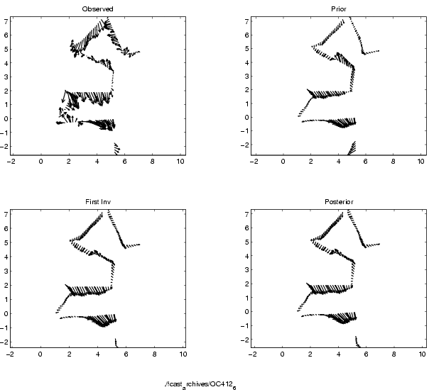
Figure N2: Observed (shipboard ADCP) and predicted velocities for FC_6: alongtrack (left) and spatial comparisons (right).
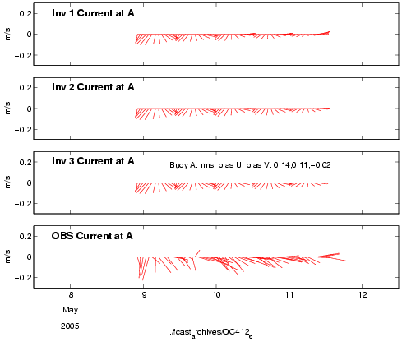 | 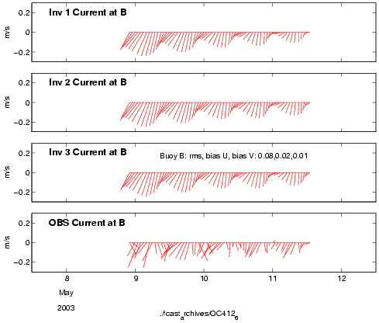
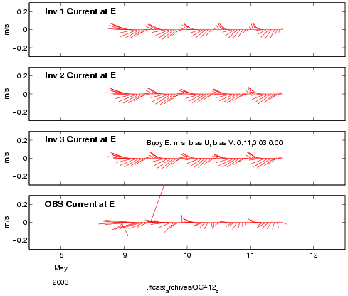 | 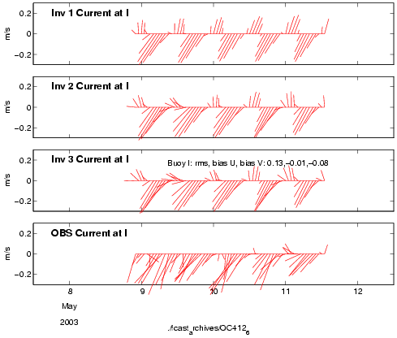
Figure N3: Observed and predicted velocities at GoMOOS moorings A,B,E,I from FC6.

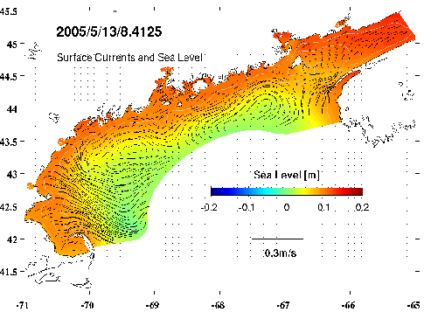 | 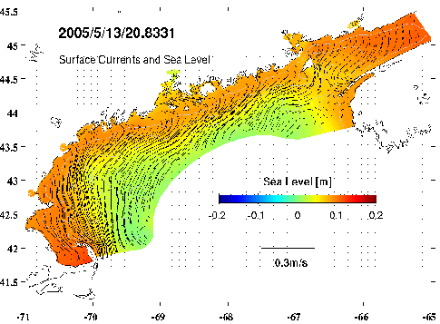
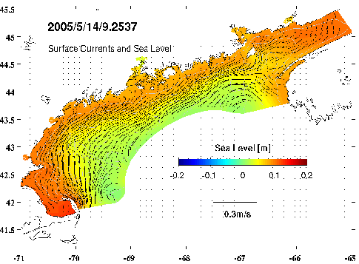 | 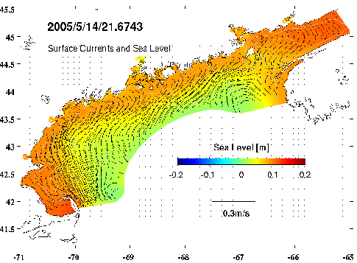
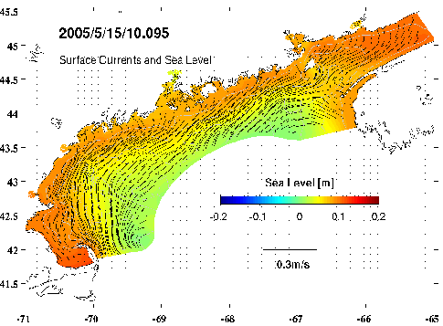 | 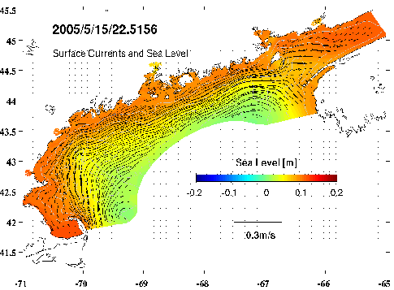
Figure N4: Forecast surface currents and sea level: FC_6.

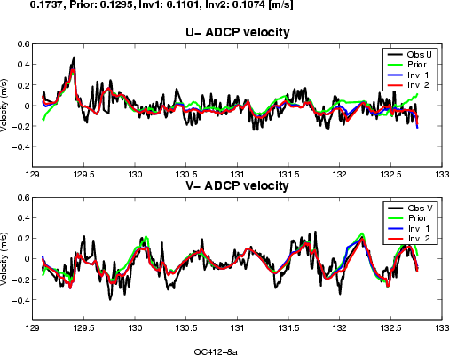 | 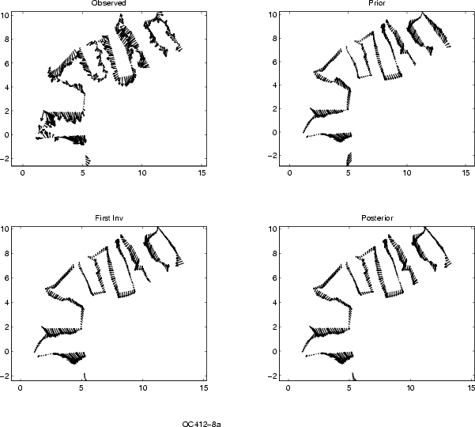
Figure N5: Observed (shipboard ADCP) and predicted velocities for FC_8a: alongtrack (left) and spatial comparisons (right).

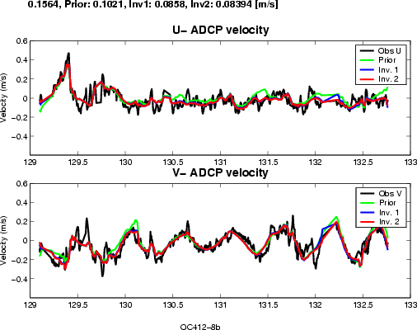 | 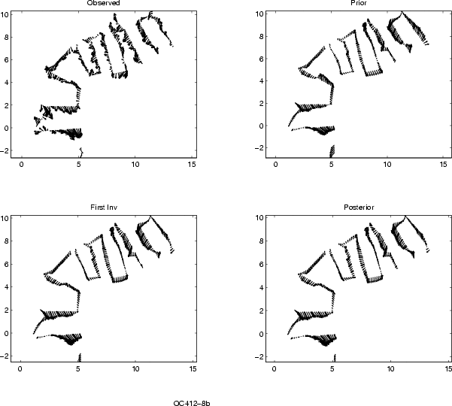
Figure N6: Observed (shipboard ADCP) and predicted velocities for FC_8b: alongtrack (left) and spatial comparisons (right).

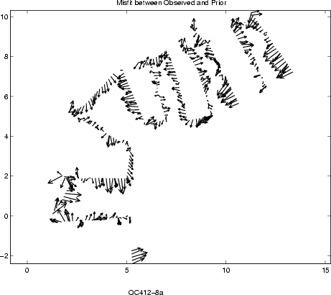 | 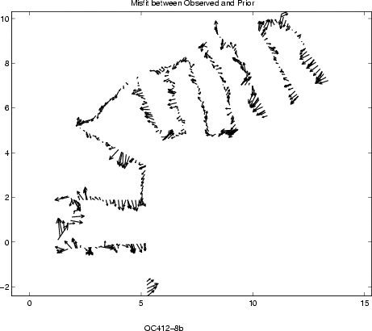
Figure N7: Vector difference between observed and predicted ADCP velocities for FC_8a (left) and FC_8b (right).

ID  Date | Period | Obs | ICs | Error statistics  RMS Obs/Prior/Post1/Post2  Mooring RMS Post2;  Vector bias | Winds | Comments
FC1  5/5 | 4/28-5/8 | BEI | Clim. | 11.3/8.4/7.5/7.3  B: 6.0 (1.5,3.9)  E: 8.4(6.1,0.3)  I: 7.5(4.5,3.4) | E(5/4)+NOAA | Pre-cruise  spinup
FC2  5/6 | 4/28-5/13 | BEI,CSL |  |  | E(5/5)+NOAA | Longer time period, including storm. Crashed on prior.
FC3a  5/9 | 4/28-5/13 | BEI,CSL |  |  | E(5/5)+40%NOAA | Crash on 2nd fwd run
FC3  5/10 | 4/28-5/13 | BEI |  | 15.2/10.5/9.7/9.4  A: 9.9(2.8,3.6)  B: 8.6 (2.5,8.7)  E: 8.6 (5.9,1.3)  I: 10.2 (7.1,5.9) | E(5/5)+40%NOAA | Removal of CSL allows completion
FC4  5/10 | 4/28-5/14 | BEI,ADCP |  |  | E(5/9)+NOAA | Hindcast wind doesn’t crash
FC5 5/11 | 5/3-5/15 | ADCP only |  | 19.9/13.6/11.7/11.4 | E(5/10)+NOAA
FC6 5/11 | 5/3-5/16 | ABEI,ADCP |  | 19.9/13.6/11.3/11.1  A: 14 (11,2)  B: 8 (2,1)  E: 11 (3,0)  I: 13 (1,8) | E*+NOAA | *wind starts 5/7 (bug identified 5/13)
FC7  5/12 | 5/3-5/17 | ABEI,ADCP |  |  | E*+NOAA | *wind starts 5/7 (bug identified 5/13)
FC8a  5/13 | 5/3-5/18 | ABEI,ADCP PHI=-0.4 |  | 17.4/13.0/11.0/10.7  Drifters: 4.0: 8.1 / 8.3 | E+NOAA | wind bug fixed
FC8b 5/13 |  | PHI=0.6 |  | 15.6/10.2/8.6/8.4  Drifters: 4.0: 8.0 / 8.2 |  | ADCP angle correction
FC9a 5/14 | 5/3-5/19 | ABEI,ADCP,  CSL |  | 18.8/11.3/13.6/13.8  A:16(3,3)  B:9(6,13)  E:14(11,1)  I:13(7,6)  Drifters: 4.0: 10.2/9.7 |  | Test CSL assimilation
FC9b 5/15 | 5/3-5/19 | ABEI,ADCP |  | 18.8/11.3/8.8/8.6  A:14(2,4)  B:8(6,12)  E:13(11,1)  I:12(8,7)  Drifters: 4.0: 7.9/7.9 |  | Without CSL assimilation
FC10 5/15 | 5/3-5/19 | ABEI,ADCP,  CSL |  | Drifters: 4.0: 8.7/8.6 |  | Repeat of 9a with updated wind, velocity obs, and drifters; expected elevation error 5cm instead of 1mm for FC9a
FC_11 5/15 | 5/3-5/19 | ABEI,ADCP |  | 24.6/13.6/12.1/11.8  A:13(1,3)  B: 8(6,11)  E: 13(10,1)  I: 11(7,6)  Drifters: 4.0: 8.2/8.1 |  | Repeat of 9b with updated wind, velocity obs, and drifters
FC_12 5/16 | 5/3-5/19 |  | clim |  |  | Updated winds, currents
FC_13 5/16 | 5/3-5/19 |  | OACI  obs | 24.0/13.6/12.3/12.0  A: 13(-2,1)  B: 10(8,13)  E: 12(8,1)  I:12(6,5)  Drifters: 11.0 / 9.8 |  | Updated winds, currents
FC_14 | 5/3-5/19 |  | OACI  obs |  |  | Updated winds, currents + drifter slip model

Cruise Personnel
1. Bruce Keafer bkeafer@whoi.edu
2. Deana Erdner derdner@whoi.edu
3. Dennis McGillicuddy (chief scientist) dmcgillicuddy@whoi.edu
4. Valery Kosnyrev vkosnyrev@whoi.edu
5. Olga Kosnyreva okosnyreva@whoi.edu
6. Ruoying He rhe@whoi.edu
7. Mike Brosnahan, mbrosnahan@whoi.edu
8. Mike Carlowicz, mcarlowicz@whoi.edu
9. Keston Smith keston.smith@Dartmouth.EDU
10. Emily Harrison eharrison@whoi.edu
11. Kerry Norton boundtoh2o@yahoo.com
12. Angie Molitor ADM1114@MAIL.ECU.EDU
13. Ilaria Nardello inardello@whoi.edu
14. Maureen Lynch mlynch@mail.colgate.edu
15. Luke Cole lukec@gso.uri.edu

