OC402 Cruise Report

DRAFT: DO NOT DISTRIBUTE
Updated 1/30/06

Summary

Three synoptic surveys reveal dramatic changes in near surface hydrographic properties and SHA-derived cell concentration (Figures 1 and 2). Both the Kennebec/Androscoggin (K/A) and Penobscot river plumes are evident in the salinity fields. During survey 1, the K/A plume extends far offshore due to the upwelling-favorable winds prior to and during the first survey. The eastern edge of the plume retroflects in an east-northeast direction, wrapping around a high-salinity tongue that extends from the eastern boundary toward the west-northwest all the way to the inshore portion of section 2. Highest cell concentrations occur in association with the offshore waters of the K/A plume, as well has the northwestern extension of the high-salinity tongue.

Surveys 2 and 3 were accompanied by persistent downwelling-favorable winds. During this time, the K/A plume moved closer to the coast and the retroflection at the distal end of the high-salinity tongue dissipated. Cell concentration generally decreased and moved shoreward during Survey 2. Note the apparent westward transport of the peak concentration in transect 1 of Survey 1 to the offshore end of supplementary transect A in Survey 2. Drifter trajectories document on-shore and along-coast transport (Figure 3). In particular, the surface drifters on the inshore portion of the eastern line transited directly to Casco Bay.

A final small-scale survey of Casco Bay was occupied to ascertain the degree to which the observed offshore populations were transported shoreward. Indeed, survey 4 revealed cell concentrations in that area were significant (Figure 2, lower right).

Real-time nowcasts and forecasts of regional hydrodynamics were constructed at sea using the Dartmouth Numerical Methods Laboratory finite element model. Shipboard ADCP data and velocity observations from GoMOOS moorings B, E, and I were assimilated, with atmospheric forcing provided from a combination of buoy observations and NOAA weather radio forecasts. Operational products included surface velocity maps posted in the ship’s main laboratory (see examples below), in addition to a suite of standard horizontal maps and vertical sections (“Defplots”) made available via web interface on one of the main lab computers (now available at http://science.whoi.edu/users/mcgillic/merhab/oc_402/oc402.html). Model results capture the basic dynamic of the upwelling/downwelling transition and associated transport phenomena (Figure 4).

At the beginning of the cruise, Maine DMR (Laurie Bean) had reported toxicity of 129 in Lumbo’s Hole from the previous week; all other locations in Casco Bay were clean. Monday the 24th, Laurie reported that Lumbo’s Hole was now clean, as was the rest of Casco Bay. OC402 data showed high cell concentrations offshore, and surface drifter tracks indicate onshore transport. By Wednesday the 26th, surface drifters deployed on Transect 4 had reached the mouth of Casco Bay. According to Laurie Bean’s report on the 26th, there was widespread low-level toxicity throughout Casco Bay, with the highest value reported in Lumbo’s Hole (200). Toxicity also extended further to the west to Scarborough. These observations are consistent with shoreward transport of cells to the coast via downwelling-favorable winds. These findings led to a NOAA press release on July 29, 2004: “NOAA FUNDED RESEARCHERS FORECAST TOXIC RED TIDE IN NEW ENGLAND; Show Value of Ocean Observing System Technology.”

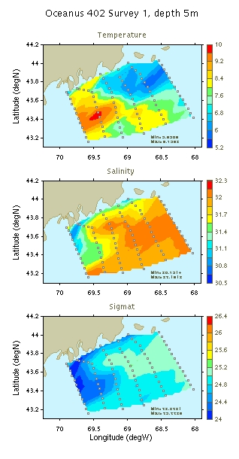 | 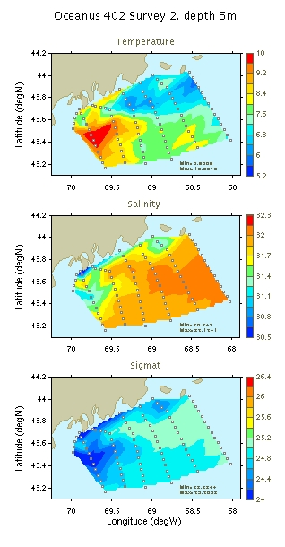 | 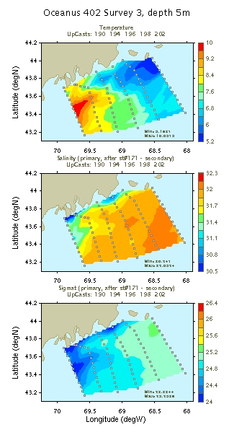
Figure 1. Temperature, salinity, and density at 5m from the first 3 surveys of OC402.

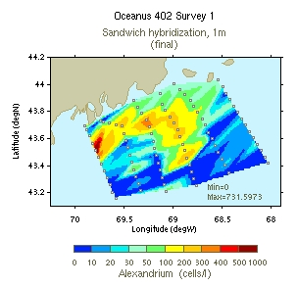 | 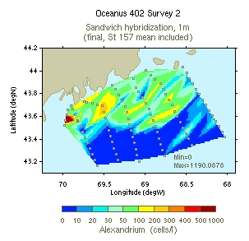
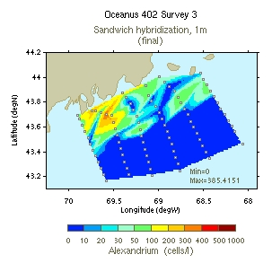 | 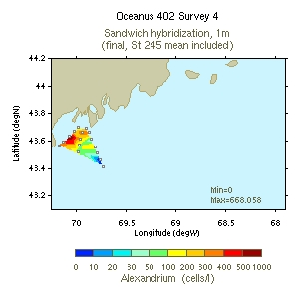
Figure 2: A. fundyense surface concentration inferred from sandwich hybridization analysis.

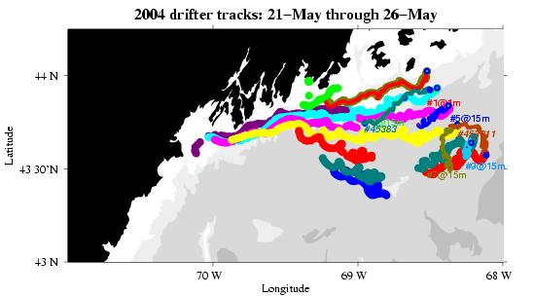
Figure 3: Drifter trajectories during OC402. The western line is comprised of all surface drifters; both surface and drogued drifters were deployed at each location on the eastern line (with the exception of the most inshore station).

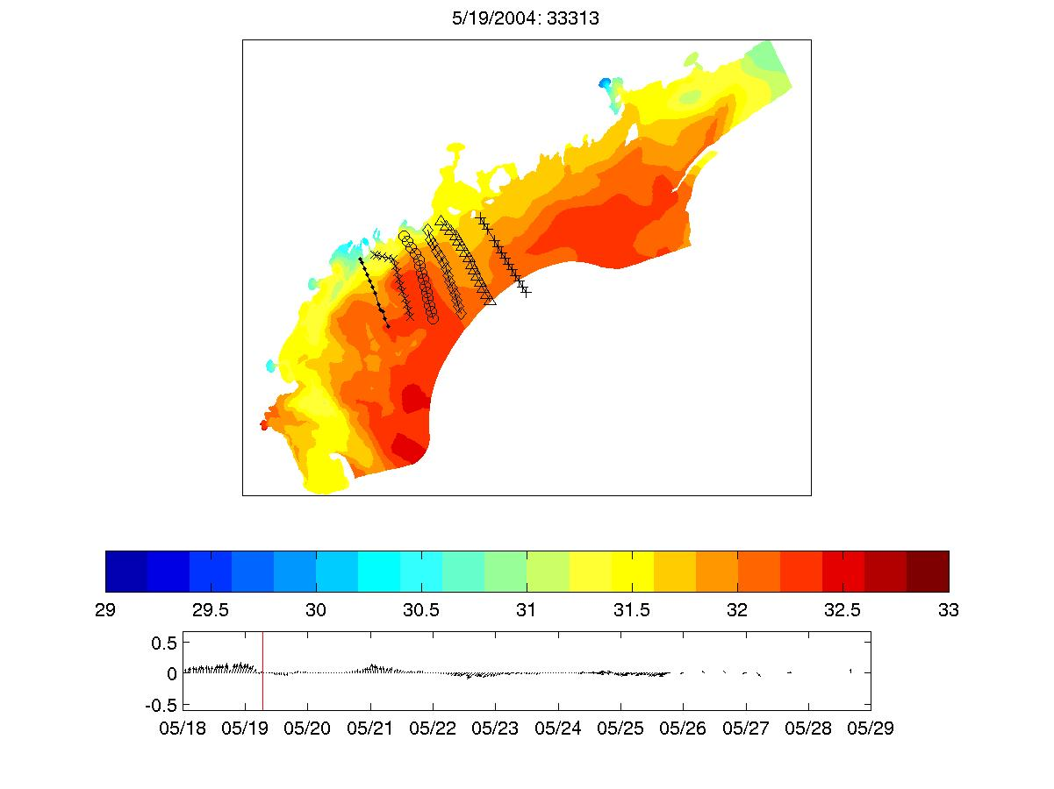 | 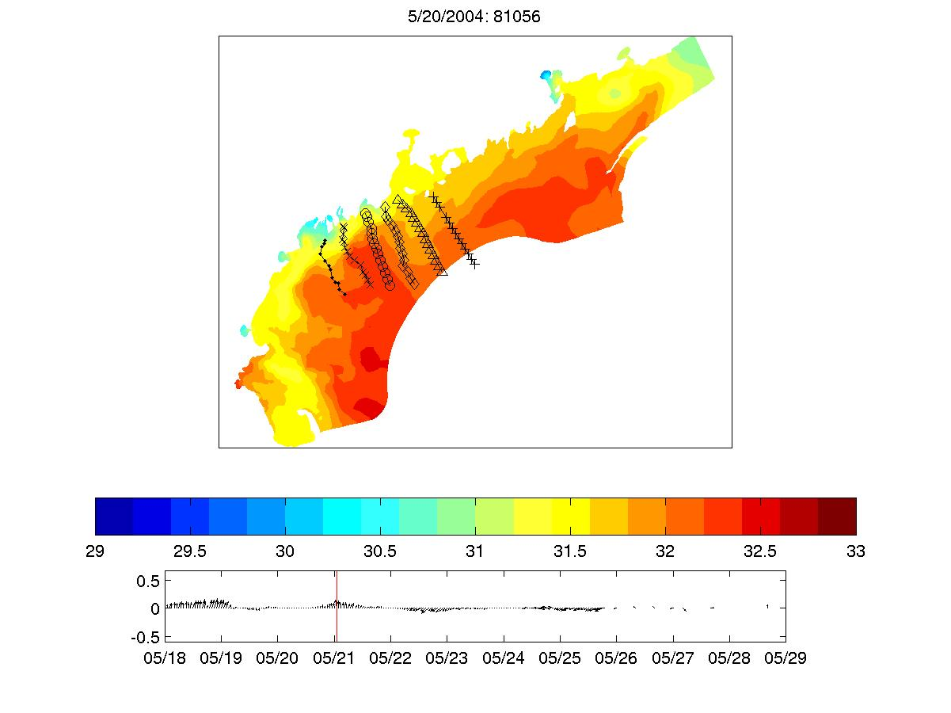
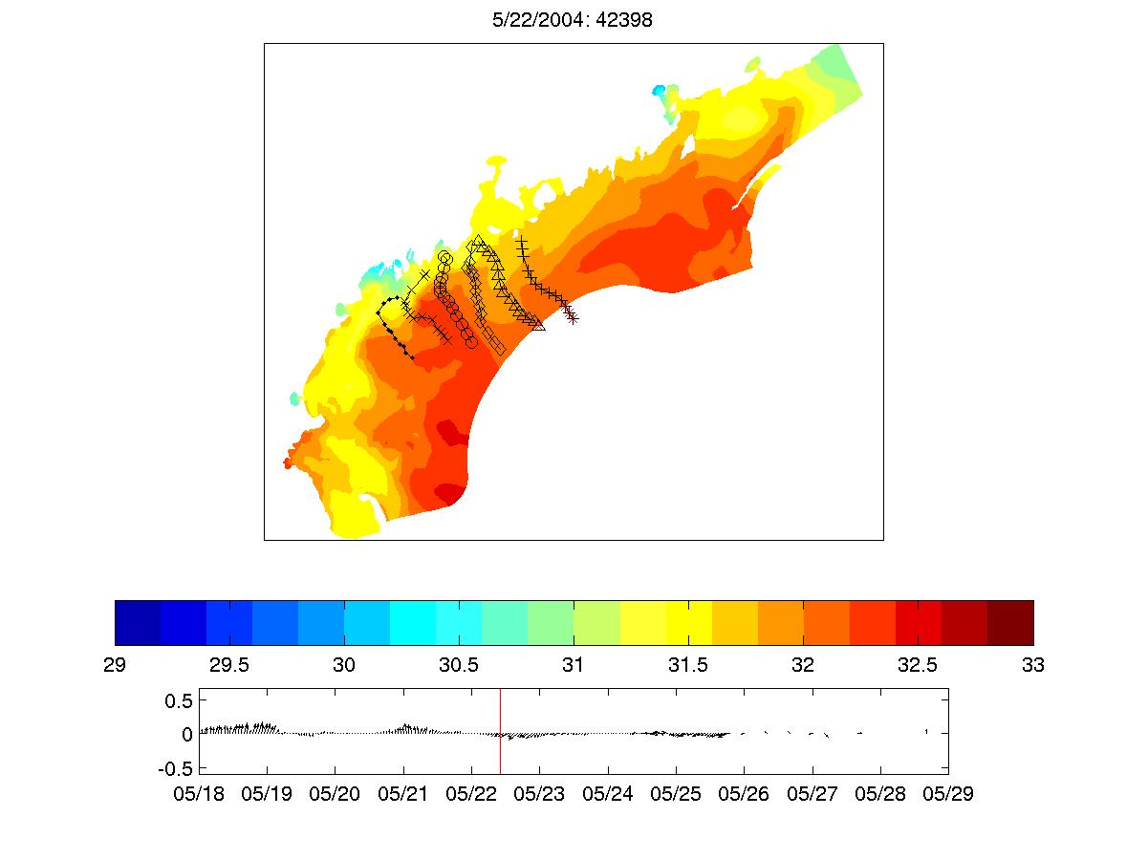 | 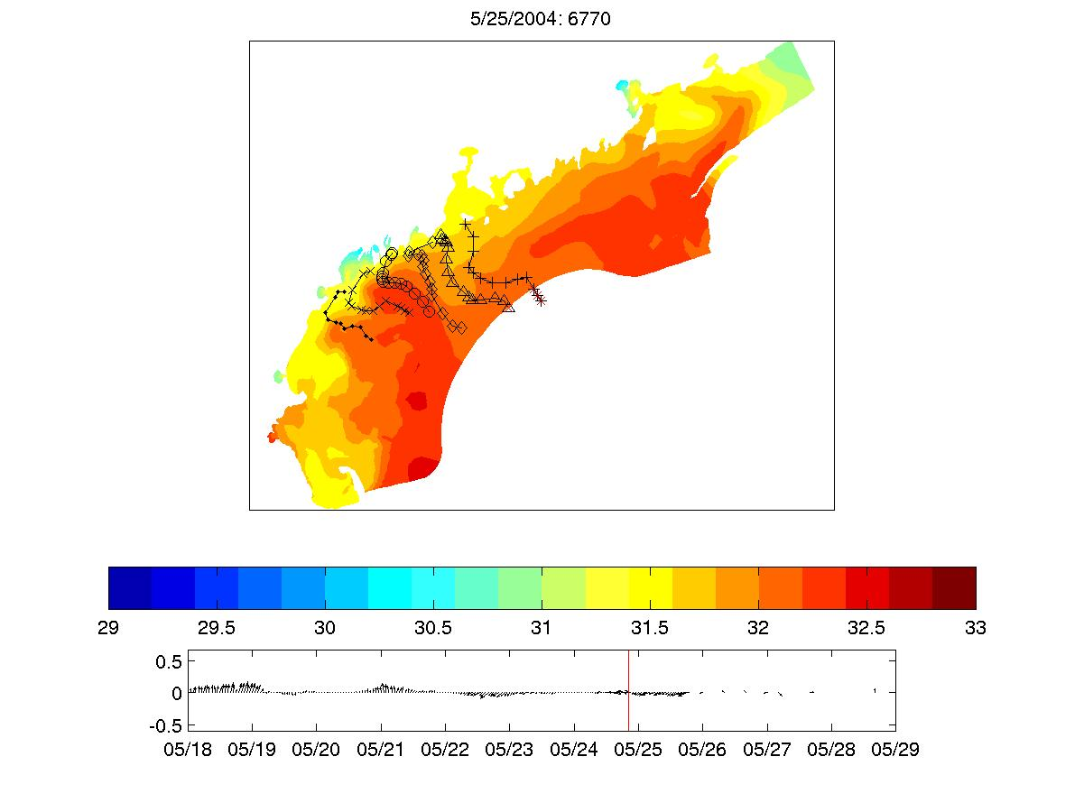
Figure 4: Hydrodynamic model results illustrating the time-dependent displacement of water parcels sampled in the OC402 survey grid.

Cruise Narrative

May 18, 2004

Departed WHOI at 1000 hrs; through Great Round Shoal Channel and headed north. First test station occupied at 1930 GMT.

Pre-cruise forecasting activities: FC1 through FC4.

-------------------------------------------------------------------
*
HS
---------|-------------------------------------------------------------------------------
*
CS [Moorings-----------]
YD 128 129 130 131 132 133 134 135 136 137 138 139 140
May 8 9 10 11 12 13 14 15 16 17 18 19 20

2.07 day ramp-up from cold start
1 day burn in prior to saving hot start
1 tidal cycle ramp-up of perturbation BCs
3 day burn in of perturbation BCs
assimilate GoMOOS moorings B,E,I for 4 days
forecast for three days

FC1, FC2, and FC4 reveal higher residuals at mooring I, both in terms of RMS and bias. This result does not appear to be sensitive to the parameters of the forecast system. Is there a systematic problem with the model in that location, or is this simply the best the model can do fitting all three moorings at once? This question motivated FC5, which will see how well the model can fit mooring I if it doesn’t have to bother with the other two moorings.

May 19, 2004

FC6 versus FC1: ICs based on OACI of NMFS survey and AVHRR image does not improve skill.

Clogging filters slows down station work near shore.

Bottle 7 misfiring; lanyard routed to pin 14 instead of pin 13.

High SHA Alex counts inshore on transects 1 and 2.

Changed sensitivity on the Knudsen HF channel from 50 to 20; bottom lock seems to operate better in the deep water.
Processed CTD files are problematic; the script seems to be missing 2 key routines present in a 1998 copy of the go.bat script found by Jim Akens. Jim adapts the 1998 go.bat to work with our data. CTD files reprocessed.

FC9 extended in time, includes more mooring data

--------------------------------------------------------------------
*
HS
---------|-------------------------------------------------------------------------------
*
CS [Moorings-------------------------------------------]
YD 128 129 130 131 132 133 134 135 136 137 138 139 140 ->144
May 8 9 10 11 12 13 14 15 16 17 18 19 20 - >24

May 21, 2004

Bottom cap on Niskin 6 broke; replaced bottle with spare. Endcap replaced on old bottle and stored for future use.

Ship’s underway intake: 1.25m below waterline.

Drifter assembly.

May 22, 2004

Drifter assembly and deployment.

May 23, 2004

Niskin 9 failures: stations 126, 114, 45, and 32. Pin did not appear to have released on failures at stations 114 and 126. Lanyard rerouted to pin 18 instead of 17.

Bucket samples continue to contain more Alexandrium as measured by SHA. Potential explanations:
1. Niskin is low because it is not collecting the same water as the bucket (e.g. surface film)
2. Water from the Niskin is not being sampled fully
a. cells are swimming to the top of the bottle
b. particles are sinking to the bottom of the bottle

Hypothesis 1 can be tested by firing the Niskin half out of the water; caveat is that ship disturbance disrupts the surface layer.

Hypothesis 2a,b can be tested by sampling the entire bottle: 1st 5l, 2nd 5l, then whole bottle. Alternative: siphon the top of the bottle, then drain the bottom out the end cap.

May 24, 2004

Petcock on Niskin 4 came apart due to failure of the outer o-ring. Bottle changed out for spare and petcock was replaced.

Niskin 9 tripped correctly for a while after changeover to pin 18, but then started to fail again. It appears the spring is weak, so it was changed out for a spare so we can replace its spring.

May 25, 2004

Niskin 9 continues to misfire; pin trips but bottle does not release. Changed Niskin 9 back to pin 17 and added a second bottle (Niskin 8) to sample at 5m depth.

Primary conductivity sensor appears to have gone bad starting at cast 175 from the previous night. Intermittent failure in the 20-50m depth interval is suggestive of biological origin, but the secondary sensor does not appear to be affected. Comparison of primary and secondary conductivity for Section 3 is illustrative (Figure X). Whereas they are identical during Survey 2, the failure of the primary is clear in Survey 3. Indeed the salinity derived from the secondary in Survey 3 provides an oceanographically realistic section; therefore we will use the secondary sensor from here on out.
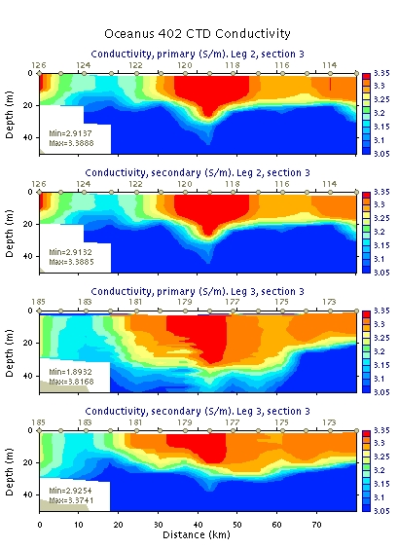

May 26, 2004

Alongtrack sections reveal continued failure of the primary conductivity (Figure). In fact, the secondary exhibits the same problem in some cases (not revealed by Survey 3 Section 3 above). To summarize, the primary functioned during Section 2 of Survey 3 (Figure). The primary failed during Section 3, but the Secondary functioned effectively (Figure). In section 4, the secondary exhibited problems in casts 190,194,196, and 198 (Figure). Replacement of the downcast with the upcast for those particular stations results in a reasonable alongtrack section (Figure). In Section 5, the secondary exhibited problems in cast 202 (Figure). Replacement of the downcast with the upcast for that particular station resulted in a reasonable alongtrack section (Figure).
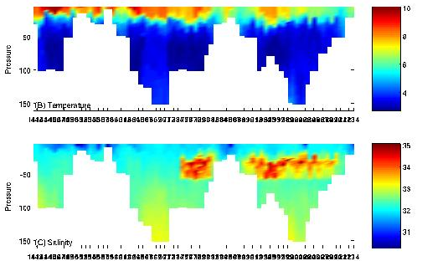

As it turns out the erratic behavior of the conductivity sensors appears to be associated with activity of the pump (Figure). The pump status trace for cast 175 shows the pump is deactivated down to a depth of ca. 25m on the downcast. When the pump turns on, the salinity decreases and appears realistic for the remainder of the downcast. The upcast is realistic, and cuts off the salinity anomaly that occurs between 25 and 30m.

Deactivation of the pump was first noticed while following the standard operating procedure:
1. lower package to 5m
2. await “11” on the deck unit to indicate pump is on
3. raise package to surface
4. start data acquisition
5. begin lowering package
It appears that the pump can shut off during the time the package is at the surface just prior to beginning the downcast (Figure cast 175). Therefore it is essential to ensure the pump is still on prior to starting the downcast. This necessitates a change in the operational procedure:
1. lower package to 5m
2. await “11” on the deck unit to indicate pump is on
3. raise package to surface
4. start data acquisition
5. check deck unit to make sure pump is still on
if the pump is off then
stop data acquisition
send the package back down to 5m
raise package to 1m (under surface)
go to step 4
6. begin lowering package

Once this change to the operating procedure was implemented, we were able to sample effectively with the secondary. Subsequently it was of interest to find out whether or not the new procedure would also correct the problems with the primary. Comparison of the primary and secondary salinities for cast 226 illustrates a primary failure when the secondary is functioning properly. Note that the pump status indicates the pump is on for the entire cast in both cases (in fact there is no separate pump status for the primary and secondary). Thus it appears that (1) the pressure sensor for the pump on the primary is malfunctioning, and (2) the pump status reported on the deck unit and in the DAS is the secondary.
Figure X. CTD profiles for cast 228: secondary (left) and primary (right) salinities.

It is not clear whether the deck unit reports the pump status for the primary or the secondary. During our operations on May 26 with the new protocol, it appears that it is reporting the secondary. It is clear that the two pumps are behaving differently given the differences between the primary and secondary conductivity sensors.

At the beginning of the cruise, Laurie Bean reported toxicity of 129 in Lumbo’s Hole from the previous week; all other locations in Casco Bay were clean. Monday the 24, Laurie reported that Lumbo’s Hole was now clean, as was the rest of Casco Bay. OC402 data showed high cell concentrations offshore, and surface drifter tracks indicate onshore transport. By Wednesday the 26th, surface drifters deployed on Transect 4 had reached the mouth of Casco Bay. According to Laurie Bean’s report on the 26th, there was widespread low-level toxicity throughout Casco Bay, with the highest value reported in Lumbo’s Hole (200). Toxicity also extended further to the west to Scarborough. These observations are consistent with shoreward transport of cells to the coast via downwelling-favorable winds.

Drifter deployments

Dft # | Type | ID | Date | GMT | Lat | Lon | Comment | Drogue | Station
45380 | Rachel |  | 5/21/04 | 1538 | 44 01.4 | 68 31.3 |  | - | 6N – 70
45381 | Argos | 24394 | 5/21/04 | 1538 | 44 01.4 | 68 31.3 |  | 15m | 6N – 70
45382 | Rachel |  | 5/21/04 | 1704 | 43 56.0 | 68 26.9 |  | - | 6L – 72
45383 | Argos | 22455 | 5/21/04 | 1704 | 43 56.0 | 68 26.9 |  | 15m | 6L – 72
45384 | Rachel |  | 5/21/04 | 1836 | 43 50.5 | 68 22.2 |  | - | 6J – 74
45385 | Argos | 20087 | 5/21/04 | 1836 | 43 50.5 | 68 22.2 |  | 15m | 6J – 74
45386 | Rachel |  | 5/21/04 | 2011 | 43 44.6 | 68 18.0 |  | - | 6H – 76
45387 | Argos | 20089 | 5/21/04 | 2011 | 43 44.6 | 68 18.0 | Strobe  malfunction | 15m | 6H – 76
45388 | Rachel |  | 5/21/04 | 2130 | 43 39.0 | 68 12.7 |  | - | 6F – 78
45389 | Argos | 20277 | 5/21/04 | 2130 | 43 39.0 | 68 12.7 |  | 15m | 6F – 78
453810 | Rachel |  | 5/21/04 | 2244 | 43 33.6 | 68 8.1 |  | - | 6D – 80
453811 | Argos | 01732 41630* | 5/21/04 | 2244 | 43 33.6 | 68 8.1 | blue drogue | 15m | 6D – 80
453812 | Rachel |  | 5/22/04 | 1455 (est) | 43 55.9 | 69 08.2 |  | - | 4N – 99
453813 | Rachel |  | 5/22/04 | 1658 | 43 48.8 | 69 04.9 |  | - | 4L –101
453814 | Rachel |  | 5/22/04 | 1757 | 43 46.2 | 69 01.2 |  | - | 4K-102
453815 | Rachel |  | 5/22/04 | 1852 | 43 43.2 | 68 59.6 |  | - | 4J – 103
453816 | Rachel |  | 5/22/04 | 2007 | 43 40.0 | 68 57.3 |  | - | 4I – 104
453817 | Rachel |  | 5/22/04 | 2145 | 43 33.6 | 68 54.2 |  | - | 4G – 106
453818 | Rachel |  | 5/22/04 | 2305 | 43 27.7 | 68 50.9 | 1 float without  plate | - | 4E – 108
453819 | Rachel |  | 5/23/04 | 0047 | 43 21.4 | 68 48.1 |  | - | 4C – 110

* Gonio ID shows 01732; ARGOS ID shows

ID | FCAST | Obs | ICs | Error statistics  RMS Obs/Prior/Post1/Post2  Mooring RMS Post2;  Vector bias | Operator | Comments
FC0 | 3.1 | ADCP, BEI | OACI | 7.0 |  | Hindcast of OC391_FC22  Crashed on 3rd fwd run
FC1 | 3.1 | B,E,I | clim | 9.9/7.8/6.2/6.1  B: 4.7; (1.1,0.4)  E: 5.5;(-2.5,-0.3)  I: 7.7; (3.6,-1.8)
FC2 | 2.0 | B,E,I | clim | 9.9/7.8/6.3/6.2  B: 4.7; (1.0,0.3)  E: 5.7; (-2.5,-0.3)  I: 7.7; (3.6,-1.7)
FC3 | 3.1 | B,E,I | clim | - |  | FC1 + rivers  abandoned
FC4 | 3.1 | B,E,I | clim | 9.9/7.7/6.3/6.0  B: 4.7; (1.1,0.4)  E: 5.4; (-2.4,-0.3)  I: 7.7; (3.6,-1.8) |  | FC1 + less size penalty
FC5 | 3.1 | I | clim | 13.9/9.7/9.3/9.2  I:9.2; (3.8,1.4) | CAS | FC1 Mooring I only
FC6 | 3.1 | B,E,I | NMFS svy + AVHRR | 9.9/9.1/6.6/6.2  B:4.7;(1.1,1.1)  E:5.2;(-1.3,-0.6)  I: 8.0; (4.3,-0.8) | KWS | FC1 + AVHRR, NMFS ICs
FC7 | 3.1 | B,E,I | Clim | 9.9/7.8/6.2/6.1  B: 4.7; (1.1,0.4)  E: 5.5;(-2.5,-0.3)  I: 7.7; (3.5,-1.7) | KWS | FC1 + forecast winds
FC8 | 3.1 | B,E,I | Clim | 9.9/7.8/6.2/6.1  B: 4.7;(1.1,.4)  E: 5.5;(-2.4,-0.3)  I: 7.6;(3.5,-1.8) | KWS | FC7 + NOAA winds instead of NCEP; longer record
FC9 | 3.1 | B,E,I | Clim | 10.5/8.4/7.5/6.5  B: 6.1; (1.5,2.8)  E: 5.3; (0.7,-0.4)  I: ? | KWS | FC8 + updated buoy winds +  updated mooring data
FC10 | 3.1 | B,E,I | Clim | 10.5/8.4/7.5/6.5  B: 6.2; (1.6,2.9)  E: 5.3; (1.0,-.4)  I: 7.8; (3.6,-1.5) |  | FC9 with 10 iterations
FC11
FC12
FC13
FC14 |  | B,E,I | Clim | 10.3/8.3/7.7/6.8  B: 7.2; (2.1,4.4)  E: 5.8; (2.0,0.8)  I: 7.4; (3.4,-1.2)
FC16 |  | B,E,I | Clim | 10.5/8.4/7.7/7.1  B: 7.0; (2.0,3.6)  E: 5.8; (2.1,-0.7)  I:?
FC17 |  | B,E,I | Clim | 10.3/8.1/7.1/6.9  B: 7.7; (2.2,5.1)  E: 5.7; (2.3,0.9)  I: 7.2; (3.3,-0.9) |  | Tradeoff fit in B vs E?
FC19 | 3.1 | B,E,I | Survey 1 |  | KWS | ICs from Survey 1  Winds at E plus NOAA forecast
FC20  Central | 2.0 | Ship ADCP  B,E,I | Clim | 11.7/7.6/6.6/6.3  B: 7.1; (2.6,3.7)  E: 5.8; (0.0,-1.4)  I: 7.4; (2.1,-2.0)  ADCP: 6.0; (-1.0,0.2) | CAS | Forcing:  Winds at E plus NOAA forecast
FC21 | 3.1 | Ship ADCP  B,E,I | Clim | 11.7/7.6/6.3/5.9  B: 7.3; (2.6,4.1)  E: 5.7; (-0.1,-1.4)  I: 7.5; (1.8,-2.1)  ADCP: 5.3; (-0.1,-0.3) | KWS | FC20 using FCAST_3.1
FC22 | 3.1 | Ship ADCP  B,E,I | Survey 1 | 11.7/7.9/7.1/6.5  B: 6.0; (2.2,1.0)  E: 6.3; (-3.3,0.0)  I: ?  ADCP: 6.2; (-0.3,-0.1) | KWS | FC21 plus ICs from survey data
FC23  5/23 | 2.0 | Ship ADCP  B,E,I | Survey 1 | 11.7/7.9/6.9/6.7  B: 6.0; (2.2,1.0)  E: 6.1; (-2.8;0.0)  I: 8.2; (4.7,0.1)  ADCP: 6.7; (-0.6,0.5) |  | FC20 with ICs from survey data
FC24  5/24 | 2.0  Central | Ship ADCP  B,E,I | Clim | 12.0/8.3/7.7/7.5  B: 7.8; (2.7,4.1)  E: 5.7; (-0.3,-1.7)  I: 7.2; (2.3,-1.4)  ADCP: 7.8; (-0.7,0.2) |  | FC20 + new data
FC25  5/24 | 3.1 | Ship ADCP  B,E,I | Clim | 12.0/8.3/7.5/7.2  B: 7.6; (2.8,4.0)  E: 5.7; (-0.6,-1.8)  I: ?  ADCP: 7.3; (-0.8,-0.4) |  | FC21 + new data
FC26  5/24 | 3.1 | Ship ADCP  B,E,I | Survey 1 | 12.0/8.7/7.5/7.2  B: 6.7; (3.2,1.3)  E: 5.6; (-0.3,-0.9)  I:?  ADCP: 7.3; (-0.2,-0.3) |  | FC22 + new data + delayed advection
FC27  5/24 | 2.0 | Ship ADCP  B,E,I | Survey 1 | 12.0/9.2/8.4/8.3  B: 7.2; (1.7,-0.1)  E: 7.5; (-4.4,-1.5)  I: 10.6; (7.4,3.1)  ADCP:8.3; (-0.4,0.1)
FC28  5/25 | 3.1 | Ship ADCP  B,E,I | Clim |  |  | Central with new data
FC29  5/25 | 3.1 | Ship ADCP  B,E,I | Survey 1
FC30  5/25 | 2.0 | Ship ADCP  B,E,I | Clim
FC31  5/25 | 2.0 | Ship ADCP  B,E,I | Survey 1
FC32 | 3.1 | Ship ADCP  B,E,I | Survey 1 |  |  | (FC29) + no delay of T,S advection
FC33  5/26 | 3.1 | Ship ADCP  B,E,I | Clim |  |  | Central (5/26) with new data
FC34  5/26 | 3.1 | Ship ADCP  B,E,I | Survey 1
FC35  5/26 | 2.0 | Ship ADCP  B,E,I | Clim
FC36  5/26 | 2.0 | Ship ADCP  B,E,I | Survey 1

Near surface Alexandrium concentrations and the underway/bucket/Niskin controversy.

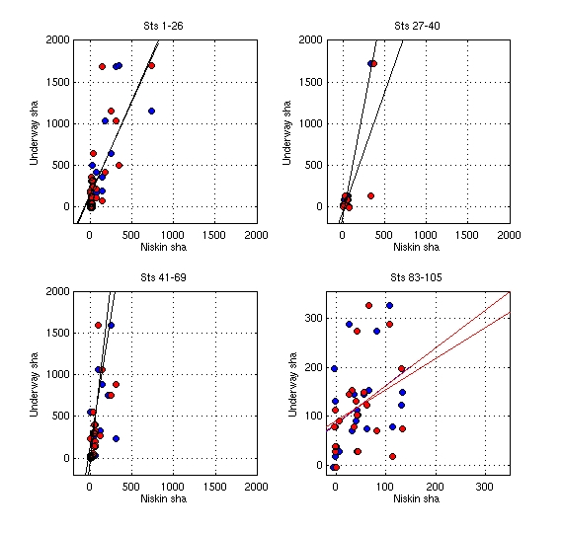

http://www.publicaffairs.noaa.gov/releases2004/jul04/noaa04-r464.html

