**SPIROPA PI MEETING APRIL 2020**

**MONDAY- 4/27 - 09:00-11:00 EST**

Discussion: Smith et al. – AR29 Phaeocystis bloom; starting point draft ms. sent for review and comment;

* Gordon: role of advection on the bloom- tidal mixing front at 50m isobath, limited exchange between onshore and offshore water, plays role in trapping water on the shoal; periods where wind can induce mixing across isobath (storms, etc.)
  + April 15-16: movement of water off shelf (as shown in the HF Radar-measured surface current below)

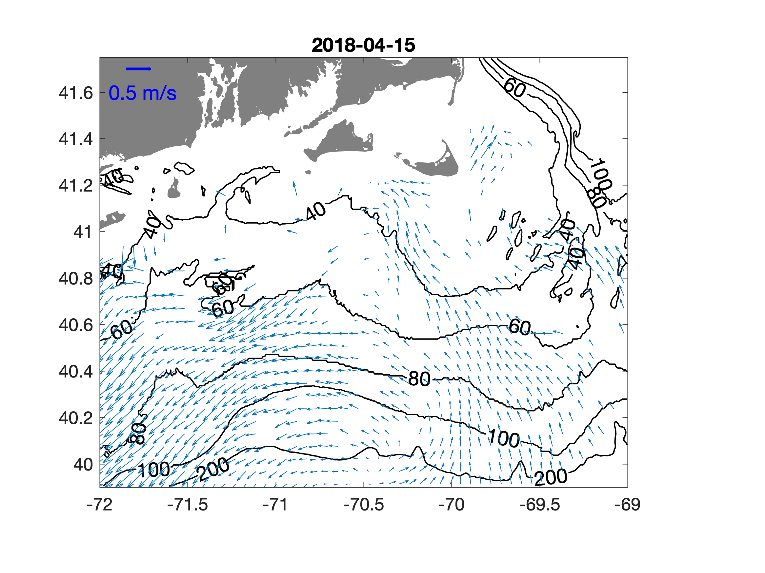

* + Dennis’ BBL conceptual model helpful here
  + HF radar plot 4-15: current along 40m isobath; wind driven southwest movement along the 60m isobath, generating chl filament which corresponds to pattern of movement of colder water via frontal motion and shelf eddies
  + SST: weak April tidal mixing front
* Abundant light to facilitate Phaeo growth (low alpha) - shoals may serve as an appropriate breeding ground
* Phaeo species identification? IFCB images available, HPLC data forthcoming post COVID-19, Corday has Lugols samples (individual cells, broken colonies), DNA?
  + Taylor has AR28 HPLC data to identify species (if we assume it will be the same)
  + DAVPR ROIs for comparison: (Chrissy agrees that below are *P. Pouchetii*)

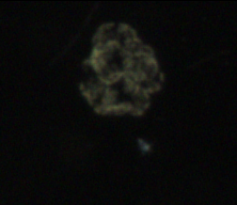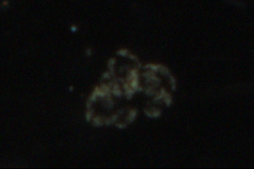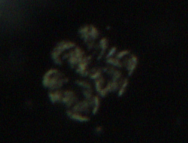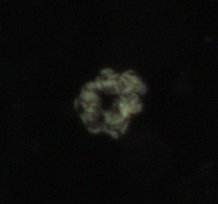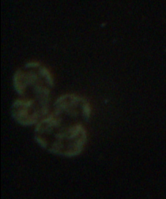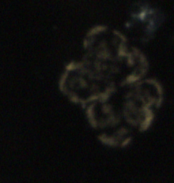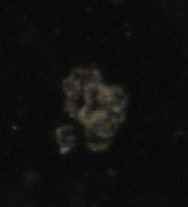

* Is the Phaeo bloom impacting the larger ecosystem? Check with Joel Llopiz about sand lance larvae
* Recurrent bloom, but AR29 sampled an extraordinary bloom (wet year)
* Significant silicic acid drawdown (from Cast 56 to end; casts 94-97 (4/23-28)) → diatom growth?
  + N disappearance, Si down 50%
  + Evidence of coexistence of Phaeo and diatom chains
    - DAVPR ROIs (Diatom chains are the thin strings):

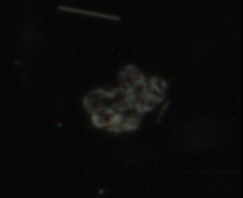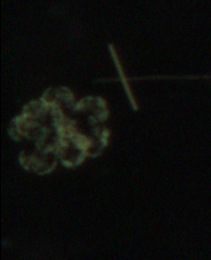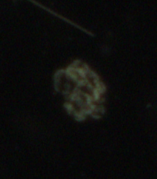

Diatom chains within bloom conditions:

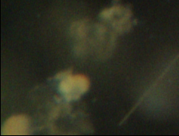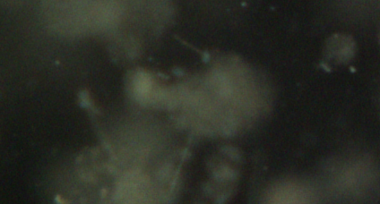

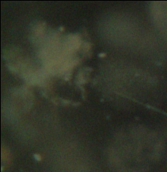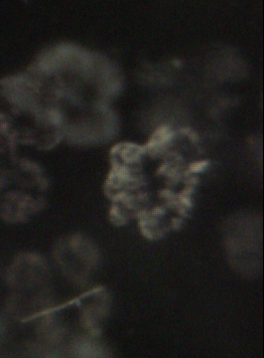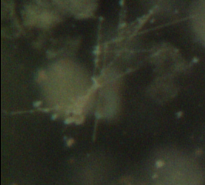

* TO-DO: Discussions with Rachel, Heidi, Andrew, Meredith (DIC), etc.
  + Integrate some Phaeo measurements from AR28 into MS, beginning of the timeseries
  + Rachel has AR28 NCP data; Taylor has HPLC data and sequencing samples

Discussion: Oliver et al. – TN368 diatom bloom

* Topics:

1. IDs
2. TIO d17
3. NCP:GOP
4. Productivity
5. Zeu calculation

* Eddy northward transport of nutrient rich GS water, increased SST
* High CHL corresponds to high conc of diatoms
* Good relationship between typical GS chl conditions and what we saw
* Location of 26.0 ispoycnal in relation to Zeu corresponds to where we see the hotspots
  + Occurring at points from the slope-sea to the shelfbreak
* Capacity of phytoplankton uptake > rate of nutrient supply
* Productivity at hotspot stations are low
  + Influence of short term events on the system; higher turnover than baseline conditions
  + Significance: despite their importance, events like this often go unseen
  + Green dot station: subsurface peak at 40 m (30-20 m below average pp peak)
  + Where are the 4 abnormally high PP measurements coming from?
  + Where are the PP lines that exhibit the same 40m subsurface peak coming from? Are they also hotspot locations?
  + What does the mean shelf station profile look like?
  + Should we compare these productivity values to more ‘true’ oceanic rates?
  + How much of a role does sample depth play?

- Are the mystery samples *Thalassiosira subtilis (PA)*

**TUESDAY- 4/28 - 10:00-12:00 EST**

Finish with TN368 Diatom Hotspot discussion (Heidi’s figures, etc.)

* Figure S5: In situ productivity
  + Hotspots: chl>4, salinity >35.6
  + If you change the parameters to chl>3 and salinity >35.5, hotspot stations include SSF2, HS1, SLP, A13
  + SLP: PP calculated ~50m, chl peak occurred slightly above 50m → mismatch between PP sampling and chl max could be driving PP down → highlights the thin layers of hotspot concentrations
  + It appears all PP sampling missed chl max depths (cast 84 is the closest)
  + WOS will develop bio-optical model calculations for Hilde’s stations
  + Extremely high PP: A5+A6 inshore stations; casts 41,43,80 (Hilde’s circled stations) very cold shelf water.
    - CTD/DAVPR Transect 11 (casts 41-52)):

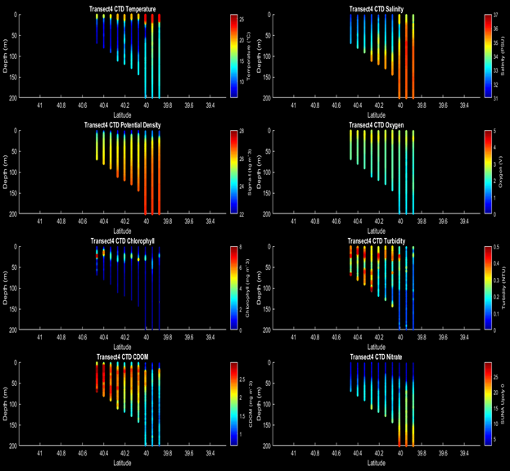

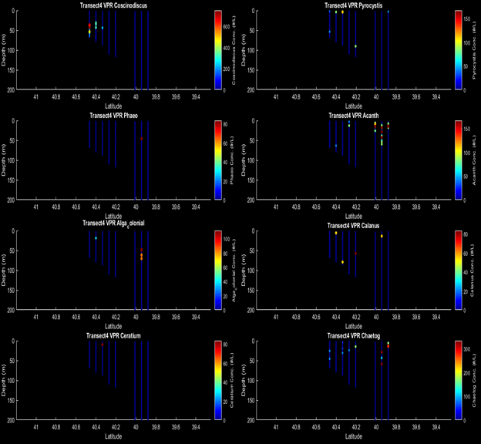

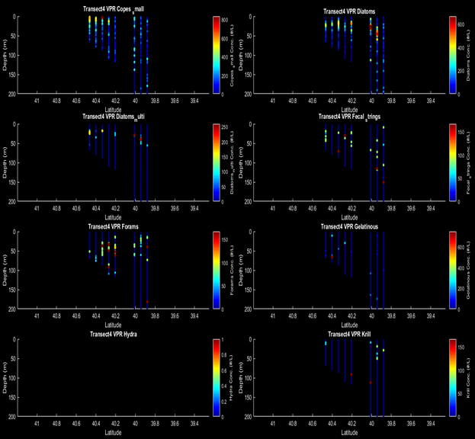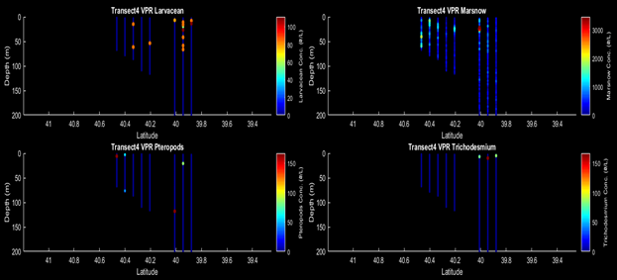

* + - CTD/DAVPR Transect 26 (casts 65-80)):

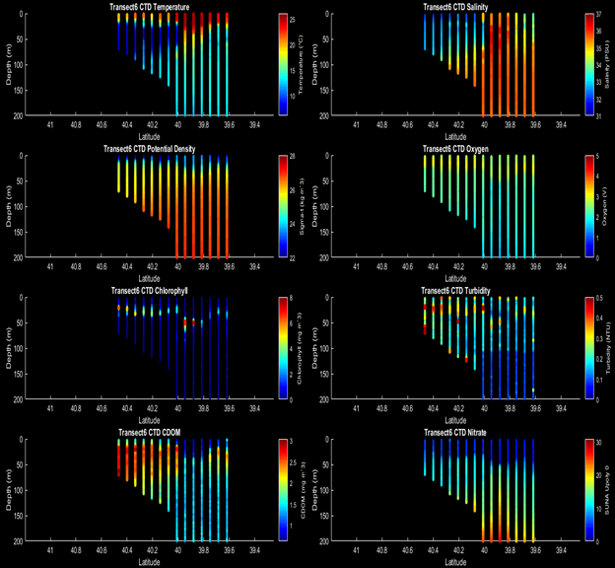

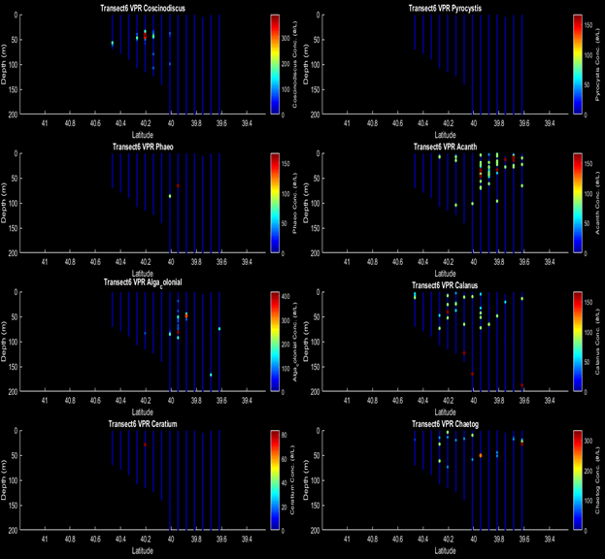

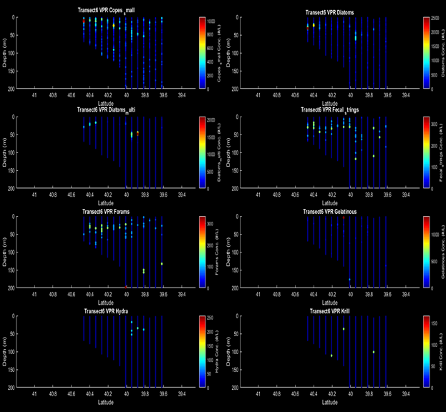

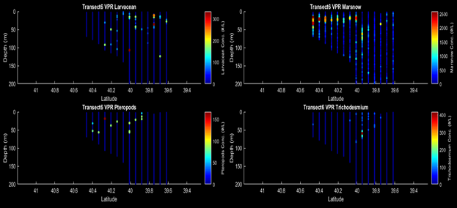

* + Hotspot stations are on par with shelf environment stations
  + Elevated d17 at ~25m Casts 81 and 62
  + S1 and S2 are examples of more oligotrophic stations, within the WCR; however, shelfwater like signal within 0-40m; can help supplement this with bio-optical model data and BATS data
  + Corday will also provide C13 data for additional prod. Measurements; Margie has PP measurements along the whole MAB shelf region
  + LTER PP data from T. Rynerson
* Did we sample the same water mass twice?
* Potential to include OOI glider measurements to look for similar hotspot features (in the slope-sea, not as offshore as our measurements)
* IDs - Heidi:
  + Rank ordered IFCB samples from hotspot stations (71,8182,62,39,100): top 5 taxa = Guinardia, Chaetoceros, Eucampia, Thalassiosira, Dactyliosolen (see ppt)
  + Definitely not monospecific diatom bloom
  + Is Alatalosphera a mucilaginous, colonial Thalassiosira? Thalassiosira subtilis or mala?
  + Cross reference our mystery findings with EcoMon cruise
  + Similar mystery findings at MVCO
  + Casts 41 and 43 are chaetoceros dominated
  + Do the species sort in any consistent way? Community sorting structure?

Finish with Smith et al. Phaeocystis paper

* Waiting on data
* Margie data set: 1 instance of Phaeo- does this instance correspond to Heidi’s observations at MVCO?
  + 41.4ºN 71ºW citing
  + Corday double checking this
* MVCO IFCB data: April 2009- Phaeo dominating images
  + Cross-reference 4/2009 satellite data with 2018 satellite data - high chl, but unable to differentiate phaeo from other phyto
  + From Bethany- Phaeo uncultured and phaeo antarctica sequencing data (monthly discrete samples)
    - With more fine-tuning, should be able to differentiate these samples (globosa vs. pouchetti)
* Can potentially build a time series from MVCO data, but will take time. . .
* Test Lugols sample and then decide if we want to ship Phaeo sequencing samples WHOI → ODU

**WEDNESDAY- 4/29 - 09:00-10:00 EST**

**Final revist to Hilde’s Hotspot Paper:**

* Action items: Smith bio-optical model, Sosik taxa analysis and synthesis (focus on casts 71, 100), Stanley gas conversions (integration into the PWP model?), ODU sequencing (end of May-beginning of June 2020 (hopefully)), Oliver thresholds for “extraordinary” OOI mobile assets, possible inclusion of 13C productivity
  + Grazing casts: 84,56; we have lugols preserved samples from these locations. Can SEM be run on them to identify mystery colonies? Heidi is confident cells would be there.
* Hilde’s submission goal: **June 1, 2020**

**Smith et al., Phaeocystis paper:**

* Heidi posted the MVCO data links (Phaeo sp. occurence timeline- several noteworthy peaks)
* Heidi saw diatoms mixed in with the Phaeo bloom during AR29; something to investigate further
* Further sequencing discussion needed

Yifan data presentation

Rachel data presentation

Corday data presentation

Gordon-Dennis data presentation

Margie PP data (?)

Time allowing:

* TN368 Streamer discussion
* RB1904 Diatom patch