SPIROPA Cruise Planning 2019
Draft 12/3/18

May cruise – R/V Ronald H. Brown (30 berths)
Load: 06 May 2019
Dep: 08 May
Arr: 21 May
Unld: 22 May

July cruise – R/V Thomas G. Thompson (36 berths)
Load: 03 Jul 2019
Dep: 05 Jul
Arr: 18 Jul
Unld: 19 Jul

1. Cruise Overview
The continental shelfbreak of the Middle Atlantic Bight supports a productive and diverse ecosystem. Current paradigms suggest that this productivity is driven by several upwelling mechanisms at the shelfbreak front. This upwelling supplies nutrients that stimulate primary production by phytoplankton, which in turn leads to enhanced production at higher trophic levels. Although local enhancement of phytoplankton biomass has been observed in some synoptic measurements, such a feature is curiously absent from time-averaged measurements, both remotely sensed and in situ. Why would there not be a mean enhancement in phytoplankton biomass as a result of the upwelling? One hypothesis is that grazing by zooplankton prevents accumulation of biomass on seasonal and longer time scales, transferring the excess production to higher trophic levels and thereby contributing to the overall productivity of the ecosystem. However, another possibility is that the net impact of these highly intermittent processes is not adequately represented in long-term means of the observations, because of the relatively low resolution of the in situ data and the fact that the frontal enhancement can take place below the depth observable by satellite.
A unique opportunity to test these hypotheses has arisen with deployment of the Ocean Observatories Initiative (OOI) Pioneer Array south of New England. The combination of moored instrumentation and mobile assets (gliders, AUVs) will facilitate observations of the frontal system with unprecedented spatial and temporal resolution (Fig. 1). This will provide an ideal four-dimensional (space-time) context in which to conduct a detailed study of frontal dynamics and plankton communities.
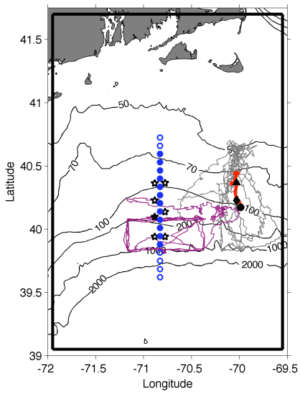 | Fig. 1. Tracks of Pioneer Array gliders (grey, magenta lines), 17 Apr – 30 Jun 2014. Red line is a cross-shelf transect on 25-26 Apr; the black triangle, diamond, and circle indicate the positions of the foot, jet and surface expression of the front, respectively. Mooring locations are shown as stars, with the central offshore mooring filled in black. Shipboard transects indicated with blue circles. The solid black boundary depicts our model domain.
With support from NSF’s Physical, Biological, and Chemical Oceanography programs, we will undertake a set of three cruises to obtain cross-shelf sections of physical, chemical, and biological properties within the Pioneer Array. Nutrient distributions will be assayed together with hydrography to detect the signature of frontal upwelling and associated nutrient supply. We expect that enhanced nutrient supply will lead to changes in the phytoplankton assemblage, which will be quantified with conventional flow cytometry, imaging flow cytometry (Imaging FlowCytobot, IFCB), in situ optical imaging (Video Plankton Recorder, VPR), traditional microscopic methods, and HPLC pigments. Zooplankton will be measured in size classes ranging from micro- to mesozooplankton with the IFCB and VPR, respectively, and also with microscopic analysis. Biological responses to upwelling will be assessed by measuring rates of primary productivity, zooplankton grazing, and net community production. These observations will be synthesized in the context of a coupled physical-biological model to test the two hypotheses that can potentially explain prior observations: (1) grazer-mediated control and (2) undersampling. Hindcast simulations will also be used to diagnose the relative importance of the various mechanisms of upwelling.
Our observational plan consists of cross-frontal transects and rate measurements, conducted in a daily cycle of activity (Fig. 2). Each day will begin with determining the precise location of the front from a combination of data from the Pioneer Array, cruise observations, and remote sensing images. Rate measurements (¹⁴C and grazing incubations) will be strategically located in one of the three key regimes: inshore, offshore, and at the front. Twelve repetitions of the observational cycle (see below) will permit four replicates in each of the three regimes, facilitating estimates of the mean and variance for each. Each of the 12 cross-frontal transects will consists of a 12-station subset of the range of possible station locations shown in Fig. 2. Each specific 12-station subset will be centered on the front, essentially shifting northward or southward as movement of the front dictates. Station spacing is 7km.
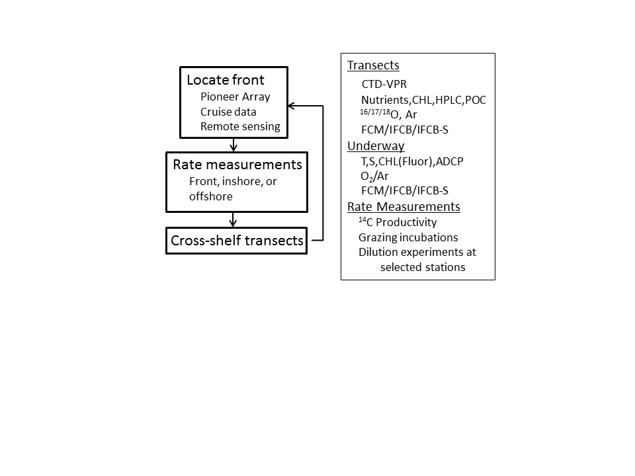
Fig. 2. Daily sampling cycle (left) and summary of measurements (right).

Sampling
CTD/VPR Transects
Underway ADCP, TSG, benchtop IFCB, benchtop FCM (Attune NxT), EIMS
Smith 3 ¹⁴C incubations per day: dawn, noon, pre-sunset
Turner incubations coupled once per day; MOCNESS net tows at that station
VPR II transects

Philosophy: while each group has their own specific measurements for which they will be responsible, what makes this study so special is the synergy among the diverse set of observations. We have had to make compromises in staffing to fit our science party into the maximum of 22 berths, and as such not every group was able to bring along all the people they would have liked to have had participate. As such, we need to help each other out—there is no one on the cruise who is solely “doing their own thing.” Please keep this in mind as we try to balance the workload to accommodate all of the various sampling needs.

Water budget (mL)

*TOI, O₂/Ar 750 Stanley 300 all surface, limited profiles at 25% of stations
DIC 350 Smith
¹⁴C 350 Smith 3 per day
POC 2000 Smith
IFCB 100 Sosik surface, Chl max, plus 3 6-depth profiles (shelf,

front, slope) every other transect
FCM 50 Sosik same as IFCB
Chl 700 Sosik every other transect; deep samples with low F omitted
HPLC 1300 Sosik surface, Chl max, plus 3 6-depth profiles (shelf,
front, slope) every other transect
Nutrients 150 McG all depths, every other transect

Total 5760

*Gases always sampled first

Water sample inventory: daily transects (12) * 12 stations * 15 depths = 2160 discrete samples
Nutrients – 1080
TOI, O₂/Ar – 300

Suggested sample vial labeling: C for cast number, N for Niskin number, and include cruise. Example: Cast 54, Niskin 11, Cruise AR-29; label would be “C54 N11 AR-29”.

Sampling depths – 15 total
Fixed: Sfc, 10, 20, 30, 40, 60, 80, 100, 120, 150, 200, 250, 300
Floating: chl max, 10mab

Shifts – AR29

Noon to Midnight Midnight to Noon

CTD Operators; help with CTD prep and water sampling
Charlie Gordon

IFCB, FCM, Chl, HPLC, nutrients
Heidi (watch chief) Taylor* (watch chief)
Kevin (nutrients) Bethany
Jackie Meredith
Addt’l hand below Emily (nutrients)

Gas Samplers
Zoe*(recovery only) Zuchuan

Additional hands
1200-1600 Phil* (also help with sampling)
1600-2000 Josh*, Melissa C.
2000-2200 Beth* (also help with water sampling)

*CTD Launch and recovery

---------------------------------------------------------------------------------

¹⁴C – daylight only – Walker

Zooplankton – day shifts
Jeff, Chrissy, Beth, Melissa C.

VPR, MOCNESS – day shifts
Phil, Josh, Melissa P.

Media – 24/7
Dan, Saskia

Personnel from AR29
- Dennis McGillicuddy
- Phil Alatalo
- Josh Eaton
- Melissa Patrician
- Zuchuan Li
- Heidi Sosik
- Taylor Crockford
- Bethany Fowler
- Kevin Archibald
- Gordon Zhang
- Zhen Cheng (Charlie)
- Walker Smith
- Jackie Friedman (WOS Lab)
- Meredith Meyer (WOS Lab)
- Jeff Turner
- Chrissy Petitpas
- Elizabeth (Beth) Larson (JT Lab)
- Melissa Campbell (JT Lab)
- Zoe Sandwith (Stanley lab)
- Dan Brinkhaus – Science Media
- Saskia Madlener – Science Media
- Emily Shimada – MATE (Marine Advanced Technology Education) intern

Personnel – R/V Ron Brown (30 berths)
- Dennis McGillicuddy
- Phil Alatalo
- Andrew Hirzel
- TBA – McG
- TBA – McG
- Gordon Zhang
- Hilde Oliver
- Walker Smith
- Meredith Meyer
- Mar Arroyo
- TBA – Smith
- Jeff Turner
- Chrissy Petitpas
- TBA – Turner
- TBA – Turner
- TBA - Turner

Personnel – R/V Thomas G. Thompson (36 berths)
- Dennis McGillicuddy
- Phil Alatalo
- Andrew Hirzel
- TBA – McG
- TBA – McG
- Gordon Zhang
- Hilde Oliver
- Walker Smith
- Meredith Meyer
- Mar Arroyo
- TBA – Smith
- Jeff Turner
- Chrissy Petitpas
- TBA – Turner
- TBA – Turner
- TBA - Turner
- Dan Brinkhaus

Zhang group tasks
1. CTD deployment, real-time CTD data processing
2. EK80 system monitoring, adjusting and data interpretation
3. Shipboard ADCP system monitoring and data interpretation
4. Real-time satellite SST data access and processing
5. Real-time Pioneer Array data access and processing
6. Real-time Wilkin model data access and processing
7. Real-time data integration and identification of the shelf break front
8. Inform decisions on the locations of CTD and biological sampling stations

Event logger
http://elog-dev.whoi.edu/default/eloghelp_R2R_EventLogger_User_Guide.html

Retrospective data analysis
AR16 Science Verification Cruise
AR22 Joint Program Cruise
Pioneer turnarounds
Fishing effort

Synergy with NES LTER https://nes-lter.whoi.edu/
Endeavor 1/31/18-2/5/18
Pioneer 10 leg 1 (24 Mar - 2 Apr)
Pioneer 10 leg 2 (3 Apr - 14 Apr)
IFCB, DAVPR, EIMS [Taylor Crockford, Zoe Sandwith, Ellen Roosen]
Endeavor 7/20/18 – 7/25/18

Miscellaneous

Underway pCO2 sensor:
https://www.km.kongsberg.com/ks/web/nokbg0240.nsf/AllWeb/7870D62A7A6DD9E9C1257EDC00447C6A?OpenDocument

Pioneer AUV cruise: April 23-28 (Peter Brickley, contact)
Across-shore mission as planned
Latitude of along-shore mission TBD based on frontal location.

Incubator Platforms

Smith Lab: incubator footprint is 60x48”, and we’d like it the base of the incubator to be lifted by 24”. We suggest using ¾” plywood and 4 4x4” posts at each corner, with two additional posts of the same size in the center (since this beast when filled with water is a bit heavy). We likely will bring our own plywood and supports as back-up as well.

