CTD data reprocessing info

CTD Fluorescence vs Chla+Phaeoa regression plot built using CTD data from final processing showed that CTD Fluorescence measurements do not fit Chlorophyll data (Figure 1). This means that Fluorescence calibration should be corrected and CTD data reprocessed. Corrected Fluorescence calibration can be calculated from channel original calibration and parameters from Fluorescence vs Chlorophyll regression.

Procedure of data reprocessing:

(1) CTD data was reprocessed to include Fluorescence Voltage V0 data (not available in final processing);

(2) Bottle file was created with CTD BTL and Chlorophyll data;

(3) Scatter plot Fluorescence (old calibration) vs Chla+Phaeoa was created and parameters of linear fit were calculated;

(4) Fluorescence sensor calibration coefficients were taken from the original CTD configuration file;

(5) First order polynomial fit coefficients were calculated using regression parameters and original Fluorescence calibration;

(6) CTD configuration file was updated selecting "USERPOLY 0" sensor for channel V0 instead of Fluorescence Wet labs ECO-AFL/FL sensor. Calculated coefficients were aplied as input for the "USERPOLY 0" sensor;

(7) CTD data was reprocessed;

(8) Bottle file was recalculated;

(9) For check: corrected Scatter plots were created (Figures 3 and 4).

Coefficients for first order polynomial fit calculation (figure 2) – USERPOLY 0 configuration:

(1) Voltage V0 from Bottle:

V = D(:,colVoltage_0);

(2) Fluorescence sensor configuration from ar29 original configuration file:

Serial number: 0149

Calibration date: 2016-11-28

Dark output (dV): 0.0820

Scale Factor (sf): 1.60000000e+001

Fluorescence sensor coefficients and formula:

sf=16;

dV=0.0820;

F = (V-dV)*sf = sf*V - sf*dV;

(3) Regression parameters from scatter plot Fluorescence (original calibration) vs Chla+Phaeoa:

Intercept (a0) = -0.81276;

Slope (a1) = 0.88275;

(4) First order polynomial fit coefficients calculation:

F = a0 + a1*EP;

where EP is End Product – corrected Fluorescence, F if original Fluorescence.

Then:

EP = (F-a0)/a1 =

(sf*V - sf*dV - a0)/a1 = sf/a1 *V - (sf*dV+a0)/a1;

A0 = -(sf*dV+a0)/a1;

A1 = sf/a1;

(6) Calculated coefficients and formula for "USERPOLY 0" sensor for channel V0:

A0 = -0.56555 and A1 = 18.1252.

EP=A0 + A1*V;

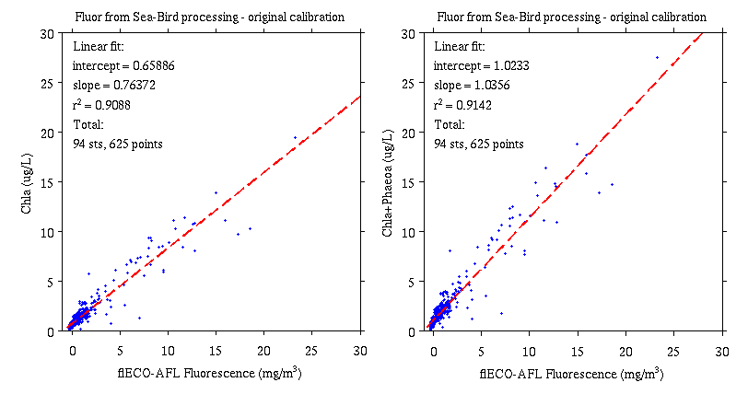

Figure 1

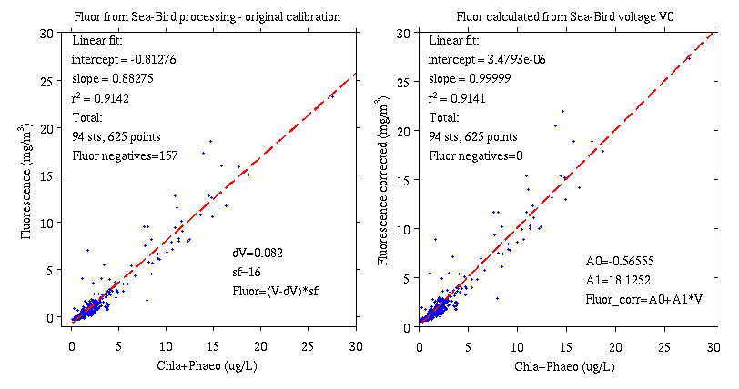

Figure 2

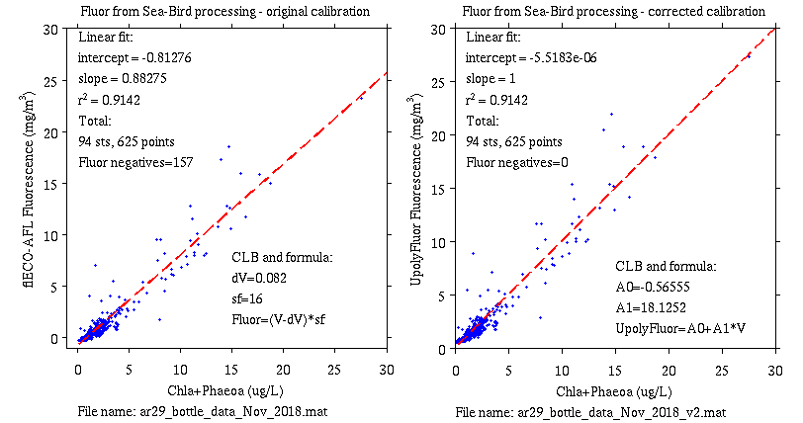

Figure 3

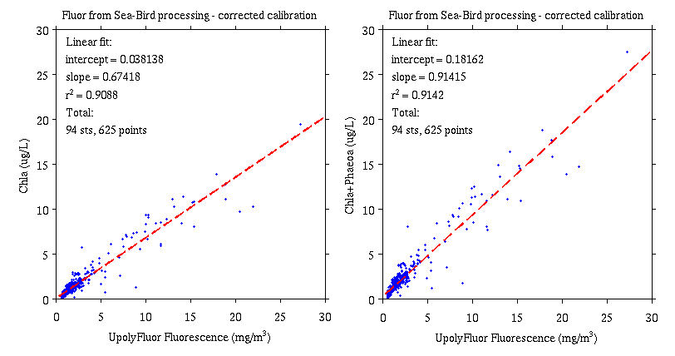

Figure 4