**A regional bloom of *Phaeocystis* on the southern New England Shelf**

Draft 1/1/19

Voyage #29 of the R/V *Neil Armstrong* (AR 29, 16-29 April 2018) focused on sampling hotspots in net community production at the shelf break front south of New England, in the vicinity of the Ocean Observatories Initiative’s Pioneer Array. Mid-way through the cruise we observed an area of high chlorophyll well inshore of the shelfbreak front. Algae of the genus *Phaeocystis* were detected in these samples (Figure 1, upper right), and its origin is made clear in satellite imagery (Figure 1, left): the April 22 image shows tendrils of a large-scale patch of chlorophyll south of Martha’s Vineyard and Nantucket impinging on the north-south transect of stations we were occupying at the time. Curiously, the surface expression of this disappeared a day later (April 23).

These observations led us to carry out VPR survey of *Phaeocystis* bloom. Image classification remains to be carried out, but qualitative observations during the tow suggest optical backscatter was a reasonable proxy for the highest concentrations of *Phaeocystis* colonies. Whereas *Phaeocystis* was confined mostly to the bottom boundary layer near in the west, it outcropped at the surface as we transited north and east into the least stratified region (Figure 1, lower right). More opaque colonies were more prevalent in that area, with *Phaeocystis* colonies spanning from the surface to the bottom.

Our data suggest sinking as an explanation. Although the fluorescence distribution from A2 to A4 on April 23 (Figure 2) appears to be distributed uniformly from surface to bottom, saturation of the color bar obscures the fact that the highest fluorescence occurs in the BBL. As time went on, surface waters above the deep population of *Phaeocystis* became very clear (Figure 3), and fluorescence in the BBL became very high, with values exceeding 15 μg Chl L-1. One potential explanation for the observed distribution can be framed in a regime consisting of a surface mixed layer (SML), euphotic zone (EZ), and bottom mixed layer (BML), each of uniform depth (Figure 4). Suppose the widespread bloom observed in the satellite image on April 22 (Figure 1) was confined to the mixed layer over the shelf, except for the region where the SML and BML intersect (Figure 4, top). If the near-surface bloom were to terminate due to exhaustion of the nutrient inventory in the SML, it may sink down to the BML as a result. Based on climatology (Zhang et al., 2013), we expect the BML to have an ample supply of nutrients. Therefore, the bloom could continue to thrive in the region where the BML is in contact with the euphotic zone—thus setting the across-shelf extent of the BML population. Irradiance observations at station A2 indicate a 1% light depth of ca. 40m, which would be sufficient to illuminate the top of the BML. A subsurface oxygen maximum overlying the BML is consistent with the notion that the deep *Phaeocystis* population is actively photosynthesizing. The VPR survey into the high-Chl region of the April 23 satellite image reveals distributions of *Phaeocystis* relative to hydrographic, bio-optical, and structure that is roughly consistent with the conceptual model (Figure 0428.3).

**The VPR provided critical technology to adaptively sample this unusual regional bloom of *Phaeocystis*. A short video describing the at-sea operation is available online[1]. This bloom is of particular interest from an ecosystem perspective, insofar as the colonial form of *Phaeocystis* tends to be resistant to grazing by zooplankton. In circumstances when a large fraction of the primary production is comprised by these unpalatable algae, the ramifications for higher trophic levels could be substantial.**

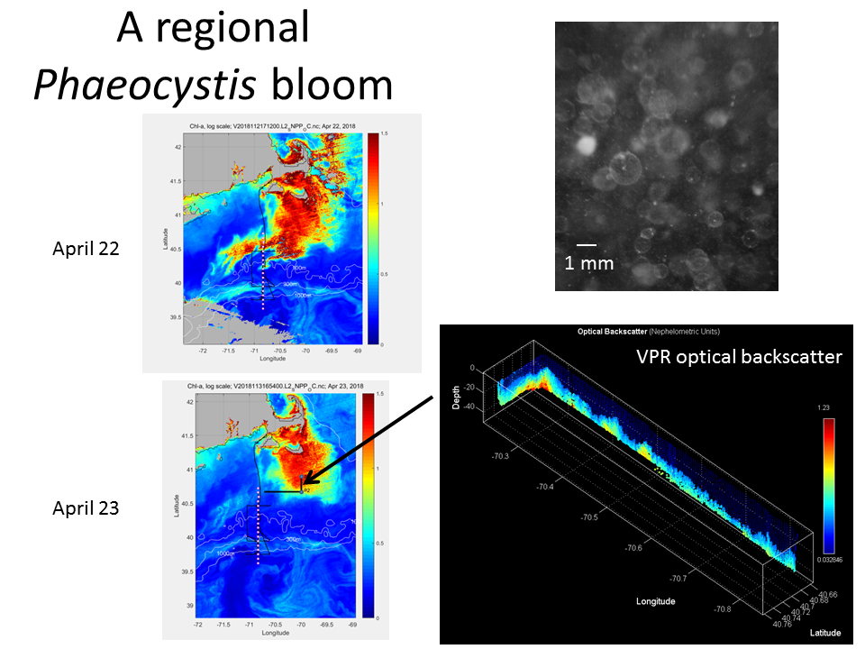

Figure 1. Left: satellite images of surface ocean chlorophyll on 22 and 23 April 2018. White circles indicate the cross-shelf line of stations on which the voyage was focused, and the cruise track is shown as a thin black line. Upper right: VPR image of *Phaeocystis* colonies. Lower right: VPR transect of optical backscatter, which is a proxy for *Phaeocystis* abundance in this case. Note the orientation of the axes is looking down toward the southeast, with the VPR survey track plotted in bold on the April 23 image.

|  |  |
| --- | --- |
|  |  |
| Figure 2: April 23 CTD section. Note the change in color bar for chlorophyll fluorescence (upper right). | |

|  |  |
| --- | --- |
|  |  |
| Figure 3: April 25-26 CTD section. | |

|  |
| --- |
|  |
| Figure 4: Conceptual model for how bottom boundary layer turbulence could sustain a regional bloom of *Phaeocystis*. |

|  |  |
| --- | --- |
|  |  |
|  |  |
| Figure 5: VPR survey carried out 28 April 2018. Cruise track shown in Figure 1. | |

1. <http://science.whoi.edu/users/olga/SPIROPA/video/ar29vpr.mp4>