Did the A4 deep O₂ anomaly change in magnitude or extent
between OC415-1/X0506, OC415-3/X0508, and OC415-4?

Updated July 17, 2006

OC415-1/X0506

The deep oxygen anomaly was detected in five profiles of X0506 (Figures 1, 2), with the strongest signature detected at station 29. It was bounded by background conditions observed 10km to the north and east by stations 30 and 31, occupied within 5 hours of station 29. Stations 38 and 39, 10km to the south and west, were occupied 48 and 50 hours after station 29. These stations showed weak oxygen anomalies, ca. 50% or less than that observed at station 29.

These data are characterized by variability on short spatial and temporal scales. For example, a mid-range oxygen anomaly was present at station 32, but that station 33, only 3.1-hours later at the same site, showed no evidence of it-- nor did station 36, 12.5 hours later than 32. A mid-range oxygen anomaly was detected at station 8, when eddy center was near that station. Thirty-eight hours later that same site was occupied (station 13), yet no anomaly was found.

All profiles within the oxygen anomaly are clearly distinguishable in a TS anomaly as well (Figure 3).

OC415-1 data did not capture the feature because the 700m profiles did not go deep enough.

OC415-3/X0508

The oxygen anomaly was observed in many more profiles during OC415-3 (Figures 4, 5). Stations 43 and 44 were 30km apart and were occupied within three 3 hours of each other, both of which hit the core of the oxygen anomaly (Figure 4). The same is true of the station pair 66/67. Thus the core of the oxygen anomaly appears to be at least 30km in spatial scale. Note the magnitude of the oxygen anomaly in its core is substantially stronger than observed during X0506 (compare Figures 2 and 5). However, so is the scope of the water mass anomaly (compare Figures 3 and 6). Oxygen profiles and water mass characteristics from X0508 (Figures 7 and 8) are consistent with those observed on OC415-3.

Thus, the core of the anomaly appears to have been more extensively sampled in OC415-3/X0508 than in OC415-1/X0506.

OC415-4

The core of the anomaly was sampled again on Tracer 2, OC415-4 (Figures 9 and 10). There does not appear to be any major change in the characteristics of the anomaly. However, the lower boundary of the 125-140 μ mol kg⁻¹ oxygen interval is about 50m shallower in the OC415-4 profiles than in those from OC415-3. In addition, the T-S anomaly at ca. 9.8 degrees is slightly less in OC415-4 than in OC415-3, and a few stations pass through T=9.5, S=35.22. Perhaps these latter two aspects are a manifestation of mixing.

Interpretation

Station 29 of X0506 likely sampled the northeast corner of the oxygen anomaly. By the time stations 38 and 39 were occupied 10km south and west of station 29, the eddy would have moved ca. 12km in that same direction (eddy center trajectories derived from OI of ADCP data are indicated in Figures 1 and 4). Thus stations 38 and 39 sampled the northeast periphery of the oxygen anomaly, and the core of the anomaly was presumably located further south and west.

Thus it does not appear that we can make a compelling argument that the oxygen anomaly grew between OC415-1/X0506 and OC415-3/X0508; the apparent growth was due to undersampling of the feature in OC415-1/X0506.

Minor differences in oxygen and water mass characteristics are evident in comparing observations from OC415-3/X0508 and OC415-4. However, it is difficult to say whether these differences reflect real temporal changes in the feature or simply artifacts of undersampling.

Based on these data, we cannot reject the null hypothesis that the oxygen and water mass characteristics of the deep anomaly in A4 were stable during the time period of our observations.

To first order, the anomaly traveled with the eddy (Figure 11), and was confined to its center (Figure 12).

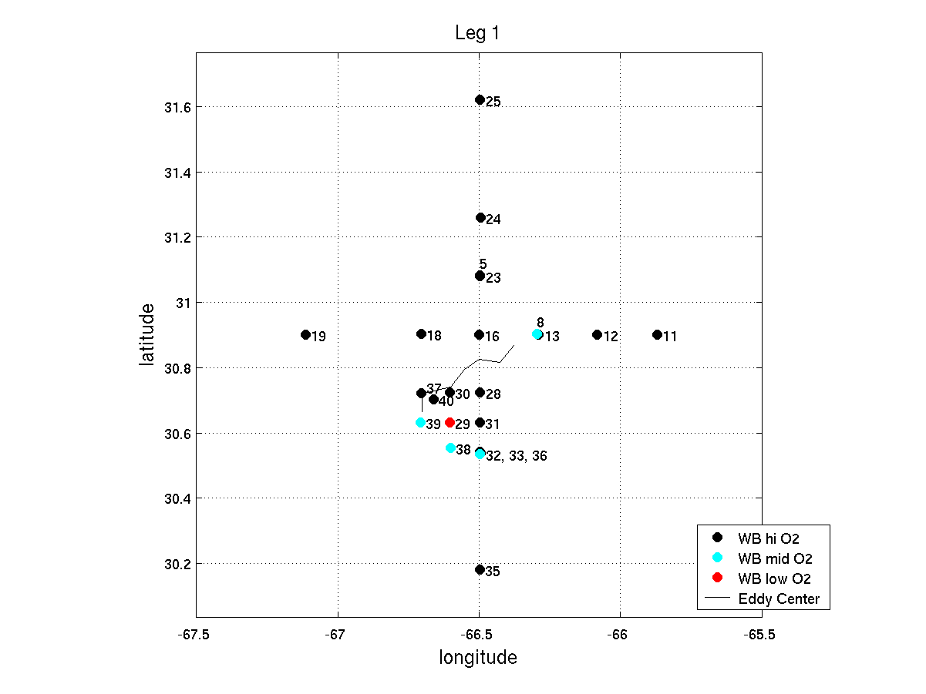
Figure 1. Station positions, WBII X0506 EDT3. Trajectory of eddy center (determined by OI of ADCP data) corresponds with the time of the stations plotted [187.5:1:194.5], starting in the NE at the time of station 5 and ending in the SW at the time of station 40. At the time of station 29, the EC is directly north of station 40, 11.8 km away from Station 29.

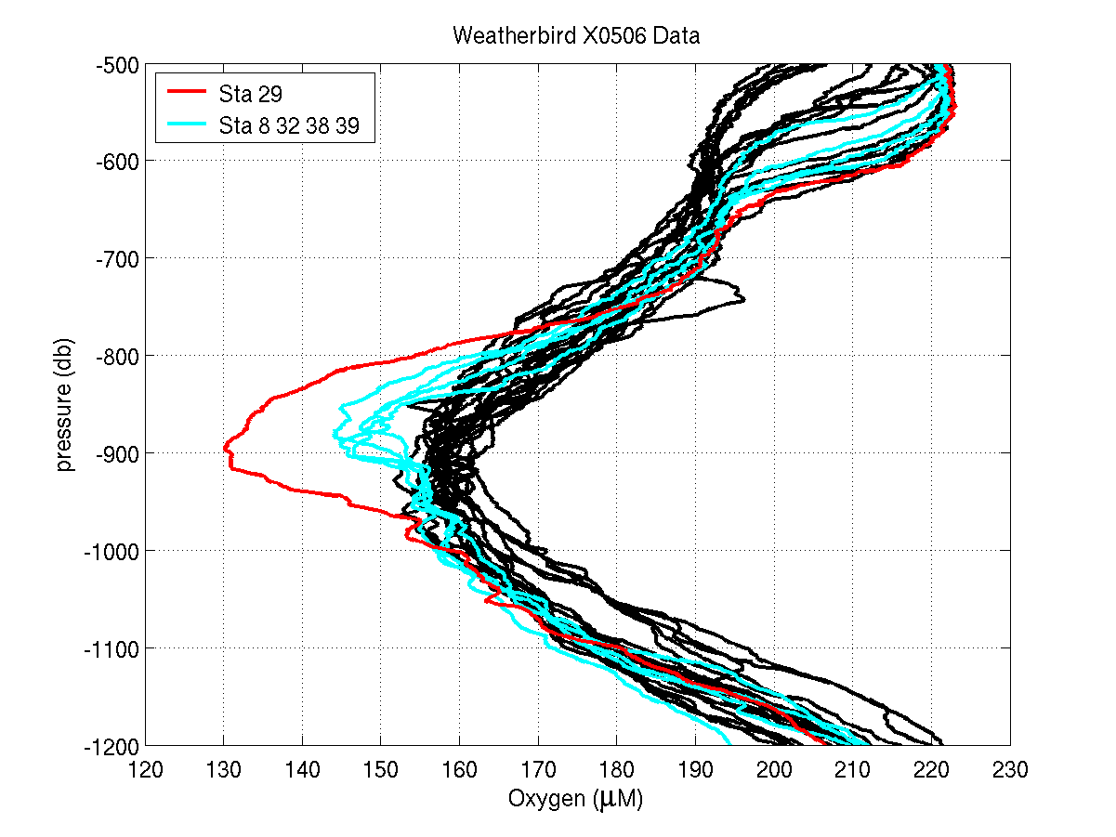
Figure 2. Oxygen profiles, WBII X0506 EDT3.

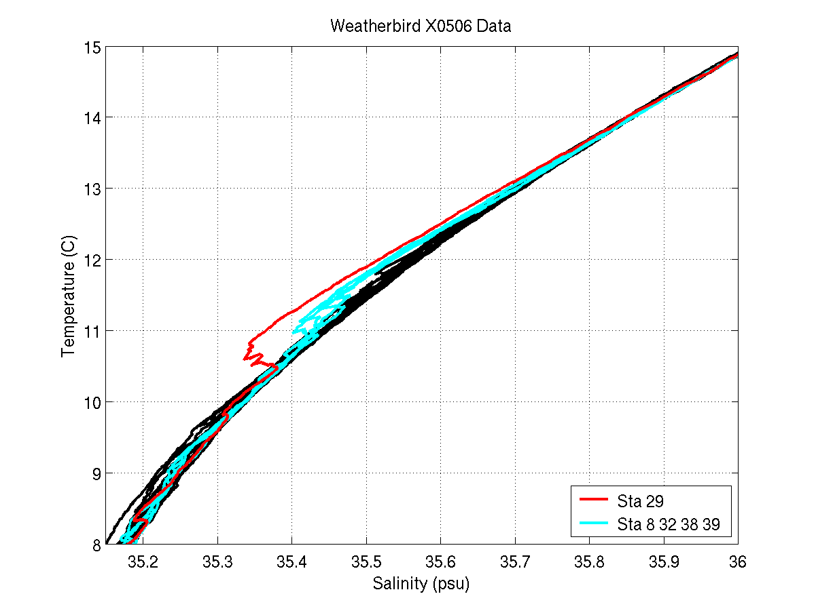
Figure 3. Water mass characteristics, WBII X0506 EDT3.

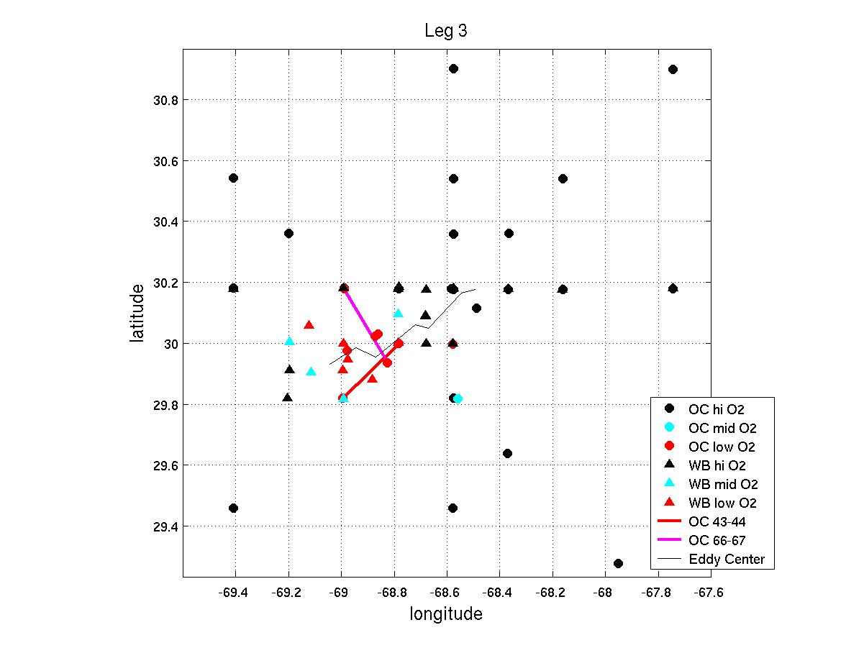
Figure 4. Station positions, OC415-3 and WBII X0508 EDT4. Trajectory of eddy center (determined by OI of ADCP data) corresponds with the time of the stations plotted. EC is near the center of the sampling star pattern at first, then moves SW. At the time of OC 43-44 (red line) the oxygen anomaly is SW of EC; at the time of OC 66-67 (magenta line), the oxygen anomaly is NE of EC.

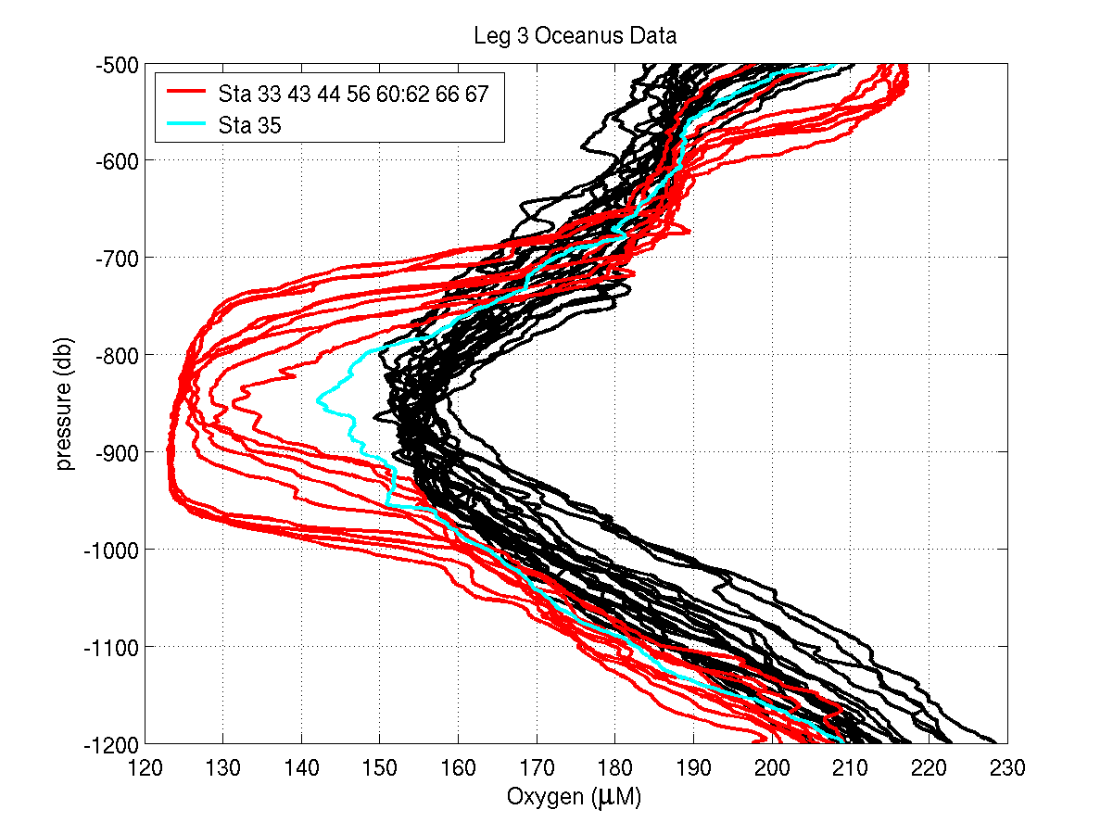
Figure 5. Oxygen profiles, OC415-3.

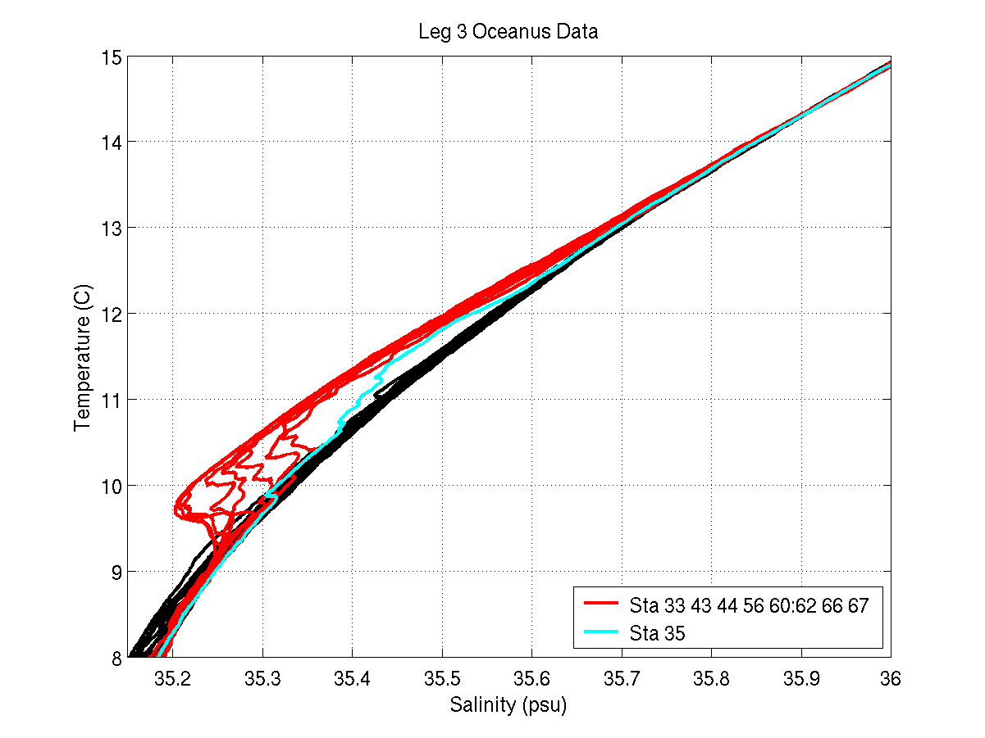
Figure 6. Water mass characteristics, OC415-3.

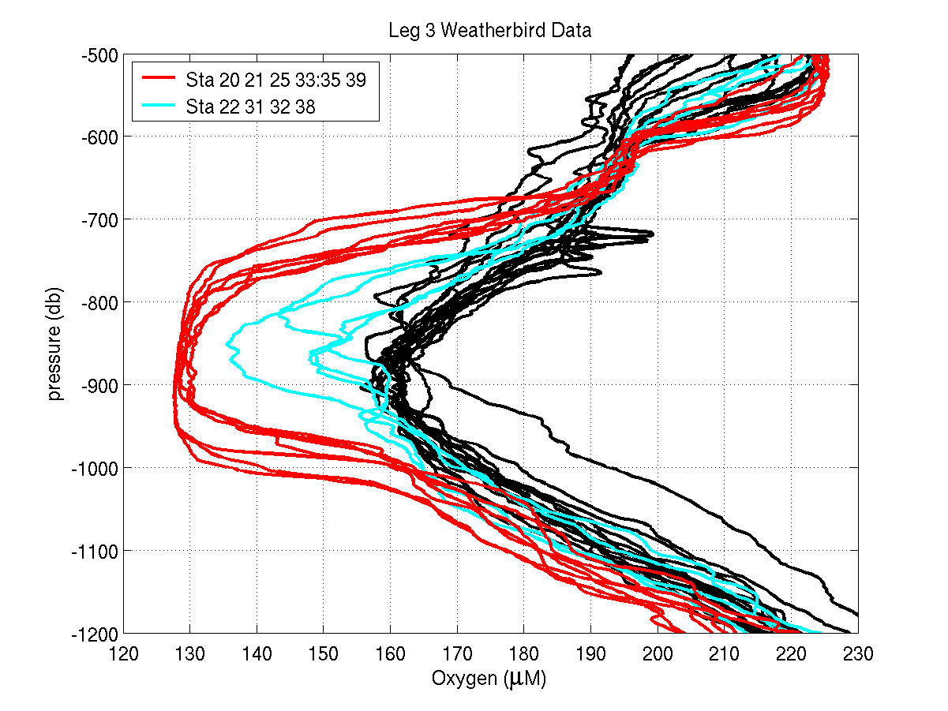
Figure 7. Oxygen profiles, WBII X0508 EDT4.

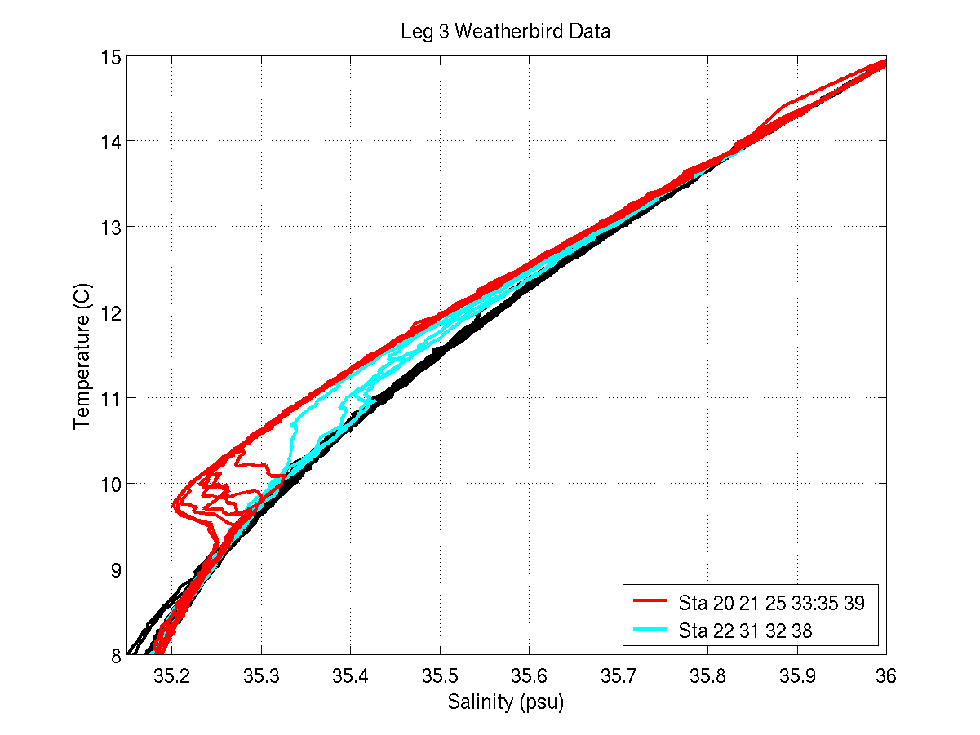
Figure 8. Water mass characteristics, WBII X0508 EDT4.

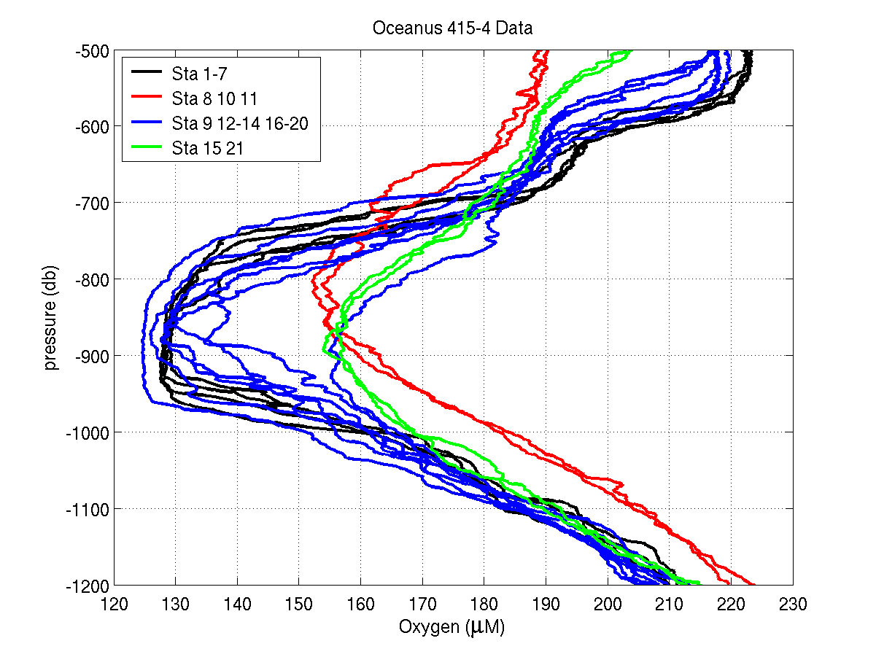
Figure 9. Oxygen profiles, OC415-4.

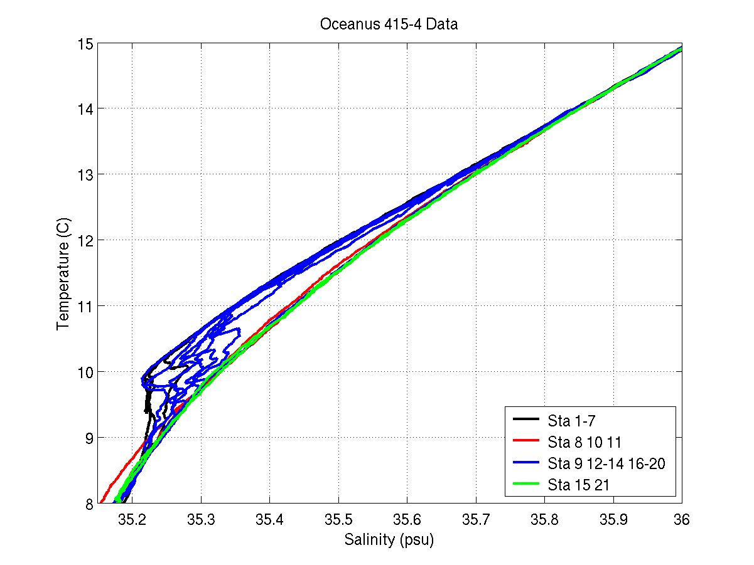
Figure 10. Water mass characteristics, OC415-4.

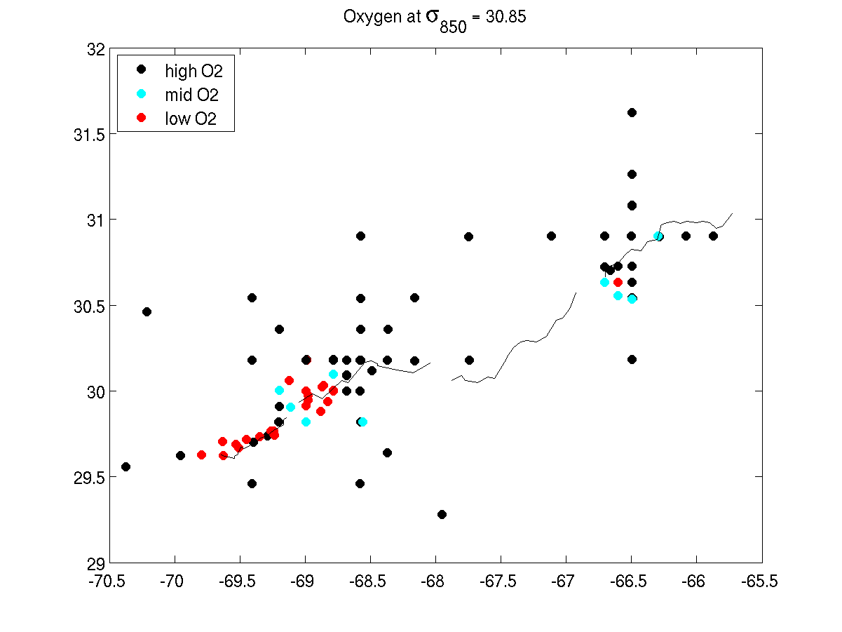
Figure 11. A4 oxygen anomaly locations (dots) in relation to the trajectory of eddy center determined from objective analysis of ADCP data (thin lines).

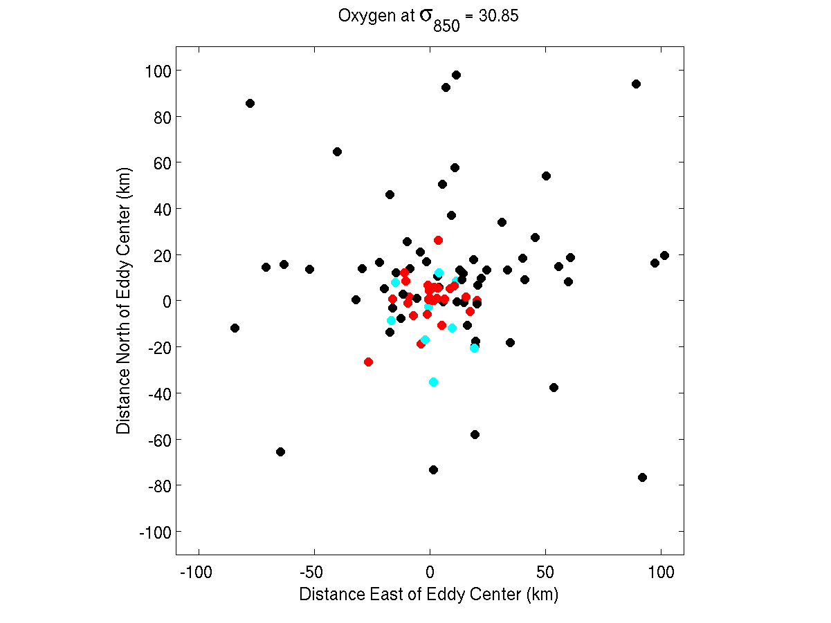
Figure 12: A4 oxygen anomaly locations (dots) plotted in eddy-following coordinates, using the trajectory of eddy center derived from objective analysis of ADCP data (Figure 11).

