Was the A4 oxygen anomaly observed at Hydrostation S in February/March 2005?
Draft 6/29/06

A deep oxygen anomaly with water mass characteristics strikingly similar to that observed in A4 was encountered during HS1028 (25 Feb 2005) and HS1029 (7 Mar 2005); see Figure 1. Note that these figures are based on the secondary sensor suite, as the salinity and oxygen values in the primary sensor suite appear to be problematic in HS1030. Also note there is a significant offset in the oxygen values between the HS and OC415-3 data (Figure 2). This offset was corrected for in the plot presented in Figure 1 [need to verify this correction with Rod].

The altimetric history of A4 indicates is was in the general vicinity in late February / early March, with the estimated position of eddy center east of BATS (Figure 3). Because Hydrostation S is located at a midpoint between altimetric tracks, it is not possible to discern the details of the connection between core of the A4 sea level anomaly and the HS hydrographic observations. However, it does appear that A4 was interacting with another anticyclonic feature north of Bermuda (Figure 4), and the spatial extent of the eddy-eddy interaction may have overlapped with HS during the time at which the oxygen anomaly was detected.

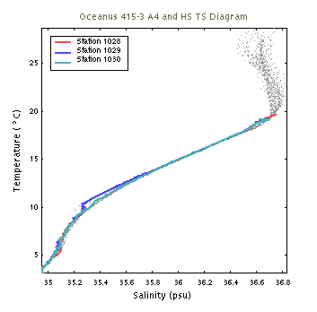 | 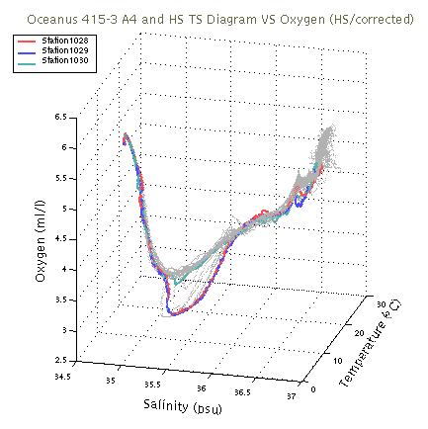
Figure 1. Comparison of water mass characteristics for Hydrostation S profiles 1028, 1029, and 1030 with those of OC415-3. Note that an offset correction has been applied to the oxygen data.

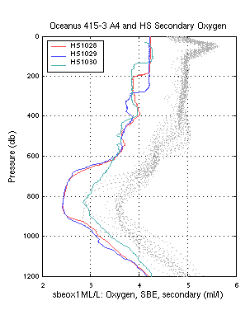 | 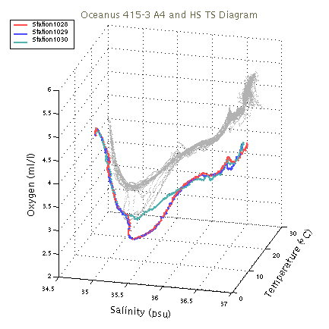
Figure 2. Comparison of uncorrected oxygen profiles and water mass characteristics from Hydrostation S stations 1028, 1029, and 1030 with those observed in OC415-3.

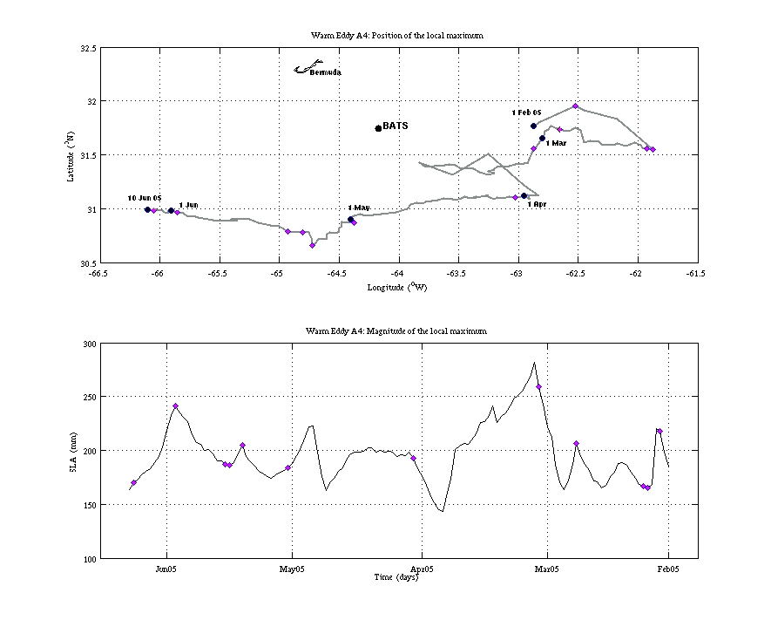
Figure 3. Altimetric history of mode-water eddy A4.
Top: trajectory of local maximum in SLA; bottom: time
series of SLA amplitude.

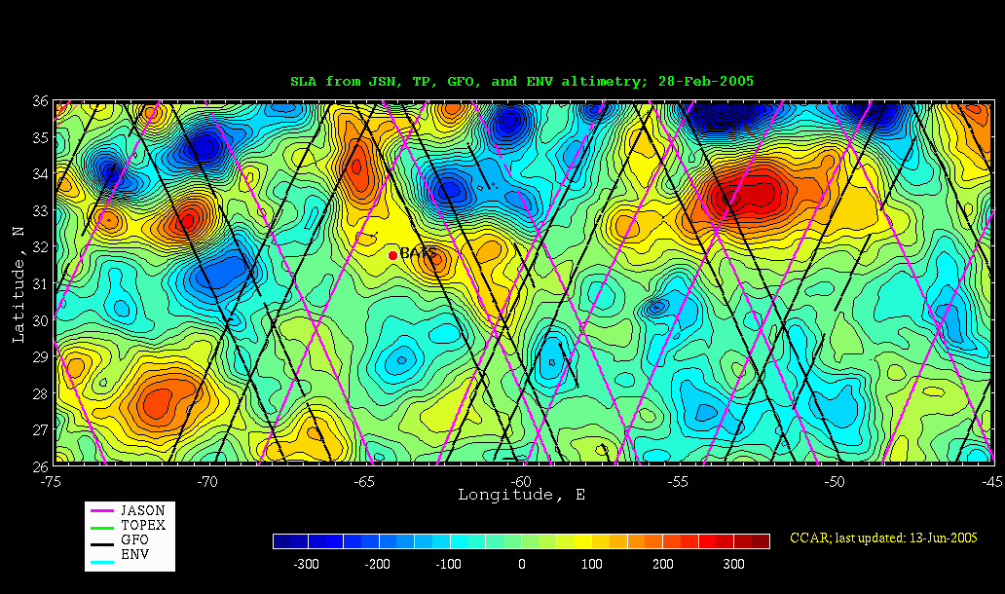
Figure 4. Sea level anomaly map for February 28, 2005. Note A4 anomaly east of BATS,
apparently interacting with another anticyclone to the north of Bermuda.

