**Georges Bank: a leaky incubator of *Alexandrium fundyense* blooms**

D.J. McGillicuddy, Jr.a

D.W. Townsendb

B.A. Keaferc

M.A. Thomasb

D.M. Andersonc

Manuscript revised in preparation for re-submission to *Deep-Sea Research II*

September 4, 2012

aDepartment of Applied Ocean Physics and Engineering, Woods Hole Oceanographic Institution, Woods Hole, MA 02543, USA. Tel: 508-289-2683 Fax: 508-457-2194 Email: dmcgillicuddy@whoi.edu (Corresponding Author).

bSchool of Marine Sciences, University of Maine, Orono, ME 04469, USA.

cBiology Department, Woods Hole Oceanographic Institution, Woods Hole, MA 02543, USA.

# Abstract

A series of oceanographic surveys on Georges Bank document variability of populations of the toxic dinoflagellate *Alexandrium fundyense* on time scales ranging from synoptic to seasonal to interannual. Blooms of *A. fundyense* on Georges Bank can reach concentrations on the order of 104 cells L-1, and are generally bank-wide in extent. Georges Bank populations of *A. fundyense* appear to be quasi-independent of those in the adjacent coastal Gulf of Maine, insofar as they occupy a hydrographic niche that is colder and saltier than their coastal counterparts. In contrast to coastal populations that rely on abundant resting cysts for bloom initiation, very few cysts are present in the sediments on Georges Bank. Bloom dynamics must therefore be largely controlled by the balance between growth and mortality processes, which are at present largely unknown for this population. Based on correlations between cell abundance and nutrient distributions, ammonium appears to be an important source of nitrogen for *A. fundyense* blooms on Georges Bank.

Key words: Phytoplankton; Population dynamics; Red tides; Paralytic shellfish poisoning; USA, Gulf of Maine, Georges Bank. **1. Introduction**

Whereas the ecology and oceanography of the toxic dinoflagellate *Alexandrium fundyense* are relatively well characterized in the coastal Gulf of Maine (Anderson et al. 2005b; Franks and Anderson 1992), comparatively less is known about blooms of this organism in offshore waters of that region. Evidence of its presence offshore was documented more than fifty years ago, when small amounts of Paralytic Shellfish Toxins (PSTs) were detected in the viscera of sea scallops (*Placopecten magellanicus*) harvested on Georges Bank (Bourne 1965). This finding was later confirmed by measurements in 1977-1981 (Jamieson and Chandler 1983). It was not until the late 1980s that elevated levels of PSTs were found in the digestive glands of Georges Bank scallops in a monitoring program associated with an emergent roe-on scallop fishery in the Canadian sector of the bank (White et al. 1993). Toxicity assays on surfclams (*Spisula solidissima*) harvested from southern Georges Bank in August 1989 yielded PST levels far in excess of the regulatory standard for safe human consumption, prompting an emergency closure. The fishery was re-opened the following year, only to be closed again in May 1990 when surfclam toxicities were again above the threshold. Two incidents involving eight cases of paralytic shellfish poisoning (PSP) occurred in May-June 1990 when fishermen became ill after eating blue mussels (*Mytilus edulis*) from bycatch on Georges Bank. Recognition of the long-term persistence of PSTs in surfclams on Georges Bank (White et al. 1993) and the difficulties of monitoring this offshore resource led to the closure being extended indefinitely, and it was expanded to include ocean quahogs, mussels, and all parts of sea scallops except for the adductor muscle. Only recently has the Georges Bank surfclam fishery become accessible on a limited basis under an onboard screening and dockside testing protocol (DeGrasse et al. submitted), in concert with a research program (GOMTOX[1]) focused on understanding the heretofore uncharacterized blooms of *A. fundyense* on Georges Bank.

Study of these offshore blooms is facilitated by a substantial body of knowledge concerning the physical, biological, chemical, and geological aspects of Georges Bank, which is home to prodigious natural resources, both living and mineral (Backus 1987). Mean circulation on the bank (Figure 1) is clockwise (Bigelow 1927), fed by adjacent waters emanating from coastal currents of the Gulf of Maine. The around-bank current results from a combination of tidal rectification (Loder 1980) and buoyancy-driven flow (Flagg 1987), the latter varying seasonally (Butman and Beardsley 1987). Residence times on Georges Bank inferred from drifter observations range from 40 days in winter to 90 days in summer (Brink et al. 2003), reflecting higher retention of water on the bank when the around-bank flow is stronger. The mean circulation is subject to episodic intrusions from the western Gulf of Maine, the Scotian Shelf, and warm-core Gulf Stream Rings (Brink et al. 2009; Smith et al. 2001).

The energetic hydrodynamic setting of Georges Bank fuels one of the most productive ecosystems in the world (Cohen and Grosslein 1987; Steele et al. 2007). Tidal pumping provides a persistent source of nutrients from the adjacent deep basins (Franks and Chen 2001; Horne et al. 1989; Hu et al. 2008; Ji et al. 2008). Phytoplankton chlorophyll is typically highest on the crest and decreases in the deeper areas along the periphery of the bank, with high rates of primary production throughout the year (O'Reilly et al. 1987). Winter/spring blooms dominated by diatoms can begin as early as January, with dinoflagellates becoming more abundant in the post-bloom period (Cura 1987; Townsend and Thomas 2002).

This classical paradigm of plankton species succession, together with the observed seasonal characteristics of *A. fundyense* blooms in the Gulf of Maine (Anderson 1997; Anderson et al. 2005b; Franks and Anderson 1992; McGillicuddy et al. 2005a; Townsend et al. 2001), framed the temporal parameters for this investigation of blooms of this species on Georges Bank. Detailed surveys, similar in spatial extent to the U.S. GLOBEC Georges Bank Broad-scale sampling pattern (Wiebe et al. 2006), were conducted in the April – August time frame in each of three years. These observations document the abundance and distribution of *A. fundyense* vegetative cells along with relevant environmental parameters such as hydrography, nutrients, and total chlorophyll—providing information on bloom dynamics for time-scales ranging from synoptic to seasonal to interannual. In light of the importance of resting cysts for initiation of blooms in the coastal Gulf of Maine (Anderson et al. 2005c), cyst distributions on Georges Bank were also measured on a single survey in fall 2007.

## 2. Methods

Hydrographic profiles and water samples were collected with a standard CTD-rosette system with Niskin bottles on a series of eleven cruises (Table 1; see Figure 2 for station positions). Nutrient samples were filtered through Millipore HA filters, placed immediately in a sea water-ice bath for 5–10 min, and frozen at −18°C. Concentrations of NO3+NO2, NH4, Si(OH)4 and PO4 were measured on shore following each cruise with a Bran Luebbe AA3 AutoAnalyzer using standard techniques.

*A. fundyense* cells were enumerated from water samples using a species-specific oligonucleotide probe and methods described in Anderson et al. (2005a). Both *A. tamarense* and *A. fundyense* occur in the Gulf of Maine, and these are considered to be varieties of the same species (Anderson et al. 1994; Scholin et al. 1995). Available molecular probes cannot distinguish between them, and only detailed analysis of the thecal plates on individual cells can provide this resolution—which is not practical for large numbers of field samples. Accordingly, for the purpose of this study, the name *A. fundyense* is used to refer to both forms.

Cysts of *A. fundyense* were collected and enumerated from sediment samples using methods described in Anderson et al. (2005c). Samples were obtained with a Craib corer in a dedicated survey in fall 2007. The sampling pattern consisted of 14 cross-shore transects in the coastal Gulf of Maine and three transects across Georges Bank, for a total of approximately 120 stations. *A. fundyense* cysts from the upper 1 cm of sediment are viable for germination (Anderson et al. 2005c) and thus only that vertical fraction of the sediment samples is included in the computations presented herein.

## 3. Results

*3.1 Surface distributions of A. fundyense vegetative cells*

Surveys in 2007, 2008, and 2010 document significant spatial and temporal variability in *A. fundyense* populations on Georges Bank (Figure 2). In May 2007, a widespread bloom covered most of the bank except for the Northeast Peak. Highest abundance occurred on the Southern Flank, with peak surface concentrations of more than 7,000 cells l-1. The population extended southwest of Georges Bank along the outer continental shelf, consistent with the exit pathway from the bank across the southern end of the Great South Channel (Figure 1). It is particularly noteworthy that the bloom on Georges Bank was well underway in May 2007 despite the near absence of *A. fundyense* from the coastal waters of the Gulf of Maine.

Cell concentrations on Georges Bank dropped somewhat from May to June/July 2007, although there were several stations with thousands of cells l-1 and a peak concentration in excess of 12,000 cells l-1. The bank-wide pattern also changed, insofar as concentrations on the crest decreased to a local minimum. Again, highest abundances occurred along the Southern Flank. Continued west-southwestward advection of the Georges Bank population was also evident, with concentrations on the southern New England shelf rising to several hundred cells l-1 over much of the area sampled.

During the fall 2007 cyst survey, “live” counts of *Alexandrium* spp. vegetative cells were taken from underway surface water samples during a portion of the cruise. These measurements revealed high cell concentrations along the southern periphery of Georges Bank, in the Bay of Fundy, and in the interior of the Gulf of Maine (Figure 2). Selected samples were subsequently reanalyzed with the oligonucleotide probe, confirming the presence of *A. fundyense*. Because of the long time period that elapsed between the June/July and October surveys, it is difficult to make inference about the continuity (or lack thereof) in the bloom dynamics between summer and fall. Specifically, it is not known whether the summer bloom continued into October, or if the summer bloom terminated and a subsequent bloom re-emerged in the fall.

A series of four cruises from April/May to July/August 2008 captured both onset and termination of the bloom on Georges Bank. In April/May, cell concentrations ranged from zero to hundreds of cells l-1, with highest concentrations on the northwest part of the bank. Tens to hundreds of cells l-1 extended through the western half of the crest to the Southern Flank. The southernmost measurements in the western Gulf of Maine indicated very low concentrations (<20 cells l-1), again suggesting that the Georges Bank bloom was initiated independently of the coastal population.

Between April/May and May/June, both the coastal and Georges Bank populations increased significantly. Measurements east of Cape Cod in the northern part of the Great South Channel detected *A. fundyense*, suggesting advective connectivity between the two populations at that time. Over most of the bank, concentrations ranged from several hundred to several thousand cells l-1, with a peak of over 5000 cells l-1 on the western side. A local minimum occurred in the central part of the crest, albeit of lesser spatial extent than that observed in June/July 2007. Concentrations of several hundred to nearly 2000 cells l-1 were present seaward of the shelf edge along the Southern Flank, such that the survey did not delimit the southern extent of the population in some areas. As in 2007, *A. fundyense* was detected in sections on the Southern New England continental shelf consistent with westward advection from Georges Bank across the Great South Channel. However, the more southerly extent of the coastal population in 2008 provides the means for an additional pathway to the Southern New England shelf, namely southward along the Great South Channel followed by a turn to the west south of Nantucket Shoals.

A dramatic decline of *A. fundyense* took place on Georges Bank from May/June to June/July 2008. The north flank and most of the crest were nearly devoid of cells. A modest tongue of cells (tens to less than 200 cells l-1) emanated from the western side of the Northeast Peak, extending down the southern flank. Peak cell concentrations of 224 and 378 cells l-1 were found at the western end of the tongue on the southwestern part of the bank. Similar patterns were observed at 20m depth (not shown), although the cell concentrations were even lower than at the surface. Cell concentrations declined even further from June/July to July/August. *A. fundyense* was absent in the two westernmost transects on Georges Bank in which peak cell concentrations typically reside—and therefore the bank-wide mapping effort was abandoned.

In 2010, concentrations of *A. fundyense* on Georges Bank were the lowest of all three years sampled. Abundance was very low in early May, with concentrations ranging from zero to a maximum of only 25 cells l-1. Concentrations increased modestly in May/June, with a swath of 100-200 cells l-1 straddling the 60m isobath on the Southern Flank. The bloom developed further in June/July, with a broad swath of cell concentrations in excess of 100 cells l-1 occurring along the western two-thirds of the Southern Flank, peaking at 1300 cells l-1. Elsewhere on the bank, abundance was generally low except for a few isolated stations on the crest where concentrations rose to 100-500 cells l-1. On-board live counts indicated the presence of planozygotes (the large precursors to *A. fundyense* resting cysts), suggesting the bloom was nearing its end. That is precisely what was observed in July/August, with *A. fundyense* absent from all stations except for one. In none of the four surveys in 2010 was there any indication of connectivity between the coastal and Georges Bank populations.

*3.2 Vertical distributions*

Vertical sections of temperature and salinity reveal several of the canonical features of Georges Bank hydrography: a well-mixed area over the crest, stratified areas along the flanks, and a tidal mixing front separating the two, nominally located near the 60m isobath (Figure 3 provides an example from May 2007; see Appendix A for a complete atlas). The vertical distribution of *A. fundyense* generally corresponds to that which one would expect based on the horizontal distribution (Figure 2) and knowledge of the mixing environment. Specifically, the population is spread throughout the water column on the crest, and confined to the upper layer in the stratified areas, where subsurface maxima sometimes occur. It should be noted that although the vertical distribution is more uniform in the shallowest areas of the bank, the population is not entirely well-mixed—nor are the hydrographic properties.

The most conspicuous relationship between *A. fundyense* and the distribution of nutrients is an inverse one: *A. fundyense* is most abundant where nitrate is most depleted. Peak *A. fundyense* concentrations occur in the waters overlying the highest concentrations of ammonium along the Southern Flank, suggesting that the near-surface populations may be deriving their nitrogenous nutrition from a vertical flux of ammonium. There is little evidence of systematic relationships between the distributions of *A. fundyense* and the other nutrients silicate and phosphate, nor with chlorophyll *a*.

*3.3 Distribution of A. fundyense cysts*

Given the importance of benthic resting cysts as sources for planktonic blooms of the coastal population of *A. fundyense* (Anderson et al. 2005c; McGillicuddy et al. 2003; McGillicuddy et al. 2011), a survey was carried out to ascertain the abundance of resting cysts in sediments on Georges Bank. Cyst concentrations on the bank were low (Figure 4), all below 100 cysts cm-3. These low numbers are especially striking given the thousands of cysts cm-3 that are typically present over widespread areas offshore of mid-coast Maine and in the Bay of Fundy. The lack of cysts on Georges Bank are likely related to sediment composition, as coarse-grained sediments are found in most areas (Twichell et al. 1987). High abundances of cysts typically occur in fine-grained sediments (Anderson this issue; Anderson et al. 2005c), and thus the high-energy environment of Georges Bank may not be favorable to cyst accumulation from a geological perspective.

## 4. Discussion

*4.1 Seasonal variability*

Quantification of the seasonal variability of *A. fundyense* blooms on Georges Bank is made difficult by the lack of time-series observations over a suitably long time interval (Figure 5). For example, the pair of surveys in 2007 document neither initiation nor termination of the bloom. Only in four-survey sequences in 2008 and 2010 does a seasonal pattern emerge, with bloom initiation in May, peaks in June-July, and termination in August. The two summertime snapshots of *A. fundyense* from 2007, as well as observations of *Alexandrium* spp. in 1998 and 1999 (Appendix B) are compatible with that May – August seasonal window for blooms on Georges Bank. However, the bloom observed during the cyst survey in October 2007 (Figure 2) most certainly is not. As stated in section 3.1, it is difficult to interpret those observations in a seasonal context.

*4.2 Synoptic variability*

*A. fundyense* populations on Georges Bank are prone to significant fluctuations on event-driven or “synoptic” time scales, and termination of the bloom in 2008 provides an excellent example. On-bank bloom conditions in late May / early June 2008 were generally similar to those observed in May 2007 (Figure 2), with average bank-wide cell concentrations of ca. 1000 cells l-1 (Figure 5). Hydrographic characteristics during this time were similar for 2007 and 2008 (Figure 6). Whereas the 2007 bloom persisted from May to late June / early July, the 2008 bloom declined during this time (Figure 2), with bank-wide cell concentrations dropping by more than an order of magnitude (Figure 5). The dramatic decrease in *A. fundyense* from May to late June / early July 2008 was accompanied by a substantial change in water mass characteristics, with near surface waters over most of the bank being warmer and fresher than they were during the same period in 2007 (Figure 6).

What processes might be responsible for the warming and freshening of Georges Bank from late May / early June to late June / early July 2008? The spatial structure of the water mass change (Figure 7) reflects the clockwise around-bank circulation, and is thereby suggestive of an advective phenomenon. Interrogating the regional climatology (Lynch et al. 1996) for the warm and fresh water mass bounded by 31.5 < S < 32.5 and 13.0°C < T < 19.0°C (Figure 6, third panel, dashed line), the apparent origin is the western Gulf of Maine (Figure 7, lower right panels). But why would there be more water from the western Gulf of Maine on Georges Bank in 2008 relative to 2007? In May 2008, there was a large-amplitude meander of the Gulf Stream that appears to have been drawing water off the continental shelf from ca. 67-70ºW (Figure 8). A natural source for replacement of water lost from the bank would be the western Gulf of Maine, and a drifter released northeast of Cape Cod in May 2008 illustrates that transport pathway was active during this period. However, a single drifter is not sufficient to quantify whether the flux of water from the western Gulf of Maine to Georges Bank was stronger than average at that time.

*4.3 Interannual variability*

Computation of a mean seasonal cycle of *A. fundyense* abundance (Figure 5) permits quantification of departures from that mean, which in turn yield estimates of interannual variability. Assessment of these bank-wide abundance anomalies together with contemporaneous water mass properties (Figure 6) provides some insight into the mechanisms underlying these interannual variations. Specifically, at the times when *A. fundyense* was most abundant (May, June 2007; June 2008), water on the bank was relatively cold and salty. In contrast, relatively low *A. fundyense* abundance was found in waters that were relatively warm and fresh. These water mass associations appear to be robust regardless of whether the blooms were waxing or in decline. For example, the highest bank-wide abundances observed in May 2007, late June / early July 2007, and June 2008 were associated with the coldest and saltiest conditions observed during those times of year. In contrast, abundances during the first two cruises in 2010 were lower than the seasonal mean, and waters on Georges Bank were warmer and fresher than at the same time of year in 2008. In late April / early May, the core Georges Bank water (4-8°C, 31.5-33.5) was nearly 2°C warmer and perhaps 0.5 fresher in 2010 than 2008, consistent with a large-scale hydrographic anomaly that affected the region in 2010 (McGillicuddy et al. 2011; Smith et al. in press). As the water mass anomaly lessened in late June through early August 2010, *A. fundyense* abundance was more similar to that present during that same time of year (bloom decline) in 2008. Yet another example of low abundance in a warm and fresh anomaly comes from the advective termination of the 2008 bloom (section 4.2). Earlier observations of *Alexandrium* spp. on Georges Bank in the 1990s appear to be consistent with this overall tendency toward higher abundance when conditions are relatively cold and salty (Appendix B).

*4.4 Hydrographic niche of A. fundyense populations on Georges Bank*

Covariation of the *A. fundyense* population with a suite of environmental variables (Figure 3; Appendix A) was examined to assess the degree to which a distinct hydrographic niche could be identified. No systematic relationship was apparent between *A. fundyense* concentration and chlorophyll *a*, phosphate, or silicate. However, a pattern does emerge from the union of temperature, salinity, nitrate plus nitrite, and ammonium measurements (Figure 9). Specifically, *A. fundyense* is most abundant at temperatures of ca. 9°C and salinities of ca. 32.8. Whereas the highest concentrations of *A. fundyense* occur at low nitrate plus nitrite, they are accompanied by ammonium concentrations that range from the limit of detection up to 3 µM. This suggests that ammonium is an important source of nitrogenous nutrition for *A. fundyense* populations on Georges Bank. Utilization of ammonium has been demonstrated both in laboratory culture of *A. tamarense* (Leong et al. 2004) and in experimental enrichment of natural populations of *A. fundyense* (Hattenrath et al. 2010).

This temperature-salinity niche of *A. fundyense* on Georges Bank is distinct from those occupied by other populations in the region (Figure 10). In the western Gulf of Maine, *A. fundyense* resides in fresher waters that span a much wider range of temperatures than the population on Georges Bank. The eastern Gulf of Maine and Bay of Fundy populations tend to occupy intermediate salinities and somewhat warmer temperatures (>10°C). On the southern New England shelf, *A. fundyense* is found at salinities ranging from the relatively fresh waters of the western Gulf of Maine to the saltier waters of Georges Bank. This is consistent with two separate pathways by which *A. fundyense* populations are advected to the southern New England shelf (Figures 1,2), and the higher temperatures associated with this niche reflect warming of near-surface waters during transport.

Given the wide range of temperatures at which *A. fundyense* resides in the region, it is primarily salinity that makes the Georges Bank population distinct from a hydrographic point of view (Figure 10). However, the higher salinities characteristic of the Georges Bank environment are not sufficient to bring about an appreciable difference in maximal growth rate, as laboratory cultures suggest weak salinity dependence in this range (Etheridge and Roesler 2005; Prakash 1967). Thus the distinctness of the hydrographic niche of the Georges Bank population may be of relatively minor consequence from an ecological point of view, except for its utility as a diagnostic of oceanographic isolation from the surrounding populations.

To assess the statistical robustness of the hydrographic niche of *A. fundyense* on Georges Bank, we fit a simple linear/quadratic model to the cell concentration data *C* as a function of temperature (*T*) and salinity (*S*). The model takes the form log(*C*+1) = *a + bT + cS + dT2 + eS2 + ε*. As expected, the coefficients for salinity sensitivity (*c* and *e*) for the Georges Bank data were significantly different (*p* = 0.01,0.02 respectively) from those for the eastern and western Gulf of Maine observations. The coefficients for temperature sensitivity (*b* and *d*) were not significantly different among the regions (*p* = 0.3,0.4 respectively).

## 5. Conclusions

To first order, populations of *A. fundyense* on Georges Bank appear to bloom quasi-independently of those in the adjacent coastal Gulf of Maine. Although there is an advective connection between the two, blooms on Georges Bank are initiated earlier than those in the coastal area. Hence, at least on the time scale of bloom initiation, an upstream source cannot account for the blooms that occur on the bank. Nor are benthic resting cysts likely to constitute a significant source of vegetative cells comprising the blooms, insofar as cyst concentrations in the sediments of Georges Bank are roughly two orders of magnitude smaller than in the coastal Gulf of Maine, where they play a major role in population dynamics of the organism. It is possible that near-bottom suspended cysts could be transported onto the bank from adjacent deep basins by the same tidal pumping mechanism that contributes to the cold, salty, nutrient-rich hydrographic environment. However, the deep basins have not yet been sampled for suspended cysts (Pilskaln et al. this issue), so it is not possible to assess this potential. Regardless of the origin of the initial inoculum of vegetative cells, *A. fundyense* blooms on Georges Bank are clearly a result of a local increase in growth over mortality (Turner 2010). Although little is known about the precise mechanisms that foster such conditions, ammonium appears to be a primary source of nitrogen fueling the blooms.

Additional support for the hypothesis that *A. fundyense* populations on Georges Bank are quasi-separate is provided by observations of toxigenic properties. Petitpas et al. (this issue) report cellular toxin quotas that are consistently lower on Georges Bank than in the coastal Gulf of Maine. Deeds et al. (this issue) document differences in toxin composition between Georges Bank and the coastal Gulf of Maine in two out of the three years sampled. The underlying causes for these variations are not clear, as toxin production can be affected by a variety of factors including nutritional status, growth phase, and environmental conditions—all of which can be distinct for different species, and even isolates within species (Anderson et al. 1994; Anderson et al. 1990; Etheridge and Roesler 2005; Poulton et al. 2005). Leong et al. (2004) found intracellular toxin production in cultures of *A. tamarense* varies as a function of nitrogen source, with ammonium yielding a higher toxicity than nitrate or urea. Given that cellular toxin quotas are actually *lower* on Georges Bank where the population appears to be relying on ammonium, the observed variations in toxicity are more likely driven by other factors. Indeed, comparisons of microsatellite markers among various subpopulations in the region suggest that the Georges Bank population is genetically distinct (M. Richlen, personal communication).

*A. fundyense* cells on Georges Bank occupy a hydrographic environment that is colder and saltier than their coastal counterparts, and it is tempting to speculate on the processes that lead to this distinct niche. Tidal pumping is thought to be the primary mechanism by which cold, salty, nutrient-rich water is brought up onto the bank, primarily along the northern edge (Franks and Chen 2001; Horne et al. 1989; Hu et al. 2008; Ji et al. 2008). The bulk of the new nitrate is presumably taken up by phytoplankton other than *A. fundyense*, given that it makes up such a small component of the autotrophic biomass. Apparently, as nitrate is removed and the phytoplankton species assemblage transitions to one that is fueled by recycled production, *A. fundyense* begins to proliferate. As this succession unfolds, the clockwise around-bank circulation tends to displace the community from the location of the initial injection of nutrients, which may explain why highest concentrations of *A. fundyense* are often found on the Southern Flank.

The observations presented herein are consistent with a “leaky incubator” model for *A. fundyense* populations on Georges Bank. When the bank is relatively isolated from its surroundings (cold and salty), *A. fundyense* thrives. When large volumes of warm and fresh waters flow onto Georges Bank, two factors potentially hinder *A. fundyense* populations: (1) dilution with water containing low concentrations of *A. fundyense*, and (2) delivery of relatively low-nutrient water that is unfavorable for *A. fundyense* growth. In any case, this ‘incubator’ can create *A. fundyense* blooms of magnitude sufficient to intoxicate shellfish beds on Georges Bank. Moreover, these blooms also constitute a potential threat to areas downstream on the Southern New England shelf, where water ‘leaked’ off the bank tends to be transported.

The mechanisms regulating *in situ* production of *A. fundyense* by the incubator remain obscure. There does appear to be a seasonal modality, with bloom initiation in April-May, peaks in June-July, and termination in July-August. However, blooms at other times of year cannot be ruled out due to lack of observations—and there is at least one example of significant *A. fundyense* populations being present on the bank outside of this seasonal envelope (October 2007). Interannual variability in abundance is no doubt significant, and our observations from 2007-2010 suggest peak bank-wide abundance of *A. fundyense* can vary by at least an order of magnitude from year to year. We suspect this is a lower bound on interannual variation, as sampling conducted in 1990-1992, albeit far more limited in spatial extent than the surveys described herein, failed to detect *A. fundyense* in concentrations greater than 50 cells L-1 (Appendix B; Nassif and Timperi, 1993). Understanding of the processes responsible for the dramatic seasonal to interannual variations of *A. fundyense* on Georges Bank will require detailed process studies constraining both bottom-up and top-down controls, as fluctuations in the balance between them ultimately determines bloom dynamics (Turner 2010).

## Acknowledgments

We are very grateful for the outstanding efforts of the officers, crews, and shore support of R/V *Oceanus*, R/V *Endeavor*, and R/V *Tioga*, as well as the hard work of all those who participated in the seagoing science teams. Olga Kosnyrev, Valery Kosnyrev, and Keston Smith assisted in data analysis and figure preparation. Jim Manning provided the drifter track illustrating the advective connection between the western Gulf of Maine and Georges Bank (Figure 8). Discussion with Julianne Nassif was beneficial in recounting the prior history of toxicity and plankton sampling on Georges Bank. Hydrographic data presented in Appendix B were collected by the National Oceanic Atmospheric Administration’s Northeast Fisheries Science Center as part of an ongoing mission to monitor and assess the Northeast Continental Shelf ecosystem. We appreciate financial support of the National Oceanic Atmospheric Administration (grant NA06NOS4780245 for the Gulf of Maine Toxicity (GOMTOX) program) and the Woods Hole Center for Oceans and Human Health through National Science Foundation grants OCE-0430724 and OCE-0911031 and National Institute of Environmental Health Sciences grant 1P50-ES01274201. This is the Ecology and Oceanography of Harmful Algal Blooms Program contribution number XXXX.

Careful reviews by two anonymous referees helped improve the initial version of this manuscript.

**References**

Anderson, D. M. 1997. Bloom dynamics of toxic *Alexandrium* species in the northeastern U.S. Limnol. Oceanogr. **42:** 1009-1022.

---. this issue. Cyst dynamics. Deep-Sea Research II.

Anderson, D. M., D. M. Kulis, G. J. Doucette, J. C. Gallagher, and E. Balech. 1994. Biogeography of toxic dinoflagellates in the genus *Alexandrium* from the northeastern United States and Canada. Marine Biology **120:** 467-478.

Anderson, D. M., D. M. Kulis, B. A. Keafer, K. E. Gribble, R. Marin, and C. A. Scholin. 2005a. Identification and enumeration of *Alexandrium* spp. from the Gulf of Maine using molecular probes. Deep-Sea Research II **52:** 2467-2490.

Anderson, D. M., D. M. Kulis, J. J. Sullivan, S. Hall, and C. Lee. 1990. Dynamics and physiology of saxitoxin production by the dinoflagellates *Alexandrium* spp. Marine Biology **104:** 511-524.

Anderson, D. M., D. J. McGillicuddy, D. W. Townsend, and J. T. Turner. 2005b. The ecology and oceanography of toxic *Alexandrium fundyense* blooms in the Gulf of Maine: Preface. Deep-Sea Research II **52:** 2365-2368.

Anderson, D. M., C. A. Stock, B. A. Keafer, A. C. Bronzino, D. J. McGillicuddy, M. D. Keller, B. Thompson, P. A. Matrai, and J. Martin. 2005c. *Alexandrium fundyense* cyst dynamics in the Gulf of Maine. Deep-Sea Research II **52:** 2522-2542.

Backus, R. H. [ed.]. 1987. Georges Bank. MIT Press.

Beardsley, R. C., B. Butman, W. R. Geyer, and P. Smith. 1997. Physical oceanography of the Gulf of Maine: An update, p. 39-52. Proceedings of the Gulf of Maine Ecosystem Dynamics Scientific Symposium and Workshop. Regional Association for Research in the Gulf of Maine.

Bigelow, H. B. 1927. Physical oceanography of the Gulf of Maine. Bull. U.S. Bur. Fish. **40:** 511-1027.

Bourne, N. 1965. Paralytic shellfish poison in sea scallops. J. Fish. Res. Bd. Can. **22:** 1137-1149.

Brink, K. H., R. C. Beardsley, R. Limeburner, J. D. Irish, and M. Caruso. 2009. Long-term moored array measurements of currents and hydrography over Georges Bank: 1994–1999. Progress In Oceanography **82:** 191-223.

Brink, K. H., R. Limeburner, and R. C. Beardsley. 2003. Properties of flow and pressure over Georges Bank as observed with near-surface drifters. J. Geophys. Res. **108:** 8001.

Butman, B., and R. C. Beardsley. 1987. Long-Term Observations on the Southern Flank of Georges Bank. Part I: A Description of the Seasonal Cycle of Currents, Temperature, Stratification, and Wind Stress. Journal of Physical Oceanography **17:** 367-384.

Cohen, E. B., and M. D. Grosslein. 1987. Production on Georges Bank compared with other shelf ecosystems, p. 383-391. *In* R. H. Backus [ed.], Georges Bank. The MIT Press.

Cura, J. J. 1987. Phytoplankton, p. 213-218. *In* R. H. Backus [ed.], Georges Bank. The MIT Press.

Deeds, J. R., C. M. Petitpas, V. Shue, K. D. White, B. A. Keafer, D. J. McGillicuddy, P. J. Milligan, D. M. Anderson, and J. T. Turner. this issue. PSP Toxin Levels and Plankton Community Composition and Abundance in Size-Fractionated Vertical Profiles During Spring/Summer Blooms of the Toxic Dinoflagellate *Alexandrium fundyense* in the Gulf of Maine and on Georges Bank, 2007, 2008, and 2010. 1. Toxin Levels. Deep-Sea Research II.

DeGrasse, S., S. Conrad, P. DiStefano, C. V. D. Wallace, P. Jensen, M. H. F. Cenci, J. Pitt, D. Deardorff, F. Rubio, D. Easy, M. A. Donovan, M. Laycock, D. Rouse, and J. Mullen. submitted. Onboard screening dockside testing as a new means of managing paralytic shellfish poisoning risks in federally closed waters. Deep Sea Res. II.

Etheridge, S. M., and C. S. Roesler. 2005. Effects of temperature, irradiance, and salinity on photosynthesis, growth rates, total toxicity, and toxin composition for Alexandrium fundyense isolates from the Gulf of Maine and Bay of Fundy. Deep-Sea Research II **52:** 2491-2500.

Flagg, C. N. 1987. Hydrographic structure and variability, p. 108-124. *In* R. H. Backus [ed.], Georges Bank. The MIT Press.

Franks, P. J. S., and D. M. Anderson. 1992. Toxic phytoplankton blooms in the southwestern Gulf of Maine: testing hypotheses of physical control using historical data. Marine Biology **112:** 165-174.

Franks, P. J. S., and C. Chen. 2001. A 3-D prognostic numerical model study of the Georges Bank ecosystem. Part II: biological-physical model. Deep-Sea Research II **48:** 457-482.

Hattenrath, T. K., D. M. Anderson, and C. J. Gobler. 2010. The influence of anthropogenic nitrogen loading and meteorological conditions on the dynamics and toxicity of Alexandrium fundyense blooms in a New York (USA) estuary. Harmful Algae **9:** 402-412.

Horne, E. P. W., J. W. Loder, P. J. Harrison, R. Mohn, M. R. Lewis, B. Irwin, and T. Platt. 1989. Nitrate supply and demand at the Georges Bank tidal front. Scientia Marina **53:** 145-158.

Hu, S., D. W. Townsend, C. Chen, G. Cowles, R. C. Beardsley, R. Ji, and R. W. Houghton. 2008. Tidal pumping and nutrient fluxes on Georges Bank: A process-oriented modeling study. Journal of Marine Systems **74:** 528-544.

Jamieson, G. S., and R. A. Chandler. 1983. Paralytic shellfish poison in sea scallops in the west Atlantic. Can. J. Fish. Aquat. Sci. **40:** 313-318.

Ji, R., C. Davis, C. Chen, and R. Beardsley. 2008. Influence of local and external processes on the annual nitrogen cycle and primary productivity on Georges Bank: A 3-D biological–physical modeling study. Journal of Marine Systems **73:** 31-47.

Keafer, B. A., J. H. Churchill, D. J. McGillicuddy, and D. M. Anderson. 2005. Bloom development and transport of toxic *Alexandrium fundyense* populations within a coastal plume in the Gulf of Maine. Deep-Sea Research II **52:** 2674-2697.

Kemper, K. 2000. Dynamics of Silicate and the Late Spring Phytoplankton Community on Georges Bank, May and June 1998. M.Sc. Thesis. University of Maine.

Leong, S. C. Y., A. Murata, Y. Nagashima, and S. Taguchi. 2004. Variability in toxicity of the dinoflagellate Alexandrium tamarense in response to different nitrogen sources and concentrations. Toxicon **43:** 407-415.

Loder, J. W. 1980. Topographic Rectification of Tidal Currents on the Sides of Georges Bank. Journal of Physical Oceanography **10:** 1399-1416.

Lynch, D. R., J. T. C. Ip, C. E. Naimie, and F. E. Werner. 1996. Comprehensive coastal circulation model with application to the Gulf of Maine. Continental Shelf Research **16:** 875-906.

McGillicuddy, D. J., D. M. Anderson, D. R. Lynch, and D. W. Townsend. 2005a. Mechanisms regulating the large-scale seasonal fluctuations in *Alexandrium fundyense* populations in the Gulf of Maine: results from a physical-biological model. Deep-sea Research II **52:** 2698-2714.

McGillicuddy, D. J., D. M. Anderson, A. R. Solow, and D. W. Townsend. 2005b. Interannual variability of *Alexandrium fundyense* abundance and shellfish toxicity in the Gulf of Maine. Deep Sea Research II **52:** 2843-2855.

McGillicuddy, D. J., R. P. Signell, C. A. Stock, B. A. Keafer, M. D. Keller, R. D. Hetland, and D. M. Anderson. 2003. A mechanism for offshore initiation of harmful algal blooms in the coastal Gulf of Maine. Journal of Plankton Research **25:** 1131-1138.

McGillicuddy, D. J., D. W. Townsend, R. He, B. A. Keafer, J. L. Kleindinst, Y. Li, J. P. Manning, D. G. Mountain, M. A. Thomas, and D. M. Anderson. 2011. Suppression of the 2010 *Alexandrium fundyense* bloom by changes in physical, biological, and chemical properties of the Gulf of Maine. Limnology and Oceanography **56:** 2411–2426.

Nassif, J., and R. J. Timperi. 1993. Survey of molluscan shellfish for certain marine biotoxins. Report # 223-89-4064, U.S. Food and Drug Administration, Public Health Service, Department of Health and Human Services.

O'Reilly, J. E., C. Evans-Zetlin, and D. A. Busch. 1987. Primary Production, p. 220-233. *In* R. H. Backus [ed.], Georges Bank. The MIT Press.

Petitpas, C. M., J. T. Turner, J. R. Deeds, B. A. Keafer, D. J. McGillicuddy, P. J. Milligan, V. Shue, K. D. White, and D. M. Anderson. this issue. GOMTOX - PSP Toxin Levels and Plankton Community Composition and Abundance in Size-Fractionated Vertical Profiles During Spring/Summer Blooms of the Toxic Dinoflagellate *Alexandrium fundyense* in the Gulf of Maine and on Georges Bank, 2007, 2008, and 2010. 2. Plankton community composition and abundance. Deep-Sea Research II.

Pilskaln, C. H., K. Hayashi, B. A. Keafer, D. M. Anderson, and D. J. McGillicuddy. this issue. Benthic nepheloid layers in the Gulf of Maine and *Alexandrium* cyst inventories. Deep-Sea Research II.

Poulton, N. J., B. A. Keafer, and D. M. Anderson. 2005. Toxin variability in natural populations of *Alexandrium fundyense* in Casco Bay, Maine—evidence of nitrogen limitation. Deep-Sea Research II **52:** 2501-2521.

Prakash, A. 1967. Growth and toxcity of a marine dinoflagellate, *Gonyaulax tamarensis*. Journal of the Fisheries Research Board of Canada **24**.

Scholin, C. A., G. M. Hallegraeff, and D. M. Anderson. 1995. Molecular evolution of the *Alexandrium tamarense* 'species complex' (Dinophyceae): Dispersal in the North American and West Pacific regions. Phycologia **34:** 472-485.

Silvert, W., V. M. Bricelj, and A. D. Cembella. 1998. Dynamic modeling of PSP toxicity in the surfclam (*Spisula solidissima*): multicompartmental kinetics and biotransformation, p. 437-440. *In* B. Reguera, J. Blanco, M. L. Fernandez and T. Wyatt [eds.], Harmful Algae. IOC of UNESCO.

Silvert, W. L., and A. D. Cembella. 1995. Dynamic Modelling of Phycotoxin Kinetics in the Blue Mussel, Mytilus edulis, with Implications for other Marine Invertebrates. Canadian Journal of Fisheries and Aquatic Sciences **52:** 521-531.

Smith, P. C., R. W. Houghton, R. G. Fairbanks, and D. G. Mountain. 2001. Interannual variability of boundary fluxes and water mass properties in the Gulf of Maine and Georges Bank. Deep-Sea Research II **48:** 37-70.

Smith, P. C., N. R. Pettigrew, P. Yeats, D. W. Townsend, and G. Han. in press. Regime shift in the Gulf of Maine. Trans. Amer. Fish. Soc.

Steele, J. H., J. S. Collie, J. J. Bisagni, D. J. Gifford, M. J. Fogarty, J. S. Link, B. K. Sullivan, M. E. Sieracki, A. R. Beet, D. G. Mountain, E. G. Durbin, D. Palka, and W. T. Stockhausen. 2007. Balancing end-to-end budgets of the Georges Bank ecosystem. Progress In Oceanography **74:** 423-448.

Townsend, D. W., N. R. Pettigrew, and A. C. Thomas. 2001. Offshore blooms of the red tide dinoflagellate *Alexandrium* sp., in the Gulf of Maine. Continental Shelf Research **21:** 347-369.

Townsend, D. W., and M. A. Thomas. 2002. Springtime nutrient and phytoplankton dynamics on Georges Bank. Marine Ecological Progress Series **228:** 57-74.

Turner, J. T. 2010. Zooplankton community grazing impact on a bloom of Alexandrium fundyense in the Gulf of Maine. Harmful Algae **9:** 578-589.

Twichell, D. C., B. Butman, and R. S. Lewis. 1987. Shallow structure, surficial geology, and processes currently shaping Georges Bank, p. 31-37. *In* R. H. Backus [ed.], Georges Bank. MIT Press.

White, A. W., J. Nassif, S. E. Shumway, and D. K. Whittaker. 1993. Recent occurrence of paralytic shellfish toxins in offshore shellfish in the northeastern United States, p. 435-440. *In* T. J. Smayda and Y. Shimizu [eds.], Toxic phytoplankton blooms in the sea. Elsevier Science Publishers.

Wiebe, P. H., R. C. Beardsley, D. G. Mountain, and R. G. Lough. 2006. Dynamics of Plankton and Larval Fish Populations on Georges Bank, the North Atlantic U.S. GLOBEC Study Site. Deep-Sea Research II **53:** 378 pps.

**Figure Captions**

Figure 1. General circulation in the Gulf of Maine / Georges Bank region during stratified conditions (May to September). From Beardsley et al. (1997).

Figure 2. *A. fundyense* surface concentrations observed on survey cruises in 2007, 2008, and 2010. Black dots denote the locations of samples used to construct the maps; colored dots indicate *A. fundyense* surface concentrations in areas for which there are not sufficient data to map the distribution. The horizontal position of each map reflects the timing of each survey (time axis located above the color bar), with the exception of the upper right panel which reports “live” microscope counts from underway samples collected during the fall 2007 cyst survey (October 8-18, 2007). The live counts from fall 2007 are presented for informational purposes only and not included in further analysis.

Figure 3. Vertical sections of *A. fundyense*, temperature, salinity, chlorophyll a, nitrate + nitrite, ammonium, silicate, and phosphate from R/V *Endeavor* cruise EN435, May 17-31 2007. Black dots along the top of each section indicate the station locations. Standard sampling depths were 1, 10, 20, 30, 40, 50, 100, 150, 200, 250m / near bottom. Grey shading shows bathymetry; 60m, 100m, and 150m isobaths are indicated.

Figure 4. *A. fundyense* cyst abundance in the upper 1cm layer of sediment observed in October 2007 (R/V *Oceanus* Voyage #440). Black dots denote the locations of sediment samples used to construct the maps.

Figure 5. Seasonal to interannual variability in surface *A. fundyense* concentrations on Georges Bank.

Figure 6. Temperature / salinity characteristics of hydrographic profiles on Georges Bank: 2007, 2008, 2010. Cruise numbers refer to Table 1. The dashed box in the June /July panel indicates the criteria (31.5 < S < 32.5, 13.0°C < T < 19.0°C) used to infer the origin of the water mass anomaly associated with bloom decline in 2008 (see text).

Figure 7. Temperature and salinity at 5m in late May / early June and late June / early July 2007 and 2008. Solid black contour in the lower right panels indicates the origin of the water mass bounded by 31.5 < S < 32.5 and 13.0°C < T < 19.0°C (dashed box in Figure 6) based on the climatology of Lynch et al. (1996).

Figure 8. Sea surface temperature image for May 26, 2008. The white circle indicates the meander-driven shelf water export described in the text. Trajectory of a surface drifter released northeast of Cape Cod on May 6 is plotted in magenta (drifter ID #85291 obtained from http://www.nefsc.noaa.gov/drifter/).

Figure 9. *A. fundyense* concentration plotted as a function of temperature and nitrate plus nitrite (left) and ammonium (right); note that live counts from OC440 (October 8-18, 2007, Figure 2) are not included.

Figure 10. *A. fundyense* concentration plotted as a function of temperature and salinity for the entire Gulf of Maine / Georges Bank region (upper left) and various subdomains: Georges Bank (GB), the western Gulf of Maine (WGOM), the eastern Gulf of Maine (EGOM), the Bay of Fundy (BOF), and the southern New England shelf (SNE). Note that these plots include not only data from the present study, but also prior data in the region starting in 1998 (Anderson et al. 2005b; Keafer et al. 2005; McGillicuddy et al. 2005b; Townsend et al. 2001); live counts from OC440 (October 8-18, 2007, Figure 2) are not included.

**Tables**

|  |  |  |
| --- | --- | --- |
| Year | Dates | Vessel / Voyage number |
| 2007 | May 17-31 | R/V *Endeavor*, EN435 |
| 2007 | June 21- July 5 | R/V *Endeavor*, EN437 |
| 2007 | October 8-18 | R/V *Oceanus*, OC440 |
| 2008 | April 28 – May 5 | R/V *Oceanus*, OC445 |
| 2008 | May 27 – June 4 | R/V *Oceanus*, OC447 |
| 2008 | June 27 – July 3 | R/V *Endeavor*, EN448 |
| 2008 | July 29-30 | R/V *Tioga*, TI326 |
| 2010 | May 1-10 | R/V *Oceanus*, OC460 |
| 2010 | May 26 – June 4 | R/V *Endeavor*, EN476 |
| 2010 | June 30 – July 8 | R/V *Oceanus*, OC465 |
| 2010 | July 26 – August 6 | R/V *Oceanus*, OC467 |
| Table 1. Research voyages during which *A. fundyense* populations were sampled on Georges Bank. | | |

McGillicuddy et al., Figure 1.

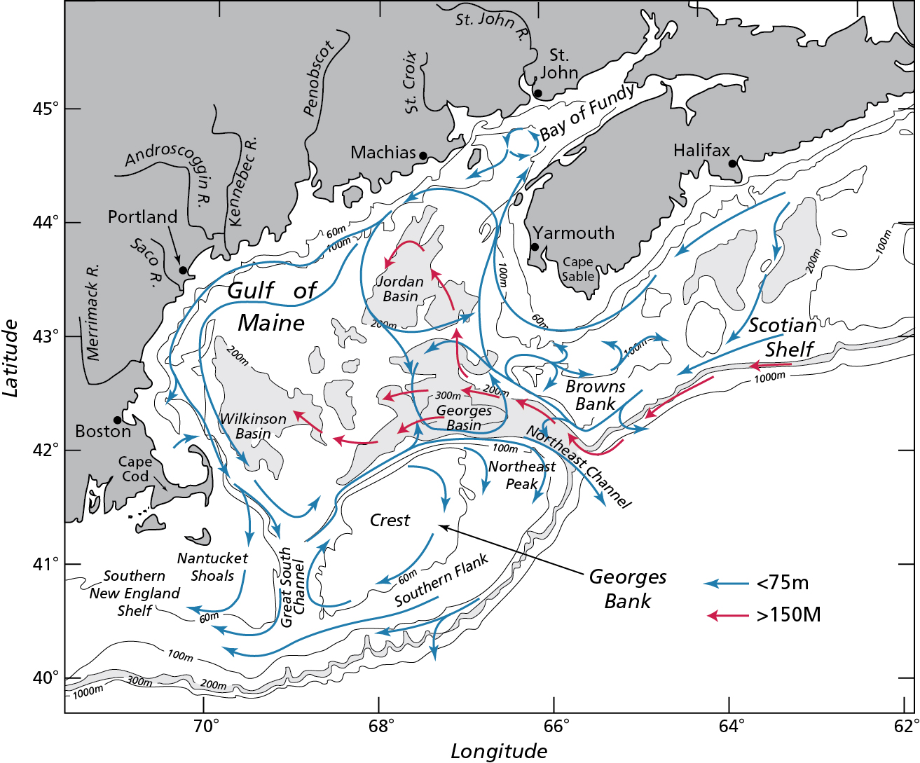

Figure 1. General circulation in the Gulf of Maine / Georges Bank region during stratified conditions (May to September). From Beardsley et al. (1997).

McGillicuddy et al., Figure 2.

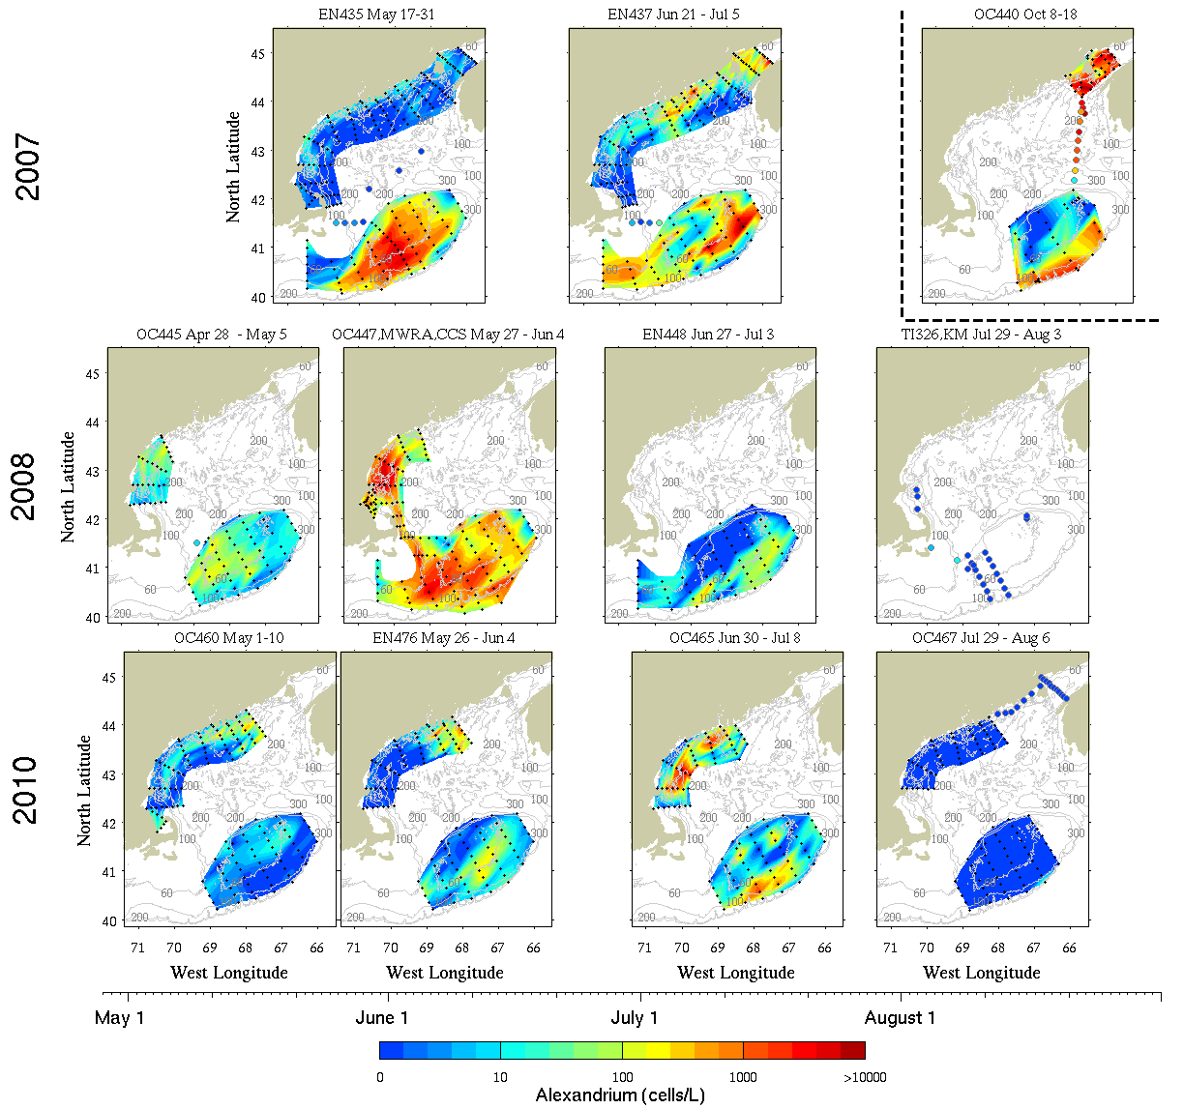

Figure 2. *A. fundyense* surface concentrations observed on survey cruises in 2007, 2008, and 2010. Black dots denote the locations of samples used to construct the maps; colored dots indicate *A. fundyense* surface concentrations in areas for which there are not sufficient data to map the distribution. The horizontal position of each map reflects the timing of each survey (time axis located above the color bar), with the exception of the upper right panel which reports “live” microscope counts from underway samples collected during the fall 2007 cyst survey (October 8-18, 2007). The live counts from fall 2007 are presented for informational purposes only and not included in further analysis.

McGillicuddy et al., Figure 3.

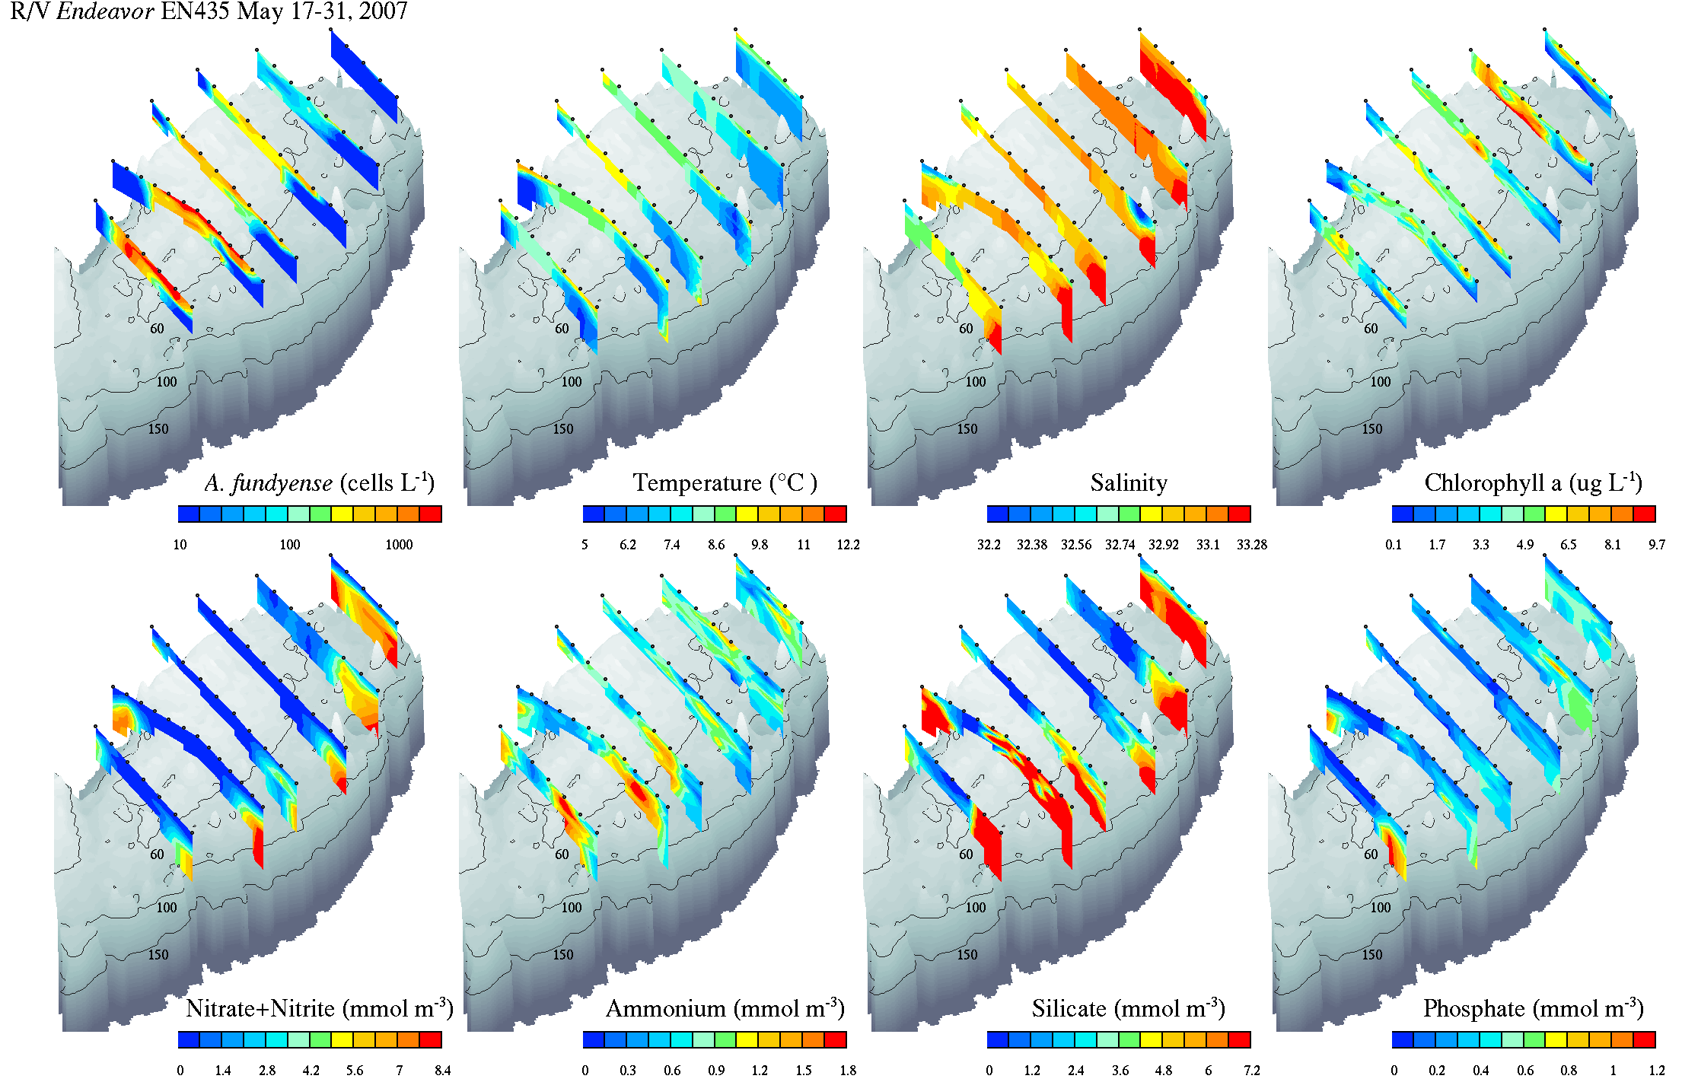

Figure 3. Vertical sections of *A. fundyense*, temperature, salinity, chlorophyll a, nitrate + nitrite, ammonium, silicate, and phosphate from R/V *Endeavor* cruise EN435, May 17-31 2007. Black dots along the top of each section indicate the station locations. Standard sampling depths were 1, 10, 20, 30, 40, 50, 100, 150, 200, 250m / near bottom. Grey shading shows bathymetry; 60m, 100m, and 150m isobaths are indicated.

McGillicuddy et al., Figure 4.

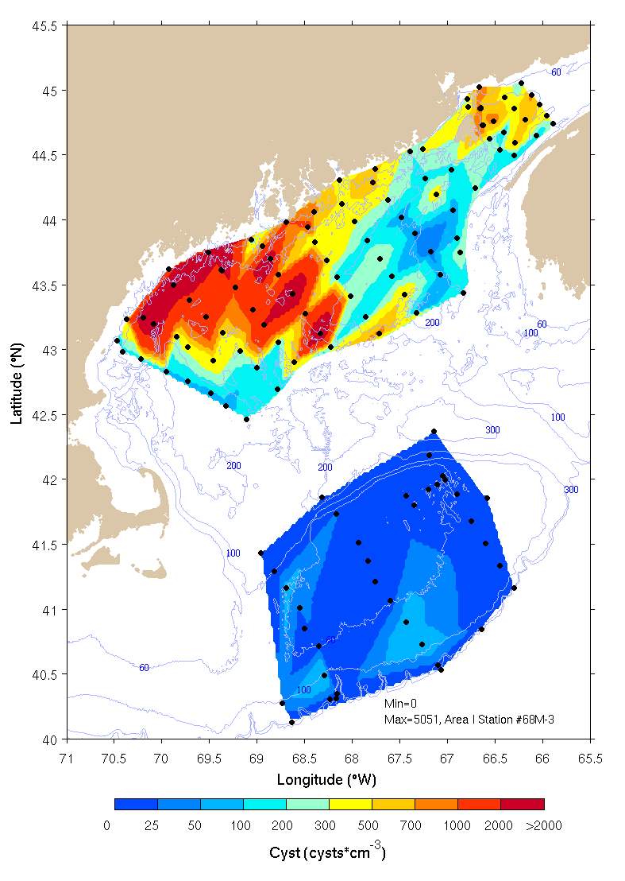

Figure 4. *A. fundyense* cyst abundance in the upper 1cm layer of sediment observed in October 2007 (R/V *Oceanus* Voyage #440). Black dots denote the locations of sediment samples used to construct the maps.

McGillicuddy et al., Figure 5.

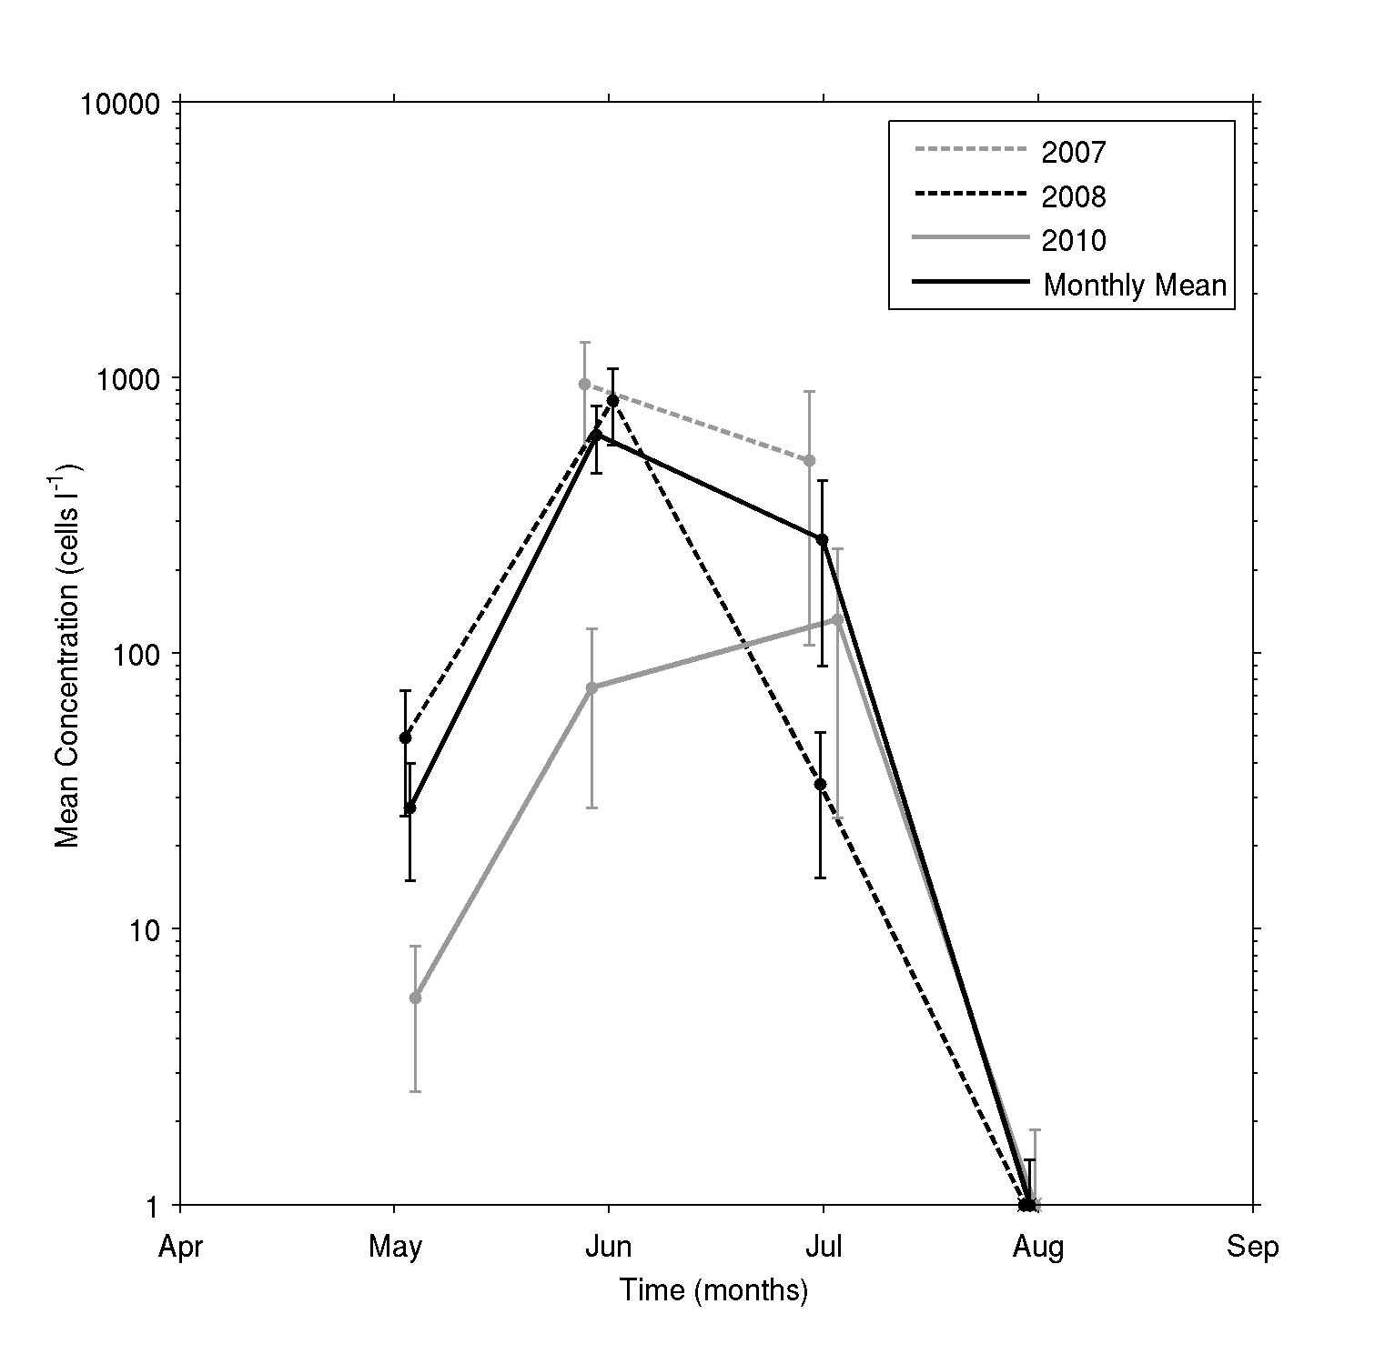

Figure 5. Seasonal to interannual variability in surface *A. fundyense* concentrations on Georges Bank.

McGillicuddy et al., Figure 6.

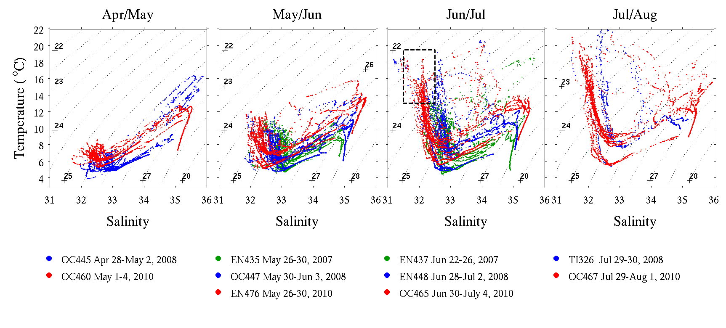

Figure 6. Temperature / salinity characteristics of hydrographic profiles on Georges Bank: 2007, 2008, 2010. Cruise numbers refer to Table 1. The dashed box in the June /July panel indicates the criteria (31.5 < S < 32.5, 13.0°C < T < 19.0°C) used to infer the origin of the water mass anomaly associated with bloom decline in 2008 (see text).

McGillicuddy et al., Figure 7.

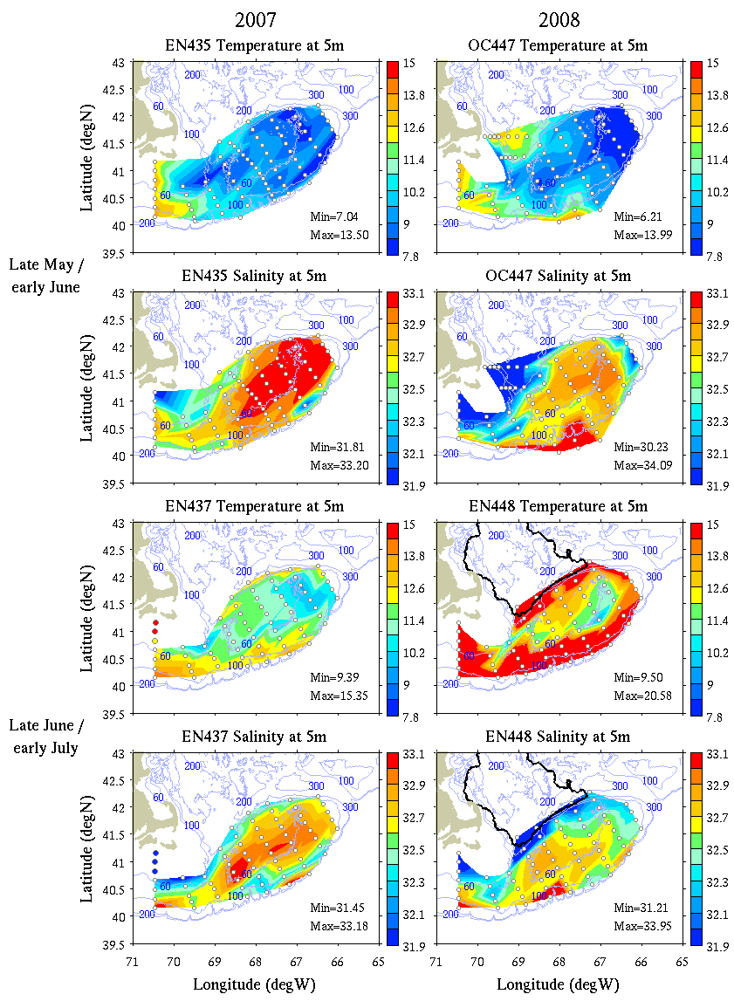

Figure 7. Temperature and salinity at 5m in late May / early June and late June / early July 2007 and 2008. Solid black contour in the lower right panels indicates the origin of the water mass bounded by 31.5 < S < 32.5 and 13.0°C < T < 19.0°C (dashed box in Figure 6) based on the climatology of Lynch et al. (1996).

McGillicuddy et al., Figure 8.

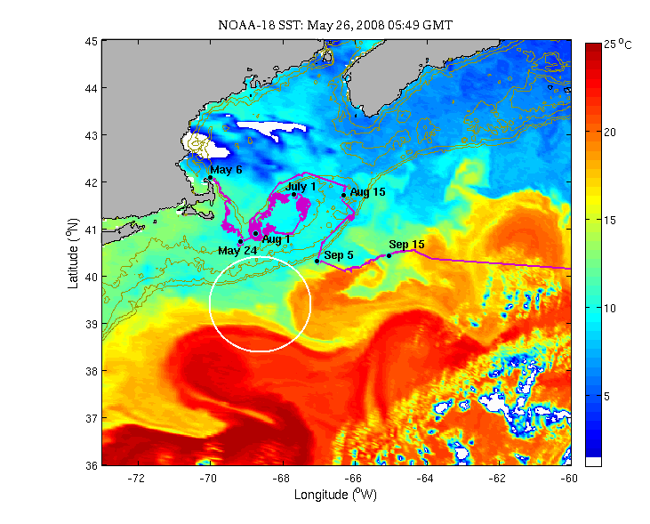

Figure 8. Sea surface temperature image for May 26, 2008. The white circle indicates the meander-driven shelf water export described in the text. Trajectory of a surface drifter released northeast of Cape Cod on May 6 is plotted in magenta (drifter ID #85291 obtained from http://www.nefsc.noaa.gov/drifter/).

McGillicuddy et al., Figure 9.

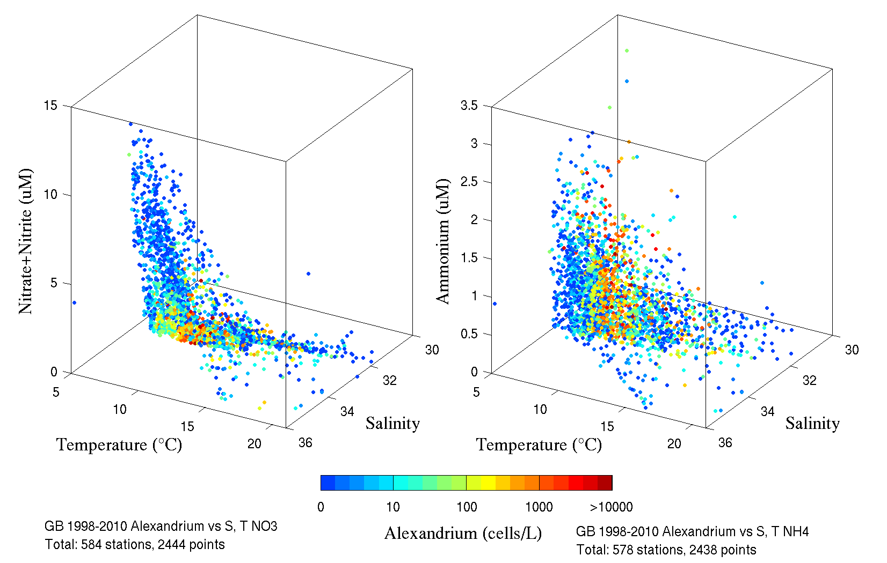

Figure 9. *A. fundyense* concentration plotted as a function of temperature and nitrate plus nitrite (left) and ammonium (right); note that live counts from OC440 (October 8-18, 2007, Figure 2) are not included.

McGillicuddy et al., Figure 10.

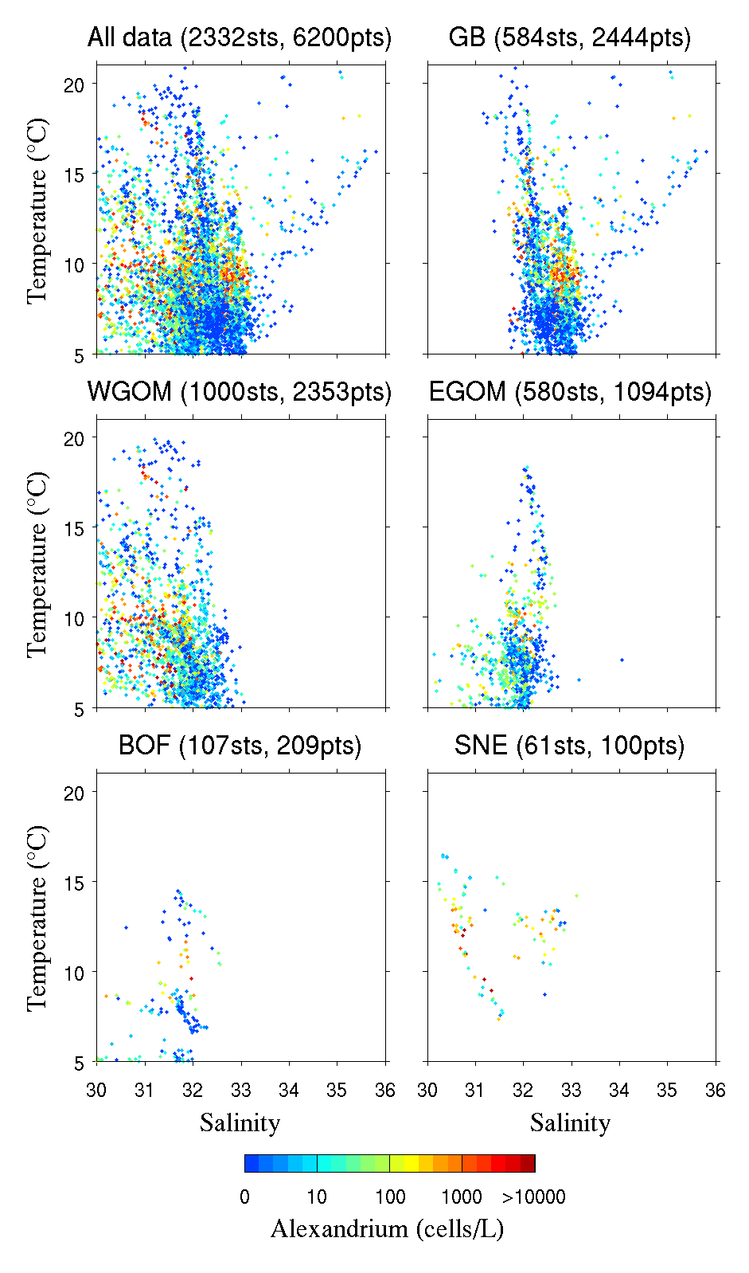

Figure 10. *A. fundyense* concentration plotted as a function of temperature and salinity for the entire Gulf of Maine / Georges Bank region (upper left) and various subdomains: Georges Bank (GB), the western Gulf of Maine (WGOM), the eastern Gulf of Maine (EGOM), the Bay of Fundy (BOF), and the southern New England shelf (SNE). Note that these plots include not only data from the present study, but also prior data in the region starting in 1998 (Anderson et al. 2005b; Keafer et al. 2005; McGillicuddy et al. 2005b; Townsend et al. 2001); live counts from OC440 (October 8-18, 2007, Figure 2) are not included.

**Appendix A: Vertical sections.**

Vertical sections of *A. fundyense*, temperature, salinity, chlorophyll a, nitrate + nitrite, ammonium, silicate, and phosphate from the cruises listed in Table 1 for which cell counts are available throughout the water column. Black dots along the top of each section indicate the station locations. Standard sampling depths were 1, 10, 20, 30, 40, 50, 100, 150, 200, 250m / near bottom. Grey shading shows bathymetry; 60m, 100m, and 150m isobaths are indicated.

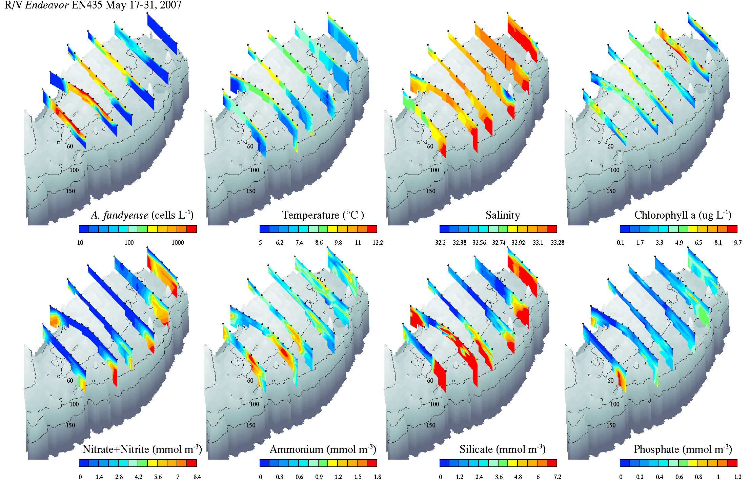

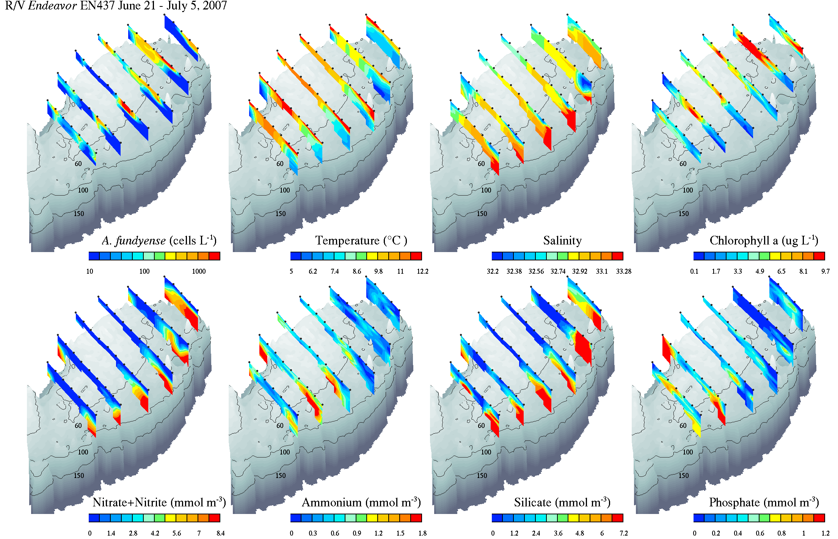

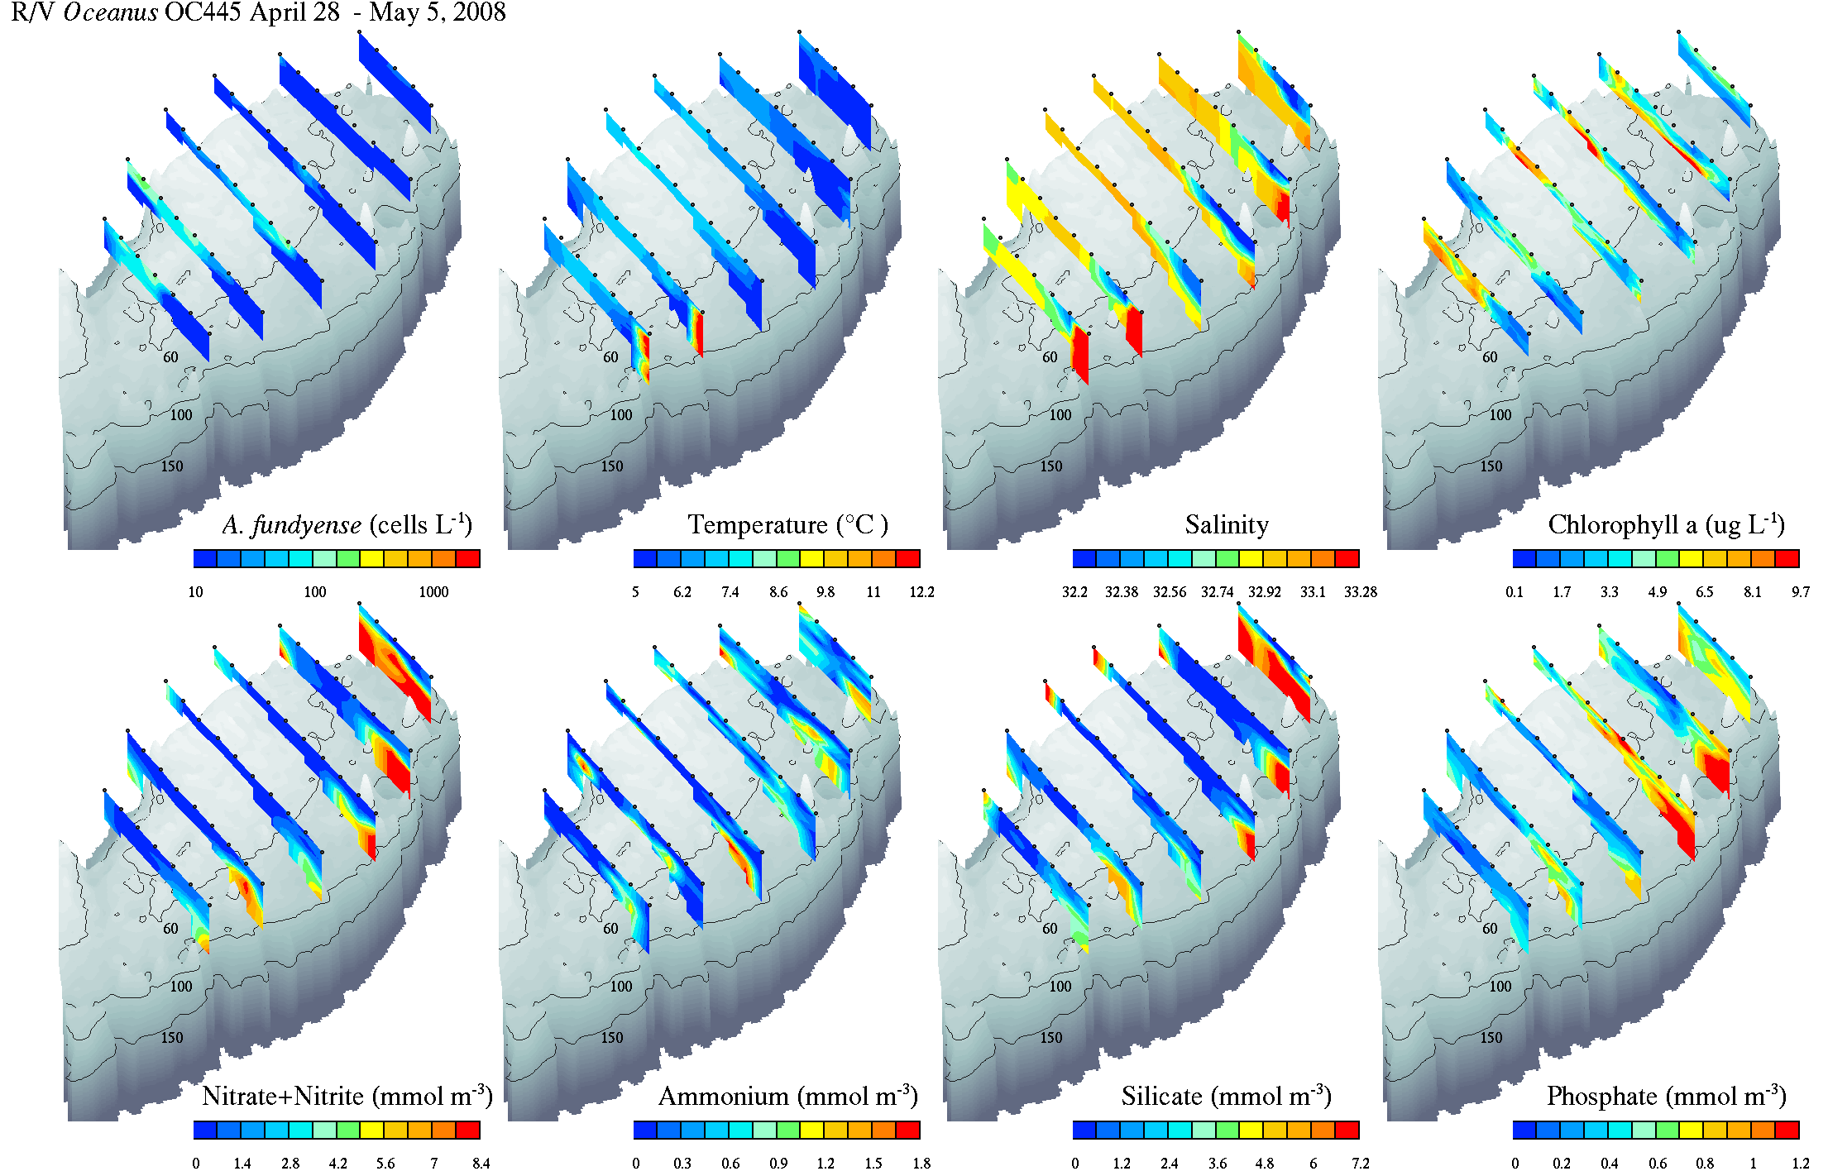

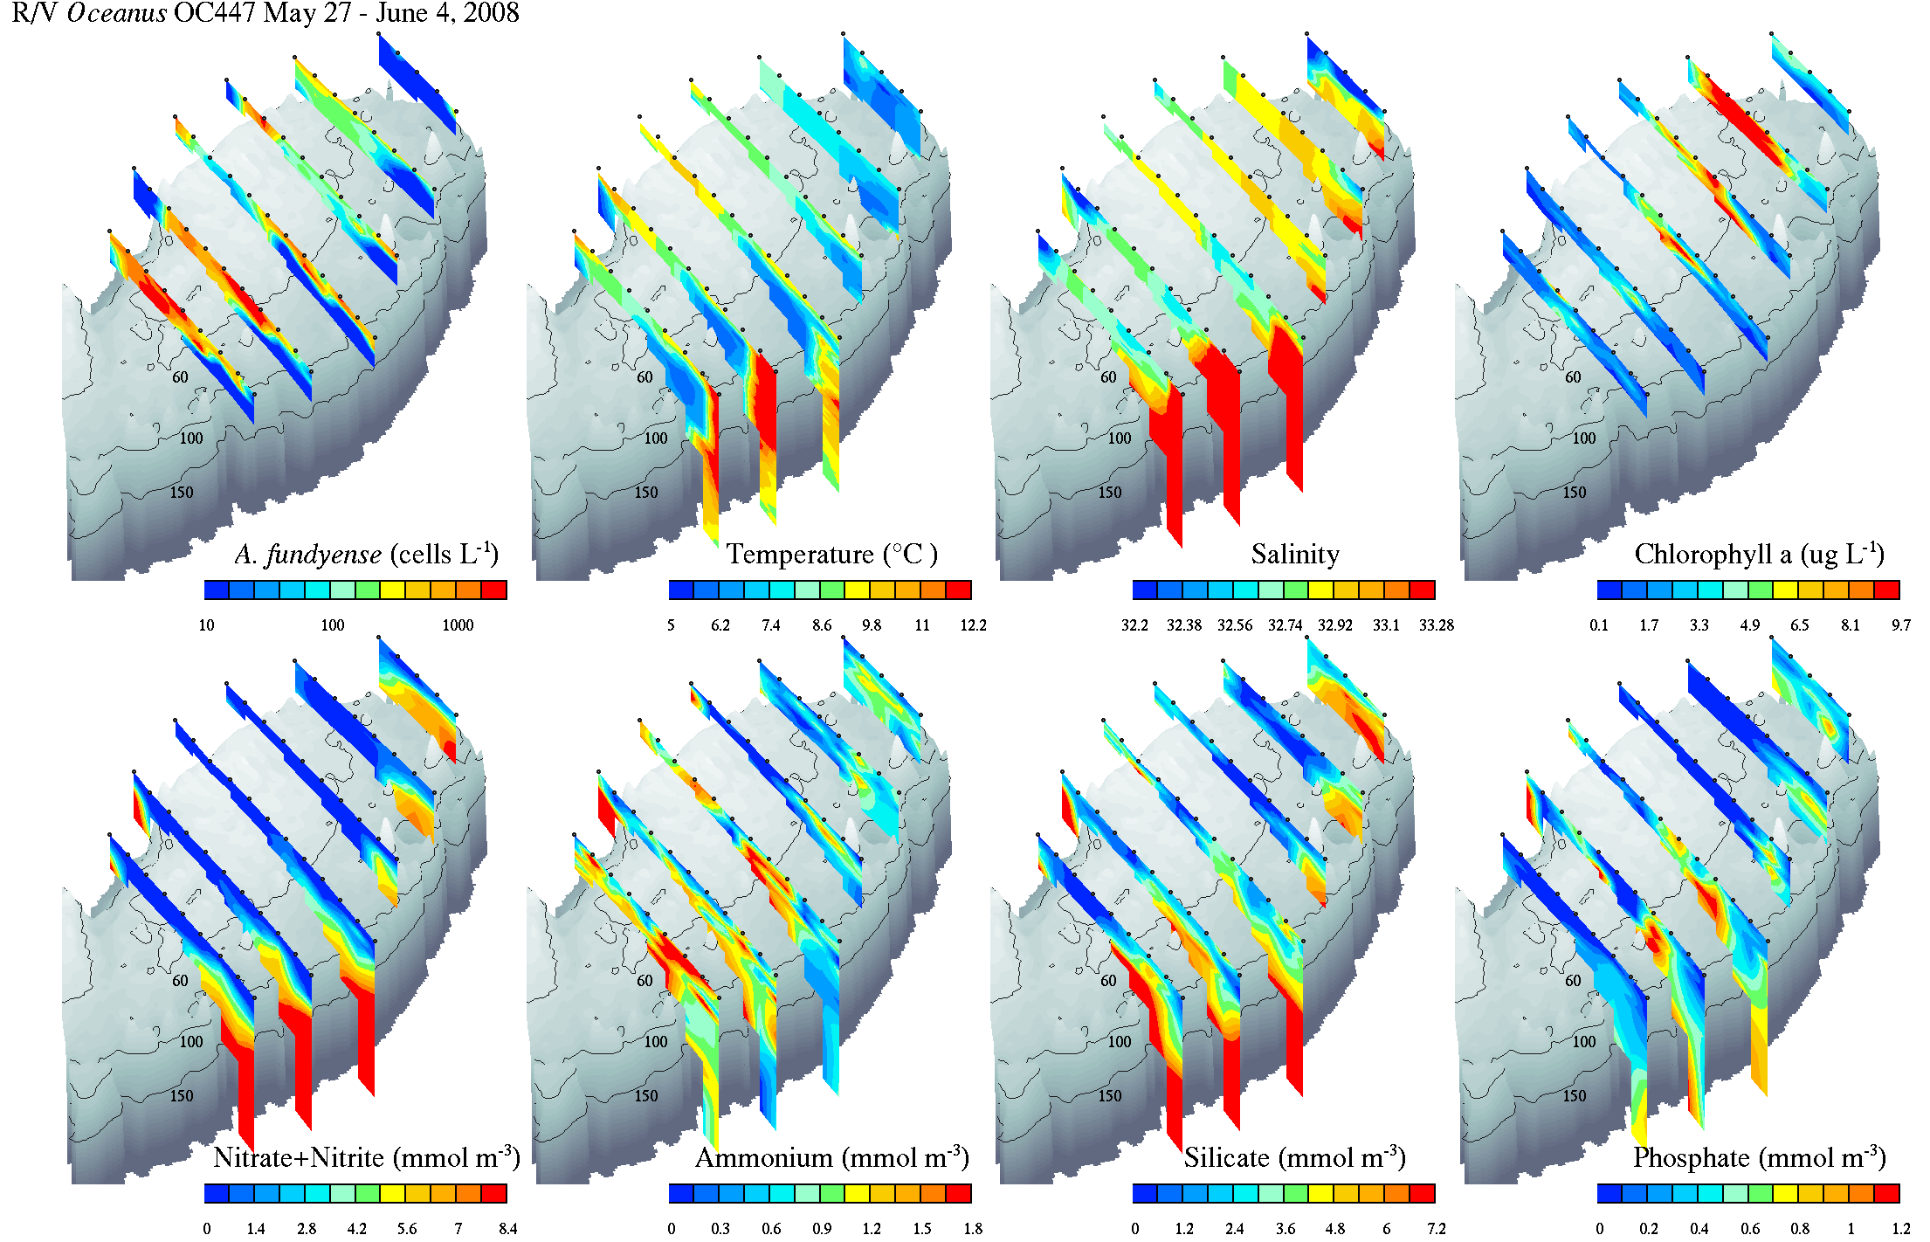

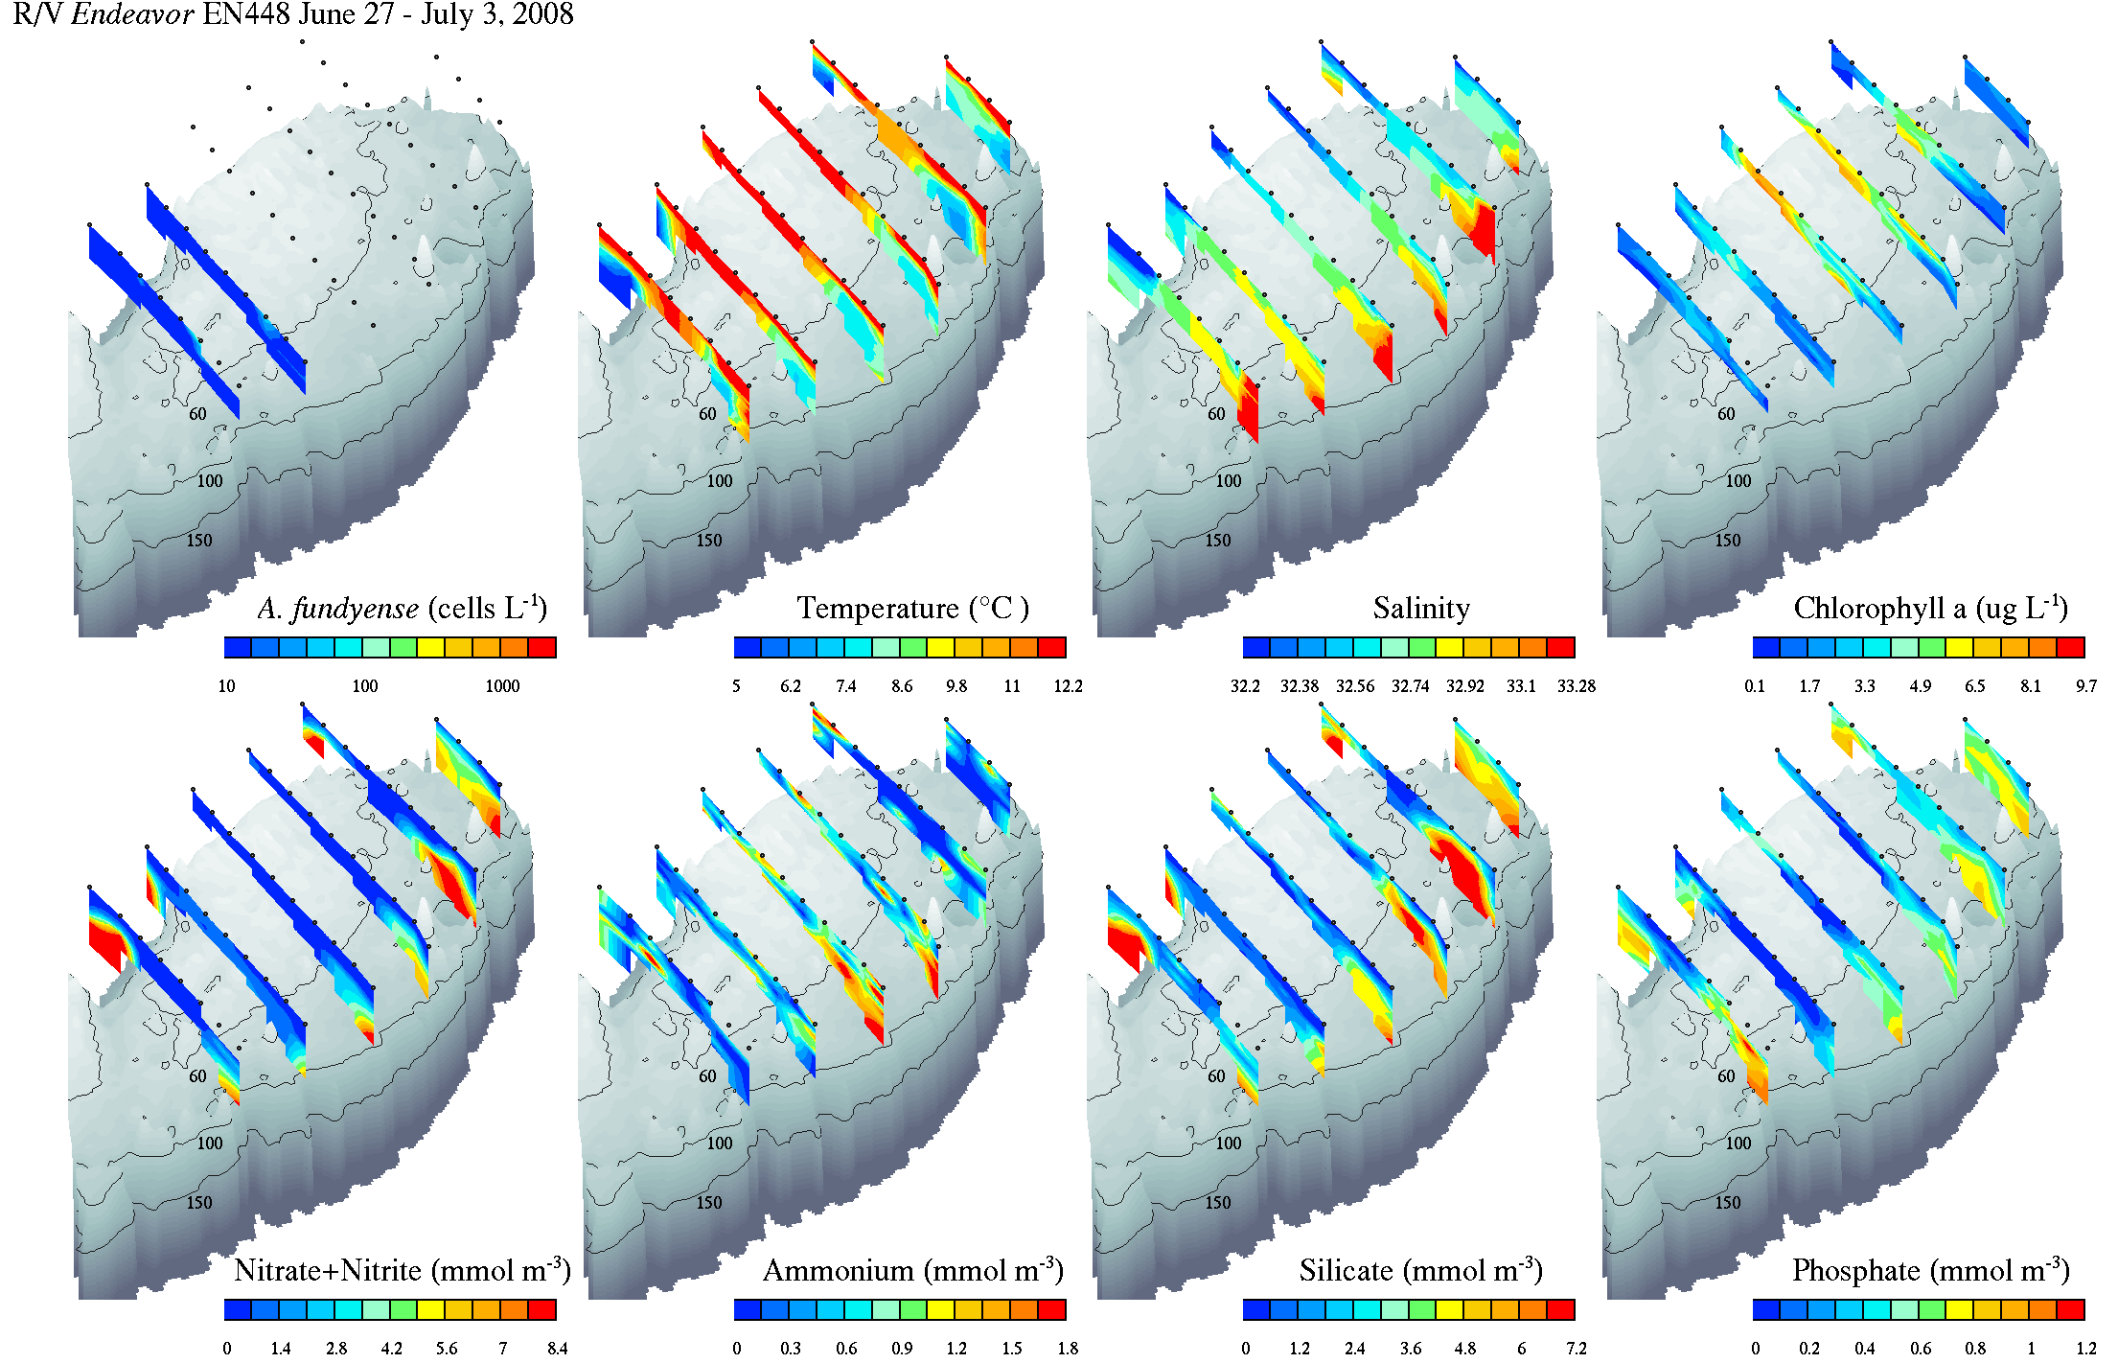

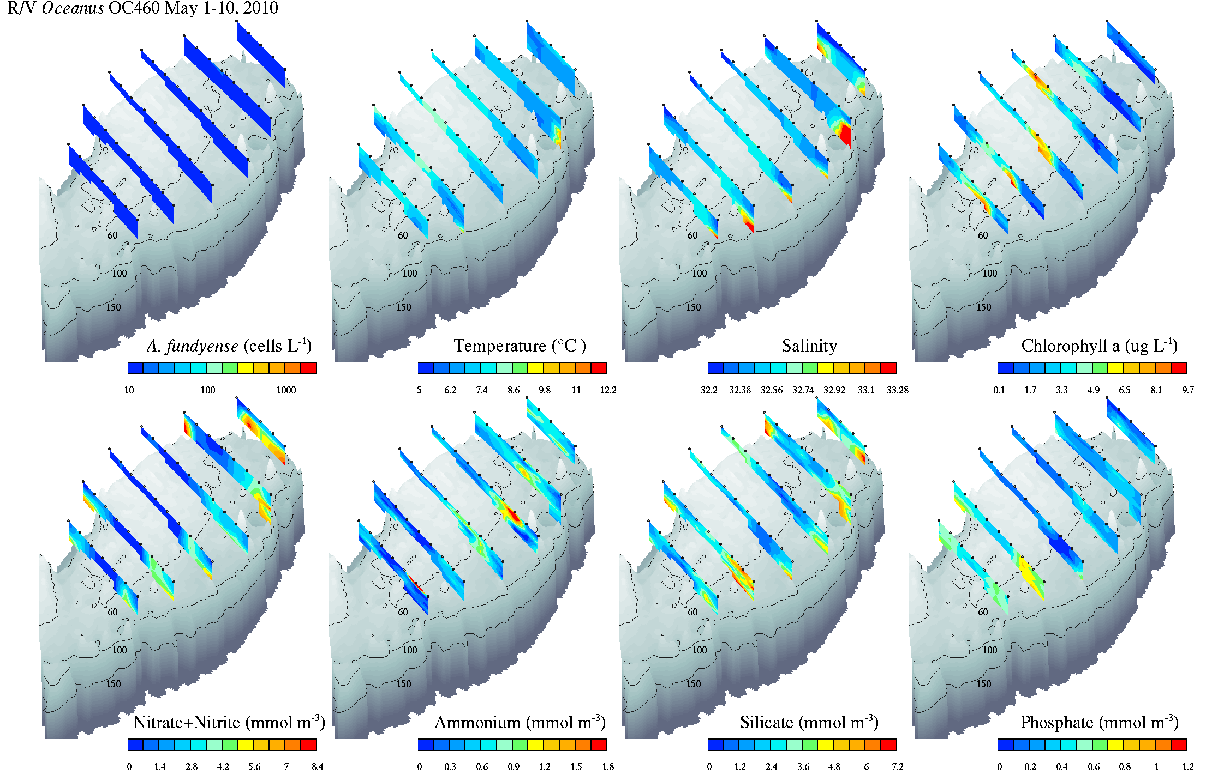

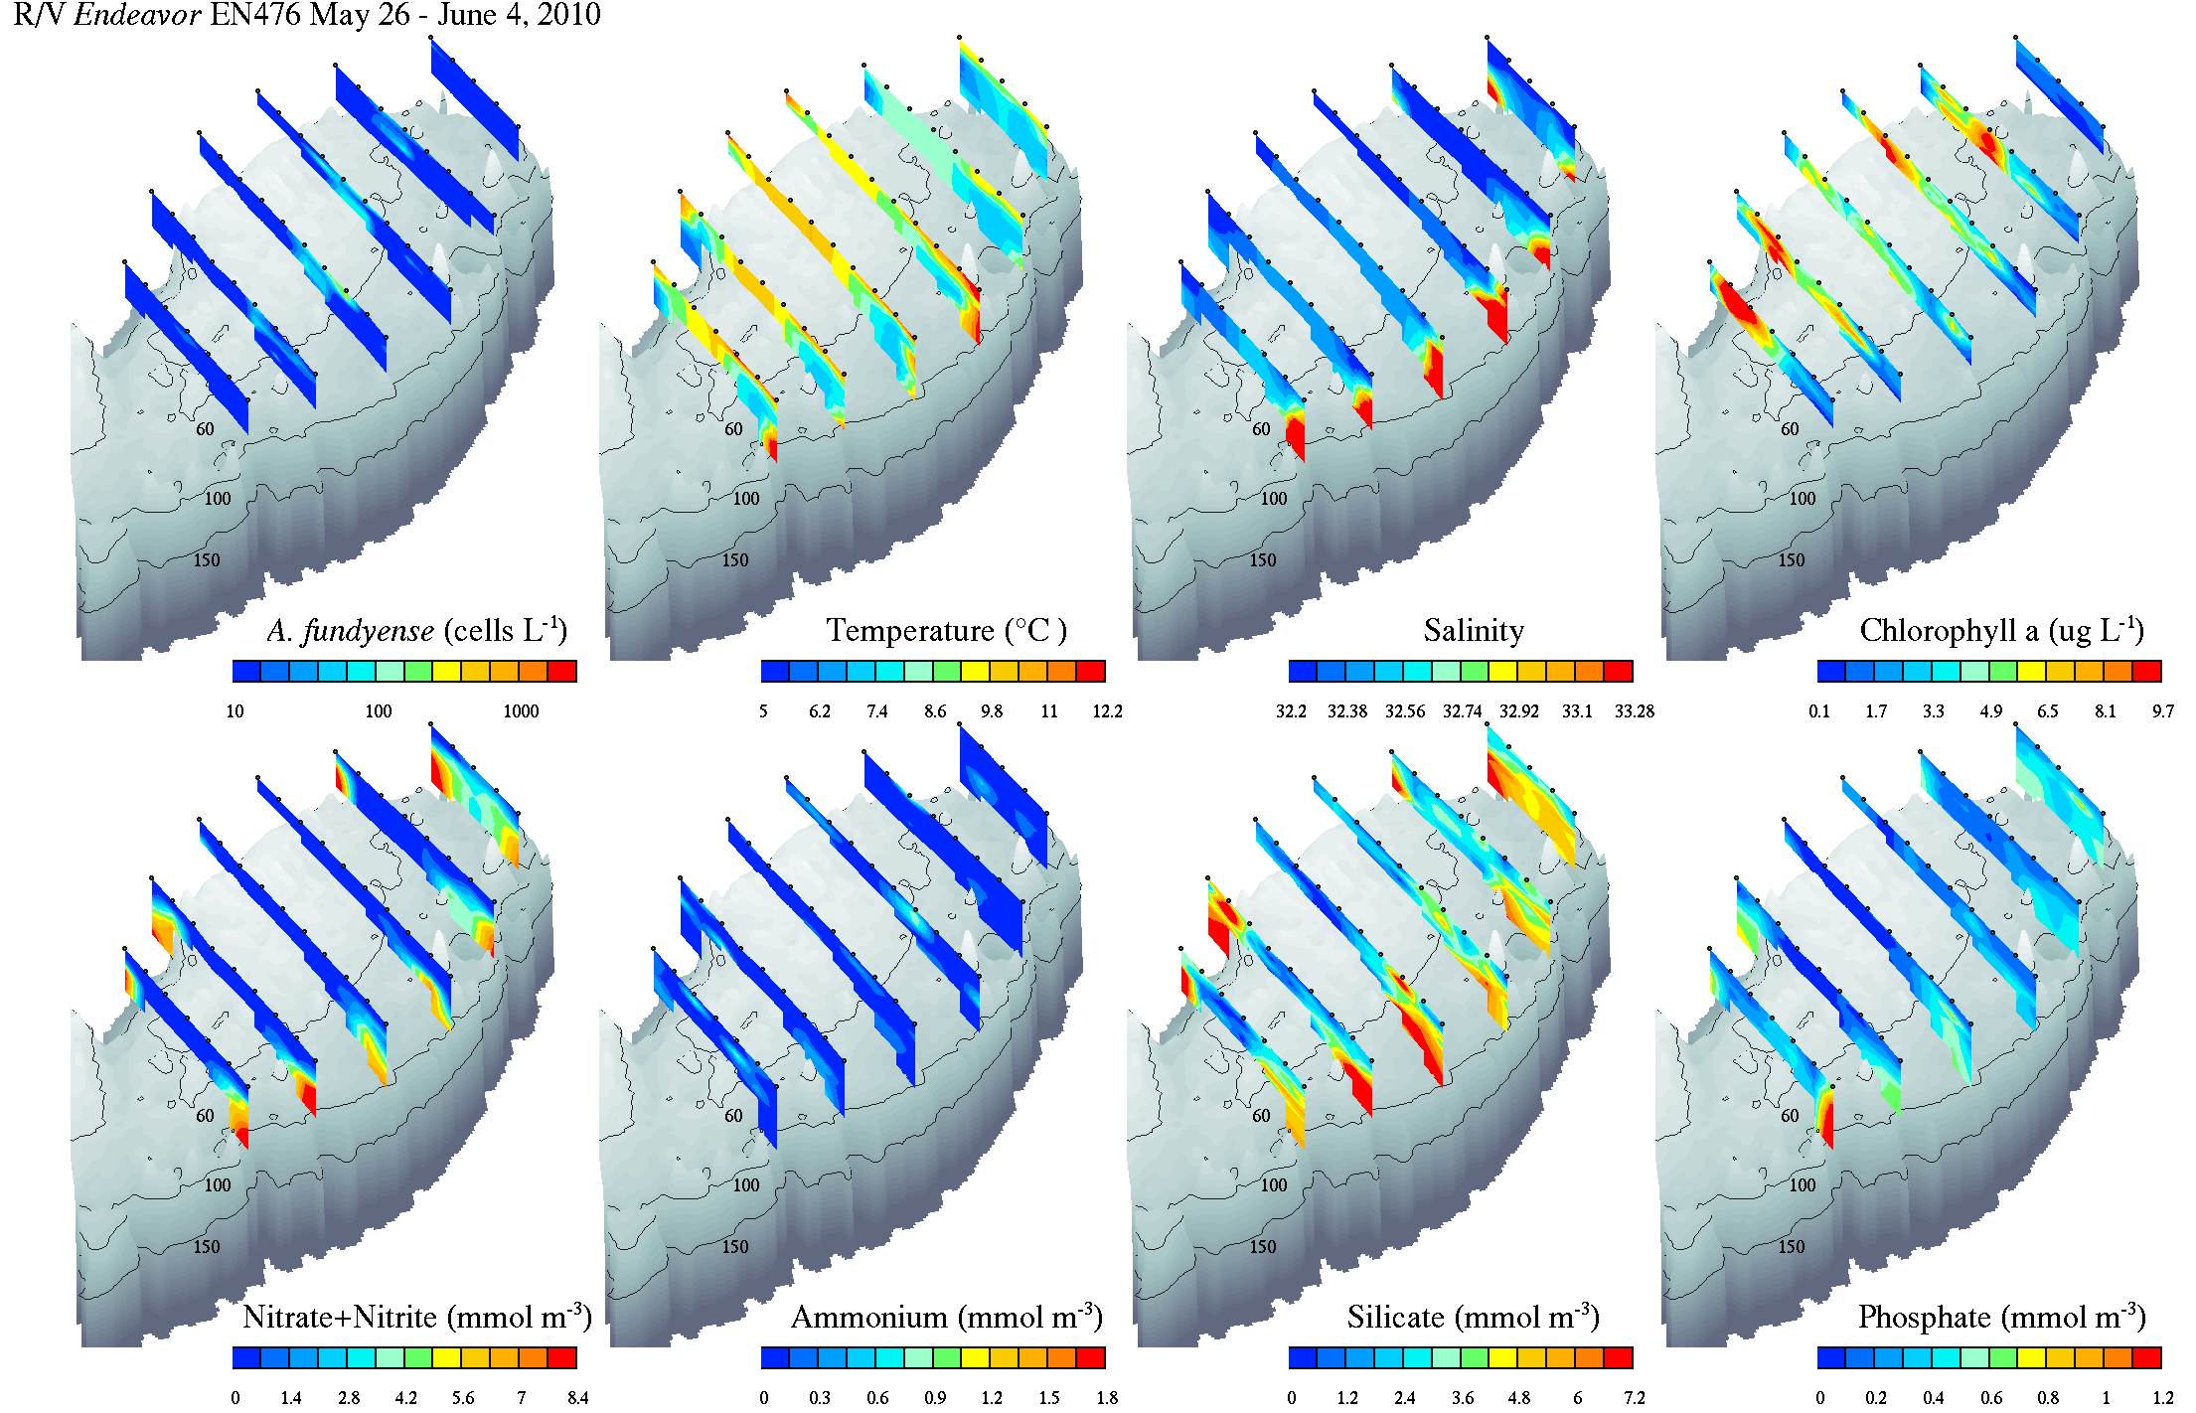

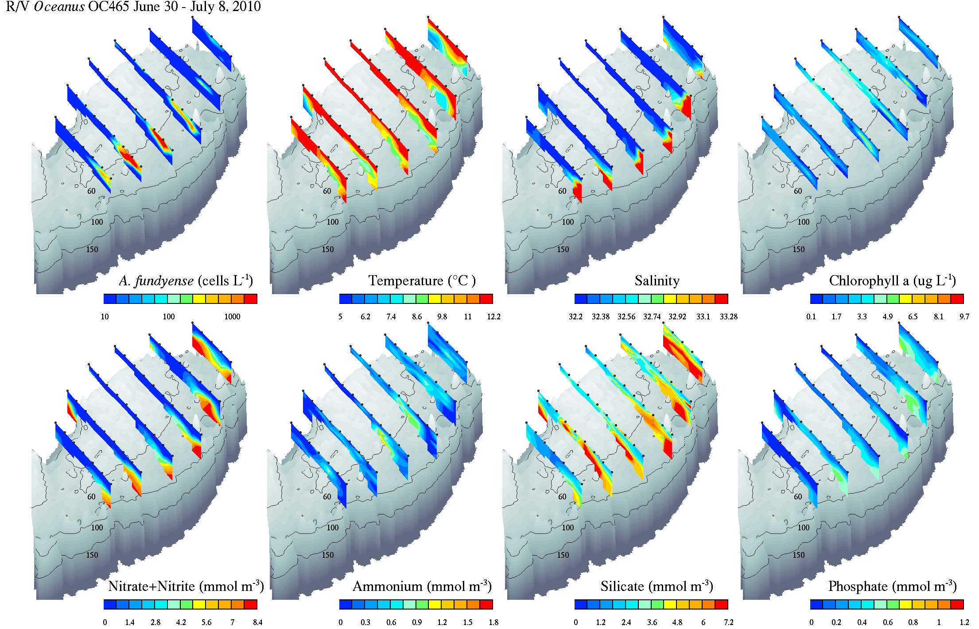

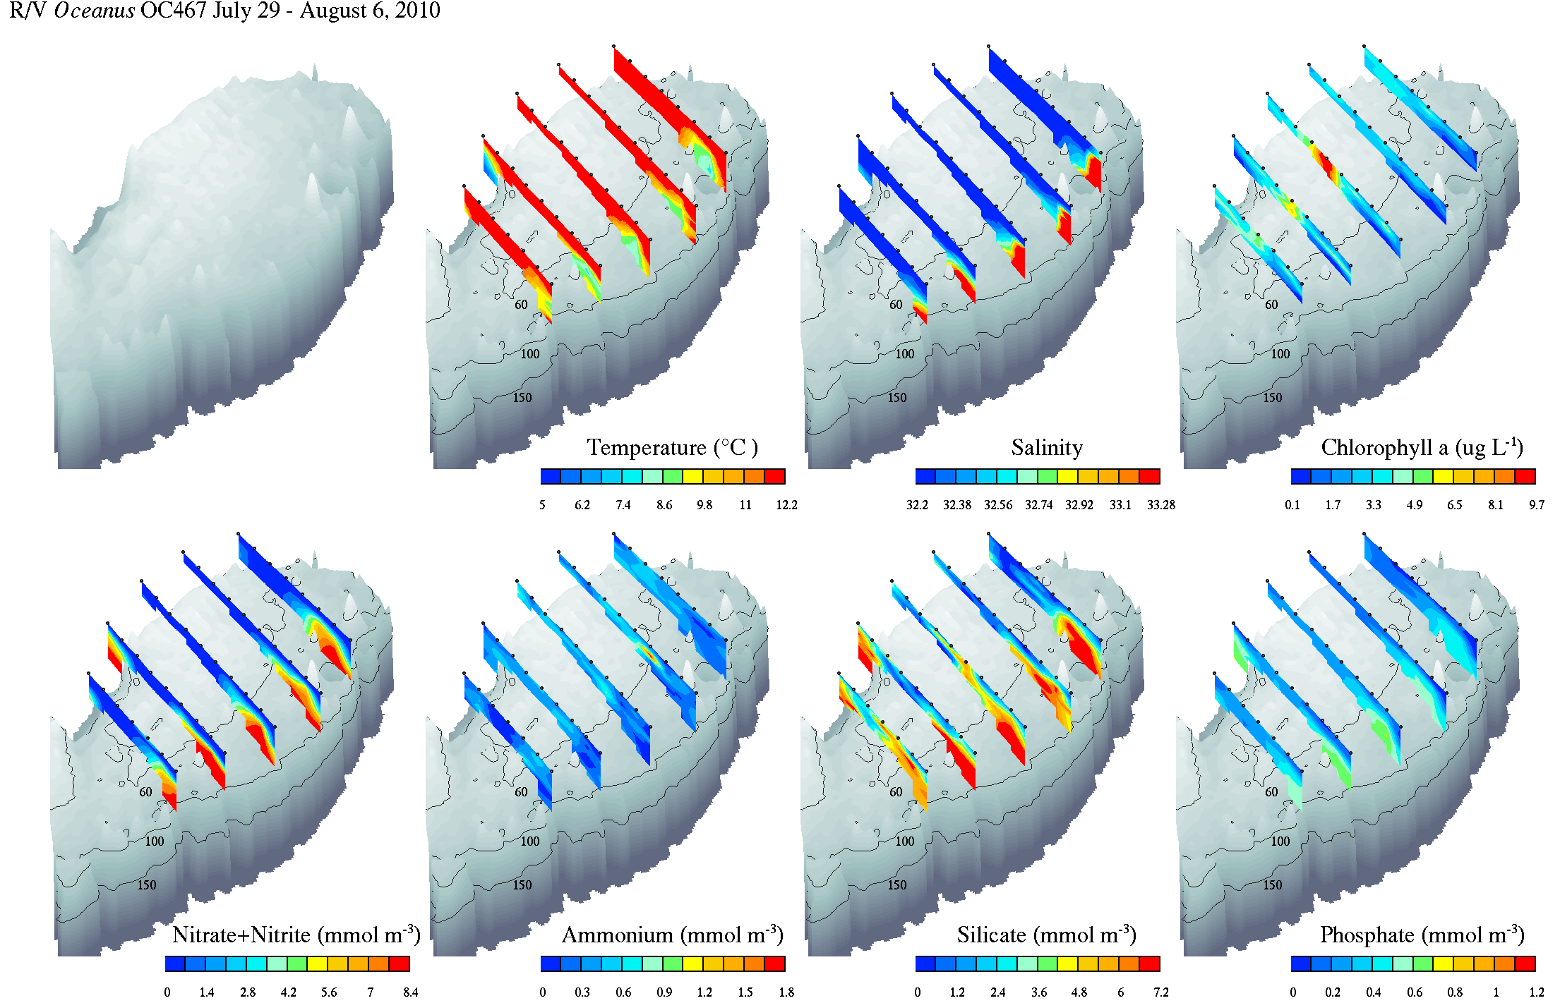

**Appendix B: Prior sampling of *Alexandrium* spp. on Georges Bank.**

In the aftermath of shellfish toxicities on Georges Bank exceeding the threshold for safe human consumption in the spring of 1990, plankton sampling was undertaken in concert with ongoing monitoring of shellfish for the period 1990-1992 (Nassif and Temperi, 1993; Figures B1-B3). Samples in 1990 were collected with a 15µ mesh conical plankton net, whereas those in 1991 and 1992 were collected with Niskin bottles. In all cases the samples were analyzed with standard light microscropy. *Alexandrium* spp. was not found at any of the stations sampled in 1990 and 1992. Most of the samples from 1991 contained no *Alexandrium* spp., but there were a few stations in which low concentrations (< 50 cells l-1) were present.

Bank-wide surveys were carried out in May and June 1998 (Kemper 2000) and June 1999 (Table B1) in conjunction with the U.S. GLOBEC Georges Bank Broad-scale cruises (Wiebe et al. 2006). Although cell detection methods used in these data sets do not permit distinction between *A. fundyense* and other morphologically similar non-toxic species, it is nevertheless valuable to compare the observed distributions (Figure B4) and mean bank-wide concentrations (Figure B5) of *Alexandrium* spp. with the results presented herein. In May and June 1998, the observed abundance was within the range of variability observed in 2008-2010. However, in June 1999 far fewer *Alexandrium* spp. were present, with the mean concentration falling well below the seasonal average in 2008-2010.

Analysis of contemporaneous hydrography suggests that the interannual variations in *Alexandrium* spp. observed in 1990-1992 and 1998-1999 are generally consistent with the present finding that *A. fundyense* populations thrive when waters on Georges Bank are relatively cold and salty. This is precisely the condition that prevailed in 1990 when the spike in shellfish toxicity occurred (Figure B6). Although no *Alexandrium* spp. were found in the plankton tows (Figure B1), sampling did not begin until late June when the bloom is typically winding down (Figure B5). In light of the high toxin content observed in mussels in May 1990 (White et al. 1993) and the characteristic depuration time of months for *Mytilus edulis* (Silvert and Cembella 1995), there is little doubt that an *A. fundyense* bloom had occurred earlier that spring/summer.

In contrast, 1991 and 1992 were characterized by an anomalously cold water mass (Figure B6). The temperature minimum on the bank was at least 2°C colder than in the 2008-2010 era sampled herein, and appeared to be accompanied by a freshening in April/May 1991. Sampling for *Alexandrium* spp. was undertaken before, during, and after the time at which the population typically peaks, and no appreciable concentrations were found. The long-term decline in toxicity of surf clams (White et al. 1993), for which the depuration time scale is on the order of years (Silvert et al. 1998), is consistent with the absence of *A. fundyense* blooms while this anomalously cold water mass was present during this period.

Water mass conditions in 1998 and 1999 were more similar to 2008-2010 (Figure B6), as was the abundance of *Alexandrium* spp. (Figures B4, B5). However, abundance was lower in June 1999 than it was in June 1998, despite the saltier conditions. Although this could have been a result of differences in bloom timing, the lack of a seasonal data set for this time period precludes a definitive answer. A more likely explanation is of course the limitations inherent in correlating *Alexandrium* spp. abundance with temperature and salinity. Nevertheless, the observations from 1990-1992 and 1998-1999 offer a means for additional scrutiny of the hypothesized niche of *A. fundyense* on Georges Bank, and to first order they are consistent with the “leaky incubator” model.

|  |  |  |  |
| --- | --- | --- | --- |
| Year | Dates | Vessel / Voyage number | Cell detection method |
| 1998 | May 13-22 | R/V *Albatross IV*, AL9806 | Light microscopy |
| 1998 | June 16-26 | R/V *Albatross IV*, AL9808 | Light microscopy |
| 1999 | June 14-24 | R/V *Albatross IV*, AL9906 | Immunofluorescence assay |
| Table B1. Research voyages in the 1990s during which *Alexandrium* spp. populations were sampled on Georges Bank as part of the U.S. GLOBEC Broad-scale sampling program (Wiebe et al. 2006). | | | |

Figure B1. Sampling locations in 1990.

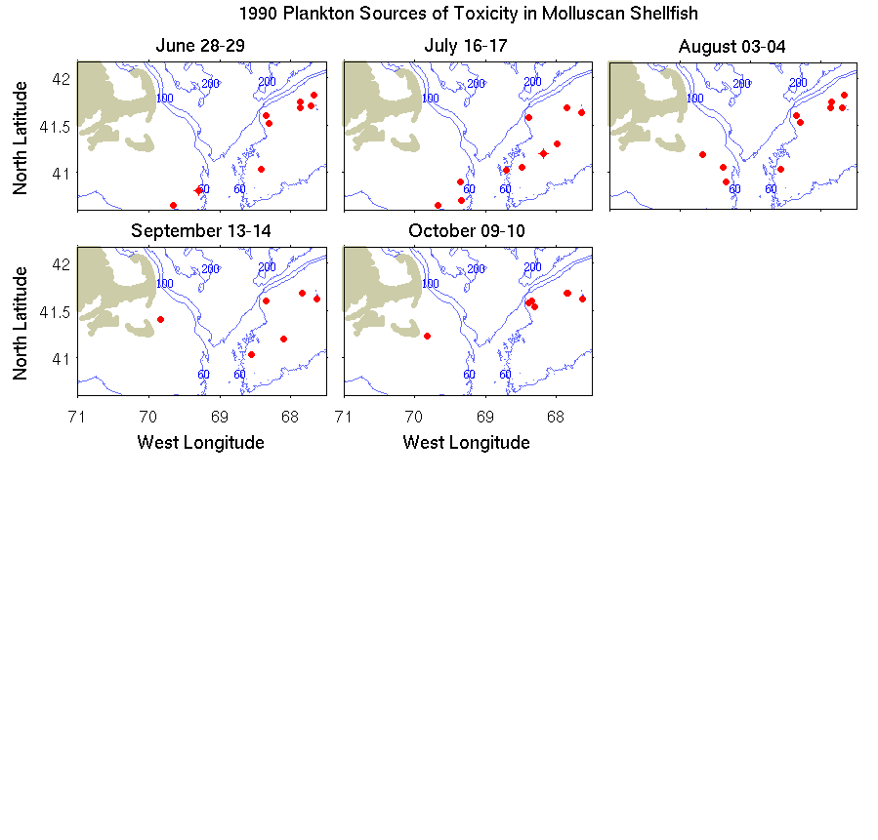

Figure B2. Sampling locations in 1991.

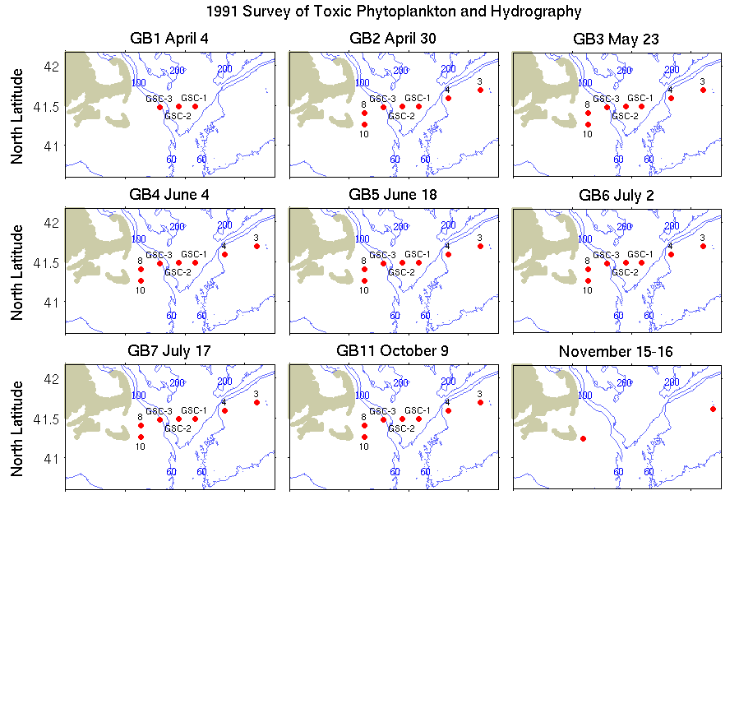

Figure B3. Sampling locations in 1992.

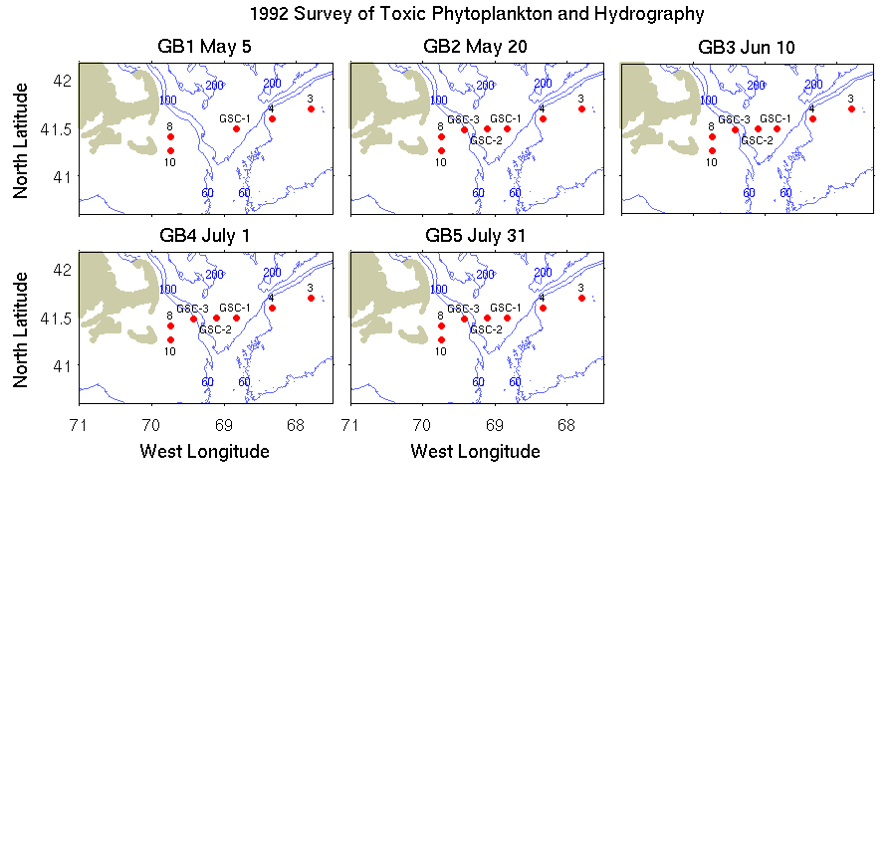

Figure B4. Surface *Alexandrium* spp. distributions derived from the cruises listed in Table B1.

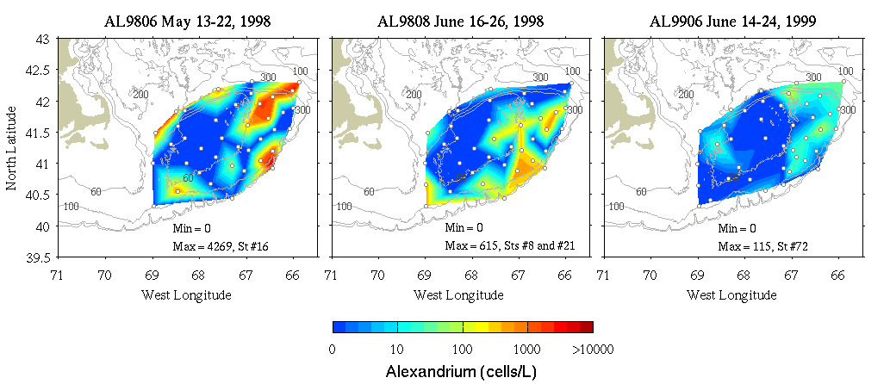

Figure B5. Seasonal to interannual variability in surface *Alexandrium* spp. concentrations on Georges Bank. Monthly means are computed from the 2007-2010 data specific to *A. fundyense*, as in Figure 5. Data from 1998 and 1998 (Table B1) are not species-specific and therefore not included in the monthly means.

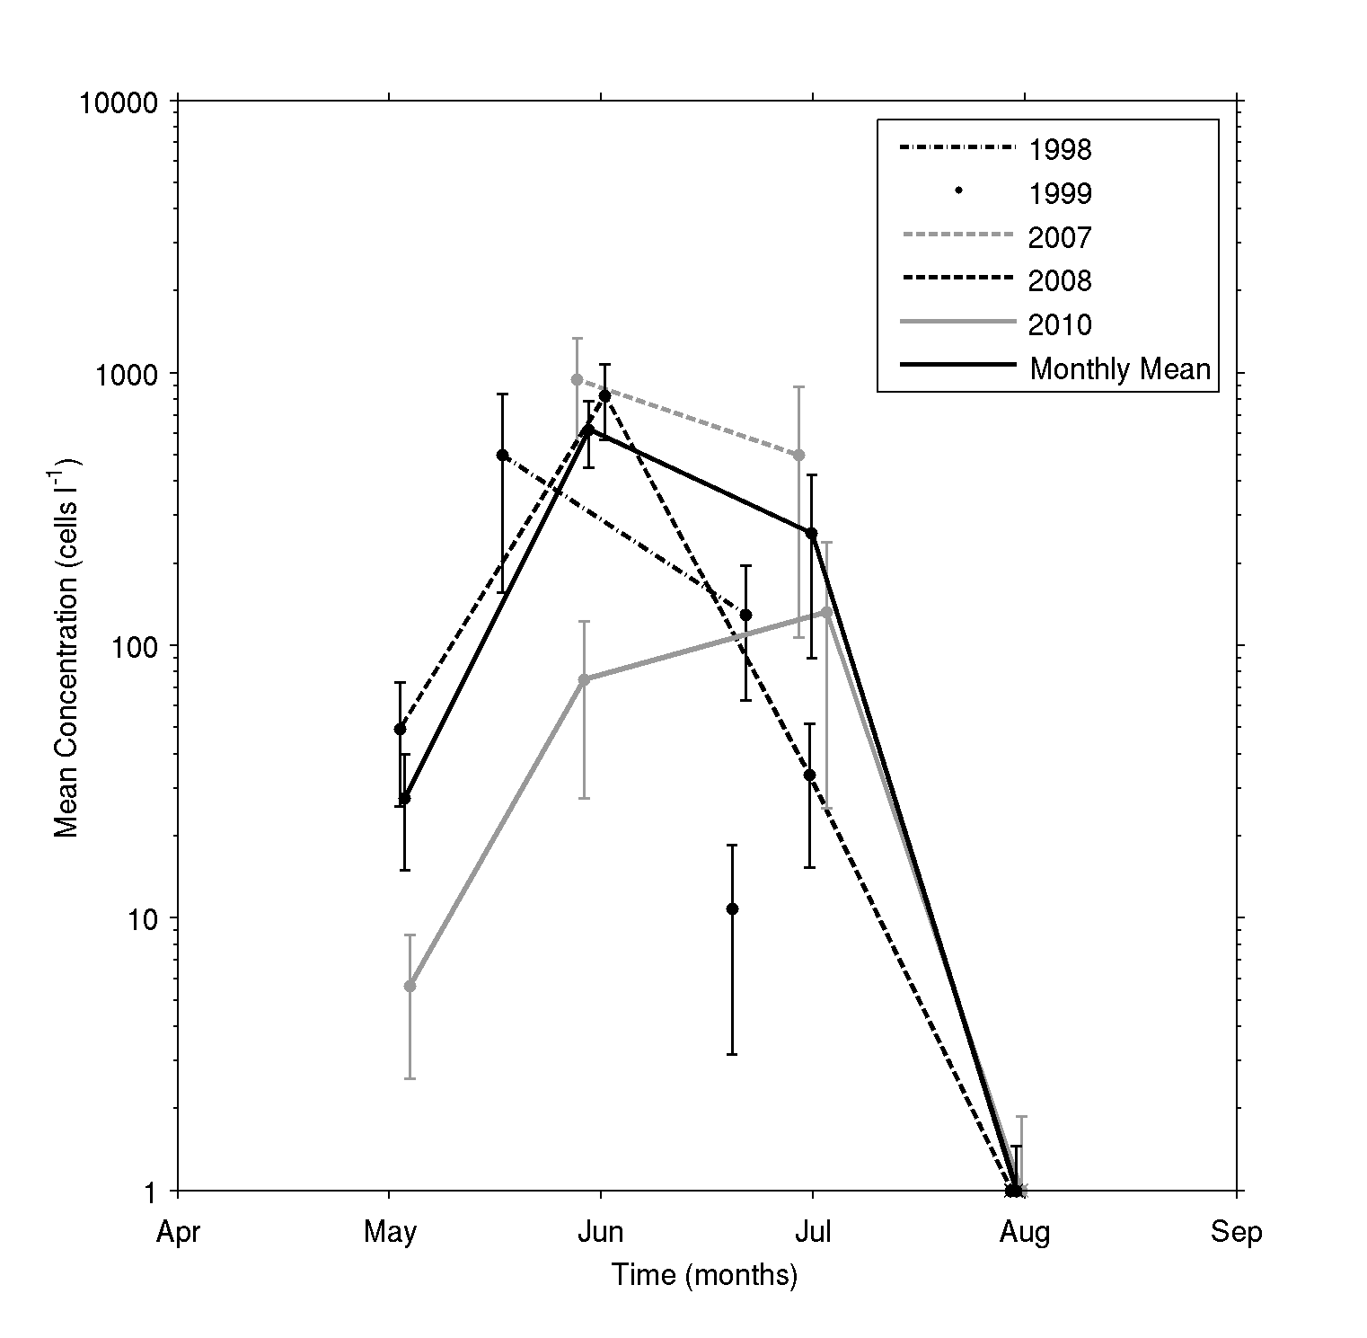

Figure B6. Temperature / salinity characteristics of hydrographic profiles on Georges Bank. Cruises from 2007, 2008, and 2010 (Table 1) are shown in gray. Data from 1990-1992 are from the National Oceanic and Atmospheric Administration’s ongoing monitoring of the region by the Northeast Fisheries Science Center (NEFSC; see <http://www.nefsc.noaa.gov/HydroAtlas/>). Data from 1998 and 1999 come from U.S. GLOBEC Broad-scale survey cruises (Table B1).

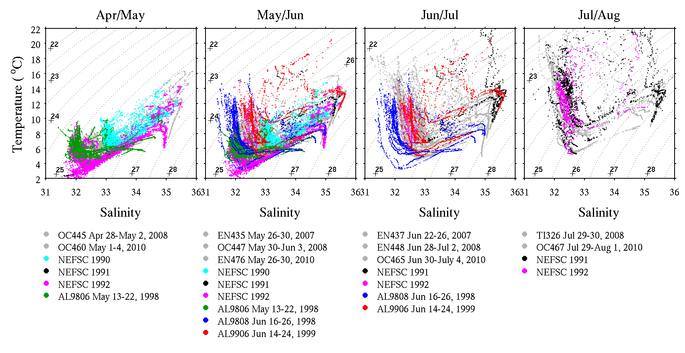

1. Gulf of Maine TOXicity (GOMTOX) <http://www.whoi.edu/gomtox/>