The Effect of Varying Freshwater Inputs on
Regional Ecosystems in the North Atlantic

Annual Report 2011

Findings Report

We began our joint project with a kickoff meeting in Woods Hole in September 2008. During that meeting, our overall objectives were refined and initial milestones were identified, including the following specific objectives for the UMass project:

- Implement and test a proto-type high-resolution workbench (HRW) model;
- Add the COSiNE ecosystem model to ROMS, evaluate the resulting coupled model, and begin simulations in the HRW domains;

The combined project team has continued to make sustained progress across these science and technical areas as was reported by Haidvogel from Rutgers; here we report the progress from the UMassD team as follows.

Objectives

Our research specifically addresses several mechanisms by which freshwater influx (or the lack thereof) might impact the population dynamics and production of Calanus finmarchicus in the North Atlantic. To address these objectives, we are (i) simulating basin-scale circulation fields from 1985-2007 using an eddy-resolving, validated model extended to include sea ice and riverine inputs of fresh water; (ii) utilizing a 10-component (lower trophic level) biogeochemical model to understand the biophysical pathways connecting the three Calanus gyres during the GLOBEC decade from 1990 to 1999; and (iii) forecasting the next 20 years (i.e., 2008-2028) of the state of the North Atlantic Ocean using idealized forcing fields (wind curl, heat flux, E-P) representing IPCC scenarios of climate change.

At UMassD, the focus for the first year had been on setting up the high-resolution North Atlantic basin-scale model and development of a salinity data base for validation. During the second year, the physical model has been running successfully and in recent months (February-March 2010) the joint team of UMass-UMaine has coupled the 10-component CoSINE with the ROMS high-resolution workbench (HRW) model. The second year of the coupled model run is complete and the first year of coupled model biogeochemical fields are being analyzed.

In the first combined project meeting at WHOI in September 2008, it was decided that two parallel development tracks for the basin-scale modeling would be needed to achieve accelerated progress on both the bio-physical coupling and adjoint modeling studies. Therefore, in addition to the low-resolution studies described by Haidvogel in the Rutgers Annual Report (2009), we at UMassD were pursuing a parallel implementation of the North Atlantic / Arctic model at higher (1/12°) resolution. The ultimate objectives of the high-resolution modeling are to simulate basin-scale circulation fields from 1985-2007 using an eddy-resolving, validated model extended to include sea ice and riverine inputs of fresh water; and to forecast the next 20 years (i.e., 2008-2028) of the state of the North Atlantic Ocean using idealized forcing fields (wind, heat, E-P) representing IPCC scenarios of climate change with a model without salinity restoration.

Our focus for the second year was on running and validating the high-resolution north Atlantic basin-scale model, coupling it with the 10-component CoSINE, and setting up the design of the climate simulations. During the second and third years, the high-resolution physical model was run in both physical and bio-physically-coupled mode at the NCAR supercomputing facility. Six years of physical run (1985-1991) and three years of biophysical run (1985, 1986, and 1989) are now complete. Analysis of these runs shows encouraging results for the seasonal variability of the temperature, currents and nutrient/silicate fields. However, there was a noticeable increasing trend in the upper 200-400m of salinity signal. Further investigation led us to conclude that the causes of such a drift might be restricted by revisiting (i) the initial ice field, (ii) opening the Bering Sea; (iii) inclusion of Med outflow condition; (iv) better parameterization of vertical mixing (KPP as opposed to GLS); (v) inclusion of inter-annual variability of rivers; and (vi) slow restoration of salinity (with a temporal decay scale of 360 days).

A one-year extension (July 1, 2011 to June 30, 2012) will allow us to implement these changes and complete the physical, biophysical and climate simulations. We have already begun implementing the first three improvements and expect to complete the others by mid-summer, 2011. The extension will allow us to wrap up the work and prepare the publications as well.

In the following we describe the findings of third year in segments of: (1) Physical Model issues and future implementation plan (2) Biogeochemical results and implementation plan (3) Climate implementation plan and (4) Summary of future tasks.

- Physical Model issues and Future Implementation Plan

The model grid is four times finer than the LRW, with higher resolution on the order of 5 km in the North Atlantic and Arctic and lower resolution on the order of 50 km in the Equatorial and South Atlantic. There are 50 vertical levels in the model. The total grid size is 1258 x 780 x 50. The boundary conditions are derived from Simple Ocean Data Assimilation (SODA) reanalysis data [Carton et al., 2000 a, b], and atmospheric forcing is obtained from the Common Ocean-Ice Reference Experiment (CORE) data [Large and Yeager, 2004]. Note that our model resolution north of the subtropical Atlantic near the Gulf Stream region is about 5-6 km in this pole-shifted, varying-resolution grid.
During the first phase (last year) of this project, we started the physical simulation from 1985 as planned. However, the model simulations (no restoring was planned as the motivation is to understand the freshwater impact) were drifting away from climatological/observational salinity ranges rather quickly. This is the first simulation (1985-1989) in year 1. After considerable debugging, it was realized that the run-off inputs were not properly synchronized in space and time during the model simulation. Once the run-off was synchronized, the second simulation was carried out (1985-1991) during the second year. This simulation had very robust physical circulation and temperature evolution (without restoring). Some of the results were described in the last annual report (2009-2010). However, during this later simulation, a number of persistent salinity drifts were noticeable, which are region-specific and uneven (e.g., salting in Arctic shelves, salting in subpolar regions; freshening in the sub-tropics to tropics). We thus decided to diagnose this behavior first, before continuing to run long-term physical simulations as planned in Phase I.

The physical circulation model at high resolution was run for seven years (1985-1991) and validated against annual climatological t-s profiles and circulation fields. The model skill for its 5-year average is compared against the World Ocean Atlas (2005) data in Figure 1 in a Taylor diagram (Taylor, 2001). The Taylor diagram …. The model climatology parameters (SST, SSS, Ice concentration, mixed layer depth, Nitrate, Silicate) were determined by computing 1-degree bin average from 5-years of simulation.

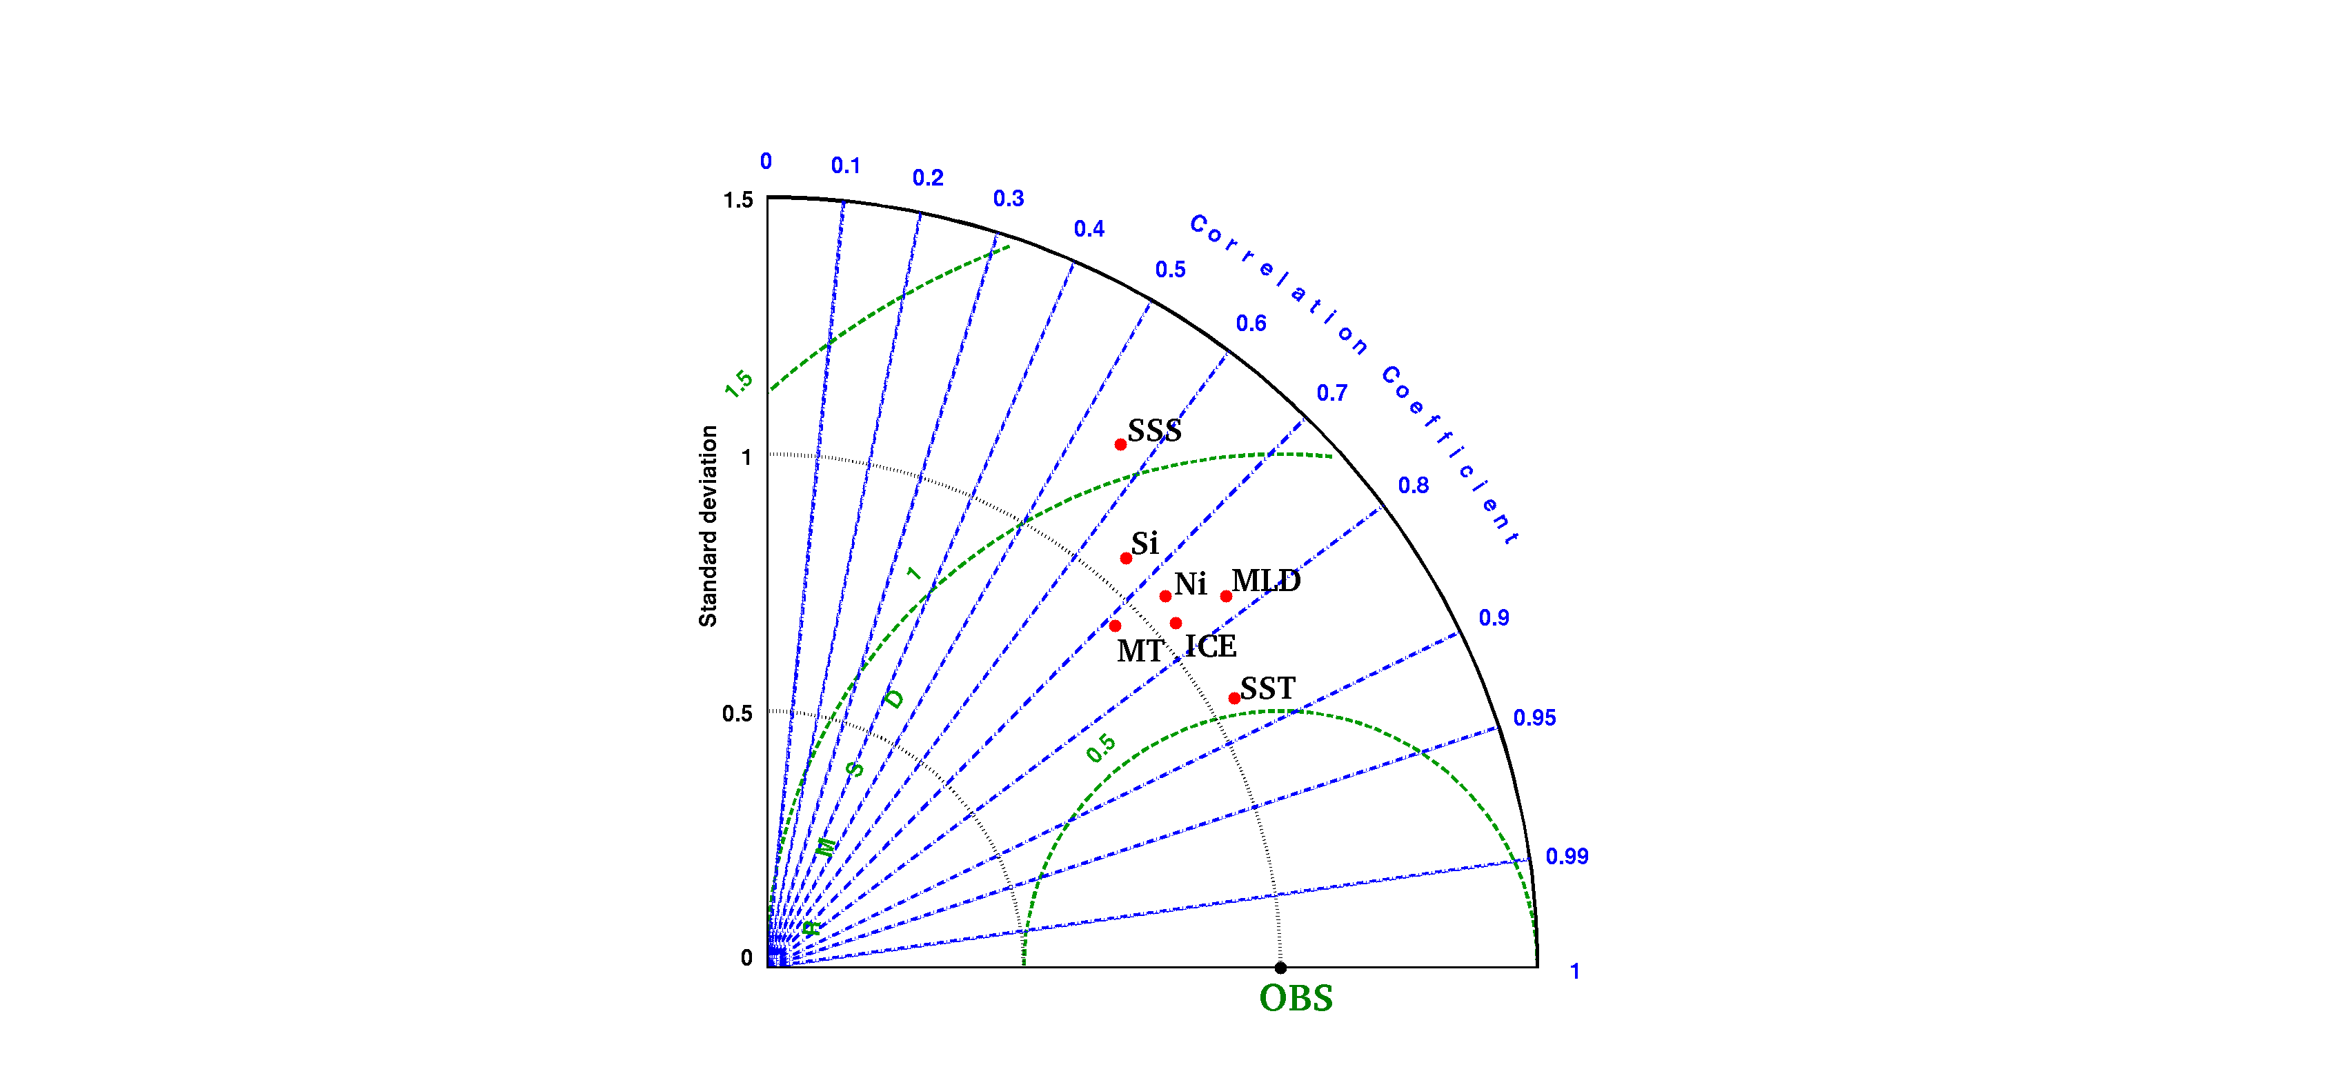
Figure 1. Taylor diagram presentation of the HRW model climatology compared against WOA climatology.
The simulated hydrological cycle was found to be deviating from the climatology which prompted us to investigate the salinity simulation further. It was found that the model salinity was slowly increasing over the whole domain at 0.16 psu per year. The volume-averaged salinity drift is shown in Figure 2.

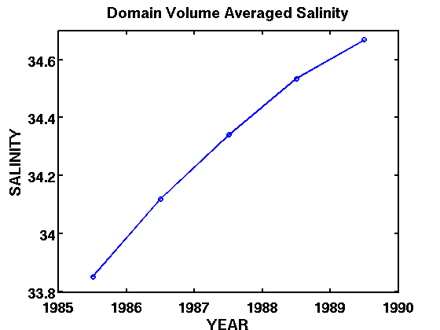
Figure 2. Volume averaged salinity drift from the seven-year of simulation.

Salinity is seen to be gradually increasing from 33.85 in 1985 to 34.66 in 1989.
To understand the spatial distribution of this drift, we subdivided the whole domain in nine sub-domains (Figure 3). Volume averaged salinity is then computed for each of the nine sub-domains for the five years. Figure 4 shows the salinity drift for these sub-domains, and Table 4 lists the numbers for the corresponding volume averaged salinity.

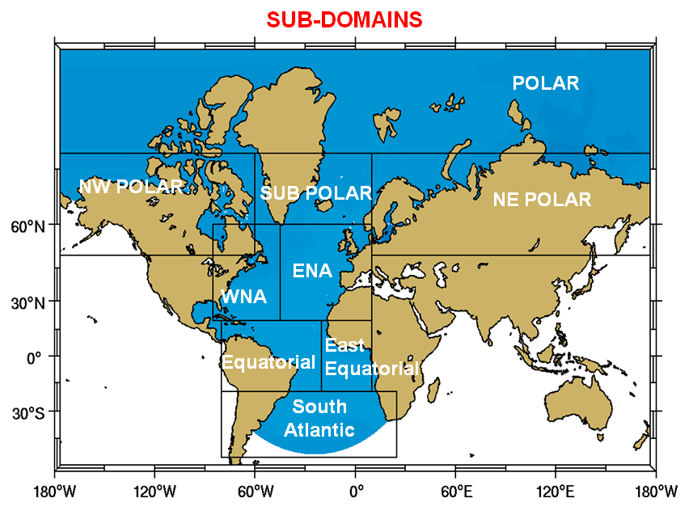

Figure 3. Sub-domains for understanding the hydrological cycle.

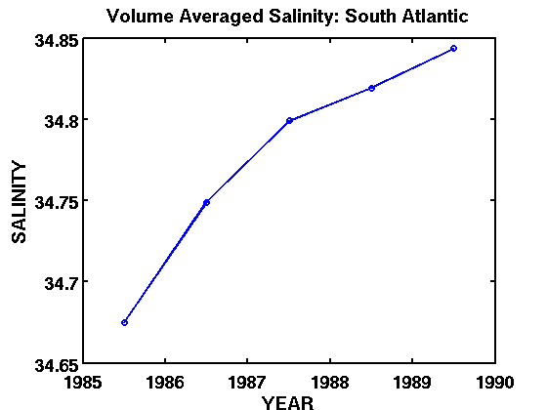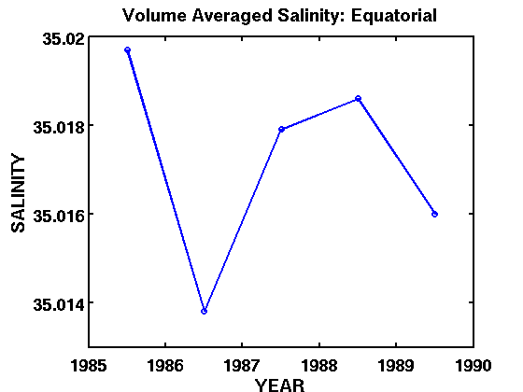

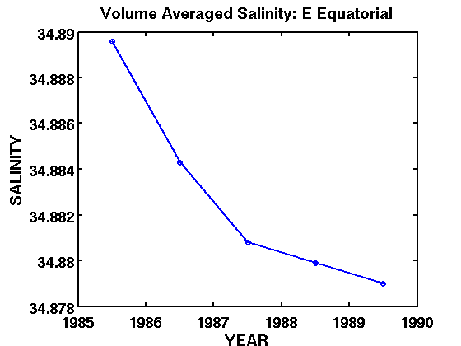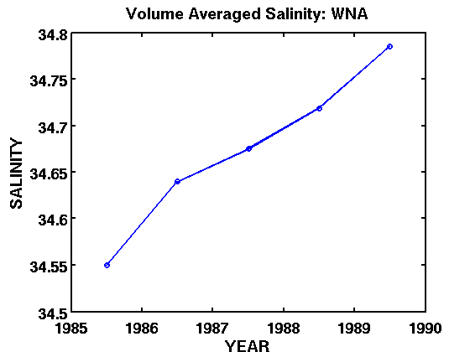

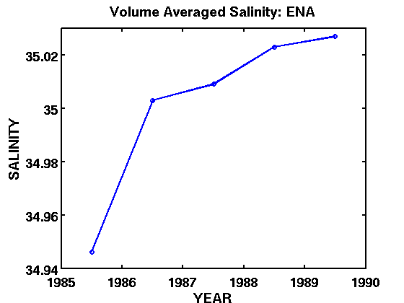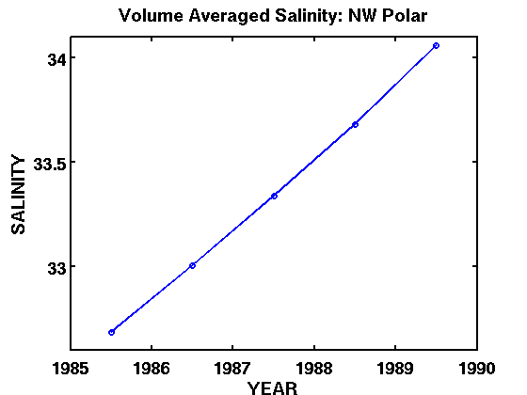
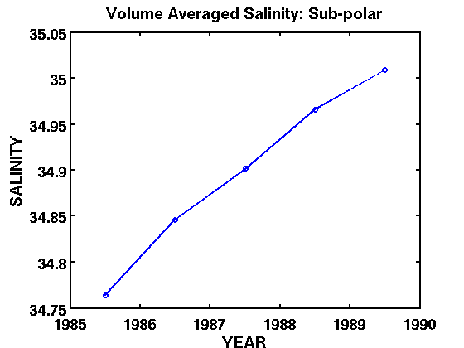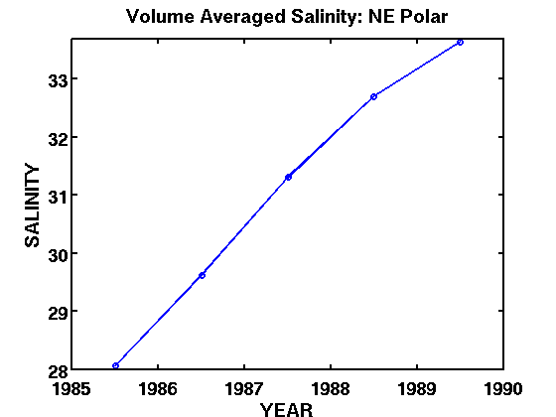

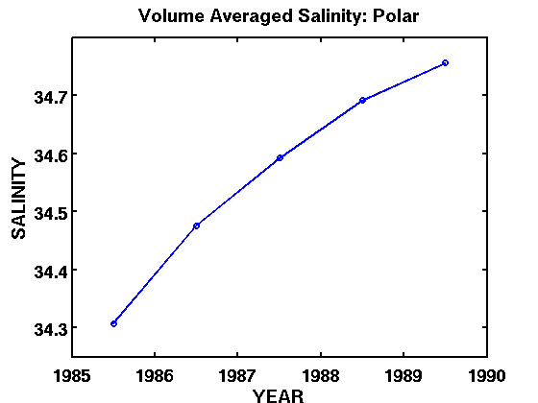

Figure 4. Volume averaged Salinity drifts for the 9 sub-domains.
From Table 1 and Figure 4 it is evident that the change in salinity in the South Atlantic, Equatorial, East Equatorial and ENA is minimal compared to that in the WNA, NW Polar, Sub-Polar, NE Polar and Polar Regions. Except the East Equatorial Region, all other sub-domains show a steady increase in the salinity. Specifically, there is a drastic change in the salinity in the NE Polar (5.58) and NW Polar (1.37) over the five years.

Depth-wise salinity change was computed to determine drift of salinity with depth (0 - 100 m, 100 - 200 m, 200 - 500 m, 500 – 1000 m, 1000 - 2000 m, 2000 – 4000 m and 4000 – 6000 m). This depth-dependence of the drift for the nine sub-domains is shown in Figure 5.
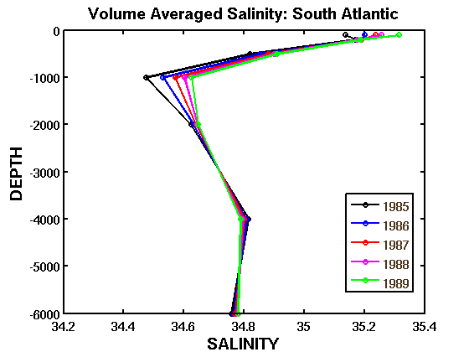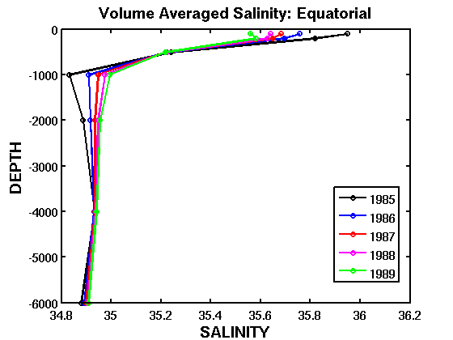

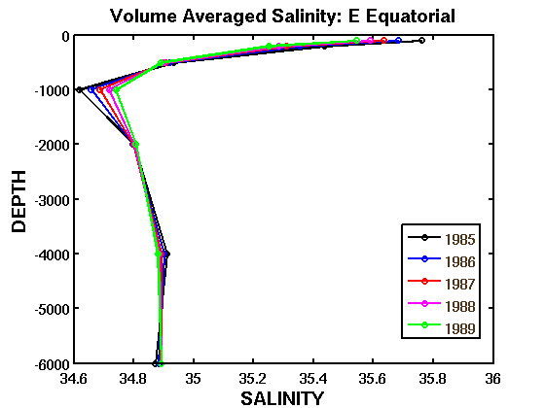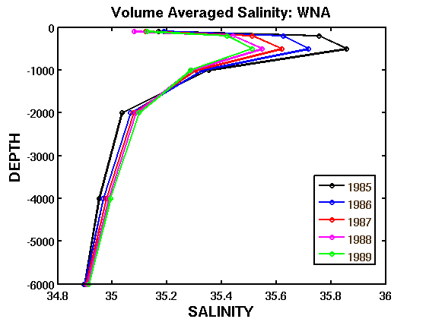

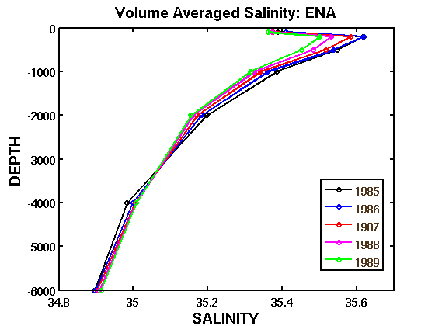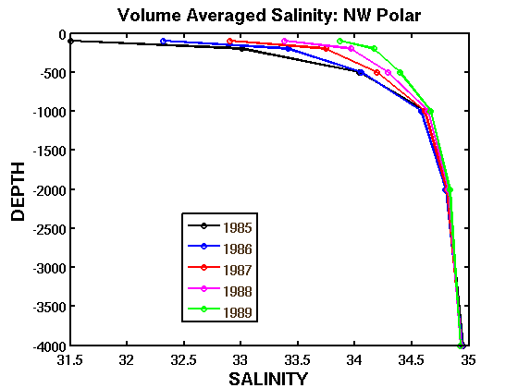
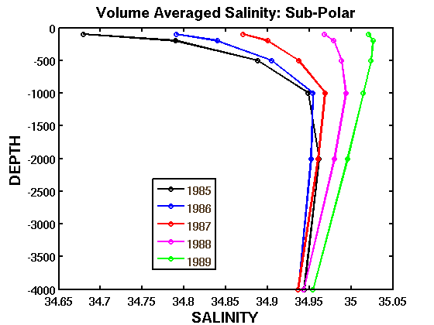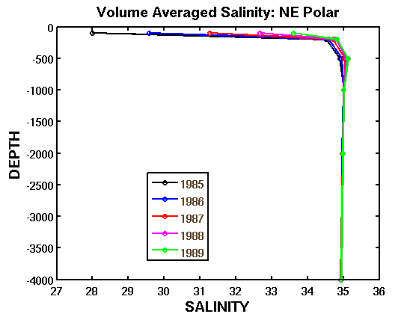

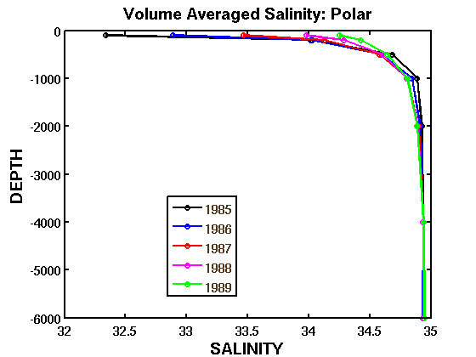

Figure 5. Depth-binned salinity of the sub-domains.

For the sub-domains South Atlantic, Equatorial and Eastern Equatorial, the averaged salinity for the five years first decreases up to 1000 m, and then the salinity increases, and finally becomes constant around 2000 m deep. The rest of the six sub-domains have a different trend. In the WNA region, the salinity increases to 500 m and then it starts decreasing; the salinity drift is seen in the upper 1000 m, after which the change is almost negligible. In the NW Polar region, the salinity drift increases to 1000m, and then the drift becomes negligible. In the Sub-Polar Region the salinity drift first increases to 1000 m and then it decreases. For the NE Polar region the salinity drift is very distinct in the upper 200 m, and it remains constant below 1000 m. In the Polar Region the drift is also in the upper 1000 m of the ocean, and remains the same at depth below 2000 m. It is clear that in all the 9 sub-domains the drift takes place in the upper 1000 – 1500 m of the ocean.
To understand the vertical extent of the salinity drift a number of sections were studied (Figure 2). We present the result from only one section (Section 1, across 59N) next (Figure 6). A distinct and clear front can be seen in the shelf-slope area in both winter and summer, for both salinity and temperature. During winter, stratification is seen in between 200 – 400 m in 1985, which deepens to 400 – 600 m in 1986, and finally the stratified layer cannot be seen during 1987 – 1989. During summer 1985 the stratified layer is observed in between 200 – 600 m, which deepens to 400 – 1000 m in 1986 and by the end of 1989 no stratification is seen. So the sea water is becoming more salty in the upper 1000 m over the five years.
During both winter and summer, the temperature at the eastern side of the section decreases from 9⁰C to 8⁰C and the water column becomes more stratified from 1985 to 1989. During summer 1985 – 1989 the surface layer has a temperature of 6⁰C, which is not seen in the sections during winter. A distinct vertical stratification is seen in all the temperature sections for both winter and summer at ~3500 km.

Figure 6. Section 1. To be added… Being redone in black and white. with contours.
Furthermore, the drift of sea ice volume over the five years was then computed to correlate it with the salinity drift. The sea ice volume for the sub-domains in WNA, NW Polar, Sub-Polar, NE Polar and Polar Regions, where the salinity drift is more apparent are shown in Figure 7.

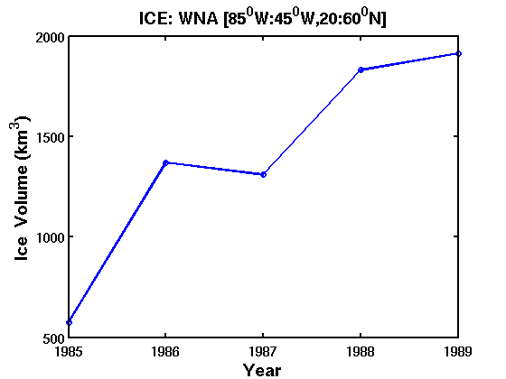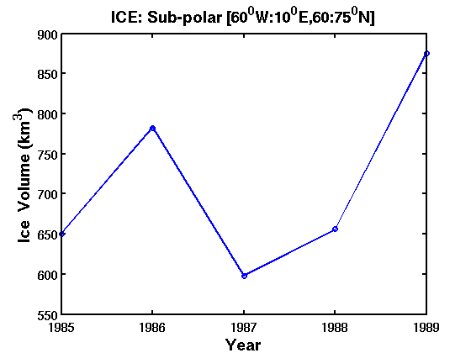

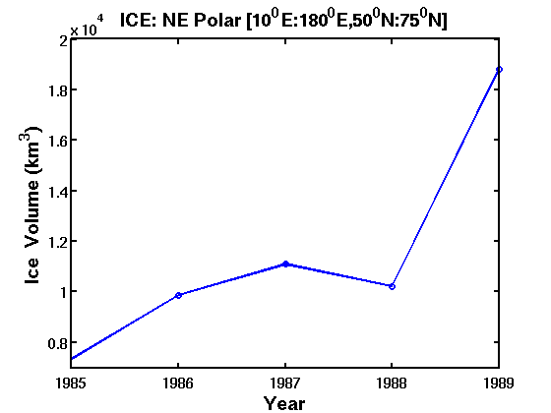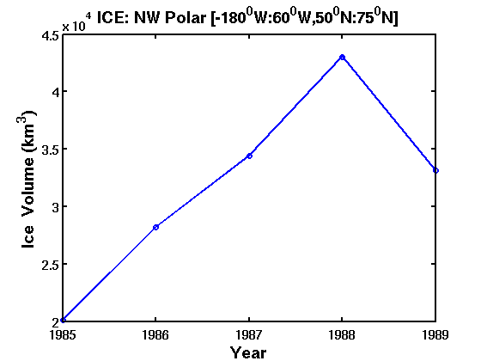

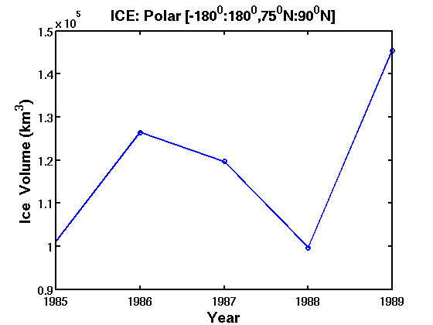

Figure 7. Ice trends in 5 sub-domains.
The seasonal formation and melt of sea ice is the dominant factor controlling the salinity and density of surface ocean waters in the Polar Regions. As the ocean water freezes to form sea ice, salt is expelled and thus the salinity of the ocean increases. The NE Polar, NW Polar and Polar Regions have the maximum volume of ice which may be responsible for the salinity drift. With the formation of more sea-ice over the years, the salinity increases, this is in accordance with the Figure 6. In NE Polar and Polar Regions there is a drop in the ice volume in 1988, and then it increases in 1989. But in the NW Polar Region the ice volume increases from 1985 to 1988, and then a sudden drop in ice volume in 1989.

- Biogeochemical Results and Implementation
The mean modeled surface velocity averaged over three years simulation was done for the months of February and March. The Slope Sea gyre is not pronounced during winter, but the Northern North Atlantic gyre and the Norwegian gyre is pronounced during these two months, as seen from Figure 8.
The mean modeled surface nitrate and silicate averaged over three years simulation for February and March is seen in Figure 9. The model captured the winter deep mixing, which resulted in highest surface nutrients during March. The high surface nutrients in late winter set up phytoplankton spring bloom in the North Atlantic.
The modeled surface small phytoplankton and diatoms during May (A, B) and June (C, D) is seen in Figure 10. The modeled phytoplankton biomass is averaged over three year’s simulation for May and June. The modeled diatoms tend to bloom first and progress towards higher latitude. The small phytoplankton bloom after the diatoms, then moves to the north. Note that the biogeochemical model comparison presented in the 2009-2010 annual report showed clearly how the high-resolution model was an improvement in realizing the seasonal signals compared to the low resolution counterpart.

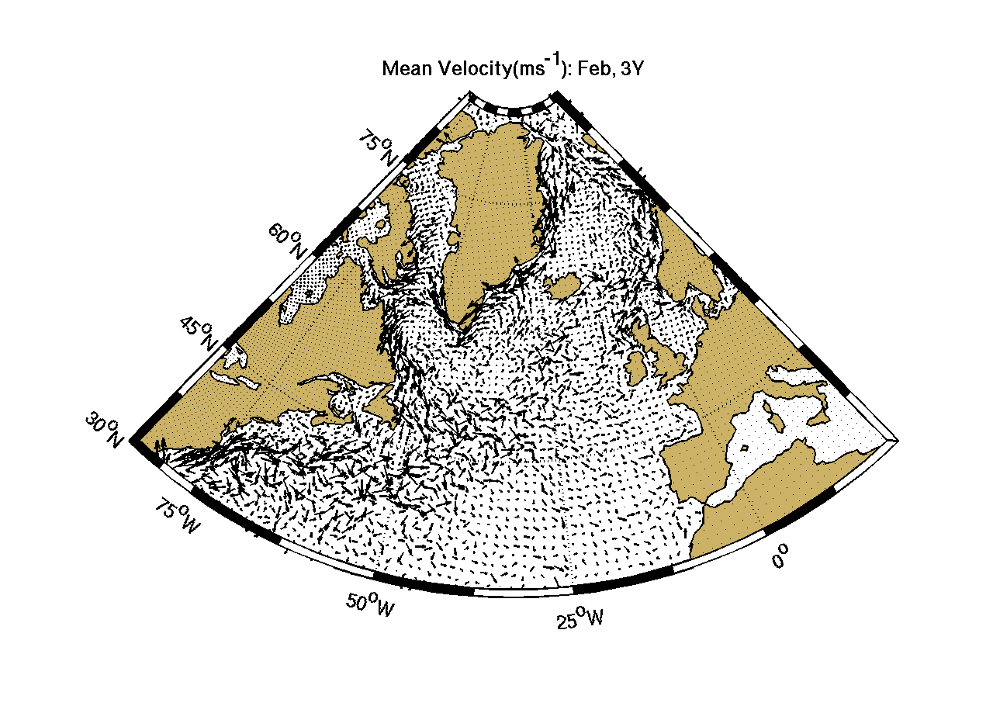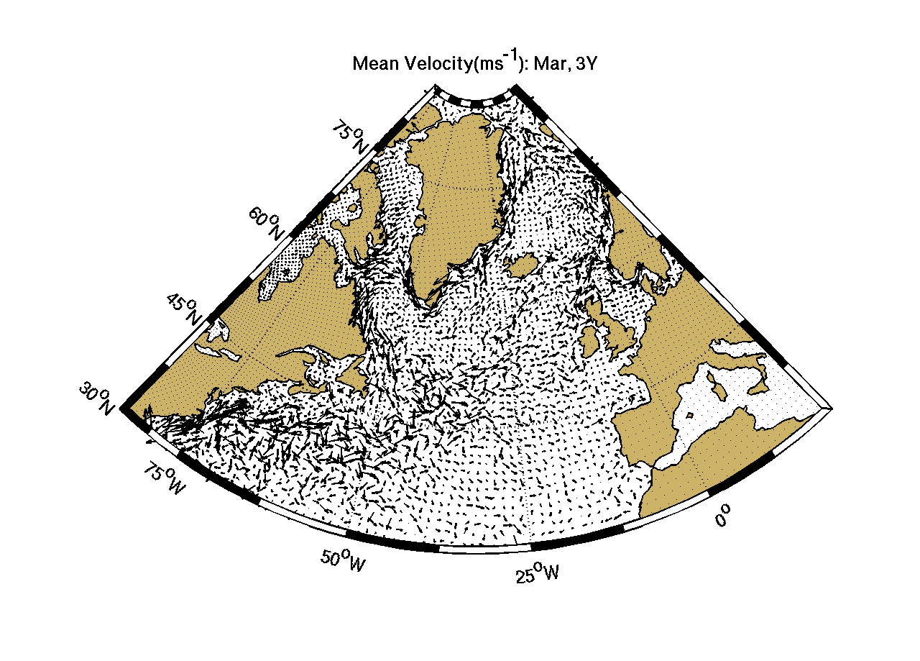
- (B)
Figure 8. Mean modeled surface velocity for February and March.

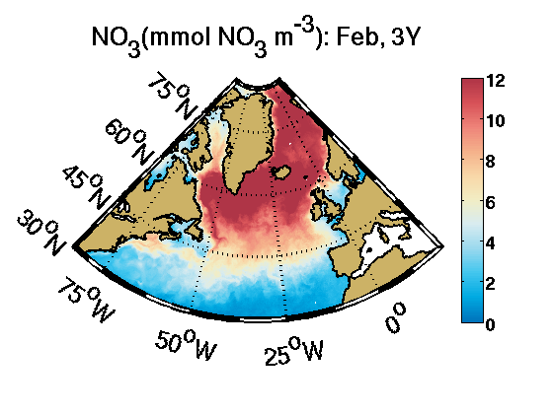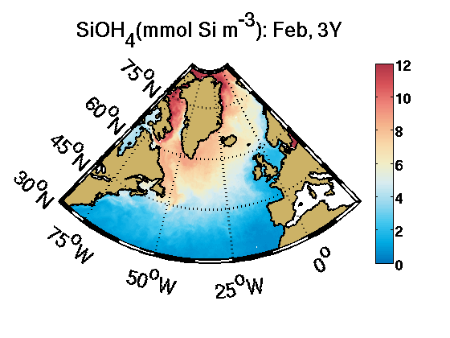
(A) (B)

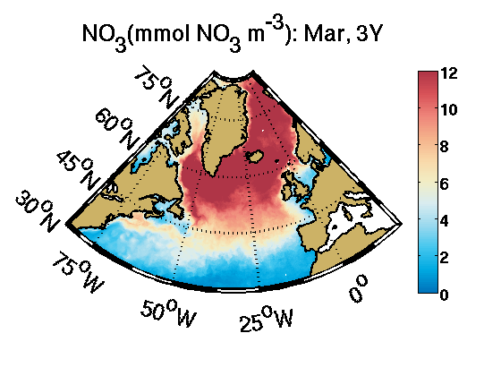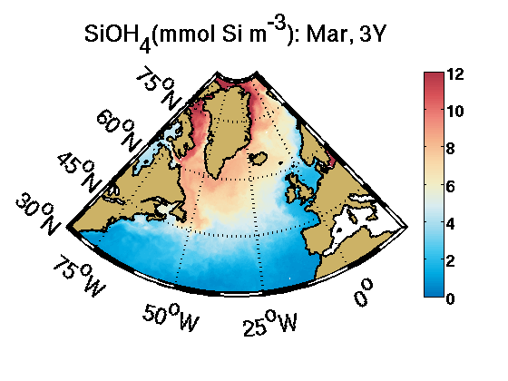
(C) (D)
Figure 9. Modeled surface nitrate and silicate in February and March.

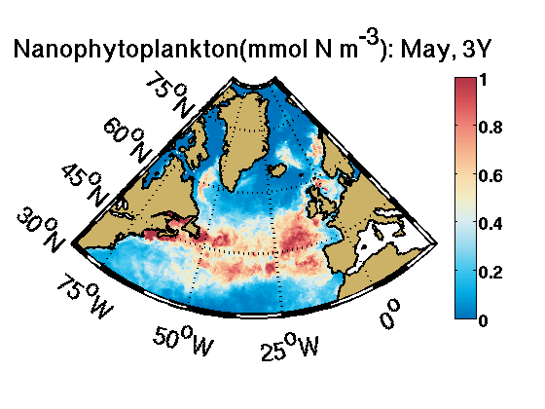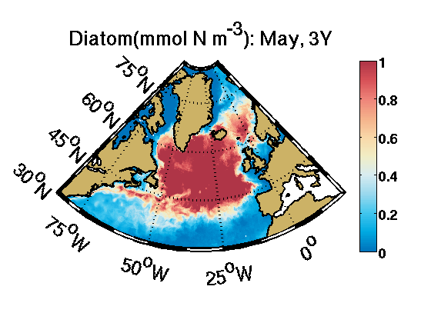
(A) (B)
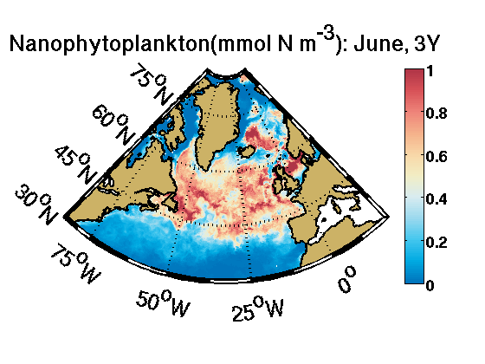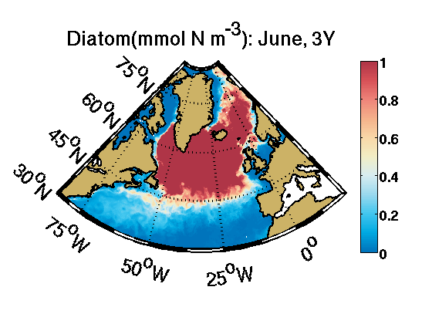
(C) (D)
Figure 10. Modeled surface small phytoplankton and diatom in May and June.

Figure 10 (A, C) clearly shows that the small phytoplankton first blooms in the WNA gyre and then the bloom is carried north with the NNA gyre. Figure 10 (B, D) shows that the diatom bloom in the NNA gyre is carried north with the Norwegian gyre.

The biogeochemical modeled data and figures clearly indicate that silicate and nitrate transport regulate diatom and small phytoplankton productivity respectively. The three gyres play an important role in the advection of the phytoplankton bloom northwards. The phytoplankton bloom occur in lower latitude in May, and then progress northwards in June. This is probably a consequence of incident light and mixed layer depth, as was shown by Siegel et al., 2002. Note that better HRW results in comparison to LRW gives us reasonable confidence in the biogeochemical parameterization and the same will be used with a “salinity corrected” physical model.

- Climate Simulations Implementation Plan

For the climate simulations, we are collaborating with Dr. Mike Alexander and Dr. Antonietta Capotondi of NOAA. After considerable group discussions in various PRS meetings over the last three years, we converged on a plan of forcing ROMS with difference fields (21st century minus 20th century) from the IPCC models. This type of experiment aims at understanding the regional-scale aspects of the large-scale changes in mean condition. The use of difference fields is intended to minimize the climate model biases in mean conditions. We will focus on the NCAR-CCSM3, and consider the SRES-A2 high-forcing scenario, which seems to better track the observed CO2 evolution over the first ten years of the 21st Century. The differences will be computed between the second half of the 21st century and the second half of the 20th century (2050-2099 minus 1950-1999). The length of this simulation will be 20 years.

The following difference fields have been graciously prepared by Dr. Capotondi at the present time: (i) surface air temperature, (ii) surface air humidity, (iii) surface wind stresses; (iv) wind speed, (v) precipitation, (vi) radiation, and (vii) temperature T and salinity S over the whole 3D domain. The sensible and latent heat fluxes will be computed using the model SST and wind speed, air temperature and humidity. The T and S fields will be used for open boundary conditions as well as to initialize the T and S structure of the interior ocean to minimize spin-up time. The difference fields were first provided on the climate model grid and then interpolated on the ROMS grid. These fields are now ready for the proposed climate simulations and will be done after the model is configured to reduce the salinity drift.

4. Summary and Future Tasks
The salinity drift seen in the model run in the first five years of the whole domain could not be accounted in the very beginning. Dividing the whole domain into nine sub-domains made us realize that the salinity drift seen for the whole domain is mainly due to the NW Polar, Sub Polar, NE Polar and Polar Regions, where drastic changes in salinity are observed. The results from depth-binned salinity study of all the nine sub-domains concludes that the salinity drift takes place in the upper 1000 – 1500 m of the ocean.
The future plans to solve the salinity drift include: (i) modify the ice initial conditions from climatology to January 1985; (ii) provide open boundary condition for the Bering Strait; (iii) improve vertical mixing parameterization (implement KPP instead of GLS); and (iv) include inter-annual river run-off data in the model to account for the freshwater input into the model.
Based on the results obtained so far in the two 2-year long biophysical simulations, we are encouraged to continue running the biophysical simulations for the remaining period in the 1990’s, i.e., 1992-1999. These runs will be carried out with the modified configuration (with correction for the salinity drift) and after implementing the monthly river runoff data from Dai and Trenberth (2002) and Dai et al. (2009).

In summary, a diagnostic method has been constructed among the collaborators (Haidvogel, Gangopadhyay and Chaudhuri) to quantify the effects of the primary factors responsible for the simulated salinity drift. These are E-P, River runoff (RR), Ice melt and possibly the freshwater flow through the Canadian Arctic Archipelago. First, we have quantified the salinity drift in each of the four regions: Arctic, Sub-polar, Sub-tropical and WNA. This non-conservative annual salt gain/loss over the regional volume was converted to a rate of missing/addition of freshwater to the ‘ambient’ or ‘reference’ salt content of that volume (i.e., climatological volume-averaged salt content from Levitus). This rate, or the dilution factor, which is a rate of freshwater input (m3/s per year) was compared with the observed E-P, RR, Ice melt and/or CAA through-flow as appropriate. Preliminary investigation points to a combination of E-P, RR and Ice Melt in mostly polar region.

In addition to the above diagnostics, we have begun implementing the monthly-varying river runoff input from the recently published Dai et al (2009) data set. This will replace the currently implemented annual mean precipitation of the RR which does not provide any seasonality. With the additional support requested in this proposal we hope to provide a very robust framework of providing physical and biological fields for the North Atlantic during the 1990s.

The Bering Strait is the only ocean gateway between the Pacific and Arctic. It is a triangular shape strait, about 85km wide, about 55m deep, and divided into 2 channels by the two Diomede Islands. It is generally covered by sea-ice from January to April. The annual mean flow of 0.8 Sv is generally northward, but can flow southward for a week or more. The flow is driven (supposedly) by a pressure gradient between the Pacific and the Arctic oceans, opposed by the local winds. Four different water masses: Bering shelf water, Alaskan Coastal Current, Siberian Coastal Current, and Aleutian North Slope- Bering slope water are found at different levels across the strait. An important Website with papers is: http://psc.apl.washington.edu/HLD/Bstrait/bstrait.html#BERING_STRAIT_ICE_FLUX

We have identified the Bering Straits transport and t-s data for implementation to LRW (first) and HRW (next). Woodgate et al. (2005) provided the climatology (t, s, and transport) based on 14 years of data. The annual cycle shows a range of variation of temperature (-1.8C to +2.2C); of salinity (31.91 to 32.88), and of transport (0.4 Sv to 1.3 Sv). The annual mean values are -0.1 C, 32.5 psu, and 0.8 Sv. (Table 1 of Woodgate et al. (2005)). We are investigating two options: (i) design a t,s transport profile for the annual mean signal and persist over time, or (ii) design a annual cycle (with monthly variations) based on Table 1 and accompanying analysis (Figures 2, 4, 5) that would be both depth and time-dependent information (of monthly t,s and transport) across the Straits.
We have also identified the Bryden et al. 1994 paper in Progress in Oceanography as a basis to design the Mediterranean-Atlantic outflow-inflow condition for the HRW/LRW set up.
In the fourth (current) year, our approach is to quickly configure an LRW framework with (i) weak restoration of salinity (to compensate for E-P imbalances); (ii) inter-annual RR; (iii) KPP vertical mixing implementation; and (iv) January 1985 ice fields as initialization. We would like to run this LRW configuration for 10-15 years to evolve a dynamic- equilibrium state of North Atlantic. We would use this LRW state to initialize the HRW set up and use the CORE2 forcing from 1985 to 2000 to develop the biophysical fields. (More to be added)…

References

Bacon, S., P.G. Myers, B. Rudels, and D.A. Sutherland, (2008), Accessing the inaccessible: buoyancy-driven coastal currents on the shelves of Greenland and eastern Canada. Arctic-Subarctic ocean fluxes: Defining the role of the Northern Seas in climate. Eds. Dickson, Meincke, and Rhines. Springer, 703-722.
Belkin, I.M., Cornillon, P.C., Sherman, K. (2009) Fronts in Large Marine Ecosystems. Progress in Oceanography, 81(1-4), 223-236, doi:10.1016/j.pocean.2009.04.015.
Bretherton, F. P., R. E. Davis, and C. B. Fandry, 1976. A technique for objective analysis and design of oceanographic experiments applied to MODE-73. Deep-Sea Research 23:559-582.
Bucklin, A., O.S. Astthorsson, A. Gislason, L.D. Allen, S.B. Smolenack, and P.H. Wiebe. 2000. Population genetic variation of C. finmarchicus in Icelandic waters: preliminary evidence of genetic differences between Atlantic and Arctic populations. ICES Journal of Marine Science, 57: 1592-1604.
Carter, E. F. and A. R. Robinson, 1987. Analysis models for the estimation of oceanic fields. J. Atmos. Ocean. Tech., 4:49-74
Carton, J.A., G. Chepurin, X. Cao, and B.S. Giese, 2000a: A Simple Ocean Data Assimilation analysis of the global upper ocean 1950-1995, Part 1: methodology, J. Phys. Oceanogr., 30, 294-309.
Carton, J.A., G. Chepurin, and X. Cao, 2000b: A Simple Ocean Data Assimilation analysis of the global upper ocean 1950-1995 Part 2: results, J. Phys. Oceanogr., 30, 311-326.
Chai, F., S. T. Lindley and R. T. Barber, 1996. Origin and maintenance of a high nitrate condi-tion in the equatorial Pacific, Deep Sea Res. II, 43, 1031-1064.
Chai, F., R.C. Dugdale, T-H Peng, F.P.Wilkerson, and R.T. Barber (2002): One-dimensional Ecosystem Model of the Equatorial Pacific Upwelling System, Part I: Model Development and Silicon and Nitrogen Cycle. Deep-Sea Res. II, Vol. 49, No. 13-14, 2713-2745.
Chai, F., M. Jiang, R.T. Barber, R.C. Dugdale, and Y. Chao (2003): Interdecadal Variation of the Transition Zone Chlorophyll Front, A Physical-Biological Model Simulation between 1960 and 1990. Journal of Oceanography, Vol. 59, 461-475.
Chai, F., M-S Jiang, Y. Chao, R.C. Dugdale, F. Chavez, and R.T. Barber (2007): Modeling Responses of Diatom Productivity and Biogenic Silica Export to Iron Enrichment in the Equatorial Pacific Ocean. Global Biogeochemical Cycle, Vol. 21, GB3S90, doi:10.1029/2006GB002804.
Conkright, M. E., J. I. Antonov, O. Baranova, T. P. Boyer, H. E. Garcia, R. Gelfeld, D. Johnson, R. A. T. D. O’Brien, I. Smolyar, C. Stephens, 2002: World Ocean Database 2001, Volume 1: Introduction. Ed: Sydney Levitus, NOAA Atlas NESDIS 42, U.S. Government Printing Office, Washington, D. C., 167 pp.
Cuny, J., Rhines, P.B., Niiler, P.P., Bacon, S., 2002: Labrador Sea Boundary Currents and the Fate of the Irminget Sea Water, Journal of Physical Oceanography, 32, 627-647
Desprès, A., and G. Reverdin, 2010: Surface fronts in the North Atlantic Subpolar Gyre. Submitted to J. Phys. Oceanogr.
Drinkwater, K. and K. Frank, 2001. Calanus-Cod Interactions, ICES/GLOBEC Newsletter Number 8, December, 2001.
Drinkwater, K. F., R. A. Myers, R. G. Pettipas, and T. L. Wright, 1994: Climatic data for the northwest Atlantic: The position of the shelf/slope front and the northern boundary of the Gulf Stream between 50 degree W and 75 degree W, 1973-1992. Can. Data Rep. Hydrogr. Ocean Sci. 125: 107pp.
Gandin, L. S., 1963. Objective analysis of meteorological fields (in Russian) Gidrometeoizdat Leningrad (English Translation: Israel Program for Scientific Translations, Jerusalem, 1965).
Hunke, E.C., and J.K. Dukowicz, (1997), An Elastic–Viscous–Plastic Model for Sea Ice Dynamics. J. Phys. Oceanogr., 27, 1849–1867.
Large W. G. and S. G. Yeager, 2004: Diurnal to decadal global forcing for ocean and sea-ice models: The data sets and flux climatologies. Technical Report TN-460+STR, NCAR, 105pp.
Liu, G. and F. Chai, 2009a. Seasonal and interannual variability of primary and export production in the South China Sea: A three-dimensional physical-biogeochemical model study. ICES Journal of Marine Science, 66, 420-431.
Liu, G. and F. Chai, 2009b. Seasonal and interannual variation of physical and biological processes during 1994-2001 in the Sea of Japan/East Sea: a three-dimensional physical-biogeochemical modeling study. Journal of Marine Systems, in press.
Mellor, G. L., and L. H. Kantha, (1989), An ice-ocean coupled model, J. Geophys. Res., 94(C4), 10,937– 10,954.
Nobre, C. 2009. The signature of NAO and meltwater advection in the Gulf of Maine during 1995-1998. MS thesis, University of Massachusetts, Dartmouth, MA 02747.
Reiniger, R. F. and C. K. Ross, 1968: A method of interpolation with application to oceanographic data. Deep-Sea Research 15: 185-193.
Sutherland, D.A. and R.S. Pickart, (2008) The East Greenland Coastal Current: structure, variability, and forcing. Prog. Oceanogr., doi:10.1016/j.pocean.2007.09.006.
Watts, D. R. K. L. Tracy, and A. I. Friedlander, 1989. Producing accurate maps of the Gulf Stream thermal front using objective analysis. J. Geophys. Res., 94:8040-8052.

