Hindcasting blooms of the toxic dinoflagellate Alexandrium spp.
in the western Gulf of Maine

D.J. McGillicuddy, Jr., C.A. Stock, D.M. Anderson
Woods Hole Oceanographic Institution

R.P. Signell
United States Geological Survey

INTRODUCTION

Toxic or harmful algal blooms (HABs) are a serious economic and public health problem throughout the US and the world. In New England, the most serious HAB issue is paralytic shellfish poisoning (PSP), a potentially fatal illness that occurs when humans eat shellfish that have accumulated toxins as they feed on dinoflagellates in the genus Alexandrium. These organisms are responsible for human illnesses and occasional death due to PSP, repeated closures of shellfish beds in nearshore and offshore waters, the mortality of larval and juvenile stages of fish and other marine animals (White et al., 1989), and even the death of marine mammals such as humpback whales (Geraci et al., 1989). Skillful forecasts of Alexandrium blooms in this region would therefore have a number of important applications, including the management of shellfish and finfish resources, aquaculture siting, and effluent discharge. Furthermore, there are a multitude of coastal zone management issues that could utilize the hydrodynamic forecasts on which ecological predictions of Alexandrium would be based.

THE CASE STUDY

Within the western GOM region, which extends from Penobscot Bay to Massachusetts Bay, a coupling has been inferred between the abundance and distribution of Alexandrium and a buoyant coastal current that travels from northeast to southwest. A conceptual model of this linkage has been proposed, known as the river plume advection hypothesis (Franks and Anderson 1992ab). Critical features of this system include: 1) a source population of cells located to the north of Massachusetts Bay near the Androscoggin-Kennebec estuary; 2) freshwater outflow from the Androscoggin-Kennebec estuary, resulting in a coastally-trapped, buoyant plume that supports the growth of Alexandrium cells and transports them to the south and west; and 3) plume behavior, as influenced by the volume of freshwater outflow, the local wind stress, and underlying GOM circulation, all of which combine to regulate the alongshore and cross-shore location of the plume, its associated cells, and PSP toxicity.
As part of ECOHAB-GOM and its predecessor programs, a set of numerical models has been developed to study these dynamics in a three-dimensional context. Thus far these coupled physical/biological models have been used only for research purposes. Quantitative demonstration of predictive skill in a hindcast mode is a necessary precursor to transition of such models into an operational framework. The following example describes recent efforts to assess the hindcast skill of one such model.
The hydrodynamic basis of the following coupled physical/biological simulations is the Princeton Ocean Model (POM; Blumberg and Mellor, 1987) with variable horizontal resolution of a 2-4 km and 12 terrain-following vertical levels. Vertical mixing is internally generated from the Mellor-Yamada 2.5 turbulence closure model. This physical model is forced by various modeled inputs as well as land-based and shipboard observations (Table 1).

Table 1. Data sets used to force the circulation model.
Modeled Inputs (T, S) | Bi-monthly climatological model with tides (Lynch et al., 1996)
Cruise data (T, S) | Upstream sections and offshore stations
River Discharge | USGS gauges at 4 major rivers
Wind stress | Uniform distribution derived from Portland Buoy
Surface heat flux | Derived from temperature at Portland Buoy
Insolation | From land-based sensors at Woods Hole

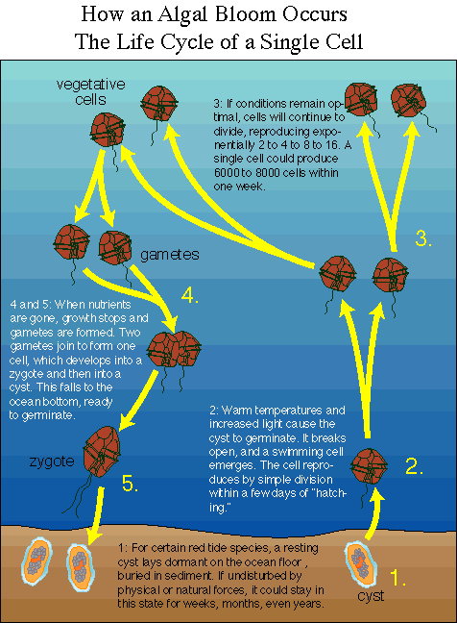
A population dynamics model for Alexandrium has been incorporated into this physical framework. Alexandrium has a very complex life cycle (Figure 1). It can lie dormant as a resting cyst in the sediments for very long time periods, perhaps a decade or more (Anderson, 1984; Keafer et al., 1992). Germination is regulated by a complex set of processes, including an endogenous clock (Anderson and Keafer, 1987) and physiological responses to environmental factors such as temperature (Anderson, 1980), light and oxygen availability (Anderson et al., 1987). Once emerged from the sediments, the cells swim toward the surface to begin a phase of vegetative growth. Photosynthetic production is fundamentally limited by light and the availability of nutrients; however, maximal growth rates occur only within a specific range of temperature and salinity conditions. When faced with environmental stress such as nutrient limitation, the vegetative cells form gametes that subsequently fuse into a zygote (Anderson et al., 1984). The zygote then encysts and the cycle is complete.
Figure 1: Life cycle of Alexandrium.
Our model for Alexandrium is summarized in Figure 2. The ecosystem in which Alexandrium resides is not explicitly modeled; ecosystem effects are parameterized through their influence on the vital rates of Alexandrium’s population dynamics processes. The top panels show the various factors that contribute to the input of cells due to germination. On the far left is the observed distribution of cysts, showing the peak offshore of Casco Bay. In the middle is our functional fit to laboratory data on the endogenous clock, shown as open circles. On the right is the germination rate as a function of light and temperature, based on the laboratory measurements (indicated by black dots). The vertical axis actually represents light intensity but has been scaled to depth. The function describing vegetative growth is based on data from Watras et al. (1982) that suggest that Alexandrium has a preferred temperature and salinity range for optimal growth. The range of temperature and salinity conditions that Alexandrium cells encounter in the simulations described below is indicated by this black rectangle. The overall growth rate is based on this function and is modulated by the ambient light field as per Liebig’s law of the minimum (Liebig, 1845). We have begun to experiment with simple representations of nutrient limitation, but this effect is not included here. An upward swimming rate of 10m/day and a net “mortality” of 0.1 per day are specified. Mortality is in quotes here because it represents the net effect of all loss processes, which include predation and encystment.
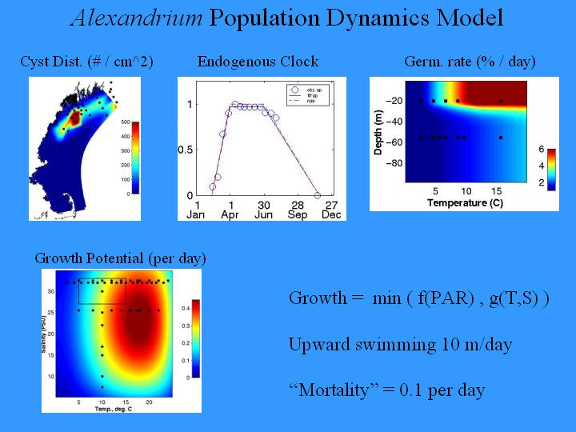
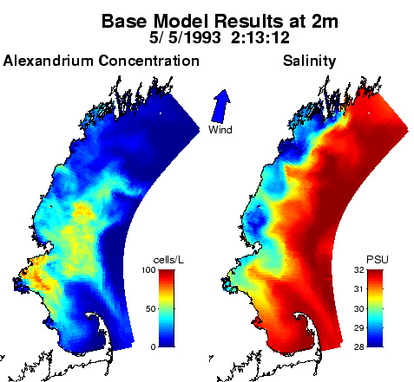
This coupled model has been used to hindcast a data set collected in the Western Gulf of Maine in 1993 as part of the Regional Marine Research Program (RMRP). An example snapshot from a hindcast simulation is shown in Figure 3; the entire simulation is available in animated form on the web site at http://science.whoi.edu/users/mcgillic/ecohab/movies/base.avi. The salinity field shows the impact of fresh water plumes originating at the Kennebec / Androscoggin and Merrimack rivers. These tend to propagate down the coast, and also undergo significant cross-shore displacements due to the effects of upwelling and downwelling winds. This particular simulation is suggestive of offshore initiation of the bloom, as the impact of the germination input from the offshore maximum in the cyst distribution is clearly evident. Features in the cell distribution are advected downstream in the coastal current, and are also clearly impacted by wind-driven upwelling and downwelling.
Figure 2: Population dynamics model for Alexandrium.
Figure 3: Example snapshot of model output.
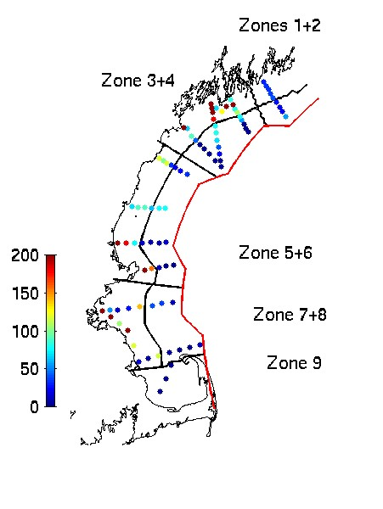
Quantitative evaluation of hindcast skill requires careful consideration of how the model results should be compared with observations. One might think this issue is as simple as subsampling the model solutions at the space/time points at which data are available. However, such an approach is problematic because the observations contain small-scale patchiness that is not resolved in the model (plots of autocorrelation functions for both simulated and observed fields bear this out). Thus, it is necessary to average both the model results and the observations on scales resolved by both. We therefore define nine zones in which the mean values of the simulated and observed concentrations are compared for each cruise (Figure 4). An error metric J quantifies the degree to which the simulated means (sim) match the observed means (obs) for each zone during each cruise: J = max(sim,obs) / min(sim,obs). A perfect fit would result in a value of 1.0, and this penalty function grows larger as the simulation diverges from the observations. A variety of error metrics are possible, and all have various advantages and disadvantages. One appealing aspect of this particular metric is that errors at low concentrations are weighted just as heavily as those at high concentrations. In summary, this approach yields a quantitative method of evaluating the large-scale spatial distribution, timing, and magnitude of the bloom.
Figure 4: Typical observational coverage during one cruise. Colored dots represent observations of Alexandrium fundyense concentration (cells per liter). The nine zones chosen for model evaluation are indicated.
There is yet another issue that confounds evaluating the skill of the model predictions: the simulations are sensitive to model parameters that are imperfectly known. Our approach to this is to tune the adjustable parameters within their envelope of reasonable values. This amounts to a manual procedure for parameter estimation. More sophisticated estimation procedures have been used in the context of zero- and one-dimensional models (e.g. Vezina and Platt, 1988; Fasham and Evans, 1995; Hurtt and Armstrong, 1996; Friedrichs and Hofmann, 2001), and we intend to pursue such methods in the future. At present, the computational demands of those approaches make them impractical for the three-dimensional system of interest here.
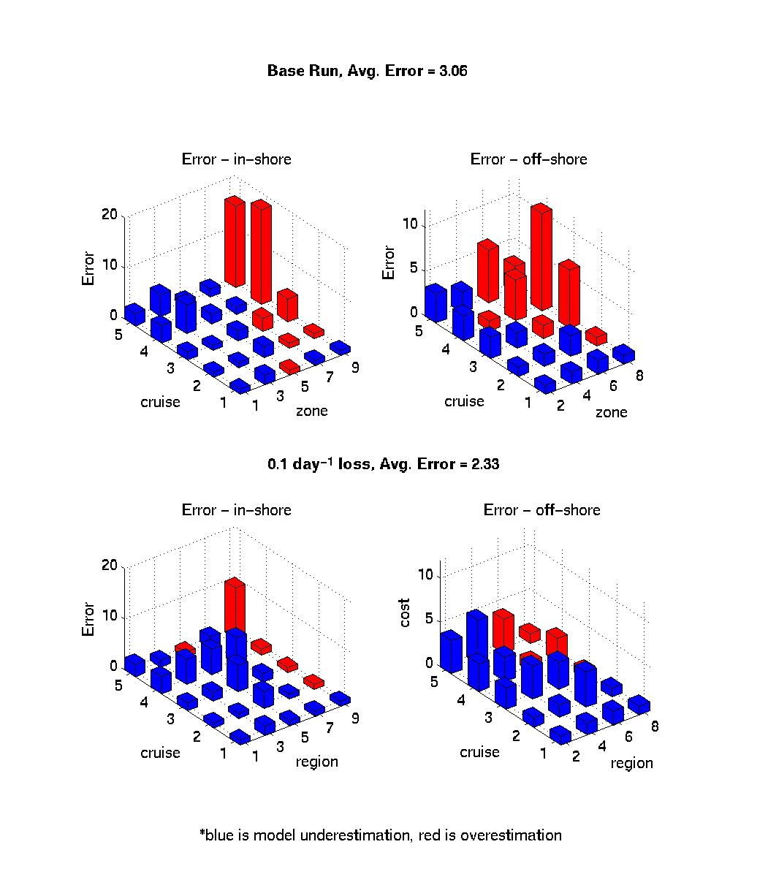
Quantitative evaluation of hindcast skill facilitates testing hypotheses concerning bloom controls by ascertaining whether one model structure fits the data significantly better than another. As an example, we compare the results of two different simulations: one without grazing of Alexandrium, and one that includes a spatially uniform loss term of 0.1 per day (Figure 5). Each of the four panels show the space/time distribution of the error metric. Time runs along the “cruise” axis with cruises 1-5 carried out in April to June. Space runs along the “zone” axis, with zones 1-9 corresponding to those indicated in Figure 6. The zones have been separated into inshore and offshore groups. The height of the vertical bars indicates the magnitude of the error metric, with blue indicating model values that are too low and red indicating model values that are too high.
Figure 5: Quantitative evaluation of hindcasts based on two different biological formulations (see text).
In the absence of mortality, cell concentration is systematically overpredicted late in the run in the southern portion of the domain. The average value of the error metric is 3, so on average the predicted values are within a factor of three of the observations. Explicit treatment of loss processes via a uniform loss rate of 0.1 per day improves the simulations dramatically: the large errors late in the run in the southern portion of the domain are reduced. The error metric drops to an average of 2.33, so the predictions are now within a factor of two of the observations. Thus we conclude that a loss term (which may represent some combination of predation and encystment) plays a key role in controlling the development and termination of the bloom. Of course one important caveat here is that the circulation fields are assumed to be correct; we cannot exclude the possibility that mismatches between the simulated and observed concentrations of Alexandrium could be a result of unknown deficiencies in the modeled circulation. In future research we will formulate measures of misfit for the physical fields as well as the biological fields.

LESSONS LEARNED

The hindcasts of the 1993 RMRP data described above do not rely on data assimilation to keep the circulation fields on track. The rationale for adopting a purely “forward” modeling approach hinged on the fact that the circulation in this relatively small regional domain is largely controlled by riverine buoyancy inputs and wind-forced dynamics. Such is clearly not the case in larger domains where a wide variety of other processes influence the circulation. Results from the ECOHAB-GOM program have shown that the dynamics of Alexandrium blooms are regional in scope, spanning the waters from the Bay of Fundy down into Massachusetts and Cape Cod Bays (Anderson et al., 2000; Townsend et al., 2001). Thus, a gulf-wide modeling approach will be necessary in an operational context. Given the complex hydrodynamics characteristic of this large regional domain, data assimilation will be an essential element of skillful prediction.

An operational system based on a data-assimilative model implies an observational network to drive it. Design of such a network would be facilitated by Observational System Simulation Experiments (OSSEs; see Robinson et al., 1998; McGillicuddy et al., 2001). The idea is that model simulations can serve as a space/time continuous representation of reality, which is then subsampled in a specified fashion to produce a simulated data set. The simulated data are then fed into an analysis scheme in which they are synthesized into a reconstruction of “reality.” Direct comparison of the reconstructed field with the “truth” as defined by the original simulation thus provides a quantitative evaluation of that particular sampling strategy.

In summary, meaningful ecological forecasts of this system will require accurate real-time data streams together with advanced data assimilation techniques.

ON THE AGENDA - NEXT STEPS

Coupled physical-biological models of Alexandrium in the Gulf of Maine have matured to the point that it is now feasible to assess their suitability and potential value in an operational context. A strategy for doing so could consist of three main elements: (1) thorough evaluation of predictive skill in a hindcast mode using data from ECOHAB-GOM and its predecessor programs; (2) improvement of the models in light of what is learned in that evaluation; and (3) formulation of a plan for transition of the models to operational use. Implied in (2) above is the fact that the dynamics of Alexandrium blooms are not yet fully understood. Thus, additional research in needed on the underlying physical/biological interactions that control these blooms.

References

Anderson, D.M. 1980. Effects of temperature conditioning on development and germination of Gonyaulax tamarensis (Dinophyceae) hypnozygotes. J. Phycol. 16:166-172.

Anderson, D.M. 1984. Shellfish toxicity and dormant cysts in toxic dinoflagellate blooms. In: Seafood Toxins, E.P. Ragelis (ed.) Amer. Chem. Soc Symposium Series No. 262 Wash. D.C.

Anderson, D.M. 1997. Bloom dynamics of toxic Alexandrium species in the northeastern U.S. Limnology and Oceanography 42:1009-1022.

Anderson, D.M., D.M. Kulis, and B.J. Binder. 1984. Sexuality and cyst formation in the dinoflagellate Gonyaulax tamarensis: cyst yield in batch cultures. J. Phycol. 20:418-425.

Anderson, D.M., D.M. Kulis, B.A. Keafer, and E. Berdalet. 1999. Detection of the toxic dinoflagellate Alexandrium fundyense (Dinophyceae) with oligonucleotide and antibody probes: Variability in labeling intensity with physiological condition. Journal of Phycology 35:870-883.

Anderson, D.M. and B.A. Keafer. 1992. Paralytic Shellfish Poisoning on Georges Bank: in situ growth or advection of established dinoflagellate populations. In: Proceedings of the Gulf of Maine Scientific Workshop, J. Wiggen and C.N.K. Mooers [Eds.]. Urban Harbors Institute, Univ. Mass. Boston. pp. 217-224.

Anderson, D.M. and B.A. Keafer. 1987. An endogenous annual clock in the toxic marine dinoflagellate Gonyaulax tamarensis. Nature 325:616-617.

Anderson, D.M., C.D. Taylor and E.V. Armburst. 1987. The effects of darkness and anaerobiosis on dinoflagellate cyst germination. Limnol. Oceanogr. 32(2):340-351.

Anderson, D.M., B.A. Keafer, J.H. Churchill, R. P. Signell, and W.R. Geyer. 2000. Alexandrium blooms in the western Gulf of Maine. Symposium on Harmful Algae in the U.S. Dec 4-9, 2000. Marine Biological Laboratory, Woods Hole, Massachusetts. Abstract

Blumberg, A.F. and G.L. Mellor, 1987. A description of a three-dimensional coastal model. Coastal and Estuarine Sciences, Volume 4, pp 1-16. American Geophysical Union, Washington, DC.

Fasham, M.J.R. and G.T. Evans, 1995. The use of optimization techniques to model marine ecosystem dynamics at the JGOFS station at 47N 20W. Phil. Trans. R. Soc. Lond. B 348: 203-209.

Franks, P.J.S. and D.M. Anderson. 1992a. Alongshore transport of a toxic phytoplankton bloom in a buoyancy current: Alexandrium tamarense in the Gulf of Maine. Marine Biology 112:153-164.

Franks, P.J.S. and D.M. Anderson. 1992b. Toxic phytoplankton blooms in the southwestern Gulf of Maine: testing hypotheses of physical control using historical data. Marine Biology 112:165-174.

Friedrichs, M.A.M. and E.E. Hofmann, 2001. Physical control of bilogical processes in the central
equatorial Pacific Ocean. Deep-Sea Research 48: 1023-1069.

Geraci, J.A., D.M. Anderson, R.J. Timperi, D.J. St. Aubin, G.A. Early, J.A. Prescott and C.A. Mayo. 1989. Humpback whales (Megaptera novaeangliae) fatally poisoned by dinoflagellate toxin. Canadian Journal of Fisheries and Aquatic Sciences 46: 1895-1898.

Hurtt, G.C. and R.A. Armstrong, 1996. A pelagic ecosystem model calibrated with BATS data. Deep-Sea Research 43: 653-683.

Keafer, B.A. and D.M. Anderson. 1993. Use of remotely-sensed sea surface temperatures in studies of Alexandrium tamarense bloom dynamics. In: Toxic Phytoplankton Blooms in the Sea, T.J. Smayda and Y. Shimizu, [Eds.] Elsevier, Amsterdam, pp. 763-768.

Keafer, B.A., K.O. Buesseler and D.M. Anderson. 1992. Burial of living dinoflagellate cysts in estuarine and nearshore sediments. Mar. Micropaleontol., 20:147-161

Liebig, J., 1845. On chemical processes in the nutrition of vegetables. In: Chemistry and its applications to agriculture and physiology. L. Playfair, Peterson, PA.

Lynch, D.R., Ip, J.T.C., Naimie, C.E. and F.E. Werner, 1996. Comprehensive coastal circulation model with application to the Gulf of Maine. Continental Shelf Research 16, pp. 875-906.

McGillicuddy, D.J., Lynch, D.R., Wiebe, P., Runge, J., Durbin, E.G., Gentleman, W.C., and C.S. Davis, 2001. Evaluating the synopticity of the U.S. Globec Georges Bank Broad-scale sampling pattern with Observational System Simulation Experiments. Deep-Sea Research II 48, 483-499.

Robinson, A., Lermusiaux, P. and Sloan, N., 1998. Data assimilation. The Sea 10: 541--594.

Townsend, D.W., N.R. Pettigrew and A.C. Thomas. 2001. Offshore blooms of the red tide organism, Alexandrium sp., in the Gulf of Maine. Continental Shelf Research 21: 347-369.

Vezina, A.F. and T. Platt, 1988. Food web dynamics in the ocean. I. Best-estimates of flow networks using inverse methods. Marine Ecology Progress Series 42: 269-287.

Watras, C.J., Chisholm, S.W., and Anderson, D.M. 1982. Regulation of growth in an
estuarine clone of Gonyaulax tamarensis Lebour: salinity-dependent temperature
responses. Journal of Experimental Maine Biology and Ecology 62: 25-37.

White, A.W, O. Fukuhara, and M. Anraku. 1989. Mortality of fish larvae from eating toxic dinoflagellates or zooplankton containing dinoflagellate toxins. pp. 395-398. In: T. Okaichi, D.M., Anderson, and T. Nemoto (ed.) Red Tides: Biology Environmental Science and Toxicology. Elsevier, N.Y.

