Tuesday, March 30, 2010
4:47 AM

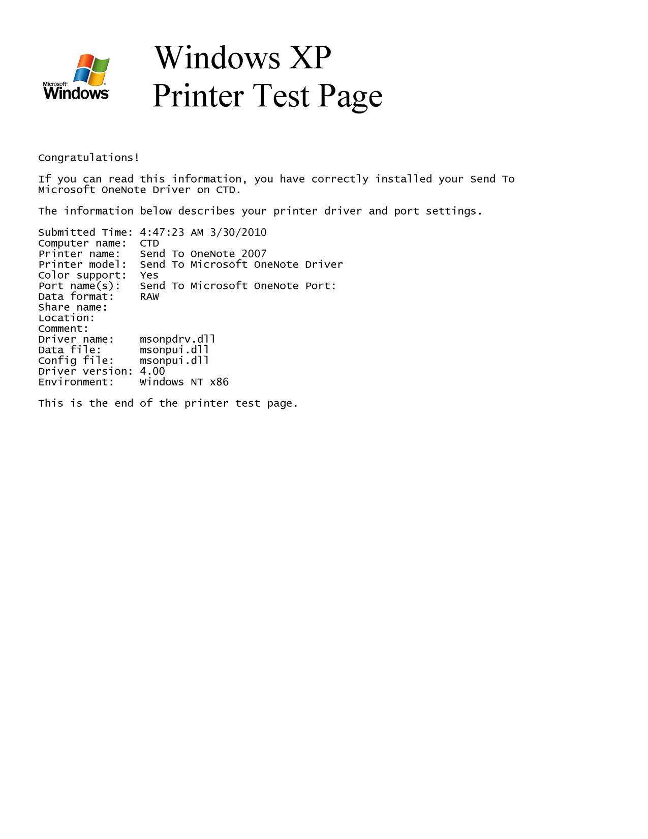

Tuesday, March 30, 2010
4:48 AM

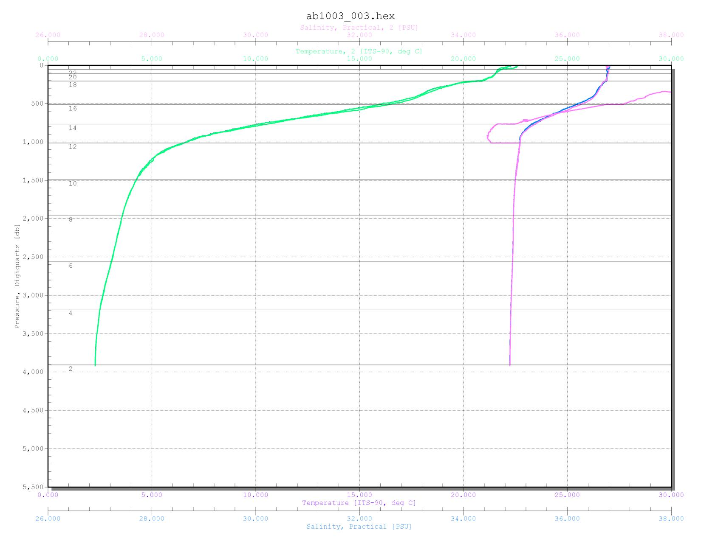

Tuesday, March 30, 2010
4:53 AM

Tuesday, March 30, 2010
4:54 AM

Wednesday, March 31, 2010
1:48 AM

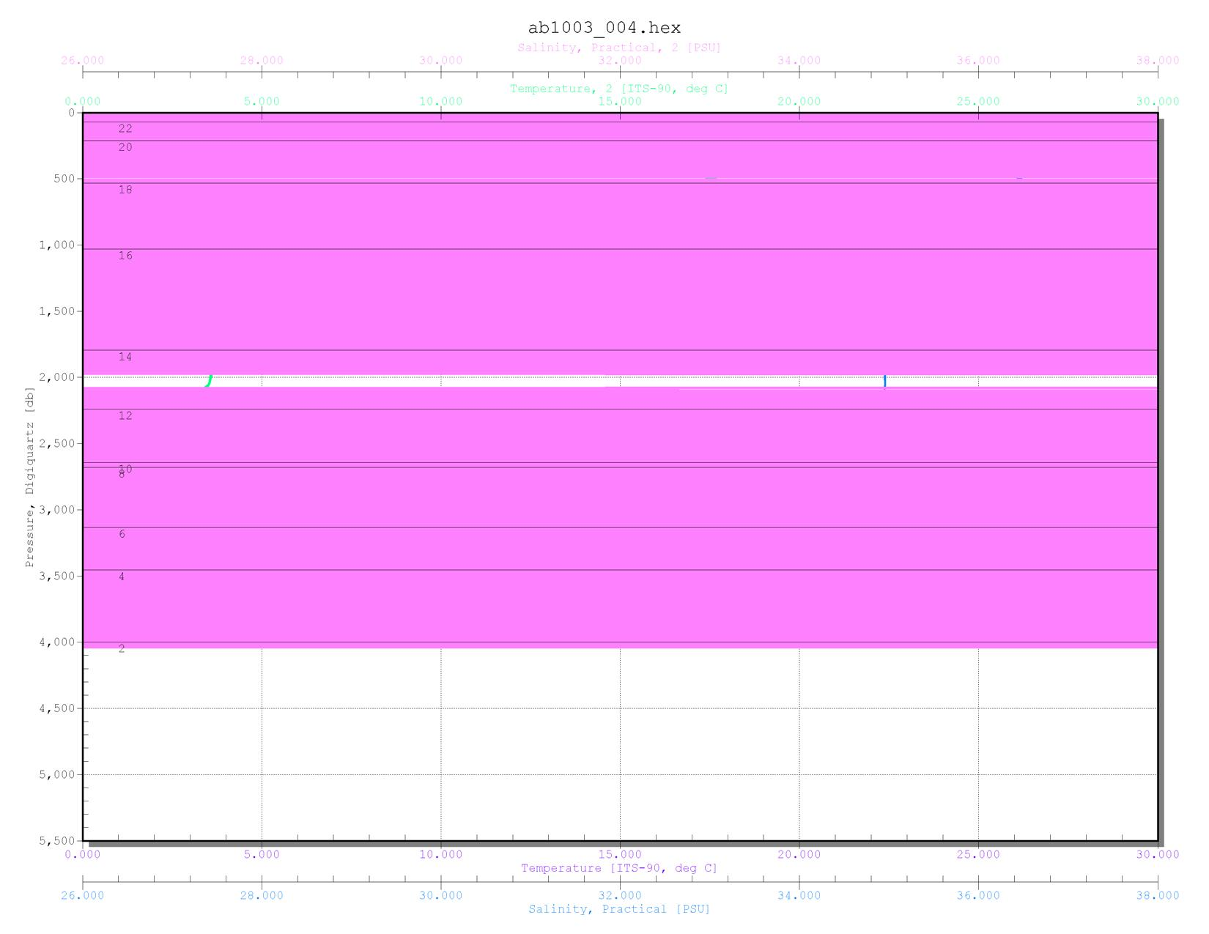

Wednesday, March 31, 2010
1:49 AM

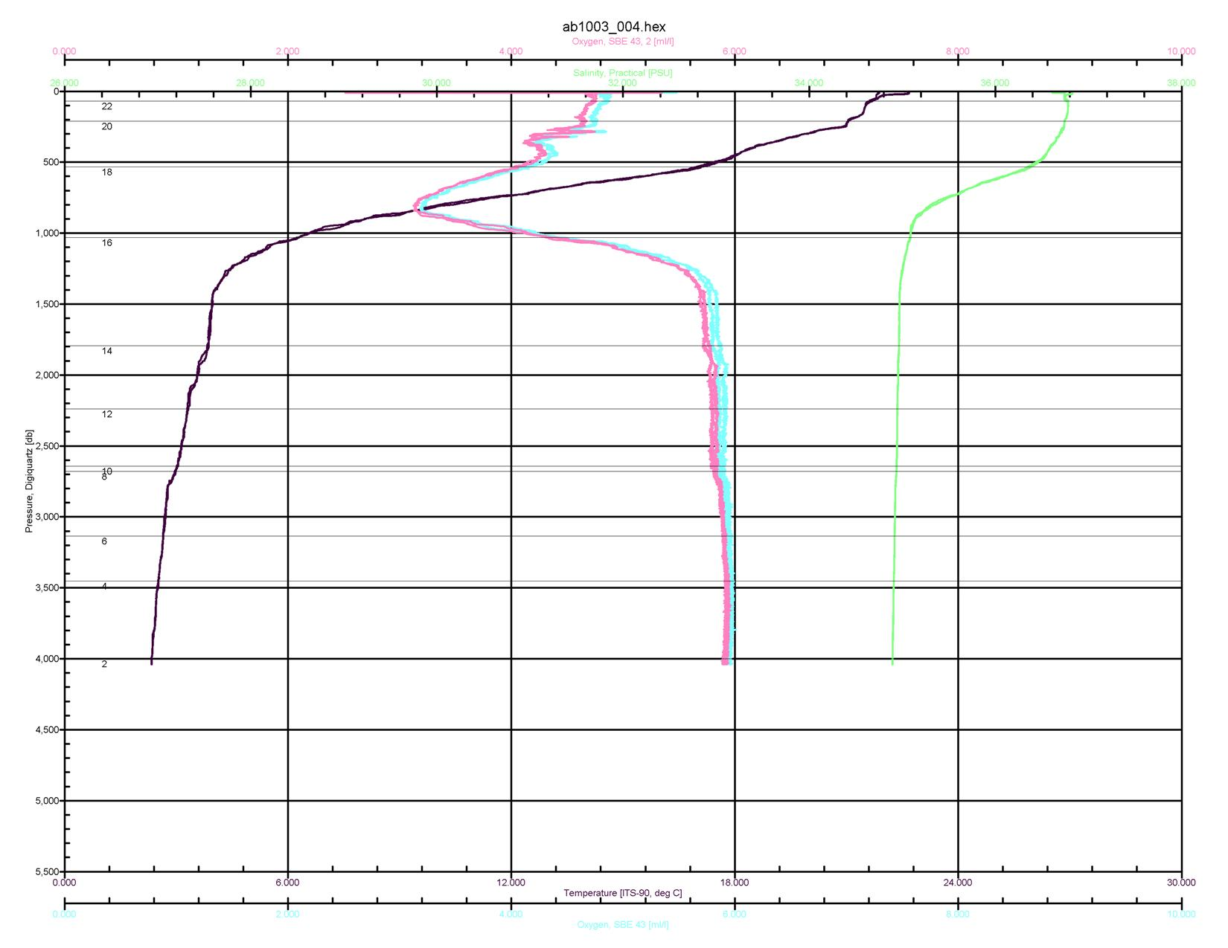

Wednesday, March 31, 2010
5:47 AM

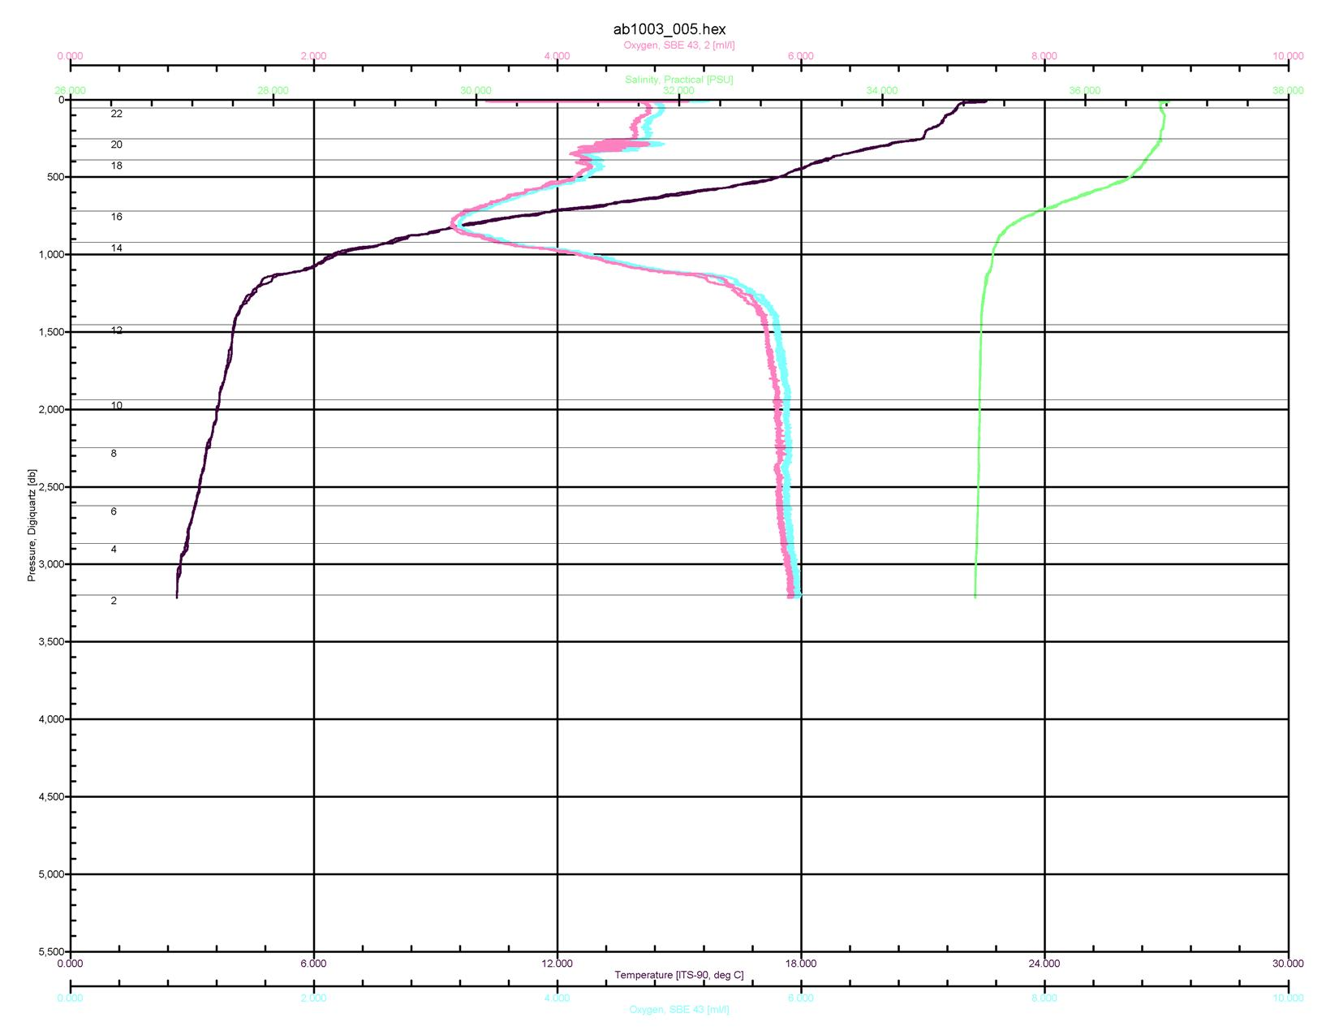

Wednesday, March 31, 2010
5:49 AM

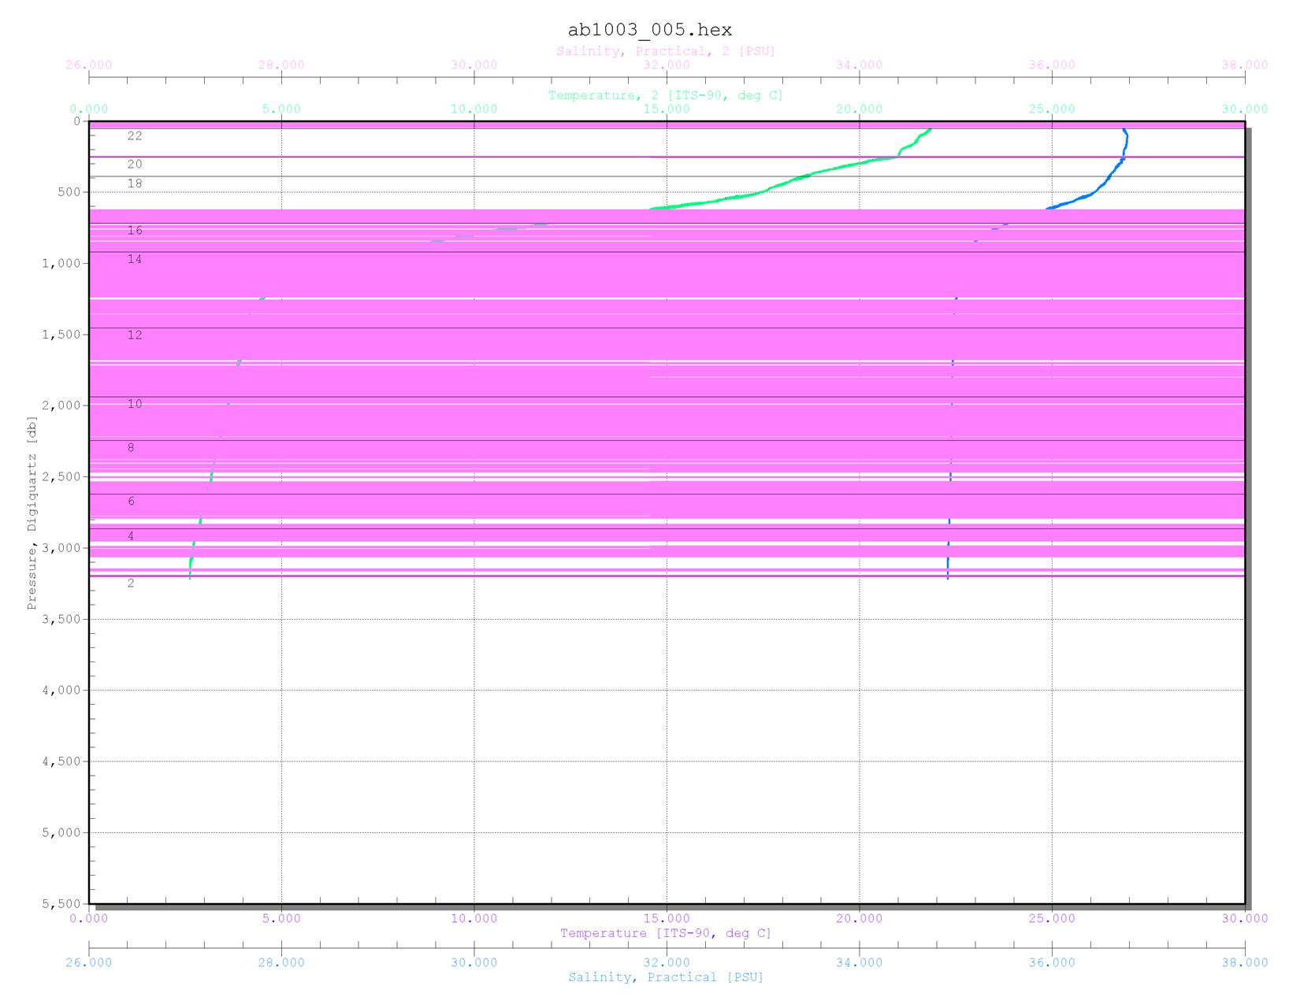

Friday, April 02, 2010
6:00 AM

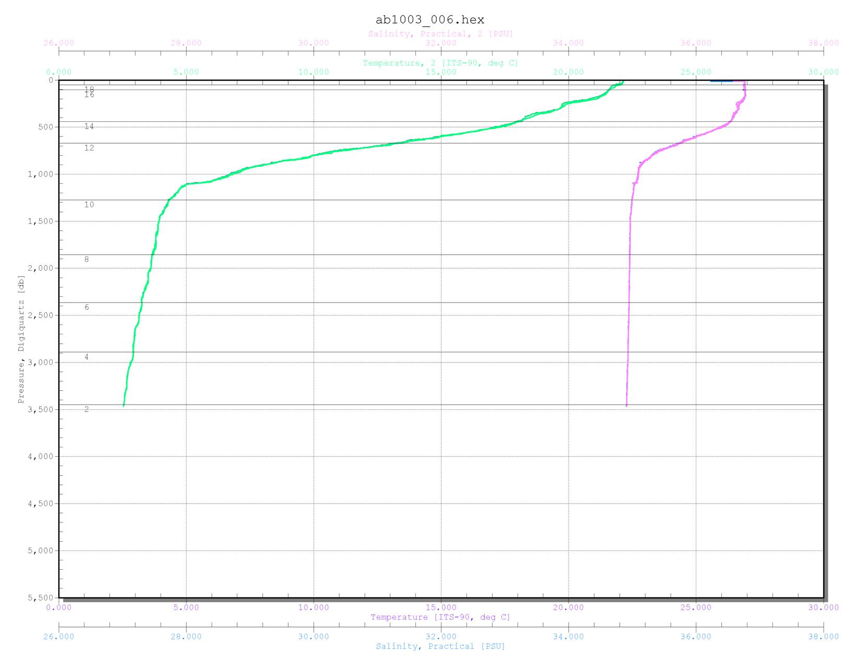

Friday, April 02, 2010
6:01 AM

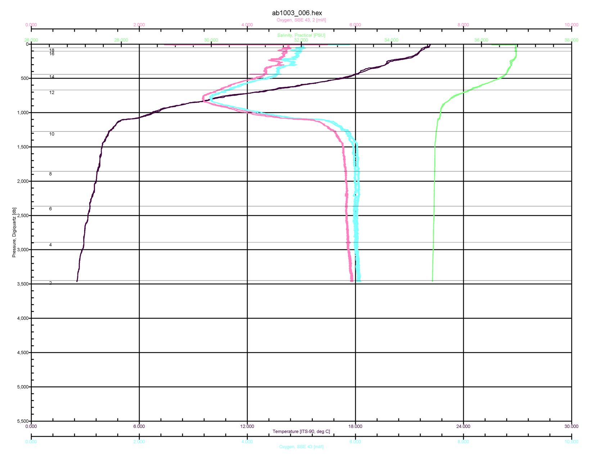

Saturday, April 03, 2010
5:28 AM

