OC451-OC454 CTD setup
Using oc451con.con that Laura had created, this was modified and saved to OC451.con by adding SBE43-0072 coefficients to .con file and inserted Flashbird#5 coefficients.
SBE9 data on Com1 at 19200,n,8,1. SBE32 modem on Com2.
Created and saved five display files with .DSA extensions for later use in c:\data\OC451 directory.
Saved all into OC451-decktest.PSA file in c:\data directory.
Created latest PSAReport and ConfileReport files in c:\data directory.
Successfully ran program several times to create demo files and check sensors.
No problems found.
Files backed up and ready for use.
Marshall 5-29-2009.
Default display screen in SeaSave7 when file OC451-decktest.psa is selected:
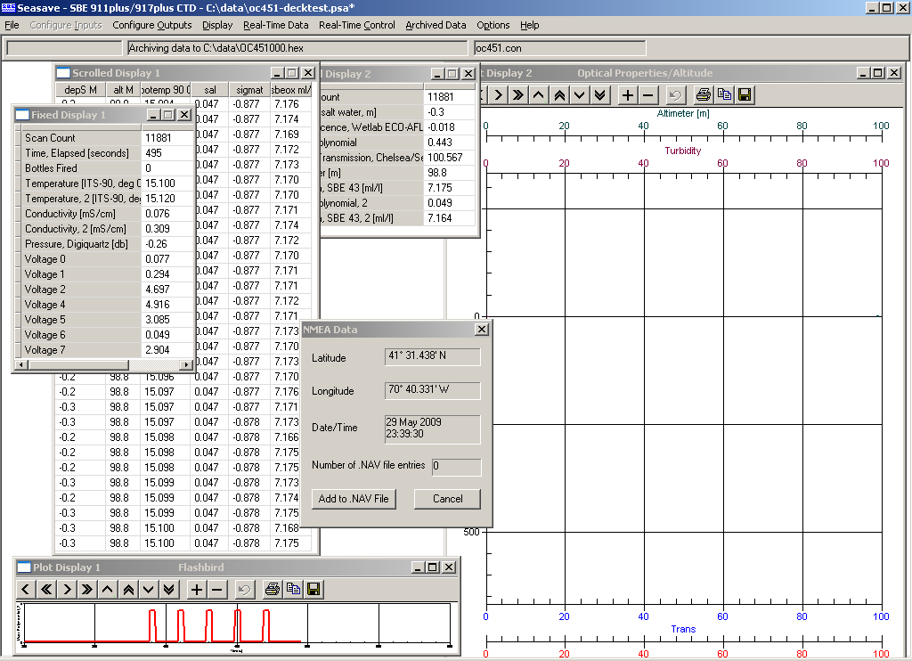
Closeup of Flashbird display showing camera startup 5-flash confirm sequence.
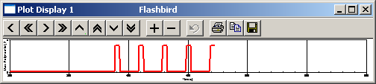

= end

