OC465 Cruise Report
Draft 7/8/10

Voyage #465 of R/V Oceanus was the third of four cruises in 2010 organized to serve complementary scientific objectives of two different projects. The two projects are:

GOMTOX: Dynamics of Alexandrium fundyense distributions in the Gulf of Maine: an observational and modeling study of nearshore and offshore shellfish toxicity, vertical toxin flux, and bloom dynamics in a complex shelf sea – NOAA ECOHAB

Objectives:
Investigate A. fundyense bloom dynamics and the pathways that link this organism to toxicity in nearshore and offshore shellfish.

Investigate the vertical structure of A. fundyense blooms, vertical toxin flux, and linkage to toxicity in offshore shellfish.

Alexandrium population biology in the Gulf of Maine – Woods Hole Center for Oceans and Human Health – NSF/NIEHS

Objectives:
Sample genetic variability of Alexandrium subpopulations throughout the Gulf of Maine.

Measure changes in relative abundance of Alexandrium genotypes in space and time.

Objectives common to both projects include:
Assess hydrodynamic and hydrographic context for interpretation of Alexandrium spp. measurements.

Incorporate field observations into a suite of numerical models for hindcasting and forecasting applications.

The primary domain of interest is Georges Bank, where a large bloom of A. fundyense was observed in 2007 and shorter and less intense bloom occurred in 2008. The four cruises in 2010 are designed to (1) resolve the seasonal variation of the Georges Bank bloom, and (2) quantify its interannual variability.

A secondary objective was added to the 2010 cruises when the results of the fall 2009 cyst survey (OC440) revealed that cyst abundance offshore of mid-coast Maine is now higher than in all prior measurements, including those that preceded the severe blooms of 2005 and 2008. This field season thus offers an exceptional opportunity for testing the hypothesis that the magnitude of the bloom in the western Gulf of Maine and Southern New England is set by the abundance of cysts. We therefore must consider the possibility of redirecting some of this year’s observational effort from Georges Bank to the Gulf of Maine. These choices will be informed by a number of factors, including real-time nowcasting and forecasting activities, as well as state agency toxicity monitoring efforts along the coasts of Maine, New Hampshire, and Massachusetts. If widespread toxicity appears along the coast, that would be consistent with the cyst hypothesis. However, if widespread toxicity does not appear, that would not necessarily be inconsistent with the hypothesis, as a large bloom could be present offshore. It is in this latter circumstance that diverting to the western Gulf of Maine would be most advantageous for hypothesis testing, insofar as confirming the absence of a large bloom would provide evidence for rejecting the hypothesis.

OC465 began with a survey of Georges Bank (Figure 1). A broad swath of cell concentrations in excess of 100 cells l⁻¹ occurred along the western two-thirds of the southern flank, peaking at 2600 cells l⁻¹. Elsewhere on the bank, cell concentrations were low. Bruce Keafer, Kerry Norton, and Chrissy Petitpas noted planozygotes in the live counts, suggesting the bloom may have reached its peak.

It is interesting to compare this survey with a prior one at the same time of year (Figure 2; EN448, June 27 – July 3, 2008). Cell concentrations observed on the bank during OC465 were higher and located further south and west than during EN448, but overall the distributions are quite similar.

Water mass analysis suggests significant interannual variability in hydrographic properties. Temperature-salinity diagrams reveal both Georges Bank water and warm/salty water characteristic of the continental slope (Figure 3, left panel). Focusing on the Georges Bank water (4-18°C, 31.5-33.5 psu), it appears to be nearly 0.5 psu fresher in 2010 than 2008. The warm temperature anomaly present in prior cruises (OC460, EN476) is no longer apparent.

The OC465 coastal survey consisted of a series of transects spanning from just south of Boston to one off Isle au Haut (Figure 1). Surface live counts revealed two population centers of Alexandrium with concentrations in excess of 1000 cells l⁻¹: one southwest of Penobscot Bay, and the other northeast of Cape Ann. These two areas are divided by consistently low concentrations in all but the outermost station of the Casco Bay line—an aspect that we find curious. In any case, the overall resurgence of the western Gulf of Maine Alexandrium population came as quite a surprise, given very low concentrations observed during OC460 (May 1-10) and EN476 (May 26-June4). We had attributed the unexpectedly low concentrations to a warm and fresh water mass anomaly. Lo and behold, OC465 hydrography reveals the water mass anomaly has lessened, with intermediate and shallower waters having become saltier in the month since our last cruise (Figure 3, right panel). We are very eager to learn if the nutrient environment has also shifted, and how that may have affected vegetative growth of Alexandrium. Data from Dave Townsend’s lab will provide insight into that aspect. In any case, it appears that retreat of the water mass anomaly allowed the Alexandrium population in the western Gulf of Maine to re-establish itself. Another potentially related factor is advection by the coastal current. Initial returns from drifters deployed off Casco Bay suggest the along-coast velocities may have increased from their earlier sluggish state (Figure 4; Appendix A, Table 3), facilitating increased transport of Alexandrium populations into the western Gulf of Maine. Although only two drifters were deployed on OC465, the offshore drifter appears to be moving nearly twice as fast as its counterpart from EN476.

Ironically, after two months of overpredictions, the forecast model is now underpredicting cell concentrations in the western Gulf of Maine (Figure 5).

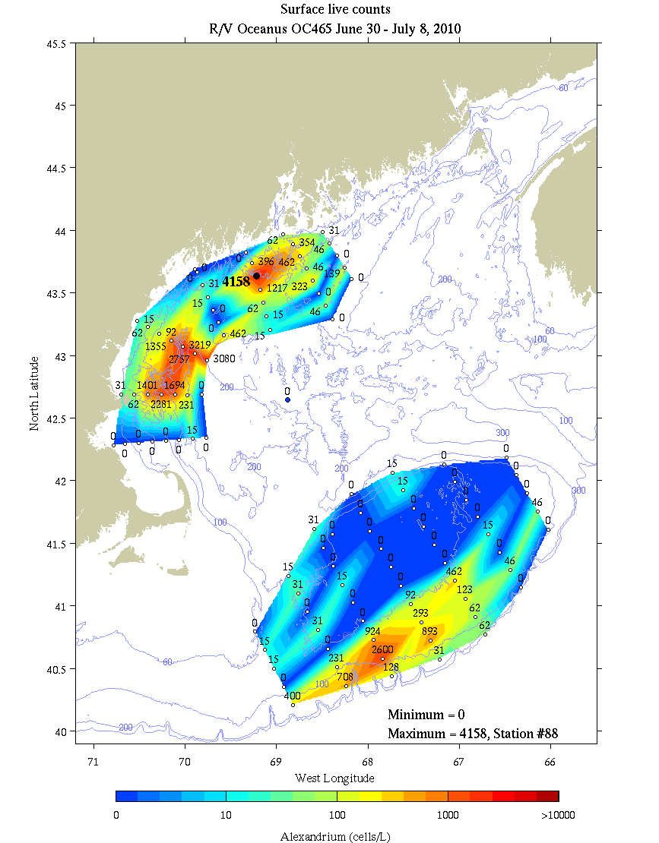
Figure 1. Alexandrium concentration (cells l⁻¹) from surface live counts on OC465.

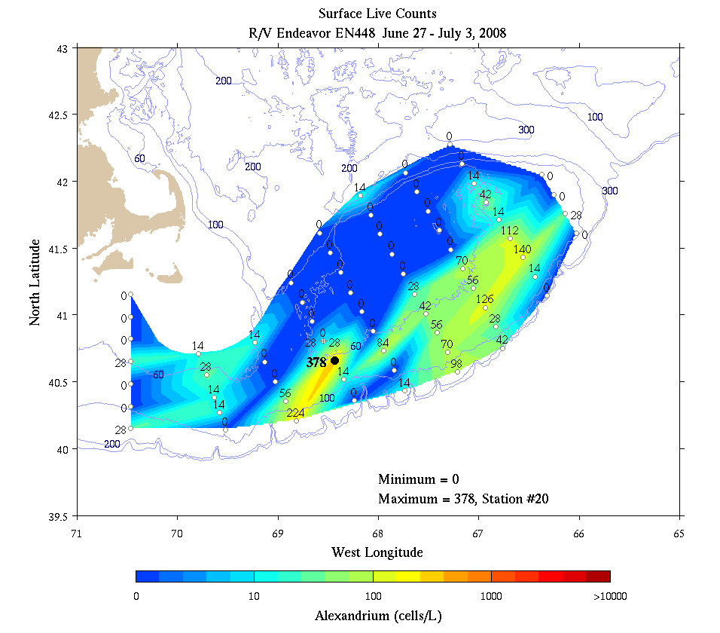
Figure 2. Alexandrium concentration (cells l⁻¹) from surface live counts on EN448, June 27 – July 3, 2008.

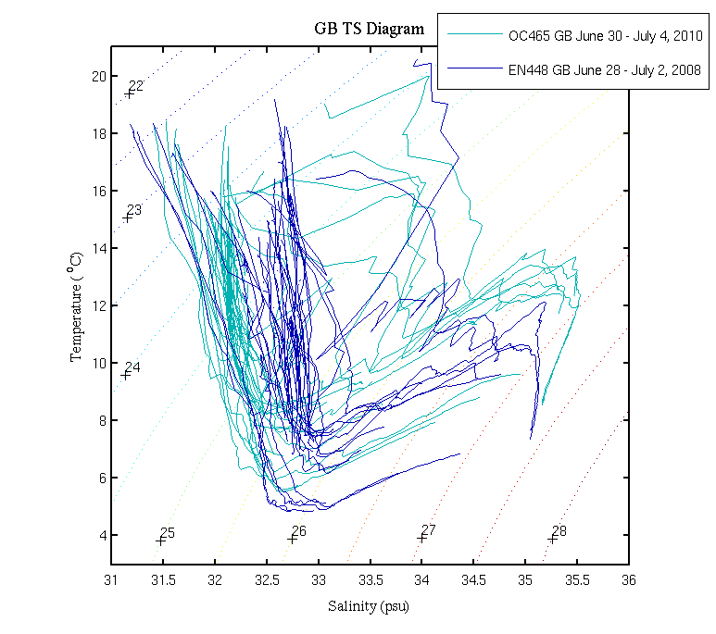 | 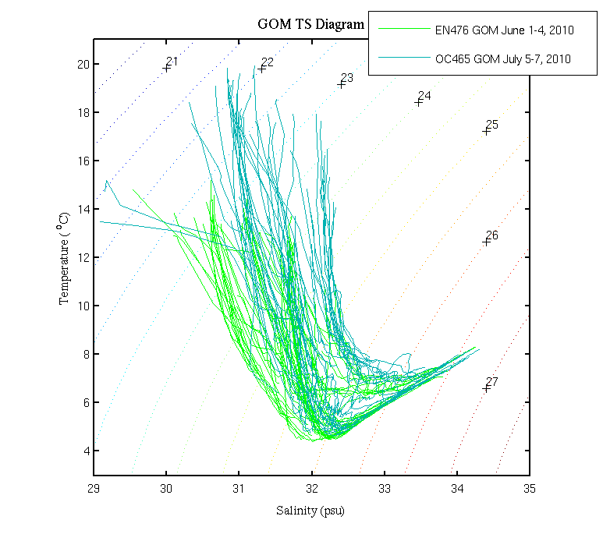
Figure 3. Left: Temperature / salinity characteristics of hydrographic profiles on Georges Bank during EN448 in 2008 (dark blue) and OC465 in 2010 (light blue). Right: T/S comparison for Gulf of Maine profiles from EN476 (light green) and OC465 (light blue). These results must be treated with caution as the OC465 salinities have not yet been calibrated with salt bottle data yet.

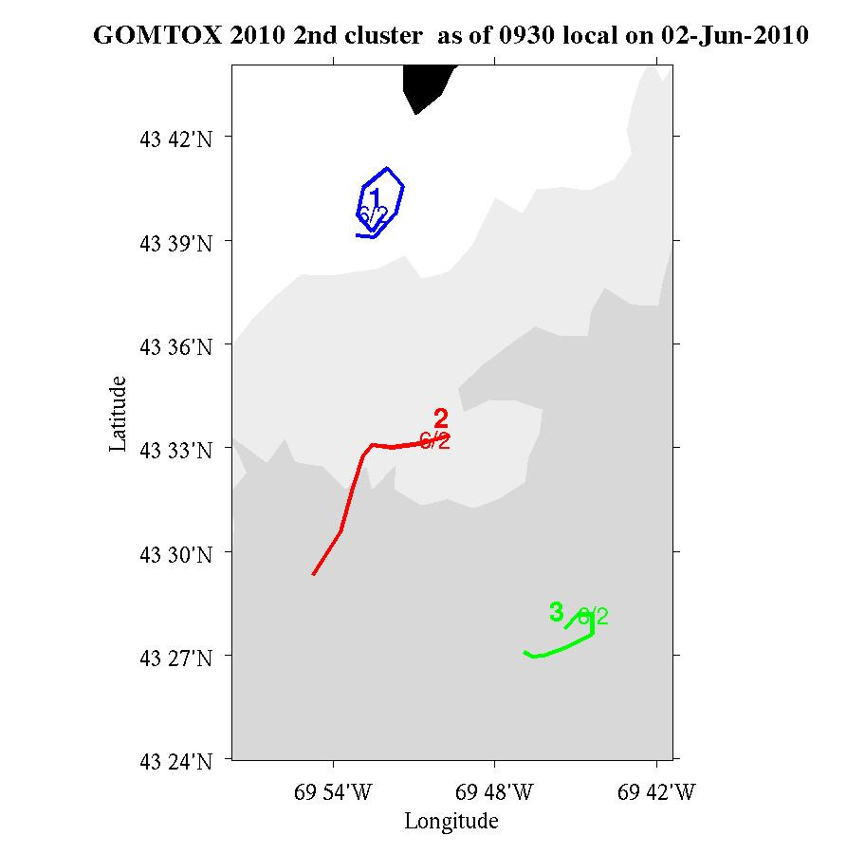 | 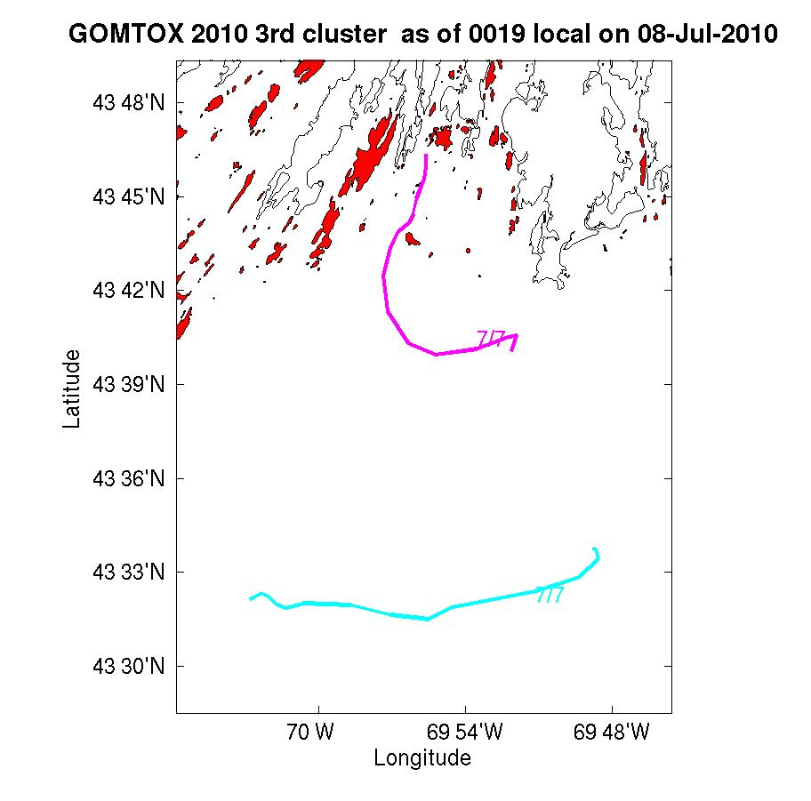
Figure 4. Initial trajectories (ca. 1 day) of drifters released along the Casco Bay line on EN476 (left) and OC465 (right). Figures courtesy of Jim Manning.

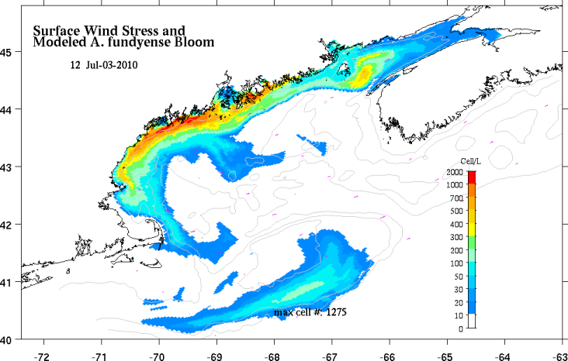
Figure 5. A. fundyense model predictions for May 8 (right). For a complete description of the forecast system and 2010 results, see http://omglnx3.meas.ncsu.edu/GOMTOX/2010forecast/.

Appendix A: Measurements made on OC465

Underway measurements
a. Acoustic Doppler Current Profiler
b. Meteorological sensors

Core hydrographic measurements
a. CTD (pressure, temperature, salinity, oxygen, fluorescence, beam attenuation, PAR)
b. Alexandrium cell counts: 1, 10, 20, 30, 40, 50m plus 250/near bottom
c. Nutrients: standard depths plus 100, 150, 200, 250m
Water budget:

Bottle # | Depth | Live | Spare | Whole Cell | SHA | Nuts/Chl | Pseuds | total
1 | 1 |  |  | 2 | 2 | 1.0 | 1.0 | 7.0
2 | 1 | 10 |  |  |  |  |  | 10
3 | 1 |  | 10 |  |  |  |  | 10
4 | 10 |  |  | 2 | 2 | 1.0 | 1.0* | 7.0
5 | 20 |  |  | 2 | 2 | 1.0 | 1.0* | 7.0
6 | 30 |  |  | 2 | 2 | 1.0 | 1.0* | 7.0
7 | 40 |  |  | 2 | 2 | 1.0 | 1.0* | 7.0
8 | 50 |  |  | 2 | 2 | 1.0 | 1.0* | 7.0
9 | 100 |  |  |  |  | 1.0 |  | 1.0
10 | 150 |  |  |  |  | 1.0 |  | 1.0
11 | 200 |  |  |  |  | 1.0 |  | 1.0
12 | 250 / near bottom |  |  |  |  | 1.0 |  | 1.0

Af water- For Whole Cell (WC) and Sandwich Hybridization (SHA) – 4 liters collected total and 20 μm sieved and split between the two assays.

4L/depth combined/split x 6 depths=6 WC tubes&6 filters/station (6 hole-manifold #1 loaded once)

Pseuds – At each station: 1) 125 ml whole water will be filtered for Pseud SHA onto 0.45µm Duropore filters; 2) 125ml whole water will be filtered for ARISA samples onto 0.45µm Isopore HA filters (as in 2008); 3) 125 ml whole water will be filtered for Domoic Acid onto 0.45µm Isopore HA filters. SHA filters will be frozen in LN2 Dewar

3 filters and cryo-vials/station will be needed. Use a 3-hole manifold—Note that the Pseud SHA filter and the ARISA/DA filters are the same pore size, but not the same material. Do not mix up the filter types.

*A vertical profile of Pseuds will be sampled at 4-6 selected stations with high abundance, in different hydrographic regimes as conditions permit. Same procedure as above but repeat for all 6 std depths.

A Domoic Acid “calibration” station will also be done at selected stations—details TBD.

Opportunistic samples– a spare 10L live sample will be available for multiple purposes; e.g., culturing of Pseuds and/or Alexandrium, life cycle stage samples, and possibly microsatellite analysis of Alexandrium populations. Additional opportunistic samples may be taken in areas of high Alexandrium and/or Pseud abundance.

Toxin size fractionation – Turner
Pump profiles were carried out at selected locations. Sampling depths were chosen to coincide as closely as possible with hydrographic sampling and sediment trap measurements. Pump deployments are summarized in Table 2.

 | Date | Time  (local) | Latitude | Longitude | Station | Live Count
1 | July 1 |  | 40 26.0 N | 67 44.4 W | Shelf edge, SW Oceanographers Canyon, CTD 6p | 708
2 | July 1 |  | 41 34.3 N | 68 23.0 W | FDA shellfish time-series site  Cultivator Shoal, CTD 14p | 0
3 | July 5 |  | 42 41.4 N | 70 15.2 W | Cape Ann line, CTD67p | 2281
4 | July 6 |  | 43 38.1 N | 69 12.9W | Monhegan line CTD88p | 4158
Table 2. Pump stations.

Drifters

ID | Mon | Day | Year | Time  GMT | Lon | Lat | Drogue  depth(m) | Station Number
ESN 319203 | 7 | 6 | 2010 | 1614 | 69 48.6 W | 43 33.7 N | 1 | CB1C
ESN 322410 | 7 | 6 | 2010 | 1705 | 69 52.0 W | 43 39.7 N | 1 | CB1B
Table 3: Summary of drifter releases on Casco Bay line. For more information see http://nefsc.noaa.gov/drifter.

Microbial community structure and bacterial abundance – Amaral-Zettler and Murphy

OC465 #1 – CTD14 – Georges Bank Cultivator Shoal – Alexandrium live count = 0
7/1/10 41 34.3 N / 68 23.0 W
Sfc (1),(2)
10m (1),(2)
20m (1),(2)

OC465 #2 – CTD24 – Georges Bank S Flank– Alexandrium live count = 893
7/2/10 40 43.4 N / 67 18.8 W
Sfc (1),(2)
10m (1),(2)
20m (1),(2)

OC465 #3 – CTD67p – Cape Ann transect – Alexandrium live count = 2281
7/5/10 42 41.4 N / 70 15.2 W
Sfc (1),(2)
10m (1),(2)
20m (1),(2)

OC465 #4 – CTD88p – Monhegan transect – Alexandrium live count = 4158
6/3/10 43 58.8 N / 68 6.5 W
Sfc (1),(2)
10m (1),(2)
20m (1),(2)

Appendix B: Hydrographic maps
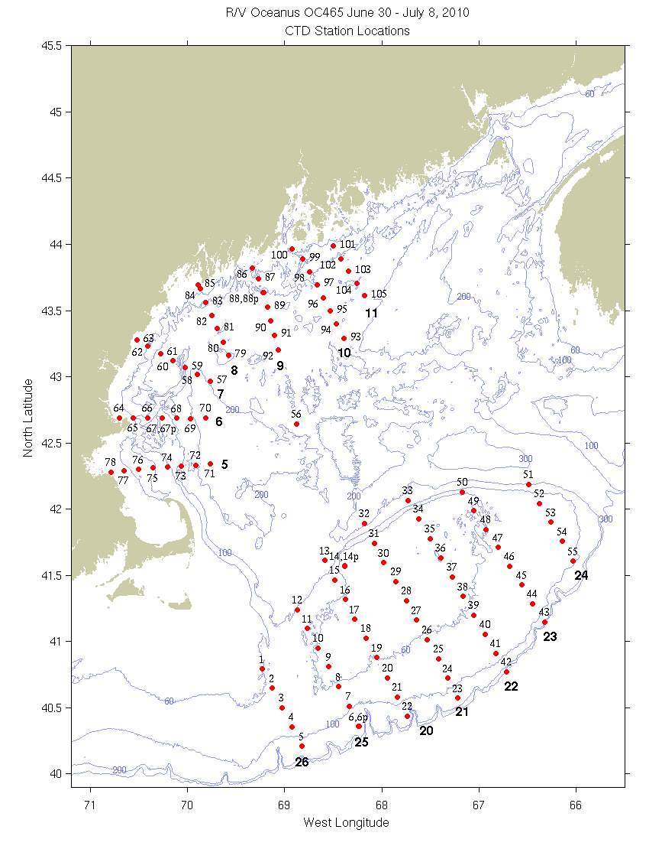
Figure B1: CTD station locations. Bold numerals indicate identifiers for the sections displayed below.

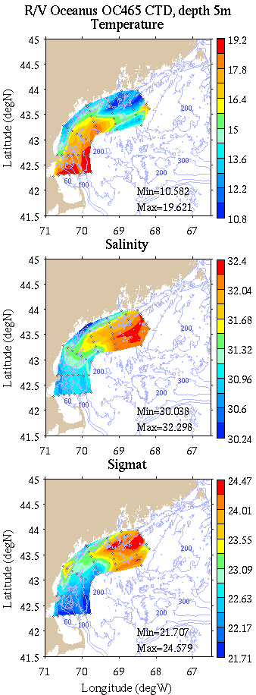 | 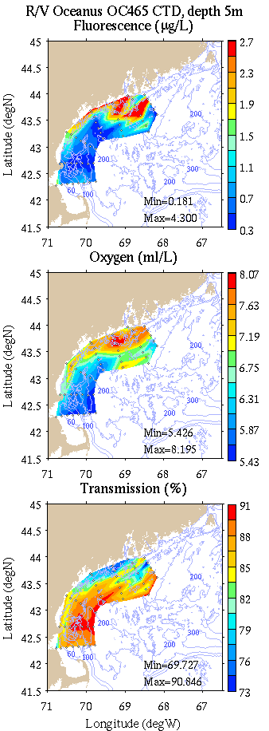
Figure B2: Coastal GOM survey maps at 5m depth. Left: temperature, salinity, and density; right: fluorescence, oxygen, and light transmission.

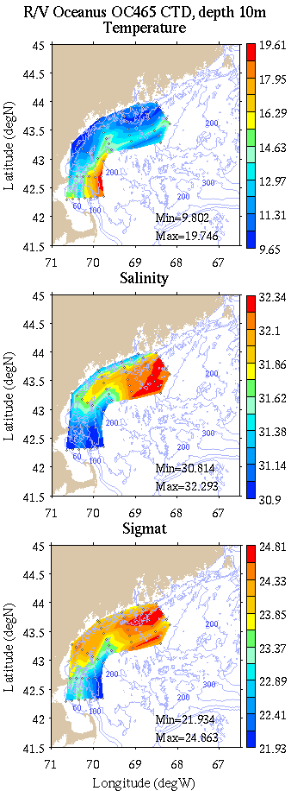 | 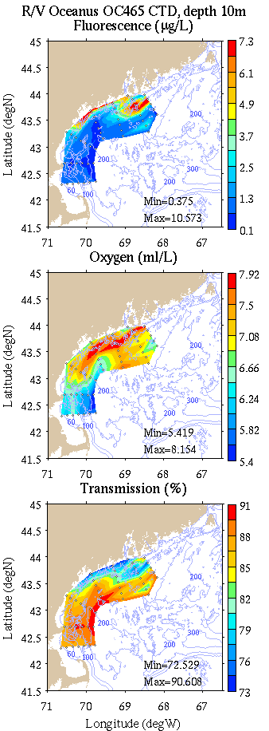
Figure B3: Coastal GOM survey maps at 10m depth. Left: temperature, salinity, and density; right: fluorescence, oxygen, and light transmission.

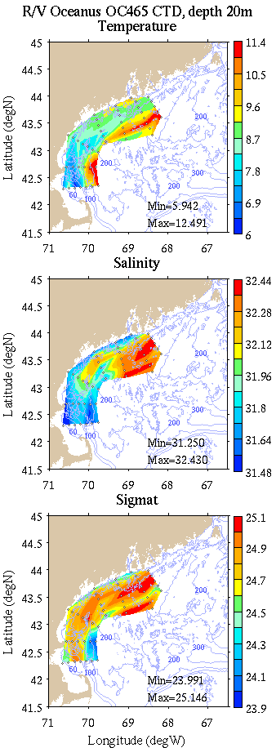 | 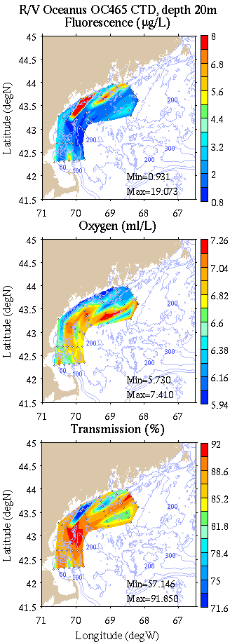
Figure B4: Coastal GOM survey maps at 20m depth. Left: temperature, salinity, and density; right: fluorescence, oxygen, and light transmission.

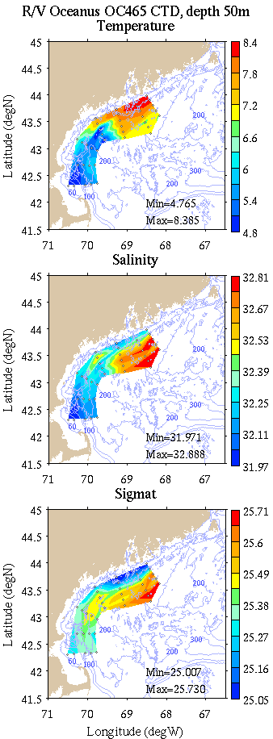 | 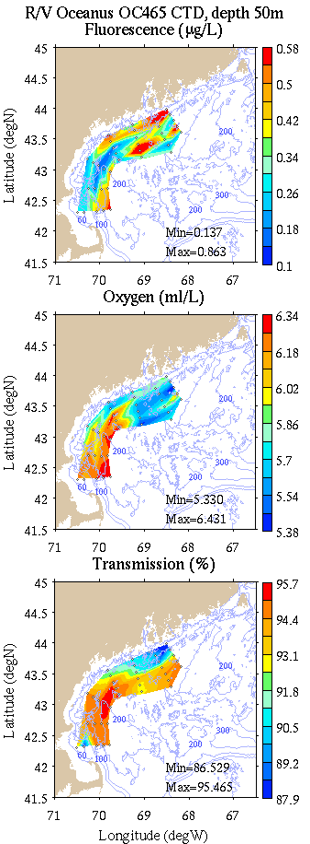
Figure B5: Coastal GOM survey maps at 50m depth. Left: temperature, salinity, and density; right: fluorescence, oxygen, and light transmission.

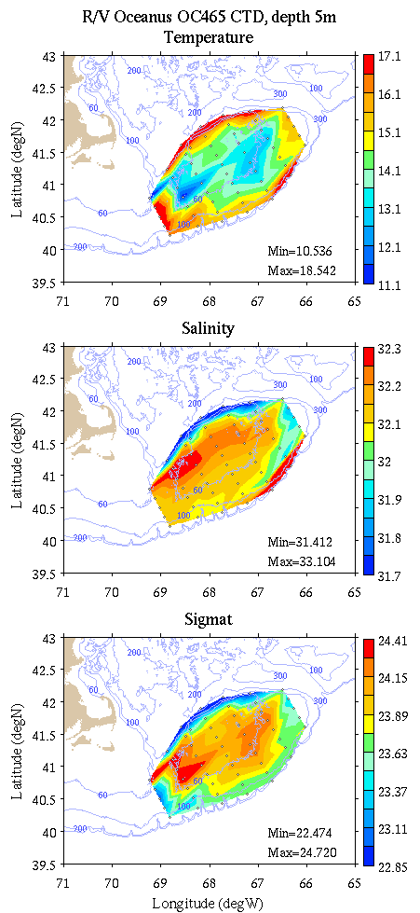 | 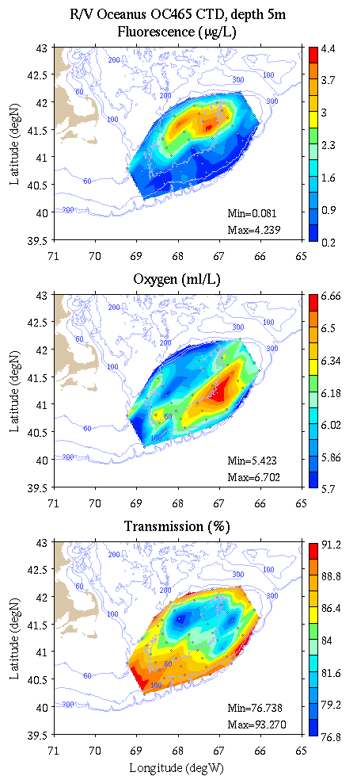
Figure B6: Georges Bank survey maps at 5m depth. Left: temperature, salinity, and density; right: fluorescence, oxygen, and light transmission.

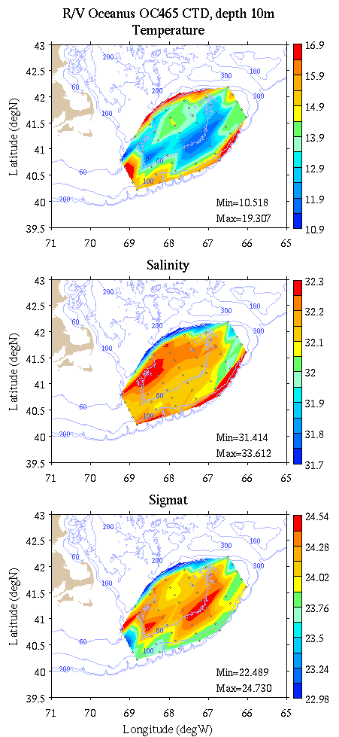 | 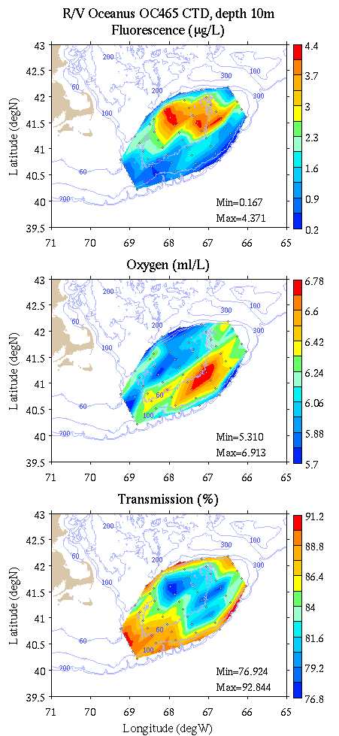
Figure B7: Georges Bank survey maps at 10m depth. Left: temperature, salinity, and density; right: fluorescence, oxygen, and light transmission.

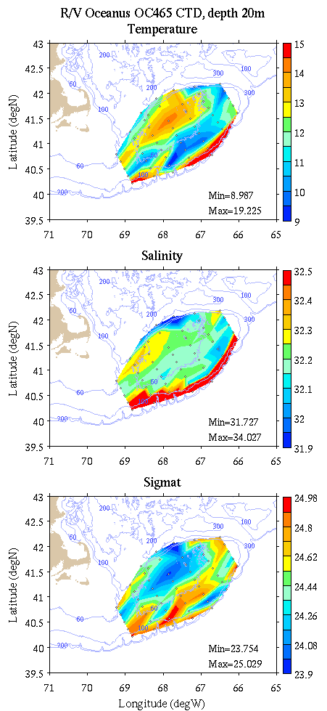 | 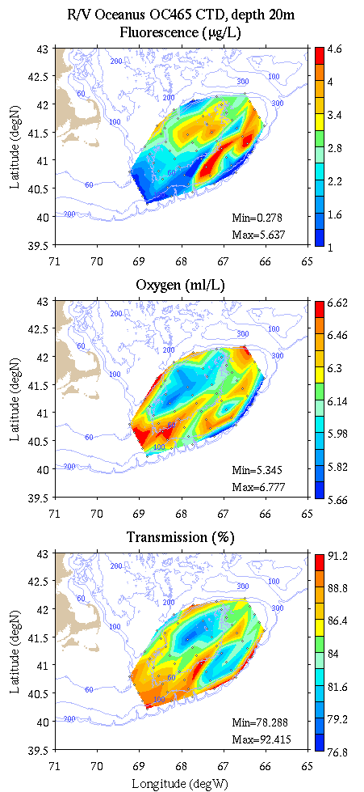
Figure B8: Georges Bank survey maps at 20m depth. Left: temperature, salinity, and density; right: fluorescence, oxygen, and light transmission.

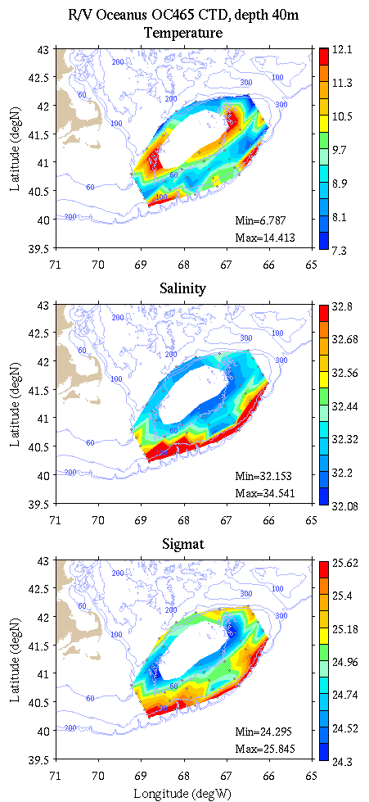 | 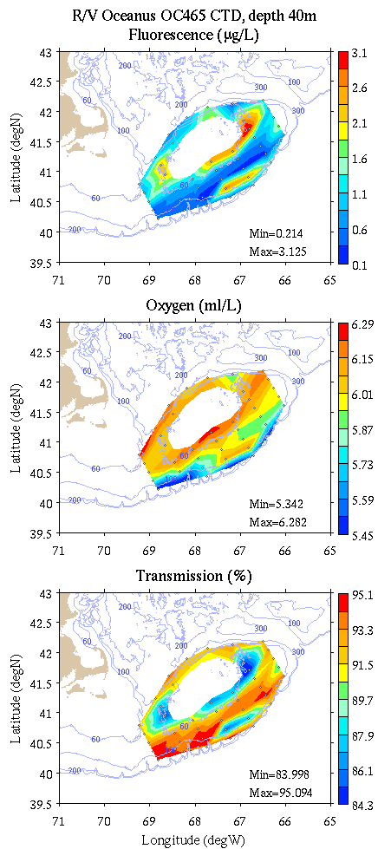
Figure B9: Georges Bank survey maps at 40m depth. Left: temperature, salinity, and density; right: fluorescence, oxygen, and light transmission.

Appendix C: Vertical sections.

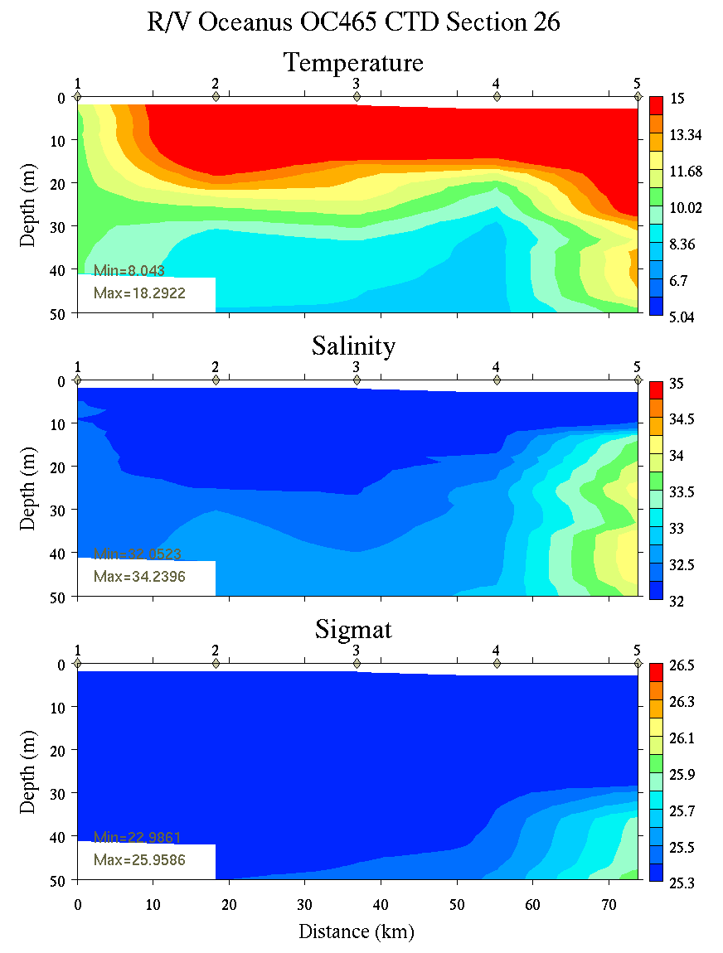 | 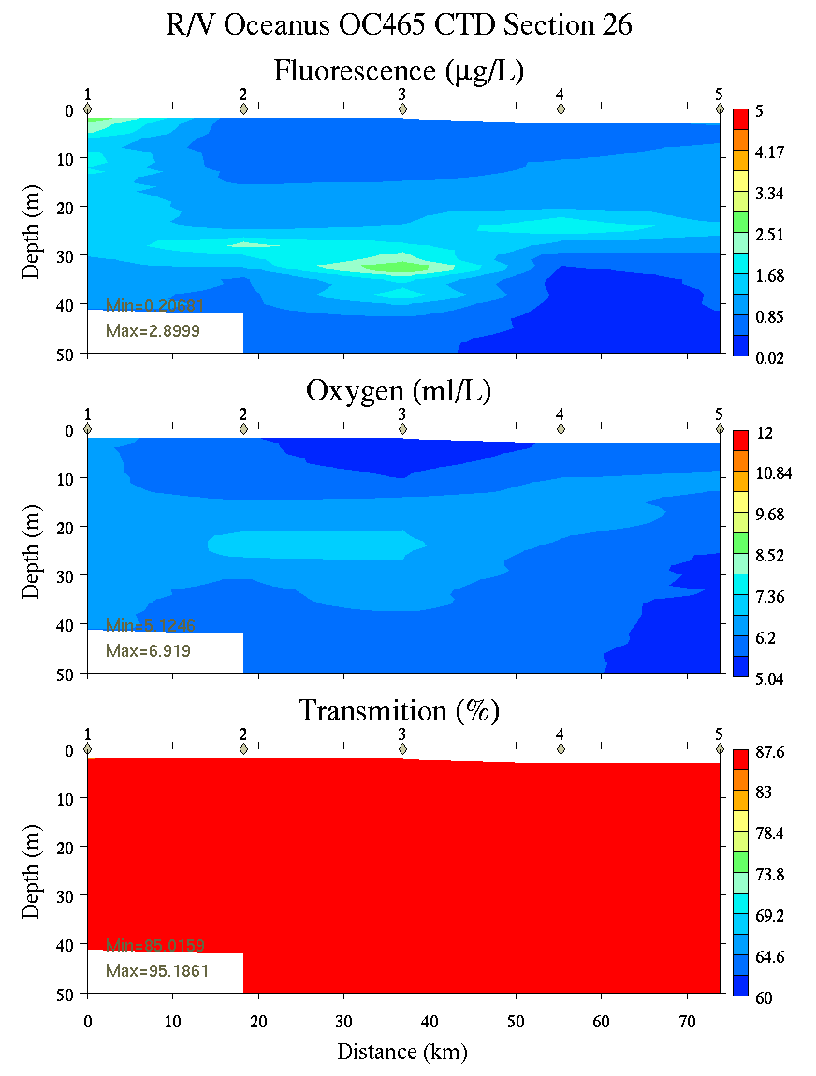
Figure C1. Section 26, 0-50m: temperature, salinity, and density (left); fluorescence, oxygen, and beam transmission (right).

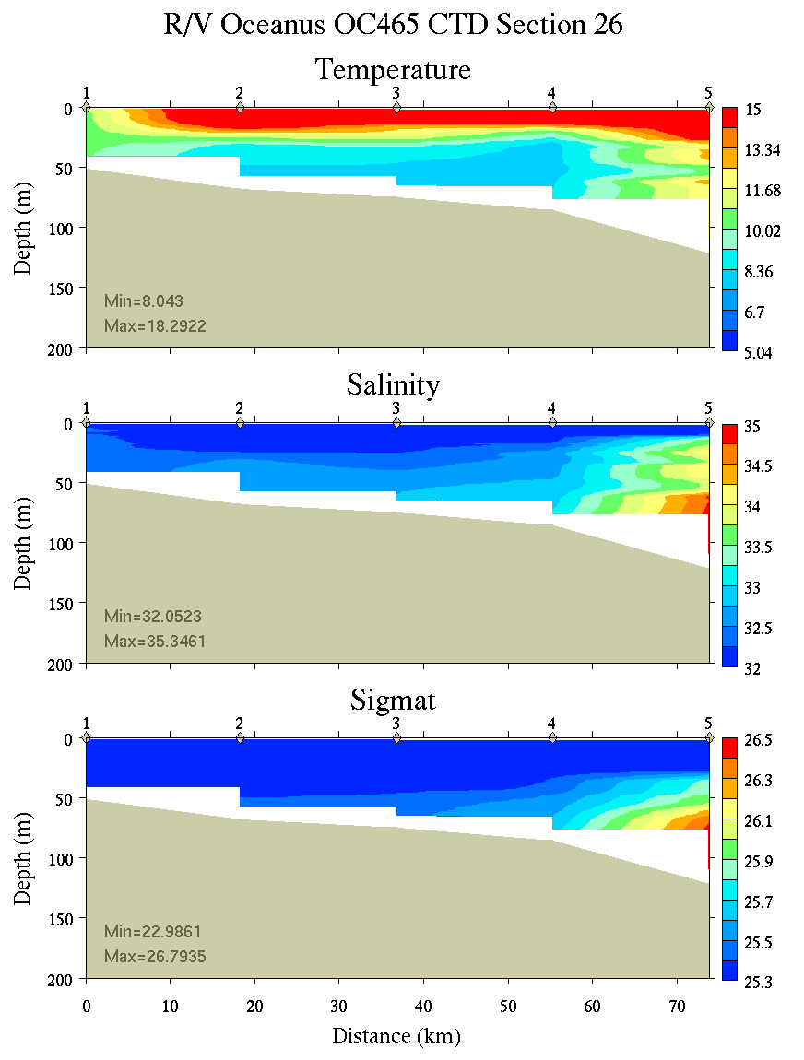 | 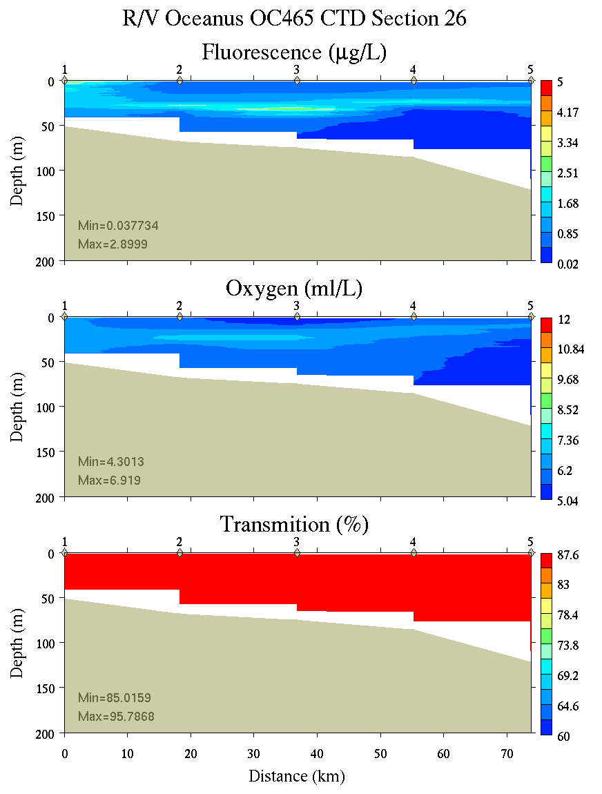
Figure C2. Section 26, 0-200m: temperature, salinity, and density (left); fluorescence, oxygen, and beam transmission (right).

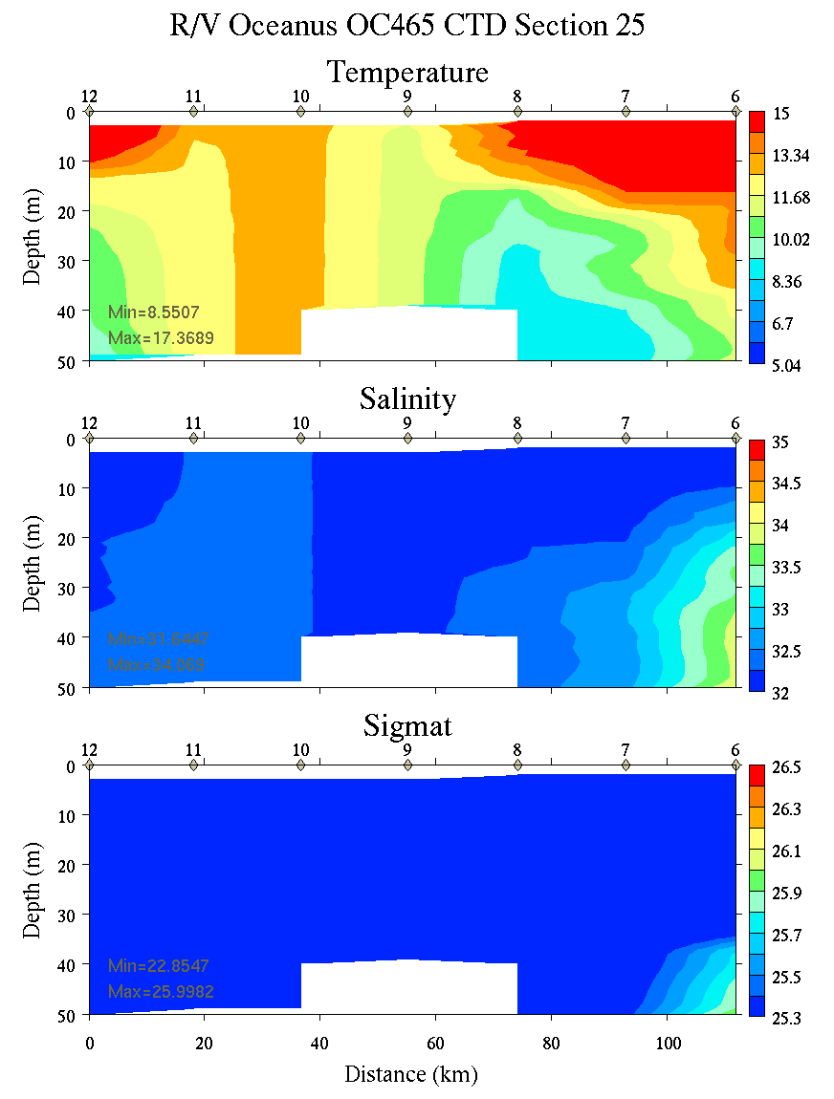 | 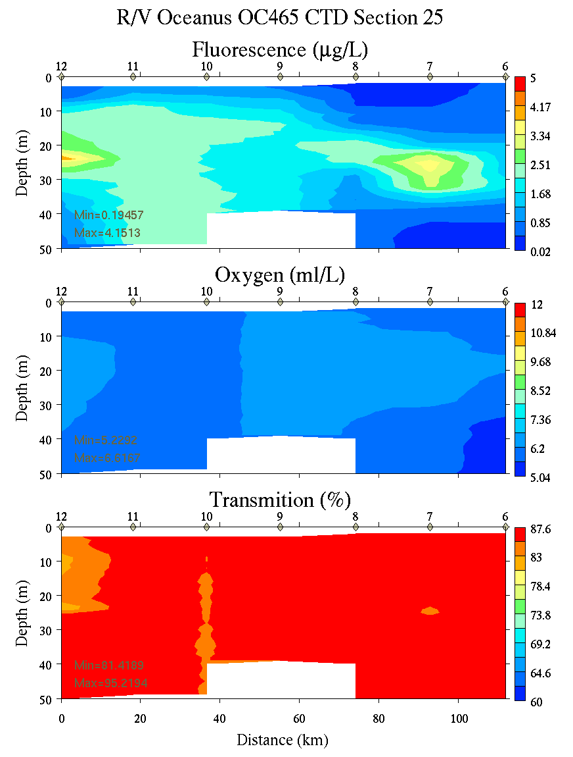
Figure C3. Section 25, 0-50m: temperature, salinity, and density (left); fluorescence, oxygen, and beam transmission (right).

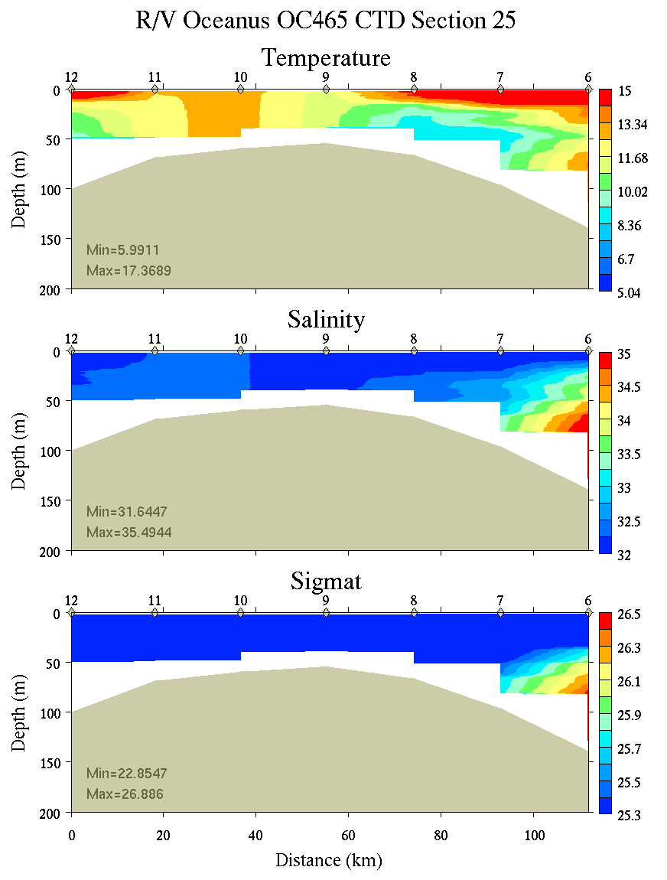 | 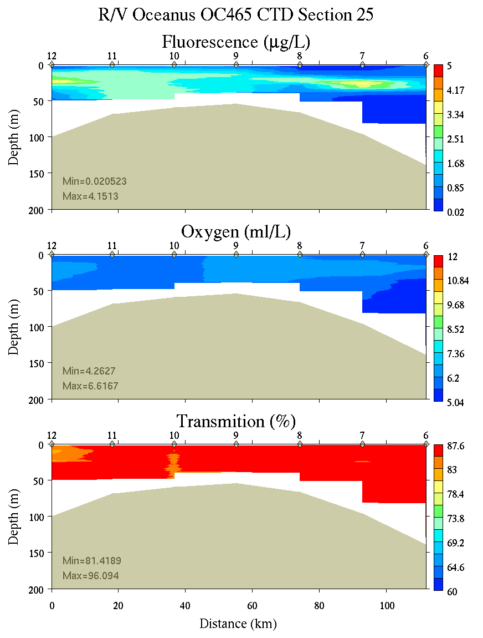
Figure C4. Section 25, 0-200m: temperature, salinity, and density (left); fluorescence, oxygen, and beam transmission (right).

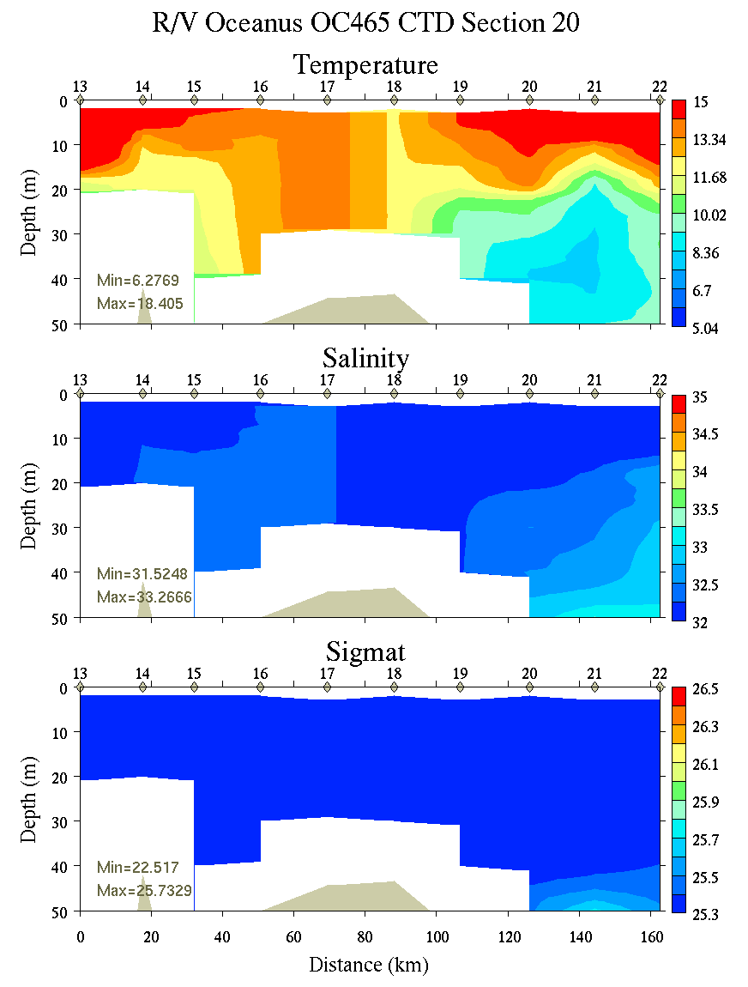 | 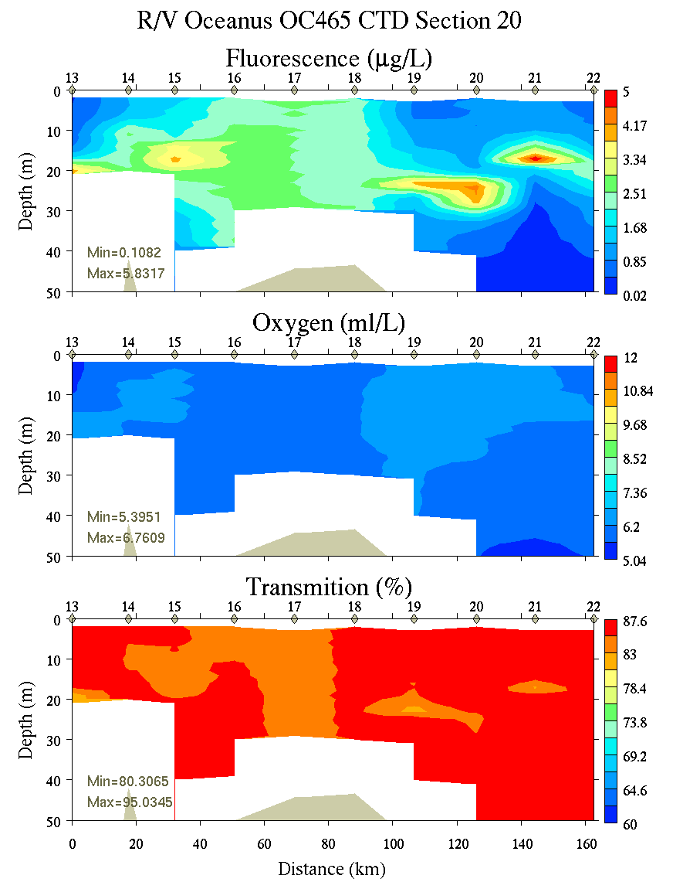
Figure C5. Section 20, 0-50m: temperature, salinity, and density (left); fluorescence, oxygen, and beam transmission (right).

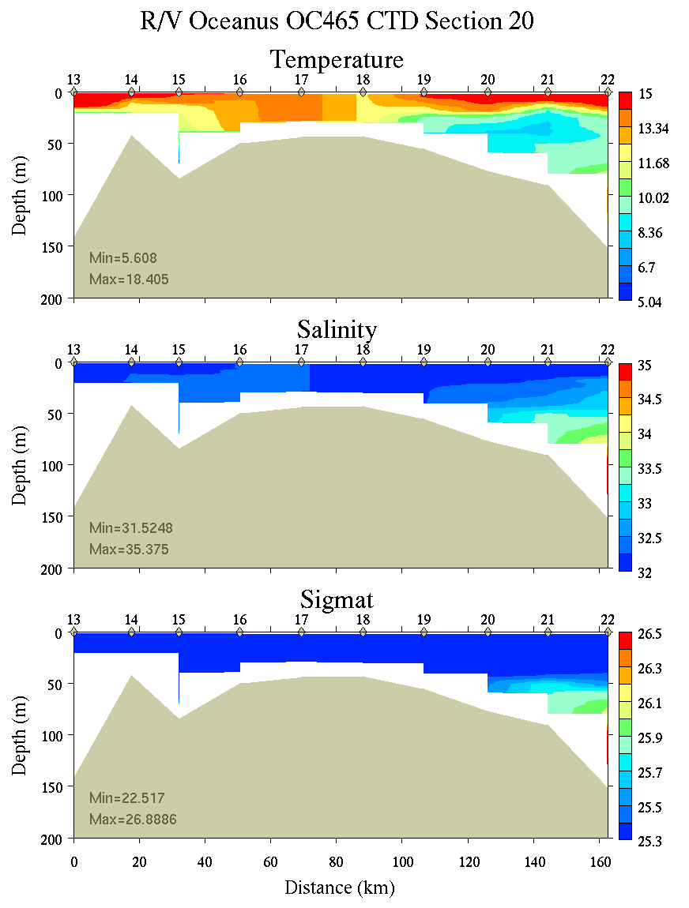 | 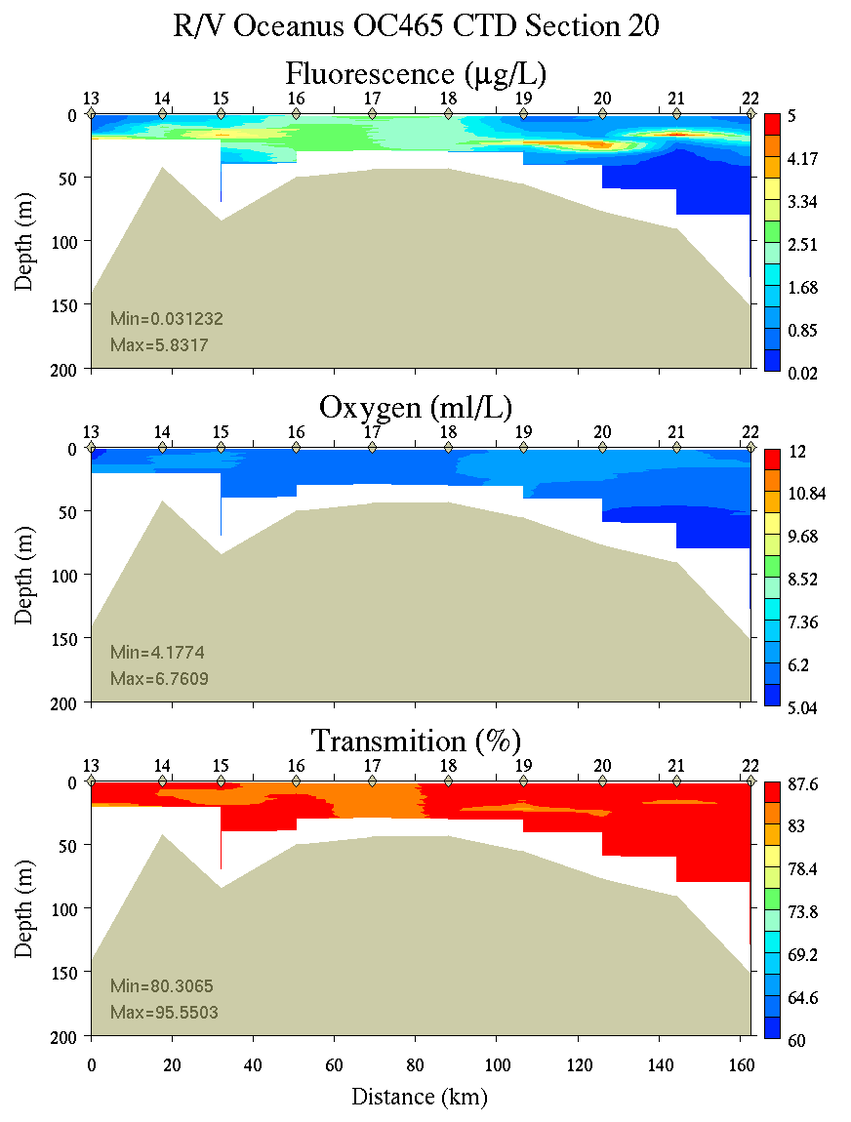
Figure C6. Section 20, 0-200m: temperature, salinity, and density (left); fluorescence, oxygen, and beam transmission (right).

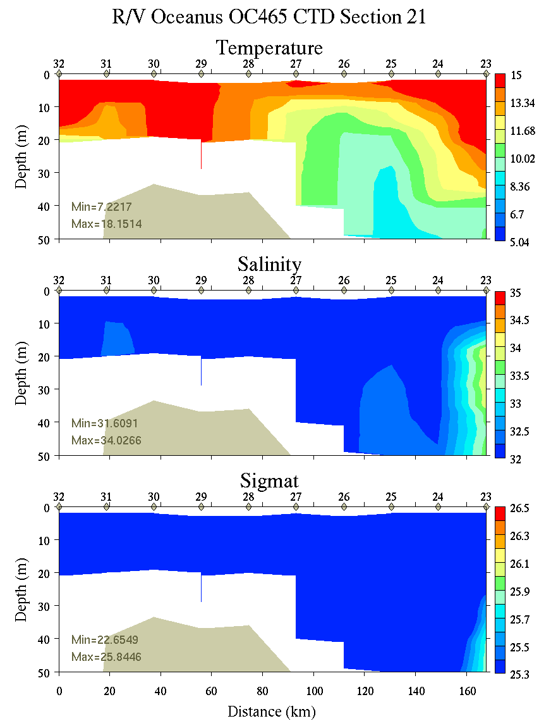 | 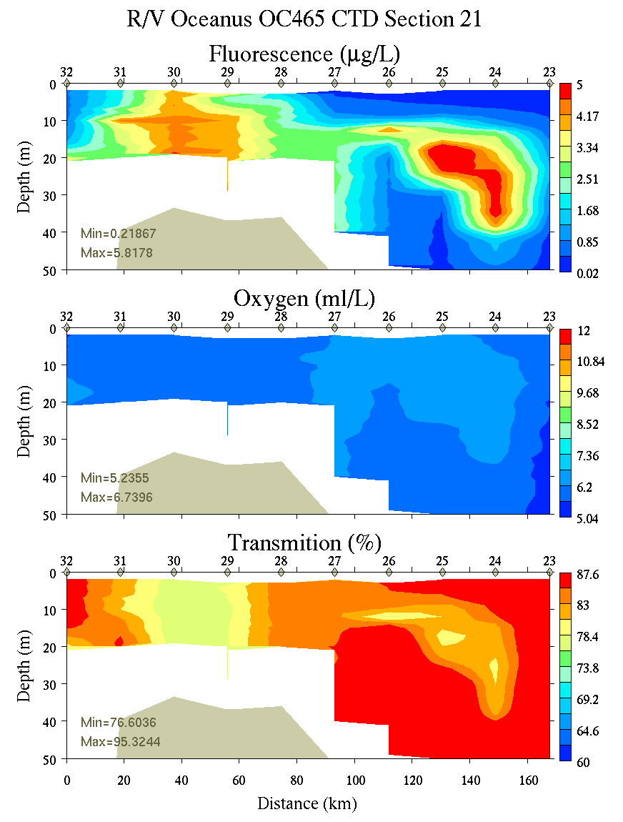
Figure C7. Section 21, 0-200m: temperature, salinity, and density (left); fluorescence, oxygen, and beam transmission (right).

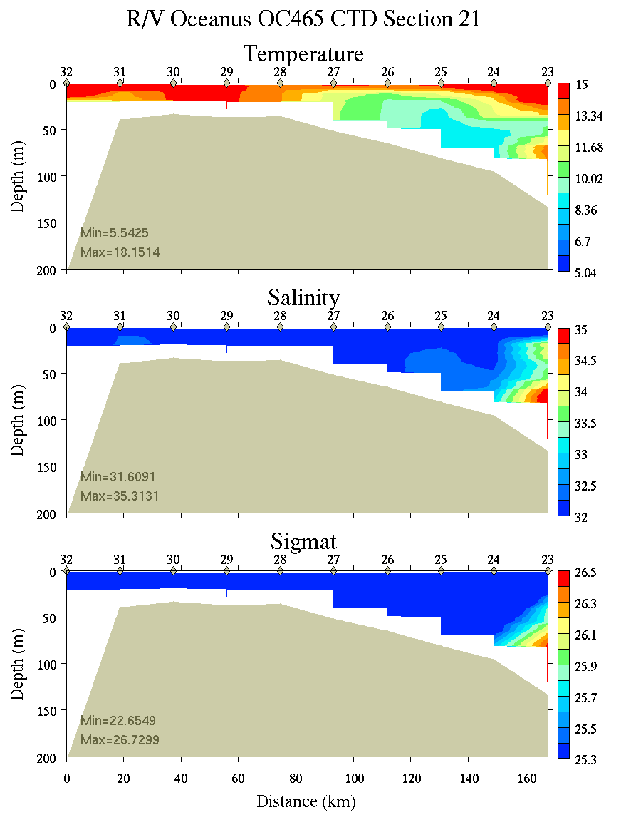 | 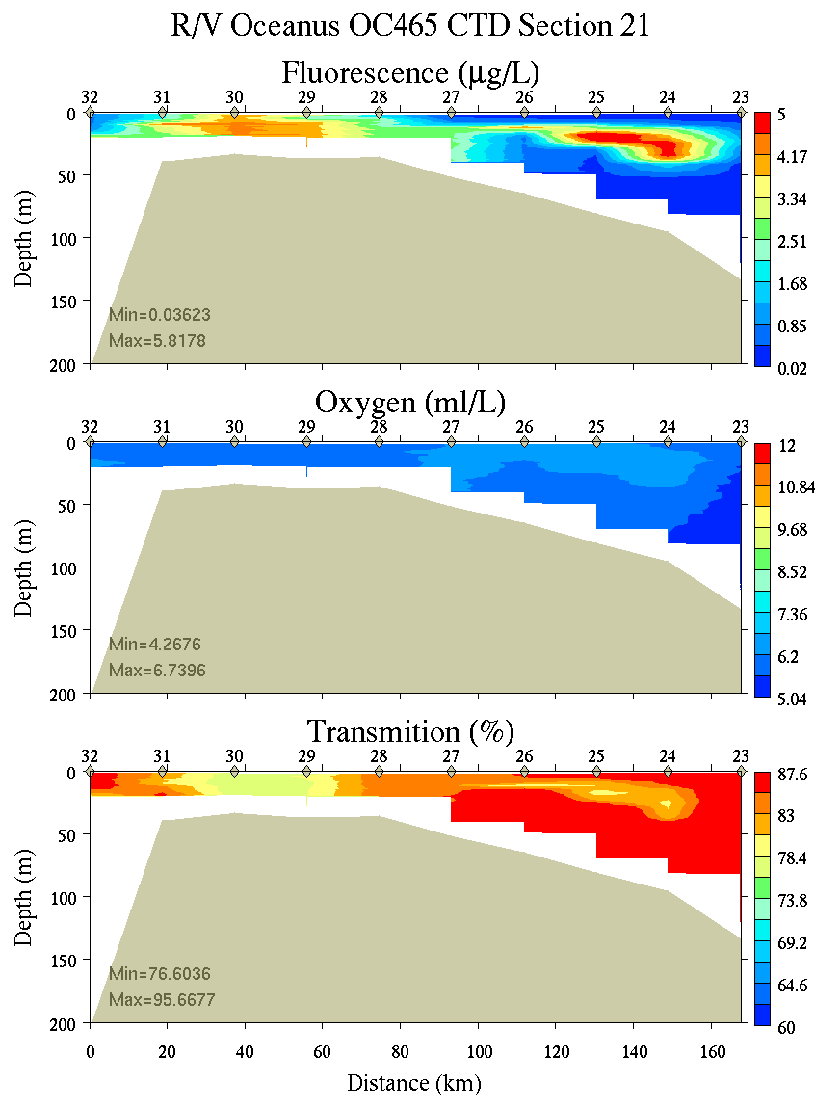
Figure C8. Section 21, 0-200m: temperature, salinity, and density (left); fluorescence, oxygen, and beam transmission (right).

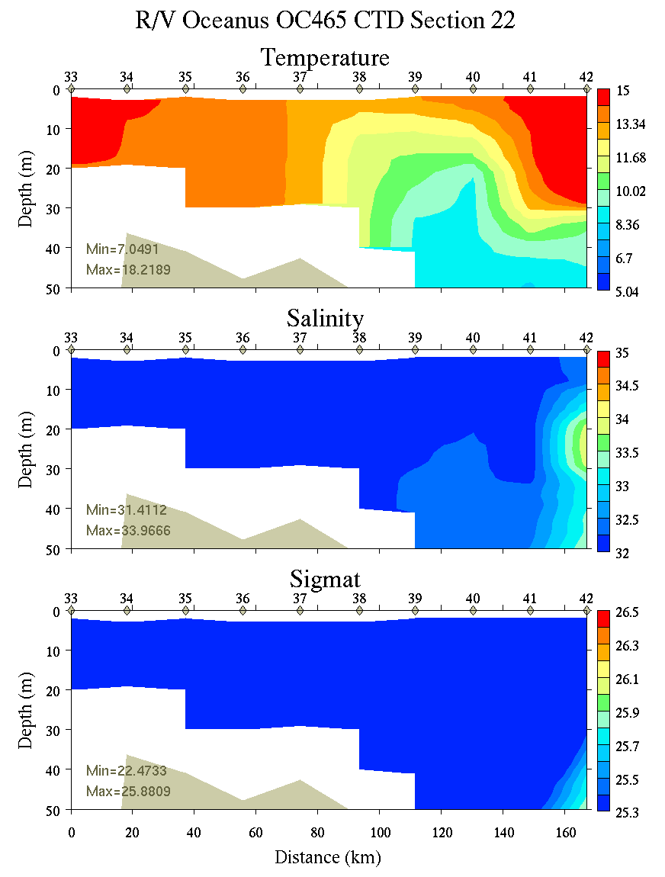 | 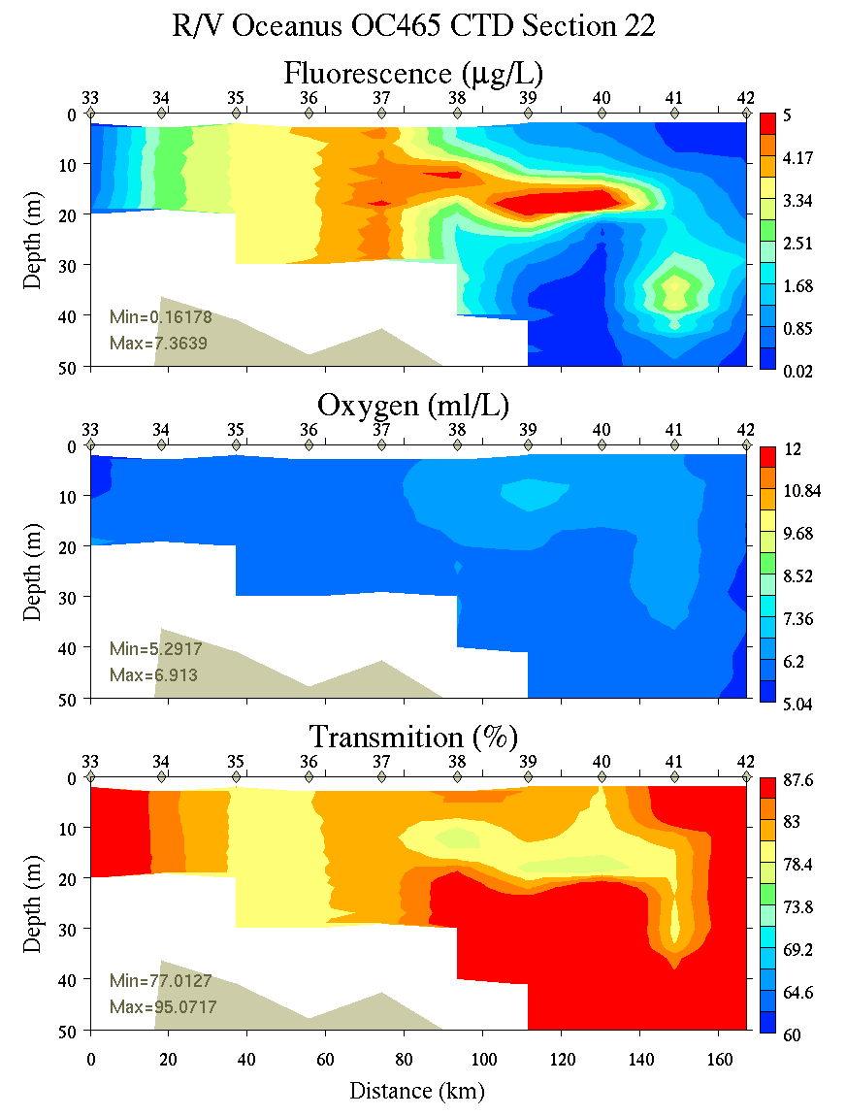
Figure C9. Section 22, 0-50m: temperature, salinity, and density (left); fluorescence, oxygen, and beam transmission (right).

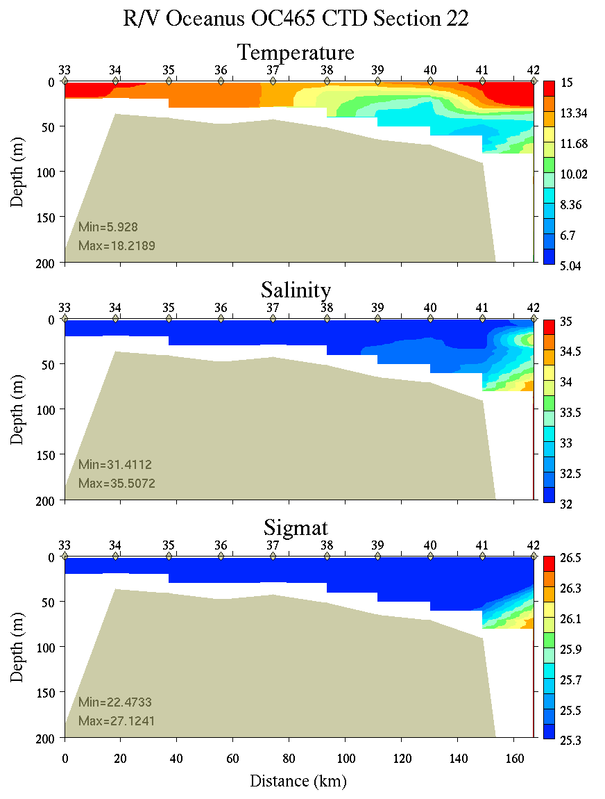 | 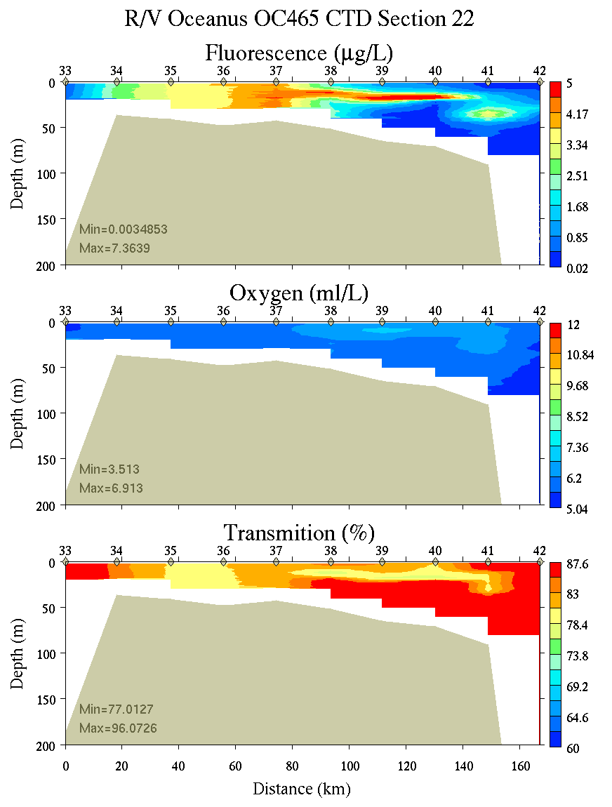
Figure C10. Section 22, 0-200m: temperature, salinity, and density (left); fluorescence, oxygen, and beam transmission (right).

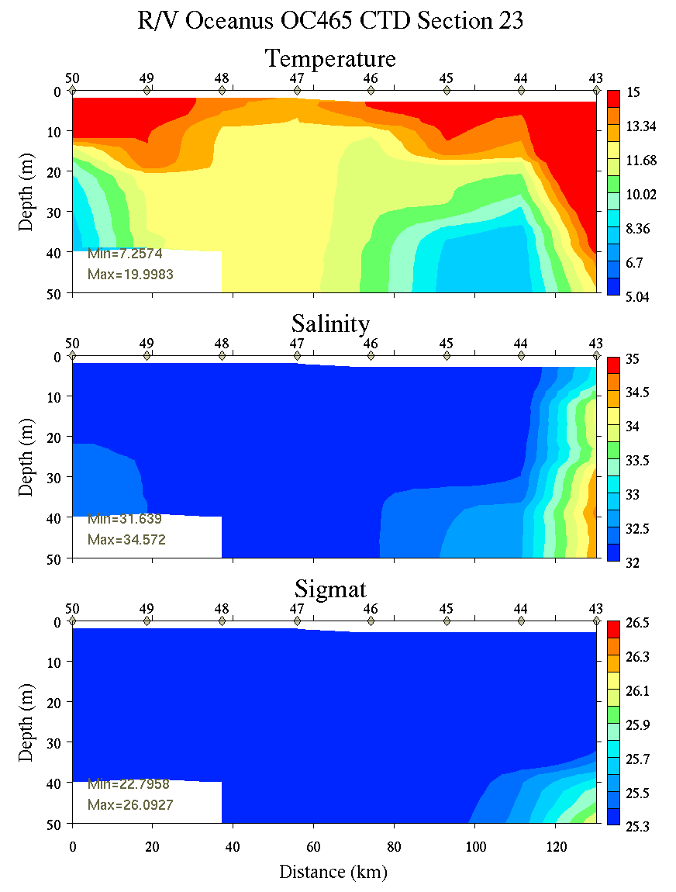 | 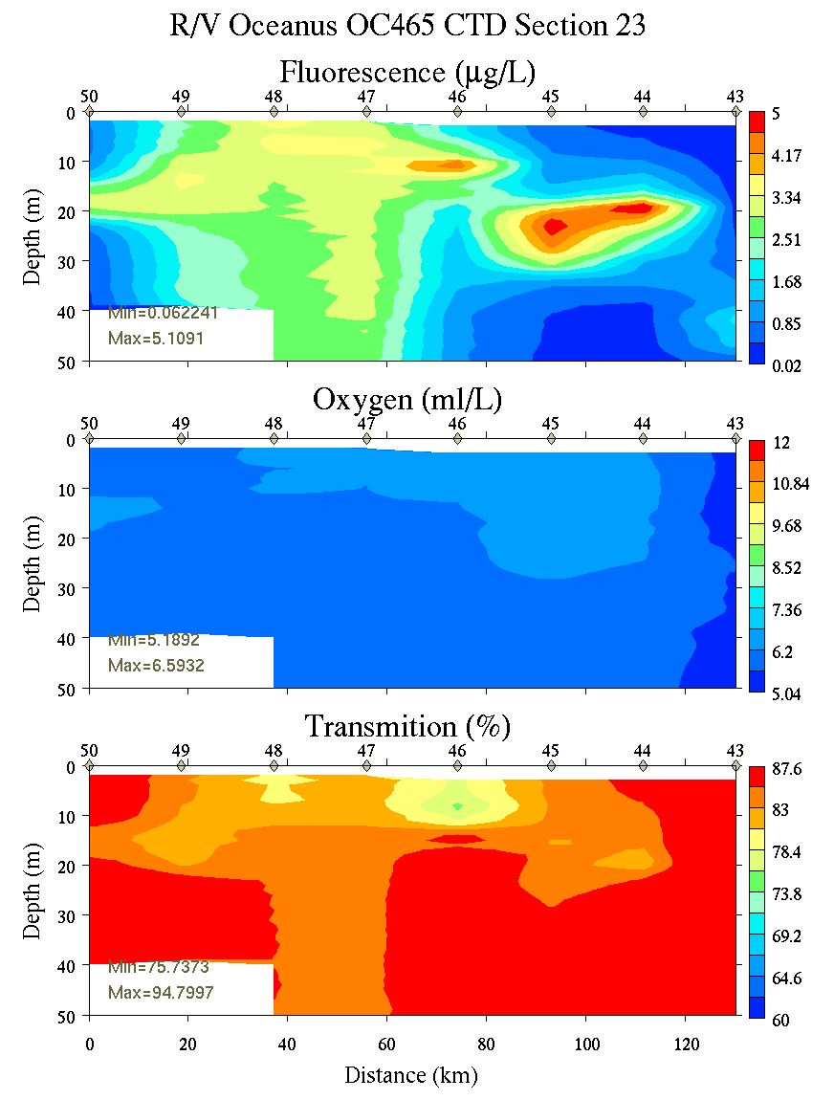
Figure C11. Section 23, 0-50m: temperature, salinity, and density (left); fluorescence, oxygen, and beam transmission (right).

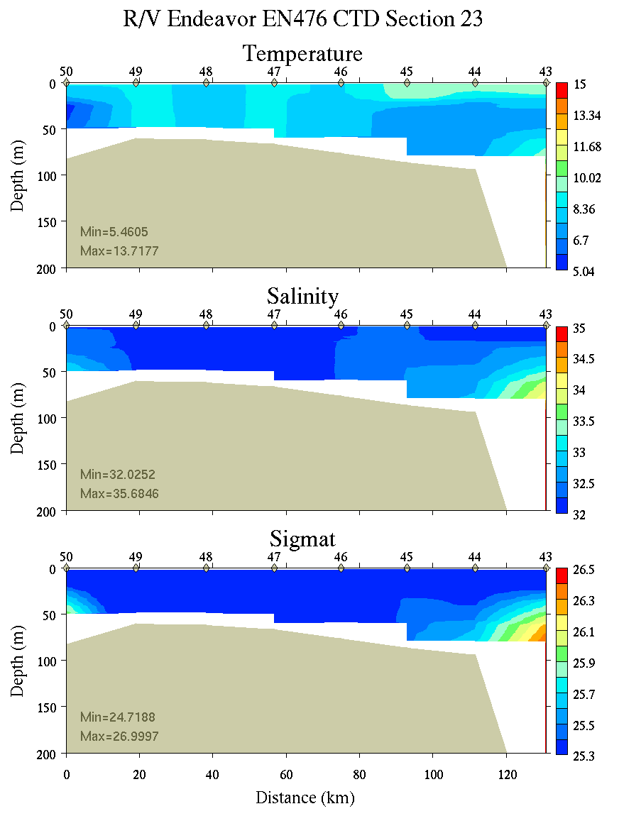 | 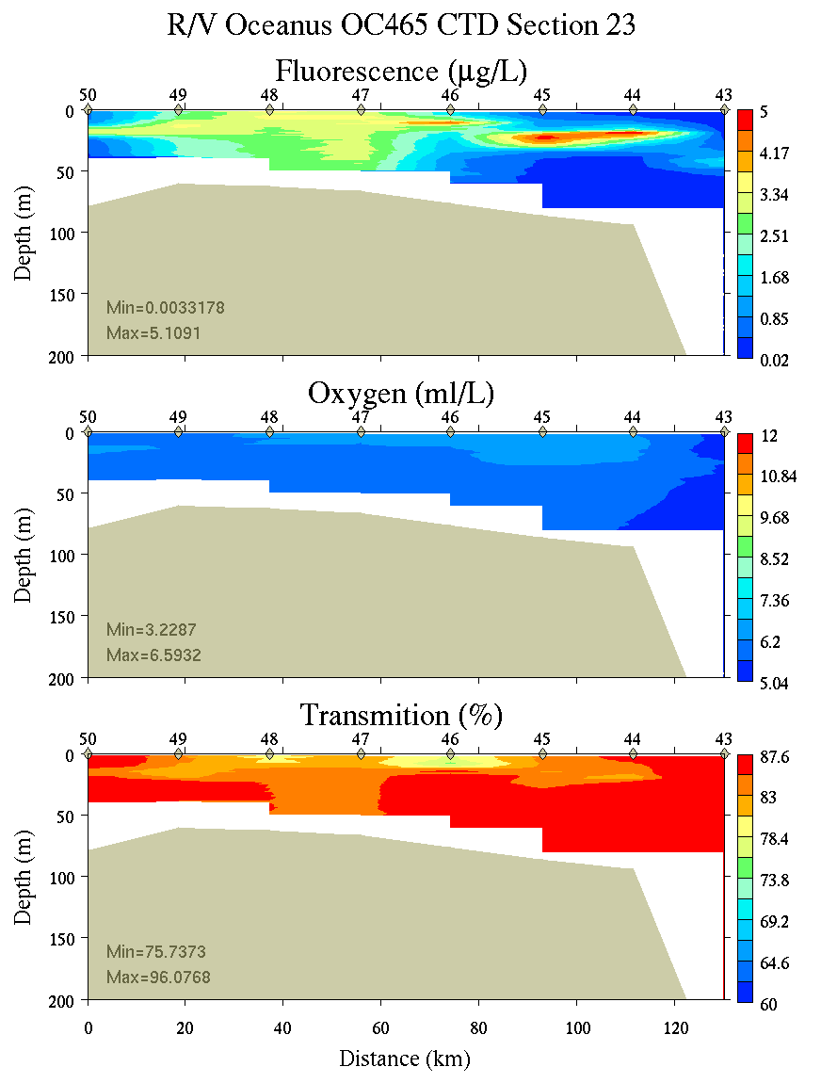
Figure C12. Section 23, 0-200m: temperature, salinity, and density (left); fluorescence, oxygen, and beam transmission (right).

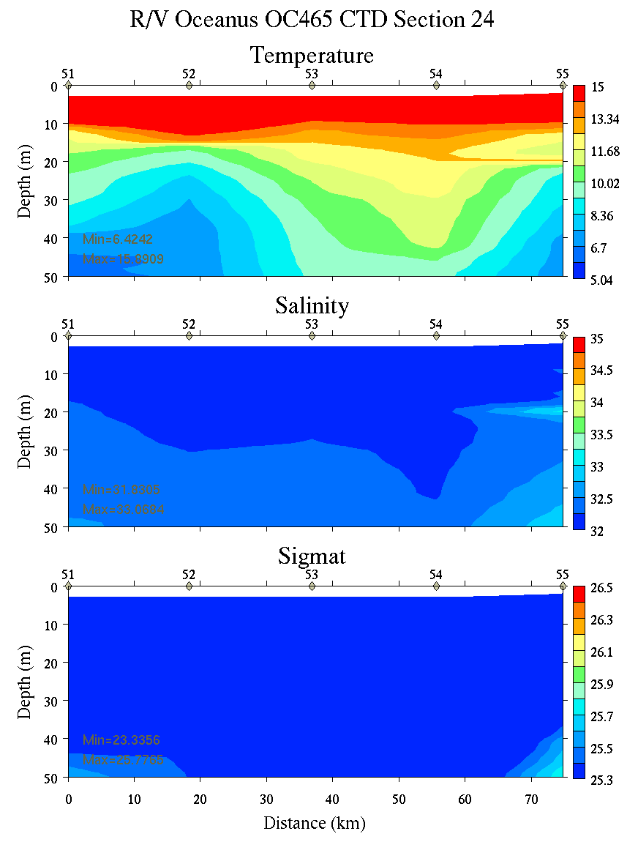 | 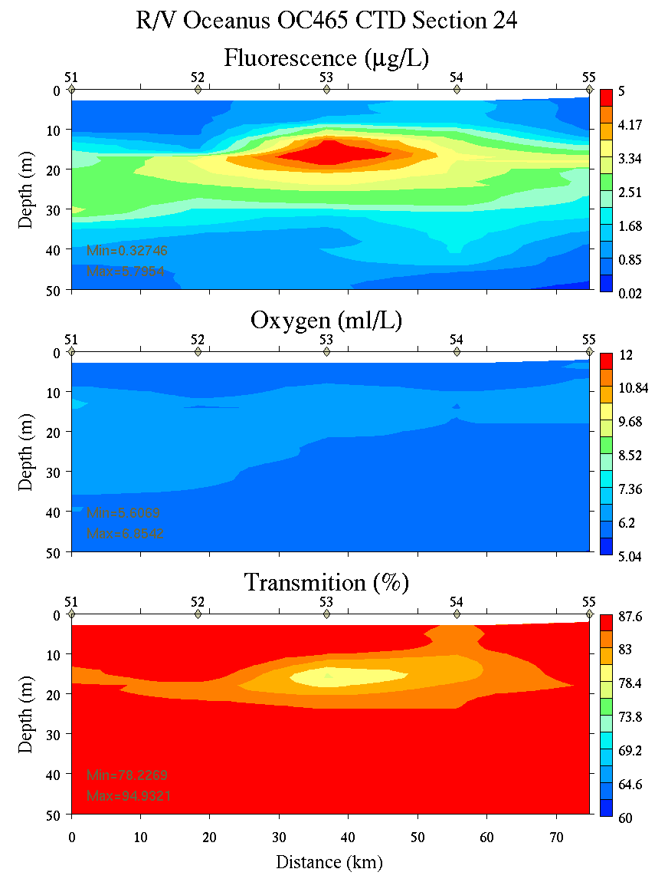
Figure C13. Section 24, 0-50m: temperature, salinity, and density (left); fluorescence, oxygen, and beam transmission (right).

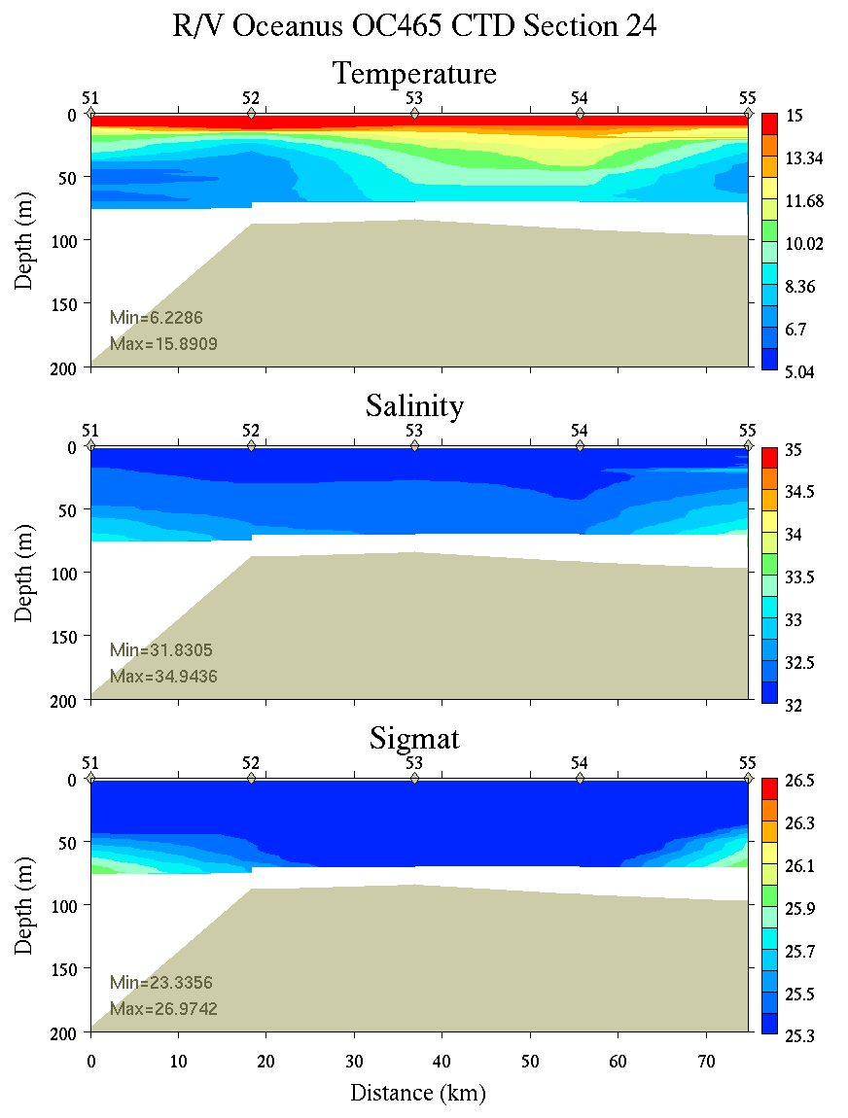 | 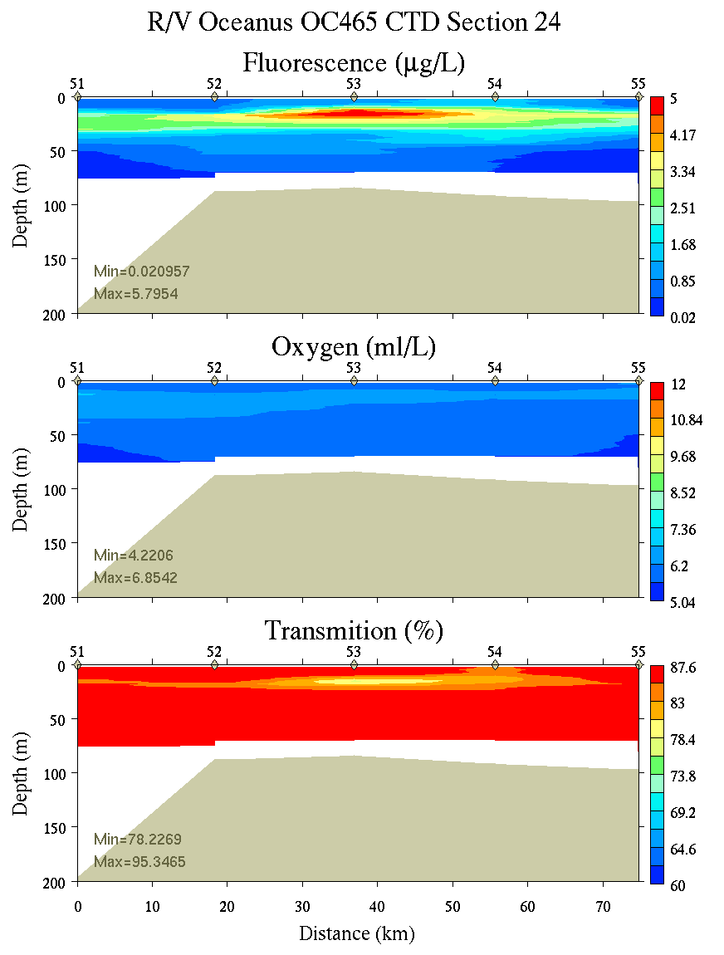
Figure C14. Section 24, 0-200m: temperature, salinity, and density (left); fluorescence, oxygen, and beam transmission (right).

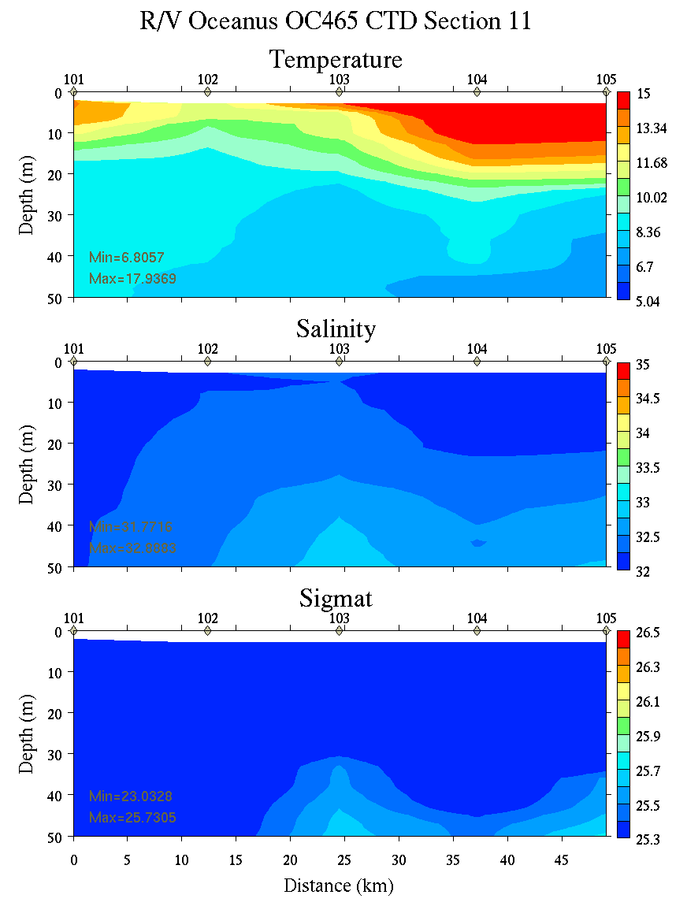 | 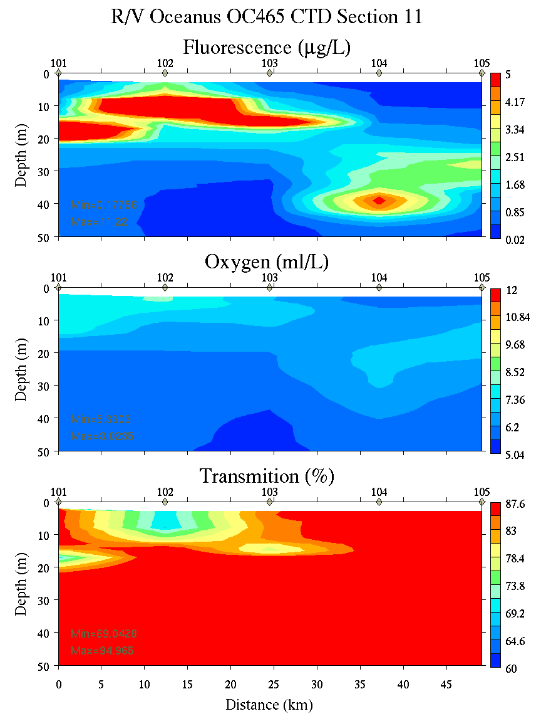
Figure C15. Section 11, 0-50m: temperature, salinity, and density (left); fluorescence, oxygen, and beam transmission (right).

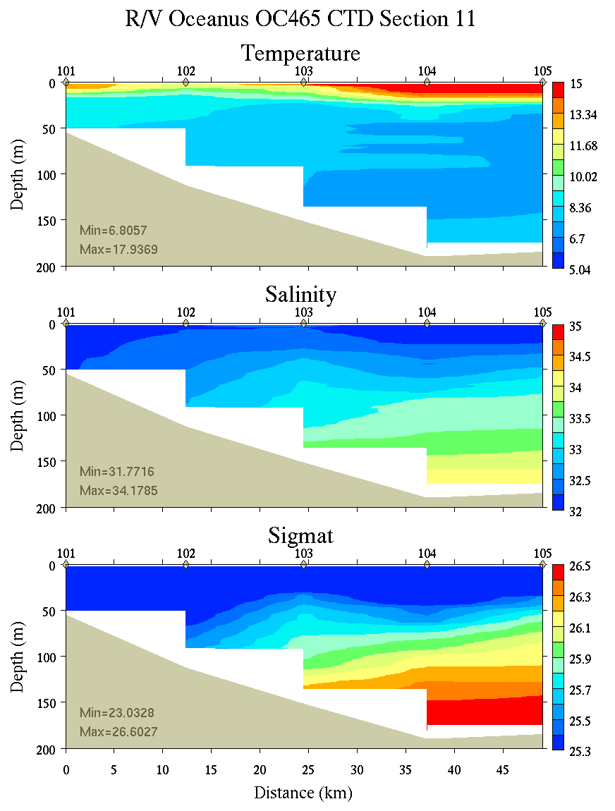 | 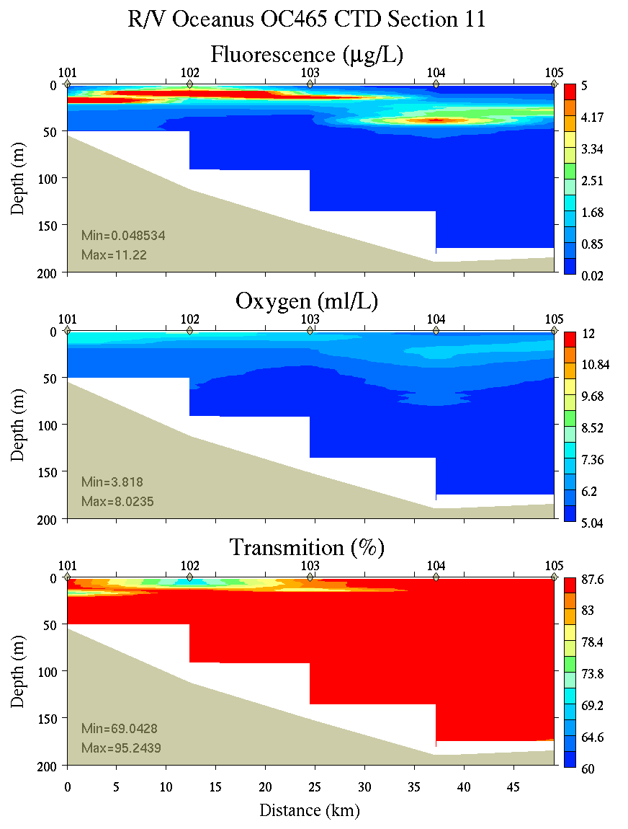
Figure C16. Section 11, 0-200m: temperature, salinity, and density (left); fluorescence, oxygen, and beam transmission (right).

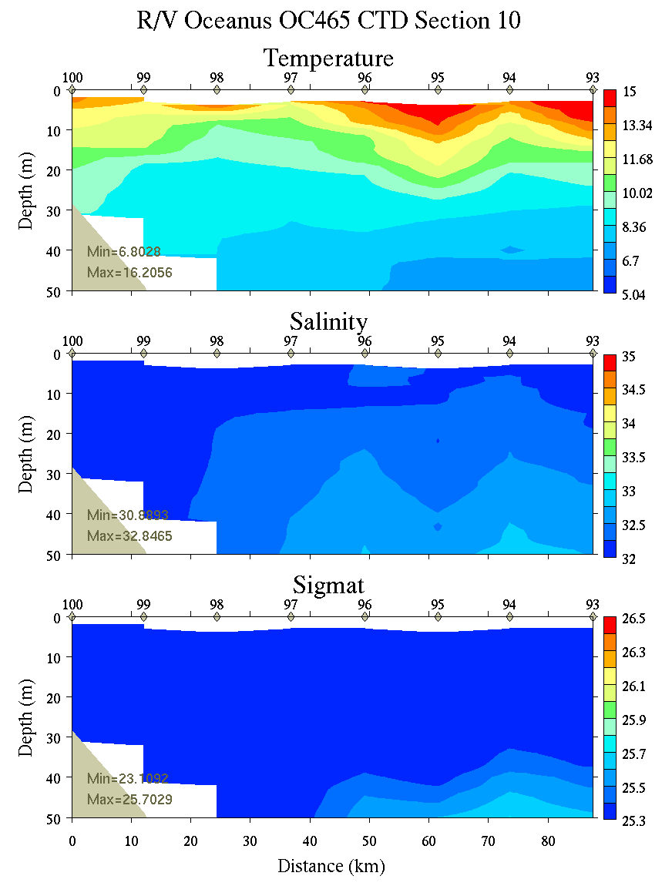 | 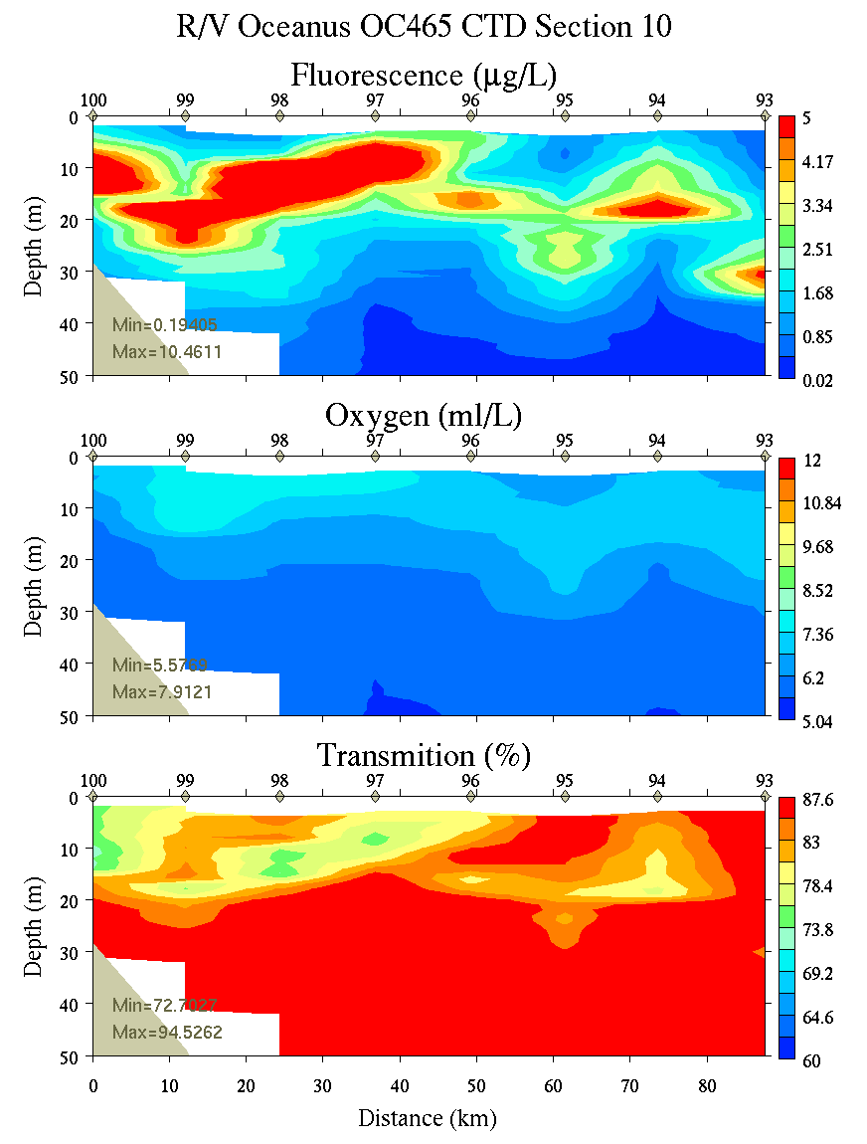
Figure C17. Section 10, 0-50m: temperature, salinity, and density (left); fluorescence, oxygen, and beam transmission (right).

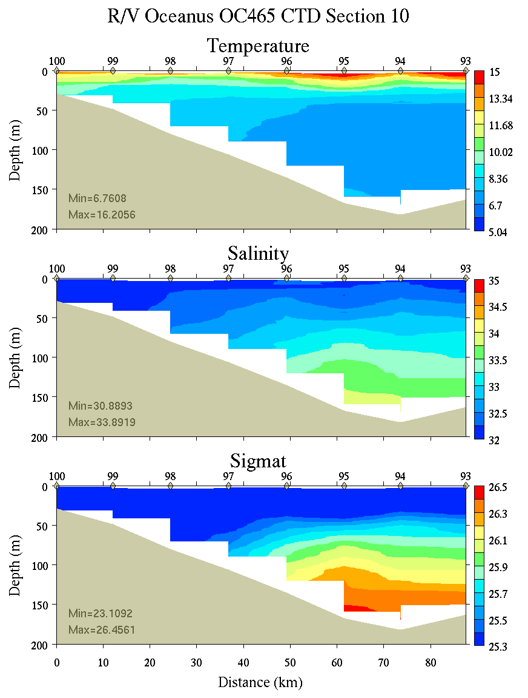 | 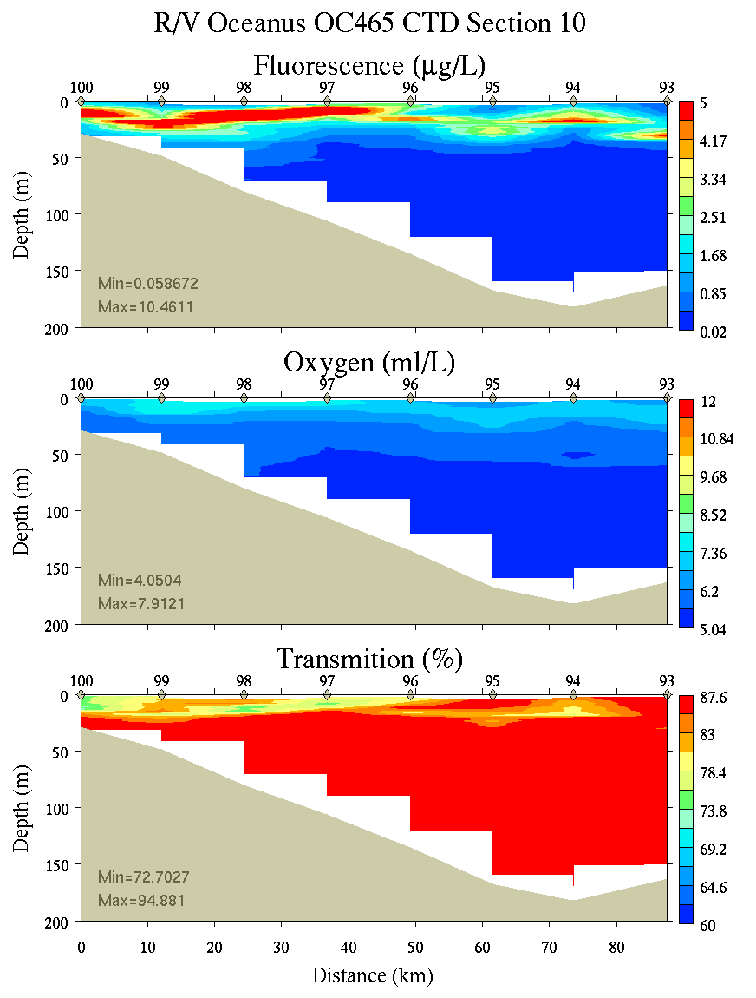
Figure C18. Section 10, 0-200m: temperature, salinity, and density (left); fluorescence, oxygen, and beam transmission (right).

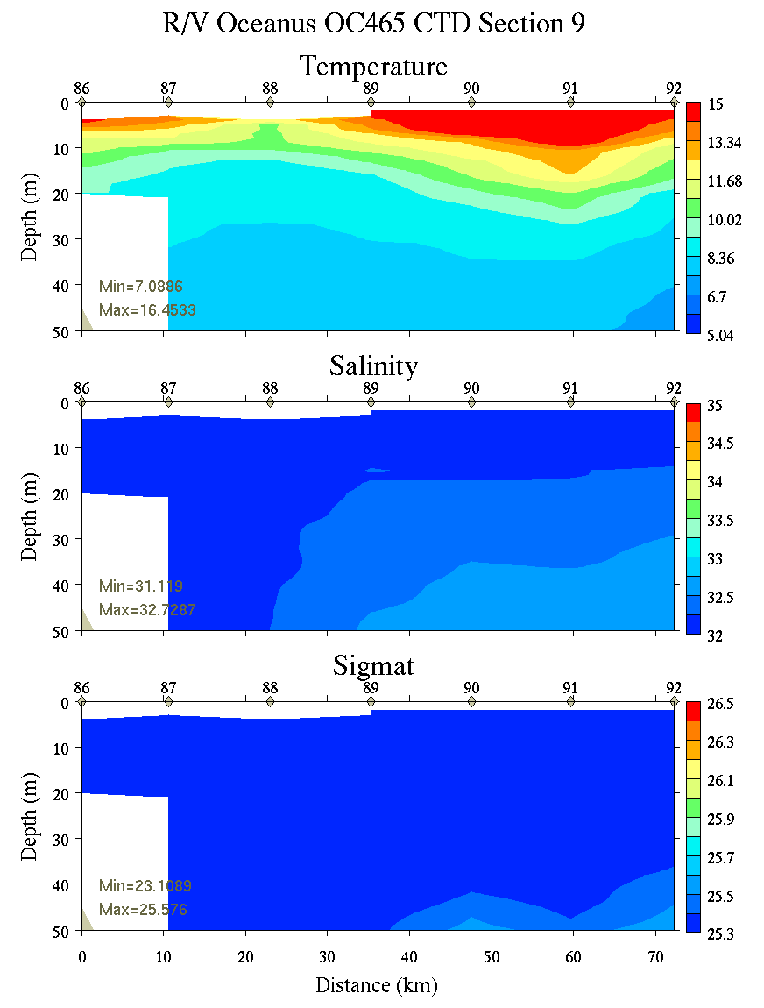 | 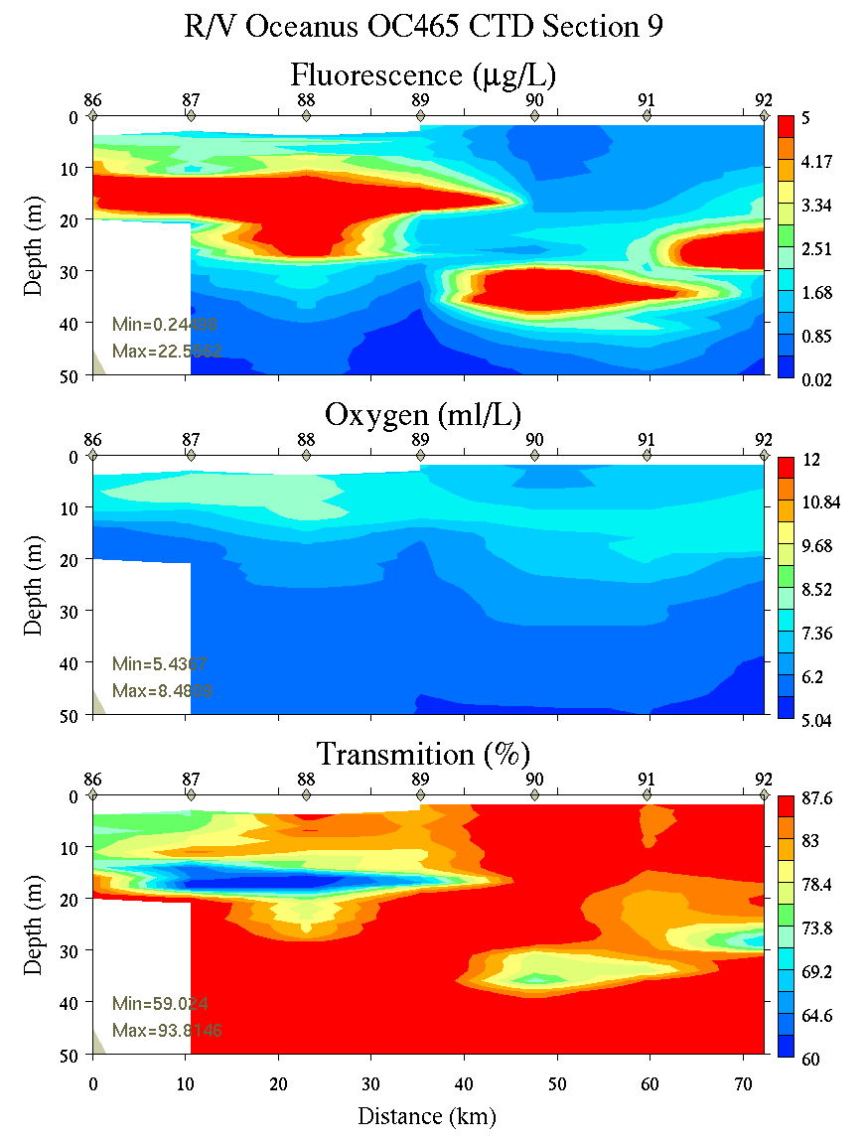
Figure C19. Section 9, 0-50m: temperature, salinity, and density (left); fluorescence, oxygen, and beam transmission (right).

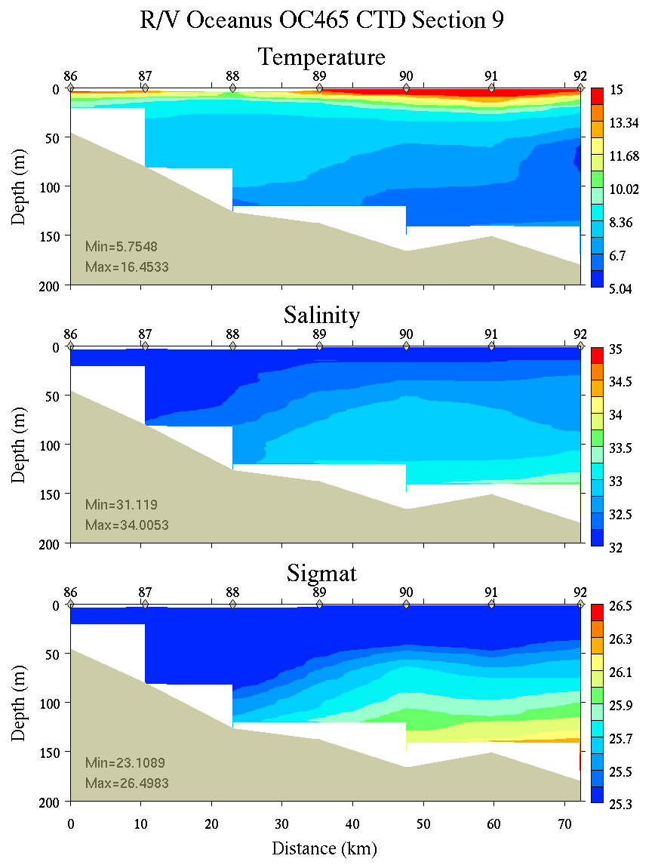 | 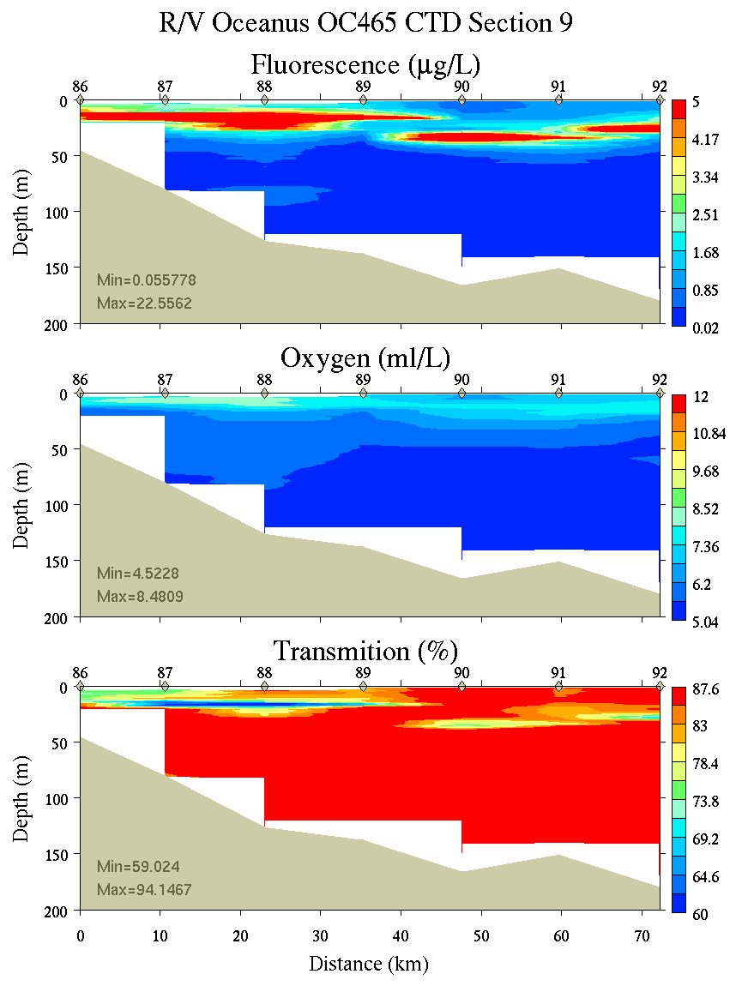
Figure C20. Section 9, 0-200m: temperature, salinity, and density (left); fluorescence, oxygen, and beam transmission (right).

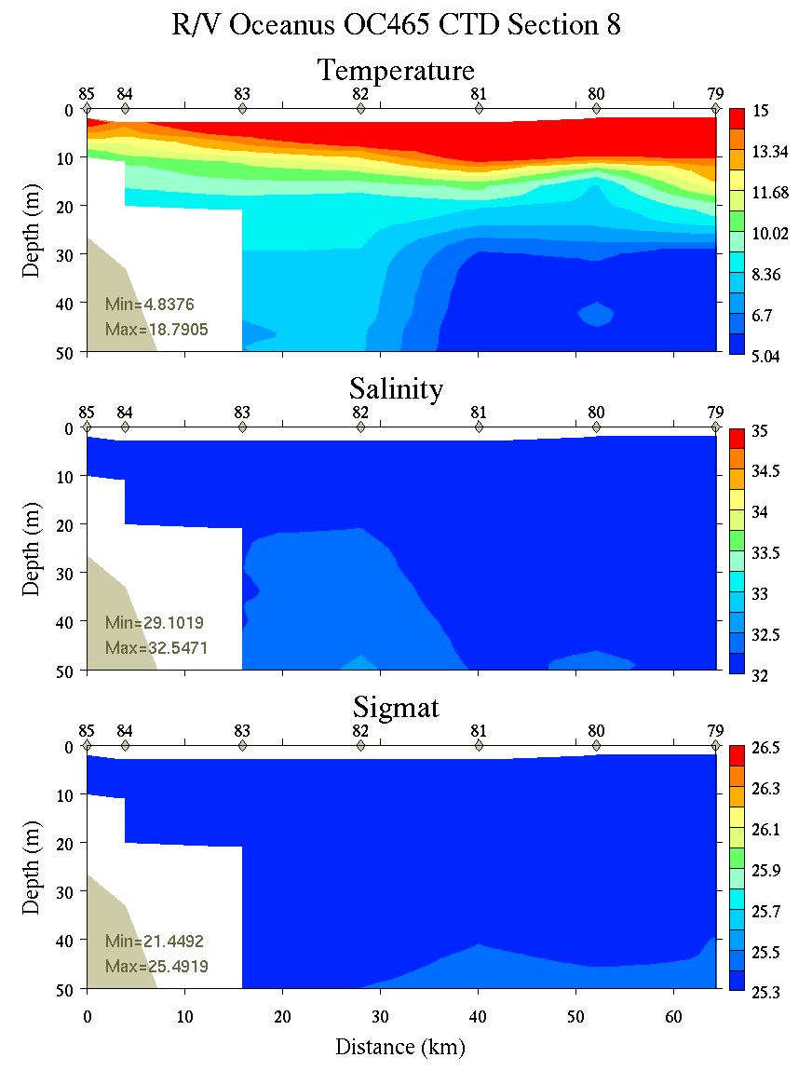 | 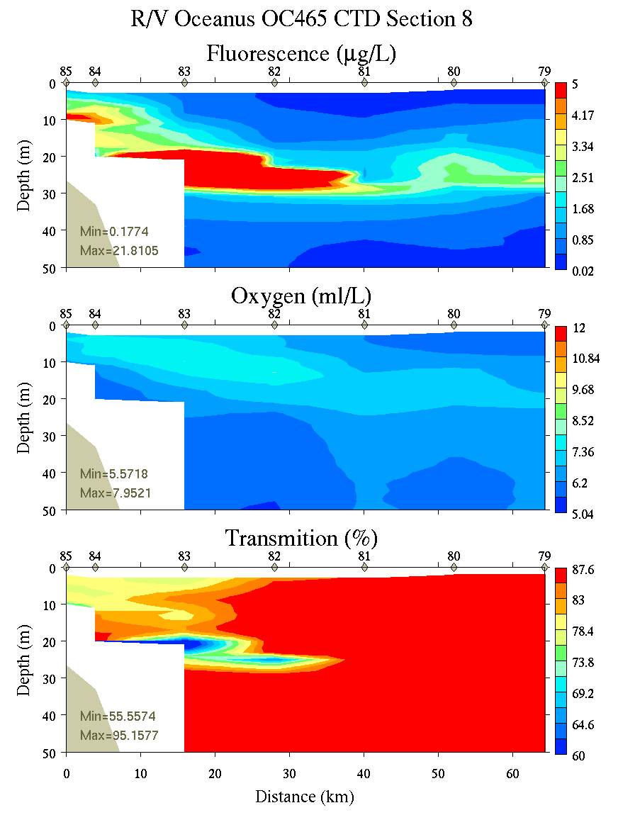
Figure C21. Section 8, 0-50m: temperature, salinity, and density (left); fluorescence, oxygen, and beam transmission (right).

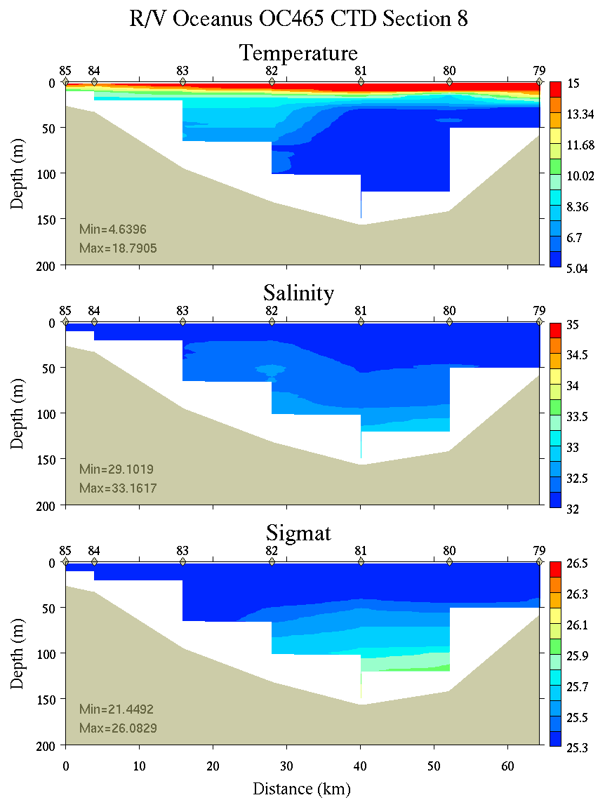 | 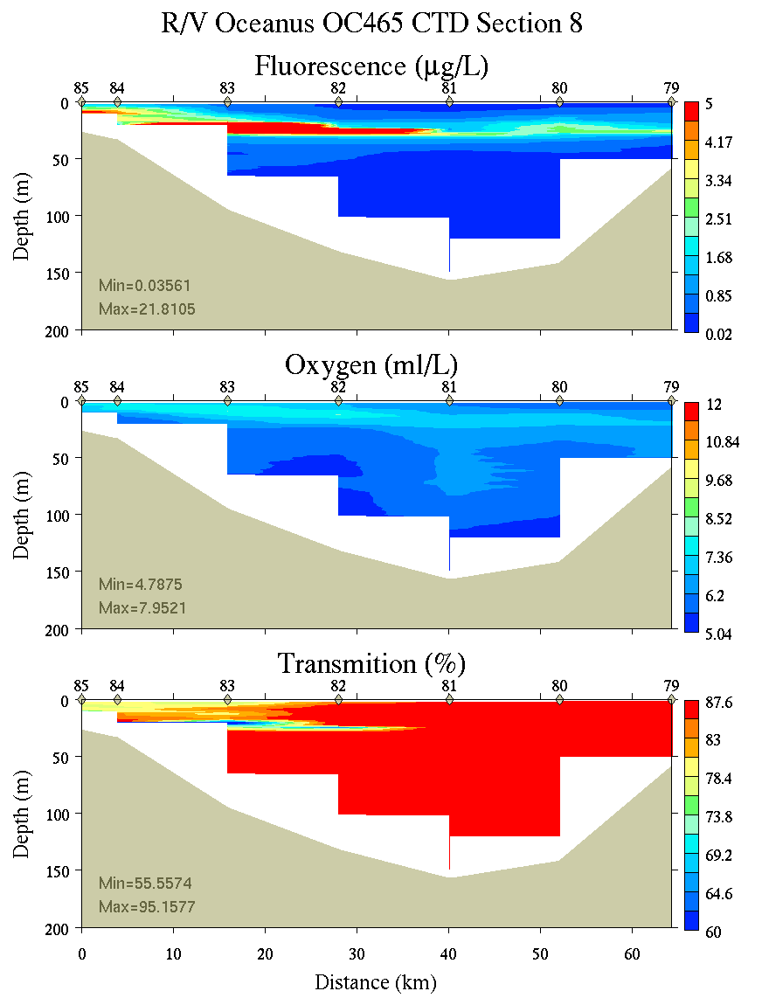
Figure C22. Section 8, 0-200m: temperature, salinity, and density (left); fluorescence, oxygen, and beam transmission (right).

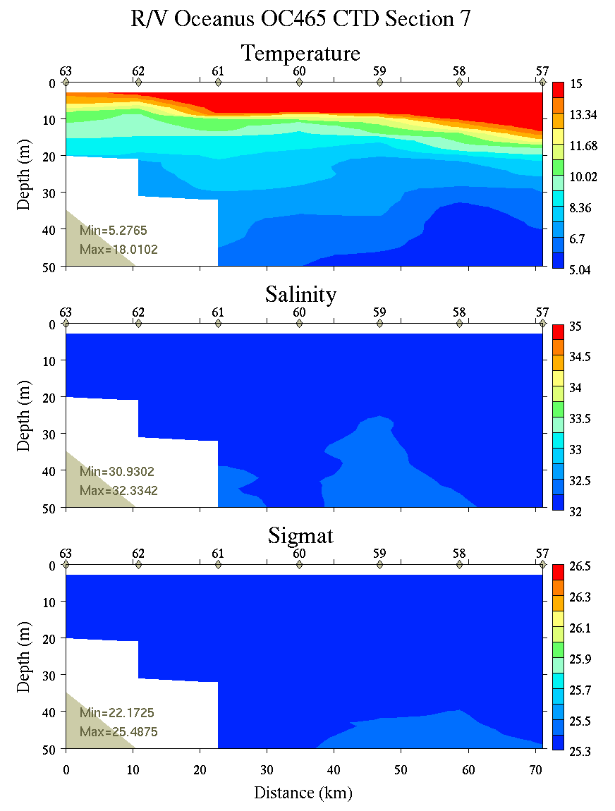 | 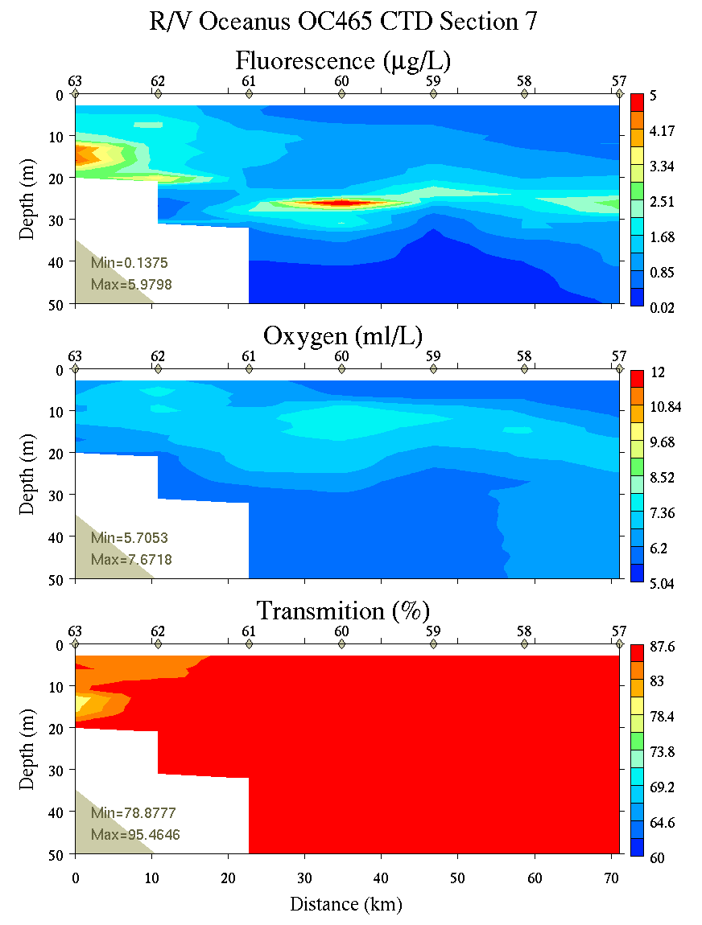
Figure C23. Section 7, 0-50m: temperature, salinity, and density (left); fluorescence, oxygen, and beam transmission (right).

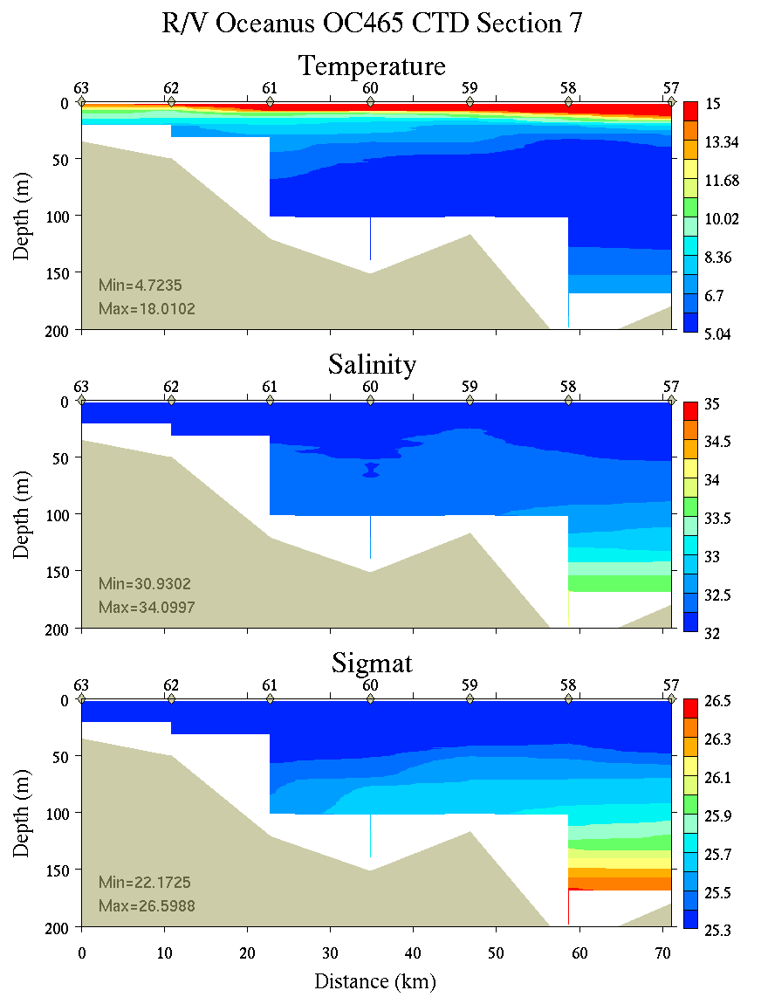 | 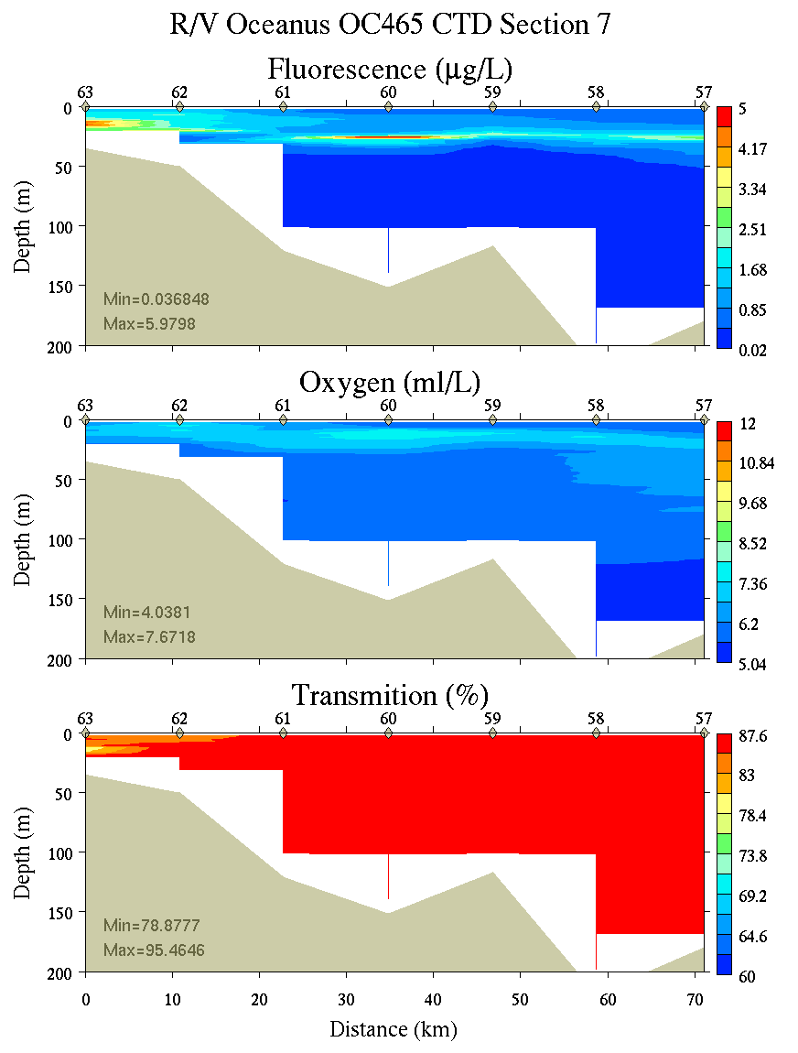
Figure C24. Section 7, 0-200m: temperature, salinity, and density (left); fluorescence, oxygen, and beam transmission (right).

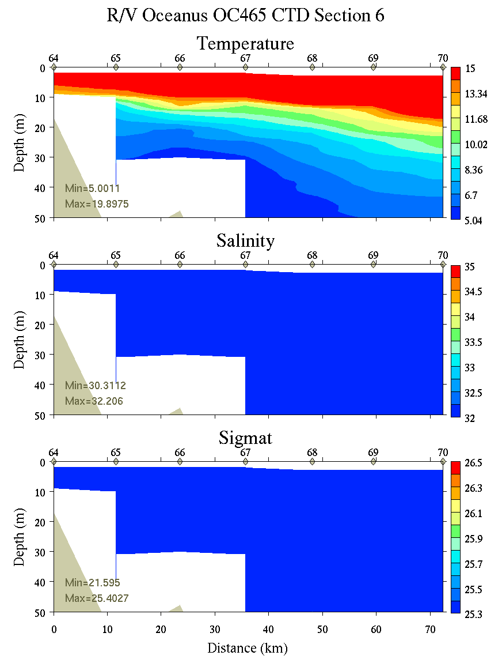 | 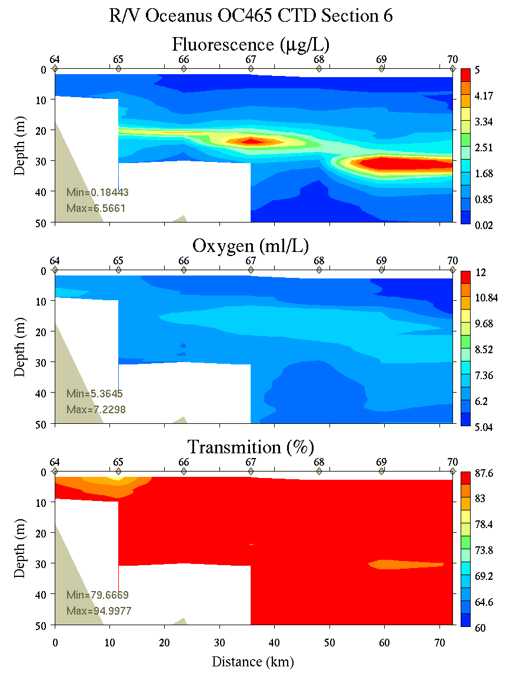
Figure C25. Section 6, 0-50m: temperature, salinity, and density (left); fluorescence, oxygen, and beam transmission (right).

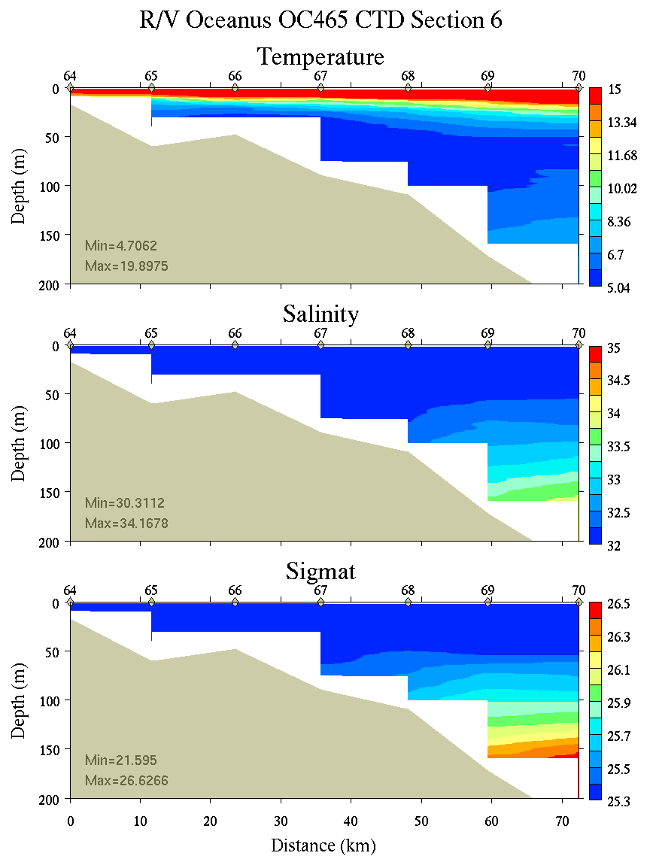 | 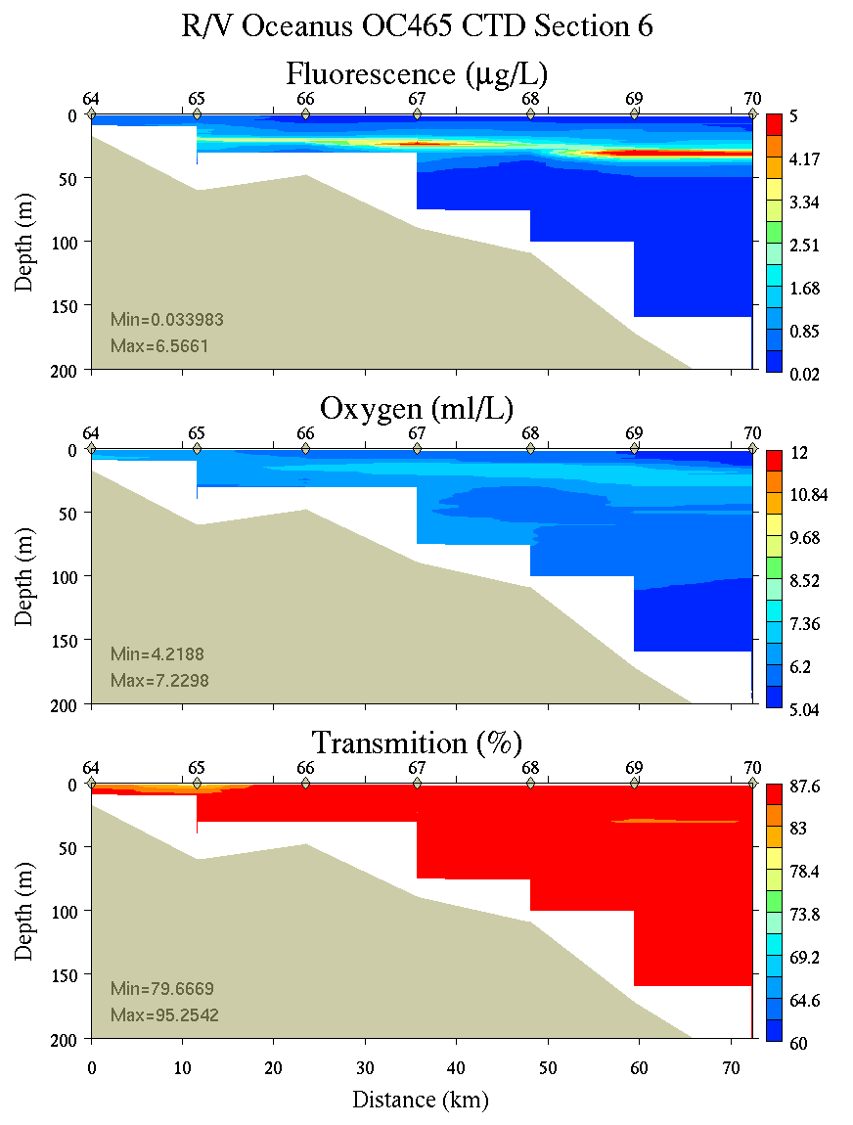
Figure C26. Section 6, 0-200m: temperature, salinity, and density (left); fluorescence, oxygen, and beam transmission (right).

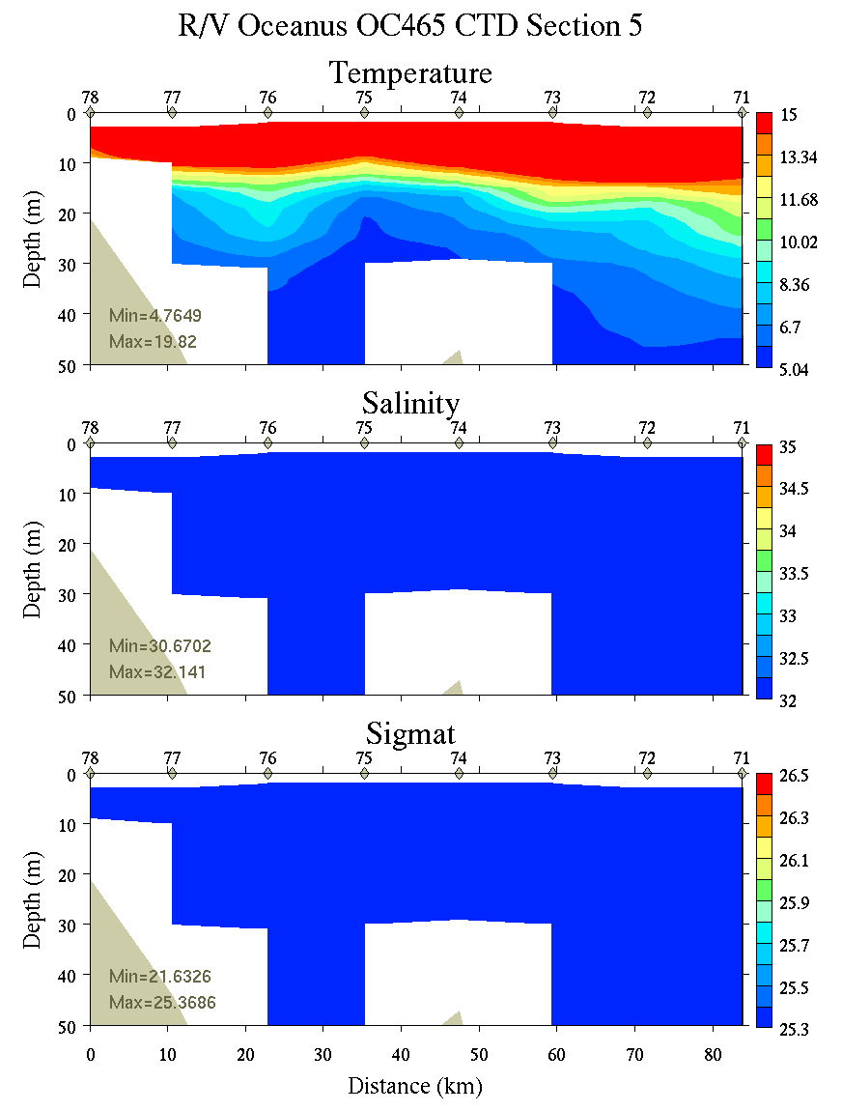 | 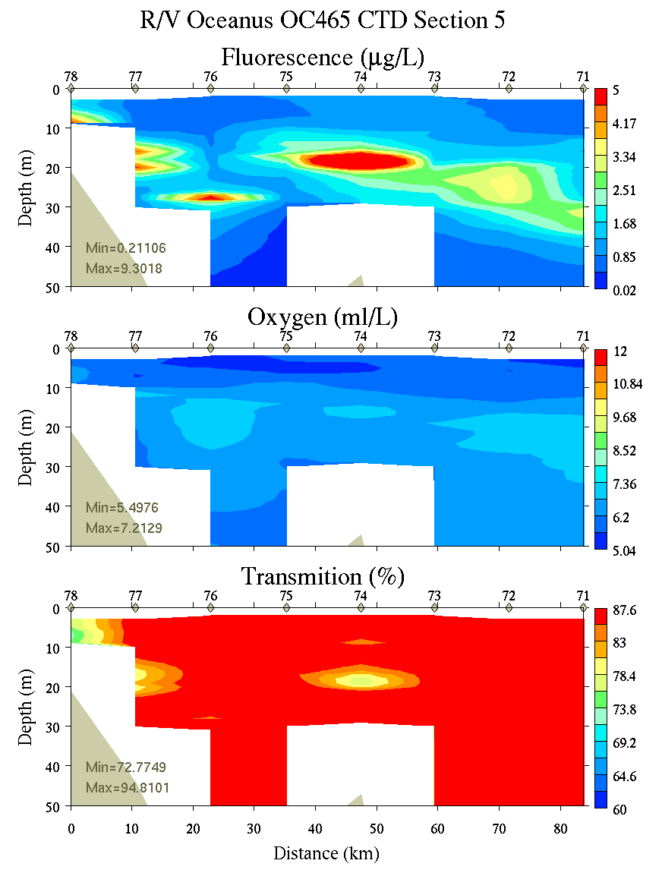
Figure C27. Section 5, 0-50m: temperature, salinity, and density (left); fluorescence, oxygen, and beam transmission (right).

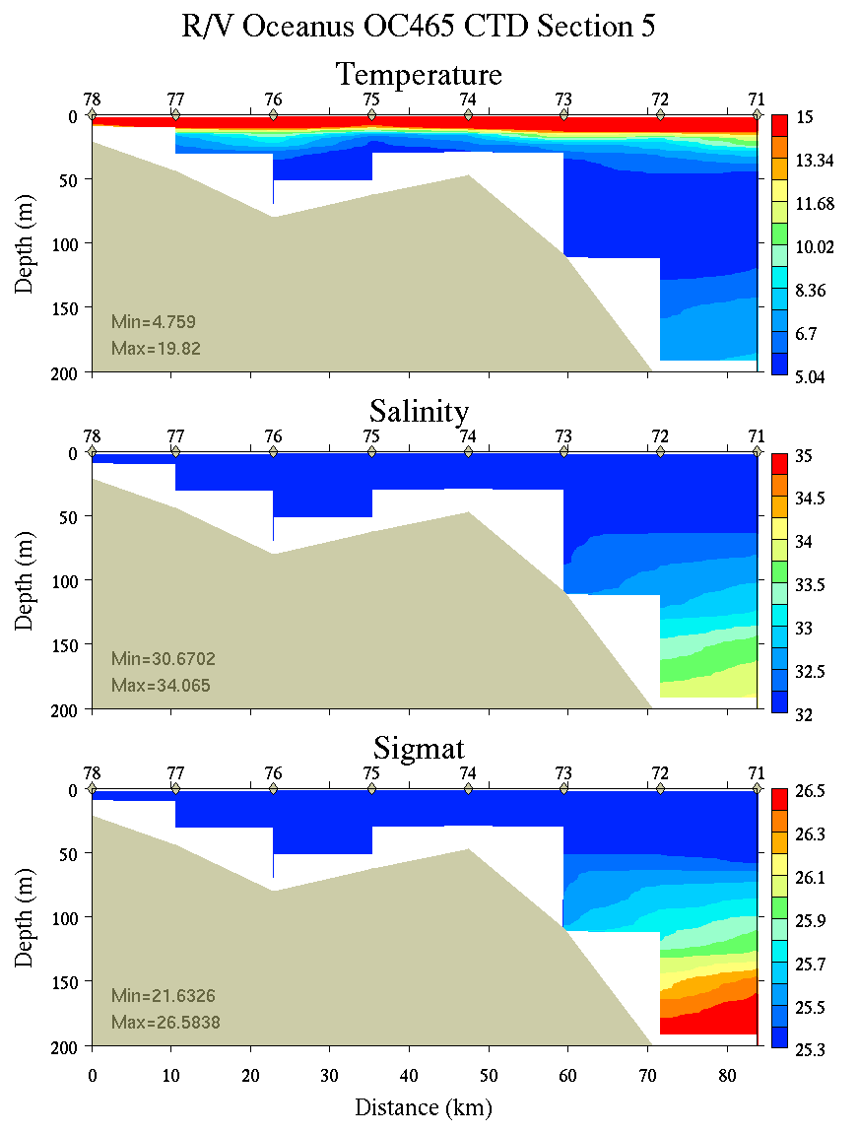 | 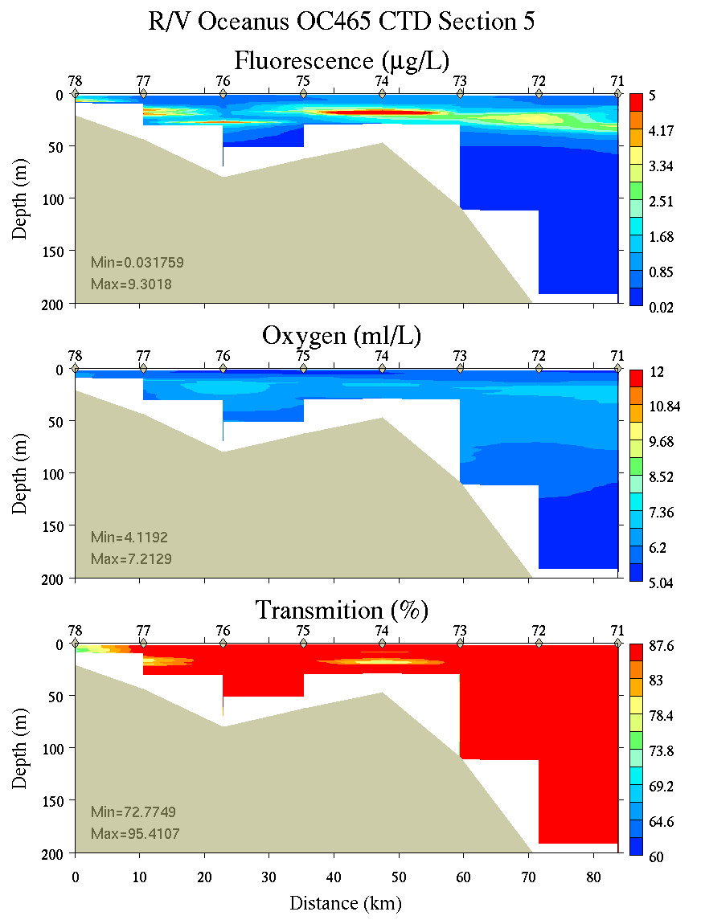
Figure C28. Section 5, 0-200m: temperature, salinity, and density (left); fluorescence, oxygen, and beam transmission (right).
Appendix D: Satellite imagery
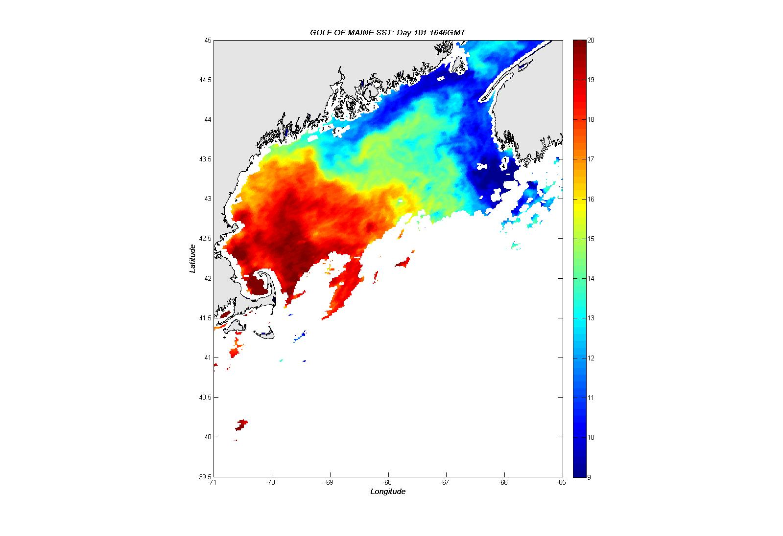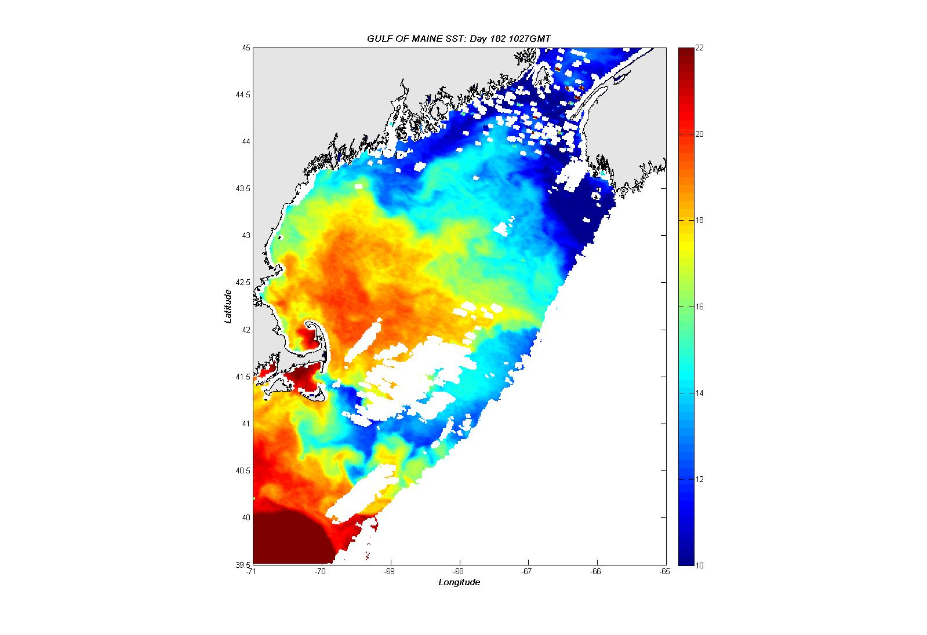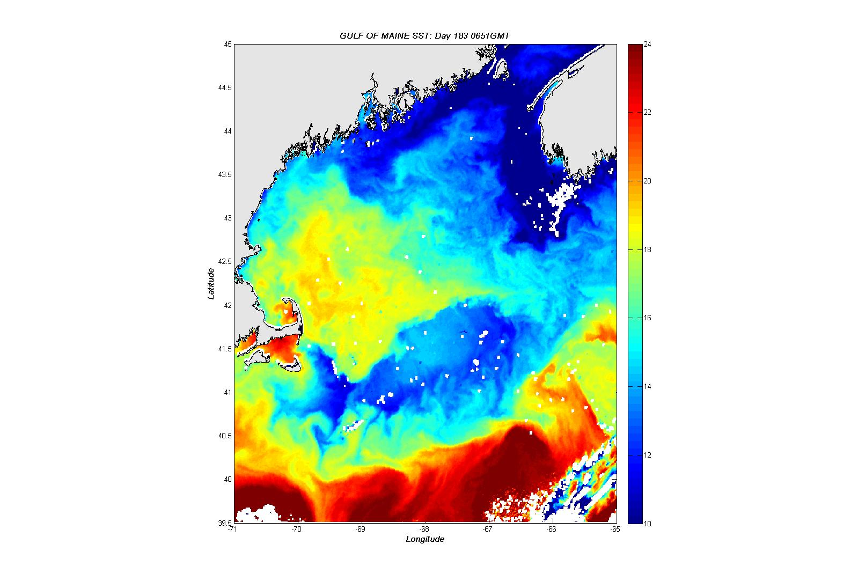
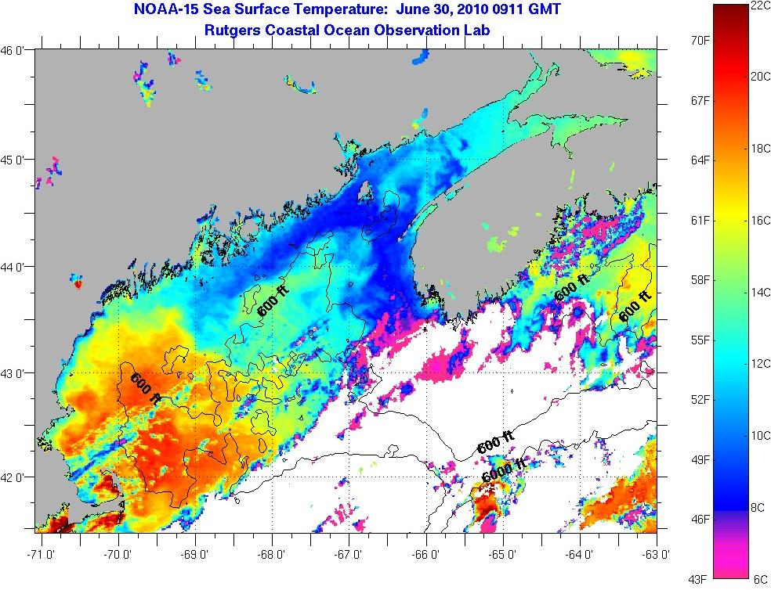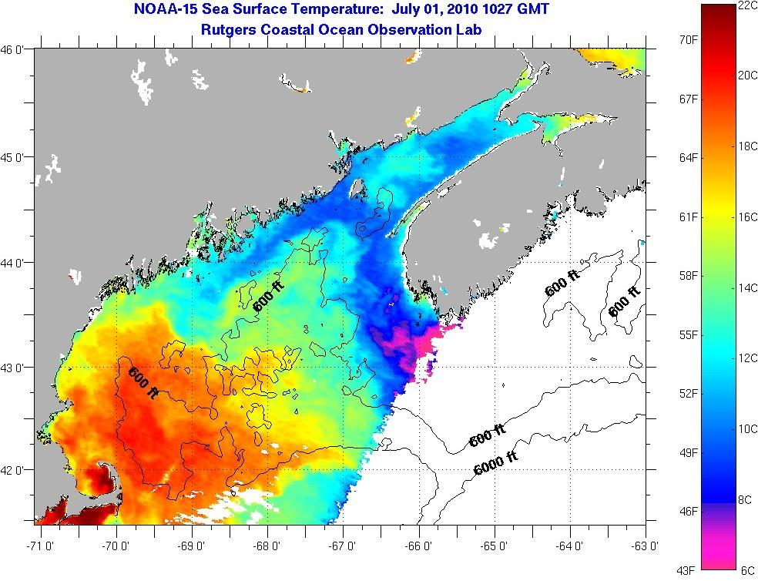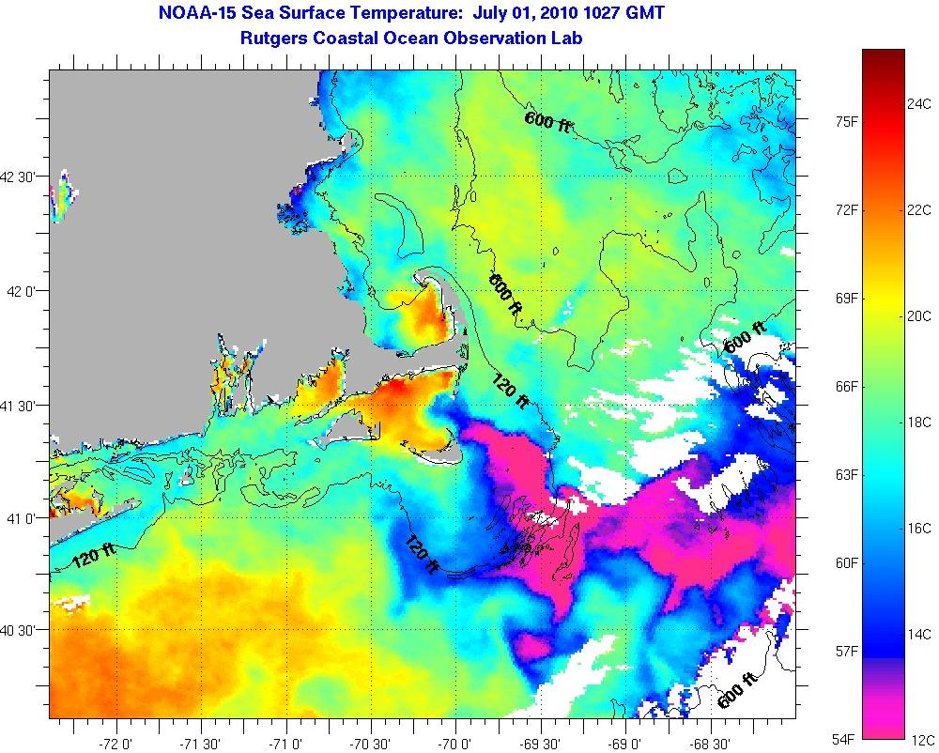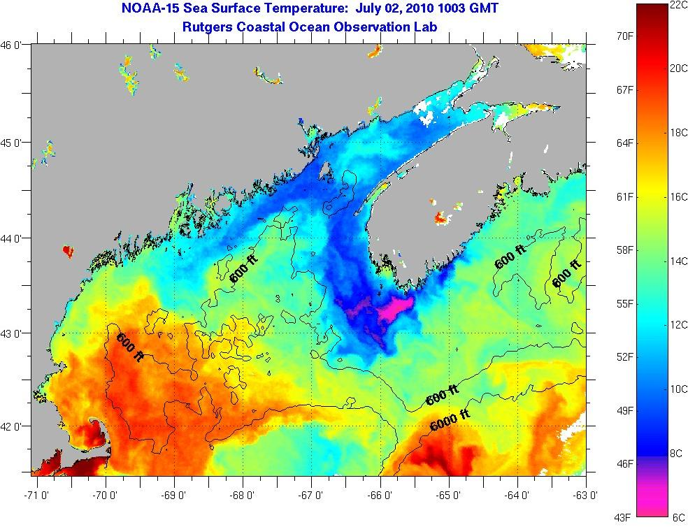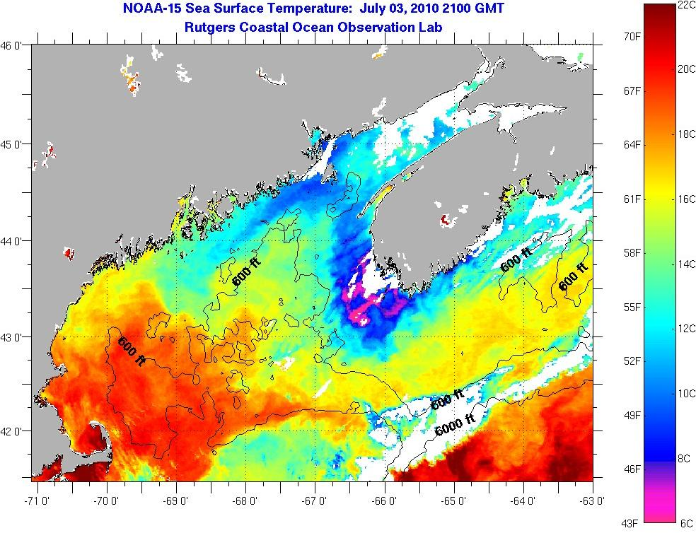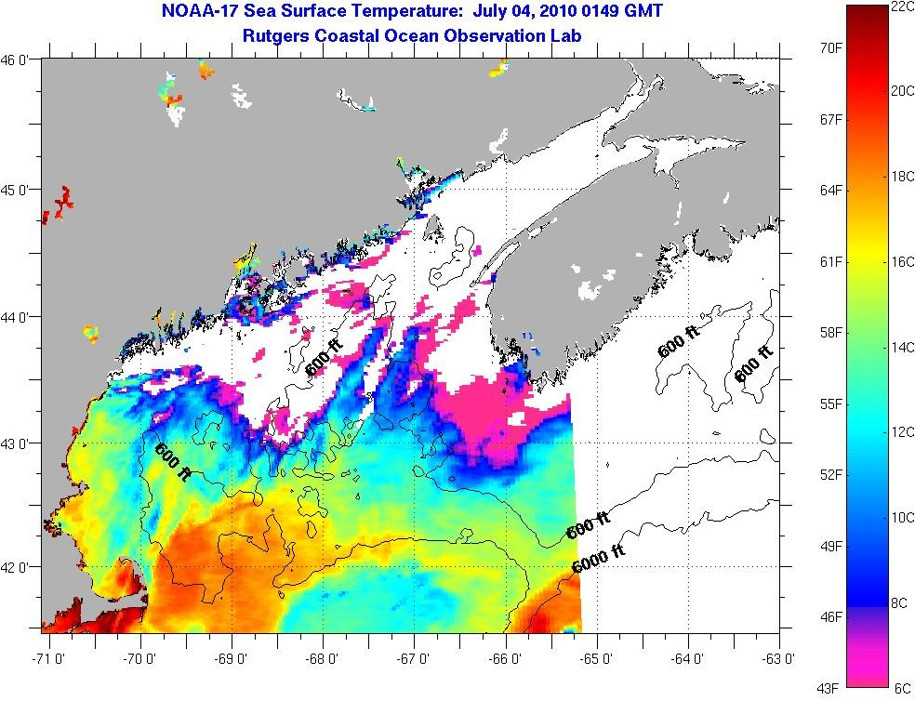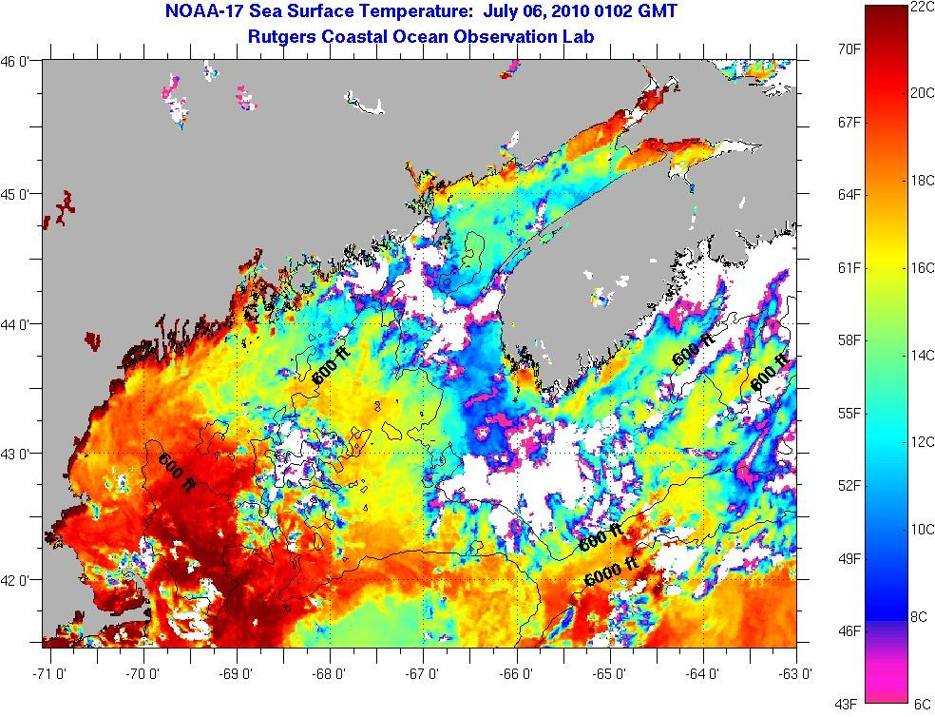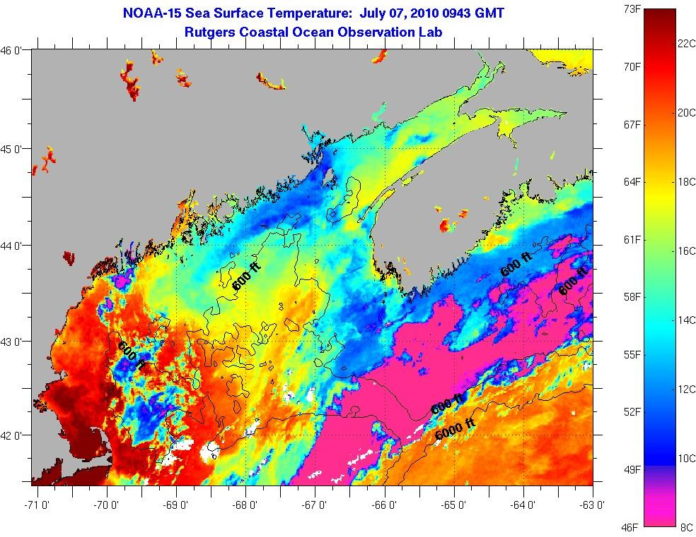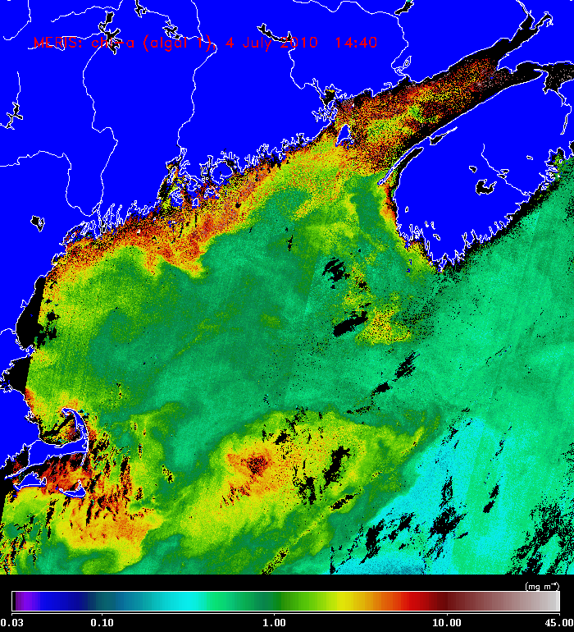

Appendix E: CTD Salinity Calibrations

[Figure to be provided]

Appendix F: Personnel

McGillicuddy Dennis WHOI
Keafer Bruce WHOI
Norton Kerry WHOI
*Tong Jesse WHOI
*Xu Yixiao WHOI
*Bonin Zachary NEU
Kosnyrev Olga WHOI
Smith Keston WHOI
Townsend Dave UMe
Thomas Maura UMe
*Young Ashley UMe
*Olson Elise WHOI
*Brisson Nicole UMe
*Petitpas Chrissy UMassD
*Milligan Peter UMassD
*Knapp Stacy UMe
*Gainusabogdan Alina UMe

*Student/postdoc

Watch number 1 2 3
4 on / 8 off 8-12 12-4 4-8

1. CTD Operator Elise Keston Stacy
2. Cell Counter Bruce* Kerry#* Chrissy*
3. Nutrient sampler Dave# Ashley Maura#
4. Water sampler Olga# Zachary# Jesse
5. Water sampler Yixiao Nicole Peter#
Alina

* Wetlab chief
# CTD slip line handlers

http://www.whoi.edu/science/cohh/whcohh/projects/habs1_abstract.htm
http://omglnx3.meas.ncsu.edu/GOMTOX/2010forecast/
Also see http://nefsc.noaa.gov/drifter

