OC460 Cruise Report
Draft 5/11/10

Voyage #460 of R/V Oceanus was the first of four cruises in 2010 organized to serve complementary scientific objectives of two different projects. The two projects are:

GOMTOX: Dynamics of Alexandrium fundyense distributions in the Gulf of Maine: an observational and modeling study of nearshore and offshore shellfish toxicity, vertical toxin flux, and bloom dynamics in a complex shelf sea – NOAA ECOHAB

Objectives:
Investigate A. fundyense bloom dynamics and the pathways that link this organism to toxicity in nearshore and offshore shellfish.

Investigate the vertical structure of A. fundyense blooms, vertical toxin flux, and linkage to toxicity in offshore shellfish.

Alexandrium population biology in the Gulf of Maine – Woods Hole Center for Oceans and Human Health – NSF/NIEHS

Objectives:
Sample genetic variability of Alexandrium subpopulations throughout the Gulf of Maine.

Measure changes in relative abundance of Alexandrium genotypes in space and time.

Objectives common to both projects include:
Assess hydrodynamic and hydrographic context for interpretation of Alexandrium spp. measurements.

Incorporate field observations into a suite of numerical models for hindcasting and forecasting applications.

The primary domain of interest is Georges Bank, where a large bloom of A. fundyense was observed in 2007 and shorter and less intense bloom occurred in 2008. The four cruises in 2010 are designed to (1) resolve the seasonal variation of the Georges Bank bloom, and (2) quantify its interannual variability.

A secondary objective was added to the 2010 cruises when the results of the fall 2009 cyst survey (OC440) revealed that cyst abundance offshore of mid-coast Maine is now higher than in all prior measurements, including those that preceded the severe blooms of 2005 and 2008. This field season thus offers an exceptional opportunity for testing the hypothesis that the magnitude of the bloom in the western Gulf of Maine and Southern New England is set by the abundance of cysts. We therefore must consider the possibility of redirecting some of this year’s observational effort from Georges Bank to the Gulf of Maine. These choices will be informed by a number of factors, including real-time nowcasting and forecasting activities, as well as state agency toxicity monitoring efforts along the coasts of Maine, New Hampshire, and Massachusetts. If widespread toxicity appears along the coast, that would be consistent with the cyst hypothesis. However, if widespread toxicity does not appear, that would not necessarily be inconsistent with the hypothesis, as a large bloom could be present offshore. It is in this latter circumstance that diverting to the western Gulf of Maine would be most advantageous for hypothesis testing, insofar as confirming the absence of a large bloom would provide evidence for rejecting the hypothesis.

OC460 began with a survey of Georges Bank (Figure 1). Surface live counts indicate very low Alexandrium concentrations over the entire bank, with most samples coming up zero. The only systematic pattern in the data is on the northern edge of the bank, where concentrations are consistently low, although they are at the limit of detection.

It is interesting to compare this survey with a prior one at the same time of year, in which cell concentrations were significantly higher (Figure 2; OC445, April 28 – May 5, 2008). Surface live counts on OC445 indicated cell concentrations ranging from zero to several hundred cells per liter, with highest concentrations on the northwest part of the bank. Tens to hundreds of cells per liter extend through the western half of the crest to the southern flank.

Water mass analysis suggests interannual variability in hydrographic properties. Temperature-salinity diagrams reveal both Georges Bank water and warm/salty water characteristic of the continental slope (Figure 3). Focusing on the Georges Bank water (4-8°C, 31.5-33.5 psu), it appears to be nearly 2 degrees warmer and perhaps 0.5 psu fresher in 2010 than 2008. The cause of this interannual variability is unknown at this time.

The OC460 coastal survey consisted of a series of transects spanning the area from Cape Cod Bay to Bar Harbor Maine (Figure 2). Surface live counts revealed low Alexandrium abundance south and west of Penobscot Bay, with cell concentrations at or below the limit of detection in that area. From Penobscot Bay to the east, cell concentrations were patchy, but higher overall—with values ranging from zero to 578 cells l⁻¹.

Just as on Georges Bank, water mass properties in the Gulf of Maine show significant interannual variability. Slope waters in the deep basins are more than a degree warmer in comparison with this same time period in 2008 (Figure 3). Maine intermediate waters are a few tenths of a degree warmer and a few tenths of a psu fresher than in 2008. However, these results must be treated with caution as the salinities have not yet been calibrated with salt bottle data yet.

These findings are in stark contrast with those from 2007, where the western Gulf of Maine was virtually devoid of Alexandrium cells in mid-to-late May (even later in the bloom season). Live counts from EN437 (May 17-31 2007) were almost all zeros, with Alexandrium detected at only a few isolated stations. The peak concentration of 84 cells l⁻¹ was observed at the innermost station of the Saco Bay transect.

Observations in this area during the late April / early May time period during the ECOHAB-GOM era range from zero to approximately 200 cells l⁻¹ (Table 1). In comparing the live counts from the present cruise with those published observations, one must bear in mind the methodological differences: the former are not able to distinguish A. fundyense from other species that are morphologically similar, whereas the latter are more species specific. Nevertheless, the initial results of OC460 suggest higher than average cell concentrations in the western Gulf at this very early stage of the bloom season. Our findings are thus not inconsistent with the hypothesis that the 2010 bloom will be anomalously large. However, we note that the observed cell concentrations are significantly lower than those predicted by the forecast model (Figure 4).

A total of 3 surface drifters were deployed at the inshore stations of the Casco Bay transect (Figure 5; Appendix A, Table 3). Trajectories of all three indicate a significant offshore velocity component, with only a modest alongshore velocity component.

Date | Max surface  concentration  (cells l⁻¹) | Location | Reference
21-23 April 1998 | 200 | Inshore Casco Bay | Keafer et al. 2005a
28-29 April 2000 | 50 | Offshore Casco Bay | Keafer et al. 2005a
April/May 2000 | 200 | Inshore Casco Bay | Townsend et al. 2005
3-4 May 2000 | 200 | Offshore Casco Bay | Keafer et al. 2005a
6-11 May 2001 | 0 | N/A | Keafer et al. 2005b
Table 1. Maximum A. fundyense cell concentrations found in western Gulf of Maine waters (Casco Bay and westward) in late April / early May.

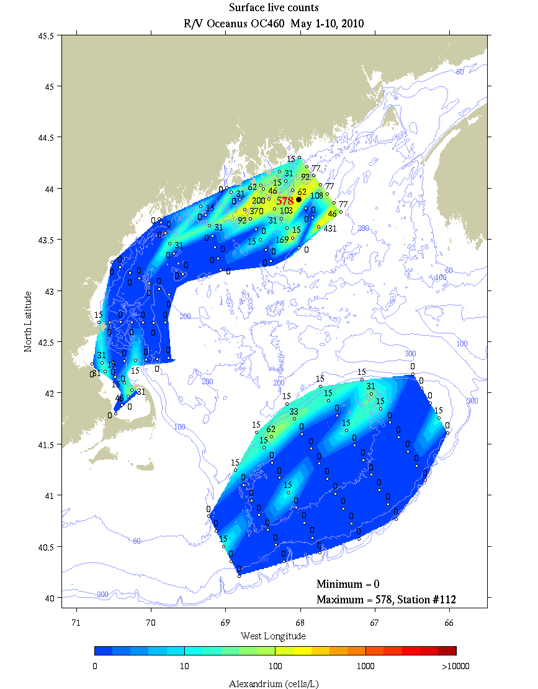
Figure 1. Alexandrium concentration (cells l⁻¹) from surface live counts on OC460.

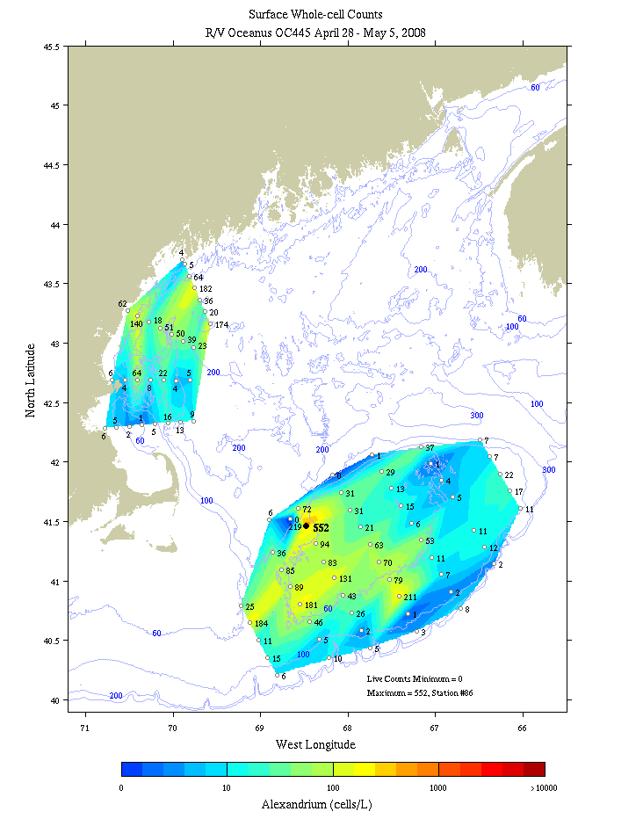
Figure 2. Alexandrium concentration (cells l⁻¹) from surface live counts on OC445.

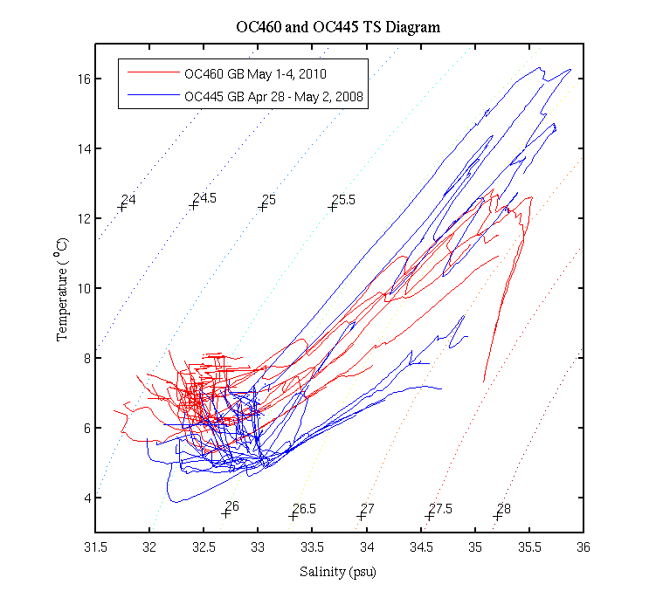 | 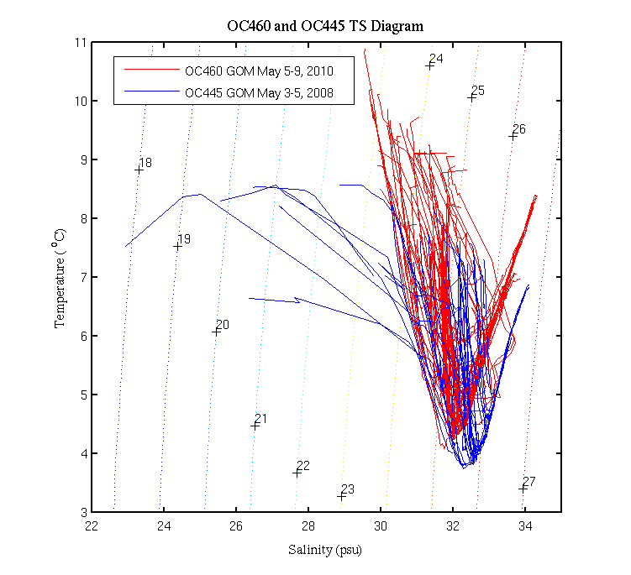
Figure 3. Temperature / salinity characteristics of hydrographic profiles during OC445 in 2008 (blue) and OC460 in 2010 (red). Left: Georges Bank; right: Gulf of Maine.

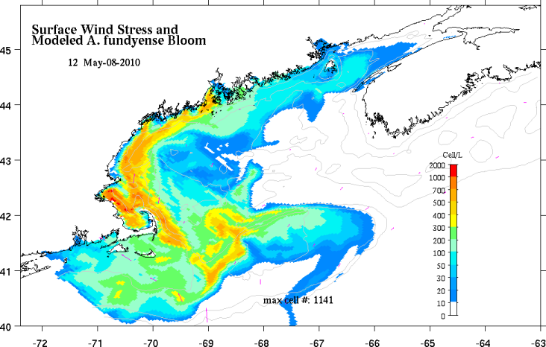
Figure 4. A. fundyense model predictions for May 8 (right). For a complete description of the forecast system and 2010 results, see http://omglnx3.meas.ncsu.edu/GOMTOX/2010forecast/.

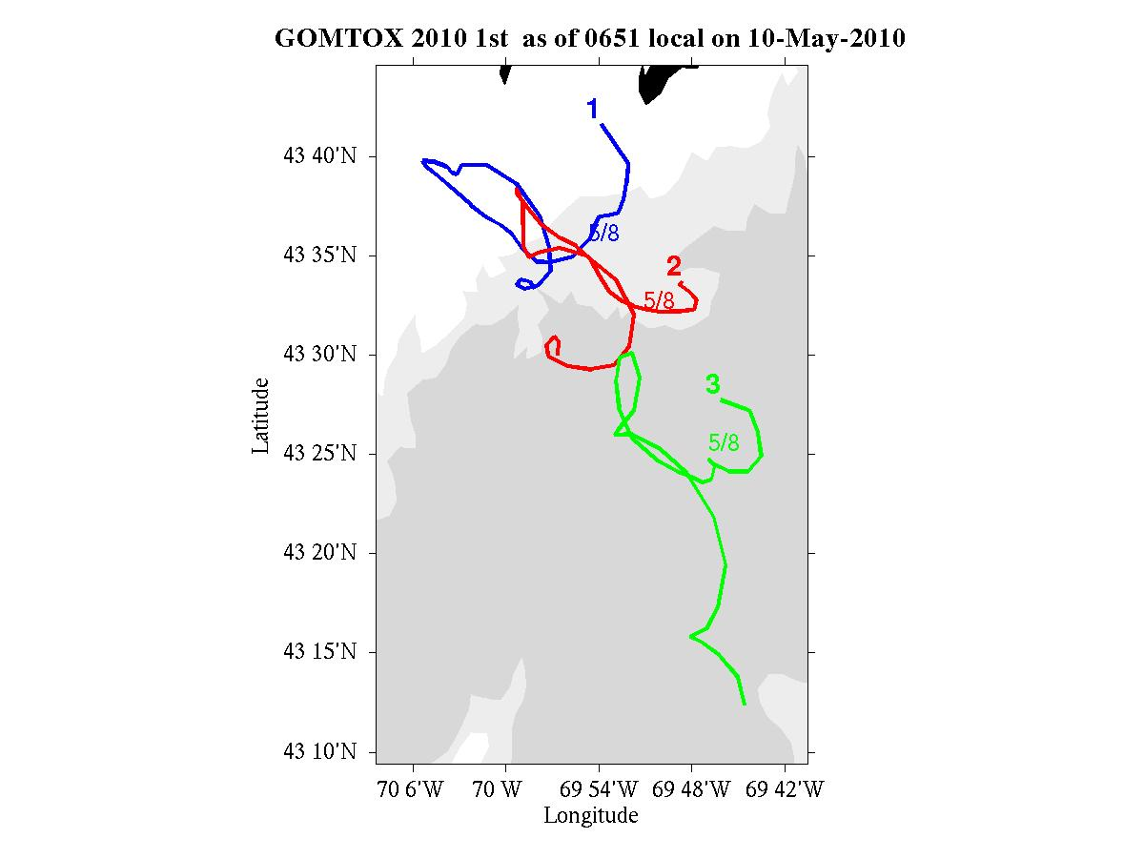
Figure 4. Trajectories of drifters released along the Casco Bay line on OC460.

Appendix A: Measurements made on OC460

Underway measurements
a. Acoustic Doppler Current Profiler
b. Meteorological sensors

Core hydrographic measurements
a. CTD (pressure, temperature, salinity, oxygen, fluorescence, beam attenuation, PAR)
b. Alexandrium cell counts: 1, 10, 20, 30, 40, 50m plus 250/near bottom
c. Nutrients: standard depths plus 100, 150, 200, 250m
Water budget:

Bottle # | Depth | Live | Spare | Whole Cell | SHA | Nuts/Chl | Pseuds | total
1 | 1 |  |  | 2 | 2 | 1.0 | 1.0 | 7.0
2 | 1 | 10 |  |  |  |  |  | 10
3 | 1 |  | 10 |  |  |  |  | 10
4 | 10 |  |  | 2 | 2 | 1.0 | 1.0* | 7.0
5 | 20 |  |  | 2 | 2 | 1.0 | 1.0* | 7.0
6 | 30 |  |  | 2 | 2 | 1.0 | 1.0* | 7.0
7 | 40 |  |  | 2 | 2 | 1.0 | 1.0* | 7.0
8 | 50 |  |  | 2 | 2 | 1.0 | 1.0* | 7.0
9 | 100 |  |  |  |  | 1.0 |  | 1.0
10 | 150 |  |  |  |  | 1.0 |  | 1.0
11 | 200 |  |  |  |  | 1.0 |  | 1.0
12 | 250 / near bottom |  |  |  |  | 1.0 |  | 1.0

Af water- For Whole Cell (WC) and Sandwich Hybridization (SHA) – 4 liters collected total and 20 μm sieved and split between the two assays.

4L/depth combined/split x 6 depths=6 WC tubes&6 filters/station (6 hole-manifold #1 loaded once)

Pseuds – At each station: 1) 125 ml whole water will be filtered for Pseud SHA onto 0.45µm Duropore filters; 2) 125ml whole water will be filtered for ARISA samples onto 0.45µm Isopore HA filters (as in 2008); 3) 125 ml whole water will be filtered for Domoic Acid onto 0.45µm Isopore HA filters. SHA filters will be frozen in LN2 Dewar

3 filters and cryo-vials/station will be needed. Use a 3-hole manifold—Note that the Pseud SHA filter and the ARISA/DA filters are the same pore size, but not the same material. Do not mix up the filter types.

*A vertical profile of Pseuds will be sampled at 4-6 selected stations with high abundance, in different hydrographic regimes as conditions permit. Same procedure as above but repeat for all 6 std depths.

A Domoic Acid “calibration” station will also be done at selected stations—details TBD.

Opportunistic samples– a spare 10L live sample will be available for multiple purposes; e.g., culturing of Pseuds and/or Alexandrium, life cycle stage samples, and possibly microsatellite analysis of Alexandrium populations. Additional opportunistic samples may be taken in areas of high Alexandrium and/or Pseud abundance.

Toxin size fractionation – Turner
Pump profiles were carried out at selected locations. Sampling depths were chosen to coincide as closely as possible with hydrographic sampling and sediment trap measurements. Pump deployments are summarized in Table 2.

 | Date | Time  (local) | Latitude | Longitude | Station | Live Count
1 | May 1 |  | 41 34.3 N | 68 23.0 W | FDA shellfish time-series site  Cultivator Shoal, CTD 55
2 | May 9 |  | 42 17.6 N | 70 39.3 W | Near Minots Light, Boston,  CTD 123
Table 2. Pump stations.

Drifters

ID | Mon | Day | Year | Local Time | Lon | Lat | Drogue  depth(m) | Station Number
105430691 | 5 | 7 | 2010 | 0612 | 69 52.050W | 43 39.750N | 1 | CB1B
105430692 | 5 | 7 | 2010 | 0703 | 69 48.642W | 43 33.720N | 1 | CB1C
105430693 | 5 | 7 | 2010 | 0750 | 69 45.102W | 43 27.738N | 1 | CB1D
Table 3: Summary of drifter releases on Casco Bay line. For more information see http://nefsc.noaa.gov/drifter.

Microbial community structure and bacterial abundance – Amaral-Zettler and Murphy

OC460 #1 – CTD55 – Georges Bank – Alexandrium live count = 0
5/5/10 41 34.3 N / 68 23.0 W
Sfc (1),(2)
10m (1),(2)
20m (2) [replicate 1 lost]

OC460 #2 – CTD79 – Casco Bay – Alexandrium live count = 0
5/7/10 43 39.8 N / 69 52.0 W
Sfc (2) [replicate 1 lost]
10m (1),(2)
20m (1),(2)

OC460 #3 – CTD106 – Isle au Haut – Alexandrium live count = 0
5/8/10 43 53.6 N / 68 25.1 W
Sfc (1),(2)
10m (1) [replicate 2 lost]
20m (1),(2)

OC460 #4 – CTD123 – Minots Light – Alexandrium live count =
5/9/10 42 17.6 N / 70 39.3 W
Sfc (1),(2)
10m (1),(2)
20m (1) [no filter left for replicate sample]

Appendix B: Hydrographic maps
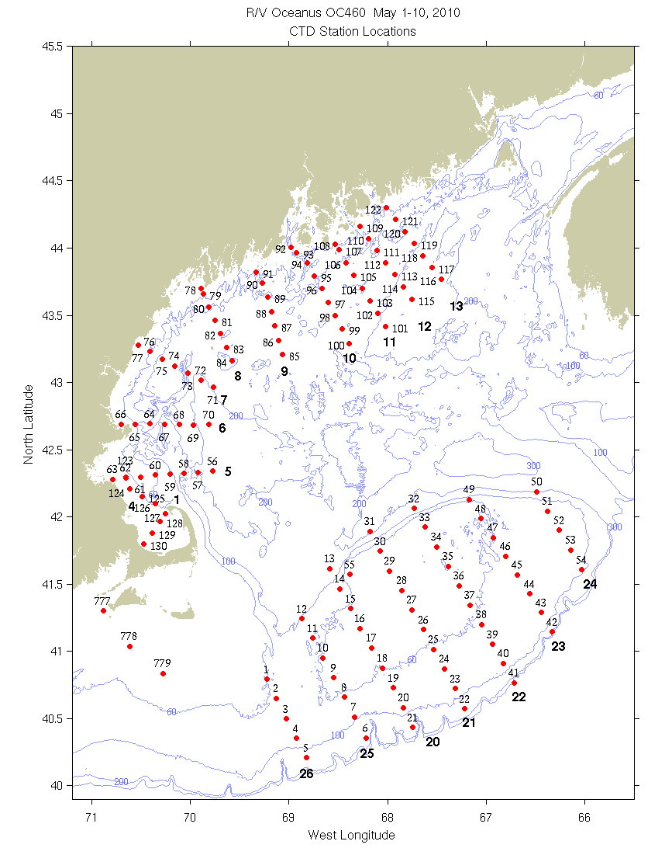
Figure B1: CTD station locations. Bold numerals indicate identifiers for the sections displayed below.

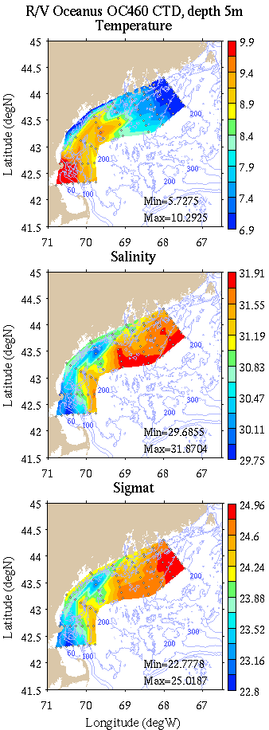 | 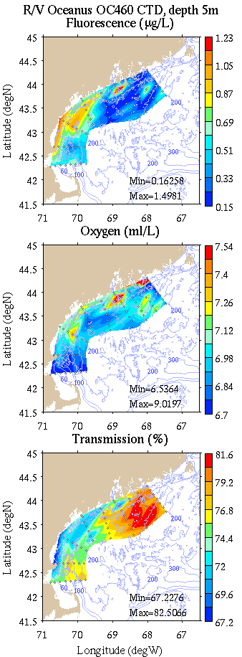
Figure B2: Coastal GOM survey maps at 5m depth. Left: temperature, salinity, and density; right: fluorescence, oxygen, and light transmission.

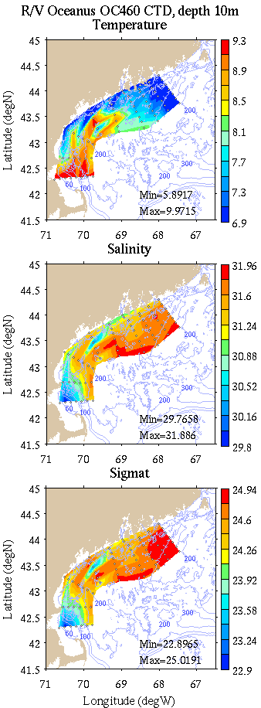 | 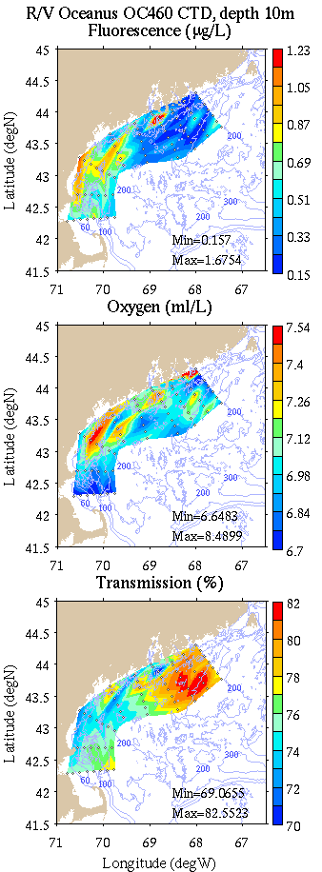
Figure B3: Coastal GOM survey maps at 10m depth. Left: temperature, salinity, and density; right: fluorescence, oxygen, and light transmission.

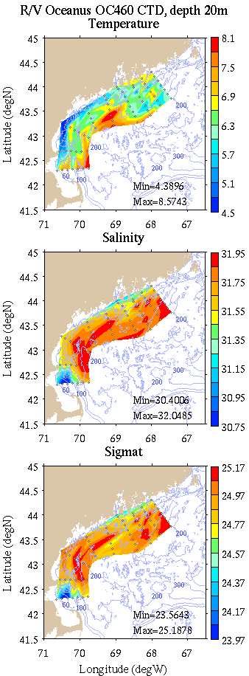 | 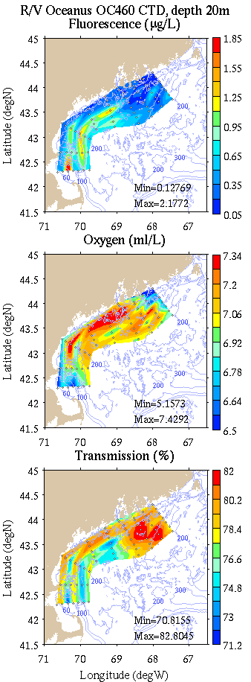
Figure B4: Coastal GOM survey maps at 20m depth. Left: temperature, salinity, and density; right: fluorescence, oxygen, and light transmission.

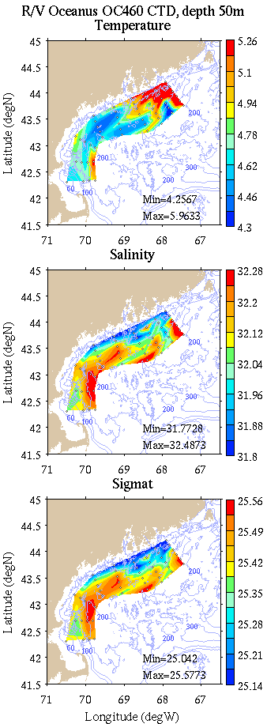 | 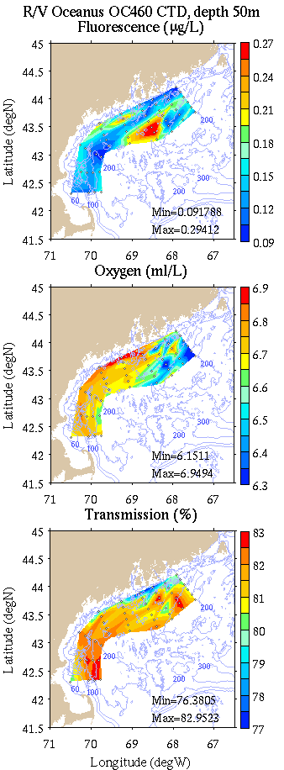
Figure B5: Coastal GOM survey maps at 50m depth. Left: temperature, salinity, and density; right: fluorescence, oxygen, and light transmission.

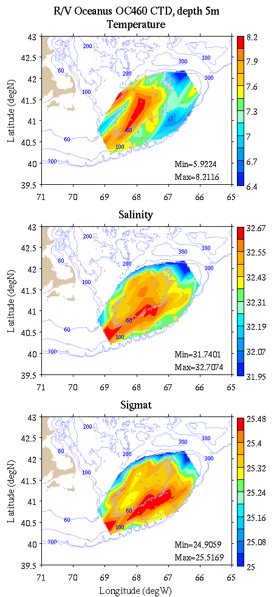 | 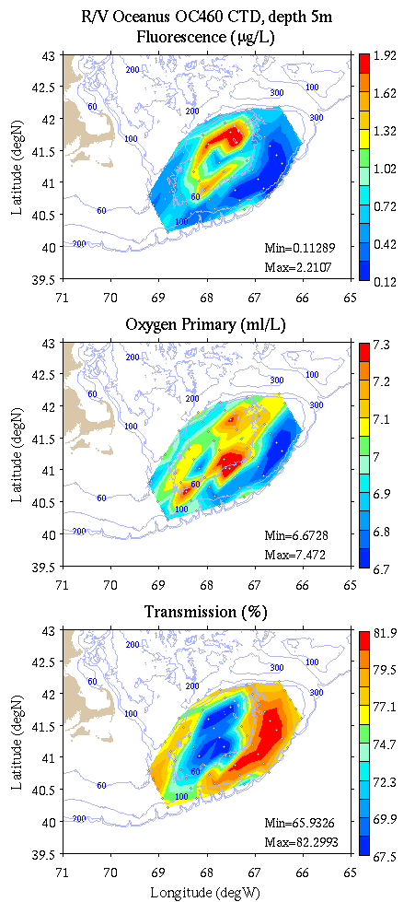
Figure B6: Georges Bank survey maps at 5m depth. Left: temperature, salinity, and density; right: fluorescence, oxygen, and light transmission.

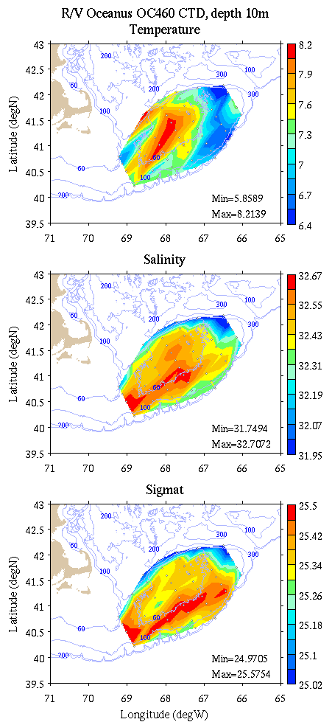 | 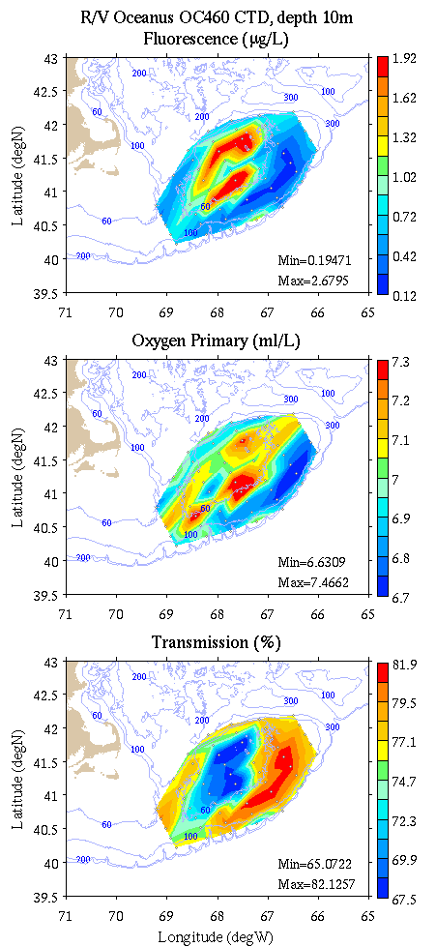
Figure B7: Georges Bank survey maps at 10m depth. Left: temperature, salinity, and density; right: fluorescence, oxygen, and light transmission.

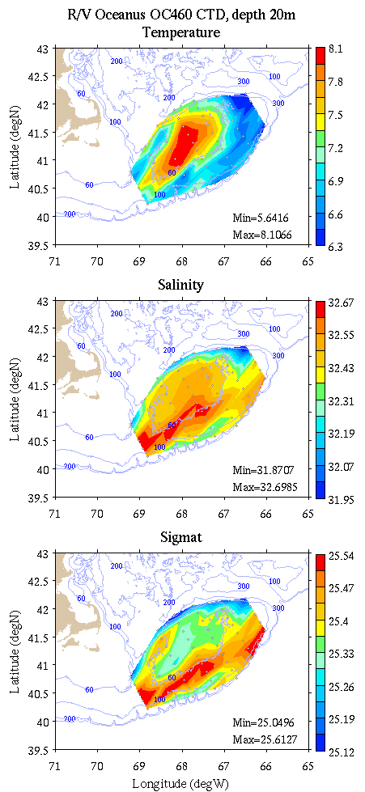 | 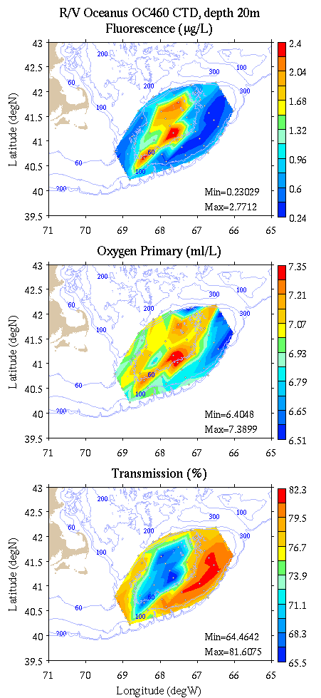
Figure B8: Georges Bank survey maps at 20m depth. Left: temperature, salinity, and density; right: fluorescence, oxygen, and light transmission.

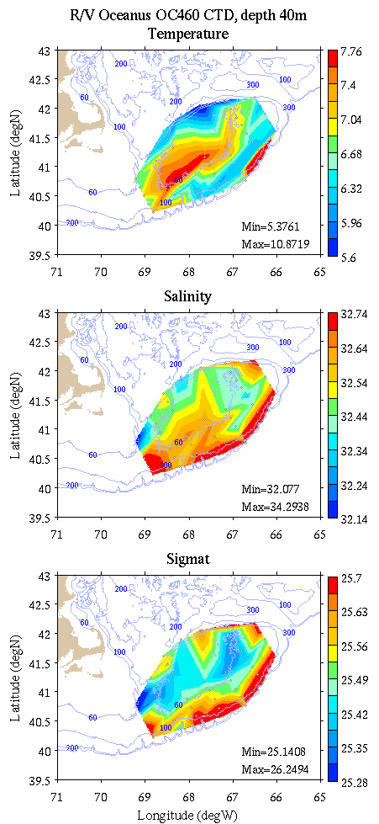 | 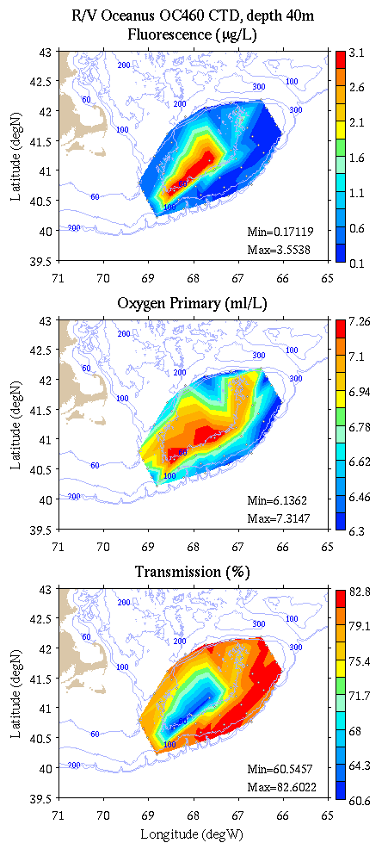
Figure B9: Georges Bank survey maps at 50m depth. Left: temperature, salinity, and density; right: fluorescence, oxygen, and light transmission.

Appendix C: Vertical sections.

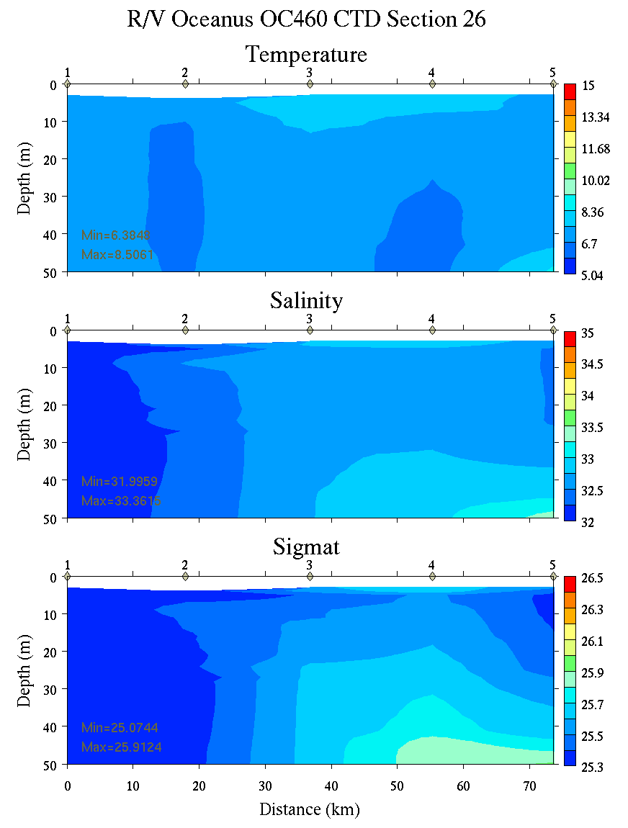 | 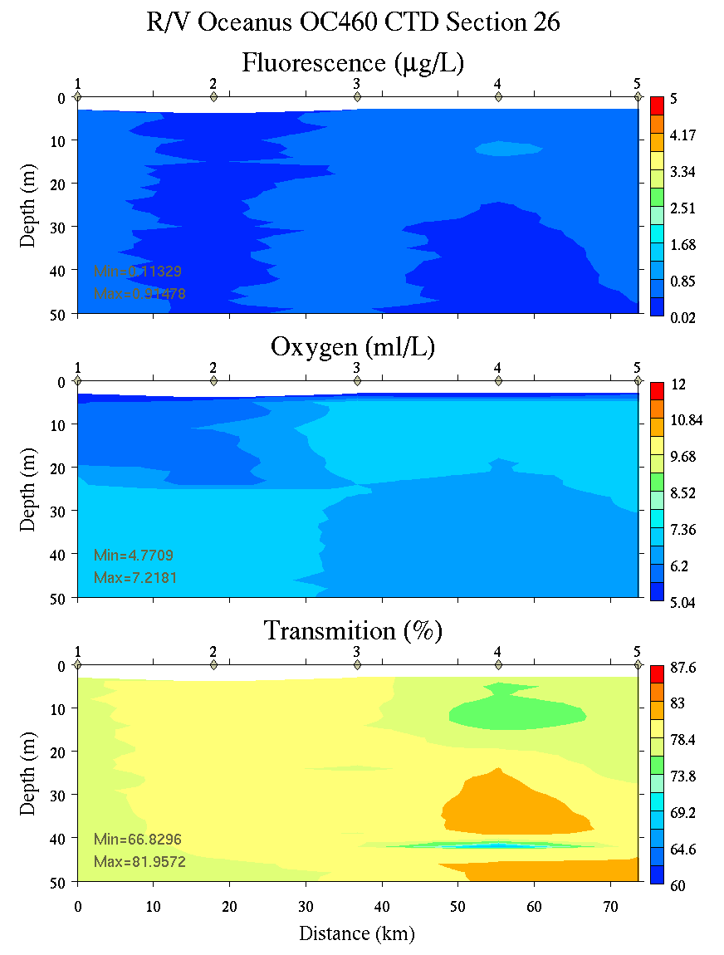
Figure C1. Section 26, 0-50m: temperature, salinity, and density (left); fluorescence, oxygen, and beam transmission (right).

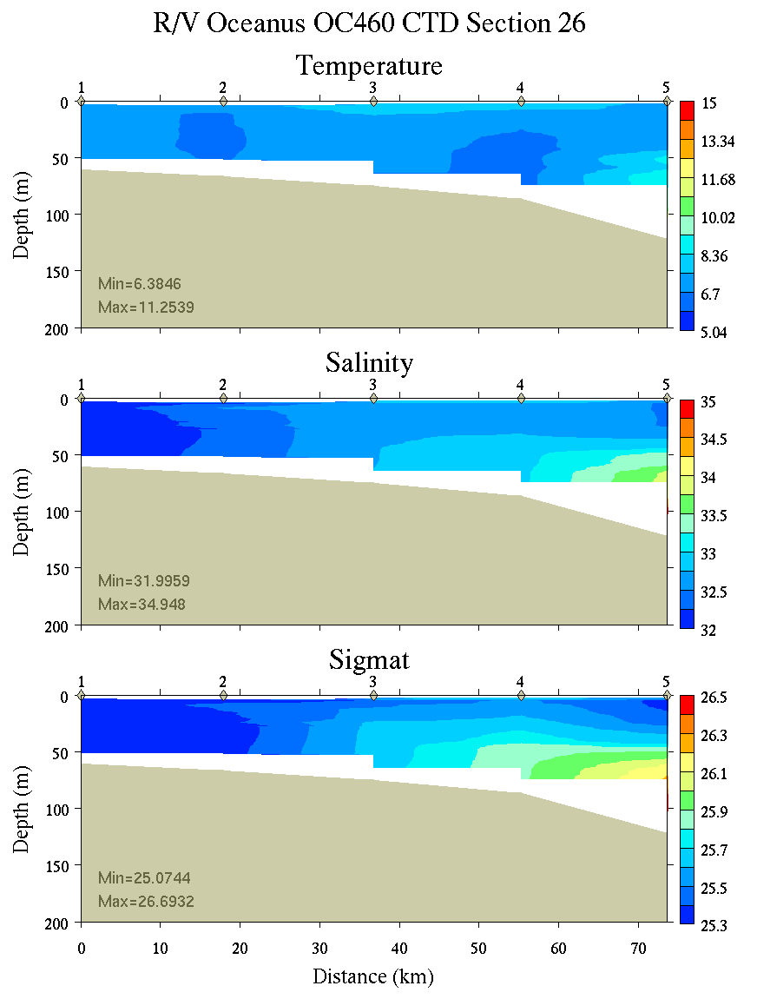 | 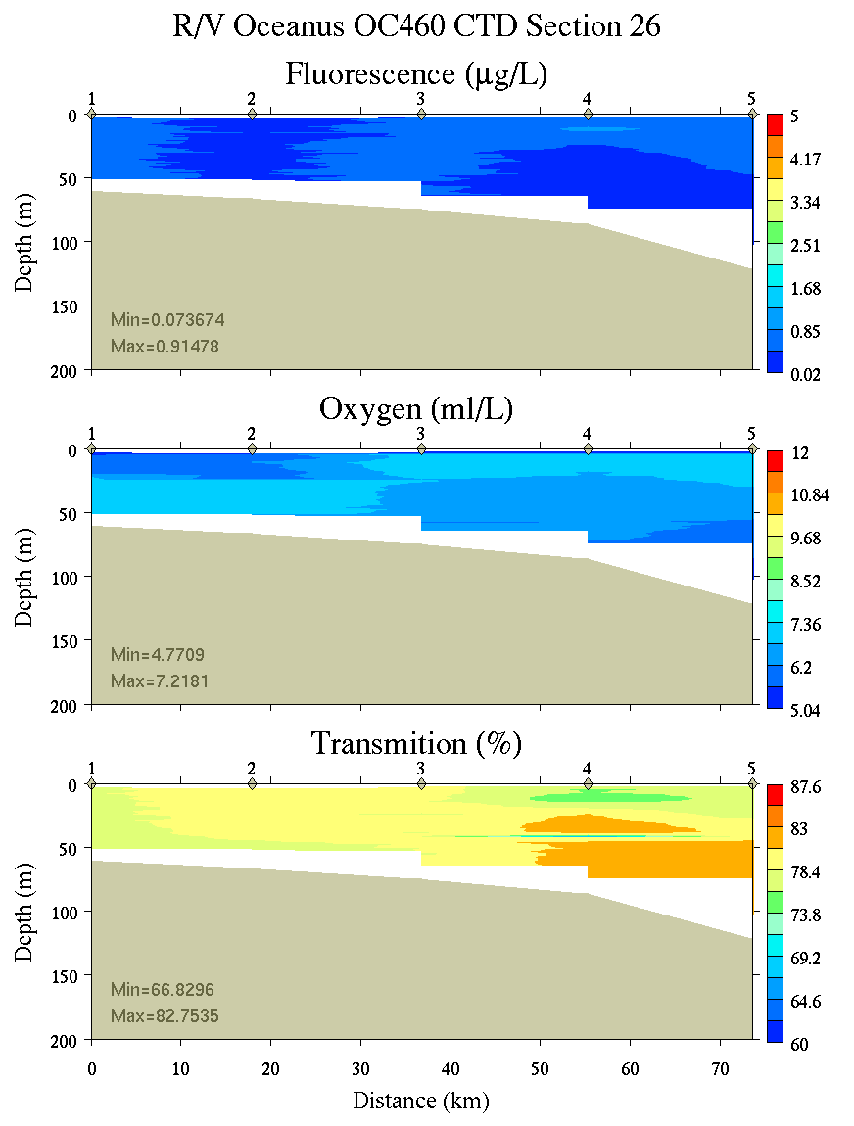
Figure C2. Section 26, 0-200m: temperature, salinity, and density (left); fluorescence, oxygen, and beam transmission (right).

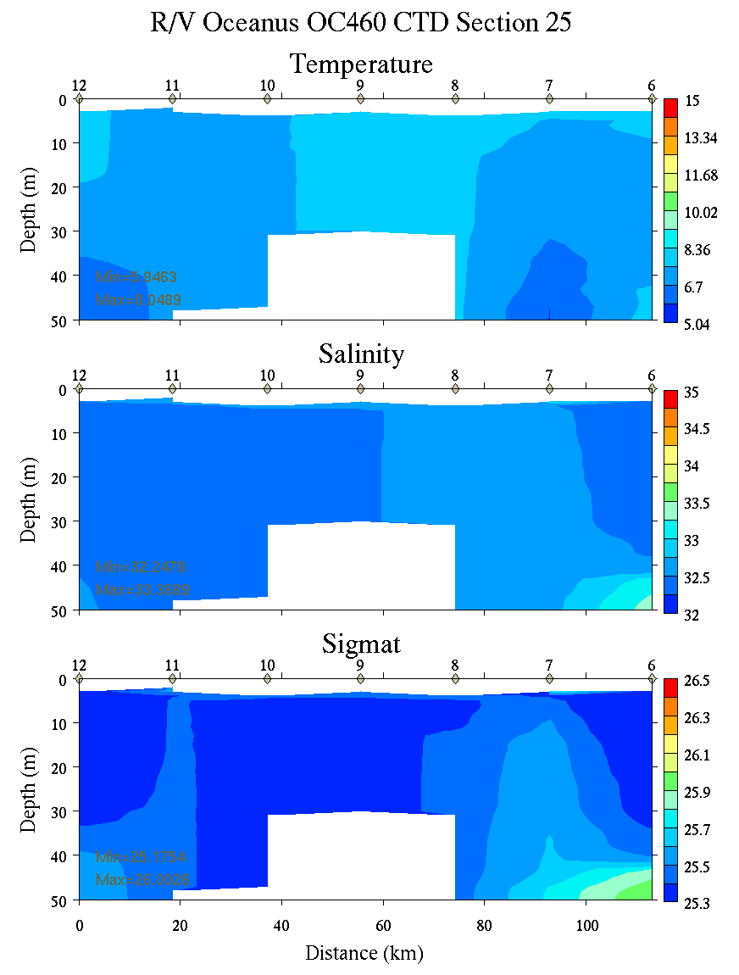 | 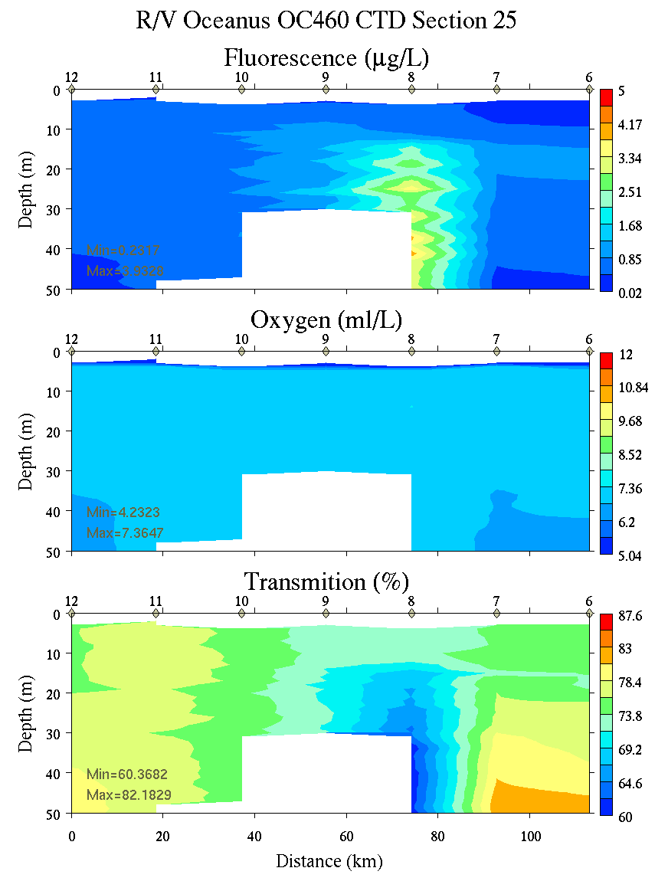
Figure C3. Section 25, 0-50m: temperature, salinity, and density (left); fluorescence, oxygen, and beam transmission (right).

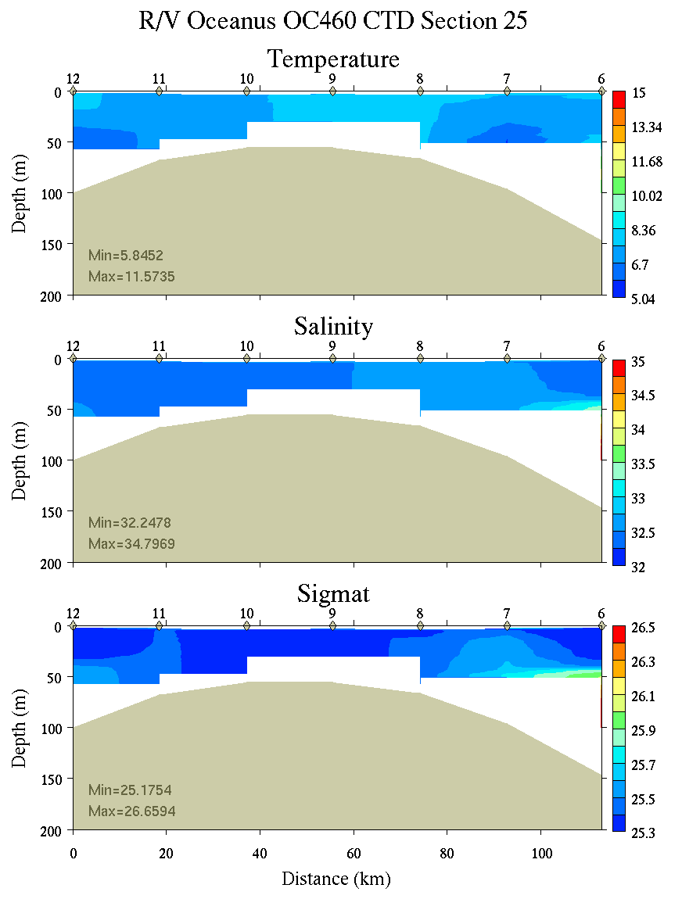 | 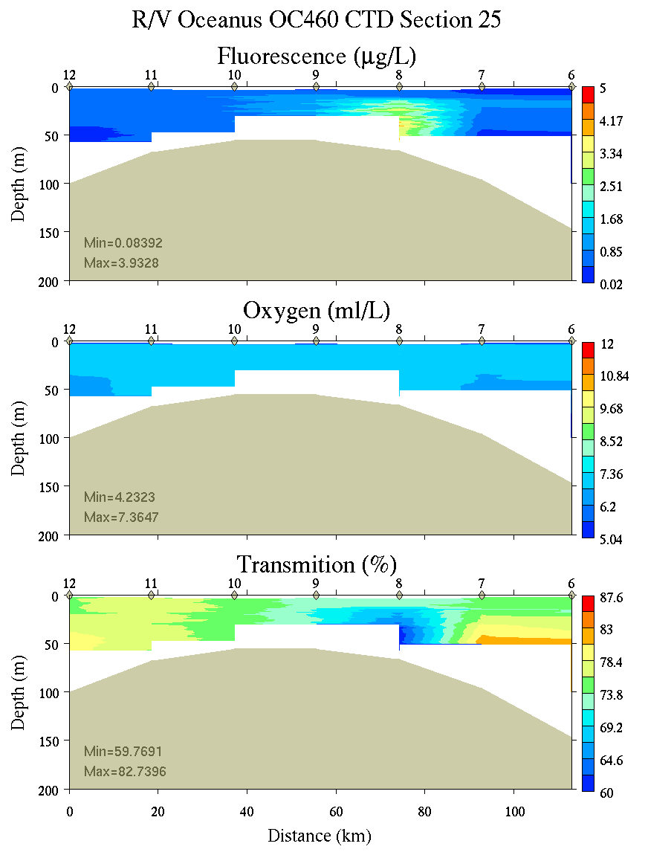
Figure C4. Section 25, 0-200m: temperature, salinity, and density (left); fluorescence, oxygen, and beam transmission (right).

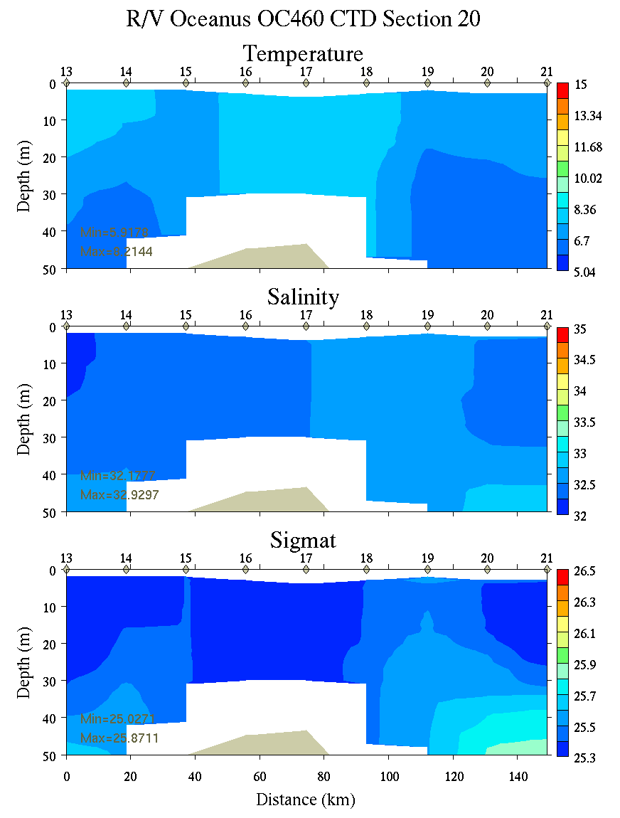 | 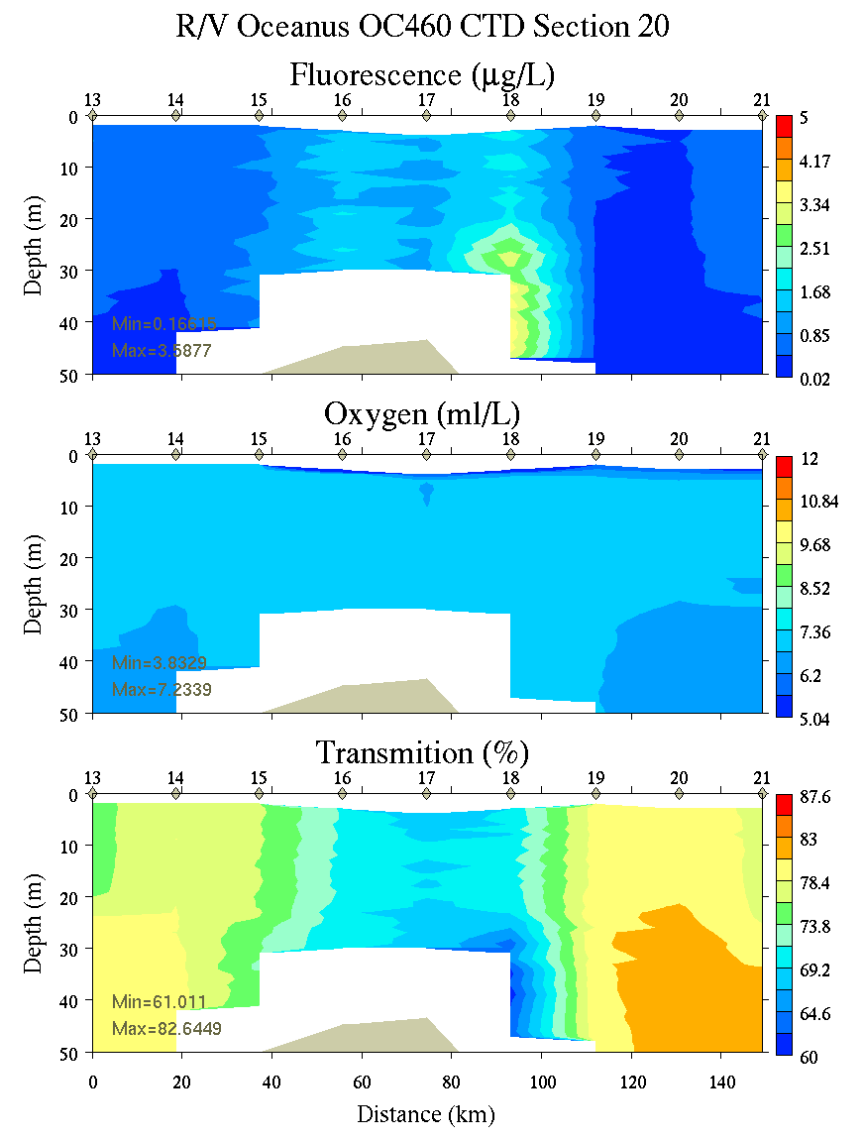
Figure C5. Section 20, 0-50m: temperature, salinity, and density (left); fluorescence, oxygen, and beam transmission (right).

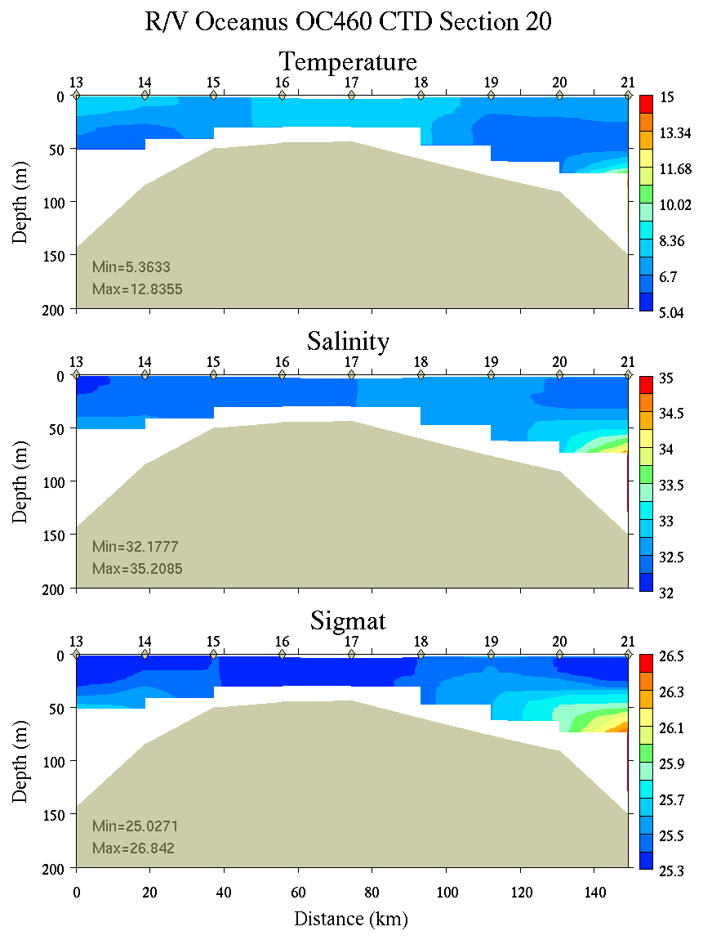 | 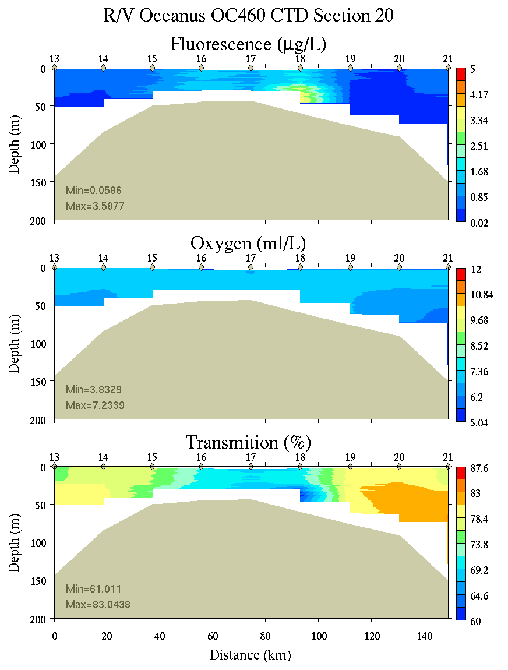
Figure C6. Section 20, 0-200m: temperature, salinity, and density (left); fluorescence, oxygen, and beam transmission (right).

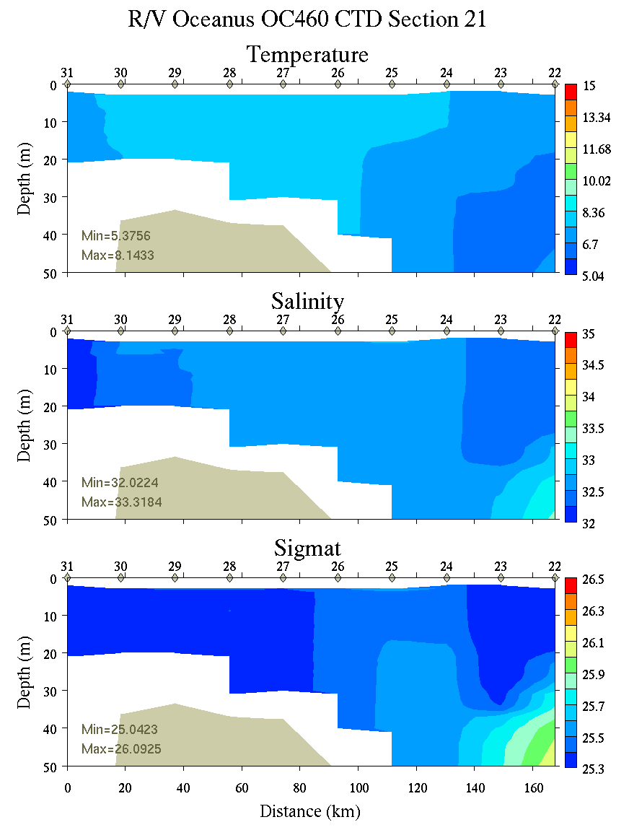 | 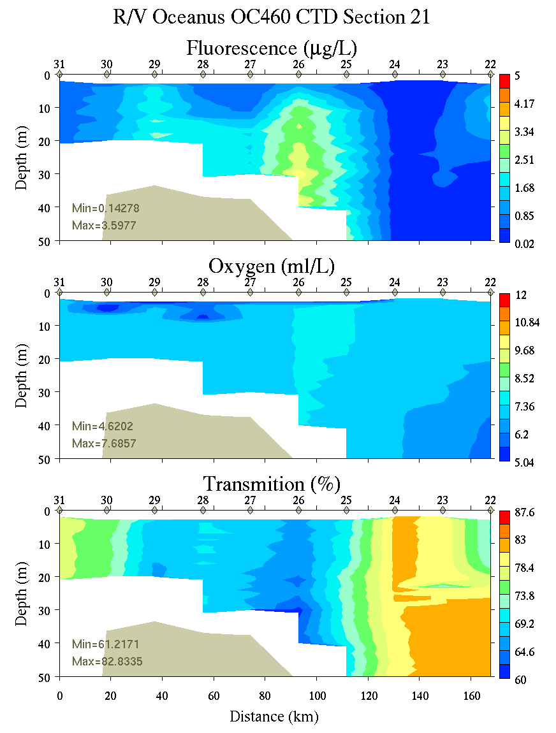
Figure C7. Section 21, 0-200m: temperature, salinity, and density (left); fluorescence, oxygen, and beam transmission (right).

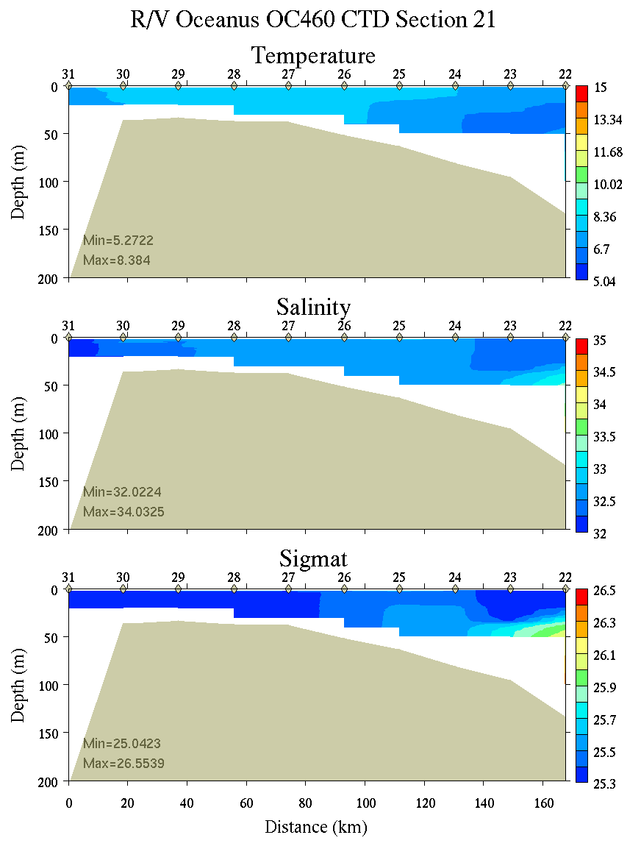 | 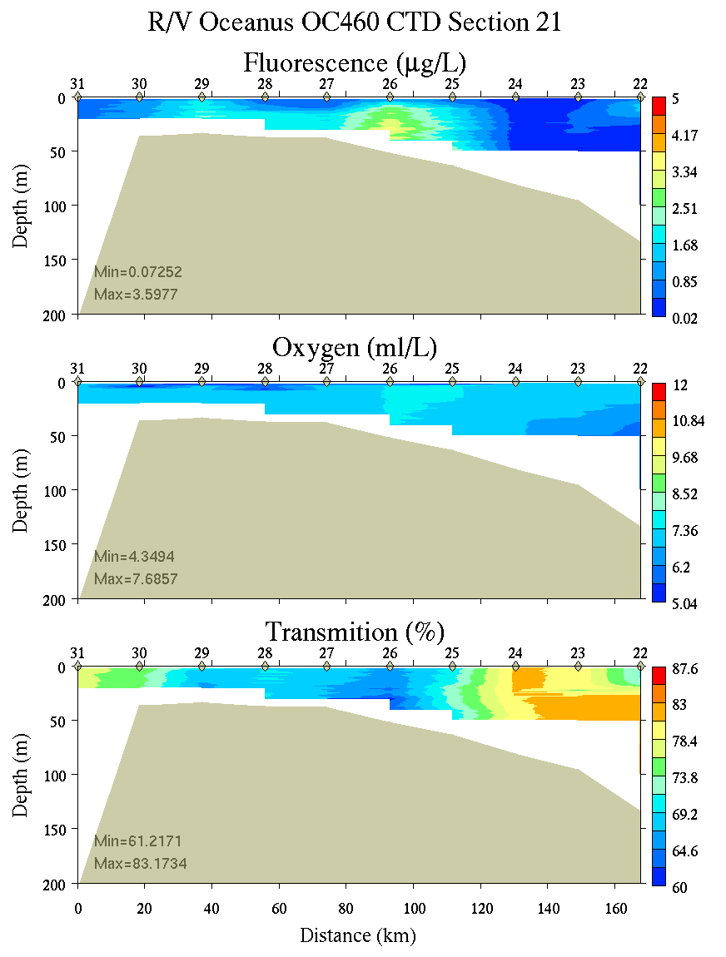
Figure C8. Section 21, 0-200m: temperature, salinity, and density (left); fluorescence, oxygen, and beam transmission (right).

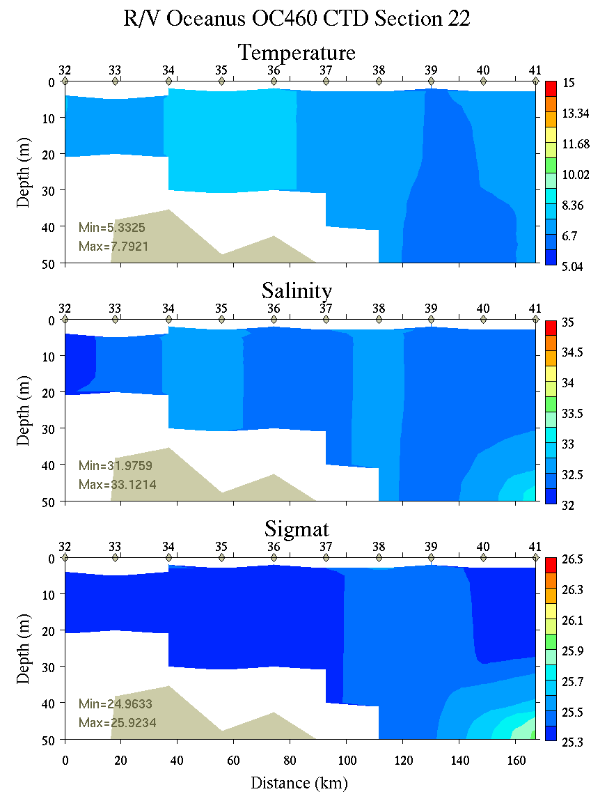 | 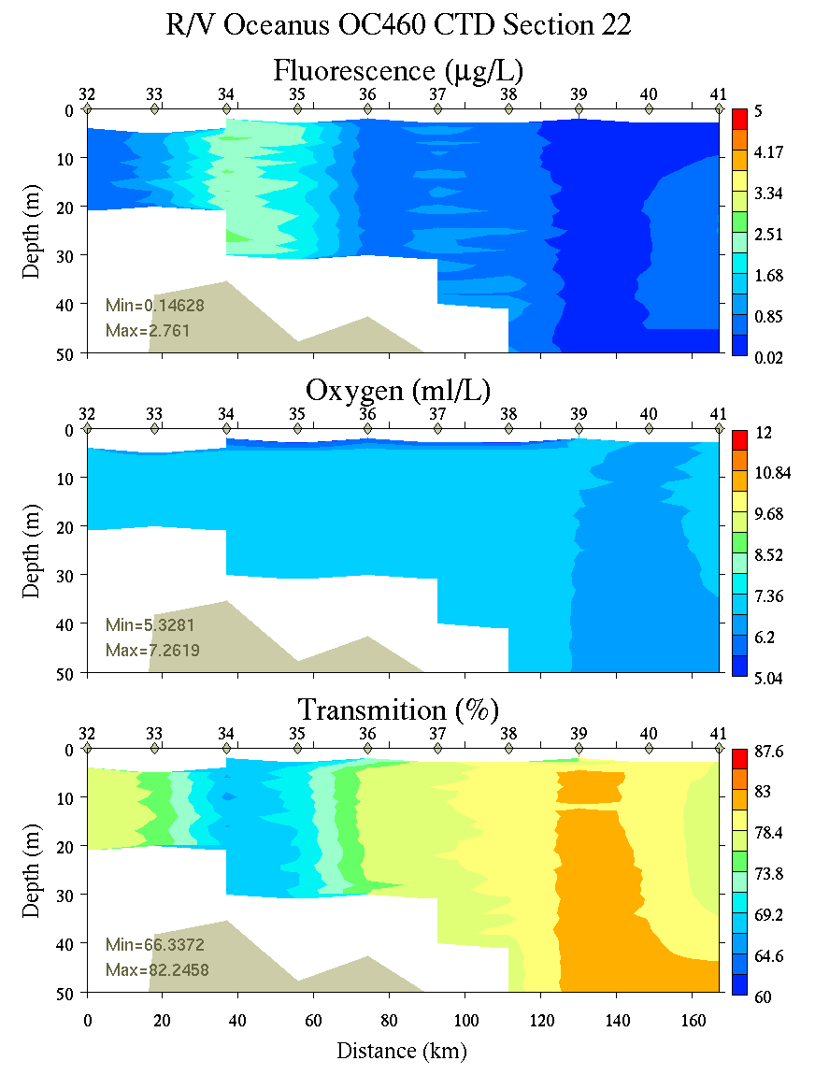
Figure C9. Section 22, 0-50m: temperature, salinity, and density (left); fluorescence, oxygen, and beam transmission (right).

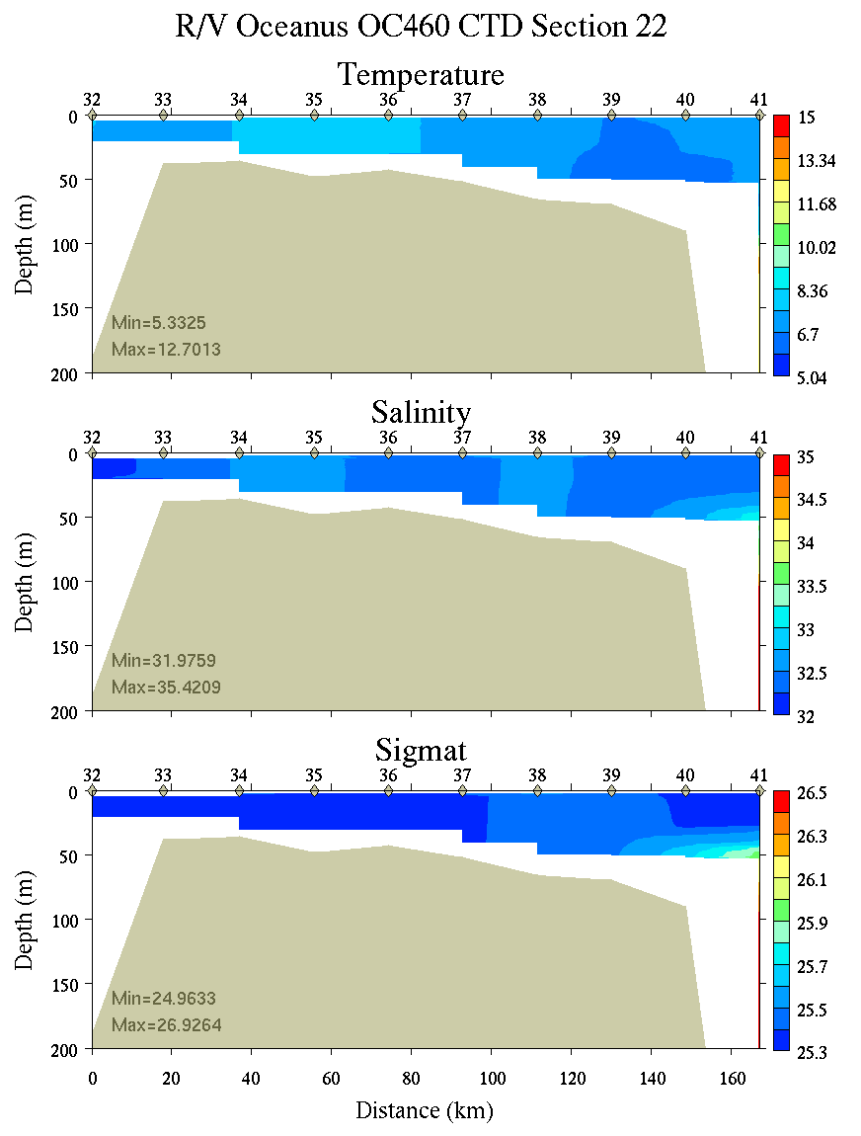 | 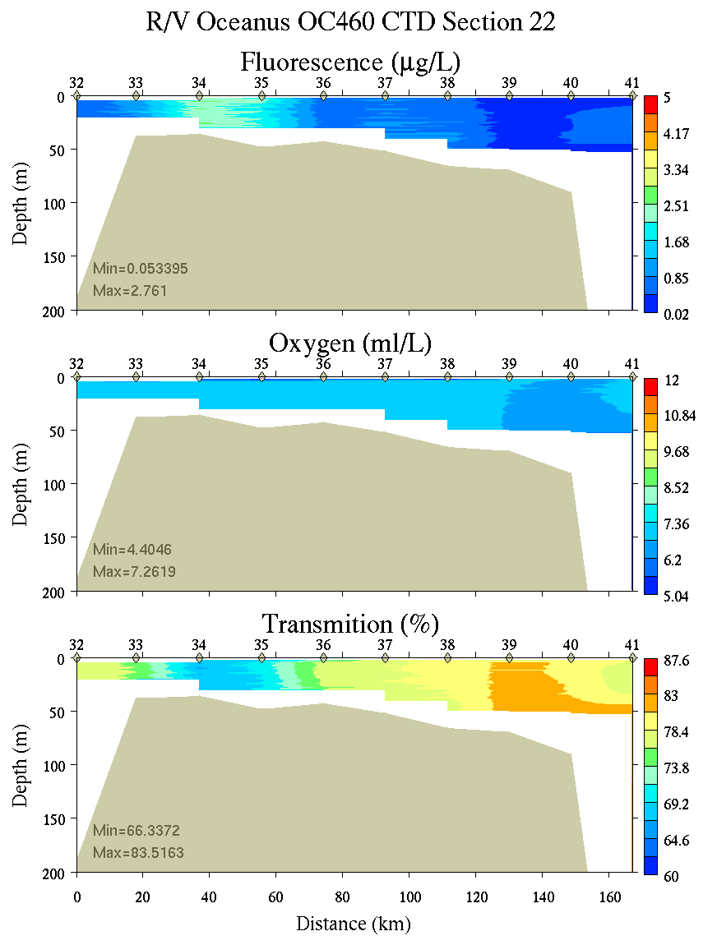
Figure C10. Section 22, 0-200m: temperature, salinity, and density (left); fluorescence, oxygen, and beam transmission (right).

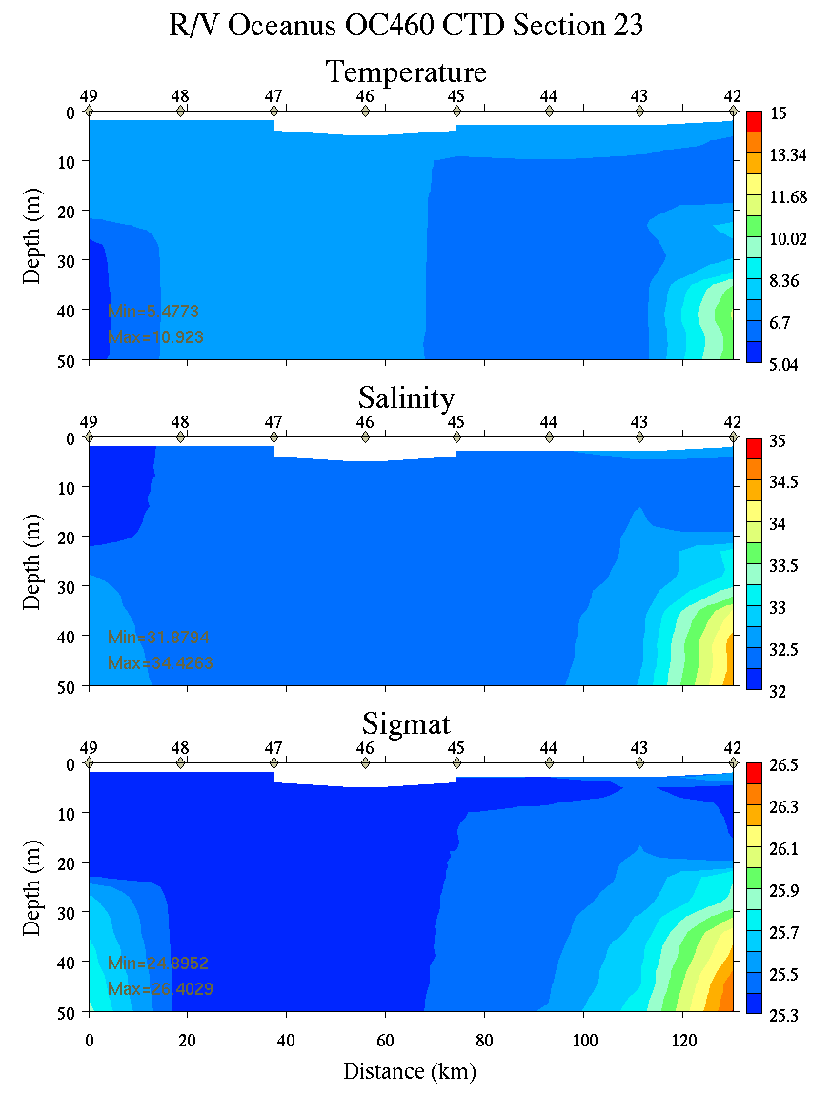 | 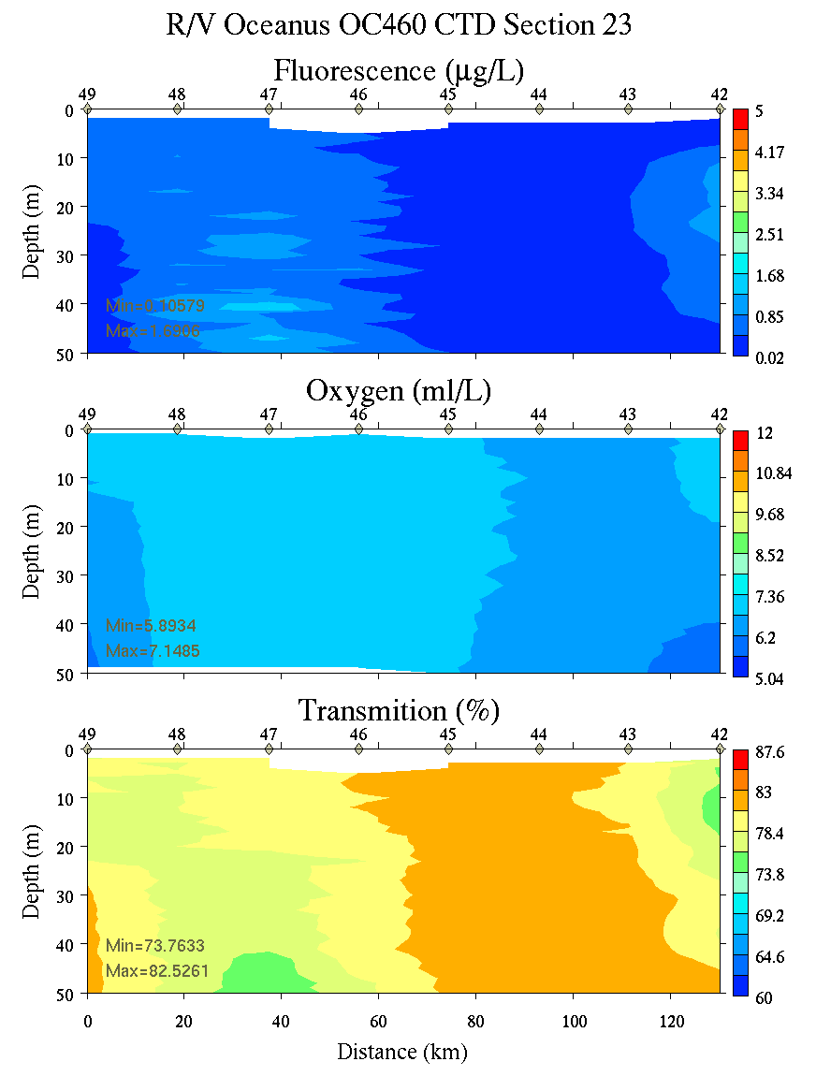
Figure C11. Section 23, 0-50m: temperature, salinity, and density (left); fluorescence, oxygen, and beam transmission (right).

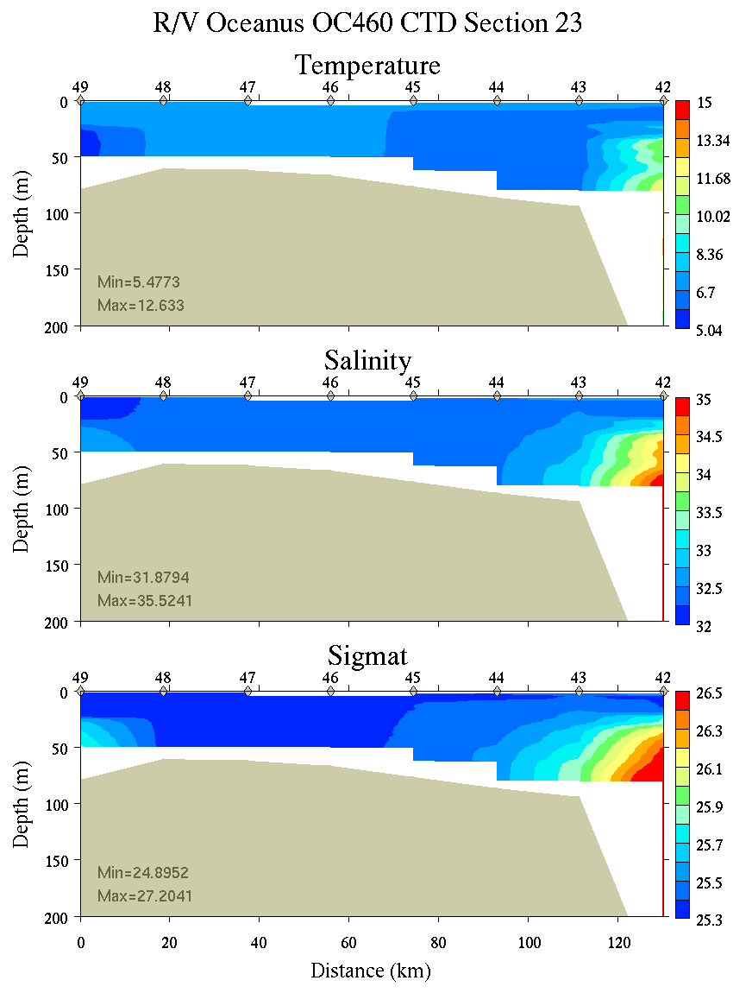 | 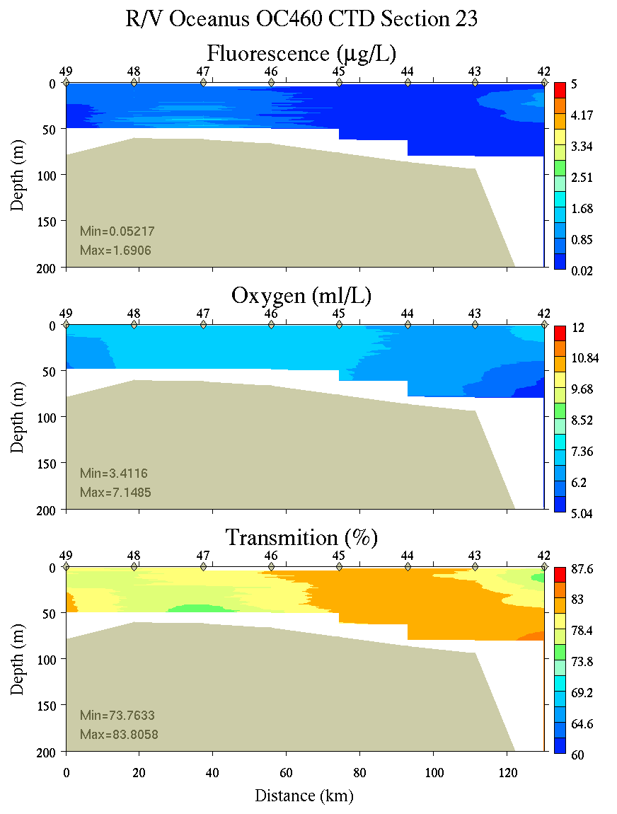
Figure C12. Section 23, 0-200m: temperature, salinity, and density (left); fluorescence, oxygen, and beam transmission (right).

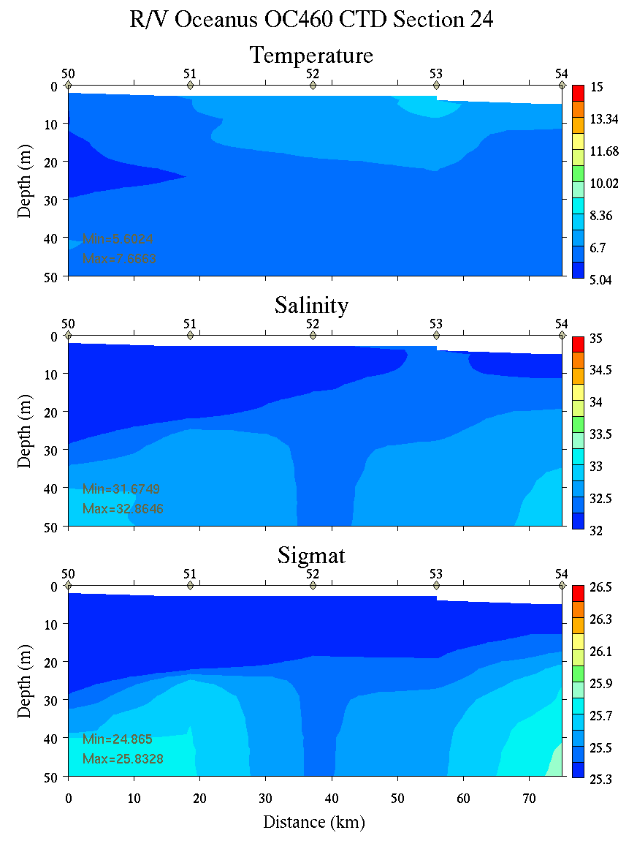 | 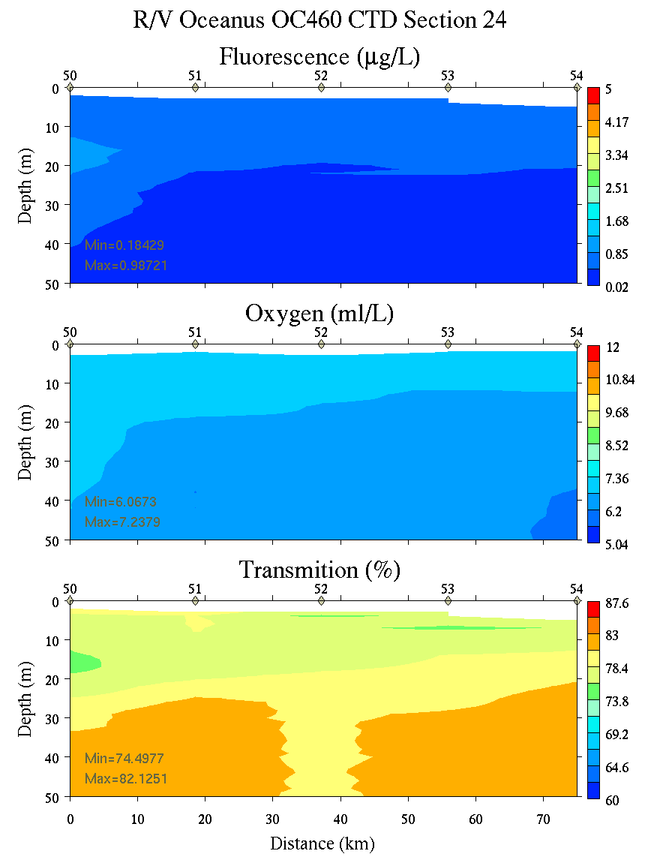
Figure C13. Section 24, 0-50m: temperature, salinity, and density (left); fluorescence, oxygen, and beam transmission (right).

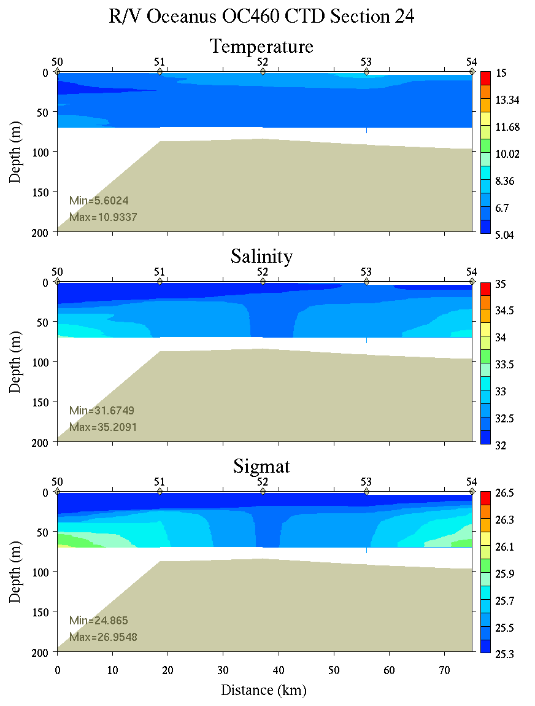 | 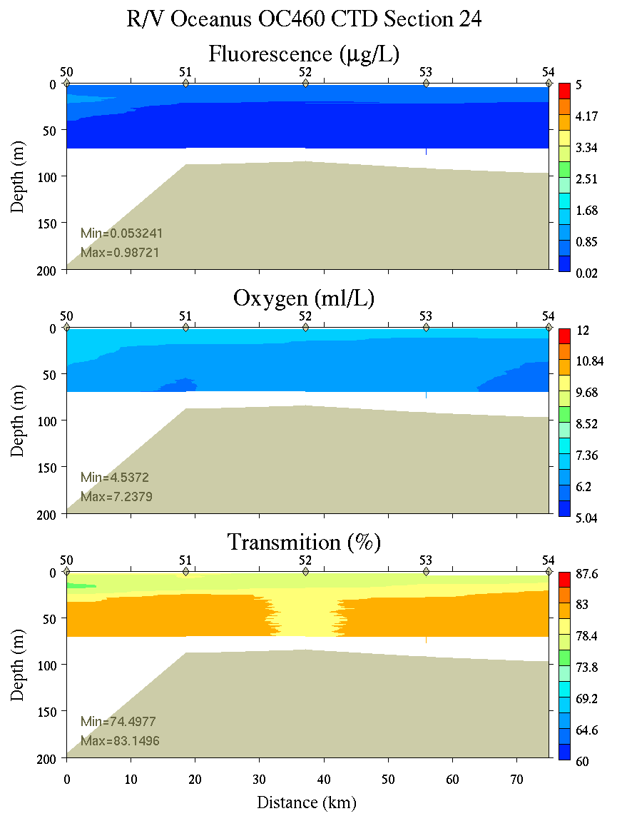
Figure C14. Section 24, 0-200m: temperature, salinity, and density (left); fluorescence, oxygen, and beam transmission (right).

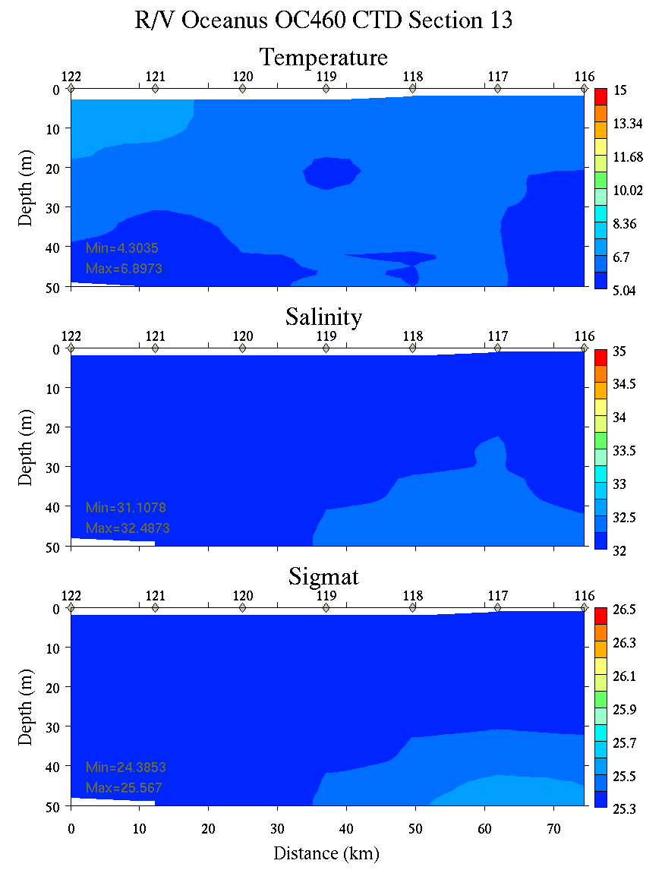 | 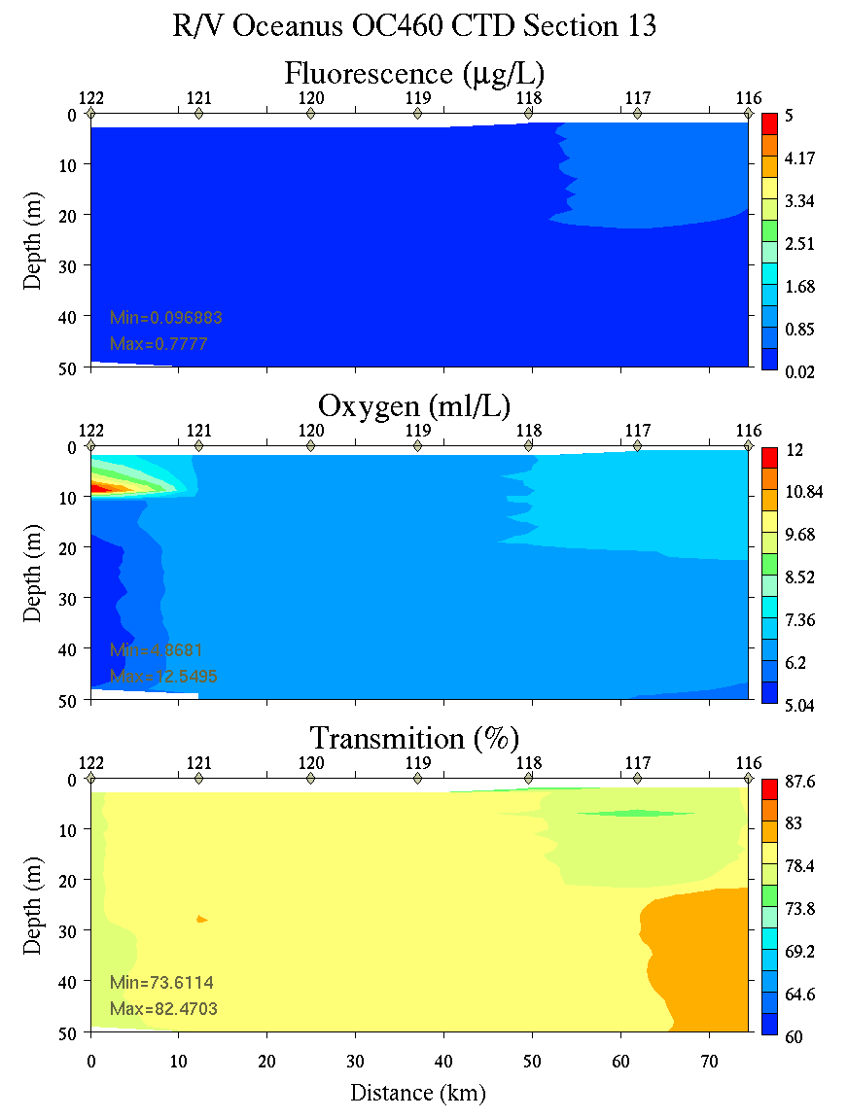
Figure C15. Section 13, 0-50m: temperature, salinity, and density (left); fluorescence, oxygen, and beam transmission (right).

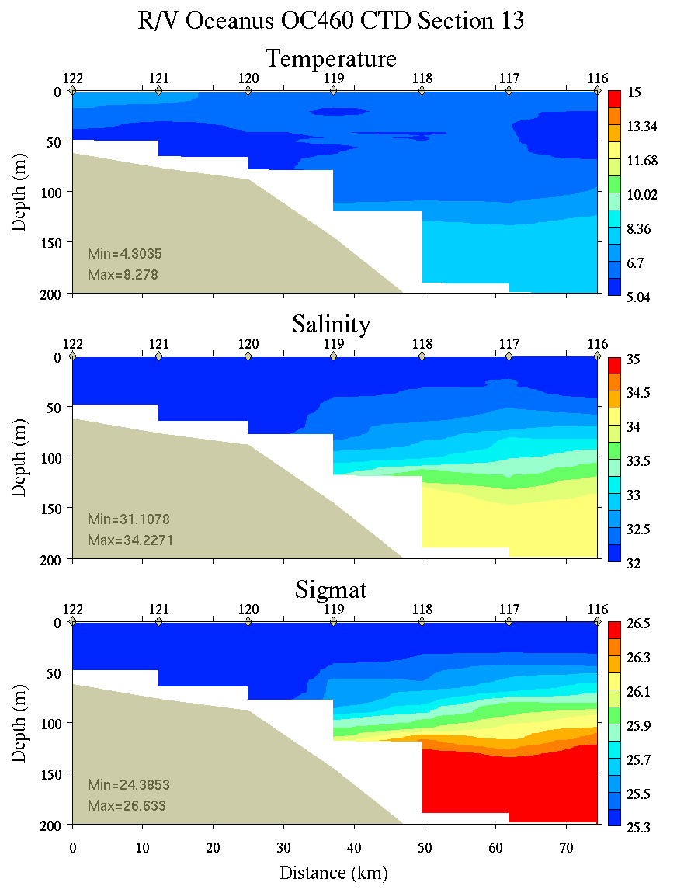 | 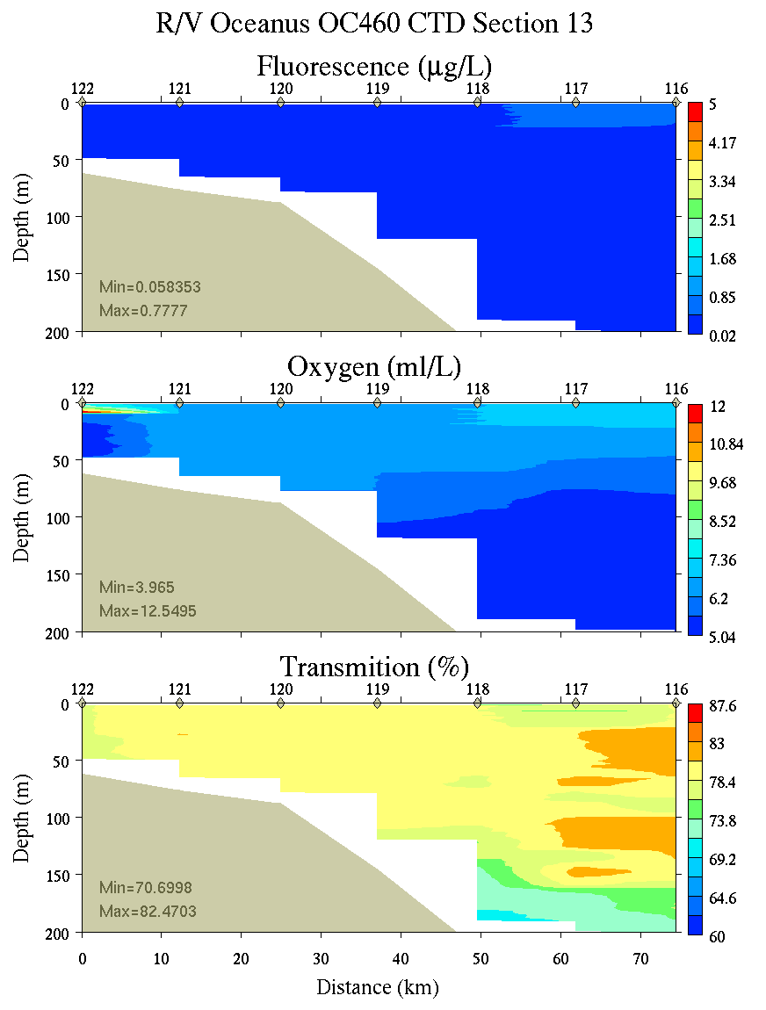
Figure C16. Section 13, 0-200m: temperature, salinity, and density (left); fluorescence, oxygen, and beam transmission (right).

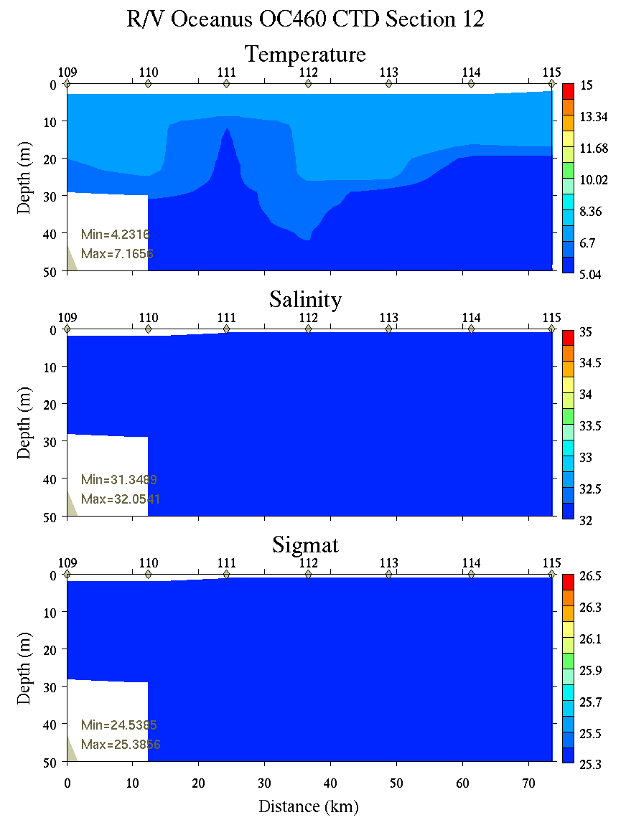 | 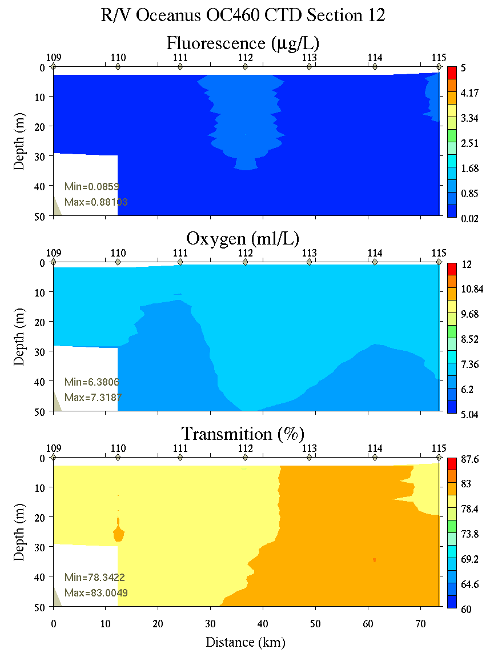
Figure C17. Section 12, 0-50m: temperature, salinity, and density (left); fluorescence, oxygen, and beam transmission (right).

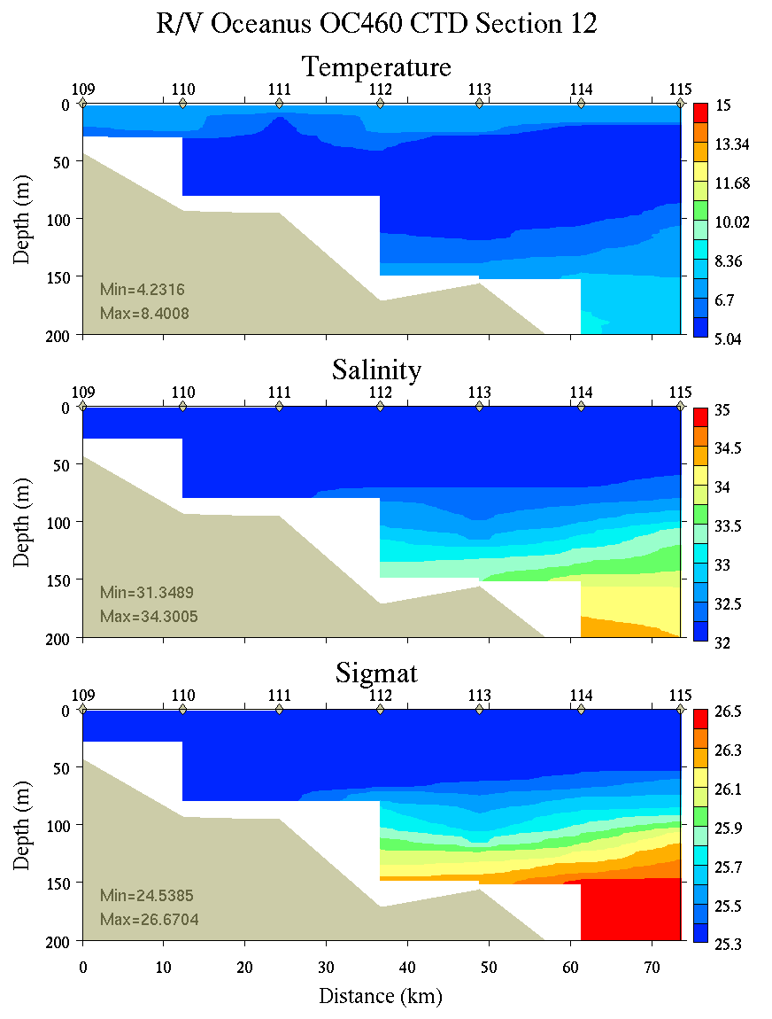 | 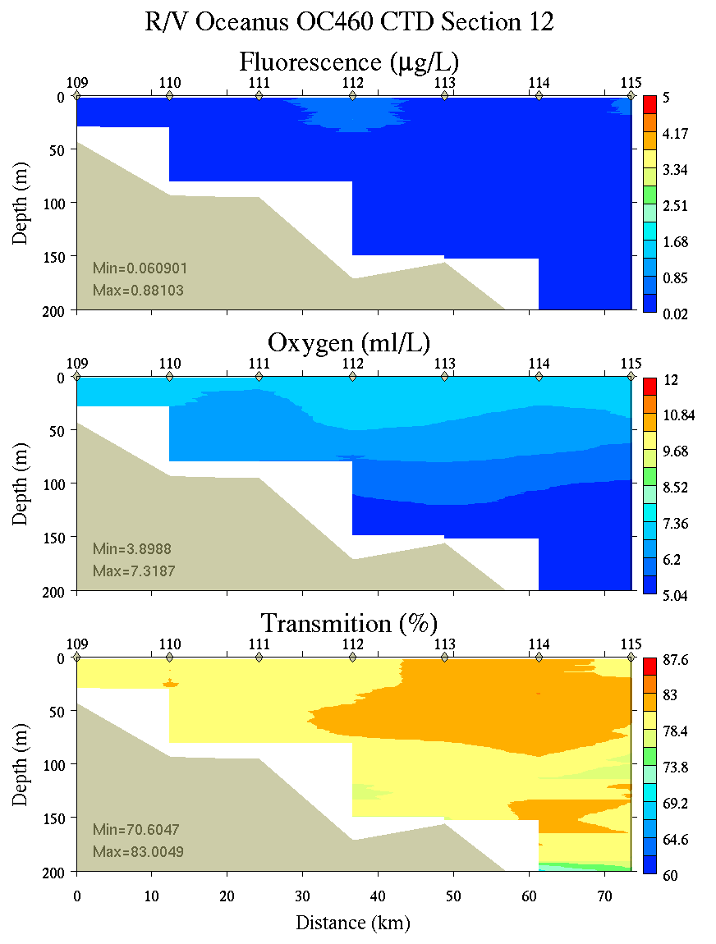
Figure C18. Section 12, 0-200m: temperature, salinity, and density (left); fluorescence, oxygen, and beam transmission (right).

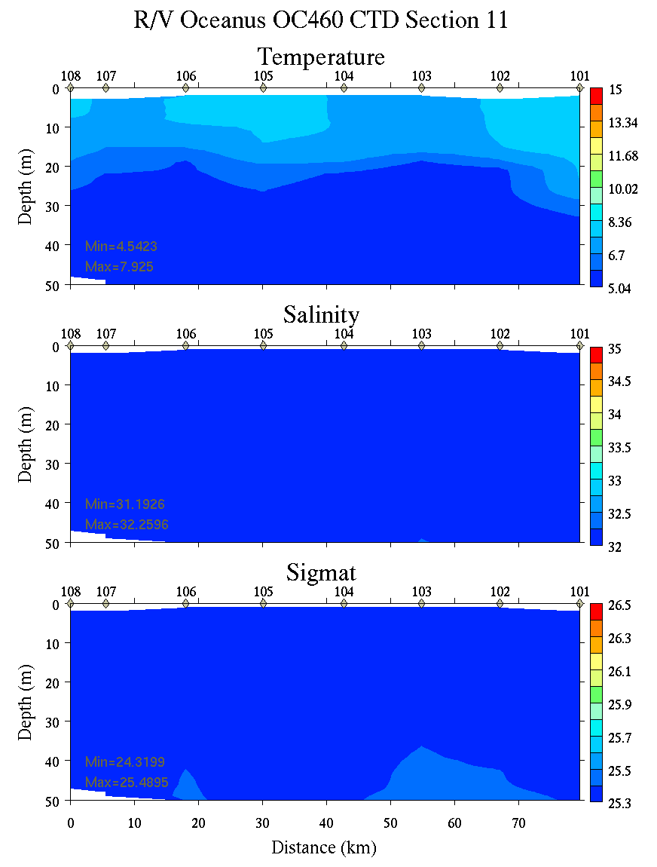 | 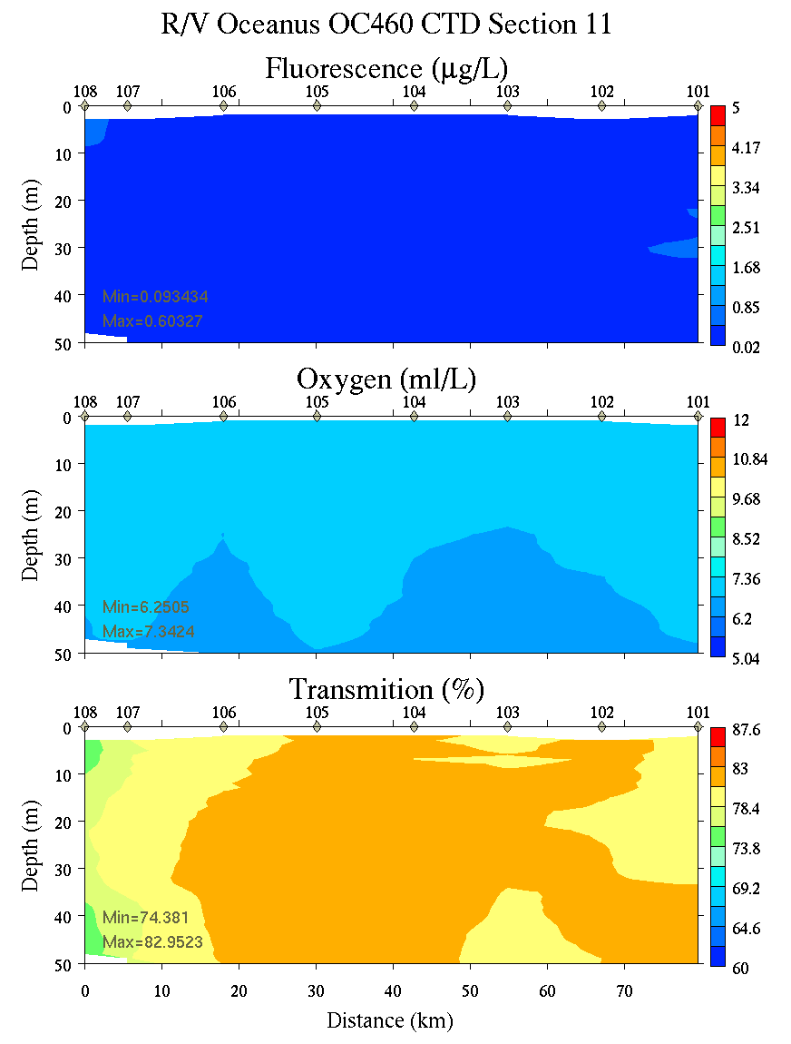
Figure C19. Section 11, 0-50m: temperature, salinity, and density (left); fluorescence, oxygen, and beam transmission (right).

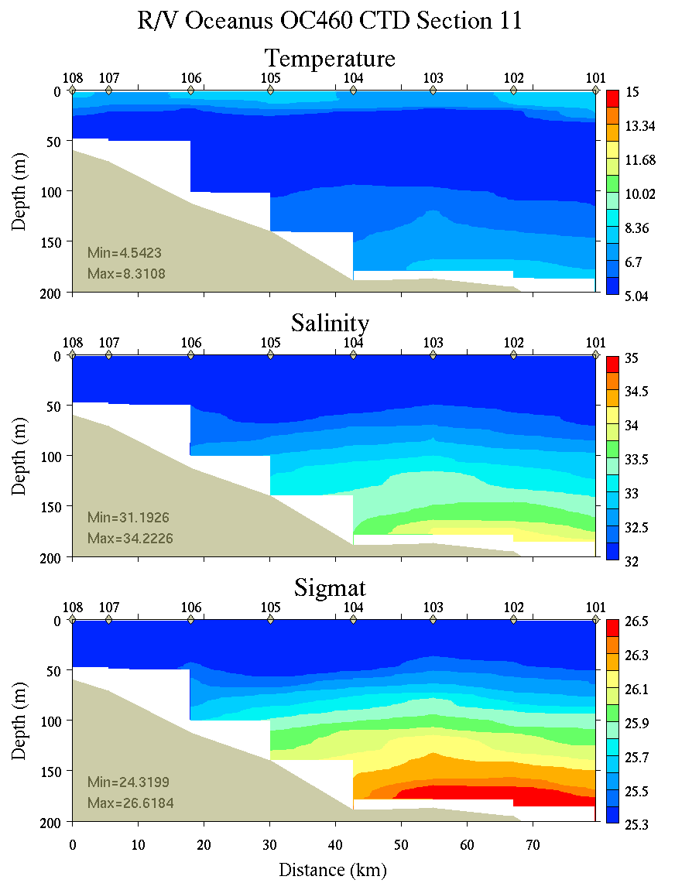 | 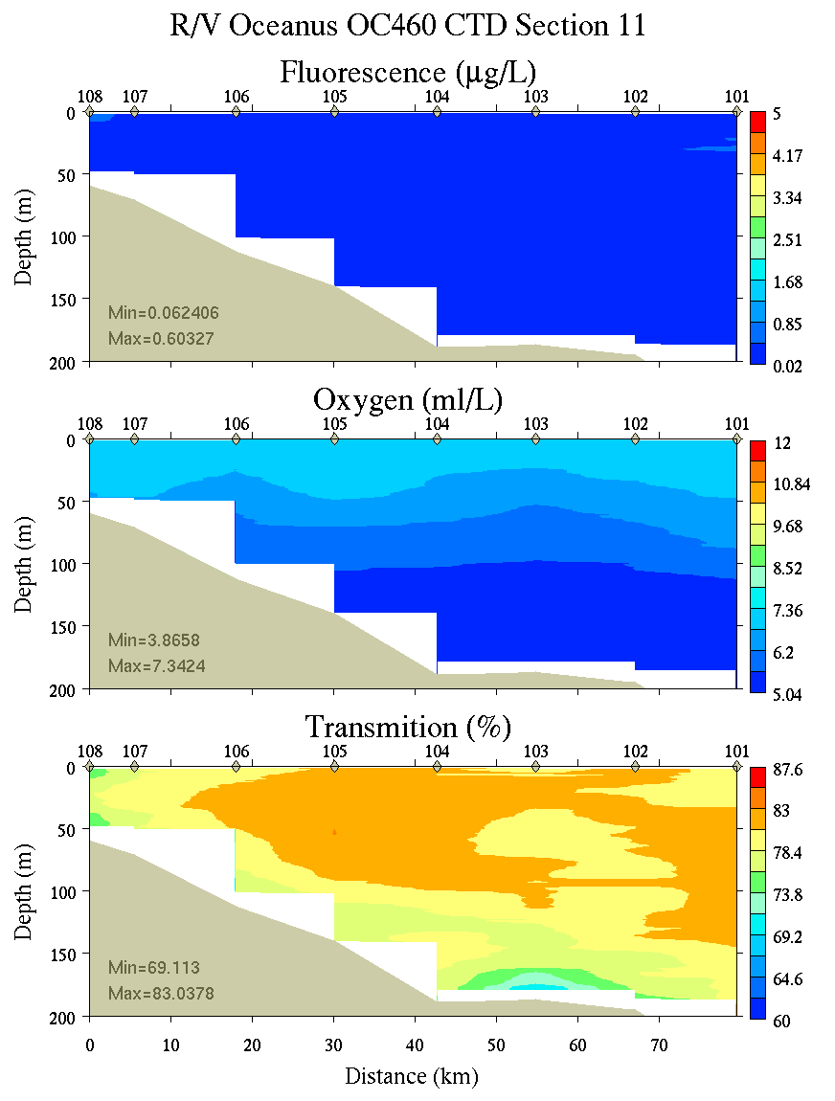
Figure C20. Section 11, 0-200m: temperature, salinity, and density (left); fluorescence, oxygen, and beam transmission (right).

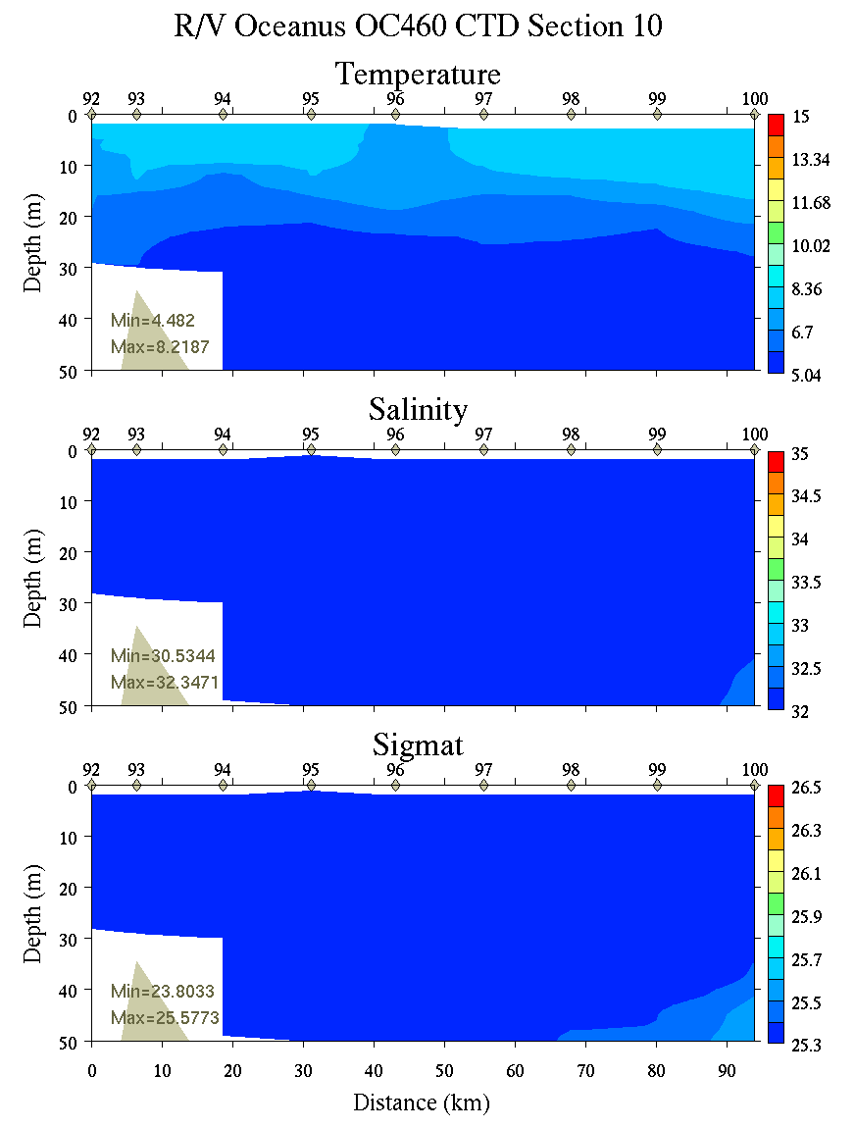 | 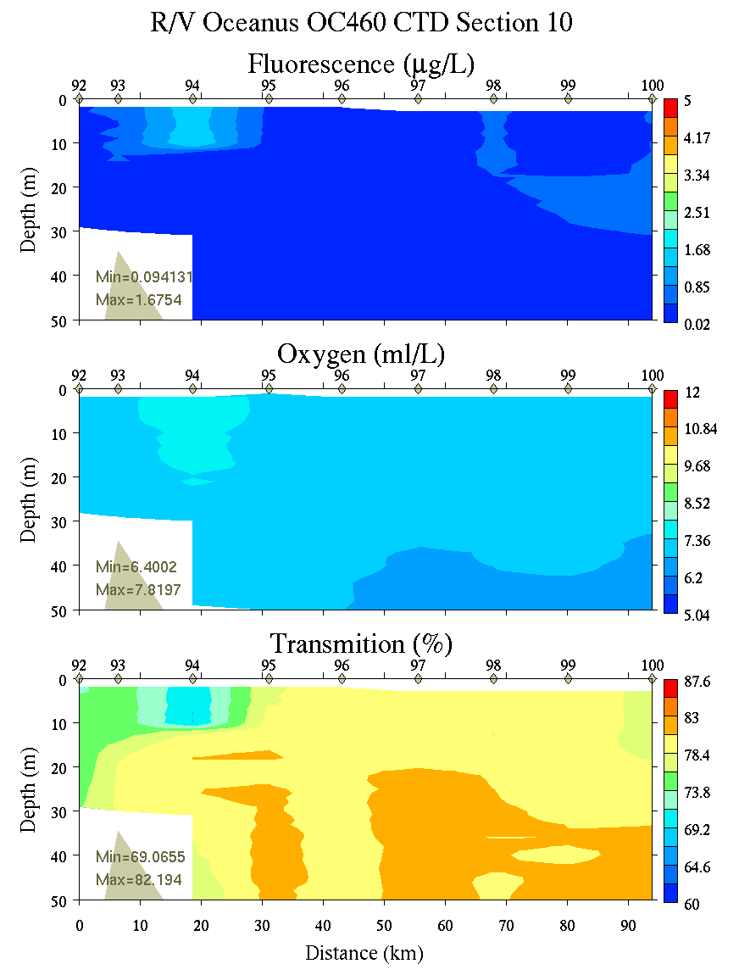
Figure C21. Section 10, 0-50m: temperature, salinity, and density (left); fluorescence, oxygen, and beam transmission (right).

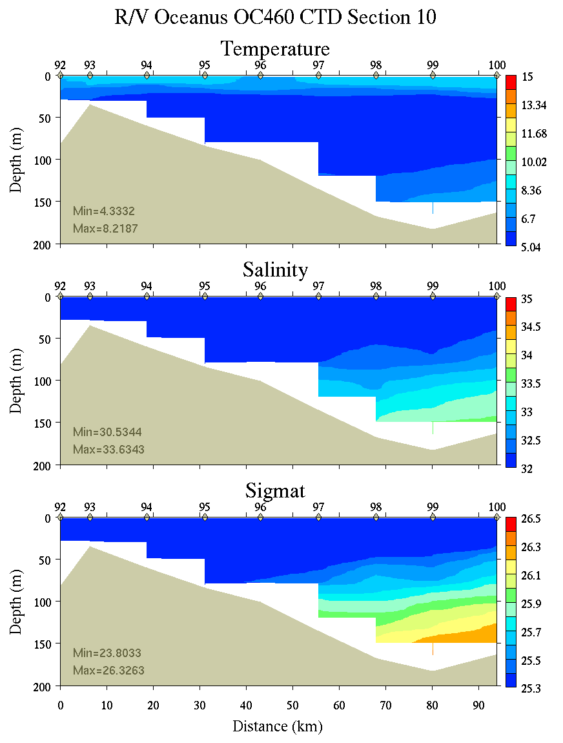 | 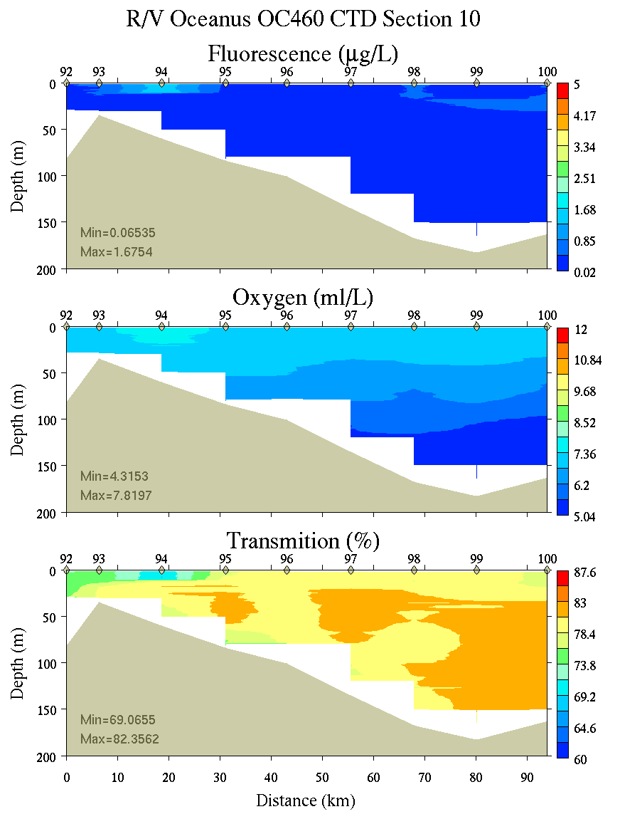
Figure C22. Section 10, 0-200m: temperature, salinity, and density (left); fluorescence, oxygen, and beam transmission (right).

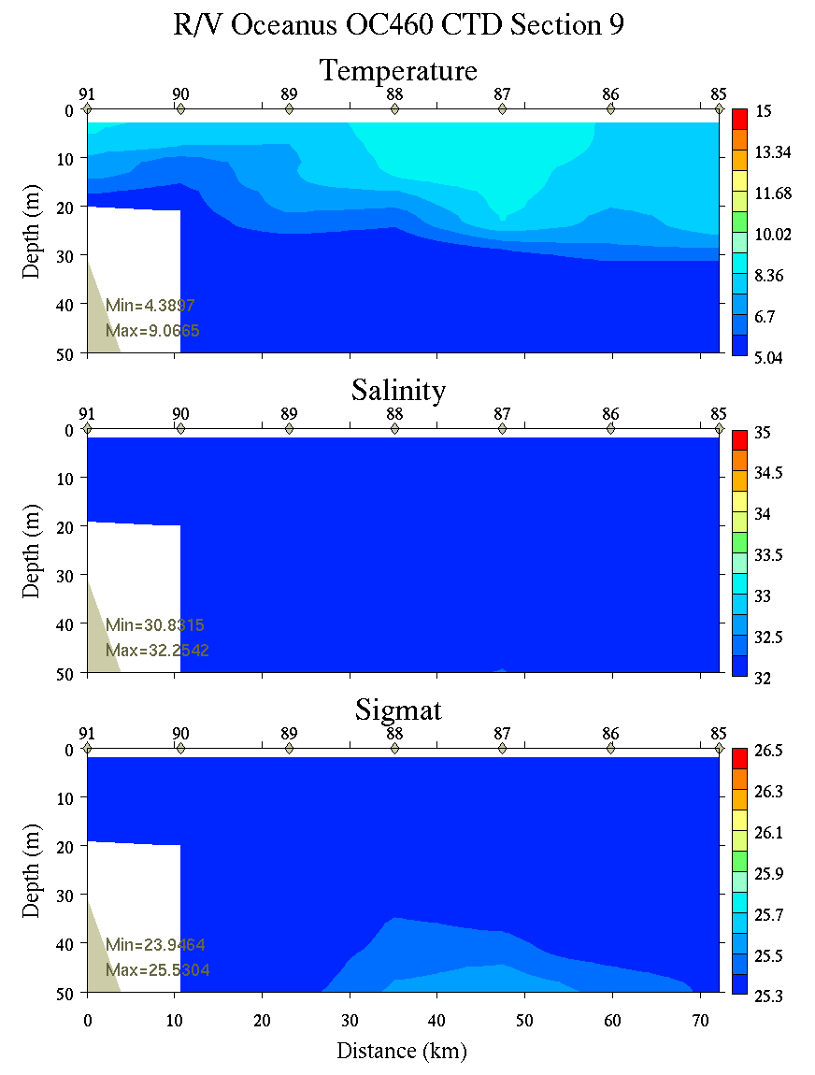 | 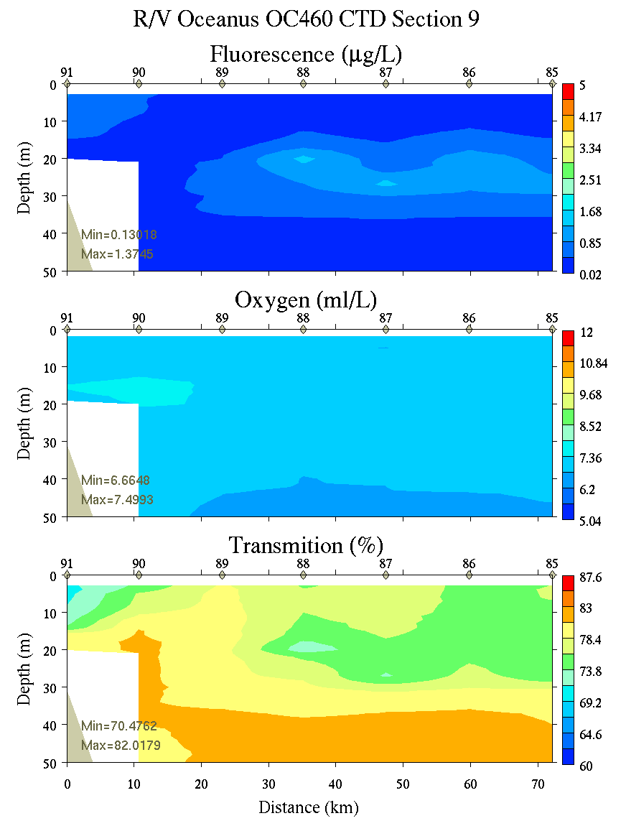
Figure C23. Section 9, 0-50m: temperature, salinity, and density (left); fluorescence, oxygen, and beam transmission (right).

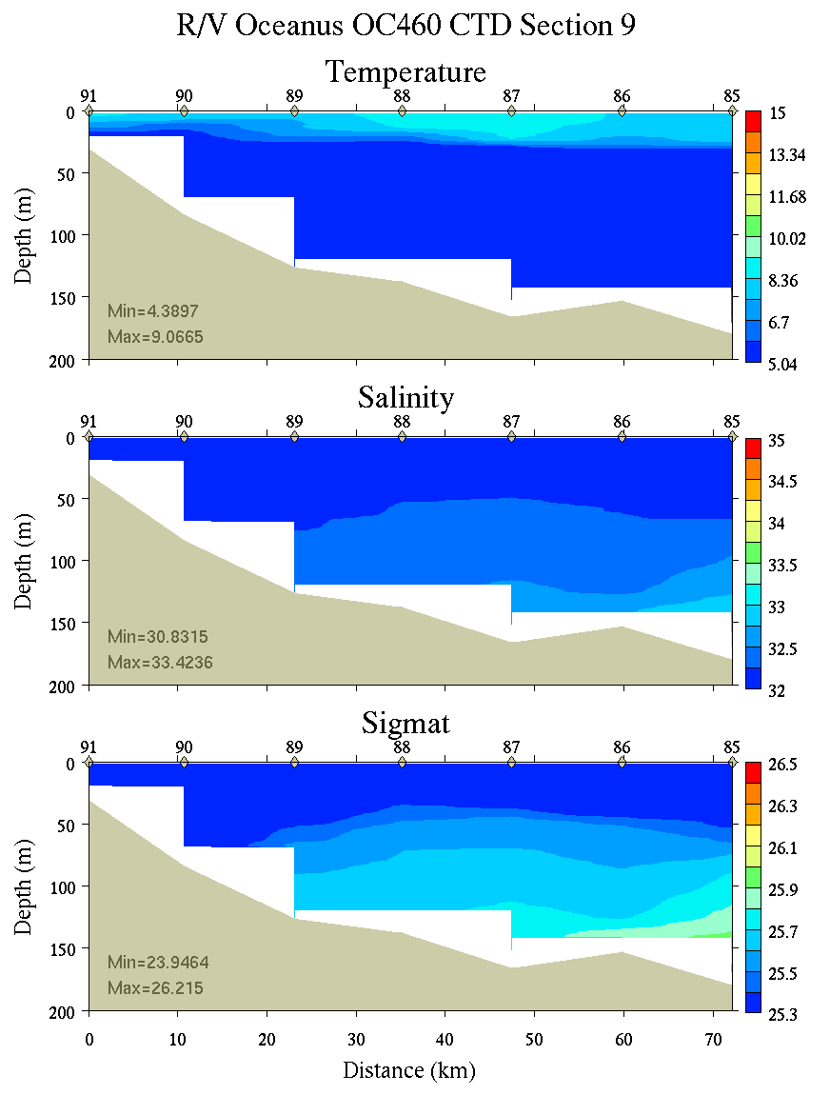 | 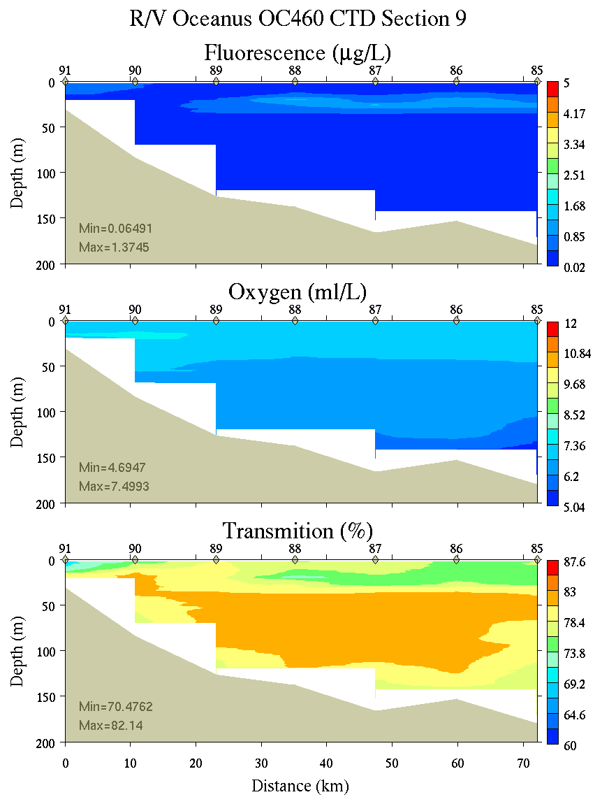
Figure C24. Section 9, 0-200m: temperature, salinity, and density (left); fluorescence, oxygen, and beam transmission (right).

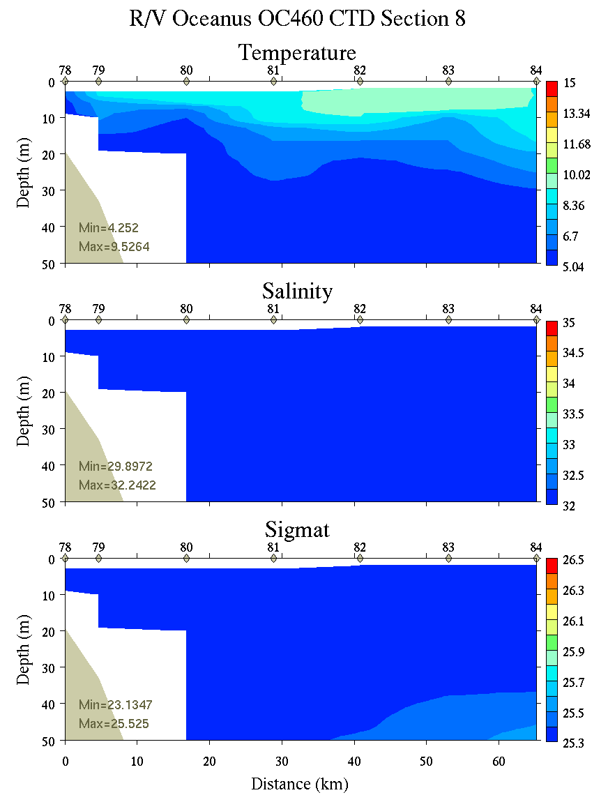 | 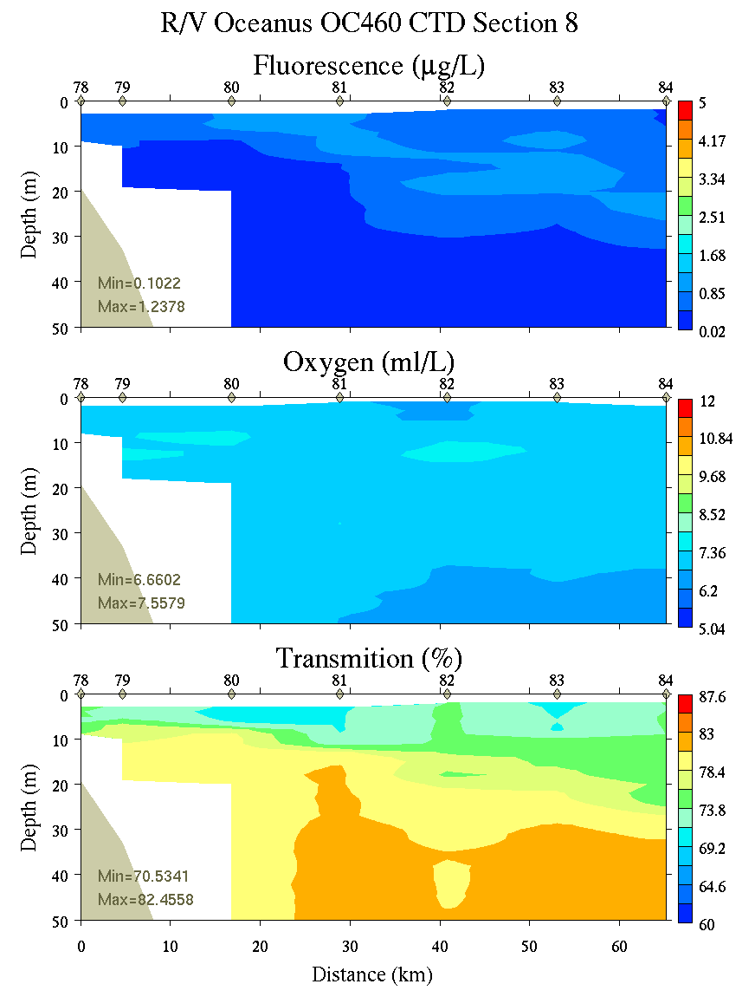
Figure C25. Section 8, 0-50m: temperature, salinity, and density (left); fluorescence, oxygen, and beam transmission (right).

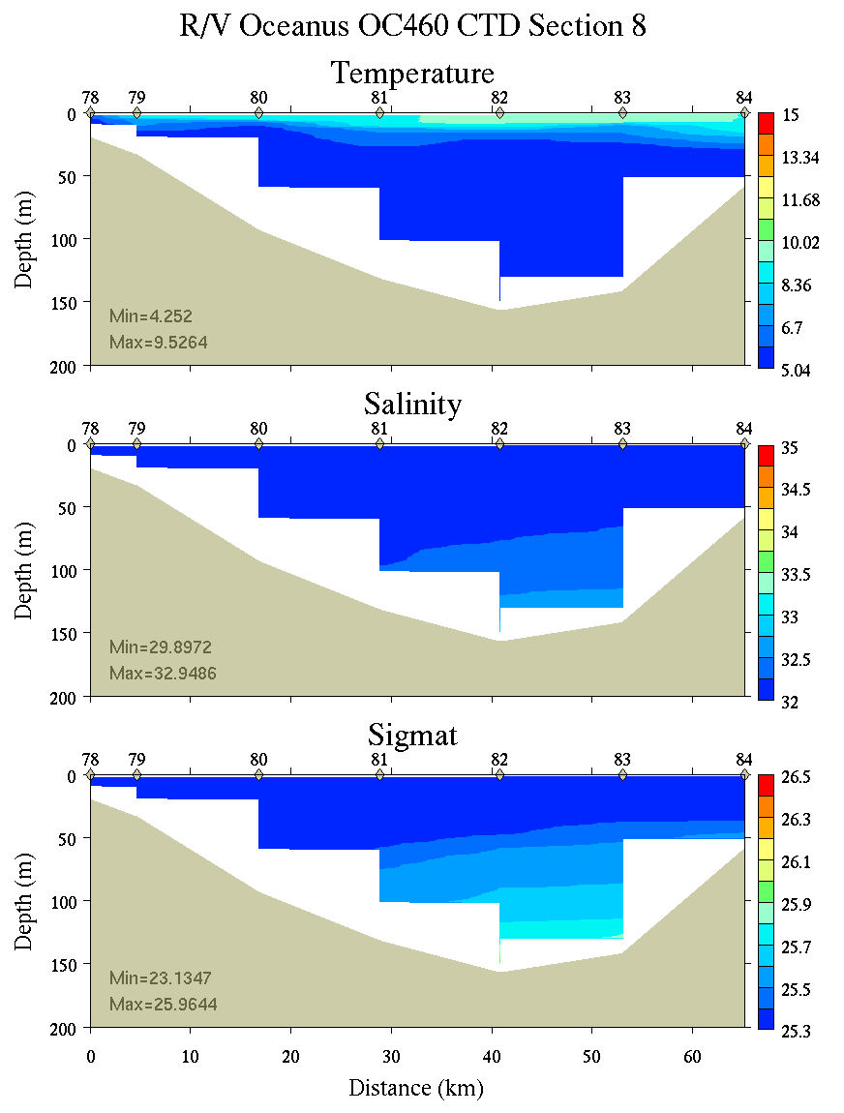 | 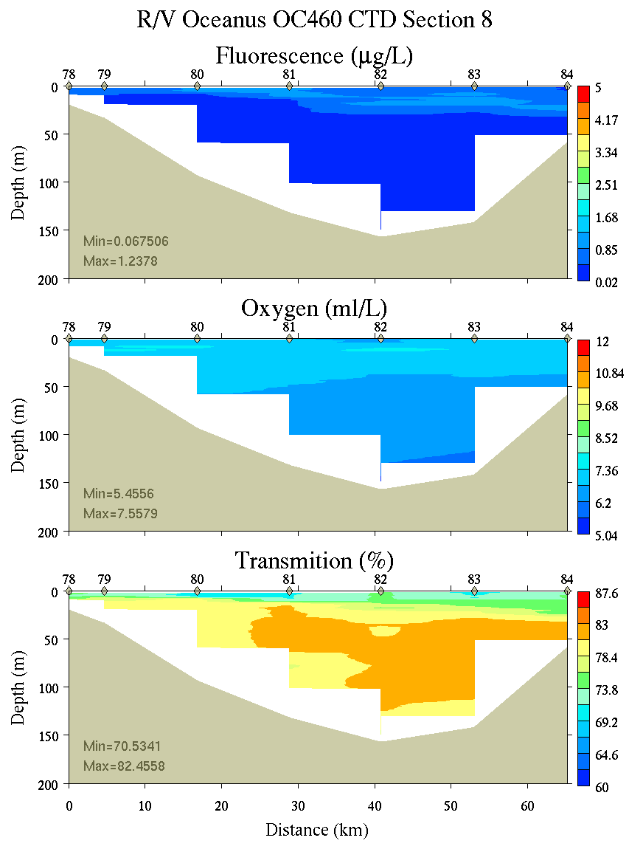
Figure C26. Section 8, 0-200m: temperature, salinity, and density (left); fluorescence, oxygen, and beam transmission (right).

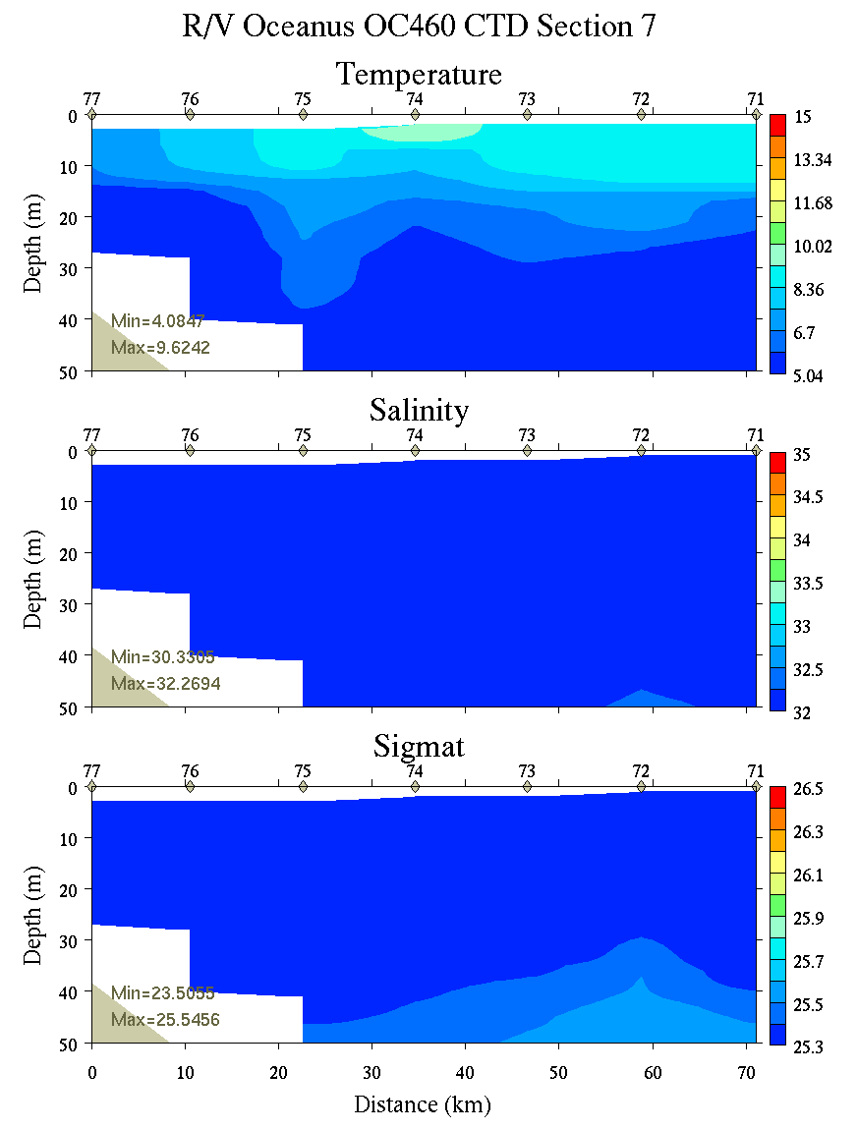 | 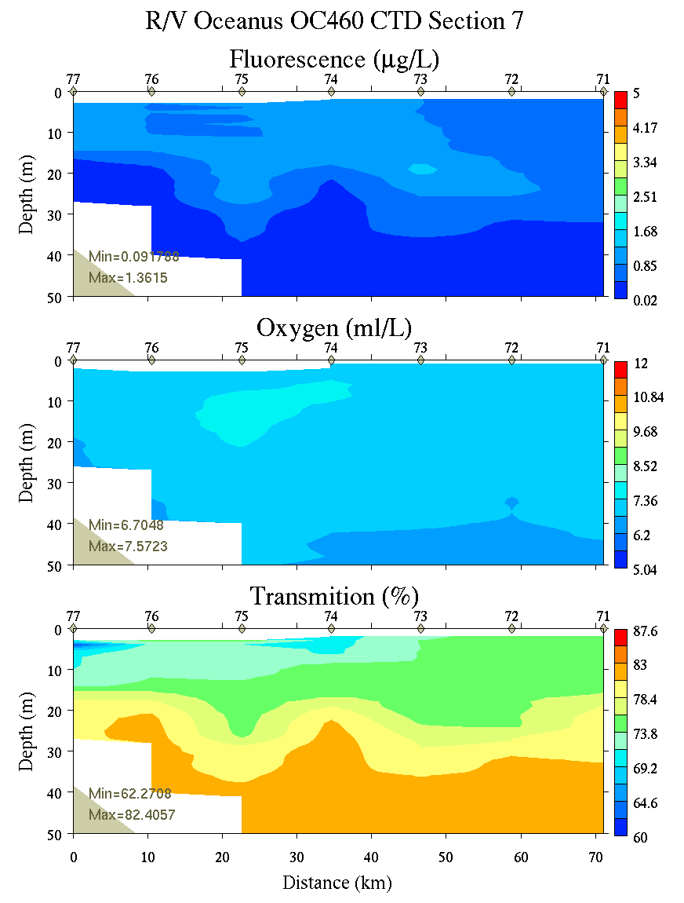
Figure C27. Section 7, 0-50m: temperature, salinity, and density (left); fluorescence, oxygen, and beam transmission (right).

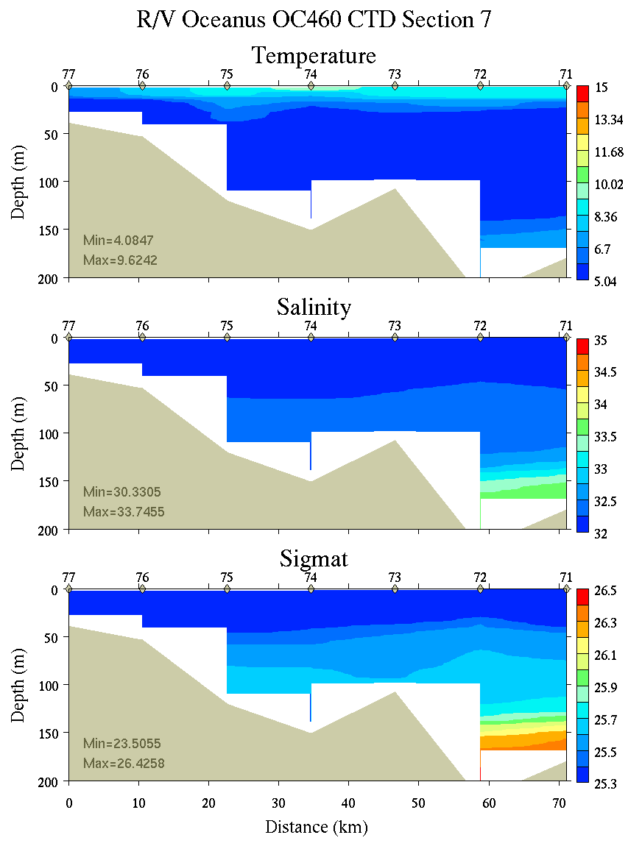 | 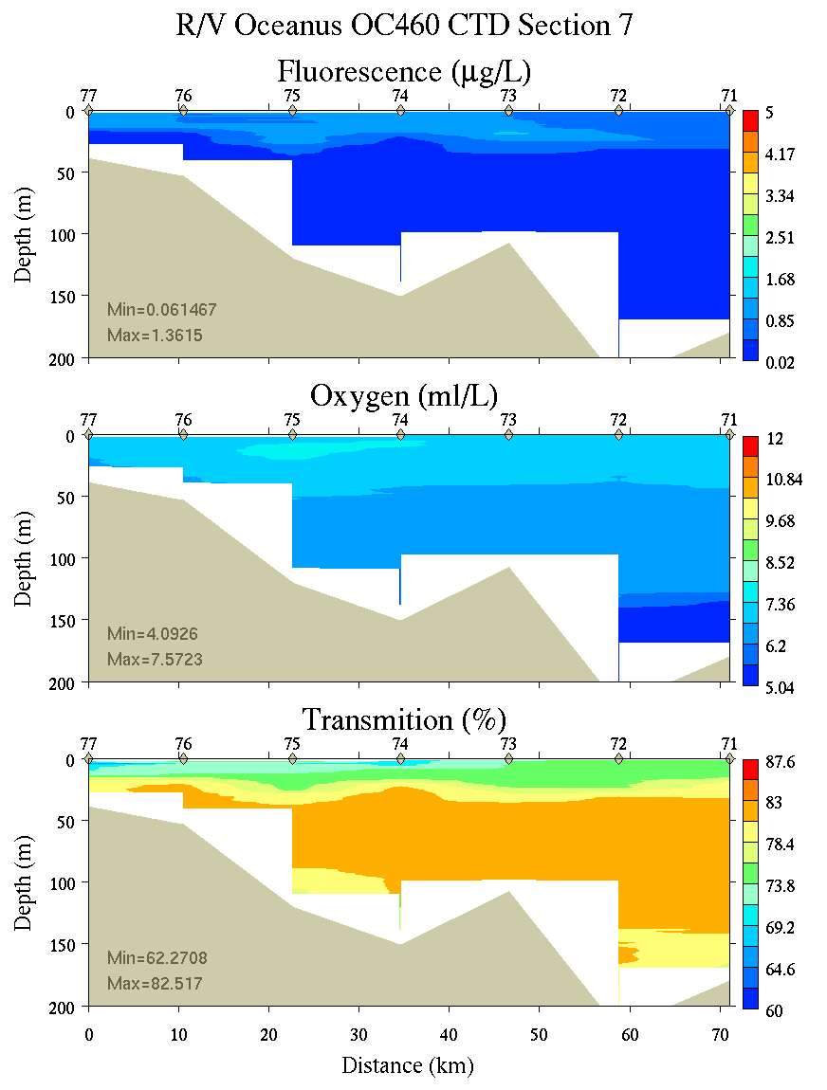
Figure C28. Section 7, 0-200m: temperature, salinity, and density (left); fluorescence, oxygen, and beam transmission (right).

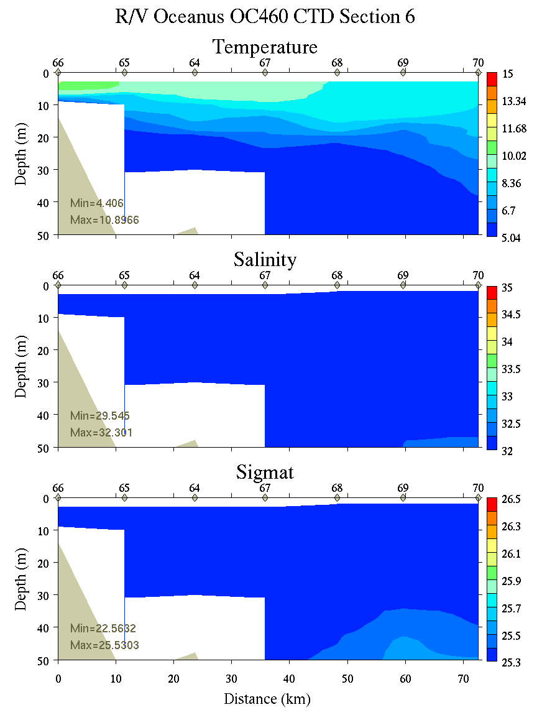 | 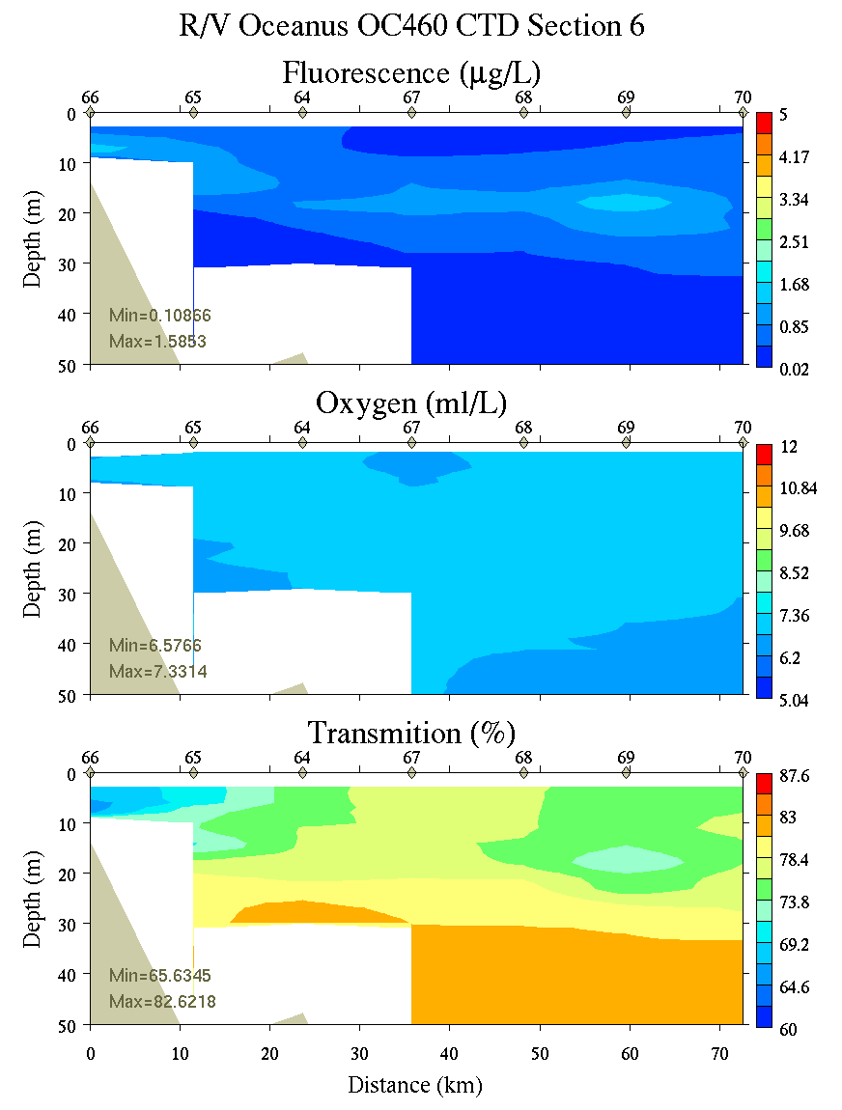
Figure C29. Section 6, 0-50m: temperature, salinity, and density (left); fluorescence, oxygen, and beam transmission (right).

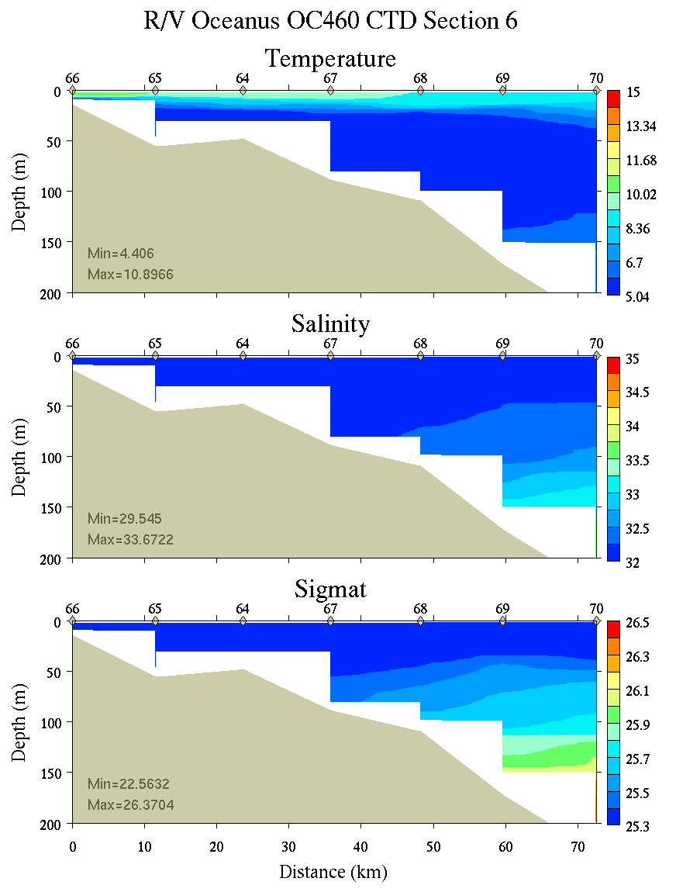 | 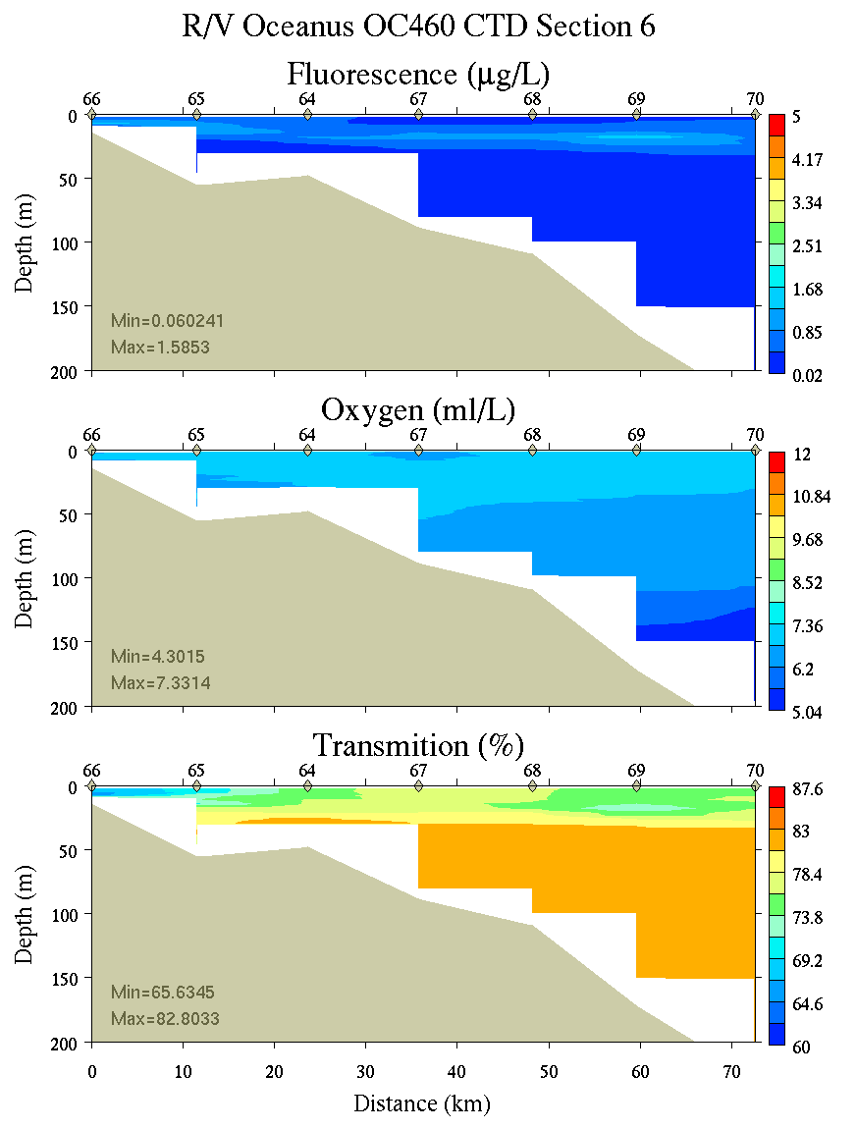
Figure C30. Section 6, 0-200m: temperature, salinity, and density (left); fluorescence, oxygen, and beam transmission (right).

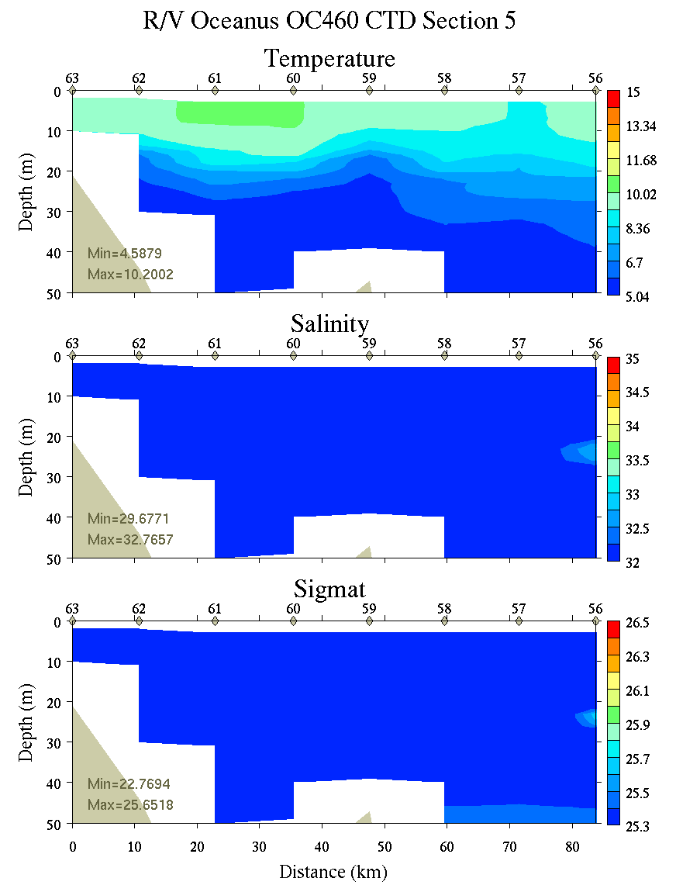 | 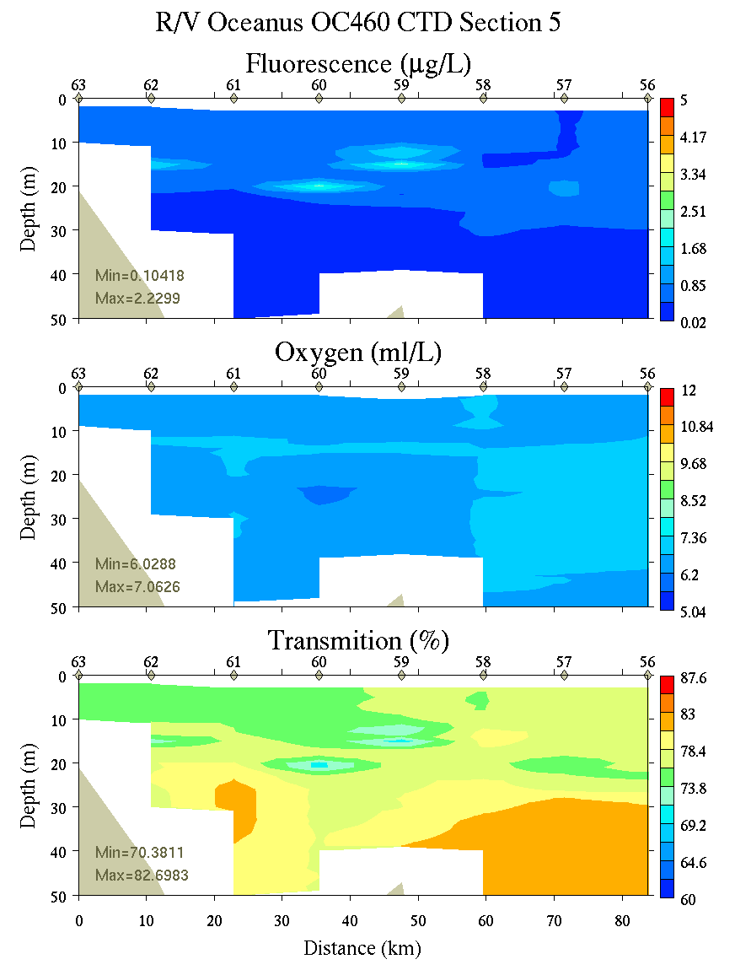
Figure C31. Section 5, 0-50m: temperature, salinity, and density (left); fluorescence, oxygen, and beam transmission (right).

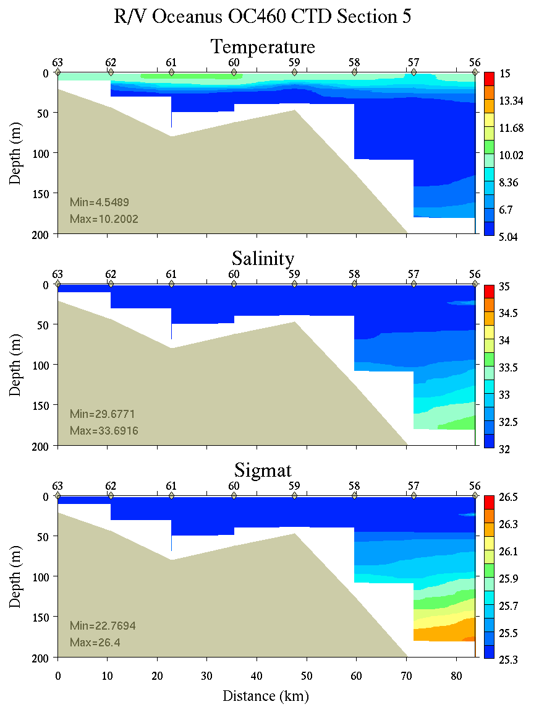 | 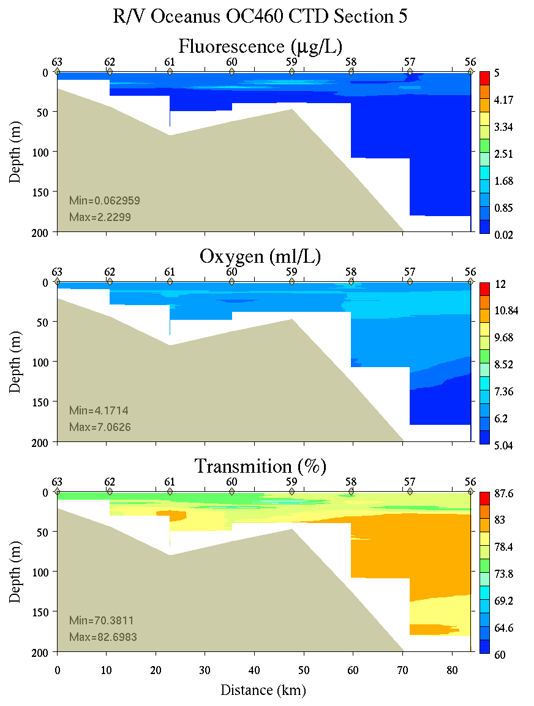
Figure C22. Section 5, 0-200m: temperature, salinity, and density (left); fluorescence, oxygen, and beam transmission (right).
Appendix D: Satellite imagery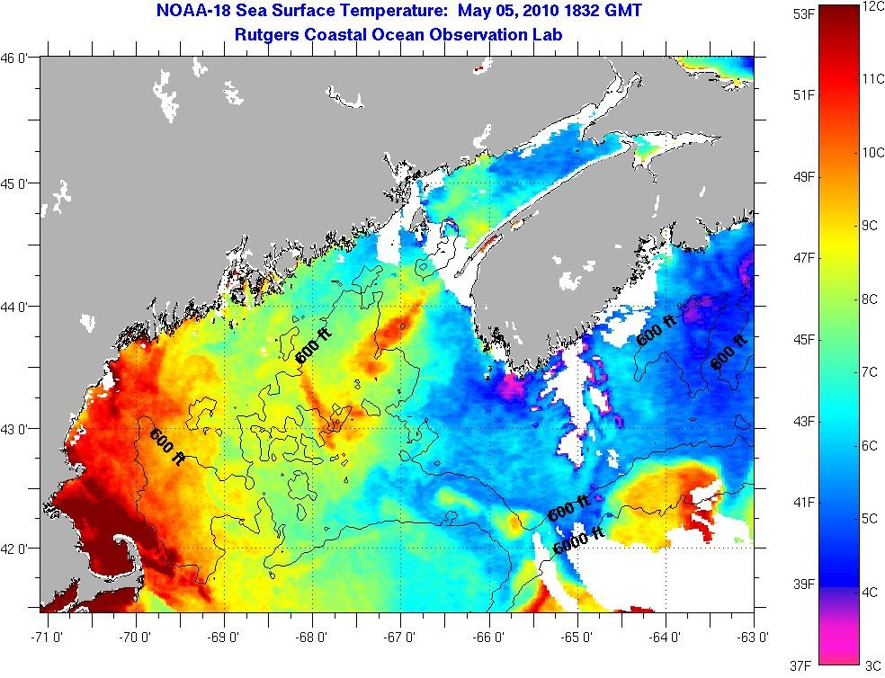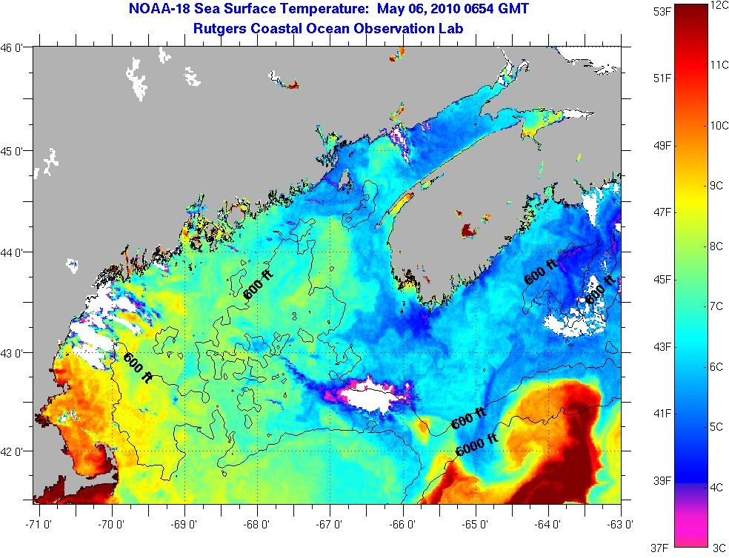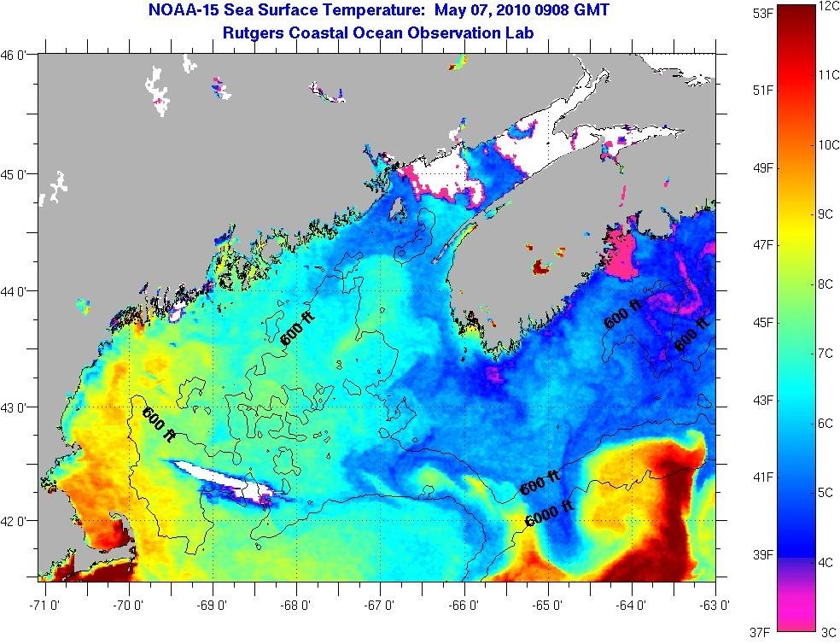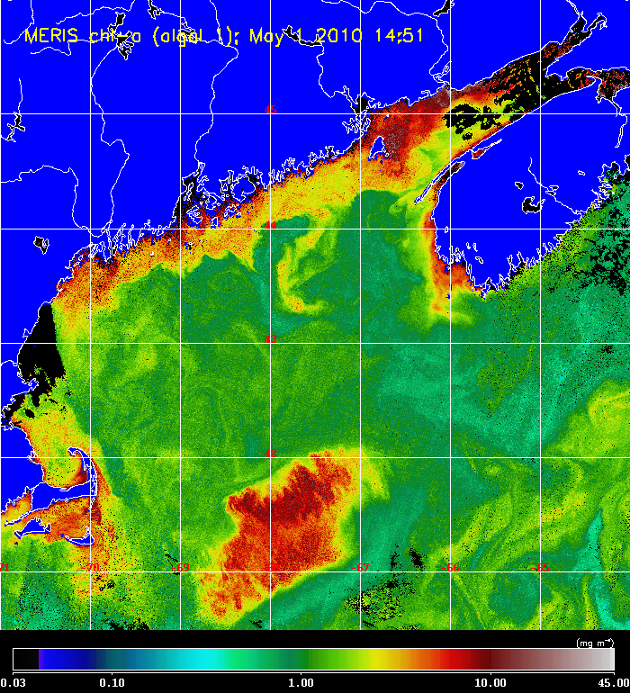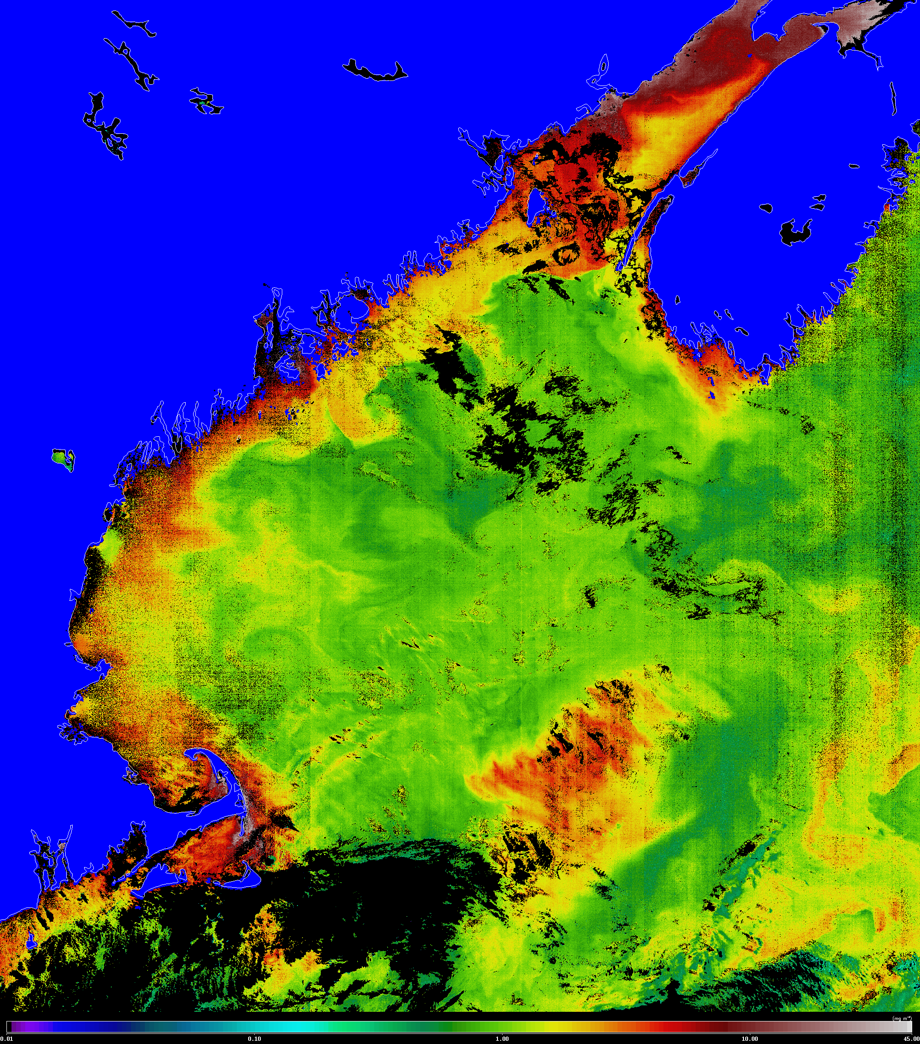

Appendix E: Personnel

McGillicuddy Dennis WHOI
Keafer Bruce WHOI
Payette Jack
Conroy Brandon* NEU
Adams Jillian* NEU
Stone Mollie* NEU
Smith Keston WHOI
Rebuck Nathan* UMe
Thomas Maura UMe
Kosnyrev Olga WHOI
Turner Jeff UMassD
Petitpas Chrissy* UMassD
Milligan Peter* UMassD
Emde Grant NMFS
Stessel Robert* UMe
Wilson Emily* Memorial University
Zhang Gordon* WHOI

*Student/postdoc
Watch schedule

Watch number 1 2 3
4 on / 8 off 8-12 12-4 4-8

1. CTD Operator Gordon Keston Robert
2. Cell Counter Bruce* Brandon* Chrissy*
3. Nutrient sampler Olga# Nathan# Maura#
4. Water sampler Jack# Grant# Jeff
5. Water sampler Mollie Jillian Peter#

* Wetlab chief
# CTD slip line handlers

http://www.whoi.edu/science/cohh/whcohh/projects/habs1_abstract.htm
http://omglnx3.meas.ncsu.edu/GOMTOX/2010forecast/
Also see http://nefsc.noaa.gov/drifter

