OC447 Cruise Report
Draft 6/6/08

Voyage #447 of R/V Oceanus was the second of four cruises in 2008 organized to serve complementary scientific objectives of two different projects. The two projects are:

Alexandrium population biology in the Gulf of Maine – Woods Hole Center for Oceans and Human Health – NSF/NIEHS

Objectives:
Sample genetic variability of Alexandrium subpopulations throughout the Gulf of Maine.

Measure changes in relative abundance of Alexandrium genotypes in space and time.

GOMTOX: Dynamics of Alexandrium fundyense distributions in the Gulf of Maine: an observational and modeling study of nearshore and offshore shellfish toxicity, vertical toxin flux, and bloom dynamics in a complex shelf sea – NOAA ECOHAB

Objectives:
Investigate A. fundyense bloom dynamics and the pathways that link this organism to toxicity in nearshore and offshore shellfish.

Investigate the vertical structure of A. fundyense blooms, vertical toxin flux, and linkage to toxicity in offshore shellfish.

Objectives common to both projects include:
Assess hydrodynamic and hydrographic context for interpretation of Alexandrium spp. measurements.

Incorporate field observations into a suite of numerical models for hindcasting and forecasting applications.

The primary domain of interest is Georges Bank, where a large bloom of A. fundyense was observed in 2007. The bloom was present on Georges Bank upon our arrival in May (EN435) and still quite conspicuous during our second cruise in June/July (EN437). The four one-week cruises in 2008 are designed to (1) resolve the seasonal variation of the Georges Bank bloom, and (2) quantify its interannual variability.

A secondary objective was added to the 2008 cruises when the results of the fall 2007 cyst survey (OC447) revealed that cyst abundance offshore of mid-coast Maine is now 30% higher than it was just prior to the historic bloom of 2005. This field season thus offers an exceptional opportunity for testing the hypothesis that the magnitude of the bloom in the western Gulf of Maine and Southern New England is set by the abundance of cysts. We therefore must consider the possibility of redirecting some of this year’s observational effort from Georges Bank to the Gulf of Maine. These choices will be informed by a number of factors, including real-time nowcasting and forecasting activities (http://omglnx3.meas.ncsu.edu/yli/08forecast/), as well as state agency toxicity monitoring efforts along the coasts of Maine, New Hampshire, and Massachusetts.
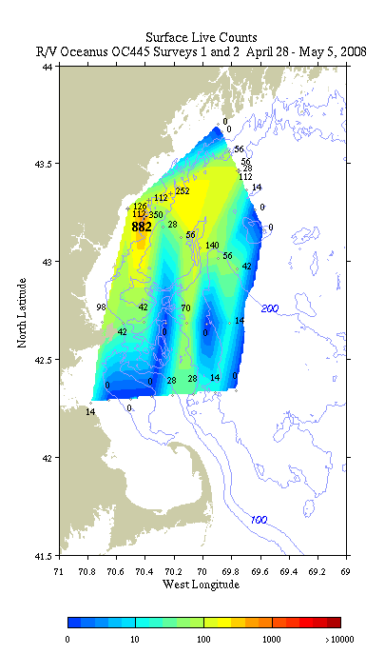 | 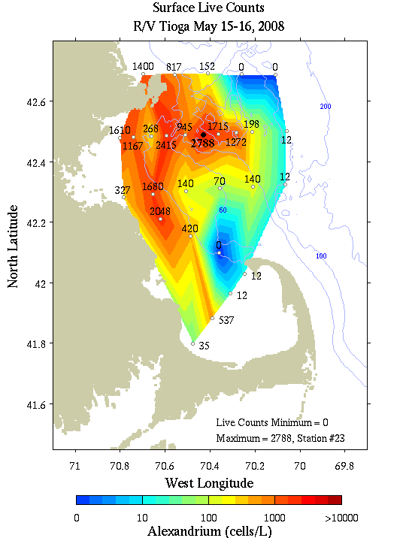
Figure 1. Left: Alexandrium concentration (cells l⁻¹) in the western Gulf of Maine from surface live counts on OC445 (left) and TI303 (right). Note that several of the TI303 cell counts were revised upward upon subsequent completion of whole-cell assays.
Results

There were several compelling reasons to begin OC447 with a survey of the western Gulf of Maine (WGOM).

First, Alexandrium concentrations in the WGOM are increasing as predicted (Figure 1). In early May, cell concentrations measured on OC445 were low overall because it was still early in the season; however peak surface concentrations were approximately four times higher than the highest ever measured in the WGOM at that time of year. By mid May, cell concentrations inside Massachusetts Bay had risen to thousands of cells per liter (Figure 1, right panel). Several of these counts eclipse the peak of 2336 cells l⁻¹ found on the second occupation of Massachusetts Bay in 2005 on OC412, which also occurred in mid May.
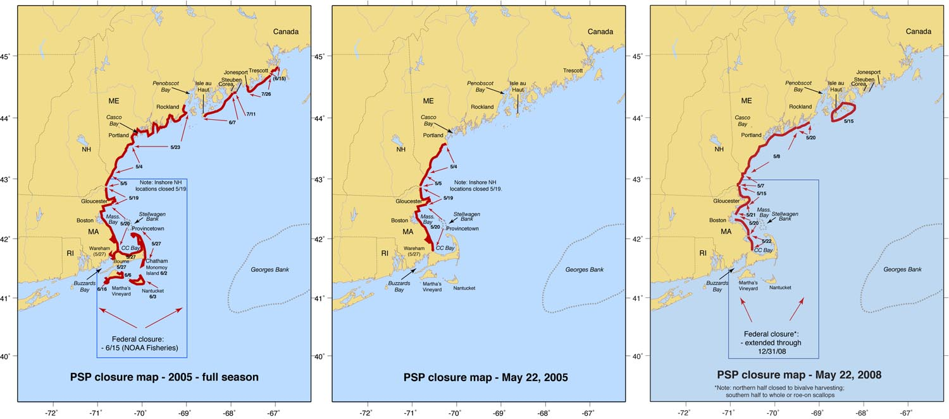
Figure 2. Red lines indicate areas closed to shellfishing for (left) the entire 2005 season (cumulative), up through May 22, 2005 (middle), and through May 22, 2008 (right).
Second, toxicity is on the rise (Figure 2). As of May 22, coastal areas from the Cape Cod Canal all the way to Isle au Haut Maine had been closed. The spatial extent of the closure actually exceeds that which had been closed by that same date in 2005.
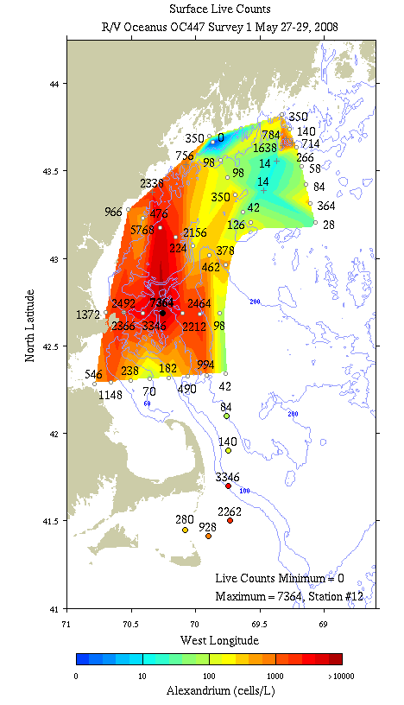
Figure 3. Alexandrium concentration (cells l⁻¹) in the western Gulf of Maine from surface live counts on OC447.
Surface live counts from OC447 show that the Alexandrium bloom in the western Gulf of Maine is in full swing (Figure 3). Underway counts during our exit from Nantucket Sound and northward along the back side of Cape Cod showed significant numbers of cells in the range of 1000-3000 cells l⁻¹. Once our transit took us seaward of the 100m isobath east of Wellfleet, cell counts dropped precipitously to ca. 100 or less. We began CTD operations at the Boston line, where cell counts in the 500-1000 range were present in the inner two stations and also offshore near the end of the transect. All but the most offshore station of the Cape Ann transect had cell concentrations in excess of 1000 cells l⁻¹, with peak concentrations exceeding 7000. Concentrations decreased overall in the Saco Bay line, although the peak reached nearly 6000 cells l⁻¹. Underway counts between Saco Bay and Casco Bay ranged from 2300 to 800. Cell concentrations decreased dramatically on the Casco Bay line, peaking at 350 cells l⁻¹. Underway counts from SW to NE in between the Casco Bay line and the Monhegan line were low until a near-shore tongue of cells was encountered with patchy concentrations ranging from 140 to 1600. Offshore waters in the Monhegan transect were generally below 100 except for a single station with 364 cells l⁻¹.

Upon completion of the WGOM survey, we turned our attention to Georges Bank (Figure 4). Surface underway counts across the gulf in between the two regions yielded mostly zeros, as did most of the cross-bank section on the northeast peak of Georges Bank. The remainder of the bank was almost completely covered by cell concentrations ranging from a few hundreds to a few thousands of cells l⁻¹. Concentrations on the central part of the crest were generally lower than the surrounding waters, with cell counts of ca. 200 cells l⁻¹ or less. Highest concentrations were observed on the southern and southwestern parts of the bank, with the peak concentration reaching 3626 cells l⁻¹. Surprisingly, cell concentrations in excess of 1000 cells l⁻¹ extended all the way out to the shelf break in some cases. A set of six stations offshore of the 300m isobath were occupied in an attempt to delimit the southern extent of bloom; even these showed cell counts of several hundred to nearly 1000 cells l⁻¹.

The Georges Bank survey was integrated into the WGOM survey through additional stations east of Cape Cod occupied by the Center for Coastal Studies, in addition to two sections across the Great South Channel occupied by Oceanus. A tongue of several hundred cells per liter extends down the back side of Cape Cod, into the Great South Channel, and appears contiguous with the mass of thousands of cells l⁻¹ on the southwestern part of Georges Bank.
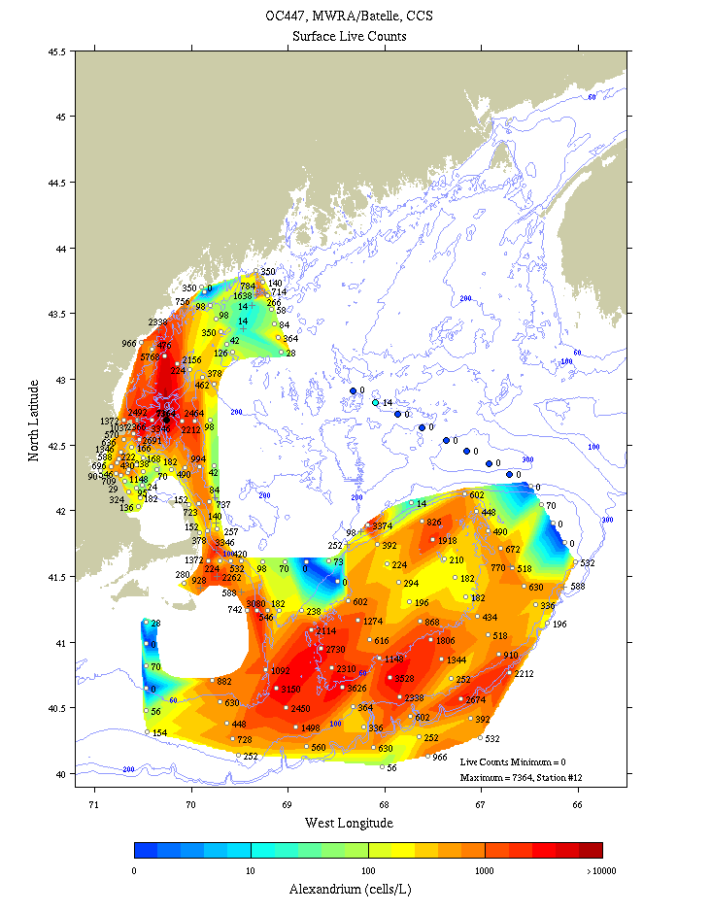
Figure 4. Alexandrium concentration (cells l⁻¹) from surface live counts on OC447, whole-cell assays from MWRA/Battelle surveys in Massachusetts Bay, and whole-cell assays of two sections east of Cape Cod occupied by the Center for Coastal Studies.
Transects on the continental shelf of southern New England suggest the Georges Bank population is being swept westward by the prevailing flow. The Nantucket Shoals line was populated by several hundred to nearly 1000 cells l⁻¹. Cell counts diminished considerably on the Martha’s Vineyard line, with only the most offshore station exceeding the 100 cell l⁻¹ mark.

Drifters [Contributed by Jim Manning]

A total of nine surface drifters were deployed at the inshore stations of the Cape Ann and Casco Bay transects (Appendix A, Table 3). The deployments consisted of two clusters: 3 units off Cape Ann on 28 May and 6 units off Cape Small (northeast of Casco Bay) on 29 May. An additional lone surface drifter was deployed on 3 June on Phelps Bank (southeast corner of Nantucket Shoals). These deployments make a significant contribution to the compiled set of drifter tracks in 2008 (Figure 5). They add to the set deployed by an earlier GOMTOX cruise (off Cape Small) as well as those deployed by NOAA (in Jordan Basin in late winter) and the University of New England (off Saco Bay in Southern Maine in late spring).
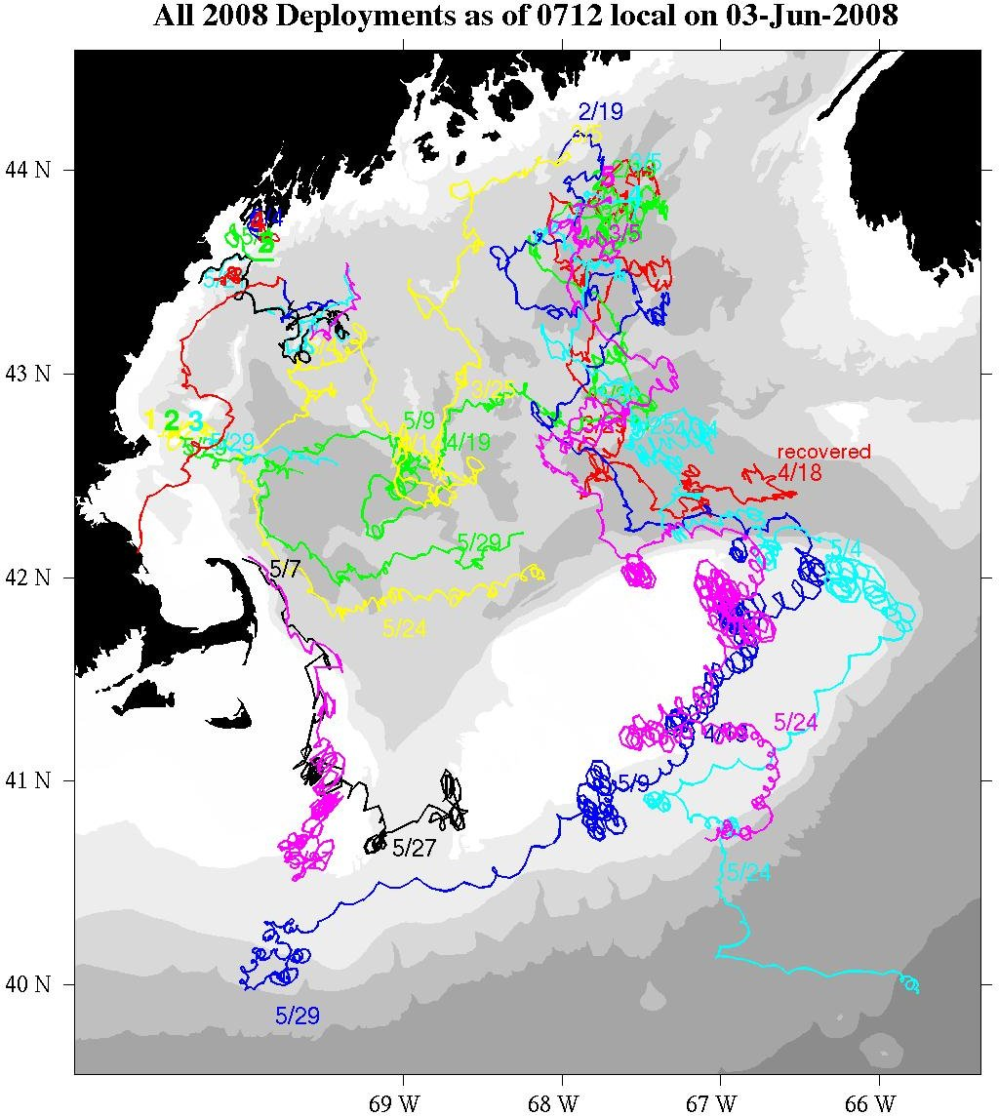
Figure 5. Drifter deployments in 2008 as of June 3, 2008.
Cape Ann/Mass Bay Cluster: As documented in the drifter log, these three units (85201-85203) were deployed along a transect running offshore with the central unit being on the top of southern-most ridge of Jeffrey's Ledge. The purposes in deploying them at this location were to a) add to the collection of deployments made at this location in the past and b) to document the potential transport of higher-than-normal concentrations of Alexandrium for this time of year. Since their mean velocities were near 15 cm/s towards the east, all three units moved away from the coast (Figure 6, upper left) and into Wilkinson Basin before the end of the cruise.

Cape Small/Casco Bay Cluster: These six units (85394-85399) were deployed along a transect running offshore spanning water depths ranging from 32m to 174m (Figure 6, upper right). The shallow shoreward-most unit (#85394) moved quickly into Casco Bay and was recovered by a fisherman “about a half-mile from shore” near Harpswell, Maine (and then subsequently returned to the Southern Maine Community College by a student). The next unit offshore (#85395) appeared confused on which way to go. While it moved generally in the direction of the Western Maine Coastal Current, its progress over the course of the cruise period was slow and erratic. The other four units were advected more offshore and generally towards the northeast in a direction opposite the mean WMCC. This was especially the case for the two offshore-most units which were deployed in relatively shallow water (120m near Platts Bank). The slow offshore movement by these mid-transect drifters contrasts the fast southwestward advection of drifter #85391 deployed in this area in early May (which ended up coming ashore inside Mass Bay in a little more than a week's time). While the strong and persistent winds from the southwest were probably the leading cause of this somewhat anomalous reverse flow, satellite imagery of this area shows multiple filaments of the Maine Coastal Current veering offshore with very little indication of WMCC penetrating the coastal waters south of Casco Bay (Figure 6, lower left). This type of complex structure will pose a significant challenge to numerical models when it is difficult to initialize the density fields sufficiently and accurately.

Phelps Bank/Nantucket Shoals drifter: Drifter #86091 was deployed on the morning of 3 June in a tidally-active region of the Phelps Bank. It joins a unit already in this area, #85291, that was deployed off Cape Cod in early May by NOAA's marine mammal researchers and had been retained in this region for the last few weeks (Figure 5). As usual, the tidal-fronts appear in the SST imagery (Figure 6, lower right) as well as small filaments of offshore slope water penetrating the Great South Channel.
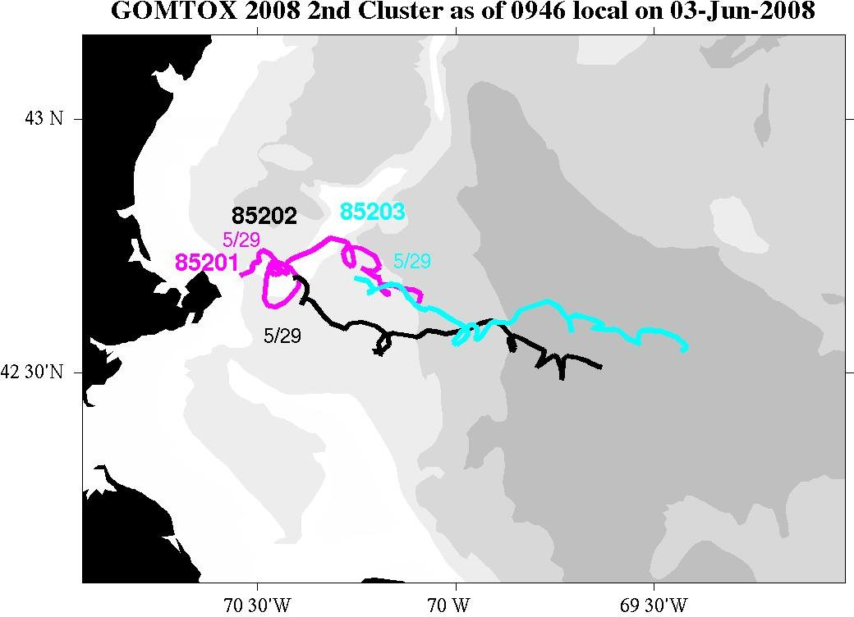 | 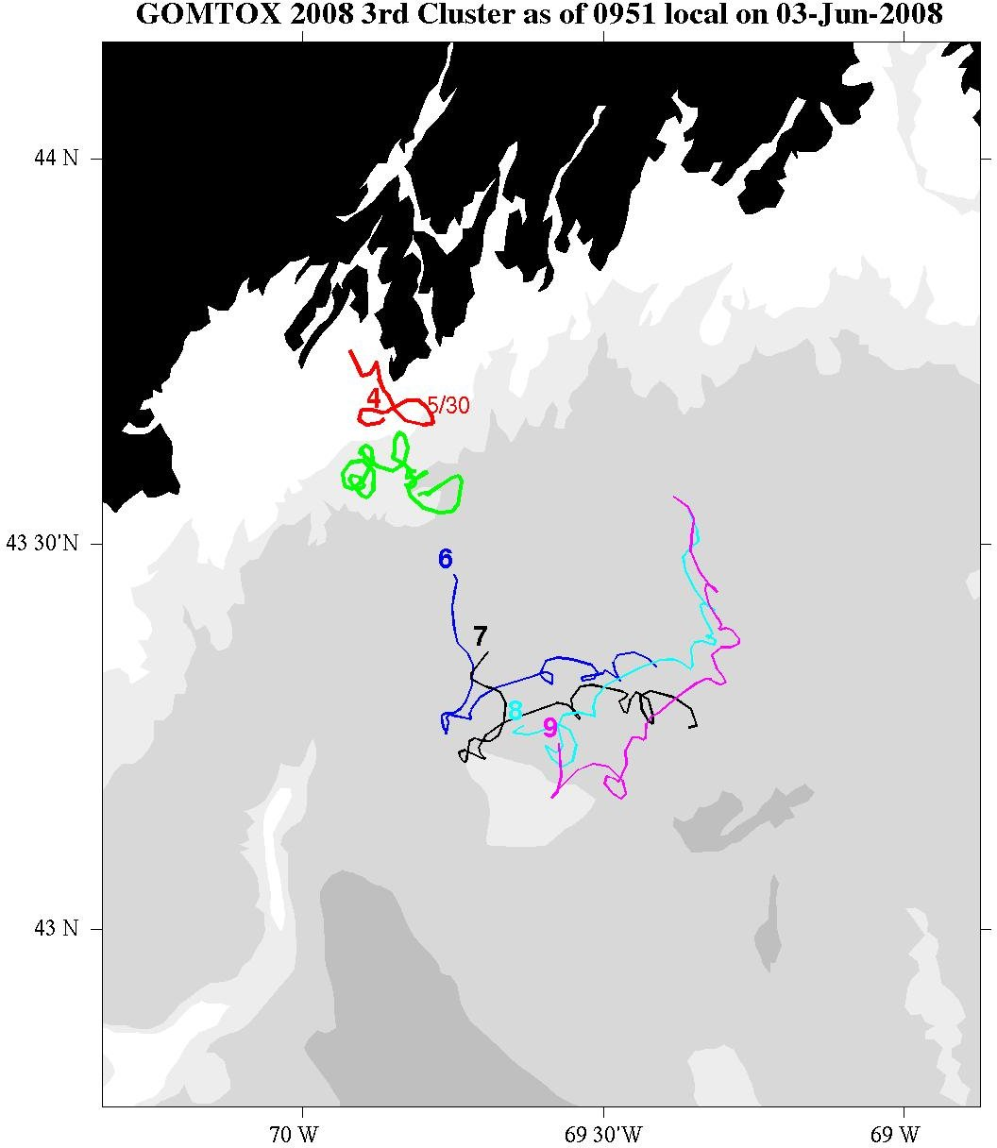
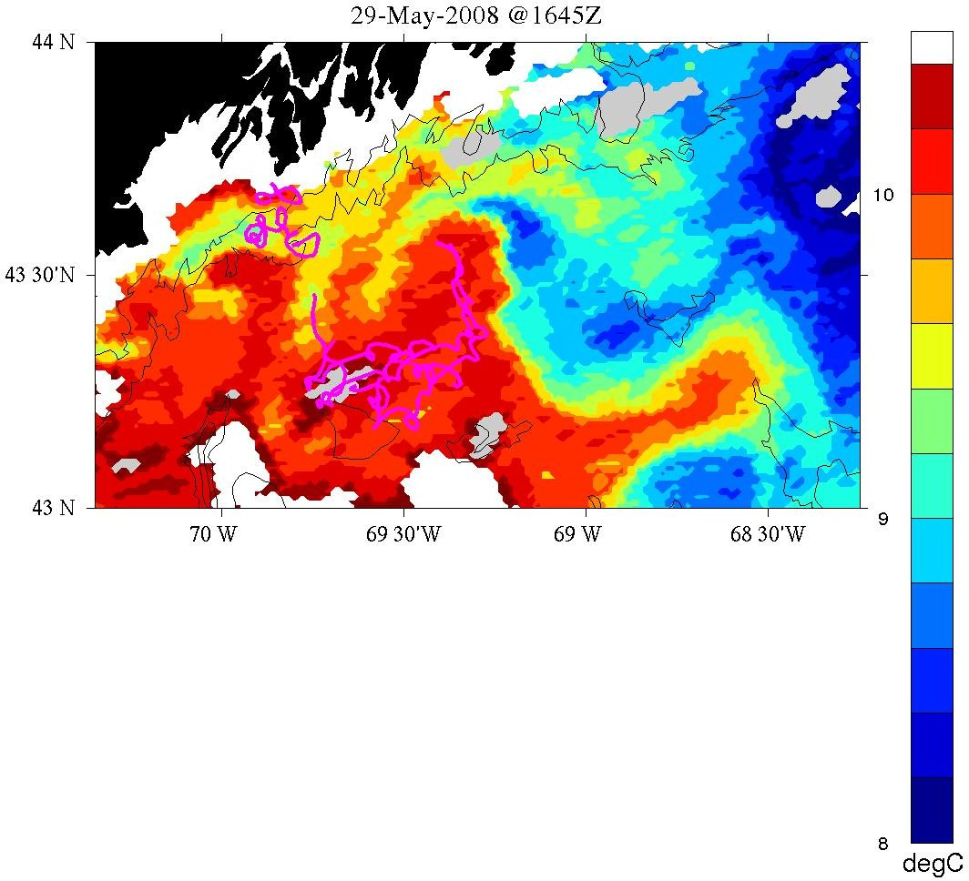 | 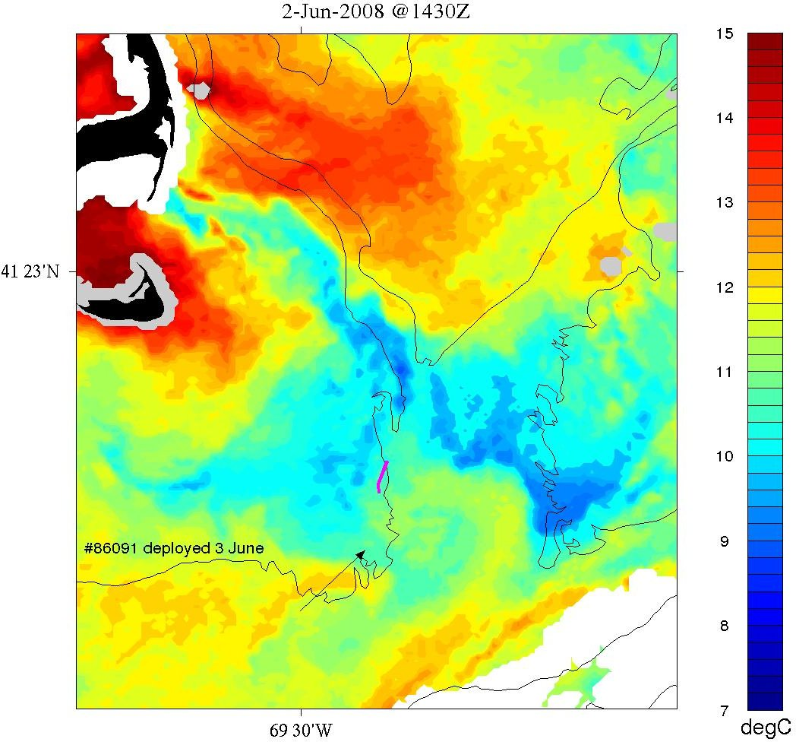
Figure 6. Trajectories of the Cape Ann (upper left) and Casco Bay (upper right) clusters. Trajectories of the Casco Bay cluster and the Phelps Bank drifter are overlayed on satellite SST in the lower left and lower right, respectively.

Comparison of WGOM Alexandrium observations with model predictions

Overall the observations thus far are consistent with predictions from a near-real-time quasi-operational model (Figure 6). In late April / early May, at the beginning of the bloom season, the model predicted a broad swath of cell concentrations on the order of 1000 cells l⁻¹ in the western Gulf of Maine, extending from Penobscot Bay down to Cape Ann. Observations are not sufficient to delimit the northeastern edge of the bloom, but cell counts approaching 1000 cells l⁻¹ were observed offshore of Saco Bay, albeit in a narrower strip than predicted. These findings are in stark contrast to prior observations in this area during the same time of year, in which peak cell concentrations have ranged from zero to 200 cells l⁻¹ (Keafer et al., 2005ab; Townsend et al., 2005). The southwestward extent of the bloom, as depicted by the location 100 cells l⁻¹ contour, reached Cape Ann in both the observations and the model.

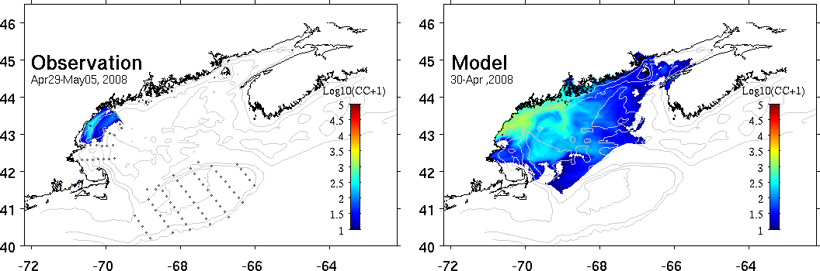
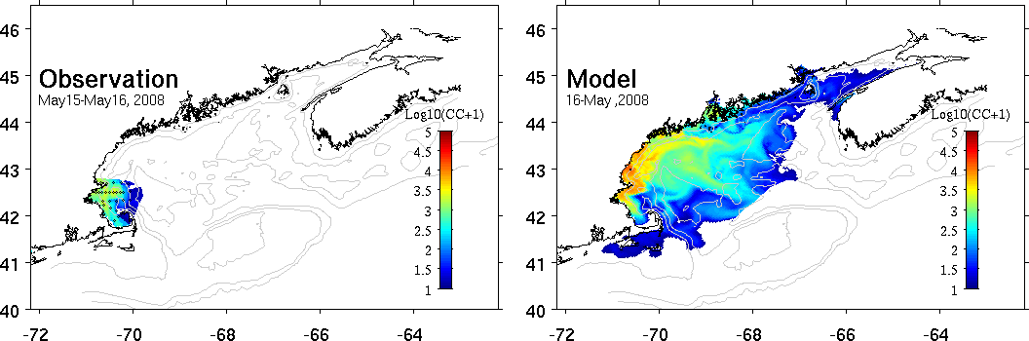
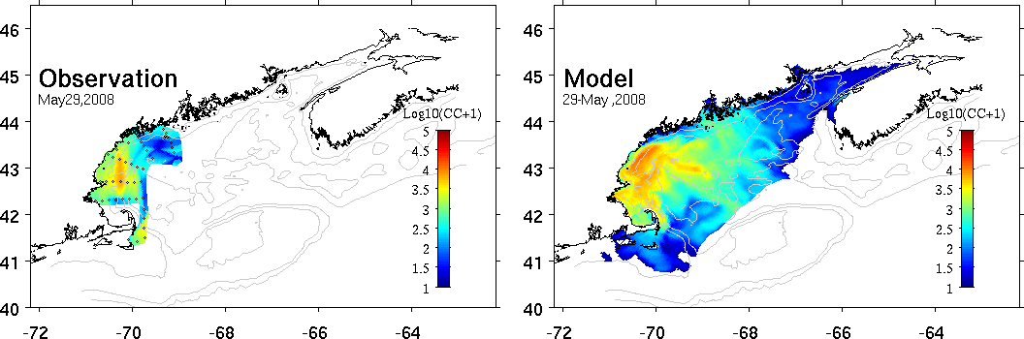
Figure 7. Observations (left) and predictions (right) of Alexandrium concentrations at the surface. For a complete description of the forecast system and 2008 results, see http://omglnx3.meas.ncsu.edu/yli/08forecast/.

A subsequent survey in mid-May confirmed the model prediction of thousands of cells l⁻¹ penetrating into Massachusetts Bay, with the southern terminus extending all the way down into Cape Cod Bay (Figure 4, middle). With the exception of 2005, such cell concentrations had not been observed in Massachusetts and Cape Cod Bays in more than a decade. For the period 1994-2004, observed cell concentrations rarely if ever exceeded a few hundred cells l⁻¹ (MWRA ref), and shellfish toxicity was virtually undetected during that time period.
The 2008 bloom continued its rise into late May, with 1000 cells l⁻¹ covering a large area extending from Casco Bay south to Cape Ann (Figure 4, bottom). Both the observations and the model also show a narrow swath of cells extending southward east of Cape Cod, although the southern terminus was observed further south than the model predicted.

At-sea data assimilative modeling [contributed by Keston Smith]

Nine data assimilative hydrodynamic experiments were conducted aboard OC447, as described in the table below. The simulations followed the approach developed during GLOBEC and recent MERHAB, COHH and GOMTOX cruises. Oceanus ADCP data was inverted to estimate barotropic boundary conditions and the hydrographic survey was used to estimate the initial conditions (Figure 8). The approach is described in detail in Arextabaleta et al. (in preparation). The forward simulator is the finite element primitive equation model Quoddy. The data assimilation system consists of the tide band inverter, Truxton, the wind band inverter, Casco, and the hydrographic data assimilation system OACI.
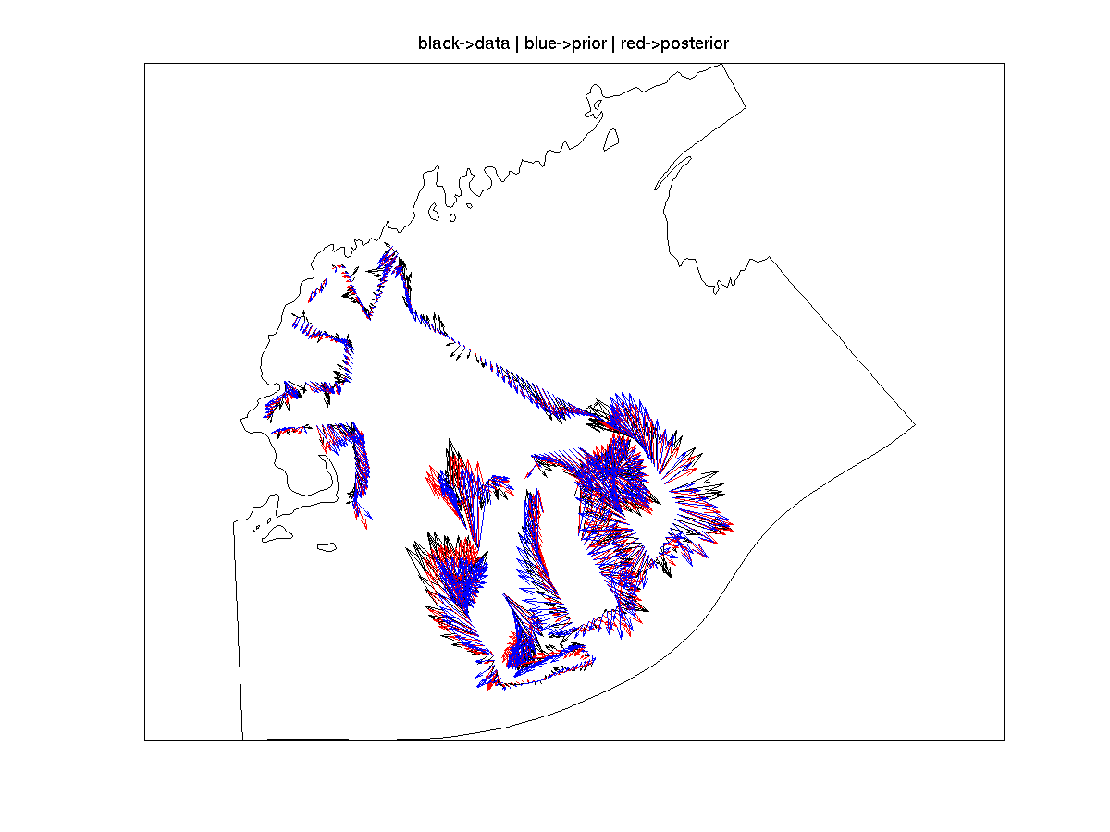
Figure 8. Example assimilation of ADCP velocity data. Observed ADCP velocity (black), prior estimate (blue), and data assimilative posterior (red).

The computational domain "gomtox" (Figure 9) was developed to provide moderate resolution in
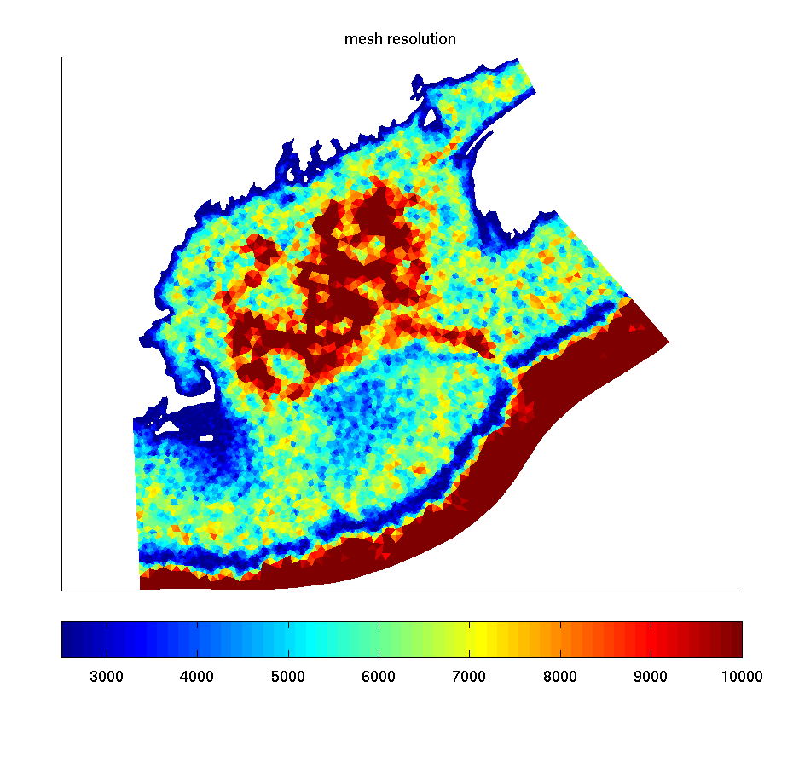
Figure 9. Resolution in meters of the finite element mesh “gomtox.”
the western, eastern gulf of Maine, and Georges bank (2000m-5000m) while extending beyond the shelf break to encompass the full survey domain. The steep topography of in the shelf break necessitates high resolution (2500m and less).

Wind data was processed by James Manning of NOAA and sent to the ship daily. The wind was spatially homogeneous taken from GOMOOS buoy A. The 3 day forecast wind was an NCEP product. Heat flux was set to climatological values. Barotropic tidal forcing with M2, N2, O1, K1, and S2 frequencies was taken from a database as were initial hydrography.

Model skill was evaluated by comparison with unassimilated drifter data (see table below). The degradation of the fit to the drifters after simulation #5 is likely related to the data assimilative procedure fitting velocity data on Georges Bank and coincidently degrading the forecast of the drifter tracks in the western Gulf. Surface drifters such as those used in the present study are difficult to appropriately forecast with models with vertical resolution at the surface (1m) comparable to the height of the drifter sail (1m). There is strong sensitivity to mixed layer depth and windage on the drifter's transmitter and surface response to wind forcing in general.
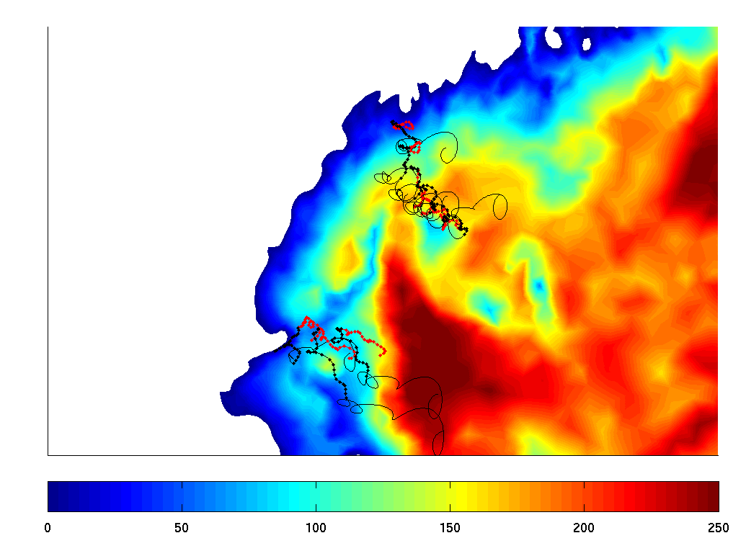
Figure 10. Simulated (black) and observed (red) drifters from experiment 5. The lines without dots indicate the predicted trajectories during the forecast period.
To assess the effect of the currents on the synopticity of the OC447 survey, a Lagrangian calculation was carried out to track water parcels after they were sampled. After each station was occupied, the representative water parcel in the model was tracked with a particle until the end of the simulation (Figure 11). An animated presentation of these results depicts the effects of the mean flow and wind on the terminal station position. In addition, tidal excursions on the order of 15km were simulated on Georges Bank during the cruise period which included the strongest spring tides of the lunar cycle.

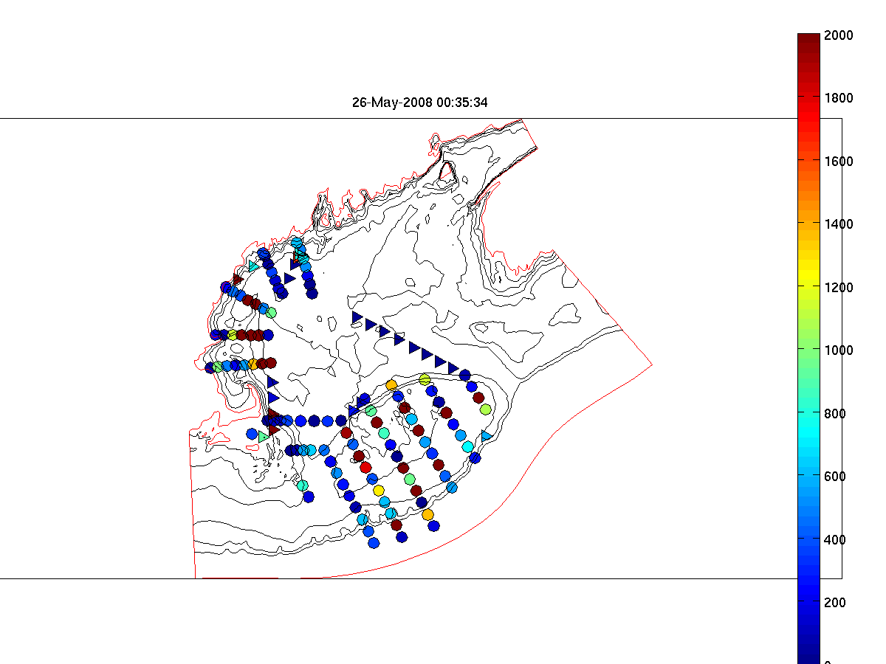 | 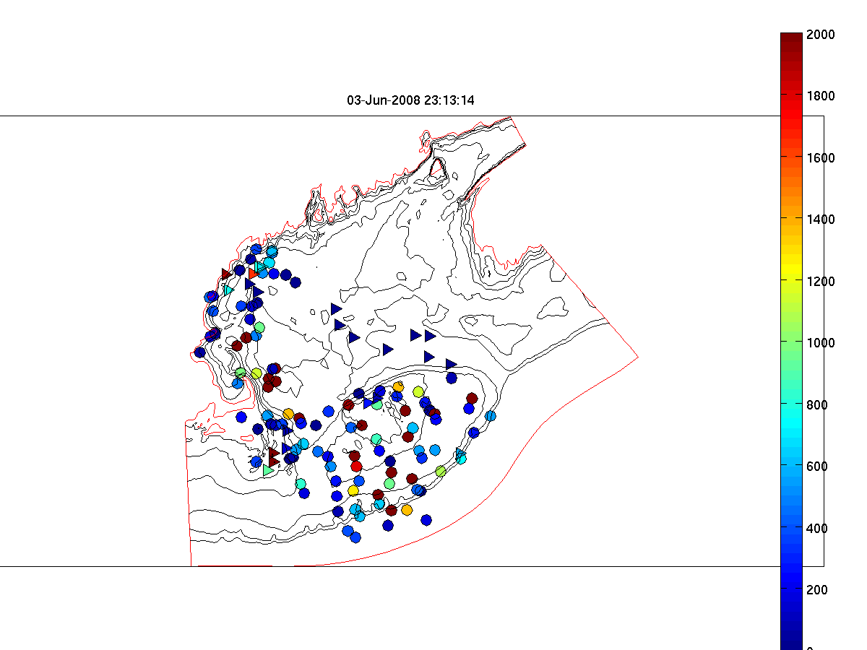
Figure 11. Left: Alexandrium concentrations taken before June 2 at sampled positions. Circles represent CTD cast stations and triangles the underway stations. Right: Estimated position of water samples taken before June 2 at the end of June 3 after accounting for advection. In this figure the 10m sample position is shown.

Run # | Start | End | Data RMS (cm/s) | Prior misfit | Posterior misfit | Drifter misfit | Hydro-DA
1 | May 26 | May 30 |  |  |  | X | NO
2 | May 26 | May 31 | 14.8 | 11.7 | 8.4 | X | NO
3 | May 26 | June 1 | 12.4 | 9.8 | 8.3 | 8.7 | NO
4 | May 26 | June 1 | 12.5 | 9.7 | 8.2 | 9.5 | Yes
5 | May 26 | June 2 | 19.7 | 10.4 | 8.8 | 7.8 | Yes
6 | May 26 | June 3 | 29.6 | 12.0 | 10.1 | 15.2 | Yes
7 | May 26 | June 4 | 31.6 | 13.0 | 10.6 | 14.1 | Yes
8 | May 26 | June 5 | 33.2 | 13.8 | 11.5 | 14.3 | Yes
9 | May 26 | June 5 | INC | INC | INC | INC | Yes
Appendix A: Measurements made on OC447

Underway measurements
a. Acoustic Doppler Current Profiler
b. Meteorological sensors

Core hydrographic measurements
a. CTD (pressure, temperature, salinity, oxygen, fluorescence, beam attenuation, PAR)
b. Alexandrium cell counts: 1, 10, 20, 30, 40, 50m plus 250/near bottom
c. Nutrients: standard depths plus 100, 150, 200, 250m

Bottle # | Depth | Live | Whole Cell | SHA | qPCR | Nuts/Chl | Pseuds | total
1 | 1 |  | 2 | 2 | 2 | 1.0 | 0.5 | 7.5
2 | 1 | 10 |  |  |  |  |  | 10
3 | 1 |  |  |  |  |  |  | spare
4 | 10 |  | 2 | 2 | 2 | 1.0 | 0.5 | 7.5
5 | 20 |  | 2 | 2 | 2 | 1.0 | 0.5 | 7.5
6 | 30 |  | 2 | 2 | 2 | 1.0 | 0.5 | 7.5
7 | 40 |  | 2 | 2 | 2 | 1.0 | 0.5 | 7.5
8 | 50 |  | 2 | 2 | 2 | 1.0 | 0.5 | 7.5
9 | 100 |  |  |  |  | 1.0 |  | 1.0
10 | 150 |  |  |  |  | 1.0 |  | 1.0
11 | 200 |  |  |  |  | 1.0 |  | 1.0
12 | 250 / near bottom |  | 8? |  |  | 1.0 |  | 9.0
Table 1. Water budget

Af water- one 6 hole-manifold loaded twice
6L/depth combined/split x 6 depths=6 WC tubes&12 filters/station
Pseuds – 100-500 ml whole water onto 0.65um Duropore? Frozen in Dewar; manifold 2; 6 filters/station
Additional opportunistic samples may be taken in areas of high Alexandrium abundance.

Toxin size fractionation – Turner
Pump profiles were carried out at selected locations. Sampling depths were chosen to coincide as closely as possible with hydrographic sampling and sediment trap measurements. Pump deployments are summarized in Table 2.

 | Date | Time  (UTC) | Latitude | Longitude | Station | Live Count  (cells l⁻¹)
1 | May 28 | 1054 | 42 41.39 N | 70 33.35 W | 9a Cape Ann | 2492
2 | May 29 | 1453 | 43 38.26 N | 69 12.78 W | 32a Monhegan | 714/266
3 | May 30 | 2020 | 41 34.47 N | 66 41.79 W | 45a Georges | 770/518
4 | June 2 | 1117 | 40 40.19 N | 68 26.92 W | 87a Georges SW | 4004/3626
5 | June 3 | 0930 | 40 47.72 N | 069 13.77 W | 103a Phelps Bank / Asia Rip | 2632/1092
Table 2. Pump stations.

Drifters

ID | Mon | Day | Year | GMT | Lon | Lat | Drogue  depth(m) | Station Number
85201 | 5 | 28 | 2008 | 1208 | 70 32.562 | 42 41.493 | 1 | 9a
85202 | 5 | 28 | 2008 | 1255 | 70 24.573 | 42 41.187 | 1 | 11
85203 | 5 | 28 | 2008 | 1348 | 70 15.321 | 42 41.182 | 1 | 12
85394 | 5 | 29 | 2008 | 0423 | 69 51.92 | 43 39.72 | 1 | 24
85395 | 5 | 29 | 2008 | 0520 | 69 48.40 | 43 33.76 | 1 | 25
85396 | 5 | 29 | 2008 | 0620 | 69 44.93 | 43 27.59 | 1 | 26
85397 | 5 | 29 | 2008 | 0717 | 69 41.50 | 43 21.60 | 1 | 27
85398 | 5 | 29 | 2008 | 0810 | 69 38.01 | 43 15.79 | 1 | 28
85399 | 5 | 29 | 2008 | 0852 | 69 34.46 | 43 34.46 | 1 | 29
86091 | 6 | 2 | 2008 | 1049 | 69 14.46 | 40 48.60 | 1 | 103a
Table 3: Summary of drifter releases on OC447. For more information see http://nefsc.noaa.gov/drifter.

Other measurements
a. Mussel bags: Casco, Cobscook, Blue Hill, Frenchman’s – Darcy Couture
b. AVHRR, SeaWiFS, MODIS false-color imagery – Andy Thomas
c. GoMOOS moorings
d. NOAA coastal tide gauges
e. NMFS quarterly survey – March-April CTD data

Appendix B: Hydrographic maps

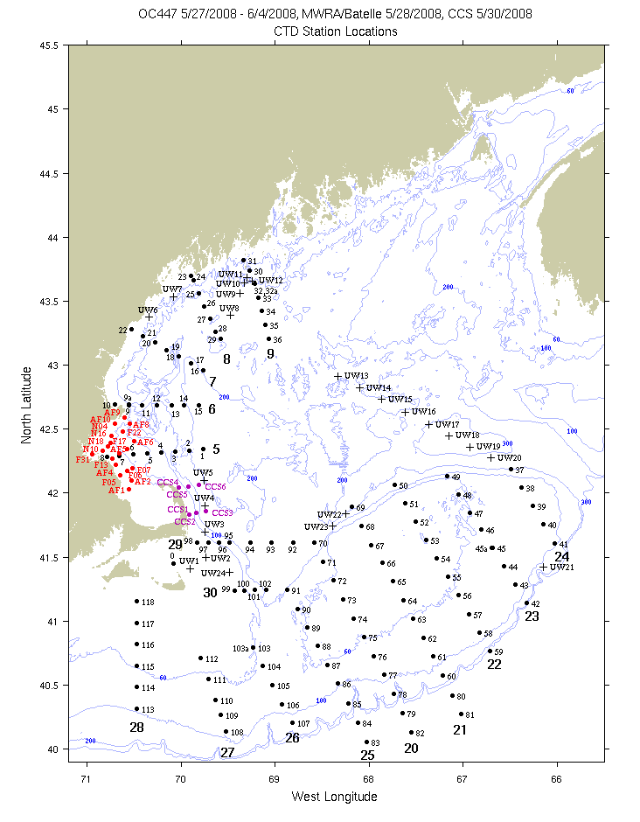
Figure B1: CTD (dots) and underway (crosses) station locations for OC447 (black), MWRA/Battelle (red), and CCS (magenta) surveys. Bold numerals indicate identifiers for the sections displayed below.

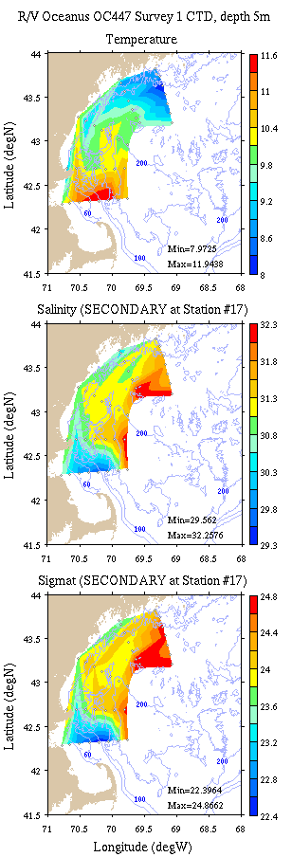 | 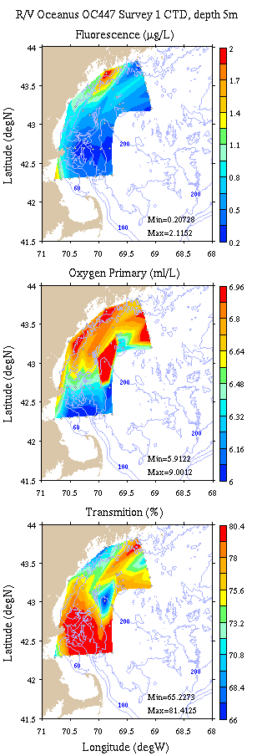
Figure B2: Coastal GOM survey maps at 5m depth. Left: temperature, salinity, and density; right: fluorescence, oxygen, and light transmission.

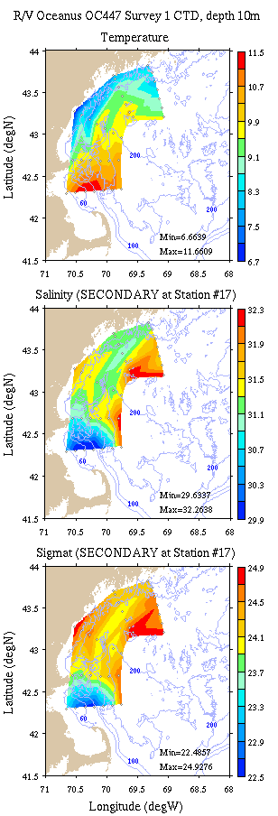 | 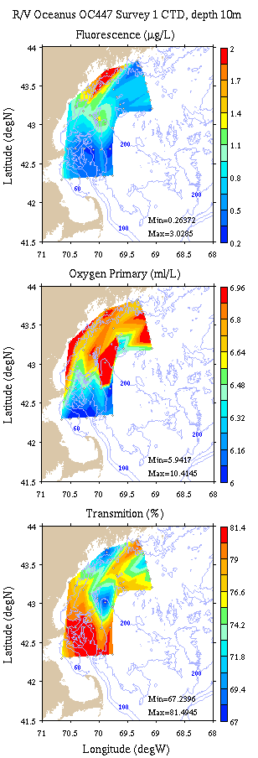
Figure B3: Coastal GOM survey maps at 10m depth. Left: temperature, salinity, and density; right: fluorescence, oxygen, and light transmission.

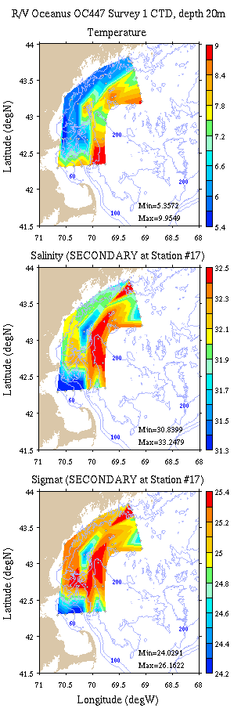 | 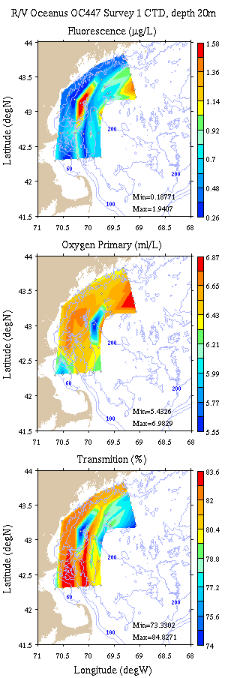
Figure B4: Coastal GOM survey maps at 20m depth. Left: temperature, salinity, and density; right: fluorescence, oxygen, and light transmission.

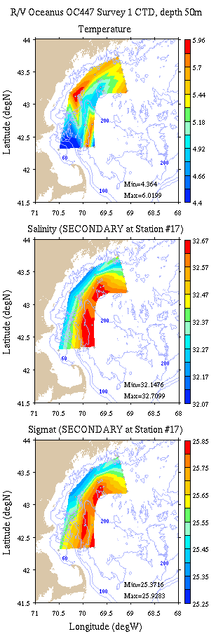 | 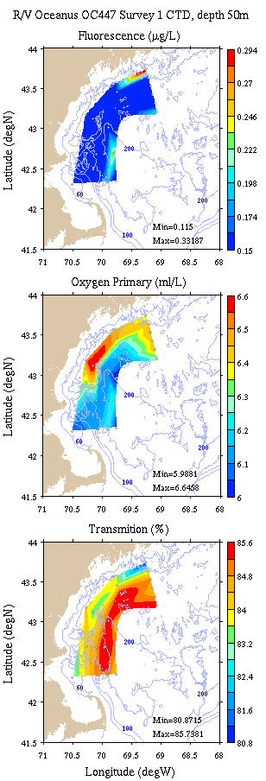
Figure B5: Coastal GOM survey maps at 50m depth. Left: temperature, salinity, and density; right: fluorescence, oxygen, and light transmission.

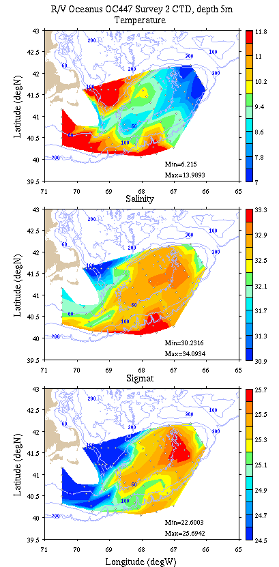 | 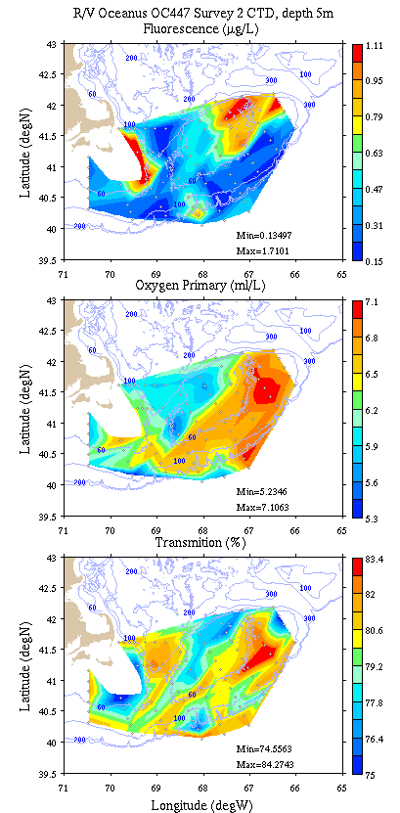
Figure B6: Georges Bank / Southern New England survey maps at 5m depth. Left: temperature, salinity, and density; right: fluorescence, oxygen, and light transmission.

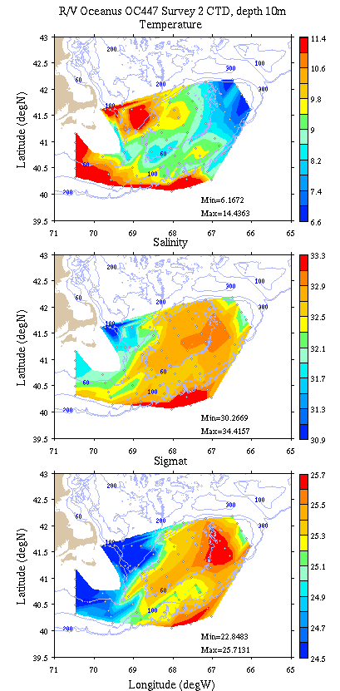 | 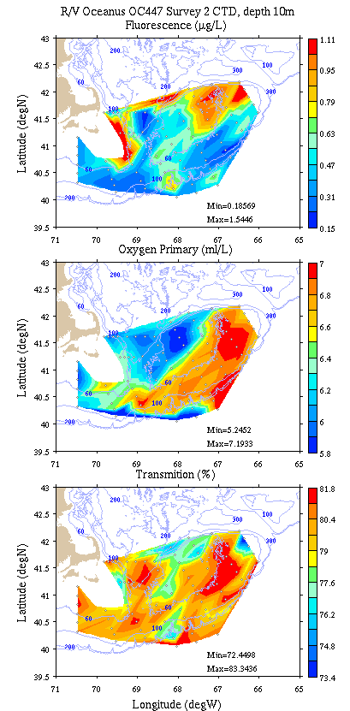
Figure B7: Georges Bank / Southern New England survey maps at 10m depth. Left: temperature, salinity, and density; right: fluorescence, oxygen, and light transmission.

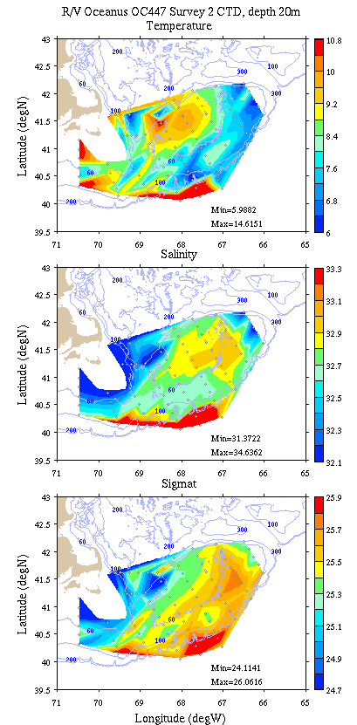 | 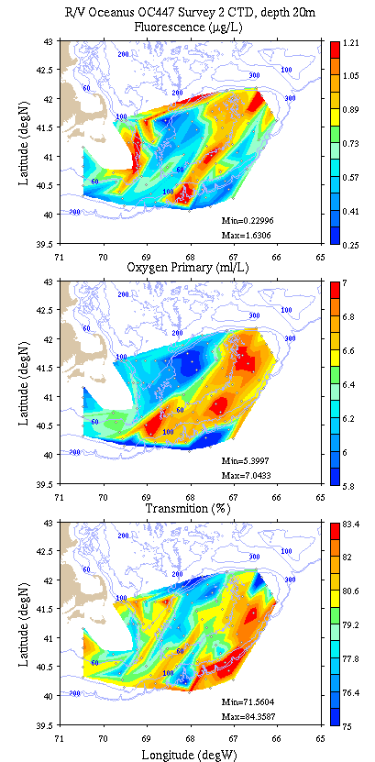
Figure B8: Georges Bank / Southern New England survey maps at 20m depth. Left: temperature, salinity, and density; right: fluorescence, oxygen, and light transmission.

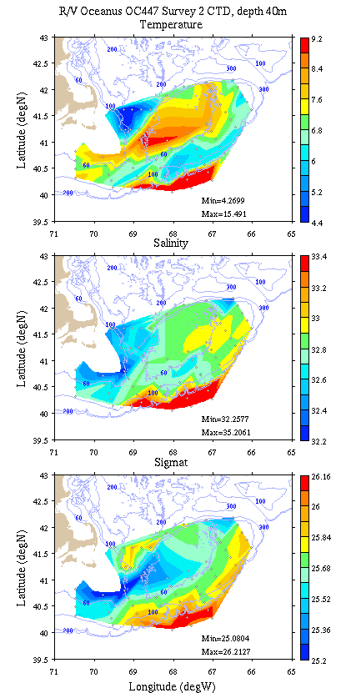 | 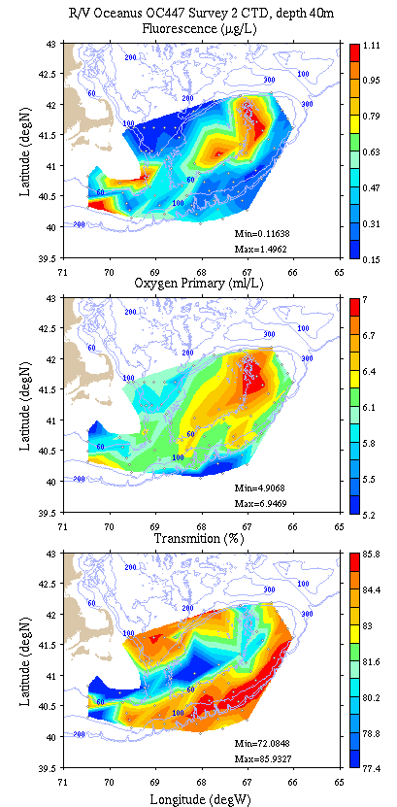
Figure B9: Georges Bank / Southern New England survey maps at 40m depth. Left: temperature, salinity, and density; right: fluorescence, oxygen, and light transmission.

Appendix C: Vertical sections.

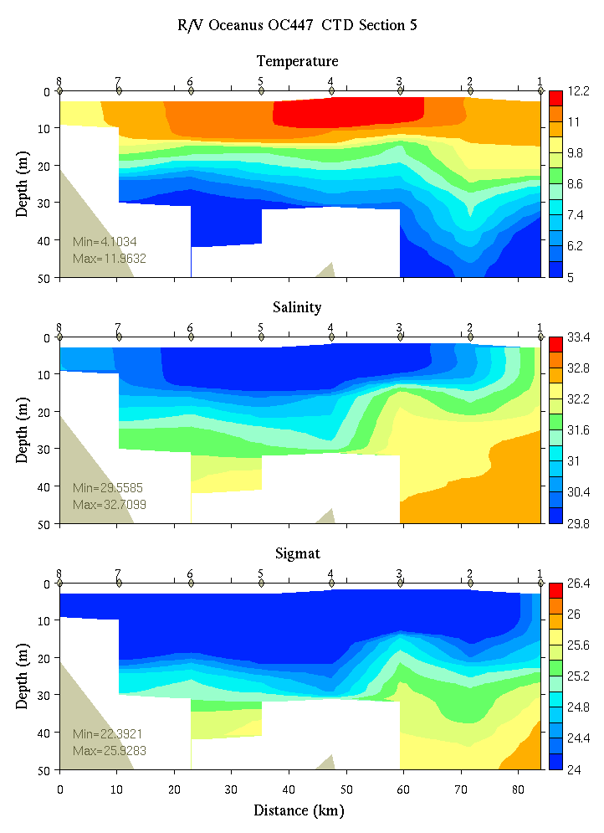 | 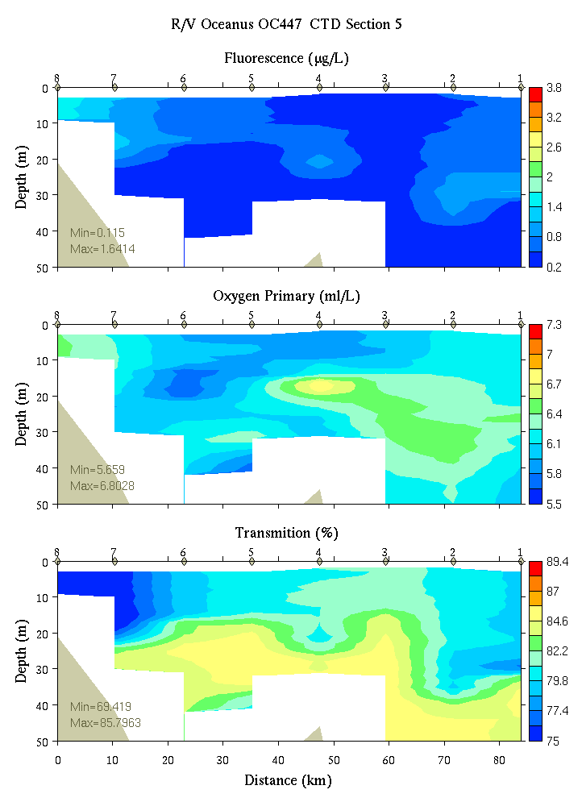
Figure C1. Section 5, 0-50m: temperature, salinity, and density (left); fluorescence, oxygen, and beam transmission (right).

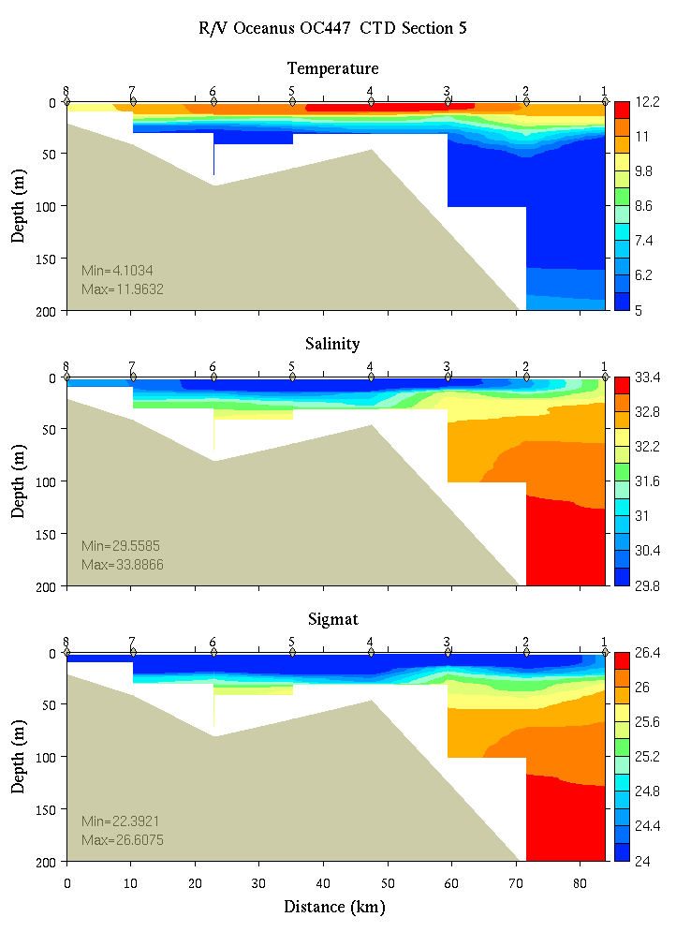 | 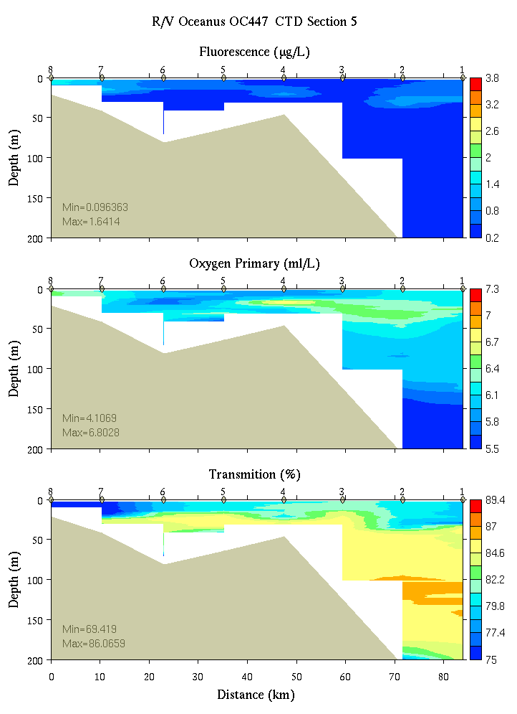
Figure C2. Section 5, 0-200m: temperature, salinity, and density (left); fluorescence, oxygen, and beam transmission (right).

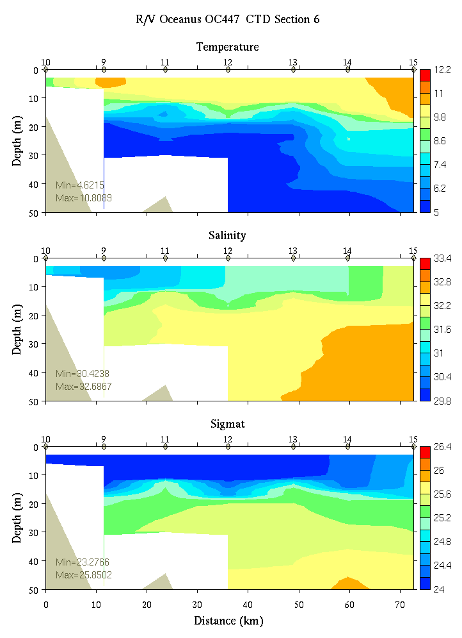 | 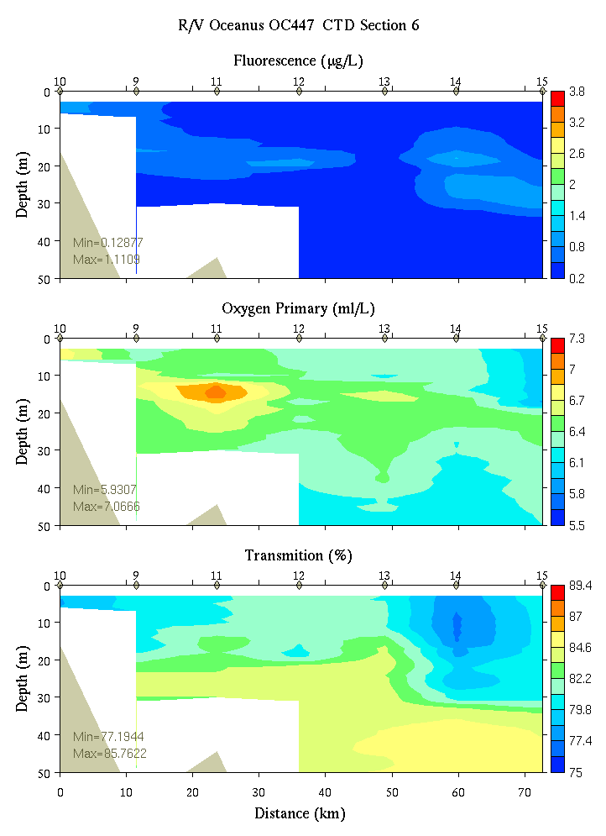
Figure C3. Section 6, 0-50m: temperature, salinity, and density (left); fluorescence, oxygen, and beam transmission (right).

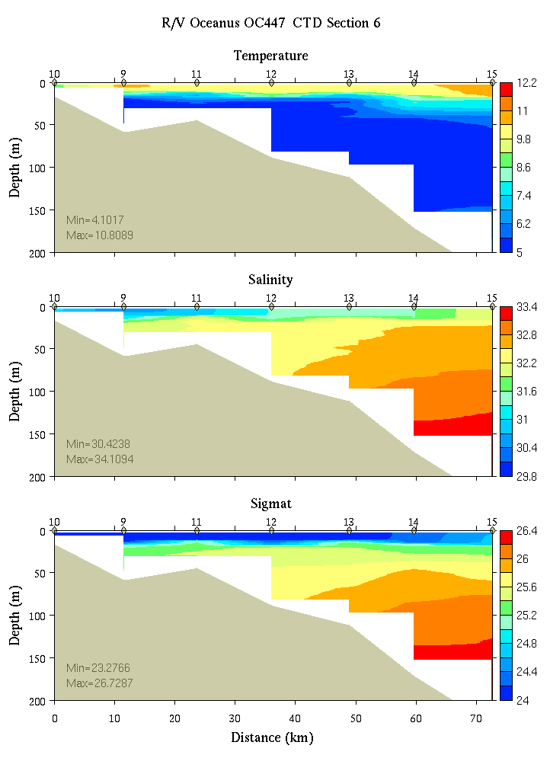 | 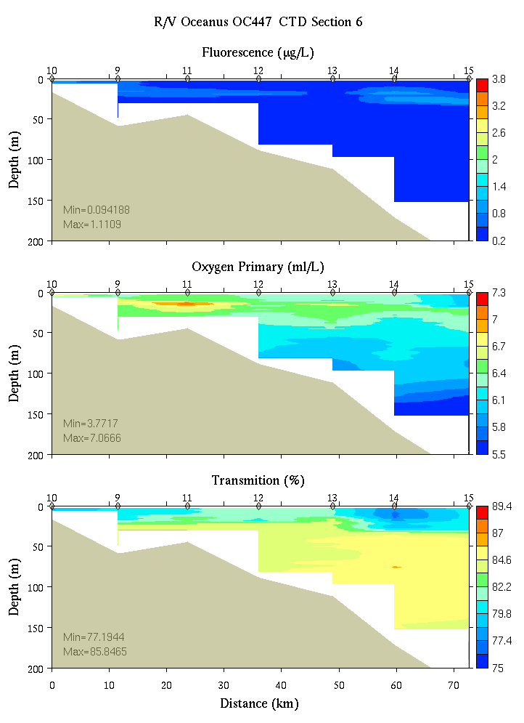
Figure C4. Section 6, 0-200m: temperature, salinity, and density (left); fluorescence, oxygen, and beam transmission (right).

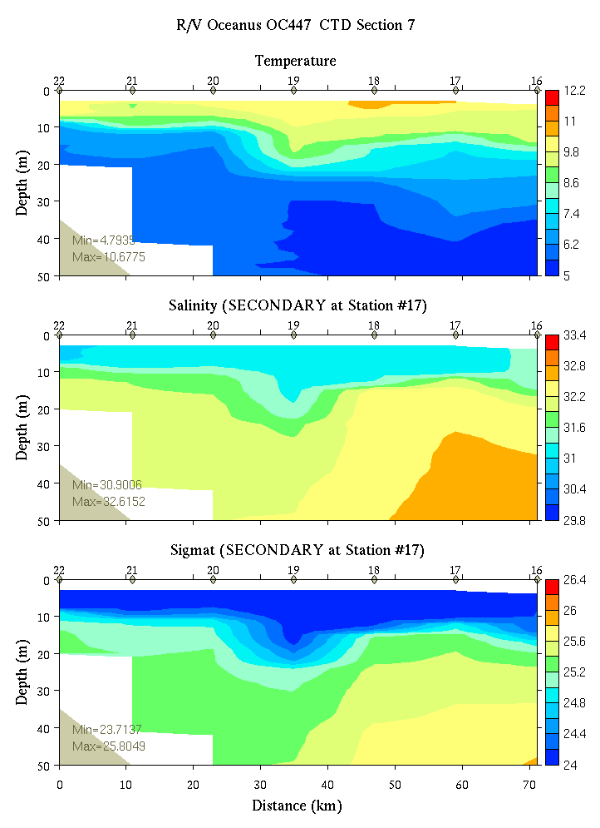 | 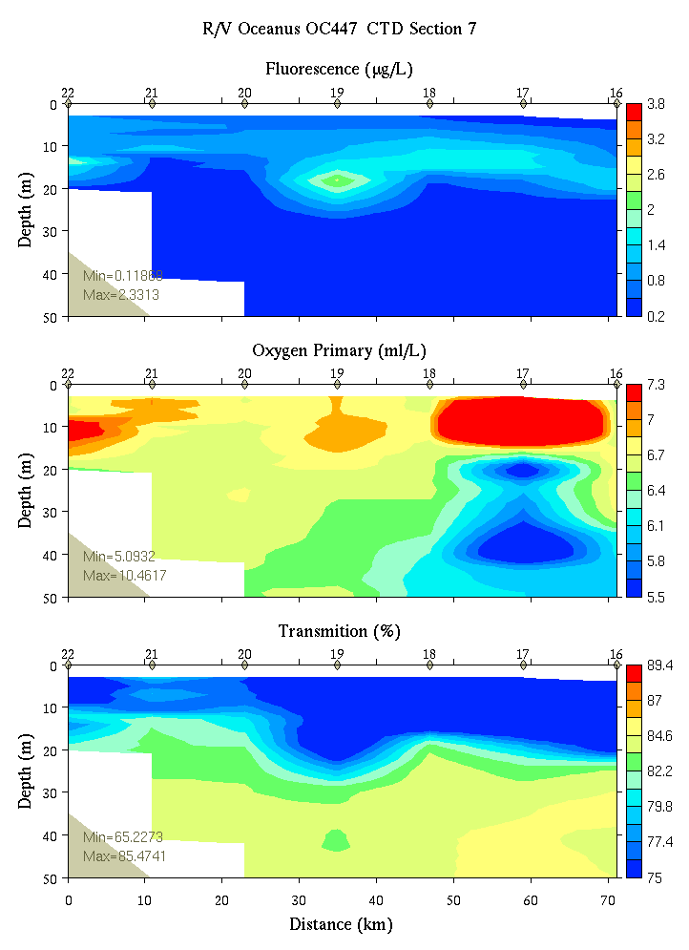
Figure C5. Section 7, 0-50m: temperature, salinity, and density (left); fluorescence, oxygen, and beam transmission (right).

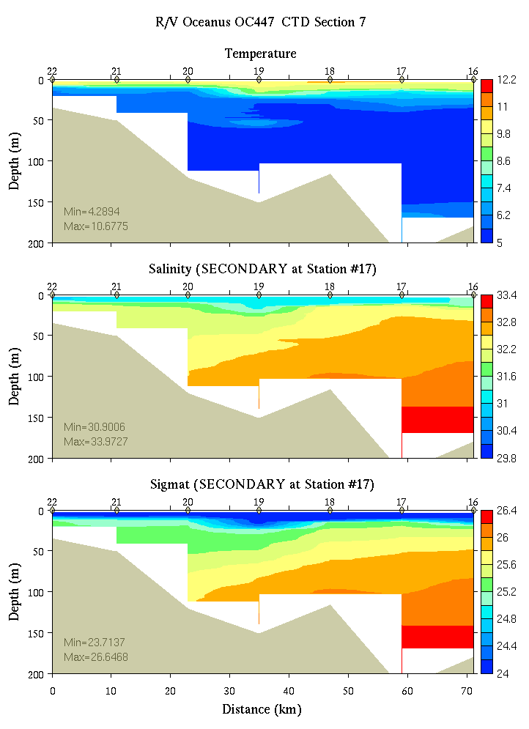 | 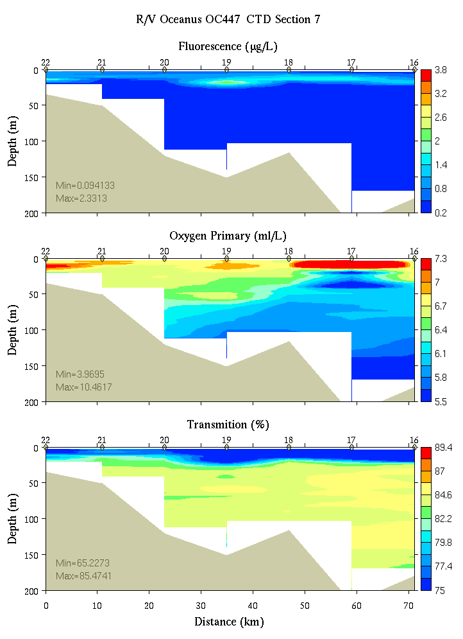
Figure C6. Section 7, 0-200m: temperature, salinity, and density (left); fluorescence, oxygen, and beam transmission (right).

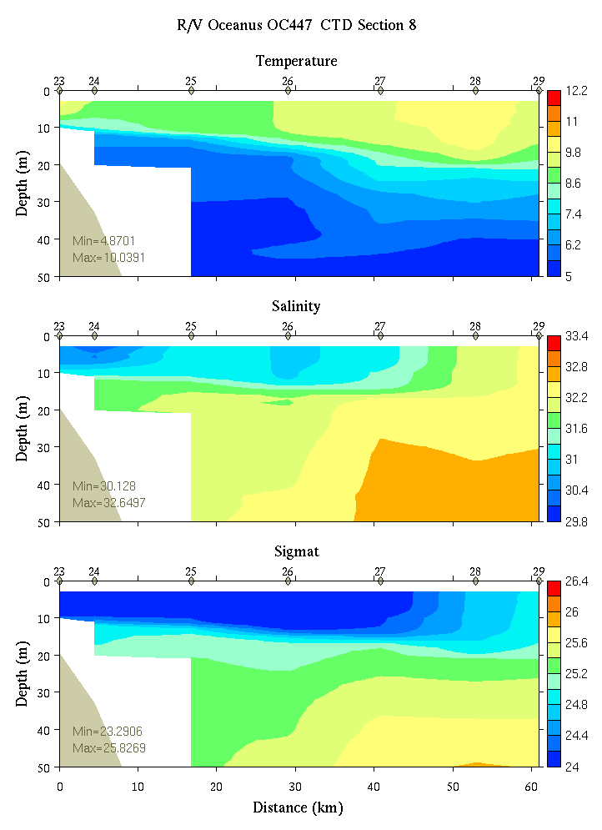 | 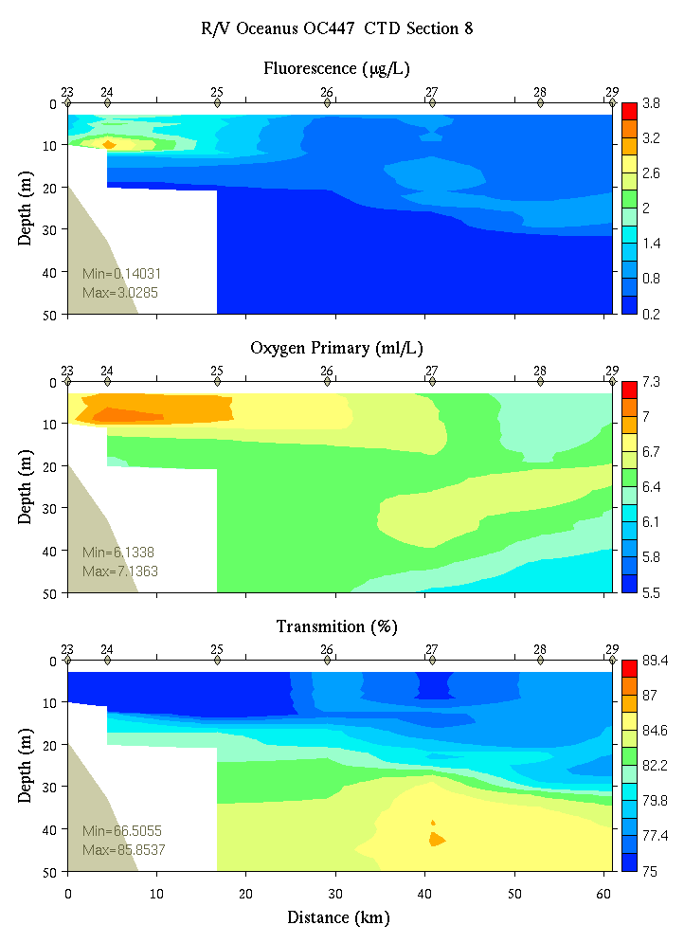
Figure C7. Section 8, 0-200m: temperature, salinity, and density (left); fluorescence, oxygen, and beam transmission (right).

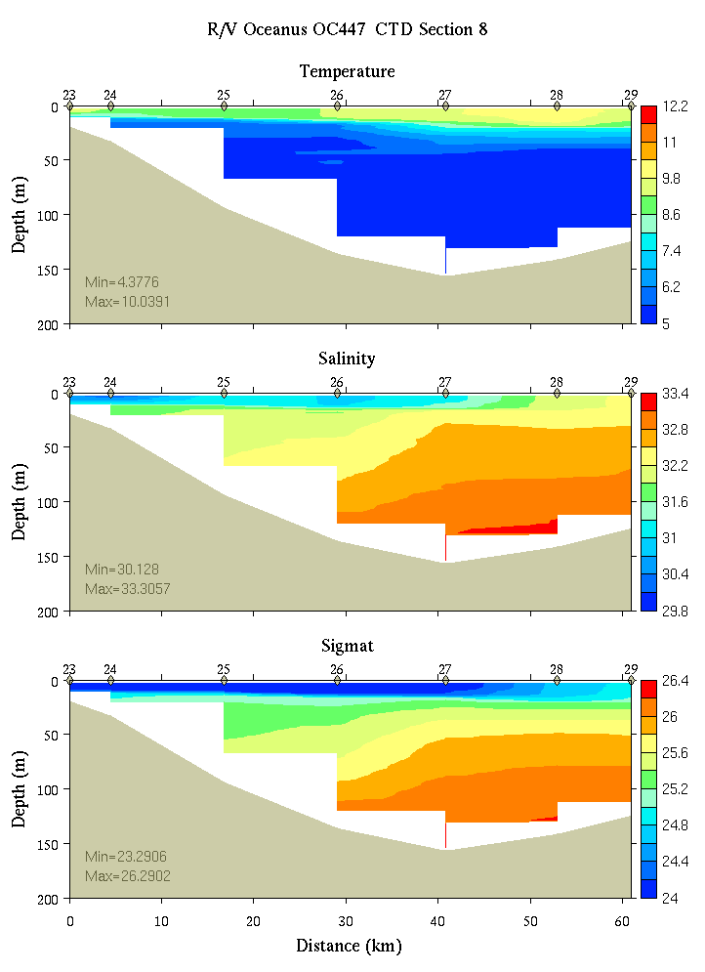 | 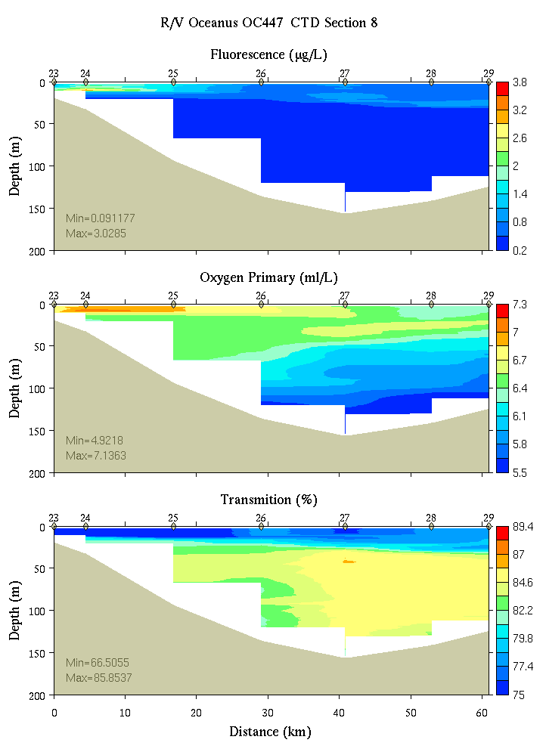
Figure C8. Section 8, 0-200m: temperature, salinity, and density (left); fluorescence, oxygen, and beam transmission (right).

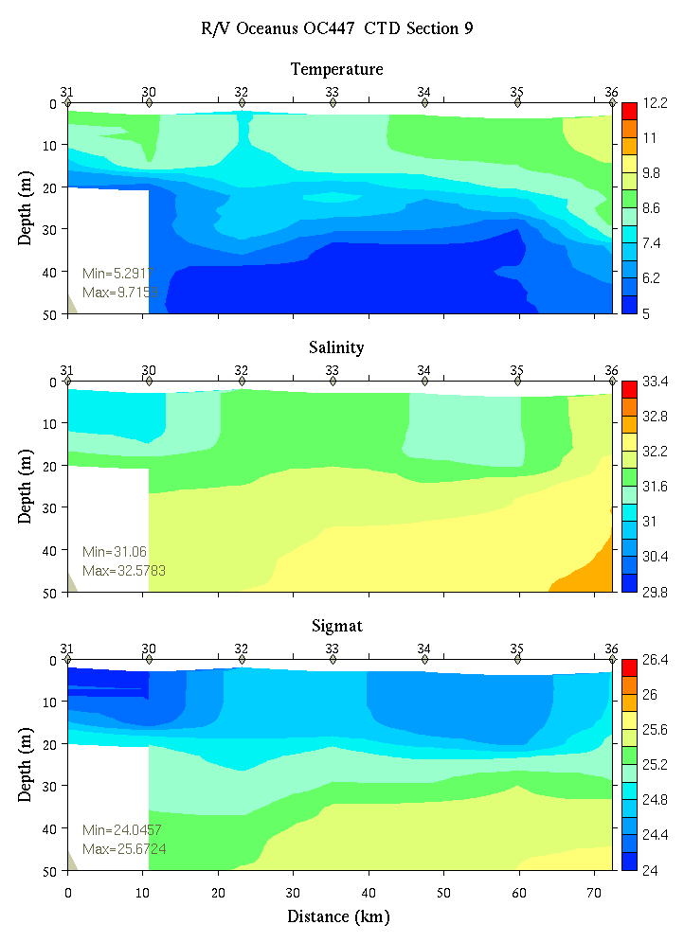 | 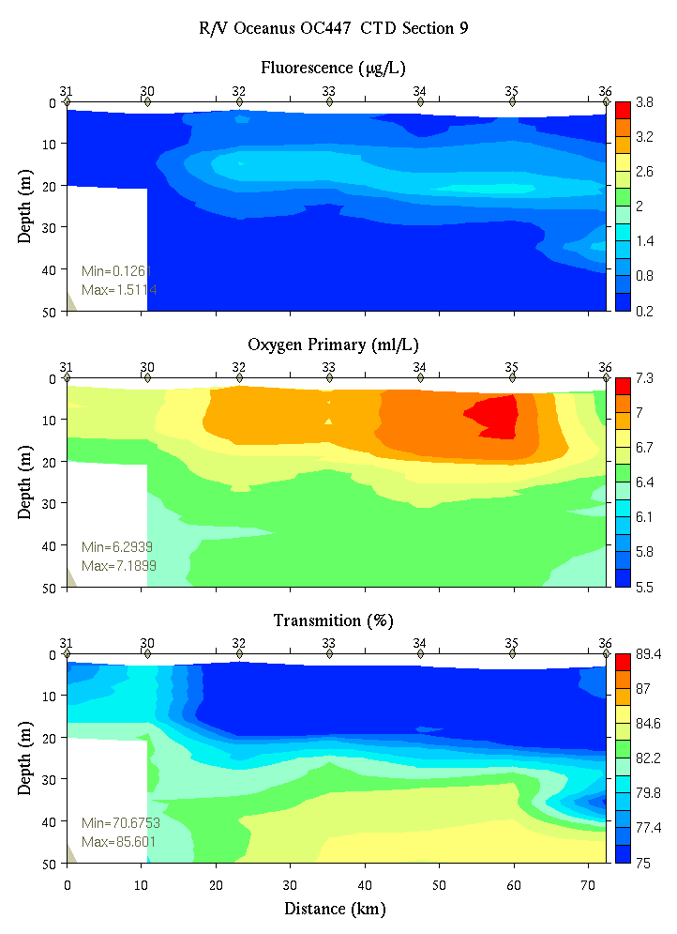
Figure C9. Section 9, 0-50m: temperature, salinity, and density (left); fluorescence, oxygen, and beam transmission (right).

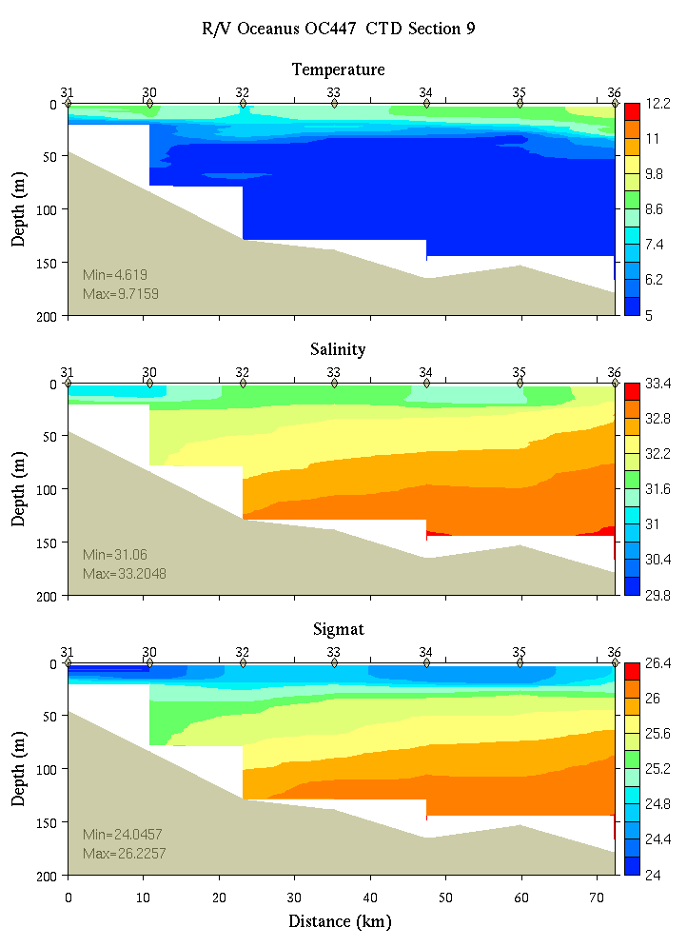 | 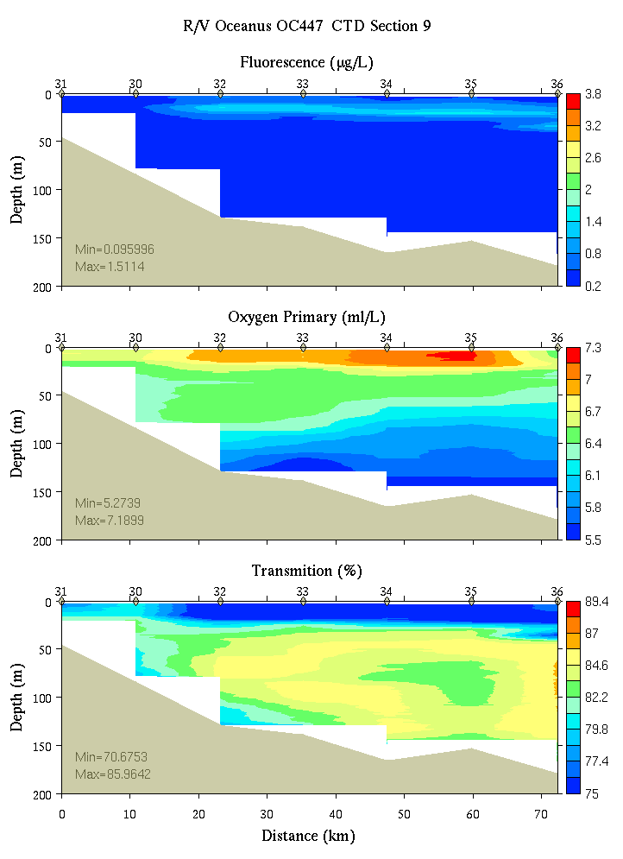
Figure C10. Section 9, 0-200m: temperature, salinity, and density (left); fluorescence, oxygen, and beam transmission (right).

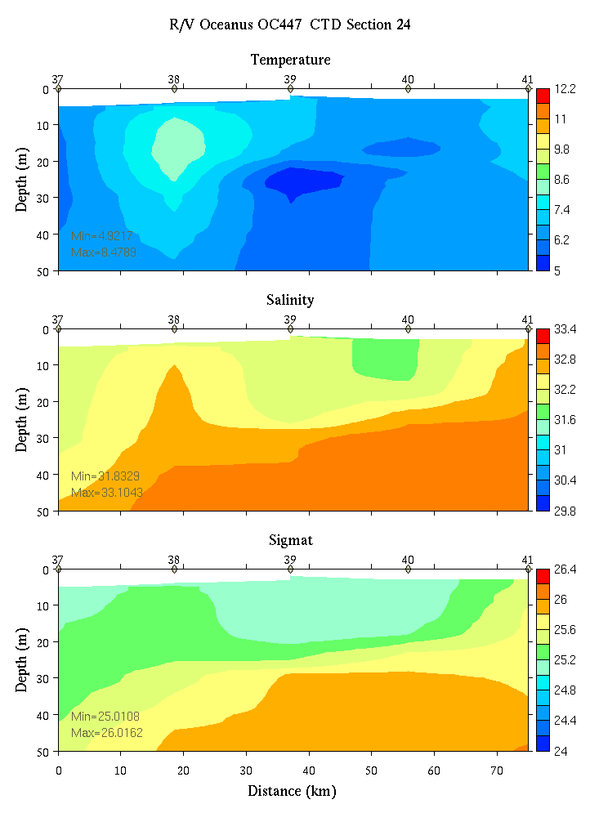 | 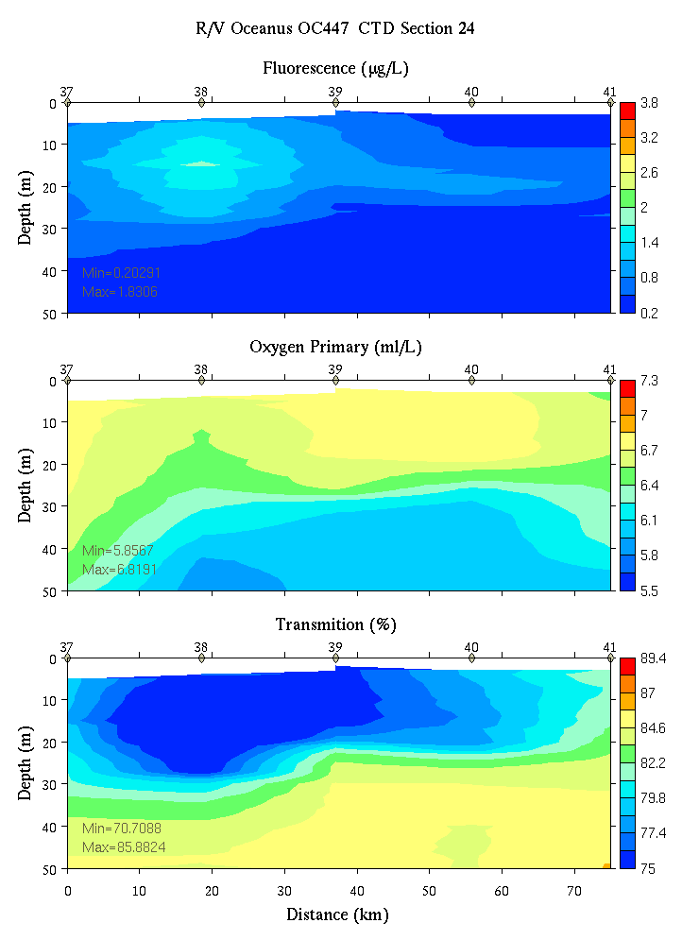
Figure C11. Section 24, 0-50m: temperature, salinity, and density (left); fluorescence, oxygen, and beam transmission (right).

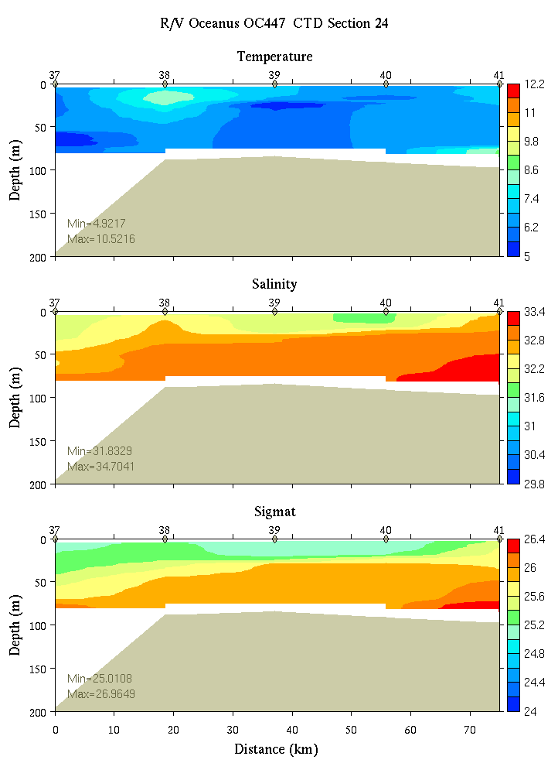 | 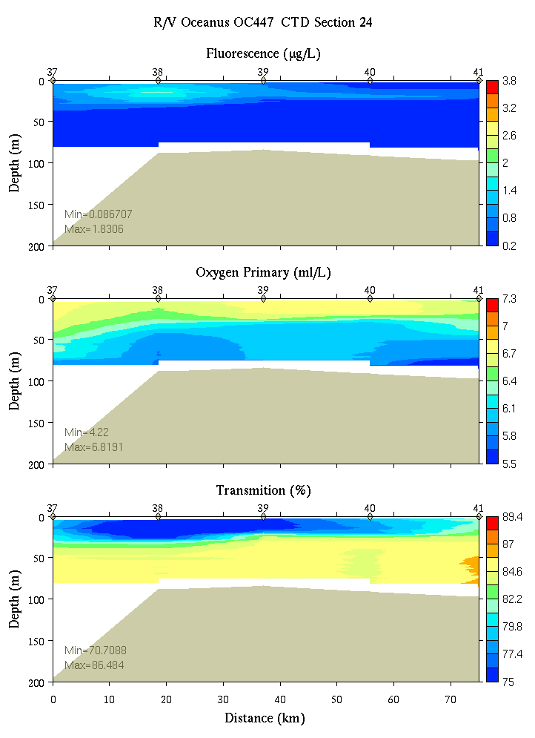
Figure C12. Section 24, 0-200m: temperature, salinity, and density (left); fluorescence, oxygen, and beam transmission (right).

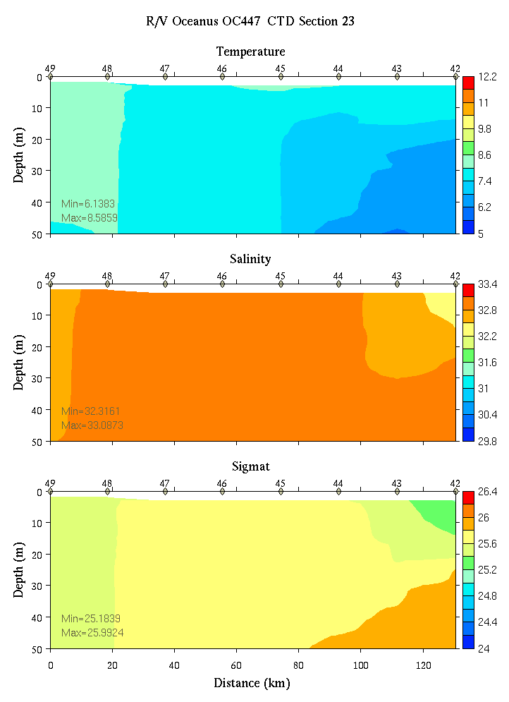 | 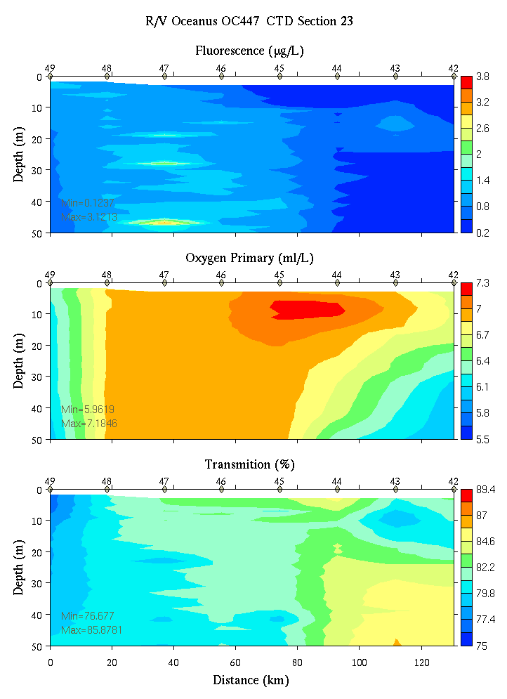
Figure C13. Section 23, 0-50m: temperature, salinity, and density (left); fluorescence, oxygen, and beam transmission (right).

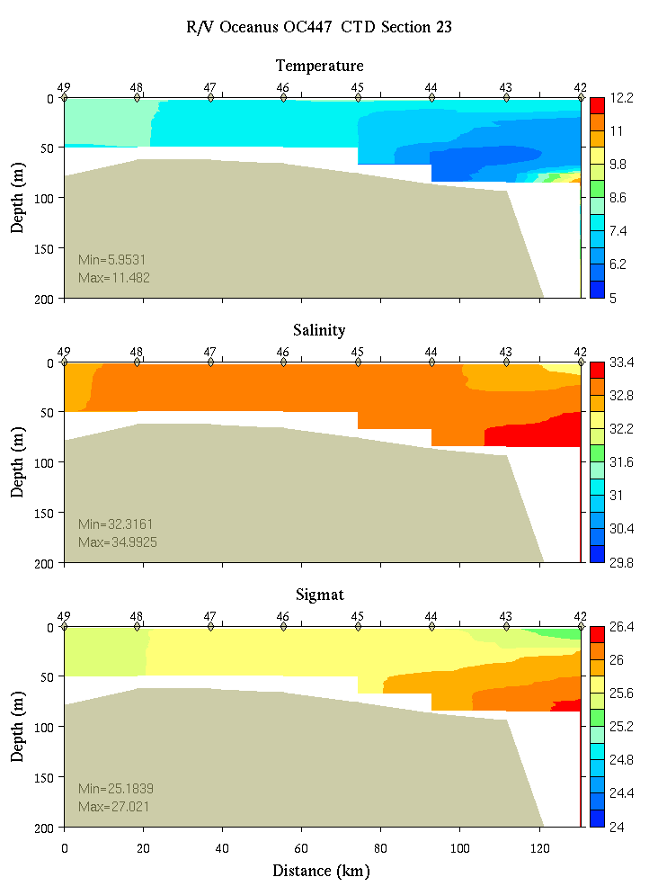 | 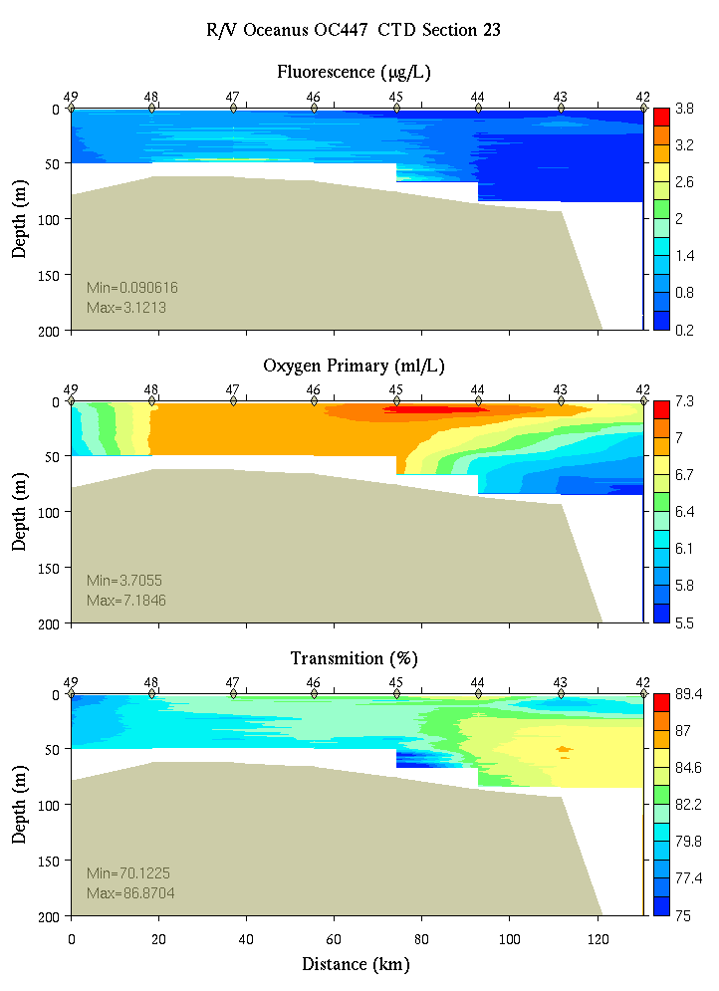
Figure C14. Section 23, 0-200m: temperature, salinity, and density (left); fluorescence, oxygen, and beam transmission (right).

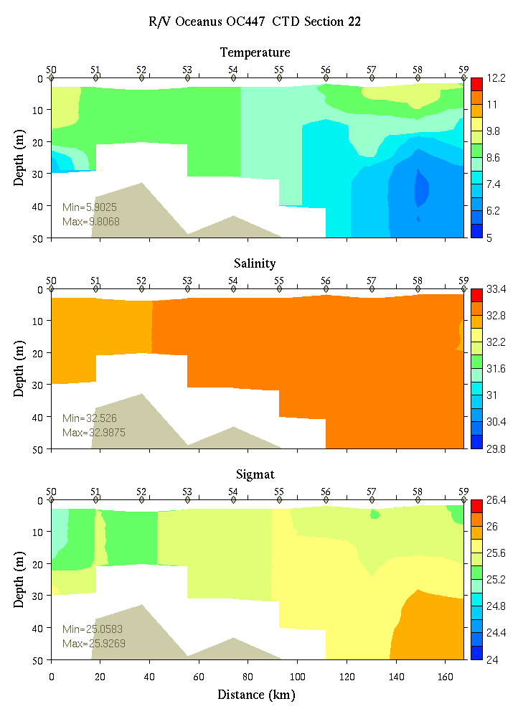 | 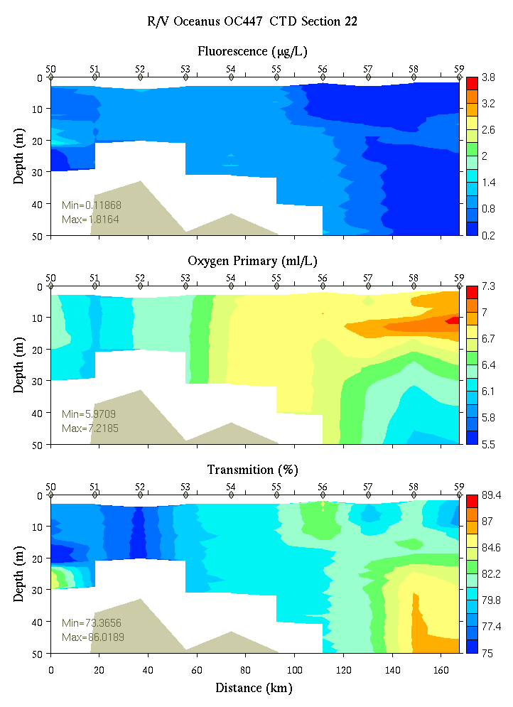
Figure C15. Section 22, 0-50m: temperature, salinity, and density (left); fluorescence, oxygen, and beam transmission (right).

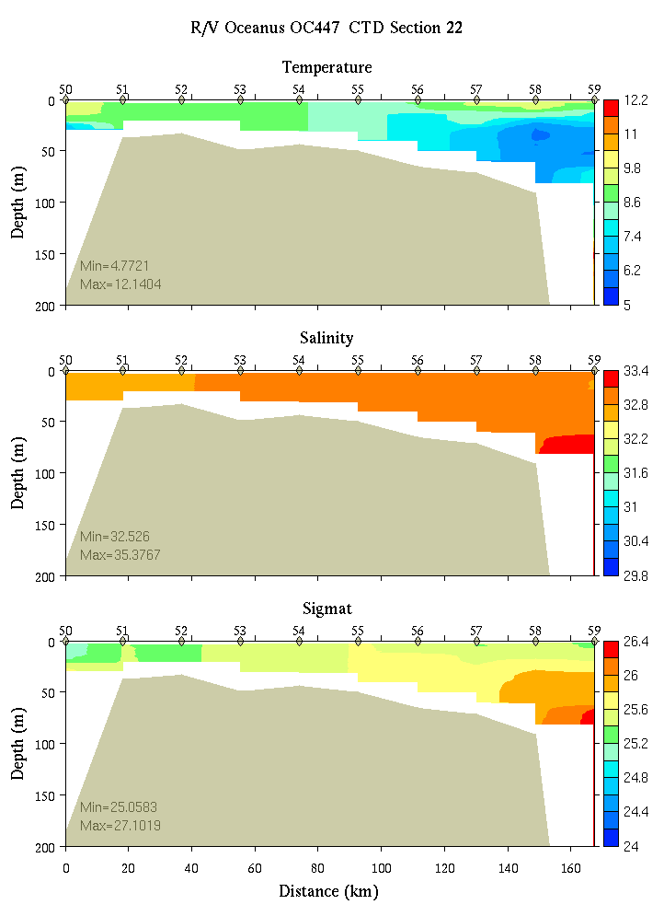 | 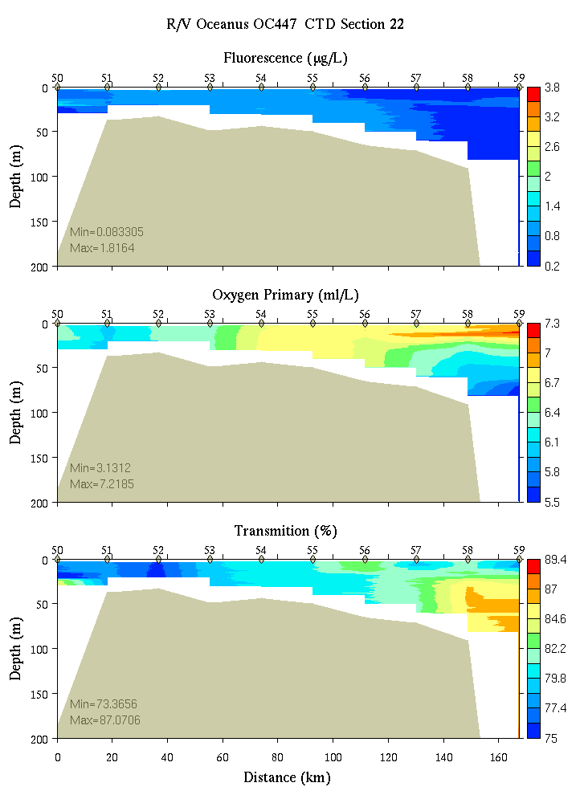
Figure C16. Section 22, 0-200m: temperature, salinity, and density (left); fluorescence, oxygen, and beam transmission (right).

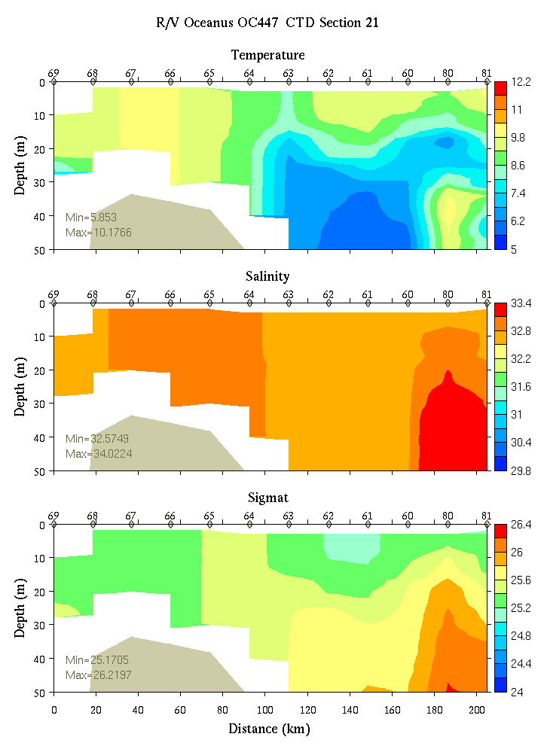 | 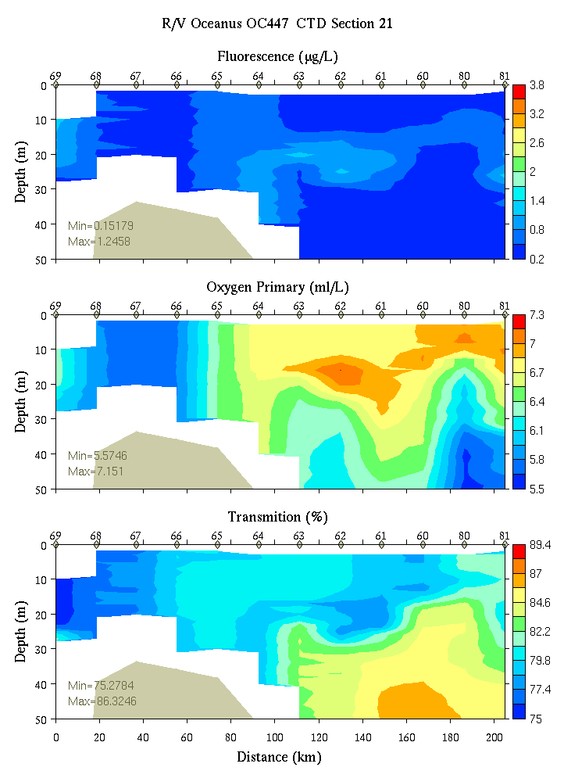
Figure C17. Section 21, 0-50m: temperature, salinity, and density (left); fluorescence, oxygen, and beam transmission (right).

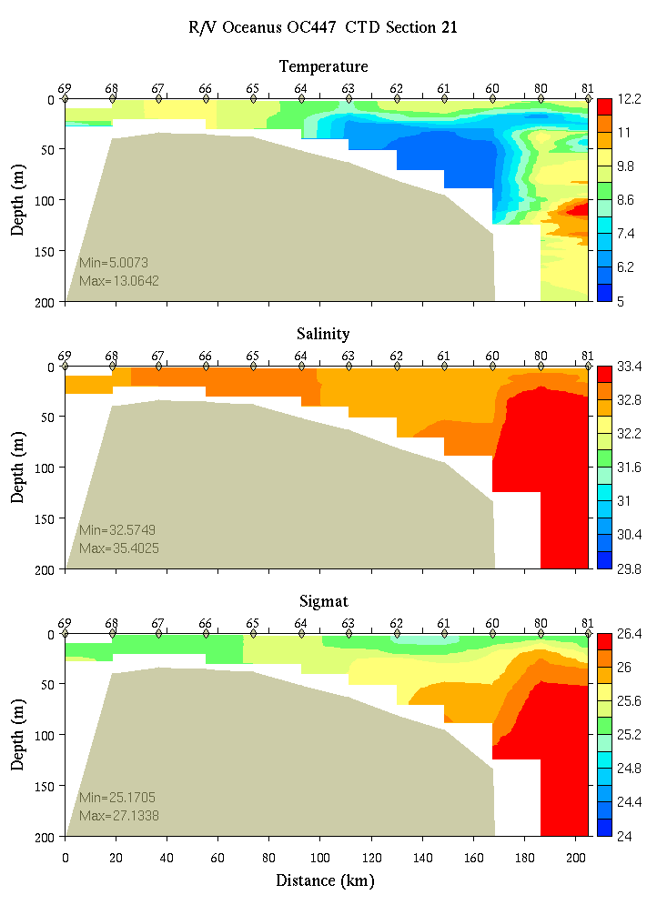 | 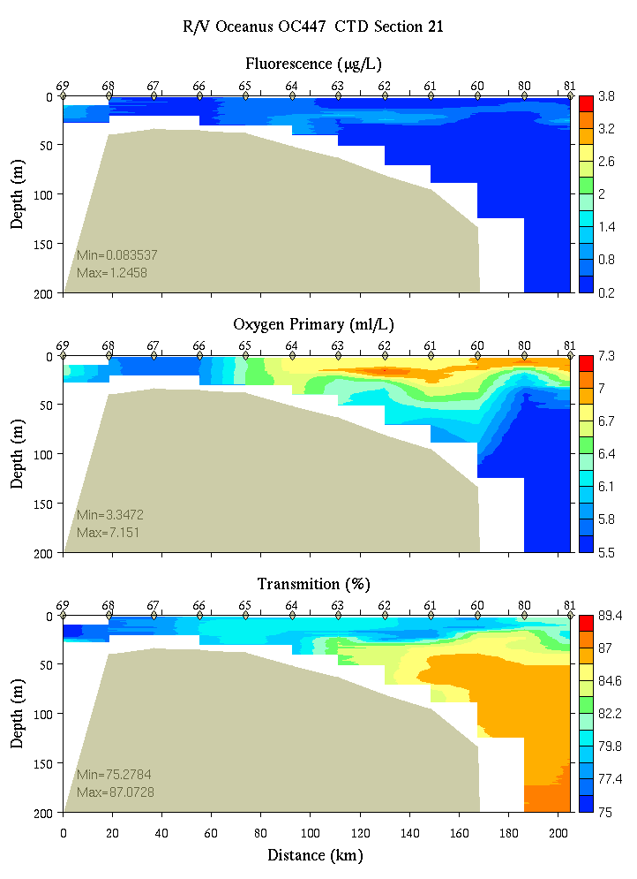
Figure C18. Section 21, 0-200m: temperature, salinity, and density (left); fluorescence, oxygen, and beam transmission (right).

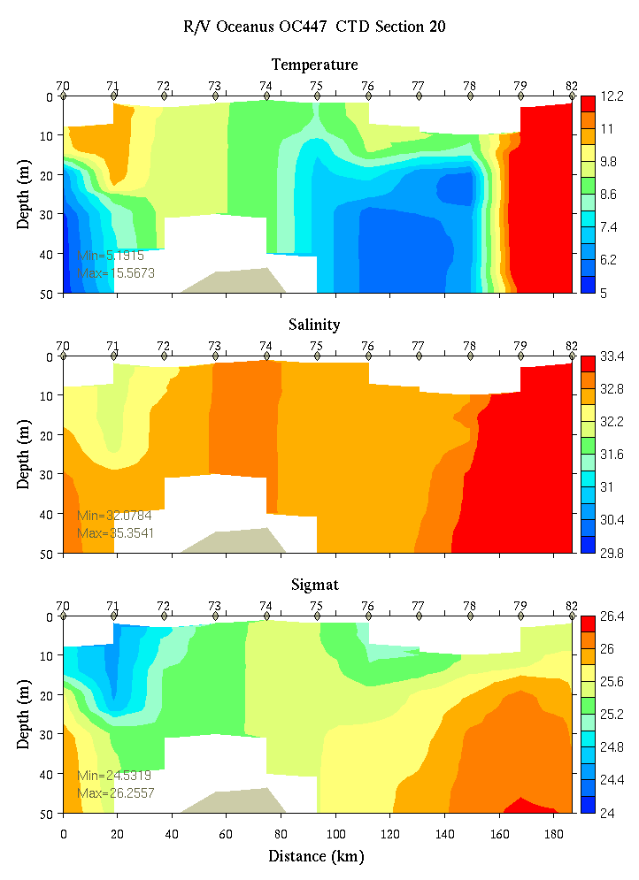 | 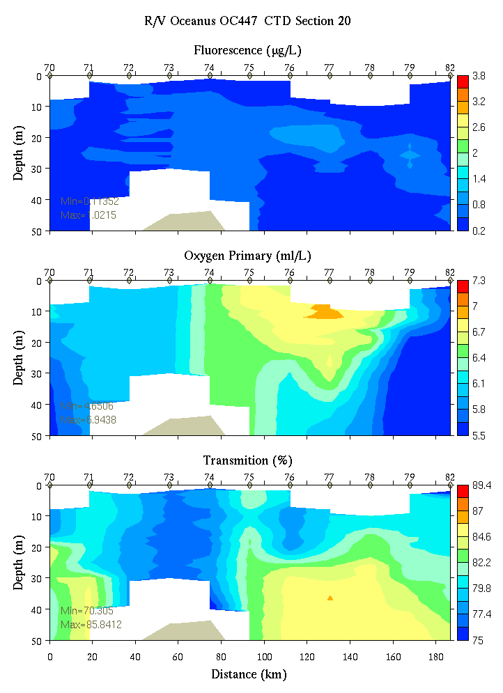
Figure C19. Section 20, 0-50m: temperature, salinity, and density (left); fluorescence, oxygen, and beam transmission (right).

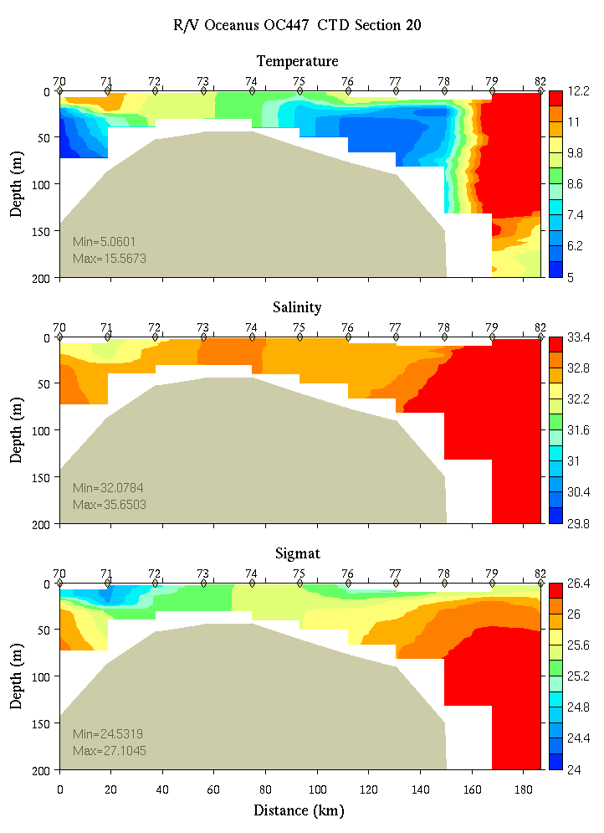 | 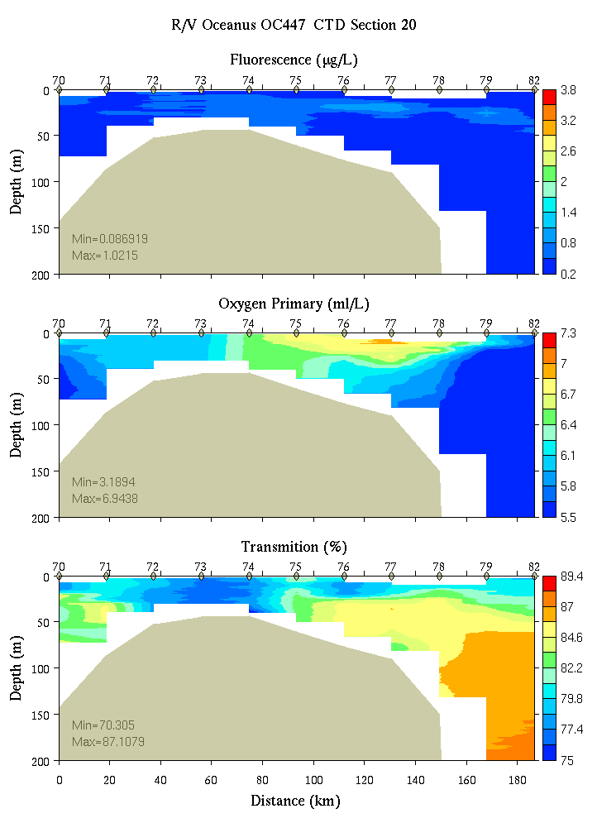
Figure C20. Section 20, 0-200m: temperature, salinity, and density (left); fluorescence, oxygen, and beam transmission (right).

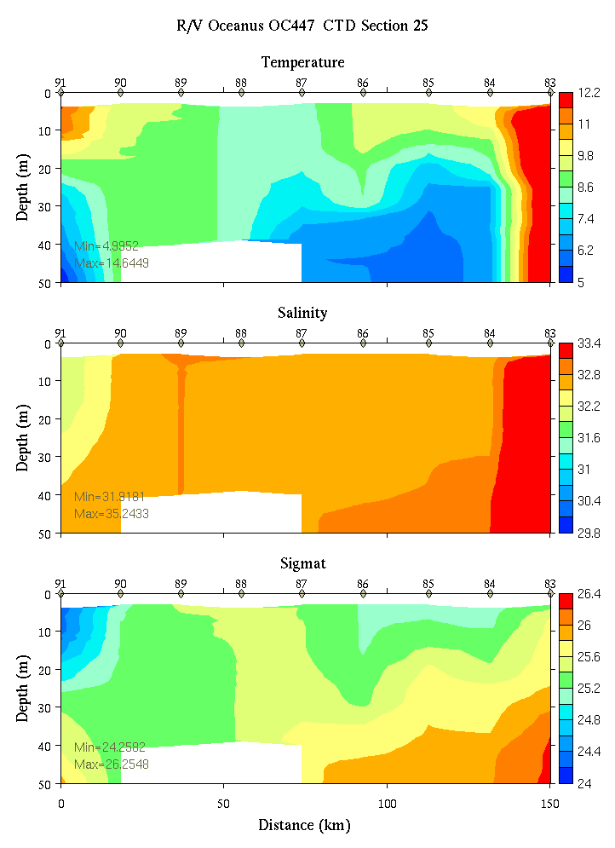 | 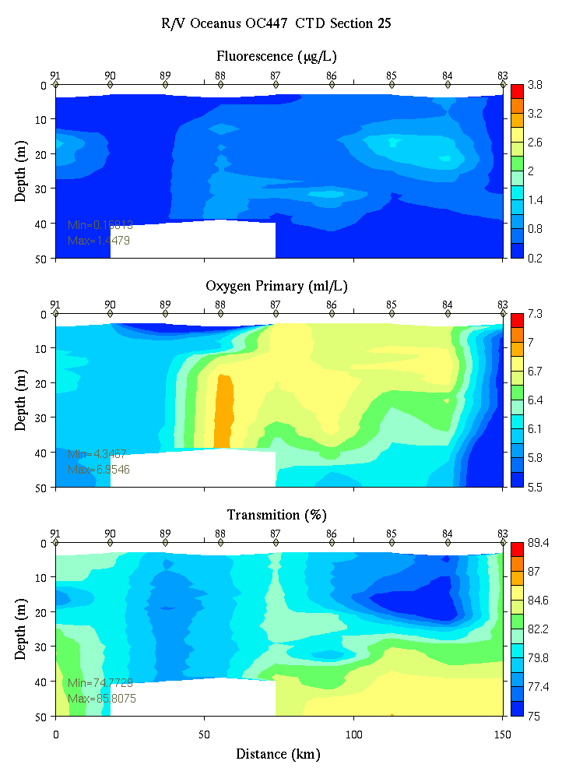
Figure C21. Section 25, 0-50m: temperature, salinity, and density (left); fluorescence, oxygen, and beam transmission (right).

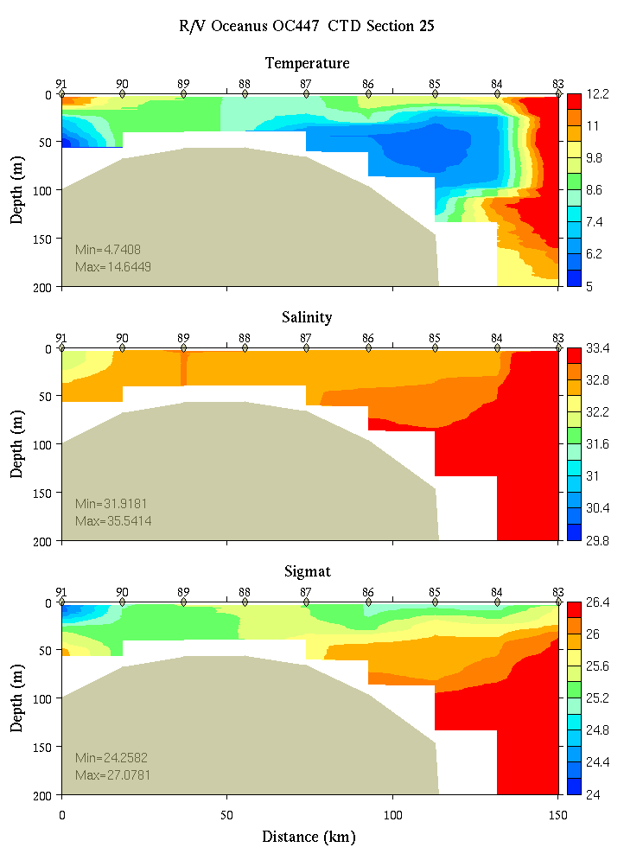 | 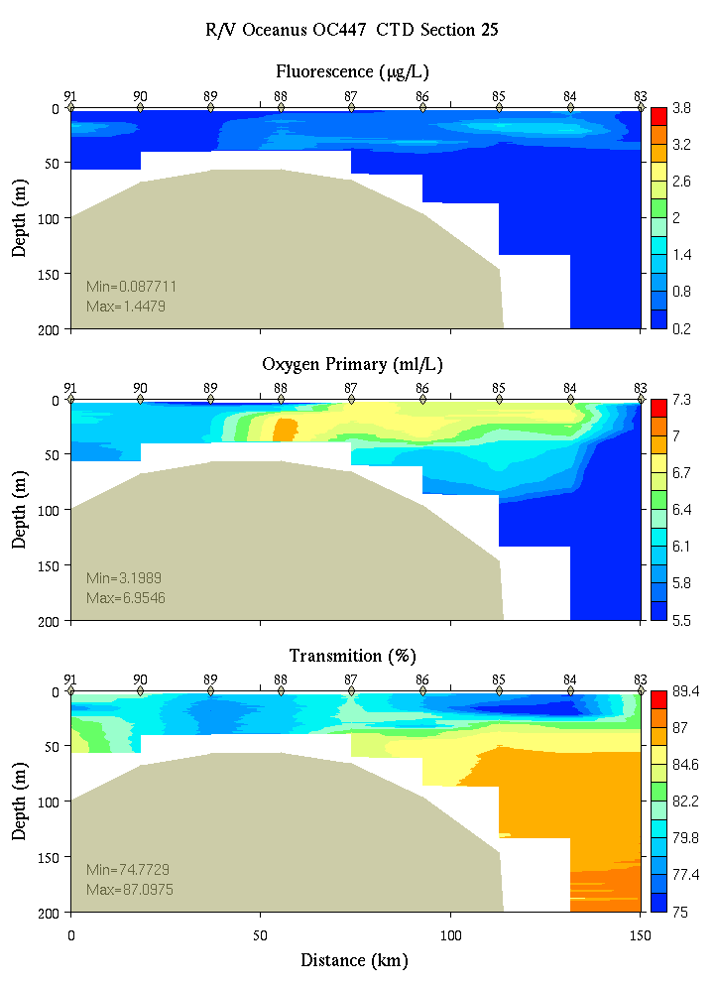
Figure C22. Section 25, 0-200m: temperature, salinity, and density (left); fluorescence, oxygen, and beam transmission (right).

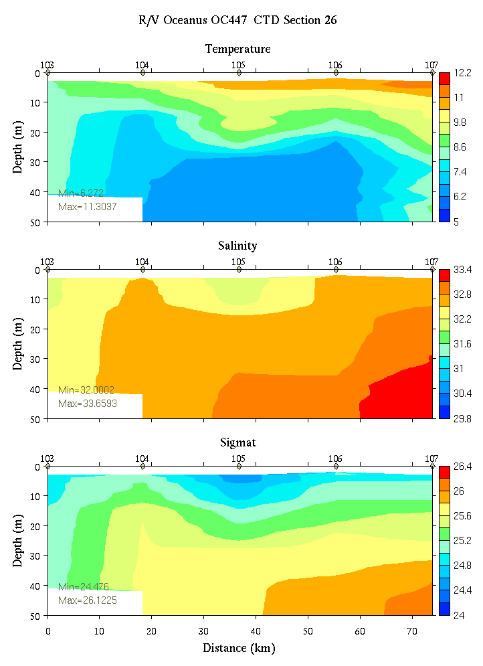 | 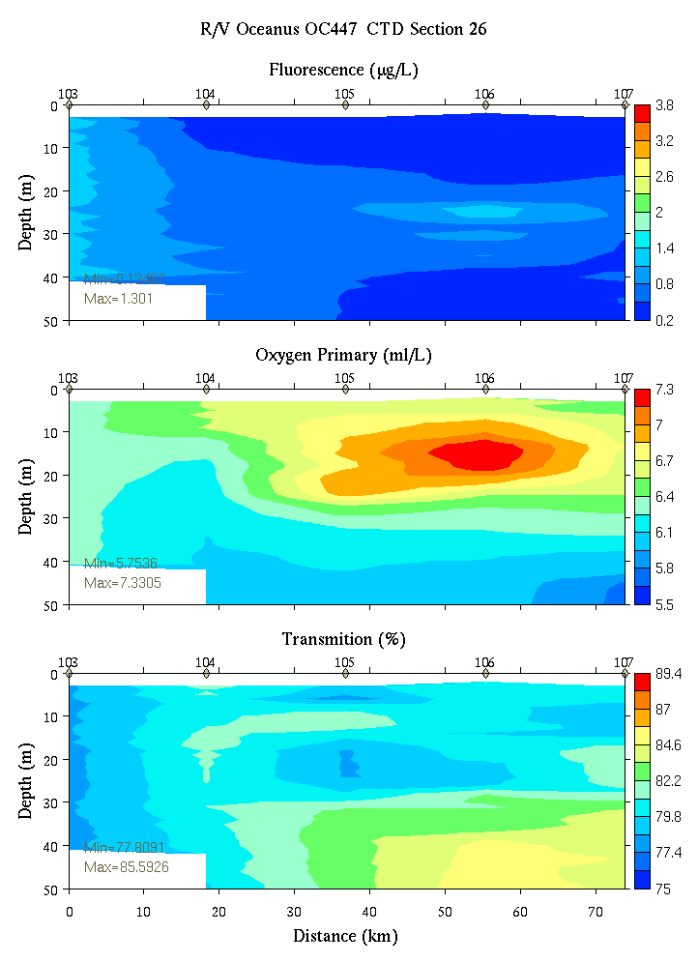
Figure C23. Section 26, 0-50m: temperature, salinity, and density (left); fluorescence, oxygen, and beam transmission (right).

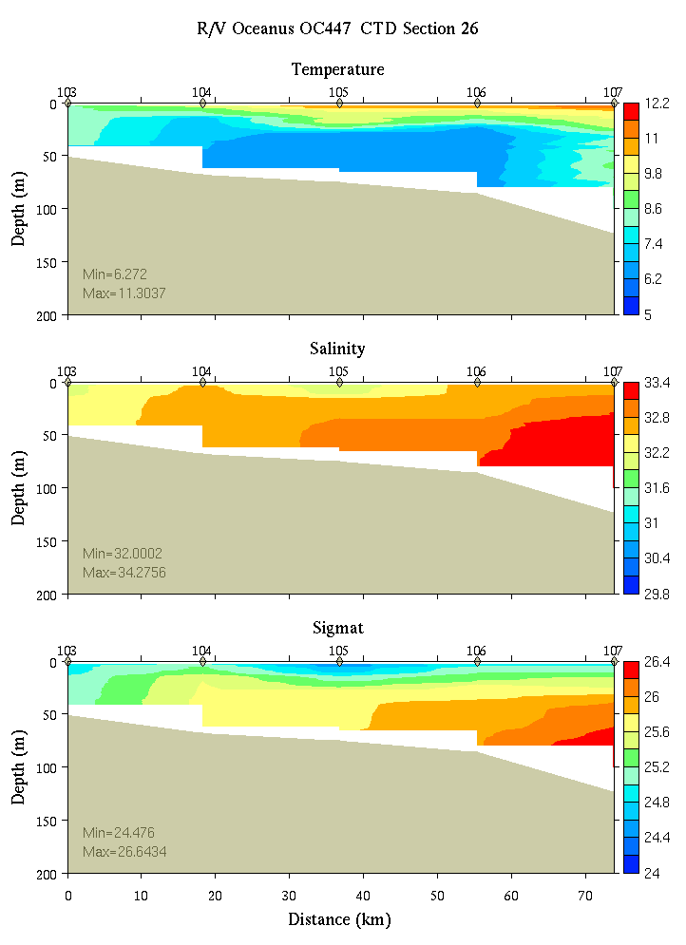 | 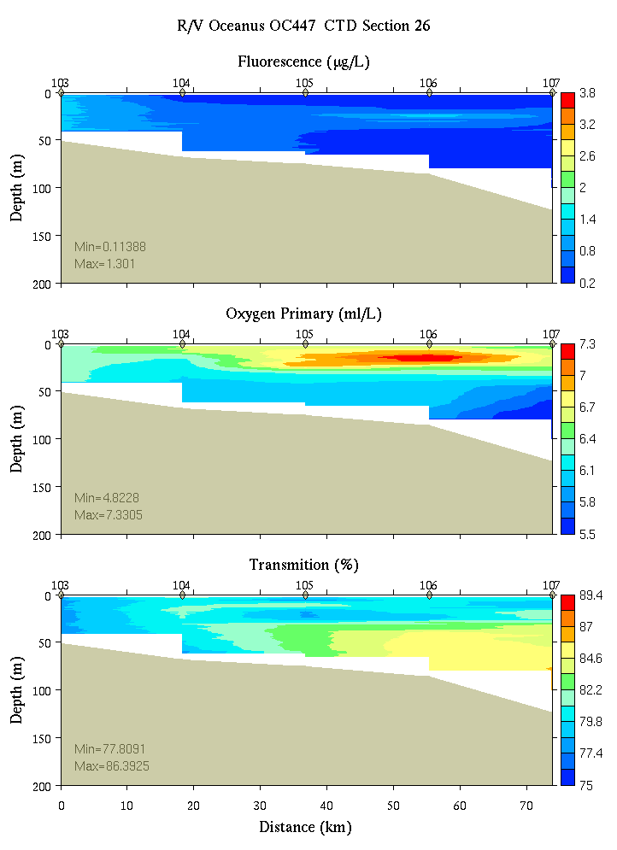
Figure C24. Section 26, 0-200m: temperature, salinity, and density (left); fluorescence, oxygen, and beam transmission (right).

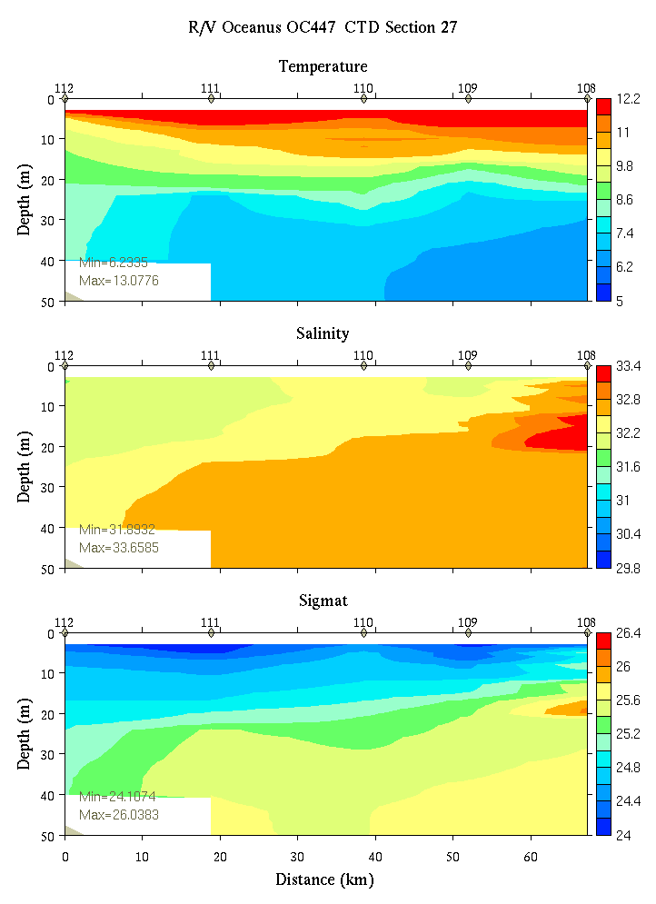 | 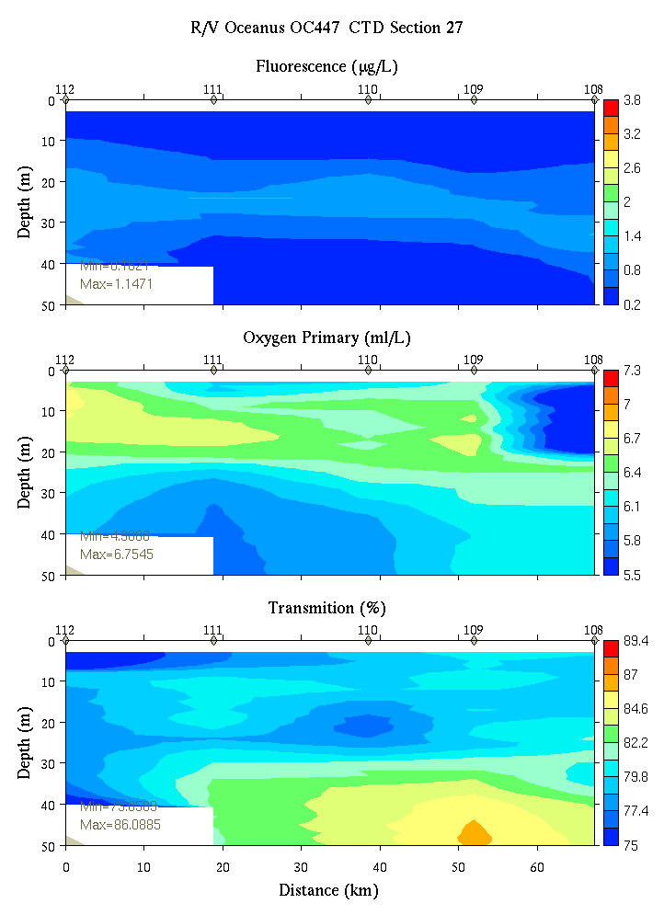
Figure C25. Section 27, 0-50m: temperature, salinity, and density (left); fluorescence, oxygen, and beam transmission (right).

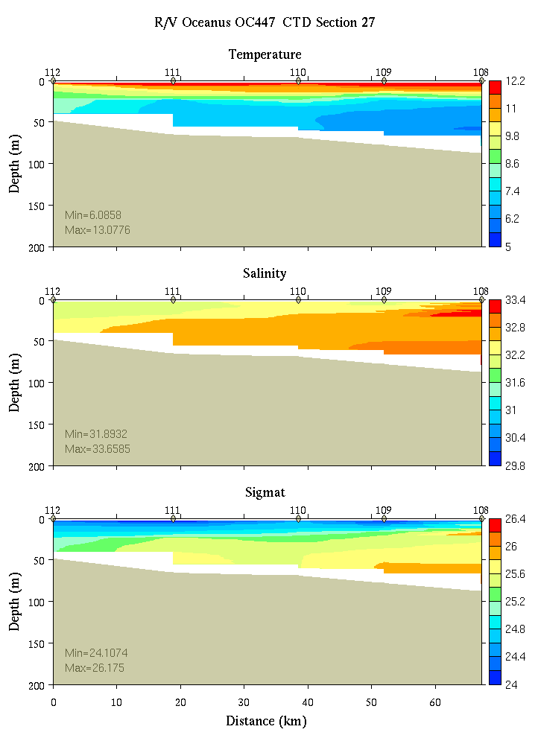 | 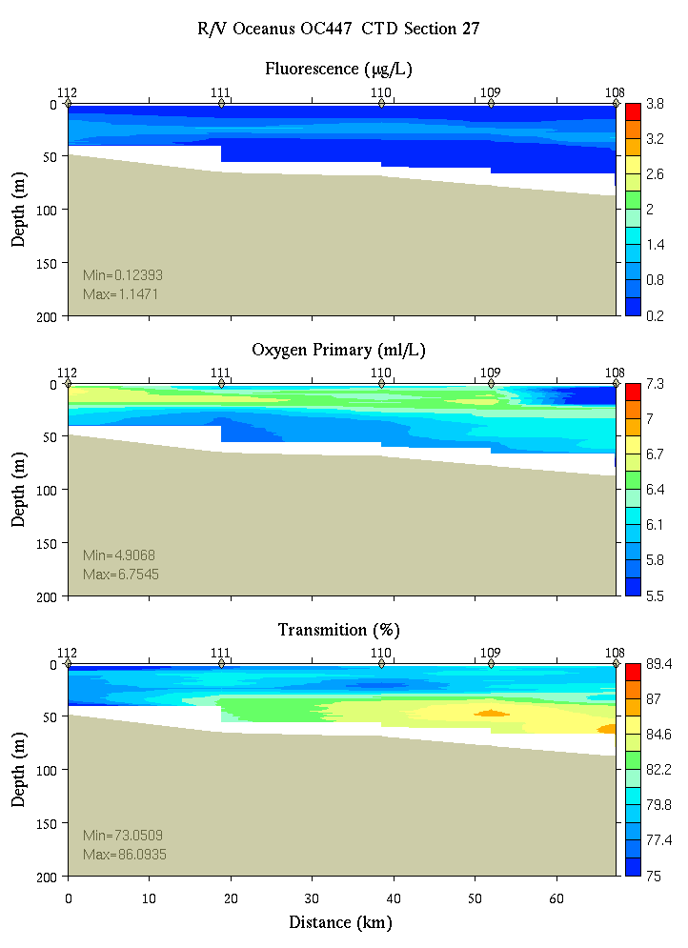
Figure C26. Section 27, 0-200m: temperature, salinity, and density (left); fluorescence, oxygen, and beam transmission (right).

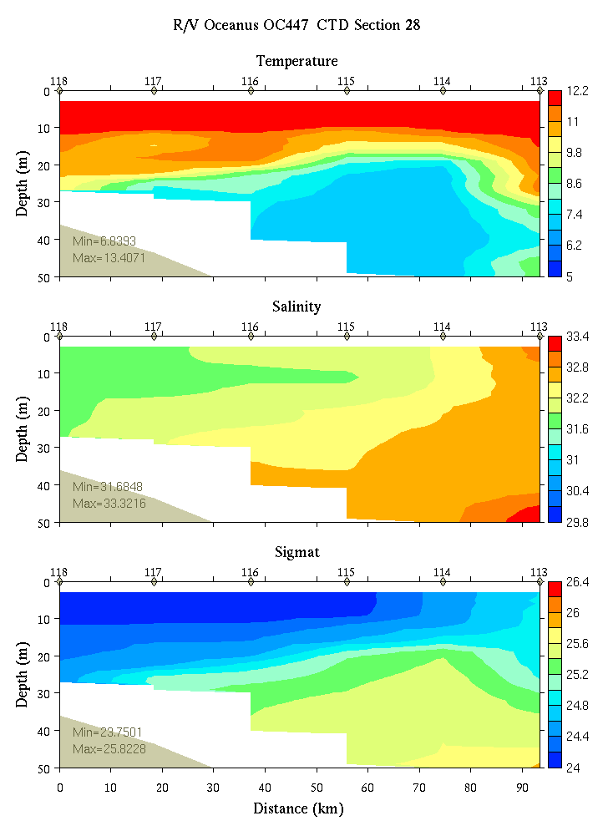 | 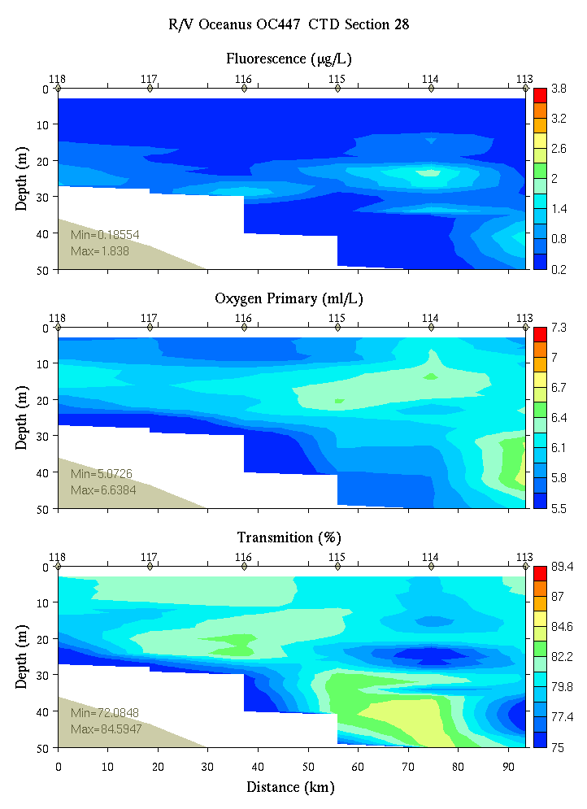
Figure C27. Section 28, 0-50m: temperature, salinity, and density (left); fluorescence, oxygen, and beam transmission (right).

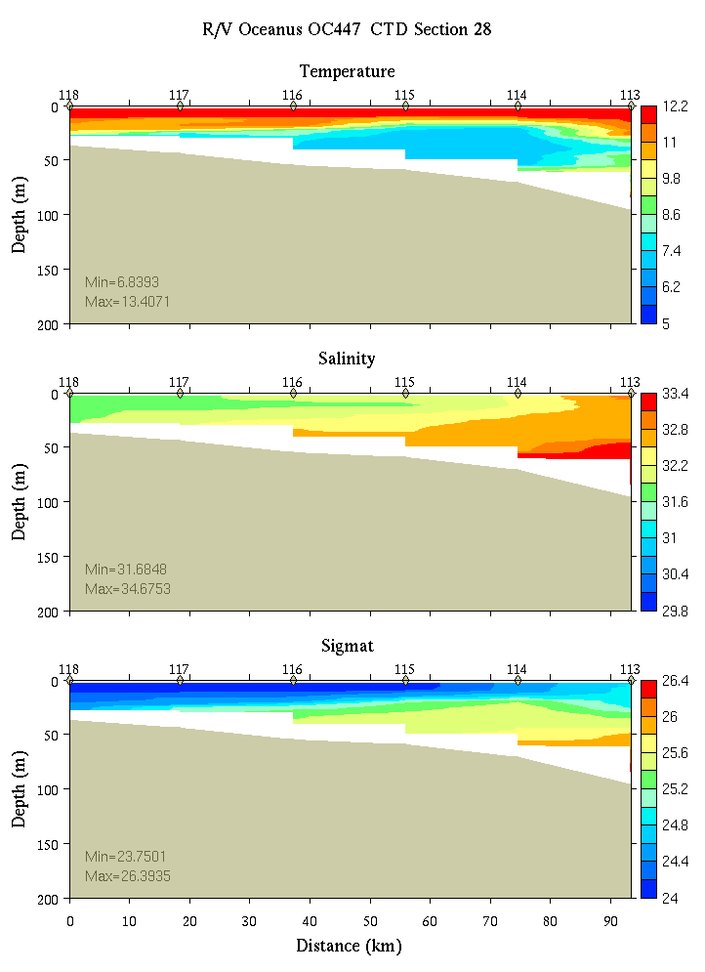 | 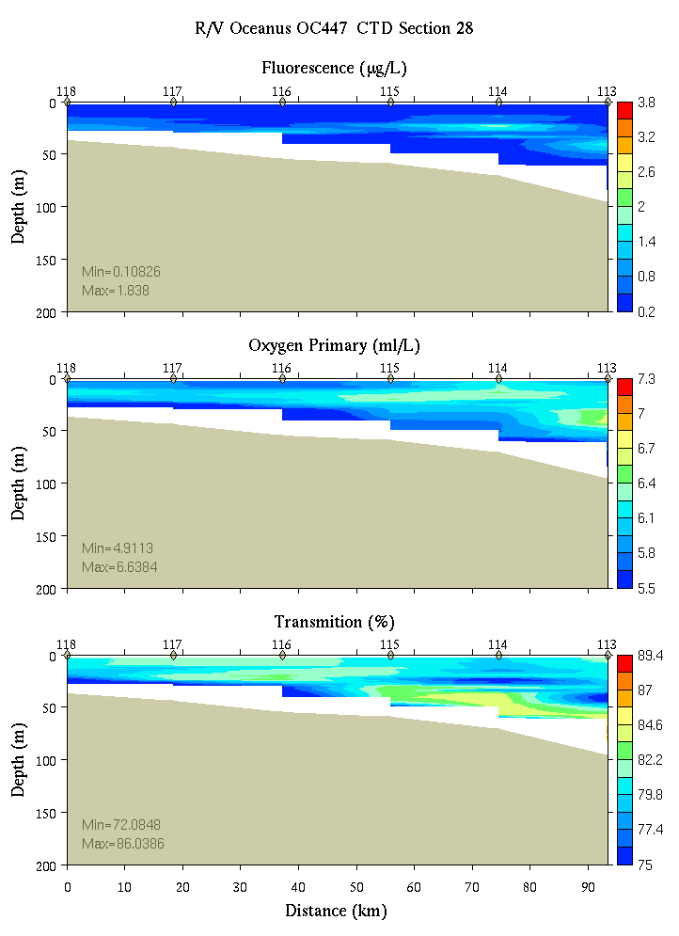
Figure C28. Section 28, 0-200m: temperature, salinity, and density (left); fluorescence, oxygen, and beam transmission (right).

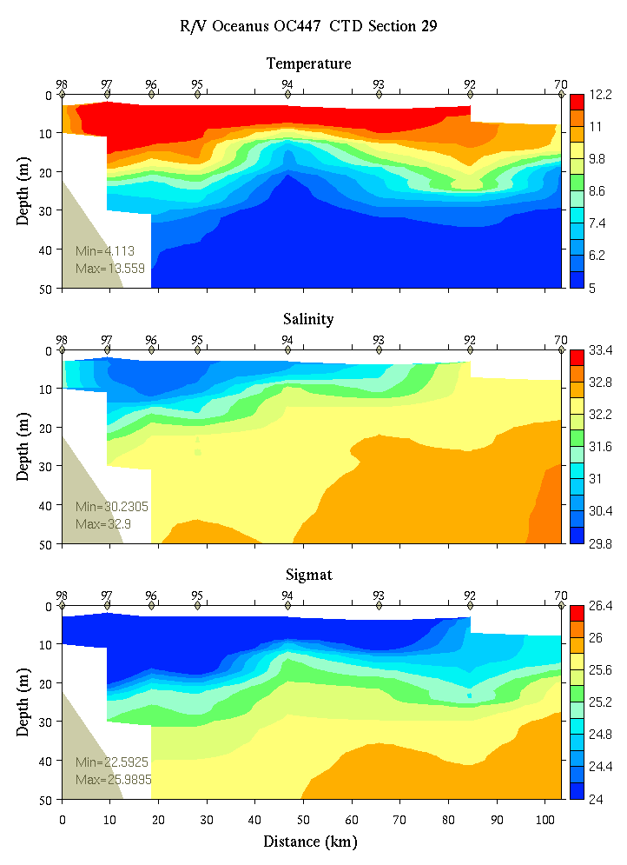 | 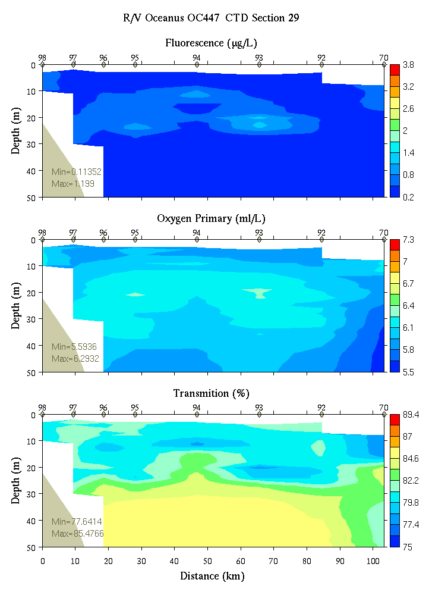
Figure C29. Section 29, 0-50m: temperature, salinity, and density (left); fluorescence, oxygen, and beam transmission (right).

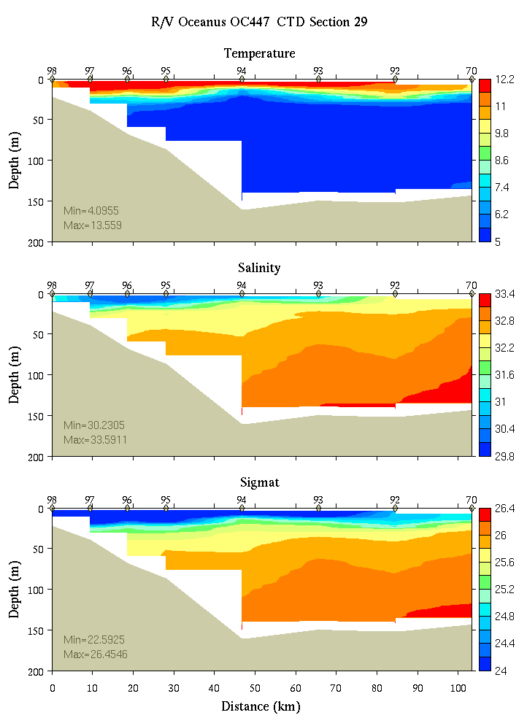 | 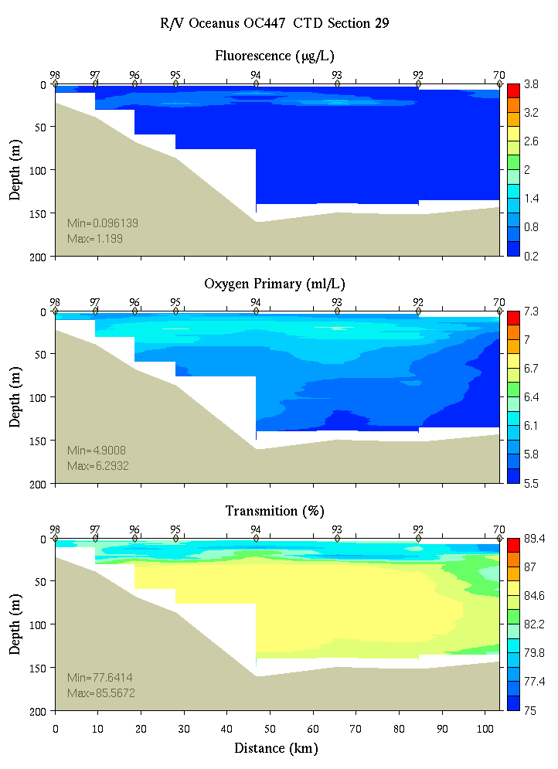
Figure C30. Section 29, 0-200m: temperature, salinity, and density (left); fluorescence, oxygen, and beam transmission (right).

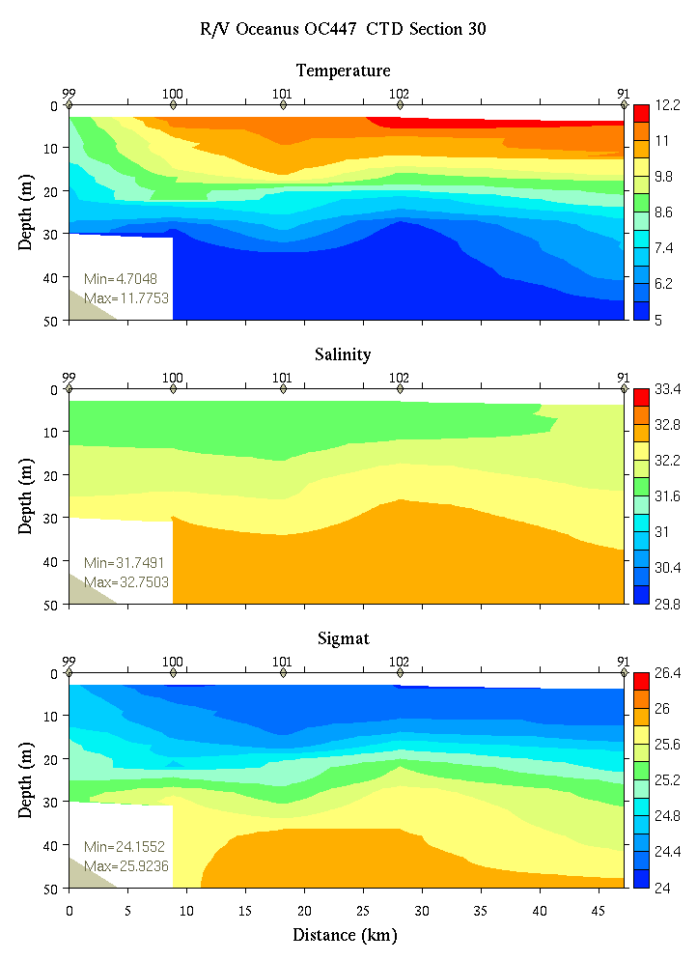 | 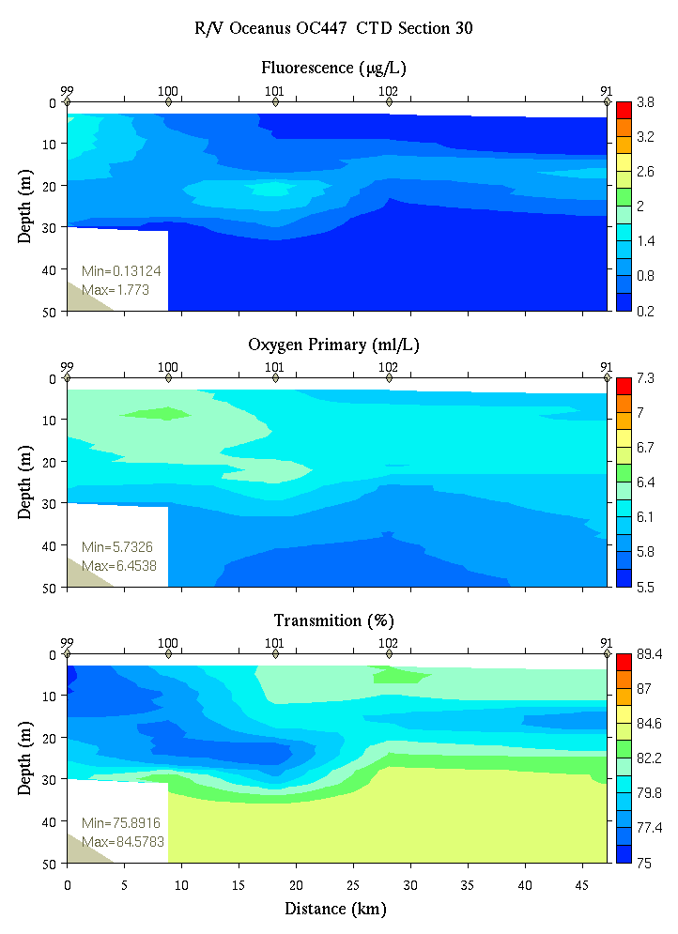
Figure C31. Section 30, 0-50m: temperature, salinity, and density (left); fluorescence, oxygen, and beam transmission (right).

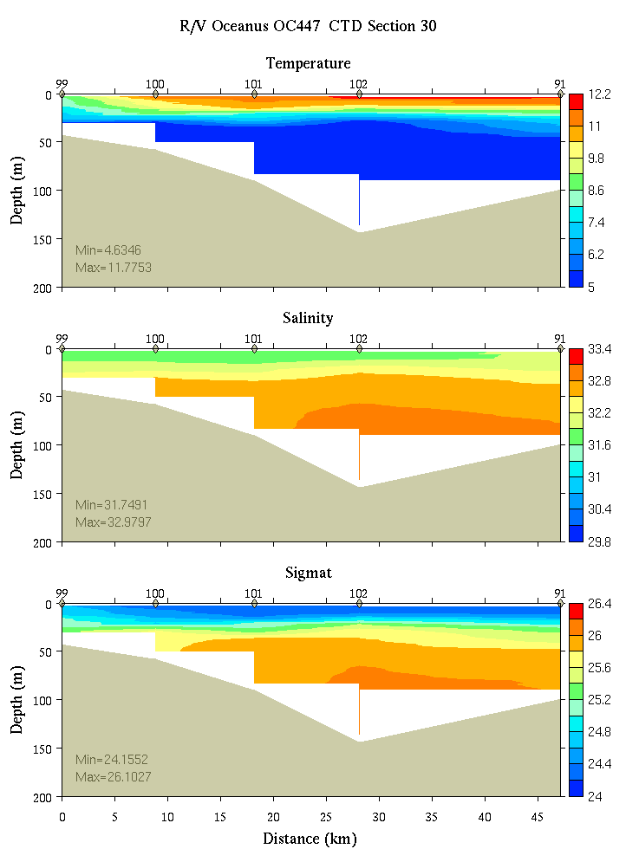 | 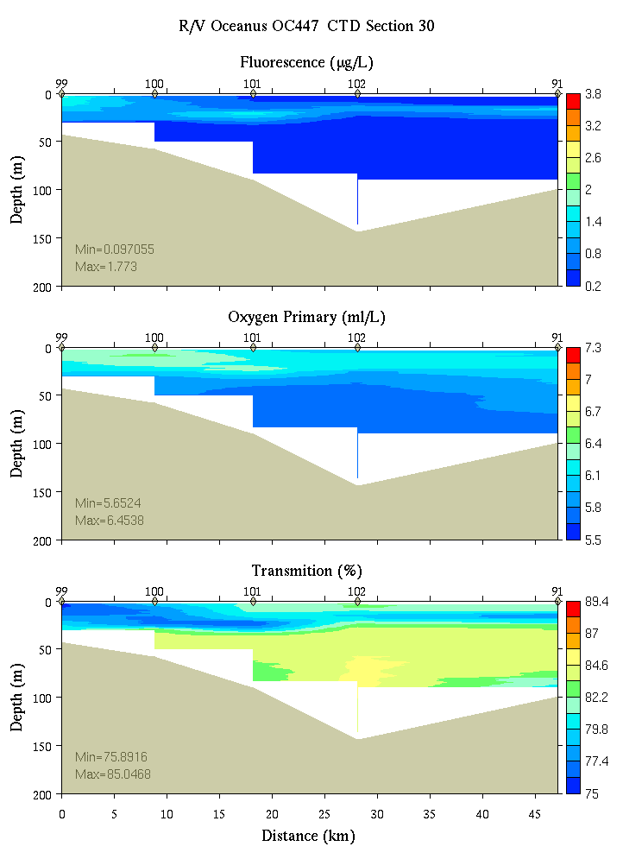
Figure C32. Section 30, 0-200m: temperature, salinity, and density (left); fluorescence, oxygen, and beam transmission (right).

Appendix D: Satellite imagery
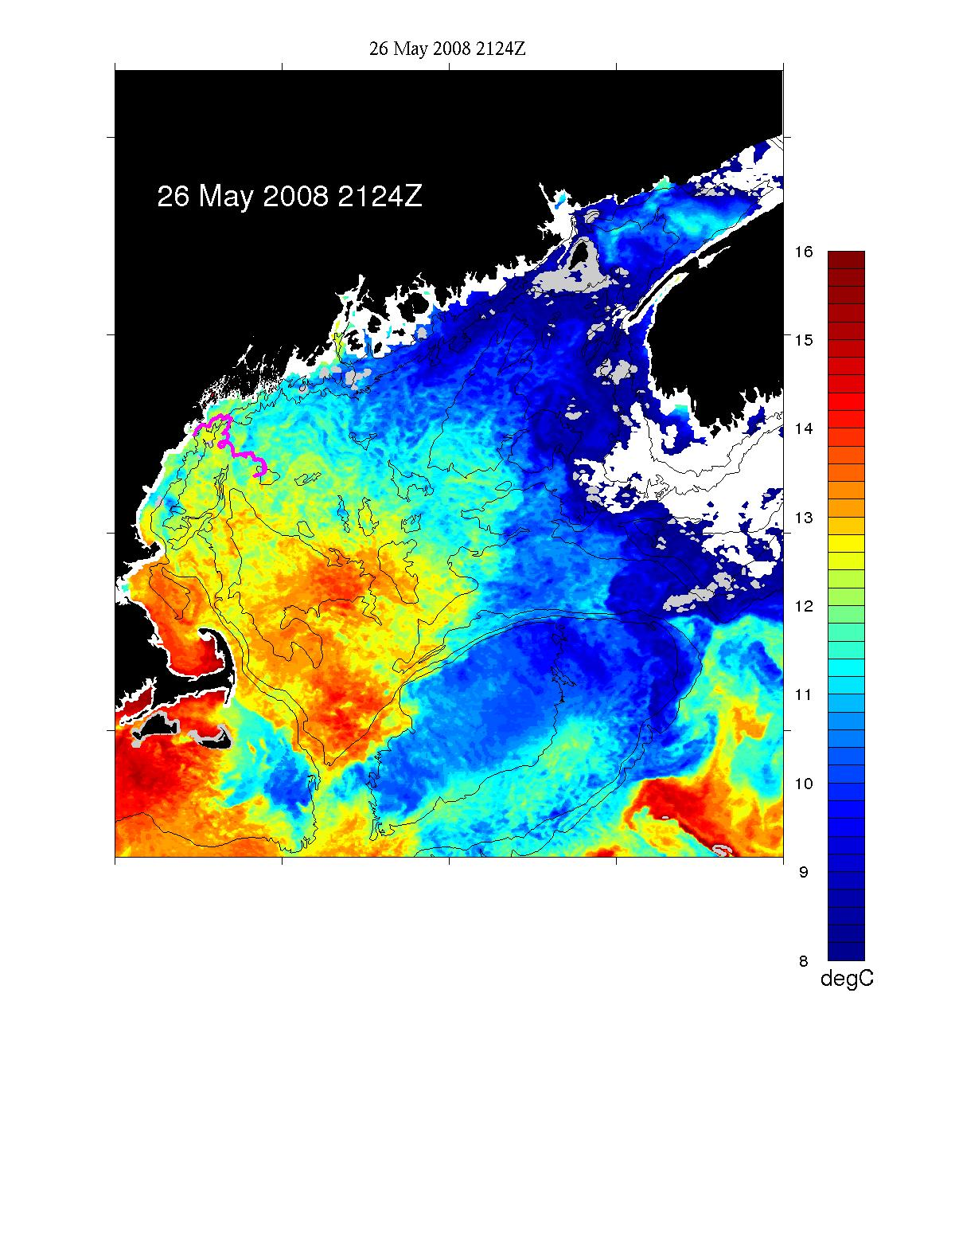
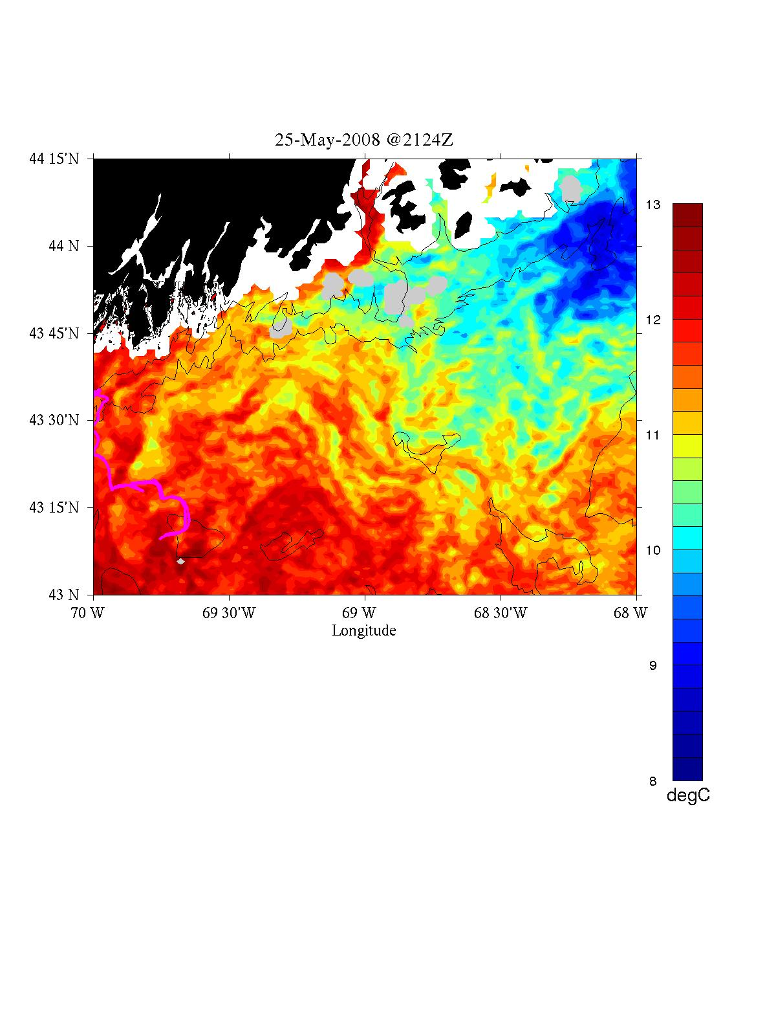
May 28, 2008
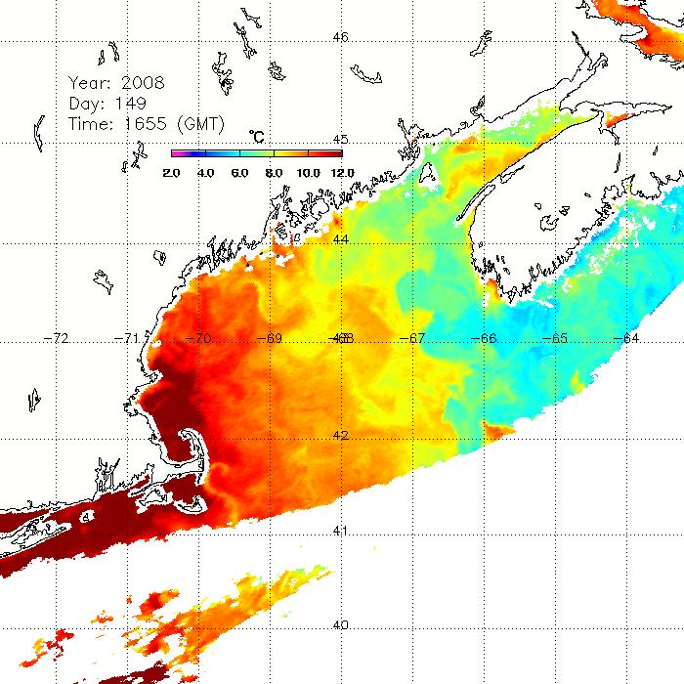

May 29, 2008

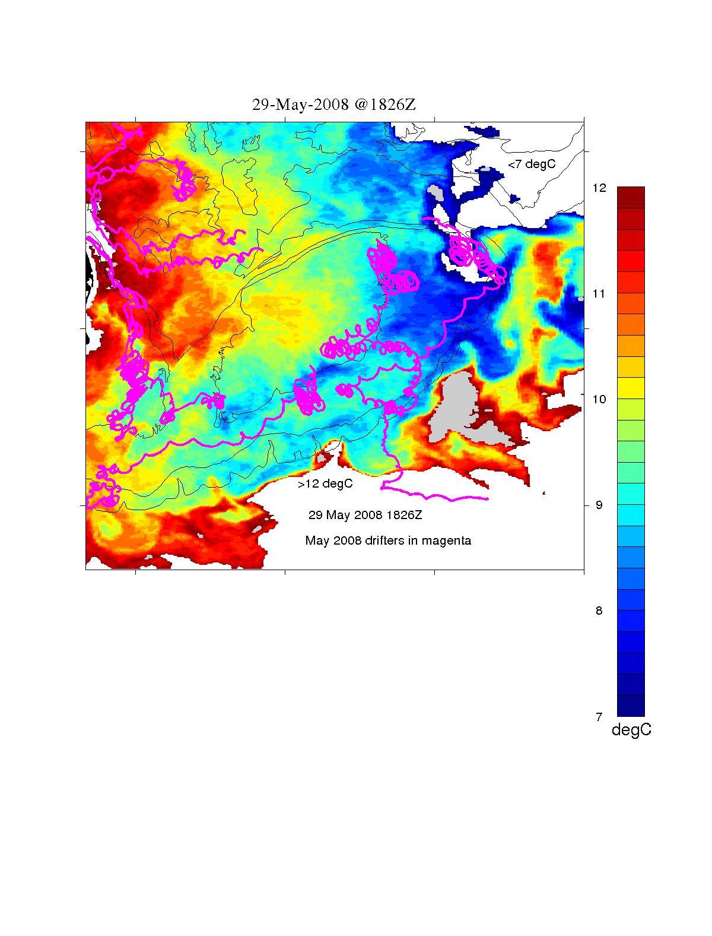

May 30, 2008
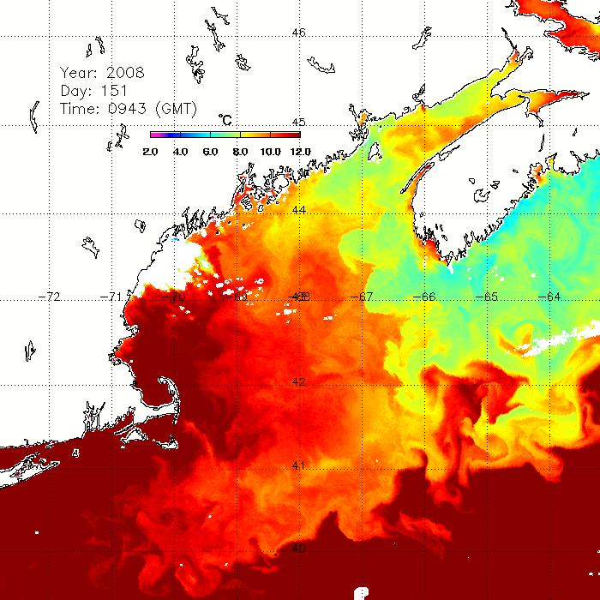
May 30, 2008
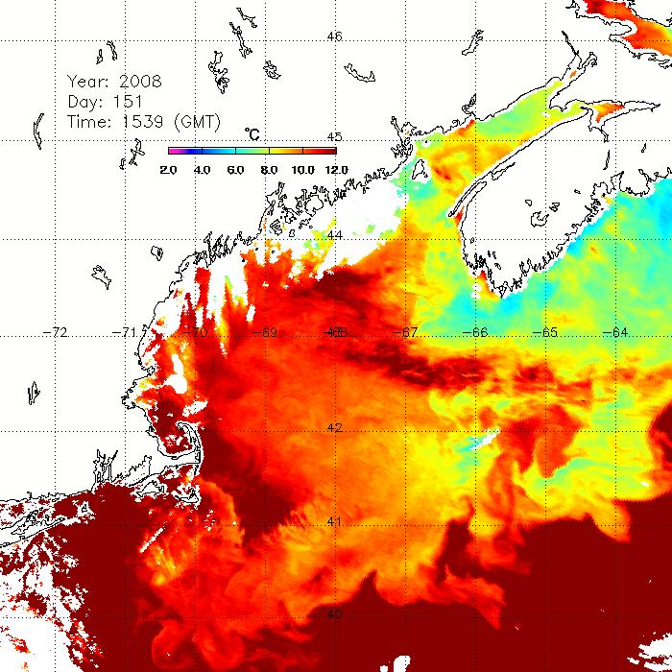

May 30, 2008

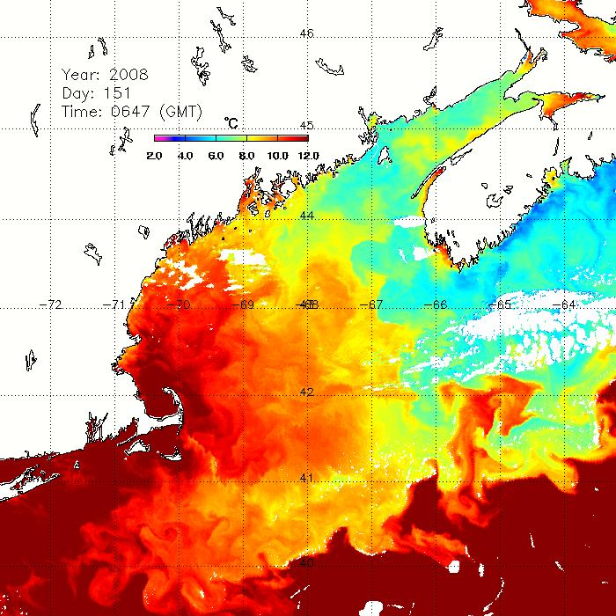

Appendix E: Personnel

1. Dennis McGillicuddy (Chief Scientist)
2. Valery Kosnyrev
3. Olga Kosnyreva
4. Keston Smith
5. Bruce Keafer
6. Kerry Norton
7. Bibiana Crespo
8. Luciano Fernandez
9. Stacey Lee
10. David Townsend
11. Maura Thomas
12. Nathan Reebuck
13. Rachel Gettings
14. Morgan Brunbauer
15. Jeff Turner
16. Peter Milligan
17. Meri Ratzel
18. Larry Anderson
Watch Schedule

Watch number 1 2 3
4 on / 8 off 8-12 12-4 4-8

1. CTD Operator Morgan Larry Keston
2. Cell Counter Meri* Kerry* Bruce*&
3. Nutrient sampler Dave# Nathan# Maura#
4. Water sampler Valery# Luciano#& Jeff
5. Water sampler Stacey Bibiana Peter#
6. Water sampler Olga Rachel

* Wetlab chief
# CTD deck operations: 2 slip line handlers (#)
& qPCR leader

http://www.whoi.edu/science/cohh/whcohh/projects/habs1_abstract.htm
Also see http://nefsc.noaa.gov/drifter
Available at http://science.whoi.edu/users/mcgillic/oc447/at_sea_modeling

