OC445 Cruise Report
Draft 5/7/08

Voyage #445 of R/V Oceanus was the first of four cruises in 2008 organized to serve complementary scientific objectives of two different projects. The two projects are:

Alexandrium population biology in the Gulf of Maine – Woods Hole Center for Oceans and Human Health – NSF/NIEHS

Objectives:
Sample genetic variability of Alexandrium subpopulations throughout the Gulf of Maine.

Measure changes in relative abundance of Alexandrium genotypes in space and time.

GOMTOX: Dynamics of Alexandrium fundyense distributions in the Gulf of Maine: an observational and modeling study of nearshore and offshore shellfish toxicity, vertical toxin flux, and bloom dynamics in a complex shelf sea – NOAA ECOHAB

Objectives:
Investigate A. fundyense bloom dynamics and the pathways that link this organism to toxicity in nearshore and offshore shellfish.

Investigate the vertical structure of A. fundyense blooms, vertical toxin flux, and linkage to toxicity in offshore shellfish.

Objectives common to both projects include:
Assess hydrodynamic and hydrographic context for interpretation of Alexandrium spp. measurements.

Incorporate field observations into a suite of numerical models for hindcasting and forecasting applications.

The primary domain of interest is Georges Bank, where a large bloom of A. fundyense was observed in 2007. The bloom was present on Georges Bank upon our arrival in May (EN435) and still quite conspicuous during our second cruise in June/July (EN437). The four one-week cruises in 2008 are designed to (1) resolve the seasonal variation of the Georges Bank bloom, and (2) quantify its interannual variability.

A secondary objective was added to the 2008 cruises when the results of the fall 2007 cyst survey (OC447) revealed that cyst abundance offshore of mid-coast Maine is now 30% higher than it was just prior to the historic bloom of 2005. This field season thus offers an exceptional opportunity for testing the hypothesis that the magnitude of the bloom in the western Gulf of Maine and Southern New England is set by the abundance of cysts. We therefore must consider the possibility of redirecting some of this year’s observational effort from Georges Bank to the Gulf of Maine. These choices will be informed by a number of factors, including real-time nowcasting and forecasting activities (URL), as well as state agency toxicity monitoring efforts along the coasts of Maine, New Hampshire, and Massachusetts. If widespread toxicity appears along the coast, that would be consistent with the cyst hypothesis. However, if widespread toxicity does not appear, that would not necessarily be inconsistent with the hypothesis, as a large bloom could be present offshore. It is in this latter circumstance that diverting to the western Gulf of Maine would be most advantageous for hypothesis testing, insofar as confirming the absence of a large bloom would provide evidence for rejecting the hypothesis.

Results

OC445 began with a survey of Georges Bank (Figure 1). Surface live counts indicate cell concentrations ranging from zero to several hundred cells per liter, with highest concentrations on the northwest part of the bank. Tens to hundreds of cells per liter extend through the western half of the crest to the southern flank. Two distinct water mass anomalies are present on the southern flank: a warm salty intrusion to the west, and a cold fresh tongue to the east, which appears to have originated from a crossover of Scotian Shelf water visible in satellite imagery (Appendix C). Both of these water mass anomalies are nearly devoid of cells, thus these water mass anomalies may be contributing to the relatively low cell concentrations on that part of the bank. The west-to-east gradient in cell concentration on the northern half of the bank is more difficult to explain.

Early completion of the Georges Bank survey allowed for some sampling in the western Gulf of Maine. The near-real-time quasi-operational A. fundyense forecast was received at sea, indicating that the strong southeast winds early in the week reduced cell concentrations (presumably by vertical mixing) and arrested the along-shore movement of the bloom (Figure 2). It was therefore decided to begin the WGOM sampling with the Casco Bay transect, just upstream of where the model indicates the highest cell concentrations reside.

Live counts from the western Gulf of Maine survey indicate significant cell concentrations in the Casco Bay and Saco Bay transects (Figure 3). In the Casco Bay transect, the peak concentration of 112 cells l⁻¹ was observed just offshore of a very strong river plume signature that extended 30 km offshore. The extent of the river plume is particularly noteworthy given the easterly wind conditions that have predominated recently. This may be a reflection of excessive river runoff resulting from the heavy snowfall that occurred in the western Maine river catchment area during the winter of 2007/2008. Salinities as low as 14 were measured at inshore stations and the underway system. Cell concentrations were considerably higher in the Saco Bay transect, where the peak concentration of 882 cells l⁻¹ was observed. Alexandrium concentrations decreased to below 100 cells l⁻¹ in the Cape Ann transect, and below 30 cells l⁻¹ in the Boston transect. The volume of fresh water is very large in the Boston transect, with the outcrop of the 32 ppt isohaline nearly 70km offshore.

These findings are in stark contrast with those from 2007, where the western Gulf of Maine was virtually devoid of Alexandrium cells in mid-to-late May (even later in the bloom season). Live counts from EN437 (May 17-31 2007) were almost all zeros, with Alexandrium detected at only a few isolated stations. The peak concentration of 84 cells l⁻¹ was observed at the innermost station of the Saco Bay transect.

Observations in this area during the late April / early May time period during the ECOHAB-GOM era range from zero to approximately 200 cells l⁻¹ (Table 1). In comparing the live counts from the present cruise with those published observations, one must bear in mind the methodological differences: the former are not able to distinguish A. fundyense from other species that are morphologically similar, whereas the latter are more species specific. Nevertheless, the initial results of OC445 suggest higher than average cell concentrations in the western Gulf at this very early stage of the bloom season. Our findings are thus not inconsistent with the hypothesis that the 2008 bloom will be anomalously large. Qualitatively, the observations agree with the model predictions for May 1 (Figure 2) insofar as (1) cells are present from Casco Bay down to Cape Ann; (2) peak concentrations occur offshore of Saco Bay; (3) cells are virtually absent from Massachusetts Bay.

A total of 3 surface drifters were deployed at the inshore stations of the Casco Bay transect (Figure 4; Appendix A, Table 3). Two of the drifters entered Casco Bay (one grounded), and the offshore most drifter deployed outside the river plume moved southwest in the coastal current.

Date | Max surface  concentration  (cells l⁻¹) | Location |  | Reference
21-23 April 1998 | 200 | Inshore Casco Bay |  | Keafer et al. 2005a
28-29 April 2000 | 50 | Offshore Casco Bay |  | Keafer et al. 2005a
April/May 2000 | 200 | Inshore Casco Bay |  | Townsend et al. 2005
3-4 May 2000 | 200 | Offshore Casco Bay |  | Keafer et al. 2005a
6-11 May 2001 | 0 | N/A |  | Keafer et al. 2005b
Table 1. Maximum A. fundyense cell concentrations found in western Gulf of Maine waters (Casco Bay and westward) in late April / early May.
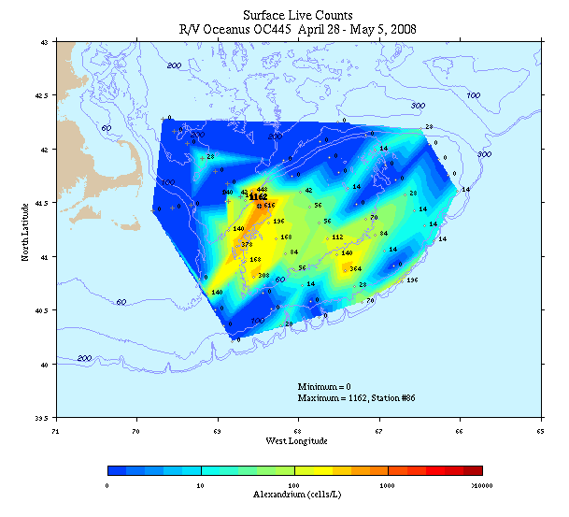 |  |  | 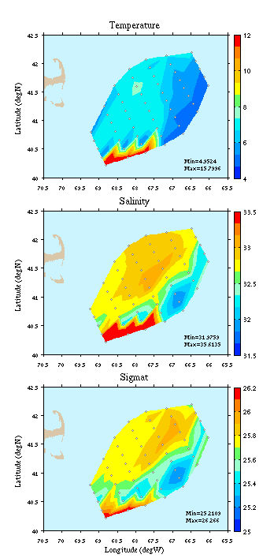
Figure 1. Left: Alexandrium concentration (cells l⁻¹) on Georges Bank from surface live counts on OC445. Right: temperature, salinity, and density at 10m depth.

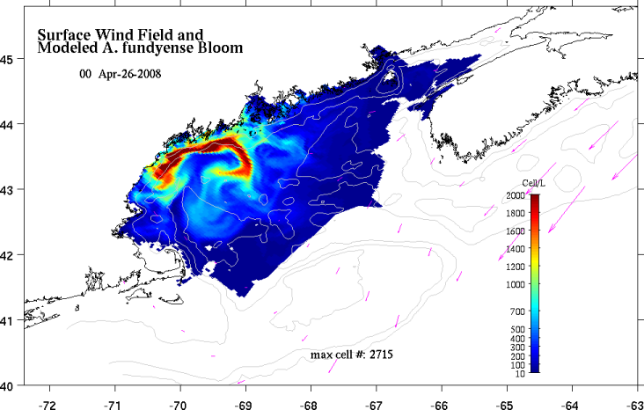 | 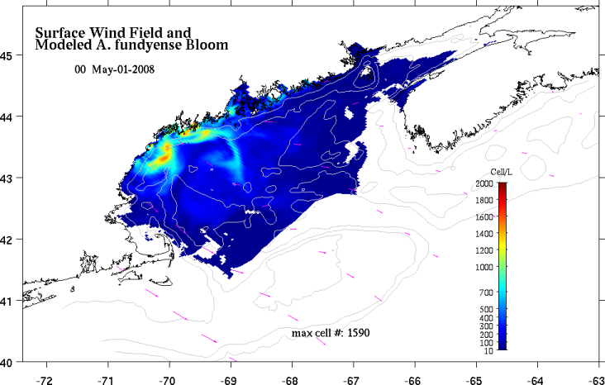
Figure 2. A. fundyense model predictions for April 26 (left) and May 1 (right). For a complete description of the forecast system and 2008 results, see http://omglnx3.meas.ncsu.edu/yli/08forecast/.

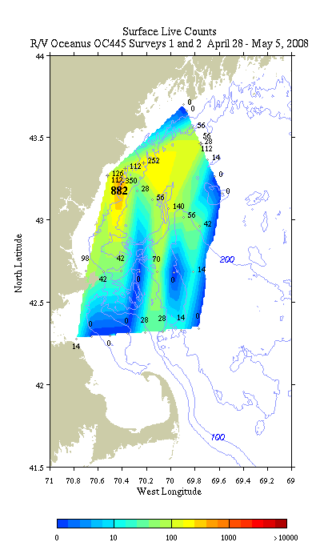 | 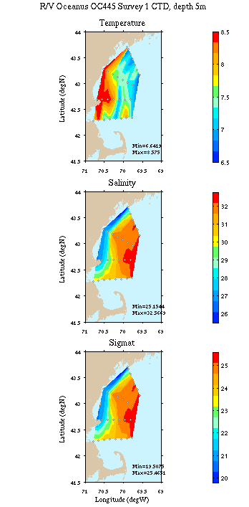
Figure 3. Left: Alexandrium concentration (cells l⁻¹) in the western Gulf of Maine from surface live counts on OC445. Right: temperature, salinity, and density at 10m depth.

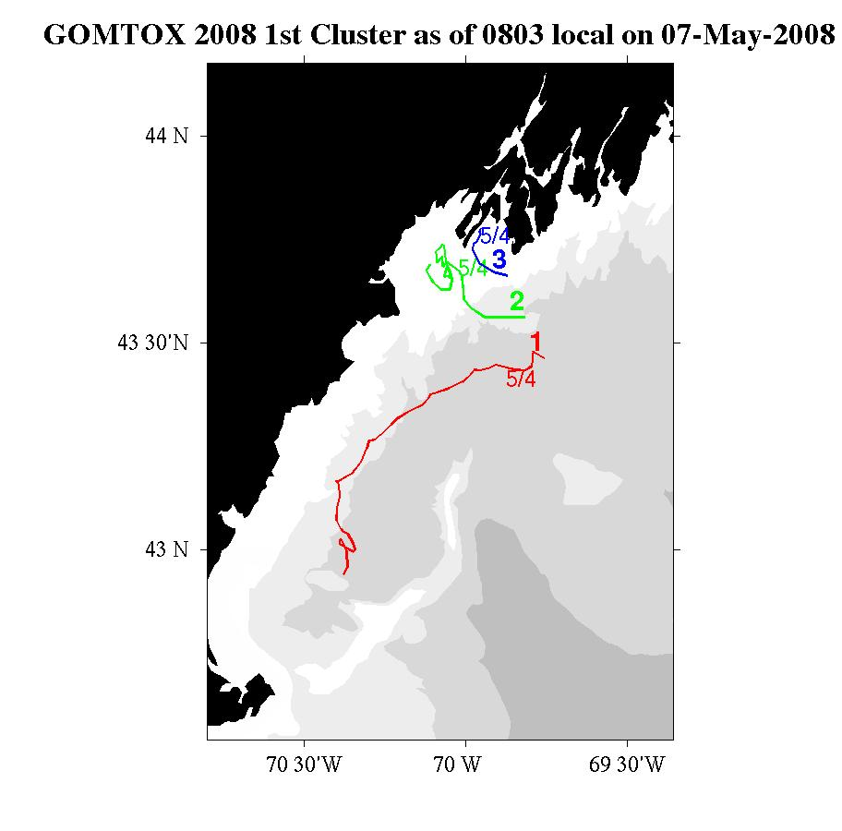
Figure 4. Trajectories of drifters released along the Casco Bay line on OC445.

Appendix A: Measurements made on OC445

Underway measurements
a. Acoustic Doppler Current Profiler
b. Meteorological sensors

Core hydrographic measurements
a. CTD (pressure, temperature, salinity, oxygen, fluorescence, beam attenuation, PAR)
b. Alexandrium cell counts: 1, 10, 20, 30, 40, 50m plus 250/near bottom
c. Nutrients: standard depths plus 100, 150, 200, 250m

Bottle # | Depth | Live | Whole Cell | SHA | qPCR | Nuts/Chl | Pseuds | total
1 | 1 |  | 2 | 2 | 2 | 1.0 | 0.5 | 7.5
2 | 1 | 10 |  |  |  |  |  | 10
3 | 1 |  |  |  |  |  |  | spare
4 | 10 |  | 2 | 2 | 2 | 1.0 | 0.5 | 7.5
5 | 20 |  | 2 | 2 | 2 | 1.0 | 0.5 | 7.5
6 | 30 |  | 2 | 2 | 2 | 1.0 | 0.5 | 7.5
7 | 40 |  | 2 | 2 | 2 | 1.0 | 0.5 | 7.5
8 | 50 |  | 2 | 2 | 2 | 1.0 | 0.5 | 7.5
9 | 100 |  |  |  |  | 1.0 |  | 1.0
10 | 150 |  |  |  |  | 1.0 |  | 1.0
11 | 200 |  |  |  |  | 1.0 |  | 1.0
12 | 250 / near bottom |  | 8? |  |  | 1.0 |  | 9.0
Table 1. Water budget

Af water- one 6 hole-manifold loaded twice
6L/depth combined/split x 6 depths=6 WC tubes&12 filters/station
Pseuds – 100-500 ml whole water onto 0.65um Duropore? Frozen in Dewar; manifold 2; 6 filters/station
Additional opportunistic samples may be taken in areas of high Alexandrium abundance.

Toxin size fractionation – Turner
Pump profiles were carried out at selected locations. Sampling depths were chosen to coincide as closely as possible with hydrographic sampling and sediment trap measurements. Pump deployments are summarized in Table 2.

 | Date | Time  (local) | Latitude | Longitude | Station | Live Count
1 | May 1 | 0820 | 41 11.95 N | 67 02.14 W | 38a GB S Flank | 84
2 | May 3 | 0840 | 43 27.8 N | 69 45.1 W | 59a Portland Shipping Lanes | 112
3 | May 3 | 1408 | 43 13.8 N | 070 24.5 W | 64a offshore Saco Bay | 882
8 | May 4 | 1038 | 41 27.88 N | 68 28.97 W | NW GB | 1200
Table 2. Pump stations.

Drifters

ID | Mon | Day | Year | GMT  (hhmm) | Lon (ddmm) | Lat  (ddmm) | Drogue  depth(m) | Station Number
85171 | 5 | 3 | 2008 | 0910 | 69 45.36 | 43 27.79 | 1 | 59
85172 | 5 | 3 | 2008 | 0959 | 69 49.00 | 43 33.72 | 1 | 60
85173 | 5 | 3 | 2008 | 1043 | 69 52.30 | 43 39.79 | 1 | 61
76381 | 6 | 29 | 2007 | 2304 | 6831.90 | 4401.80 | 1 | 55
Table 3: Summary of drifter releases on Casco Bay line. For more information see http://nefsc.noaa.gov/drifter.

Other measurements
a. Mussel bags: Casco, Cobscook, Blue Hill, Frenchman’s – Darcy Couture
b. AVHRR, SeaWiFS, MODIS false-color imagery – Andy Thomas
c. GoMOOS moorings
d. NOAA coastal tide gauges
e. NMFS quarterly survey – March-April CTD data

Appendix B: Hydrographic maps

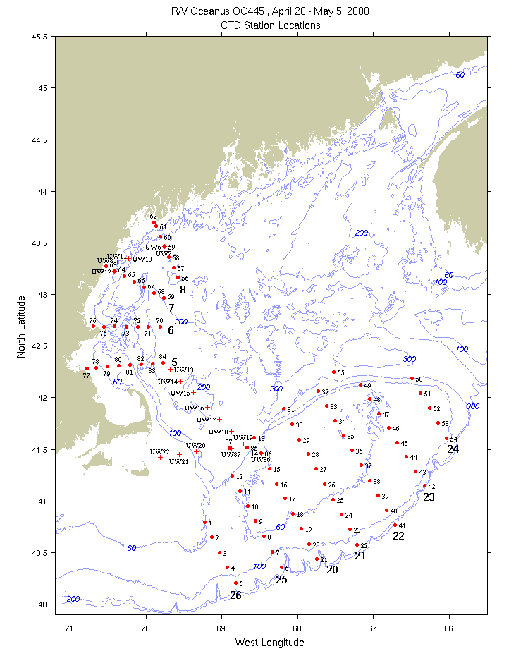
Figure B1: CTD (red dots) and underway (red crosses) station locations. Bold numerals indicate identifiers for the sections displayed below. Note: some of the underway station positions may be incorrect; check back soon for updates.

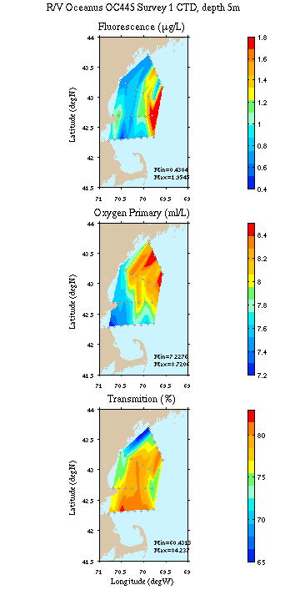
Figure B2: Coastal GOM survey maps at 5m depth. Left: temperature, salinity, and density; right: fluorescence, oxygen, and light transmission.

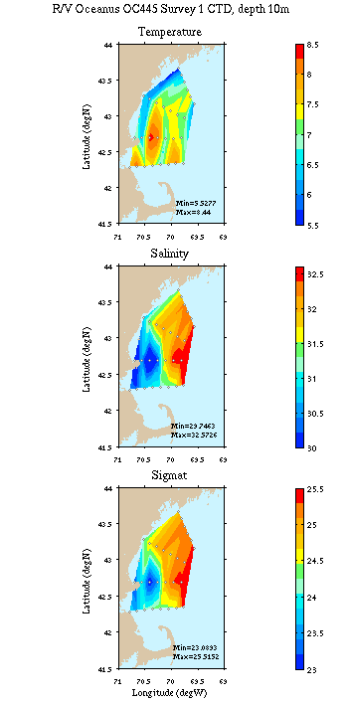 | 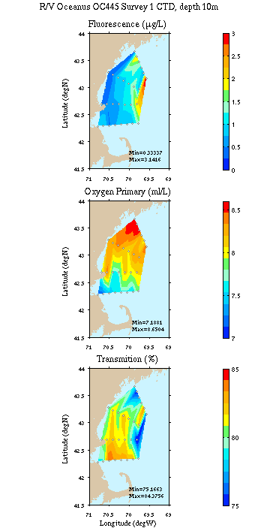
Figure B3: Coastal GOM survey maps at 10m depth. Left: temperature, salinity, and density; right: fluorescence, oxygen, and light transmission.

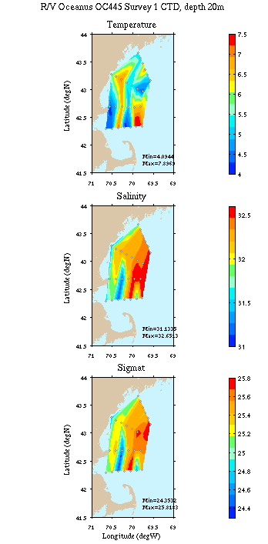 | 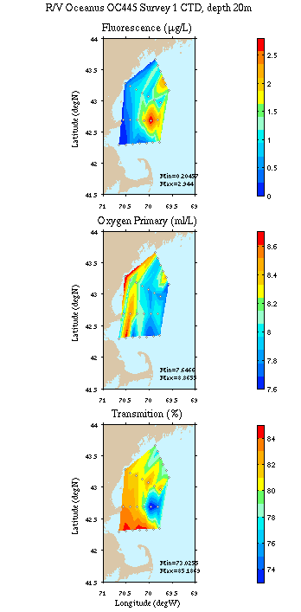
Figure B4: Coastal GOM survey maps at 20m depth. Left: temperature, salinity, and density; right: fluorescence, oxygen, and light transmission.

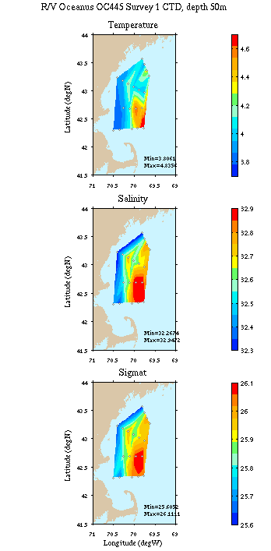 | 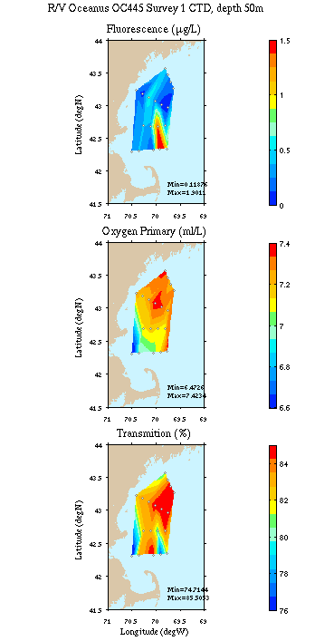
Figure B5: Coastal GOM survey maps at 50m depth. Left: temperature, salinity, and density; right: fluorescence, oxygen, and light transmission.

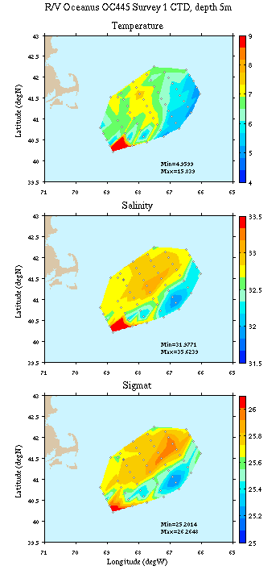 | 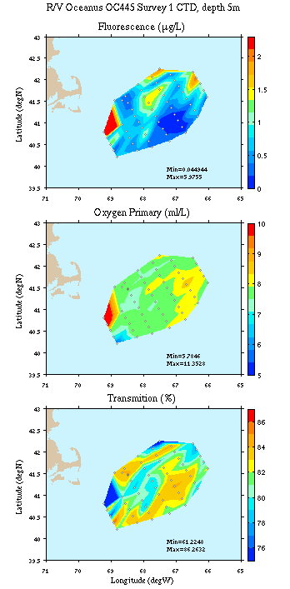
Figure B6: Georges Bank / Southern New England survey maps at 5m depth. Left: temperature, salinity, and density; right: fluorescence, oxygen, and light transmission.

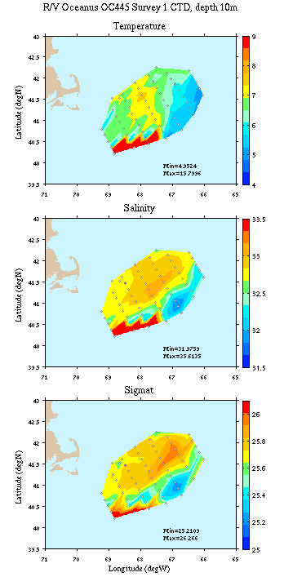 | 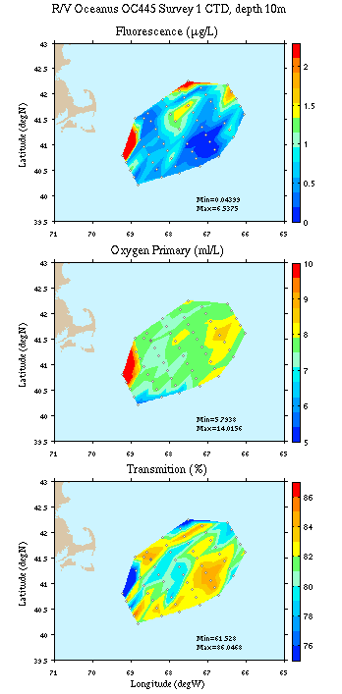
Figure B7: Georges Bank / Southern New England survey maps at 10m depth. Left: temperature, salinity, and density; right: fluorescence, oxygen, and light transmission.

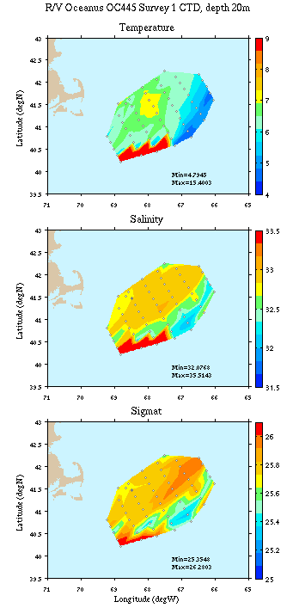 | 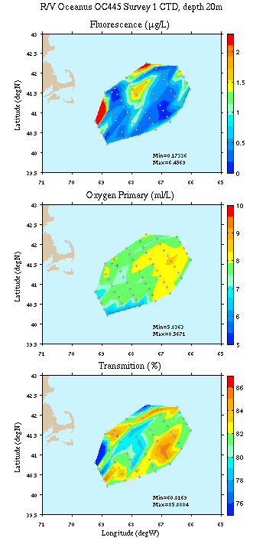
Figure B8: Georges Bank / Southern New England survey maps at 20m depth. Left: temperature, salinity, and density; right: fluorescence, oxygen, and light transmission.

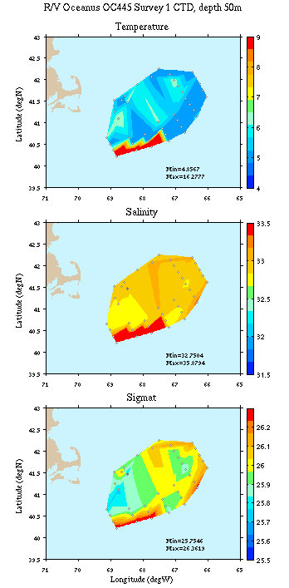 | 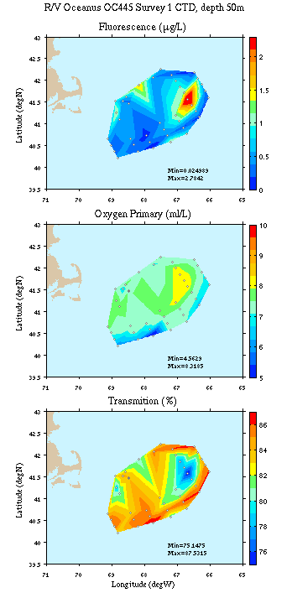
Figure B9: Georges Bank / Southern New England survey maps at 50m depth. Left: temperature, salinity, and density; right: fluorescence, oxygen, and light transmission.

Appendix C: Vertical sections.

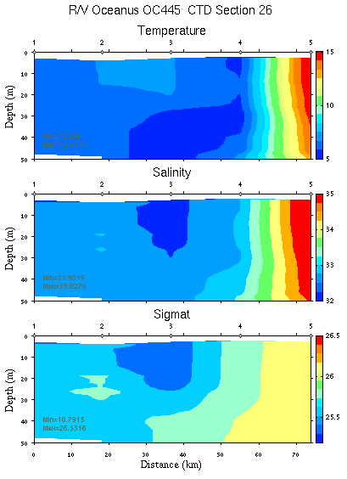 | 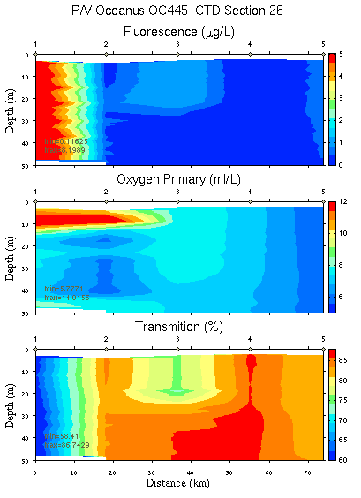
Figure C1. Section 26, 0-50m: temperature, salinity, and density (left); fluorescence, oxygen, and beam transmission (right).

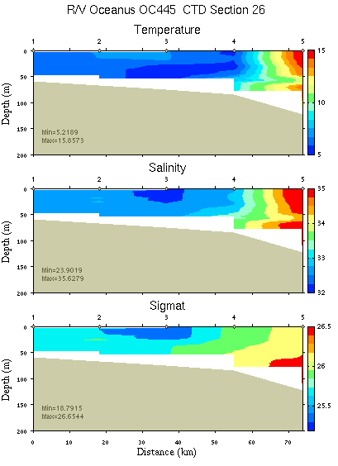 | 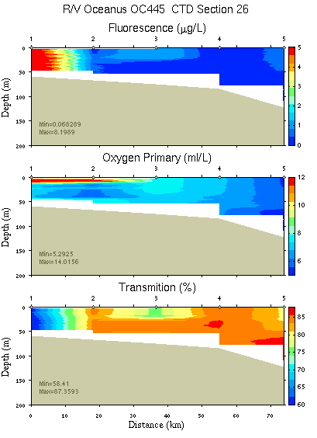
Figure C2. Section 26, 0-200m: temperature, salinity, and density (left); fluorescence, oxygen, and beam transmission (right).

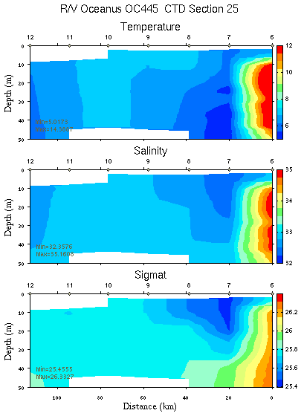 | 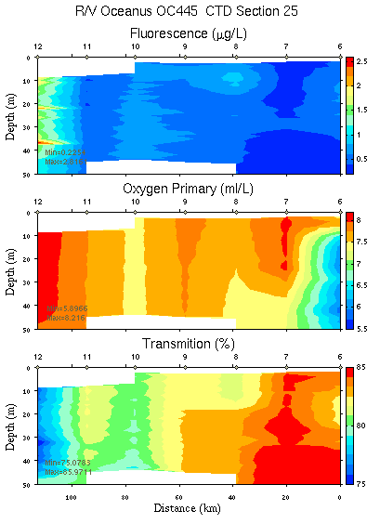
Figure C3. Section 25, 0-50m: temperature, salinity, and density (left); fluorescence, oxygen, and beam transmission (right).

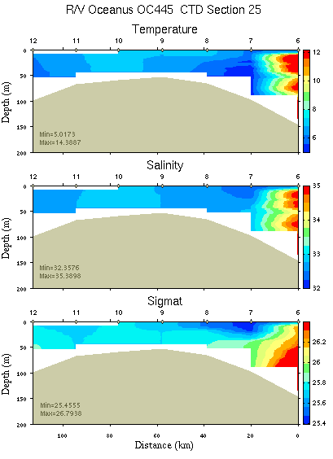 | 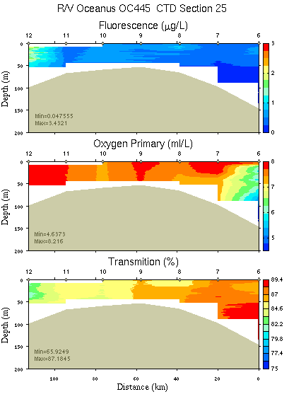
Figure C4. Section 25, 0-200m: temperature, salinity, and density (left); fluorescence, oxygen, and beam transmission (right).

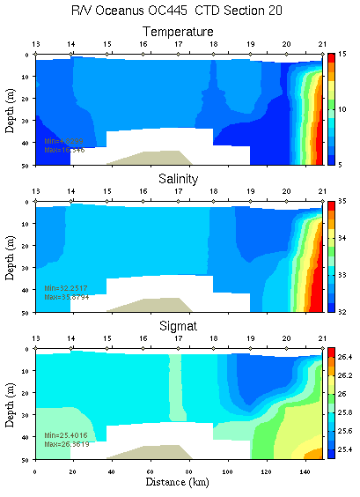 | 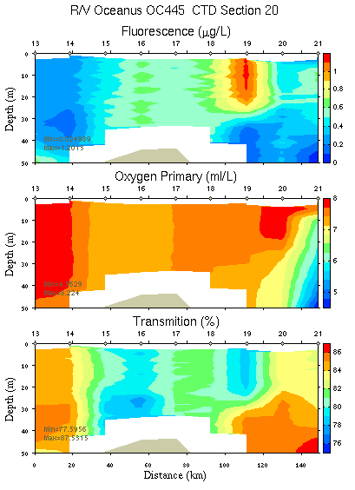
Figure C5. Section 20, 0-50m: temperature, salinity, and density (left); fluorescence, oxygen, and beam transmission (right).

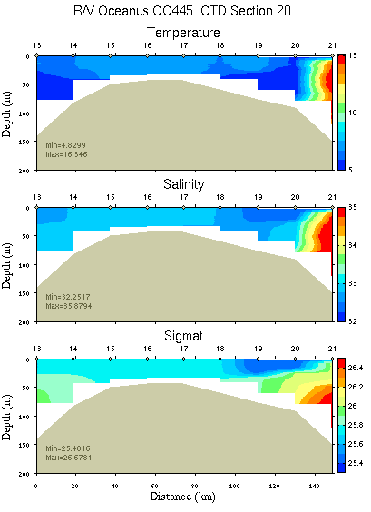 | 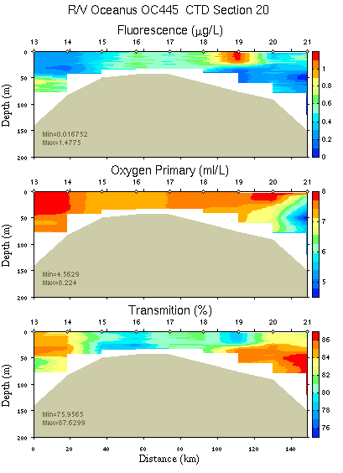
Figure C6. Section 20, 0-200m: temperature, salinity, and density (left); fluorescence, oxygen, and beam transmission (right).

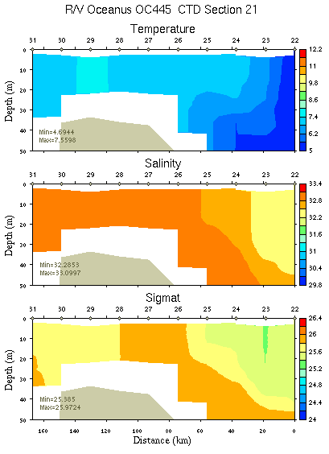 | 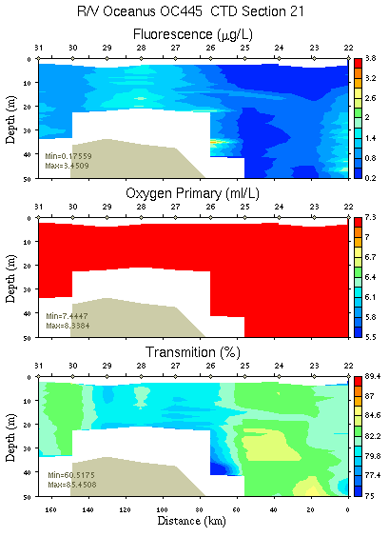
Figure C7. Section 21, 0-200m: temperature, salinity, and density (left); fluorescence, oxygen, and beam transmission (right).

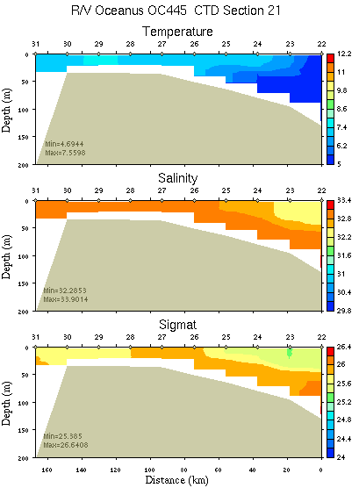 | 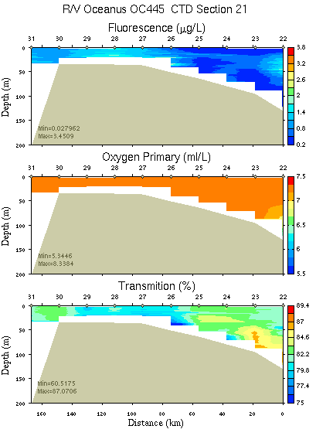
Figure C8. Section 21, 0-200m: temperature, salinity, and density (left); fluorescence, oxygen, and beam transmission (right).

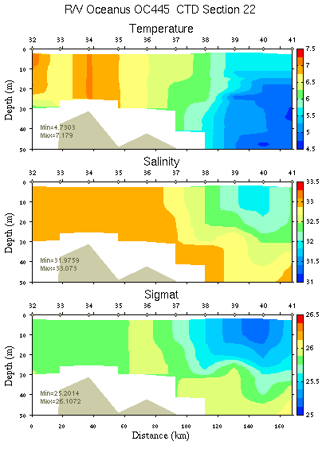 | 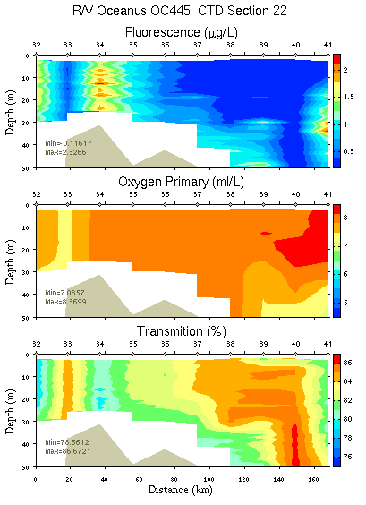
Figure C9. Section 22, 0-50m: temperature, salinity, and density (left); fluorescence, oxygen, and beam transmission (right).

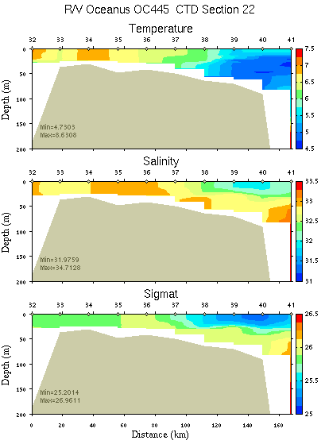 | 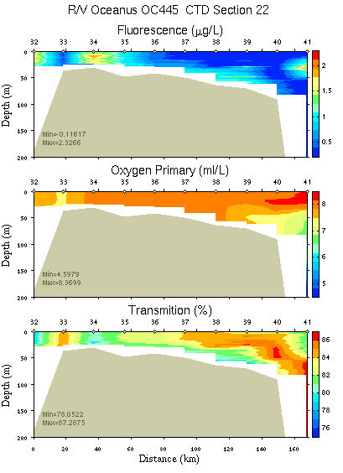
Figure C10. Section 22, 0-200m: temperature, salinity, and density (left); fluorescence, oxygen, and beam transmission (right).

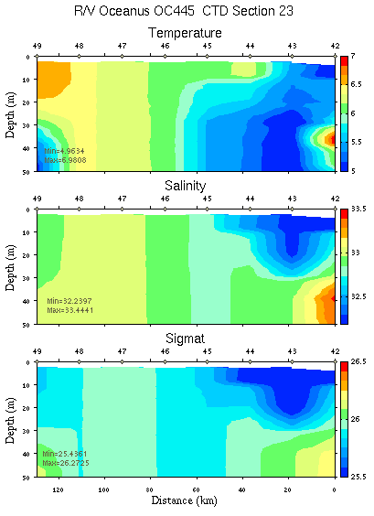 | 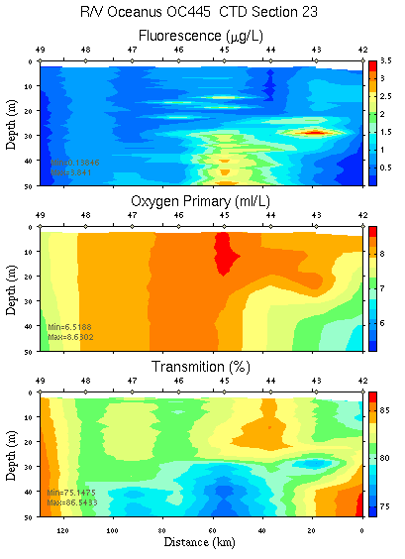
Figure C11. Section 23, 0-50m: temperature, salinity, and density (left); fluorescence, oxygen, and beam transmission (right).

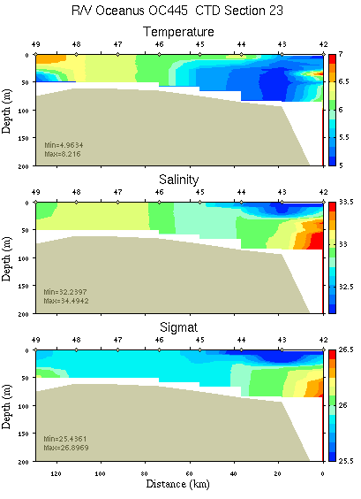 | 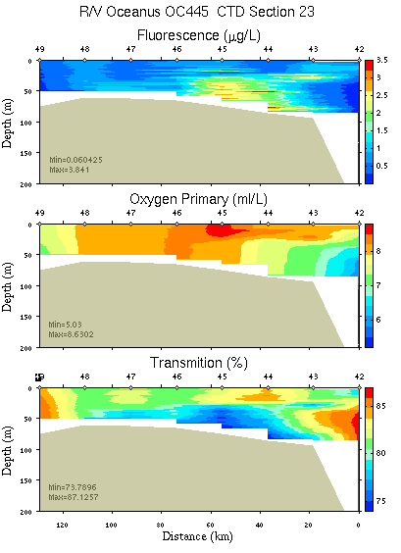
Figure C12. Section 23, 0-200m: temperature, salinity, and density (left); fluorescence, oxygen, and beam transmission (right).

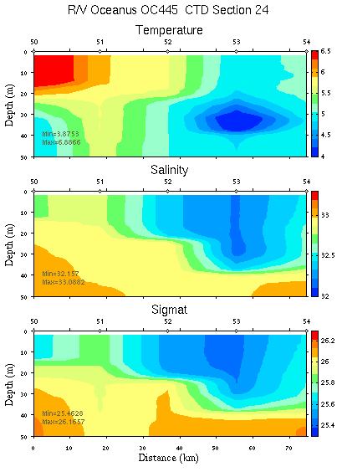 | 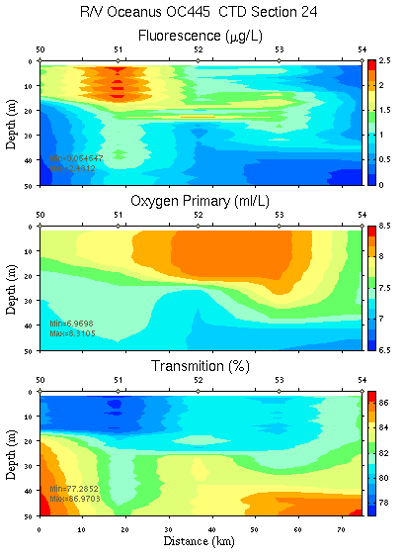
Figure C13. Section 24, 0-50m: temperature, salinity, and density (left); fluorescence, oxygen, and beam transmission (right).

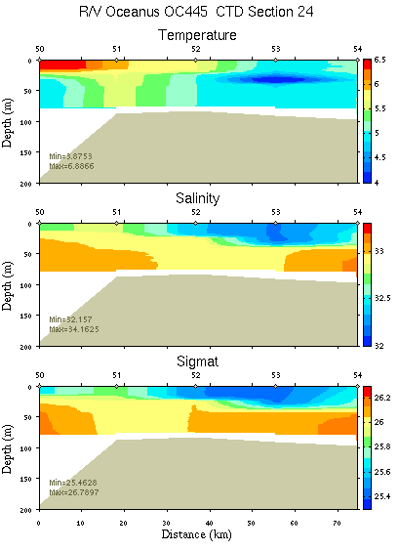 | 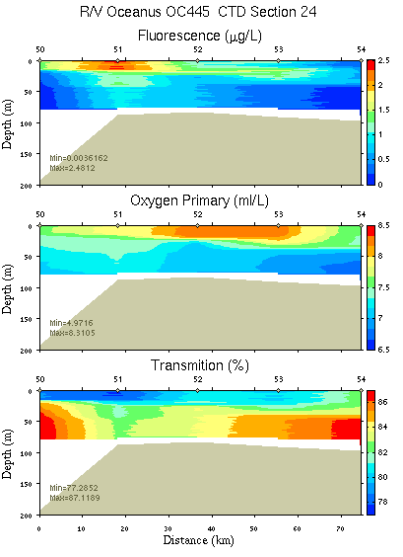
Figure C14. Section 24, 0-200m: temperature, salinity, and density (left); fluorescence, oxygen, and beam transmission (right).

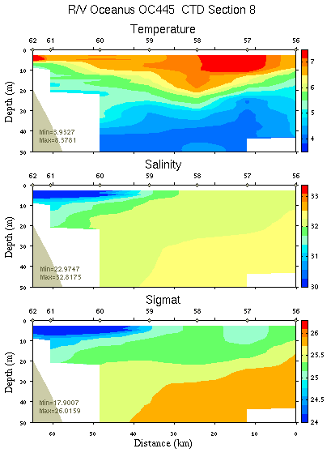 | 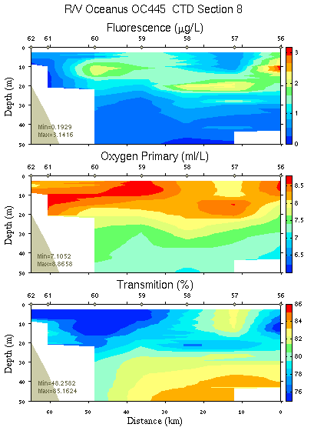
Figure C15. Section 8, 0-50m: temperature, salinity, and density (left); fluorescence, oxygen, and beam transmission (right).

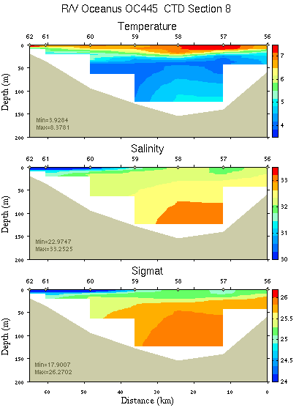 | 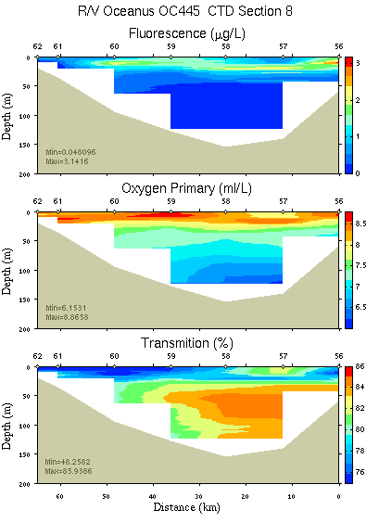
Figure C16. Section 8, 0-200m: temperature, salinity, and density (left); fluorescence, oxygen, and beam transmission (right).

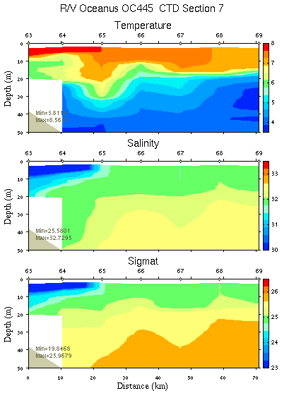 | 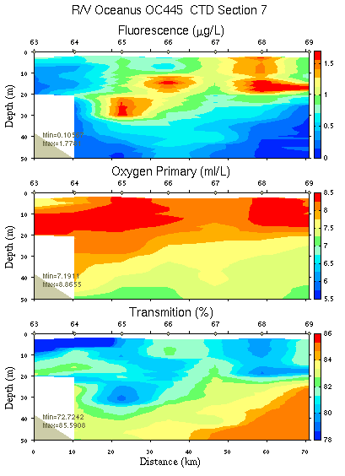
Figure C17. Section 7, 0-50m: temperature, salinity, and density (left); fluorescence, oxygen, and beam transmission (right).

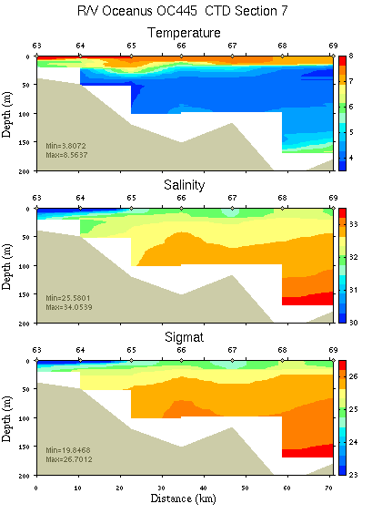 | 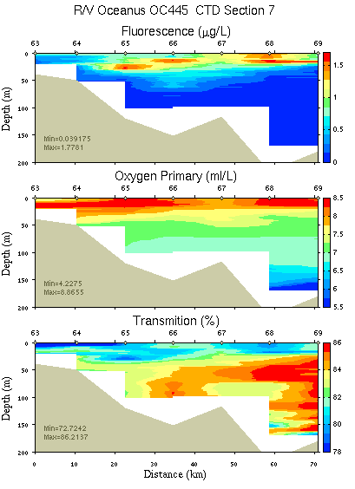
Figure C18. Section 7, 0-200m: temperature, salinity, and density (left); fluorescence, oxygen, and beam transmission (right).

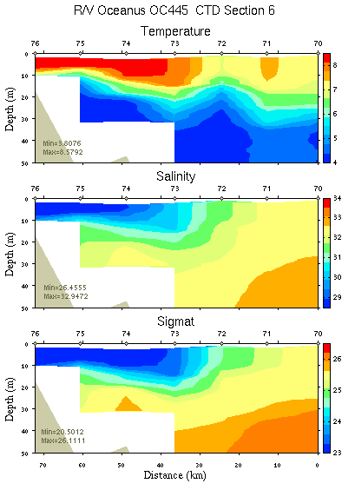 | 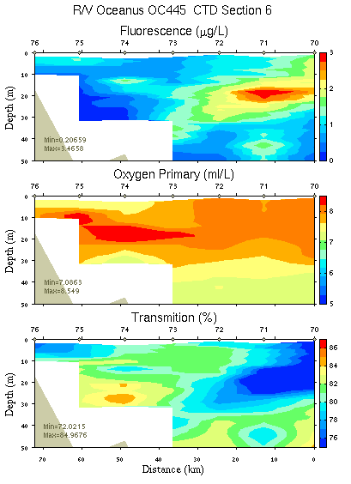
Figure C19. Section 6, 0-50m: temperature, salinity, and density (left); fluorescence, oxygen, and beam transmission (right).

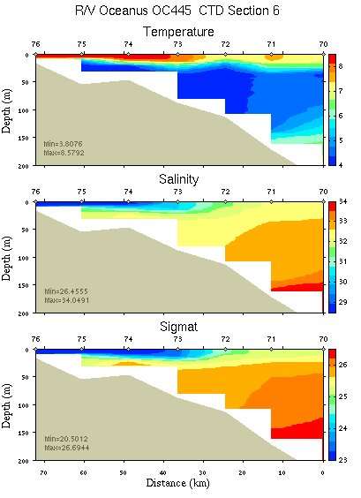 | 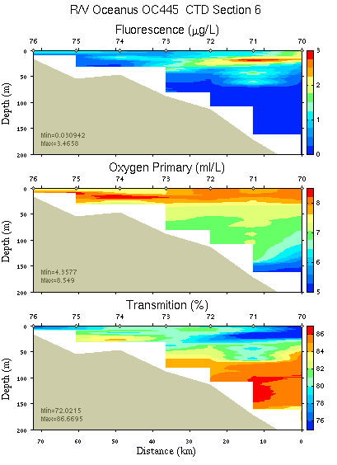
Figure C20. Section 6, 0-200m: temperature, salinity, and density (left); fluorescence, oxygen, and beam transmission (right).

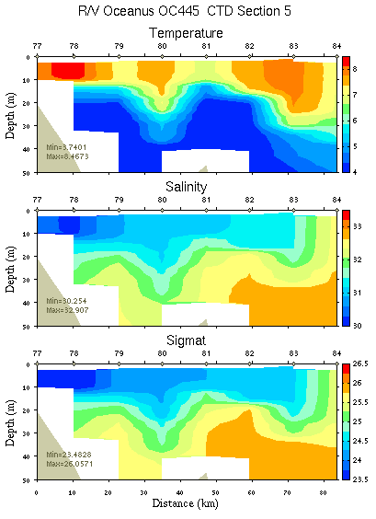 | 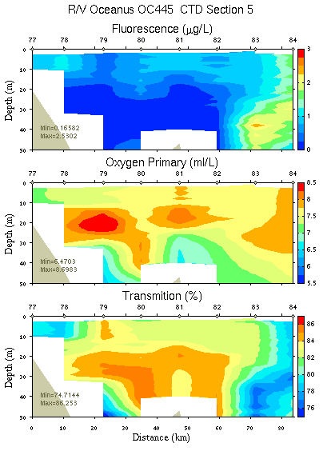
Figure C21. Section 5, 0-50m: temperature, salinity, and density (left); fluorescence, oxygen, and beam transmission (right).

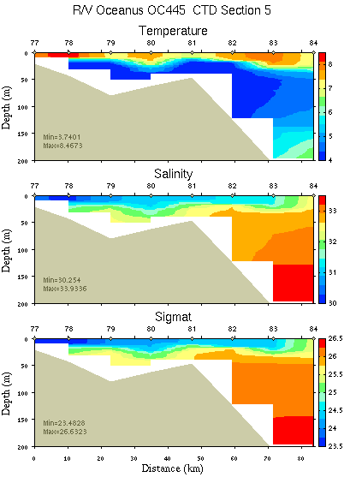 | 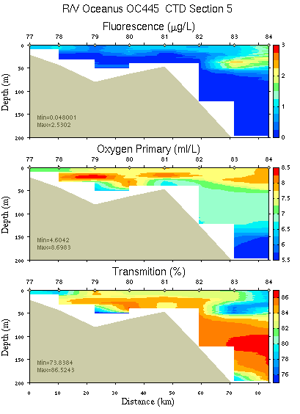
Figure C22. Section 5, 0-200m: temperature, salinity, and density (left); fluorescence, oxygen, and beam transmission (right).
Appendix D: Satellite imagery

April 26
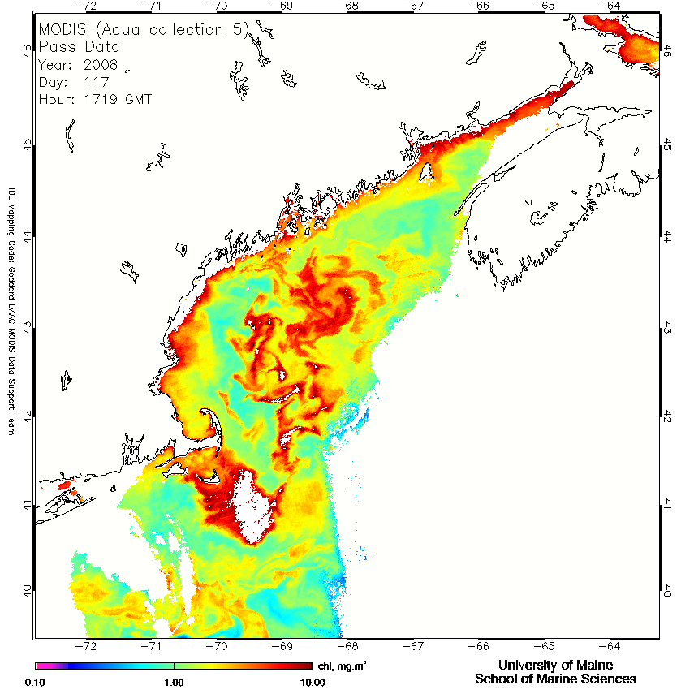

April 26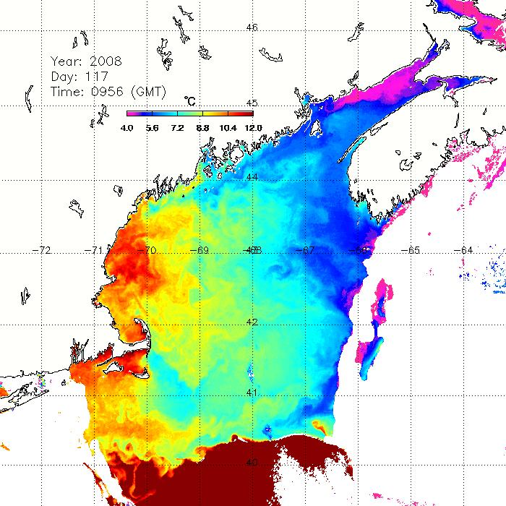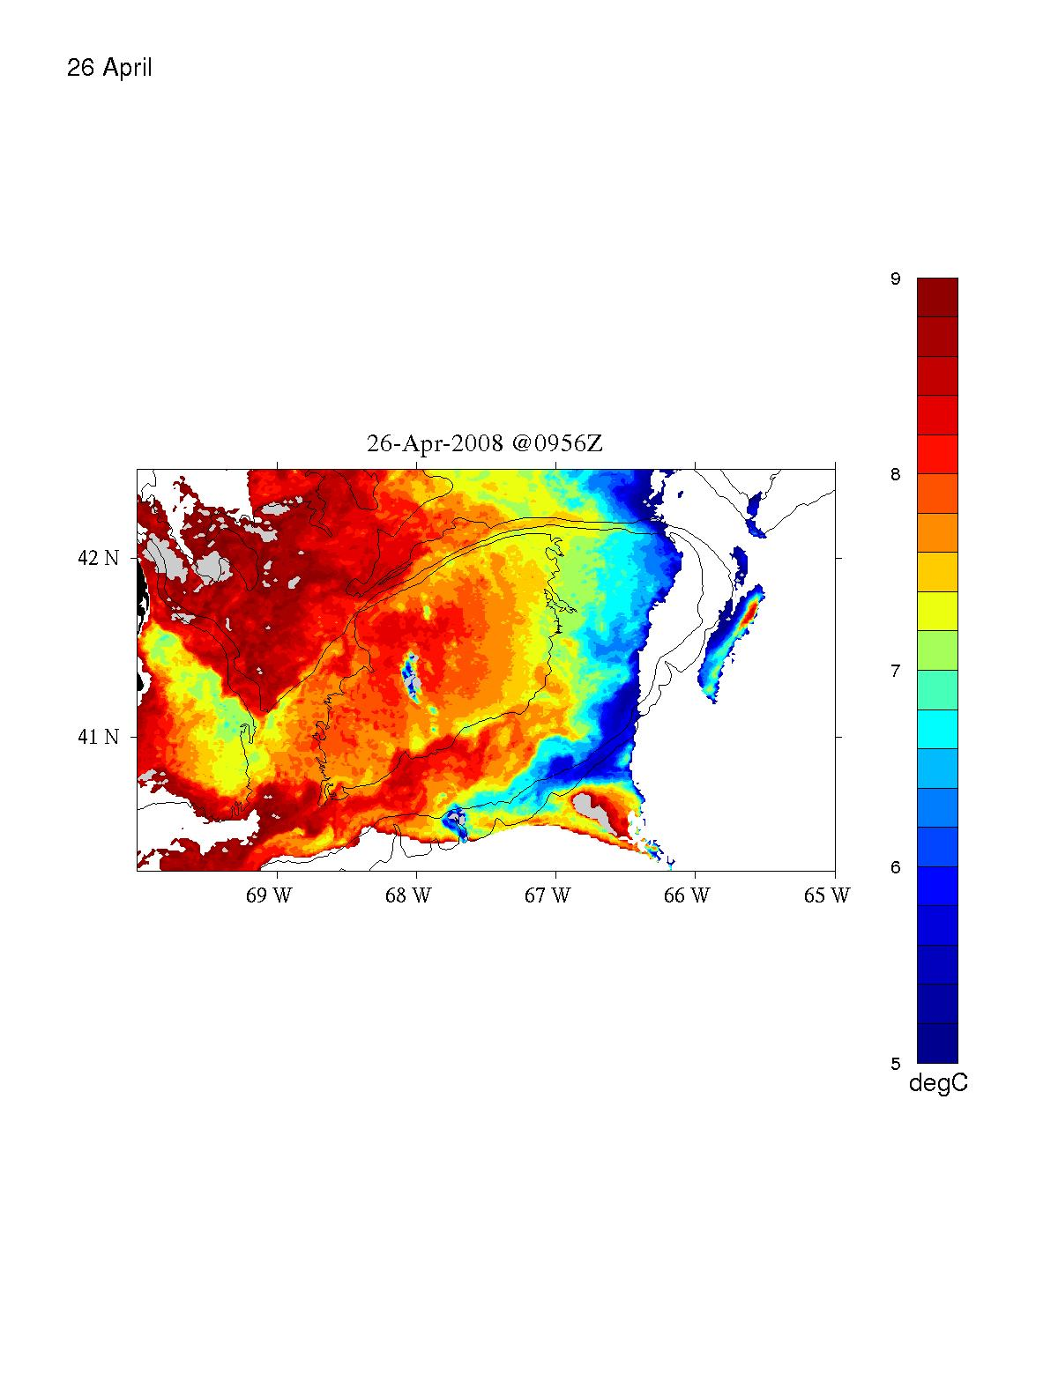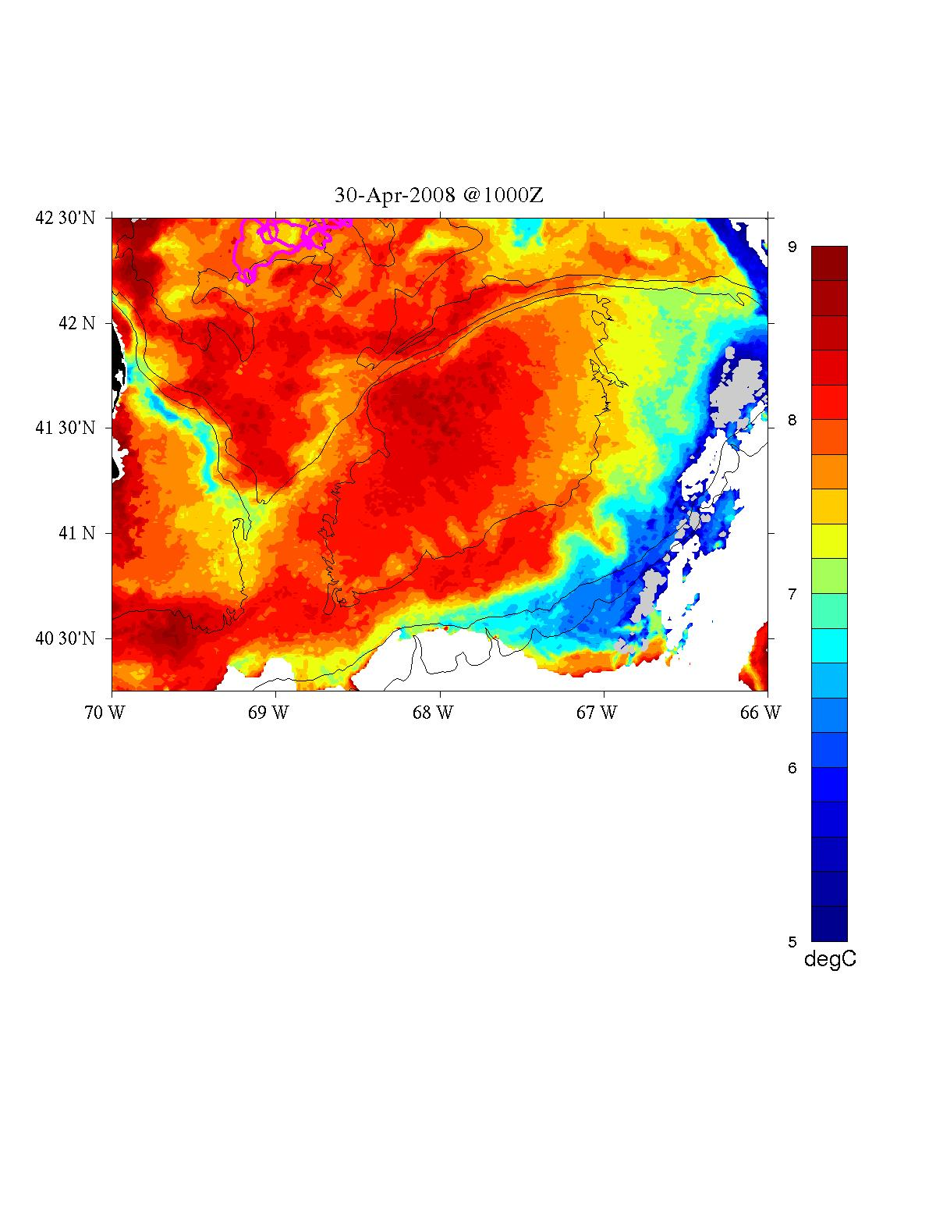

May 1, 2008

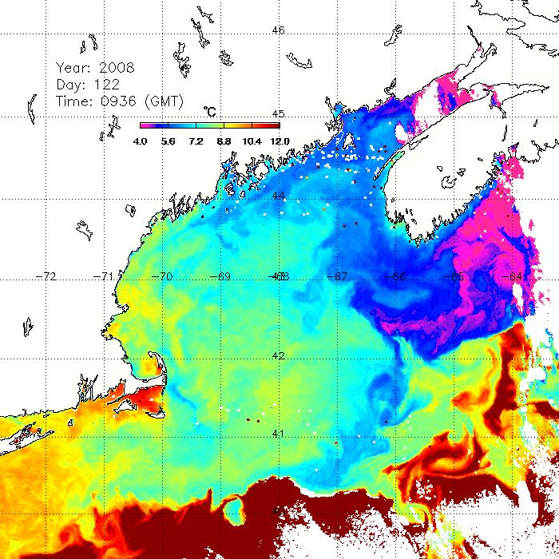

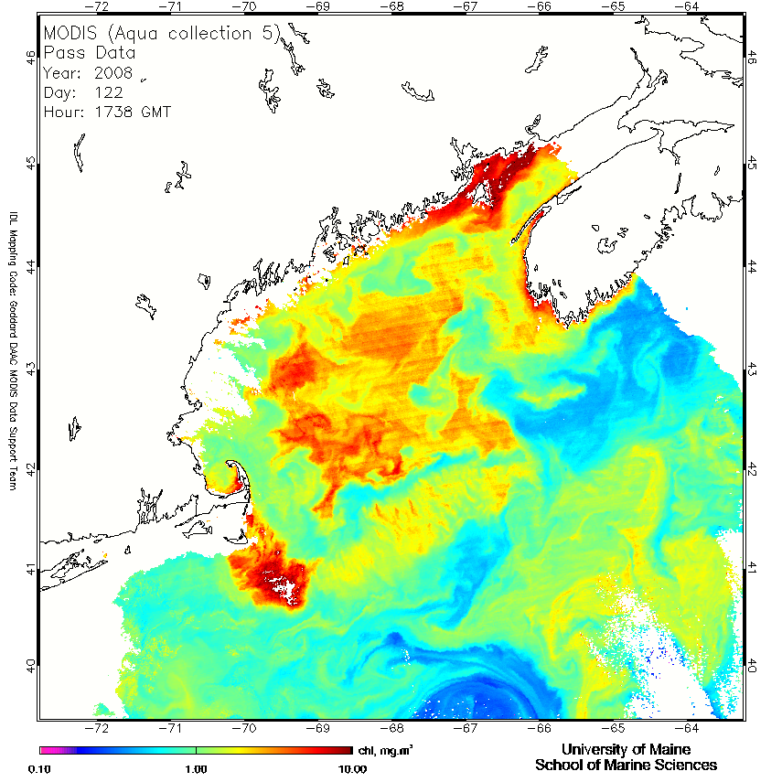
Appendix E: Personnel

1. Dennis McGillicuddy WHOI (Chief Scientist)
2. Valery Kosnyrev
3. Erin Dupuis
4. Keston Smith
5. Bruce Keafer
6. Kerry Norton
7. Bibiana Crespo
8. Luciano Fernandez
9. Stacey Lee
10. David Townsend
11. Maura Thomas
12. Nathan Reebuck
13. Jeff Turner
14. Peter Milligan
15. Meri Ratzel
16. Artur Palacz
17. Larry Anderson
18. Katie Libera

Watch schedule

Watch number 1 2 3
4 on / 8 off 8-12 12-4 4-8

1. CTD Operator Larry Artur Keston
2. Cell Counter Meri* Kerry* Bruce*&
3. Nutrient sampler Dave# Nathan# Maura#
4. Water sampler Valery# Luciano#& Jeff
5. Water sampler Katie& Bibiana Peter#
6. Water sampler Erin Stacey

* Wetlab chief
# CTD deck operations: 2 slip line handlers (#)
& qPCR leader

http://www.whoi.edu/science/cohh/whcohh/projects/habs1_abstract.htm
Also see http://nefsc.noaa.gov/drifter

