OC425 Cruise Report
Draft 6/26/06
Includes KWS changes and DJM edits

During April and early May 2006, surveys in Massachusetts and Cape Cod Bays by R/V Tioga revealed significant concentrations A. fundyense in Massachusetts and Cape Cod Bays. At thousands of cells per liter, these concentrations are an order of magnitude greater than the threshold required to yield toxicity in shellfish (ca. 200 cells l⁻¹). By mid May, these concentrations were on par with those observed during the same time period during the historic bloom of 2005. At that time it appeared that New England could be threatened by another widespread outbreak of PSP, yet large-scale oceanographic observations to document the scope of the bloom were unavailable at the time.

Voyage 425 of R/V Oceanus (June 6-17, 2006) was a rapid-response survey from to provide such observations (NOAA CICOR Cooperative Agreement No. NA17RJ1223, D.M. Anderson and D.J. McGillicuddy, Jr., PIs). The scientific objectives were to survey hydrography, currents, and the abundance of A. fundyense from Cape Cod to the Bay of Fundy. Sampling consisted of traditional CTD/Rosette hydrography, underway ADCP measurements, and drifter observations (Appendix A). At-sea modeling activities consisted of a data-assimilative hydrodynamic model (Lynch et al.), into which an individual based model (IBM) of A. fundyense population dynamics was incorporated. Results of shore-based modeling of coastal hydrodynamics and concentration-based A. fundyense population dynamics was transmitted to the ship on a regular basis.

The initial survey (June 6-13) spanned the entire region from Cape Cod to the Bay of Fundy (Figure 1, left panel; see Appendix B for hydrographic maps and sections). Live counts from the first survey indicated a substantial mass of cells from mid-coast Maine down into northern Massachusetts Bay. Peak concentrations were of thousands of cells per liter. Patches of cells on the order of hundreds of cells per liter were also present in a filament branching offshore to the south in between Casco and Penobscot Bays, extending to the east along the offshore-most set of stations. A similar feature is present in the coupled physical-biological model (Figure 2). Examination of the model output in animated form suggests this offshore filament originates at the coast, branches offshore in between Casco and Penobscot Bays, and then retroflects back toward the east-northeast in the offshore waters. Offshore waters east of Penobscot Bay were generally devoid of cells. Concentrations on the order of hundreds of cells per liter were present in the near-coastal region from the Bay of Fundy southwestward about half way to Penobscot Bay. Only a single station exceeded 1000 cells l⁻¹ in that area, at the station southwest of the Wolves islands.

The large bloom in the western Gulf of Maine (WGOM) was resampled during the final phase of the cruise (Figure 1, right panel; see Appendix A for hydrographic maps and sections). Concentrations in the nearshore region off Casco Bay appear to have decreased somewhat, with concentrations generally in the hundreds of cells l⁻¹ and only one station exceeding 1000 cells l⁻¹ in that area. Cell counts on the Saco Bay line remained relatively stable, with a 30-40km wide swath of cells ranging in concentration from ca. 1700 to 4200 cells l⁻¹. The cross-shore extent of the population decreased to 20-30km along the Cape Ann line, with only one station exceeding 1000 cells l⁻¹ on that section. Perhaps the most striking temporal change in the distribution is the offshore movement of the high cell counts in Massachusetts Bay. In the first survey, occupied during storm-driven downwelling conditions (Figure 3), cell counts of hundreds of cells l⁻¹ were present in the nearshore area (Figure 1, left panel). In contrast, the nearshore waters of Massachusetts Bay were nearly devoid of cells at the coast during the second survey (Figure 1, right panel). This is consistent with offshore movement of surface waters, characteristic of relaxation following a downwelling event. Temporal changes in hydrographic properties are consistent with this scenario. For example, the salinity section across the Salem line reveals a thick plume confined to the coast in the first occupation, and a thinner plume spread further offshore in the second occupation (cf. sections #6 [Figure B11] and #25 [Figure B30]). Similarly, horizontal maps of salinity at 3m (Figure B2) show offshore spreading of the near-coastal plume in the southern portion of the domain (although this could be due in part to an additional pulse of freshwater input from rivers).

Subsequent to completion of the second survey, we transited a section from the Nauset line out to Cultivator Shoal on Georges Bank. Underway cell counts were very low until we reached the edge of the bank, where they jumped into the thousands of cells per liter, peaking at near 10,000 cells l⁻¹. Large Pseudo-nitzchia cells are also present, and a Jellet assay tested positive for ASP.

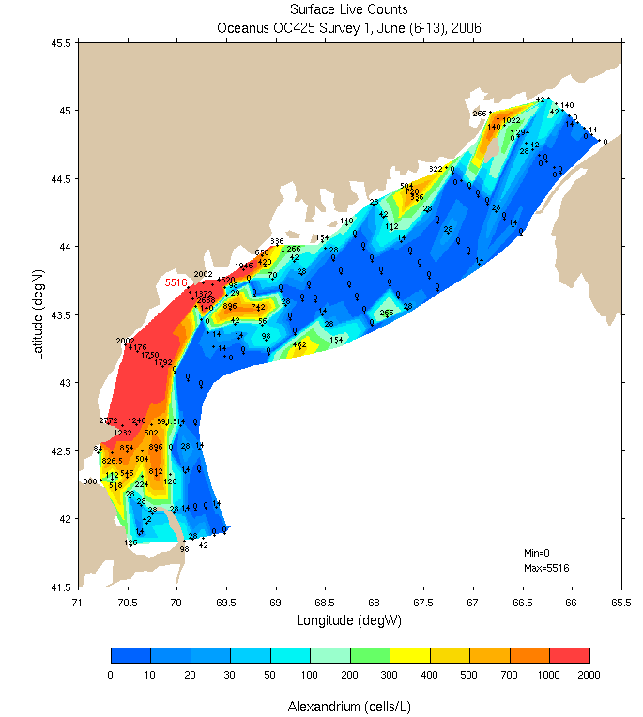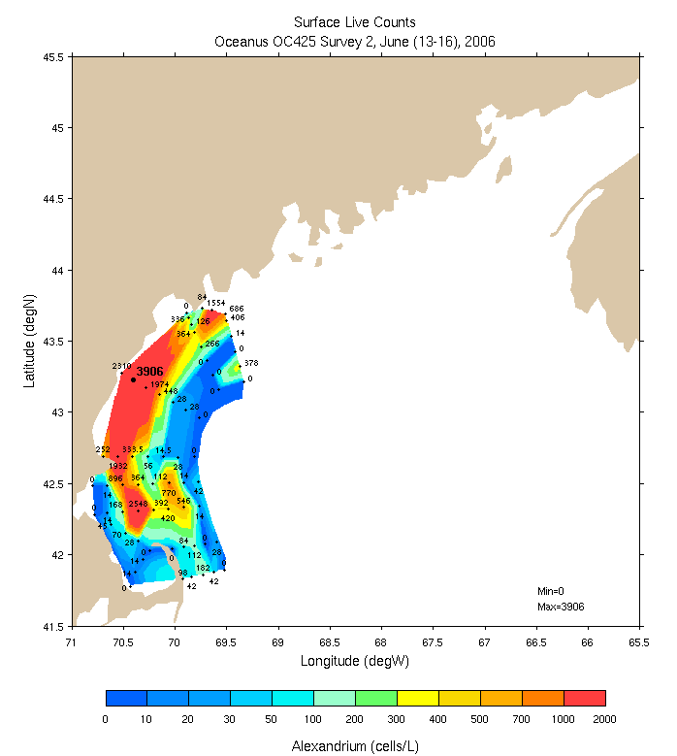
Figure 1. Surface live counts from the first survey June 6-13 (left) and the second survey June 13-16 (right).

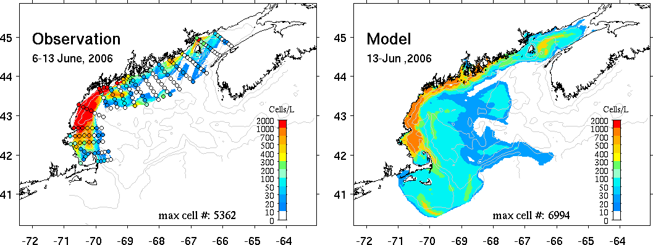
Figure 2. Comparison of A. fundyense live counts (left) with model predictions for the same time period (right). See http://science.whoi.edu/users/ruoying/Redtide_06/ for a description of the coupled physical-biological model.

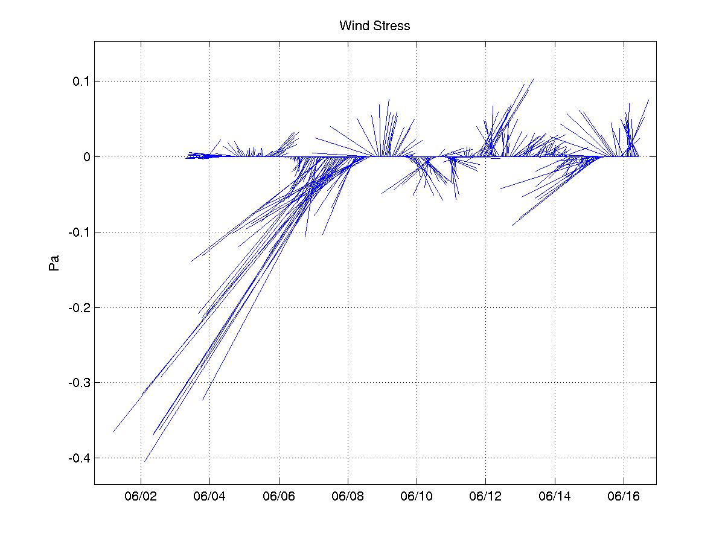
Figure 3. Wind stress during OC425.

Drifters were deployed along three transects (Figure 4; Tables 1-3): Isle Au Haut (6 surface drifters), the Bay of Fundy (9 drogued drifters), and Cape Ann (3 surface drifters). The Isle Au Haut line of drifters exhibited evidence of well-documented circulation features: the innermost two proceeded southwest along the coast in the Gulf of Maine Coastal Plume (GOMCP), whereas the outermost six illustrated the cyclonic shear of the Jordan Basin Gyre.

The Bay of Fundy drifters were suggestive of the hypothesized gyre at the mouth of the bay, with drifters 3-9 exhibiting cyclonic circulation. Drifters 1 and 2 were not entrained in that feature, instead proceeding southwest along the coast west of Grand Manan.

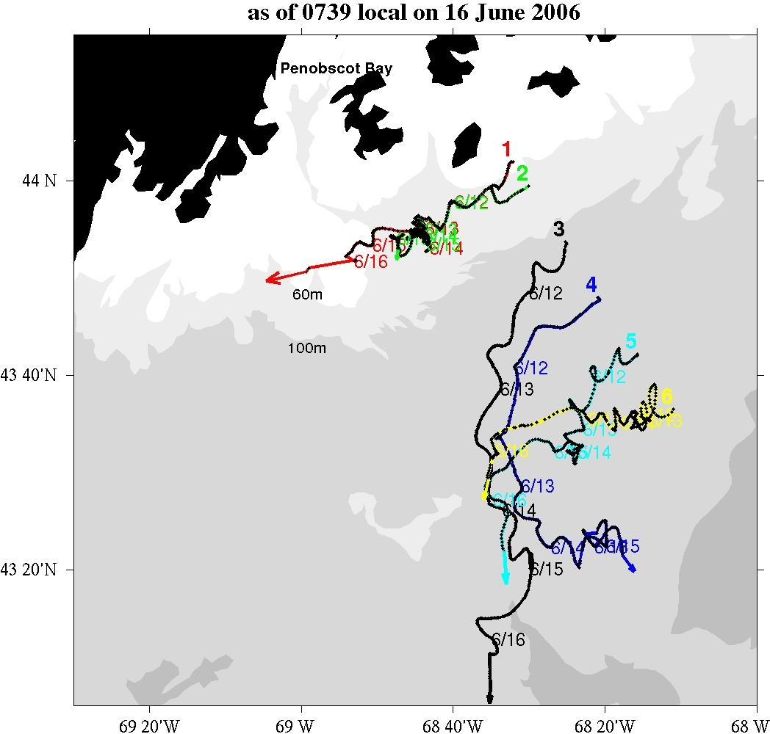 | 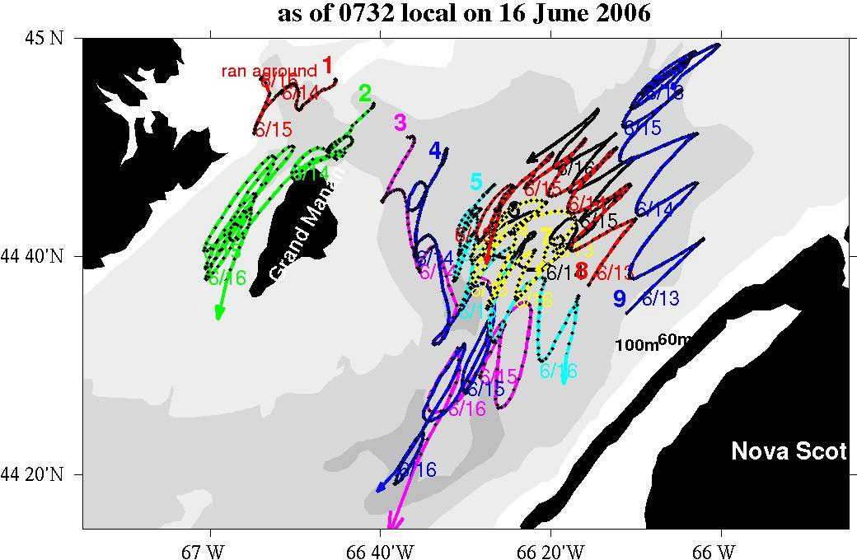
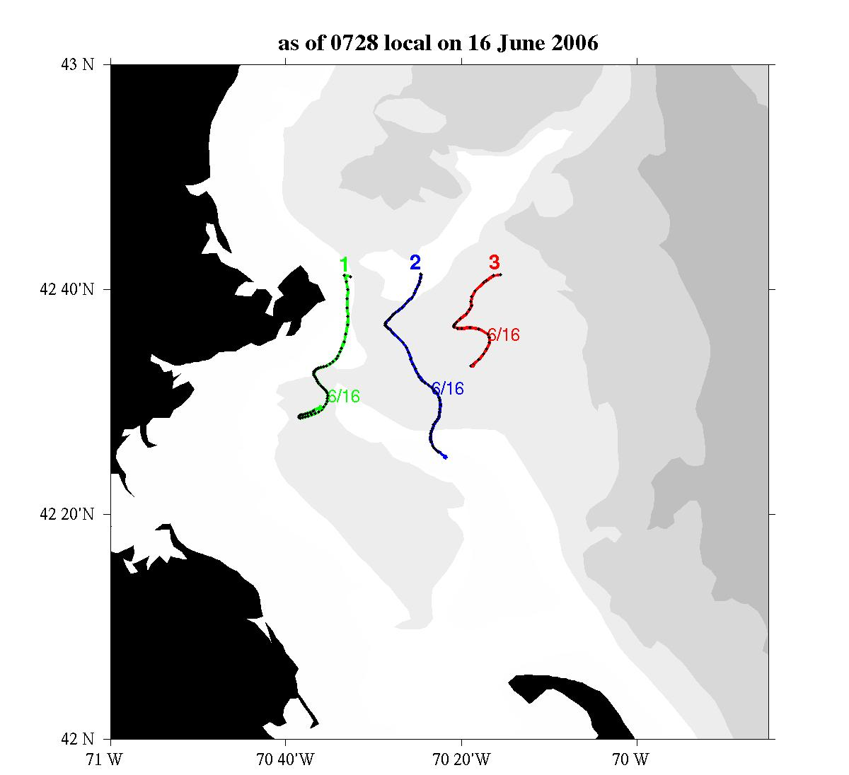
Figure 4. Trajectories for the Isle Au Haut surface drifters (upper left), Bay of Fundy drogued drifters (upper right), and Cape Ann surface drifters (lower left).

ID | Waypoint | Station # | Time (GMT) | Lat | Lon | Depth
66381 | 95 | 89 | 0254 | 44 02.081 | 68 31.944 | 61.2
66382 | 94 | 90 | 0327 | 43 59.312 | 68 29.992 | 72.8
66383 | 93 | 91 | 0422 | 43 53.598 | 68 24.982 | 112.4
66384 | 92 | 92 | 0517 | 43 47.745 | 68 20.678 | 154.1
66385 | 91 | 93 | 0617 | 43 42.005 | 68 15.724 | 205.1
66386 | 90 | 94 | 0717 | 43 36.362 | 68 11.084 | 196.1
Table 1. Isle Au Haut Drifter Deployments 6/11/06

ID | Waypoint | Station # | Time (GMT) | Lat | Lon | Depth
66469 | 144 | 134 | 2231 | 44 34.806 | 66 11.057 | 116
66468 | 143 | 135 | 2313 | 44 37.348 | 66 15.551 | 138
66467 | 142 | 136 | 2357 | 44 40.417 | 66 19.660 | 132
66466 | 141 | 137 | 0036 | 44 42.921 | 66 23.466 | 164
66465 | 140 | 138 | 0115 | 44 45.511 | 66 27.918 | 168
66464 | 139 | 139 | 0152 | 44 48.385 | 66 32.794 | 126
66463 | 138 | 140 | 0224 | 44 50.912 | 66 36.807 | 128
66462 | 137 | 141 | 0256 | 44 53.660 | 66 40.952 | 109
66461 | 136 | 142 | 0326 | 44 56.231 | 66 45.367 | 72
Table 2. Bay of Fundy Drifter Deployments 6/12-6/13

ID | Waypoint | Station # | Time (GMT) | Lat | Lon | Depth
65208 | 39 | 178 | 0431 | 42 41.280 | 70 16.169 | 94
66202 | 38 | 179 | 0541 | 42 41.283 | 70 24.733 | 45
66201 | 37 | 180 | 0630 | 42 41.235 | 70 33.715 | 60
Table 3. Cape Ann Drifter Deployments 6/15/06

Hydrography, shipboard ADCP velocity measurements and GoMOOS mooring observations were assimilated into a numerical model to provide the hydrodynamic context in which to interpret the biological observations. Table 4 lists the numerical simulations conducted at sea. The fidelity of the circulation fields was quantified by evaluating the ability of the model to simulate the trajectories of drifters deployed during the survey. Detailed error statistics are presented in Table 4.

Initial efforts were focused on simulating the trajectories of the Isle Au Haut line, and it was noted that run FC_13 did not capture the observed offshore turning of drifters 3 and 4 (Figure 5, top panels). This offshore turning is characteristic of the Jordan Basin gyre, in turn controlled by the geostrophic pressure gradient associated with dense slope water that fills the basin. Thus there are at least two factors are potentially important in accurate simulation of that feature: a realistic density field and a suitable barotropic open boundary condition. Some improvement in representation of the offshore turning resulted from replacement of the climatological density field used in run FC_13 with an objective analysis of OC425 hydrography in run FC_15 (Figure 5, middle panels). Further improvement was achieved in run FC_17 (Figure 5, lower panels) by assimilating velocity data only in this particular region of interest (Figure 6). By relaxing the constraint to fit domain-wide velocity data, the model is more free to invert for a barotropic boundary condition that is consistent with this particular localized feature. This finding speaks to the need to implement a mechanism in the forecast system to assign spatially variable weights in the velocity data assimilated into the model.

Another issue that came to the forefront in this discussion was the curious finding that, in some cases, improvement of the prior leads to degradation of the posterior. For example, compare runs FC_17 and FC_18 (Table 4). Using the velocity misfit of the prior as a skill metric, the so-called “Mary-Jo” boundary condition used in FC_18 yields a better prior than run FC_17. However, the velocity misfit of the posterior in FC_18 is actually worse than FC_17. The same is true of the drifter evaluation: despite its inferior prior, FC_17 performed better than FC_18 in terms of the posterior drifter misfit. Keston noted similar experience in the past; the underlying cause is unknown and is worthy of future study.

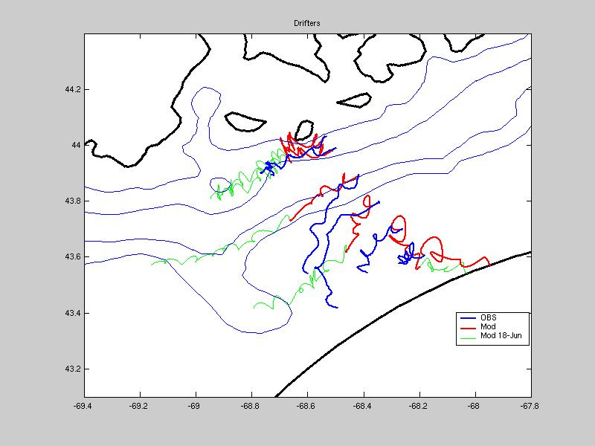 | 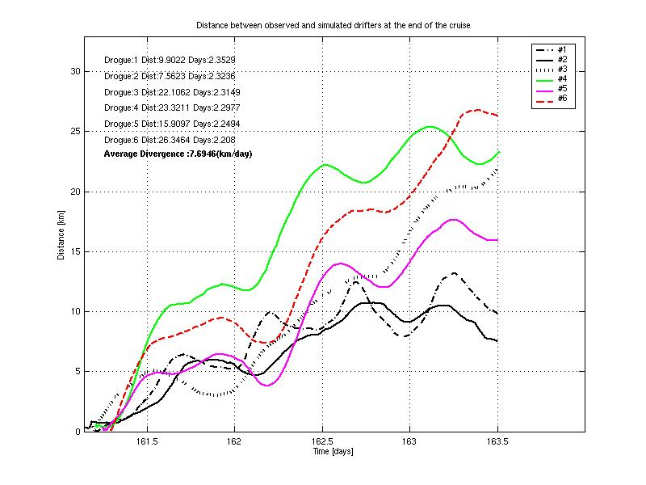
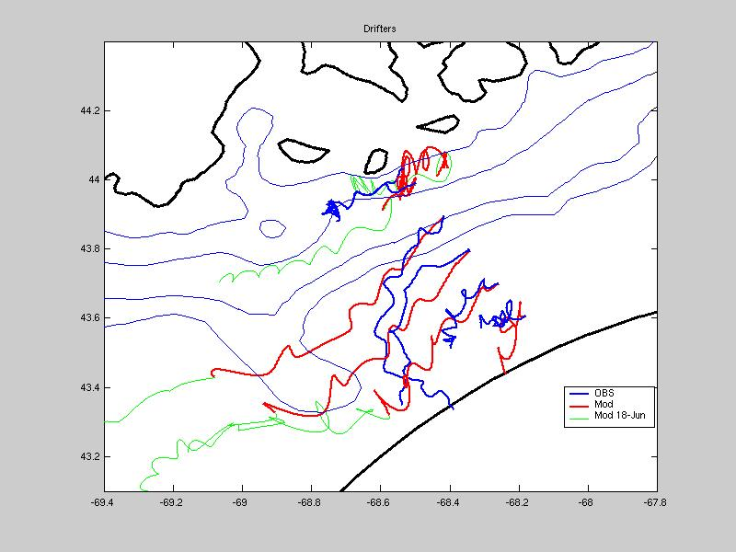 | 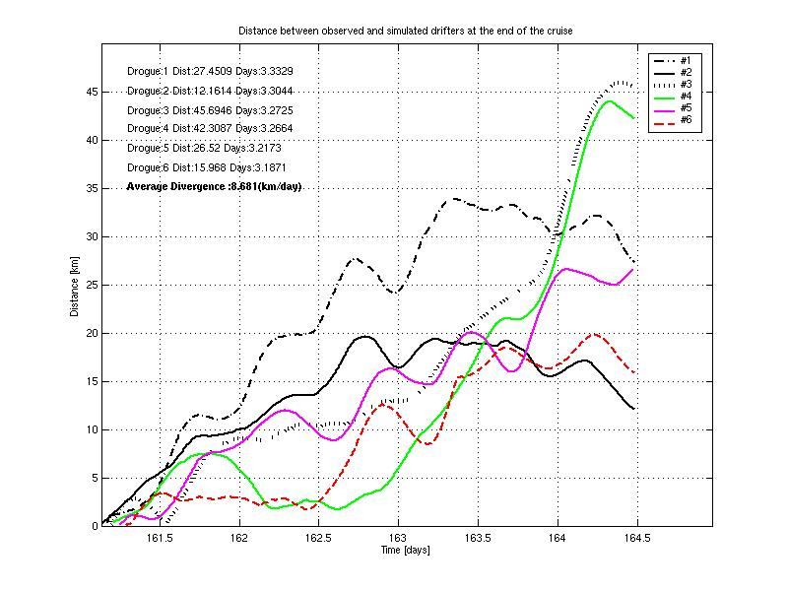
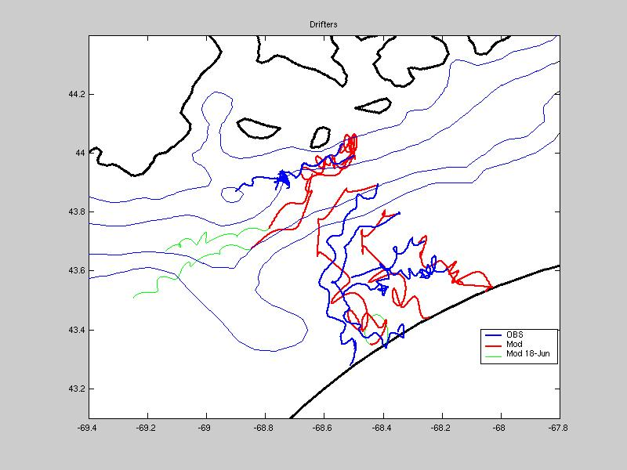 | 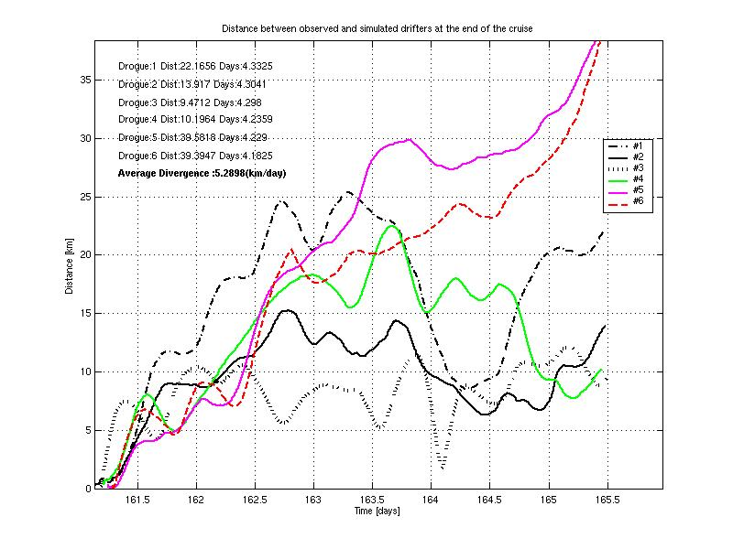
Figure 5. Simulated and observed drifter trajectories (left) and separation as a function of time (right) for runs FC_13 (top), FC_15 (middle), and FC_17 (bottom). Note differences in the x- and y-axes in the right hand panels. Also note the “old” method of computing drifter separations is used: it does not account for simulated drifters hitting the boundary, and the mean separation rate is computed from the endpoint rather than a regression of the entire time series.

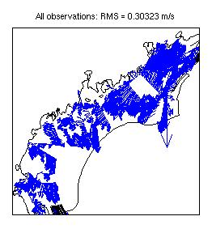 | 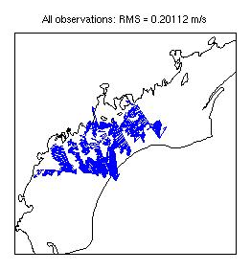
Figure 6. Velocity observations assimilated in runs FC_13 and
FC_15 (left) and FC_17 (right).

An at-sea prediction of the transport of the WGOM bloom was made using the data-assimilative hydrodynamic model. Objective analysis of stations 1-105 (Figure 7, left panel) is qualitatively similar to the live count map made with simple polynomial interpolation (Figure 1) that assumes all stations were occupied simultaneously at the central time. A forecast of the A. fundyense distribution for the central time of the second survey was made by advecting the station positions, along with their associated concentration values (assuming zero net growth), using the forecast surface velocity field (from hydrodynamic simulation OC425_FC12). Objective analysis of the advected concentration observations (Figure 7, right panel) indicates significant along-coast transport of the bloom, as well as a tendency to move slightly offshore during relaxation from the storm-driven downwelling event (Figure 3). The three local maxima off Casco Bay, Saco Bay, and Cape Ann evident in the “frozen field” map also tend to merge together into a quasi-continuous filament from Casco Bay to Provincetown.

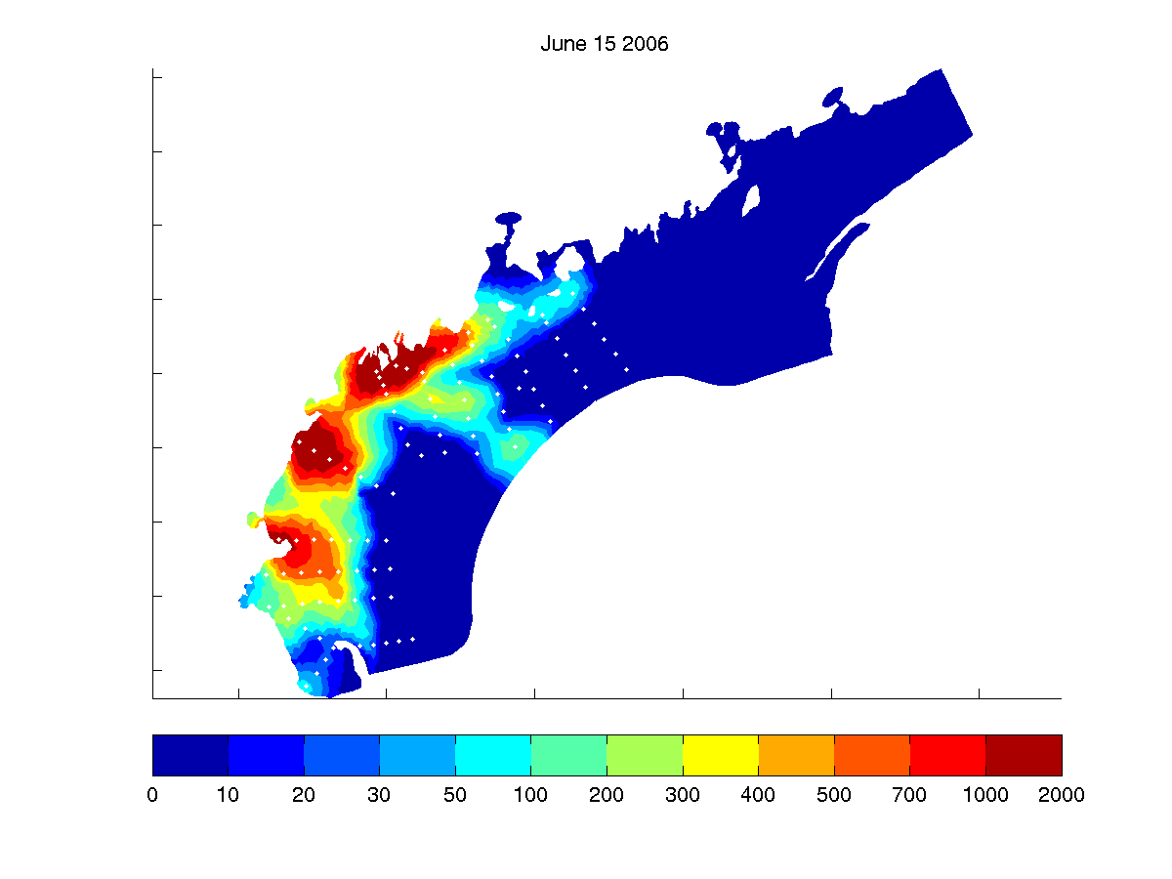 | 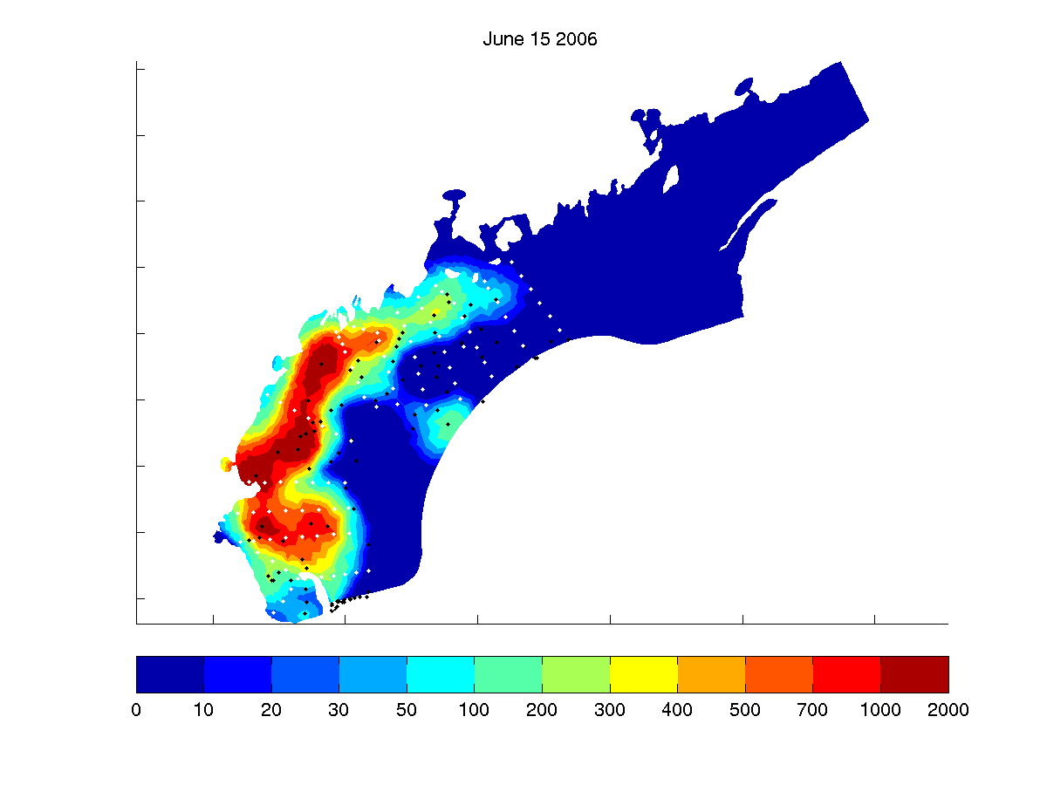
Figure 7. Objectively analyzed A. fundyense concentrations (cells l⁻¹) from surface live counts for stations 1-105. Left panel: map assumes all stations (white dots) occupied simultaneously at the central time of the first survey. Right panel: initial station positions (white dots) advected to their predicted positions (black dots) at the central time of the second survey (June 15). Transport predictions (IBM model with population dynamics turned off) were computed based on hydrodynamic forecast OC425_FC12. Note that particles advected out of the domain at the southern boundary are not included in the objective analysis, thereby producing a subtle boundary artifact in the resulting map.

An Individual Based Model (IBM) of A. fundyense was employed to study the transport and fate of observed cells (Figure 8). The velocity from the posterior simulation, averaged from 5m below mean sea level to the free surface, is used to advect individual cells. The cells are assumed to diffuse with a diffusion coefficient of 10 m^2/s. For each station the model is initialized at that point with the number of cells that were estimated to be present by the live counts. Biological dynamics of the organisms modeled include growth, mortality and encystment. These transformations occur as Poisson processes with a rate which is dependent on the local conditions. The IBM model is described in detail in NML-03-19 (http://www-nml.dartmouth.edu/Publications/internal_reports/NML-03-19/).

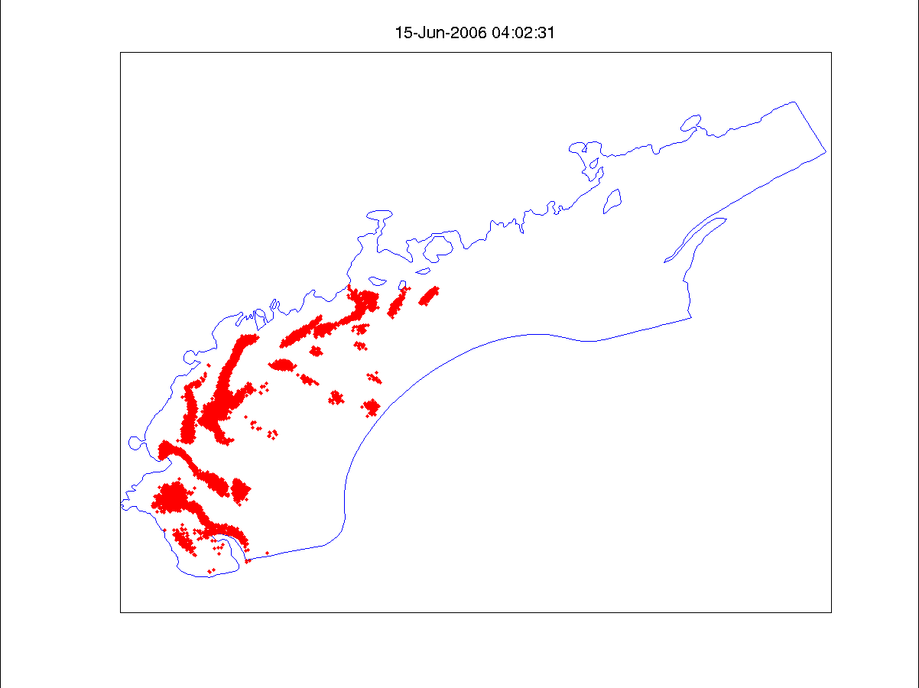
Figure 8. Prediction of IBM particle locations on June 15th 2006,
based on an initialization using live counts from the first 105 stations
and flow from OC425_FC12.

A third approach to modeling the population of A. fundyense was implemented at sea in the interest of forecasting concentrations across the full domain, rather than strictly downwind of observations. The growth term was modified so that rather than an individual cell dividing with a probability proportional to the local growth conditions, the concentration represented by an individual was programmed to change deterministically according to the net growth rate. A removal rate (due to mortality and encystment) of 0.2 / day was assumed. This model was initialized with a fixed number (20) of particles at each station. Each particle is initialized with the same initial concentration as was observed at the station. The particles are advected and diffused as in the initial IBM. At the forecast time an objective analysis of the concentrations represented at each particles location was carried out (Figure 9). The objective analysis was carried out using Objective Analysis for Finite Elements (OAFE). Parameter values in OAFE were K2=0.00002, sigma=0.00002 and sigma_obs=1.0. The velocity fields used in the objective analysis were the time average velocity used in the particle advection. The diffusivity field was specified using the time average of the Smagorinsky diffusion coefficient.

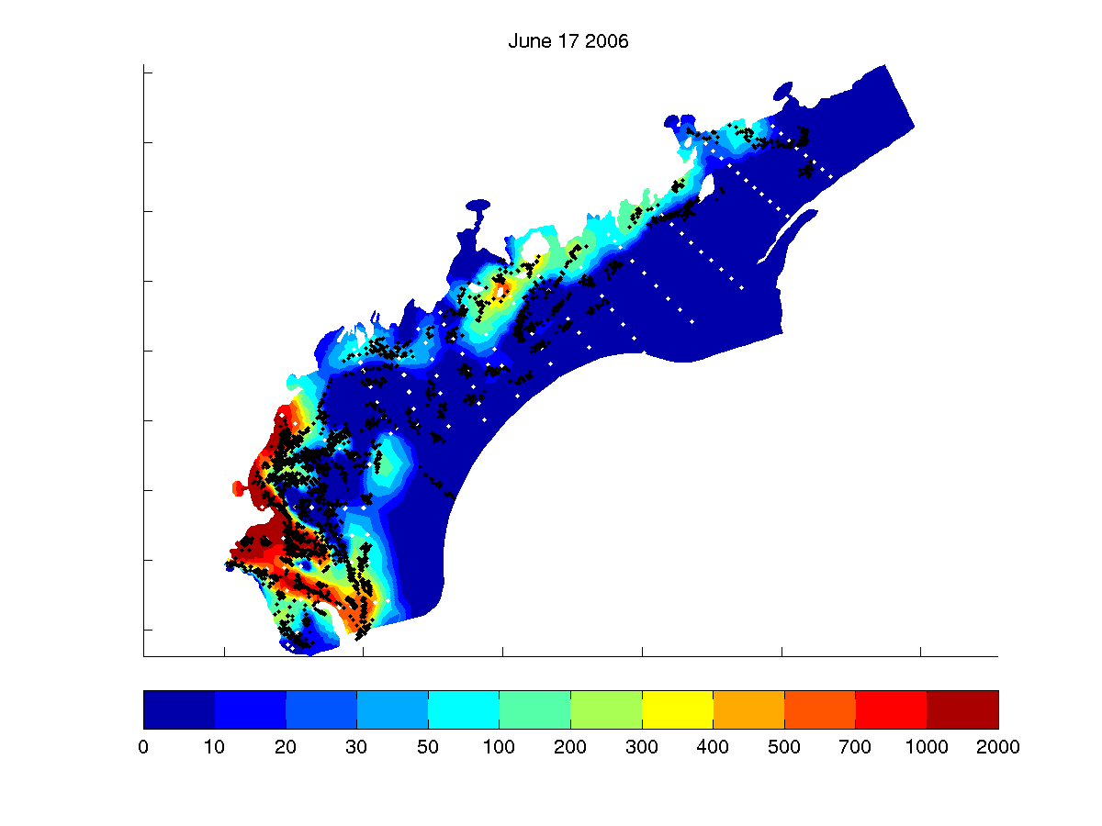
Figure 9. IBM forecast using 20 particles per station, cell counts from the first and second legs of OC425 and growth dynamics. The black dots are the advected and dispersed station locations. Velocity and diffusivity are from the posterior of OC425_FC20.

The BOF drifter trajectories (Figure 4, upper right) follow a pattern observed in climatological simulations of the Gulf of Maine predicted in

http://www-nml.thayer.dartmouth.edu/Publications/internal_reports/NML-05-2/.

Lacking a ship-based improvement, this constitutes the effective forecast for the region.

ID  Date | Period | Obs | ICs | Error statistics  Obs RMS Prior/Post1/Post2; Vector bias  Mooring RMS Post2;  Vector bias | Winds | Comments
FC_7 | 6/1-6/12 | ADCP 6/6-6/9 | Clim | 20.4  14.2/10.3/9.8  (-0.6,0.7) | Ship + NCEP
FC_8 | 6/1-6/12 | ADCP 6/6-6/9 | ROMS | 20.4  12.5/9.9/9.6 (-0.6,0.4) | Ship + NCEP | FC_7 + ROMS Ics and HYCOM BCs
FC_9 | 6/1-6/12 | ADCP  6/6-6/9  + moorings 6/3-6/9 | Clim | 17.2  14.2/10.5/10.2 (-.6,.3)  A: 8.9 ()  B: 8.9 (2.5,2.1)  E: 7.6 (0.9,-2.8)  I: 11.6 (-0.8,-3.7) | Ship + NCEP | FC_7 + moorings
FC_10 | 6/1-6/12 | ADCP 6/6-6/9 | ROMS | 20.4  12.6/9.9/9.6 (-0.6,0.4) | Ship + NCEP | FC8 + variable rivers (USGS stream gauges); reduced time step
FC_11 | 6/1-6/12 | ADCP  6/6 – 6/10 + moorings 6/3-6/10 | Clim | 17.8  14.2/12.1/12.7 (-0.5,-1.1)  A: 9.1 (3.7,-1.7)  B: 9.2 (2.7,2.9)  E: 7.2 (1.9,-2.9)  I: 11.8 (-1.1,-3.9) | Ship + NCEP | FC9, updated ADCP, moorings, winds
FC_12 | 6/1-6/18 | ADCP  6/6 – 6/11 + moorings 6/3-6/11 | Clim | 17.8  14.1/11.0/10.7(-0.6,-0.5)  A: 9.2 (3.9,-1.9)  B: 9.2 (2.3,2.5)  E: 7.7 (2.0,-2.6)  I: 10.8 (-0.2,-2.4)  Drifters |  | FC11, updated ADCP, moorings, extended to 6/18; [prior crashed after data period]
FC_13 | 6/1-6/18 | ADCP  6/6 – 6/12 + moorings 6/3-6/12 | Clim | 21.0  17.3/13.5/13.1 (-0.6,-0.6)  A: 8.9 (3.9,-1.7)  B: 9.1 (2.6,2.5)  E: 7.5 (2.4,-2.6)  I: 9.6 (1.5,-0.9)  Drifters: IAH 7.7 (2.3d) |  | FC11, updated ADCP, moorings, winds, 5 tidal constituents
FC_14 | 6/1-6/18 | ADCP  6/6 – 6/12 + moorings 6/3-6/12 | ROMS | 21.0  17.1/13.7/13.0 (-1.0,-0.6)  A: 9.4 (3.5,-3.1)  B: 10.9 (3.4,4.5)  E: 7.3 (2.3,-2.1)  I: 9.9 (3.3,1.2)  Drifters: IAH 8.2 (2.3d) |  | FC_13 + ROMS Ics+ HYCOM BCs
FC_15 | 6/1-6/18 | ADCP  6/6 – 6/13 + moorings 6/3-6/13 | OACI | 30.3  23.6/21.8/20.8 (-0.7,0.6)  A: 8.7 (1.6,-4.5)  B: 8.5 (3.0,2.1)  E: 9.0 (-5.0,-3.1)  I: 11.8 (0.9,-1.9)  Drifters:  IAH 8.7 (3.2d)  BoF 13.9 (1.4d) |  | FC_16 OACI Ics and Mary-Jo BCs  Revised slip
FC_16 | 6/1-6/18 | ADCP  6/6 – 6/13 + moorings 6/3-6/13 | Clim | 30.3  23.9/21.2/20.5 (-0.6,0.4)  A: 8.7 (4.0,-1.6)  B: 8.7 (2.6,2.1)  E: 7.2 (1.9,-2.7)  I: 10.2 (1.6,-0.6)  Drifters:  IAH 7.0 (3.2d)  BoF 12.1 (1.4d) |  | Updated 13
Corrected drifter separation algorithm (boundary impact, regression slope)
FC_17 | 6/1-6/18 | ADCP mid coast only | OACI | 20.1  14.7/10.2/9.8 (-0.2,0.7)  Drifters:  IAH 4.8 (4.3d)  BoF 11.6 (2.4d) |  | FC_15  Mid-coast ADCP  No moorings  No Mary-Jo BC
FC_18 | 6/1-6/18 | ADCP mid coast only | OACI | 20.1  14.0/11.2/10.8 (-0.5,0.7)  Drifters:  IAH 5.7 (4.3d)  BoF 11.6 (2.4d) |  | FC_17 plus Mary-Jo
FC_19 | 6/1-6/18 | ADCP south and west of Bar Harbor | OACI | Crashed; terminates on June 13 |  | ADCP south and west of Bar Harbor;  MaineCC5 mesh
FC_20 | 6/1-6/18 | ADCP south and west of Bar Harbor | OACI | 19.0  13.2/11.6/11.2 (0.3,-0.4)  Drifters:  IAH 5.7 (4.3d)  BoF 11.6 (2.4d) |  | FC_19 on stw2 mesh
FC_21 | 6/1-6/18 | ADCP mid coast only | clim | Still running |  | FC_17 with clim ICs
FC_22 | 6/1-6/18 | ADCP south and west of Bar Harbor | OACI | Still running |  | FC_20 minus Mary-Jo

*** Note runs FC_6,8,10 have ROMS problem T=S.

Appendix A: Measurements made on OC425

Core measurements:
a. CTD (pressure, temperature, salinity, fluorometer, transmissometer,
underwater PAR, surface PAR)
b. Niskin sampling (1, 10, 20, 30m depths from 10 liter bottles – 2 bottles each)
A. fundyense surface live counts
A. fundyense preserved samples
c. Nutrients: standard depths plus 50, 100, 150, 200m
d. Drifters
e. ADCP: NB150 and OS75 data collection with UHDAS

Ancillary measurements:
a. AVHRR and SeaWiFS imagery
b. GoMOOS moorings
c. Coastal tide gauges

Appendix B: Hydrographic maps and sections

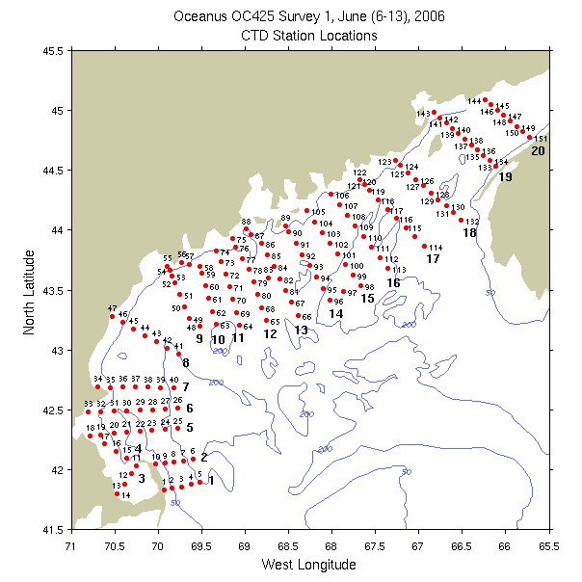 | 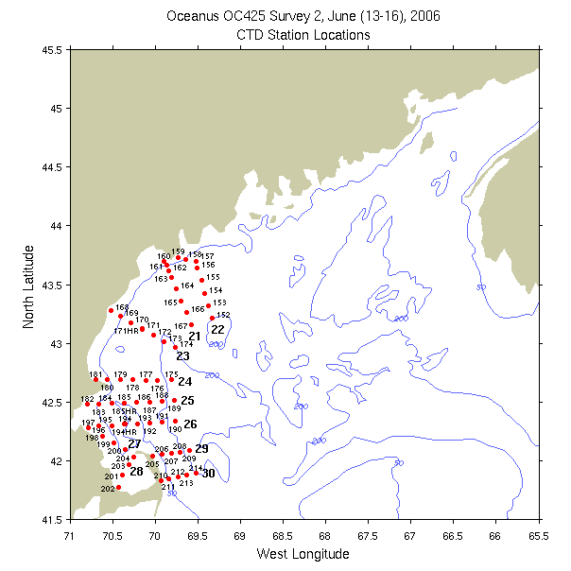
Figure B1: CTD (red dots) and underway (blue dots) station locations of the first (left panel) and second (right panel) surveys. Bold numerals indicate identifiers for the sections displayed below.

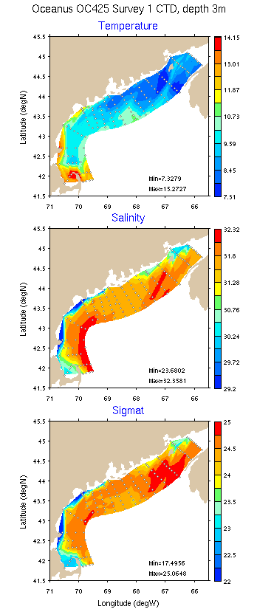 | 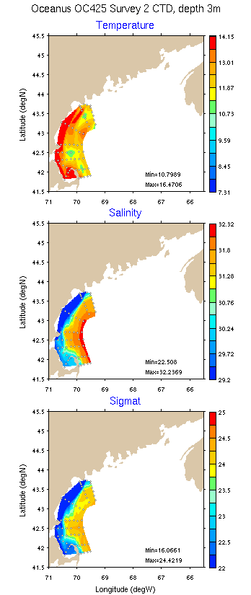
Figure B2: Temperature, salinity, and density for the first survey: 3m (left), and 10m (right)

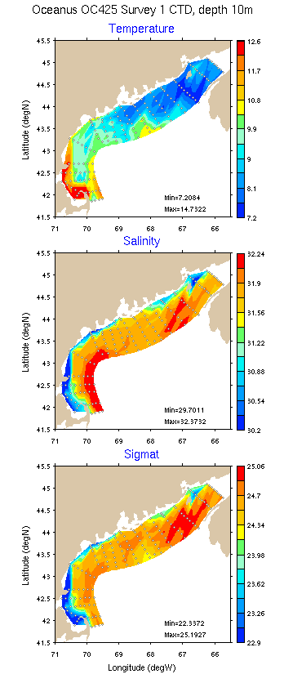 | 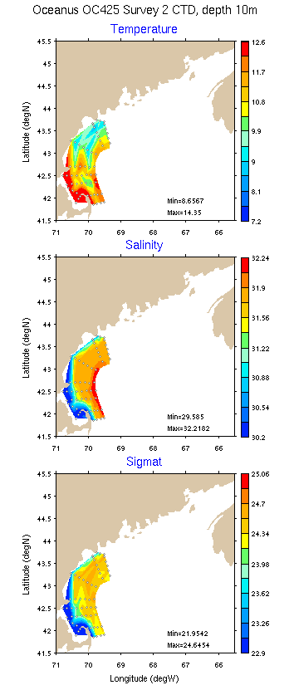
Figure B3: Temperature, salinity, and density for the first survey: 20m (left), and 50m (right)

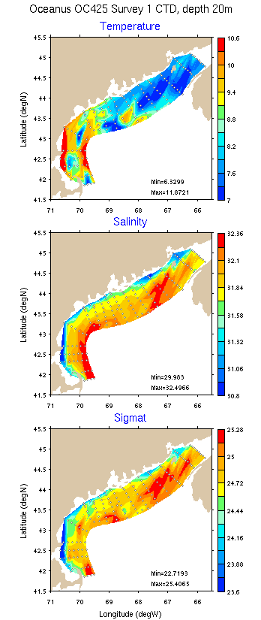 | 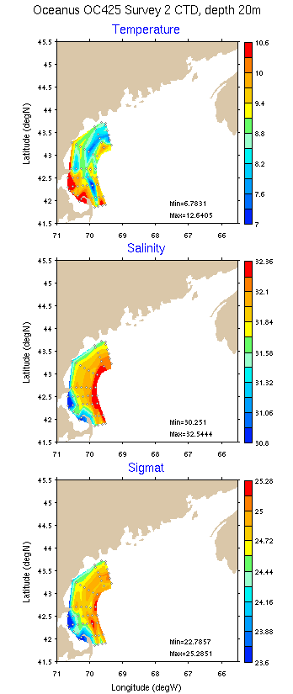
Figure B4: Temperature, salinity, and density for the first survey: 20m (left), and 50m (right)

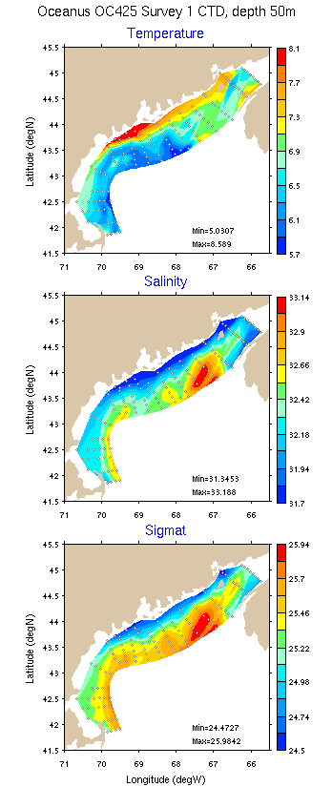 | 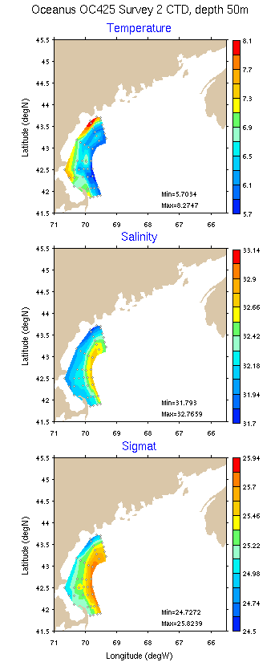
Figure B5: Temperature, salinity, and density for the first survey: 20m (left), and 50m (right)

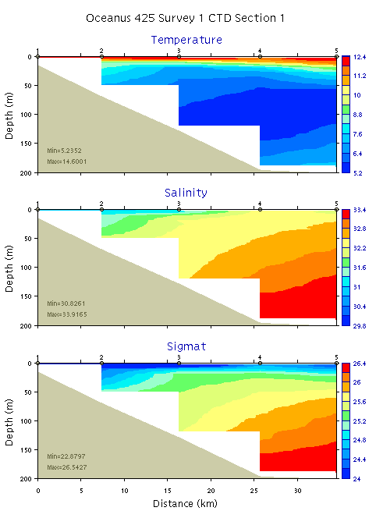 | 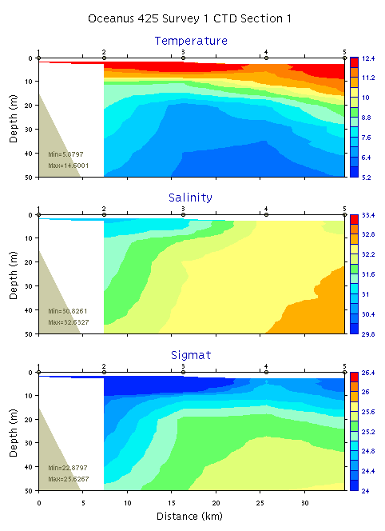
Figure B6. Temperature, salinity, and density from section 1: 0-200m (left) and 0-50m (right)

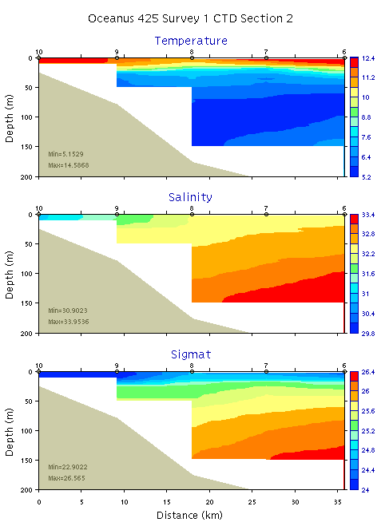 | 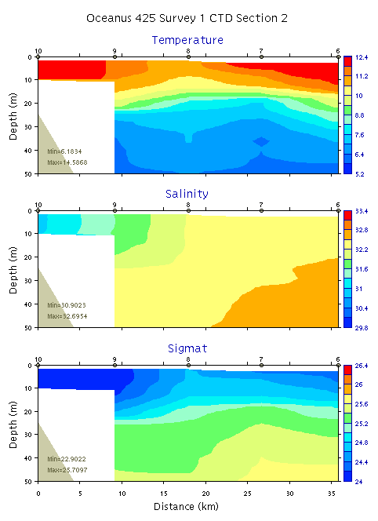
Figure B7. Temperature, salinity, and density from section 2: 0-200m (left) and 0-50m (right)
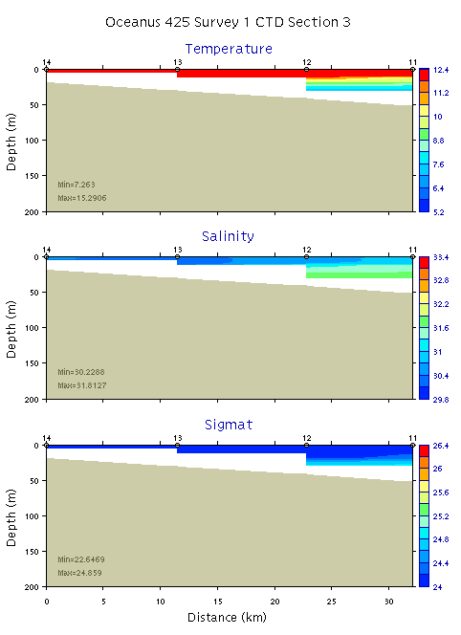 | 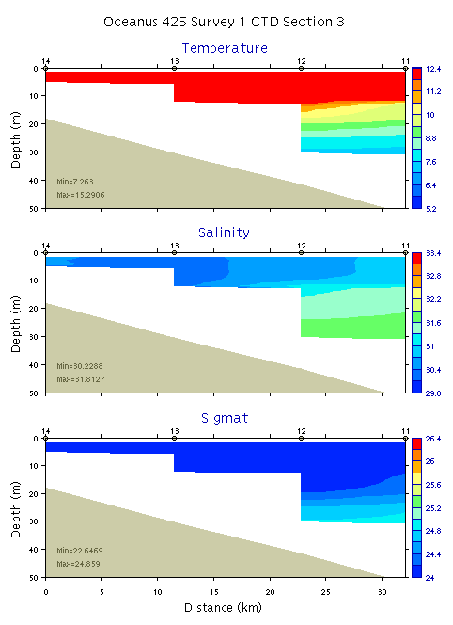
Figure B8. Temperature, salinity, and density from section 3: 0-200m (left) and 0-50m (right)

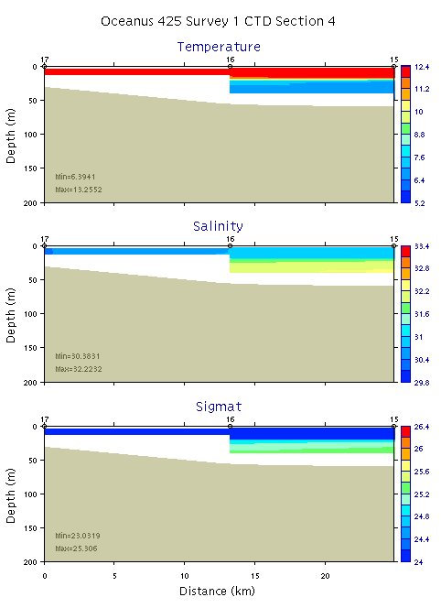 | 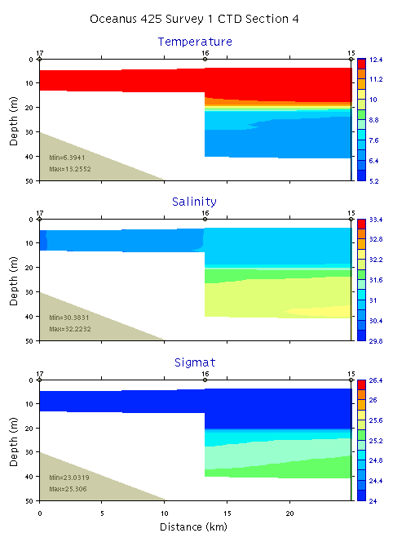
Figure B9. Temperature, salinity, and density from section 4: 0-200m (left) and 0-50m (right)
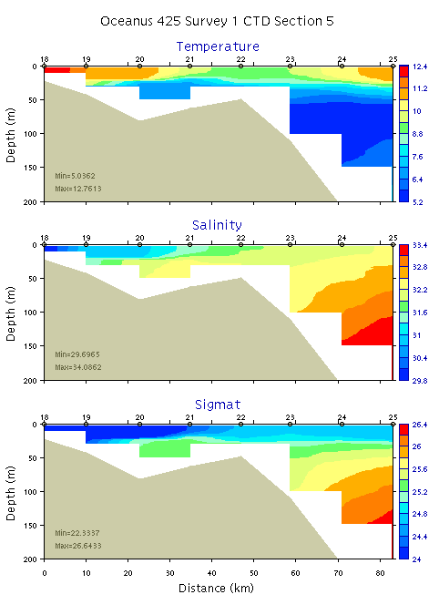 | 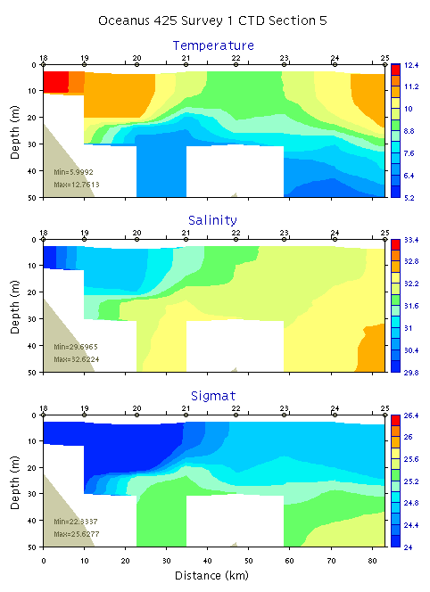
Figure B10. Temperature, salinity, and density from section 5: 0-200m (left) and 0-50m (right)

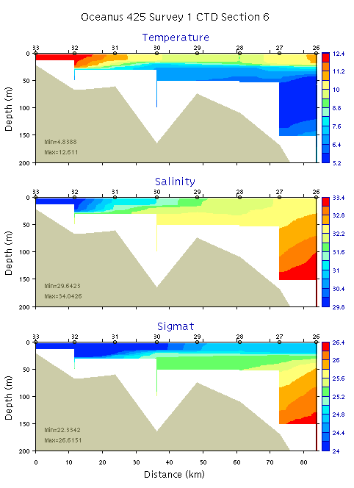 | 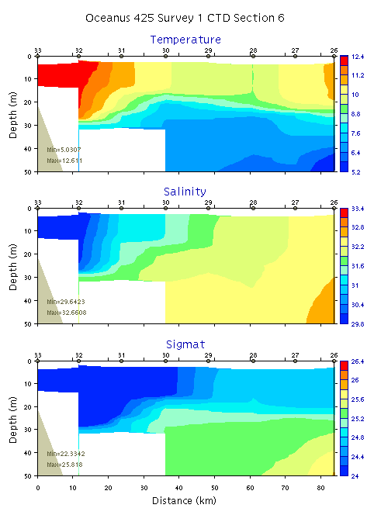
Figure B11. Temperature, salinity, and density from section 6: 0-200m (left) and 0-50m (right)
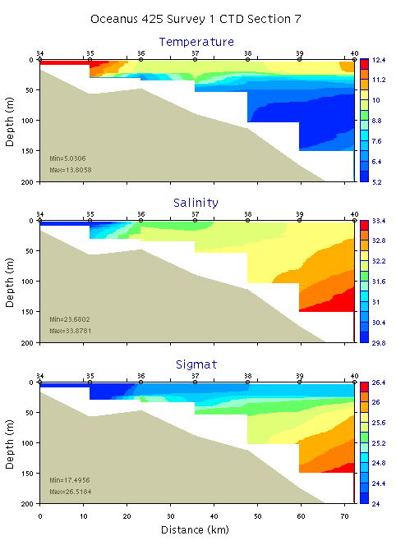 | 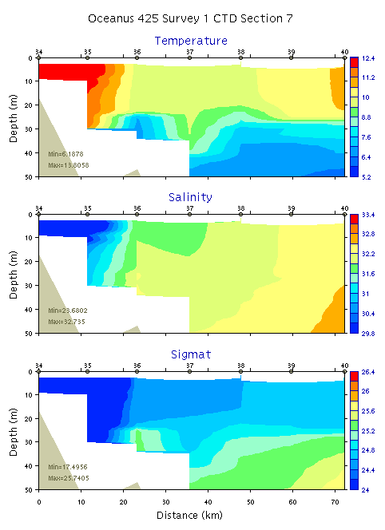
Figure B12. Temperature, salinity, and density from section 7: 0-200m (left) and 0-50m (right)

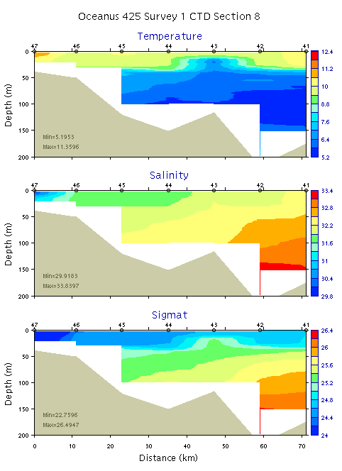 | 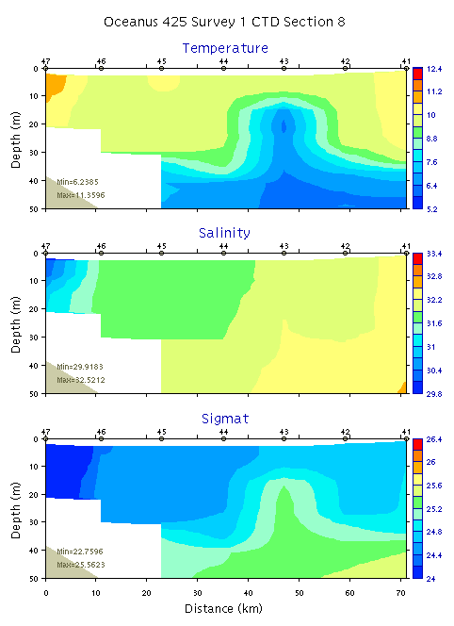
Figure B13. Temperature, salinity, and density from section 8: 0-200m (left) and 0-50m (right)
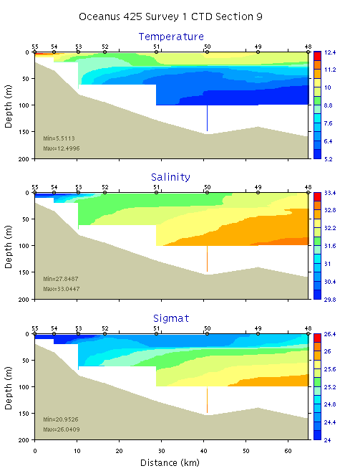 | 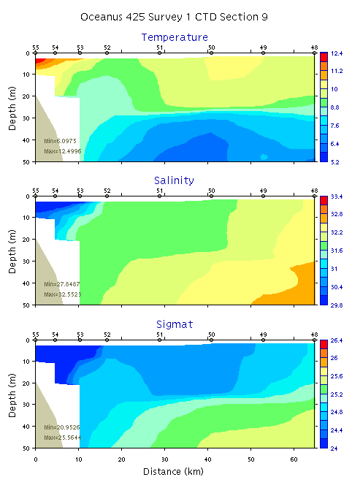
Figure B14. Temperature, salinity, and density from section 9: 0-200m (left) and 0-50m (right)

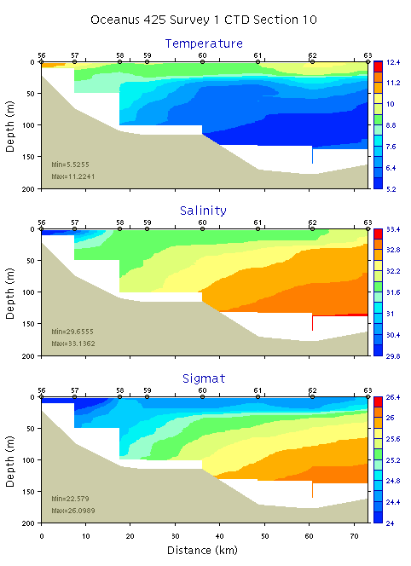 | 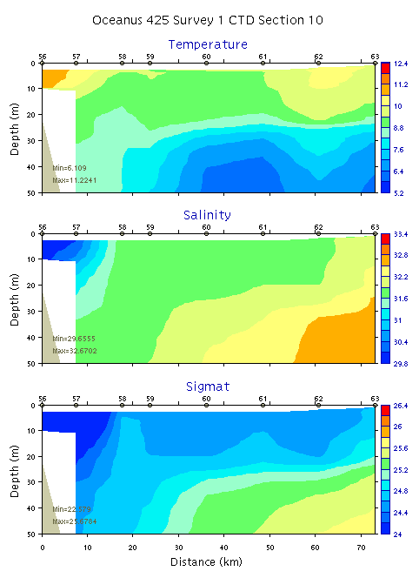
Figure B15. Temperature, salinity, and density from section 10: 0-200m (left) and 0-50m (right)
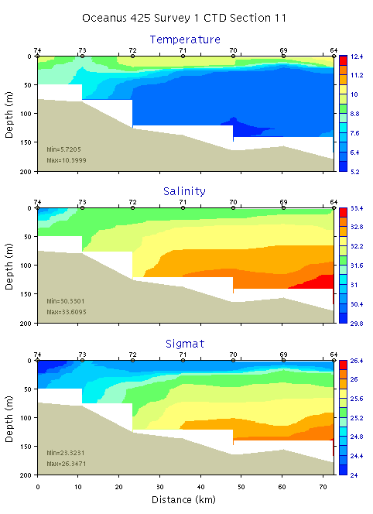 | 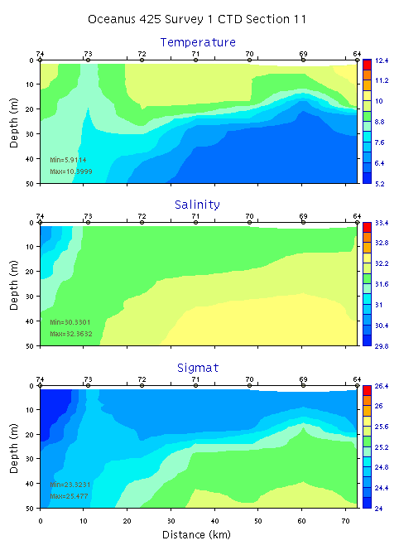
Figure B16. Temperature, salinity, and density from section 11: 0-200m (left) and 0-50m (right)

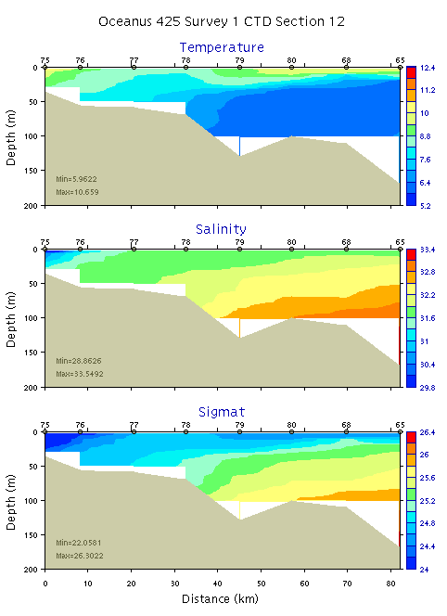 | 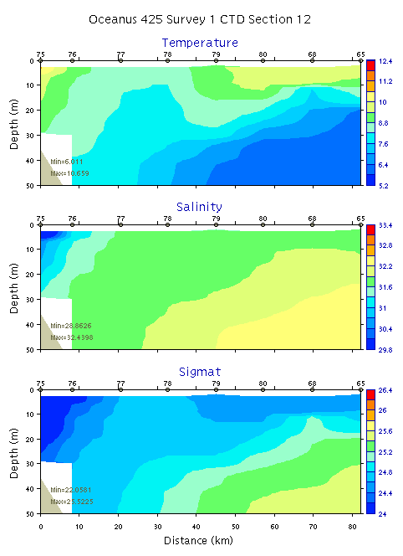
Figure B17. Temperature, salinity, and density from section 12: 0-200m (left) and 0-50m (right)
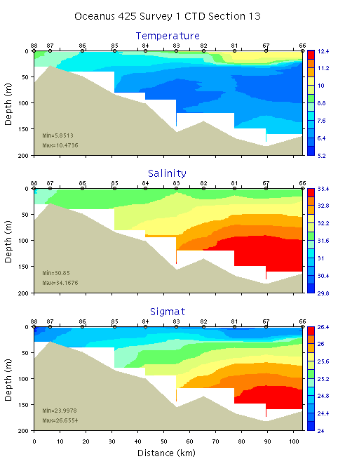 | 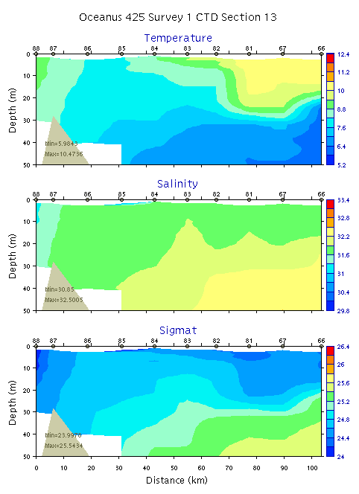
Figure B18. Temperature, salinity, and density from section 13: 0-200m (left) and 0-50m (right)

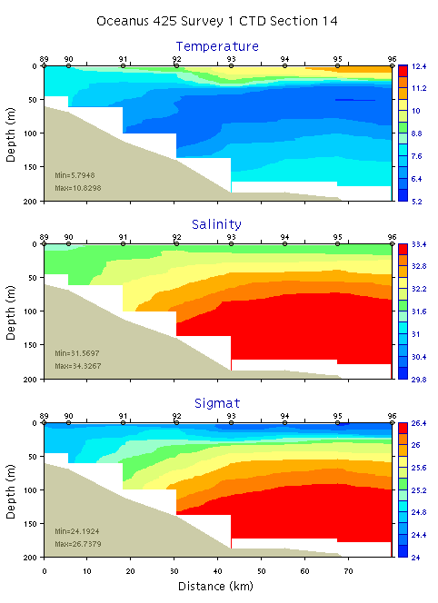 | 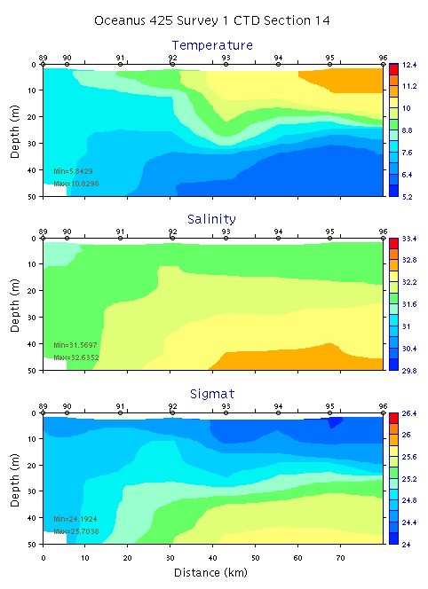
Figure B19. Temperature, salinity, and density from section 14: 0-200m (left) and 0-50m (right)
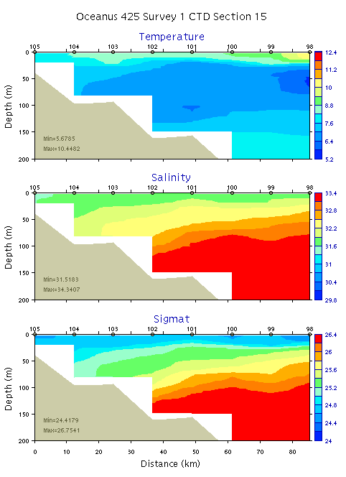 | 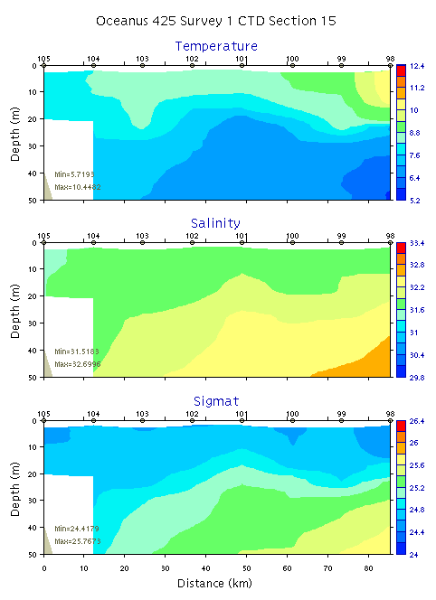
Figure B20. Temperature, salinity, and density from section 15: 0-200m (left) and 0-50m (right)

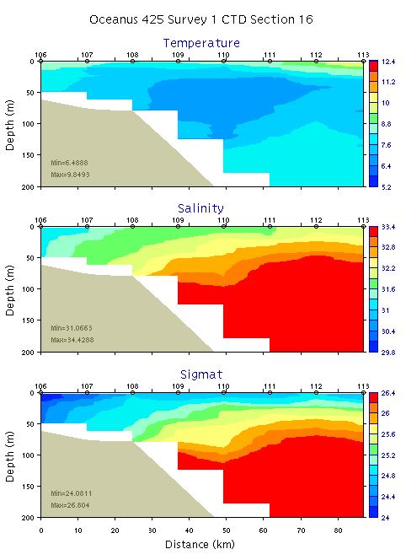 | 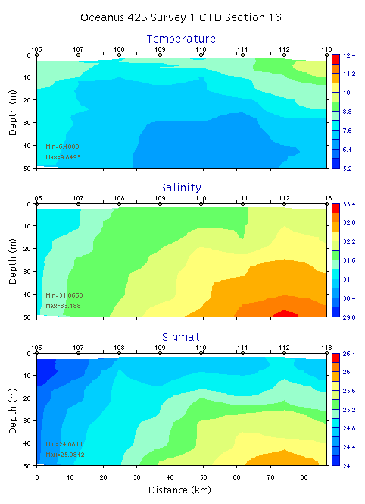
Figure B21. Temperature, salinity, and density from section 16: 0-200m (left) and 0-50m (right)
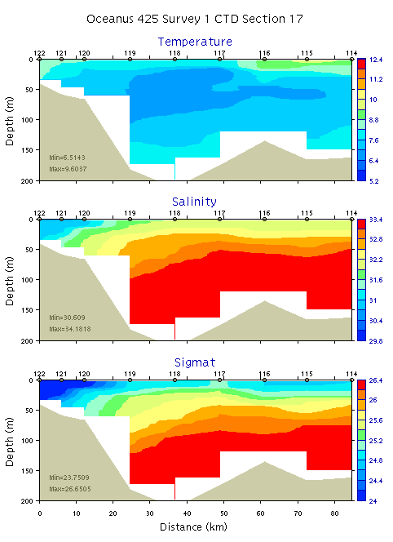 | 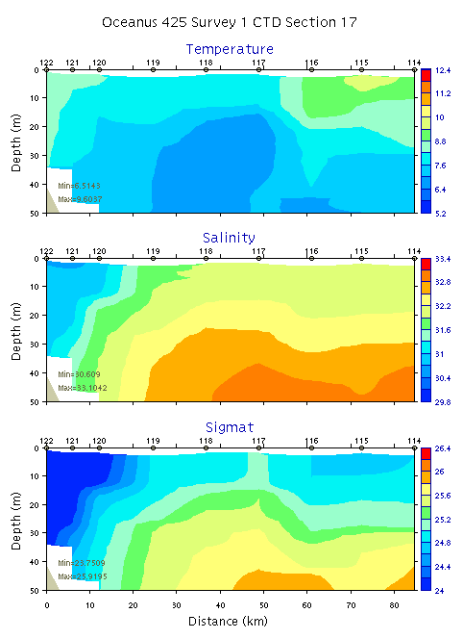
Figure B22. Temperature, salinity, and density from section 17: 0-200m (left) and 0-50m (right)

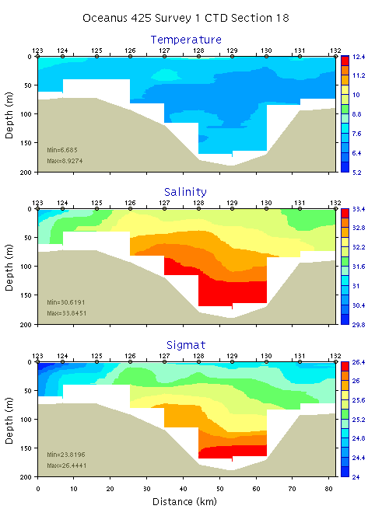 | 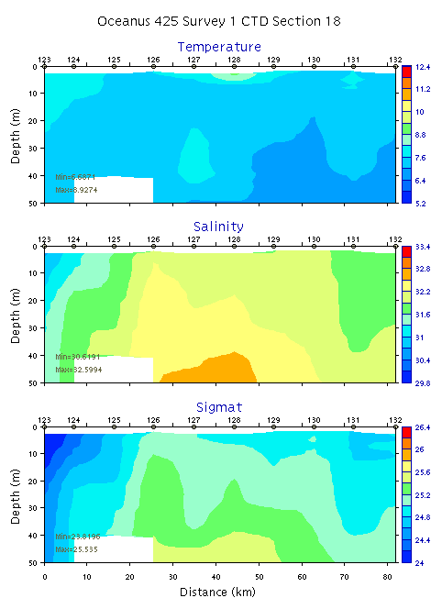
Figure B23. Temperature, salinity, and density from section 18: 0-200m (left) and 0-50m (right)
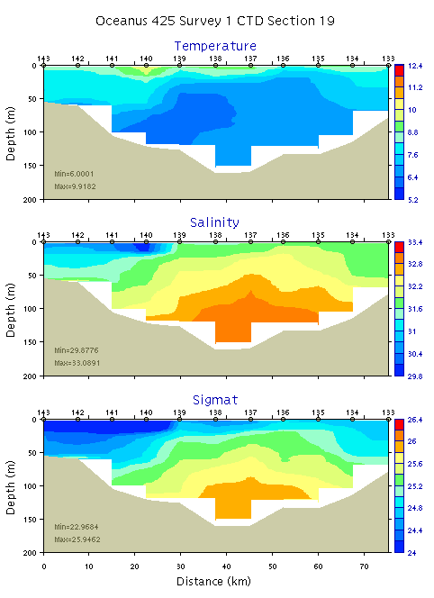 | 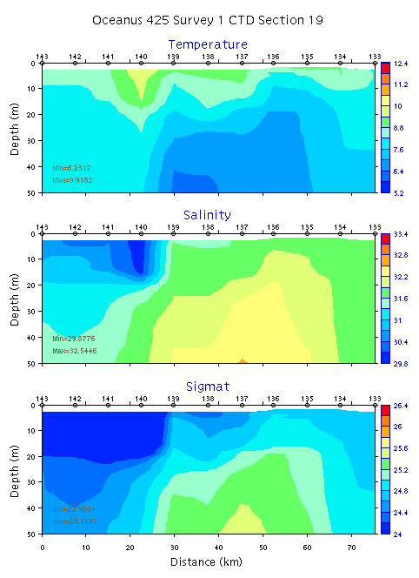
Figure B24. Temperature, salinity, and density from section 19: 0-200m (left) and 0-50m (right)

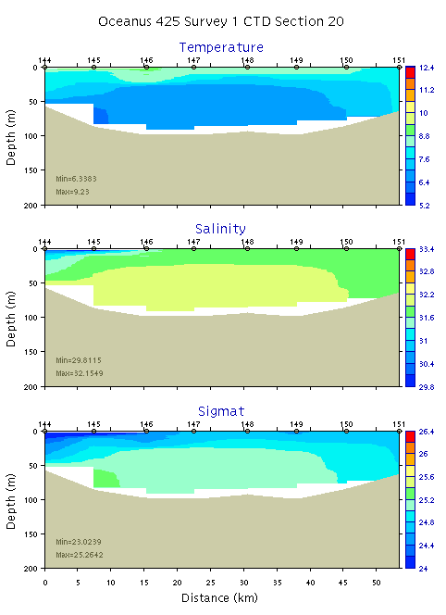 | 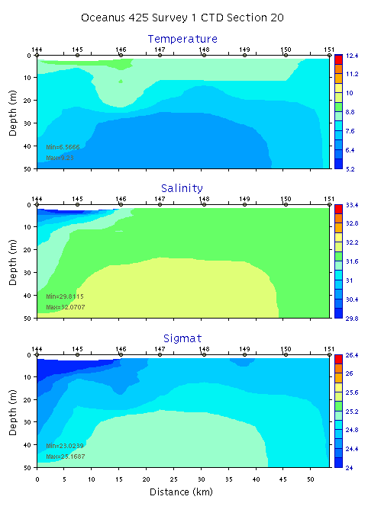
Figure B25. Temperature, salinity, and density from section 20: 0-200m (left) and 0-50m (right)
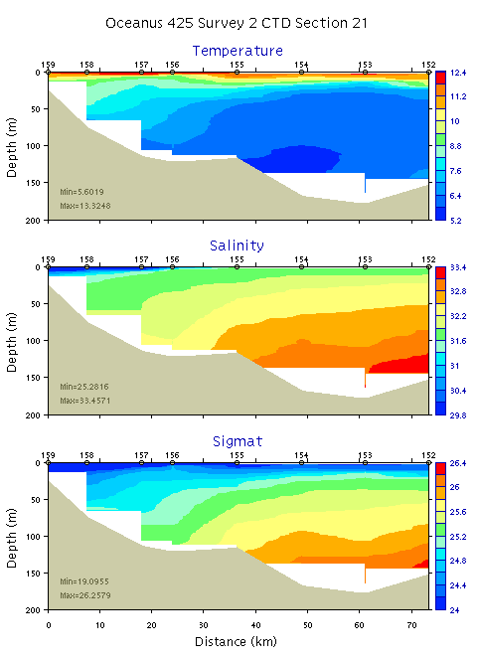 | 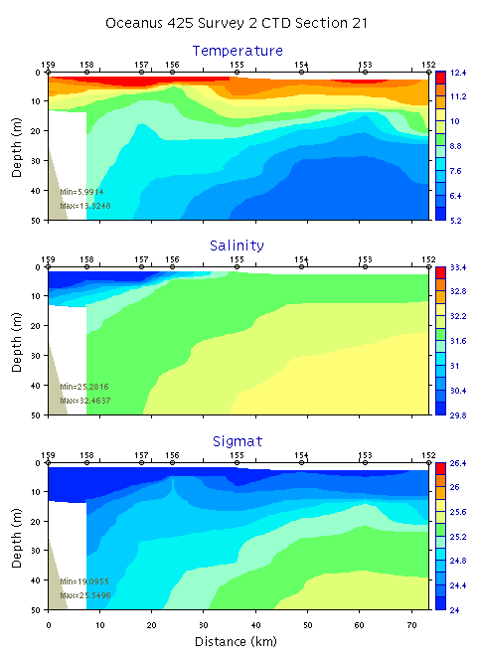
Figure B26. Temperature, salinity, and density from section 21: 0-200m (left) and 0-50m (right)

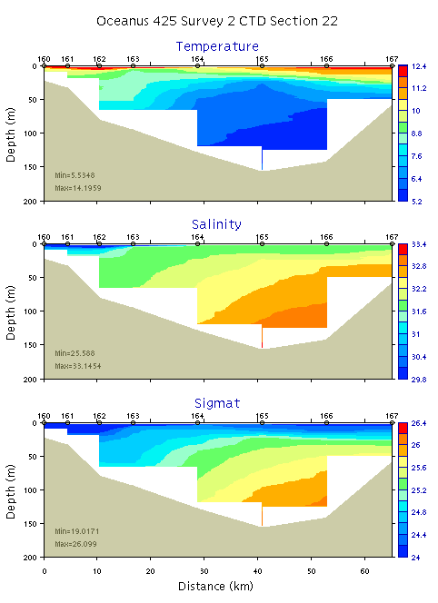 | 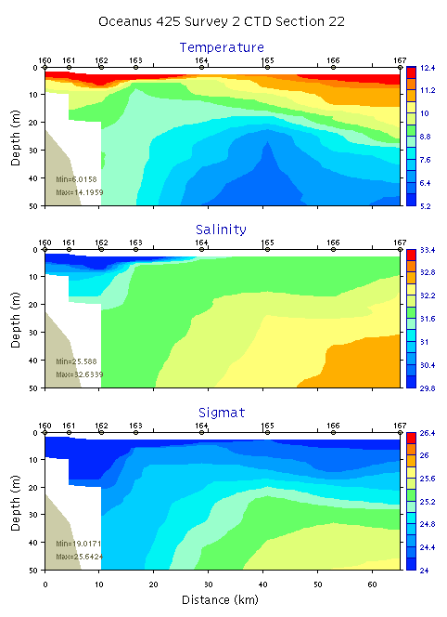
Figure B27. Temperature, salinity, and density from section 22: 0-200m (left) and 0-50m (right)
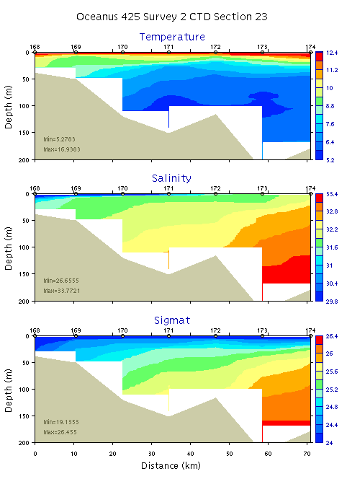 | 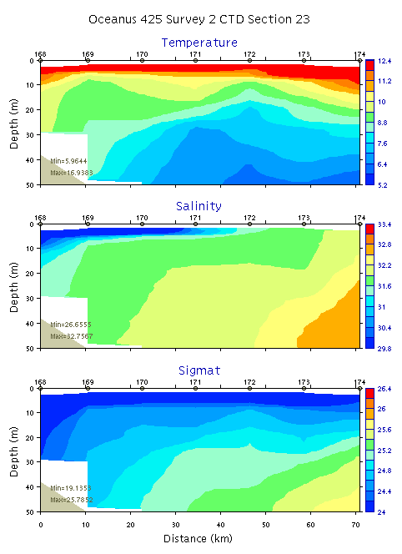
Figure B28. Temperature, salinity, and density from section 23: 0-200m (left) and 0-50m (right)

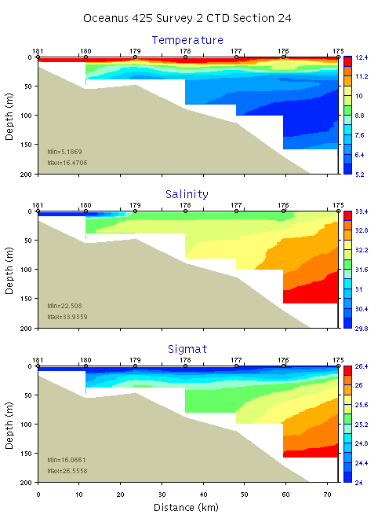 | 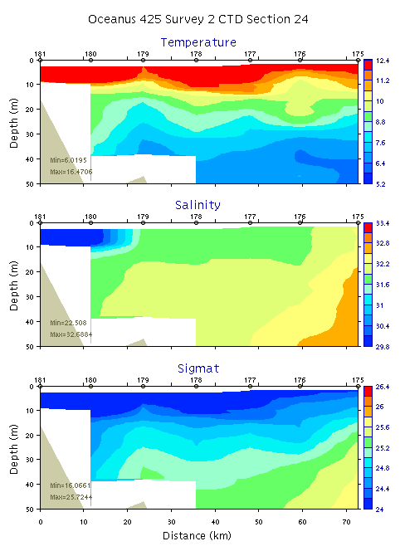
Figure B29. Temperature, salinity, and density from section 24: 0-200m (left) and 0-50m (right)
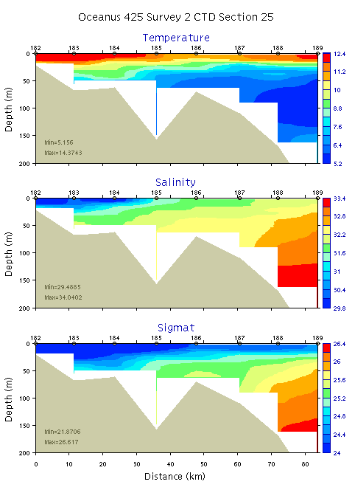 | 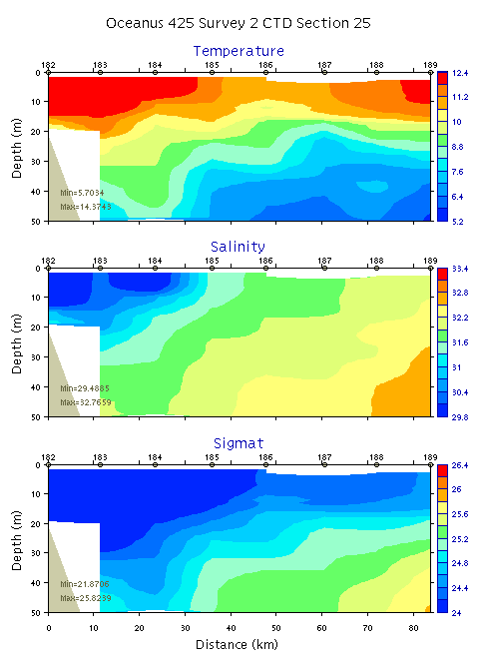
Figure B30. Temperature, salinity, and density from section 25: 0-200m (left) and 0-50m (right)

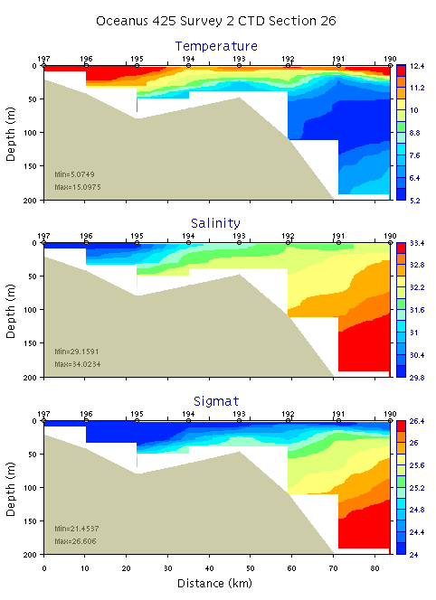 | 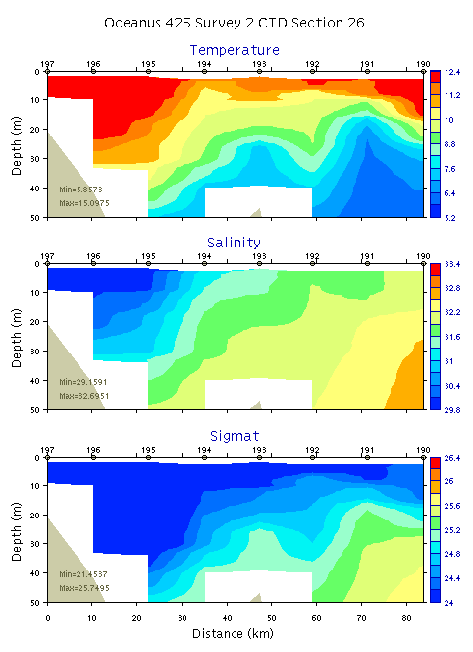
Figure B31. Temperature, salinity, and density from section 26: 0-200m (left) and 0-50m (right)
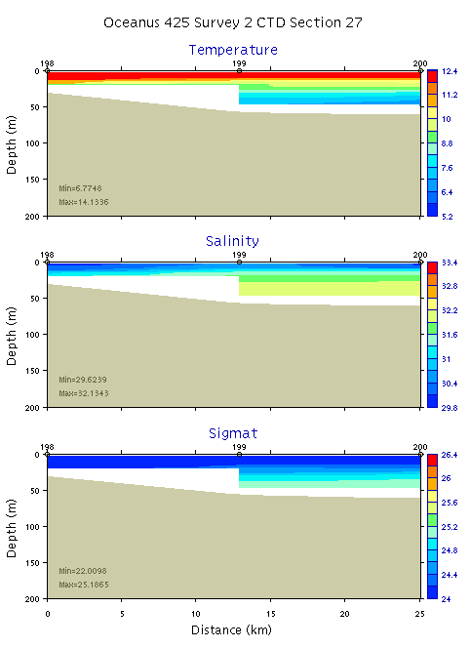 | 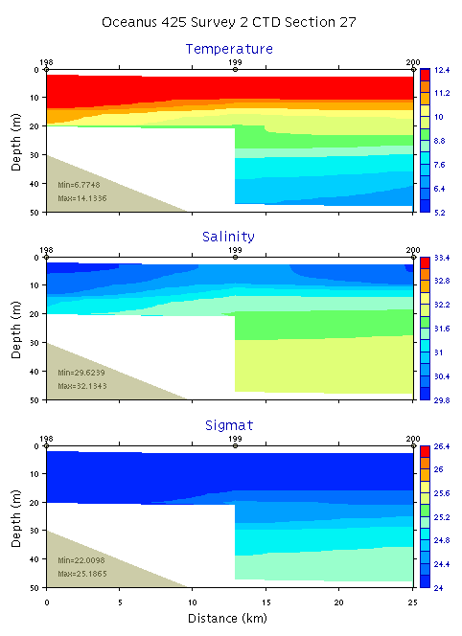
Figure B32. Temperature, salinity, and density from section 27: 0-200m (left) and 0-50m (right)

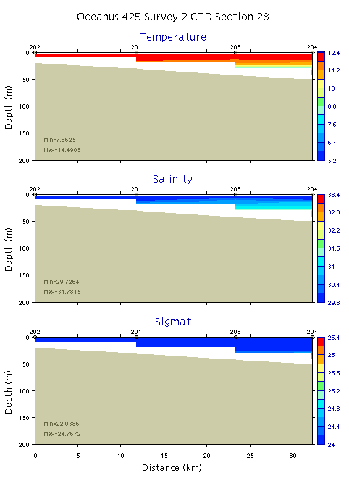 | 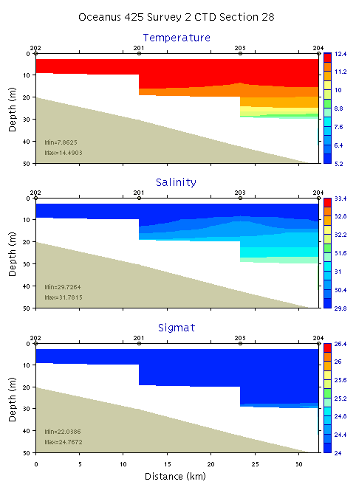
Figure B33. Temperature, salinity, and density from section 28: 0-200m (left) and 0-50m (right)
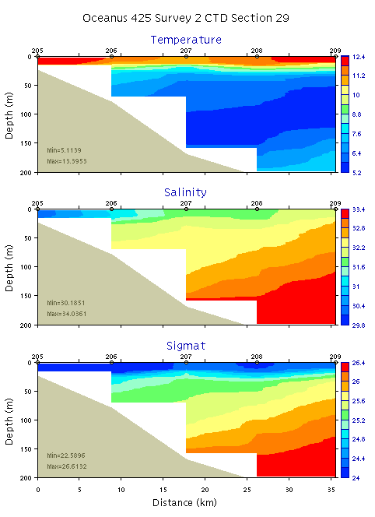 | 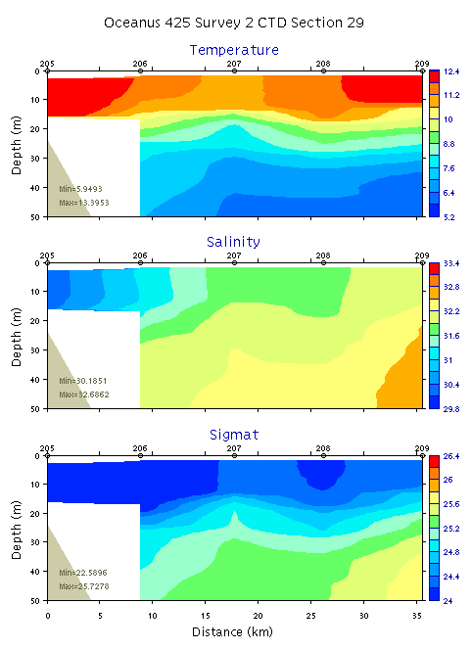
Figure B34. Temperature, salinity, and density from section 29: 0-200m (left) and 0-50m (right)

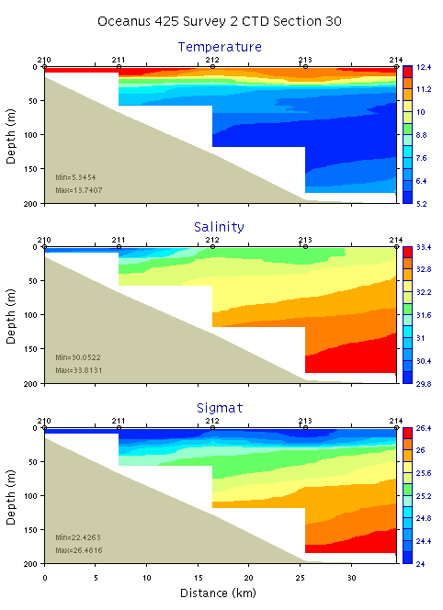 | 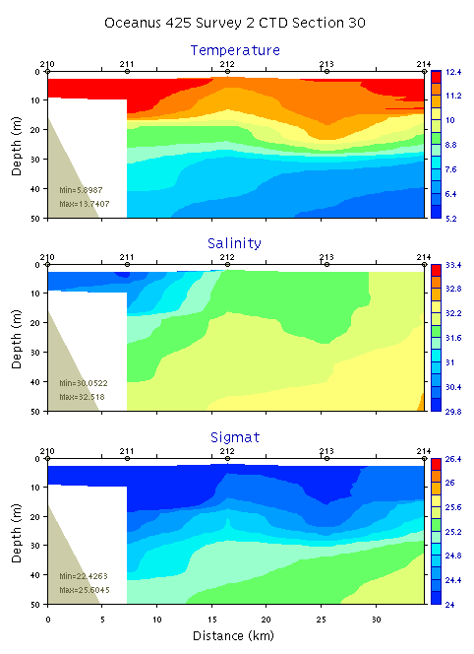
Figure B35. Temperature, salinity, and density from section 30: 0-200m (left) and 0-50m (right)
Appendix C: OC425 Personnel

1. Dennis McGillicuddy dmcgillicuddy@whoi.edu (Chief Scientist)
2. Bruce Keafer bkeafer@whoi.edu
3. Elizabeth (Libby) A Yranski <yranski.e@neu.edu>
4. Patrick Curran <patrickbrennancurran@gmail.com>
5. Kerry Norton knorton@whoi.edu
6. Deborah Osborne dosborn@bucknell.edu
7. Robert J Cannata <cannata.r@neu.edu>
8. Bryn Warren imprint19@hotmail.com
9. Alfredo Arextabaleta alfredo@email.unc.edu
10. Olga Kosnyreva okosnyreva@whoi.edu
11. Scotty McCue smccue@whoi.edu
12. Legena Henry legena@gmail.com
13. Christie Wood clw@MIT.EDU
14. Dennis Evangelista devangel@MIT.EDU
15. Maureen Lynch mlynch@mail.colgate.edu
16. Keston Smith keston.smith@dartmouth.edu
17. Jefferson Turner jturner@umassd.edu

http://science.whoi.edu/users/olga/alex_surveys_2006/WHOI_Alexandrium_Surveys_2006.html
http://science.whoi.edu/users/ruoying/Redtide_06/
http://www-nml.thayer.dartmouth.edu/Software/oafe/
Transmissometer readings were erratic, with frequent data dropouts.
Underwater PAR sensor is suspected to be damaged during installation; dark voltage measurements 6/11/06 ranged from 0.48 to 0.67, in contrast to factory calibration of 0.1885.

