RADTRACK Usage Manual

Prepared by
Raytheon Polar Services
7400 South Tucson Way
Centennial, CO 80112
303-790-8606

Table of Contents
Table of Contents i
Introduction 1
Setting Up the Database 1
Locking the Form 3
Using RADTRAK During a Cruise 5
Project Usage 5
Hazardous Waste Information Sheet number (HWIS) 7
Reports 7
References 10
Index 11

Introduction
RADTRAK, a Microsoft Access database, documents radioisotope use by science groups during a cruise or season. The MST sets up the database with grantee specifics (such as the initial amount of radioisotope stock) and locks the database. The grantee uses the database to track radioisotope use and generate reports for the Rad Log Book. The final RADTRAK database is returned to the Lab Supervisor in Denver and kept in the MST folder.
The blank RADTRAK database is sent down from Denver, probably on a disc in the Rad Log Book. If you don’t receive a database, you maybe able to find a current version of RADTRAK on the ship, either as blank template or as another group’s completed database. Make sure to use the most current version. If you need to name the database, include science group number and the year i.e., S032_99.mdb or B047 RadTrak2004-5.mdb.

Setting Up the Database
- During the portcall, copy the blank RADTRAK to the public drive for each science group. Remember, one RADTRAK per science group.
- Open the database, and the Main Menu of RADTRAK, Figure 1 will appear. Click on Data Input.

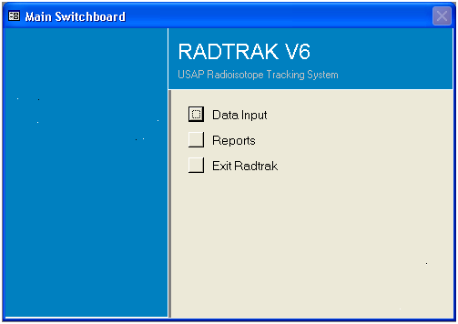
Figure 1. RADTRAK Main Screen Menu

- In the Data Input Menu, Figure 2, click on Open Project Inventory.
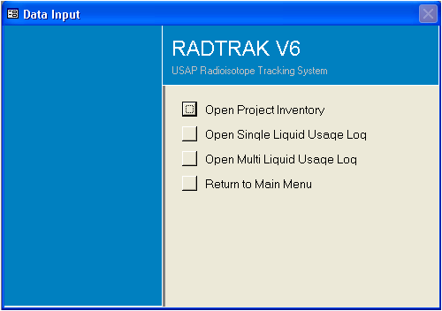
Figure 2. RADTRAK Data Input Menu

- After the Project Inventory form, Figure 3, opens, input general information. At the top of the screen, enter the project number, PI’s name, ship, season, home institution, NRC license # as listed on the NSF Radioisotope Authorization Permit.
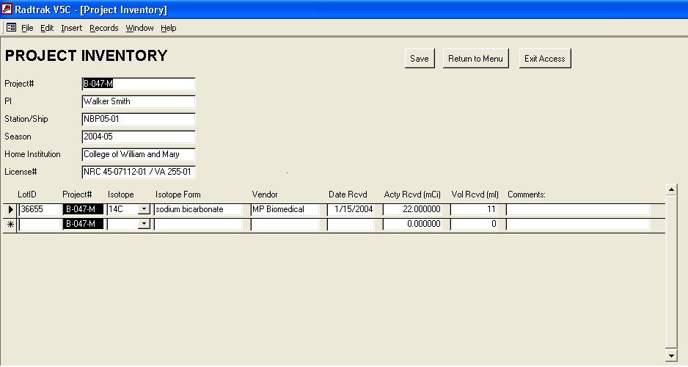
Figure 3. Project Inventory Screen (note that it scrolls right)

- Enter radioisotope stock information by Lot ID. Lot ID may be a specific lot number from the manufacturer or any identifying number given by the scientist. A scientist may choose to group several isotopes of various manufacturer lot numbers together. This is not a problem as long as the activity and volume of the various lots are summed in the inventory, the NEW lot is given a unique name, and the original lot numbers are noted in Comments.
- If multiple lots are identified, each new lot should be entered on a different line of this form. When the entries are finished, click on Save and Exit Access.

Using RADTRAK During a Cruise

Project Usage
The scientist fills out the usage logs as the isotope is used. The cursor can be moved from box to box using the mouse or the tab key. Edit the usage section of this form at any time.
- Open the database and select Data Input.
- Chose Open Single or Open Multi Liquid Usage Log. Use Open Single when you are only making one type of liquid and Open Multi when you are making multiple types of liquid.
- The project usage form, Figure 7 appears. Select the isotope LotID from the drop down box on the top of the Project.
- The LotID information from the Project Inventory will automatically fill the boxes at the top left of the screen.
- Fill in the date, user's initials, and activity used. The Checksum box will automatically update once you begin filling in the activity under each of the following headings, checking that the amount you fill in equals the amount you have indicated you've used for that date. If the value in the Checksum box does not equal 0.00000 after the information is input, there is an error either in the activity used or the activities listed under the specific headings.
- Headings: It is important to identify where the isotopes went. The following headings are available:
  - Dry Waste
  - Liquid Scintillation Vials
  - Liquid Waste
  - Carcass Waste
  - Exhaust
  - Sample
    - Underneath each heading, the grantee will input how much of the isotope resulted in that waste stream, and will also include the HWIS number of the container in which it was put. The default HWIS number is 99999999. Please see below for a discussion about HWIS numbers.
    - After the information for that date is complete, press <enter>, and the Activity Remaining field will update at the bottom of the form. This tells the grantee how much more of the isotope he/she has to work with the rest of the cruise/season.
    - Click on the Save and Return to Main Menu button to return to the Main Menu.
    - To copy a usage line entry, select the line by putting your cursor on the line and left mouse click. The black arrow will be to the left of the line selected. Select the Copy Item button and Save and Return to Menu. To see the updated entries and activities, re-enter Project Usage form.
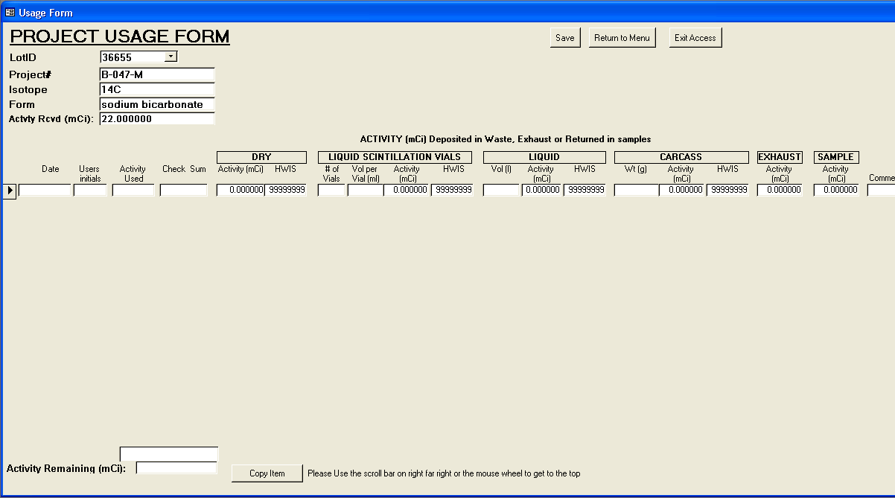
Figure 7. Project Usage Form Screen

Hazardous Waste Information Sheet number (HWIS)
The MST will inform the PI about the HWISs in the Radioisotope Orientation prior to the group's use of radioisotopes. Each group should have an 'open' HWIS for each type of radioisotope waste being generated. The number of the open form is to be placed in the appropriate box on the Project Usage form.
Upon disposal of any type of radioisotope waste, a completed HWIS will be turned in with the waste. Reports can be run from RADTRAK

Reports
Several reports can be run depending on the needs of the scientist or the MST and ultimate tracking for NSF. These are listed on the Main Menu Screen, and will be generated with the information input into the Project Inventory and Project Usage forms.
Any report can be printed by choosing File and Print while viewing the report. Examples of reports can be seen in the Example Radioisotope Usage Log located in Labstores.

Report by HWIS
This report simplifies the hazardous waste process for both the science group and RPSC. It will output data relevant to a specific HWIS (total activity, volume, etc). This is important when the scientist submits waste to RPSC.
- Click the Report by HWIS button on the Main Menu form. A dialog box will appear requesting the HWIS number and the type of waste.
- Fill in the correct HWIS and select the button for the appropriate waste type.
- The activity and other relevant information for that waste type will be summarized on the report.
- To return to the Main Menu from the report view, simply close the report (File, Close).
Note
If the report output is blank, either the HWIS number or the type of waste selected is incorrect. Close the report and re-enter the information into the dialog box.

Waste Summaries
These reports will summarize all the pertinent information for the listed waste types. The information is sorted by HWIS and by isotope.
- To run the report, select any of the Waste Summary buttons. The report will appear on the screen.
- To return to the Main Menu from Report View, simply close the report (File, Close).

Usage Form
This report summarizes the isotope usage per isotope, summarizing the various Lot IDs of the same isotope (although possibly different forms).
- To run the report, click on the Usage Form button on the Main Menu.
- Select the Lot ID from the drop-down box.
- Click on View.
- This report needs to be printed on legal size (8 ½ x 14) paper. In the Print dialog box, choose Properties to change the orientation of the report (to landscape) and the size of the paper.
- To return to the Main Menu from Report View, simply close the report (File, Close).

Inventory Log
This will generate a report of the inventory logged in by the MST.

Isotope Waste Summary
The Isotope Waste Summary report summarizes the pertinent waste information for each isotope in the database. To return to the Main Menu from Report View, simply close the report (File, Close).

NSF EOS Report
This is a report for the NSF to show isotope use and how much of each isotope went where. This is an End of Season (EOS) report.
Exit RADTRAK by choosing File from the menu bar, and Exit. This command will close the entire program. The RADTRAK database will be saved automatically.
At the end of a cruise, the copies of RADTRAK used need to be placed on a disk and accompany the radioisotope log book to RPSCHQ.
Please distribute the RADTRAK Instructions for Use in Appendix I, Forms, to those science groups who will be using RADTRAK.

