NBP12-01
Multibeam
End of Cruise Report

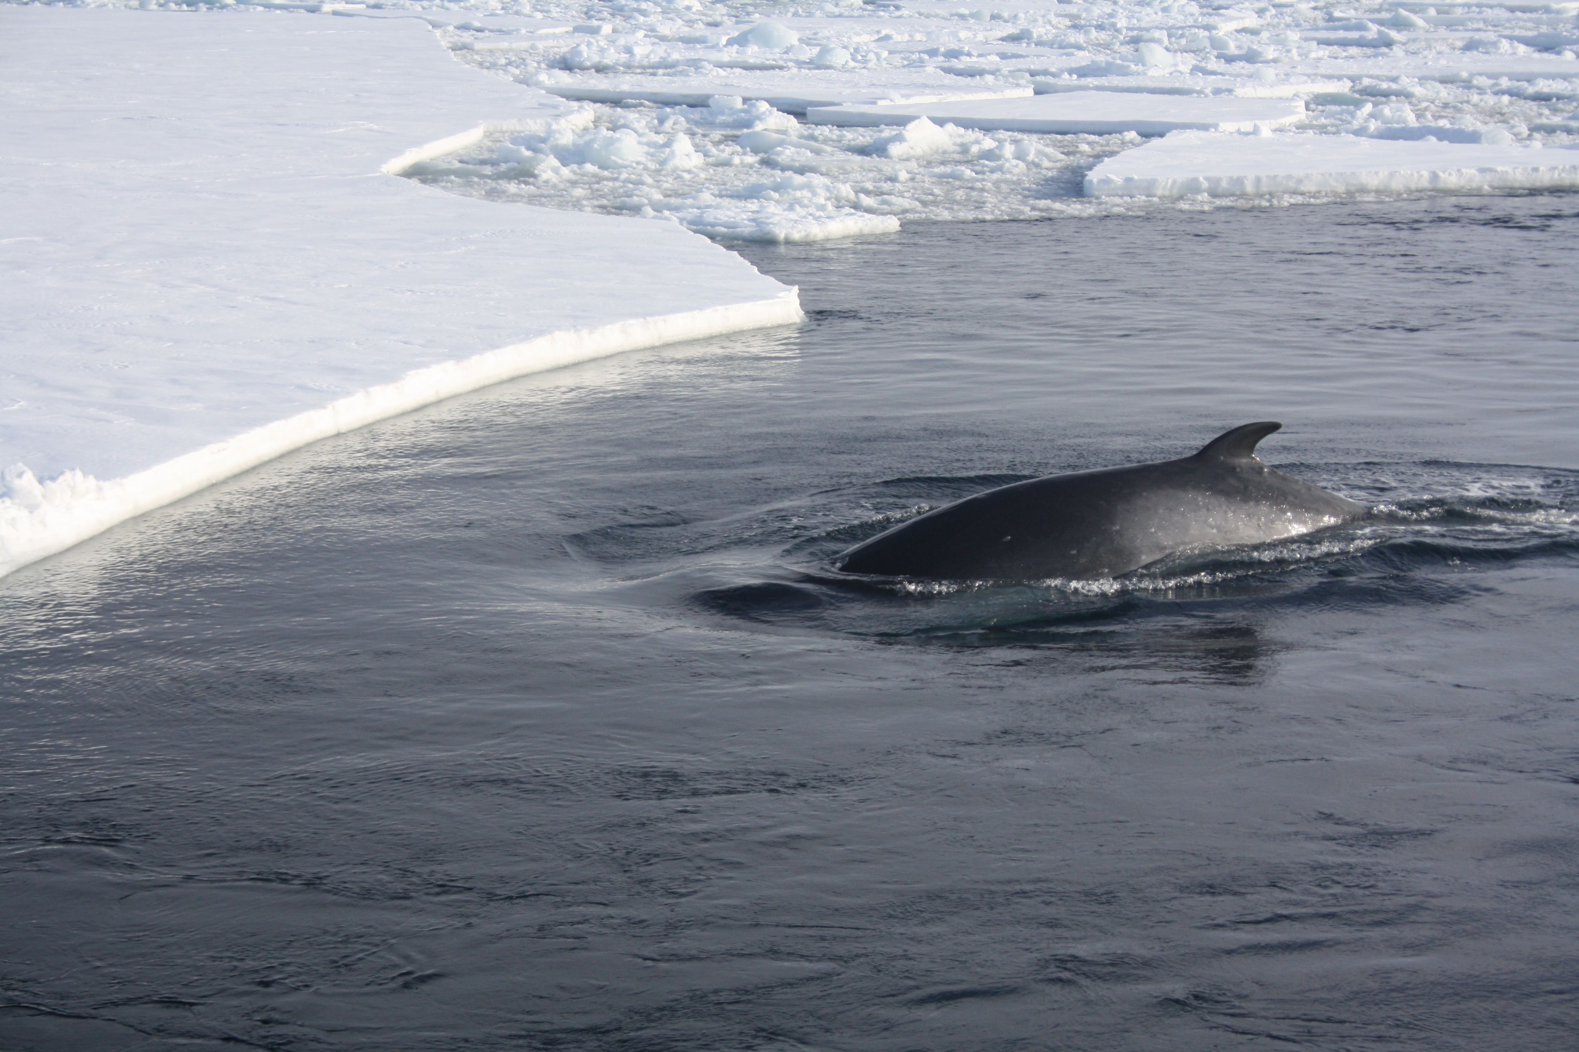
Photo by Tommy Ryan-Keogh

Prepared By Chris Linden
February 09, 2012

Contents

NBP1201 Error! Bookmark not defined.
Contents 2
Cruise Track Plot 3
Multibeam Work Area Plots 4
NBP1201 Multibeam Description of Work 12
Speed of Sound Corrections 13
NBP1201 Data Distribution 13
Data Distribution Information: 14

Cruise Track Plot
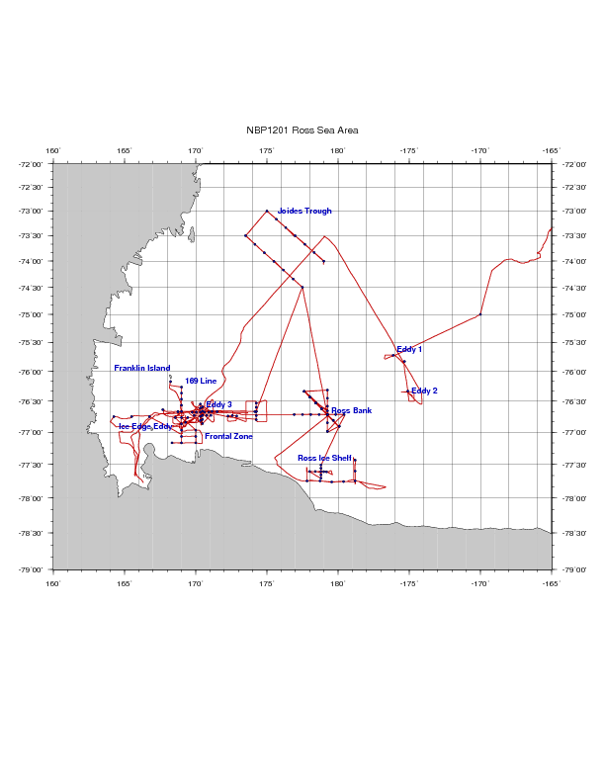

Multibeam Work Area Plots 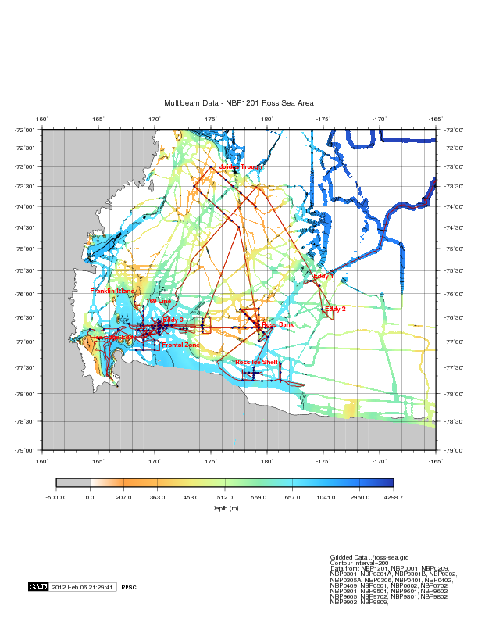
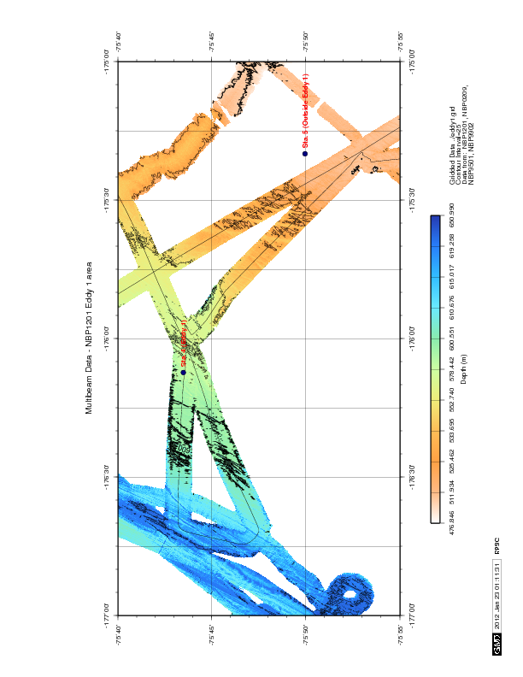

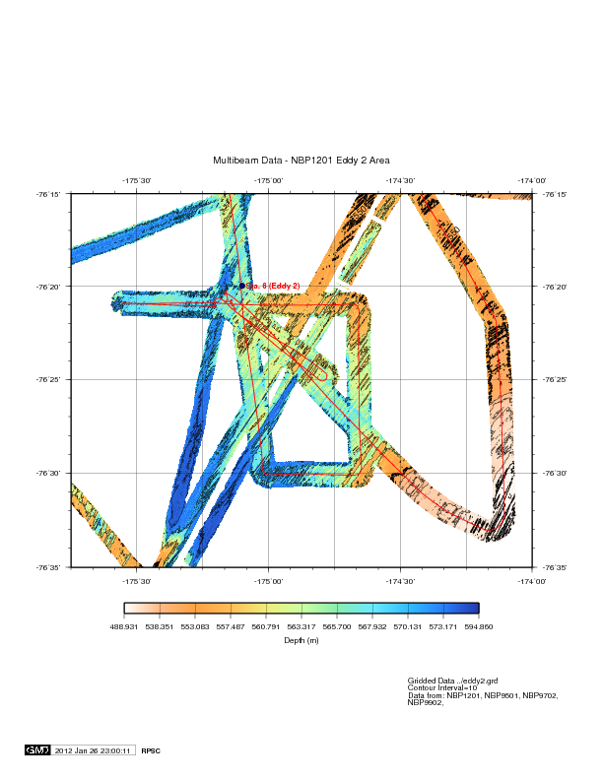

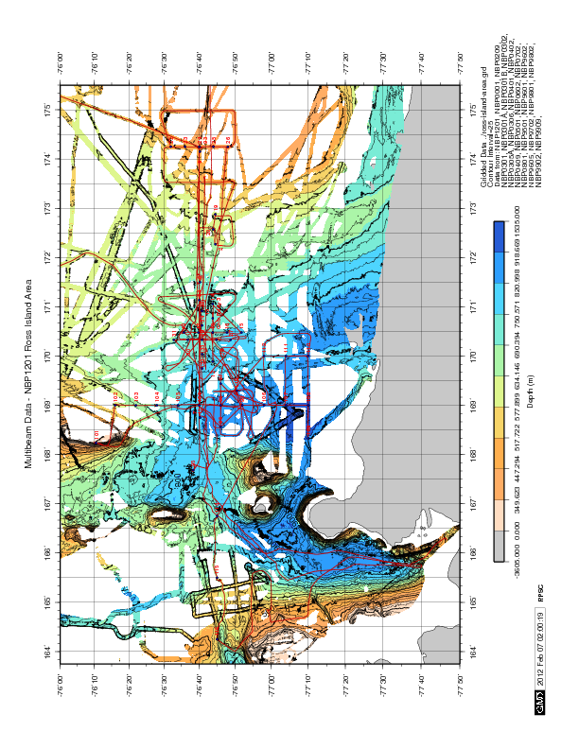

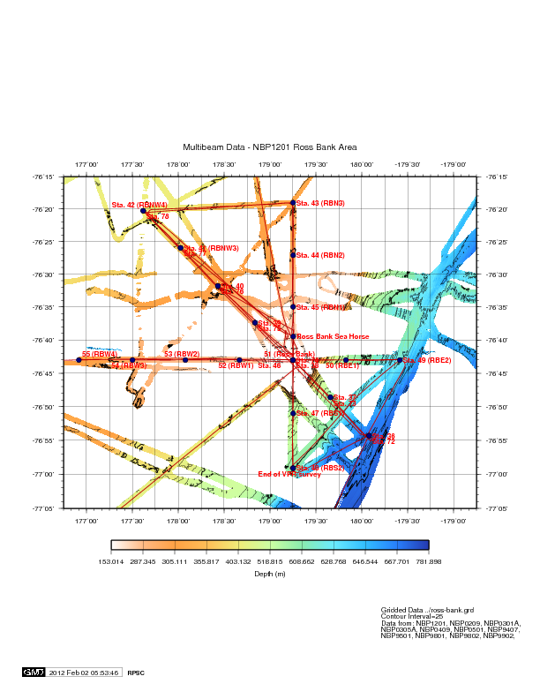

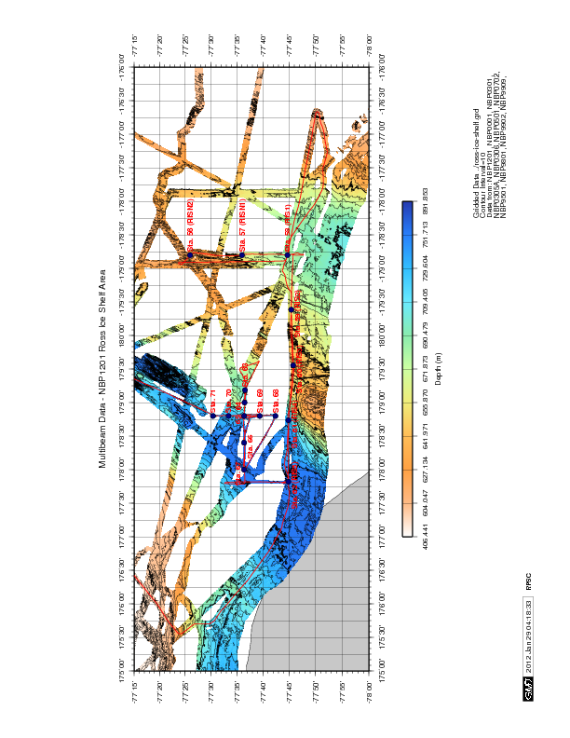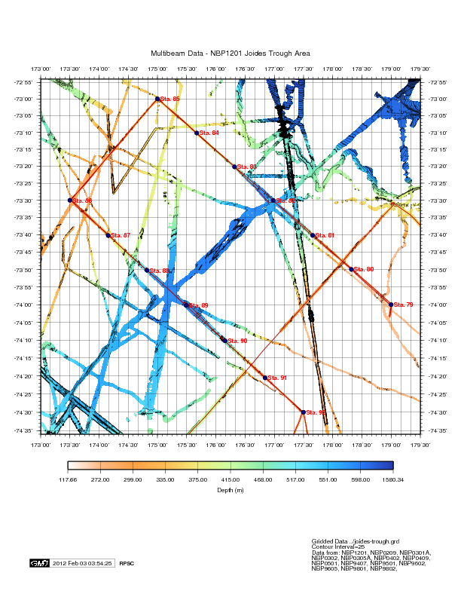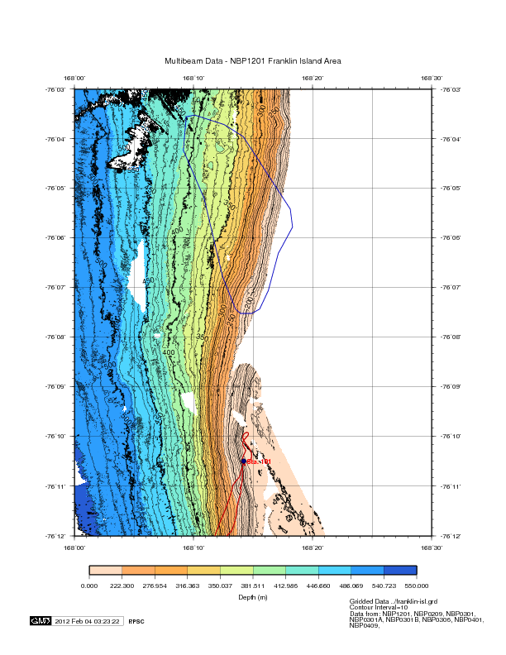

NBP1201 Multibeam Description of Work

This report covers the Simrad EM120 Multibeam data collection and processing for the RVIB Nathaniel B. Palmer cruise NBP1201. This cruise started in Punta Arenas, Chile on 24 December 2011 and ended at McMurdo Station, Antarctica on 11 February 2012. The Chief Scientist was Dennis McGillicuddy (WHOI.) The principal investigator in charge of Multibeam data acquisition and processing was John Klinck (ODU.) Chris Linden (RPSC) was responsible for Multibeam data acquisition, processing, and ping editing quality control.

The first day of Multibeam data collection was 27 December 2011 and the last day was 05 February 2012. The quality of the multibeam data was generally very good. Ice and bad weather occasionally resulted in poor data quality. The science team did an excellent job of editing the data. This cruise was not oriented towards geology or geophysics.

The raw Multibeam data were logged in approximately one hour-long files in the Kongsberg-Simrad EM120 raw format. This is a complex format that is not described in this report. The MB-System software package may be used to access the files if additional work is to be done with the data. MB-System version 5.1.1 was used for processing of data on this cruise. These raw data files are named xxxx_yyyymmdd_hhmmss_raw.all where xxxx is a consecutive line number within the survey, yyyy is the year, mm is the month, dd is the day, hh is the hour, mm is the minute, and ss is the seconds that the file was started.

The logged Multibeam data files were transferred from the data acquisition computer to a data storage area just after the end of each day. The raw hourly data files were converted from MB-System format 56 (the raw Simrad format) to format 57 using mbcopy and made available for manual editing. The format 57 files are named xxx_yyyymmdd_hhmmss.mb57 where the first part of the name is identical to the raw file. All data files were edited while at sea.

The science party was responsible for editing the Multibeam data. Mbclean was used to flag bad data points outside the valid depth range for each hour of data. Mbedit was used to manually remove bad data points from these files. Data files were edited with mbnavedit to correct navigational problems. Navigation corrections were made after the files were edited. If the velocity was observed to be incorrect, a new sound velocity was generated using mbvelocitytool and was applied to the data.

The edited files were checked using mbedit, the statistics from mbinfo, and hourly contour plots. If these checks failed, the files were re-edited by Chris Linden. When the data quality was judged acceptable, the edits were applied to the data using mbprocess. The edited files are named xxxx_yyyymmdd_hhmmssp.mb57 where the p in the dataset name denotes a processed file. Page size plots were produced of the edited data. Daily plots were also produced which showed one days worth of gridded data.

The UNIX tar command was used to write the digital data to LTO Ultrium 3 tapes at the end of the cruise. These tapes were checked before distribution. The tapes contain the raw and processed data for the entire cruise. The processing scripts and gridded data for each survey are included in the processed data directory. The contents of these tapes and an itemized distribution list are located on separate pages of this report.

Speed of Sound Corrections
The travel time of sound in water was corrected at the surface by a sound velocity calculated from the Thermosalinograph (TSG). This value was supplied directly to the EM120 system serial port and the data was transmitted by the RVDAS program rv_tsg. Sound velocity profiles were calculated from CTD casts, which were combined with the Levitus historical database. The CTD data have been provided on the RVDAS data distribution. The calculated sound velocities files and plots are in the process/svp directory in this multibeam data distribution.

NBP1201 Data Distribution
Multibeam data has been provided on LTO Ultrium 3 tapes to the science party and RPSC. The distribution consists of one (1) tape and a maps DVD which also contains this data report. The tapes were created on Linux computers using the command tar cvf /dev/st0 and verified to be sound on Linux a computer before they were distributed.

The contents of the tapes are described below. The processed data is in mbio format 57 in the process directory. The raw data is in mbio format 56 in the Raw directory. The processed data includes gridded files, processing scripts and postscript plots divided into subdirectories for each day and map area.

Each full LTO Ultrium 3 tape includes:
  - Raw has raw data and ancillary files for 27 December 2011 through 05 February 2012. The files are divided into directories by day.
  - process has logged data from 27 December 2011 through 05 February 2012. The edited data and processed data is provided from 06 Jan 2012 through 05 February 2012. The files are divided into directories by day.
  - maps contains additional maps request by the science team in the primary study area.

Portions of this cruise took place in the exclusive economic zones (EEZ) of Argentina and Chile;
However, no multibeam data was recorded in these areas.

A copy of the full data distribution will be sent to the Antarctic Multibeam Synthesis at the MGDS (http://www.marine-geo.org/). You can locate the all information for and download data from this cruise at the web site by selecting your cruise name from the data link tool. You can also download and use the java application GeoMapApp to interactively access multibeam and other data sets. Data sent to the database will not be downloadable until the Chief Scientist has released the proprietary hold.

You can contact the MGDS at:
MGDS Data Manager
Lamont-Doherty Earth Observatory
61 Route 9W
Palisades NY 10964 USA
845-818-3745 Phone/Fax
info@marine-geo.org

Data Distribution Information:

S/N | Who | Description | Type
1 | NBP | 27 Dec 2011 through 05 Feb 2012 raw, processed, maps | LTO3
2 | John Klinck | 27 Dec 2011 through 05 Feb 2012 raw, processed, maps | LTO3
3 | Dennis McGillicuddy | 27 Dec 2011 through 05 Feb 2012 raw, processed, maps | LTO3
4 | RPSC | 27 Dec 2011 through 05 Feb 2012 raw, processed, maps | LTO3
5 | MGDS | 27 Dec 2011 through 05 Feb 2012 raw, processed, maps | LTO3

The MB-System software package was used for all Multibeam data handling. This package was developed at Lamont-Doherty Earth Observatory. This system is designed to manipulate, process, list and display many kinds of Multibeam bathymetry, amplitude, and sidescan data. It has been successfully installed on many different computer platforms. To obtain more information about the MB-System programs or to obtain a copy of the current distribution, contact the authors David W. Caress (caress@mbari.org) and Dale N. Chayes (dale@lamont.ldeo.columbia.edu)

