EN476 Cruise Report
Draft 6/7/10

Voyage #476 of R/V Endeavor was the second of four cruises in 2010 organized to serve complementary scientific objectives of two different projects. The two projects are:

GOMTOX: Dynamics of Alexandrium fundyense distributions in the Gulf of Maine: an observational and modeling study of nearshore and offshore shellfish toxicity, vertical toxin flux, and bloom dynamics in a complex shelf sea – NOAA ECOHAB

Objectives:
Investigate A. fundyense bloom dynamics and the pathways that link this organism to toxicity in nearshore and offshore shellfish.

Investigate the vertical structure of A. fundyense blooms, vertical toxin flux, and linkage to toxicity in offshore shellfish.

Alexandrium population biology in the Gulf of Maine – Woods Hole Center for Oceans and Human Health – NSF/NIEHS

Objectives:
Sample genetic variability of Alexandrium subpopulations throughout the Gulf of Maine.

Measure changes in relative abundance of Alexandrium genotypes in space and time.

Objectives common to both projects include:
Assess hydrodynamic and hydrographic context for interpretation of Alexandrium spp. measurements.

Incorporate field observations into a suite of numerical models for hindcasting and forecasting applications.

The primary domain of interest is Georges Bank, where a large bloom of A. fundyense was observed in 2007 and shorter and less intense bloom occurred in 2008. The four cruises in 2010 are designed to (1) resolve the seasonal variation of the Georges Bank bloom, and (2) quantify its interannual variability.

A secondary objective was added to the 2010 cruises when the results of the fall 2009 cyst survey (OC440) revealed that cyst abundance offshore of mid-coast Maine is now higher than in all prior measurements, including those that preceded the severe blooms of 2005 and 2008. This field season thus offers an exceptional opportunity for testing the hypothesis that the magnitude of the bloom in the western Gulf of Maine and Southern New England is set by the abundance of cysts. We therefore must consider the possibility of redirecting some of this year’s observational effort from Georges Bank to the Gulf of Maine. These choices will be informed by a number of factors, including real-time nowcasting and forecasting activities, as well as state agency toxicity monitoring efforts along the coasts of Maine, New Hampshire, and Massachusetts. If widespread toxicity appears along the coast, that would be consistent with the cyst hypothesis. However, if widespread toxicity does not appear, that would not necessarily be inconsistent with the hypothesis, as a large bloom could be present offshore. It is in this latter circumstance that diverting to the western Gulf of Maine would be most advantageous for hypothesis testing, insofar as confirming the absence of a large bloom would provide evidence for rejecting the hypothesis.

EN476 began with a survey of Georges Bank (Figure 1). The peak cell concentration of 878 cells l⁻¹ occurred on the southeastern tip of Nantucket Shoals. A broad swath of several hundred cells per liter straddled the 60m isobath on the southern flank, in the vicinity of the tidal mixing front. Elsewhere cell concentrations were low. It is interesting to compare this survey with a prior one at the same time of year, in which cell concentrations were significantly higher (Figure 2; OC447, May 27 – June 4, 2008). OC447 surface underway counts across the gulf in between the two regions yielded mostly zeros, as did most of the cross-bank section on the northeast peak of Georges Bank. The remainder of the bank was almost completely covered by cell concentrations ranging from a few hundreds to a few thousands of cells l⁻¹.

Water mass analysis suggests significant interannual variability in hydrographic properties. Temperature-salinity diagrams reveal both Georges Bank water and warm/salty water characteristic of the continental slope (Figure 3, left panel). Focusing on the Georges Bank water (4-8°C, 31.5-33.5 psu), it appears to be more than a degree warmer and nearly 0.5 psu fresher in 2010 than 2008. The cause of this interannual variability is unknown at this time.

The EN476 coastal survey consisted of a series of transects spanning from just south of Boston to one off Mount Desert Island (Figure 1). Surface live counts revealed low Alexandrium abundance south and west of Penobscot Bay, with cell concentrations at or below the limit of detection in that area. From Penobscot Bay to the east, cell concentrations are patchy, ranging from zero to 1201 cells l⁻¹.

It is clear that model predictions of a larger-than-usual bloom in the western Gulf of Maine (Figure 4) have not materialized thus far. We are currently investigating the causes of low Alexandrium abundance in the WGOM observed on OC460 and EN476. At this point it appears that hydrodynamic factors may have played a role, as two of the three surface drifters deployed off Casco Bay on OC460 have shown very modest along-shore transport in the month since their release on May 7 (Figure 5). In addition, there is a distinct water mass anomaly in the deep and intermediate waters of the Gulf of Maine as compared with the major bloom that took place in 2008 (Figure 3, right panel). Deep waters are more than one degree warmer, and Maine Intermediate Waters are a few tenths of a degree warmer and a few tenths of a psu fresher than during this same time period in 2008. Near surface waters in 2010 are several degrees warmer than they were in 2008. We are very eager to learn if there is a nutrient anomaly associated with the water mass anomaly, and how its near surface expression may have affected vegetative growth of Alexandrium. Dave Townsend’s lab will begin running the nutrient samples in the near future.

During EN476 a total of 3 surface drifters were deployed at the inshore stations of the Casco Bay transect (Figure 5; Appendix A, Table 3). Thus far, little mean flow is detected in the trajectories, except for the middle one which is moving southwest along the isobaths.

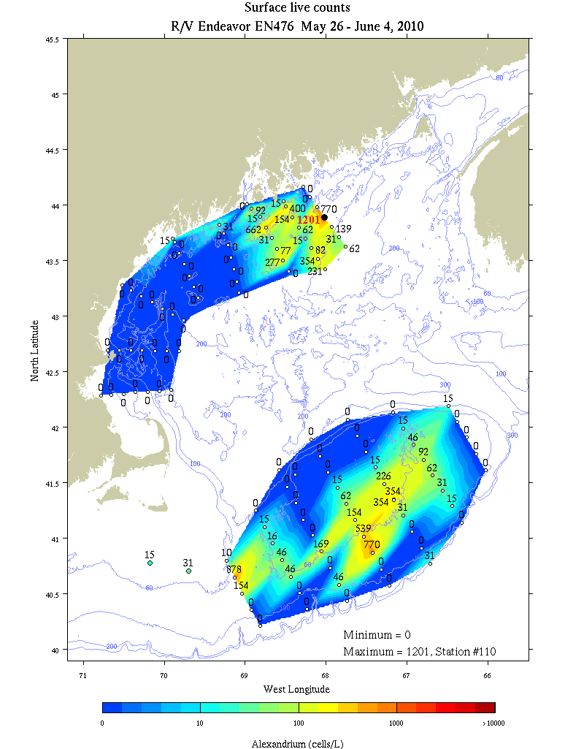
Figure 1. Alexandrium concentration (cells l⁻¹) from surface live counts on EN476.

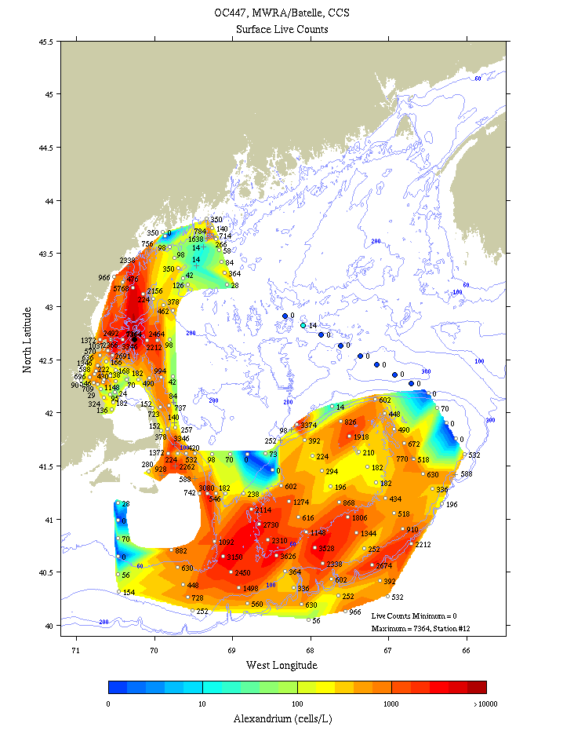
Figure 2. Alexandrium concentration (cells l⁻¹) from surface live counts on OC447, whole-cell assays from MWRA/Battelle surveys in Massachusetts Bay, and whole-cell assays of two sections east of Cape Cod occupied by the Center for Coastal Studies.

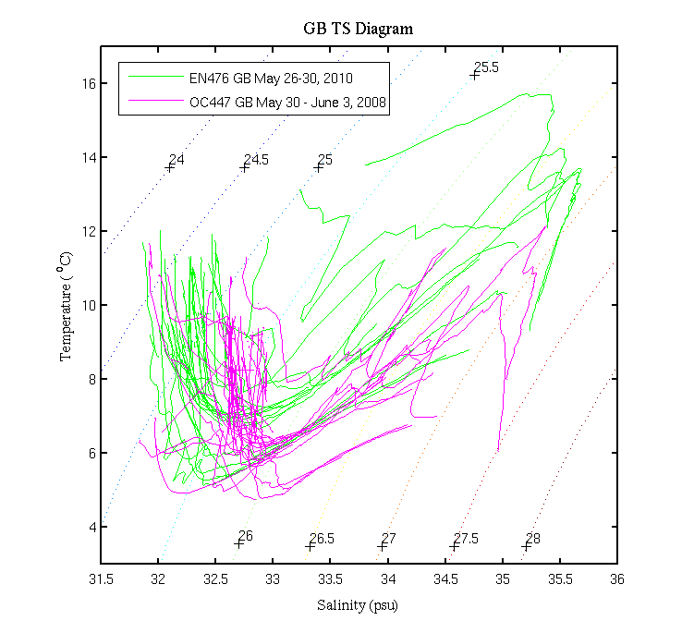 | 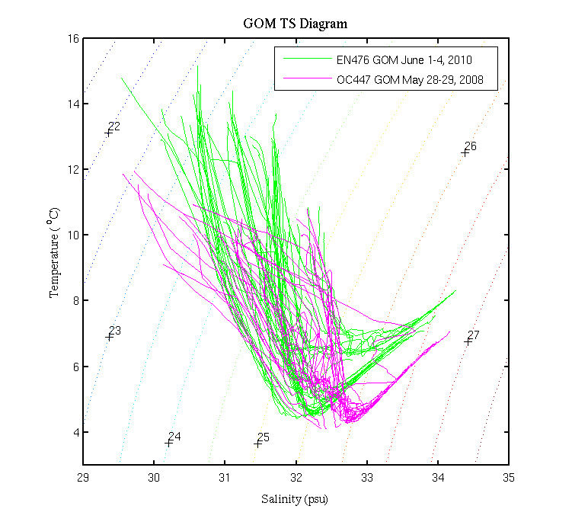
Figure 3. Temperature / salinity characteristics of hydrographic profiles during OC447 in 2008 (magenta) and EN476 in 2010 (green). Left: Georges Bank; right: Gulf of Maine. These results must be treated with caution as the EN476 salinities have not yet been calibrated with salt bottle data yet.

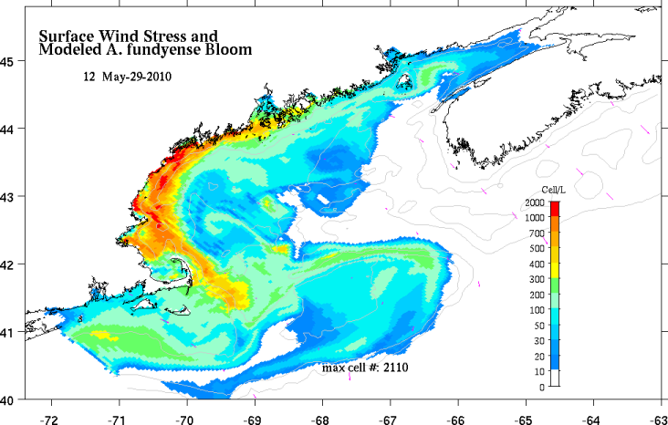
Figure 4. A. fundyense model predictions for May 8 (right). For a complete description of the forecast system and 2010 results, see http://omglnx3.meas.ncsu.edu/GOMTOX/2010forecast/.

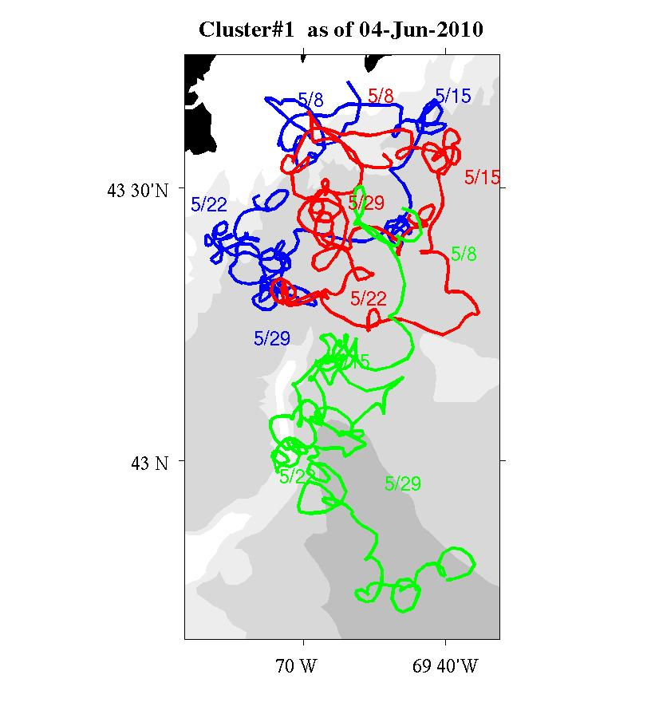 | 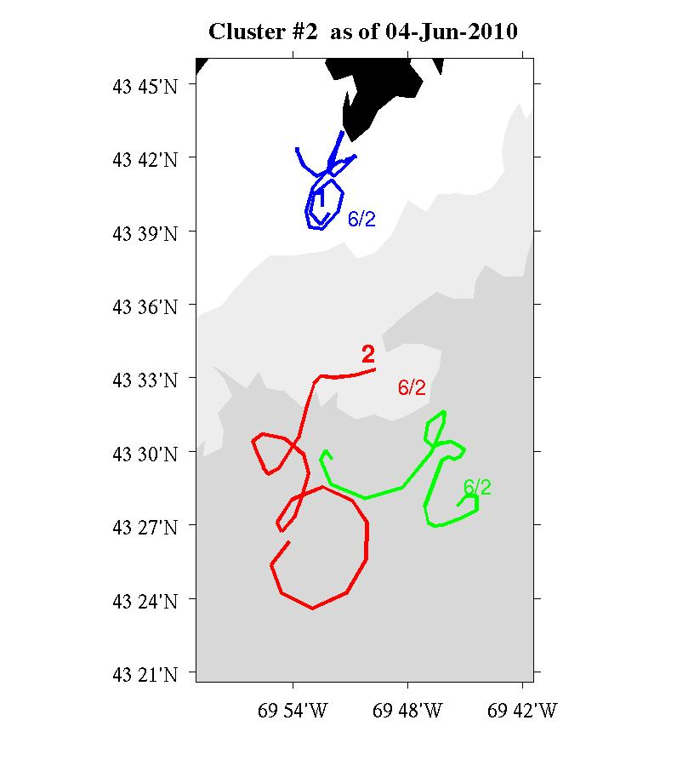
Figure 5. Trajectories of drifters released along the Casco Bay line on OC460 (left) and EN476 (right). Figures courtesy of Jim Manning.

Appendix A: Measurements made on EN476

Underway measurements
a. Acoustic Doppler Current Profiler
b. Meteorological sensors

Core hydrographic measurements
a. CTD (pressure, temperature, salinity, oxygen, fluorescence, beam attenuation, PAR)
b. Alexandrium cell counts: 1, 10, 20, 30, 40, 50m plus 250/near bottom
c. Nutrients: standard depths plus 100, 150, 200, 250m
Water budget:

Bottle # | Depth | Live | Spare | Whole Cell | SHA | Nuts/Chl | Pseuds | total
1 | 1 |  |  | 2 | 2 | 1.0 | 1.0 | 7.0
2 | 1 | 10 |  |  |  |  |  | 10
3 | 1 |  | 10 |  |  |  |  | 10
4 | 10 |  |  | 2 | 2 | 1.0 | 1.0* | 7.0
5 | 20 |  |  | 2 | 2 | 1.0 | 1.0* | 7.0
6 | 30 |  |  | 2 | 2 | 1.0 | 1.0* | 7.0
7 | 40 |  |  | 2 | 2 | 1.0 | 1.0* | 7.0
8 | 50 |  |  | 2 | 2 | 1.0 | 1.0* | 7.0
9 | 100 |  |  |  |  | 1.0 |  | 1.0
10 | 150 |  |  |  |  | 1.0 |  | 1.0
11 | 200 |  |  |  |  | 1.0 |  | 1.0
12 | 250 / near bottom |  |  |  |  | 1.0 |  | 1.0

Af water- For Whole Cell (WC) and Sandwich Hybridization (SHA) – 4 liters collected total and 20 μm sieved and split between the two assays.

4L/depth combined/split x 6 depths=6 WC tubes&6 filters/station (6 hole-manifold #1 loaded once)

Pseuds – At each station: 1) 125 ml whole water will be filtered for Pseud SHA onto 0.45µm Duropore filters; 2) 125ml whole water will be filtered for ARISA samples onto 0.45µm Isopore HA filters (as in 2008); 3) 125 ml whole water will be filtered for Domoic Acid onto 0.45µm Isopore HA filters. SHA filters will be frozen in LN2 Dewar

3 filters and cryo-vials/station will be needed. Use a 3-hole manifold—Note that the Pseud SHA filter and the ARISA/DA filters are the same pore size, but not the same material. Do not mix up the filter types.

*A vertical profile of Pseuds will be sampled at 4-6 selected stations with high abundance, in different hydrographic regimes as conditions permit. Same procedure as above but repeat for all 6 std depths.

A Domoic Acid “calibration” station will also be done at selected stations—details TBD.

Opportunistic samples– a spare 10L live sample will be available for multiple purposes; e.g., culturing of Pseuds and/or Alexandrium, life cycle stage samples, and possibly microsatellite analysis of Alexandrium populations. Additional opportunistic samples may be taken in areas of high Alexandrium and/or Pseud abundance.

Toxin size fractionation – Turner
Pump profiles were carried out at selected locations. Sampling depths were chosen to coincide as closely as possible with hydrographic sampling and sediment trap measurements. Pump deployments are summarized in Table 2.

 | Date | Time  (local) | Latitude | Longitude | Station | Live Count
1 | May 28 |  | 41 34.3 N | 68 23.0 W | FDA shellfish time-series site  Cultivator Shoal, CTD 14p | 0
2 | May 30 |  | 42 20.7 N | 67 9.8 W | Georges Bank, SE tidal mixing front | 354
3 | June 2 |  | 43 47.5 N | 68 44.5W | Matinicus line | 660
4 | June 3 |  | 43 58.8 N | 68 6.5 W | Mount Desert line | 770
Table 2. Pump stations.

Drifters

ID | Mon | Day | Year | Time  GMT | Lon | Lat | Drogue  depth(m) | Station Number
322444 | 6 | 1 | 2010 | 2117 | 69 52.0 W | 43 39.0 N | 1 | CB1B
327011 | 6 | 1 | 2010 | 2213 | 69 48.8 W | 43 33.7 N | 1 | CB1C
327604 | 6 | 1 | 2010 | 2311 | 69 45.4 W | 43 27.7 N | 1 | CB1D
Table 3: Summary of drifter releases on Casco Bay line. For more information see http://nefsc.noaa.gov/drifter.

Microbial community structure and bacterial abundance – Amaral-Zettler and Murphy

EN476 #1 – CTD14 – Georges Bank – Alexandrium live count = 0
5/28/10 41 34.3 N / 68 23.0 W
Sfc (1),(2)
10m [no water left]
20m (1),(2)

EN476 #2 – CTD56 – Georges Bank – Alexandrium live count = 354
5/28/10 41 20.7 N / 67 9.8 W
Sfc (1),(2)
10m (1),(2)
20m (1),(2)
Filters may have been loaded incorrectly for sfc(1),(2) and 10m(1)

EN476 #3 – CTD97 – Matinicus transect – Alexandrium live count = 77
6/2/10 43 35.9 N / 68 36.0 W
Sfc (1),(2)
10m (1),(2)
20m (1),(2)

EN476 #4 – CTD109 – Mt. Desert transect – Alexandrium live count = 770
6/3/10 43 58.8 N / 68 6.5 W
Sfc (1),(2)
10m (1),(2)
20m (1),(2)

Appendix B: Hydrographic maps
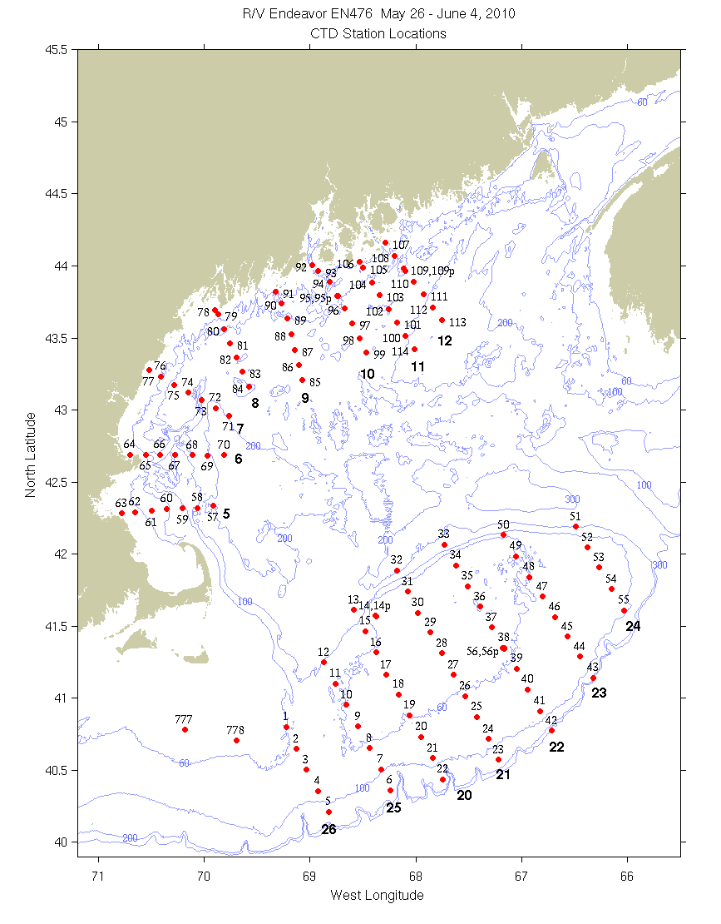
Figure B1: CTD station locations. Bold numerals indicate identifiers for the sections displayed below.

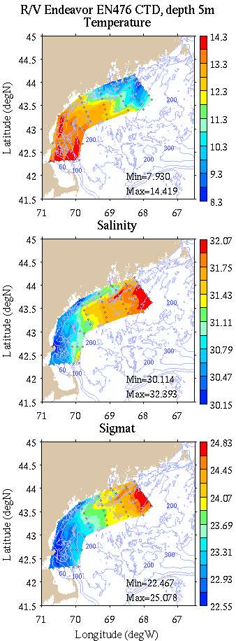 | 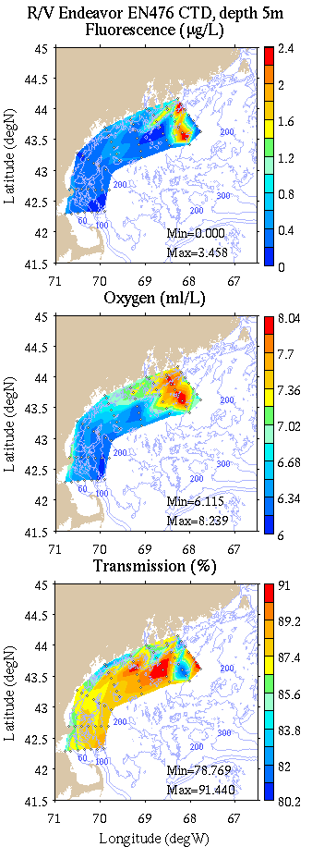
Figure B2: Coastal GOM survey maps at 5m depth. Left: temperature, salinity, and density; right: fluorescence, oxygen, and light transmission.

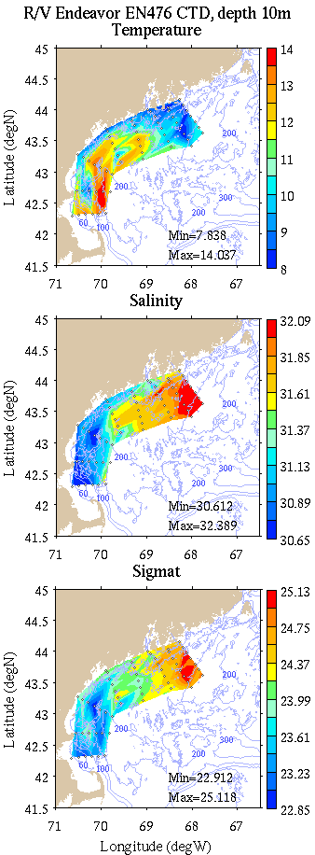 | 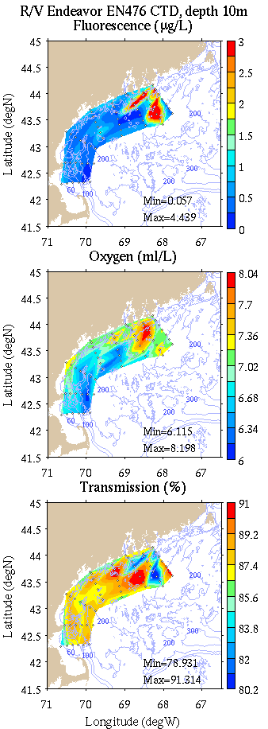
Figure B3: Coastal GOM survey maps at 10m depth. Left: temperature, salinity, and density; right: fluorescence, oxygen, and light transmission.

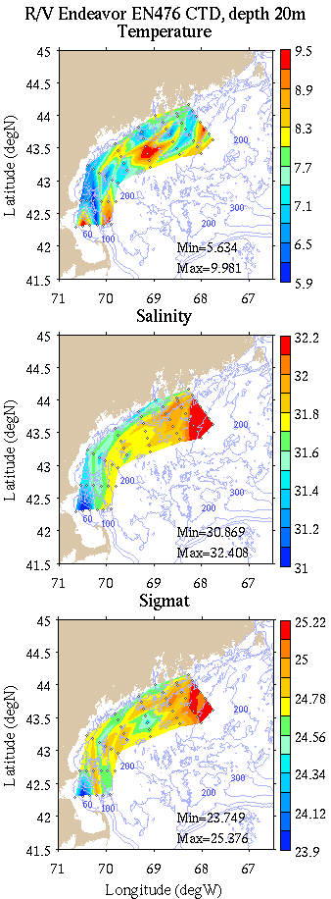 | 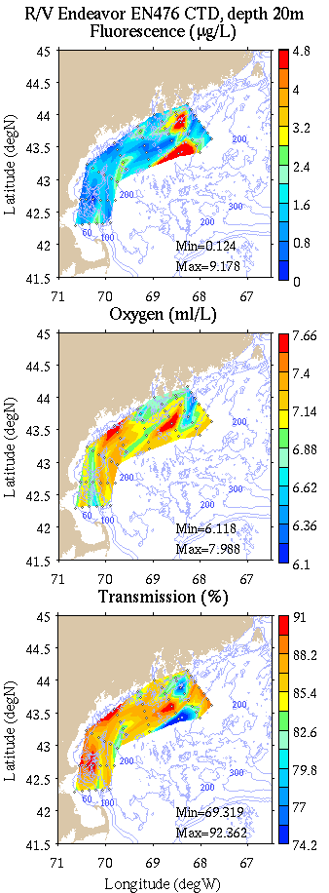
Figure B4: Coastal GOM survey maps at 20m depth. Left: temperature, salinity, and density; right: fluorescence, oxygen, and light transmission.

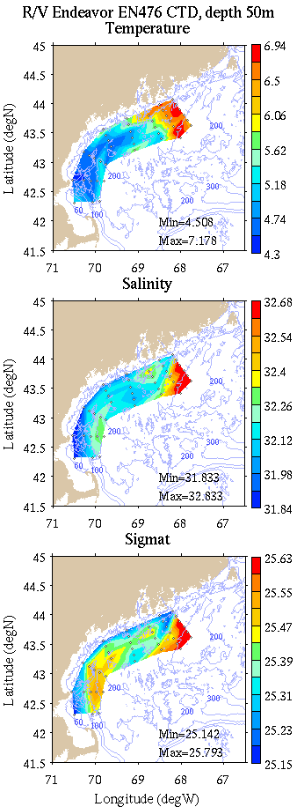 | 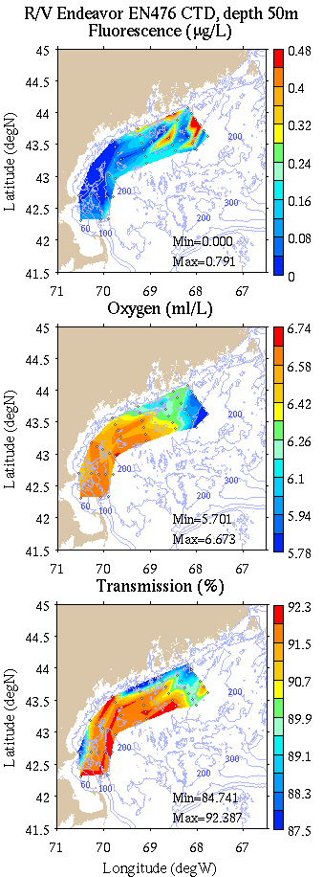
Figure B5: Coastal GOM survey maps at 50m depth. Left: temperature, salinity, and density; right: fluorescence, oxygen, and light transmission.

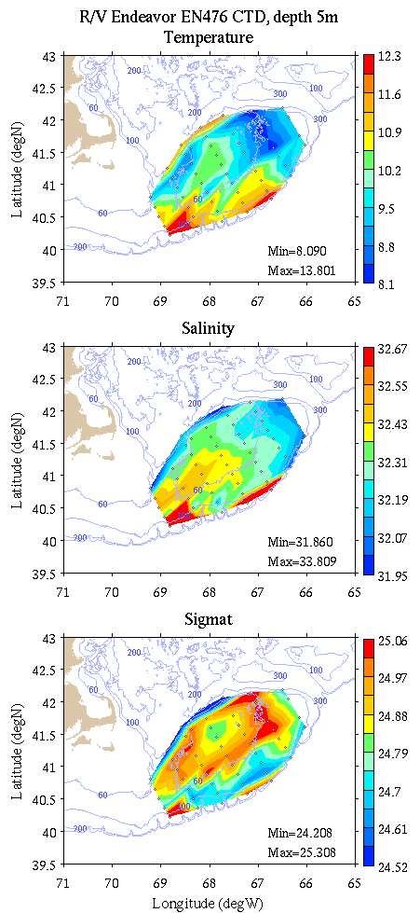 | 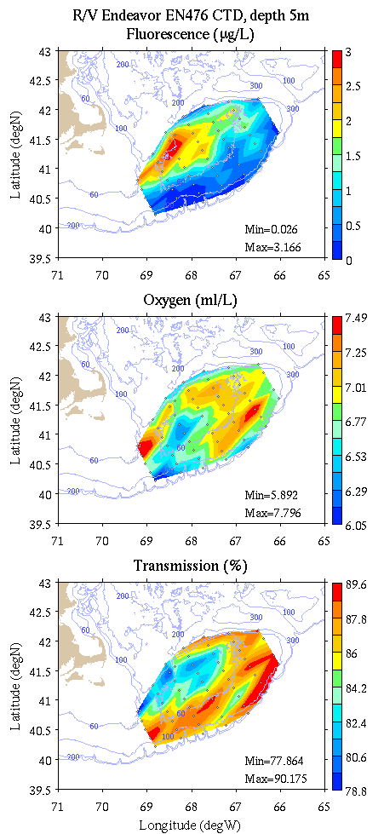
Figure B6: Georges Bank survey maps at 5m depth. Left: temperature, salinity, and density; right: fluorescence, oxygen, and light transmission.

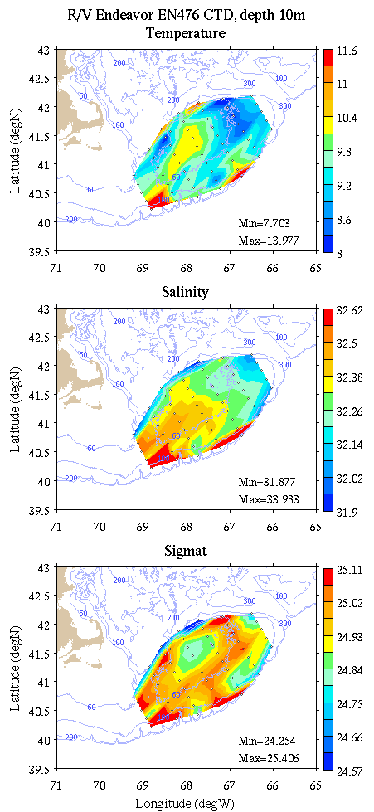 | 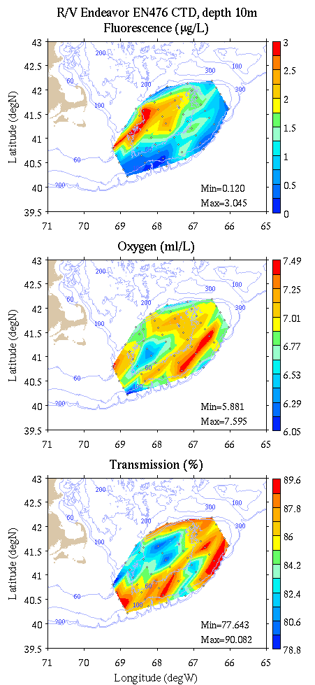
Figure B7: Georges Bank survey maps at 10m depth. Left: temperature, salinity, and density; right: fluorescence, oxygen, and light transmission.

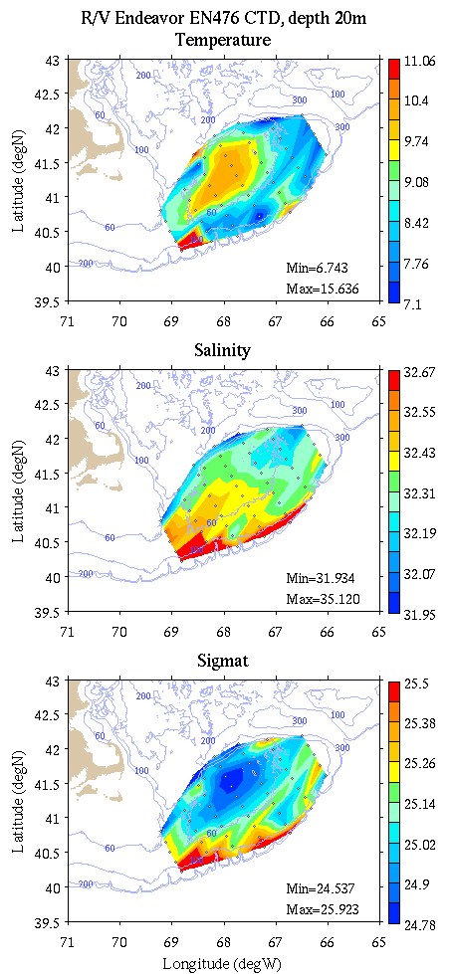 | 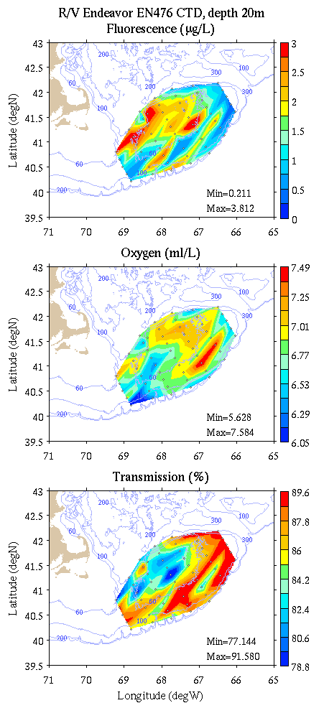
Figure B8: Georges Bank survey maps at 20m depth. Left: temperature, salinity, and density; right: fluorescence, oxygen, and light transmission.

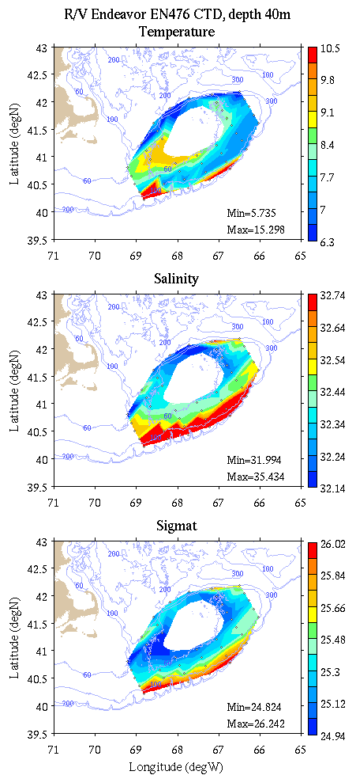 | 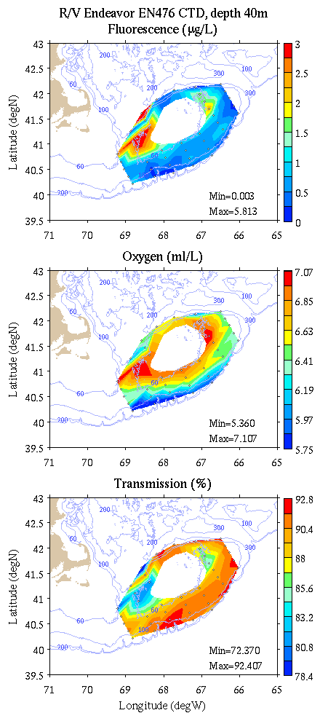
Figure B9: Georges Bank survey maps at 40m depth. Left: temperature, salinity, and density; right: fluorescence, oxygen, and light transmission.

Appendix C: Vertical sections.

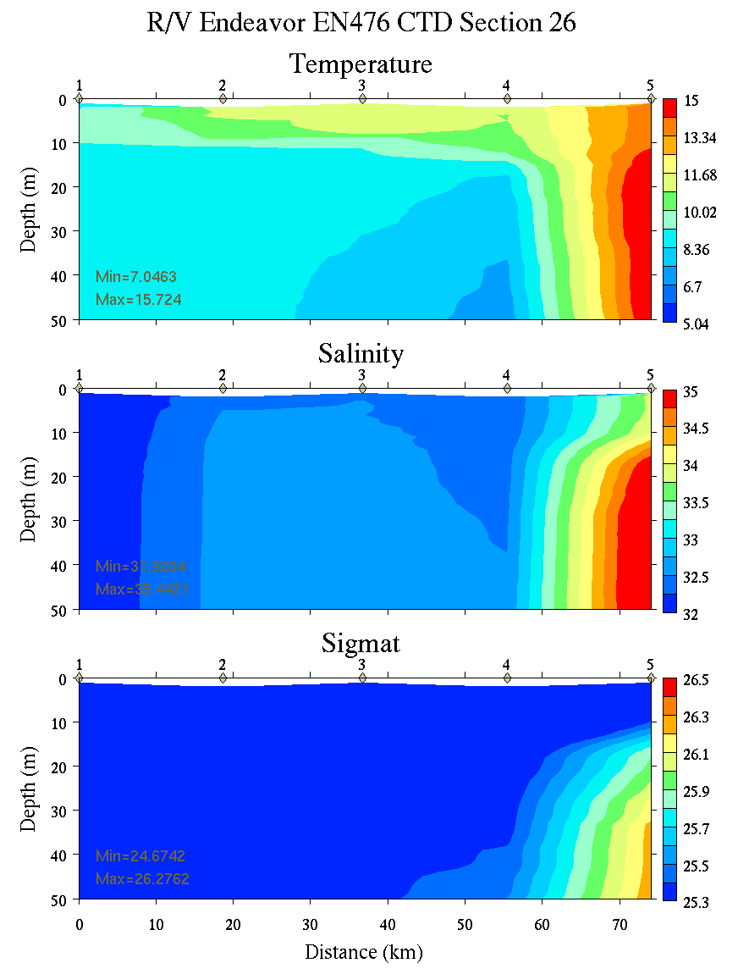 | 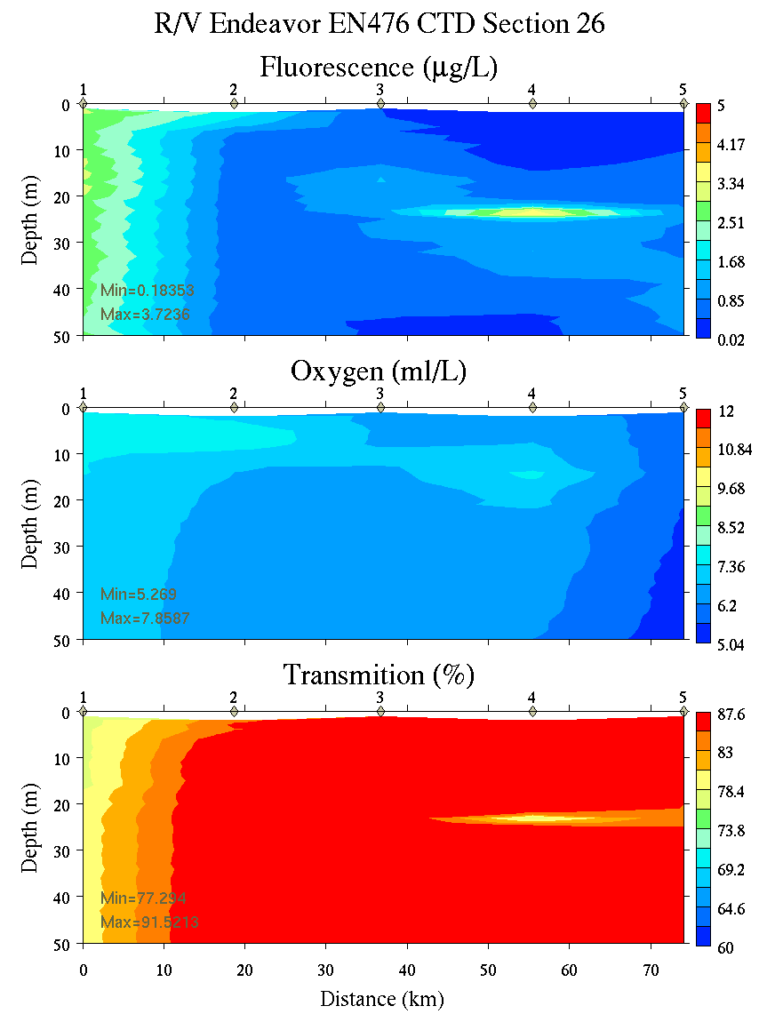
Figure C1. Section 26, 0-50m: temperature, salinity, and density (left); fluorescence, oxygen, and beam transmission (right).

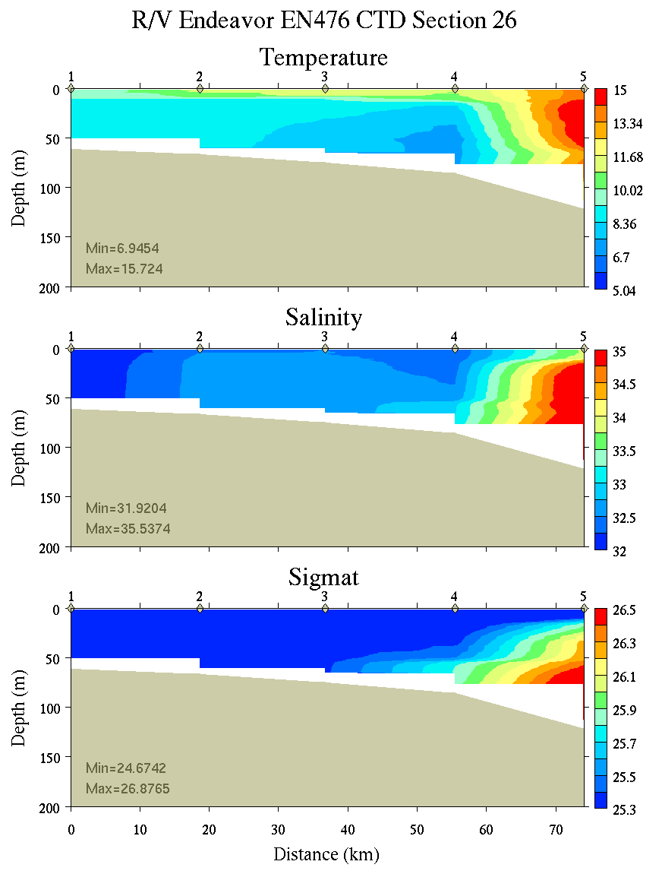 | 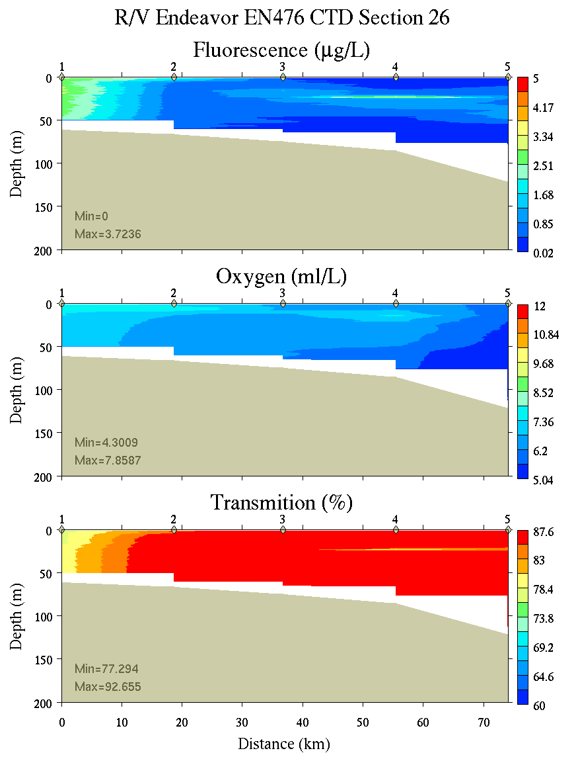
Figure C2. Section 26, 0-200m: temperature, salinity, and density (left); fluorescence, oxygen, and beam transmission (right).

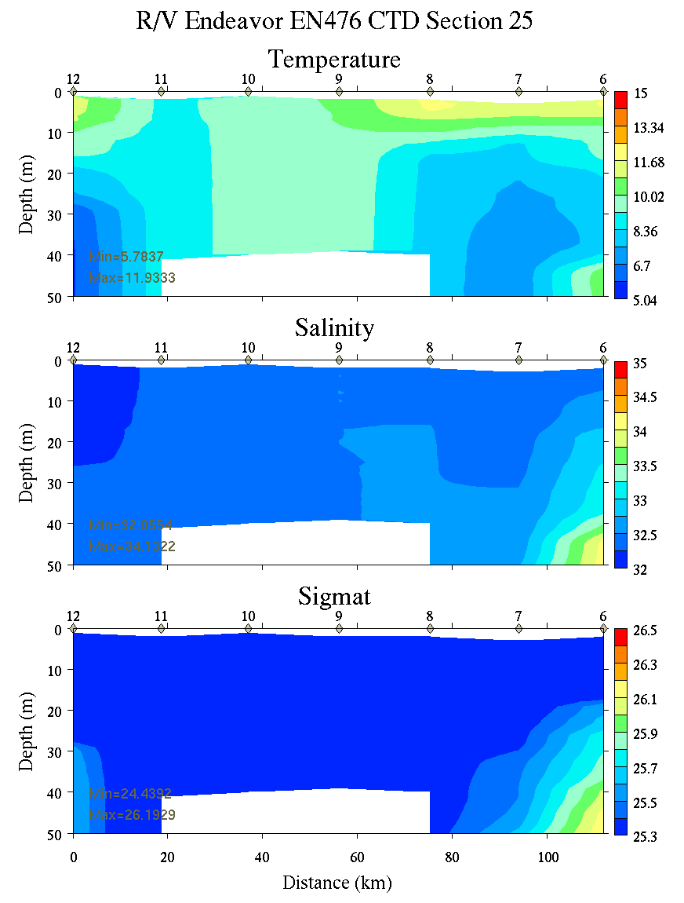 | 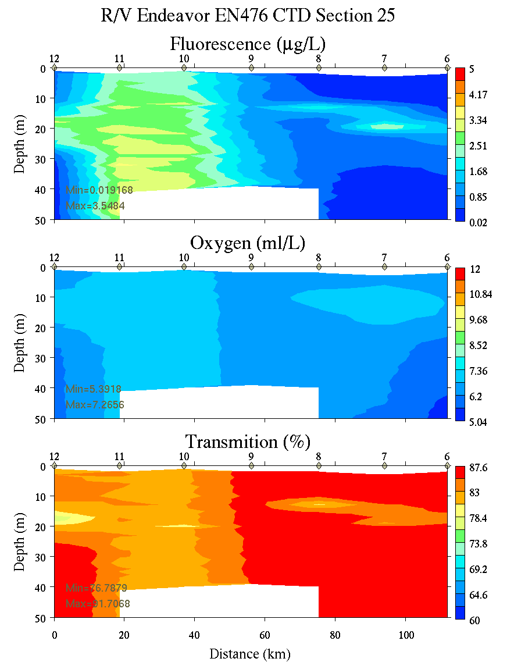
Figure C3. Section 25, 0-50m: temperature, salinity, and density (left); fluorescence, oxygen, and beam transmission (right).

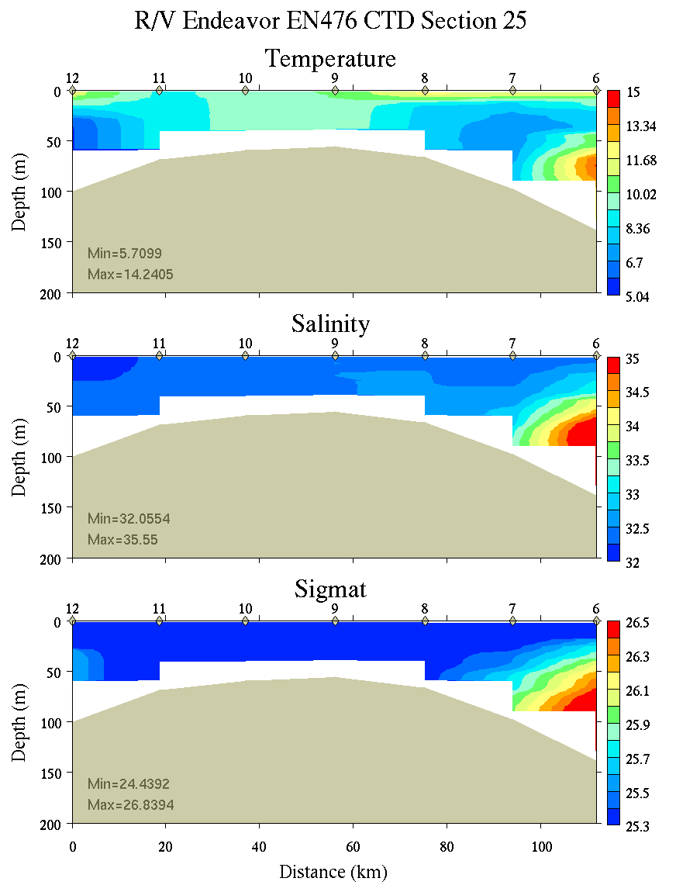 | 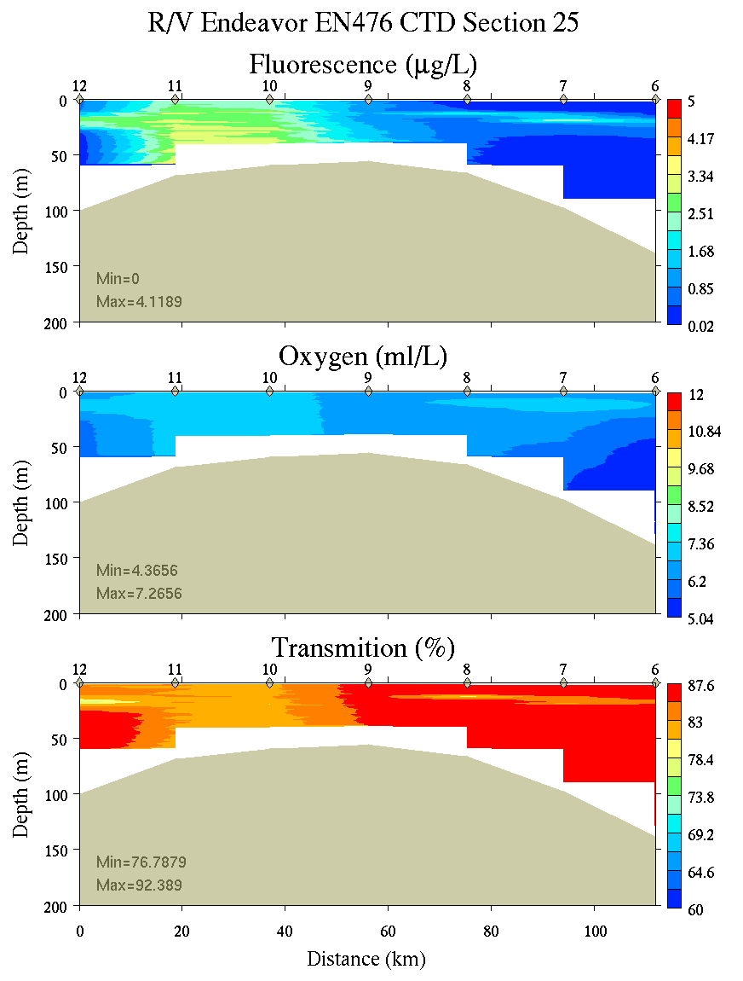
Figure C4. Section 25, 0-200m: temperature, salinity, and density (left); fluorescence, oxygen, and beam transmission (right).

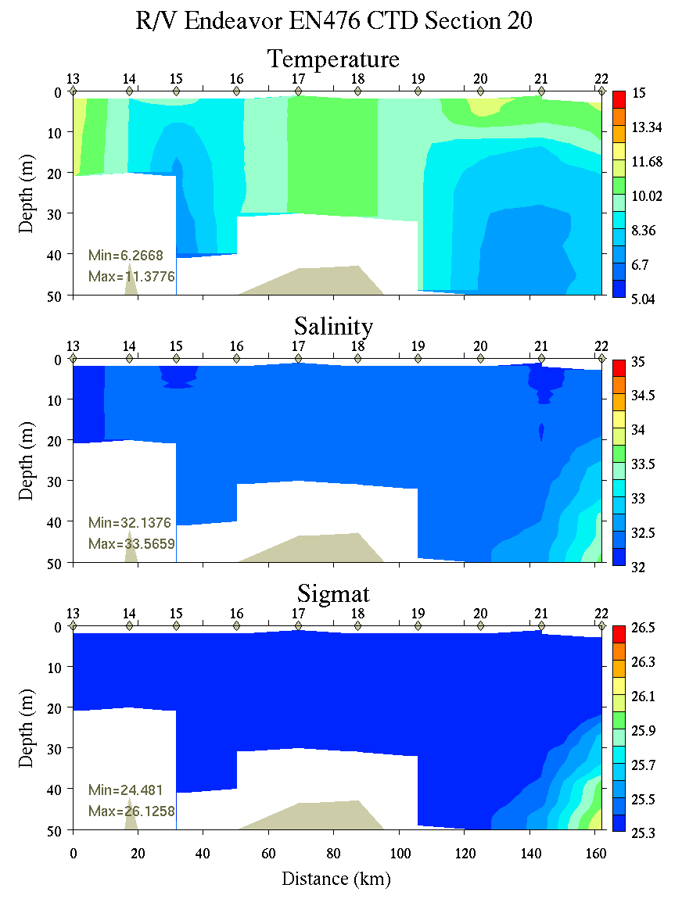 | 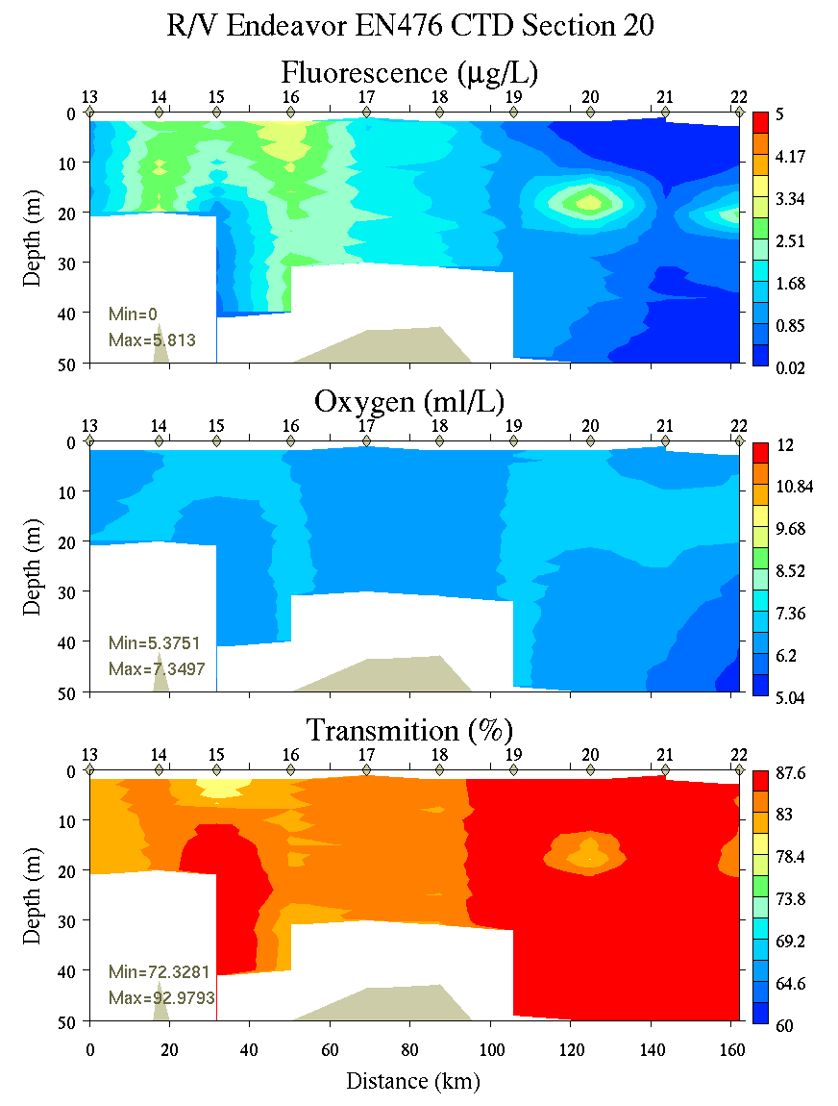
Figure C5. Section 20, 0-50m: temperature, salinity, and density (left); fluorescence, oxygen, and beam transmission (right).

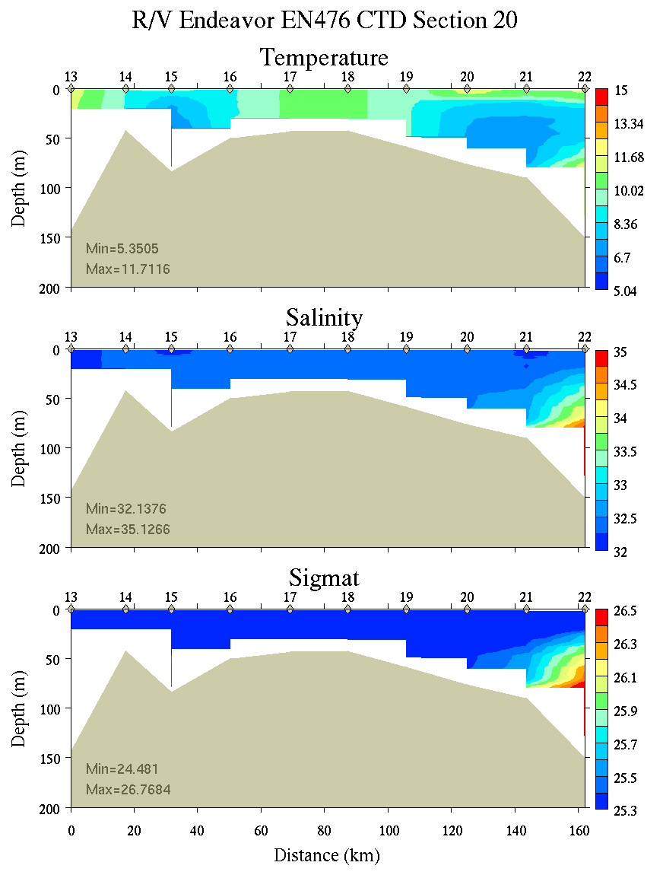 | 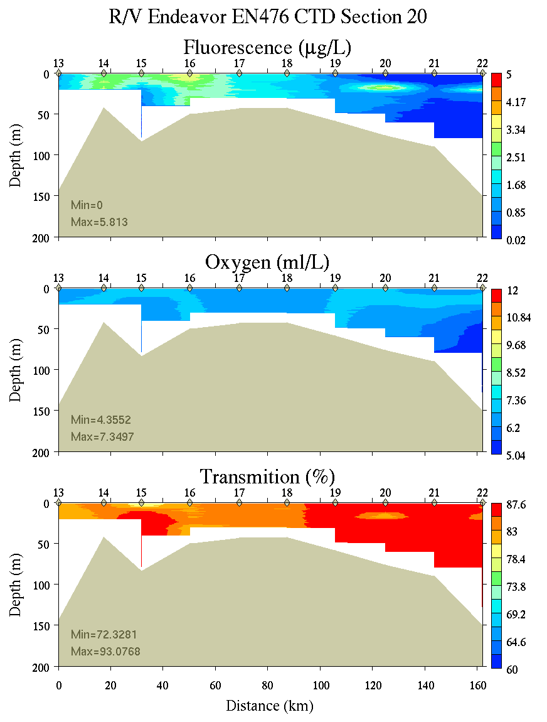
Figure C6. Section 20, 0-200m: temperature, salinity, and density (left); fluorescence, oxygen, and beam transmission (right).

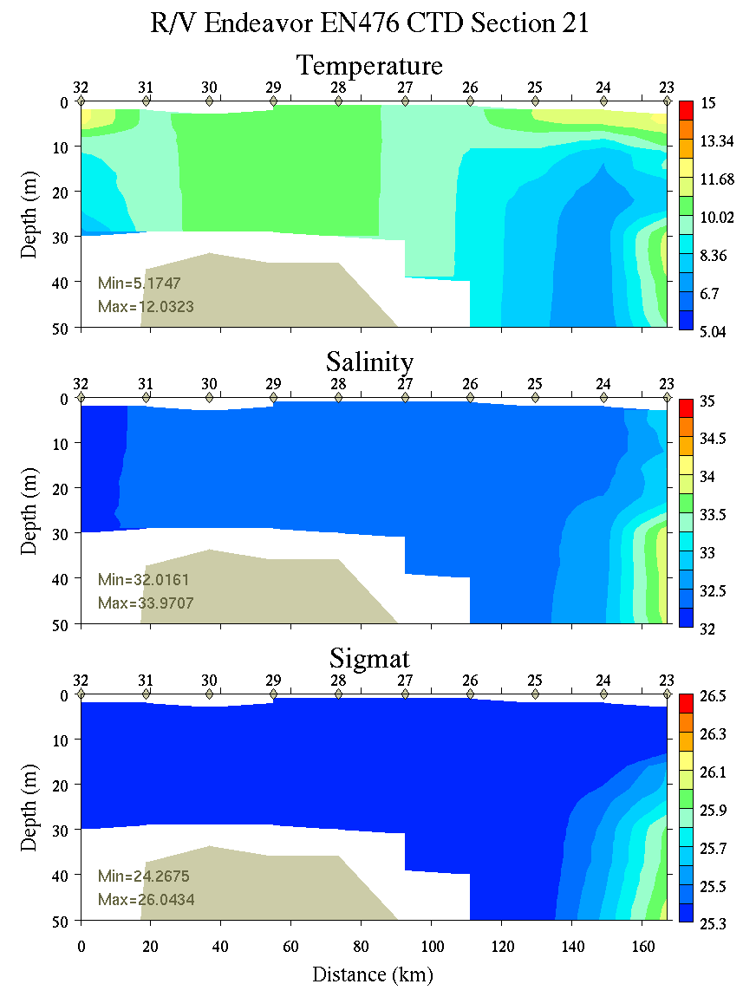 | 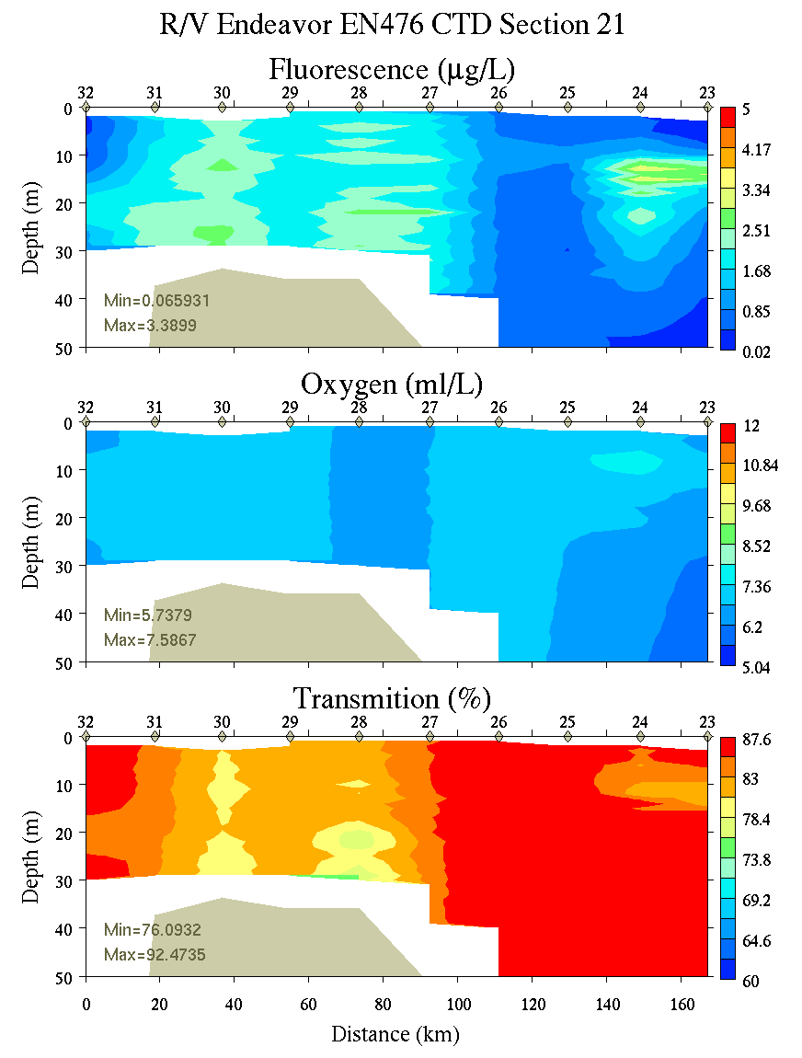
Figure C7. Section 21, 0-200m: temperature, salinity, and density (left); fluorescence, oxygen, and beam transmission (right).

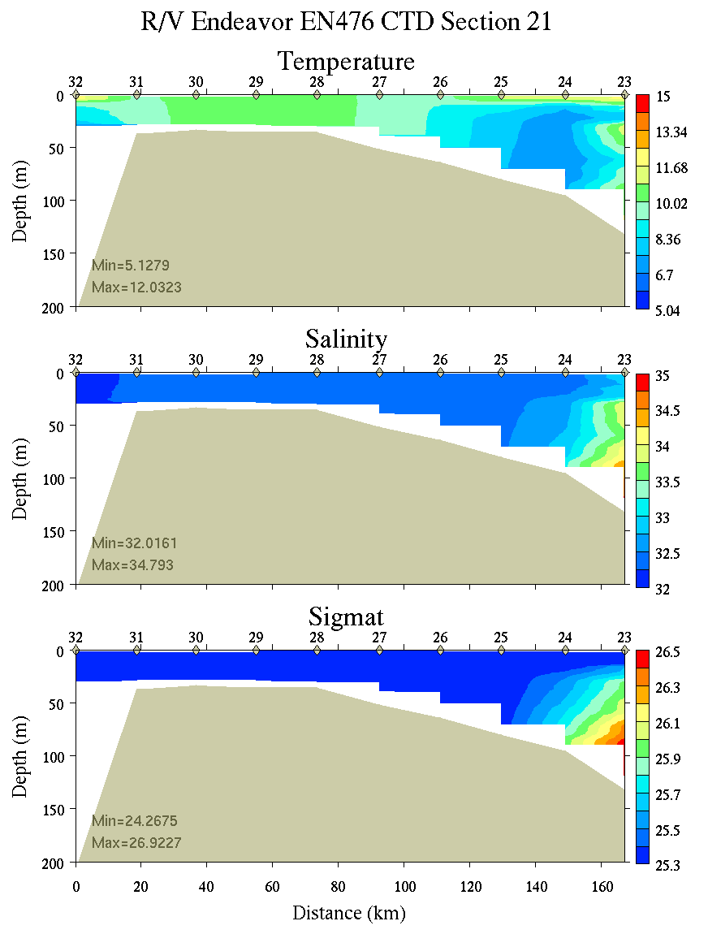 | 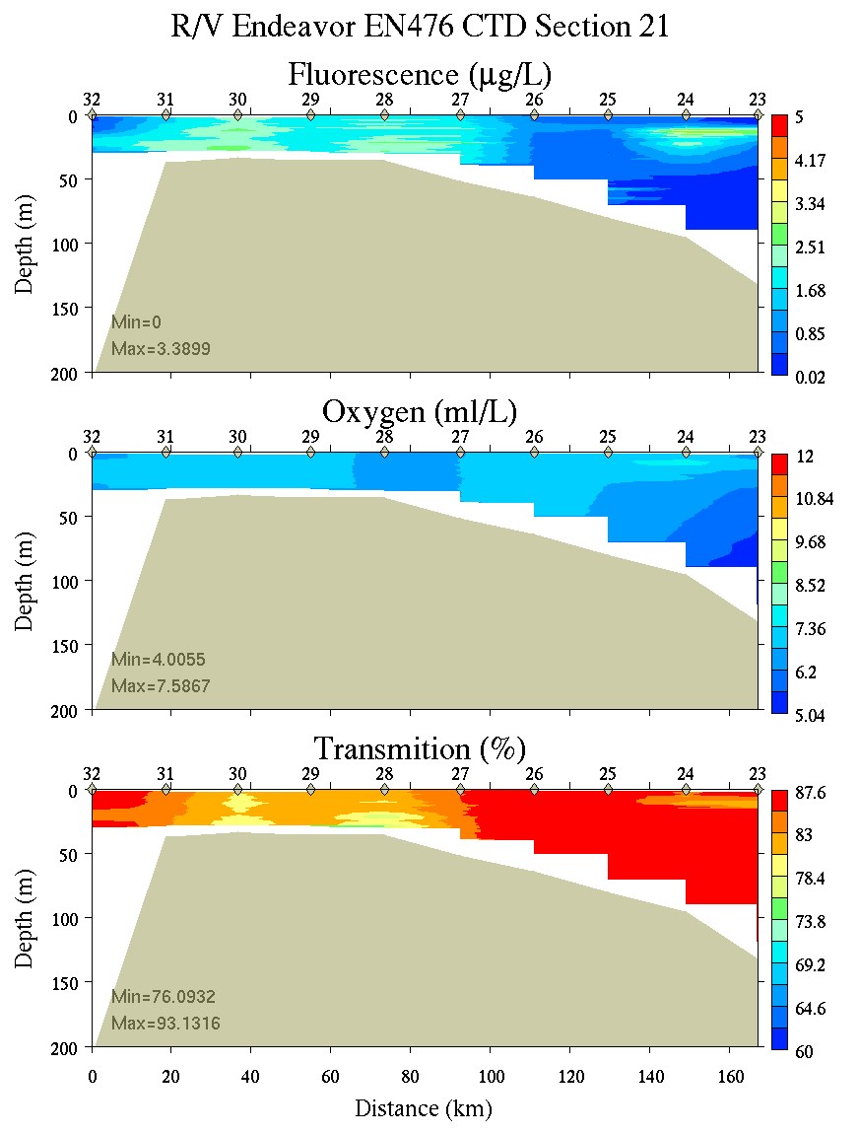
Figure C8. Section 21, 0-200m: temperature, salinity, and density (left); fluorescence, oxygen, and beam transmission (right).

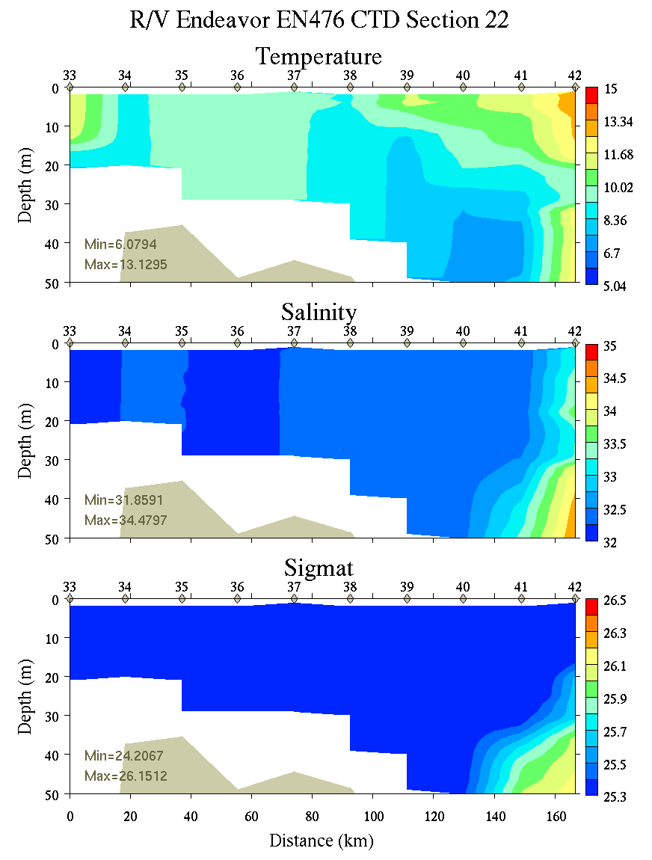 | 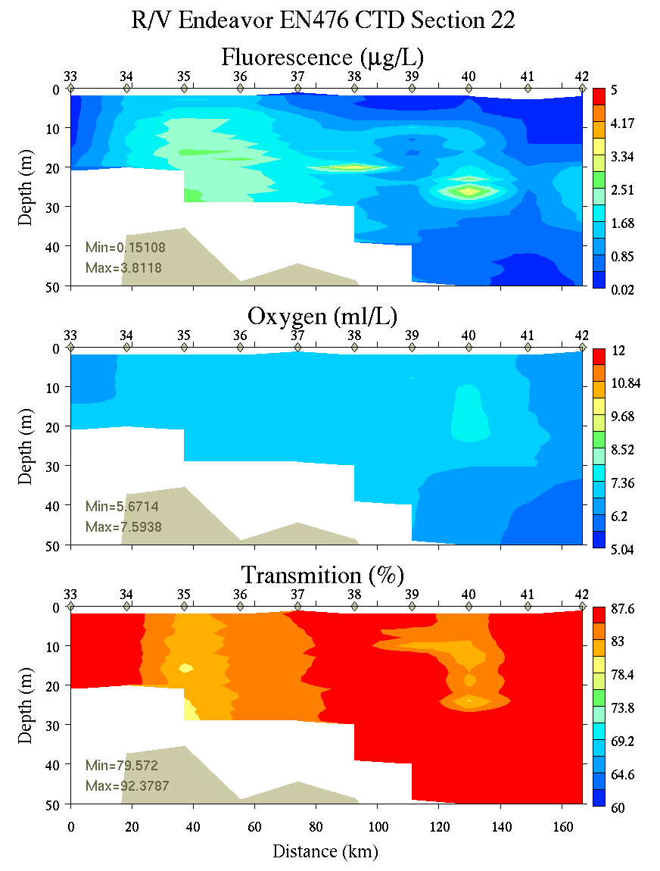
Figure C9. Section 22, 0-50m: temperature, salinity, and density (left); fluorescence, oxygen, and beam transmission (right).

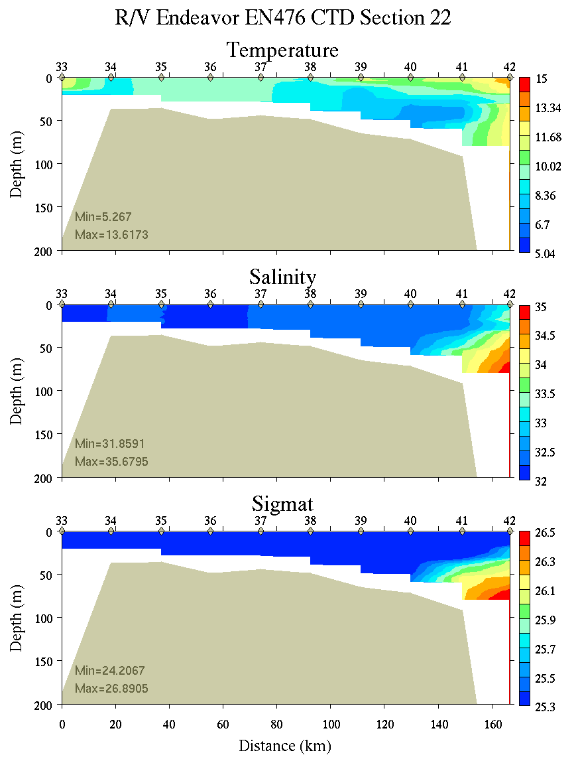 | 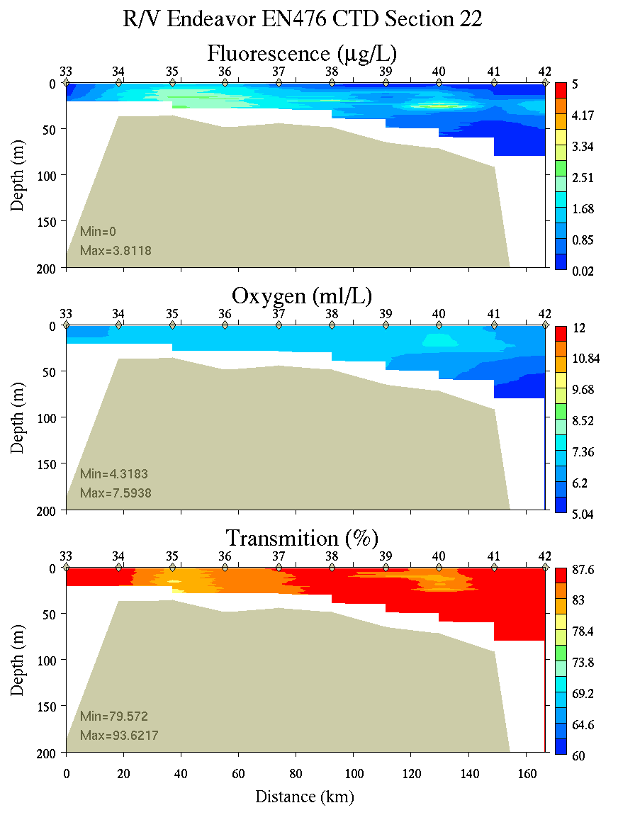
Figure C10. Section 22, 0-200m: temperature, salinity, and density (left); fluorescence, oxygen, and beam transmission (right).

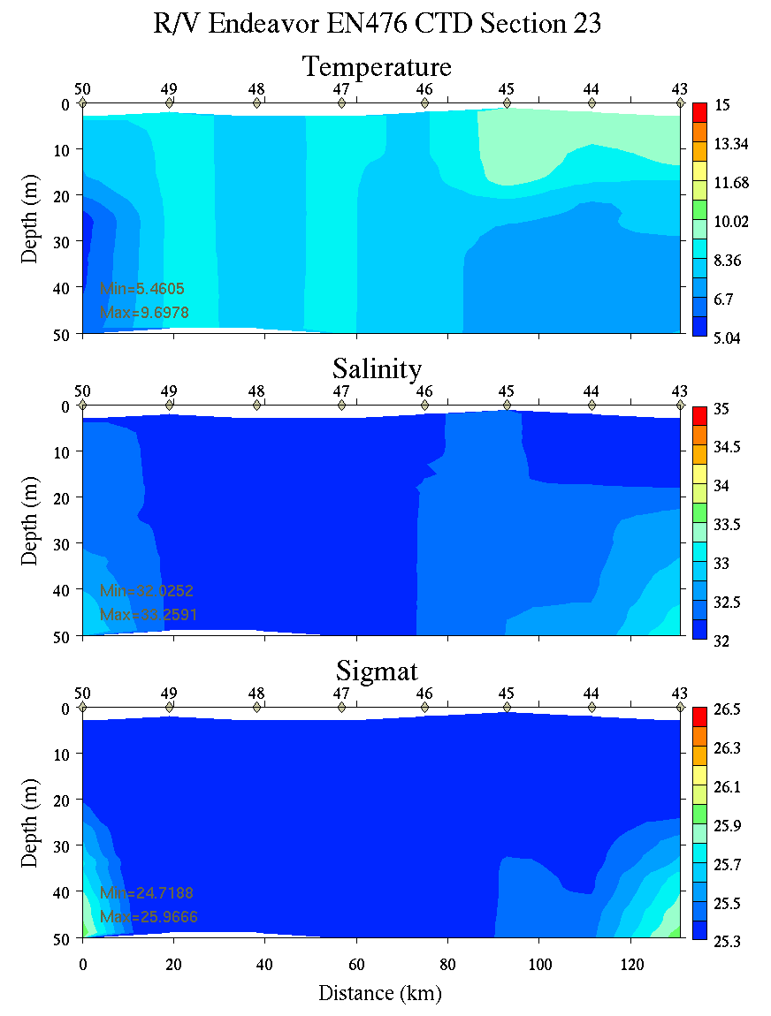 | 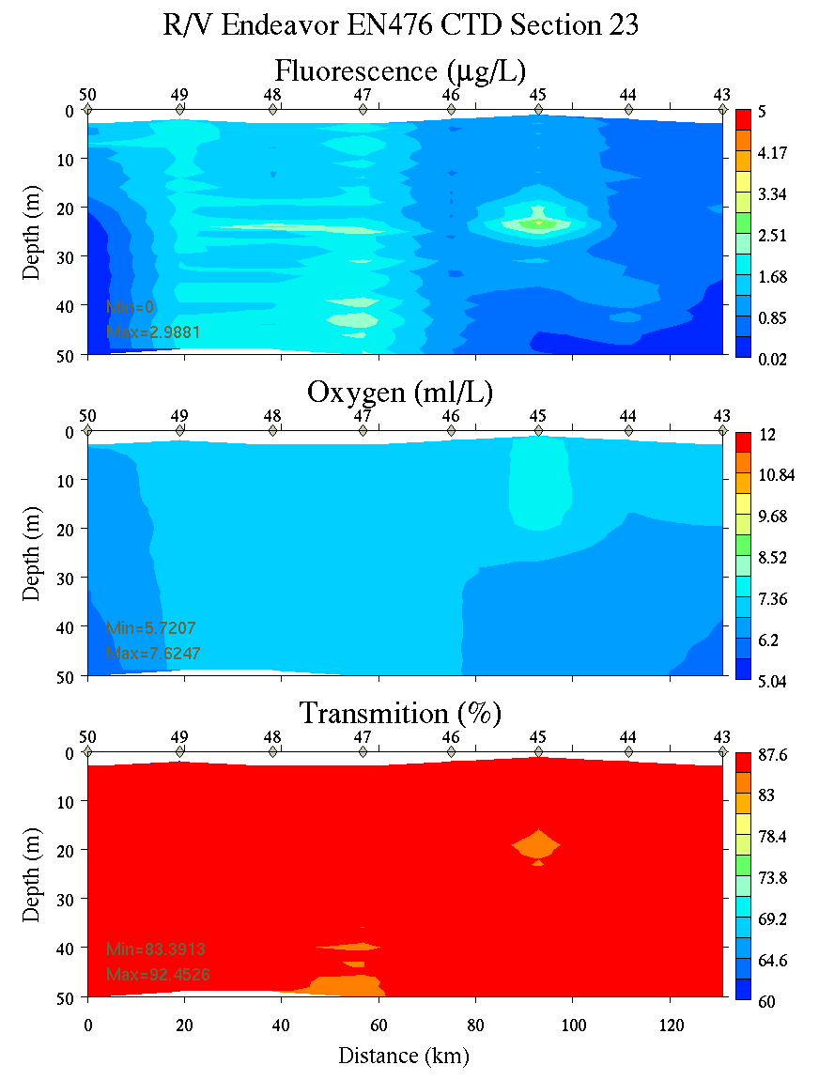
Figure C11. Section 23, 0-50m: temperature, salinity, and density (left); fluorescence, oxygen, and beam transmission (right).

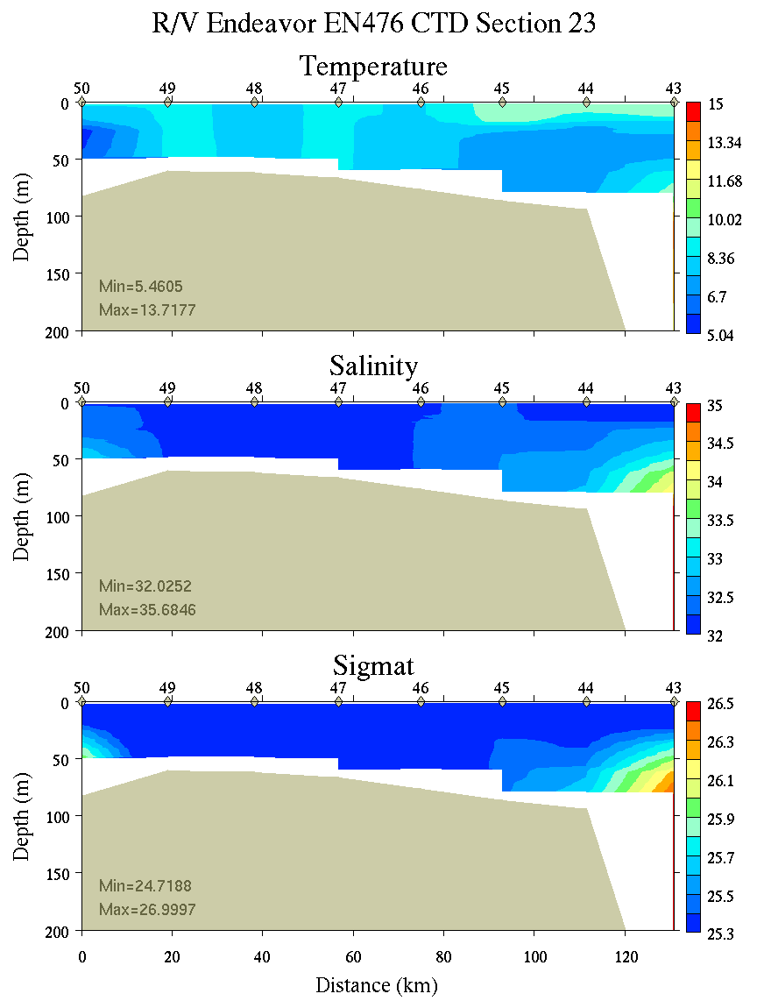 | 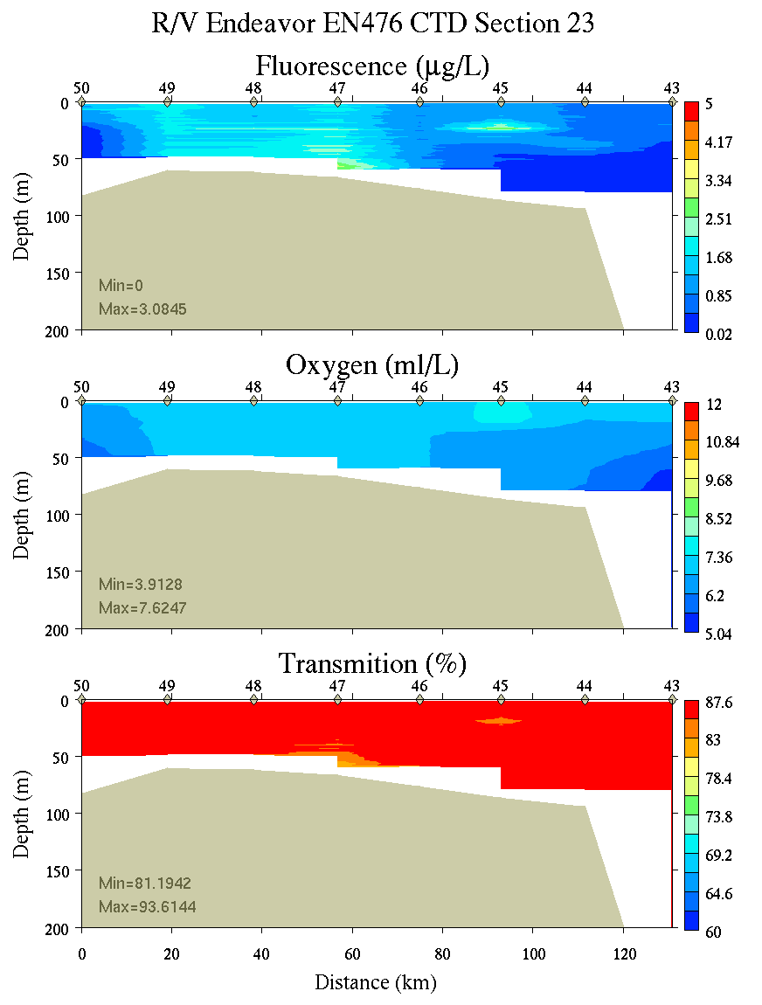
Figure C12. Section 23, 0-200m: temperature, salinity, and density (left); fluorescence, oxygen, and beam transmission (right).

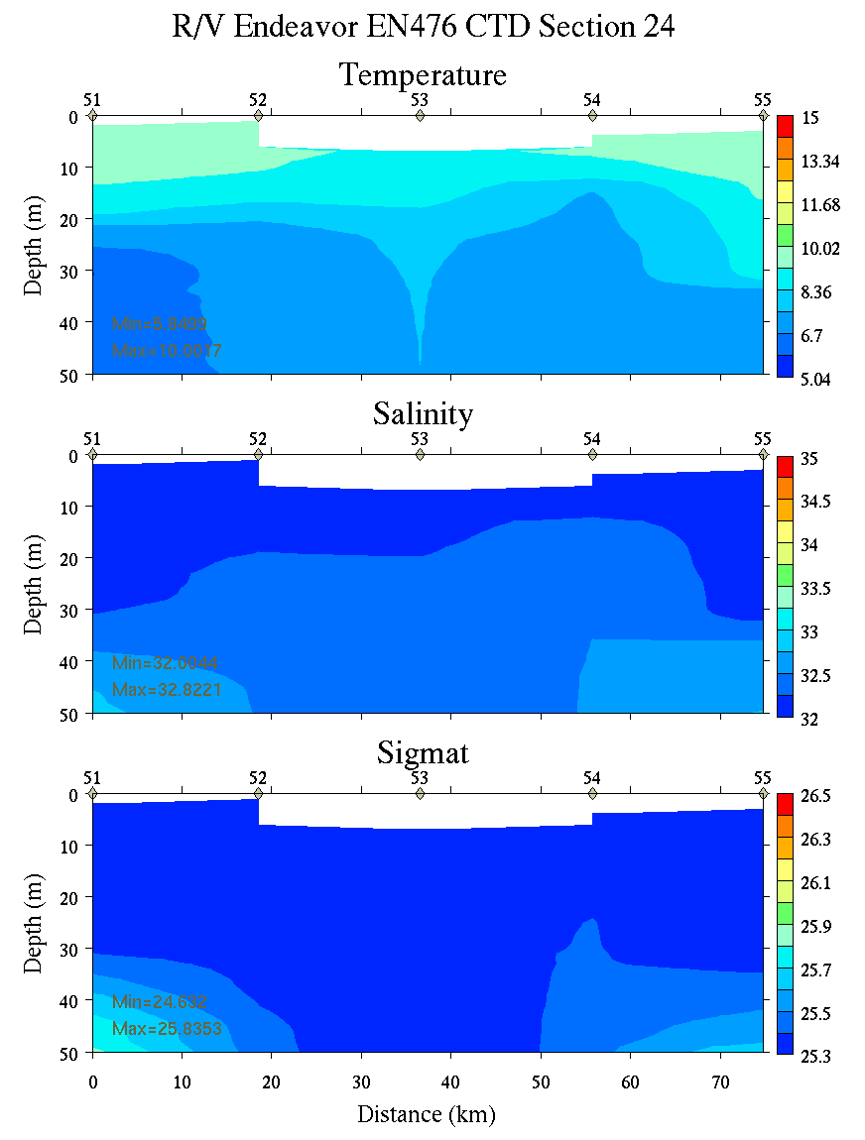 | 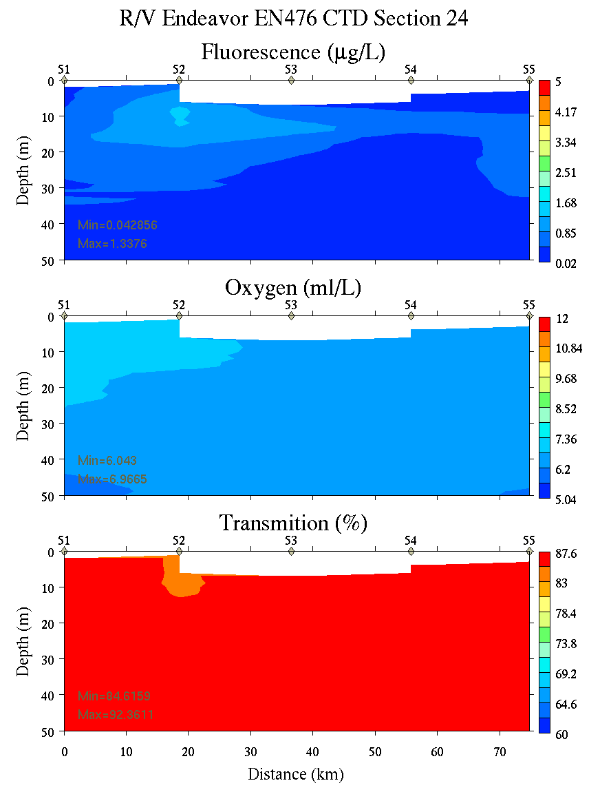
Figure C13. Section 24, 0-50m: temperature, salinity, and density (left); fluorescence, oxygen, and beam transmission (right).

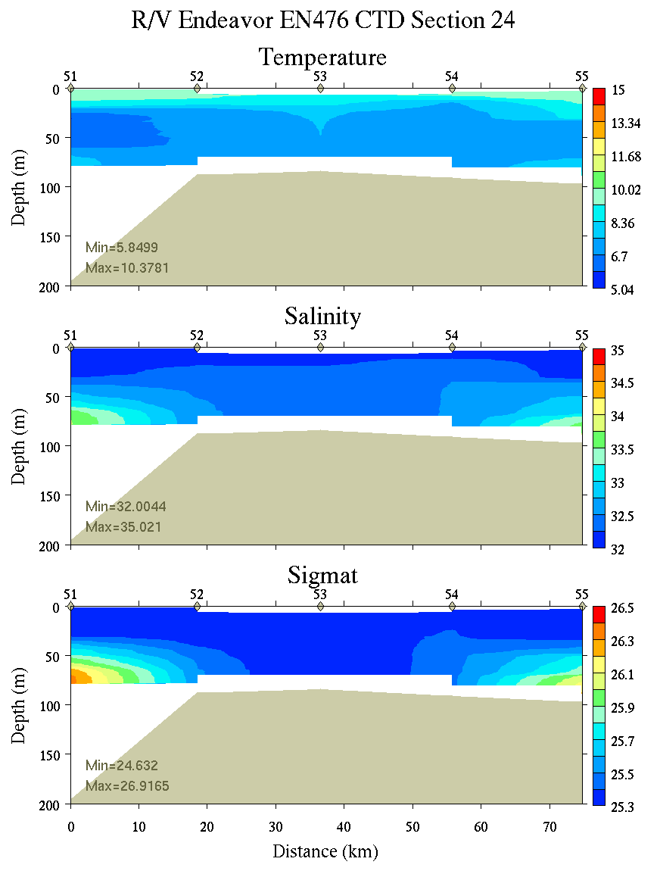 | 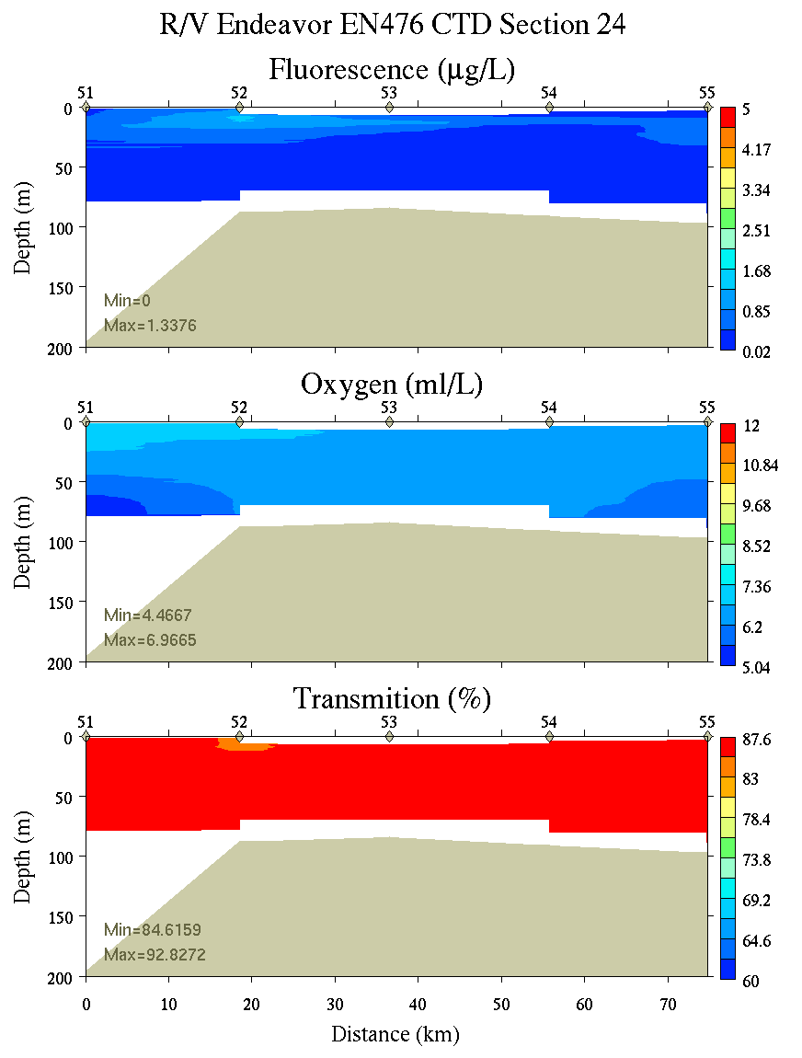
Figure C14. Section 24, 0-200m: temperature, salinity, and density (left); fluorescence, oxygen, and beam transmission (right).

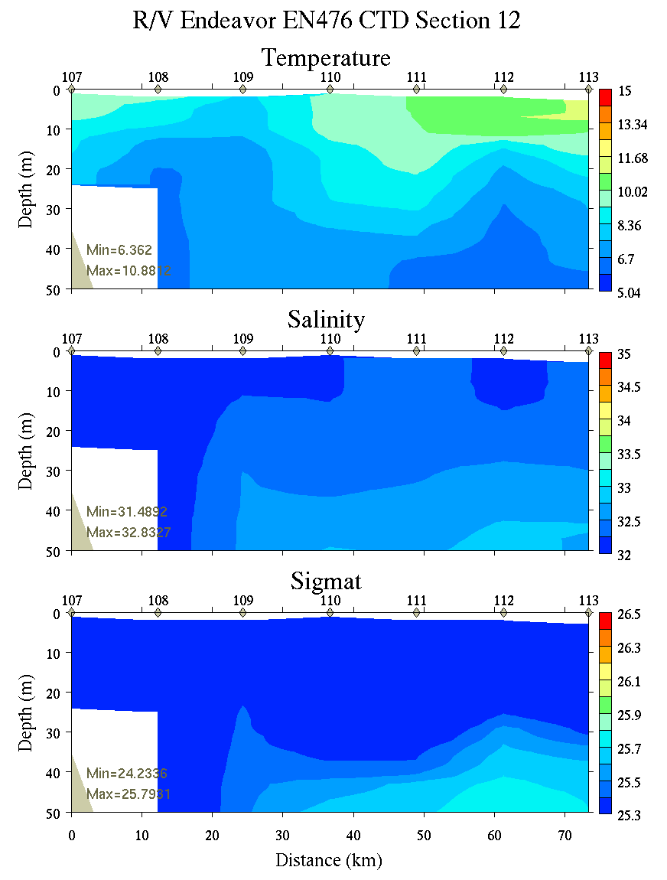 | 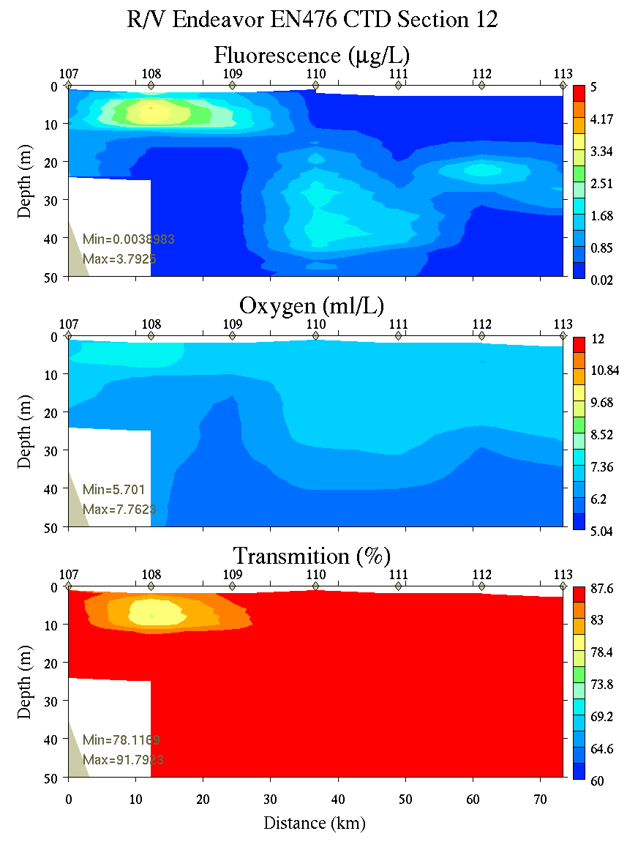
Figure C15. Section 12, 0-50m: temperature, salinity, and density (left); fluorescence, oxygen, and beam transmission (right).

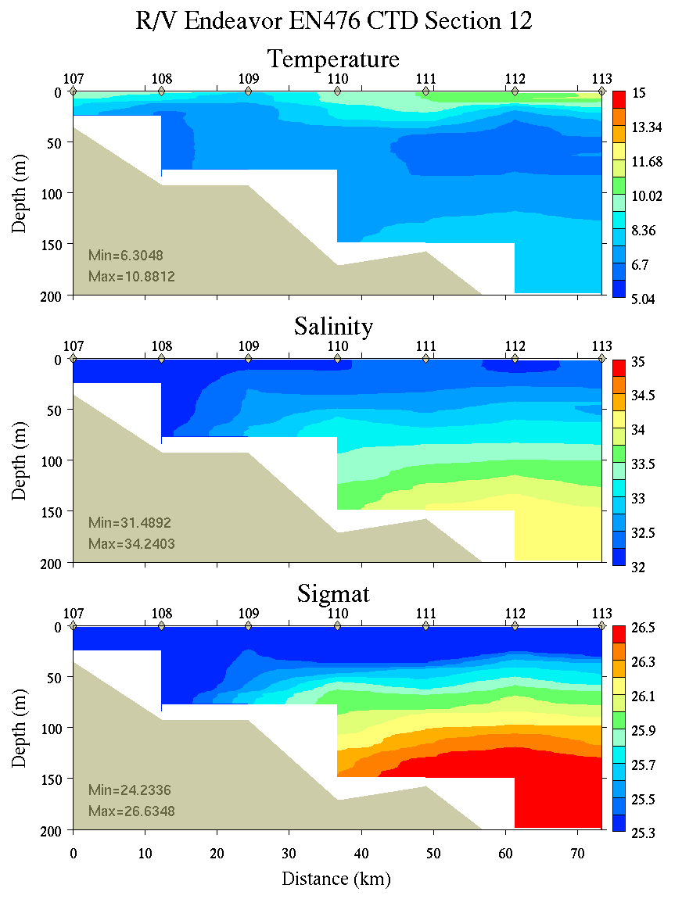 | 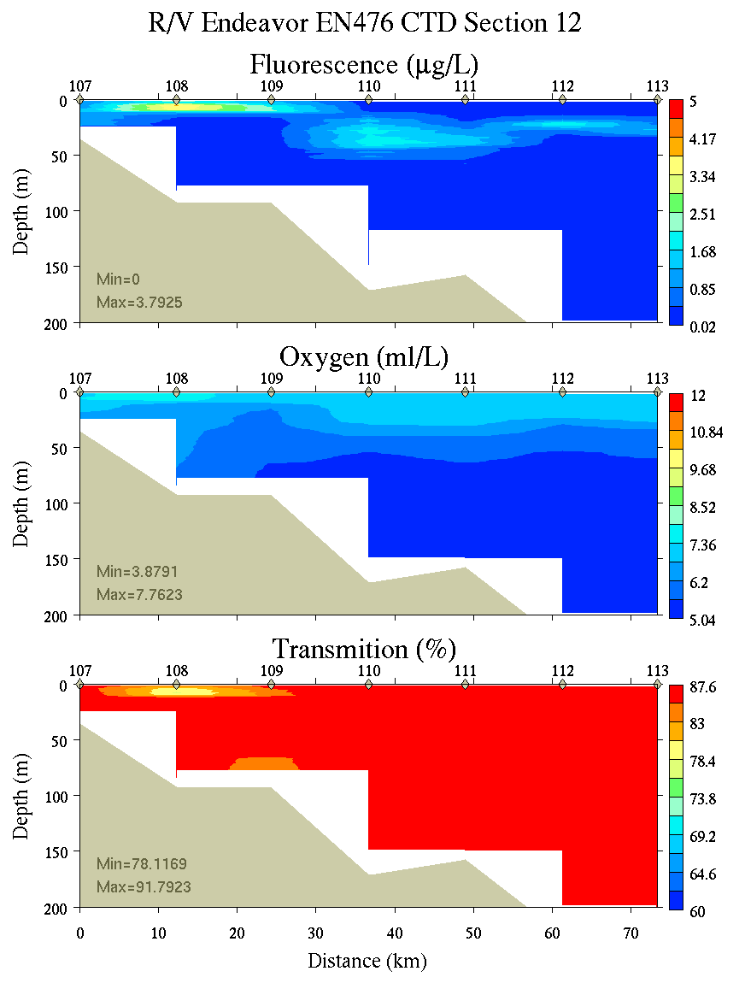
Figure C16. Section 12, 0-200m: temperature, salinity, and density (left); fluorescence, oxygen, and beam transmission (right).

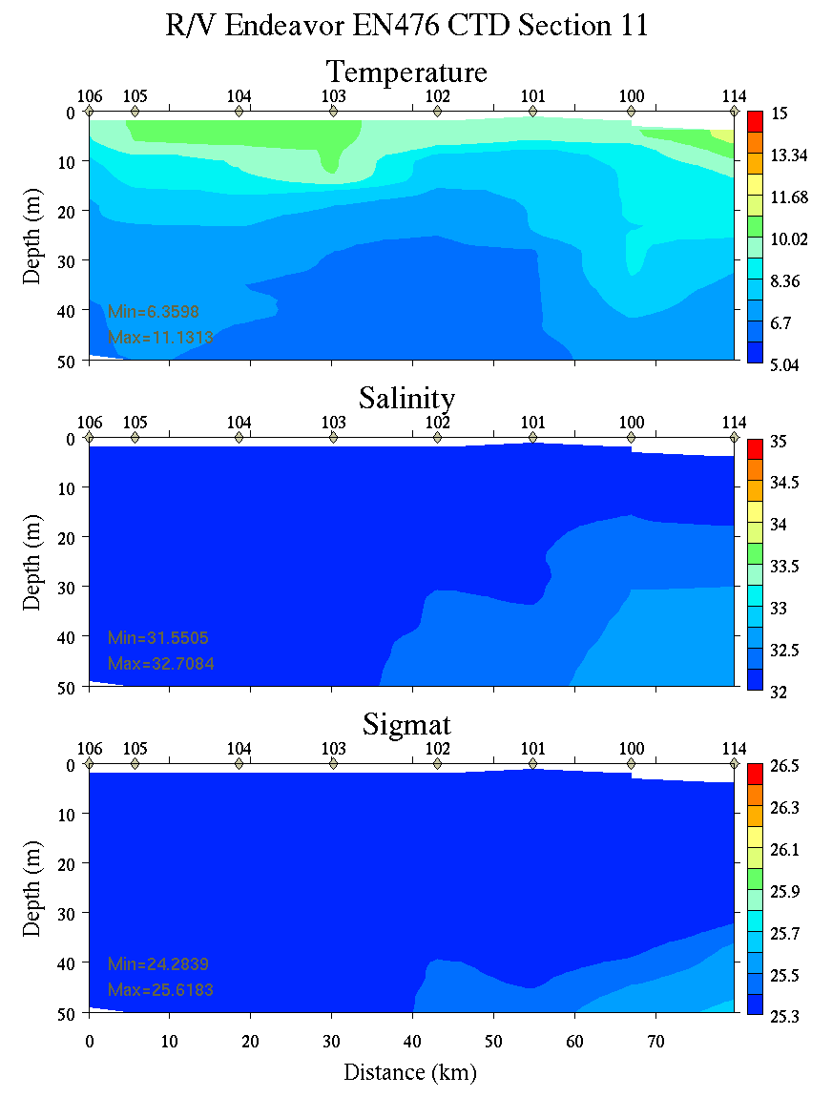 | 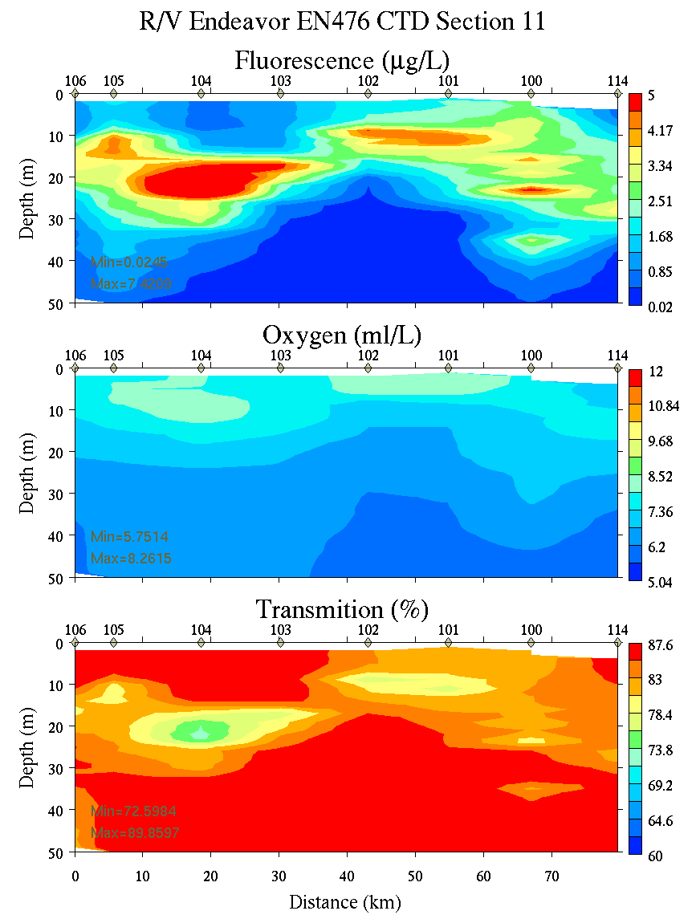
Figure C17. Section 11, 0-50m: temperature, salinity, and density (left); fluorescence, oxygen, and beam transmission (right).

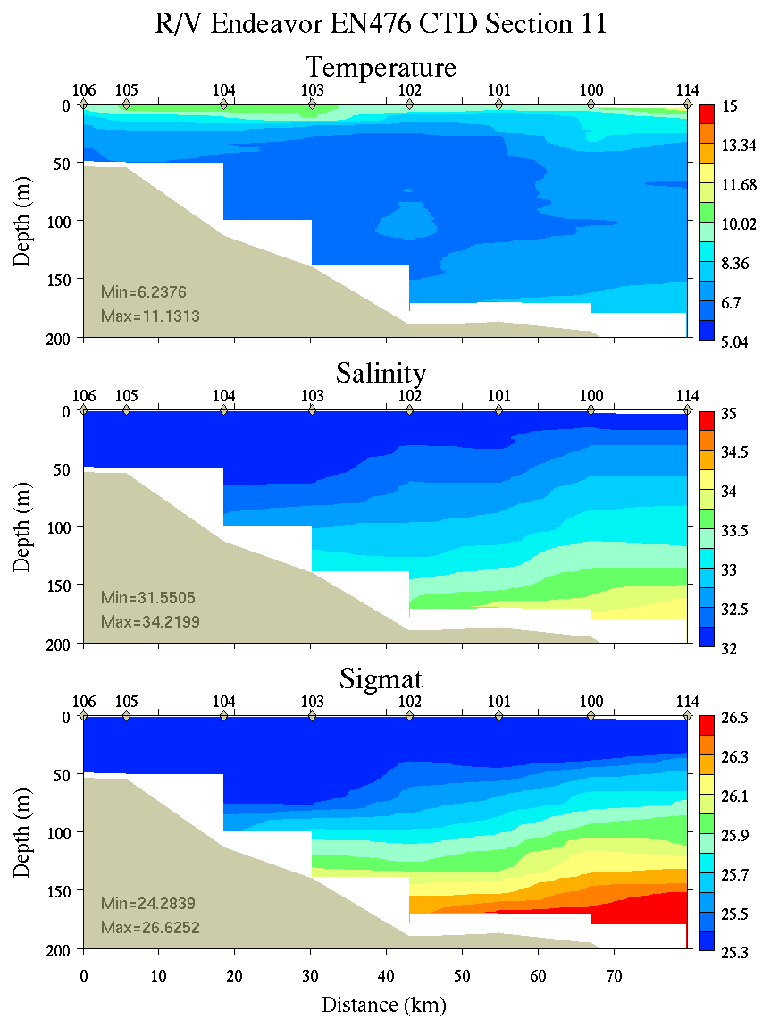 | 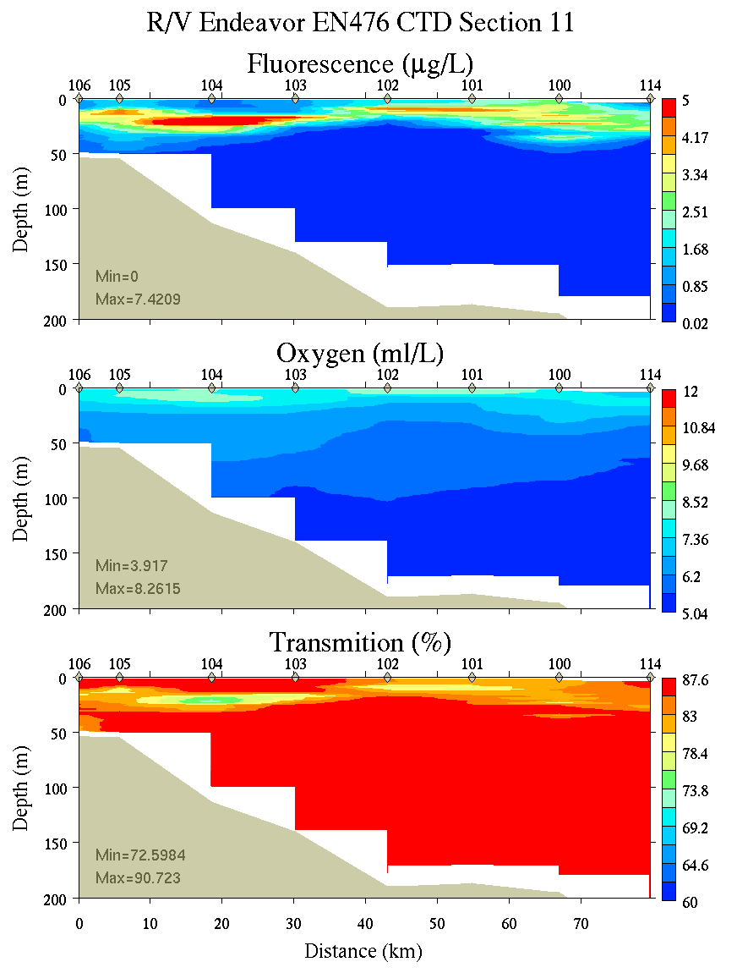
Figure C18. Section 11, 0-200m: temperature, salinity, and density (left); fluorescence, oxygen, and beam transmission (right).

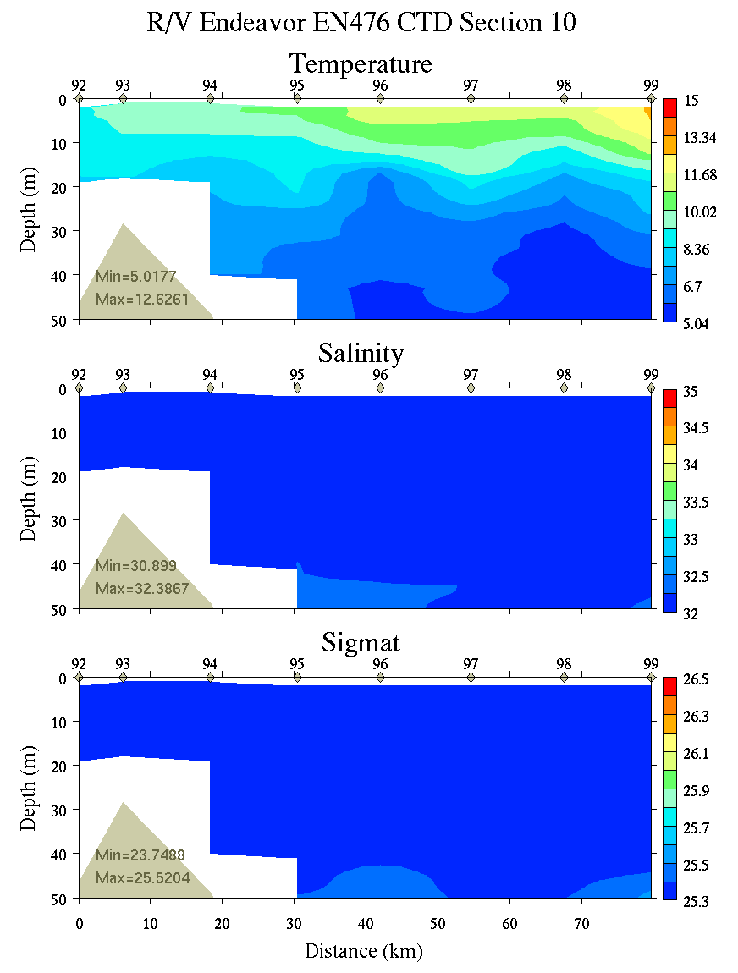 | 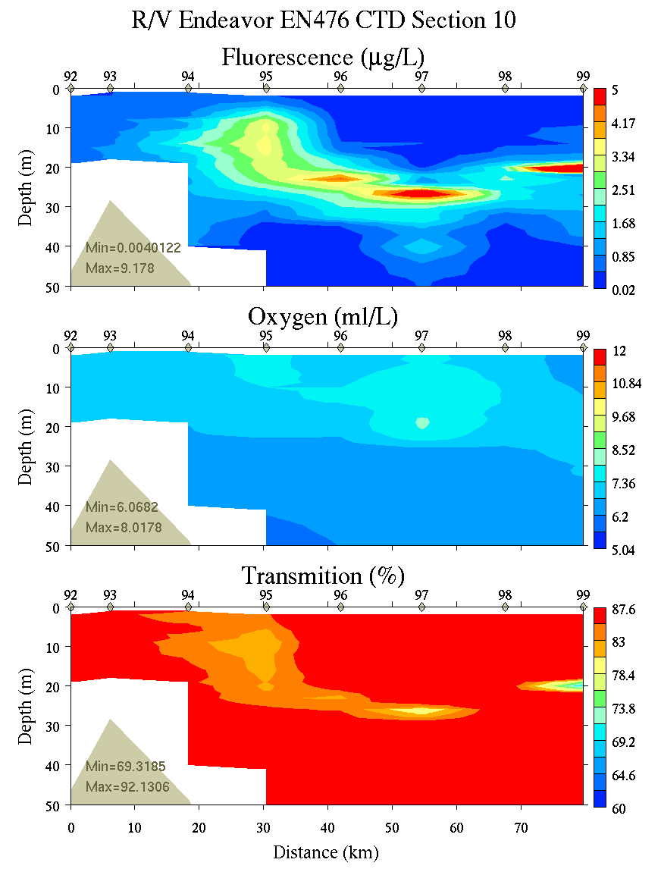
Figure C19. Section 10, 0-50m: temperature, salinity, and density (left); fluorescence, oxygen, and beam transmission (right).

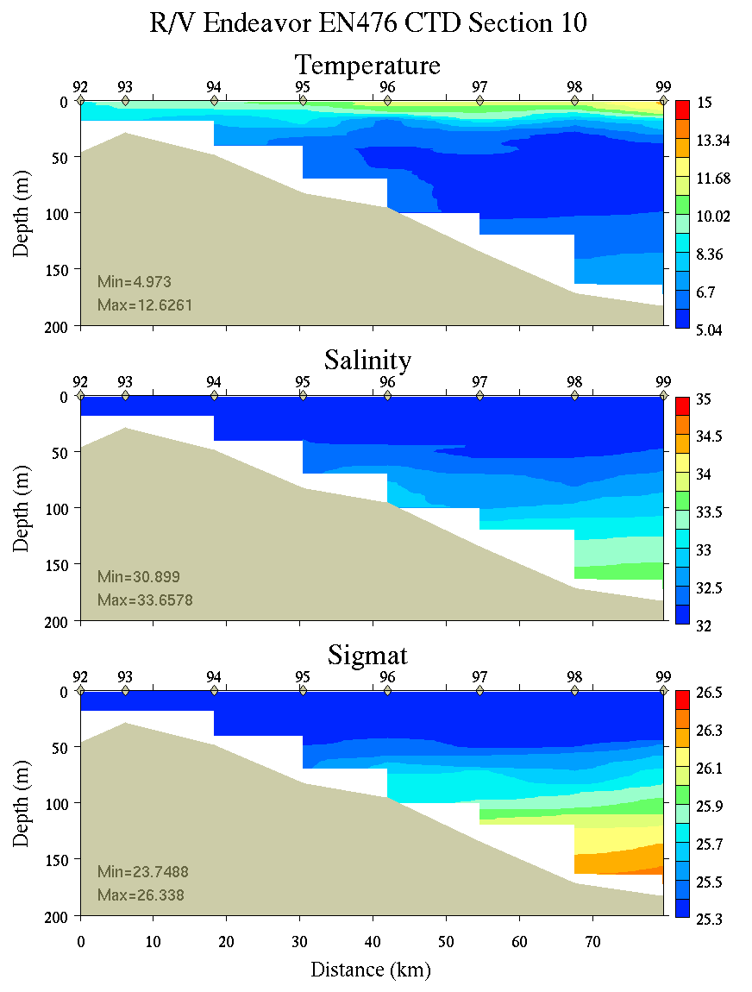 | 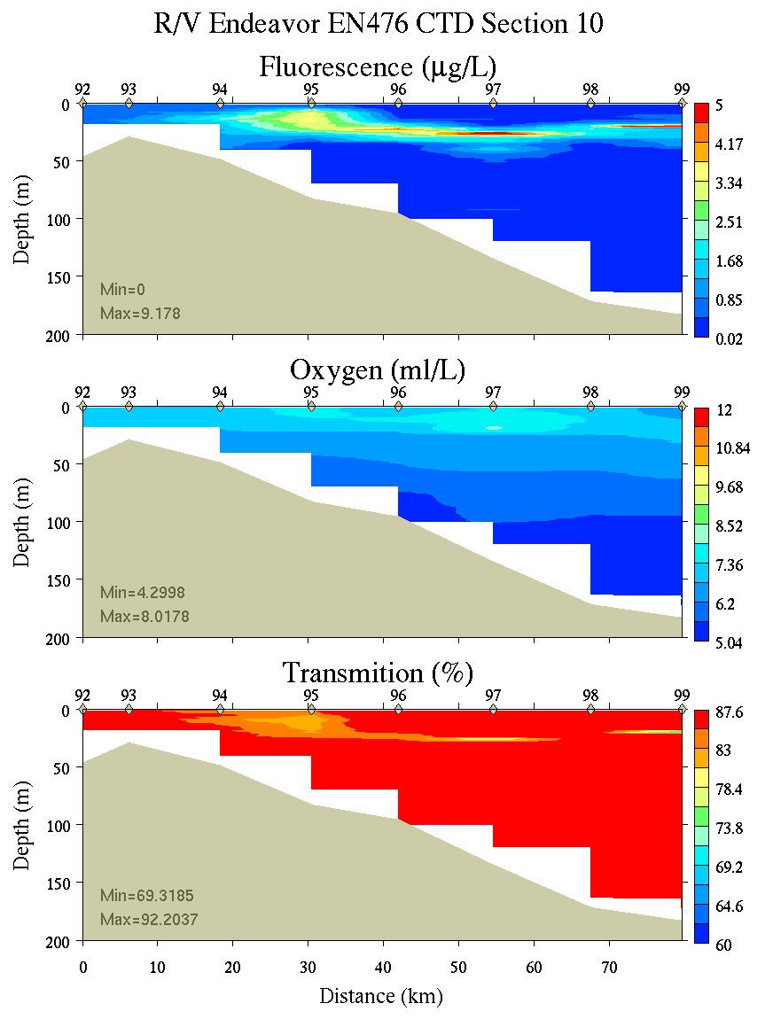
Figure C20. Section 10, 0-200m: temperature, salinity, and density (left); fluorescence, oxygen, and beam transmission (right).

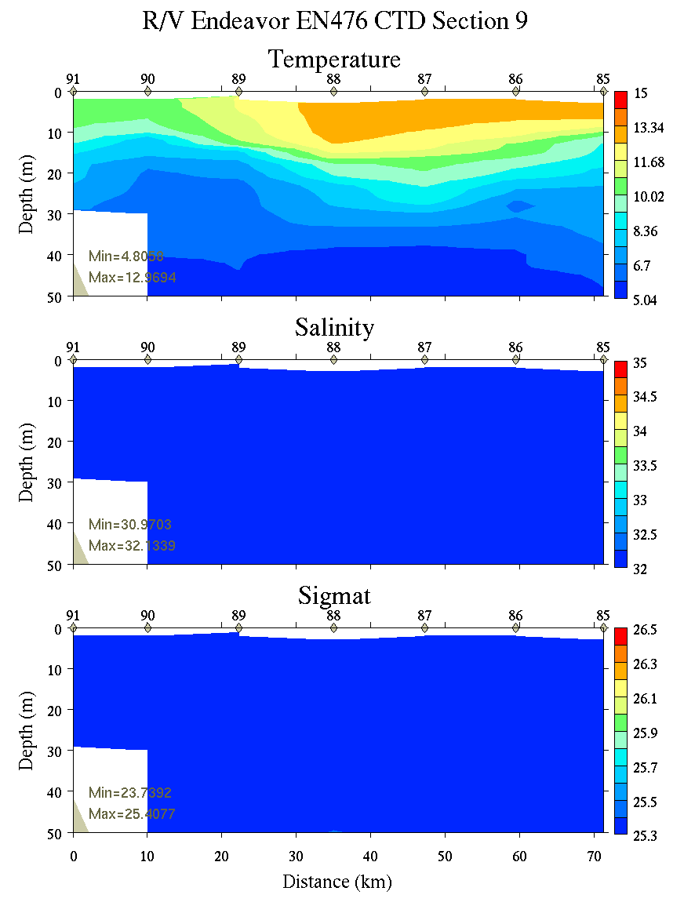 | 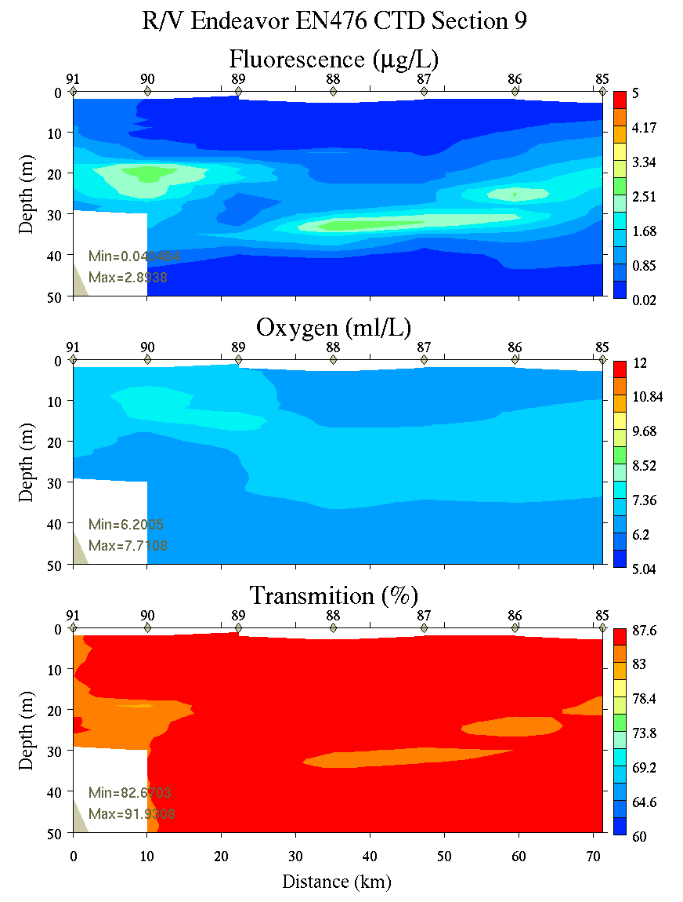
Figure C21. Section 9, 0-50m: temperature, salinity, and density (left); fluorescence, oxygen, and beam transmission (right).

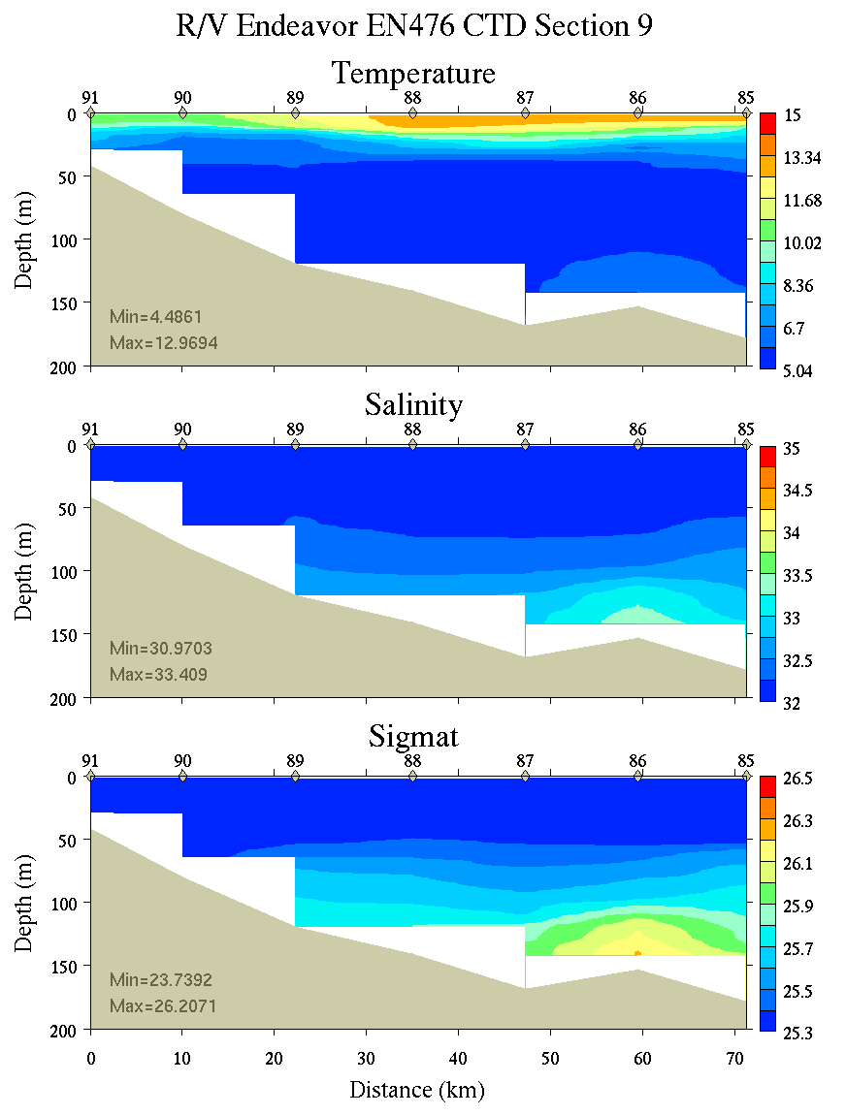 | 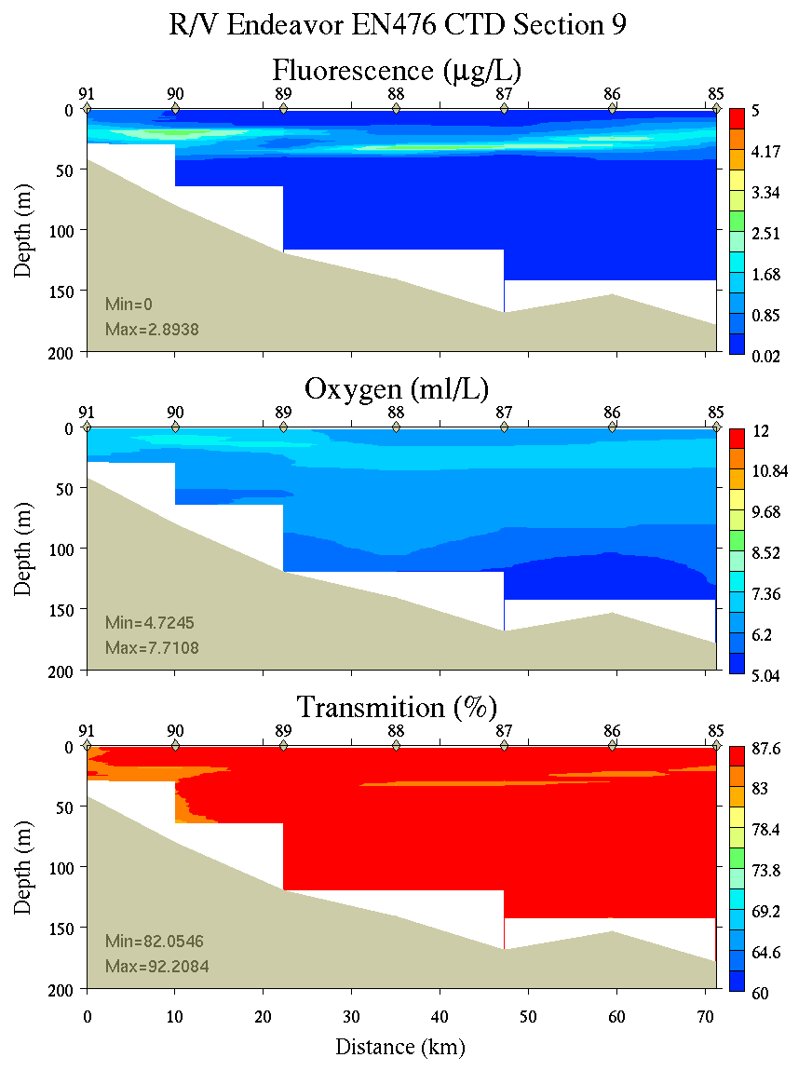
Figure C22. Section 9, 0-200m: temperature, salinity, and density (left); fluorescence, oxygen, and beam transmission (right).

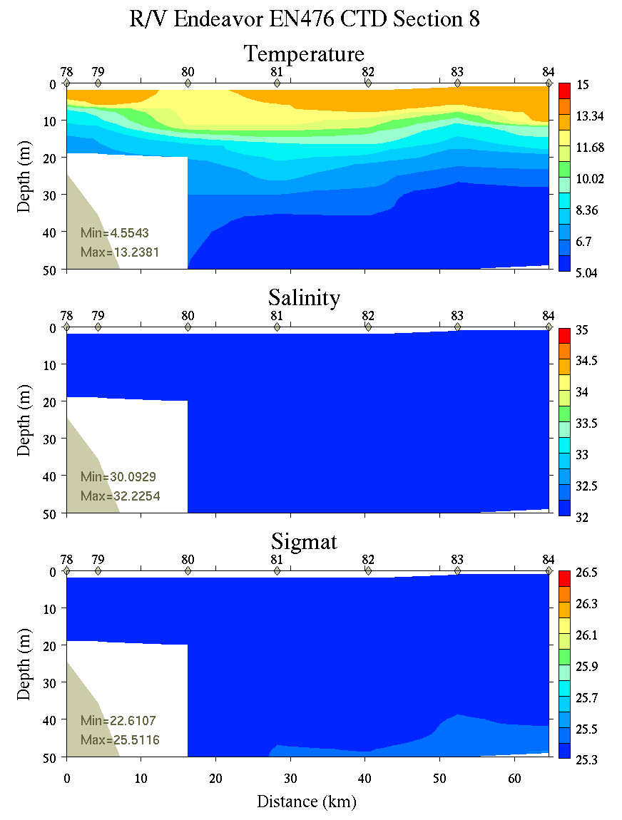 | 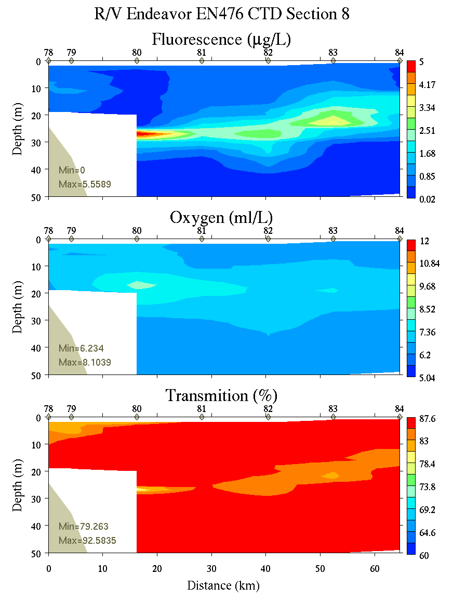
Figure C23. Section 8, 0-50m: temperature, salinity, and density (left); fluorescence, oxygen, and beam transmission (right).

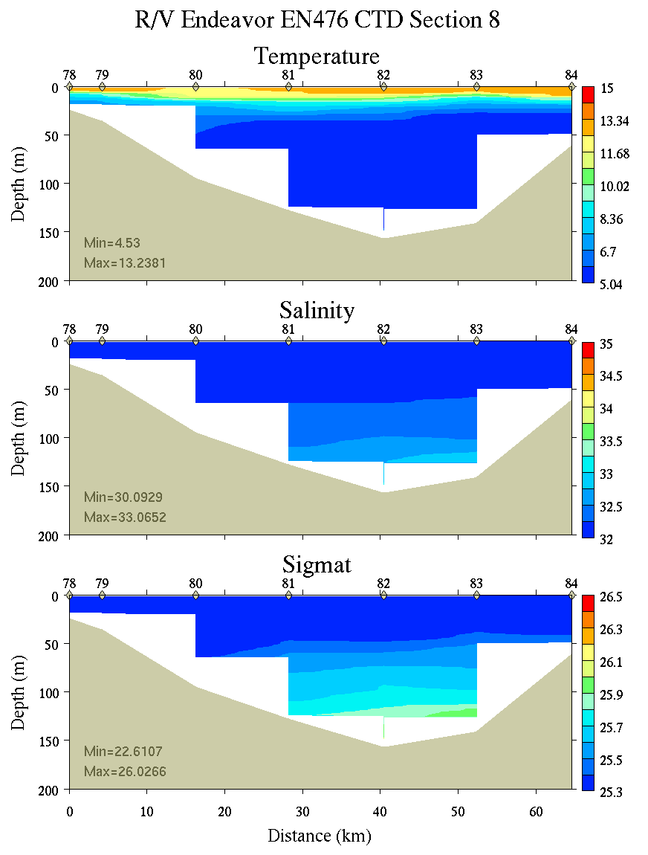 | 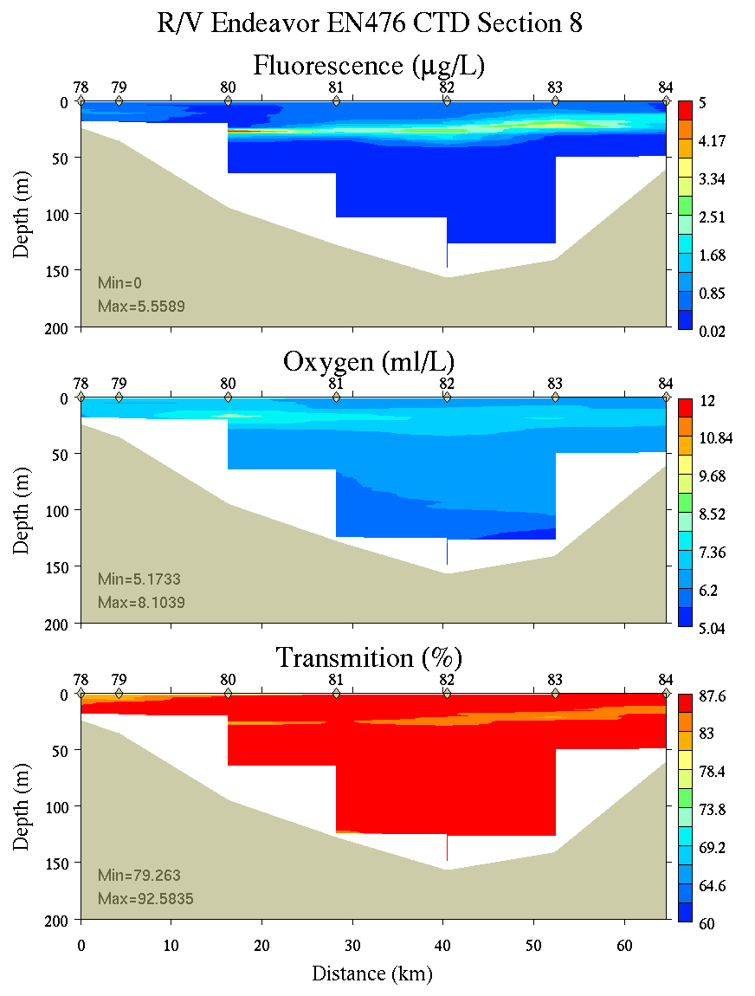
Figure C24. Section 8, 0-200m: temperature, salinity, and density (left); fluorescence, oxygen, and beam transmission (right).

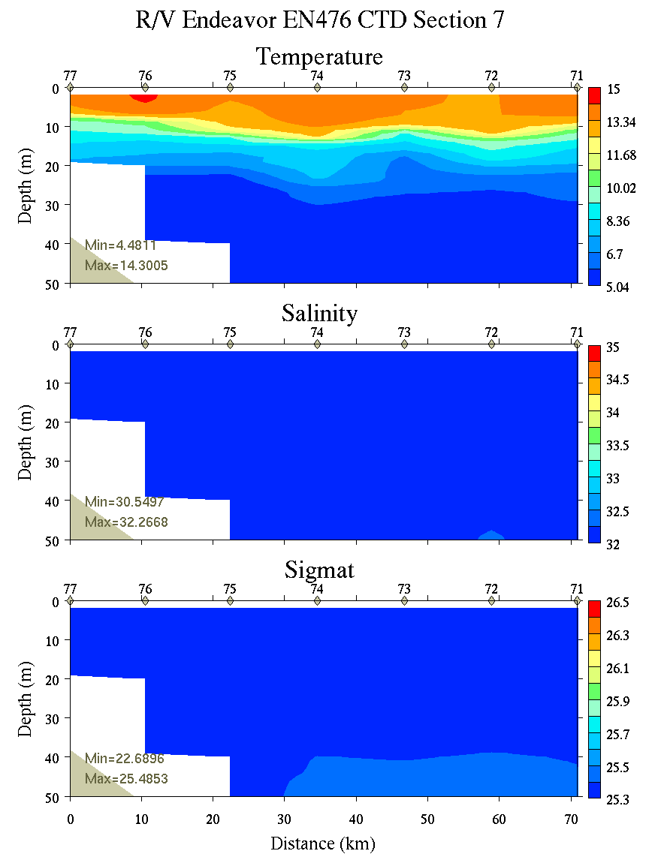 | 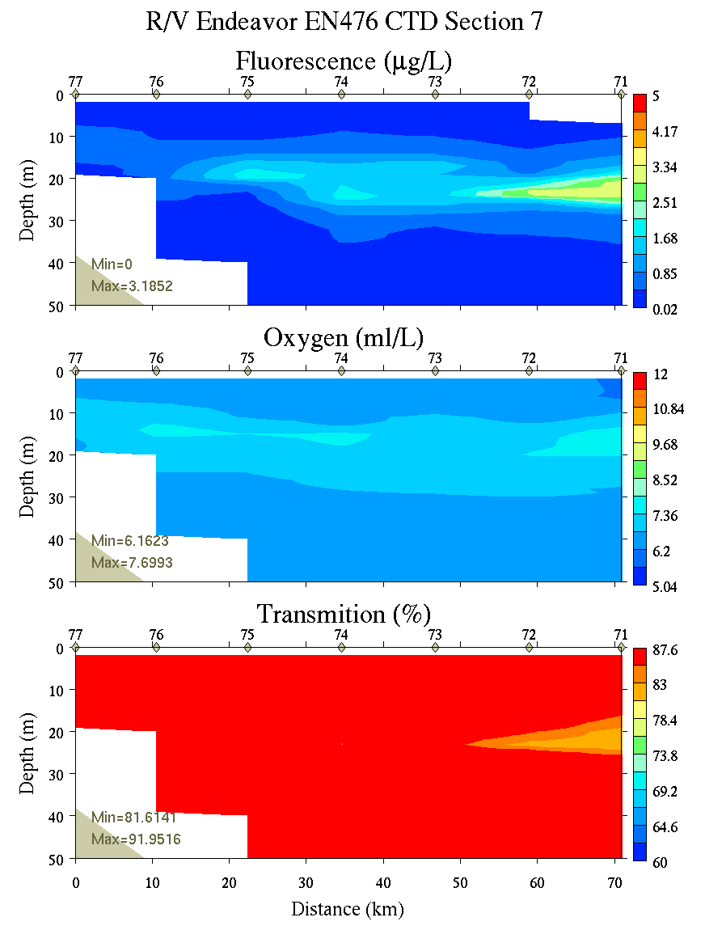
Figure C25. Section 7, 0-50m: temperature, salinity, and density (left); fluorescence, oxygen, and beam transmission (right).

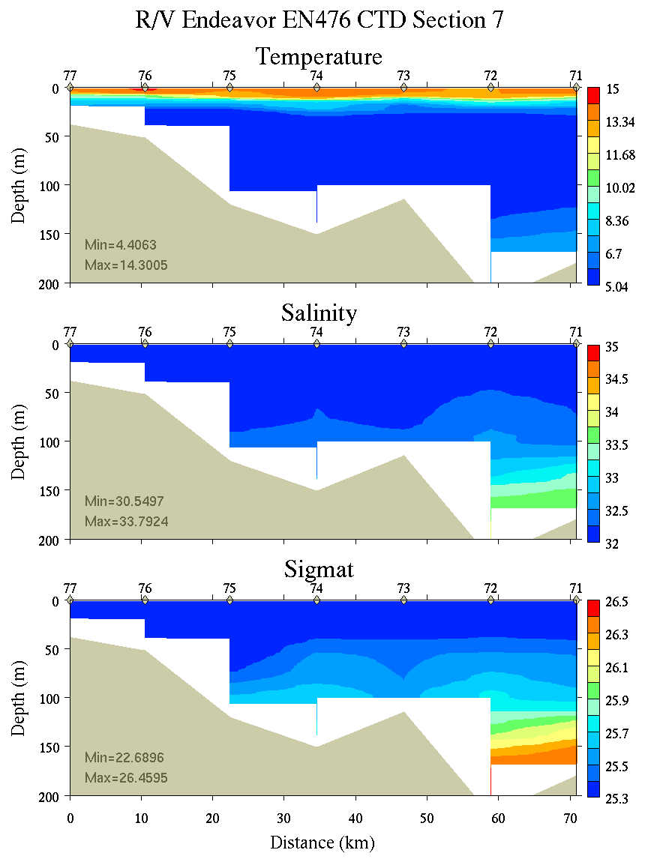 | 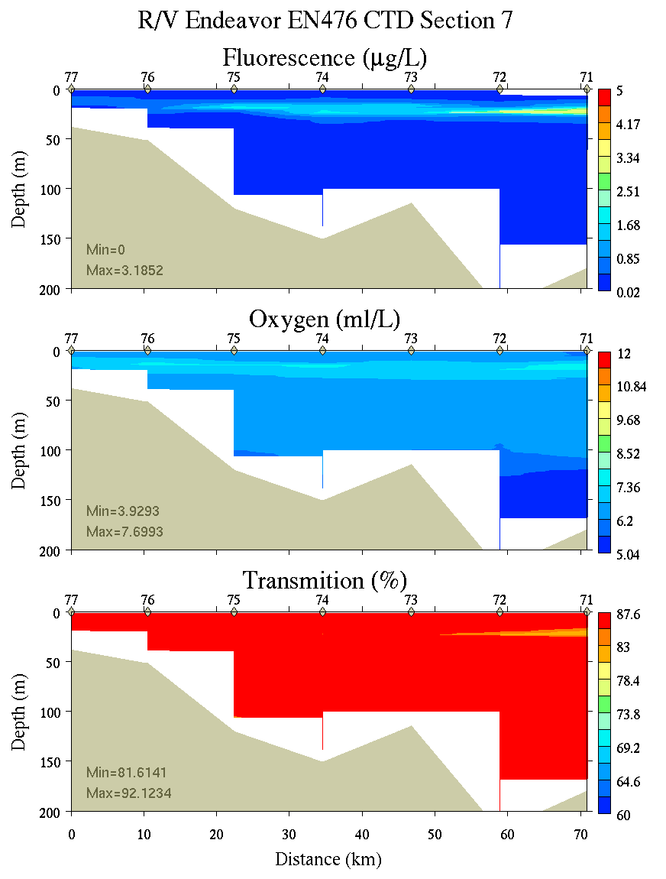
Figure C26. Section 7, 0-200m: temperature, salinity, and density (left); fluorescence, oxygen, and beam transmission (right).

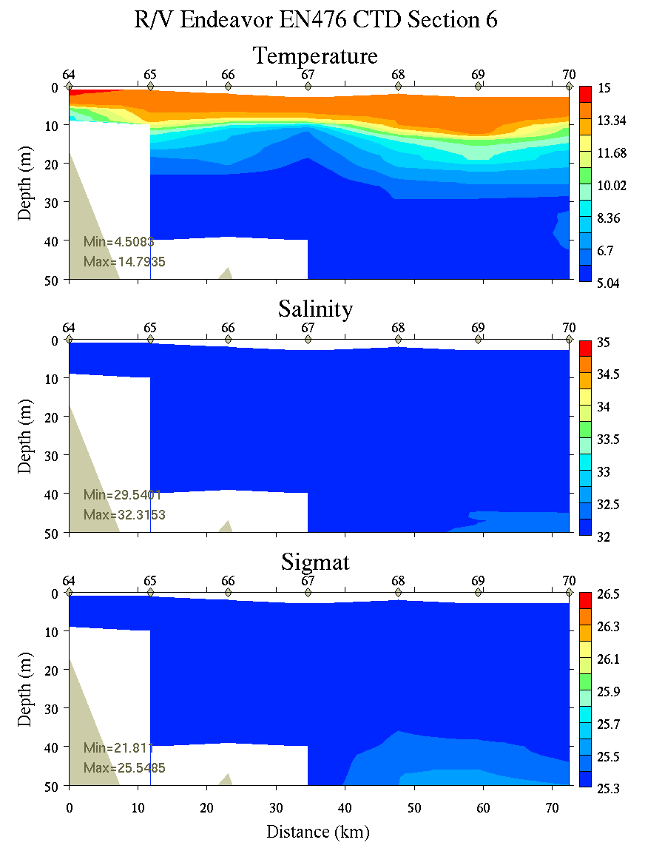 | 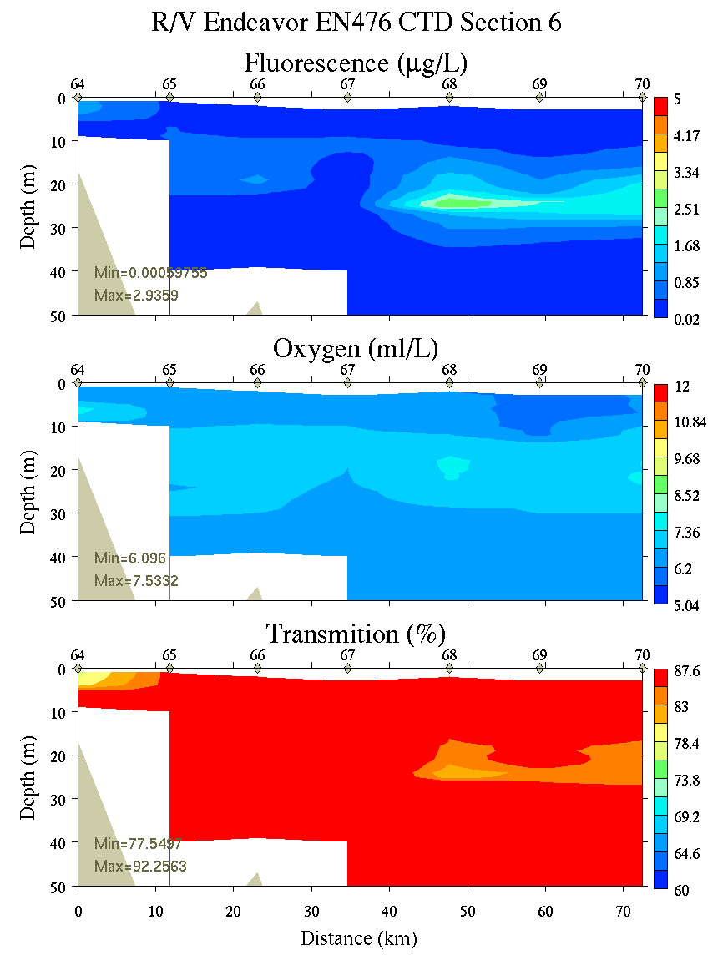
Figure C27. Section 6, 0-50m: temperature, salinity, and density (left); fluorescence, oxygen, and beam transmission (right).

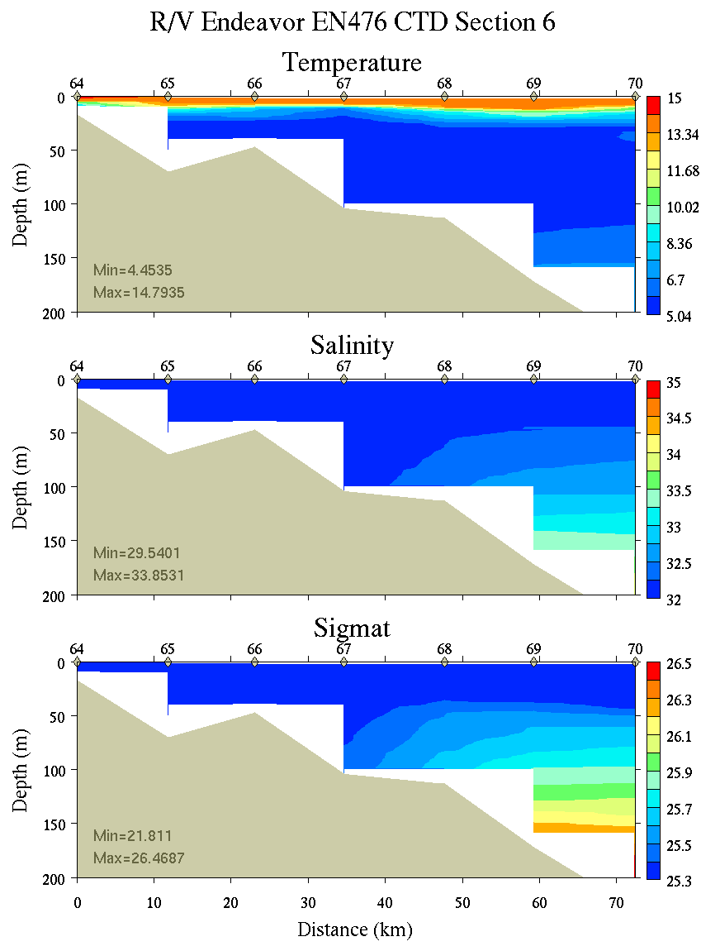 | 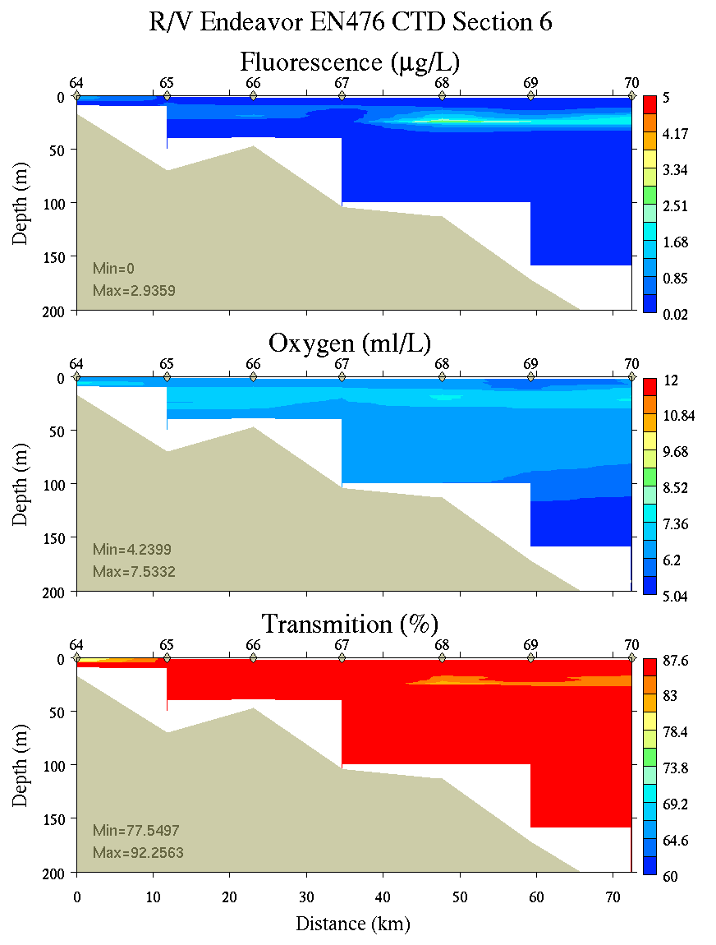
Figure C28. Section 6, 0-200m: temperature, salinity, and density (left); fluorescence, oxygen, and beam transmission (right).

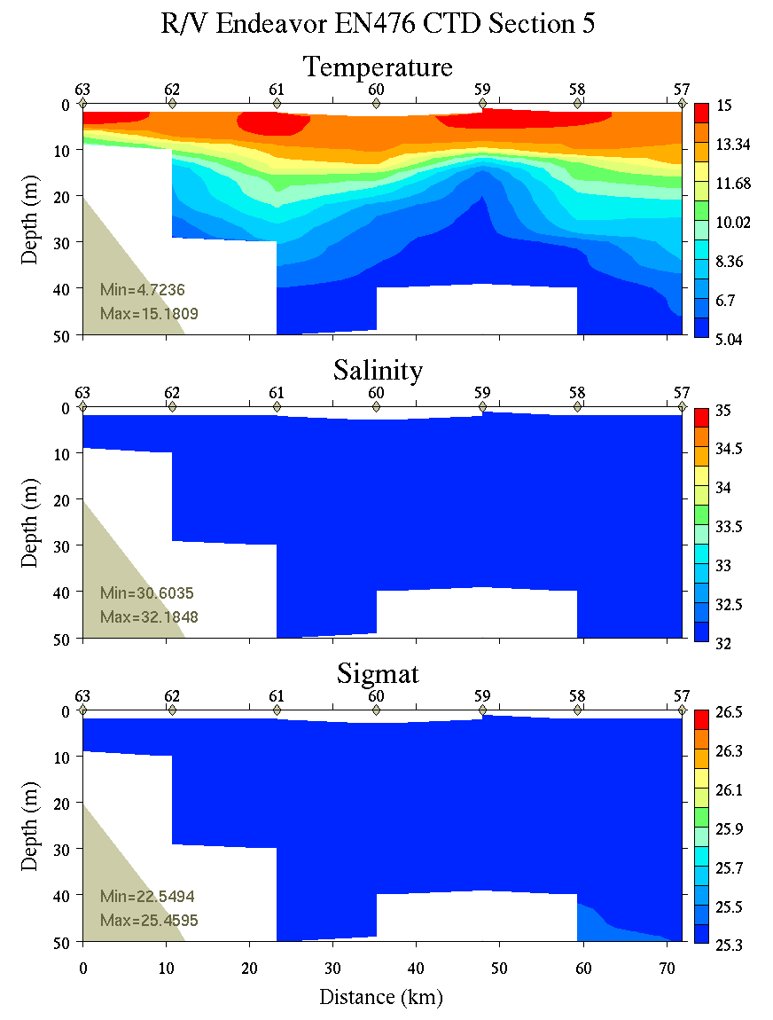 | 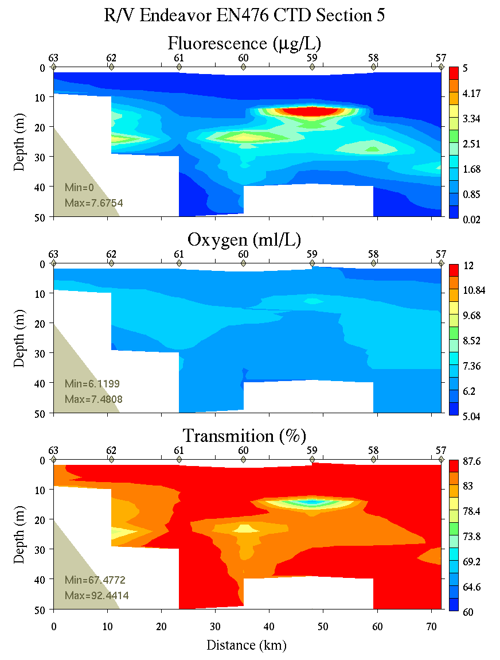
Figure C29. Section 5, 0-50m: temperature, salinity, and density (left); fluorescence, oxygen, and beam transmission (right).

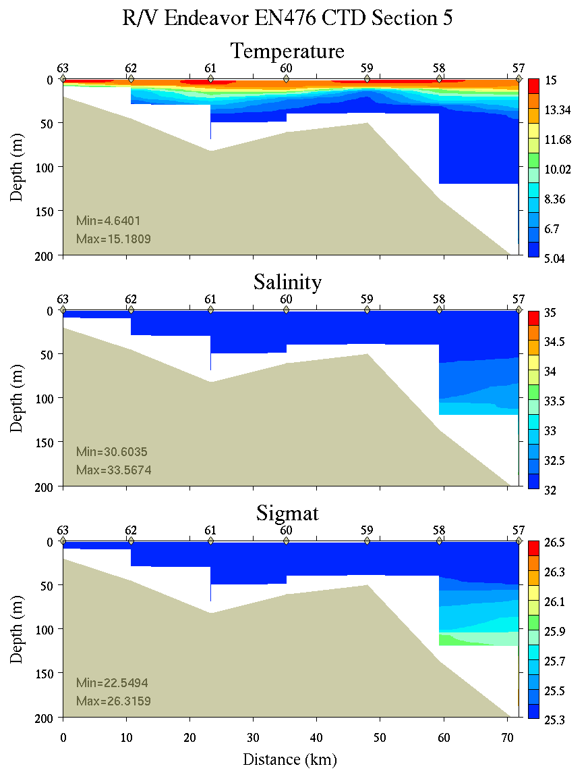 | 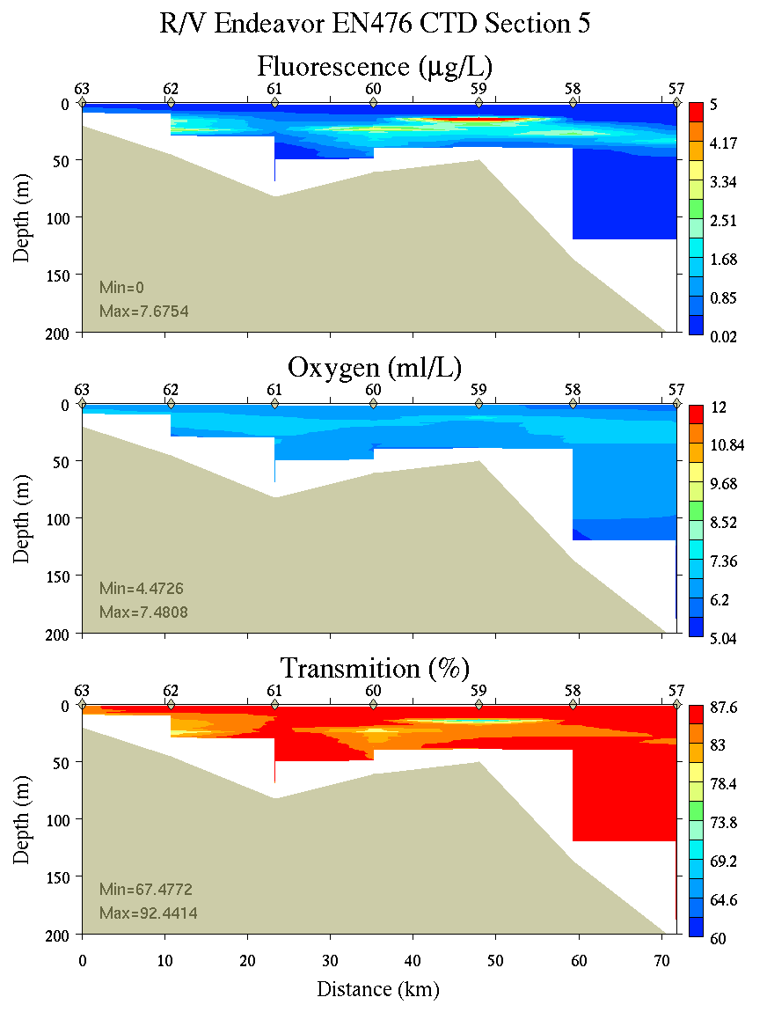
Figure C30. Section 5, 0-200m: temperature, salinity, and density (left); fluorescence, oxygen, and beam transmission (right).
Appendix D: Satellite imagery
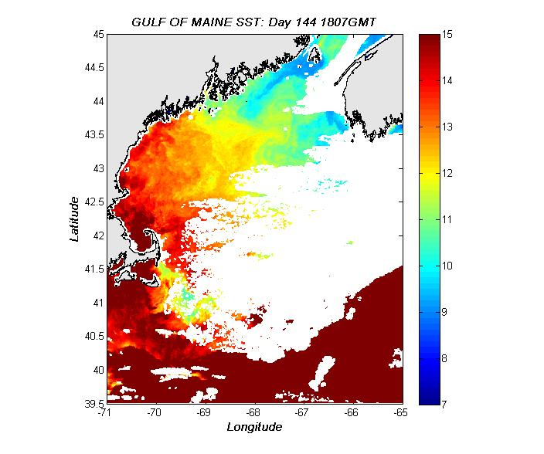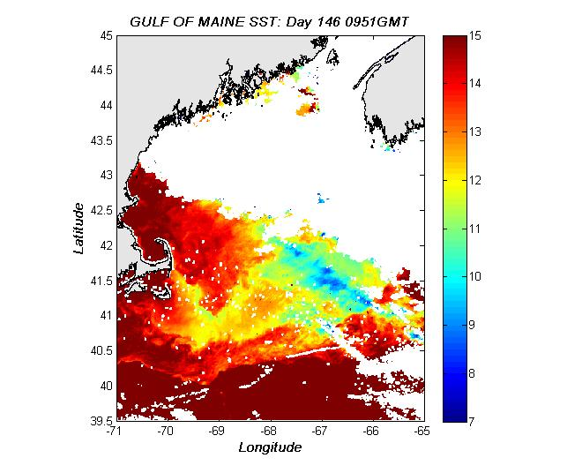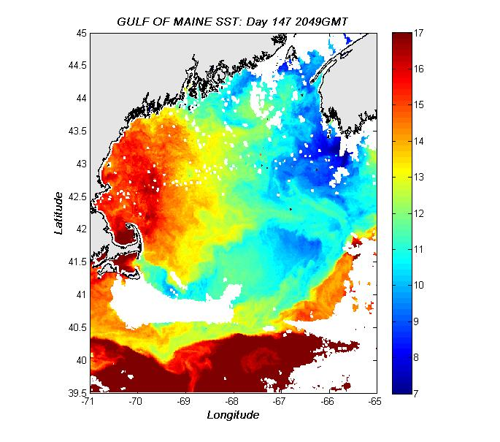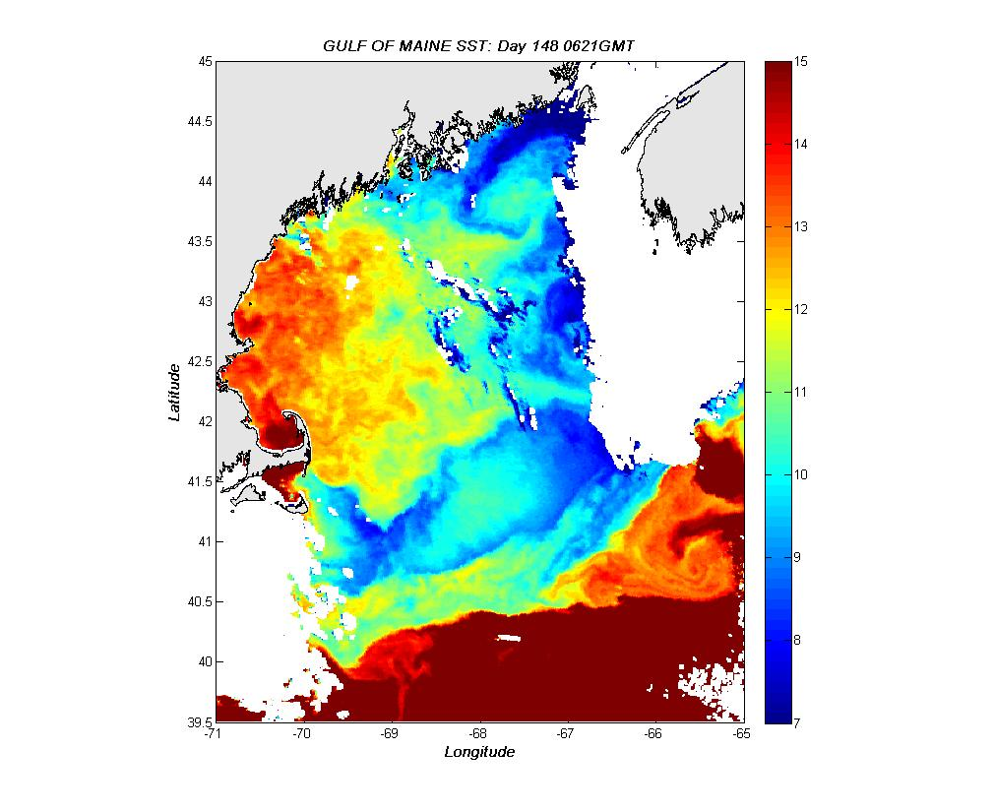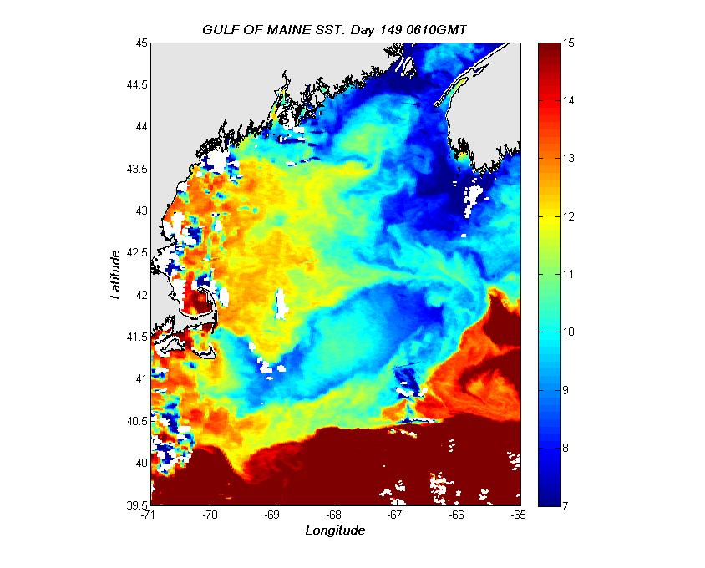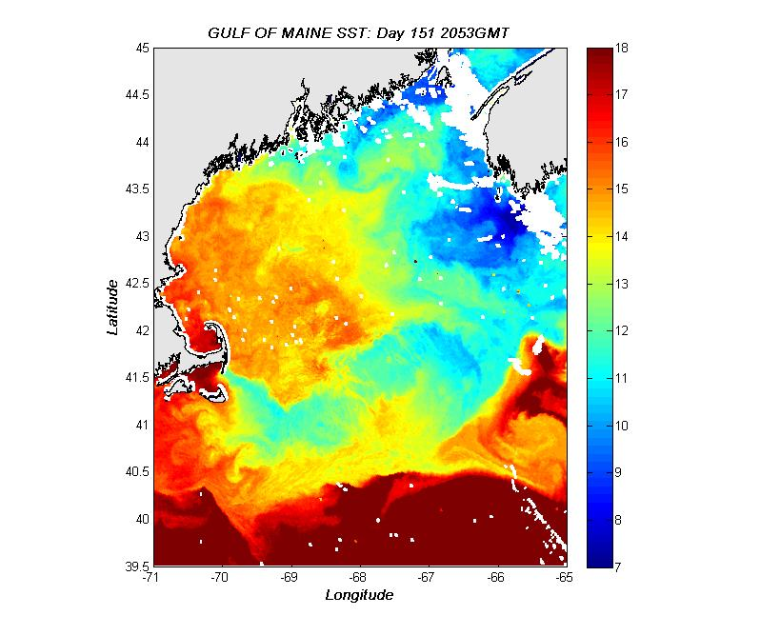
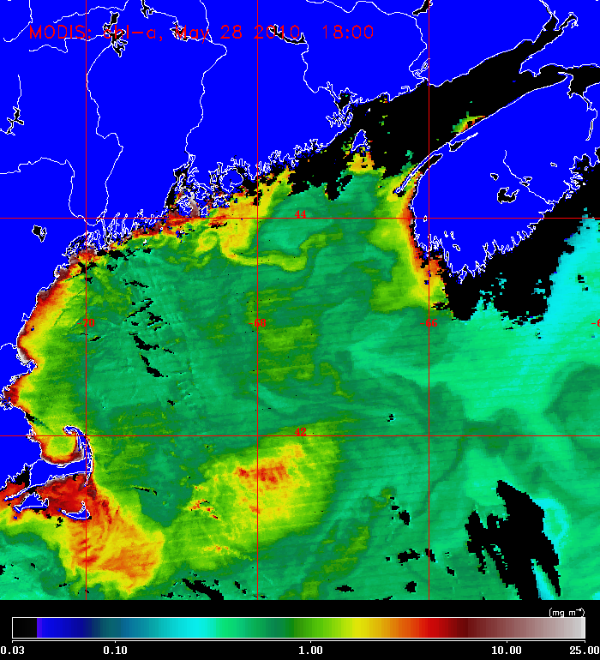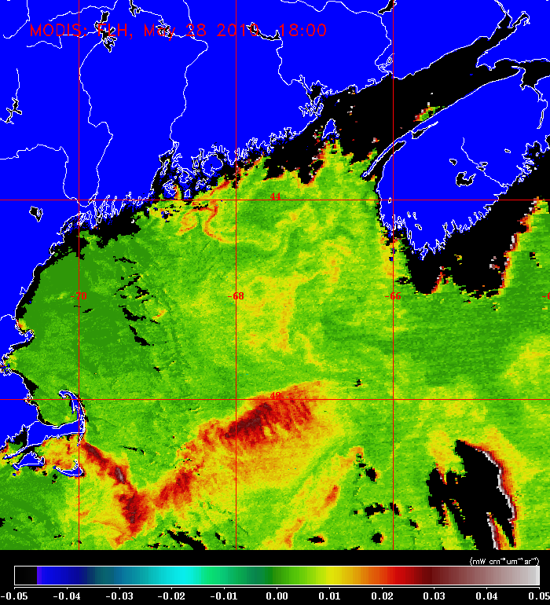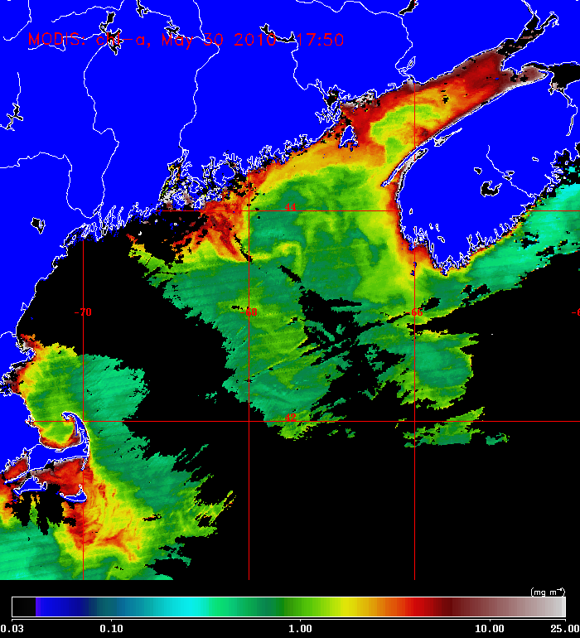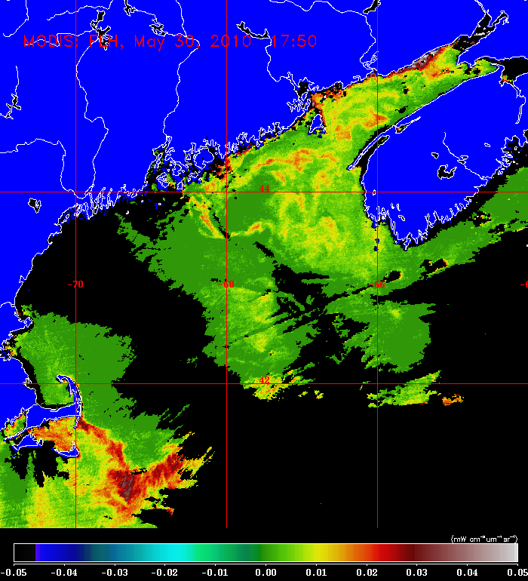
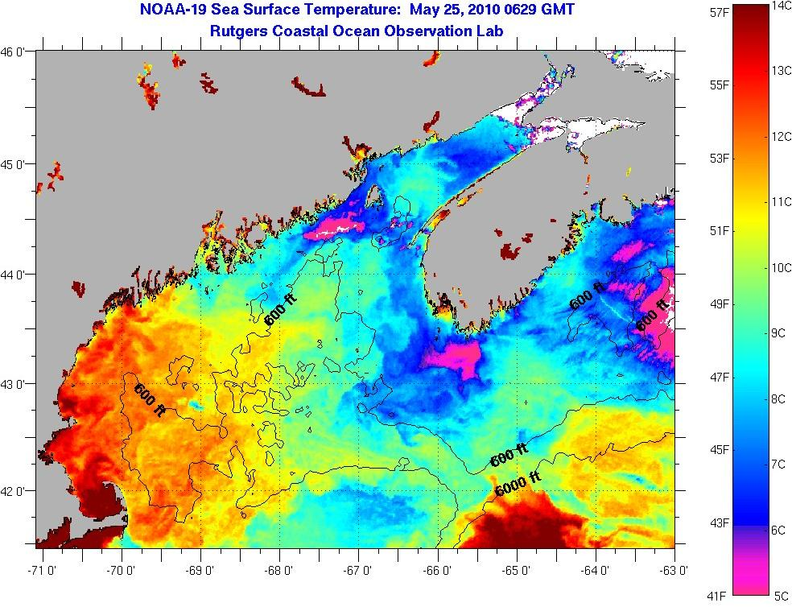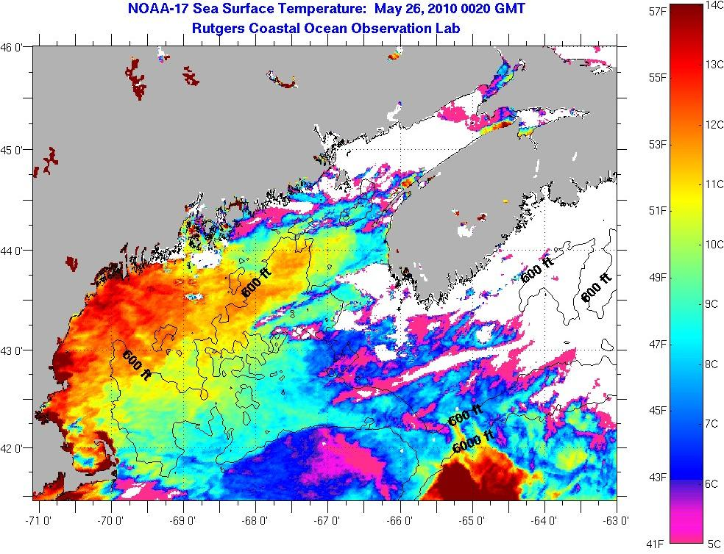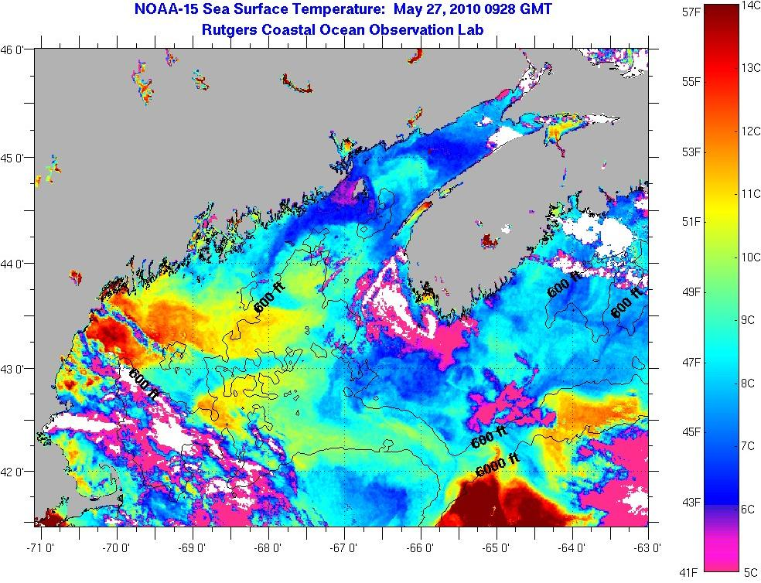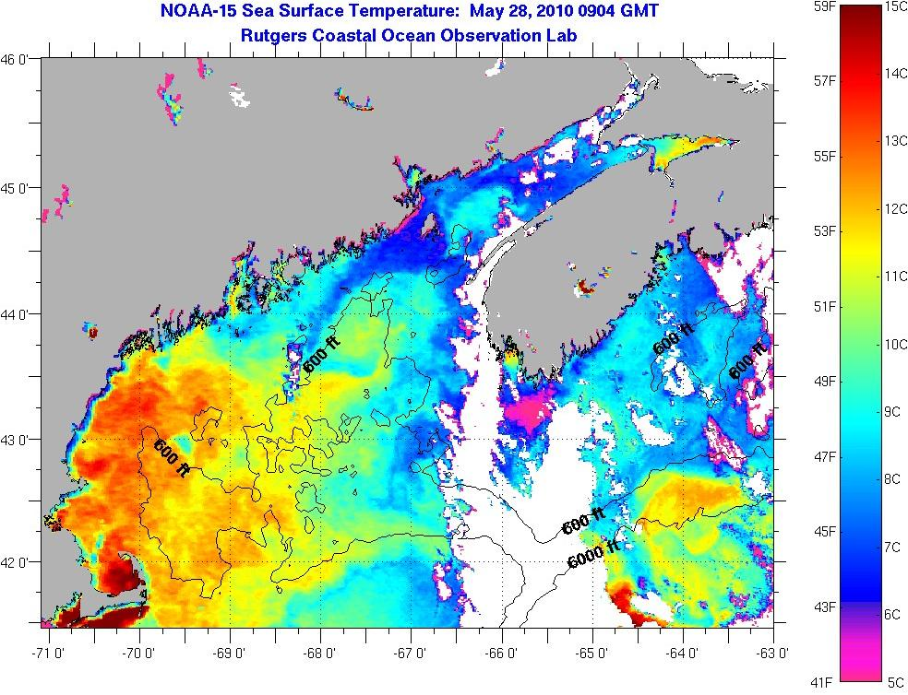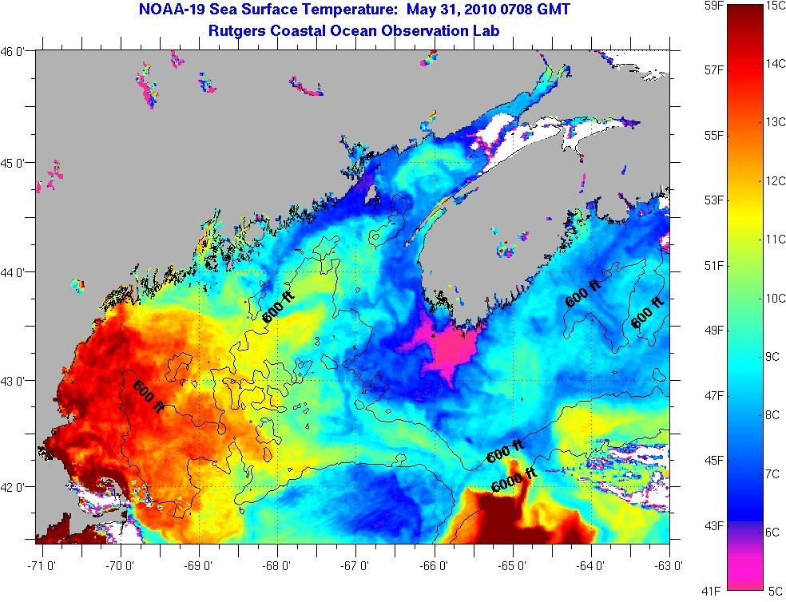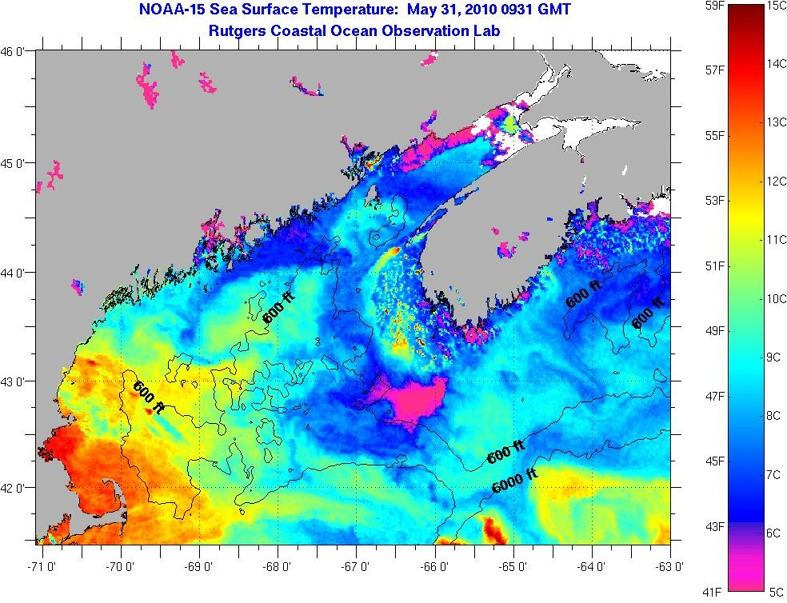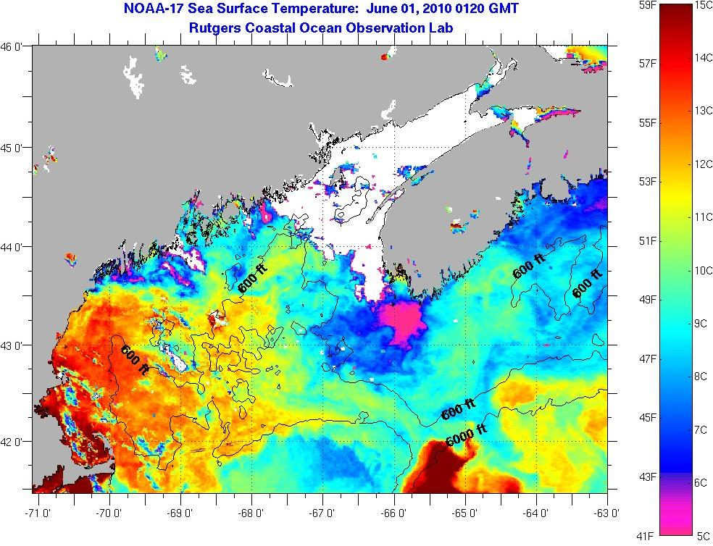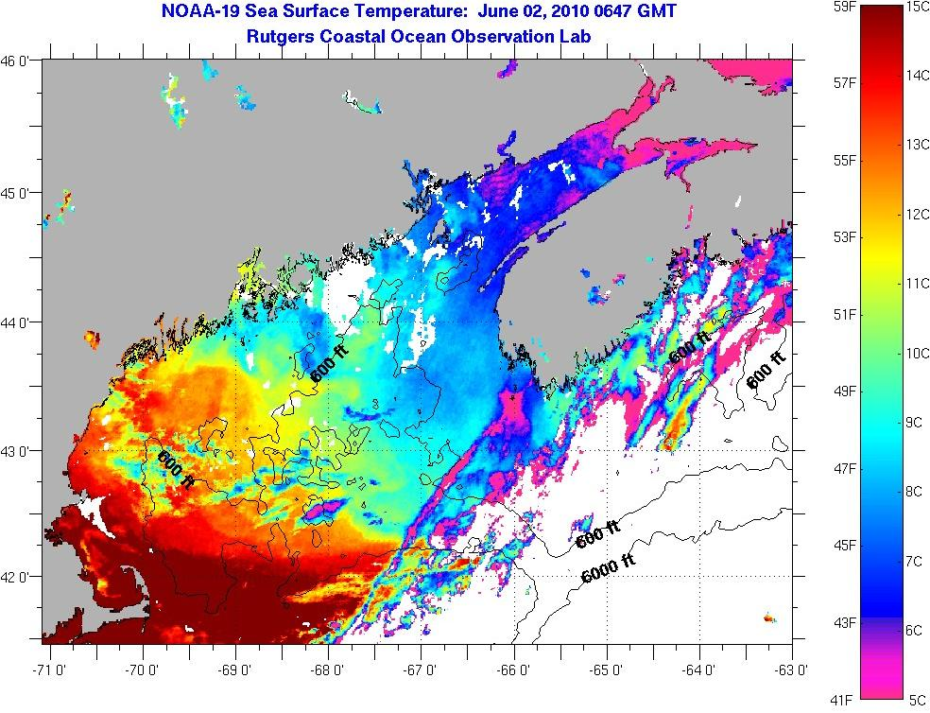

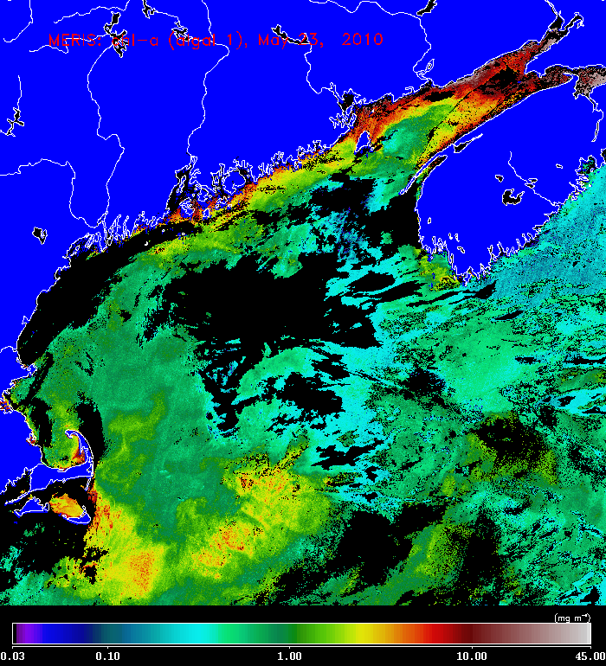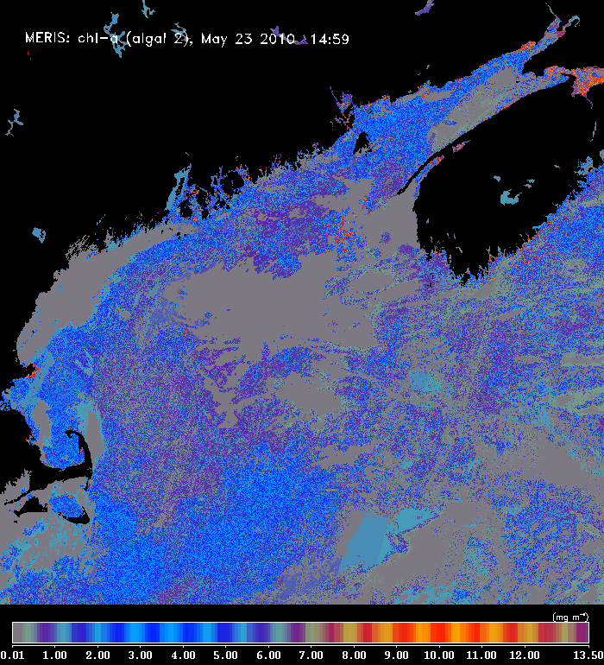
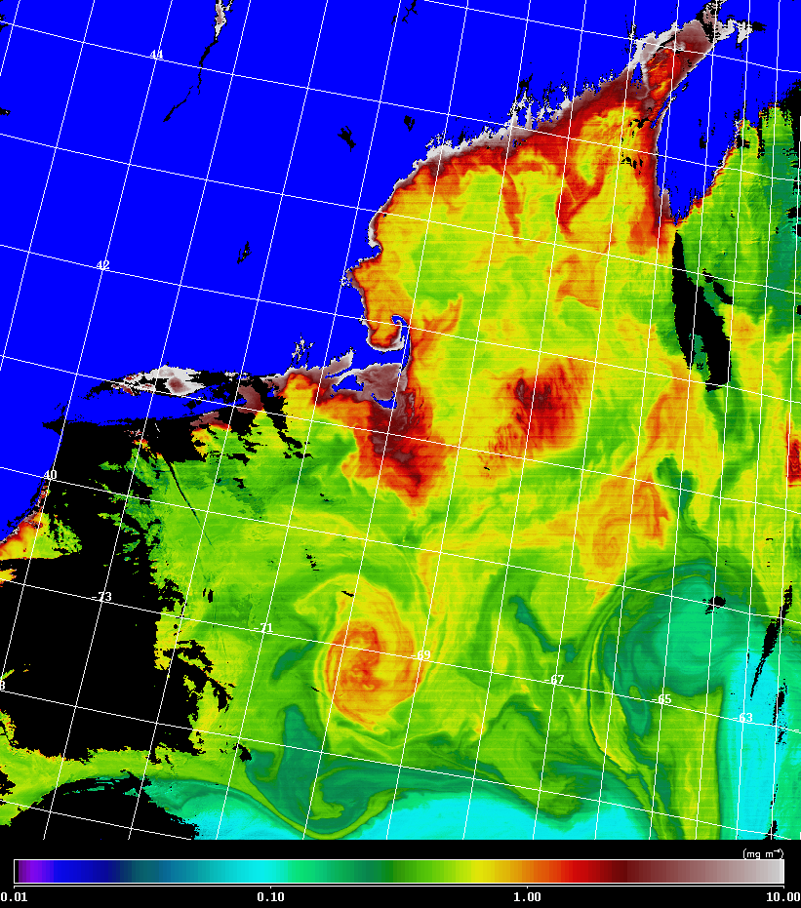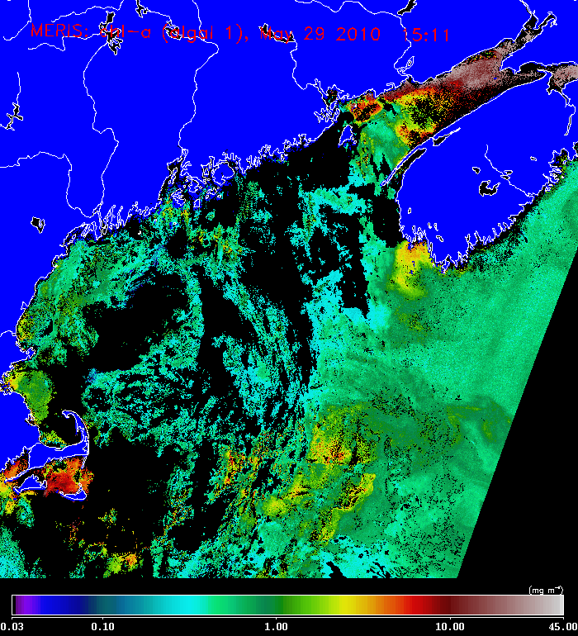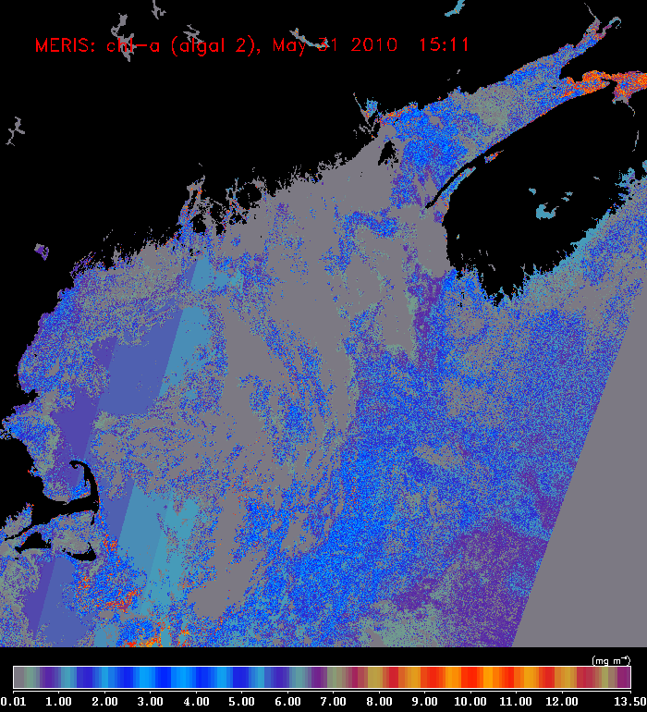

Appendix E: CTD Salinity Calibrations

[Figure to be provided]

Appendix F: Personnel

McGillicuddy Dennis WHOI
Keafer Bruce WHOI
Payette Jack
Warren Bryn
Bonk Elizabeth WHOI
Kosnyrev Olga WHOI
Smith Keston WHOI
Townsend Dave UMe
Thomas Maura UMe
Rebuck Nathan* UMe
Anderson Larry WHOI
Petitpas Chrissy* UMassD
Milligan Peter* UMassD
Knapp Stacy* UMe
Williams Mellissa* UMe
Whelan Kevin* UMe
Brisson Nicole* UMe

*Student/postdoc

Watch number 1 2 3
4 on / 8 off 8-12 12-4 4-8

1. CTD Operator Stacy Larry Keston
2. Cell Counter Bruce* @ Bryn* Chrissy*
3. Nutrient sampler Dave# Nathan@ Maura#
4. Water sampler Olga# Jack# Nicole
5. Water sampler Mellissa Kevin# Peter@
Liz#
* Wetlab chief
# CTD slip line handlers
@ Deck boss

http://www.whoi.edu/science/cohh/whcohh/projects/habs1_abstract.htm
http://omglnx3.meas.ncsu.edu/GOMTOX/2010forecast/
Also see http://nefsc.noaa.gov/drifter

