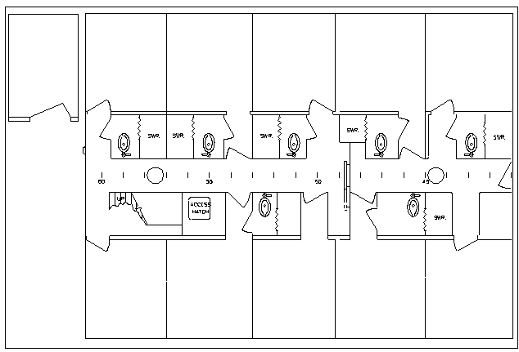

STATEROOM
01 DECK

TOP __________

BOT Tom Orvosh __

Bunks in the 01 deck stateroom are filled before the mate’s rooms

Bunk in room 5 is filled before bunk in room 6

STATEROOM
#14

TOP_Kristina Camarena

BOT_Susanne Warburton __

STATEROOM
#6

TOP ______________

BOT_Richard Chase_

STATEROOM
#5

TOP_____________

BOT Shanna Post-Maher

STATEROOM
#7

TOP_Kelsey Druken_

BOT_Anna Pfeiffer-Herbert

STATEROOM
#12

TOP_Megan O'Brien_

BOT Christelle Balt_

STATEROOM
#10

TOP_Daniel Vendettuoli_

BOT_Thor Jensen _ _

STATEROOM
#8

BOT_Tim Varney

STATEROOM
#13

TOP_Glenna Druken_

BOT__Annie Cox__

STATEROOM
#11

TOP_Chris Kincaid

BOT David Ullman_
Chief Mate
2nd Mate
Chief Scientist
Chief Engineer

URI Marine Technician

Shower
Shower
Shower
Shower

Transducer
Well
Shower
Forward

STATEROOM
#9

TOP _____________

BOT_Dave Nelson
Shower

Shower

