EN435 Cruise Report
Draft 6/1/07

Voyage #435 of R/V Endeavor was the first of two cruises organized to serve complementary scientific objectives of two different projects. The two projects are:

Alexandrium population biology in the Gulf of Maine – Woods Hole Center for Oceans and Human Health – NSF/NIEHS

Objectives:
Sample genetic variability of Alexandrium subpopulations throughout the Gulf of Maine.

Measure changes in relative abundance of Alexandrium genotypes in space and time.

GOMTOX: Dynamics of Alexandrium fundyense distributions in the Gulf of Maine: an observational and modeling study of nearshore and offshore shellfish toxicity, vertical toxin flux, and bloom dynamics in a complex shelf sea – NOAA ECOHAB

Objectives:
Investigate A. fundyense bloom dynamics and the pathways that link this organism to toxicity in nearshore and offshore shellfish.

Investigate the vertical structure of A. fundyense blooms, vertical toxin flux, and linkage to toxicity in offshore shellfish.

Objectives common to both projects include:
Assess hydrodynamic and hydrographic context for interpretation of Alexandrium spp. measurements.

Incorporate field observations into a suite of numerical models for hindcasting and forecasting applications.

The domain of interest spans the continental shelf south of Cape Cod to the Bay of Fundy including Georges Bank.

Results

The first leg of our regional scale survey covered the coastal waters from Cape Cod Bay to the Bay of Fundy (Figure 1). Cell concentrations were surprisingly low in light of the severe blooms that took place in 2005 (Anderson et al., 2005) and 2006. For example, we can compare the southwestern block of our survey plan, from Cape Cod to Cape Ann, with a nearly identical survey conducted on R/V Tioga during exactly the same time period in 2006 (Figure 2). Surface live counts in 2007 were all zeros except for one station in which a single cell was observed (corresponding to a concentration of 14 cells per liter). This constitutes a dramatic change from this same time period in 2006, when most of the area was covered by several hundred to several thousands of cells per liter. In interpreting this comparison, keep in mind that the 2007 observations were collected during and in the aftermath of significant wind forcing, resulting in surface mixed layers of up to 40m in some places. Therefore the possibility of
subsurface populations cannot be discounted.
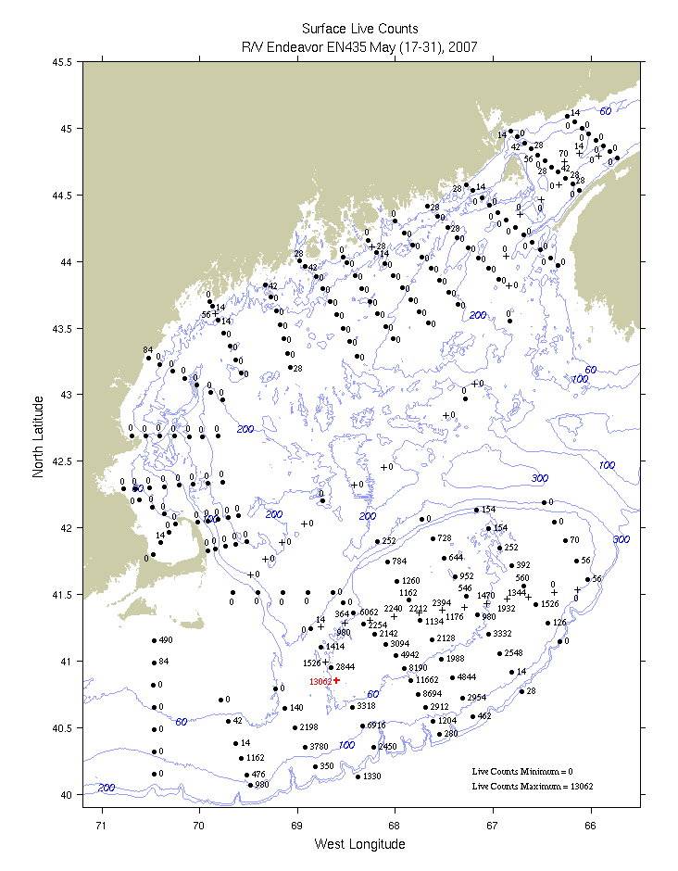
Figure 1. Alexandrium concentration (cells l⁻¹) derived from live counts
from surface samples on EN435.

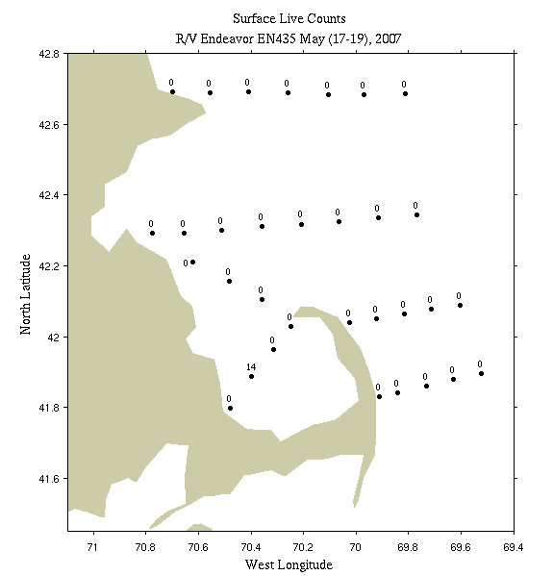 | 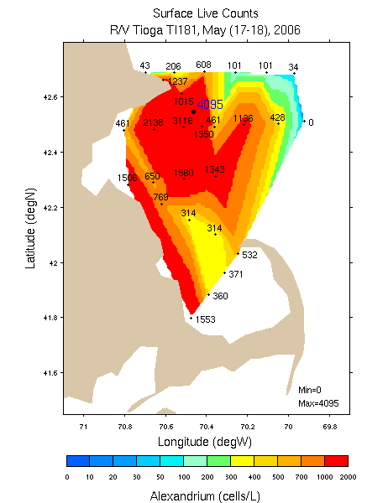
Figure 2: Alexandrium concentration (cells l⁻¹) derived from live counts from EN435 May 17-18 2007 (left) versus TI181 May 17-18 2006 (right).

Underway sampling from the Bay of Fundy southwest to the waters east of Cape Cod indicated the absence of Alexandrium in the central Gulf and northern Great South Channel (Figure 1). Upon reaching Cultivator Shoal on Georges Bank, cell concentrations rose sharply to thousands of cells per liter. Cross-bank sections had to be extended all the way to the shelf break to delimit the population. This finding indicated the cell distribution was likely to be bank-wide in extent, and our sampling plan was broadened accordingly. Highest abundances occurred along the Southern Flank, with peak concentrations just over 13,000 cells per liter (Figure 3). The population extended southwest of Georges Bank along the outer continental shelf, consistent with the southwestward exit pathway from the bank at the southern end of the Great South Channel.
Alexandrium was absent from the live counts in the offshore portion of the Martha’s Vineyard transect. Alexandrium was detected in the innermost 2 stations at concentrations of 84 and 490 cells per liter.
Interestingly, the Georges Bank population is not captured by the near-real-time nowcast/forecast model (Figure 4). Although low concentrations of cells are delivered to the bank from the western Gulf of Maine, they fail to bloom on Georges Bank. We suspect this has something to do with the way nutrients in the model are specified from climatology, and we are actively investigating this issue.

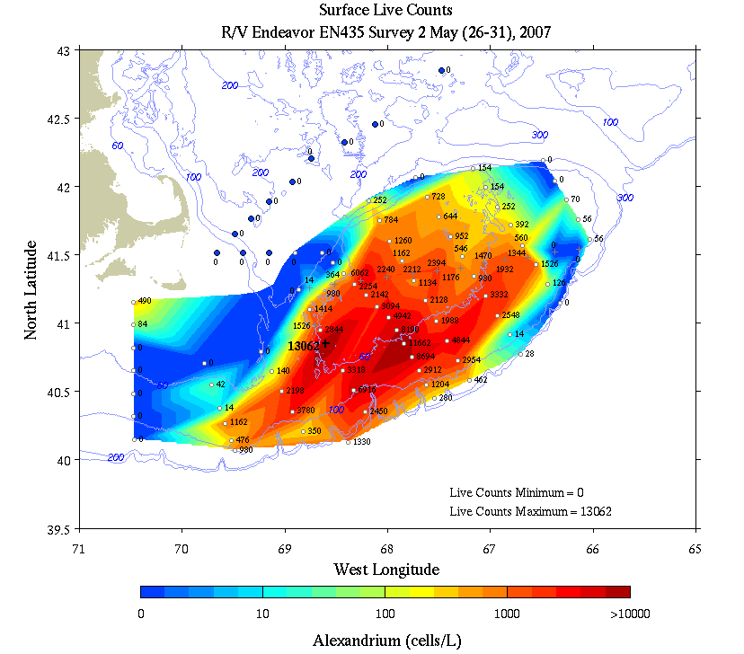
Figure 3. Alexandrium concentration (cells l⁻¹) derived from live counts from the southern portion of the EN435 survey.

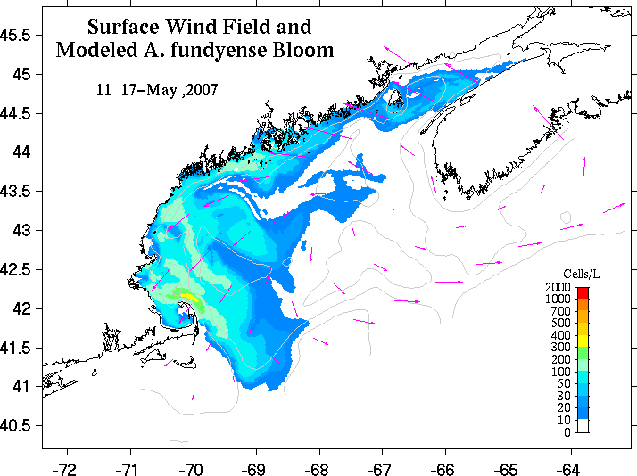 | 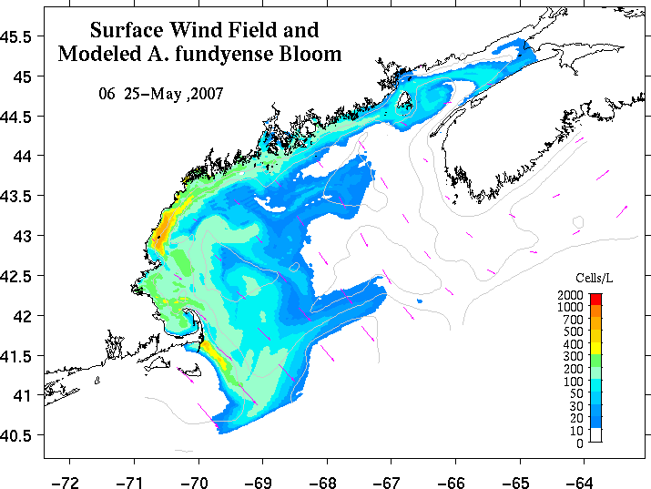
Figure 4. Snapshots from a near-real-time nowcast/forecast model (see footnote 2) at the beginning and end times of the coastal waters survey shown in Figure 1. Concentration of A. fundyense is shaded in color; pink vectors indicate wind speed and direction.
What are the mechanisms underlying this dramatic interannual variability in the Gulf of Maine?
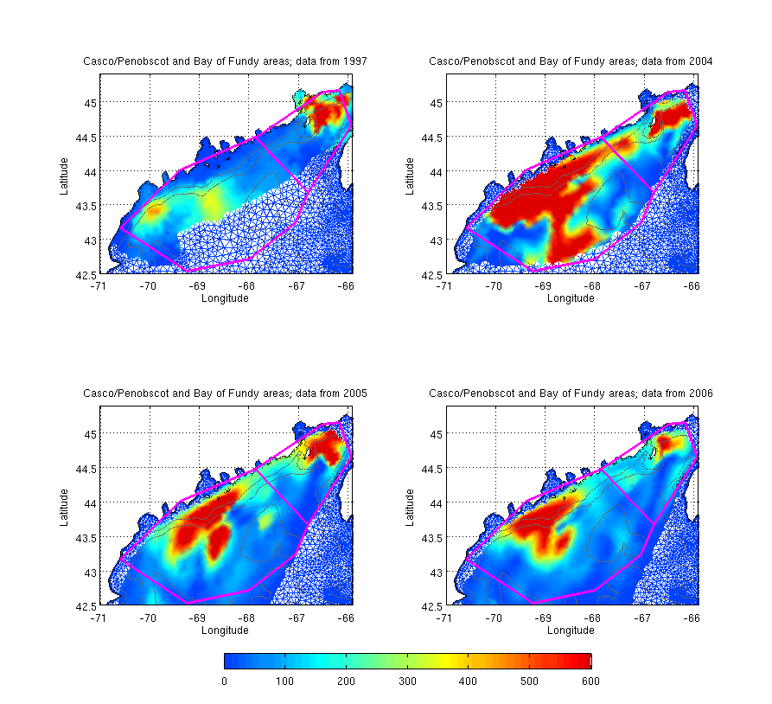
Figure 5. Cyst maps from 1997/1980/1981/1982 (upper
left), 2004 (upper right), 2005 (lower left), and 2006
(lower right). Bounding boxes for the averages in table
1 are indicated; elements without color shading are not
included in the averages.
At the moment the hypotheses on the table are: (1) lower source population: both the Bay of Fundy and Western Gulf of Maine cyst beds are down from last year, 30% and 20% respectively (Figure 5 and Table 1); (2) unfavorable growth conditions: it may be that the windy spring we have had thus far has led to deeper mixed layers leading to increased light limitation. The possibility of temperature limitation has been discussed, but observations from GoMOOS moorings A, B, E, and I suggest surface temperatures are about the same as they were this time last year (need figure for this). Perhaps the nutrient data being collected on this cruise (to be processed after the cruises are over) will provide some clues. Interestingly, the near-real time A. fundyense nowcast/forecast model (Figure 4) has predicted low cell concentrations as compared to last year, although not quite as low as we are observing.

Year | WGOM | % change WGOM | BOF | % change BOF
1997 | 71 | 100 | 202 | 100
2004 | 624 | 880 | 438 | 216
2005 | 273 | 385 | 258 | 128
2006 | 220 | 310 | 175 | 87
Table 1. Average cyst abundances (# of cysts cm⁻² in upper 1 cm) and % change relative to 1997 for the Western Gulf of Maine (WGOM) and Bay of Fundy (BOF) subdomains indicated in Figure 5.

Hydrodynamics

Shipboard ADCP velocity measurements and GoMOOS mooring observations were assimilated into a numerical model (Figure 6) to provide the hydrodynamic context in which to interpret the biological observations. The fidelity of the circulation fields was quantified by evaluating the ability of the model to simulate the trajectories of drifters deployed during the survey (Figure 7; Appendix A, Table 2). Detailed error statistics of model –data comparisons are presented in Table 2.
Drifter comparisons at the Cape Ann line reveal mixed results (Figure 8, top row). The inshore most drifter transits south in a series of loops, whereas the modeled trajectory proceeds southwest toward Boston. The middle drifter appears to have been entrained in a small-scale eddy feature, looping around near the release point and making only modest progress toward the southeast. In contrast, the simulated drifter moves rapidly south-southeast, resulting in a separation distance of 58 km by the end of the 7 day period. Both simulated and observed drifters from the offshore release point track south-southeast, accumulating a distance of approximately 33 km between them over the course of 7 days. The average separation rate for the ensemble is 6.1 km/day.
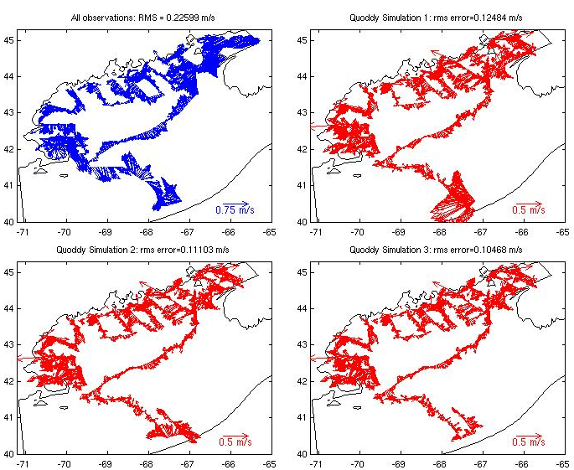
Figure 6. Upper left: velocity observations assimilated into run FC_15.
Differences between simulated and observed velocities are shown for the
prior and first two iterations of the forecast system at the upper right, lower
left, and lower right, respectively.
Simulated drifters at the Penobscot line all proceed southwestward along the coast, slightly more rapidly from the offshore release points than the inshore release points (Figure 7, middle row). The three offshore most drifters appear to have been entrained into a small scale eddy looping counterclockwise near the release points (Figure 8), accumulating a larger separation distance than the inshore group.
Only three days of comparison are available thus far for the Bay of Fundy drifters, but some initial trends are evident (Figure 7, bottom row). The three southwesternmost drifters tend to head up the bay and toward shore, yet the simulation does not predict the shoreward component of these trajectories. The next two drifters to the northwest have begun to circle each other in a tight radius, a trend that is portrayed to a more limited extent in the simulation. The next pair to the northwest proceeds to the south-southeast, whereas the simulated drifters take a more southward path. The inshore two drifters move slowly to the northeast and southwest, neither of which are accurately represented in the model. Nevertheless, the aggregate separation rate between simulated and observed drifters in the Bay of Fundy is 4.1 km day⁻¹, which is better skill than we have been able to achieve with the 2005 and 2006 data sets thus far.

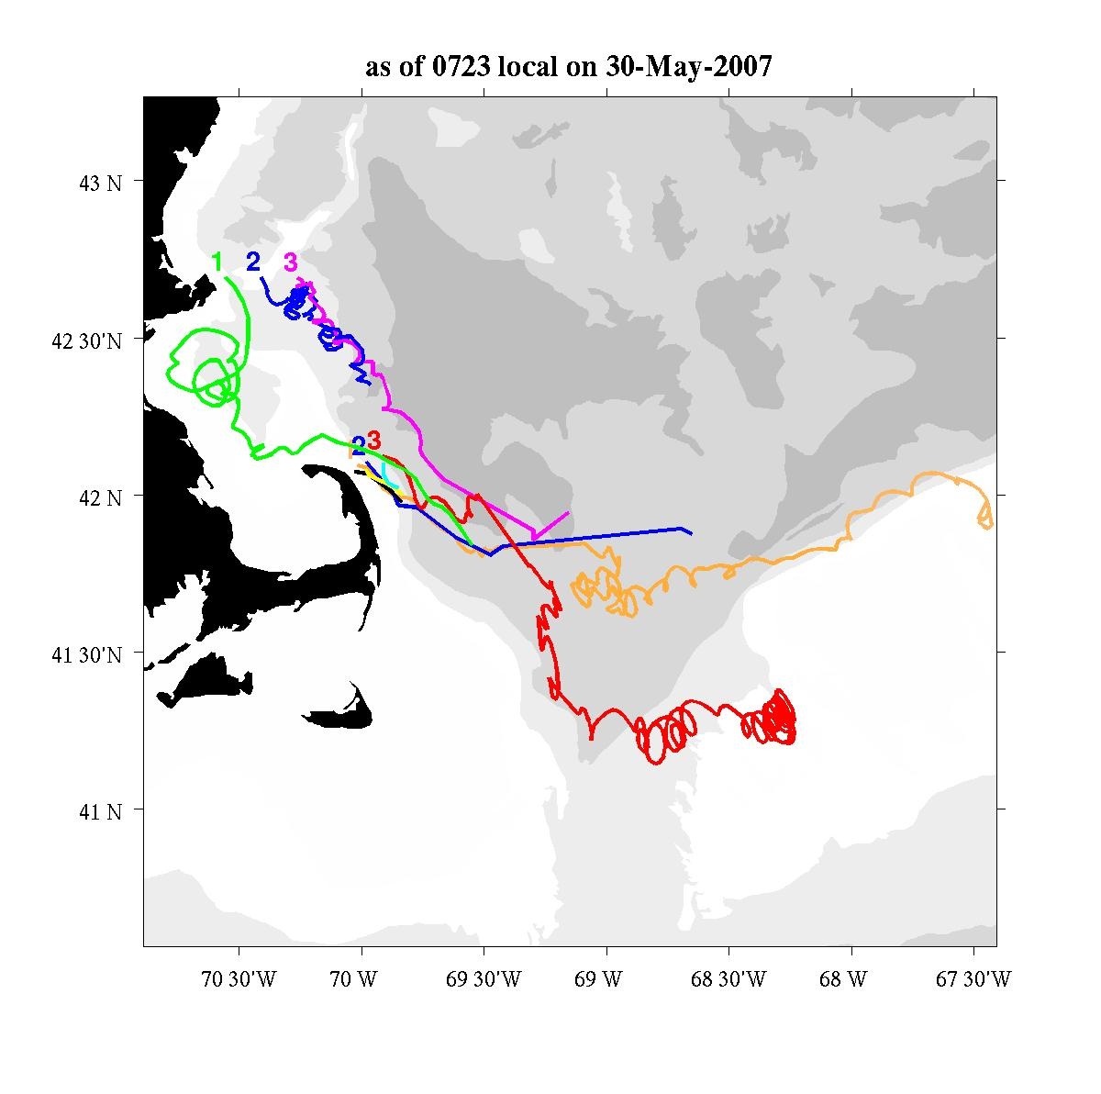 | 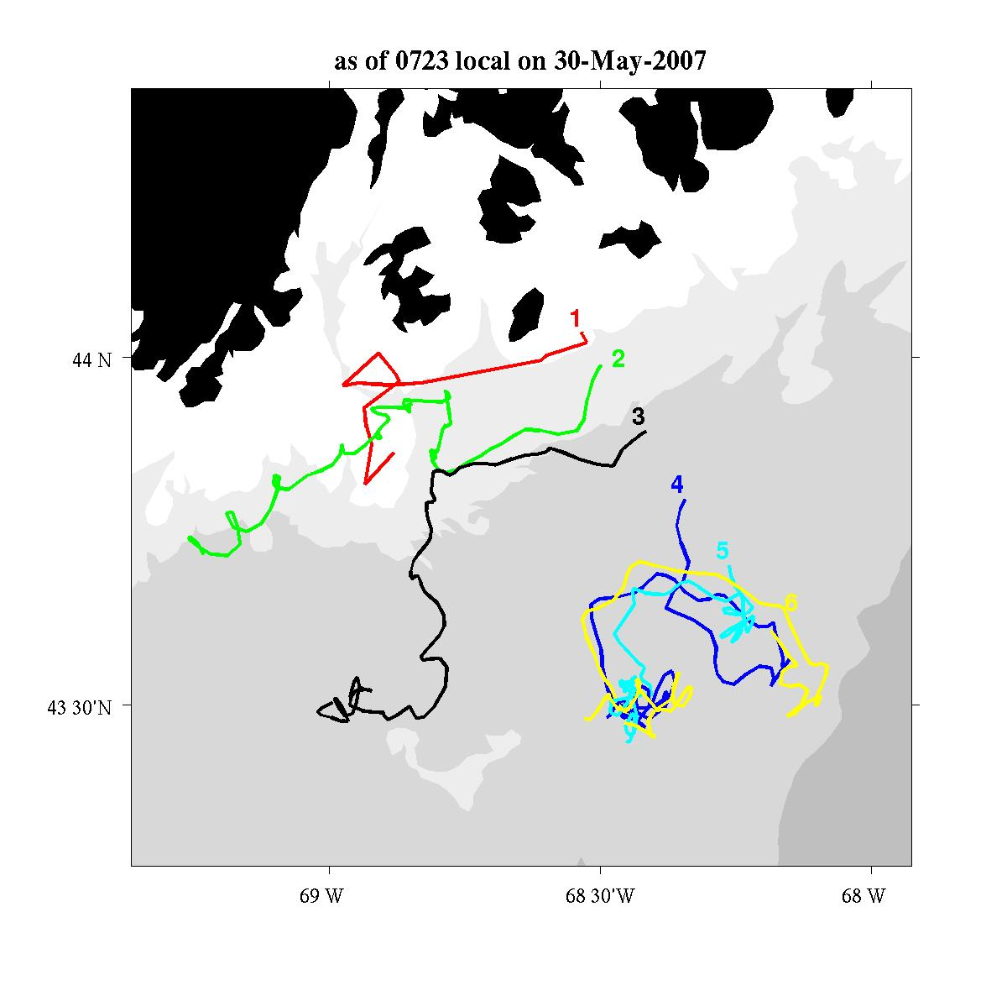
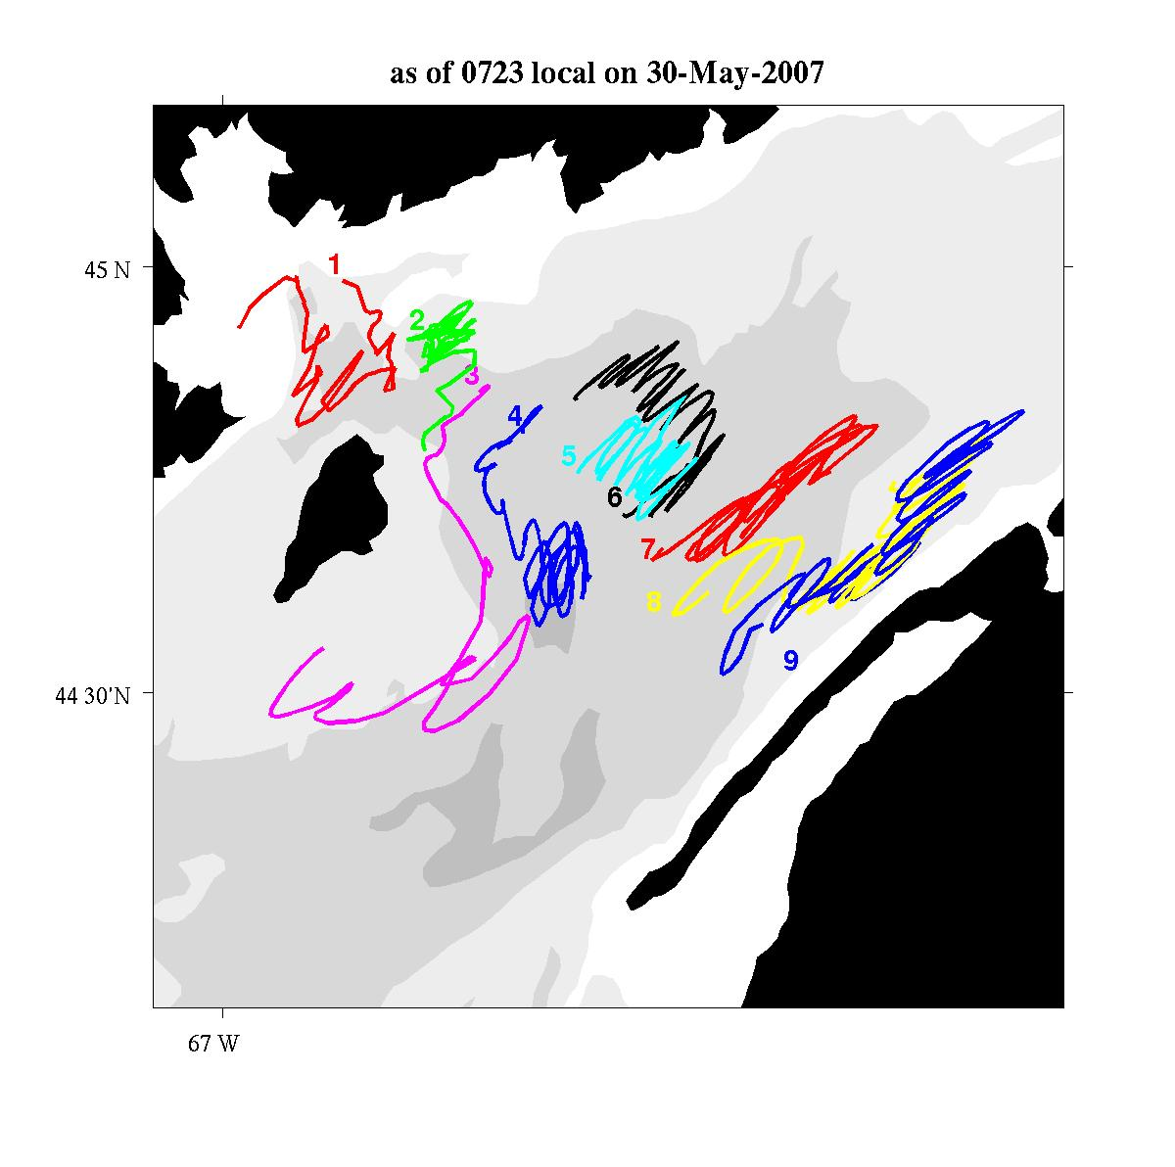 | 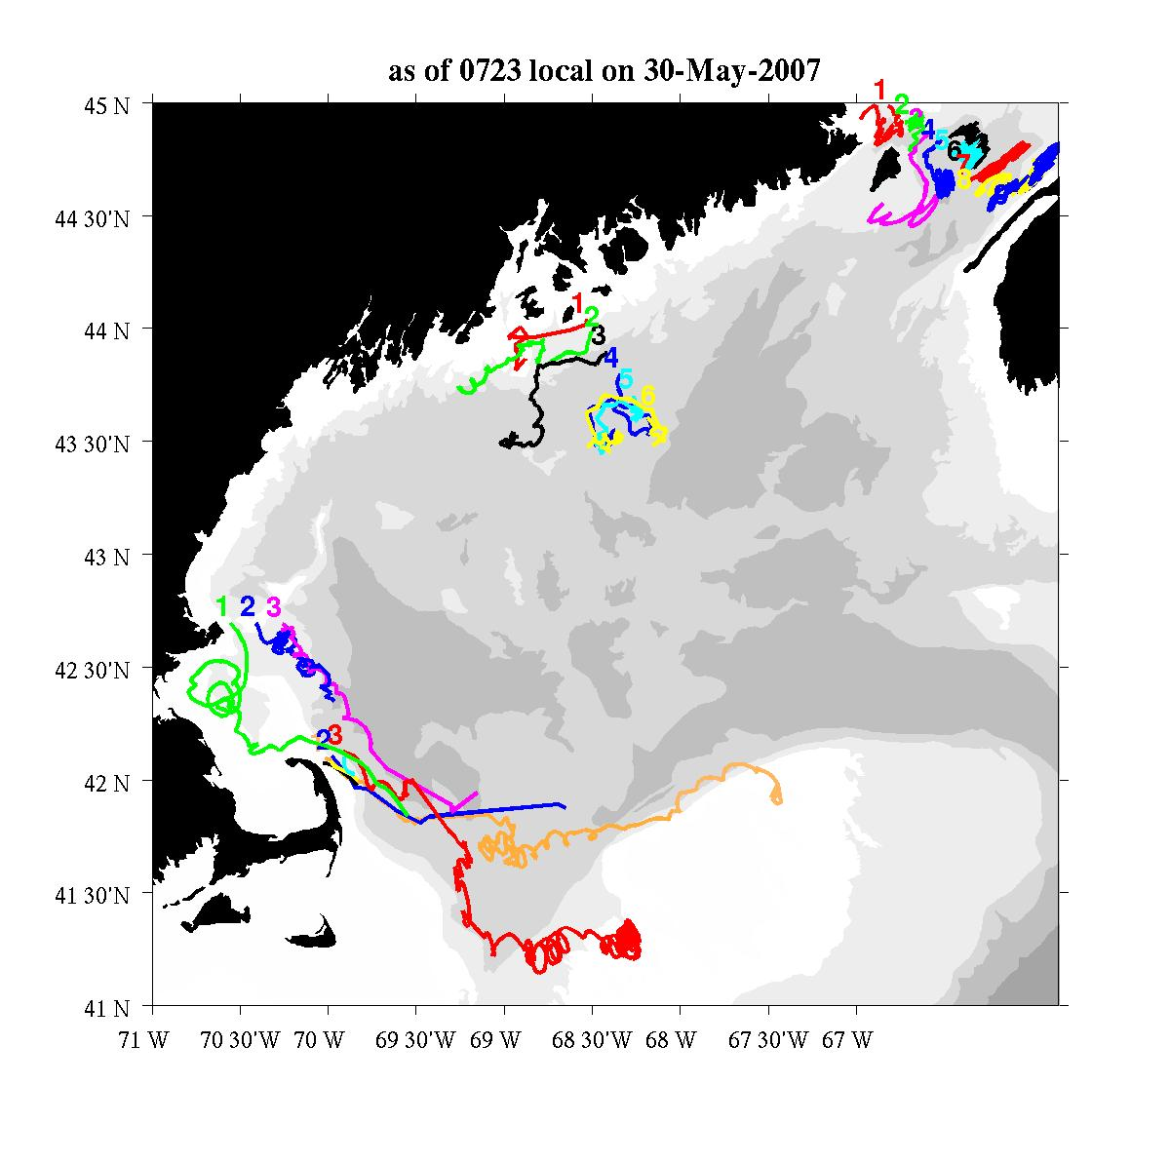
Figure 7. Trajectories for the Cape Ann and R/V Albatross surface drifters (upper left), Isle Au Haut surface drifters (upper right), Bay of Fundy drogued drifters (lower left), and all drifters together (lower right). See Table 2 in Appendix A for a summary of drifter releases. Figures courtesy of James Manning.

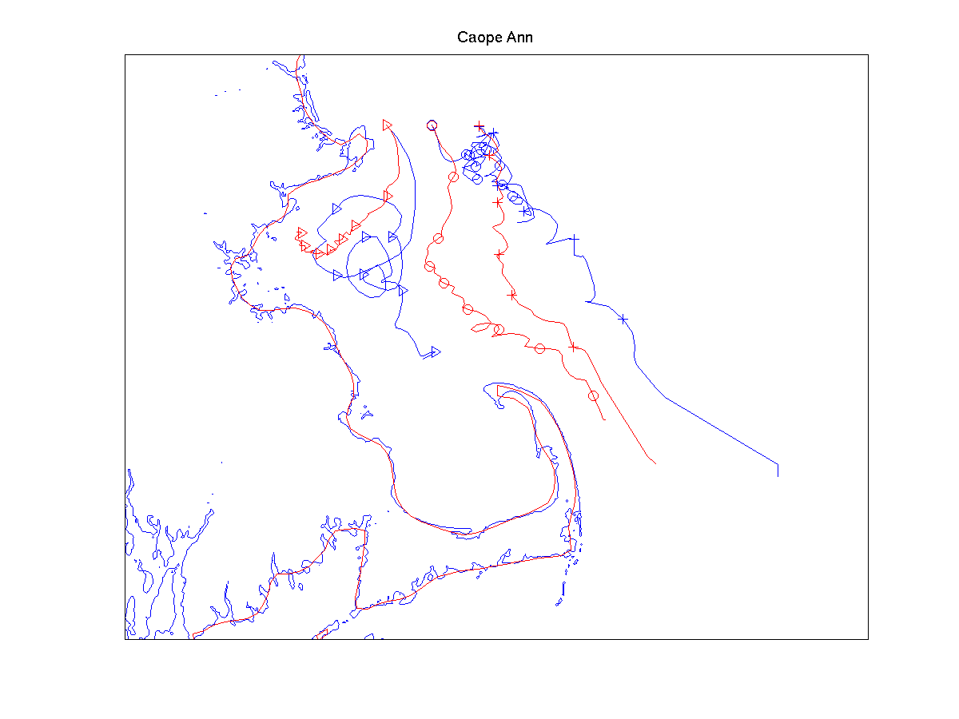 | 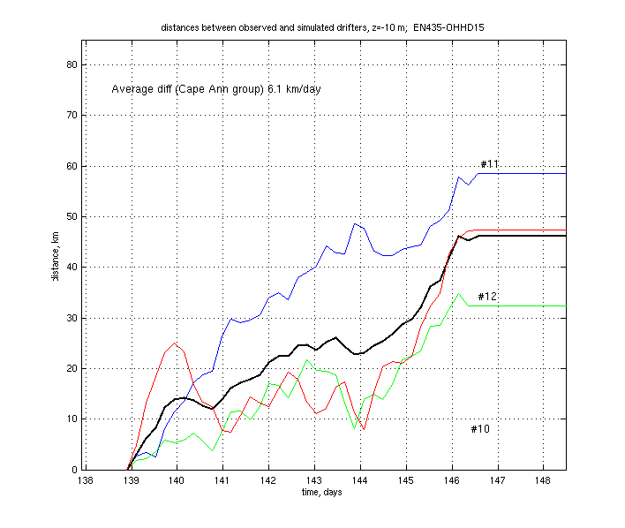
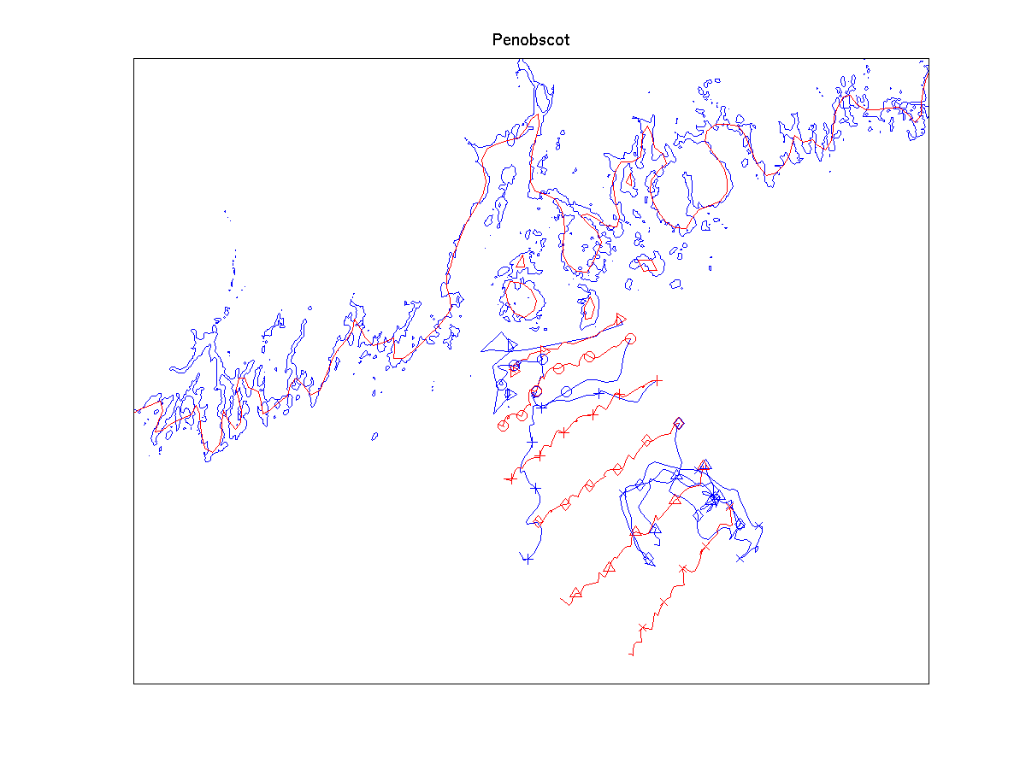 | 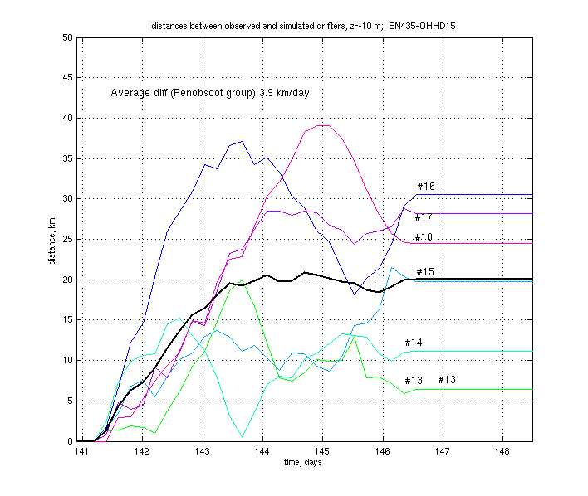
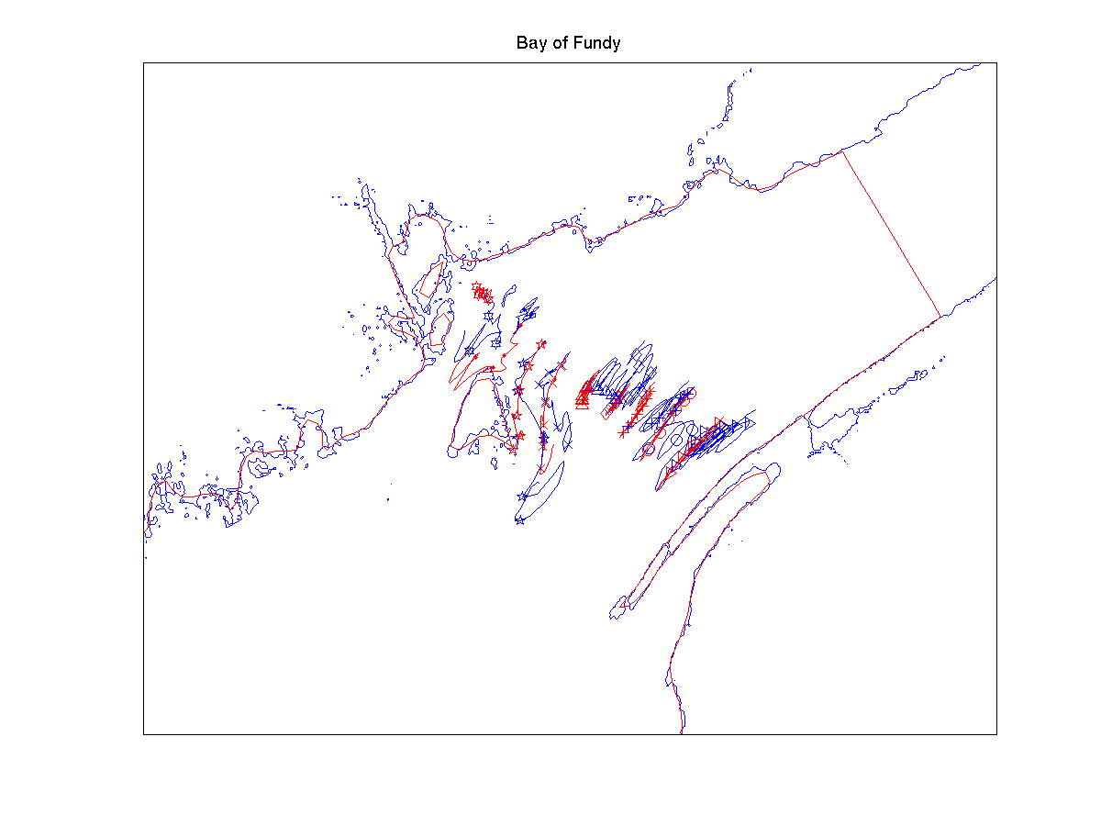 | 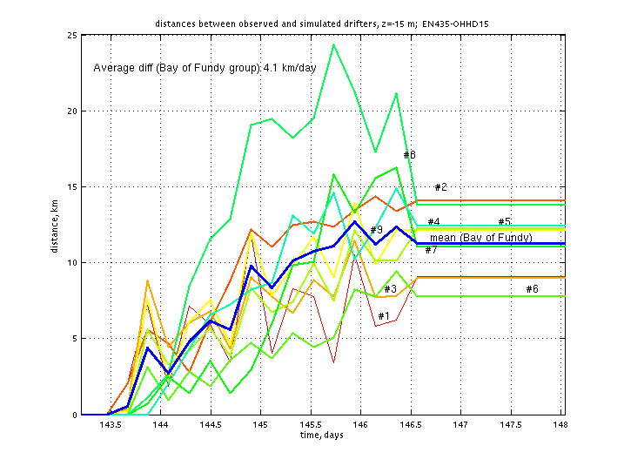
Figure 8. Simulated and observed drifter trajectories (left) and separation as a function of time (right) for run FC15 for Cape Ann line (top row), Isle Au Haut line (middle row) and the Bay of Fundy (bottom row).

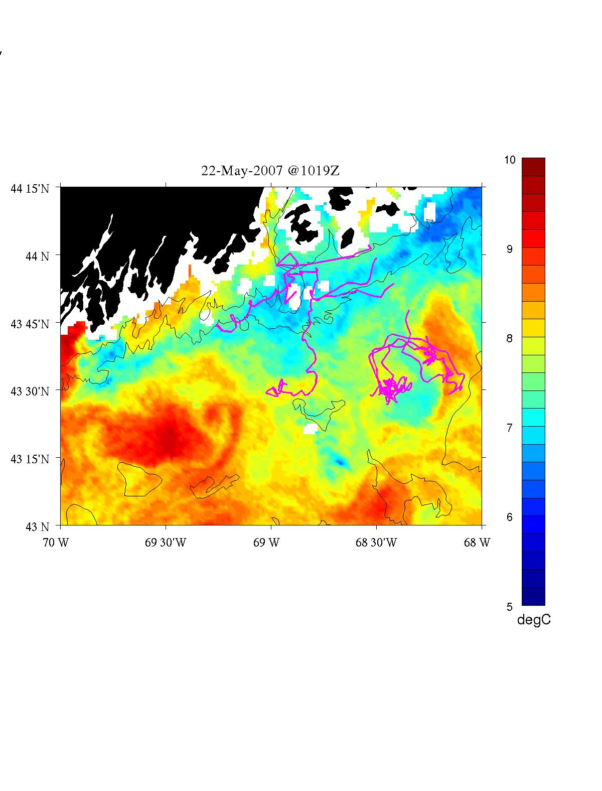 | 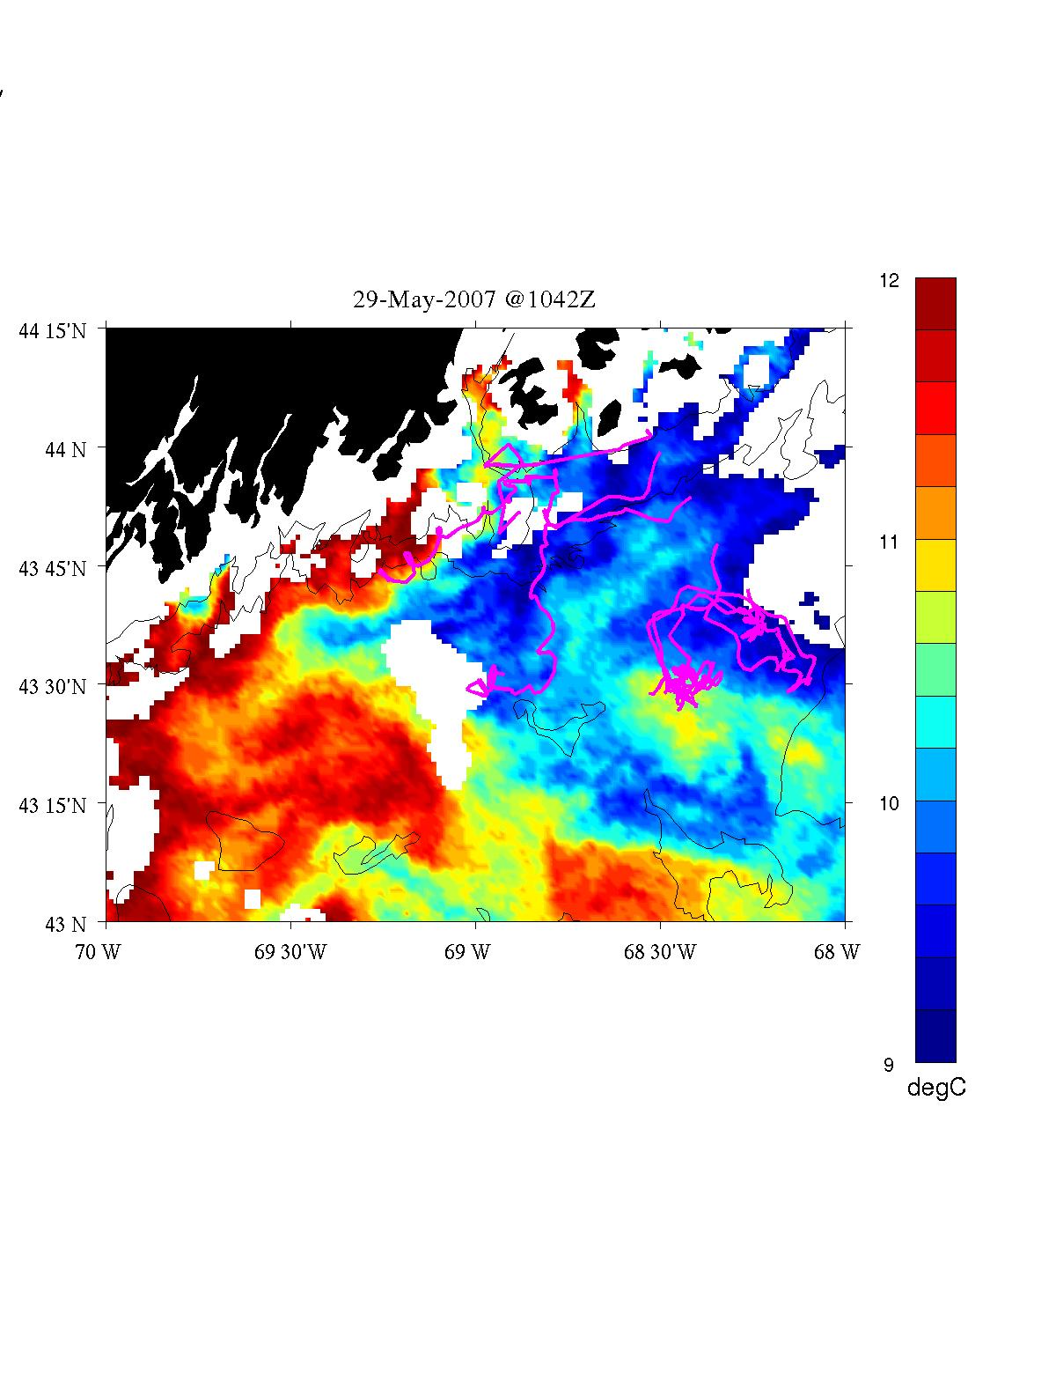
Figure 8. Isle au Haut drifter trajectories overlayed on SST images for May 22 (left) and May 29 (right). Note the small-scale eddy feature that appears to be affecting the offshore-most three drifters. Figure courtesy of James Manning.

ID  Date | Period | Obs | ICs | Error statistics  Obs RMS Prior/Post1/Post2; Vector bias  Mooring RMS Post2;  Vector bias | Winds | Comments
FC_15 | 5/16 – 6/1 | ADCP 5/17-5/28; Moorings 5/21-5/28 | Clim + OACI assim | 22.6  17.5/15.2/14.1 (-1.4,-0.5)  A: 9.0  B: 7.9 (0.2,-5.9)  E: 5.4 (-1.1,-1.6)  I: 7.7 (1.5,-1.1)  Drifters:  CA 6.1 (7 days)  IAH 3.9 (5 days)  BoF 4.1 (3 days) | GoMOOS B + NCEP
Table 2. Model-data comparison statistics for at-sea simulation #15.

Cruise narrative

Thurs 17 May – departure, completion of Cape Cod Bay transect, beginning of CCS transects

Friday 18 May – finished CCS transects, Ptown to Boston
Too rough to pump; no cells anyway

Saturday 19 May – Boston line, Cape Ann Line; 3 drifters deployed. Not enough cells to warrant a pump station.

Science meeting:

We have completed the southwestern block of our survey plan, from Cape Cod to Cape Ann. Surface live counts have all been zeros except for one station in which a single cell was observed (corresponding to a concentration of 14 cells per liter). This constitutes a dramatic change from this same time period in 2006, when most of the area was covered by several hundred to several thousands of cells per liter. In interpreting this comparison, please keep in mind that the recent observations were collected during and in the aftermath of significant wind forcing, resulting in surface mixed layers of up to 40m in some places. Therefore the possibility of subsurface populations cannot be discounted.

Sunday 20 May – picked up 84 cells per liter at inshore station of transect, back to zero on the second station. Decided not to backtrack for a pump station, in favor of prepping the pump this afternoon and targeting a station near shore of the next transect. Pump station occupied just offshore of Casco Bay.

Monday 21 May – Monhegan transect; Matinicus transect

Tuesday 22 May – Isle au Haut transect plus drifters; SW Harbor transect; pump station just inside of Mt Desert rock.

Wednesday 23 May – transect work continues

Science meeting:

We have continued surveying eastward, and are nearing the mouth of the Bay of Fundy. Much to our surprise, surface live counts continue to come up mostly empty, with only a few nearshore stations showing any cells at all. What a difference a year makes!

Interestingly, Ruoying’s forecast model is predicting low cell concentrations as compared to last year, although not quite as low as we are observing. We are currently investigating the mechanisms underlying this dramatic interannual variability. At the moment the hypotheses on the table are: (1) lower source population: both the Bay of Fundy and Western Gulf of Maine cyst beds are down from last year, 30% and 20% respectively (Figure 3 and Table 1); (2) unfavorable growth conditions: it may be that the windy spring we have had thus far has led to deeper mixed layers leading to increased light limitation. The possibility of temperature limitation has been discussed, but observations from GoMOOS moorings A, B, E, and I suggest surface temperatures are about the same as they were this time last year. Perhaps the nutrient data being collected on this cruise (to be processed after the cruises are over) will provide some clues.

Thursday 24 May – Bay of Fundy transect line; drifter deployments; pump station at the Wolves.

Friday 25 May – Bay of Fundy finished; transit back south with hourly underway samples and four stations along the way.

Saturday 25 May – Begin transect from Great Round Shoal Channel to Cultivator Shoal; pump station; ran into high cell concentrations on the crest. Continued transect to the south in order to delimit the population; had to extend all the way to the shelf break. Georges Bank survey grid reorganized to accommodate this reality—it now has to be a bank-wide survey.

Sunday 26 May – Georges Bank survey continues. Pump station. Summary to NE PSP list:

Endeavor 5/27 Update: Alexandrium on Georges Bank

Hello All,

Memorial Day Weekend has been a very busy one aboard R/V Endeavor. After transiting south from the Bay of Fundy to the eastern shore of Cape Cod taking underway samples the entire way, we had yet to break the 100 cell per liter mark. That all changed when we reached Cultivator Shoal on Georges Bank, where cell concentrations rose sharply to thousands of cells per liter. We have completed two cross-bank sections thus far, and had to extend these all the way to the shelf break to delimit the population. Highest abundances have occurred along the Southern Flank, with peak concentrations just over 11,000 cells per liter. Given these findings, we have revised our sampling plan to cover the entirety of Georges Bank as well as the exit pathway in the southern part of the Great South Channel. We will keep you informed as this unfolds. In the meantime, a map of what we have so far is attached.

Best Wishes,

Dennis McGillicuddy, on behalf of the Science Party
R/V Endeavor

Monday 28 May – Georges Bank survey continues

Tuesday 29 May – Completion of survey out to NE peak; transit back to southwestern part of Georges Bank (underway sampling); survey continues – pump station.

Wednesday 30 May – Survey of southwestern part of Georges Bank and continental shelf to the west.

Thursday 31 May – Completed survey with transect south of Martha’s Vineyard, returned to Woods Hole.
Appendix A: Measurements made on EN435

Underway measurements
a. Acoustic Doppler Current Profiler
b. Meteorological sensors

Core hydrographic measurements
a. CTD (pressure, temperature, salinity, oxygen, fluorescence, beam attenuation, PAR)
b. Alexandrium cell counts: 1, 10, 20, 30, 40, 50m plus 250/near bottom
c. Nutrients: standard depths plus 100, 150, 200, 250m

Bottle # | Depth | Live | Micro  sats | Whole Cell | SHA | qPCR | Nuts/Chl/  Humics | Pseuds | total
1 | 1 |  |  | 2 | 2 | 2 | 1.0 | 0.5 | 7.5
2 | 1 | 10 |  |  |  |  |  |  | 10
3 | 1 |  | 10 |  |  |  |  |  | 10
4 | 10 |  |  | 2 | 2 | 2 | 1.0 | 0.5 | 7.5
5 | 20 |  |  | 2 | 2 | 2 | 1.0 | 0.5 | 7.5
6 | 30 |  |  | 2 | 2 | 2 | 1.0 | 0.5 | 7.5
7 | 40 |  |  | 2 | 2 | 2 | 1.0 | 0.5 | 7.5
8 | 50 |  |  | 2 | 2 | 2 | 1.0 | 0.5 | 7.5
9 | 100 |  |  |  |  |  | 1.0 |  | 1.0
10 | 150 |  |  |  |  |  | 1.0 |  | 1.0
11 | 200 |  |  |  |  |  | 1.0 |  | 1.0
12 | 250 / near bottom |  |  | 8? |  |  | 1.0 |  | 9.0
Table 1. Water budget

Af water- one 6 hole-manifold loaded twice
6L/depth combined/split x 6 depths=6 WC tubes&12 filters/station
Pseuds – 100-500 ml whole water onto 0.65um Duropore? Frozen in Dewar; manifold 2; 6 filters/station
Microsats – a 10L sample will be concentrated and kept live for culturing and microsatellite analysis of Alexandrium populations. Samples for microsatellites will be collected at: Bay of Fundy, Casco Bay, Mass Bay, Stellwagen Bank, Nantucket Shoals, and Georges Bank. Additional opportunistic samples may be taken in areas of high Alexandrium abundance.
Real-time qPCR – possibly on cruise 2.

Toxin size fractionation - Turner
Pump profiles approximately once per day, located in patches identified by surface live counts. Samples at five depths to coincide as closely as possible with hydrographic sampling and sediment trap measurements.

Drifters
a. surface drifters: Cape Ann line (3), Isle Au Haut line (6)
b. drogued drifters: Bay of Fundy (9)
c. totals for two cruises: 18 Rachels, 18 Grahams

Other measurements
a. Mussel bags: Casco, Cobscook, Blue Hill, Frenchman’s – Darcy Couture
b. AVHRR, SeaWiFS, MODIS false-color imagery – Andy Thomas
c. GoMOOS moorings
d. NOAA coastal tide gauges
e. NMFS quarterly survey – March-April CTD data

ID | Mon | Day | Year | GMT  (hhmm) | Lon (ddmm) | Lat  (ddmm) | Drogue  depth(m) | Water  depth(m)
R/V ENDEAVOR
75201 | 5 | 20 | 2007 | 5 | 7033.30 | 4241.50 | 1 | 60
75202 | 5 | 19 | 2007 | 2257 | 7024.60 | 4241.50 | 1 | 46
75203 | 5 | 19 | 2007 | 2136 | 7015.50 | 4241.30 | 1 | 94
75381 | 5 | 22 | 2007 | 430 | 6831.94 | 4402.08 | 1 | 55
75382 | 5 | 22 | 2007 | 526 | 6829.99 | 4359.31 | 1 | 70
75383 | 5 | 22 | 2007 | 630 | 6824.98 | 4353.60 | 1 | 115
75384 | 5 | 22 | 2007 | 735 | 6820.68 | 4347.75 | 1 | 150
75385 | 5 | 22 | 2007 | 855 | 6815.72 | 4342.01 | 1 | 187
75386 | 5 | 22 | 2007 | 959 | 6811.08 | 4336.36 | 1 | 190
75461 | 5 | 24 | 2007 | 2159 | 6649.10 | 4459.00 | 1 | 71
75462 | 5 | 24 | 2007 | 1845 | 6640.95 | 4453.66 | 15 | 105
75463 | 5 | 24 | 2007 | 1800 | 6636.73 | 4451.15 | 15 | 125
75464 | 5 | 24 | 2007 | 1710 | 6632.85 | 4448.30 | 15 | 124
75465 | 5 | 24 | 2007 | 1614 | 6627.93 | 4445.47 | 15 | 166
75466 | 5 | 24 | 2007 | 1514 | 6623.81 | 4442.53 | 15 | 158
75467 | 5 | 24 | 2007 | 1421 | 6620.27 | 4440.14 | 15 | 130
75468 | 5 | 24 | 2007 | 1330 | 6616.14 | 4437.11 | 15 | 157
75469 | 5 | 24 | 2007 | 1235 | 6611.20 | 4434.79 | 15 | 120
R/V ALBATROSS
75291 | 5 | 9 | 2007 | ? | 7000.98 | 4205.65 | 1 | ?
75292 | 5 | 9 | 2007 | ? | 6958.77 | 4206.22 | 1 | ?
75293 | 5 | 9 | 2007 | ? | 6954.84 | 4207.29 | 1 | ?
75294 | 5 | 29 | 2007 | ? | 7000.98 | 4205.65 | 1 | ?
75295 | 5 | 29 | 2007 | ? | 6958.77 | 4206.22 | 1 | ?
75296 | 5 | 29 | 2007 | ? | 6954.84 | 4207.29 | 1 | ?
Table 2: Summary of drifter releases. For more information see http://nefsc.noaa.gov/drifter.
Appendix B: Hydrographic maps

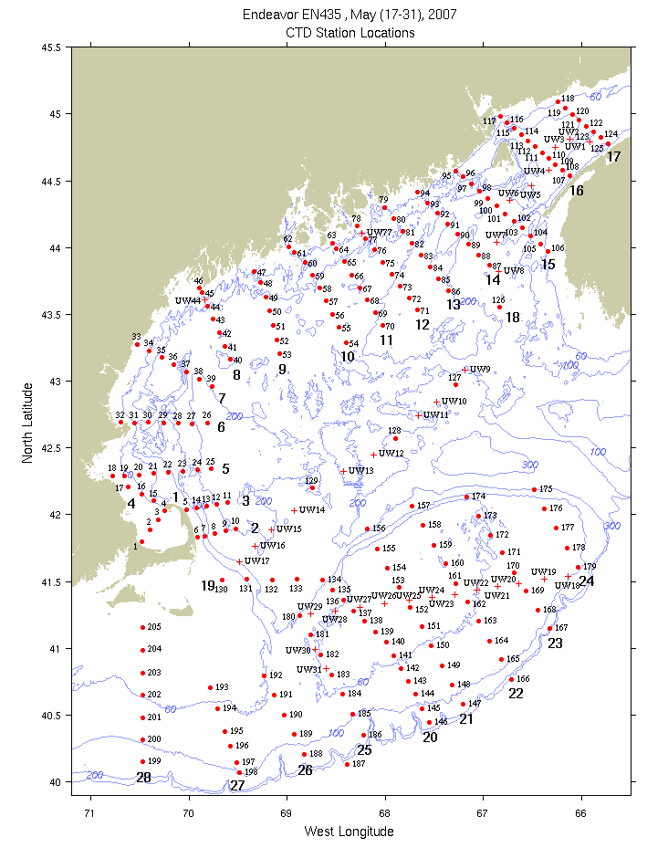
Figure B1: CTD (red dots) and underway (red crosses) station locations. Bold numerals indicate identifiers for the sections displayed below.

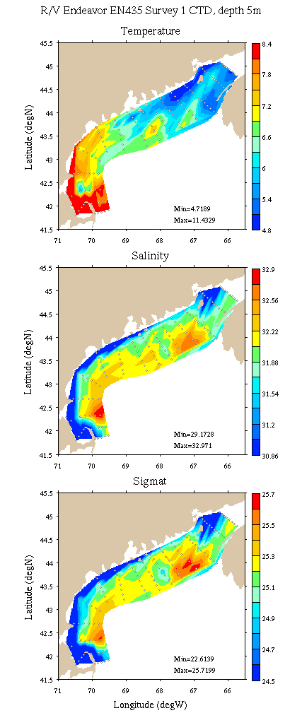 | 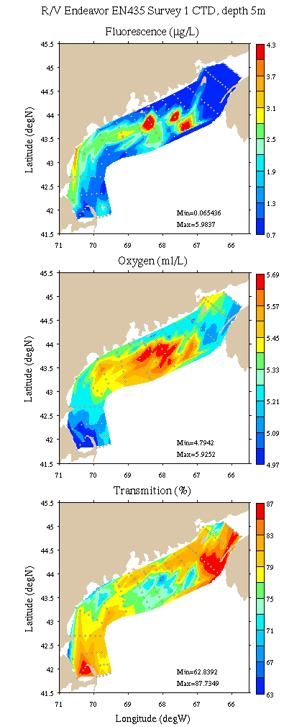
Figure B2: Coastal GOM survey maps at 5m depth. Left: temperature, salinity, and density; right: fluorescence, oxygen, and light transmission.

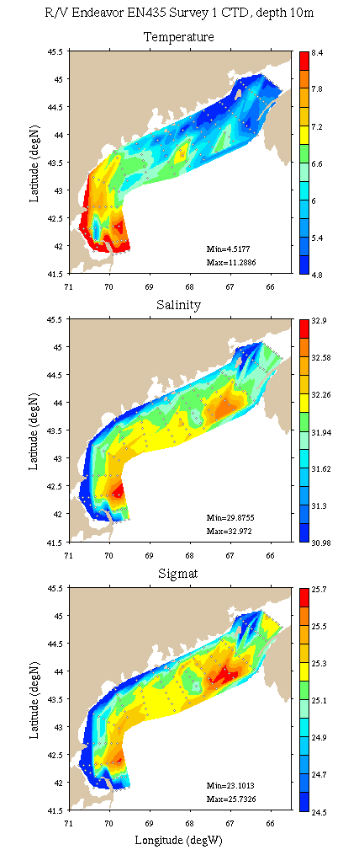 | 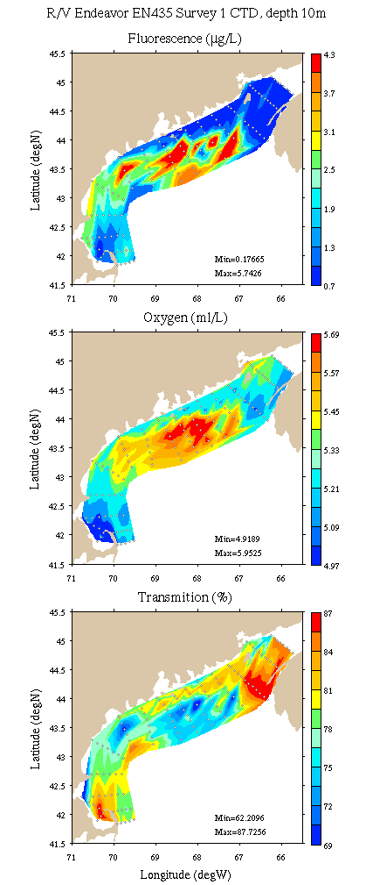
Figure B3: Coastal GOM survey maps at 10m depth. Left: temperature, salinity, and density; right: fluorescence, oxygen, and light transmission.

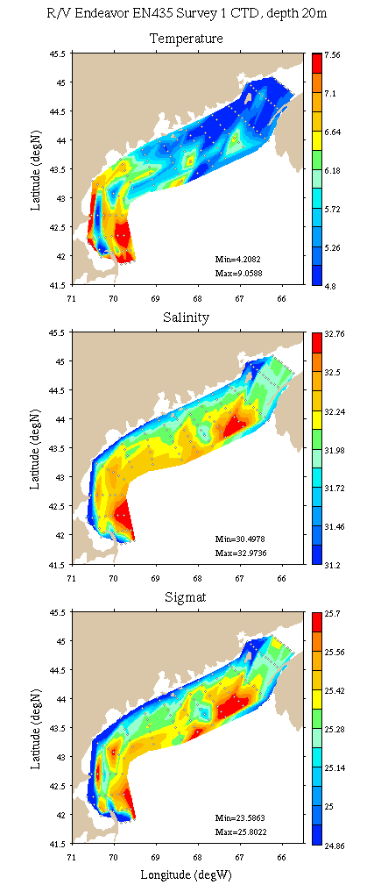 | 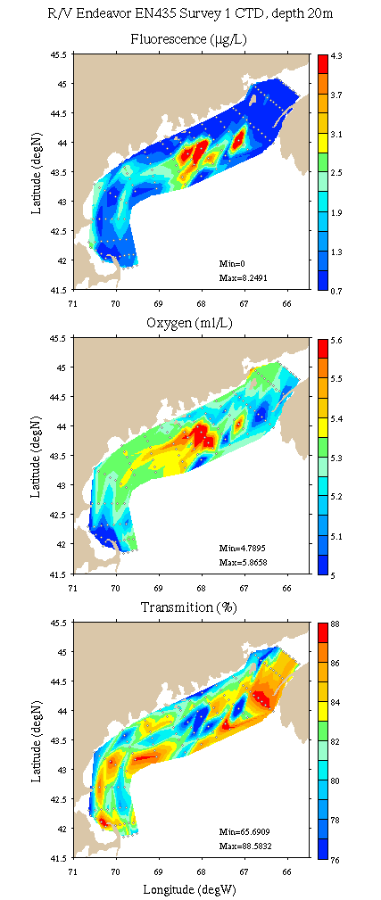
Figure B4: Coastal GOM survey maps at 20m depth. Left: temperature, salinity, and density; right: fluorescence, oxygen, and light transmission.

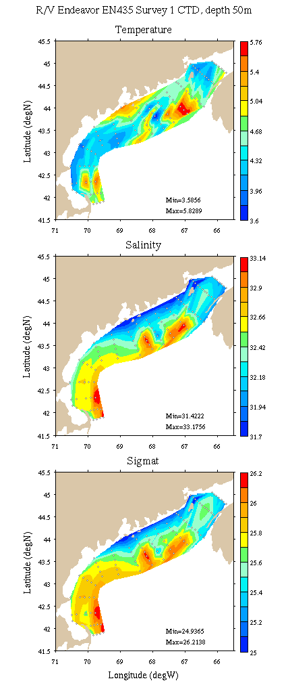 | 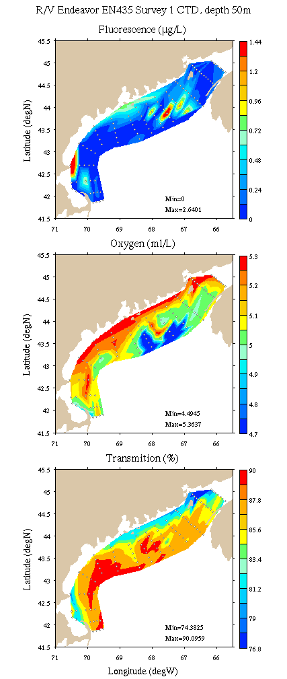
Figure B5: Coastal GOM survey maps at 50m depth. Left: temperature, salinity, and density; right: fluorescence, oxygen, and light transmission.

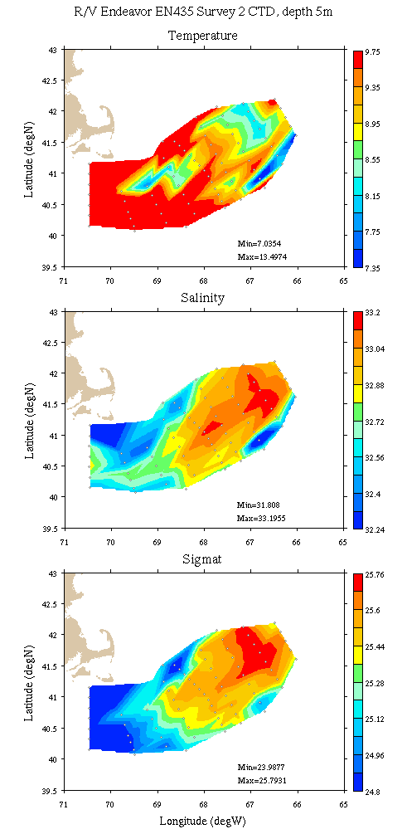 | 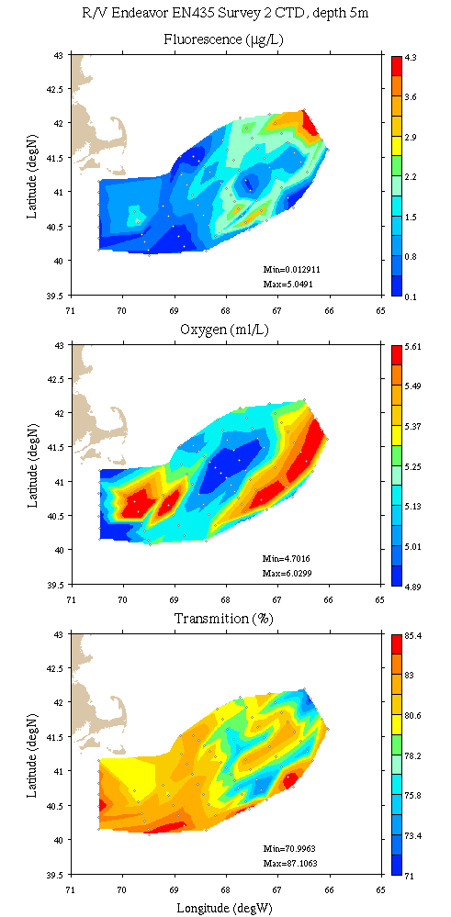
Figure B6: Georges Bank / Southern New England survey maps at 5m depth. Left: temperature, salinity, and density; right: fluorescence, oxygen, and light transmission.

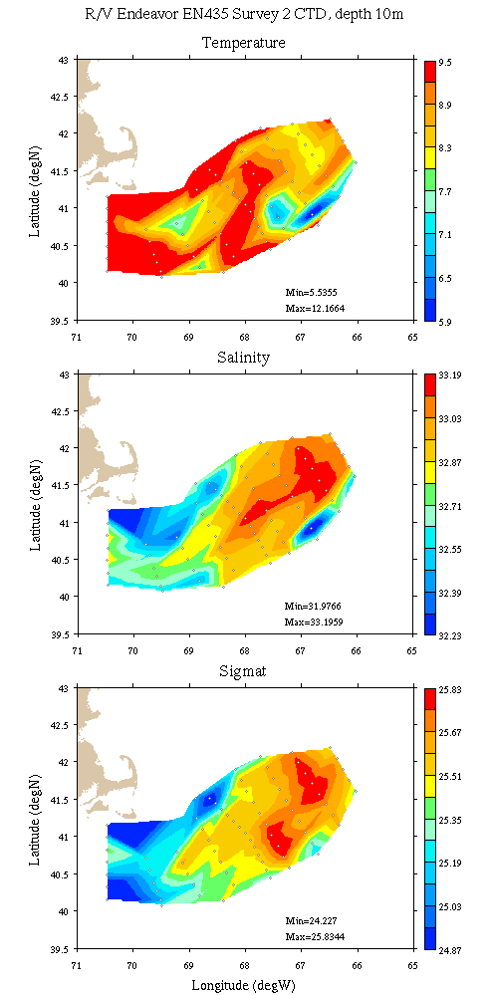 | 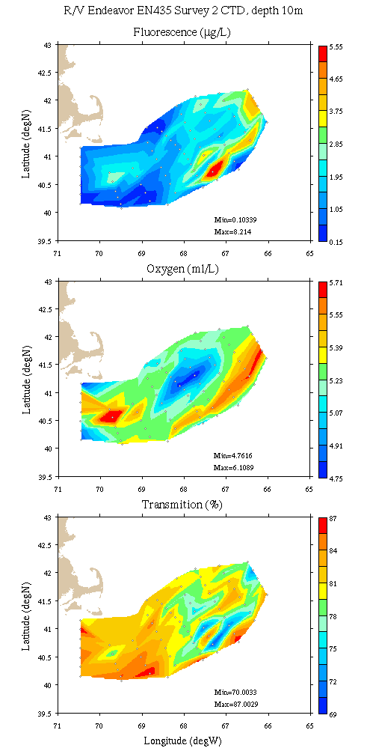
Figure B7: Georges Bank / Southern New England survey maps at 10m depth. Left: temperature, salinity, and density; right: fluorescence, oxygen, and light transmission.

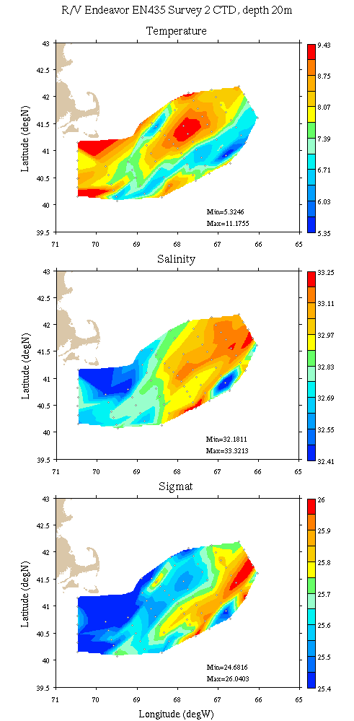 | 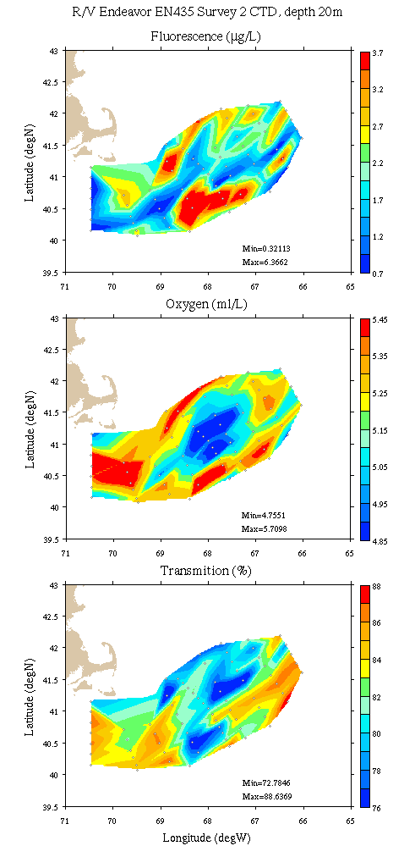
Figure B8: Georges Bank / Southern New England survey maps at 20m depth. Left: temperature, salinity, and density; right: fluorescence, oxygen, and light transmission.

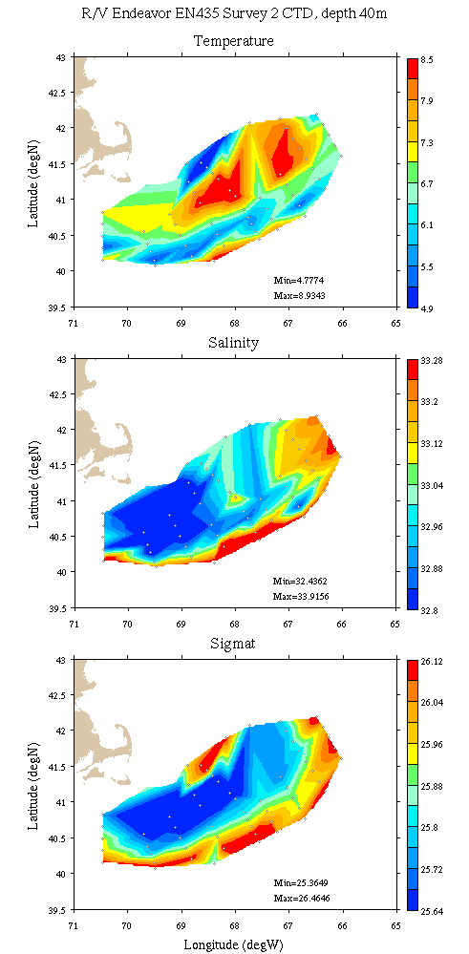 | 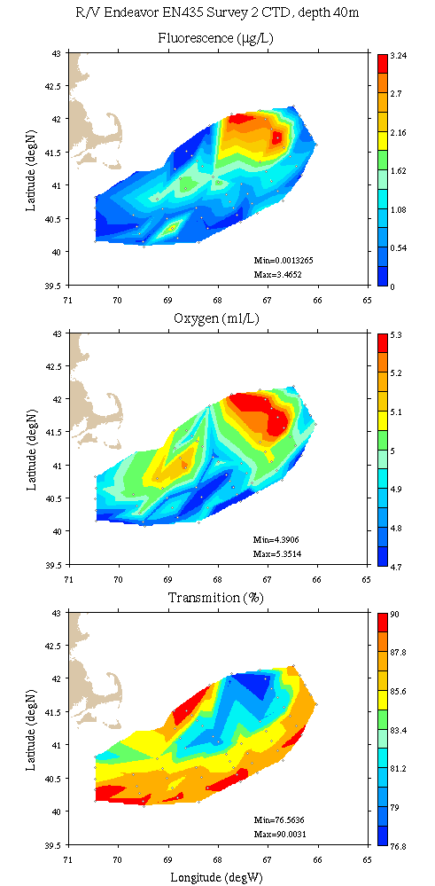
Figure B9: Georges Bank / Southern New England survey maps at 40m depth. Left: temperature, salinity, and density; right: fluorescence, oxygen, and light transmission.

Appendix C: Vertical sections.

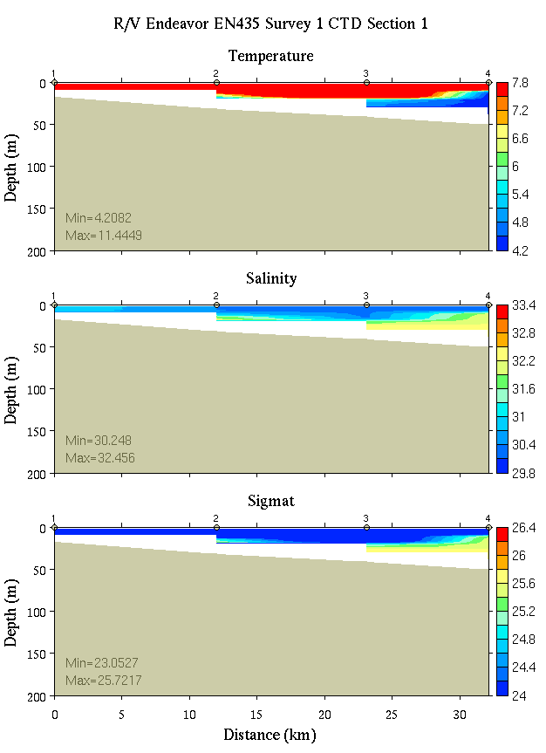 | 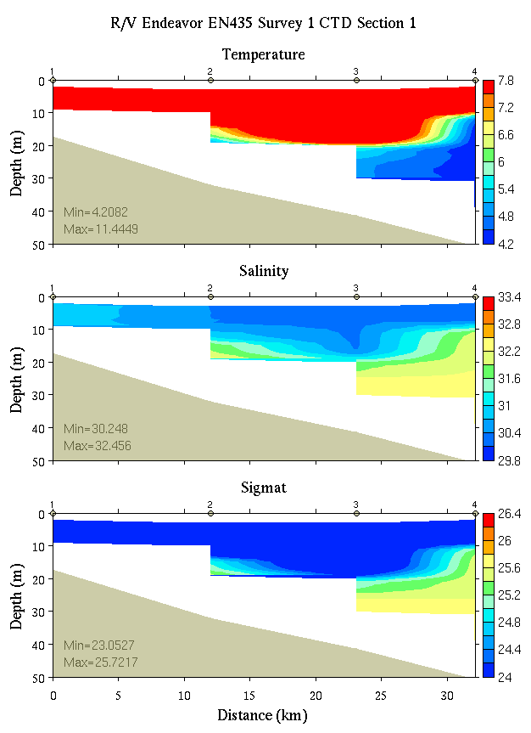
Figure C1. Temperature, salinity, and density from section 1: 0-200m (left) and 0-50m (right).

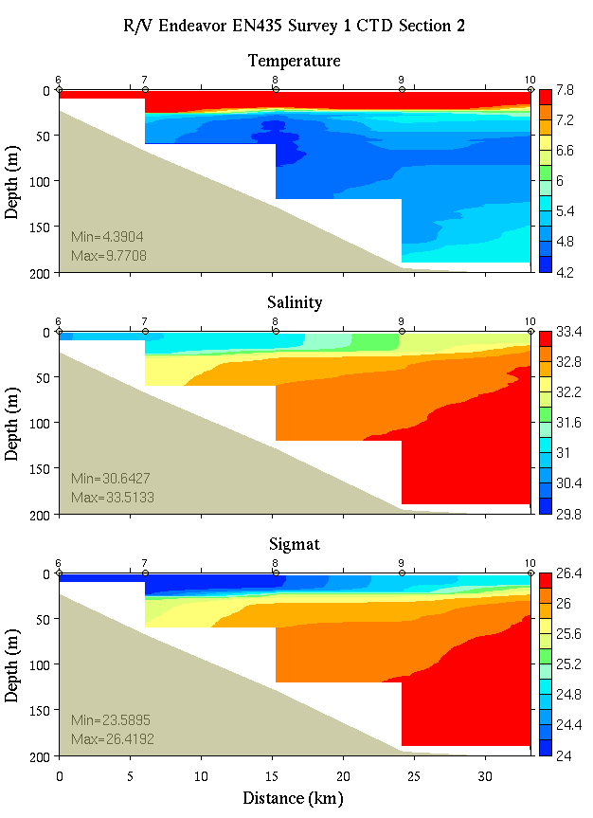 | 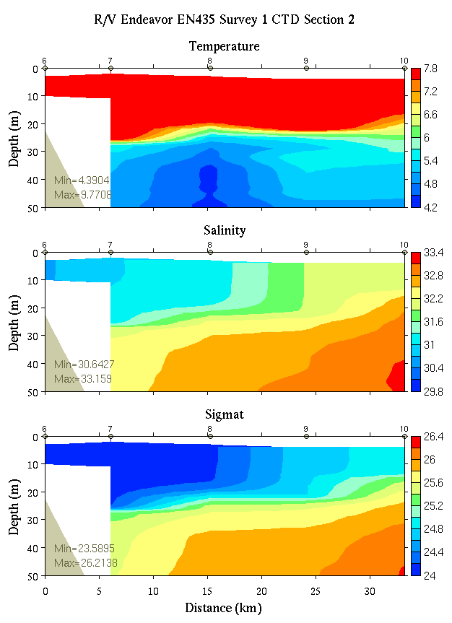
Figure C2. Temperature, salinity, and density from section 2: 0-200m (left) and 0-50m (right).

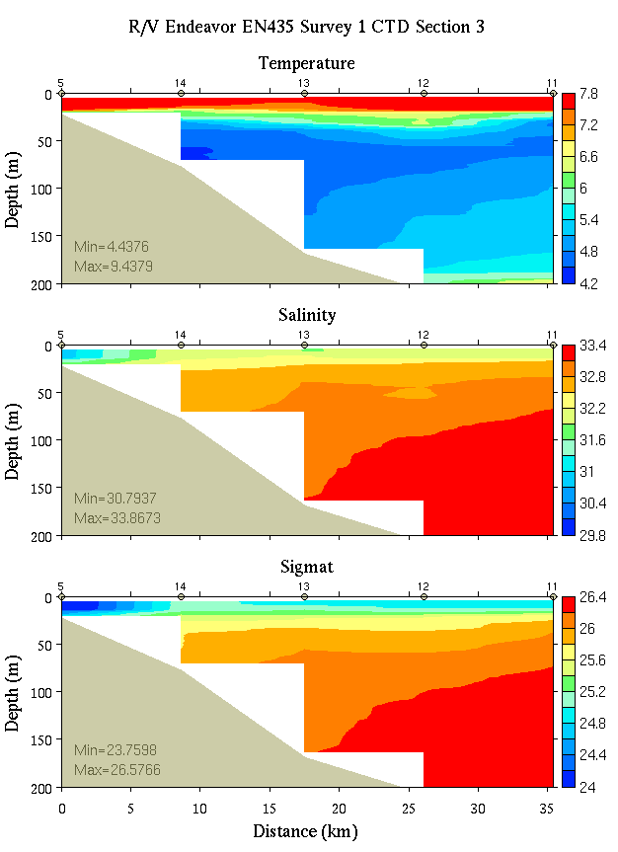 | 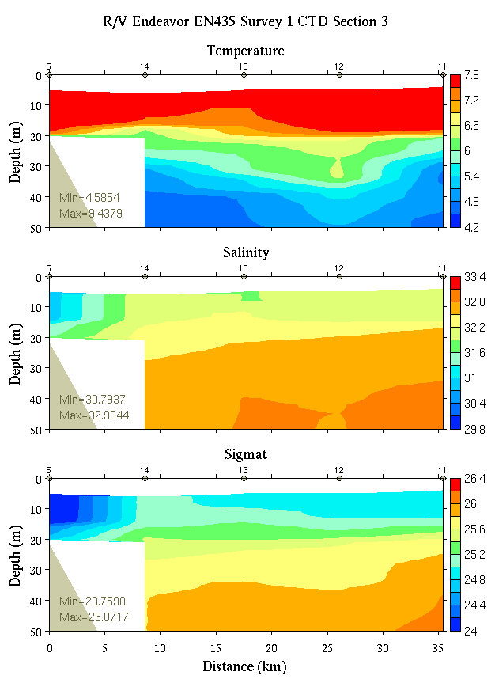
Figure C3. Temperature, salinity, and density from section 3: 0-200m (left) and 0-50m (right).
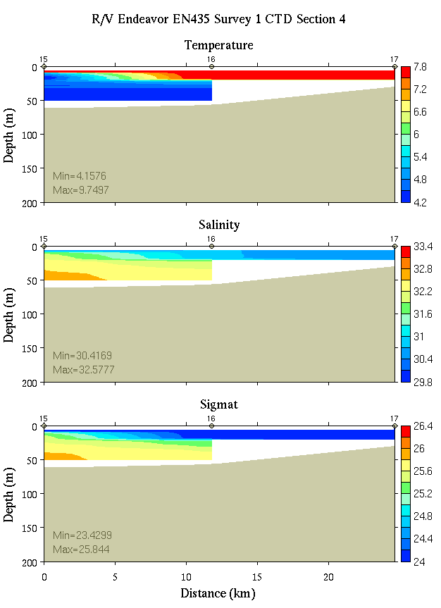 | 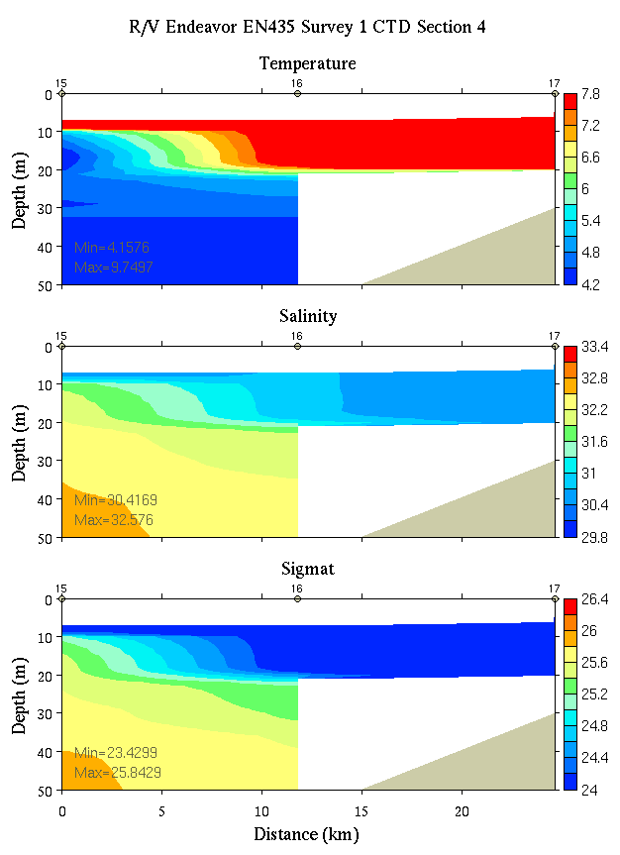
Figure C4. Temperature, salinity, and density from section 4: 0-200m (left) and 0-50m (right).

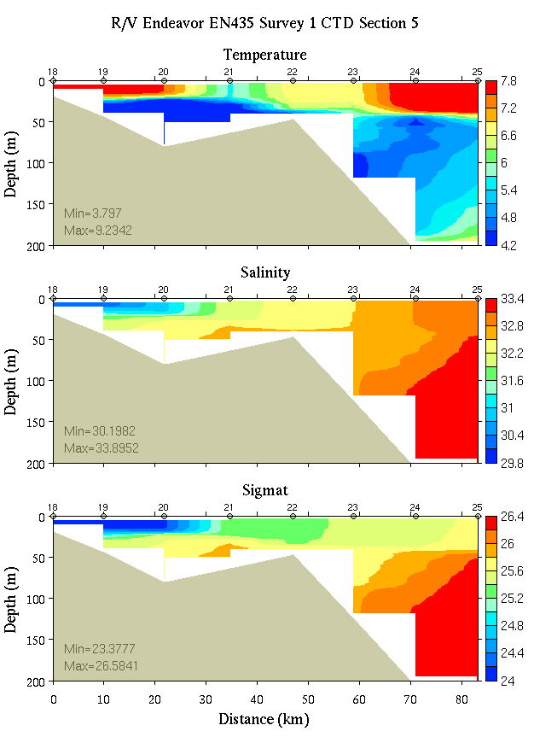 | 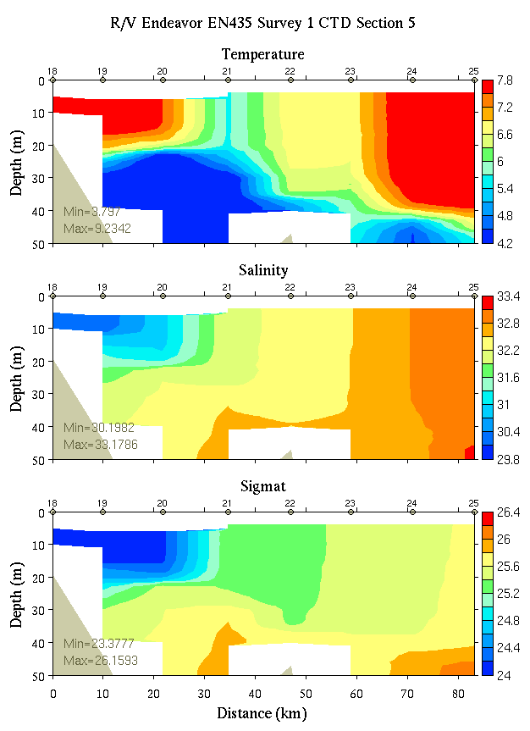
Figure C5. Temperature, salinity, and density from section 5: 0-200m (left) and 0-50m (right).
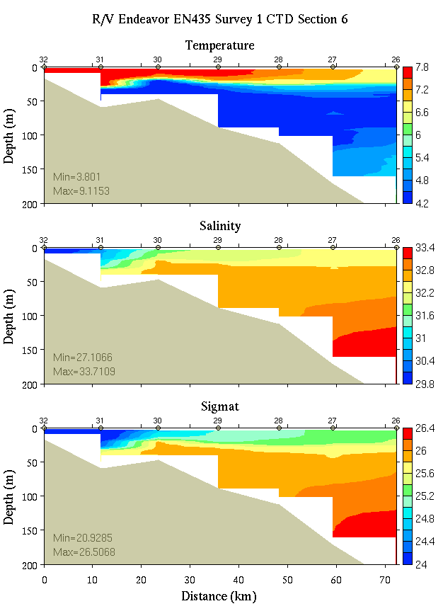 | 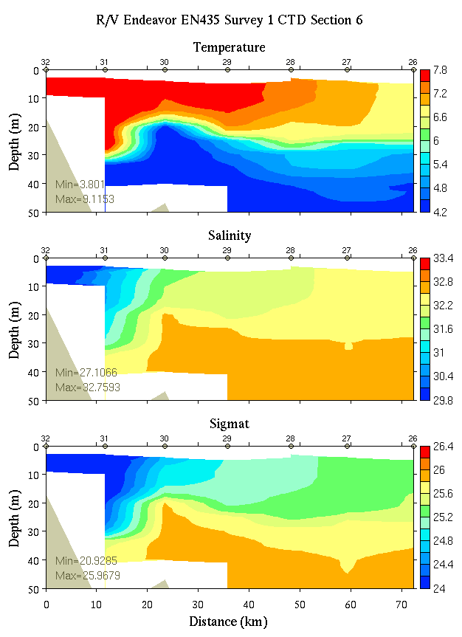
Figure C6. Temperature, salinity, and density from section 6: 0-200m (left) and 0-50m (right).

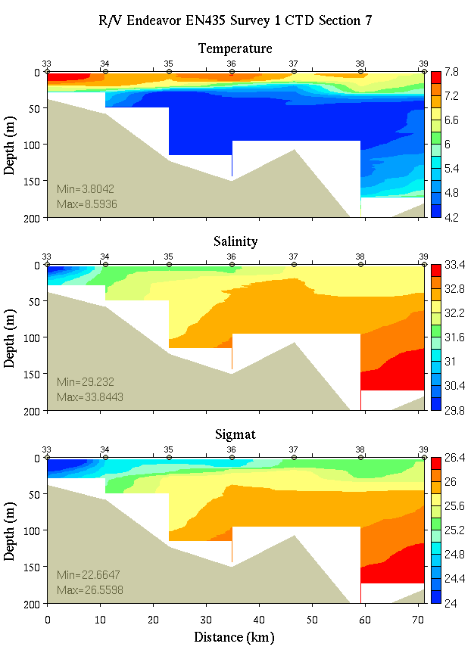 | 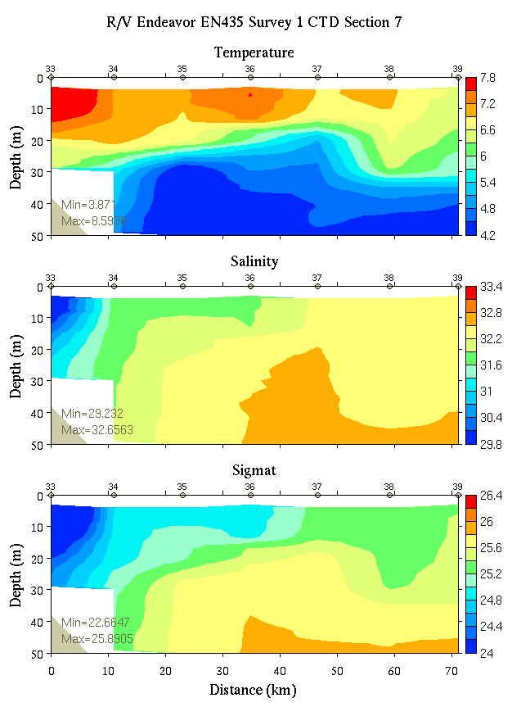
Figure C7. Temperature, salinity, and density from section 7: 0-200m (left) and 0-50m (right).
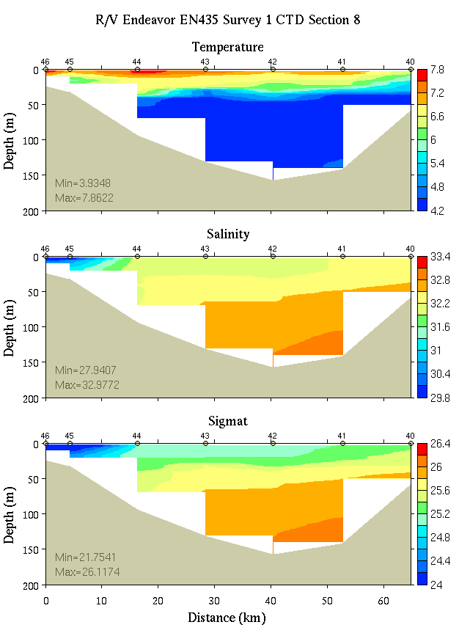 | 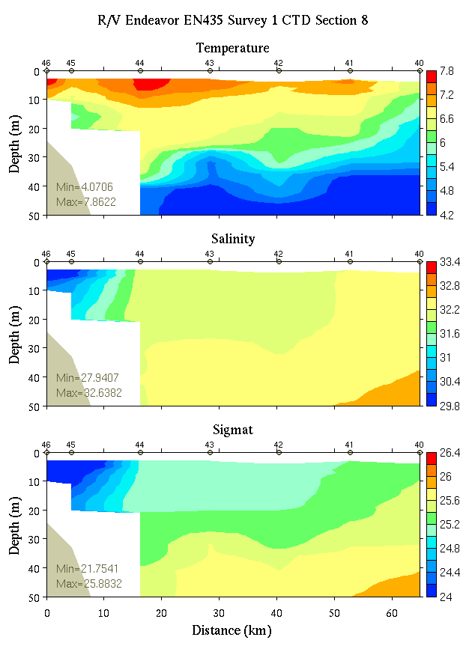
Figure C8. Temperature, salinity, and density from section 8: 0-200m (left) and 0-50m (right).

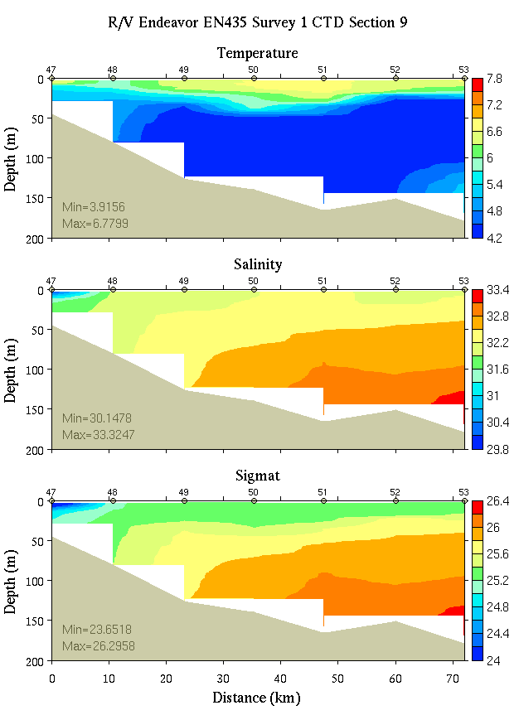 | 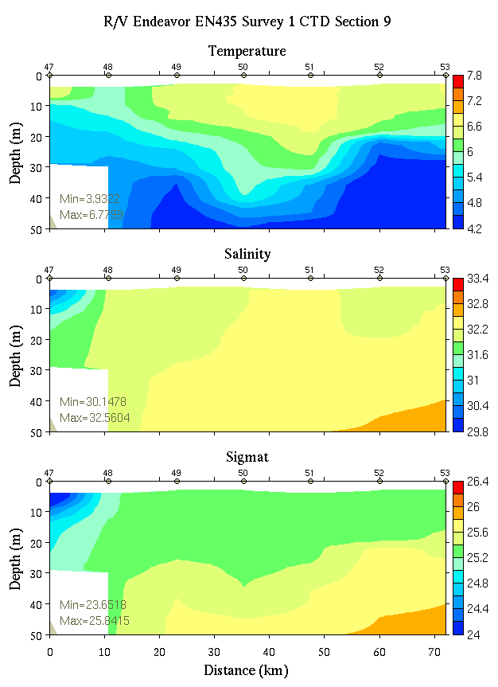
Figure C9. Temperature, salinity, and density from section 9: 0-200m (left) and 0-50m (right).
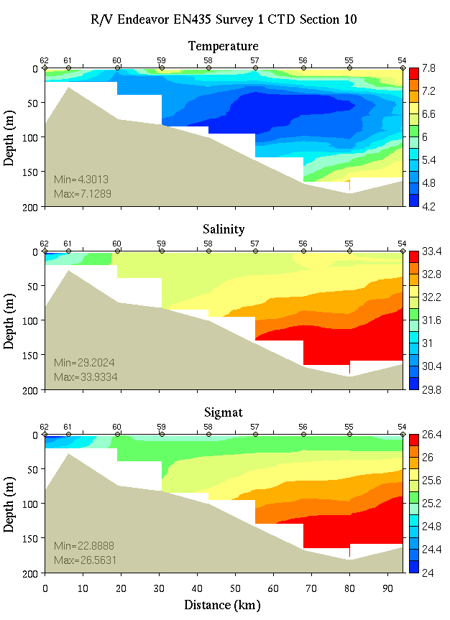 | 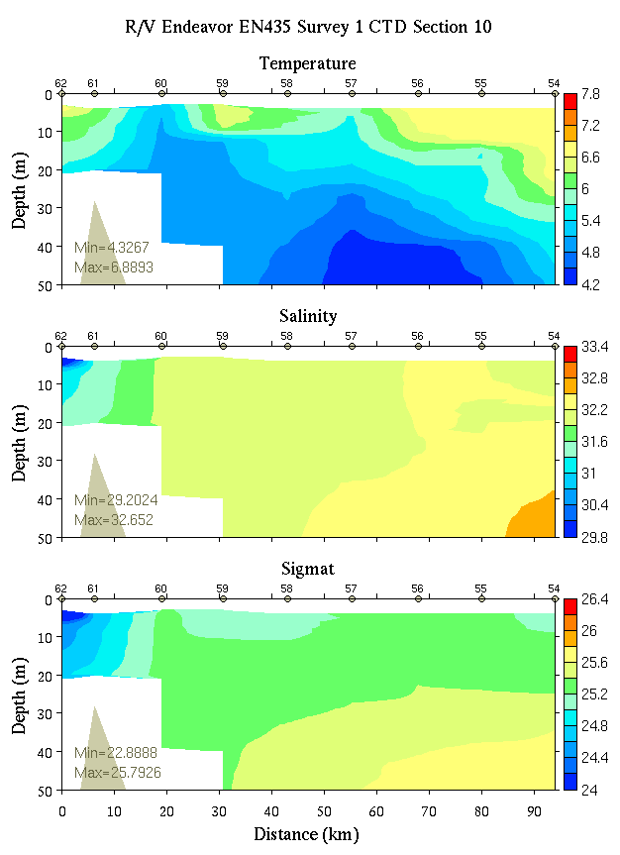
Figure C10. Temperature, salinity, and density from section 10: 0-200m (left) and 0-50m (right).

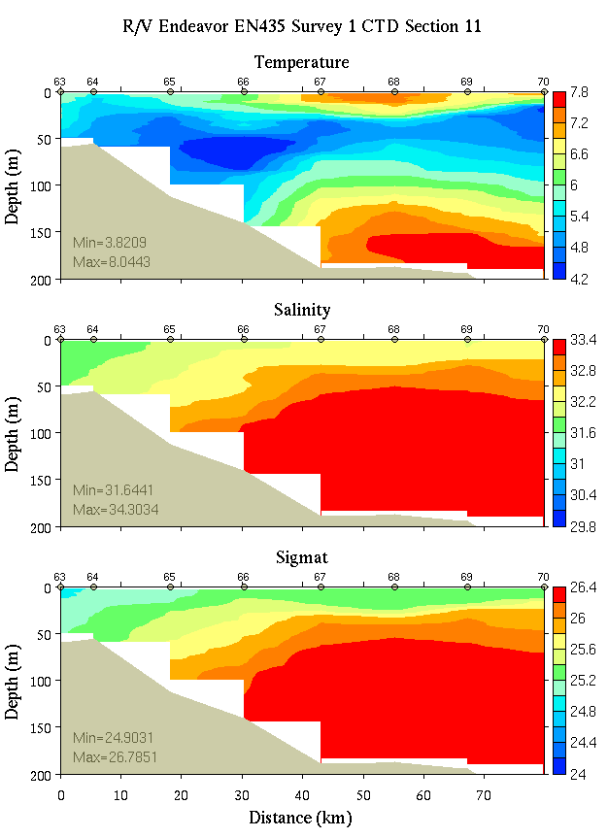 | 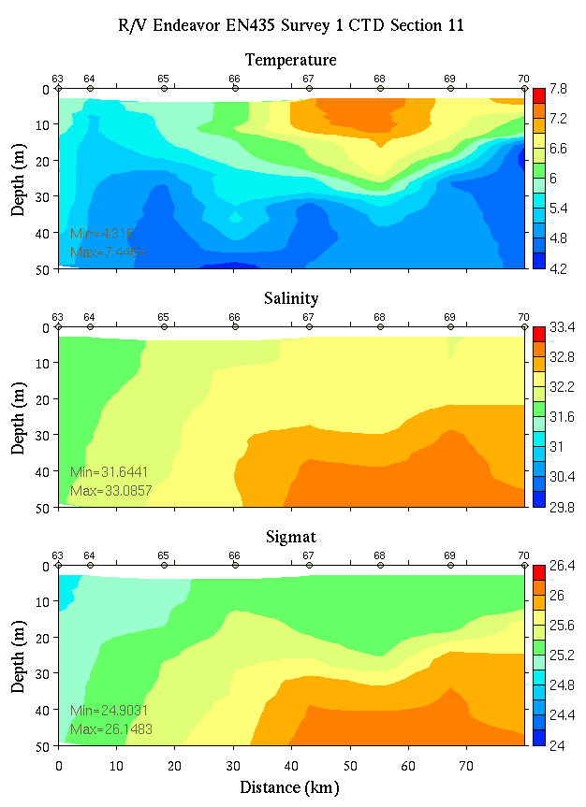
Figure C11. Temperature, salinity, and density from section 11: 0-200m (left) and 0-50m (right).
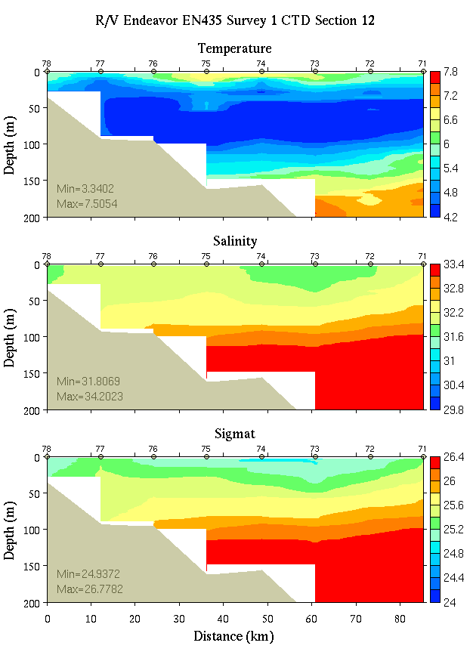 | 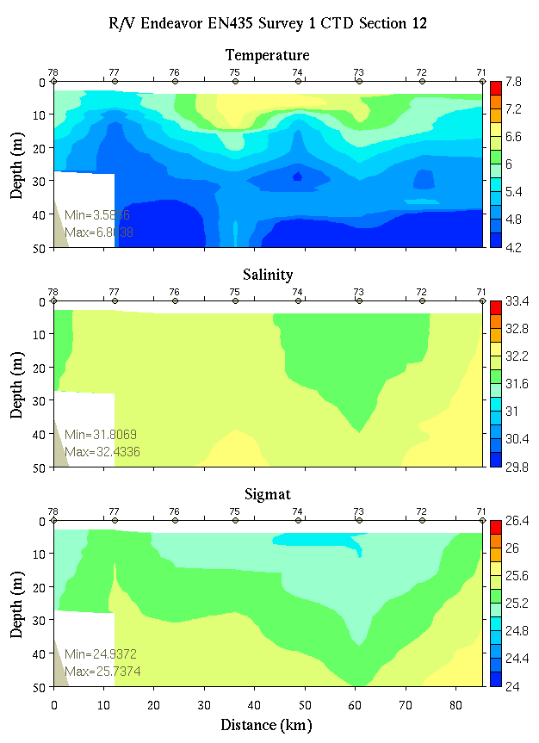
Figure C12. Temperature, salinity, and density from section 12: 0-200m (left) and 0-50m (right).

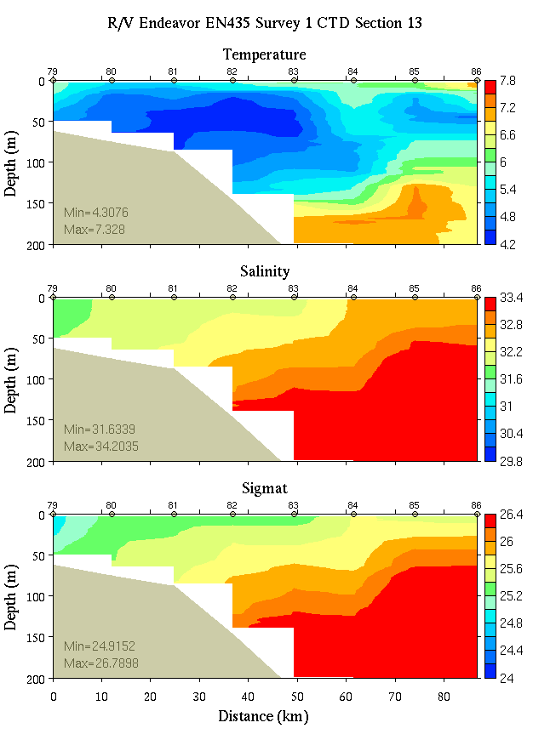 | 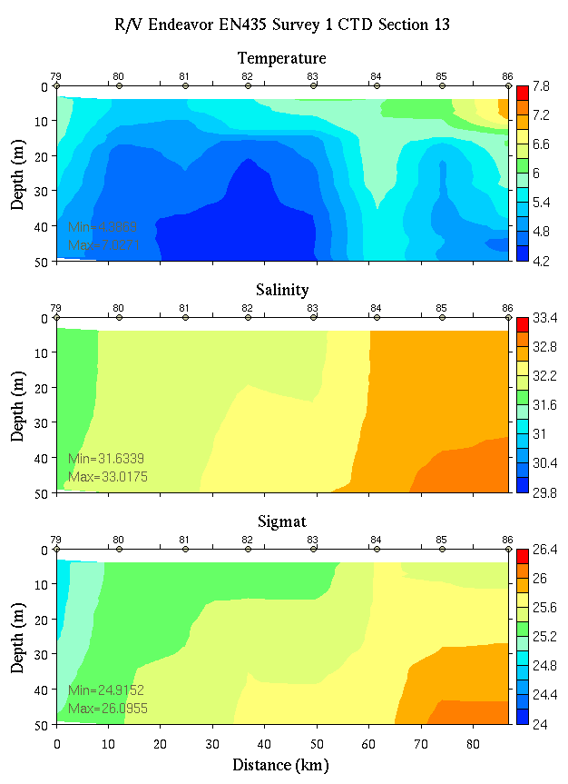
Figure C13. Temperature, salinity, and density from section 13: 0-200m (left) and 0-50m (right).
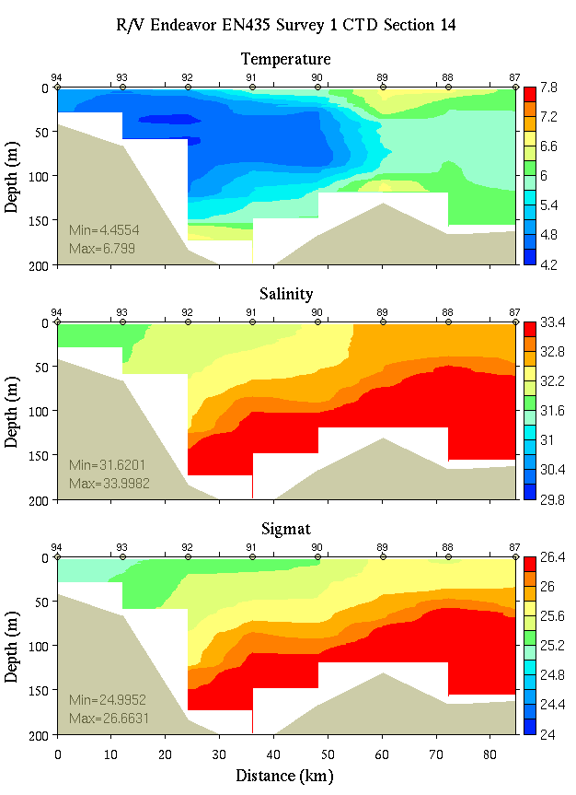 | 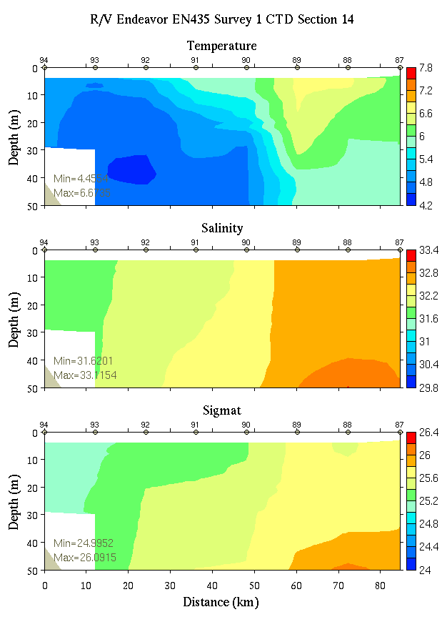
Figure C14. Temperature, salinity, and density from section 14: 0-200m (left) and 0-50m (right).

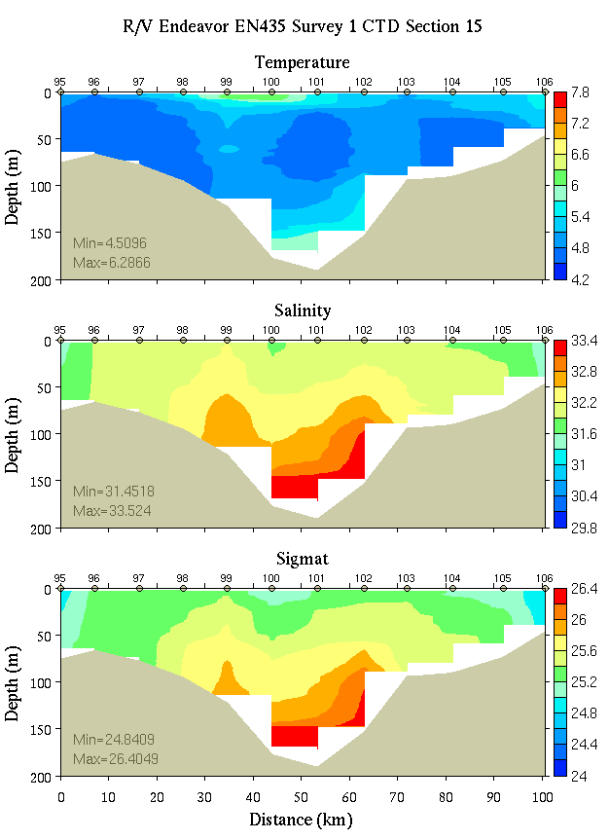 | 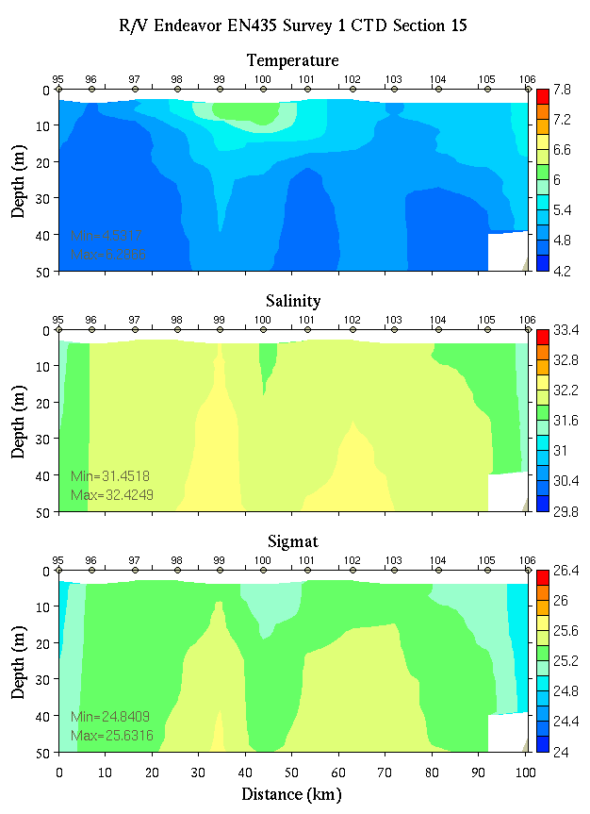
Figure C15. Temperature, salinity, and density from section 15: 0-200m (left) and 0-50m (right).
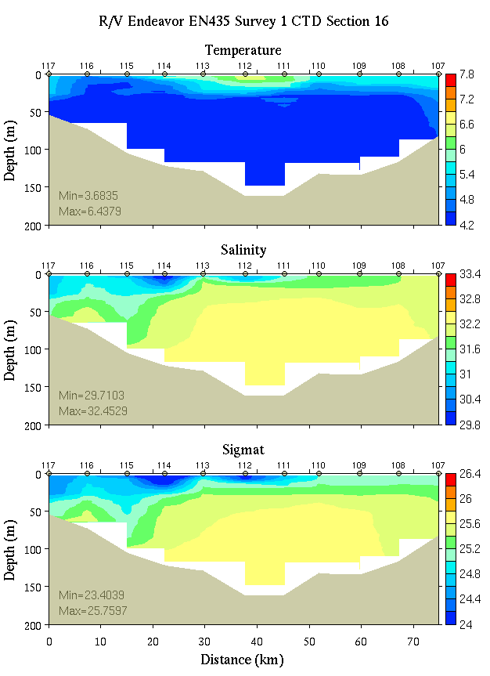 | 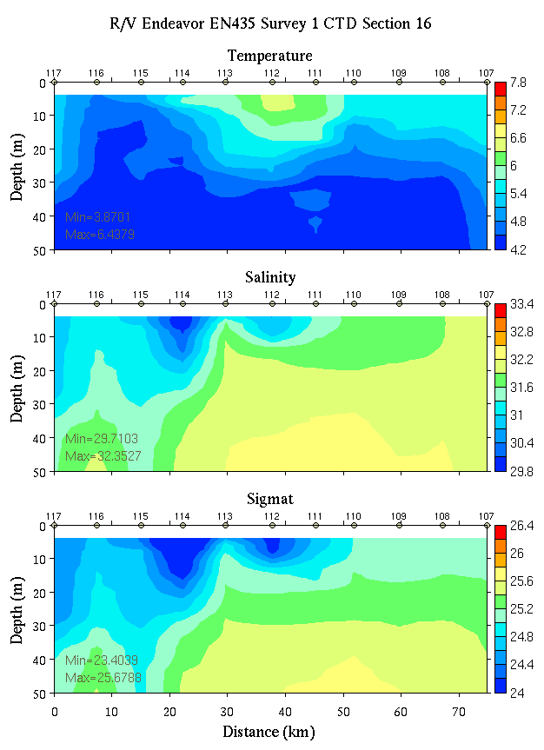
Figure C16. Temperature, salinity, and density from section 16: 0-200m (left) and 0-50m (right).

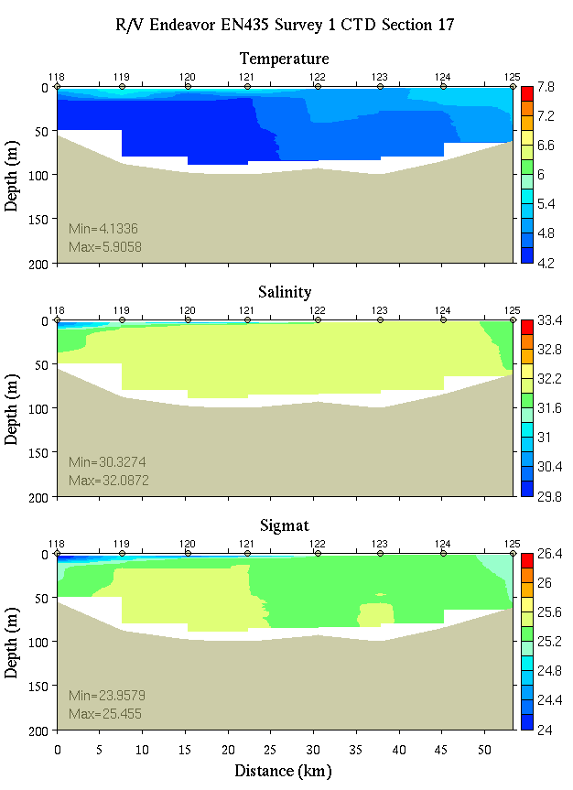 | 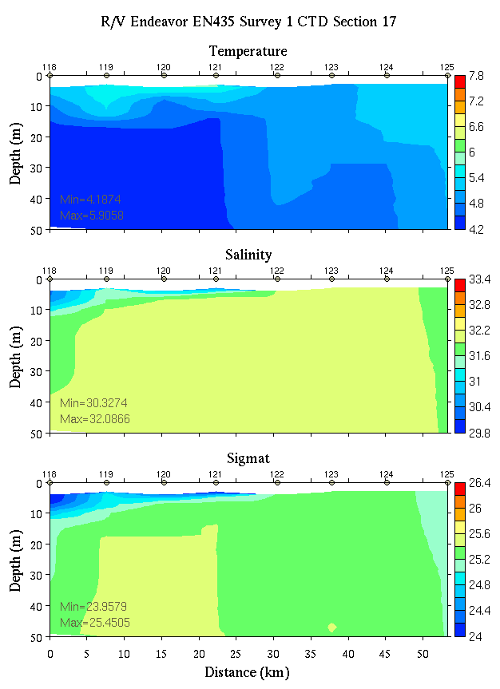
Figure C17. Temperature, salinity, and density from section 17: 0-200m (left) and 0-50m (right).
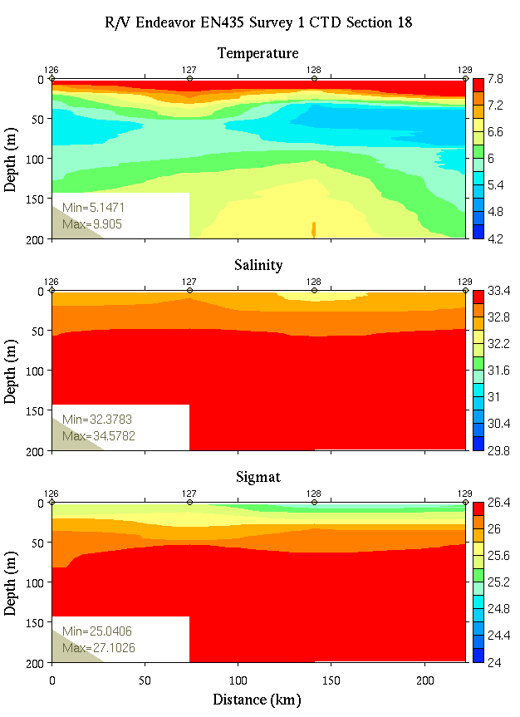 | 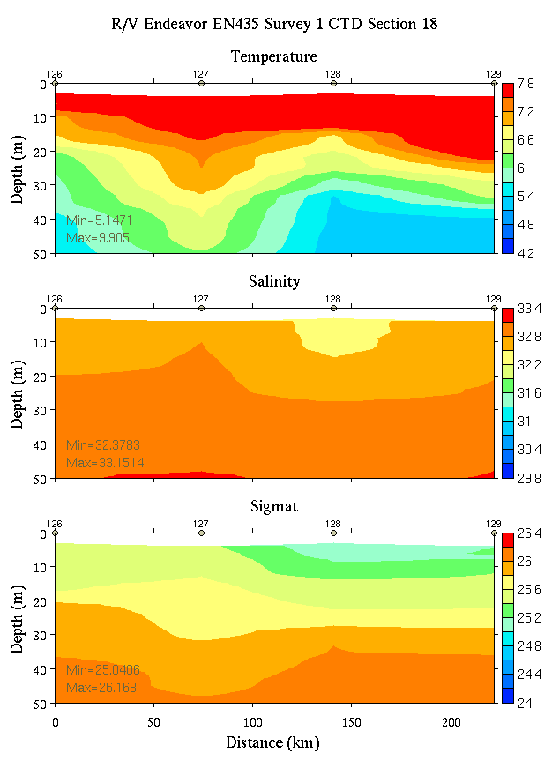
Figure C18. Temperature, salinity, and density from section 18: 0-200m (left) and 0-50m (right).

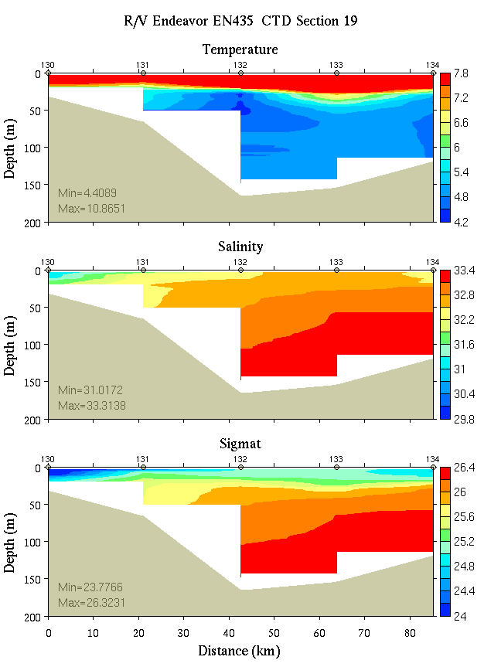 | 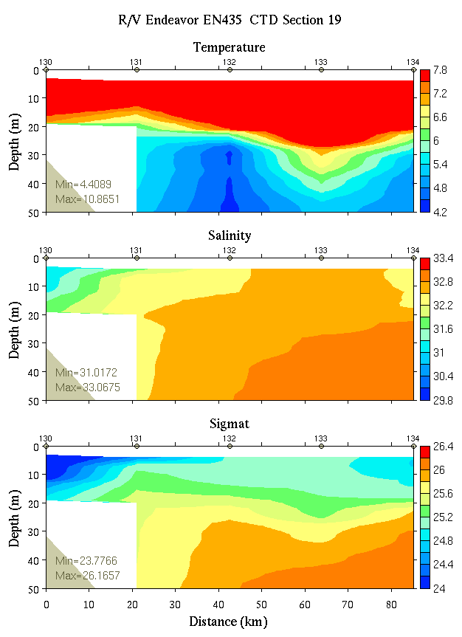
Figure C19. Temperature, salinity, and density from section 19: 0-200m (left) and 0-50m (right).
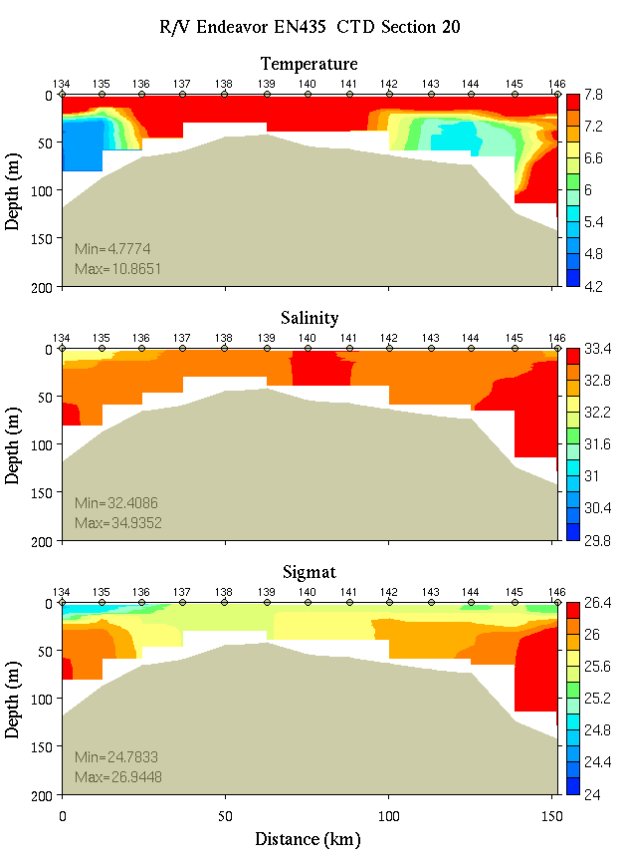 | 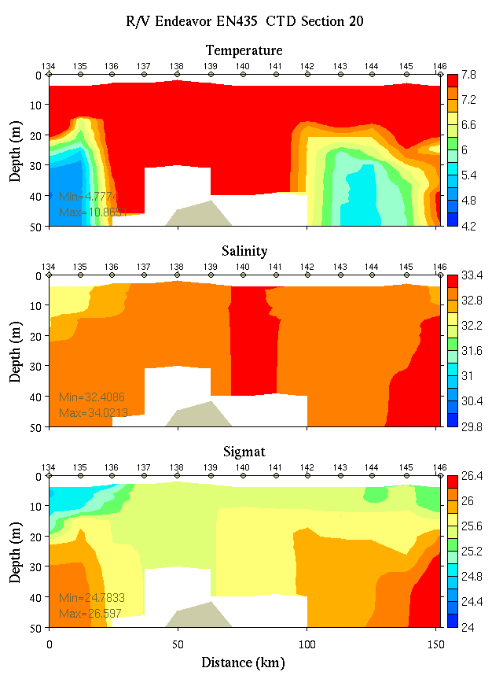
Figure C20. Temperature, salinity, and density from section 20: 0-200m (left) and 0-50m (right).

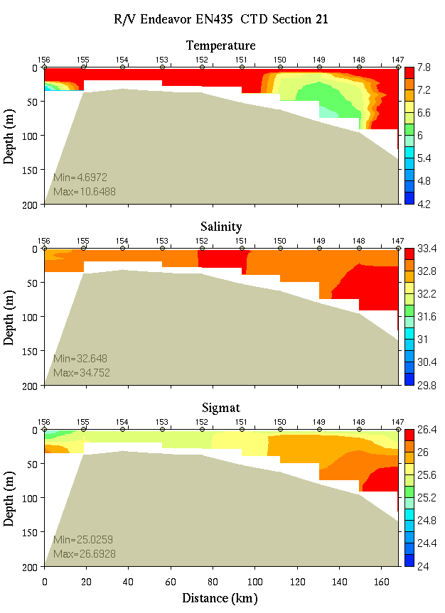 | 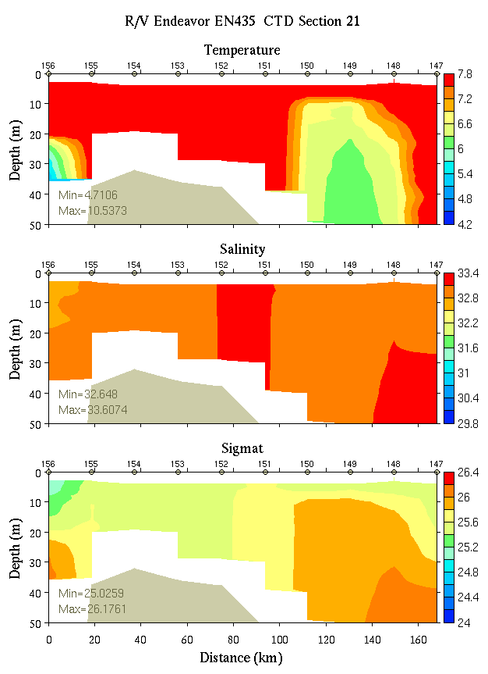
Figure C21. Temperature, salinity, and density from section 21: 0-200m (left) and 0-50m (right).

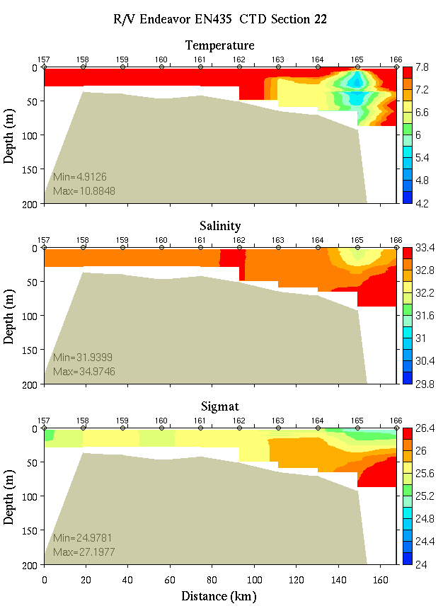 | 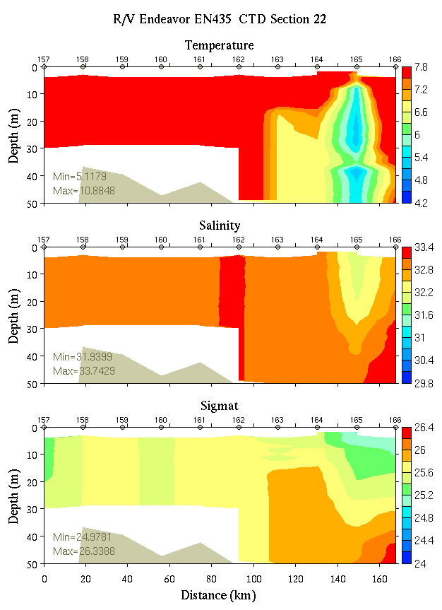
Figure C22. Temperature, salinity, and density from section 22: 0-200m (left) and 0-50m (right).

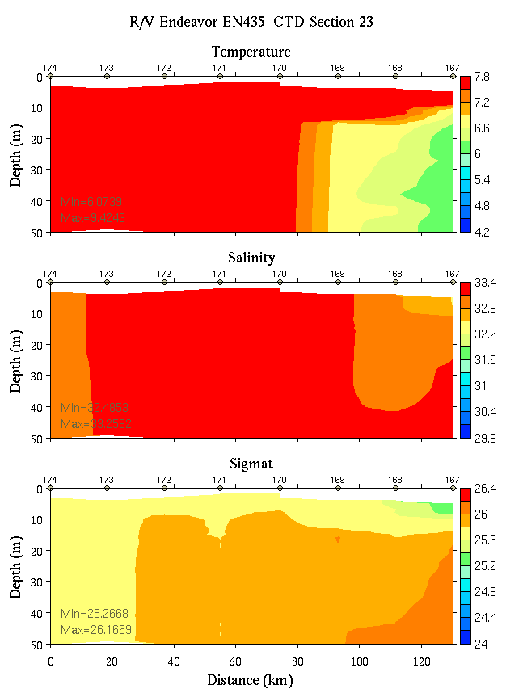 | 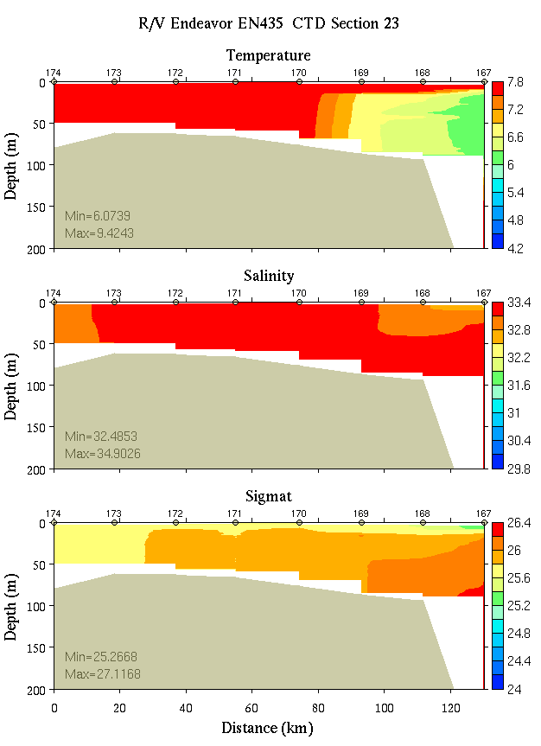
Figure C23. Temperature, salinity, and density from section 23: 0-200m (left) and 0-50m (right).
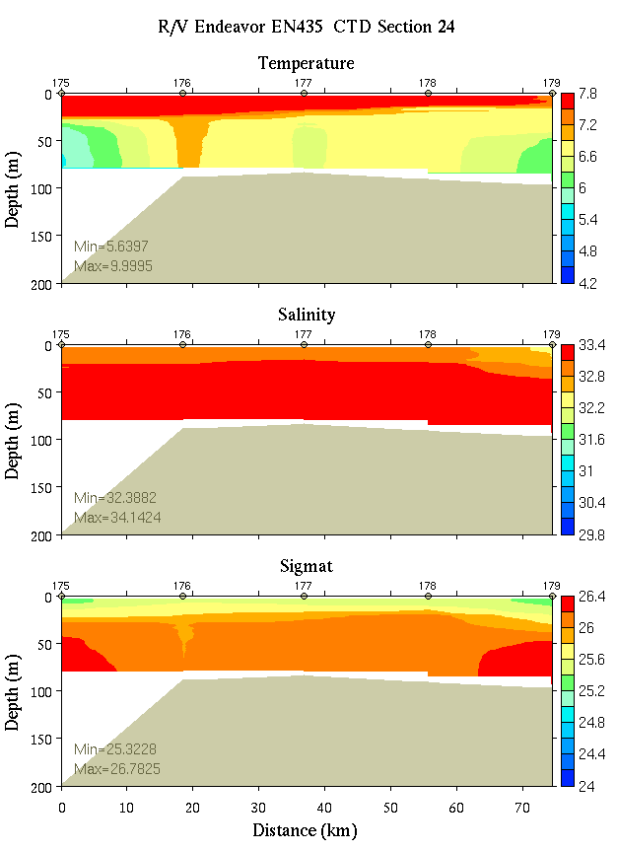 | 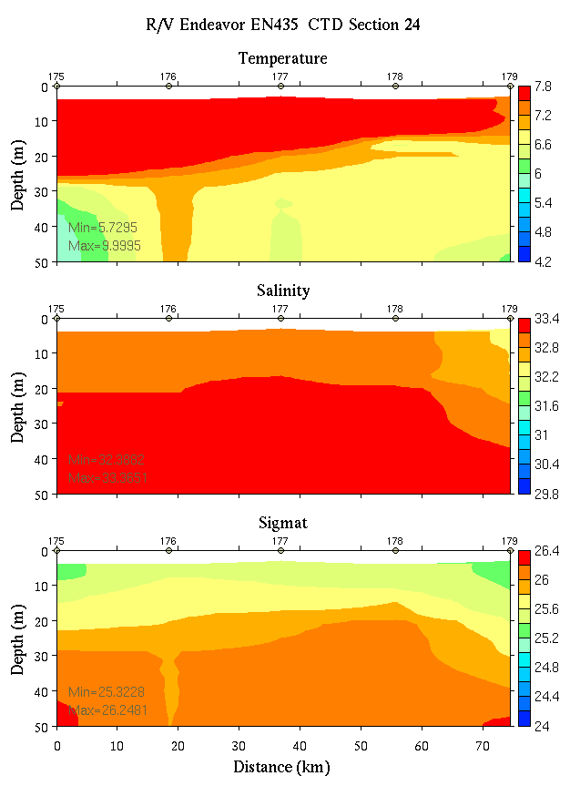
Figure C24. Temperature, salinity, and density from section 24: 0-200m (left) and 0-50m (right).

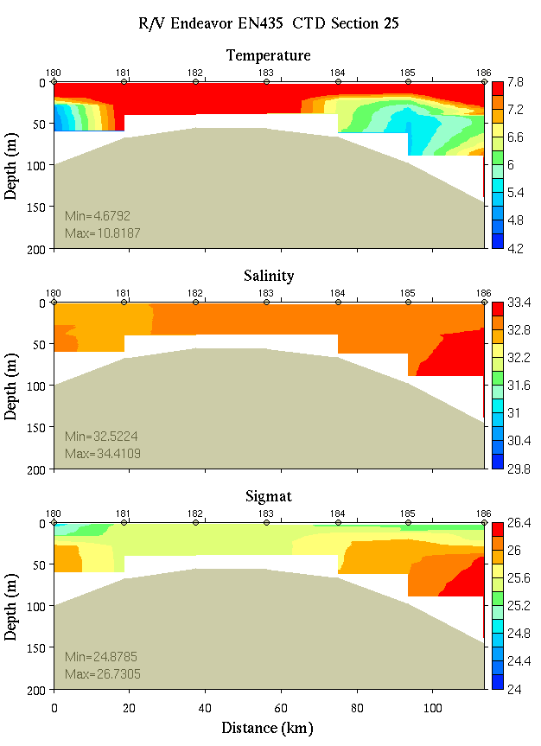 | 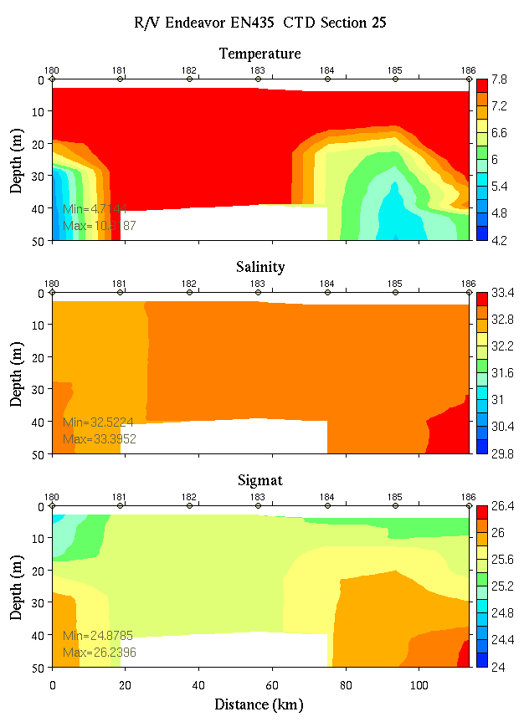
Figure C25. Temperature, salinity, and density from section 25: 0-200m (left) and 0-50m (right).

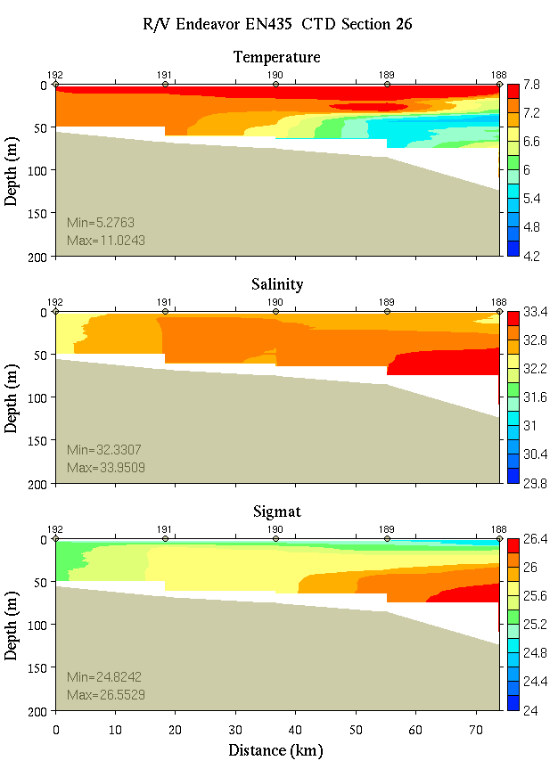 | 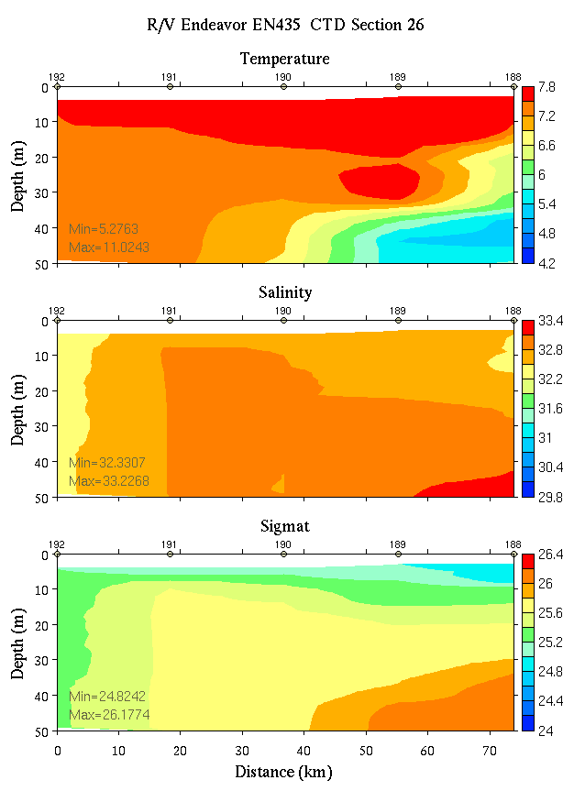
Figure C26. Temperature, salinity, and density from section 26: 0-200m (left) and 0-50m (right).

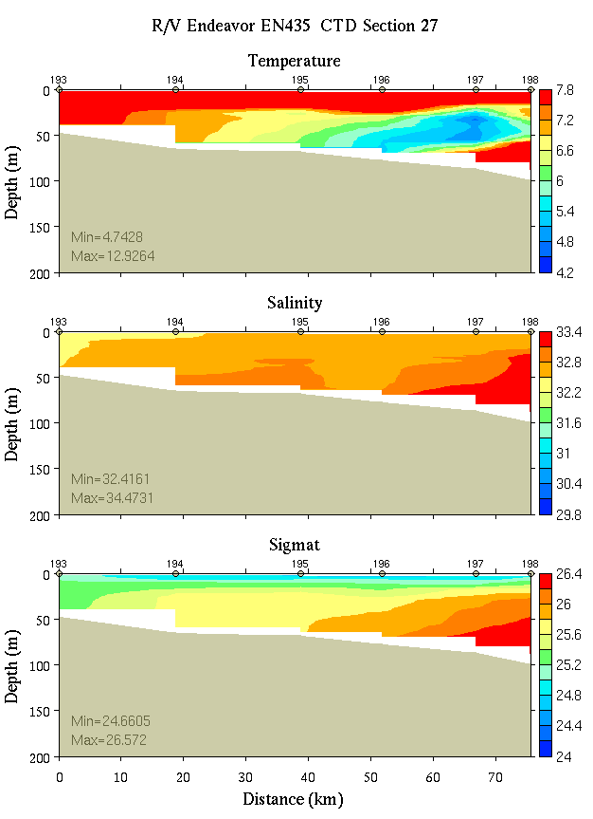 | 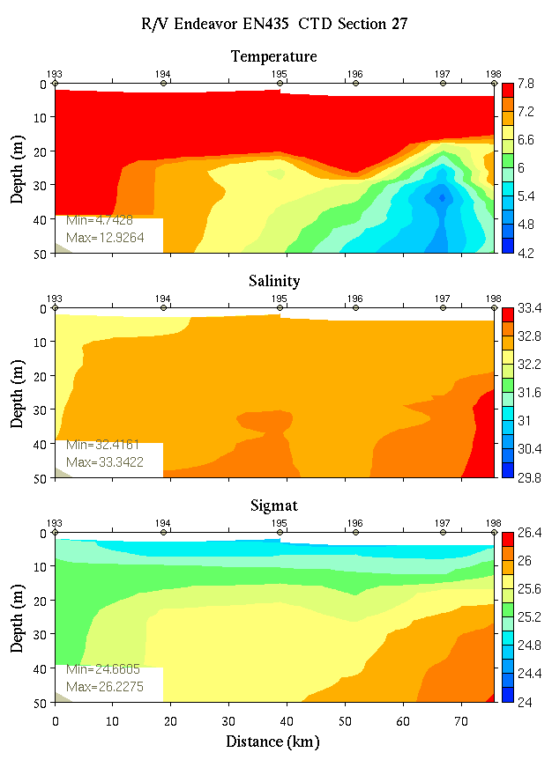
Figure C27. Temperature, salinity, and density from section 27: 0-200m (left) and 0-50m (right).

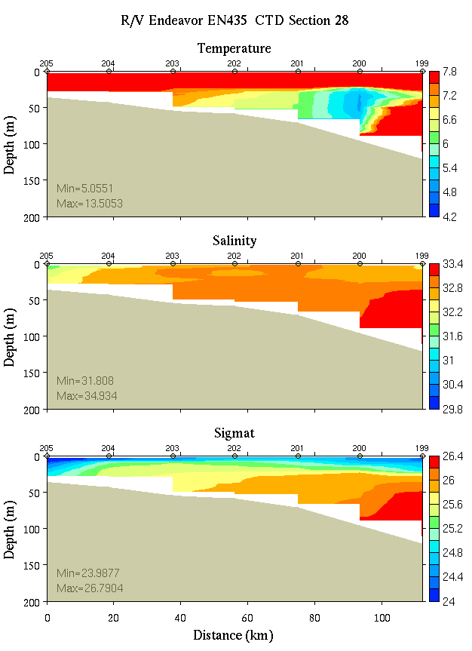 | 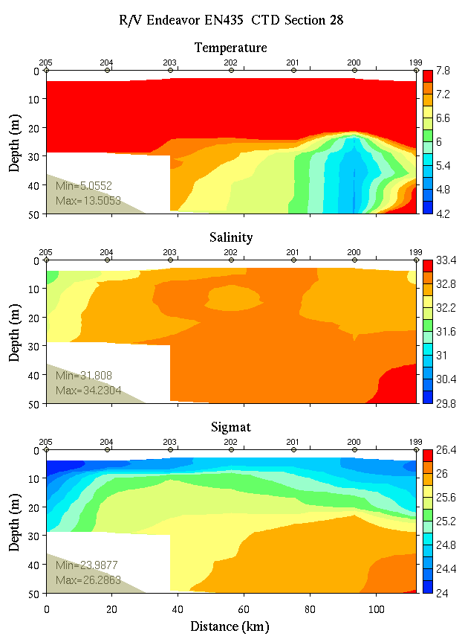
Figure C28. Temperature, salinity, and density from section 28: 0-200m (left) and 0-50m (right).

Appendix D: Satellite imagery

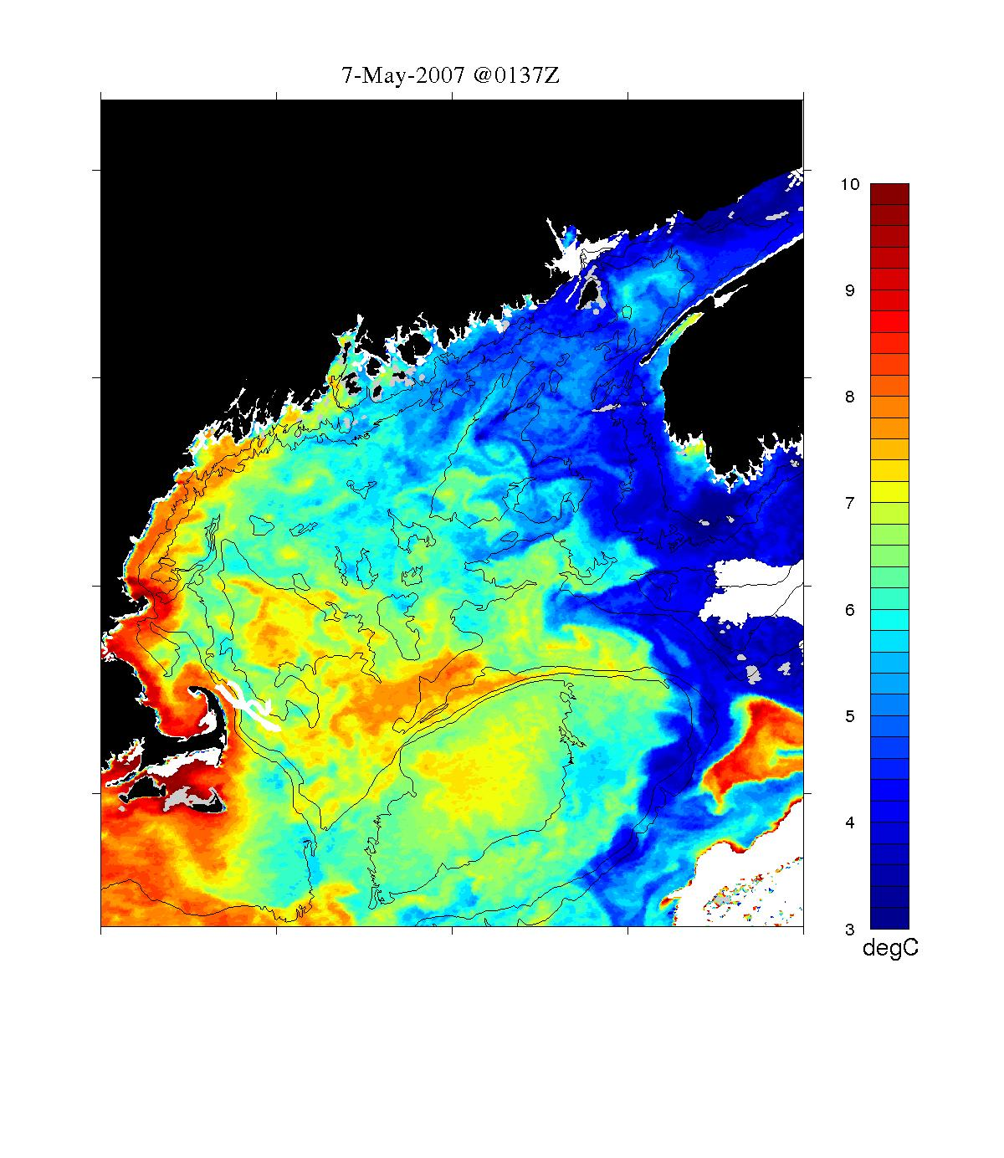
SST image for May 7, 2007.

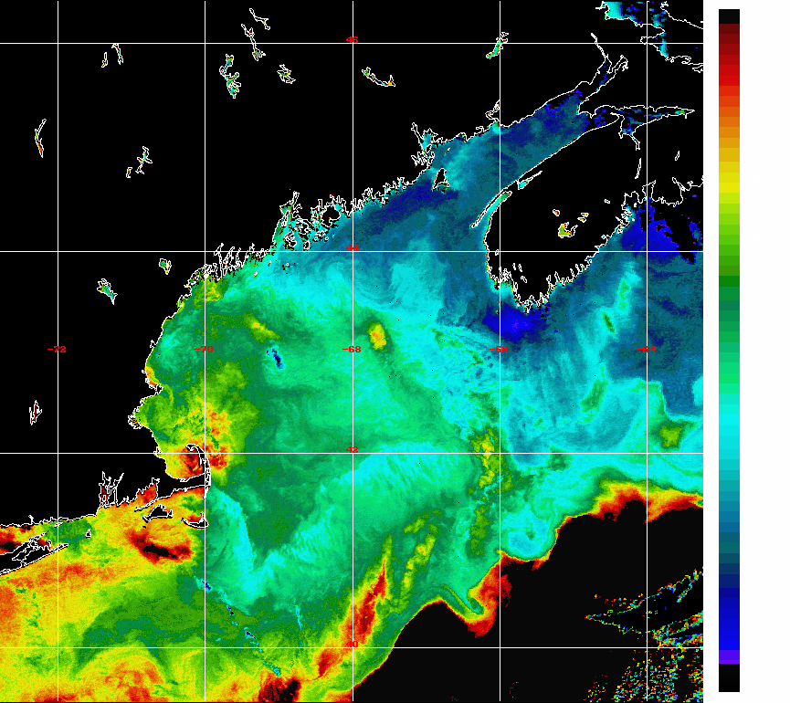

Enhanced SST image from May 14, 2007.
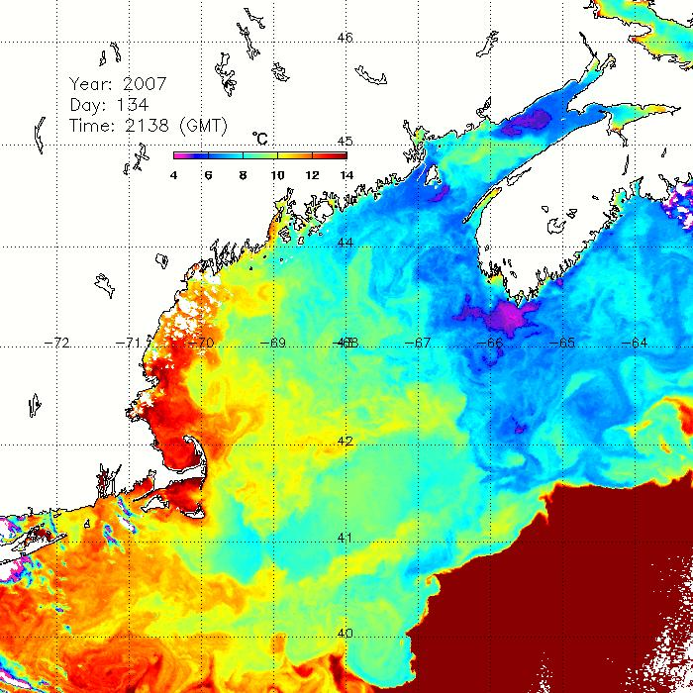

SST image for May 14, 2007

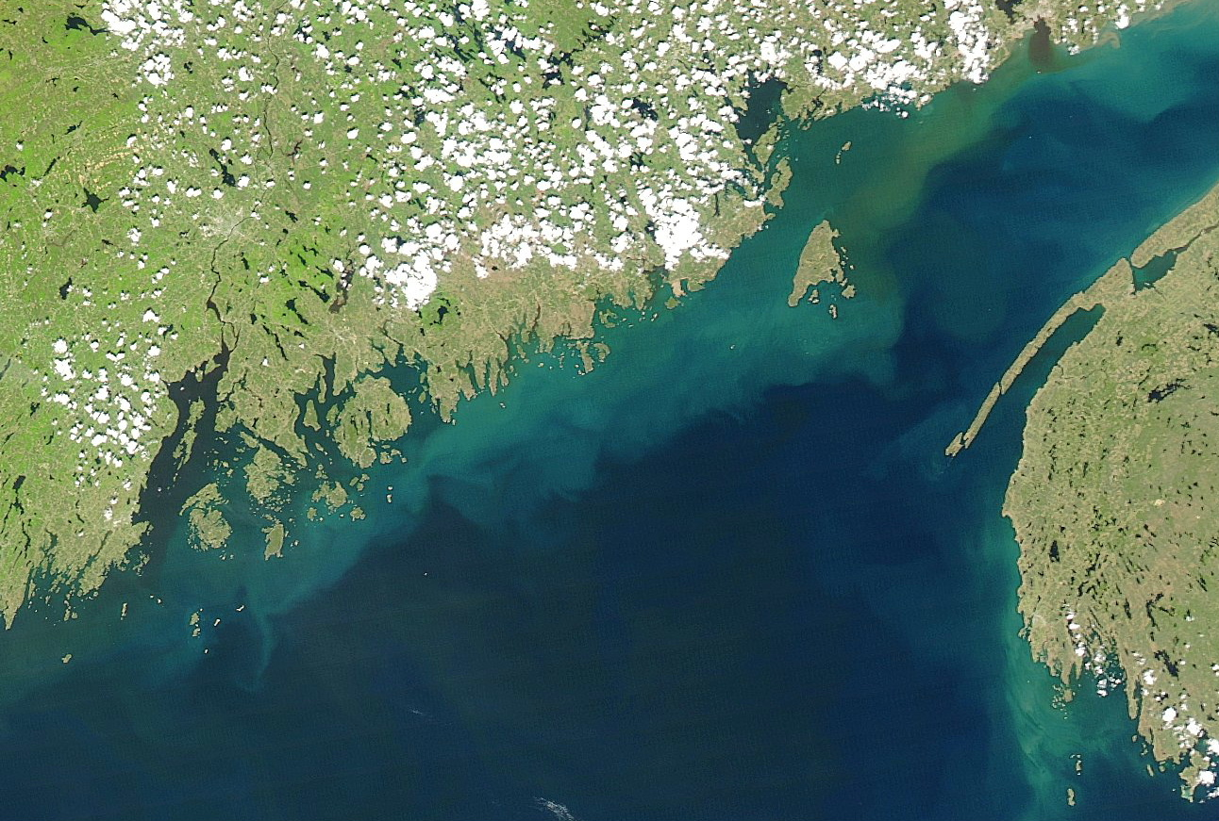

MODIS true-color image for May 22, 2007
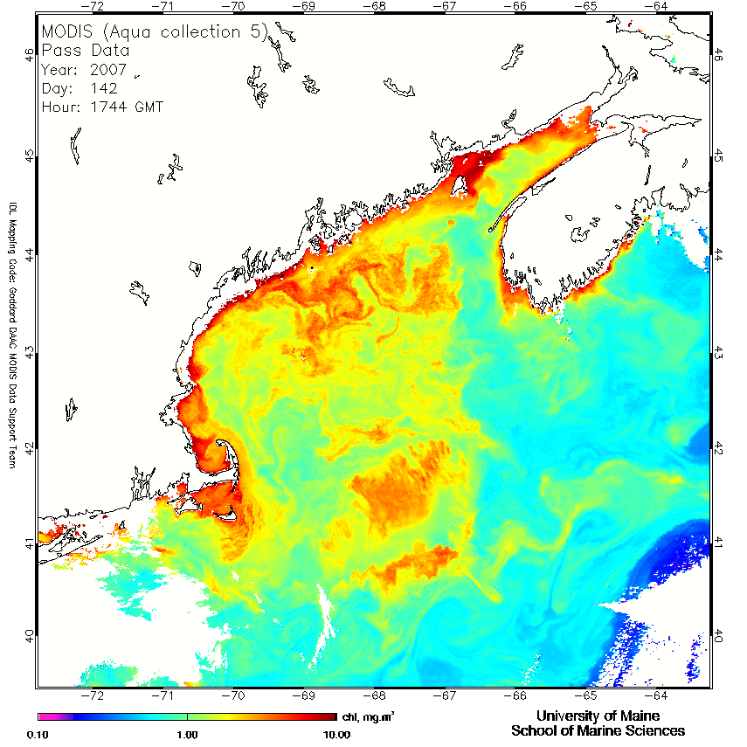

Ocean color image for May 22, 2007
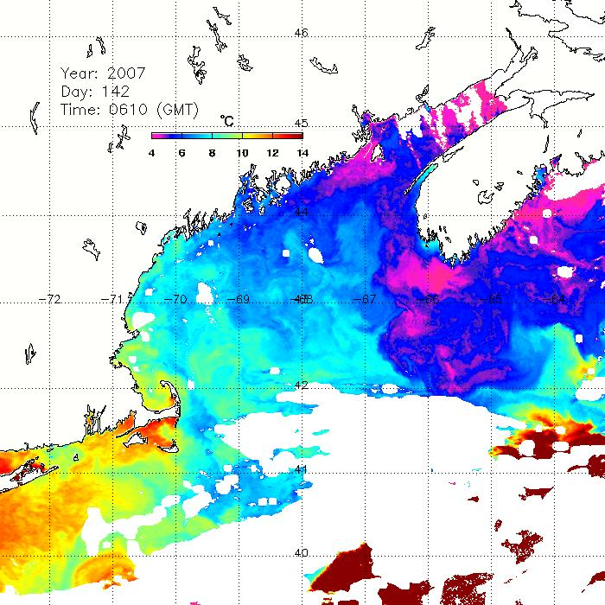

SST image for May 22, 2007.

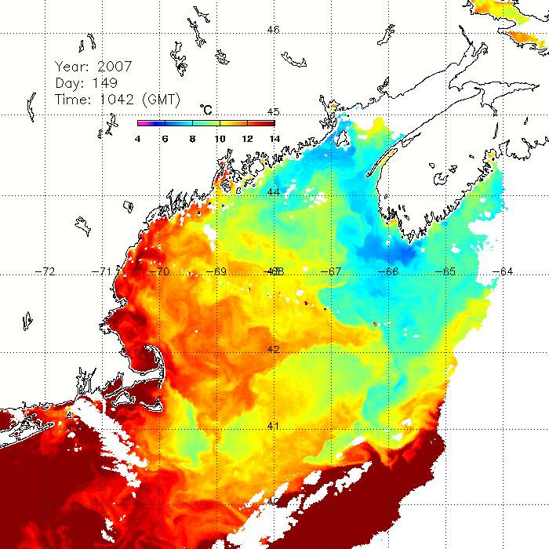
SST image for May 29, 2007.
Appendix E: Personnel

1. Dennis McGillicuddy WHOI (Chief Scientist)
2. Keston Smith WHOI
3. Valery Kosnyrev WHOI
4. Olga Kosnyreva WHOI
5. Jim Manning NMFS
6. Bruce Keafer WHOI
7. Linda Percy WHOI
8. Kerry Norton WHOI
9. Bryn Warren WHOI
10. Shannon Long WHOI
11. Rodney Withall University of Texas
12. Dave Townsend University of Maine
13. Nathan Reebuck University of Maine
14. Maura Thomas University of Maine
15. Heather Deese University of Maine
16. Jeff Turner UMass Dartmouth
17. Meri Ratzel CCS

Watch schedule

Watch number 1 2 3
4 on / 8 off 8-12 12-4 4-8

1. CTD Operator Keston Heather JiM
2. Cell Counter Bryn Kerry Bruce##
3. Nutrient sampler Dave## Nathan # Maura#
4. Deputy water sampler Olga# Linda# Jeff
5. Deputy water sampler Valery# Rodney## Shannon#
Meri

* Watch chief
# CTD deck operations: 1 deck chief (##) and 2 slip line handlers (#)

http://www.whoi.edu/science/cohh/whcohh/projects/habs1_abstract.htm
http://science.whoi.edu/users/ruoying/Redtide_07/
Also see http://nefsc.noaa.gov/drifter

