AR29 Cruise Report
Draft 5/1/18

1. Introduction

Voyage number 29 is the first of three cruises of an NSF-sponsored project entitled “Shelfbreak frontal dynamics: mechanisms of upwelling, net community production, and ecological implications.” The field work is sited on the continental shelfbreak of the Middle Atlantic Bight, which supports a productive and diverse ecosystem. Current paradigms suggest that this productivity is driven by several upwelling mechanisms at the shelfbreak front. This upwelling supplies nutrients that stimulate primary production by phytoplankton, which in turn leads to enhanced production at higher trophic levels. Although local enhancement of phytoplankton biomass has been observed in some synoptic measurements, such a feature is curiously absent from time-averaged measurements, both remotely sensed and in situ. Why would there not be a mean enhancement in phytoplankton biomass as a result of the upwelling? One hypothesis is that grazing by zooplankton prevents accumulation of biomass on seasonal and longer time scales, transferring the excess production to higher trophic levels and thereby contributing to the overall productivity of the ecosystem. However, another possibility is that the net impact of these highly intermittent processes is not adequately represented in long-term means of the observations, because of the relatively low resolution of the in situ data and the fact that the frontal enhancement can take place below the depth observable by satellite.

A unique opportunity to test these hypotheses has arisen with deployment of the Ocean Observatories Initiative (OOI) Pioneer Array south of New England. The combination of moored instrumentation and mobile assets (gliders, AUVs) will facilitate observations of the frontal system with unprecedented spatial and temporal resolution (Fig. 1). This will provide an ideal four-dimensional (space-time) context in which to conduct a detailed study of frontal dynamics and plankton communities.
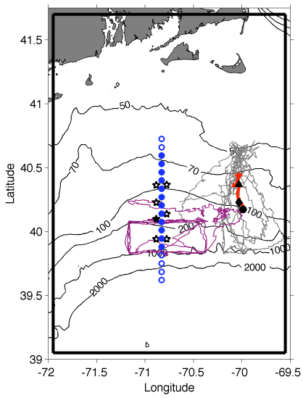 | Fig. 1. Tracks of Pioneer Array gliders (grey, magenta lines), 17 Apr – 30 Jun 2014. Red line is a cross-shelf transect on 25-26 Apr; the black triangle, diamond, and circle indicate the positions of the foot, jet and surface expression of the front, respectively. Mooring locations are shown as stars, with the central offshore mooring filled in black. Shipboard transects indicated with blue circles. The solid black boundary depicts our model domain.

With support from NSF’s Physical, Biological, and Chemical Oceanography programs, we will undertake a set of three cruises to obtain cross-shelf sections of physical, chemical, and biological properties within the Pioneer Array. Nutrient distributions will be assayed together with hydrography to detect the signature of frontal upwelling and associated nutrient supply. We expect that enhanced nutrient supply will lead to changes in the phytoplankton assemblage, which will be quantified with conventional flow cytometry, imaging flow cytometry (Imaging FlowCytobot, IFCB), in situ optical imaging (Video Plankton Recorder, VPR), traditional microscopic methods, and HPLC pigments. Zooplankton will be measured in size classes ranging from micro- to mesozooplankton with the IFCB and VPR, respectively, and also with microscopic analysis. Biological responses to upwelling will be assessed by measuring rates of primary productivity, zooplankton grazing, and net community production. These observations will be synthesized in the context of a coupled physical-biological model to test the two hypotheses that can potentially explain prior observations: (1) grazer-mediated control and (2) undersampling. Hindcast simulations will also be used to diagnose the relative importance of the various mechanisms of upwelling.

Our observational plan consists of cross-frontal transects and rate measurements, conducted in a daily cycle of activity (Fig. 2). Each day will begin with determining the precise location of the front from a combination of data from the Pioneer Array, cruise observations, and remote sensing images. Rate measurements (¹⁴C and grazing incubations) will be strategically located in one of the three key regimes: inshore, offshore, and at the front. Twelve repetitions of the observational cycle (see below) will permit four replicates in each of the three regimes, facilitating estimates of the mean and variance for each. Each of the 12 cross-frontal transects will consists of a 12-station subset of the range of possible station locations shown in Fig. 2. Each specific 12-station subset will be centered on the front, essentially shifting northward or southward as movement of the front dictates. Station spacing is 7km.
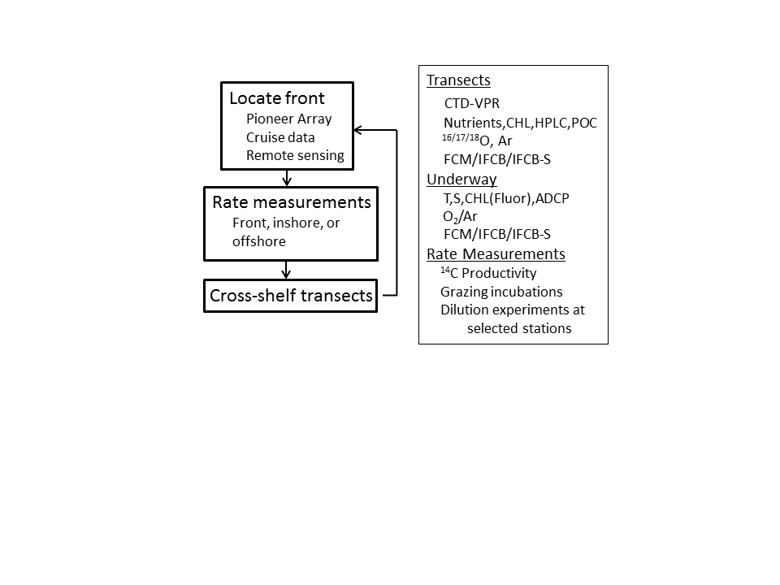
Fig. 2. Daily sampling cycle (left) and summary of measurements (right).

2. Prelude - data from AR28A and AR28B

April 6 sampling of UI-A7-A8-A9 combined with LTER stations 1-5. LTER2-4 show high F and turbidity along the bottom, perhaps due to export of the Phaeocystis bloom going on in coastal waters (Figure P1). Note that the turbidity front is offshore of the fluorescence front; could there be a gravity current of Phaeocystis?

From April 6 to April 10-11 (Figure P2) the foot of the front shoals slightly and the surface expression migrates offshore (caveat: surface expression only partially defined on April 6). Whereas there is a hint of enhanced fluorescence at the front on April 6, there is no enhancement on April 10-11.

Little change in the frontal position from April 10-11 to April 12 (Figure P3).

Satellite imagery indicates a weak ring interacting with the shelf, apparently pulling shelf water into the slope region east of the Pioneer array (Figure P4).

3. AR29 Narrative

Monday 16 April
Departure delayed from 0930 to 1630 due to weather; stood by in Menemsha Bight until 0100 to let the cold front pass.

Tuesday 17 April
Commenced science operations at 0900 with CTD transect starting at station A5. Mid-day incubation at A7 with both ¹⁴C and Grazing. Problems with MOCNESS pre-flight checks, so substituted with a ring net. Afternoon ¹⁴C at A10. Completed CTD transect, worked back inshore with an EK80 survey.
Results of the survey indicate the surface expression of the front has migrated inshore, shoreward of A12 (Figure 0417.1). Fluorescence is enhanced near the surface at A8 inshore as well as A11 at the front. A turbid bottom boundary layer remains, with a hint of upwelling along the 26.5 isopycnal.
Wednesday 18 April
VPR transect (Figure 0418.1) shows peak in fluorescence right at the front, which has moved offshore (see below). Subjective analysis of the plankton images suggests the most abundant taxa in the shelf region is echinoderm larvae and copepods. Closer to the front, chain-forming diatoms were present in the 15-40m layer; at the front and farther south they were distributed from the surface down to ca. 80m, consistent with the deeper extent of the fluorescence distribution.
Began a CTD-only transect completed on April 19 (Table 2) plus incubations (Table 1). CTD transect (Figure 0418.2) indicates the surface expression of the front between stations A13 and A14, with high fluorescence located therein, consistent with the VPR survey. Note the CTD transect was extended farther offshore with CTD-only casts (Figure 0417.1), with deep casts to assess the possibility of warm core ring interactions. Water mass analysis indicates no such influence (Figure 0417.2).
Offshore movement of the front is consistent with westward motion of front oriented WNW-ESE (Figure 0418.3,4).
Thursday 19 April

Completed CTD-plus transect (Figure 0419.1), in which the foot of the front migrated offshore and the surface expression persisted in between stations A13 and A14. Chlorophyll fluorescence is enhanced in a shallow surface layer just inshore of the front.

EK80 survey overnight; southward transect at 7.5 knots, northbound too fast.

Friday 20 April

VPR2 transect completed. In contrast to prior transects, high fluorescence is present seaward of the front and below the 26.5 isopycnal. Gordon suspects frontal subduction and is following up on that idea with the ADCP data.

Began CTD-only transect.

Saturday 21 April

CTD-only transect completed (Figure 0421.1), showing high fluorescence offshore and beneath the front as indicated in the VPR2 transect. Several casts were corrupted by blockage in the air vents, resulting erroneous oxygen values near the surface, among other problems.

CTD-plus transect (Figure 0421.2) is consistent with prior VPR tow, with highest fluorescence on the seaward side of the front. Although the spatial resolution is much coarser, there is some hint of the frontal subduction suggested by the VPR: deep penetration of the fluorescence offshore, and high fluorescence underneath the front.

Upon completion of the CTD-plus transect there was sufficient daylight for a VPR survey of the frontal area (Figure 0421.3). Again, highest fluorescence is present seaward of the front, but the high fluorescence penetrates farther shelfward, extending just past A12. The high fluorescence of this apparently subducted signal is no longer confined to below the 26.5 isopycnal, with high values extending nearly to the surface within 10km of the front.

Both the CTD-plus and VPR transects show the 26.5 isopycnal plunging downward in the vicinity of A15, apparently associated with forcing from the warm core ring offshore (Figure 0421.4, left). The ring is less visible in MODIS Chl (Figure 0421.4, right), although it is interesting to note enhanced Chl along the shelf break front just to the west of the Pioneer Array.

Carried out EIMS underway survey of lateral gradients at the front and shelf regions.

Sunday 22 April

CTD transect from A5 to A13 apparently reaches the edge of the front (Figure 0422.1). There is a patch of high fluorescence at A8 where the 26.1 to 26.3 isopycnals outcrop into the euphotic zone, suggesting the bottom boundary layer upwelling process need not reach all the way to the surface in order to stimulate phytoplankton growth.

VPR survey from A16 to A8 shows a broad area of high fluorescence in between the ring and the front. Note that the 26.5 isopycnal no longer outcrops, perhaps due to some combination of the ring interaction and surface heating. A patch of very high fluorescence is located between A8 and A9, with values approximately three times higher than see in prior transects. This area is flanked by two patches of high turbidity in the bottom boundary layer. These findings motivated adaptive sampling of these features with stations B1(high turbidity north of A8), B2 (high fluorescence in between A8 and A9), and B3 (high turbidity in between A9 and A10). CTD fluorometer read values in excess of 8 ug/L, suggesting the anomaly located by the VPR had been located. CTD sections including the adaptive sampling stations (Figure 0422.3) differ markedly from the initial transect (cf. Figure 0422.1).

Monday 23 April

In retrospect, the high fluorescence patch in the vicinity of A8 and A9 appears to be a tendril of the large scale bloom taking place south and west of Nantucket Shoals (Figure 0423.1, left). Interestingly enough, the southwestward extension of the bloom disappeared from surface waters overnight (Figure 0423.1, right).

CTD-plus survey starting at A16 extended north to A2 in order to sample the high chlorophyll region. High fluorescence in bottom waters at A2 and A3 overlain by high oxygen (Figure 0423.2), and high biological saturation was indicated in underway measurements (not shown).

Based on the latest transect, and the fact that the warm core ring to the south is pushing the front northward, the recommended AL AUV survey starting latitude is A12. This advice was conveyed to the OOI AUV team.

EK80 survey begun at A2 heading south.

Tuesday 24 April

EK80 survey completed at A13.

AUV intercalibration operations yielded four simultaneous profiles (Table 3). Across-shelf (Figure 0424.1) and along-shelf surveys (0424.2) are consistent with what we have seen thus far in CTD and VPR sampling. Nitrate values are a bit suspect: nearly all values are zero in the along-shelf survey. In the across-shelf survey, removing the zero values sprinkled throughout yields an oceanographic-looking pattern, but the values seem high. Calibration and QA/QC will be pursued post-cruise.

CTD-only transect from A16 to A9 reveals the ring has impinged upon the front, causing slope water to disappear from surface waters (Figure 0424.3). The ring interaction is depicted in ADCP velocities overlayed on sea surface temperature imagery (Figure 0424.4).

Wednesday 25 April

VPR Survey from the front (A11) to A16 provides details of the ring interaction (Figure 0425.1). As suggested by the prior CTD survey (Figure 0424.1), ring waters impinge upon shelf waters, forcing the slope water downward. There appears to be a layer of shelf water subducted under the ring as well, with a thin strip of cold, fresh, high-fluorescence water extending about 5 km underneath the ring water. Complex interleaving of ring and slope water is evident south of the front.

CTD-plus survey begun.

Thursday 26 April

CTD-plus survey completed, confirming the shelfbreak front has become a shelf-ring front between A10 and A11, with slope water underneath (Figure 0426.1). An intrusion of cold and fresh shelf water extends seaward under the ring water out to station A12. High fluorescence is present in the bottom boundary layer (BBL) in the innermost stations A2-A6. Analysis of a DAVPR profile in that area confirms the presence of high concentrations of Phaeocystis in the BBL. Might the BBL be an incubator of Phaeocystis if the top of the BBL outcrops into the euphotic zone? Need to look at the PAR data to see if this is plausible.

Too foggy to tow VPR; transited to A16 for incubations

VPR transect from A16 to A8 reveals highest fluorescence inshore of the front and in the ring streamer (Figure 0426.2). Chl and backscatter signals suggest subduction on the southern edge of the streamer.

CTD section begun A8-A16.

Friday 27 April

Upon reaching A16 it was clear that we were still in ring streamer water (Figure 0427.1), apparently due to the arrival of a thicker part of the streamer being advected in from the southwest (Figure 0427.2). Occupied two more stations, and arrived at the edge of slope water at A18 (Figure 0427.1), providing the needed material for incubations.

CTD-plus survey begun.

Saturday 28 April

CTD-plus survey completed (Figure 0428.1).

Carried out a VPR survey of Phaeocystis bloom based on the April 23 satellite image (0428.2). Image classification remains to be carried out, but qualitative observations during the tow suggest optical backscatter was a reasonable proxy for the highest concentrations of Phaeocystis colonies (Figure 0428.3). Whereas Phaeocystis was confined mostly to BBL near A2, it outcropped at the surface as we transited north into the least stratified region. More opaque colonies (“pearl drops”) more prevalent in that area, with “whiteout” conditions of Phaeocystis colonies spanning from the surface to the bottom.

Returned to A2 and completed a CTD-only transect A2-A8 (Figure 0428.4). It appears the near surface high fluorescence patch A5-A8 may be being advected in from the northwest (Figure 0428.5).

Initial synthesis

Six distinct phases of the shelf/slope regime can be discerned from our observations (Figure 0429.1). During the prelude of our voyage (phase 1), data from AR28A indicated a shelfbreak front which was in a more “upright” position, with the surface expression only about 20km offshore of its contact with the bottom (Figure 0429.2). During this phase, there was little evidence of fluorescence enhancement at the front. By the beginning of AR28B, the surface expression of the front had migrated more than 20 km offshore, whereas the bottom contact point migrated slightly offshore (phase 2), and again there was little evidence of fluorescence enhancement at the front. Five days later at the beginning of AR29, the front was in approximately the same configuration (Figure 0429.2), but fluorescence was enhanced on the inshore side of the front (Figure 0417.1). A day later, the enhanced fluorescence straddled the front, with some evidence of subduction downward on the offshore side (Figure 0418.1). On April 20, there was little fluorescence left on the inshore flank of the front, with large enhancement offshore and underneath the front (Figure 0420.1). In phase 3, a streamer from a warm core ring approached the front (Figures 0429.1, 0418.3), with high fluorescence extending across the front to the streamer edge. In phases 4 and 5, the streamer comes in contact with the front, forming a “shelf ring front” in which slope water was absent from surface waters (Figure 0429.1). Calm conditions and heating during this time increased stratification, causing the 26.5 isopycnal to descend and flatten in the interfacial region. At this point, the S=34.5 isopycnal becomes a more reliable indicator of the frontal position. To first order, high fluorescence persists inshore of the 34.5 isohaline, with the inshore extent possibly determined by where near-bottom isopycnals / isohalines outcrop into the euphotic zone, which is roughly 40 m in this region. In the final phase we observed, the ring streamer pushed the front farther inshore, to the point where the 35.4 isohaline is markedly more vertical than it was earlier in the cruise. Northward movement of these features made slope water available at the southern boundary of our sampling area, in which we collected two replicates for incubations. We note this slope water may have different origin than the “ambient,” insofar as it has been advected clockwise around the periphery of the ring from southeast all the way around to the north of the ring (Figure 0429.2).

Mid-way through the cruise we observed an area of high fluorescence well inshore of the shelfbreak front, in near-surface waters in the vicinity of A5 (Figure 0421.1) and A8-A9 (Figure 0422.1). Phaeocystis was detected in these samples, and its origin is made clear in satellite imagery: tendrils of a large-scale patch of chlorophyll south of Martha’s Vineyard and Nantucket (Figure 0423.1, left). Curiously, the surface expression of this disappeared a day later (Figure 0423.1, right). Our data suggest sinking as an explanation. Although the fluorescence distribution on from A2 to A4 on April 23 (Figure 0423.2) appears to be distributed uniformly from surface to bottom, saturation of the color bar obscures the fact that the highest fluorescence occurs in the BBL. As time went on, surface waters above the deep population of Phaeocystis became very clear (Figure 0426.1), and fluorescence in the BBL became very high, with values exceeding 15 μg Chl L⁻¹. One potential explanation for the observed distribution can be framed in a regime consisting of a surface mixed layer (SML), euphotic zone (EZ), and bottom mixed layer (BML), each of uniform depth (Figure 0429.4). Suppose the widespread bloom observed in the satellite image on April 22 (Figure 0423.1) was confined to the mixed layer over the shelf, except for the region where the SML and BML intersect (Figure 0429.4, top). If the near-surface bloom were to terminate due to exhaustion of the nutrient inventory in the SML, it may sink down to the BML as a result. Based on climatology (Zhang et al., 2013), we expect the BML to have an ample supply of nutrients. Therefore, the bloom could continue to thrive in the region where the BML is in contact with the euphotic zone—thus setting the across-shelf extent of the BML population. Irradiance observations at station A2 indicate a 1% light depth of ca. 40m, which would be sufficient to illuminate the top of the BML. A subsurface oxygen maximum overlying the BML is consistent with the notion that the deep Phaeocystis population is actively photosynthesizing. A VPR survey into the high-Chl region of the April 23 satellite image reveals distributions of Phaeocystis relative to hydrographic, bio-optical, and structure that is roughly consistent with the conceptual model (Figure 0428.3).

Appendix A. Cruise participants

Dennis McGillicuddy, Woods Hole Oceanographic Institution
Heidi Sosik, Woods Hole Oceanographic Institution
Weifeng Zhang, Woods Hole Oceanographic Institution
Walker Smith, VA Institute of Marine Science, College of William & Mary
Jefferson Turner, University of Massachusetts, Dartmouth
Christian Petitpas, University of Massachusetts, Dartmouth
Daniel Brinkhuis, ScienceMedia.nl
Saskia Madlener, ScienceMedia.nl
Meredith Meyer, Virginia Institute of Marine Science
Zuchuan Li, Woods Hole Oceanographic Institution
Zoe Sandwith, Woods Hole Oceanographic Institution
Jaclyn Friedman, Virginia Institute of Marine Science
Elizabeth Larson, UMass Dartmouth
Melissa Campbell, Division of Marine Fisheries
Philip Alatalo, Woods Hole Oceanographic Institution
Joshua Eaton, Woods Hole Oceanographic Instituion
Melissa Brennan, Woods Hole Oceanographic Institution
Taylor Crockford, Woods Hole Oceanographic Institution
Bethany Fowler, Woods Hole Oceanographic Institution
Kevin Archibald, Woods Hole Oceanographic Institution
Zhen Cheng, Woods Hole Oceanographic Institution
Christopher Seaton, Woods Hole Oceanographic Institution
Joseph McCabe, Woods Hole Oceanographic Institution
Ms. Emily Shimada – MATE Intern

Date | Morning | Midday | Afternoon
4/17 |  | ¹⁴C, Gr, ring net  A7 Shelf | ¹⁴C  A10 Shelf
4/18 | ¹⁴C  A5 Shelf | ¹⁴C, Gr, MOCNESS  A14 Slope | ¹⁴C  A16 Slope
4/19 | ¹⁴C, Gr, MOCNESS  A13 Front | ¹⁴C  A12 Shelf | -
4/20 | ¹⁴C  A5 Shelf | ¹⁴C, Gr, MOCNESS  A14 Front | -
4/21 | ¹⁴C, Gr, MOCNESS  A7 Shelf | ¹⁴C  A13 Shelf/Front | -
4/22 | ¹⁴C  A6 Shelf | ¹⁴C, Gr, MOCNESS  A13 Shelf/Front | -
4/23 | ¹⁴C, Gr, MOCNESS  A13 Slope/Front | ¹⁴C  A11 Shelf/Front | -
4/24 | ⁻ | ¹⁴C, Gr, MOCNESS  AUV AC2  W of A7/A8 Shelf | -
4/25 | ¹⁴C, Gr, MOCNESS  A11 Front | ¹⁴C  A16 Ring
4/26 | ¹⁴C  A2 Shelf  [Phaeocystis P vs I] | ¹⁴C, Gr, MOCNESS  A16 Slope | -
4/27 | ¹⁴C, Gr, MOCNESS  A18 Slope | ¹⁴C  A14 Ring | ¹⁴C  A10 Front
4/28 | ¹⁴C, Gr, MOCNESS  A2 Shelf
Table 1. Incubations.

Date | Instrument | Start | End | Foot | Surface | Criterion
4/6 | CTD |  |  | A7* | A9 | σ_{T} = 26.5
4/10-11 | CTD |  |  | A7 | A12 / A13
4/12 | CTD |  |  | A7 | A12 / A13
4/17 | CTD plus | A5 | A14 | A7/A8 | A12 | S=34.5
4/17 | EK80 | A14 | A5 | - | -
4/18 | VPR | A5 | A14 | A8 | A13/A14
4/18-19 | CTD only | A14-A18-A13-A8 | A8* | A8/A9 | A13/A14
4/19 | CTD plus | A13-A15-A12-A5 | A5 | A8 | A13/A14
4/19 | EK80 | A5-A15-A5 | A5 | - | -
4/20 | VPR | A5 | A16 | A8/A9 | A13
4/20-21 | CTD | A14-A15-A16 | A13-A5 | A8 | A13
4/21 | CTD plus | A5 | A16 | A8 | A13
4/21 | VPR no images | A16 | A11 | - | A14
4/22 | CTD | A5 | A13 | A8 | -
4/22 | VPR | A16 | A8
4/23 | CTD plus | A16-A13-A14-A15 | A2 | A8/A9 | A13
4/23-24 | EK80 | A2 | A13 | - | -
4/24-25 | CTD | A16 | A9 | - | A12
4/25 | VPR | A11 | A15
4/25-26 | CTD plus | A16 | A2 | A9 | A10/A11
4/26 | Underway | A2 | A16
4/26 | VPR | A16 | A8 | - | A11
4/26 | CTD | A8 | A17 | A9 | A11
4/27-28 | CTD plus | A18 | A2 | A8 | A10-A11
4/28 | VPR | A2-P1 | P2
4/28 | VPR | P2-P3 | A2
4/28-29 | CTD | A2 | 8 | - | -
Table 2. Transects and frontal locations based on the criteria indicated in the right-hand column. Estimates based on data that did not quite reach the surface or bottom indicated by asterisks.

Date | Time | Location | CTD Cast Number
4/24 | 0345 | AC-1 | 98
4/24 | 0945 | AL-1 | 99
4/24 | 1230 | AC-2 | 100
4/24 | 1800 | AL-2 | 101
Table 3. AUV / CTD intercalibration stations.

LTER1 LTER2 LTER3 LTER4 LTER5 UI A7 A8 A9  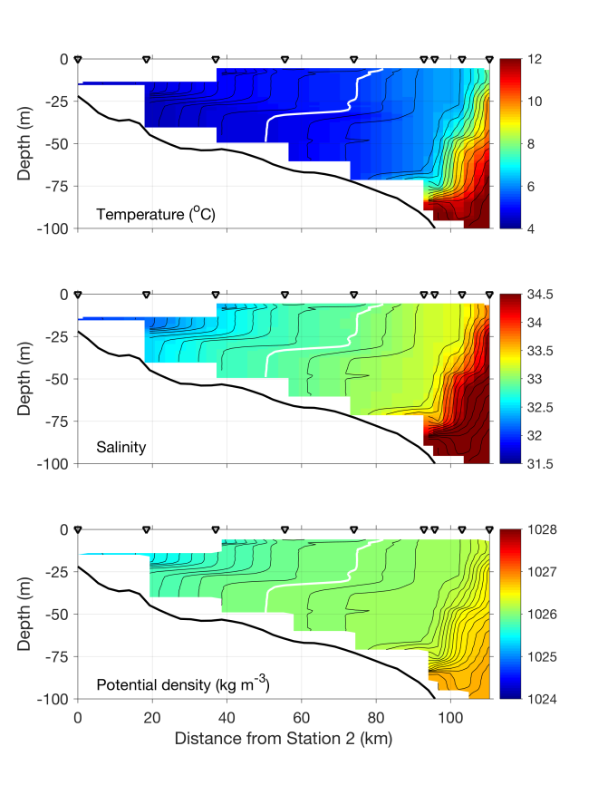 | LTER1 LTER2 LTER3 LTER4 LTER5 UI A7 A8 A9  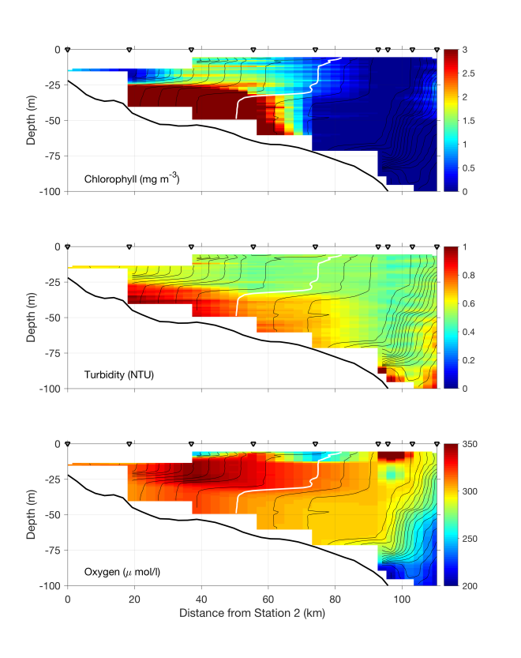
Figure P1. April 6 section.

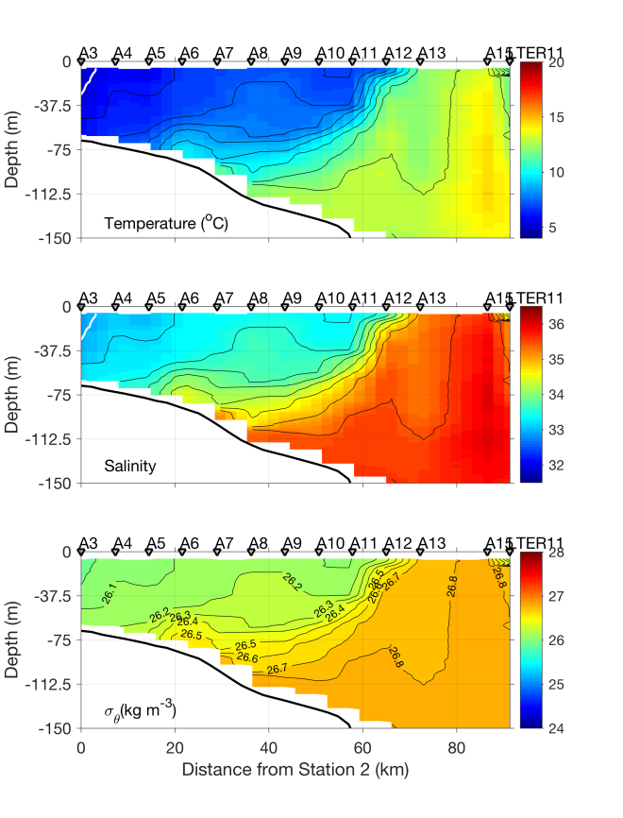 | 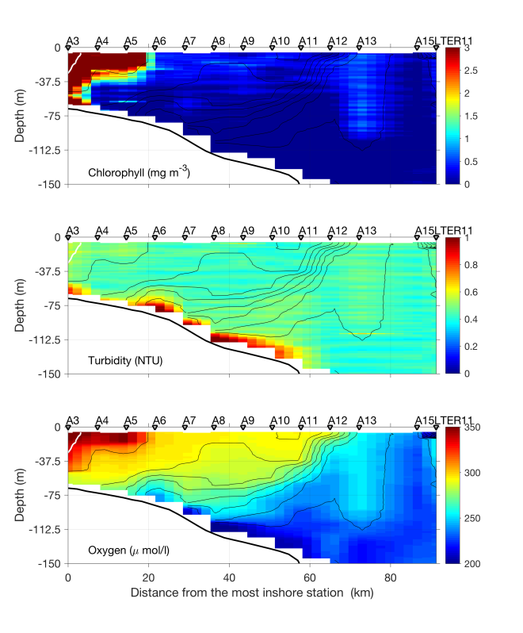
Figure P2. April 10-11 section.

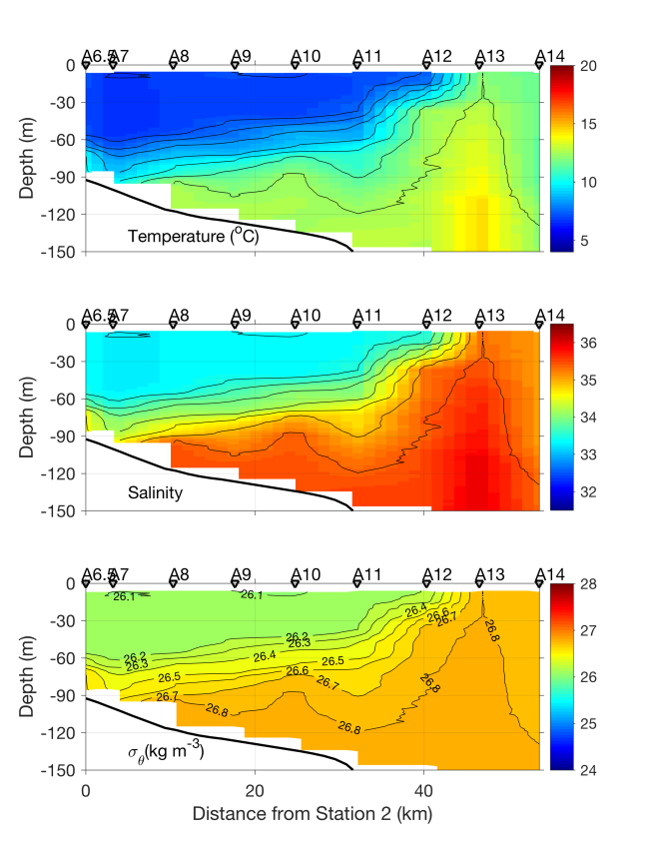 | 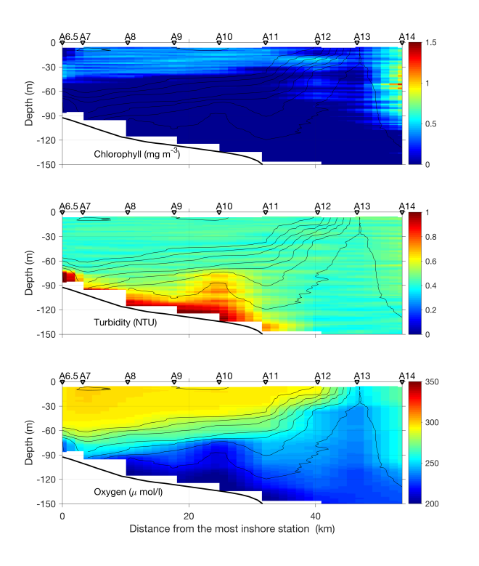
Figure P3. April 12 section.

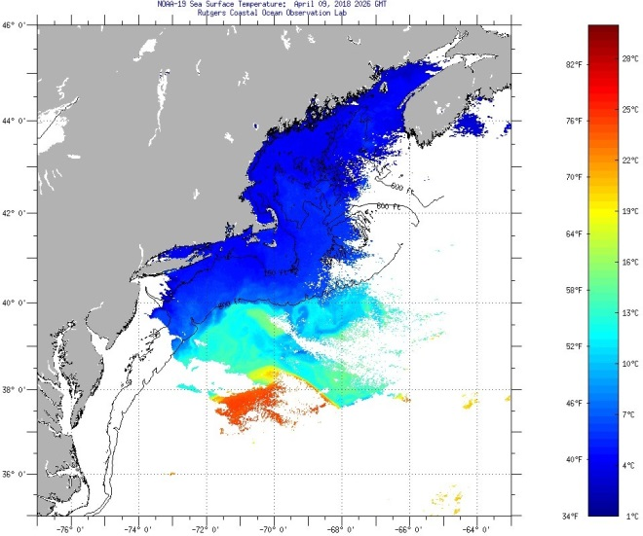 | 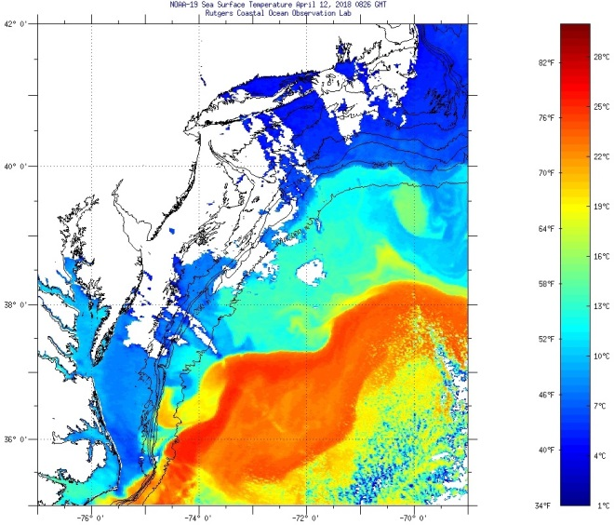
Figure P4. SST images from April 9 and April 12.

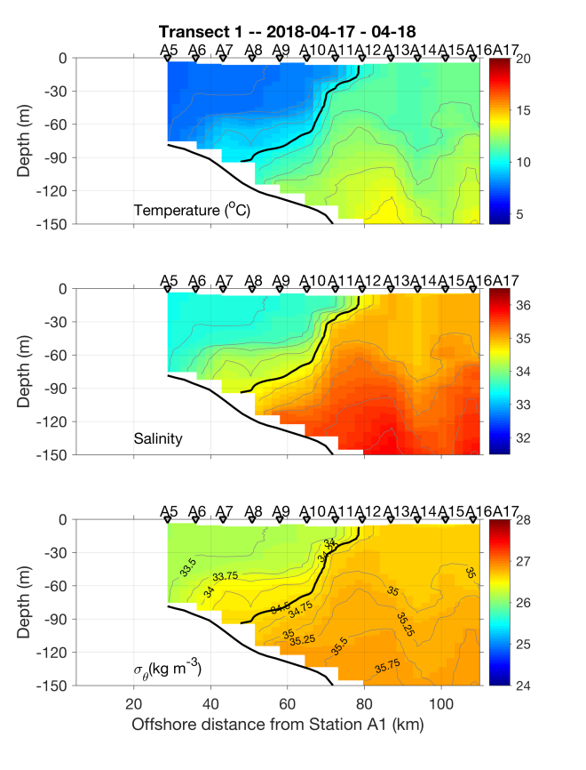 | 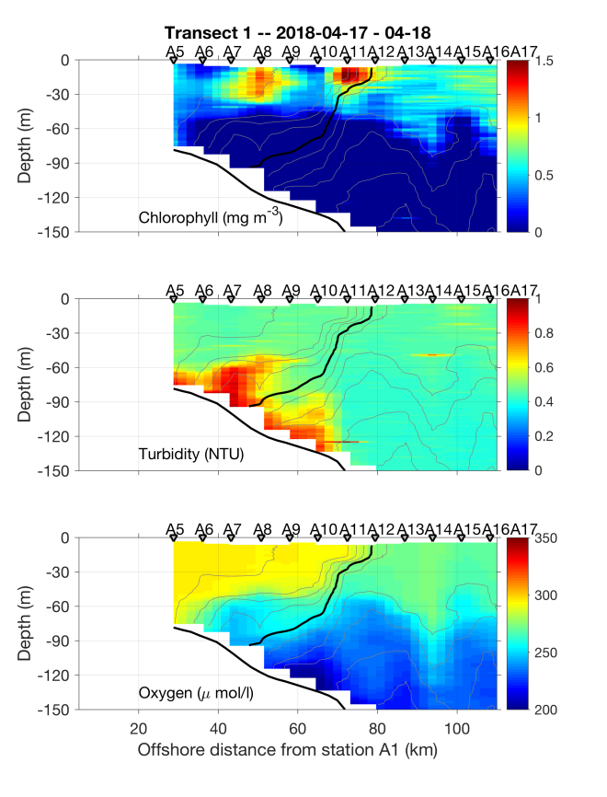
Figure 0417.1: April 17 CTD section. Note that offshore casts come from April 18, and were extended to depth (not shown).

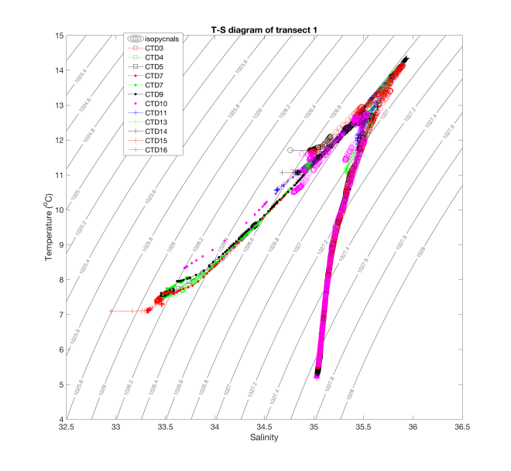
Figure 0417.2: Water mass analysis based on stations in Figure 0417.2

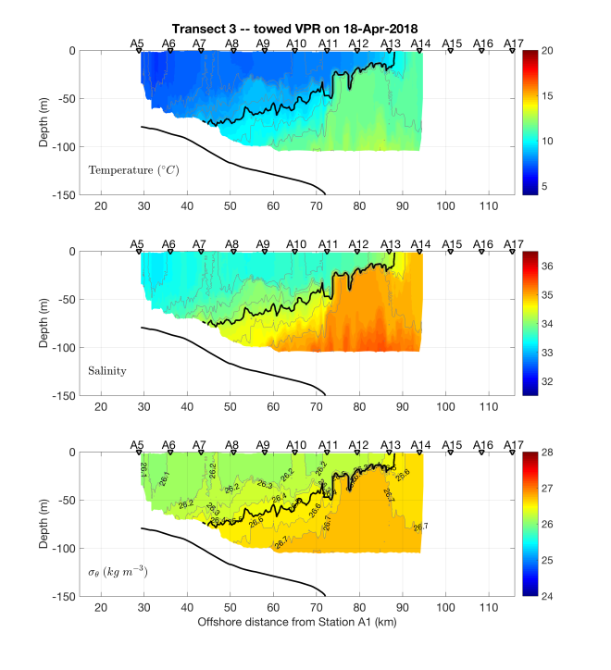 | 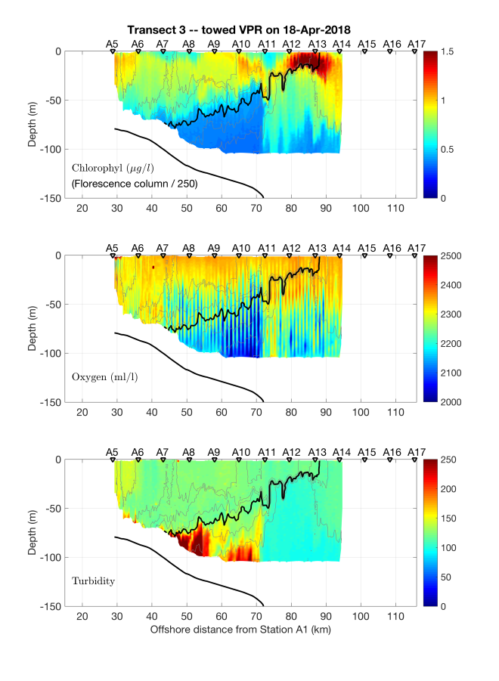
Figure 0418.1: VPR1, April 18. Note that oxygen has not been corrected for sensor temporal offsets.

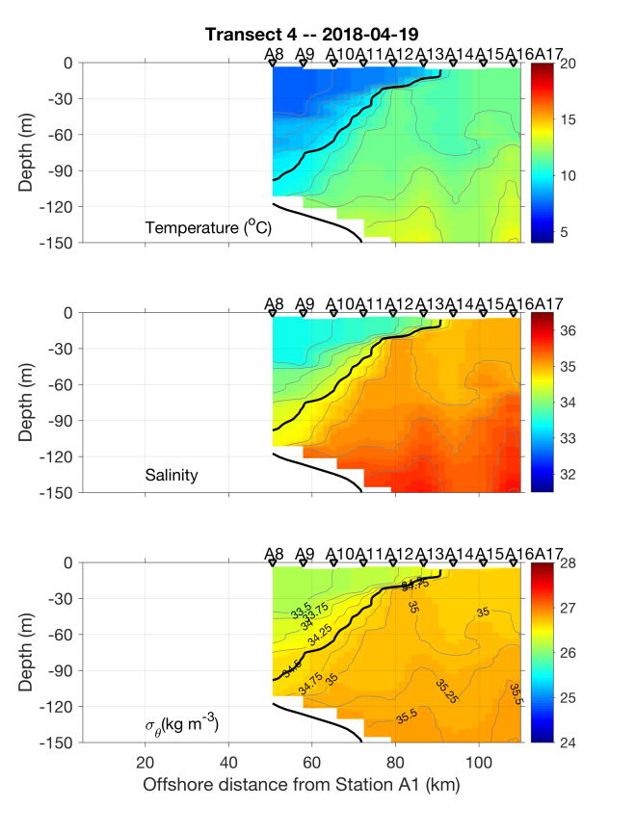 | 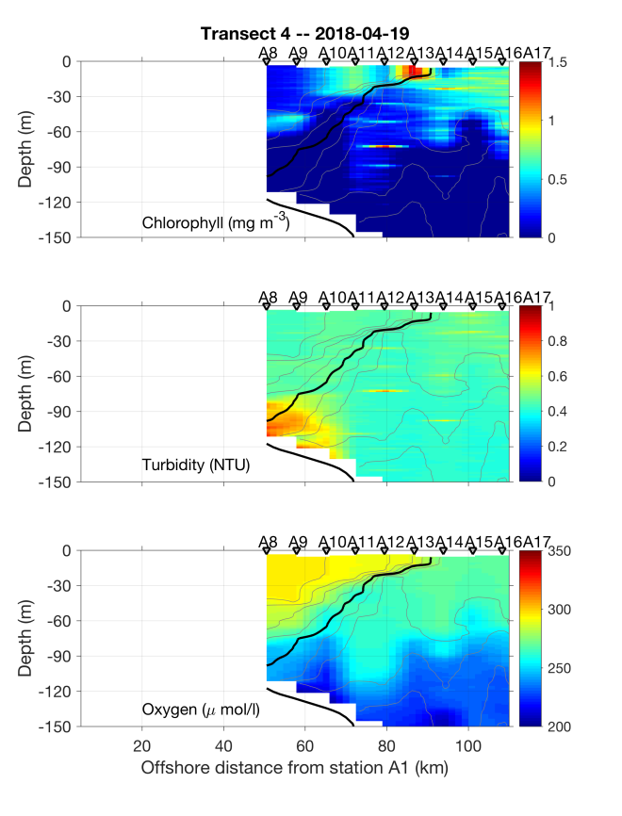
Figure 0418.2: April 18 CTD section.

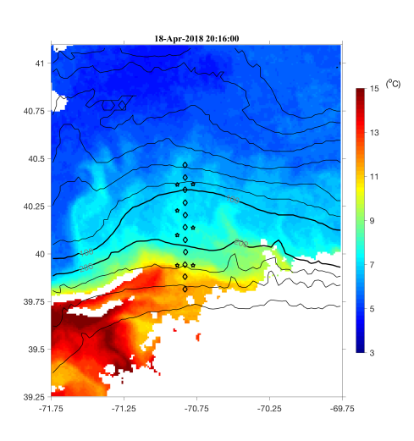 | 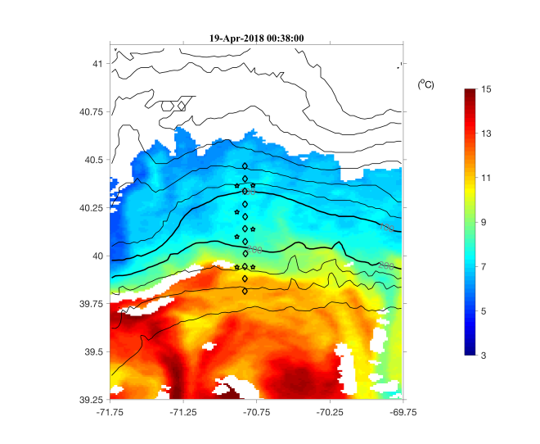
Figure 0418.3: Satellite images for 18 and 19 April.

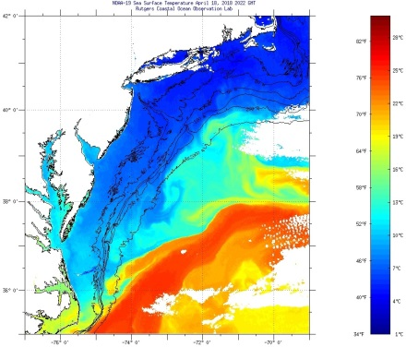 | 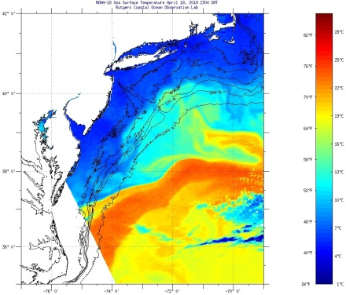 | 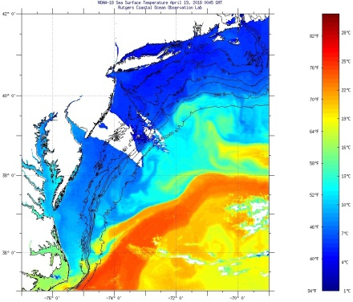
Figure 0418.4: Satellite images for 18 and 19 April.

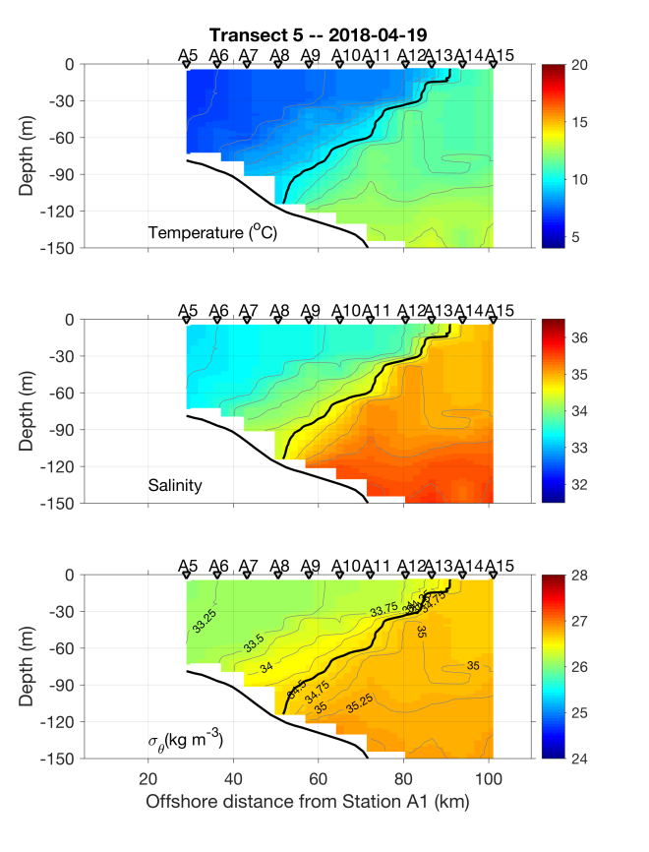 | 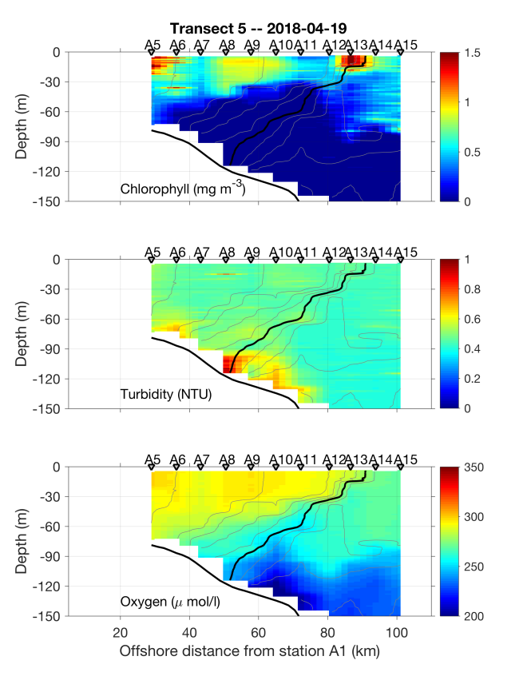
Figure 0419.1: April 19 CTD section.

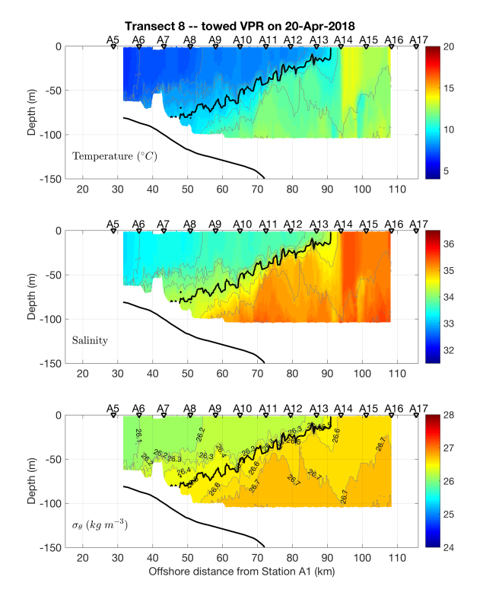 | 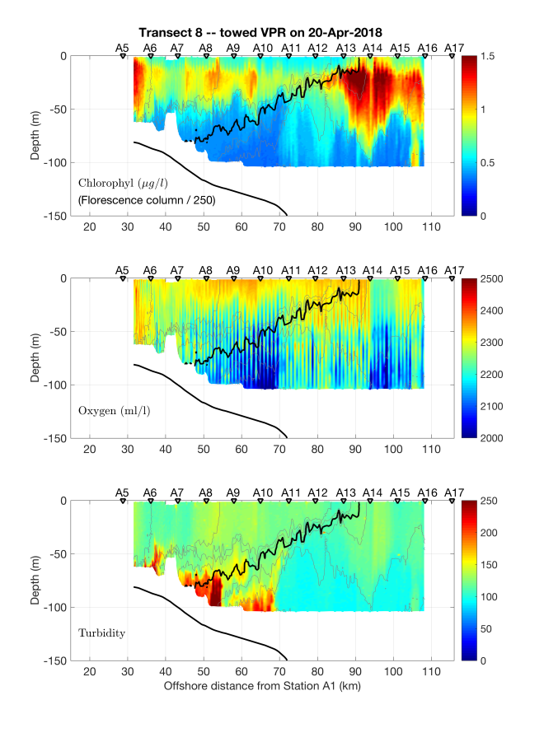
Figure 0420.1: VPR2, April 20. Note oxygen has not been corrected for sensor temporal offsets.

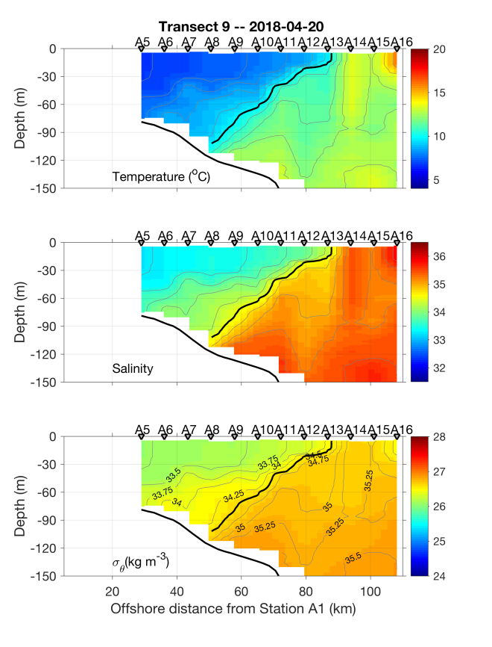 | 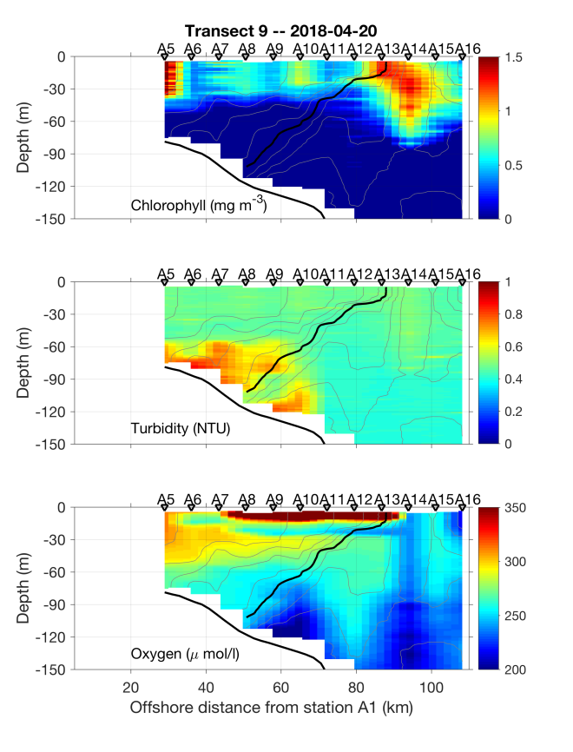
Figure 0421.1: April 20-21 CTD section.

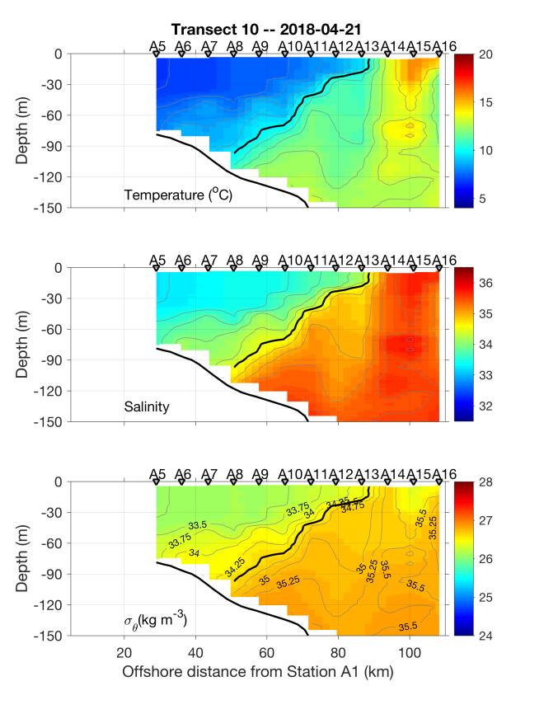 | 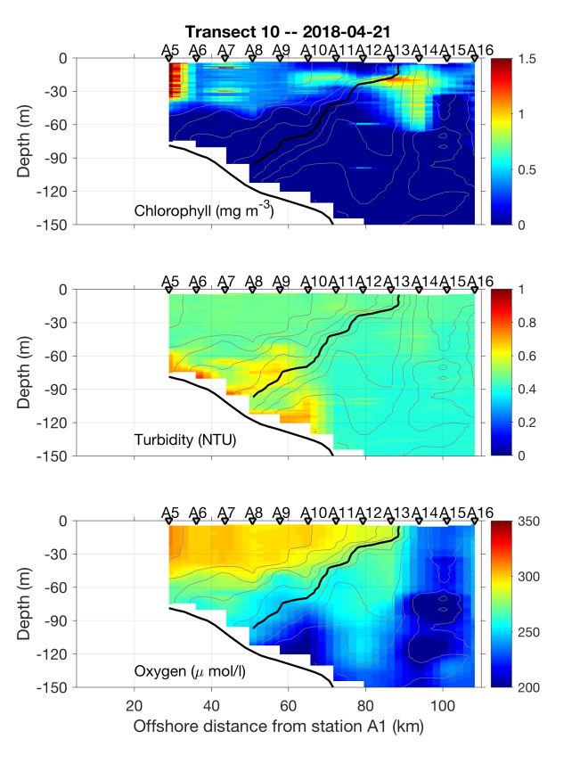
Figure 0421.2: April 21 CTD plus section.

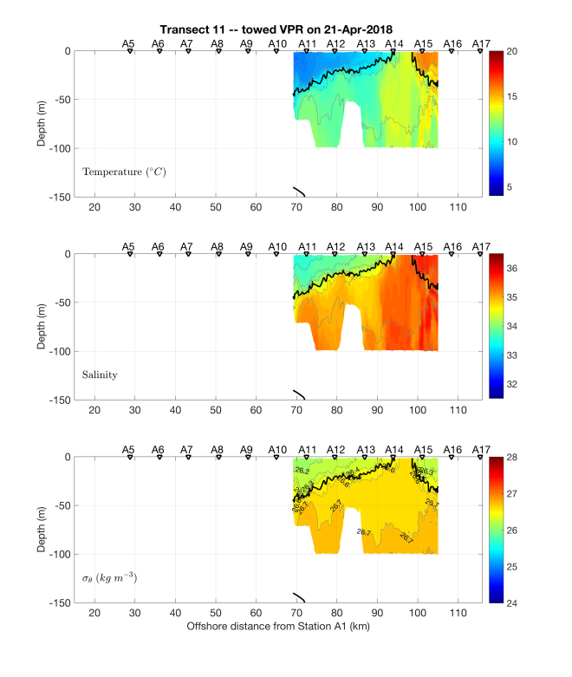 | 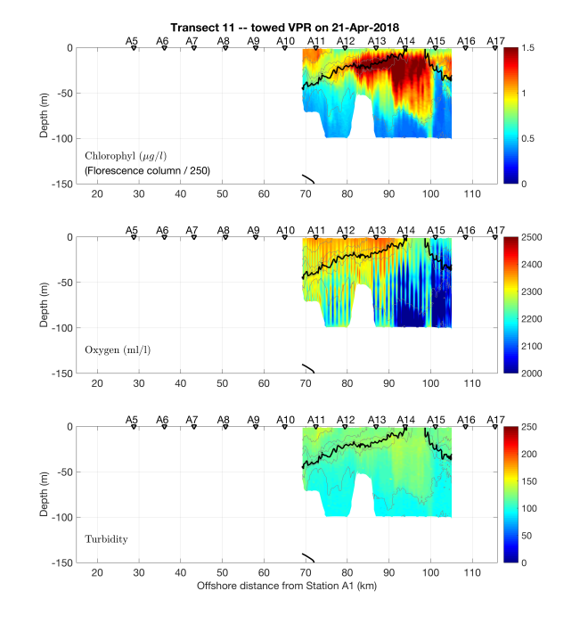
Figure 0421.3: VPR tow 3, April 21.

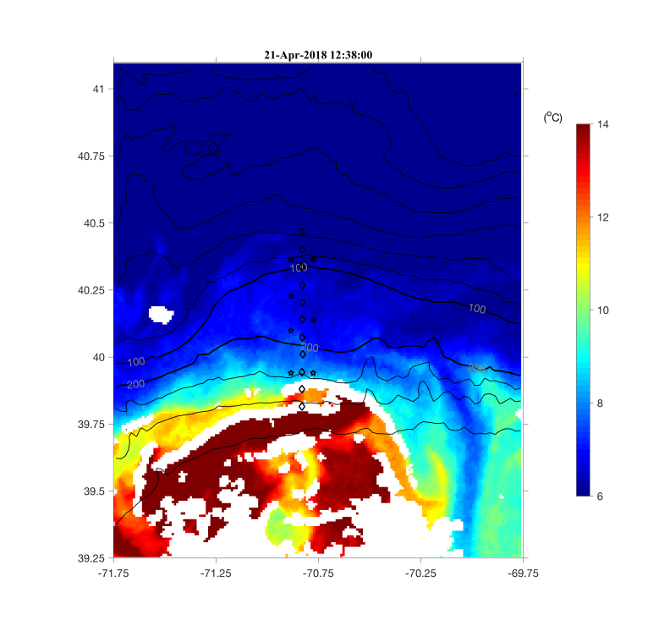 | 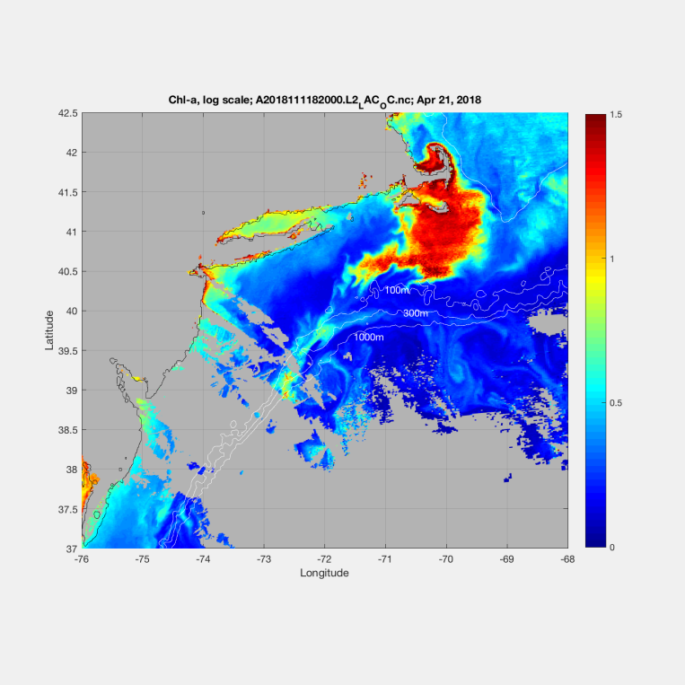
Figure 0421.4: Satellite SST (left) and ocean color (right) from April 21.

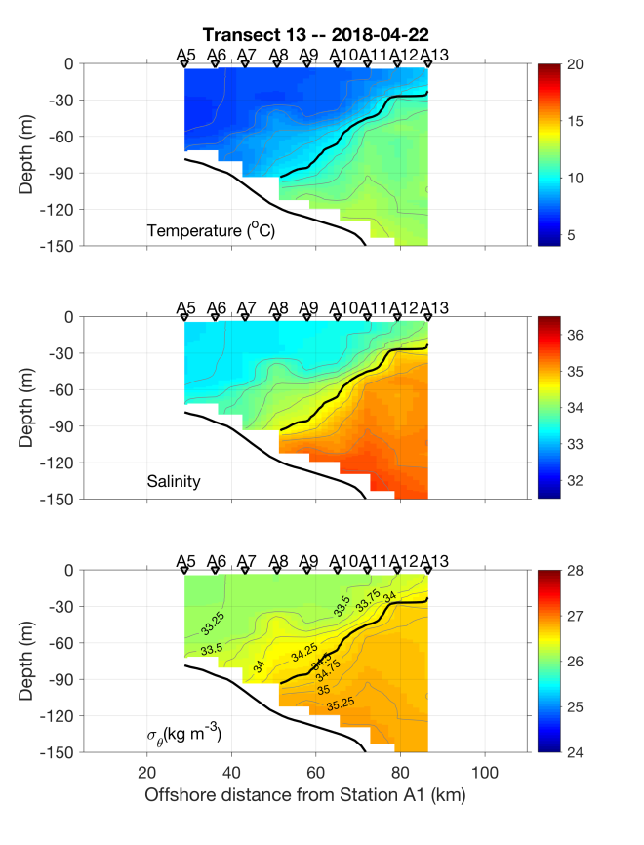 | 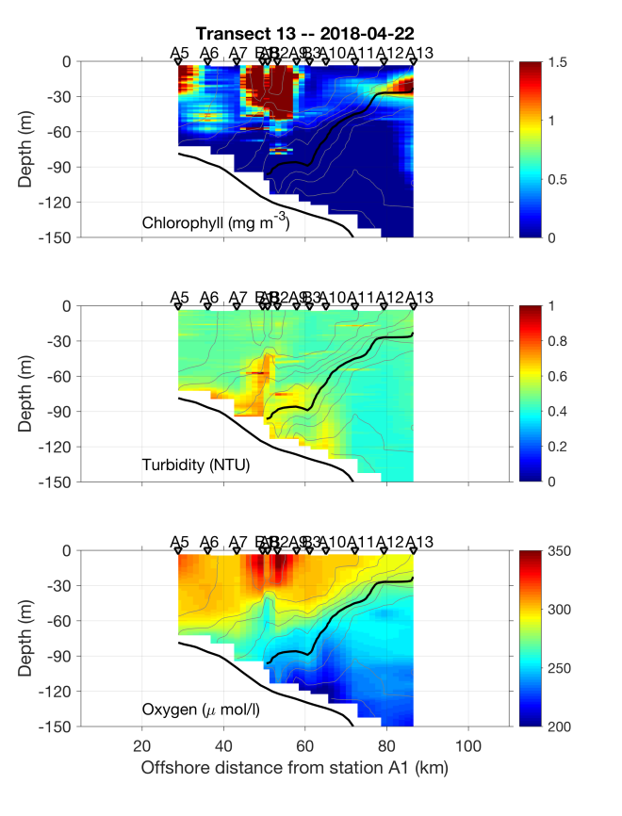
Figure 0422.1: April 22 CTD section.

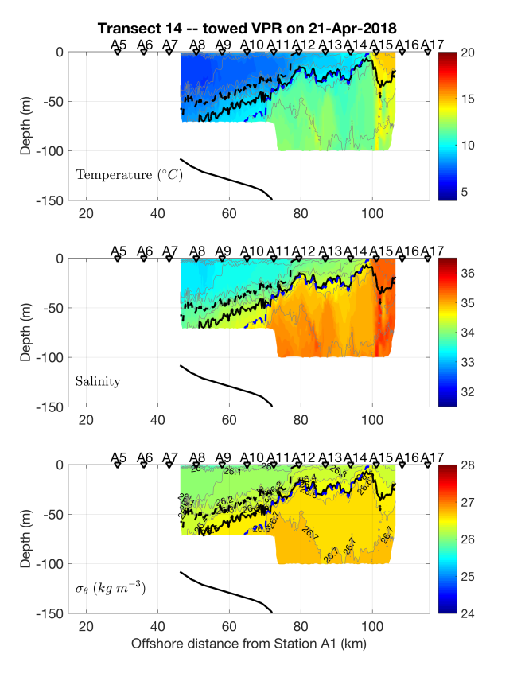 | 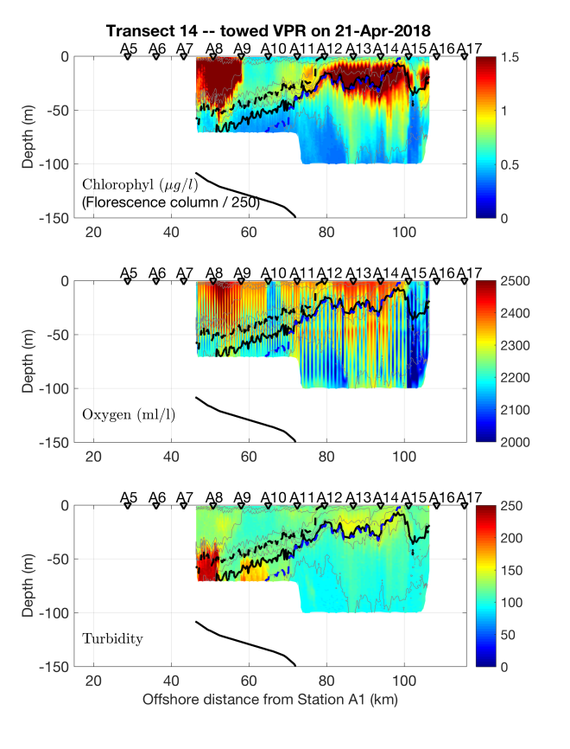
Figure 0422.2: April 22 VPR transect. Bold line is the 26.5 isopycnal; dashed and blue lines are the 34.0 and 34.5 isohalines.

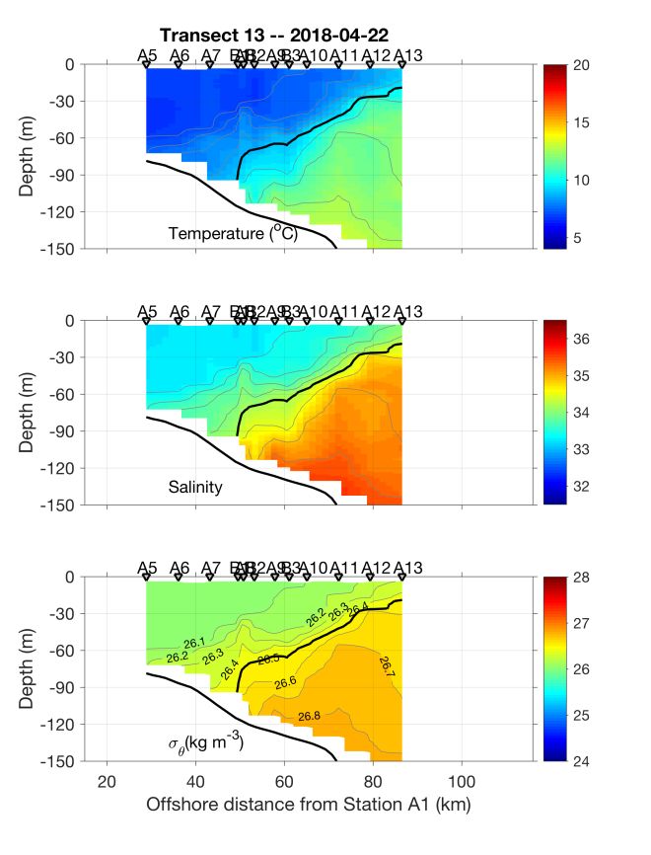 | 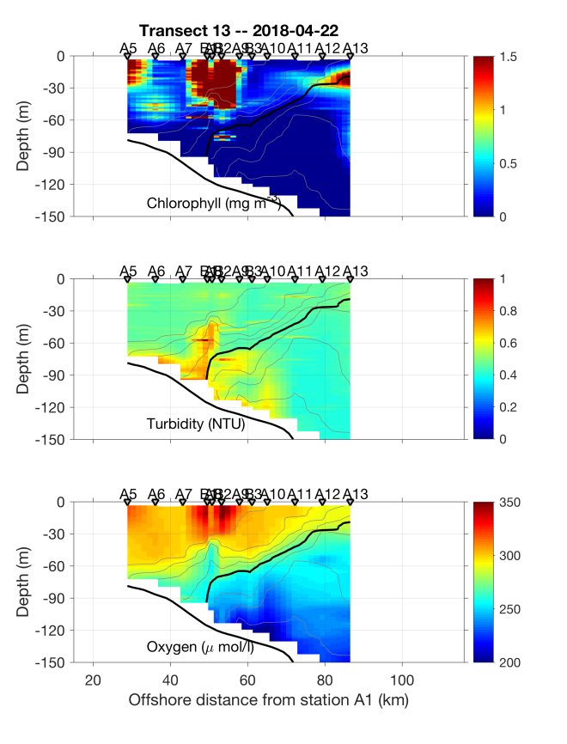
Figure 0422.3: April 22 CTD section with adaptive sampling stations B1, B2, B3 added.

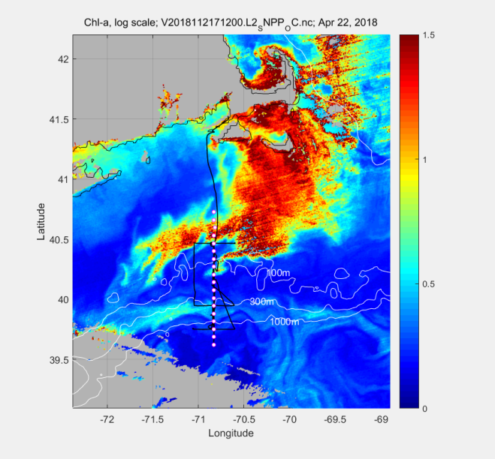 | 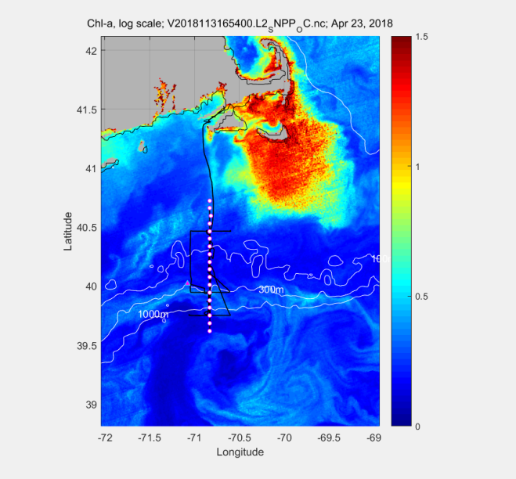
Figure 0423.1: VIIRS Chl images for April 22 (left) and April 23 (right). Track of the R/V Neil Armstrong and station positions A1-A18 indicated.

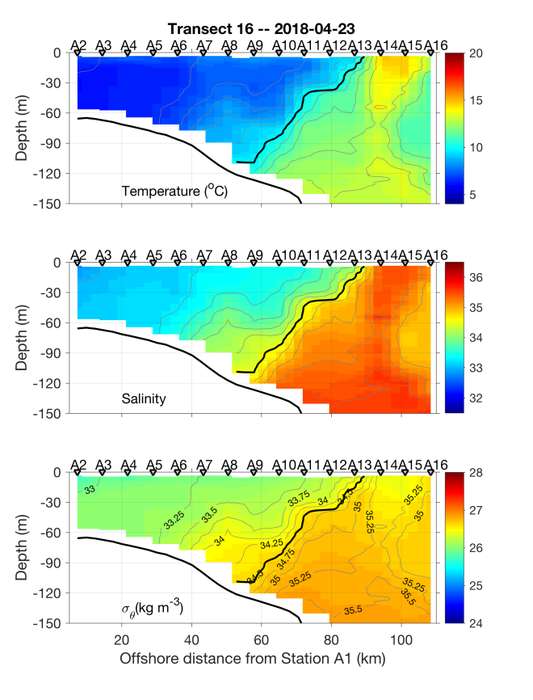 | 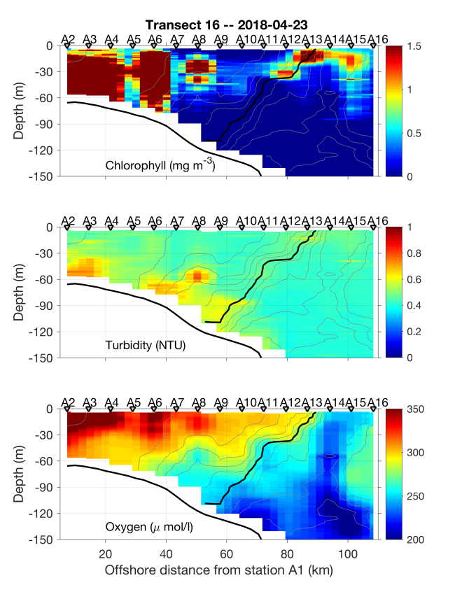
Figure 0423.2: April 23 CTD section. Note the change in color bar for chlorophyll fluorescence (upper right).

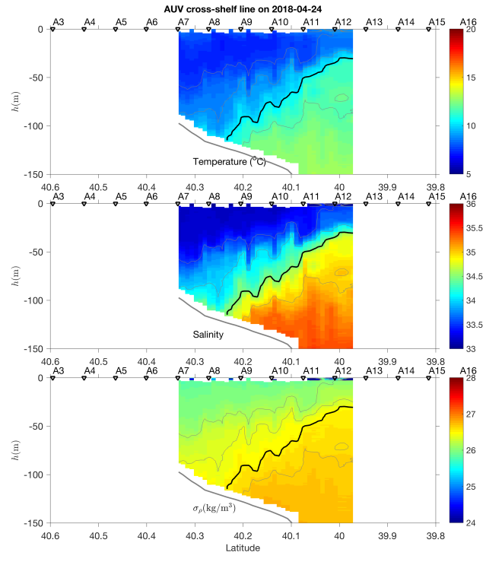 | 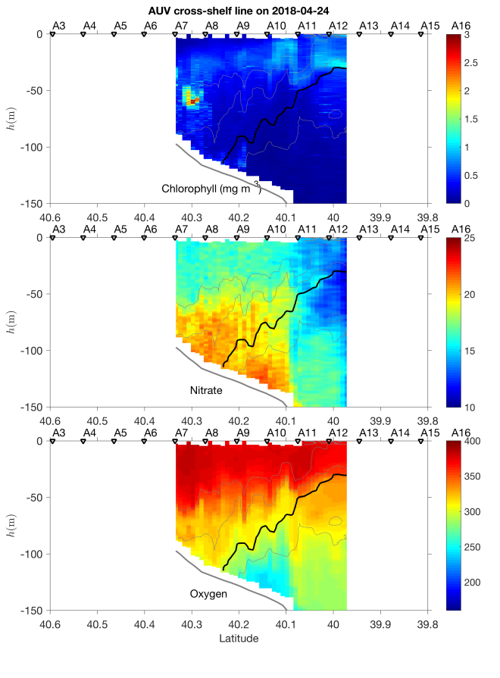
Figure 0424.1: Across-shelf AUV survey.

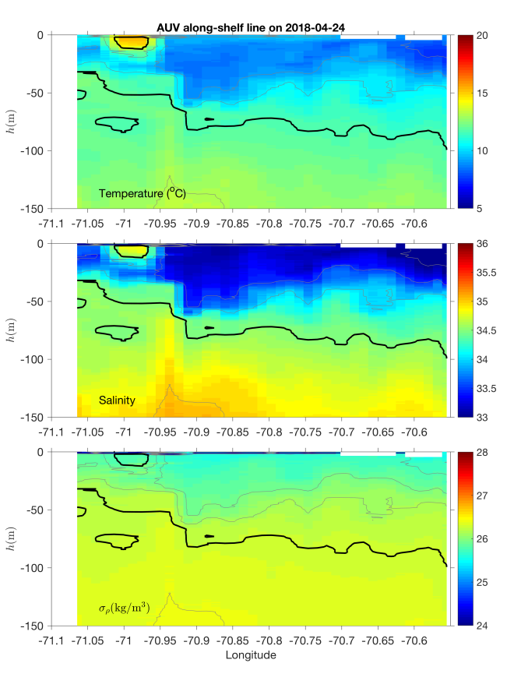 | 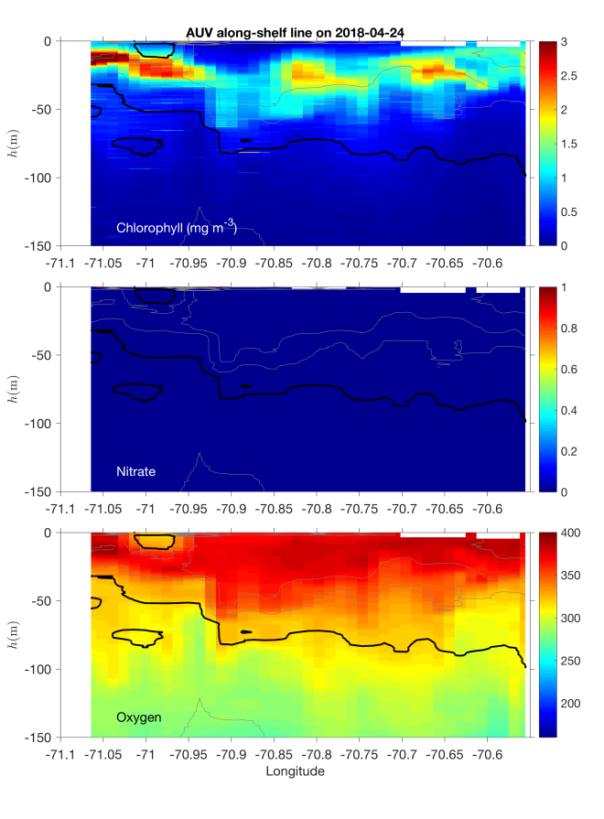
Figure 0424.2: Along-shelf AUV survey.

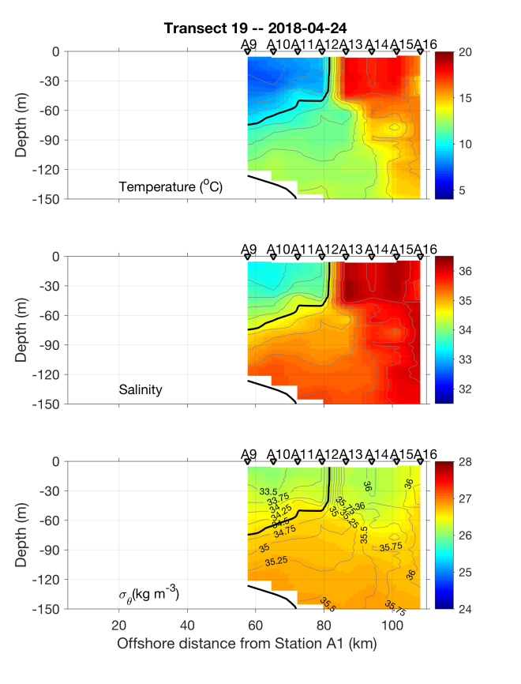 | 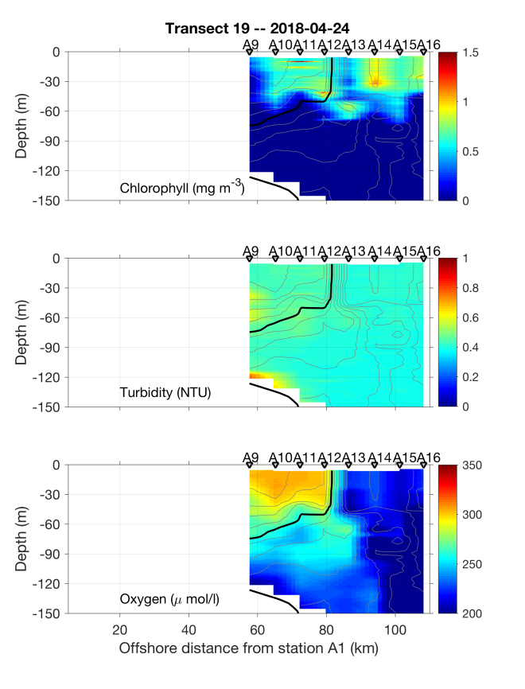
Figure 0424.3: April 24 CTD section.

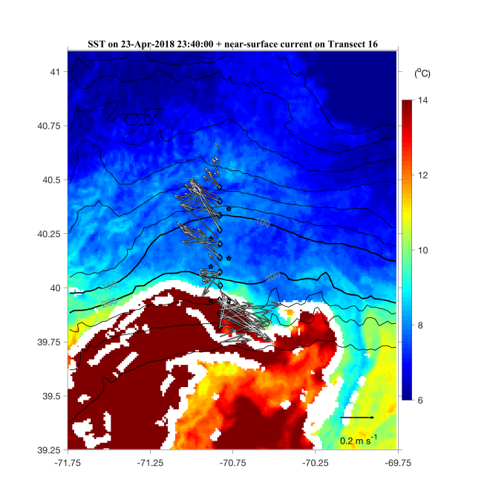
Figure 0424.4: SST image with ADCP near-surface velocity overlayed.

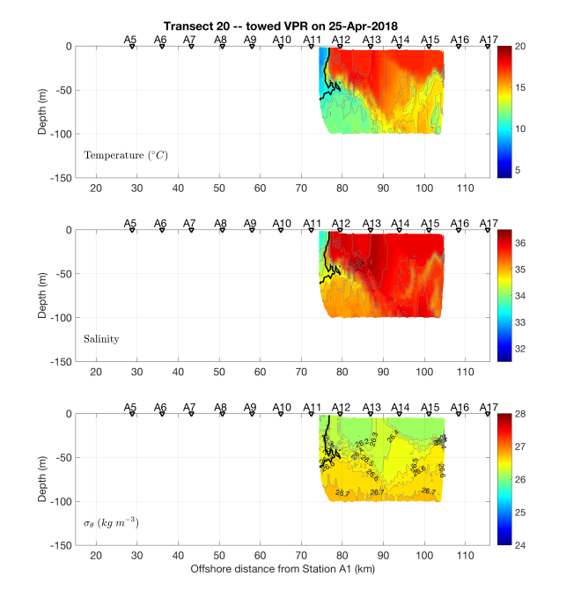 | 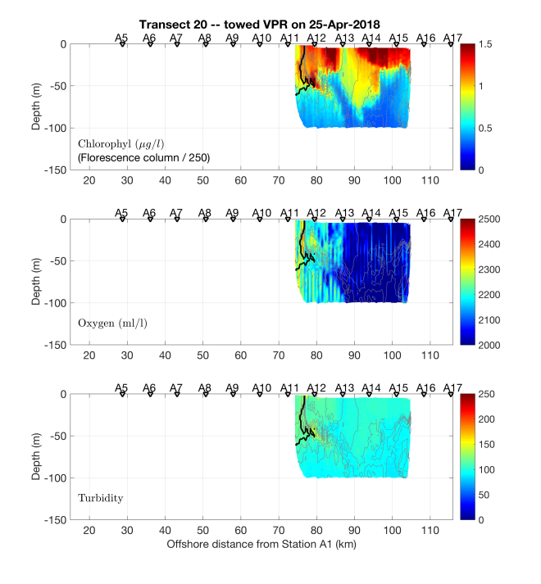
Figure 0425.1: April 25 VPR section.

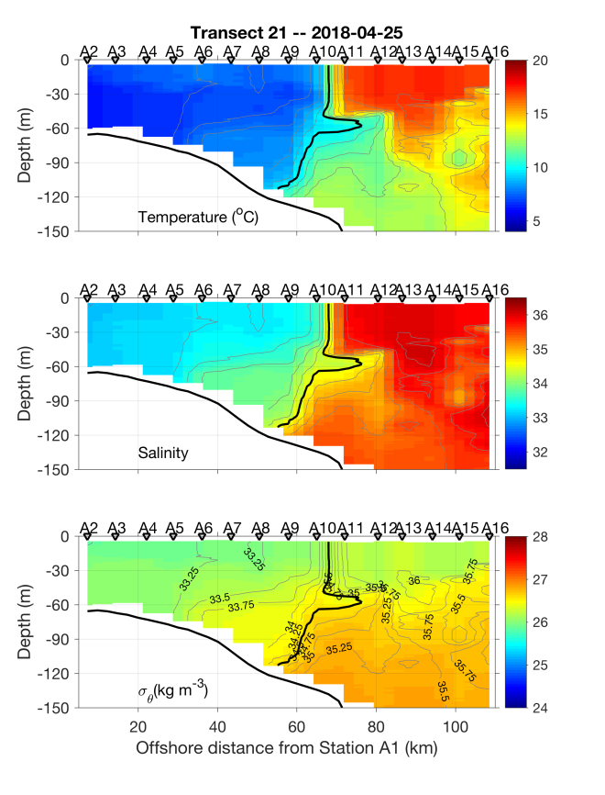 | 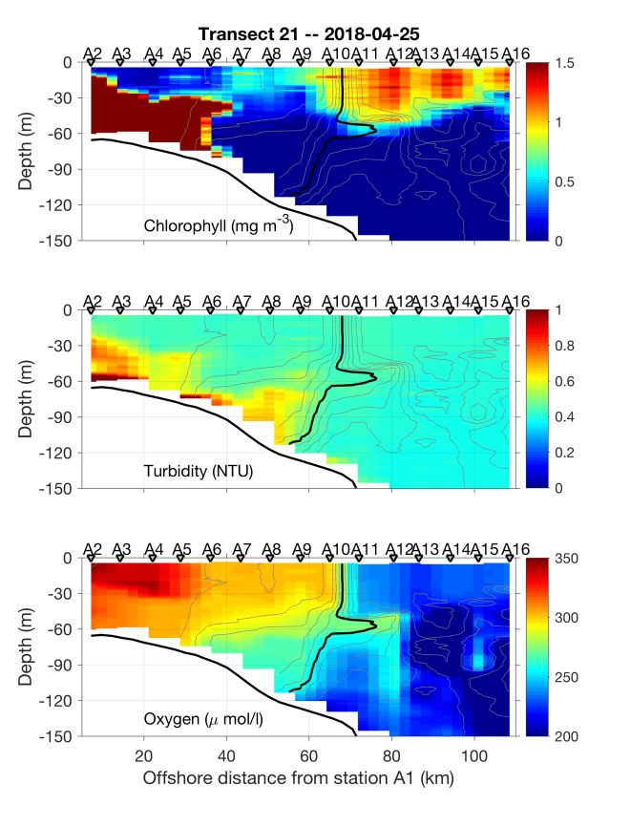
Figure 0426.1: April 25-26 CTD section.

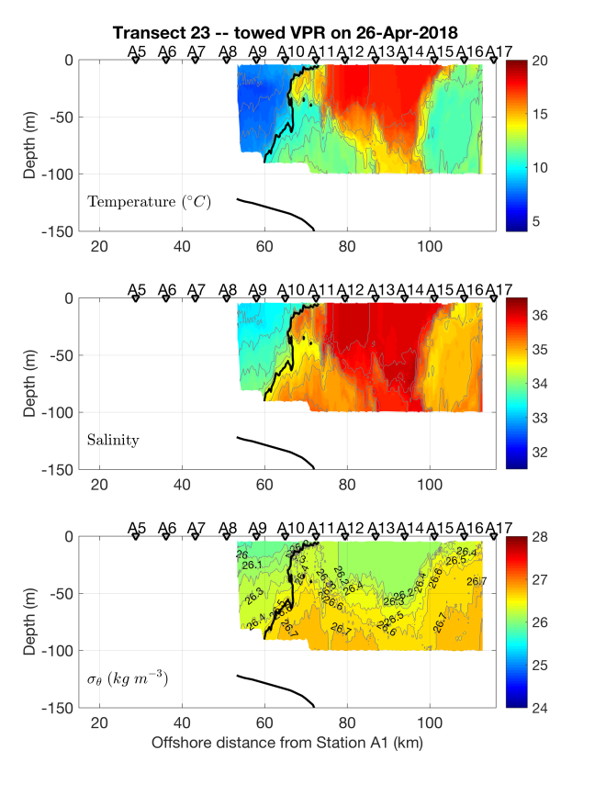 | 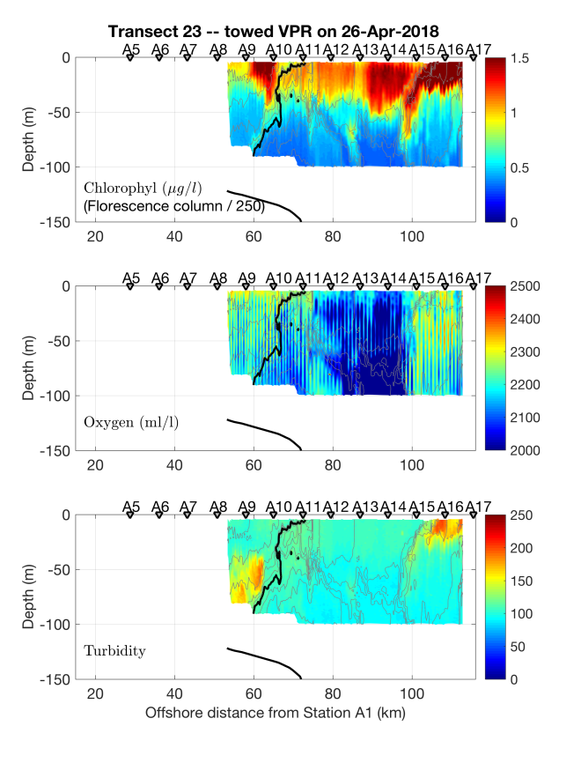
Figure 0426.2: April 26 VPR transect.

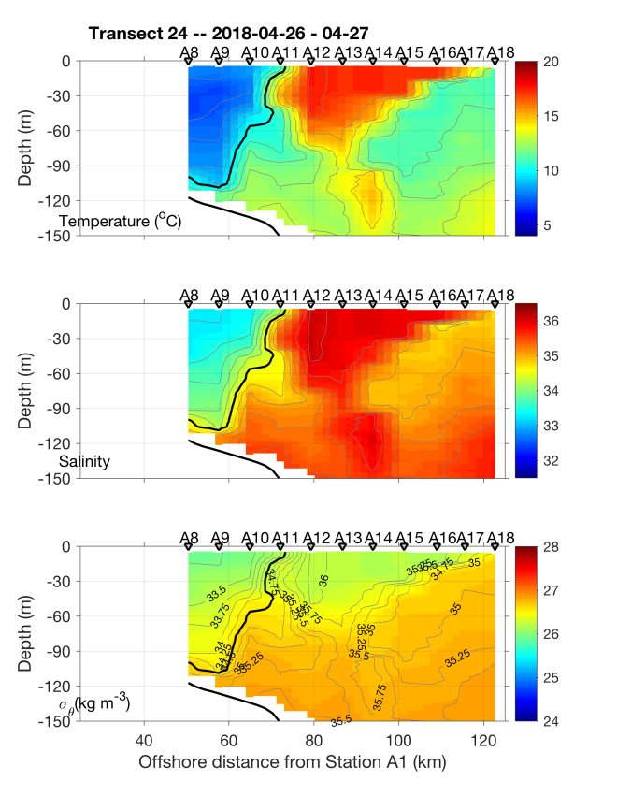 | 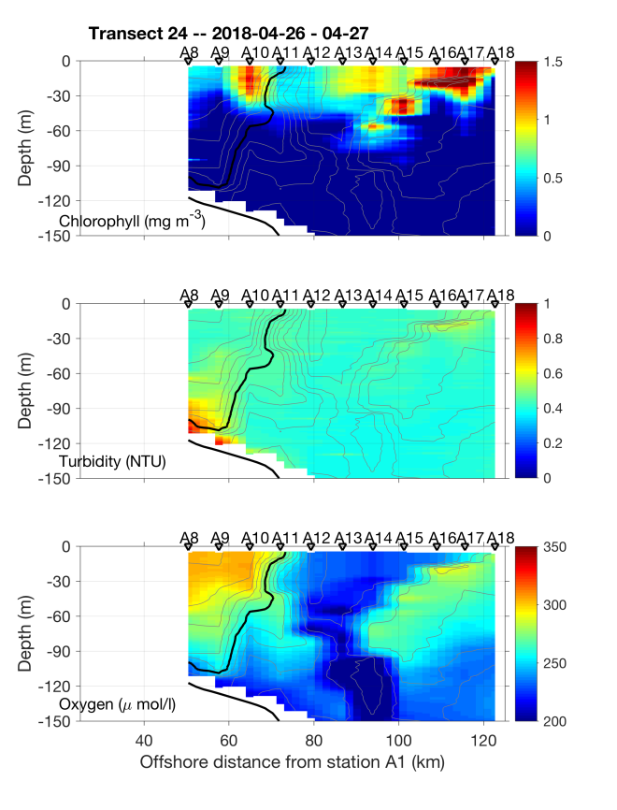
Figure 0427.1: April 26-27 CTD section.

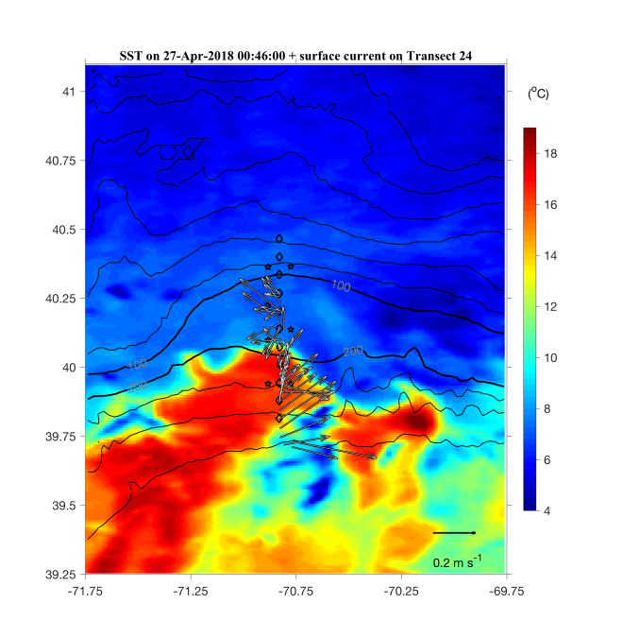
Figure 0427.2: Satellite SST from April 26.

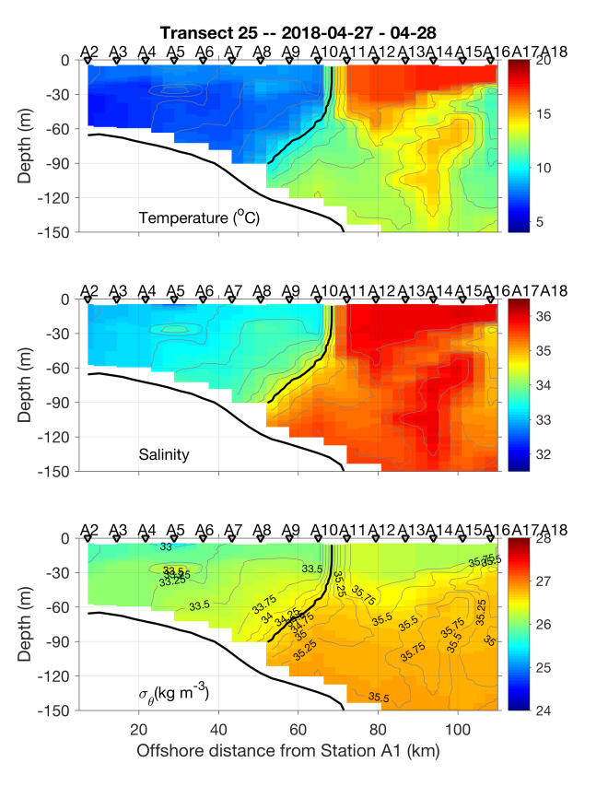 | 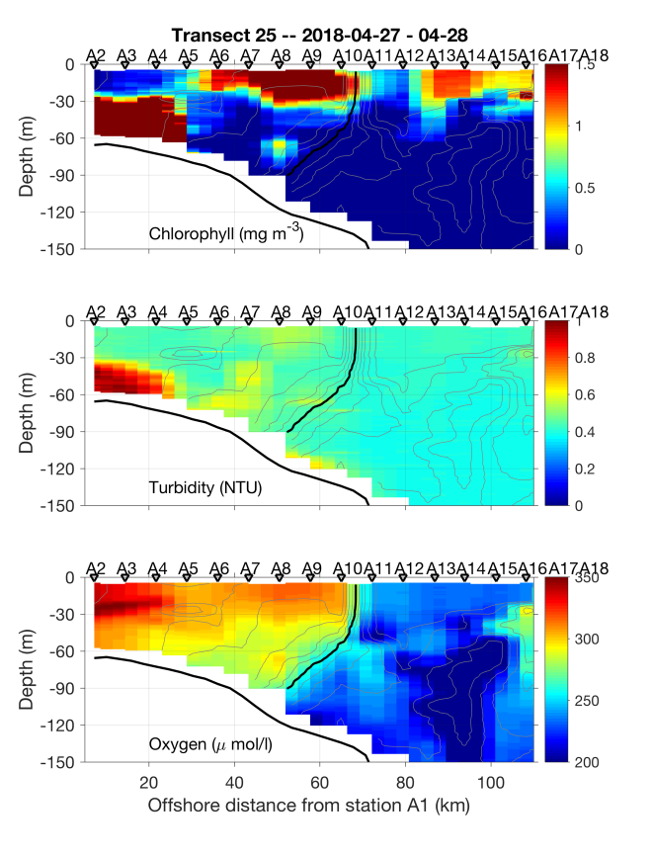
Figure 0428.1: April 27-28 CTD section.

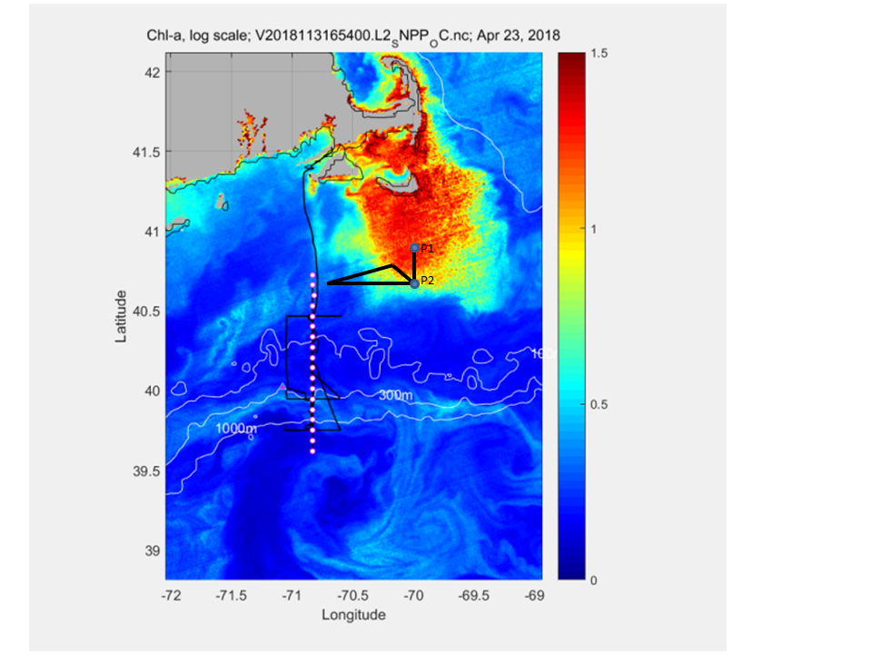
Figure 0428.2: Track of the April 28 VPR survey of Phaeocystis overlayed on the satellite image of chl from April 23 (Figure 0423.1). Water sampling stations P1 and P2 indicated.

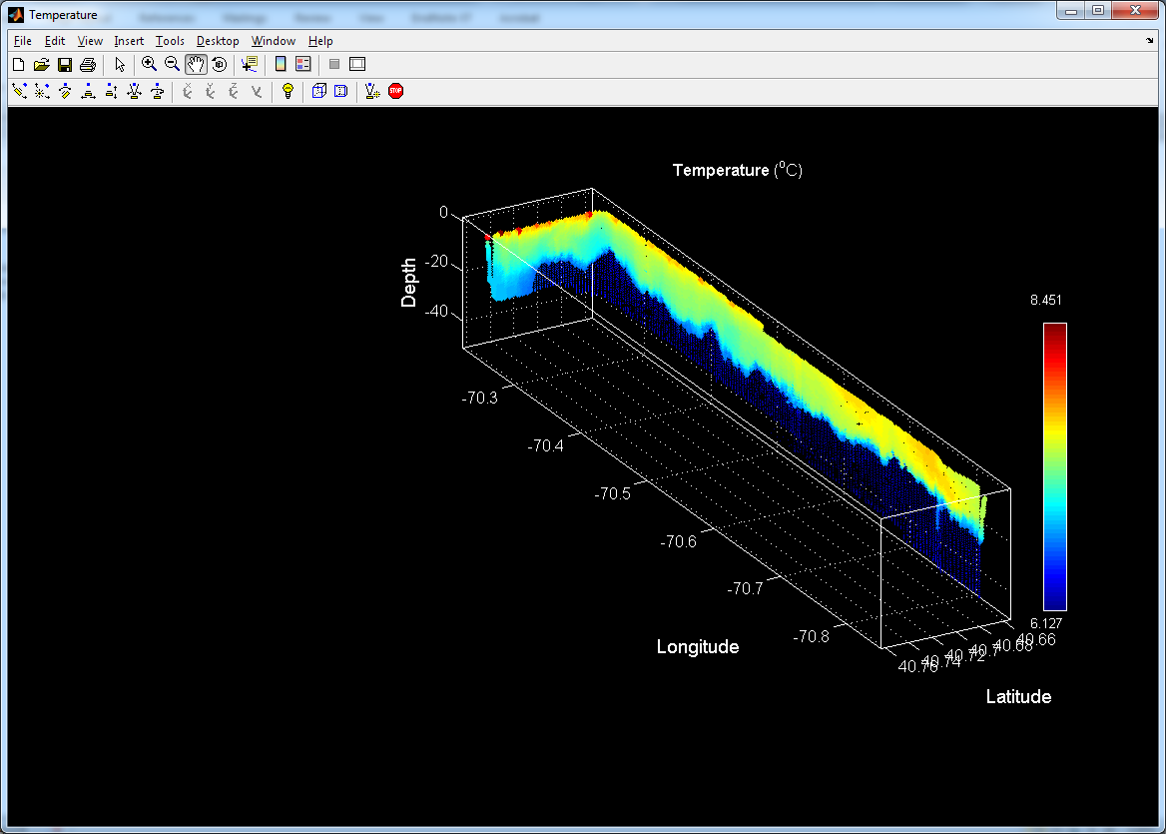 | 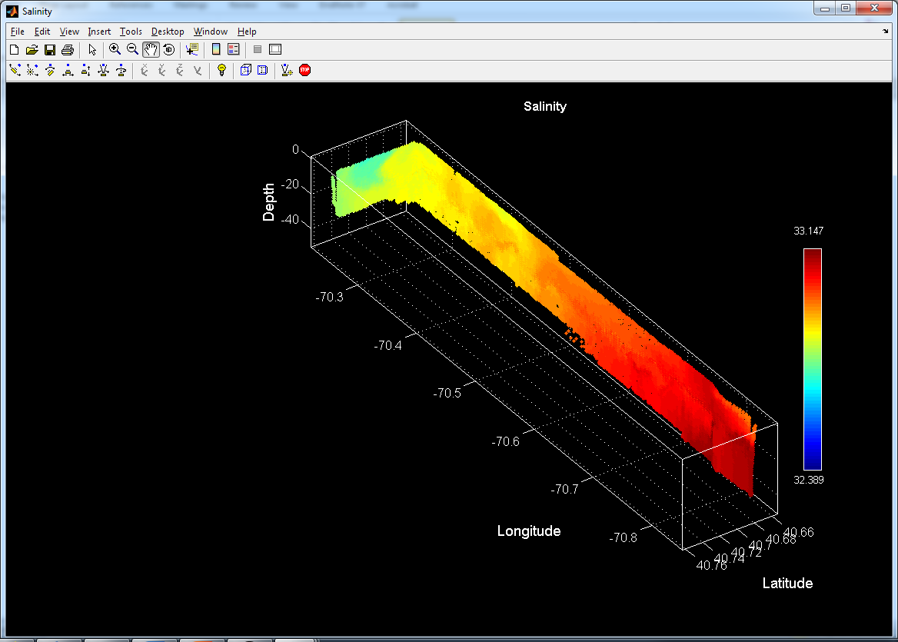
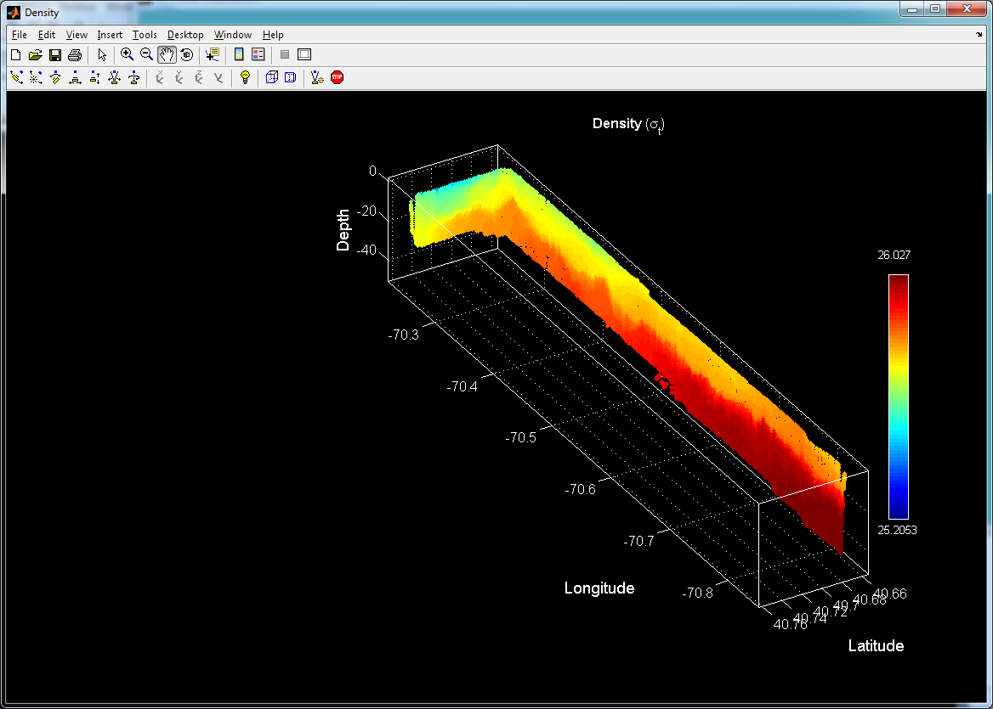 | 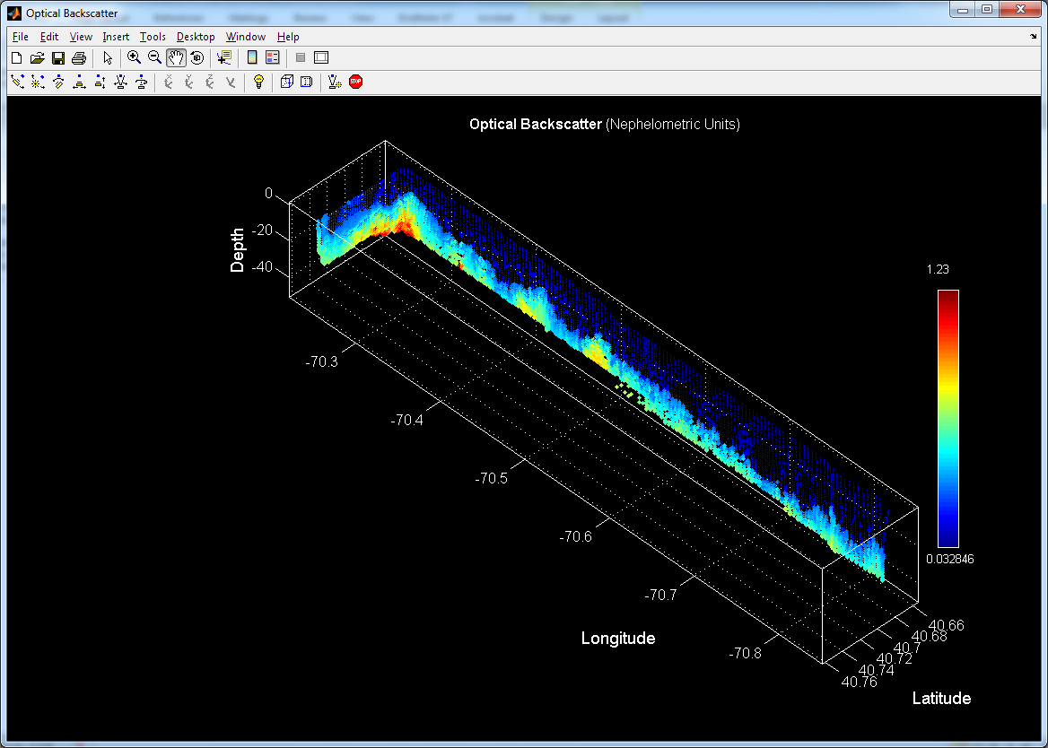
Figure 0428.3: April 17 CTD section.

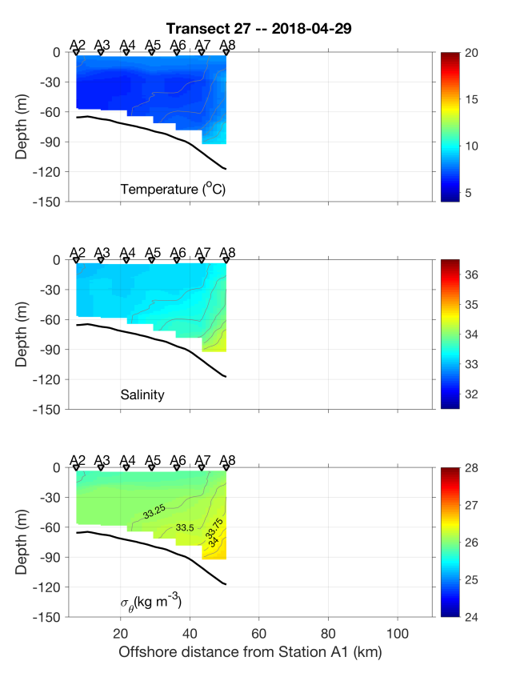 | 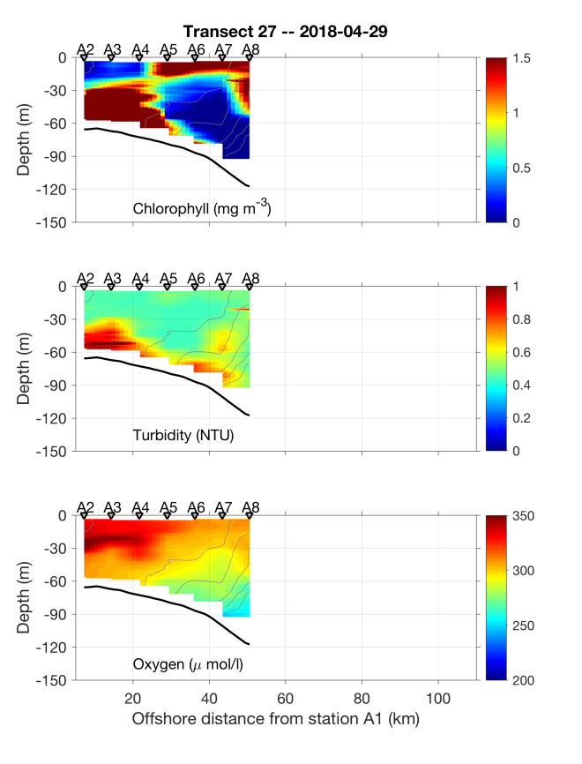
Figure 0428.4: April 28 CTD section.

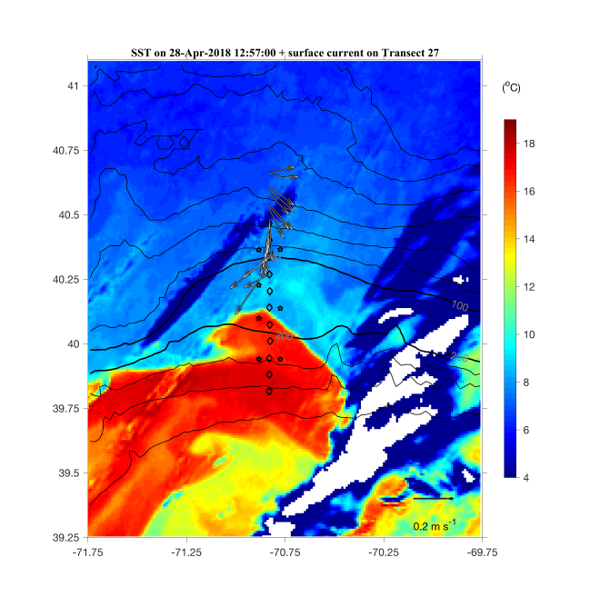
Figure 0428.5: ADCP velocity vectors overlayed on satellite image from April 28.

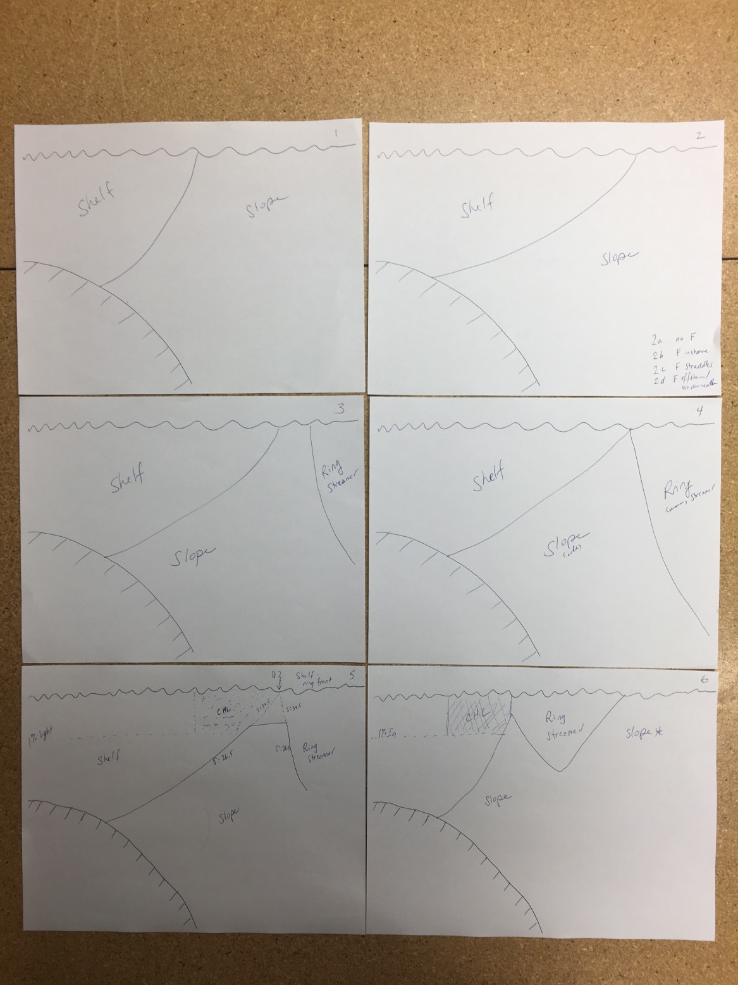
Figure 0429.1: Schematic of conditions observed during AR29.

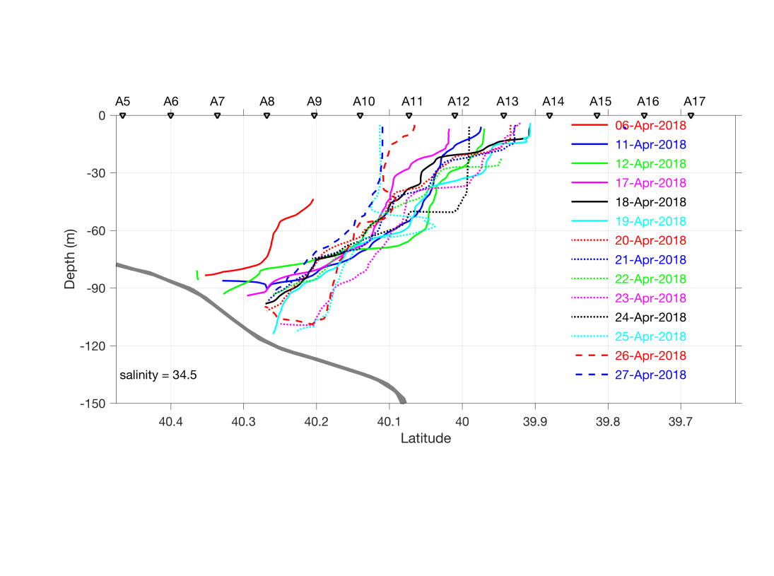
Figure 0429.2: Frontal positions as depicted by the 34.5 isohaline.

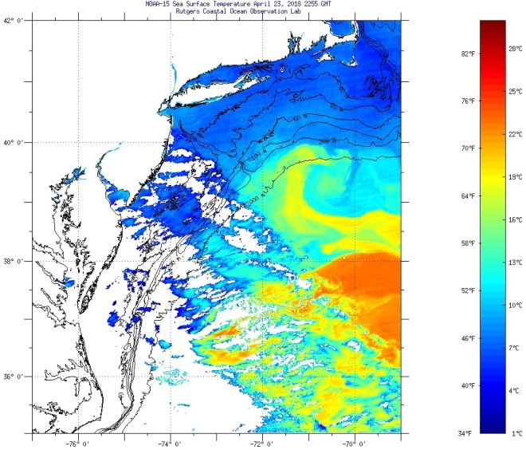
Figure 0429.3: SST image from April 23, 2018.
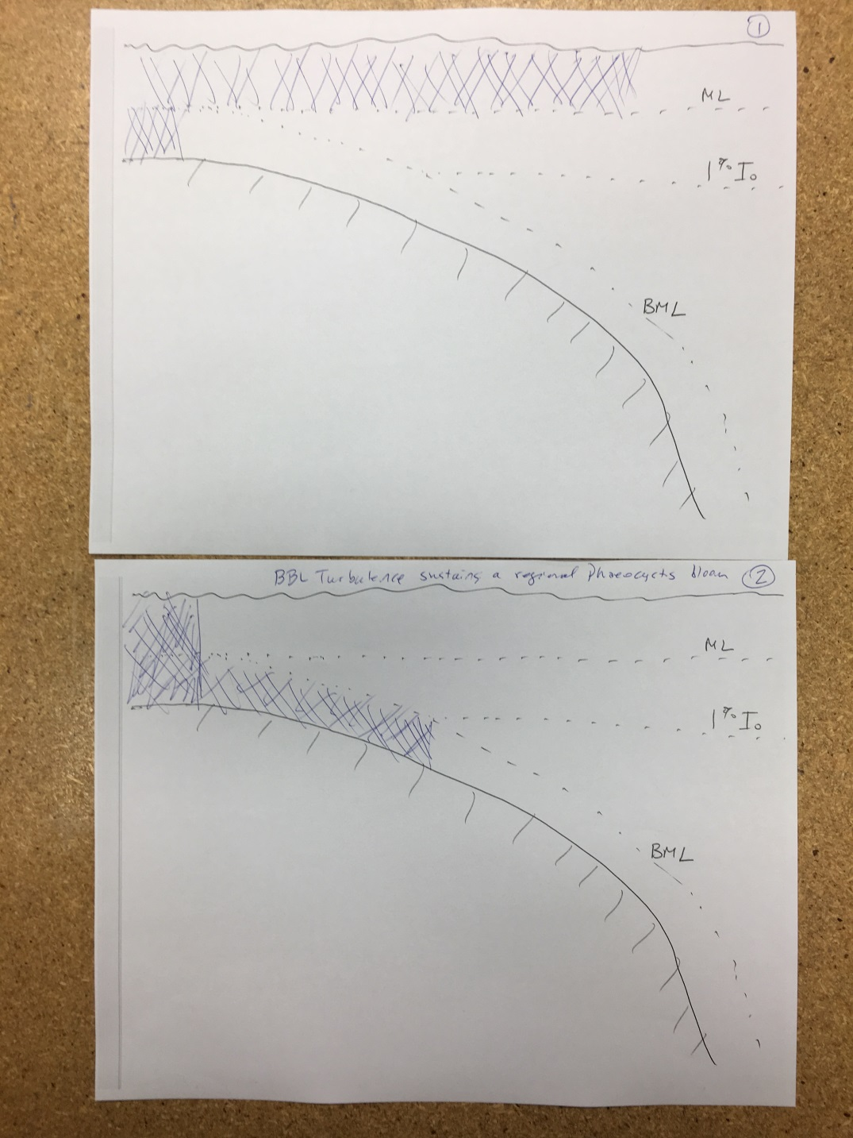
Figure 0429.4: Conceptual model for how bottom boundary layer turbulence could sustain a regional bloom of Phaeocystis.

