TN376 VPR Team Cruise Report
Draft February 29, 2020

Dennis McGillicuddy
Phil Alatalo
Andrew Hirzel
Fred Thwaites

Contents

1. Summary of findings
1.1 Meander Survey 1
1.2 Meander Survey 2
1.3 Eddy 3 Survey 1
1.4 Eddy 3 Survey 2

2. Some comments on Subantarctic Mode Water and its presence in our observations

3. Daily narrative

4. Summary of VPR tows

1. Summary of findings

Sampling on TN376 focused on two mesoscale features: a PIC-rich meander south of the Agulhas Front, and a cyclonic eddy to the north of it. Both features were sampled twice.

Meander survey 1 30 January – 4 February
Eddy 3 survey 1 5-8 February
Meander survey 2 16-21 February
Eddy 3 survey 2 22-26 February

In both cases, there were significant temporal changes in satellite-derived PIC: an increase in the meander, and a decrease in the eddy (note different color scales in the satellite images). These changes are accompanied by similar trends in total backscatter measured with the VPR.

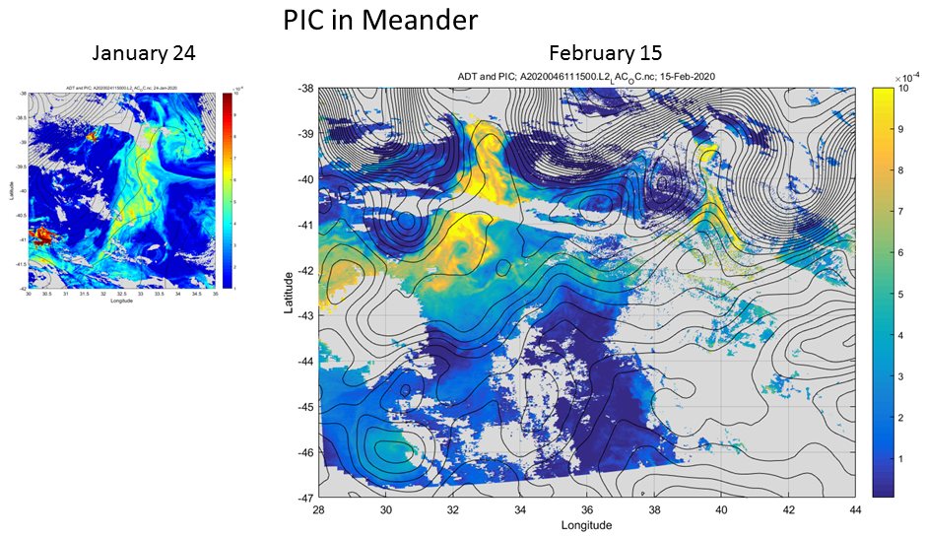
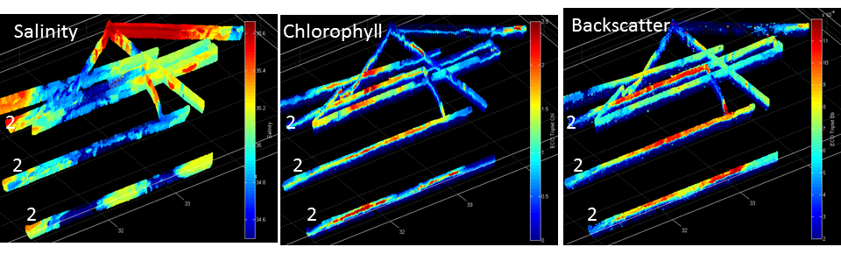
The three transect lines of Survey 2 are indicated by the numeral “2”; all other lines from Survey 1.
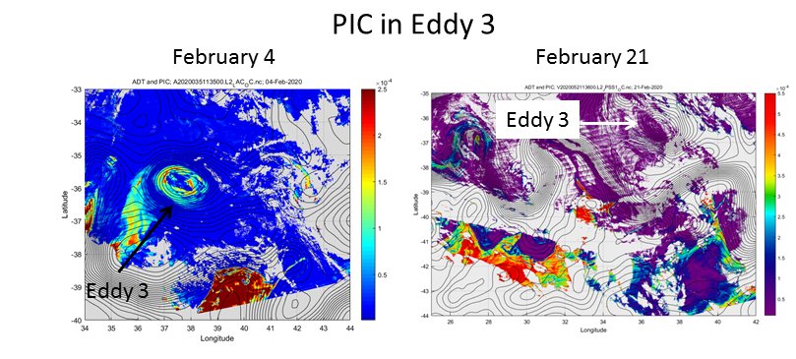

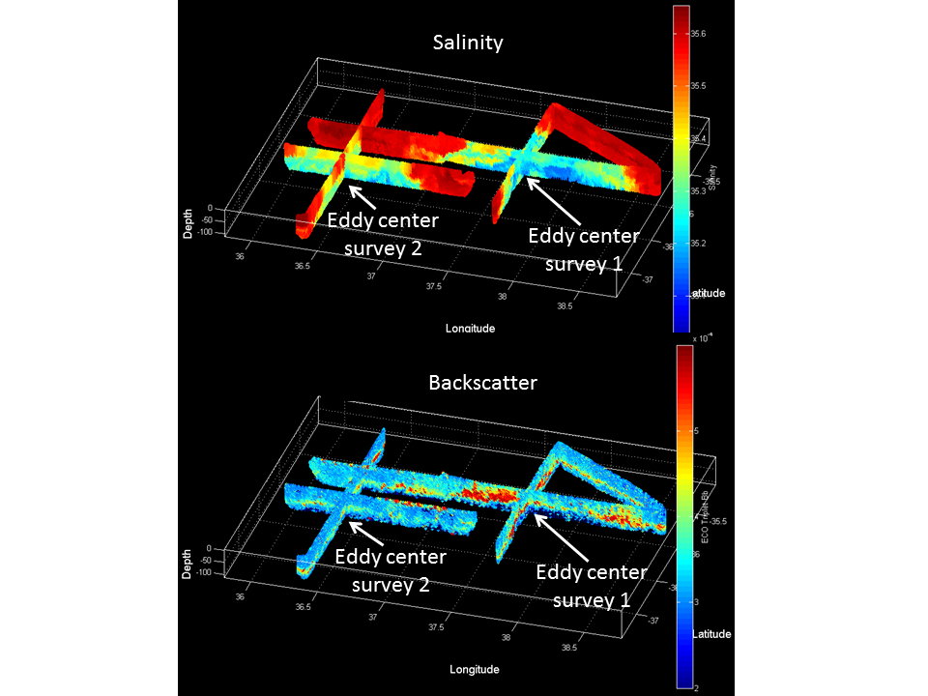

1.1 Meander Survey 1

This stanza of the cruise was inspired by satellite imagery from January 24 depicting an area of high chlorophyll and high particulate inorganic carbon (PIC) in a northward meander of the Southern Subtropical Front (SSTF) embedded within a meander of the Agulhas Front (AF) (Figure 1.1.1).

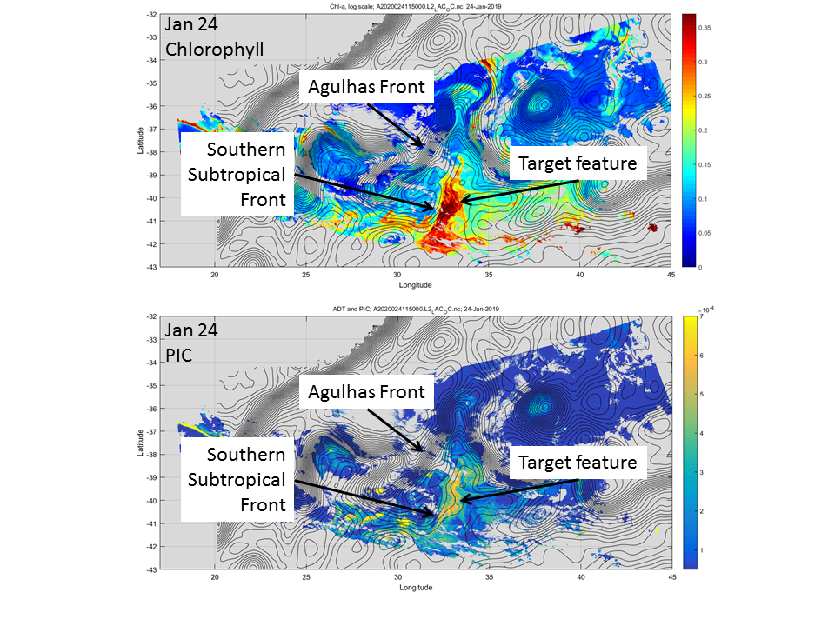
Figure 1.1.1 MODIS chlorophyll and PIC for 24 January 2020. Contours of absolute dynamic topography are overlayed.

Our initial survey focused on two main features of interest in the northern portion of the meander feature: an area of high chlorophyll and high PIC, referred to as “Eddy 1” which refers to the mesoscale character of this feature (Figure 1.1.2). Eddy 2 is a vortex like structure containing lower chlorophyll as well as appreciable backscatter. From January 24 to January 30 these features interact, with the northern limb of “Eddy 1” wrapping around the periphery of Eddy 2. Note that the apparent decrease/increase of chlorophyll/PIC is a result of changing colorbars between the upper and lower panels.

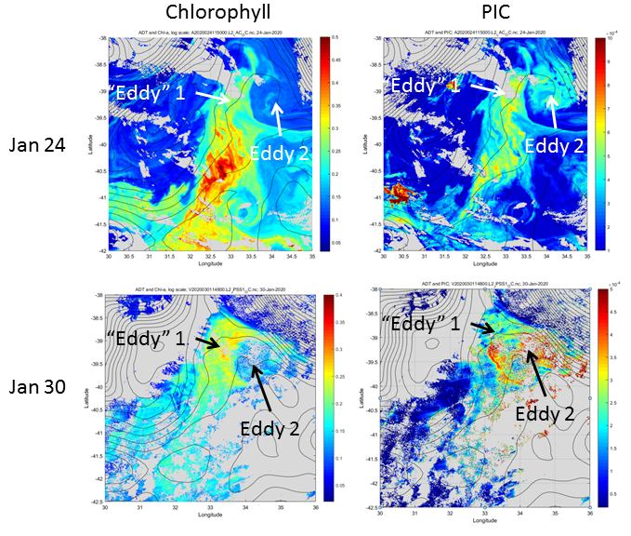
Figure 1.1.2: Chlorophyll (left) and PIC (right) images for January 24 and 30. Clouds obscured this region during the time period of in situ observations.

The altimetric history of this area (Figure 1.1.3) provides some context for the two eddies that we observed. In mid-October a meander system developed between 30 E and 34 E, leading to formation of a cyclone inside the northward meander pocket (presumable SAW) and an anticyclone to the south-southeast (October 25). By November 10, the cyclone had deepened and the vortex pair was oriented north-south. Their orientation then retrograded back northwest-southeast, with the cyclone splitting into two features and the anticyclone merging back into the Agulhas Front. On December 5, cyclone 2 and the remnant of the anticyclone were oriented north-northeast – south-southwest, and cyclone 1 had retreated farther northwest into the northward meander pocket. By December 24, cyclone 1 had pinched off into a new eddy north of the Agulhas Front, and the cyclone 2 / anticyclone pair was oriented almost east-west. On 8 January, the anticyclone began to merge with the Agulhas Front to the west, subsequently interacting with the Agulhas front to the east on 20 January. At the same time, cyclone C1 rejoins the Agulhas Front, drawing it northward, inducing flow northward up the eastern periphery of the deep meander stretching from 40S 30E to 36S 33E. That basic configuration of the meander system persisted through the time period of our observations from 30 January – 4 February (VPR) and 3-4 February (CTD). Although the general flow of in the vicinity of Eddy 1 and Eddy 2 is depicted by the altimetric fields, the detailed mesoscale and submesoscale characteristics are not resolved.

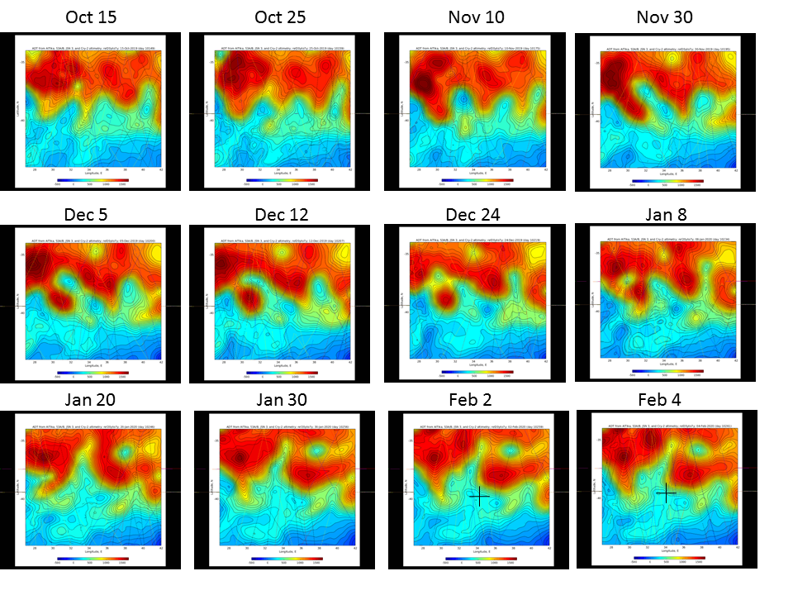
Figure 1.1.3. Time-series of absolute dynamic topography for the area of interest. The black cross in the last two panels provides the approximate position of the two CTD sections occupied on February 3-4.

Eddies 1 and 2 depicted in Figure 1.1.2 were sampled intensively from 30 January – 4 February (VPR) and 3-4 February (CTD). Joining the final portion of VPR2 with VPR3-7 provides a map of the survey region (Figure 1.1.4). Warm and salty waters of the Agulhas front are present in the northern and northeastern quadrant of the survey; they contain low fluorescence and low oxygen. High Chl / high Bb / high Bb’ water is found in the cooler fresher waters in the western portion; this is also where the highest oxygen is found. To the east of that feature lies the saltier low Chl / high Bb / high Bb’ eddy. Interestingly, the highest Bb’ was found at the southernmost terminus of the north-south line. We also encountered lower salinity water with high Chl / high Bb / high Bb’ on the eastern end of the survey, as the track passed out of the southward meander of the Agulhas front.

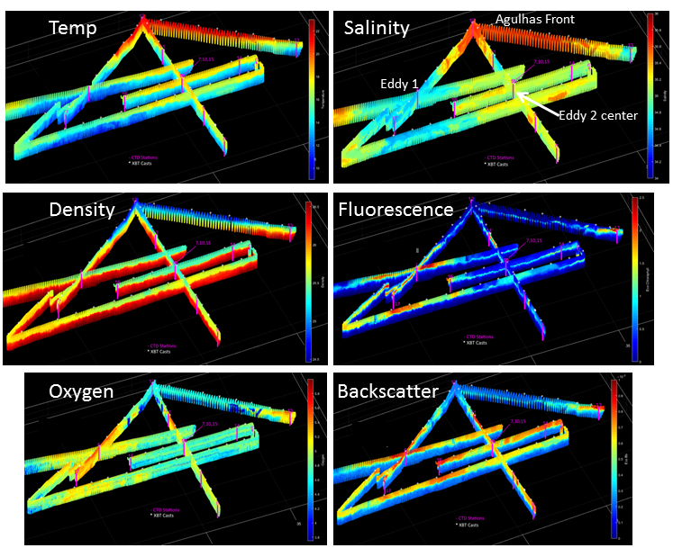
Figure 1.1.4 VPR surveys 2-7 combined. CTD stations and XBT locations indicated by magenta lines and asterisks, respectively.

The VPR surveys were used to orient CTD transects in the north-south (transect 2) and east-west (transect 3) directions (Figure 1.1.5,6; Table 1.1.1). The northern end of transect 2 (station 12) shows the depression of the thermocline in association with the Agulhas Front. Station 11 contains high-chlorophyll water apparently associated with the limb of Eddy 1 wrapping around the northern periphery of Eddy 2. The center of eddy 2 is clearly depicted at station 10 with uplift of the seasonal thermocline, which is confined mostly to the upper 400 m. Isotherms below that are comparatively flat, especially to the south.

Transect 3 shows Eddy 2 center located at station 15 where surface fluorescence is at a minimum, flanked by higher values to both the east and west. The low salinity water of Eddy 1 (station 17) contains the highest surface chlorophyll and highest oxygen. Interleaving of these two water masses is evident at the boundary between these two water masses (station 16). Eddy 2 center is located at station 15, flanked at station 14 which contains low salinity high chlorophyll water which may be the southward extent of the Eddy 1 limb wrapping around the northern portion of Eddy 2.

Transect | Station | Feature / comments
2 | 12 | AF, depressed thermocline, low fluorescence, low oxygen
 | 11 | High chlorophyll limb of Eddy 1 wrapping around Eddy 2
 | 10 | Eddy 2 center
 | 9 | Eddy 2 periphery
 | 8
3 | 17 | Eddy 1
 | 16 | Eddy 1, Eddy 2 boundary – interleaving
 | 15 | Eddy 2 center
 | 14 | Eddy 2 periphery; interleaving; Eddy 1 wrap-around?
 | 13 | Outside Eddy 2
Table 1.1.1. Station list for CTD transects 2 and 3.

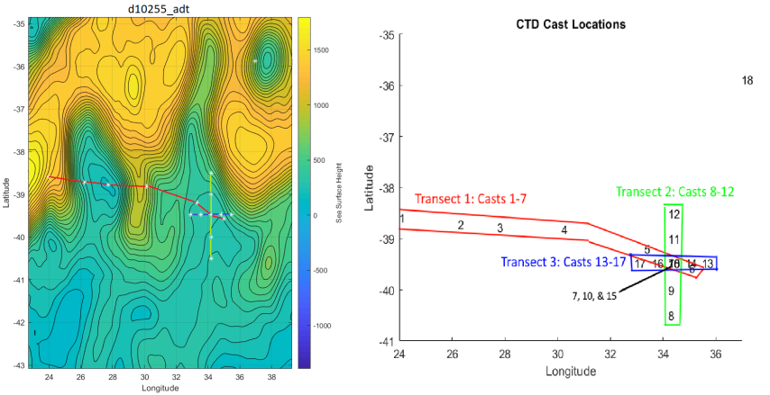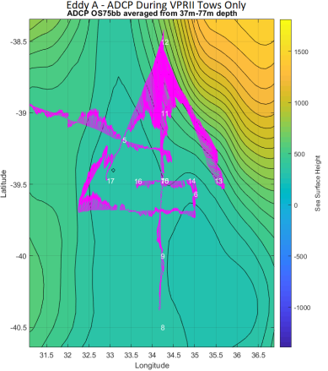
Figure 1.1.5 CTD transect and station locations (middle) overlayed on absolute dynamic topography (left) and 37-77m ADCP currents (right).

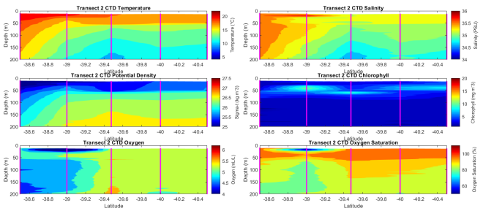 | 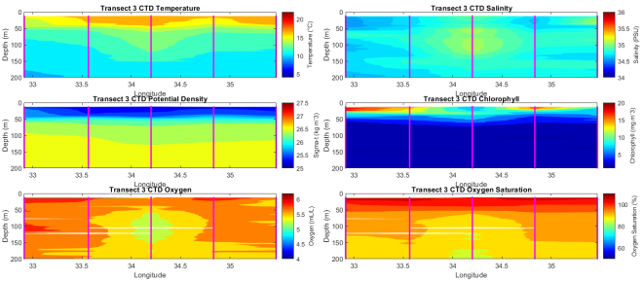
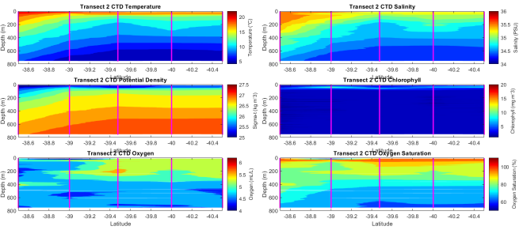 | 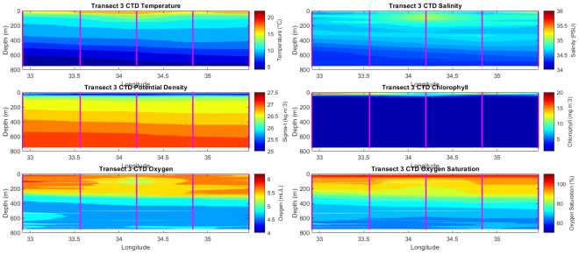
Figure 1.1.6. CTD transects 2 (left) and 3 (right). Upper panels 0-200m, lower panels 0-800m.

CTD data reveal water mass characteristics (Figure 1.1.7) consistent with those described by Gordon et al. (1987): end members consisting of Antarctic Intermediate Water (AAIW), Subtropical Surface Water (STSW), with mixing in between them to create South Indian Central Water (SICW). SAMW falls within the SICW envelope, although from the profile data it does not appear the survey captures much if any of that water mass—at least in terms of a thermostad / pycnostad.

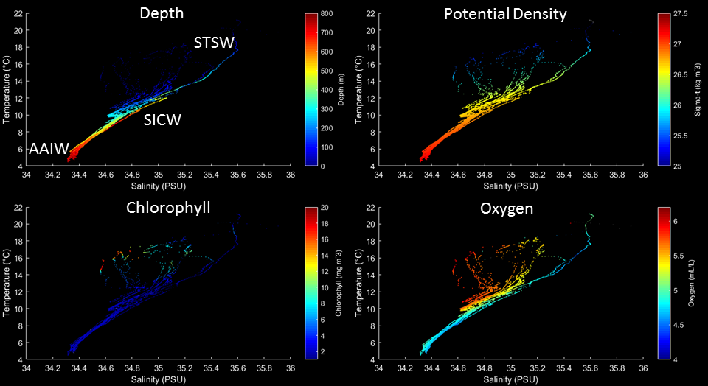

Figure 1.1.7. Depth, potential density, chlorophyll (fluorescence), and oxygen from CTDs 5-18 plotted in temperature-salinity space.

Merging of the CTD and VPR data in T-S space provides more extensive coverage of the upper water column (Figure 1.1.8).

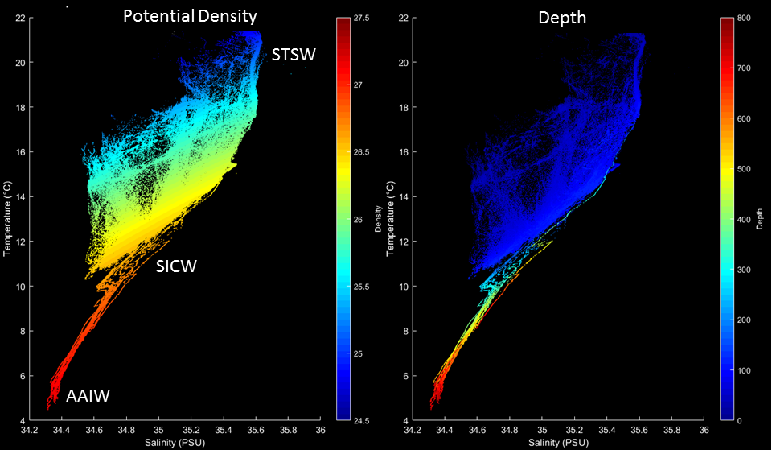
Figure 1.1.8. Potential density and depth from CTDs 5-18 and VPR tows 2-7 plotted in temperature-salinity space.
Zooming in on the VPR portion (Figure 1.1.9) facilitates delineation of the water masses associated with Eddies 1 (high chlorophyll / high Bb) and 2 (low chlorophyll / high Bb).

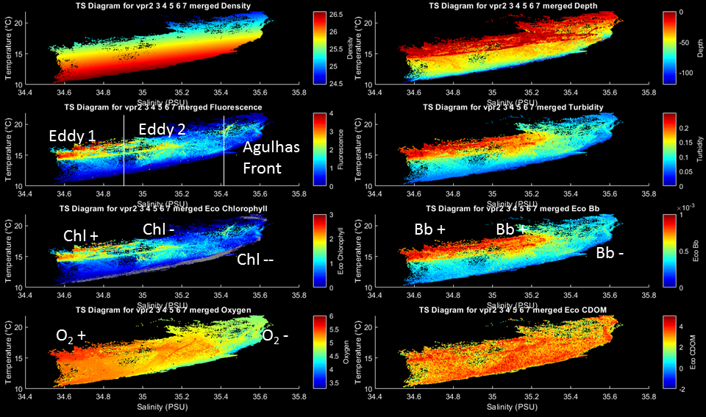
Figure 1.1.9. Potential density, depth, chlorophyll (fluorescence), turbidity, chlorophyll (fluorescence from Eco triplet), backscatter (from Eco triplet), oxygen, and CDOM (from Eco triplet) from VPR tows 2-7 plotted in temperature-salinity space.

Belkin and Gordon (1996) provide some guidance for categorization of the upper ocean water masses sampled in the VPR surveys (Figure 1.1.9). Their Tables 3, 6, and 10 report ranges for surface salinity in the SAF, SSTF, and AF respectively. One can infer that the surface waters in between the fronts are comprised of salinities falling in between the specified ranges (Table 1.1.2). In that context, Eddies 1 and 2 can be characterized as SAW and SSTW, respectively; they are bounded by AF water.

SAF |  | SSTF |  | AF
33.88 | 34.6 | 34.30 | 35.18 | 35.39 | 35.54
 | SAW |  | SSTW
Table 1.1.2. Surface salinity ranges for the Subantarctic Front (SAF), South Subtropical Front (SSTF), and Agulhas Front (AF) from Belkin and Gordon (1996). Surface salinities for Subantarctic Water (SAW) and South Subtropical Water (SSTW) are inferred as bracketed by the frontal ranges.

1.2 Meander Survey 2

Our second visit to the SSTF meander targeted 3 zonal sections across the high chl / high PIC feature, which appears to have intensified since our prior occupation (Figure 1.2.1).

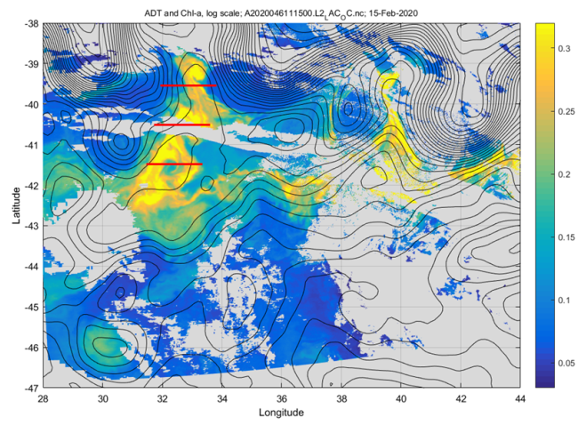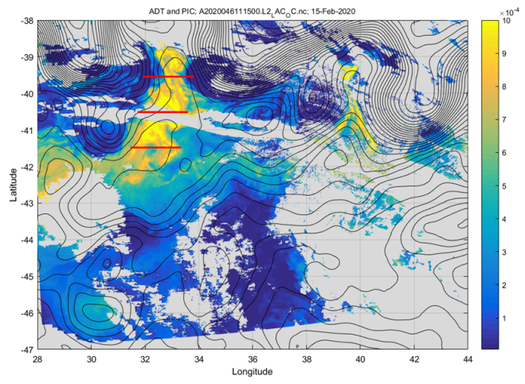
Figure 1.2.1: Chlorophyll (left) and PIC (right) images for January 24 and 30. Clouds obscured this region during the time period of in situ observations.

ADCP observations depict the northward flow on the western flank of the meander and southward flow on the eastern flank (Figure 1.2.2).
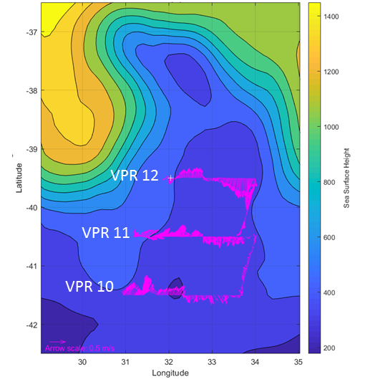
Figure 1.2.2. ADCP currents (37-77m ) from VPR tows 10, 11, and 12 overlayed on absolute dynamic topography.

Combining VPR tows 10, 11, and 12 provides a view into the hydrographic and bio-optical structure of the meander (Figures 1.2.3 and 4). In general, the cooler and fresher waters in the core of the meander contain higher chlorophyll and backscatter (HPCLS); this core is flanked by warmer waters of intermediate (moderate) salinity, lower chlorophyll, and high PIC (HPLCMS). The periphery of the meander is delineated by warmer and saltier waters that are low in both chlorophyll and PIC (LPCHS). These labels are added to a duplicate view of salinity field (Figure 1.2.4, top panel) for clarity.

LPCHS waters of the western periphery of the meander are captured in all three tows, whereas these waters were only encountered once on the eastern side, in between VPR11 and VPR12. Note that the HPCLS waters in the interior of VPR10 are interrupted by the HPLCMS waters of Eddy 4, clearly visible in the satellite images of chlorophyll and PIC (Figure 1.2.1).

The three biogeographic regions described above (HPCLS, HPLCMS, LPCHS) are clearly discernible in temperature salinity space (Figure 1.2.5).

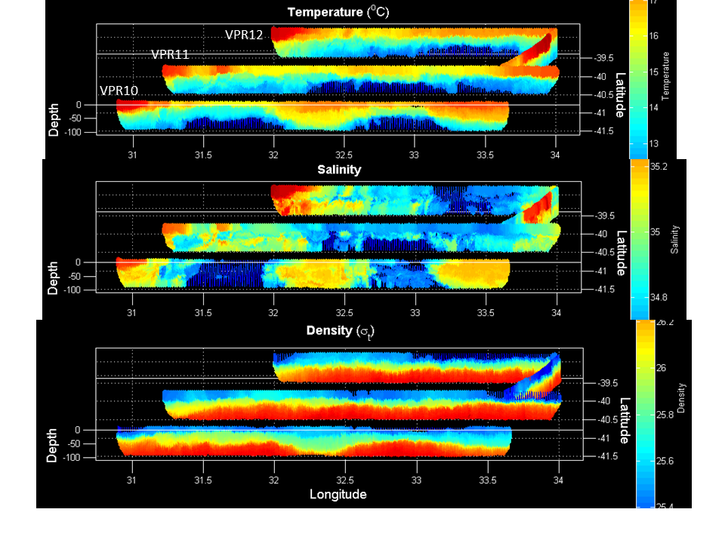
Figure 1.2.3 VPR surveys 10, 11, and 12 combined. CTD stations and XBT locations indicated by magenta lines and asterisks, respectively.

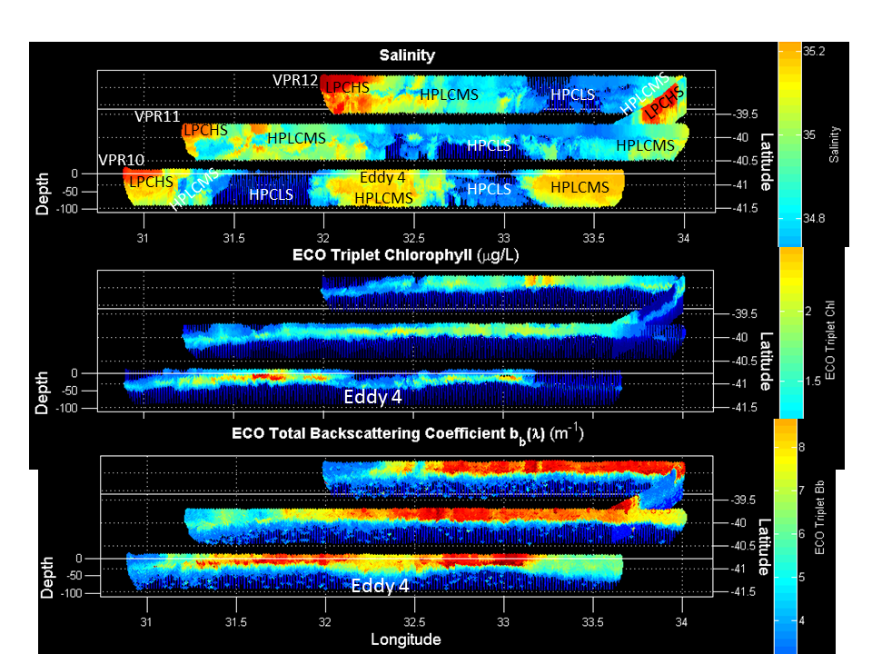
Figure 1.2.4 VPR surveys 10, 11, and 12 combined. Note the salinity field from Figure 1.2.3 is repeated here with water mass labeling (see text). CTD stations and XBT locations indicated by magenta lines and asterisks, respectively.

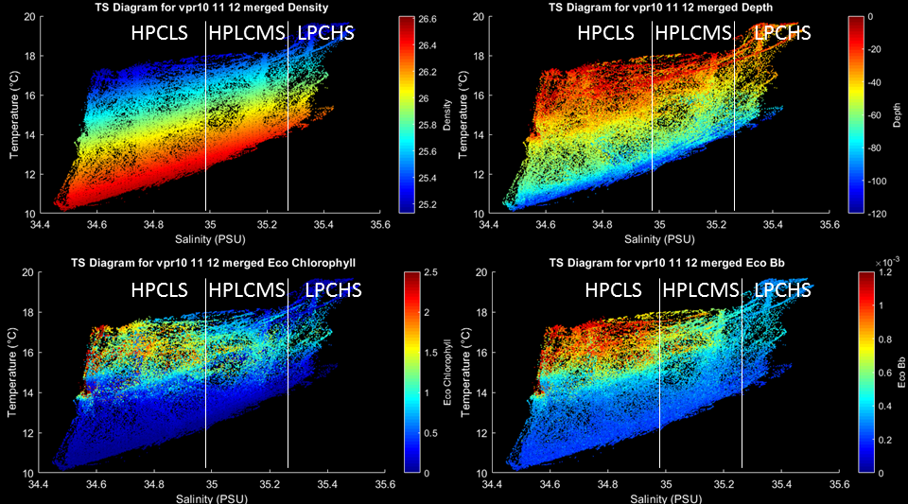
Figure 1.2.5. Potential density, depth, chlorophyll (fluorescence from Eco triplet), and backscatter (from Eco triplet), from VPR tows 10-12 plotted in temperature-salinity space. Salinity ranges for the three biogeographic regimes indicated by white vertical bars: high PIC / high Chl / low salinity (HPCLS), high PIC / low Chl / moderate salinity (HPLCMS), and low PIC / low Chl / high salinity (LPCHS).

Three CTD transects across the meander feature were collocated with the VPR lines (Figure 1.2.6), with station positions informed by the VPR observations (Table 1.2.1). The meander structure is manifested in the CTD data as upward domain of the thermocline, halocline, and pycnoline, centered at 33.4 E (station 49) in the northern transect and 32.8 E (station 40) in the middle transect. In the southern transect, the core of the meander structure is interrupted by Eddy 4, characterized by upward doming of the main pycnocline and depression of the seasonal pycnocline. This “mode-2” or “cyclonic thinny” structure creates anomalies of opposing signs in near-surface and deep ocean temperature, salinity, and oxygen saturation. As expected from the satellite image (Figure 1.2.1), chlorophyll in the eddy core is quite low.

Transect | Station | Feature / comments
6 | 26 | Western periphery outside feature
 | 27 | Frontal boundary - nutrients only
 | 28 | Frontal boundary – PP cast, TM cast, incubation water collection
 | 29 | HPCLS – nutrients only
 | 30 | Eddy 4: Low PIC, low chlorophyll, high salinity (LPCHS)
 | 31 | Frontal boundary
 | 32 | HPCLS
 | 33 | East of frontal boundary with HPCLS
 | 34 | Eastern periphery outside feature (no DAVPR)
7 | 35 | Western periphery outside feature
 | 36 | Frontal boundary – WS over CF submesoscale feature
 | 37 | HPLCMS
 | 38 | Frontal boundary – nutrients only
 | 39 | HPCLS - PP cast, TM cast, incubation water collection
 | 40 | Center of HPCLS – nutrients only
 | 41 | HPCLS
 | 42 | HPLCMS
 | 43 | HPLCMS
8 | 44 | Western periphery outside feature
 | 45 | Frontal boundary – WS over CF submesoscale feature
 | 46 | HPLCMS
 | 47 | HPLCMS
 | 48 | HPCLS - PP cast, TM cast [peak chl, Bb]
 | 49 | Center of HPCLS – nutrients only
 | 50 | HPCLS
 | 51 | HPLCMS
 | 52 | HPLCMS
Table 1.2.1. Station list for CTD transects 6-8 across the high PIC / high chlorophyll feature.

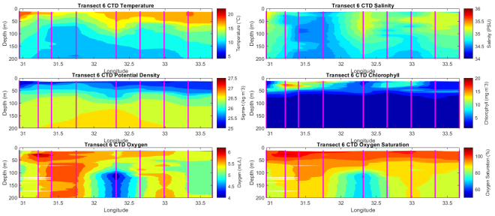 | 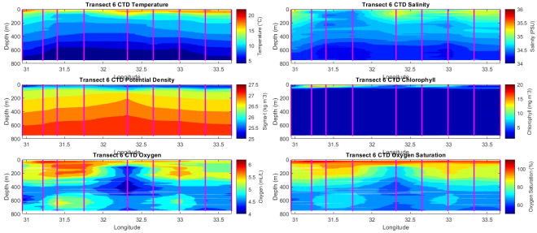
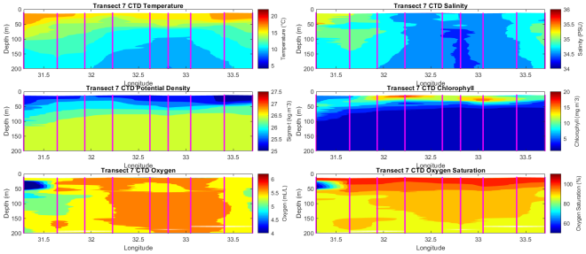 | 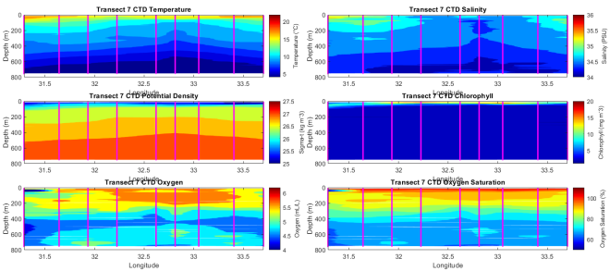
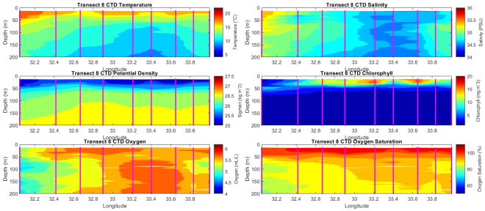 | 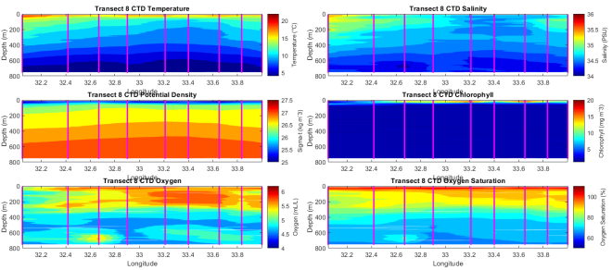
Figure 1.2.6. CTD transects 6 (top), 7 (middle), and 8(bottom). Left column 0-200m, right column 0-800m.

Overall, water mass characteristics of the second survey were similar to that of the first, although a slightly broader region of T-S space was observed (Figure 1.2.7).
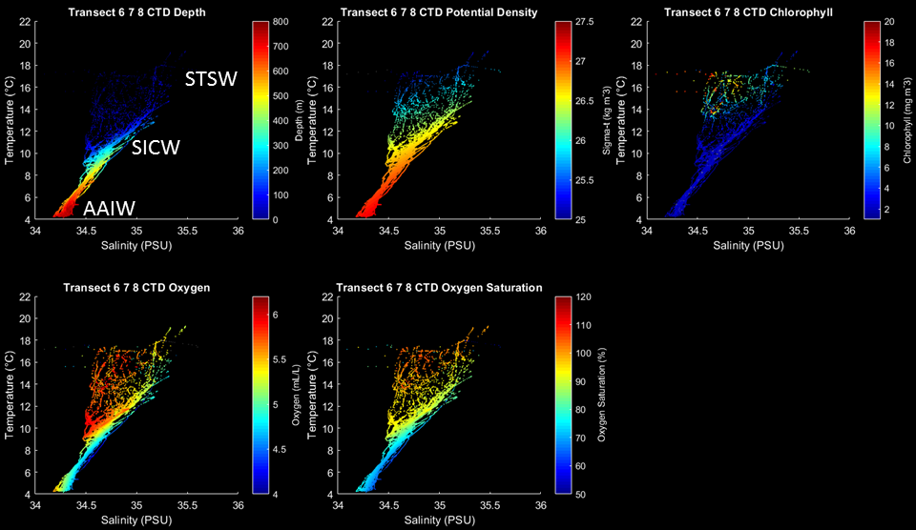
Figure 1.2.7. Depth, potential density, chlorophyll (fluorescence), oxygen, and oxygen saturation from transects 6-8 (stations 26-52) plotted in temperature-salinity space.

Merging of the CTD and VPR data in T-S space provides more extensive coverage of the upper water column (Figure 1.2.8).

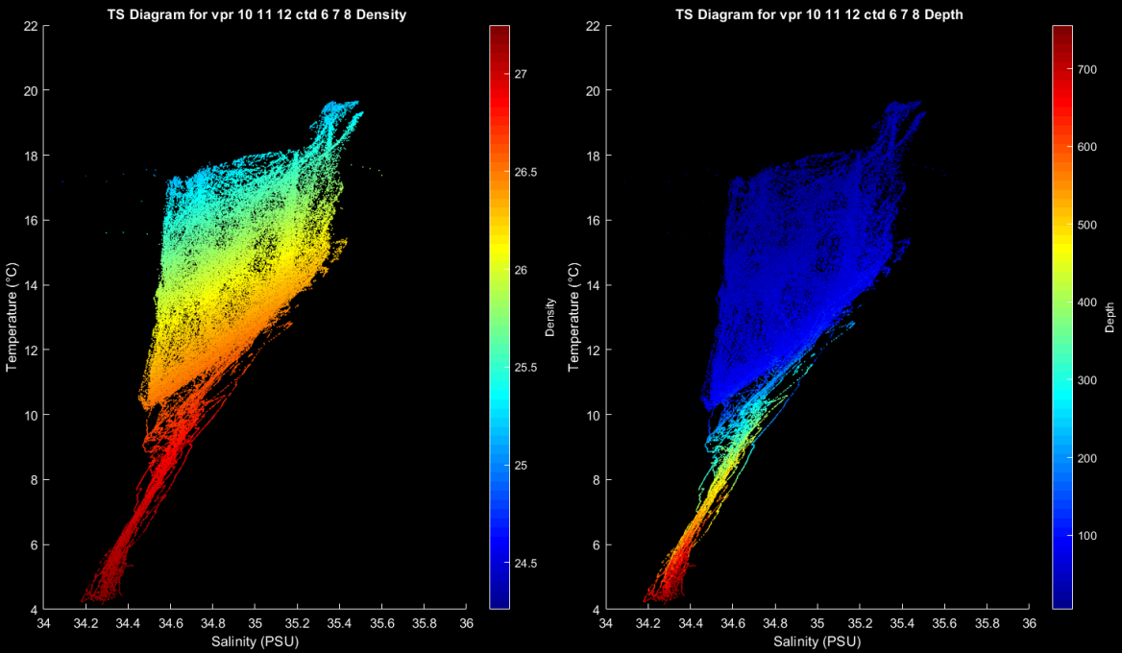
Figure 1.2.8. Potential density and depth from transects 6-8 (stations 26-52) and VPR tows 10-12 plotted in temperature-salinity space.
MODIS and VIIRS images from 16 February (Figure 1.2.9) indicate that the southern terminus of the high chlorophyll / high PIC feature meander appears to be connected to the SSTF, with high chlorophyll and high PIC extended well east of our present position. Thus what we have observed here may be generalizable over a much larger area.

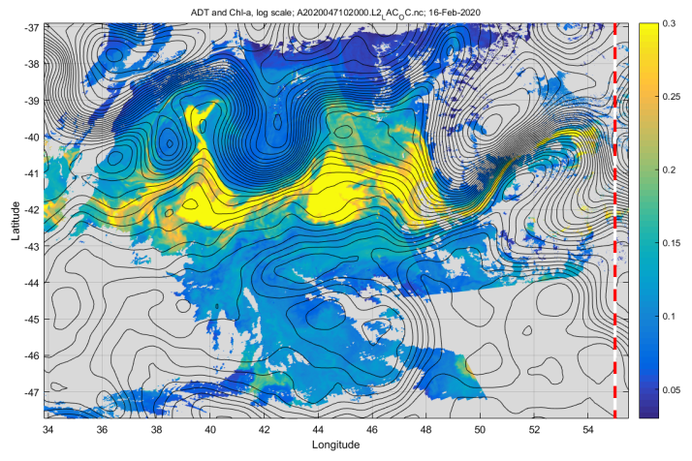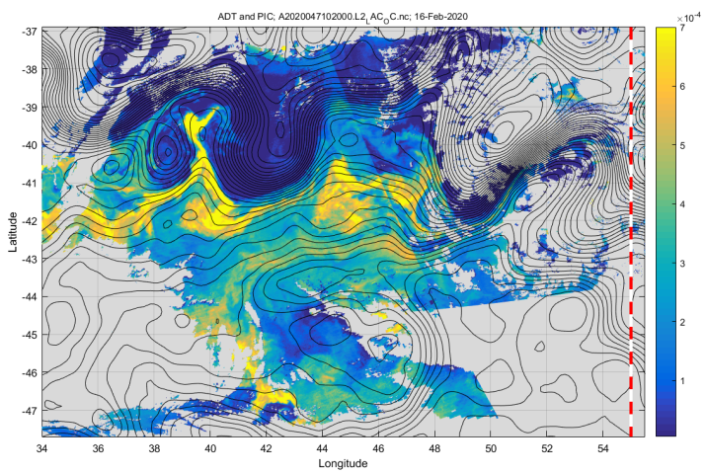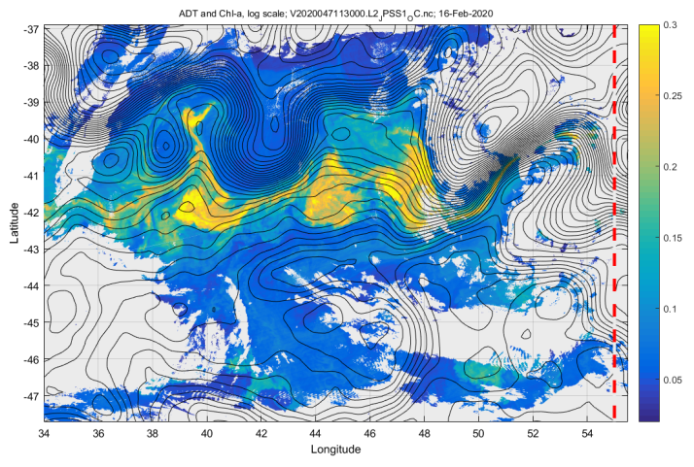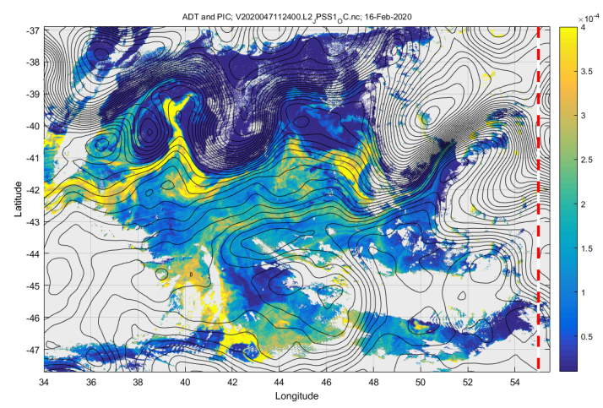
Figure 1.2.9. MODIS (top) and VIIRS (bottom) chlorophyll (left) and PIC (right) for 16 February 2020. Contours of ADT overlayed.

1.3 Eddy 3 Survey 1

This stanza of the cruise was motivated by an image from February 4 (Figure 1.3.1) depicting a ring of enhanced PIC in a ring around the center of a cyclonic eddy pinched off from a meander of the Agulhas Front (Figure 1.3.2). From February 4 to February 5, the amplitude of the PIC ring decreased, although these two images come from two different sensors (MODIS on February 4 and VIIRS on February 5).

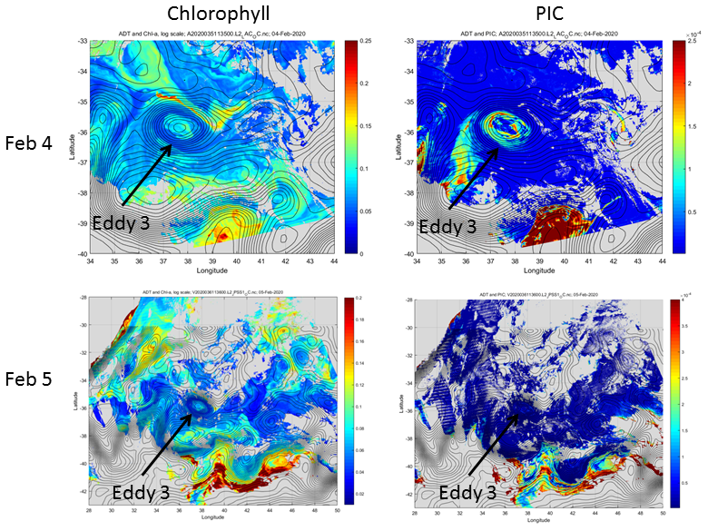
Figure 1.3.1: Chlorophyll (left) and PIC (right) images for February 4 and 5.

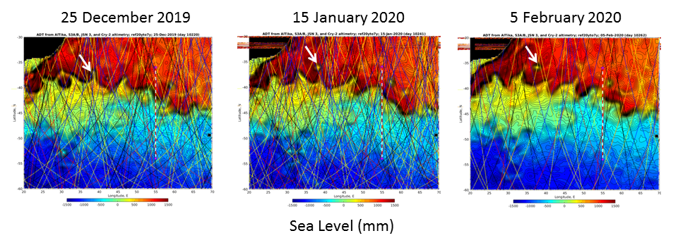
Figure 1.3.2. Time-series of absolute dynamic topography illustrating the formation of Eddy 3.

VPR surveys 8 and 9 (Figure 1.3.3) were used to orient CTD transects (Figure 1.3.4) in the north-south (transect 4) and east-west (transect 5) directions (Table 1.3.1).

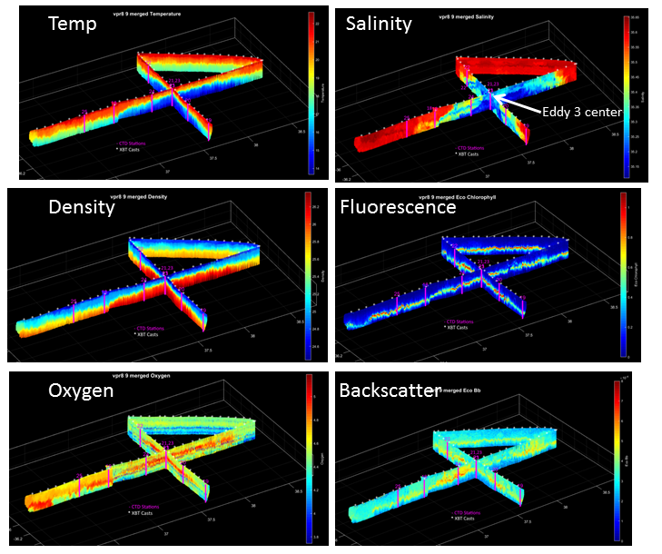
Figure 1.3.3 VPR surveys 8 and 9 combined. CTD stations and XBT locations indicated by magenta lines and asterisks, respectively.

Weather conditions precluded occupying the northernmost station planned for transect 4, as well as the two stations east of Eddy 3 center planned for transect 5. We distinguished between “inner periphery” and “outer periphery” stations in an attempt to resolve the band of high PIC present in the former; we expected to see low PIC at eddy center as well as in the outer periphery.

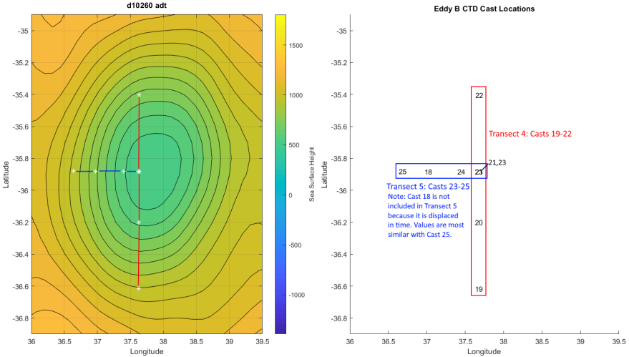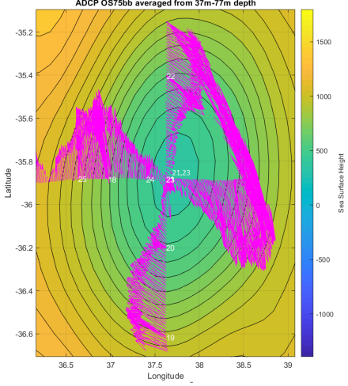
Figure 1.3.4 CTD transect and station locations (middle) overlayed on absolute dynamic topography (left) and 37-77m ADCP currents (right).

Upward doming of the pycnocline is evident at Eddy 3 center (stations 21, 23), with steeper sloping isopycnals to the north than to the south (Figure 1.3.5). Waters of the inner core are clearly fresher than the surroundings, consistent with Eddy 3 being a ring pinched off of the Agulhas Front comprised of SSTW. In contrast to Eddies 1 and 2, Eddy 3 extends well into the main thermocline.

The inner periphery station to the west of eddy center (station 24) was much closer to eddy center than those in the north-south section (stations 20 and 22), reflecting asymmetry of the band of high backscatter (Figure 1.3.1) and PIC surrounding eddy center. Interleaving of water masses between the inner periphery and eddy center is evident in the 0-200m salinity distribution at station 24 (Figure 1.3.5).

Transect | Station | Feature / comments
[5] | 18 | Eddy 3 periphery; water drawn for incubation experiments
4 | 19 | Eddy 3 outer periphery
 | 20 | Eddy 3 inner periphery
 | 21 | Eddy 3 center
 | 22 | Eddy 3 periphery
5 | 23 | Eddy 3 center
 | 24 | Eddy 3 inner periphery; interleaving
 | 18 | Eddy 3 inner/outer periphery; water drawn for incubation experiments
 | 25 | Eddy 3 outer periphery
Table 1.3.1. Station list for CTD transects 4 and 5.

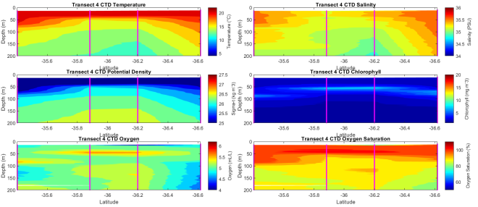 | 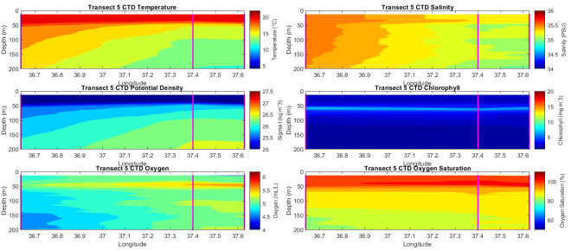
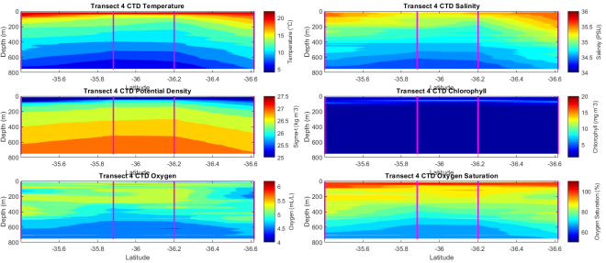 | 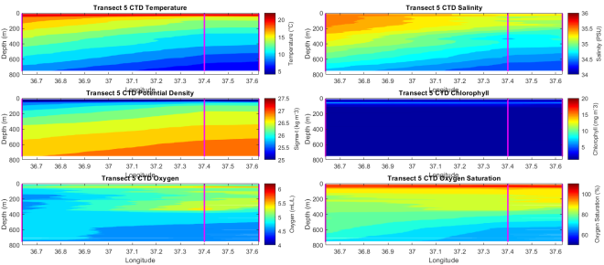
Figure 1.3.5. CTD transects 4 (left) and 5 (right). Upper panels 0-200m, lower panels 0-800m.

Water mass characteristics of the Eddy 3 CTD survey (Figure 1.3.6) are generally similar to that of the Eddy 1 and 2 survey, as described by Gordon et al. (1987): AAIW, STSW, and SICW.

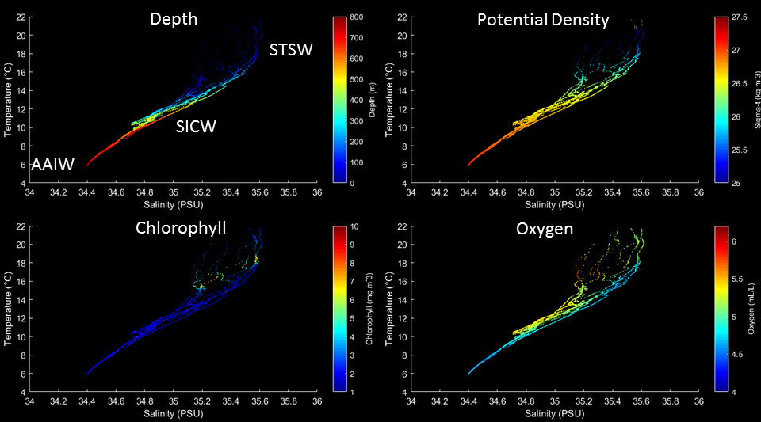
Figure 1.3.6. Depth, potential density, chlorophyll (fluorescence), and oxygen from CTDs 19-25 plotted in temperature-salinity space.

Merging of the CTD and VPR data in T-S space provides more extensive coverage of the upper water column (Figure 1.3.7).

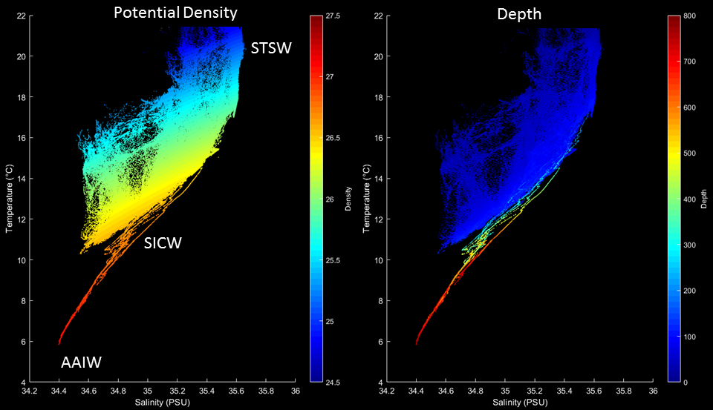
Figure 1.3.7. Potential density and depth from CTDs 19-25 and VPR tows 8-9 plotted in temperature-salinity space.

Zooming in on the VPR portion (Figure 1.3.8) illustrates the details of the eddy structure.

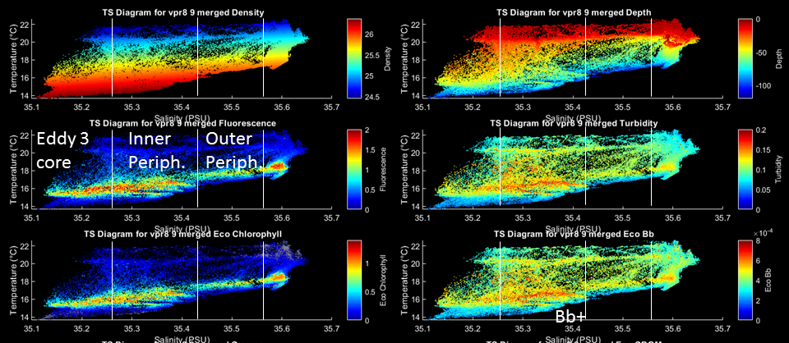
Figure 1.3.8. Potential density, depth, chlorophyll (fluorescence), turbidity, chlorophyll (fluorescence from Eco triplet), backscatter (from Eco triplet), oxygen, and CDOM (from Eco triplet) from VPR tows 8-9 plotted in temperature-salinity space.

Comparing the T-S distributions from the Eddy 1 & 2 survey with that of Eddy 3, it is clear that the core of eddy 3 water is comprised of SSTW rather than SAW (Figure 1.3.9,10).
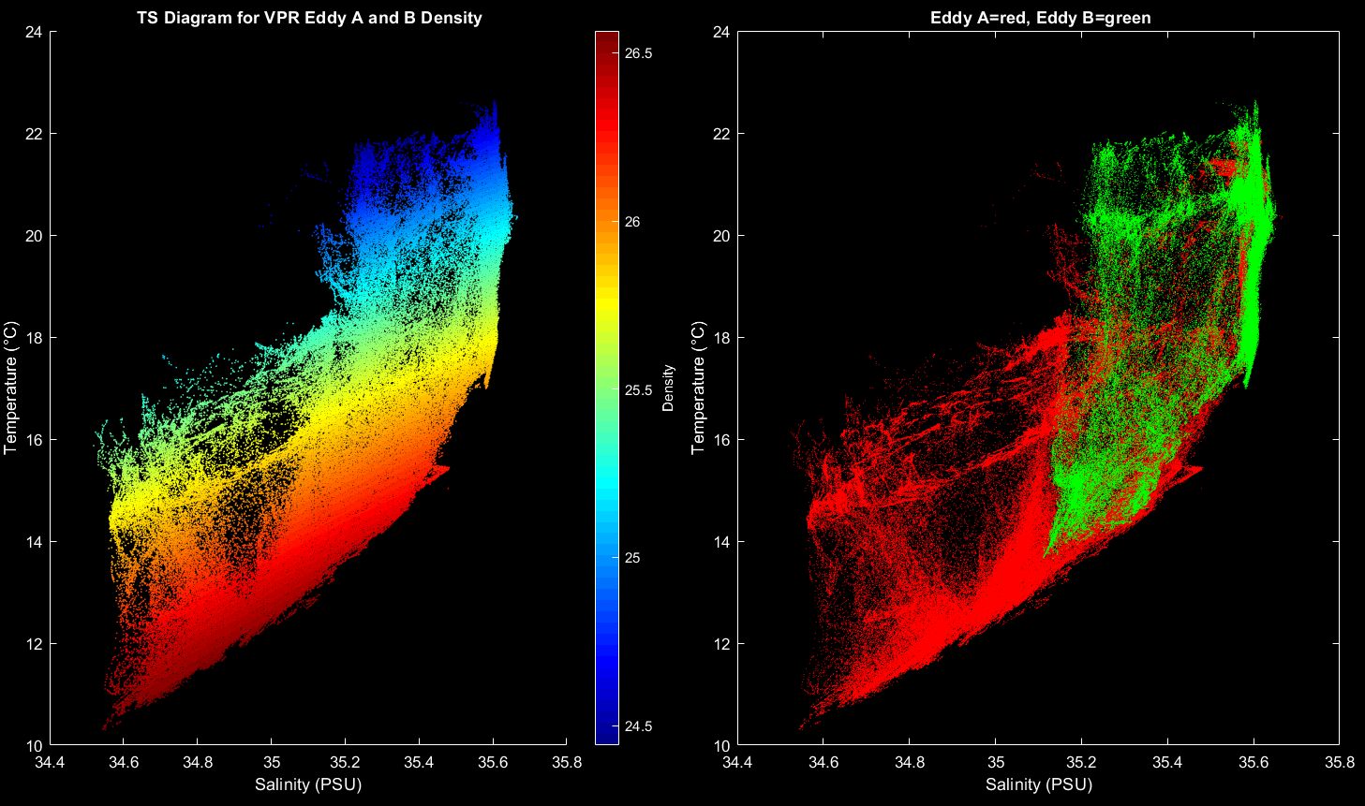

Figure 1.3.9. Left: potential density for VPR tows 2-9 (Eddy 1&2, Eddy 3 surveys) plotted in temperature-salinity space. Right: VPR tows 2-7 in red (Eddy 1 & 2 survey), VPR 8-9 in green (Eddy 3 survey).

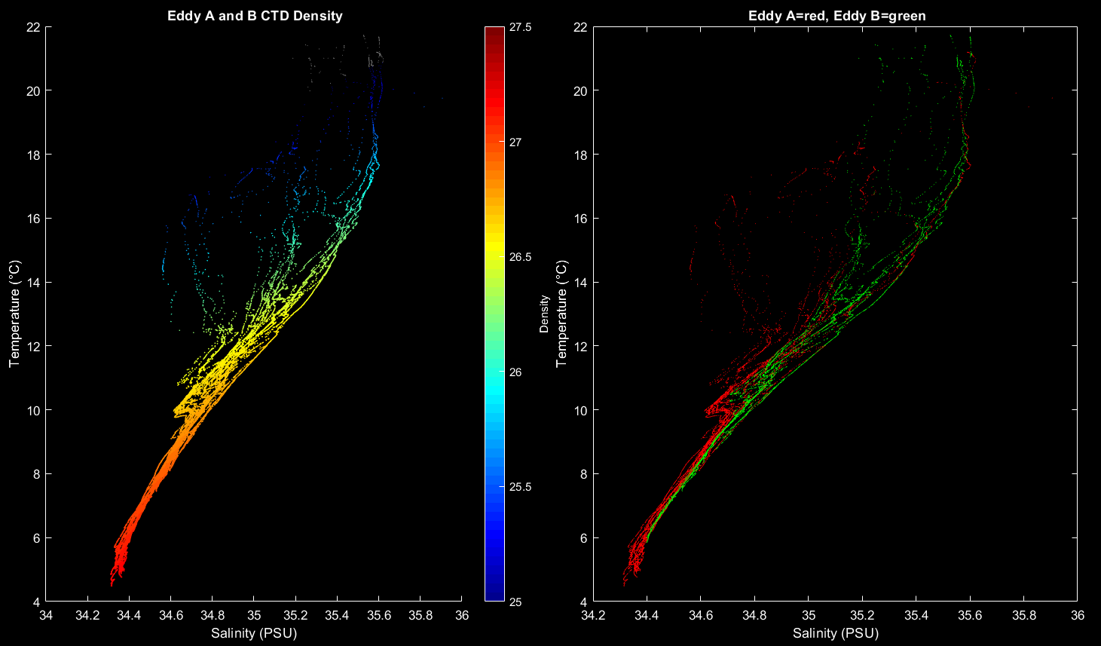

Figure 1.3.10. Left: potential density for CTDs in Eddy 1&2 and Eddy 3 surveys plotted in temperature-salinity space. Right: Eddy 1 & 2 CTD survey in red, Eddy 3 CTD survey in green.

1.4 Eddy 3 Survey 2

Two weeks later, it appears that the surface signatures of chlorophyll and PIC have diminished in Eddy 3, excepting for an area in the southwest quadrant of the eddy in the MODIS PIC image, although this may be a cloud artefact (Figure 1.4.1).

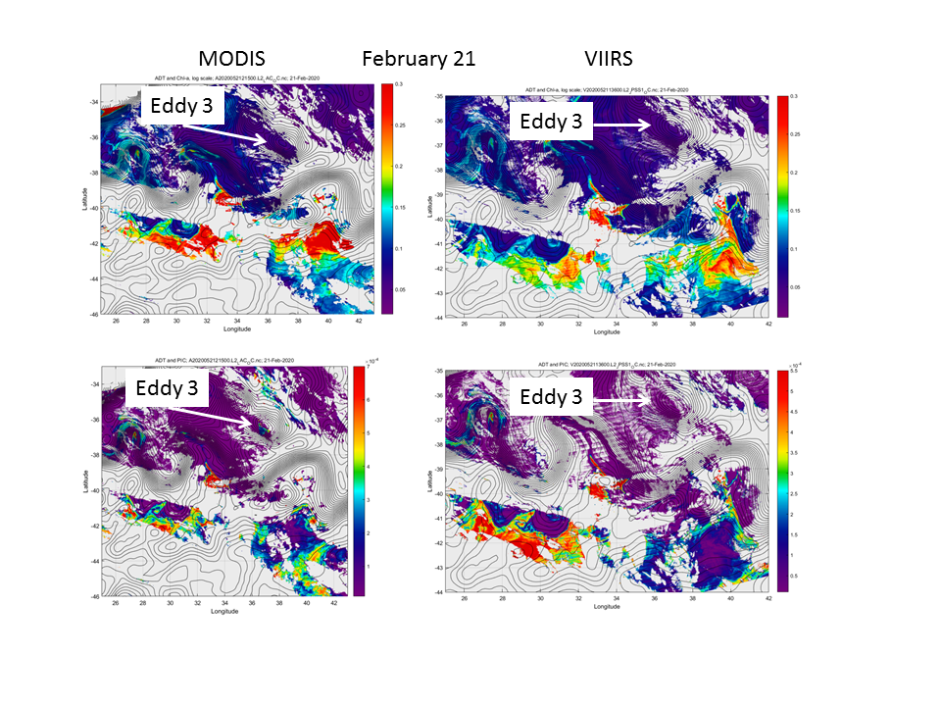
Figure 1.4.1: Chlorophyll (top row) and PIC (bottom row) images for MODIS (left column) and VIIRS (right column) on February 21.

VPR surveys (Figure 1.4.2) are consistent with a decrease in the Bb signal, especially near the surface. Very modest enhancements are present in a band surrounding eddy center at stations 56, 60, 64-65, and 67.

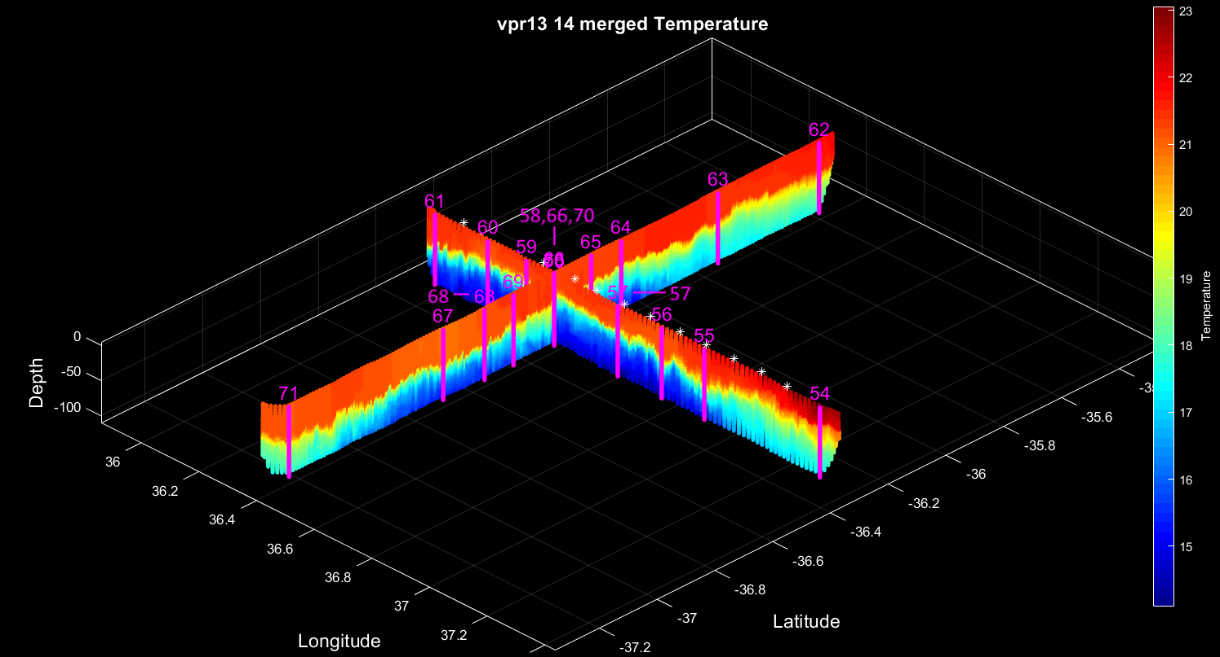

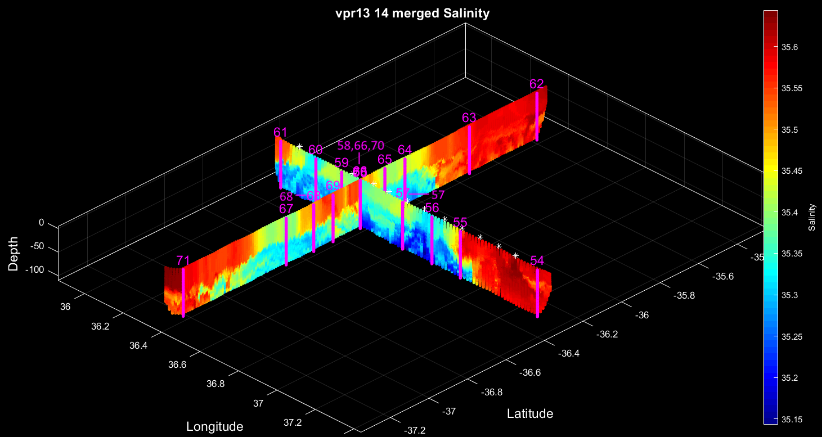
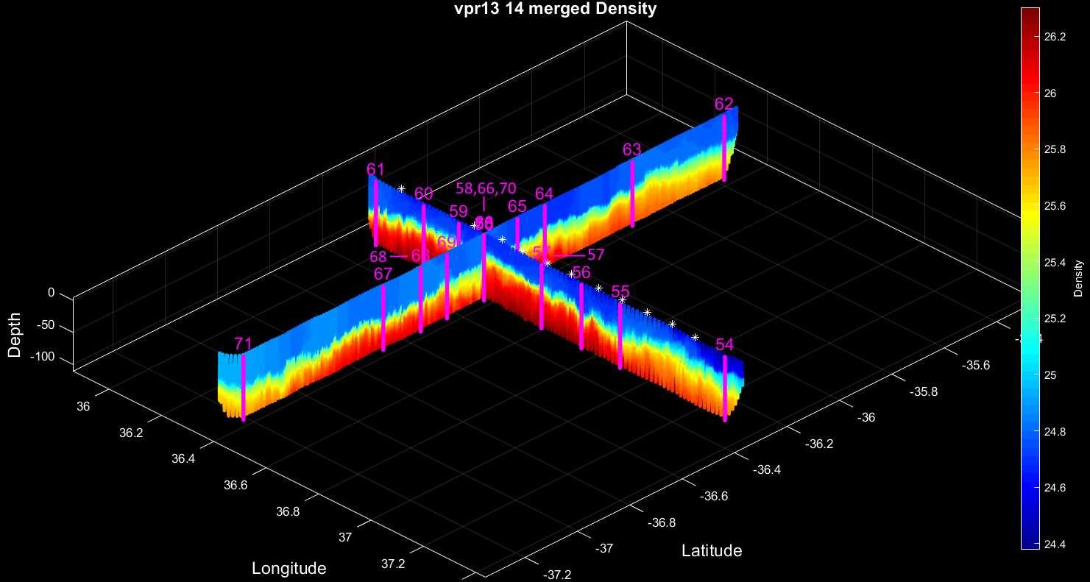

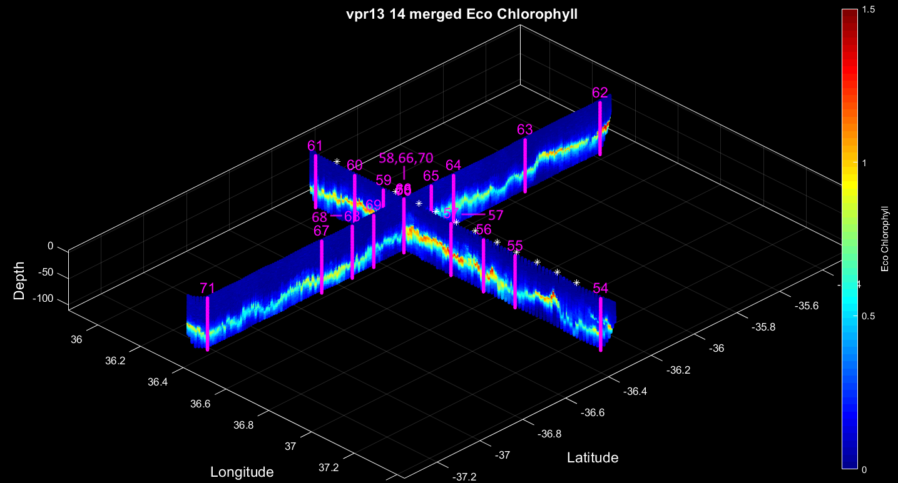

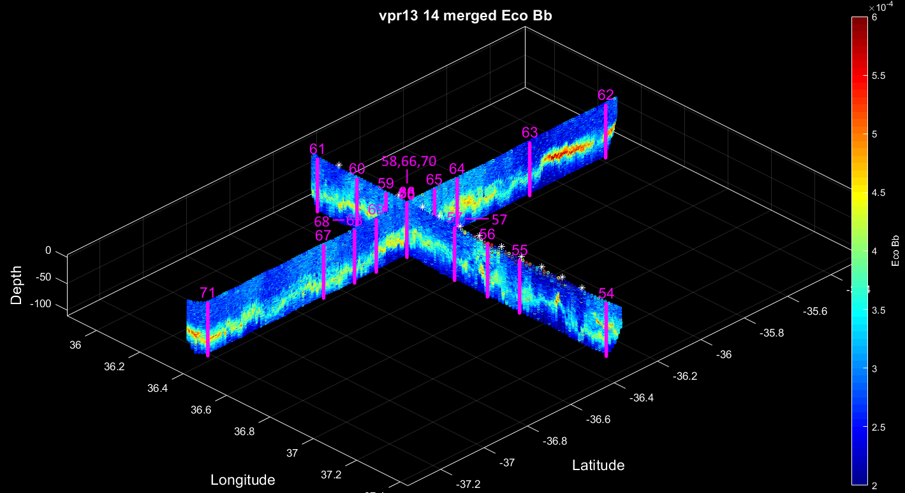

Figure 1.4.2 VPR surveys 13 and 14 combined. CTD stations and XBT locations indicated by magenta lines and asterisks, respectively.

During the two weeks in between surveys, the eddy propagated to the southwest (Figure 1.4.3). It also interacted with a newly formed cyclone to the northwest, apparently beginning to merge with it toward the end of the second survey. Eddy 3 appears to have weakened during this process, with a noticeable decrease in sea level anomaly associated with the feature.

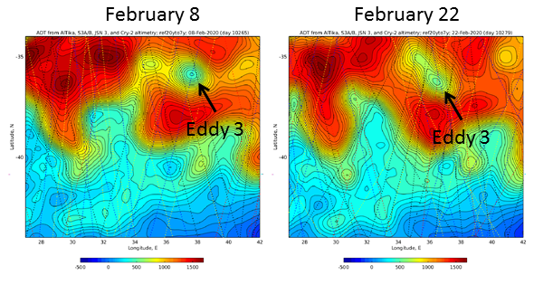
Figure 1.4.3. Altimetric changes in Eddy 3 from February 8 (left) to February 22 (right).

CTD surveys (Figure 1.4.4; Table 1.4.1) are consistent with the altimetric analysis, with modest subsidence of the main pycnoline. However, at least a portion of this apparent temporal trend could be due to the fact that the north-south section passed east of eddy center, according to the ADCP (Figure 1.4.5).

Transect | Station | Feature / comments
9 | 54 | Eastern periphery – high salinity
 | 55 | Local Smax
 | 56 | High Bb, low S: PP cast, TM cast
 | 57 | Smed
 | 58 | Eddy center
 | 59 | Smed
 | 60 | Bb slight enhancement
 | 61 | Local Smax
10 | 62 | Northern station
 | 63
 | 64
 | 65
 | 66 | Eddy center
 | 67 | 3 south of EC; diverted to get drifter
 | 68 | 2 south of EC
 | 69 | 1 south of EC
 | 70 | Eddy center repeat / TM cast
 | 71 | Southern station
Table 1.4.1. Station list for CTD transects 9 (east to west) and 10 (north to south) across Eddy 3.

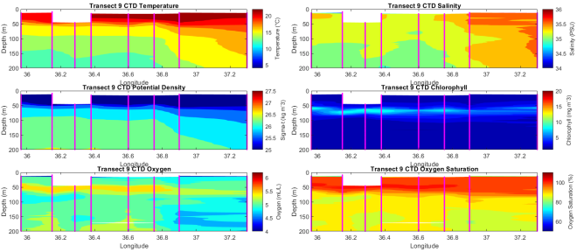 | 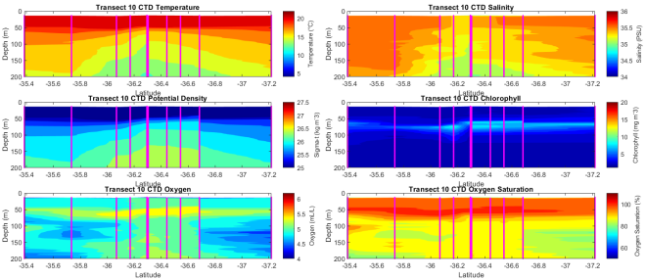
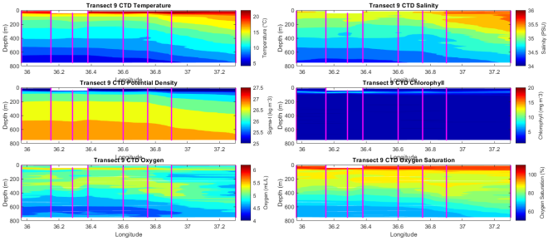 | 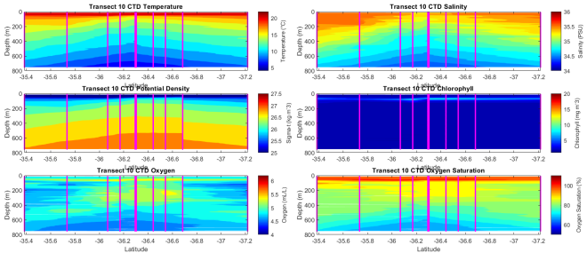
Figure 1.4.4. CTD transects 9 (left) and 10 (right). Upper panels 0-200m, lower panels 0-800m.

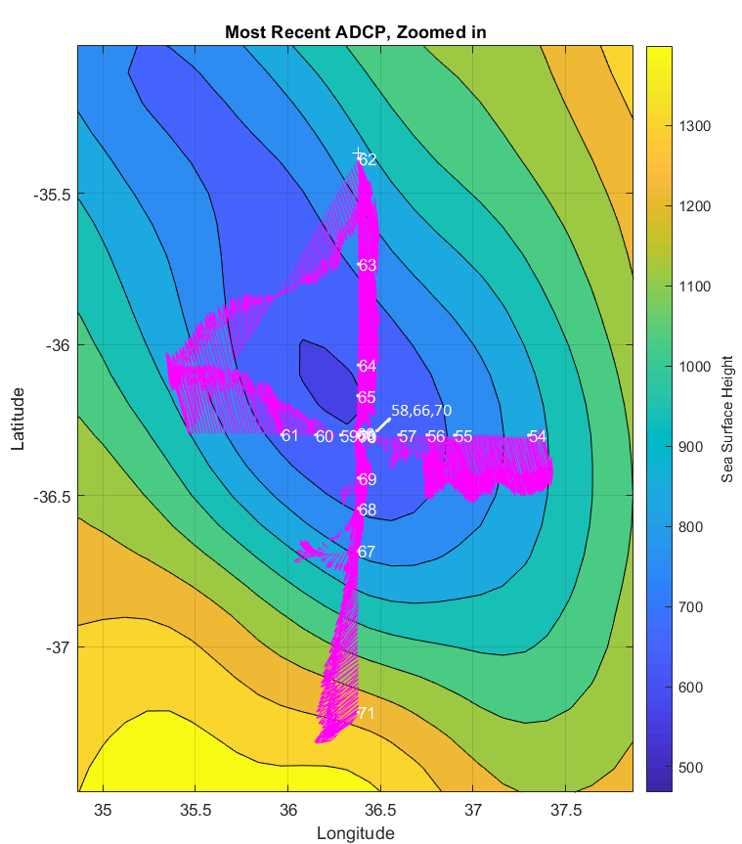
Figure 1.4.5. ADCP surveys associated with VPR 13 and VPR 14. Note that eddy center had propagated west (northwest according to the altimetry) during the time in between surveys, thus the north south line (VPR14) passed east of eddy center.

2. Some comments on Subantarctic Mode Water and its presence in our observations

SAMW is characterized by a thick layer of relatively uniform properties, formed by deep mixed layers in the wintertime, capped off by spring/summer stratification, and subsequently subducted into the main thermocline. McCartney (1977) provides an example from a hydrographic section:

Simple conceptual models convey a zonally averaged view, e.g. Sarmiento et al. (2004):

However, the production and distribution of SAMW are far from zonally uniform, as depicted in schematics by Belkin and Gordon (1996) and Koch-Larrouy et al. (2010):

A commonly used indicator of SAMW is a thick layer of low potential vorticity, which reflects low stratification: $PV\sim \frac{f}{ρ}\frac{dρ}{dz}$. Herraiz-Borreguero and Rintoul (2010) diagnose SAMW from climatology, showing a volumetric hotspot in the eastern Indian Ocean:

This general view is corroborated by their analysis of ARGO float data. Lower two panels show temperature and salinity characteristics of the SAMW identified in the upper panel as PV < 1.5 10⁻⁹ m⁻¹ s⁻¹.
26.8 neutral surface 26.9 neutral surface
Cerovecki et al. (2013) use the SOSE model to diagnose the low-potential vorticity layer associated with SAMW:

Gordon et al. (1987) document SAMW hydrographic properties in the western Indian Ocean and how they relate to other water masses present in the region:

Where is the SAMW in TN376 observations?

The first step in answering this question is what do we mean by SAMW? Various criteria have been used, usually based on a PV threshold, density interval (typically 26.5 to 27.0), and minimum depth (typically deeper than 200m in order to avoid seasonal stratification and mixing effects). Herraiz-Borreguero and Rintoul (2010) use a PV threshold of PV < 1.5 10⁻⁹ m⁻¹ s⁻¹, whereas Wong (2005) uses PV < 0.5 10⁻¹⁰ m⁻¹ s⁻¹. These differ by a factor of 30, which likely reflects different choices of the density used for the denominator in the first component of the PV computation: $PV=\frac{f}{ρ}\frac{dρ}{dz}$. Apparently Herraiz-Borreguero and Rintoul (2010) use σ_{θ}, whereas Wong (2005) uses the in situ density ρ. For σ_{θ}=26.5, the effective multiplier is $\frac{1026.5}{26.5}=38.7$, whereas for σ_{θ}=27.0, it is $\frac{1027.0}{27.0}=38.0$. Choice of density does not affect the second component of the PV computation, as it is a first derivative of that quantity. Units of 10⁻¹² m⁻¹ s⁻¹ are now commonly used for PV (Schlitzer, 2020), reflecting use of in situ density in the computation. In those units, the Herraiz-Borreguero and Rintoul’s threshold is ca. 40 ·10⁻¹² m⁻¹ s⁻¹ and Wong’s is 50 ·10⁻¹² m⁻¹ s⁻¹.

In our data (Figure 2.1), the σ_{θ} = 26.5 isopycnal is mostly shallower than 200m and embedded within the seasonal pycnocline, excepting for stations in subtropical gyre water (e.g. outside of Eddy 3) where it is deeper than 300m. There does appear to be a relatively thick layer of water in the σ_{θ} = 26.6 to 26.7 interval, which appears to be a remnant of a wintertime mixed layer of ca. 300m: note the high oxygen content in the 0-300m stratum, indicating recent ventilation (presumably this past austral winter). In a sense, mode water appears to have been formed in this location, only to be capped off locally by seasonal stratification. However, applying even the more generous criteria of Wong (50 ·10⁻¹² m⁻¹ s⁻¹), none of the profiles included in this analysis meet that definition of SAMW. However, if we relax the threshold to 100 ·10⁻¹² m⁻¹ s⁻¹, several points appear in the σ_{θ} = 26.5 to 27.0 depth interval. There are also mode waters in the deeper layers (600-800m) with σ_{θ} of ca. 27.1 – 27.2, which is presumably AAIW.

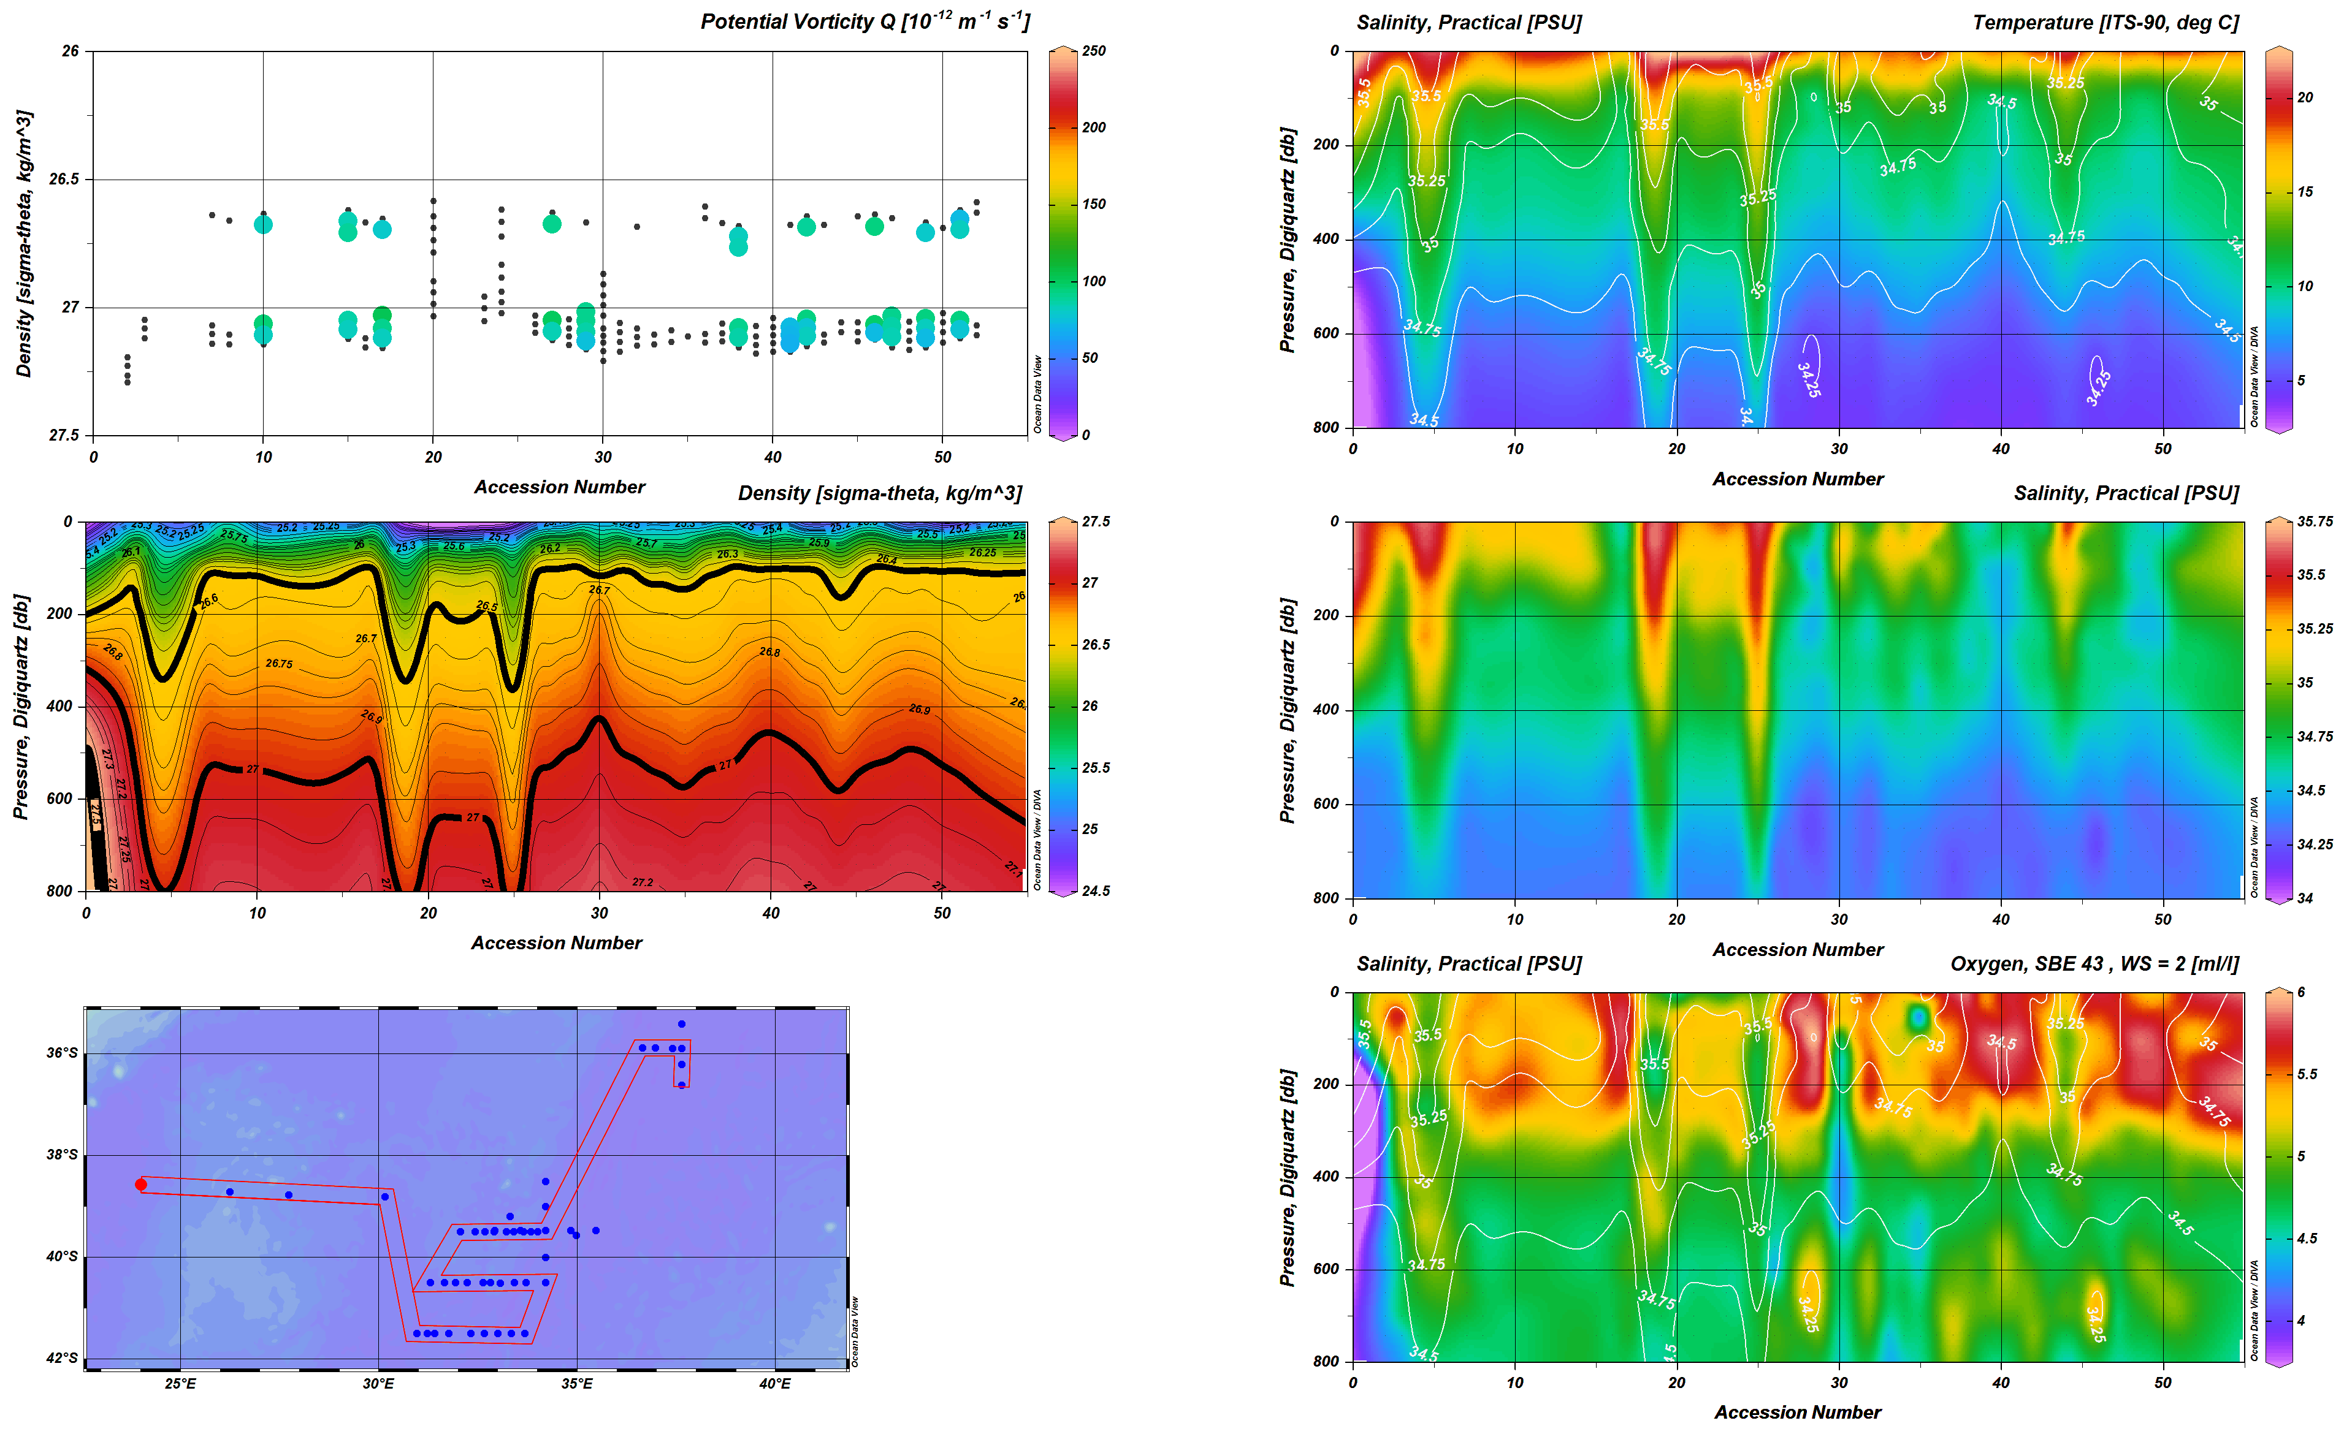
Figure 2.1. Potential vorticity, density, temperature, salinity, and oxygen for stations 1-52 on TN376. Salinity contours overlayed on temperature and oxygen panels.

3. Daily narrative

27 January 2020

VPR1 transited across the eastern flank of the Agulhas eddy (Figure 3.1). Beginning in the warm and salty waters of the eddy, the fluorescence maximum was located at ca. 60-80m. Microscopic analysis of a Niskin sample from station 1 by Colin Brownlee suggested the phytoplankton community was dominated by dinoflagellates. VPR imagery showed copepods, diatom rods, fecal pellets, and gelatinous zooplankton.

A sharp salinity front was observed at 24.15E, and the fluorescence distribution was concentrated near the surface.

As we proceeded east, a relatively warm and fresh water mass was encountered at 24.6E, with much higher fluorescence values. This area was also associated with high backscatter. VPR imagery showed a large amount of particulate matter in the upper 20m, with fewer gelatinous zooplankton present. Proceeding further east, fluorescence dropped but high backscatter persisted. As we exited the warm and fresh water mass at 25.1E, backscatter decreased back to background levels.

At around 25.2E, the pycnocline began to rise, with relatively cold and fresh waters doming upward toward the surface. It was at this front that we observed highest fluorescence values, although this could be due to a reduction in quenching as light levels dropped toward the end of the day.

Oxygen values (uncorrected) show some oceanographic trends, with lowest values in relatively fresh waters underneath the area of high backscatter.

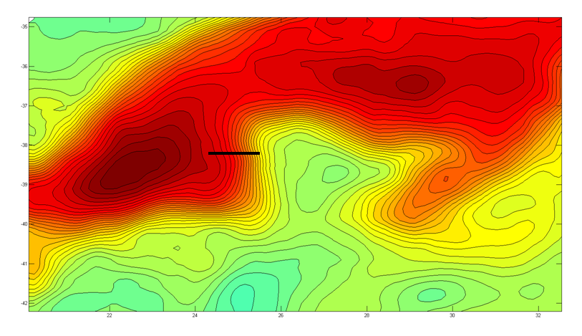
Figure 3.1. VPR1 track overlayed on absolute dynamic topography for 27 January, 2020. VPR data panels follow below.

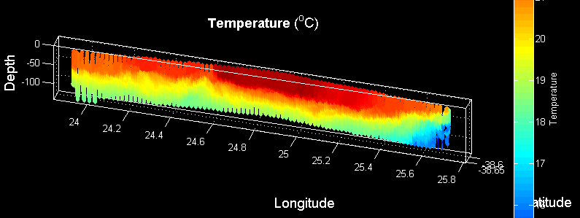

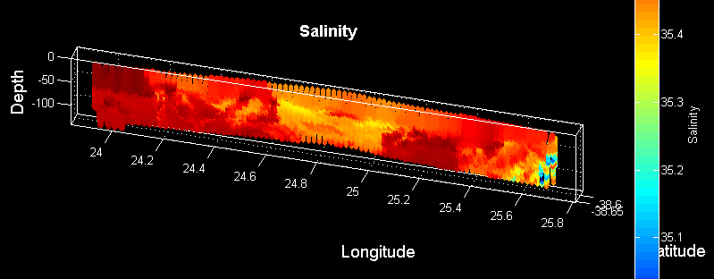

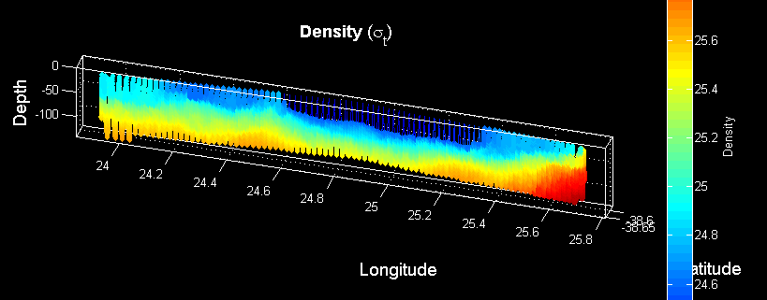

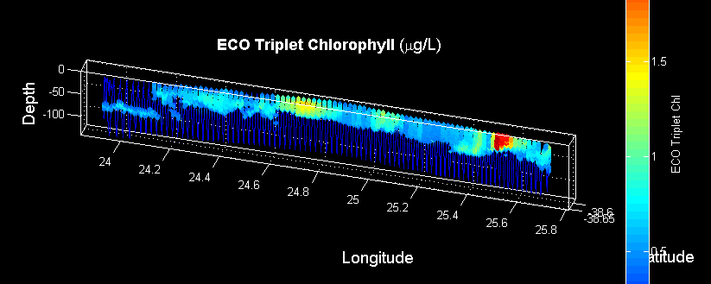

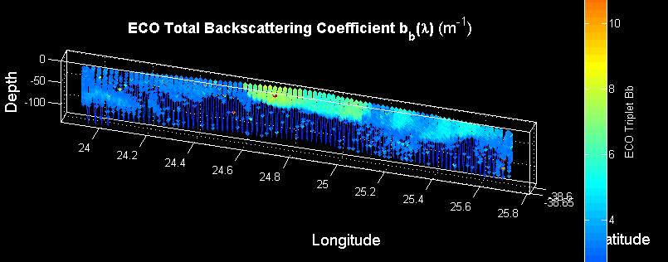

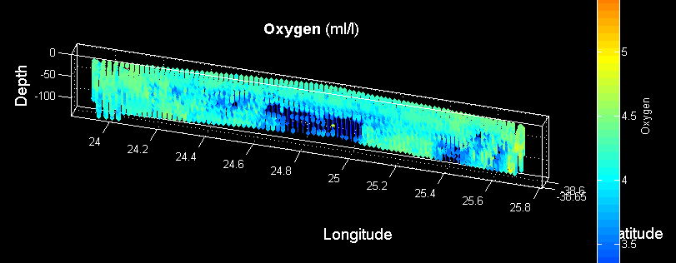

29 January 2020

Satellite imagery from 24 January indicates an area of high Chl / high PIC water in the pocket of a northward meader of the Agulhas Front (Figure 3.2). VPR2 began on the western flank of the meander, with characteristic warm and salty water. Stratification was relatively low in the upper ocean, and the fluorescence maximum was at the surface.

High Chl / high backscatter (hereafter Bb) was encountered along the track at ca. 32.7 E, indicating some eastward movement of the feature since the satellite image on 24 January. Within the broad area of high Chl / high Bb, there were two local maxima which are reminiscient of the roughly north-south banding structure in the satellite image. Underway measurements of Bb’ confirm this area to be high in PIC.

As we proceeded eastward, both Chl and Bb decreased sharply at ca. 33.6 E. After a short segment of low values, Bb rose back to levels nearly as high as was observed in the high Chl / high Bb area. Underway Bb’ measurements indicate PIC was similarly elevated. This low Chl / high Bb / high Bb’ water mass is clearly distinct from the high Chl / high Bb / high Bb’ water: the latter is moderately warmer and saltier, but clearly not as warm and salty as the Agulhas Front waters encountered earlier in the transect. Might this be a result of mixing of waters south of the front with the Agulhas Front to generate this water which is conducive to low Chl / high Bb / high Bb’?

Note the oxygen (uncorrected) is highest in the high Chl water mass.

Figure 3.2. VPR2 track overlayed on Chl (left) and PIC (right). Contours are ADT. VPR data panels follow below.

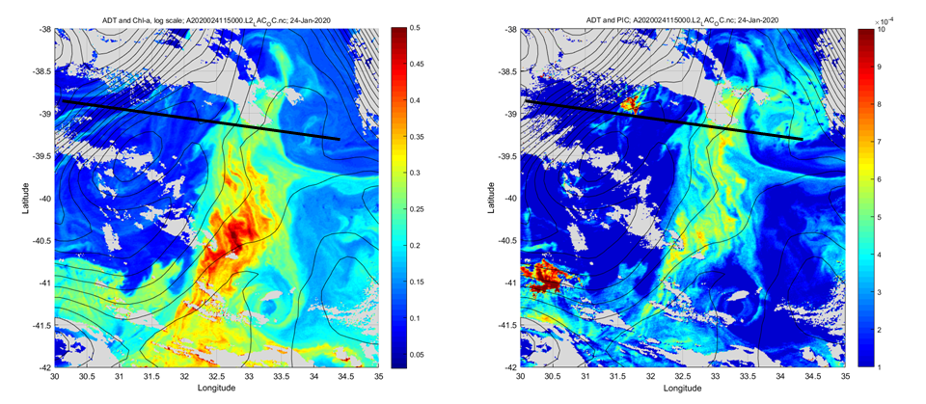

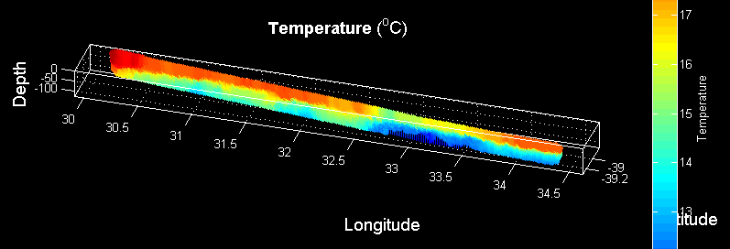

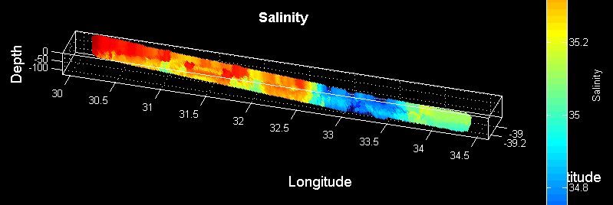

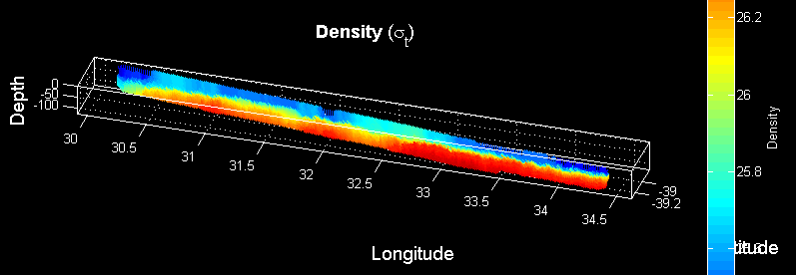

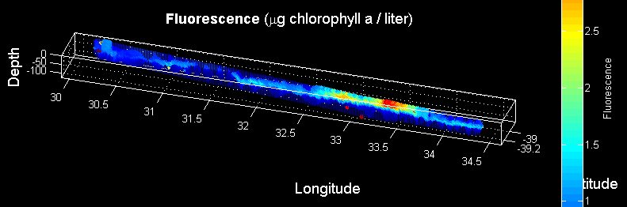

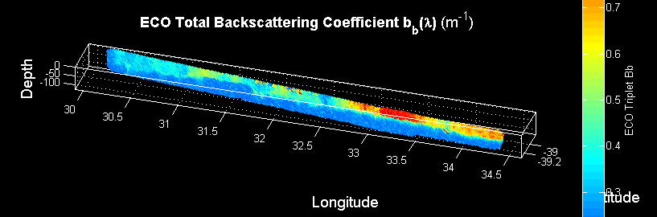

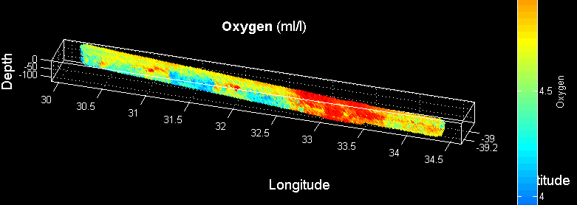

30-31 January

VPR3 deployed to start a spatial survey to the south. The initial plan was based on the imagery from 24 January, and new imagery suggests an alternative strategy. The high Chl / high Bb tendril to the south appears to have moved north; the tendril to the north appears to have wrapped eastward around the low Chl / high Bb water (Figure 3.3). ADCP data indicate an eddy-like feature associated with the low Chl / high Bb water, so the decision was made to survey in between the two quasi-zonal tracks to determine eddy center. On the transit northward on the eastern side of the survey grid, we lost communications with the flight control computer. VPR was recovered safely, and troubleshooting began. Reseating the connector on the engineering can restored communications.

It turns out that our stopping point corresponded with a high value of Bb’, perhaps the largest of the trip thus far. This may be associated with southeastward transport of the high PIC water southeast along the meander. CTD and trace metal casts were carried out at the station while VPR maintenance was taking place.

VPR4 deployed to continue areal survey. Flight control communitcations were restored for several hours, then dropouts started. Brief periods of communications were restored during the bottom of the tow, suggesting a loose connector. ROI detection has short dropouts as well, indicating a problem with comms over the science fiber as well. Toward the end of the tow, flight control comms resumed continuous operation.

VPR4 appears to have delineated eddy center at ca. 34 00 E, as confirmed by the ADCP (not shown). A local salinity maximum in surface waters at eddy center coincides with a local minimum in Bb’ based on the Balch group’s underway measurements. This appears to be consistent with the satellite Bb image. Location for the primary productivity station was chosen to be just east of eddy center (34 12’E) to be in a higher Bb’ regime within the eddy.

Underway XBT measurements along the E-W portion of VPR2 characterize thermocline variability associated with this meander / eddy system.

Figure 3.3. Tracks of VPR2, 3, and 4 overlayed on Chl (left) and PIC (right). Contours are ADT. VPR data panels follow below.
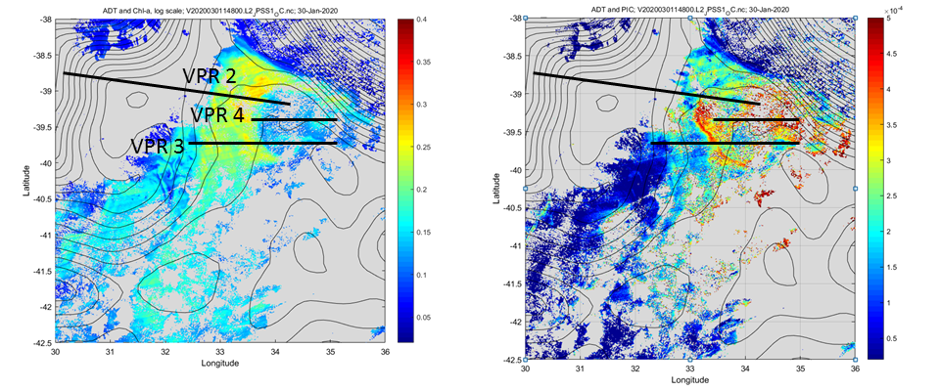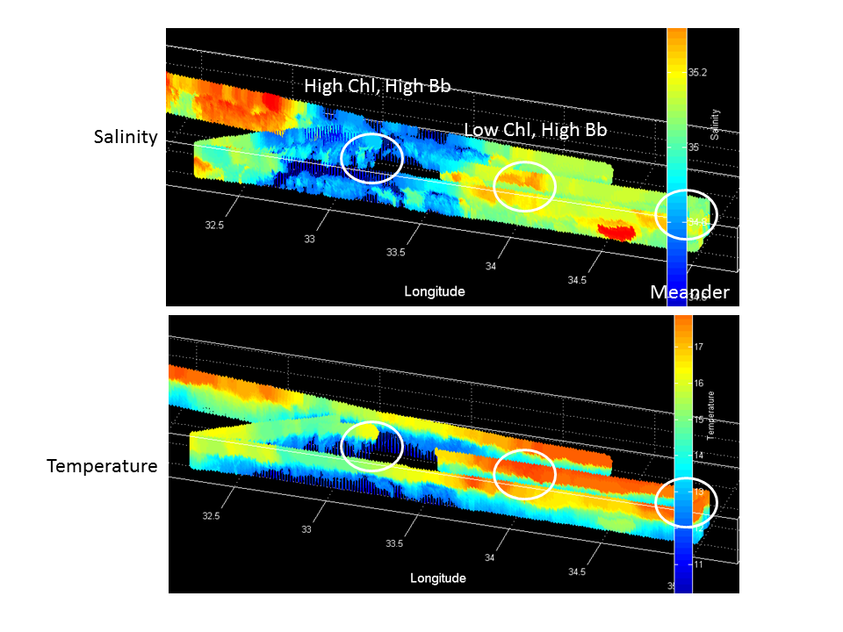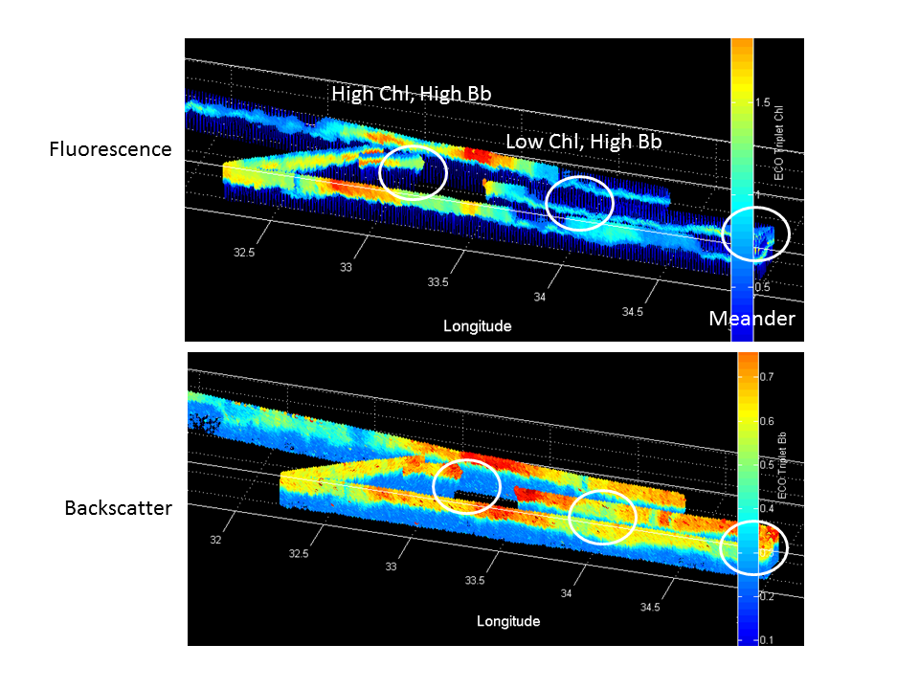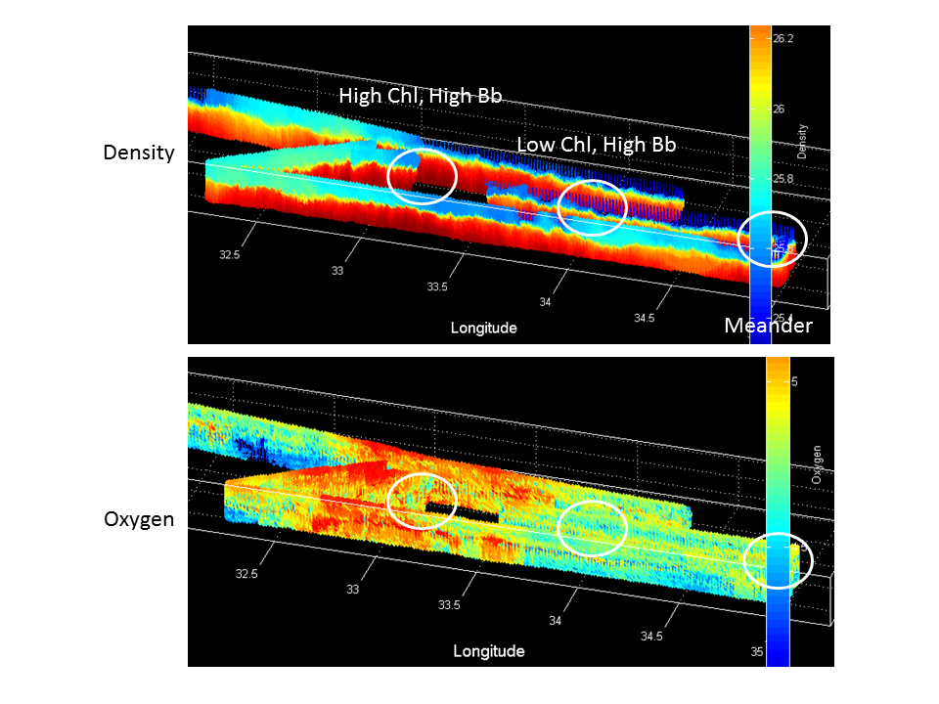

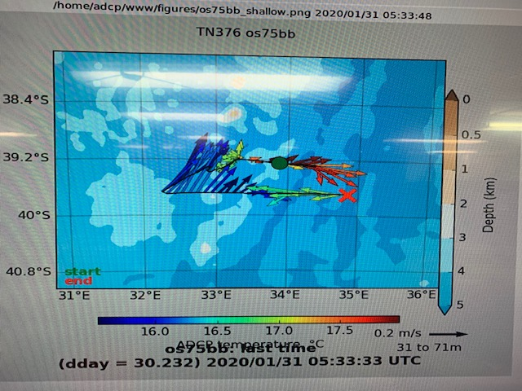

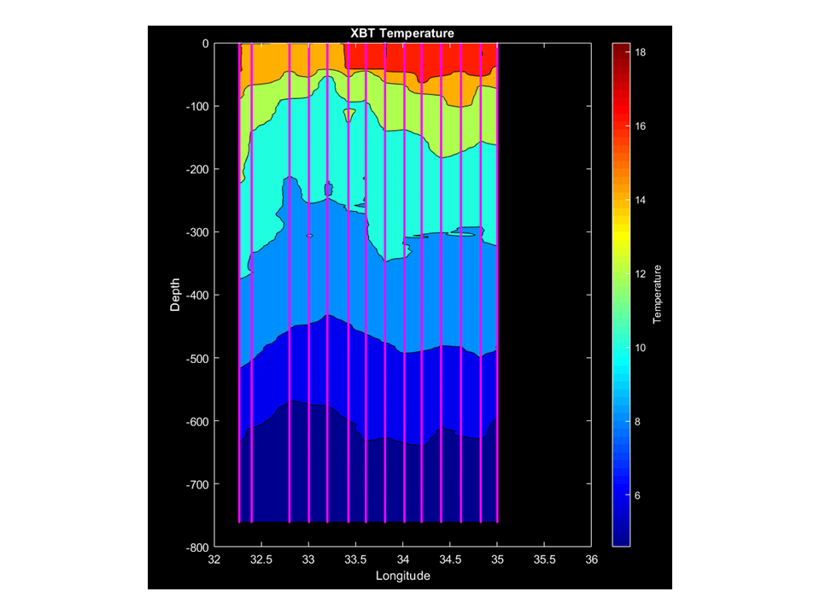

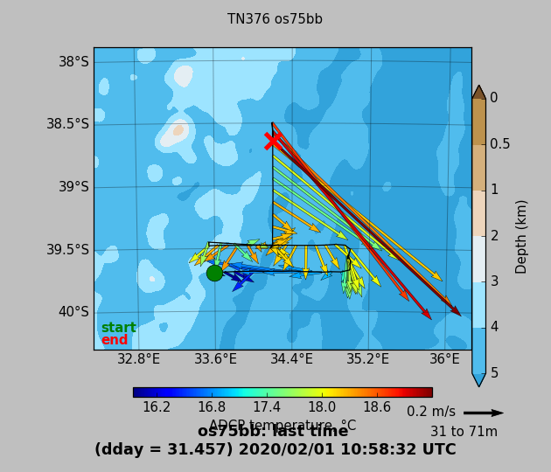

1-2 February

From the primary productivity station just east of eddy center (34 12’E, in a high Bb’ regime within the eddy), we steamed north to 38.5S. Underway measurements indicate decreasing Bb’ as we entered the Aguhlas Front. This set the stage for a southward VPR tow through the features (Figure 3.4). The warm, salty, low density water of the Aguhlas Front is associated with low Chl, Bb, and oxygen. Proceeding southward, we crossed through the limb of cool and fresh high Chl / high Bb / high oxygen waters wrapping eastward around the eddy. Farther south we entered the warmer and saltier waters of the low Chl / high Bb eddy, whose southern boundary was in the vicinity of 39.8 S. South of the eddy there was a regime of low Chl / high Bb, although the low Chl extended from the surface down to 50-60m, in contrast to the subsurface Chl max inside the eddy.

Underway XBT measurements along VPR5 characterize thermocline variability associated with the features described above.

Figure 3.4. VPR5 track overlayed on Chl (left) and PIC (right). Contours are ADT. VPR data panels follow below.

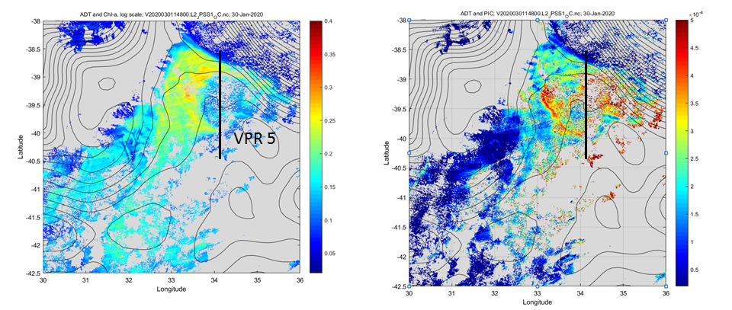

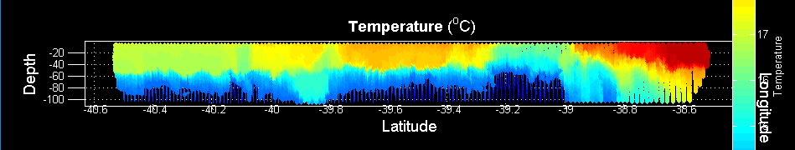

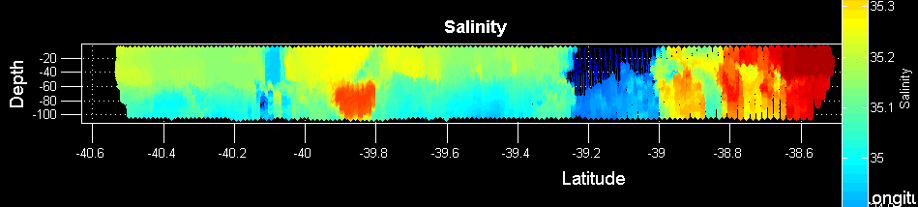

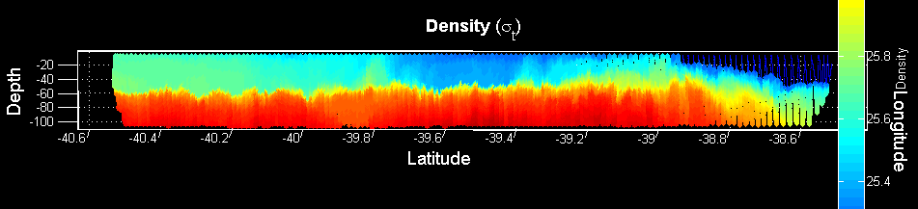

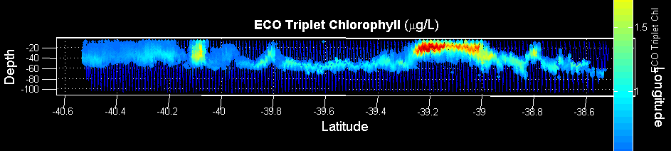

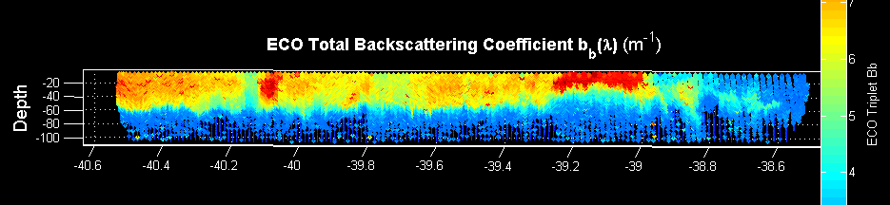

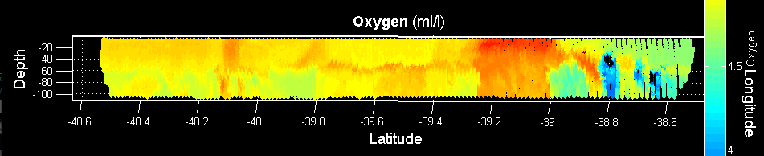

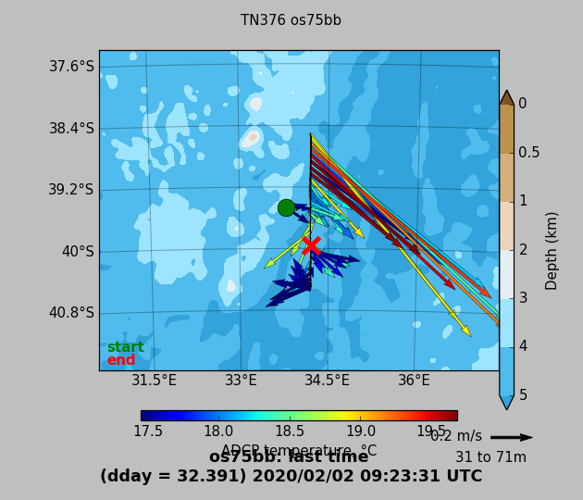

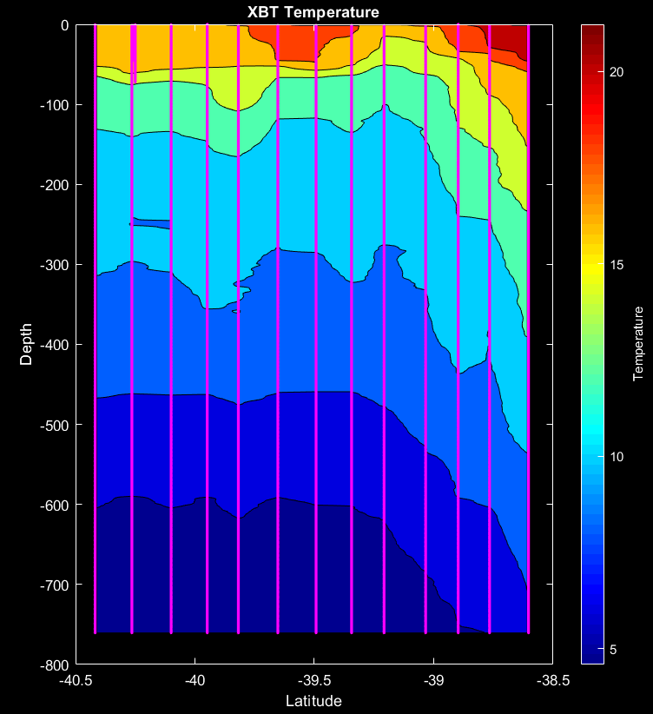

3 February

A line of CTDs was completed running back northward along the VPR5 transect. Upon completion of that, we made a towVPR 6 from the northernmost CTD station to the easternmost on the E-W line. This tow had us proceeding southeastward along the meander of the Agulhas Front, breaking out into the adjacent water mass toward the very end. Evidence of small scale frontal subduction / upwelling is present in both the hydrographic and bio-optical properties. The tow ended with a transition from high Chl / high backscatter to low Chl / low backscatter.

Figure 3.5. VPR6 track overlayed on Chl (left) and PIC (right). Contours are ADT. VPR data panels follow below.
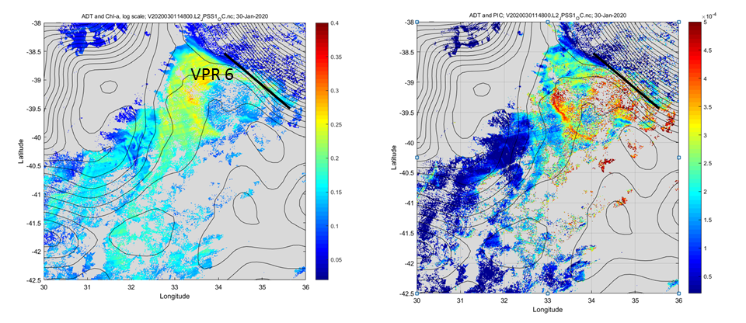

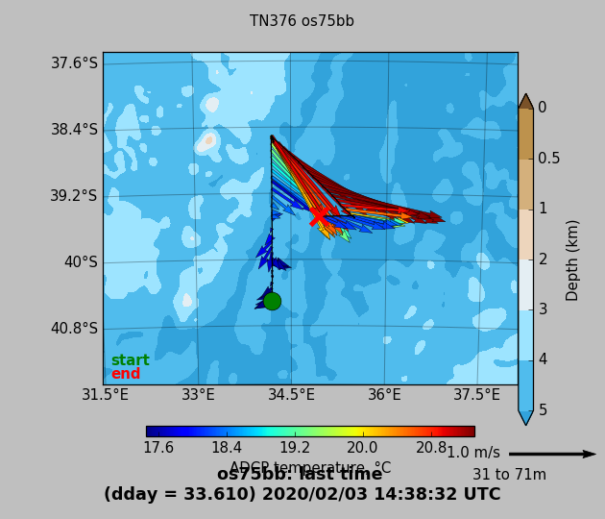

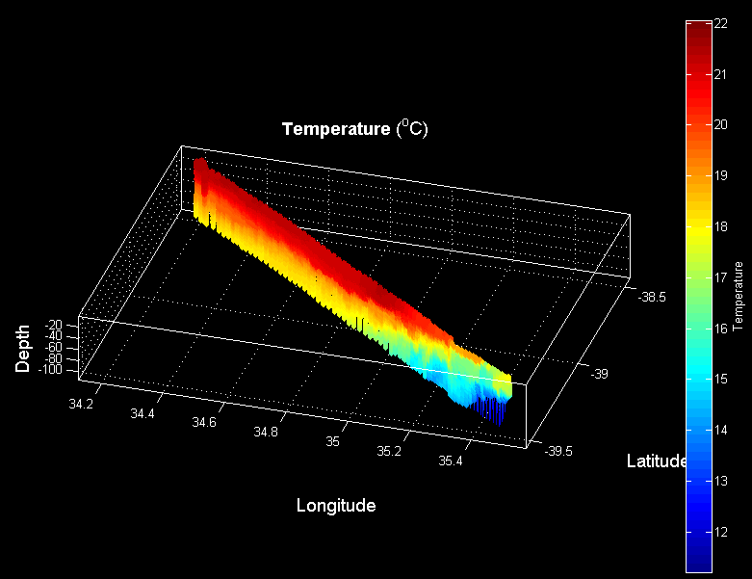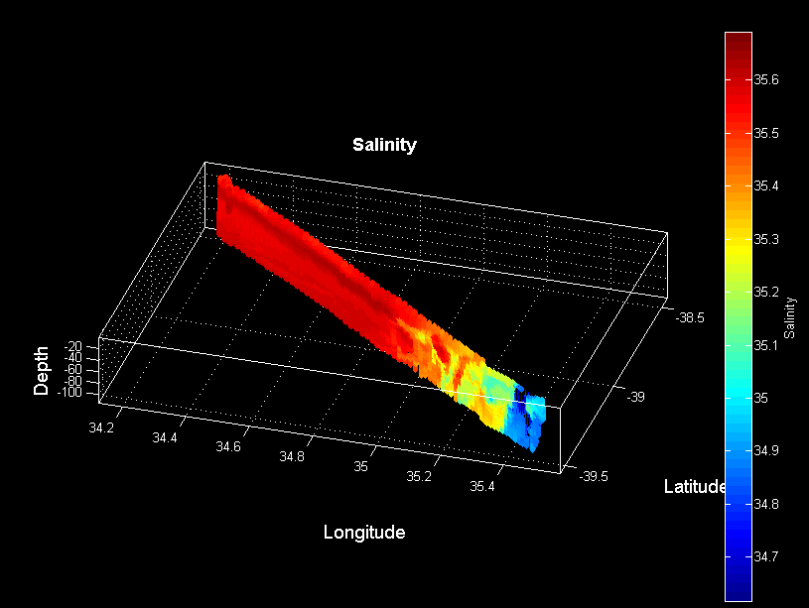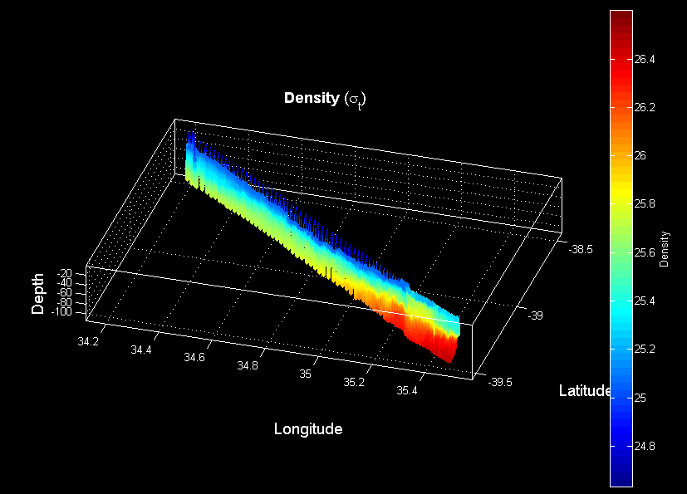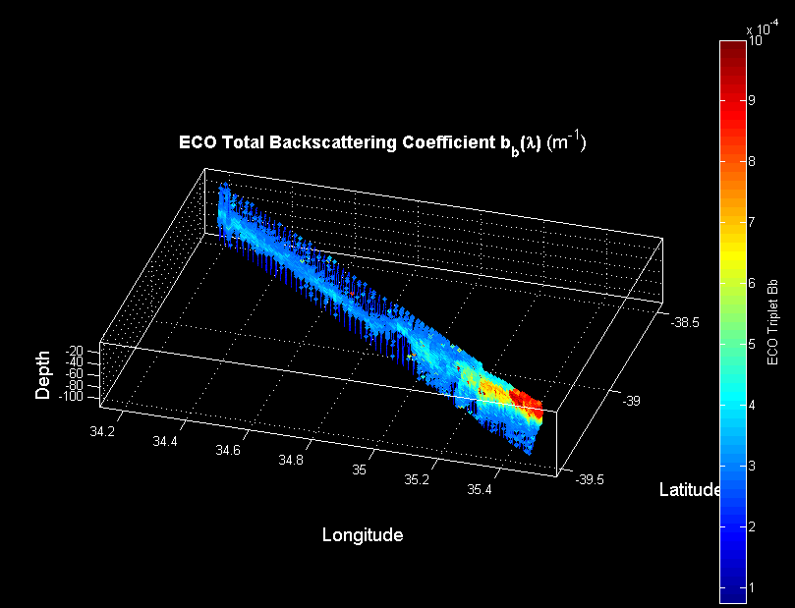
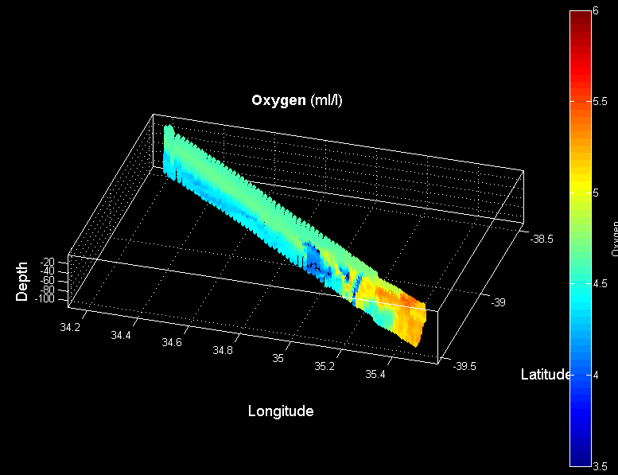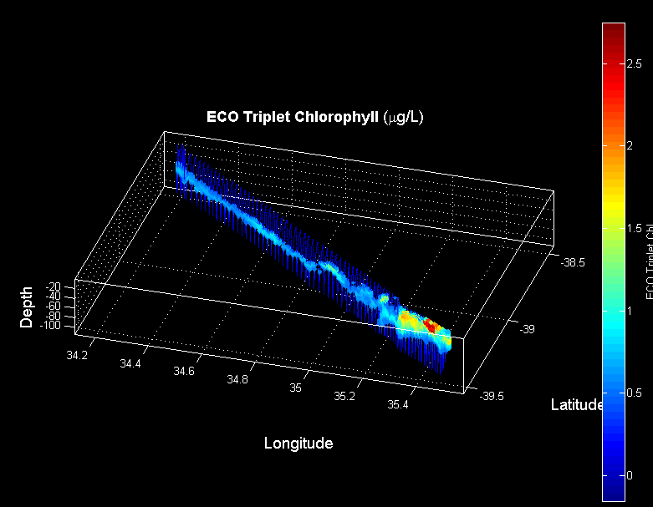

4 February

A line of CTDs was completed from east to west across the low Chl / high Bb and high Chl / High Bb feature. Upon completion of that line of CTDs, we made a towVPR 7 (Figure 3.6) from the westernmost CTD station to the northernmost on the N-S line, as this tow is almost on course with our route to the next eddy. This section shows high contrast between the cool, fresh, high chl, and high oxygen waters south of the Agulhas front, with the warm, salty, low chl, low oxygen in the front.

Figure 3.6. VPR7 track overlayed on Chl (left) and PIC (right). Contours are ADT. VPR data panels follow below.

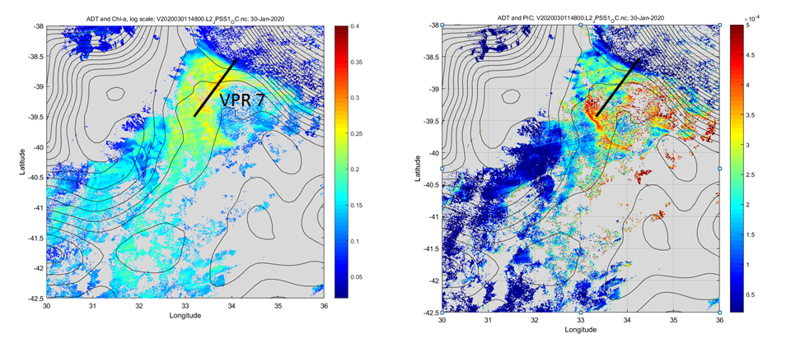
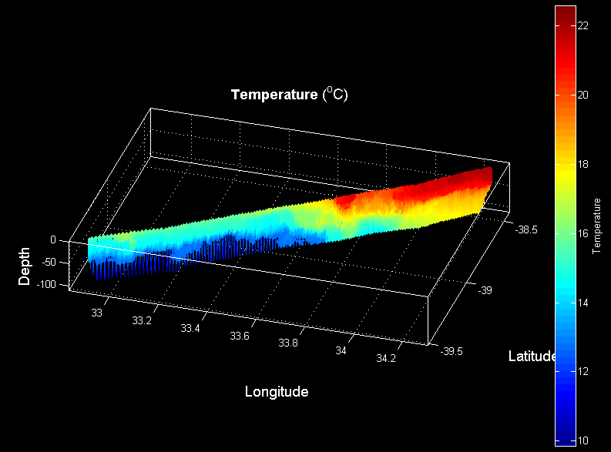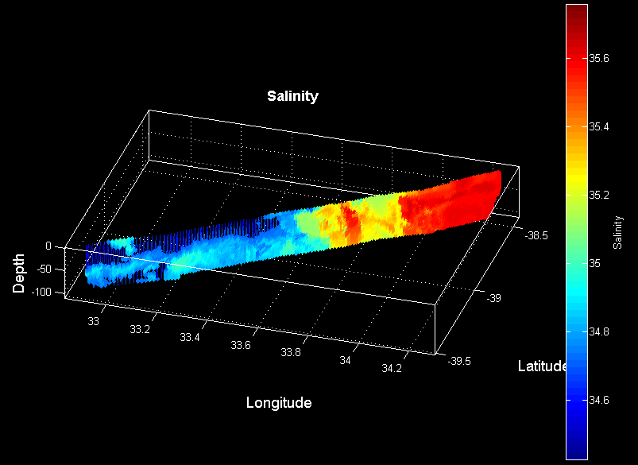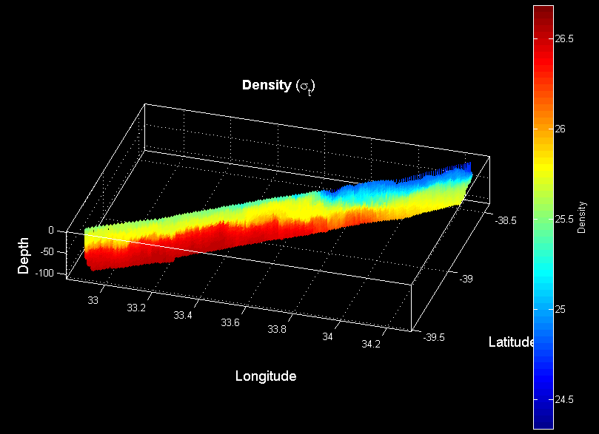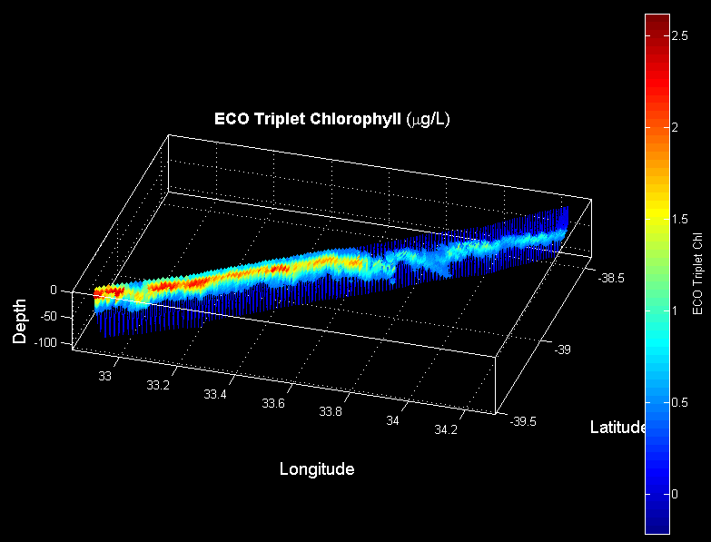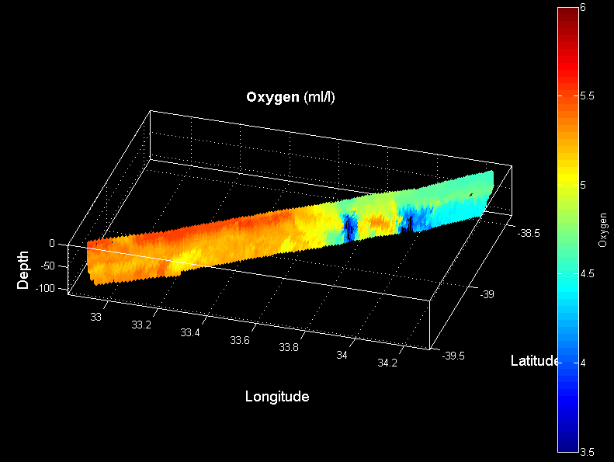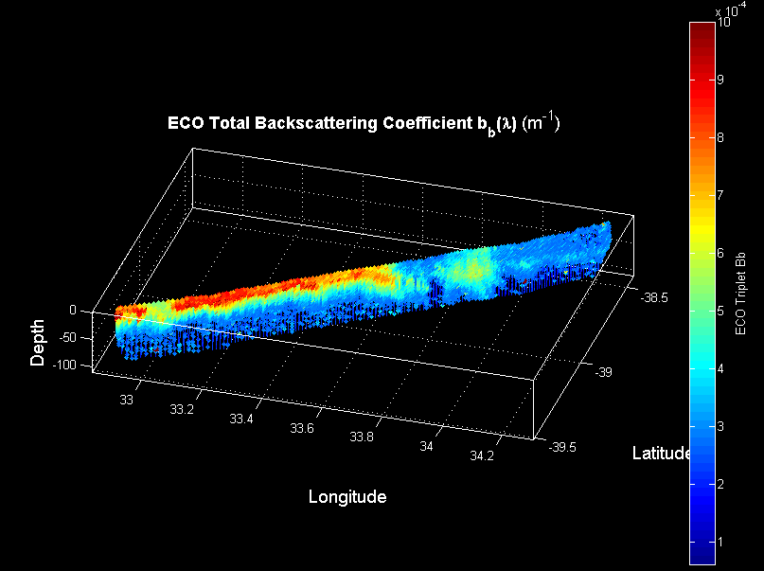

5-6 February

Steamed northeast to begin the eddy 2 survey. VPR8 entry began west of the feature, transiting east with the objective of locating the band of high Bb water encircling the eddy (Figure 3.7). Upon arriving in that area, the VPR was recovered so a station could be occupied and water collected for incubation experiments. VPR9 picked up where VPR8 left off, completing the east-west transect then proceeding northwest to occupy a north-south transect. ADCP data confirm the clockwise circulation of the cyclonic eddy, and that crossing between the two transects was very close to eddy center, just slightly to the northeast. XBT transects in the E-W direction (T-7s down to 700m) and N-S direction (T-5s down to 1300m) depict the upward doming of the main thermocline.

VPR data delineate the spatial extent of the low salinity water comprising the core of the eddy. Highest backscatter coincides with these frontal boundaries, where interleaving of water masses is apparent. Unfortunately the oxygen sensor appears to have been airlocked in VPR9, rendering those data useless.

Interior points of the CTD transects were chosen to coincide with peaks in Bb’ residing at the salinity front surrounding the eddy core.
South
36 37.0 S
37 37.7 E
Interior south
36 12.0 S
37 37.7 E
Eddy center
35 53.0 S
37 37.7 E
Interior north
35 24.0 S
37 37.7 E
North
35 09.0 S
37 37.7 E

East
35 53.0 S
38 39.0 E
Interior east
35 53.0 S
38 24.0 E
Eddy center
35 53.0 S
37 37.7 E
Interior west
35 53.0 S
37 24.0 E
West
35 53.0 S
36 30.0 E

Figure 3.7. ADT contours overlayed on Chl (left) and PIC (right). ADCP and VPR data panels follow below.

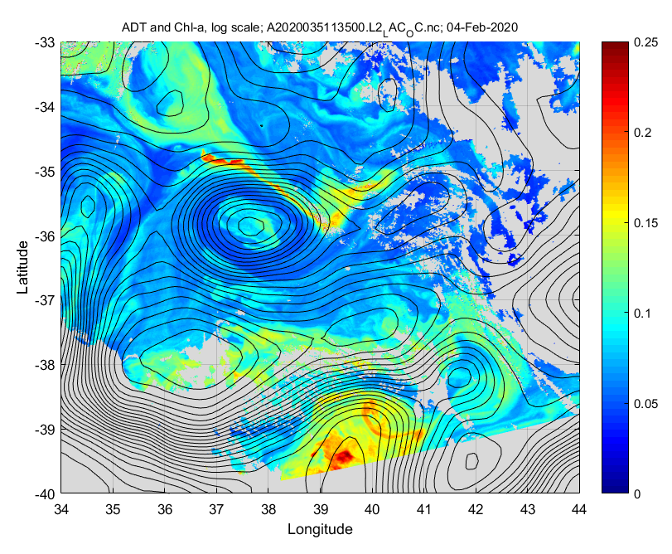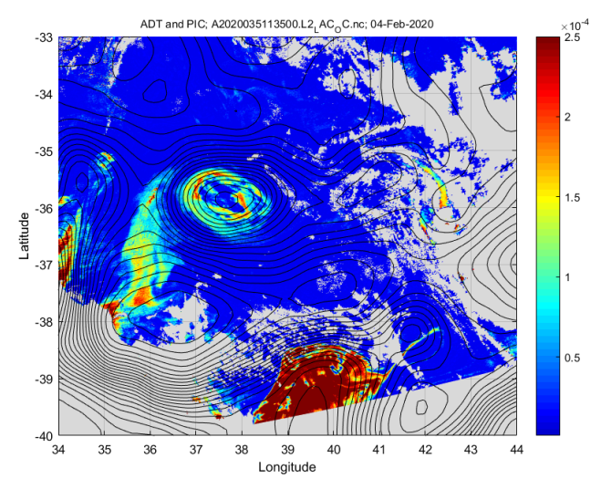

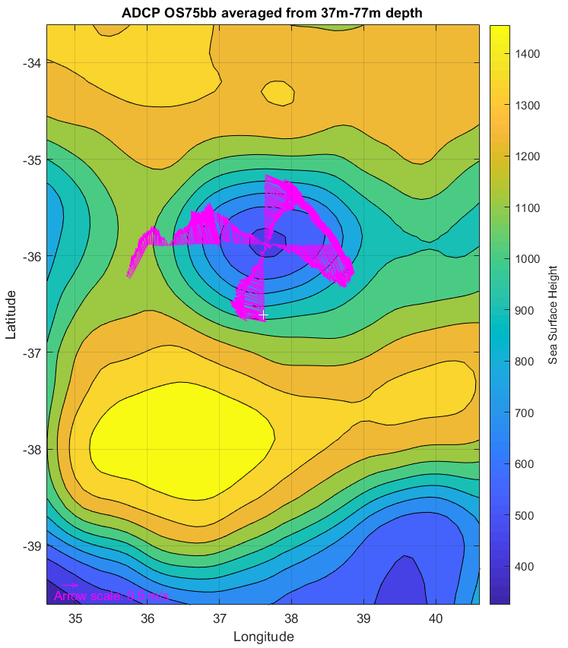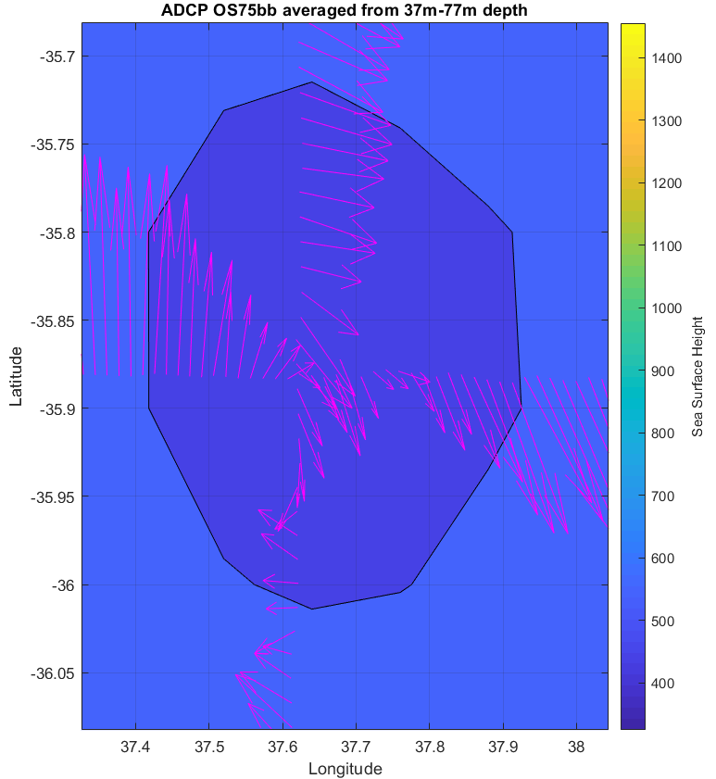
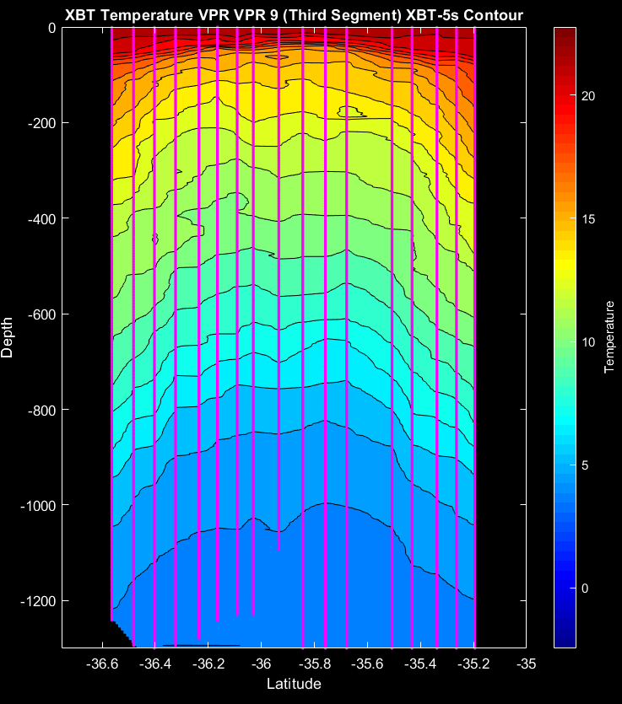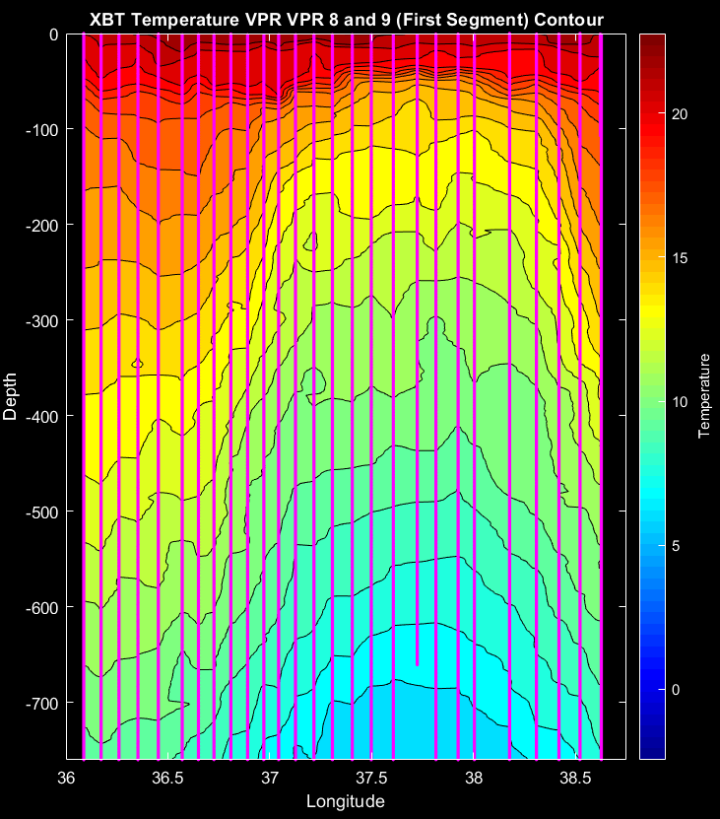

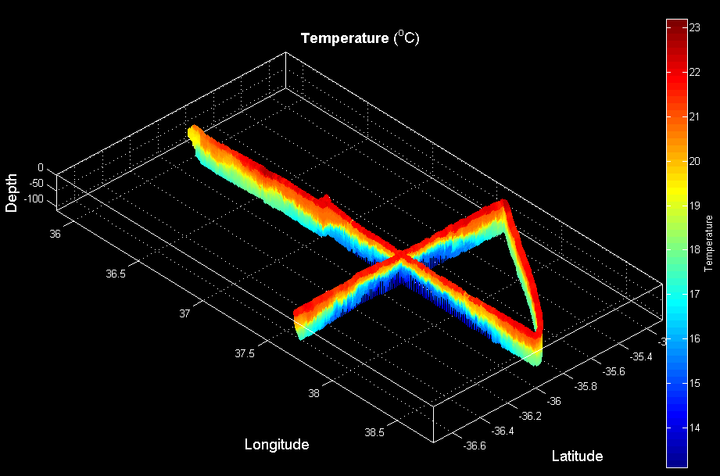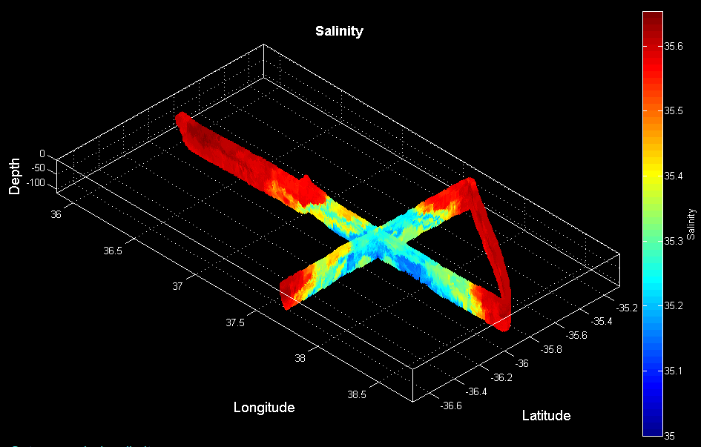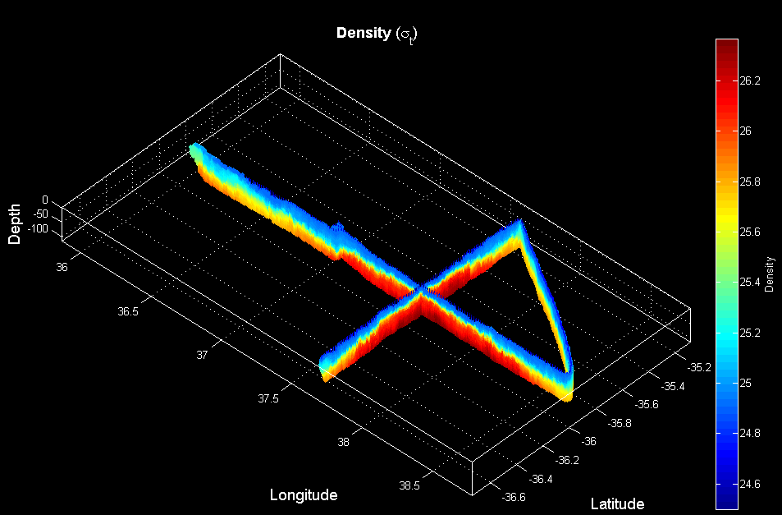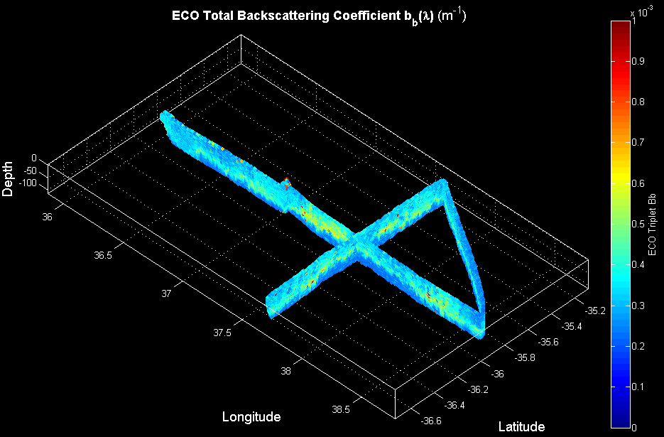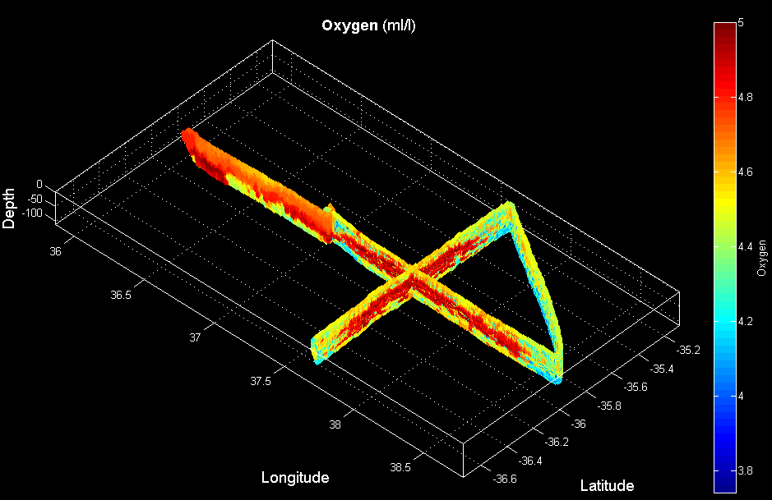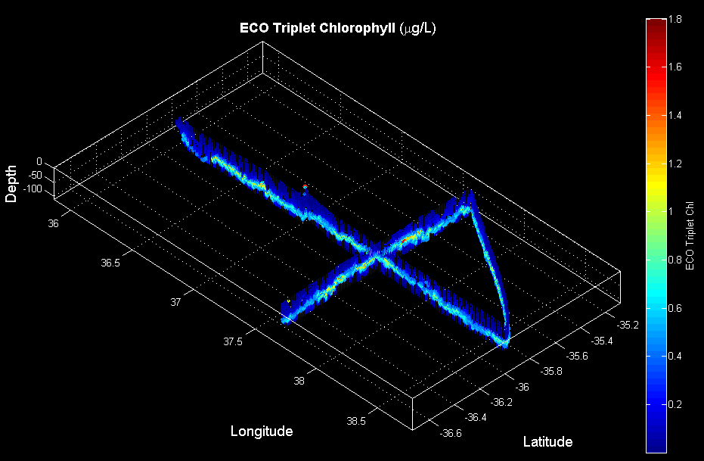

7-8 February

CTD sampling of eddy feature.

8-10 February

Transit to Durban.

10-13 February

Engine repairs in Durban

13 February

As we prepared for departure from Durban, we deliberated on which 2 features to focus on with our remaining science time, roughly two 3.5 day stanzas. There are four candidates:

Resample Eddy 3: dimishing PIC
Satellite PIC:
Feb 2 – 0.2
Feb 3 – 0.2 VIIRS
Feb 4 – 0.2 MODIS
Feb 4 – 0.1 VIIRS In situ 0.6
Feb 12 – background MODIS

Resample Eddy 1: rising PIC
Satellite PIC:
Jan 24 – 0.4 MODIS
Feb 8 – 0.4 VIIRS
Feb 11 – 0.8 VIIRS
Feb 12 – 1.2 MODIS

40/50 Eddy: quasi-stable PIC in a different regime (AC to the north of AF)
Satellite PIC:
Feb 1 – 0.6 MODIS
Feb 1 – 0.5 VIIRS
Feb 12 – 0.3 (interior) 0.5(spur) VIIRS
Feb 12 – 0.5 (interior) 1.0 (spur) MODIS

New eddy to the west of Eddy 3:
Satellite PIC:
Feb 12 – background MODIS
Feb 12 – background VIIRS

Weighing all of the scientific and logistical constraints, the choice was clear: (1) resample eddy 1, then (2) resample eddy 3.

Departed Durban at ca. 1930 Thurs 13 Feb.

14-15 February

Steamed to the high PIC region.

16 February

Carried out VPR survey of the southernmost transect of three in the high-PIC feature formerly known as Eddy 1 & 2 (Figure 3.8). The area is generally northward flowing to the west, and southward flowing to the east, with an eddy of low chlorophyll and PIC in the middle. T-S characteristics are similar to that observed in Eddy 1 and 2, with high PIC / high chl assocated with low salinity SAW (HPCLS) and low chlorophyll / high backscatter assocaited with more saline waters (SSTW) in Eddy 4. Ironically, satellite-based PIC in Eddy 4 in a local minimum rather than a local maximum as indicated by underway measurements of Bb’.
Began CTD survey back from west to east.

Figure 3.8. ADT contours overlayed on Chl (left) and PIC (right). ADCP, XBT, and VPR data panels follow below.
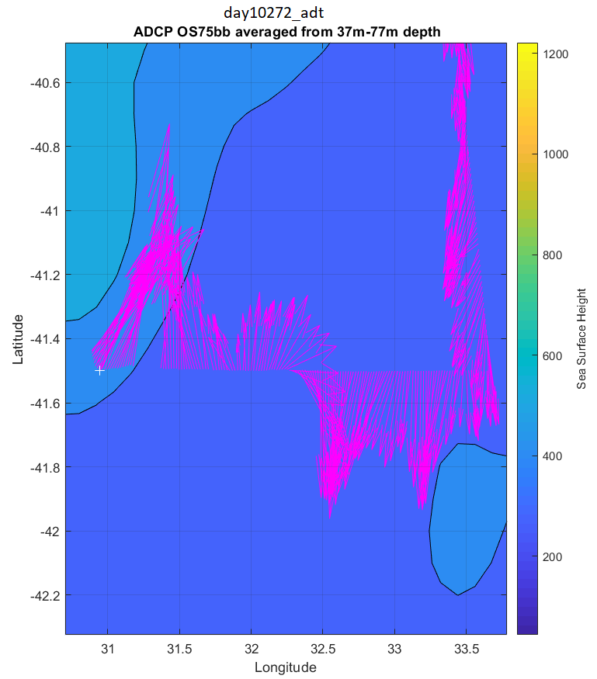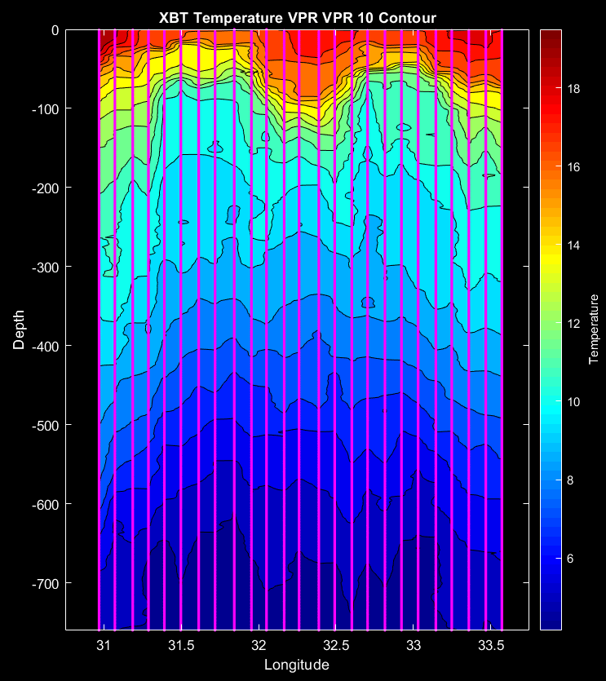

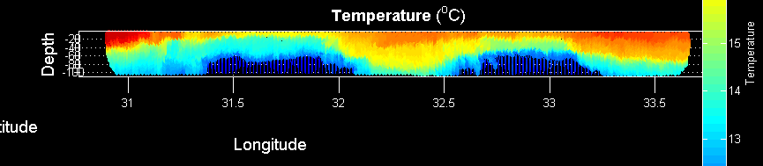
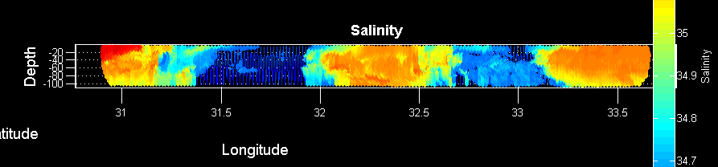
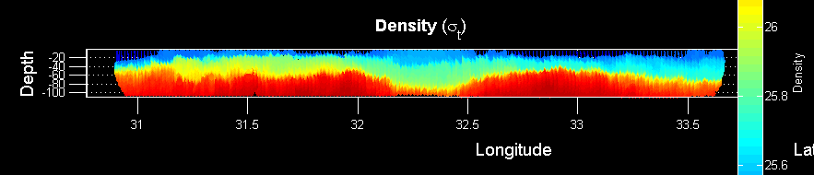
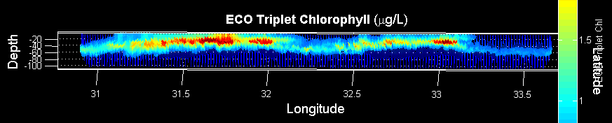
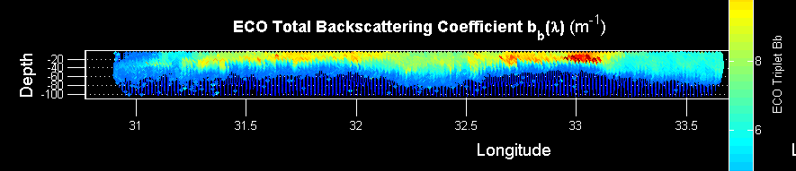
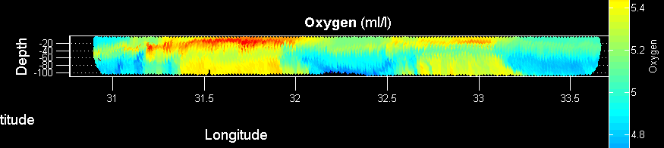
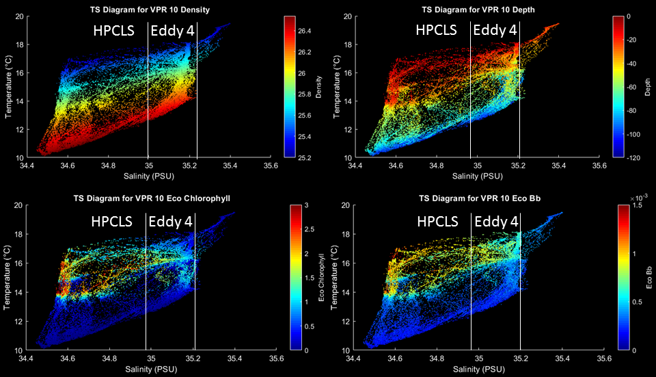

17 February
Continued CTD line (Table 3.1). Reached the end of the line in rough conditions; DAVPR removed for station 34. Too rough to deploy VPR, so transited to middle section.

Transect | Station | Feature / comments
6 | 26 | Western periphery outside feature
 | 27 | Frontal boundary – nutrients only
 | 28 | Frontal boundary – PP cast, TM cast, incubation water collection
 | 29 | HPCLS – nutrients only
 | 30 | Low PIC, low chlorophyll, high salinity (LPCHS) eddy
 | 31 | Frontal boundary
 | 32 | HPCLS
 | 33 | East of frontal boundary with HPCLS
 | 34 | Eastern periphery outside feature (no DAVPR)
Table 3.1. Station list for CTD transect 6 across southern section of the high PIC / high chlorophyll feature.

18 February
Deployed VPR in rough but subsiding conditions at the eastern end of the middle line of the high PIC region (Figure 3.9). Extended line a bit farther west to get to the edge. CTD transect begun, with station positions revised to (1) measure ambient conditions to the west (station 35), (2) avoid the 40-50m salinity anomaly at the planned station 39, in favor of a higher Bb (and Bb’ according to underway) area, and (3) target meander center as defined by the VPR salinity, the north-south swing in ADCP velocity, and peak of the seasonal thermocline in the XBT data (station 41).
Analysis of bio-optical characteristics in T-S space reveals consistent water mass characteristics: highest chl and Bb in HPCLS waters less than 35 psu (SAW), with lower chl and consistent Bb in HPLCMS associated with the moderate salinities of SSTW.
Transect | Station | Feature / comments
7 | 35 | Western periphery outside feature
 | 36 | Frontal boundary – WS over CF submesoscale feature
 | 37 | HPLCMS
 | 38 | Frontal boundary – nutrients only
 | 39 | HPCLS – PP cast, TM cast, incubation water collection
 | 40 | Center of HPCLS – nutrients only
 | 41 | HPCLS
 | 42 | HPLCMS
 | 43 | HPLCMS
Table 3.2. Station list for CTD transect 7 across the middle section of the high PIC / high chlorophyll feature.

Figure 3.9. VPR survey 11, the middle section of the high PIC meander (Figure 3.8 above).

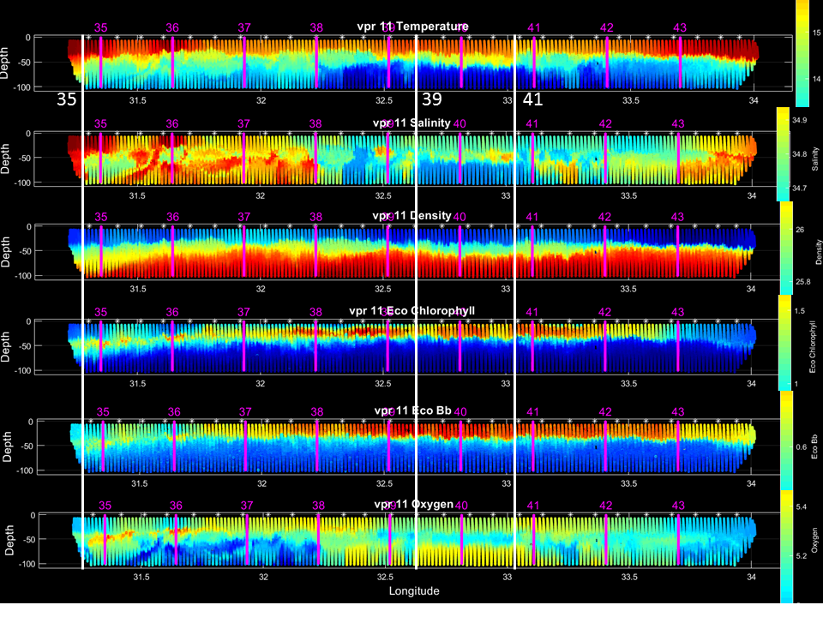
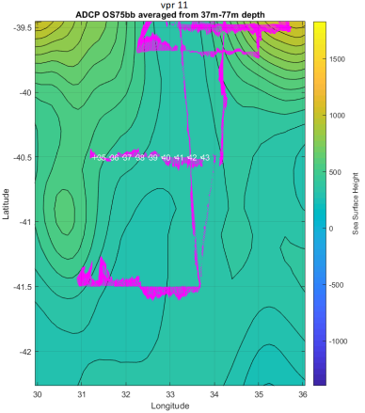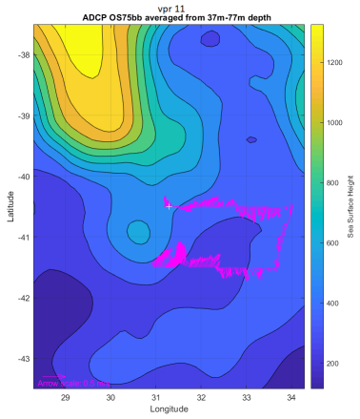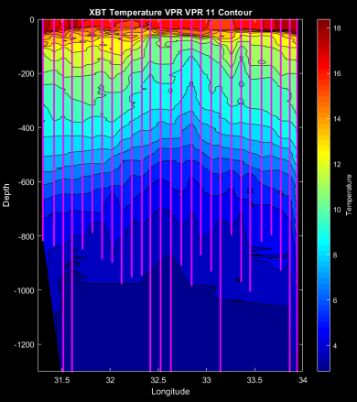

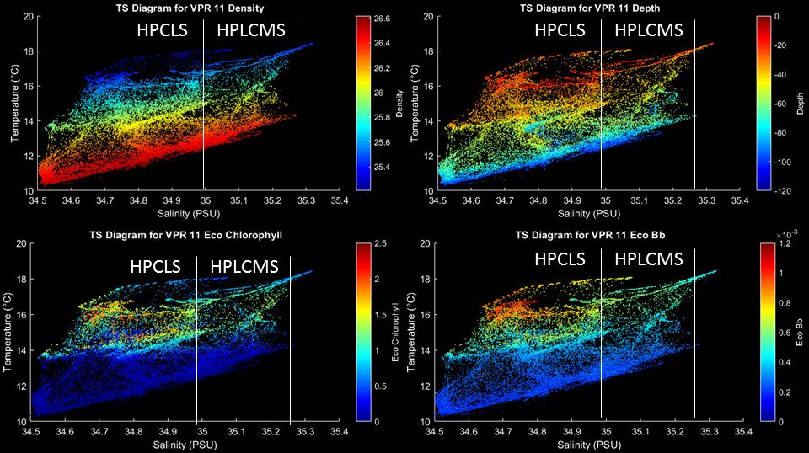
19-20 February
Completed CTD line. Deployed VPR at the the eastern end of the middle line of the high PIC region, towed north-northeast to the east end of the northern line and towed west (Figure 3.10). Positions for stations 45-51 were shifted to orient the PP/TM cast in the region of highest fluorescence and backscatter, while keeping the station spacing approximately the same.

Analysis of bio-optical characteristics in T-S space reveals consistent water mass characteristics: highest chl and Bb in HPCLS waters less than 35 psu (SAW), with lower chl and consistent Bb in HPLCMS associated with the moderate salinities of SSTW.
Transect | Station | Feature / comments
8 | 44 | Western periphery outside feature
 | 45 | Frontal boundary – WS over CF submesoscale feature
 | 46 | HPLCMS
 | 47 | HPLCMS
 | 48 | HPCLS – PP cast, TM cast [peak chl, Bb]
 | 49 | HPCLS – nutrients only
 | 50 | HPCLS
 | 51 | HPLCMS
 | 52 | HPLCMS
Table 3.3. Station list for CTD transect 8 across northern section of the high PIC / high chlorophyll feature.

Figure 3.10. VPR survey 12, the northern section of the high PIC meander (Figure 3.8 above). White vertical bars indicate the locations of the shifted stations.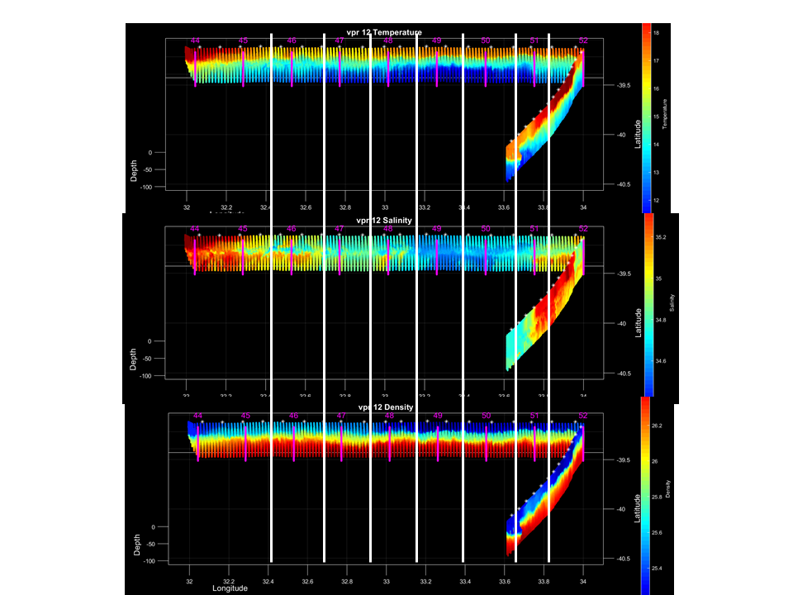
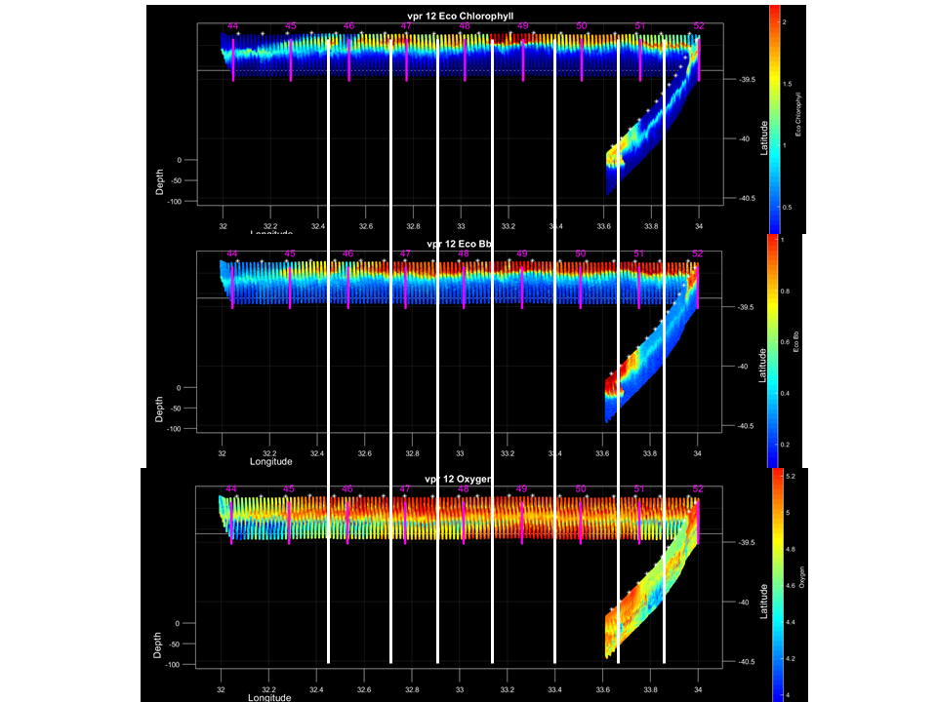

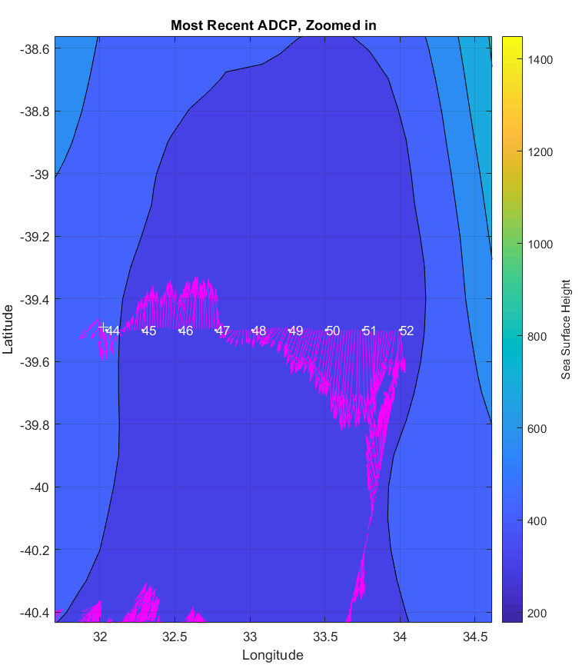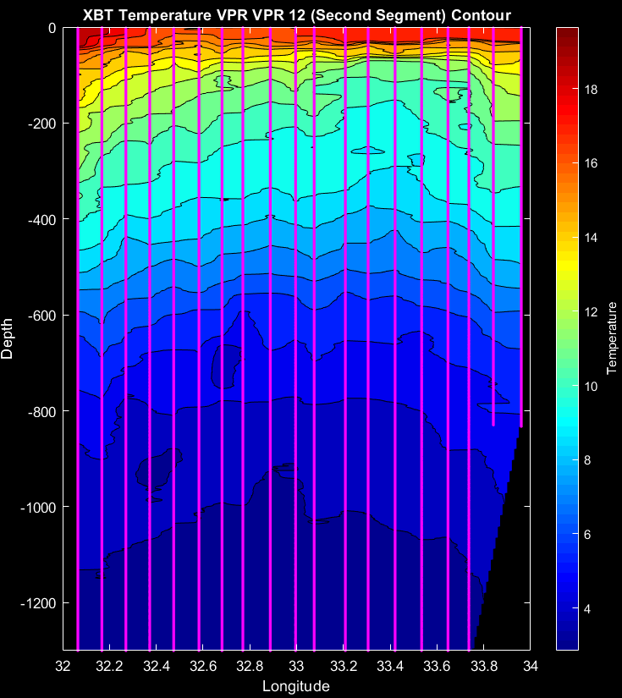

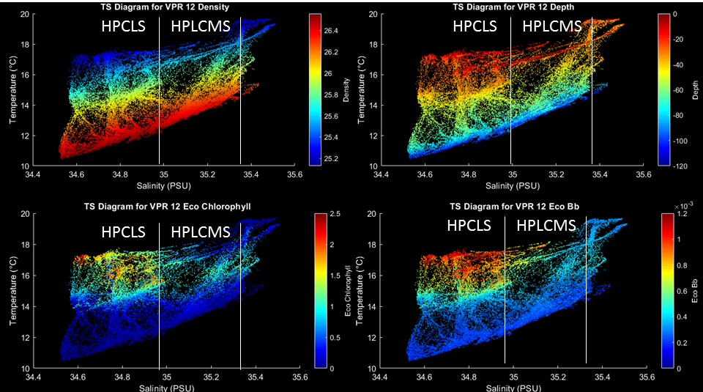

21 February
Deep CTD cast (DAVPR removed). Transit back to Eddy 3.

22 February
Satellite imagery suggest the surface signature of PIC in Eddy 3 has subsided, excepting for an area in the southwest quadrant of the eddy in the MODIS image, although this may be a cloud artefact.

VPR survey of Eddy 3 began on the western side of the feature. As it turns out, the starting point of the VPR survey was close to eddy center, as indicated by both the ADCP and XBT data. Although the XBT observations are noisy, the peak of the main thermocline occurs at ca. 36.45 E, after which it steadily descends. Clearly, the eddy has moved further southwest than anticipated based on the altimetry. Examination of the ADT animation indicates Eddy 3 is heavily influenced by its interaction with the adjacent cyclone to the west. The pair appears to be rotating around each other in a clockwise fashion, thus displacing Eddy 4 to the southwest. Close examination of the ground tracks reveals the area to the southwest of the eddy has not been sampled recently, and thus eddy center is portrayed to the east of, rather than to the west of, the westernmost ground track. Substantial adjustment of the eddy position is expected when new altimeter data fill in the current gap.

CTD transect from east to west begun.

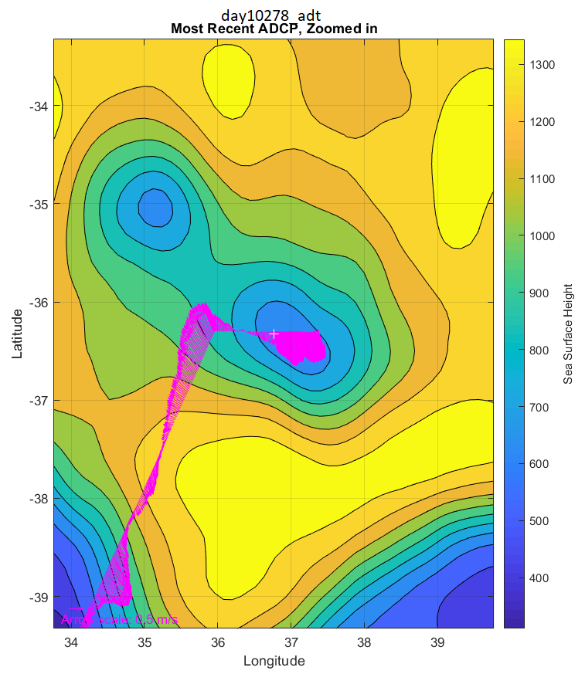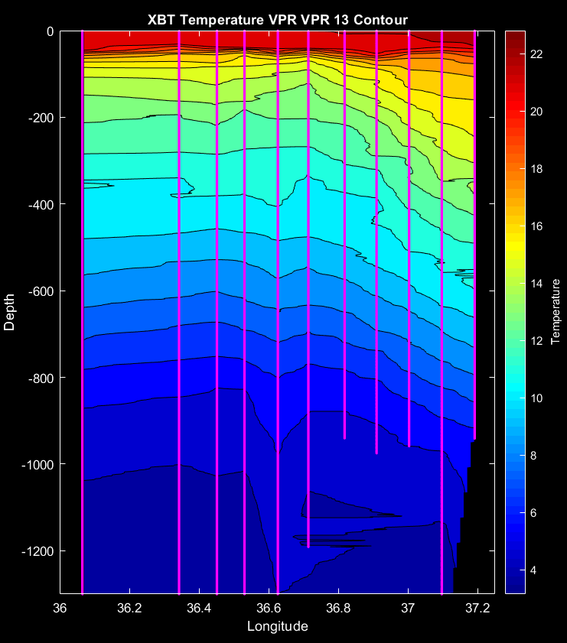
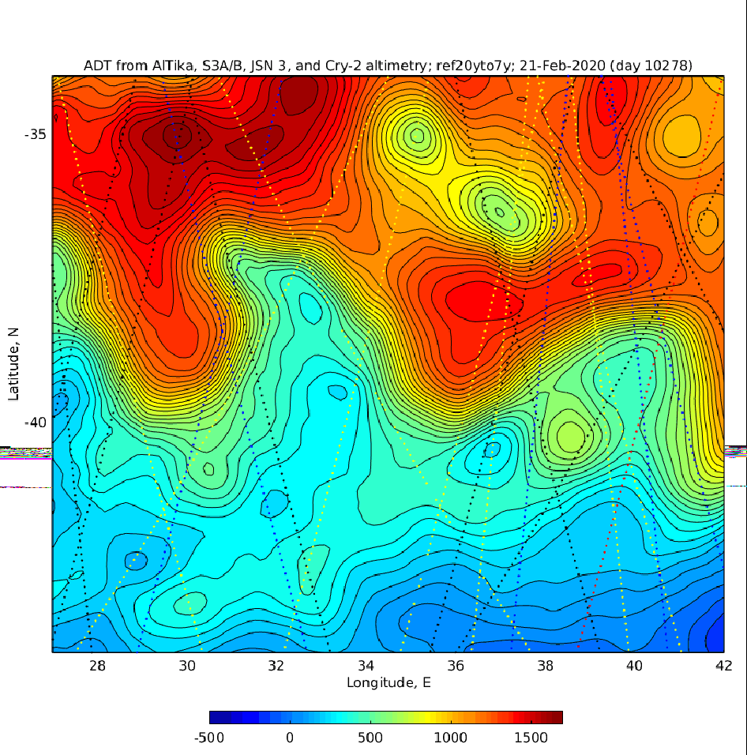

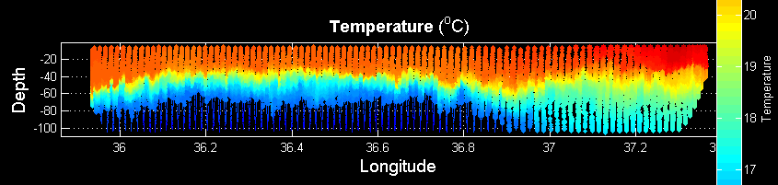
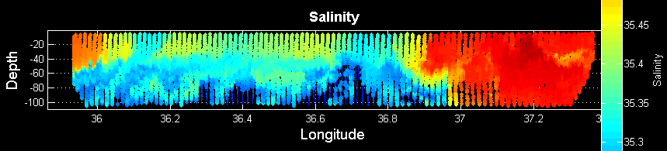

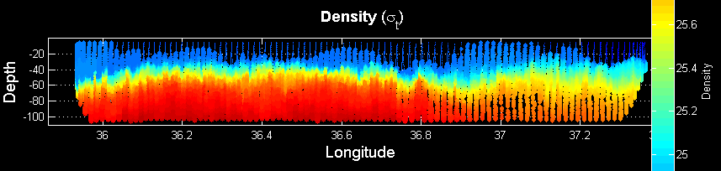

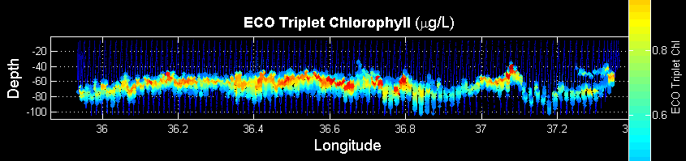

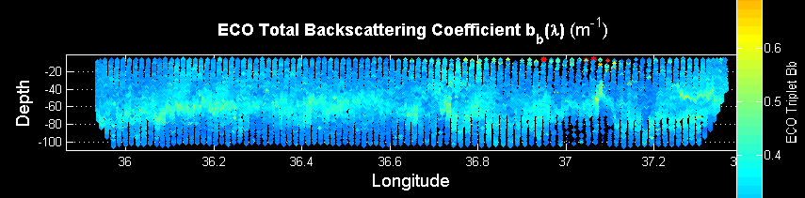

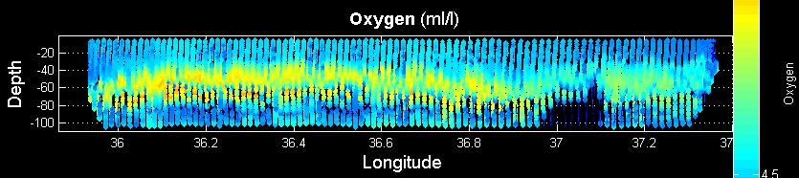

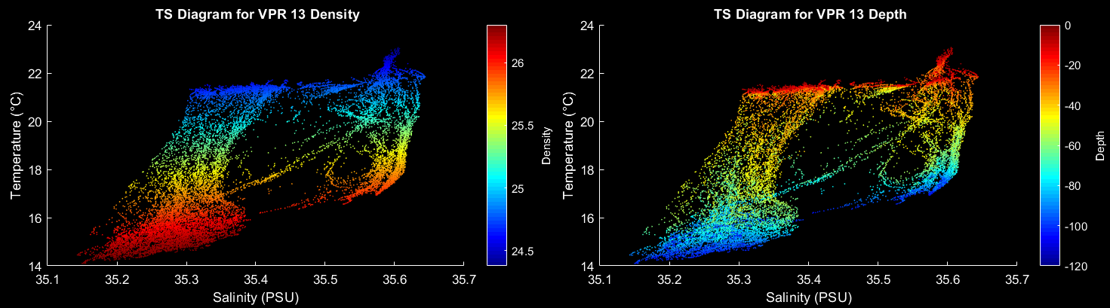

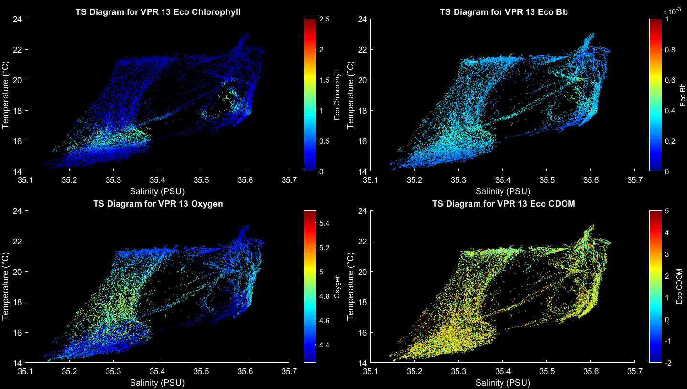

Transect | Station | Feature / comments
- | 53 | Deep cast
9 | 54 | Eastern periphery – high salinity
 | 55 | Local Smax
 | 56 | High Bb, low S: PP cast, TM cast
 | 57 | Smed
 | 58 | Eddy center
 | 59 | Smed
 | 60 | Bb slight enhancement
 | 61 | Local Smax
 | 62 | Western periphery; scrubbed due to Wx
Table 3.4. Station list for CTD transect 9, from east to west across Eddy 3.

23 February
CTD transect continues. Westernomost station had to be scrubbed due to weather. Conditions were not favorble for VPR deployment either, so we transited to the northernmost station. Although VPRdeployment was possible, the forecast calls for increasing winds from the SW, which would add to the remaining swell. We therefore decided to proceed with the CTD line, starting the VPR tow after that.

24 February
N-S CTD line continues, temporarily interupted by weather conditions making CTD operations impossible.

25 February
N-S line continues; diverted to recover drifter; had to double back to Eddy Center in order to do the trace metal cast that was not possible earlier due to Wx. Finished N-S line at southernmost station.

Transect | Station | Feature / comments
10 | 62 | Northern station
 | 63
 | 64
 | 65
 | 66 | Eddy center
 | 67 | 3 south of EC; diverted to get drifter
 | 68 | 2 south of EC
 | 69 | 1 south of EC
 | 70 | Eddy center repeat / TM cast
 | 71 | Southern station
Table 3.5. Station list for CTD transect 10, from north to south across Eddy 3.

26 February
Deployed the VPR at the southernmost station and towed north. ADCP observations indicate we passed east of eddy center, and this is consistent with the altimetry: eddy center have move west more quickly than anticipated, owing to interaction and apparent merger with another cyclone to the northwest.

Despite the transect being a bit off-center, the lower salinity of the eddy core is still visible—although in this transect it surrounds more saline waters closest to eddy center. Surface chlorophyll and backscatter are very low,with the largest signals in subsurface maxima that peak in the low-salinity band around the core and at the eddy periphery. There is a hint of enhancement of Bb in surface waters in that band, although the signal is very weak.

What is the origin of the saline water near eddy center in VPR14? The feature fills in the gap in T-S space present in VPR13 between 35.35 < S < 35.55, suggesting continuity in water mass characteristics from the eddy core to the ambient waters outside the eddy. Perhaps this is a streamer of saline water from outside the eddy intruding into the eddy core? Zhang and McGillicuddy (submitted) document a mechanism for streamer formation that may be applicable here; detailed diagnosis of the density field will be required to make that assessment.

Upon completion of the VPR survey, we began steaming for Mauritius.

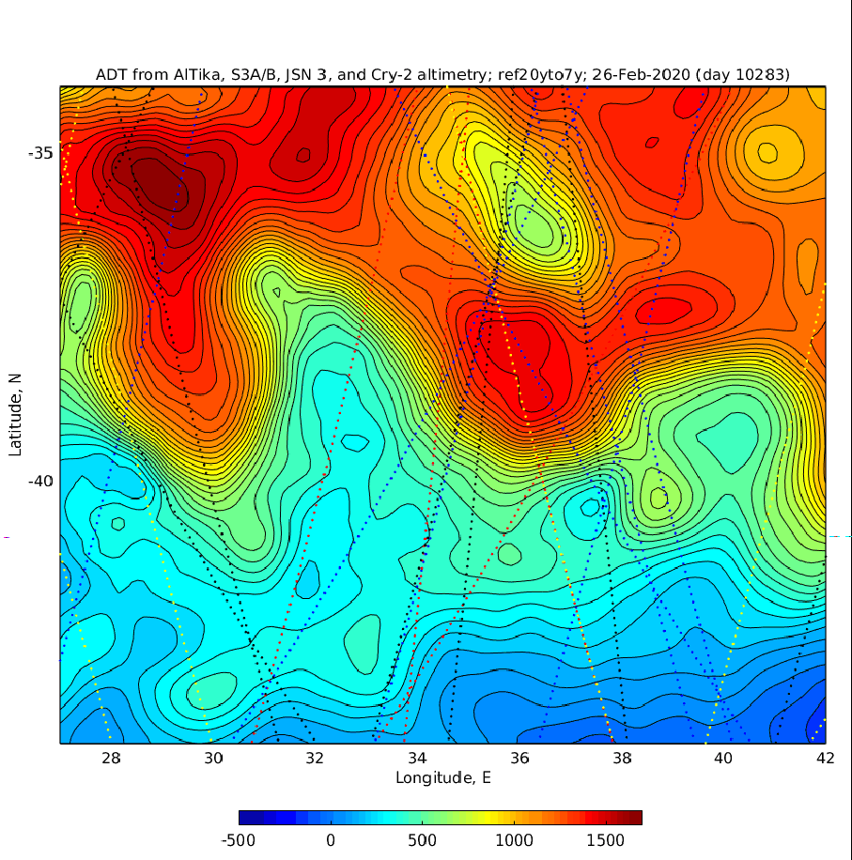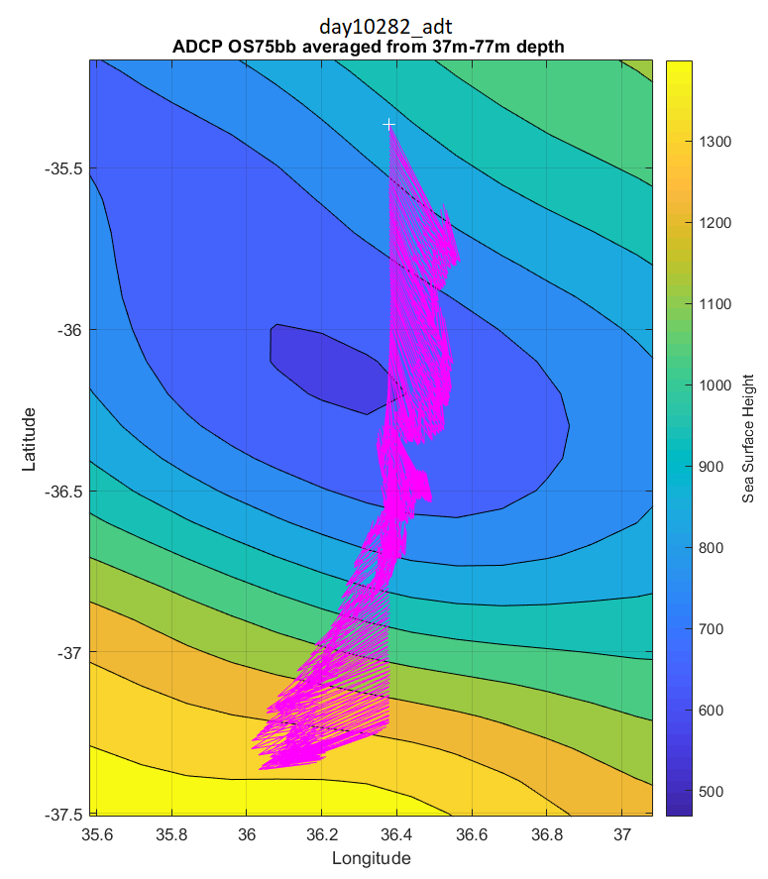

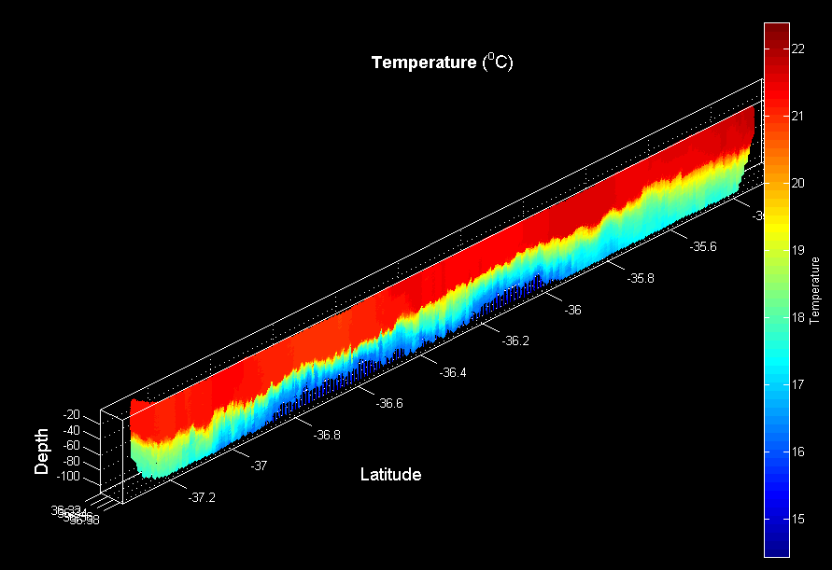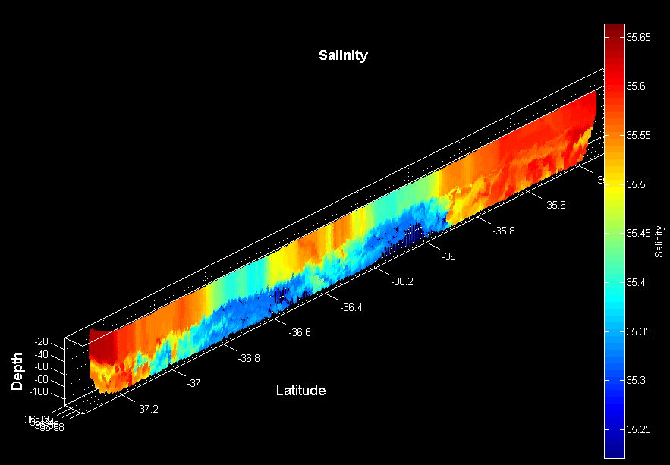

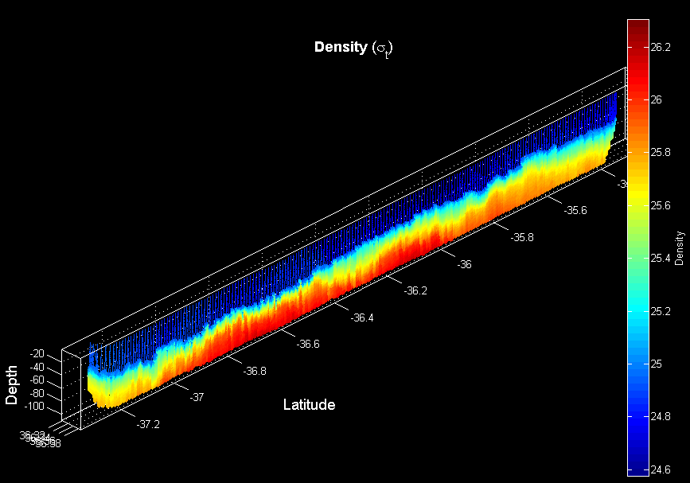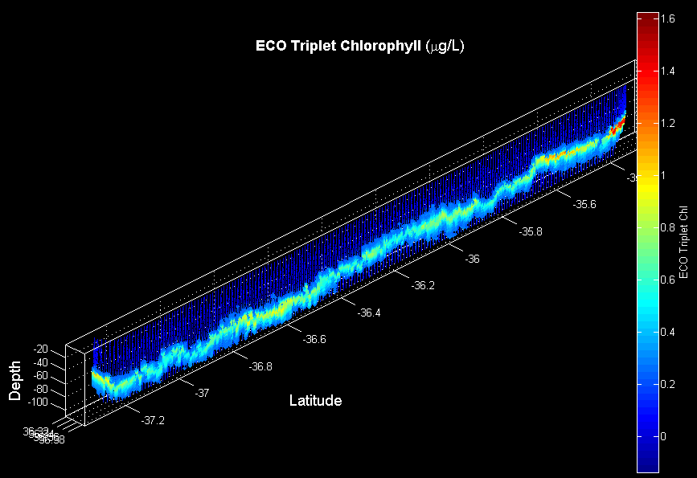

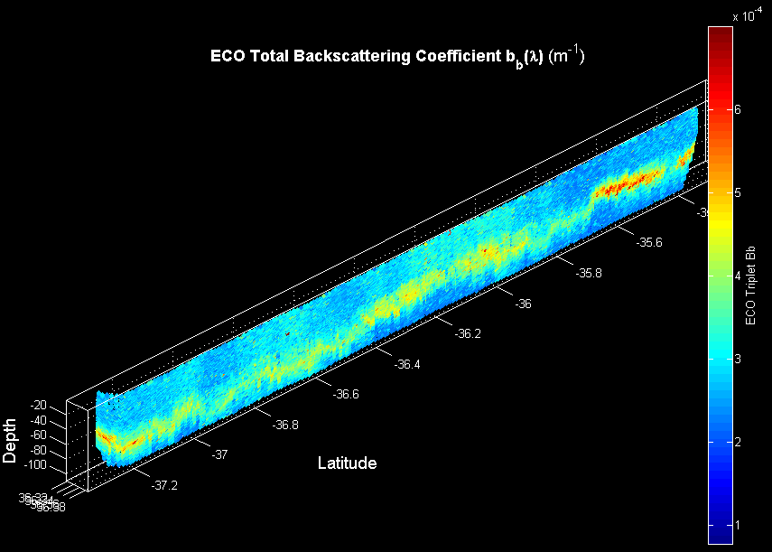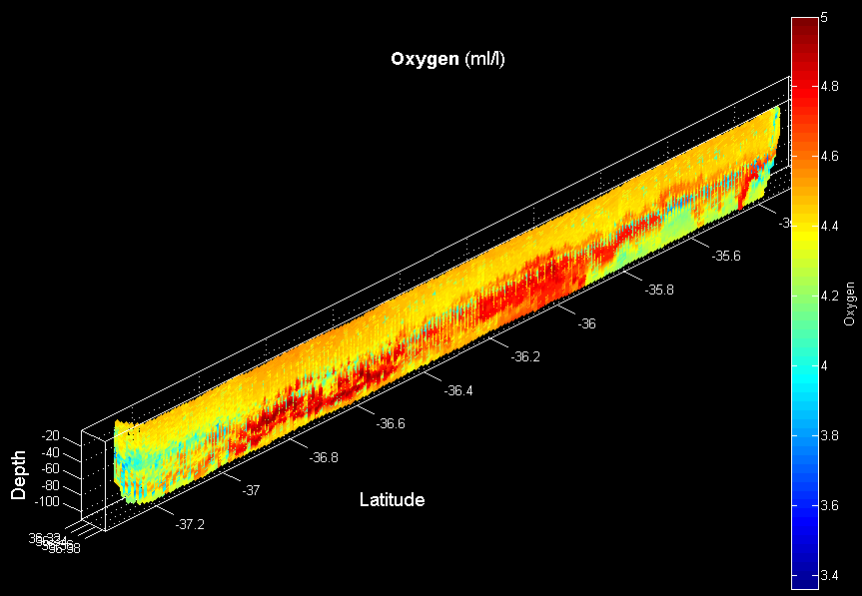

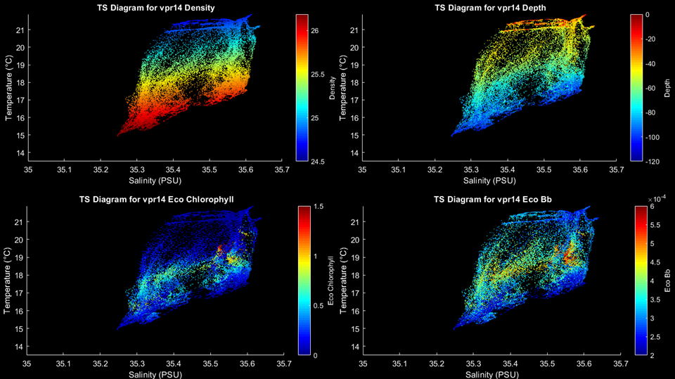

27 February – 2 March
Transit to Mauritius.

3 March
Arrival in Mauritius.

4. Summary of VPR tows

Date | Tow # | Description | Comments
1/27/20 | VPR1 | Eastern flank of Agulhas eddy
1/29/20 | VPR2 | Transect across high PIC feature
1/30/20 | VPR3 | Survey of high PIC feature | Sobel changed to acquire smaller ROIS  Tow aborted when comms with flight control lost.
1/31/20 | VPR4 | Continued survey of high PIC feature | Flight control restored for several hours, then intermittent operation, then back to continuous operation. Intermittent dropouts of ROI detection.
2/1/20 | VPR5 | North-South line through high PIC feature | Strobe not working on deck; deployed anyway and strobe came to life.
2/3/20 | VPR6 | SE tow from northernmost CTD to easternmost
2/4/20 | VPR7 | NE tow from westernmost CTD to northernmost
2/5/20 | VPR8 | West to east entry into Eddy 2
2/5/20 -2/6/20 | VPR9 | Eddy 2 survey
2/16/20 | VPR10 | High PIC region, southern transect | Very few rois captured; strobe out of alignment, corrected after the tow.
2/18/20 | VPR11 | High PIC region, middle transect | Very few rois; camera reset, normal roi rate resumes.
2/19-20/20 | VPR12 | High PIC region, northern transect | Started on east end of middle transect.
2/22/20 | VPR13 | Eddy 3 west to east survey | Lost starboard tail skid, replaced after tow.
2/26/20 | VPR14 | Eddy 3 south to north survey | Passed east of eddy center.
Table 4.1. VPR tows on TN376.

