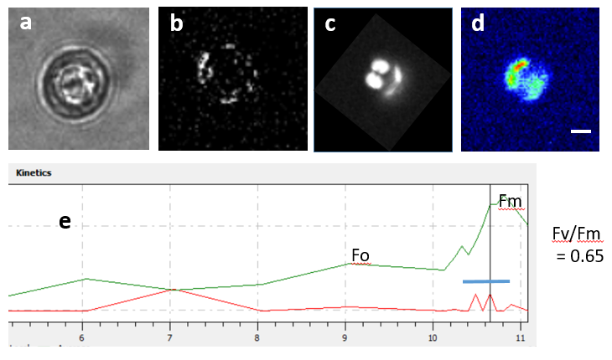

Fig. XX Single cell PAM fluorescence imaging of a calcifying coccolithophore. a) Bright filed image, b) polarized light image of external coccoliths , c) chlorophyll fluorescence, d) Maximum chlorophyll fluorescence image following a saturating light pulse, e) fluorescence plots of dark-adapted state, Fo and following a saturating light pulse, Fm (blue bar in e). The cell was from a surface underway sample taken at 16:00 h on 01.31.2020. Bar in d) = 10 m