Opportunistic Sampling of the Great Atlantic Sargassum Belt
December 18, 2019

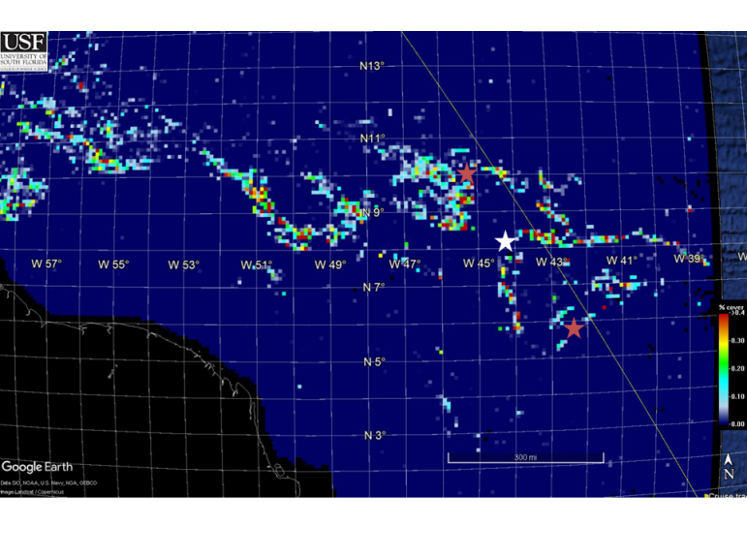
Figure 1. Station locations (stars) overlayed on USF Satellite-based Sargassum Watch System (SaWS; see https://optics.marine.usf.edu/projects/saws.html.)
Voyage # 371 of the R/V Thomas G. Thompson was a transit from WHOI to Montevideo Uruguay (August 19 – September 8) that afforded sampling of the Great Atlantic Sargassum Belt (Wang et al. 2019). Measurements were executed by three University of Washington technicians on board:

Jennifer Nomura jmnomura@uw.edu
Emily Cheung echeung@skidmore.edu
Sonia Brugger brugger.sonia@yahoo.com

Three stations were occupied in the region of highest Sargassum abundance as estimated by remote sensing (Figure 1).

August 27 10 0.5N / 45 26.3 W S. fluitans, S. natans
August 28 8 19.9 / 44 11.1W No Sargassum present
August 28 5 51.6N / 42 22.8 W S. fluitans only

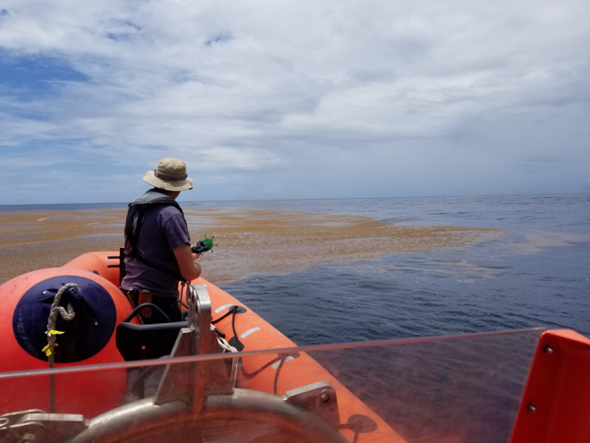
Figure 2. Collection of Sargassum at station 1.
Highest abundance was found at the first station, where tissue samples were collected from the ship’s rescue boat with a specially designed sampler provided by Scott Lindell (Figure 2). Samples of both S. fluitans and S. natans were obtained (Figure 3). No Sargassum was observed at the middle station (hence the white star in Figure 1). Moderate abundance was encountered at the third station, and tissue samples contained S. fluitans only (Figure 3) which were collected by dip net affixed to a long pole.

CTD casts were taken at each station, with bottle samples tripped at the following depths: surface, 10, 20, 30, 40, 60, 80, 100, 120, 150, 200, 250, 300, 400, 500, 600, 700m. Nutrients (inorganic and organic) were sampled at all depths, whereas A_{p} was sampled only in the upper 100m, and A_{g} was sampled in the upper 30m.

Measurement Inventory
1. CTD – McGillicuddy
2. Inorganic nutrients – WHOI nutrient analytical facility – McGillicuddy
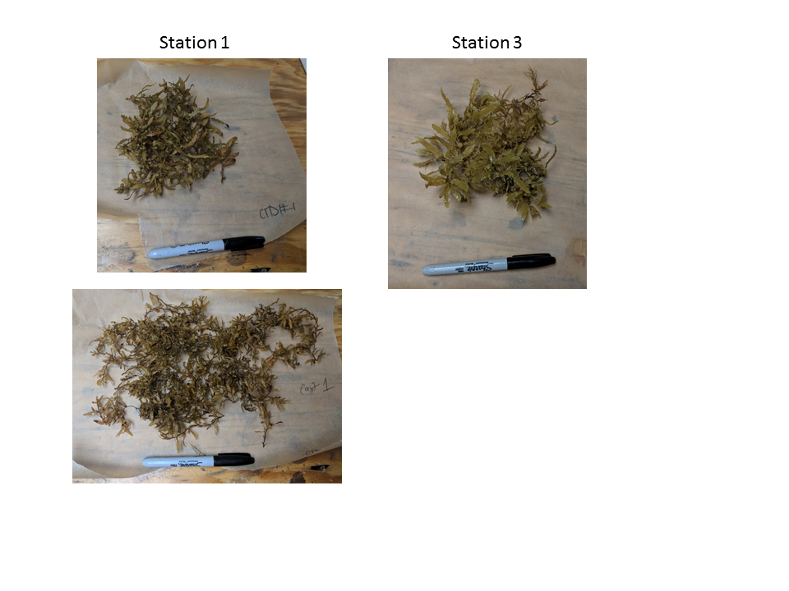
Figure 3. Sargassum tissue samples for stations 1 and 3. High resolution images available in the cruise data archive.
3. Dissolved inorganic and dissolved organic nutrients – CBL NASL - Lapointe
4. Sargassum tissue for N:P ratio, CNP isotopes, Fe and As – Lapointe
5. Preserved samples of Sargassum for speciation – Lindell
6. Absorption A_{p} and A_{g} samples – Hu
The ship’s nderway thermosalinograph reveals that the band of high Sargassum abundance depicted in Figure 1 roughly corresponds with low-salinity waters in the open ocean that are almost certainly associated with riverine outflow (Figure 4).

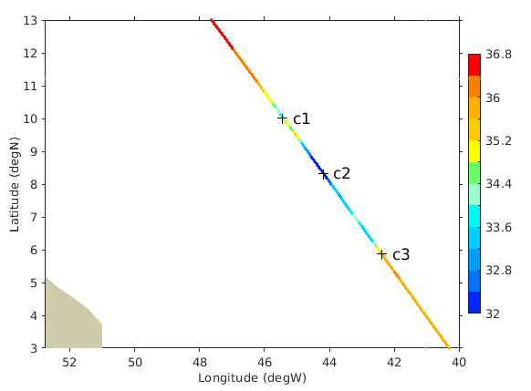
Figure 4. Underway surface salinity measurements. Locations of casts 1-3 indicated by plus signs.
Analysis of the CTD data suggest that the first cast, where Sargassum was most abundant, had a lens of low-salinity water in the near-surface region (Figure 5). The second cast revealed even lower near-surface salinity, although no Sargassum was present. Near-surface salinity at cast 3 increased to more characteristic open-ocean values, and S. fluitans was found. Thus Sargassum appears to be associated with riverine influence, with highest abundance at the margins of the freshwater plume with intermediate salinities.

Although there are significant variations in temperature structure, salinity is the main driver of upper ocean density in this region, and as such cast 1 is the most stratified, with cast 3 the least stratified. Fluorescence profiles reveal subsurface maxima typical of oligotrophic conditions in the open ocean.

Nitrate and phosphate were generally depleted in the upper 60-80m (Figure 4). The only exception was in cast 3, where modest abundance of S. fluitans was found: the CBL NASL assay indicates nitrate enhancement in the upper 10m, whereas the WHOI assay was below the limit of detection. It would be advantageous to have these samples rerun at both CBL NASL and WHOI to see if this apparent discrepancy can be resolved. Ammonium values ranged mostly between 0.1 and 0.8 μM, with one outlier above 2 μM. Given how prone such measurements are to contamination, it is likely that even the lower values are unrealistic. Silicate was present in ample concentrations, owing to nitrogen limitation of the diatom population. Total dissolved nitrogen and phosphate concentrations far exceed their inorganic counterparts, indicating substantial abundance of dissolved organic material.

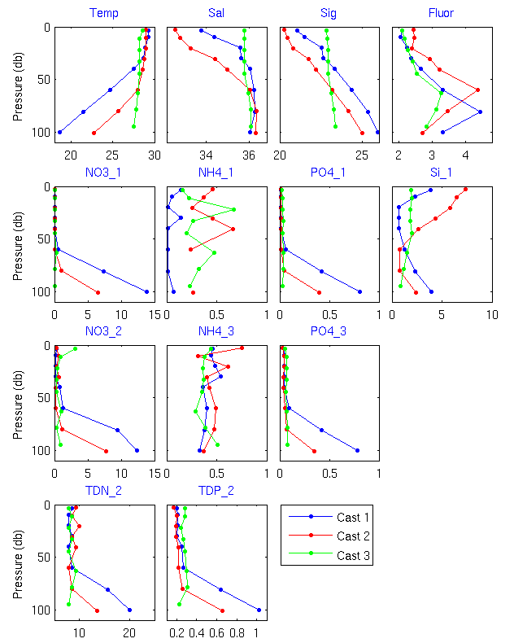
Figure 5. Hydrography and nutrient measurements obtained from CTD Niskin samples. Data available at: http://science.whoi.edu/users/mcgillic2/TN371/

Reference
Wang, M., C. Hu, B. B. Barnes, G. Mitchum, B. Lapointe, and J. P. Montoya, 2019: The great Atlantic Sargassum belt. Science, 365, 83-87.

