TN-368 Cruise Report
Draft 7/22/19

1. Introduction

R/V Thomas G. Thompson voyage number 368 is the third of three cruises of an NSF-sponsored project entitled “Shelfbreak frontal dynamics: mechanisms of upwelling, net community production, and ecological implications.” The field work is sited on the continental shelfbreak of the Middle Atlantic Bight, which supports a productive and diverse ecosystem. Current paradigms suggest that this productivity is driven by several upwelling mechanisms at the shelfbreak front. This upwelling supplies nutrients that stimulate primary production by phytoplankton, which in turn leads to enhanced production at higher trophic levels. Although local enhancement of phytoplankton biomass has been observed in some synoptic measurements, such a feature is curiously absent from time-averaged measurements, both remotely sensed and in situ. Why would there not be a mean enhancement in phytoplankton biomass as a result of the upwelling? One hypothesis is that grazing by zooplankton prevents accumulation of biomass on seasonal and longer time scales, transferring the excess production to higher trophic levels and thereby contributing to the overall productivity of the ecosystem. However, another possibility is that the net impact of these highly intermittent processes is not adequately represented in long-term means of the observations, because of the relatively low resolution of the in situ data and the fact that the frontal enhancement can take place below the depth observable by satellite.

A unique opportunity to test these hypotheses has arisen with deployment of the Ocean Observatories Initiative (OOI) Pioneer Array south of New England. The combination of moored instrumentation and mobile assets (gliders, AUVs) will facilitate observations of the frontal system with unprecedented spatial and temporal resolution (Fig. 1). This will provide an ideal four-dimensional (space-time) context in which to conduct a detailed study of frontal dynamics and plankton communities.
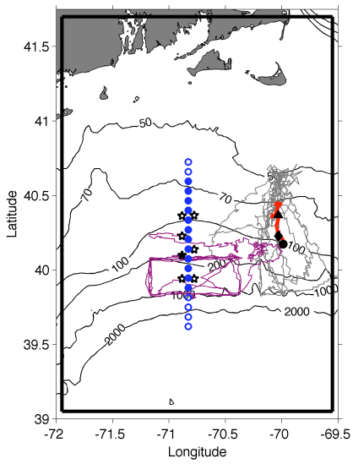 | Fig. 1. Tracks of Pioneer Array gliders (grey, magenta lines), 17 Apr – 30 Jun 2014. Red line is a cross-shelf transect on 25-26 Apr; the black triangle, diamond, and circle indicate the positions of the foot, jet and surface expression of the front, respectively. Mooring locations are shown as stars, with the central offshore mooring filled in black. Shipboard transects indicated with blue circles. The solid black boundary depicts our model domain.

With support from NSF’s Physical, Biological, and Chemical Oceanography programs, we will undertake a set of three cruises to obtain cross-shelf sections of physical, chemical, and biological properties within the Pioneer Array. Nutrient distributions will be assayed together with hydrography to detect the signature of frontal upwelling and associated nutrient supply. We expect that enhanced nutrient supply will lead to changes in the phytoplankton assemblage, which will be quantified with conventional flow cytometry, imaging flow cytometry (Imaging FlowCytobot, IFCB), in situ optical imaging (Video Plankton Recorder, VPR), traditional microscopic methods, and HPLC pigments. Zooplankton will be measured in size classes ranging from micro- to mesozooplankton with the IFCB and VPR, respectively, and also with microscopic analysis. Biological responses to upwelling will be assessed by measuring rates of primary productivity, zooplankton grazing, and net community production. These observations will be synthesized in the context of a coupled physical-biological model to test the two hypotheses that can potentially explain prior observations: (1) grazer-mediated control and (2) undersampling. Hindcast simulations will also be used to diagnose the relative importance of the various mechanisms of upwelling.

Our observational plan consists of cross-frontal transects and rate measurements, conducted in a daily cycle of activity (Fig. 2). Each day will begin with determining the precise location of the front from a combination of data from the Pioneer Array, cruise observations, and remote sensing images. Rate measurements (¹⁴C and grazing incubations) will be strategically located in one of the three key regimes: inshore, offshore, and at the front. Twelve repetitions of the observational cycle (see below) will permit four replicates in each of the three regimes, facilitating estimates of the mean and variance for each. Each of the 12 cross-frontal transects will consists of a 12-station subset of the range of possible station locations shown in Fig. 2. Each specific 12-station subset will be centered on the front, essentially shifting northward or southward as movement of the front dictates. Station spacing is 7km.
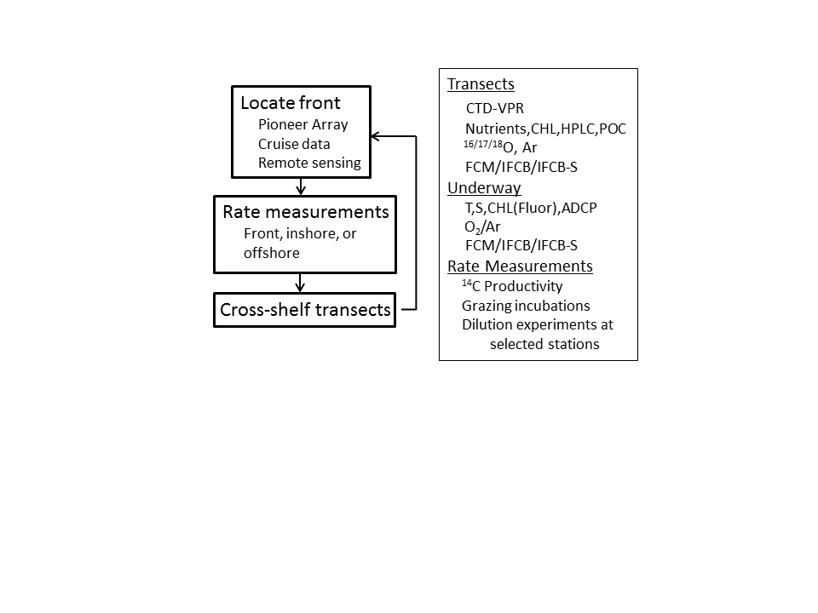
Fig. 2. Daily sampling cycle (left) and summary of measurements (right).

2. Analysis of pre-cruise satellite imagery

SST imagery from June 23 reveals a warm core ring drawing a filament of cool shelf water offshore to the east of our sampling area (Figure 0704.1a). The corresponding ocean color image indicates a similar pattern, showing the cool filament contains relatively high chlorophyll from shelf waters (Figure 0704.1b). Successive chl images on July 3 and 4 (Figure 0704.1cd) document westward propagation of the feature, with the filament directly impacting our transect stations.

3. TN-368 Narrative

Friday 5 July

Departed WHOI at 1345, proceeded to A5 and started south on Transect 1.

Saturday 6 July

Transect 1 completed (Figure 0706.1,2,3). Surface heating has contributed to high stratification in the upper 30m throughout the transect. Low salinity shelf water has been pulled southward by the ring streamer (Figure 0706.4), such that the 34.5 isohaline (our typical diagnostic of the front) does not outcrop within our sampling grid. Shelf water characteristics (high oxygen, CDOM, and turbidity) extend all the way out to station A18 with patchy subsurface chlorophyll maxima. Ammonium concentrations range from the limit of detection (ca. 10 nm) in deep waters offshore to ca. 1 μM in subsurface maxima on the shelf. Interestingly, near-surface values are nearly 100 nM or more, suggesting ammonium is an important component of the nitrogenous nutrition of phytoplankton communities in this regime.

ADCP velocities reveal strong southward flow associated with the streamer (Figure 0706.5). There is also an eddy-like feature straddling the 200m isobaths, driving eastward flow mid-way between the 100m and 200m isobaths; SST imagery suggests entrainment of cold shelf water from the east into the interior of the feature. The eddy-like feature is also evident in ocean color imagery (Figure 0703.1).

A submesoscale patch of warm and salty slope water was observed in the 30-50m depth interval at station A13. This could have come only from the slope water, thus a clear indicator of cross-front exchange. A REMUS survey was designed to sample that feature, launched at A18 after CTD 16 (intercalibration #1).

A VPR survey was conducted from A17 to A9 (Figure 0706.6). Vertical extent of the towyos was truncated on approach to the shelf edge (ca. 40N) due to the concentration of fishing gear. In any case, the results clearly depict the transition from low salinity shelf waters from high salinity slope waters at the shelf break, along with suppression of the surface expression of the front by the streamer of shelf water. Based on visual analysis of the image data, overall abundance was lower than the prior cruise, and marine snow was relatively more abundant. Copepods and diatoms tended to be more abundant in the colder and fresher waters of the shelf, with diatom chains confined to the near-surface region.

CTD-only transect begun at A5 working southward.

Sunday 7 July

Productivity cast at 0630; REMUS serendipitously came within close range at station A14 (CTD 26), providing an excellent intercalibration cast #2.

Completed CTD-only transect A5-A17 (Figure 0707.1,2). The foot of the front appears to have been driven slightly onshore, and the eddy-like feature appears to have intensified as manifested by the isotherm, isohaline, and isopycnal deflections between stations A9-A11.

REMUS recovery at A12, final intercalibration cast #3 (CTD 30).

Began VPR survey of the streamer, A12 – A18 – Streamer E – Streamer W.

Monday 8 July

Completed VPR Streamer Survey (Figure 0708.1). Streamer water is clearly delineated by the salinity distribution. Survey completed in the interior of the ring, as evidenced by the ADCP data (Figure 0708.2). Highest fluorescence detected in the VPR survey occurred in the slope waters in the south easternmost portion of the transect; plankton imagery indicates high diatom concentrations in that region. Note the fluorescence maximum is higher in the water column inside the streamer as compared to the surrounding waters.

CTD section across the streamer completed (Figure 0708.3-7). The salinity anomaly is sharp on the eastern (slope) side and more diffuse on the western (ring) side, with the 34.5 isohaline extending to the edge of the transect in the near surface region. The cold anomaly is visible in the 30-90m depth interval, with the surface layer capped off by heating. The subsurface chlorophyll maximum is 10-20m higher in the water column than in the surrounding waters. Positive CDOM and oxygen anomalies are also evident in the streamer, consistent with its shelf water origin.

REMUS deployment S4-S8 shows many of the same features as the CTD transect, albeit at higher resolution (Figure 0708.8).

Steamed back to A5 to begin CTD transect.

Tuesday 9 July

Completed CTD transect (Figure 0709.1,2,3). Foot of the front still located at A8, but the 34.5 isohaline is flattened out until rising at A11/A12 at the surface outcrop. This unusual configuration may be the result of the previously mentioned eddy. Freshening of the surface layer at A13-A14 a result of retrograde motion of the streamer, which has not yet propagated far enough west to clear our sampling area (Figure 0709.4).

VPR3 survey began at A14, transiting southward and then eastward across the streamer/slope front (Figure 0709.5). In the streamer, diatoms were confined to the near surface layer where fluorescence was relatively low. On the slope side of the streamer, diatoms were abundant in the 40-60m layer where fluorescence was high, peaking at just over 10 μg Chl l⁻¹. Marine snow was also abundant in this area. Jogging southward and then back westward, the same trends were repeated at the streamer/slope front, confirming the consistency of this pattern.

Wednesday 10 July

Joint operations were conducted with the R/V Warren Jr. to obtain intercalibration profiles for across-front and along-front AUV missions.

Section across streamer/slope front based on VPR sections from prior night (Figure 0710.1,2,3). Initial waypoints SSF1, SSF2, and SSF3 were chosen to represent the slope, hotspot, and streamer conditions of the streamer/front regime hosting the diatom bloom. SSF2 showed peak fluorescence of just over 3.0 μg Chl l⁻¹, lower than expected for the bloom conditions. Expecting the streamer had propagated west, stations SSF4 and 5 were added to the west end of the transect at twice the resolution. It became clear these western stations were in the streamer regime, so an additional station SSF6 was added in between SSF2 and SSF3; fluorescence values on the CTD exceeded 15 μg Chl l⁻¹. ADCP velocities show northwestward flow along the streamer (Figure 0710.4).

A VPR survey was carried out to assess the along-front variability of the diatom bloom (Figure 0710.5). As in prior observations of this feature, highest abundance and fluorescence occurs on the slope side of the front, in the salinity maximum spanning the 50-80m depth interval. This feature contains not only diatoms, but also globular colonial forms of unknown species, provisionally being referred to as Alatalosphera. Note that diatoms are also present on the streamer side of the front, located in the subsurface chlorophyll maximum that resides shallower (ca. 30m) in that water mass.

Thursday 11 July

Joint operations continued with the R/V Warren Jr. to obtain intercalibration profiles for across-front, along-front, and bottom boundary layer AUV missions. Timing of the AC-3 rendezvous moved up from 0700 to 0200, and unfortunately the TGT was too far away to accommodate. Proceeded with AL-3 intercalibration cast at 0700, as the timing of that was moved up as well. Gained a second intercalibration with the AC vehicle when it was sent off on the bottom boundary layer mission, thus obtaining two intercalibration profiles for both vehicles.

The across-front survey came into contact with the high chlorophyll associated with the subsurface salinity maximum in slope water (Figure 0711.1). Note the oxygen sensor on the vehicle did not report so that plot is not shown. The southern limb of the along-front mission grazed the very tip of the warm salty subsurface layer of slope water, causing a second subsurface maximum in chlorophyll albeit a very weak one (Figure 0711.2,3). Note that oxygen and nitrate are nearly mirror images of each other.

The bottom boundary layer mission (Figures 0711.4,5) depicts a slope water intrusion up the continental shelf in a layer ca. 20m thick. There is perhaps a hint of bottom boundary layer detachment just south of 40.2N that reaches up to about 80m depth. Note this mission was carried out during a very unusual configuration of the front, so it is not clear how representative these results are.

Began transect at A18 working northward. REMUS test mission A18-A16. MOCNESS tow for grazing incubation at A16. Proceeded northward with CTDs along the transect.

Friday 12 July

Completed CTD transect at A5 (Figures 0712.1,2,3), with productivity / grazing collections taken along the way at A7. The front is nearly vertical from the surface down to ca. 60m, and its lower limb now tilts offshore in a more typical configuration as compared with the July 6-7 transect (Figure 0707.1,2). The subsurface chl maximum on the slope side is associated with a relative maximum in salinity that is reminiscent of the waters containing the diatom bloom, suggesting this may be a large scale contiguous feature. Ammonium concentrations reach a local maximum of ca. 100 nM in roughly the same location as the slope water subsurface chlorophyll maximum, perhaps a bit shallower.

Transited to A13 for REMUS hotspot mapping.

CTD at A14 for positive ID of Alatalosphera.

VPR5 deployed at A14, carrying out a sawtooth pattern toward the east to examine the along-front extent and variability of the diatom bloom (Figure 0712.4). The ribbon of high fluorescence extends throughout the entirety of the survey just beyond 70W. The high fluorescence band contains both diatoms and colonial spheres / braids referred to by some as Alatalosphera. Note that the northern periphery of the sawtooth at 70 11W encountered relatively cool and fresh shelf waters due to a southward meander of the shelf break front (Figure 0712.5).

Began EIMS survey.

Saturday 13 July

Completed EIMS survey, recovered REMUS. The survey depicts the frontal boundary between A13 and A14 eastward (Figure 0713.1). As expected from the CTD transects, the subsurface fluorescence maximum is shallower / weaker on the shelf side, and deeper / stronger on the slope side of the front. Peak fluorescence values are associated with the subsurface salinity maximum in the slope water. Zoomed views show increasing fine scale variability in the various properties from temperature, salinity, nitrate, oxygen, fluorescence, and backscatter (Figure 0713.2).

Occupied a productivity station in the diatom bloom east of the transect (station HS1); P vs E obtained for deep diatom population at ca. 8 μg Chl l⁻¹. Transited to A13 for productivity / grazing.

Headed south one station to avoid fishing gear, deployed the VPR to survey the intriguing band of enhanced chlorophyll on the western edge of the streamer (Figure 0713.3). An uplift and enhancement of the subsurface chlorophyll maximum is observed in association with subduction of cool and fresh waters of the streamer, but the signal is not especially prominent (Figure 0713.4). In fact there appear to be multiple areas of subduction, making for a very complex hydrographic structure. An updated satellite image indicates the magnitude of the enhancement in the band has decreased (Figure 0713.5), but note the change in the colorbars.

Sunday 14 July

Started new CTD transect at A17. Productivity and grazing at frontal station A13. Deployment of REMUS for bottom boundary layer mission A13-A7, recovered at A6 after evening barbeque (Figure 0714.1).

CTD transect shows the front is nearly vertical at A13 (Figures 0714.2-4). The front separates the shelf water with a subsurface fluorescence maximum of ca. 5 μg L⁻¹ chl at 30m from one at 50-60m in slope waters where values exceed 8 μg L⁻¹ chl a. Interleaving of the two water masses at 50m is evident.

Conducted underway EIMS survey from EIMS_W1 to EIMS_E1 to EIMS_E4. VPR deployed along the way, surveying from the shelf edge to a slope water end member.

Monday 15 July

Completed VPR tow into slope water interior (Figure 0715.1). Sampled the high-fluorescence region upon departure from the shelf edge and proceeded southward along 70W. Encountered lower salinity water which appears to be associated with another streamer of shelf water (Figure 0715.2). South of that, the high salinity water reappears at depth. As it shoals toward the south, fluorescence is elevated to bloom values; as it again deepens south of 39N, fluorescence again decreases. Based on the VPR imagery, the bloom population consists of both colonial phytoplankton and diatoms; the colonial form appears to be more abundant than in the frontal hotspots. Along the southward leg of the VPR survey, there is westward flow (Figure 0715.3). This is consistent with satellite altimetry, which shows a cyclone just west of a newly emerging ring (Figure 0715.4).

Occupied a productivity station in the high fluorescence region just north of where the VPR tow ended, thus gathering a “slope water end member”.

Redployed the VPR and towed NW to A13 for a CTD/MOCNESS/CTD at the front (A13). Deployed REMUS at same location for a hotspot survey.

Steamed southward and began a standard CTD transect A18-A5.

Combining VPR 7 and 8 provides a large scale view (Figure 0715.5). An area of high fluorescence was encountered at ca. 70.2W in association with lower salinity water. This appears to be connected with the shelf water streamer evident in satellite imagery (Figure 0715.6). In aggregate there are five hotspots detected in the combined VPR7/8 surveys, four of which are associated with frontal phenomena, and the fifth associated with the cyclonic eddy.

Tuesday 16 July

CTD transect continued through A9; broke off to recover REMUS (Figure 0716.1) and execute grazing incubation at A13. Did an alongshore transect A13-ALF1-ALF2-ALF3. VPR 9 from ALF3 to A6; high diatom populations inshore. Began CTD transect A5-A18.

VPR 9 indicates a shelf diatom population in the vicinity of A6 with fluorescence that exceeds the slope water bloom (Figure 0716.2). A salinity intrusion from the slope onto the shelf at 20-50m depth is also evident.

Wednesday 17 July

CTD section confirms that fluorescence in the shelf subsurface maximum has now eclipsed that of the slope water (Figure 0717.1-3). Presence of the 36.5 psu water mass has decreased on the slope side of the front, with a commensurate decrease in fluorescence, diatoms, and Alatalosphera. The mid-depth salinity intrustion observed in the VPR data just east of the transect is not present in the CTD data, indicating significant along-shelf variability in hydrographic structure. A along-shelf section from A13 to ALF 1-2-3 confirms this (Figure 0717.4-6).

Transited to A9 for REMUS “billow survey” mission. Returned to A5 for CTD/MOCNESS/CTD. Transited to A16 to begin final transect.

Collected water for culturing Alatalosphera at A16 chl max. Had to break off after A12 to recover REMUS (Figure 0717.7-10). Resumed transect at A11.

Thursday 18 July

Fiinished off standard transect at A5, then occupied LTER 1-4 (Figure 0718.1-3).

4. Initial synthesis

Quantification of streamer transport of heat, salt, and biomass

Our cross section of the warm core ring streamer provides unprecedented quantification of cross shelf fluxes of heat, salt, and biomass (Figure 0718.4).

Fine scale patchiness in hotspots

REMUS surveys of the front reveal fine scale patchiness of the physical, bio-optical, and biogeochemical properties. Variance increases from temperature to salinity to fluorescence to backscatter; oxygen and nitrate lie somewhere in between. Detailed analysis of the interrelationships among variables will hopefully yield insight into the mechanisms generating the observed patchiness.

Observations of turbulent billows associated with internal wave breaking

CTD casts at A9 revealed density inversions that appeared to be associated with internal wave breaking. This motivated a REMUS mission to provide time-series in a 4-km box centered at A9, in which two additional billows were observed.

Testing of the bottom boundary layer detachment hypothesis

Two across-shelf surveys of the bottom boundary layer were occupied by REMUS vehicles, one from OOI and the other from the TN368. There are some hints of property transport upward along isopycnals, but the signal is not particularly strong. Perhaps this is a result of the stratification flattening isopycnals in the upper ocean (Figure 0718.5c).

A extraordinary bloom of diatoms and colonial plankton resulting from deep ocean – shelf interaction.

A conceptual model has emerged which can explain our observations:
(1) High salinity waters are the niche for the blooms.

(2) The cyclonic eddy identified in altimetry (Figure 0715.3) provides a means for their transport from a presumably gulf stream / ring source.

(3) The jet in between the cyclone and the ring forming to its east impacts the edge of the continental shelf.

(4) Westward flow in the northwestern lobe of the cyclone (Figure 0715.4) would tend to deliver the source waters to our sampling area.

(5) Highest fluorescence occurs when the high salinity waters are illuminated via shoaling of that water mass; this occurs in three regimes: the cyclone, along the shelf edge, and on the eastern side of the streamer.

Biogeography of the shelf break front: from the Gulf of Mexico to the Gulf of Maine and everything in between.

Stratification during this time period has flatted isopycnals in the upper ocean (Figure 0718.5c), facilitating exchange of water masses across the front. This has led to numerous cases of interleaving of shelf and slope waters and the associated strong layering of different biogeographical regimes.

Appendix A. Cruise participants

1 McGillicuddy, Dennis WHOI
2 Alatalo, Philip WHOI
3 Hirzel, Andrew WHOI
4 Thwaites, Fred WHOI
5 Eaton, Josh WHOI
6 Zhang, Gordon WHOI
7 Xiao, Canbo WHOI
8 Oliver, Hilde U Georgia
9 Xu, Yilang WHOI
10 Sandwith, Zoe WHOI
11 Smith, Walker VIMS
12 Meyer, Meredith VIMS
13 Arroyo, Mar VIMS
14 Grove, Laura College of William and Mary
15 Turner, Jefferson UMassD
16 Petitpas, Christian MA DMF
17 Larson, Elizabeth UmassD
18 Campbell, Melissa MA DMF
19 Sosik, Heidi WHOI
20 Crockford, Taylor WHOI
21 Armstrong, Cassia WHOI
22 Bain, Kyra College of William and Mary
23 Fowler, Bethany WHOI
24 Brinkhuis, Dan Science.media
25 Tapia, Alfonso Macias ODU
26 Seldon, Corday Rose ODU
27 Black, Allison NOAA
28 Poole, Judson WHOI
29 Packard, Gwyneth WHOI
30 Adams, Frannie Wellesley
31 Kinjo, Lumi Wellesley
32 Kim, Erin Wellesley
33 Zhu, Yifan ODU
34 Madlener, Saskia OSU
35 Cheung, Emily MATE

Appendix B. CTD notes

TGT deck box is V1, but retrofitted with V2 hardware. Both primary and secondary conductivities are advanced 0.073 seconds in firmware (verified via terraterm interrogation of the deck box), so there is no need to advance either channel in postprocessing.

Date | Time |  | Location
7/6 | 0645 | ¹⁴C, Gr, MOCNESS | A14 streamer
7/7 |  | ¹⁴C, Gr, MOCNESS | A12
7/8 | 0730 | ¹⁴C, Gr, MOCNESS | S1 streamer
7/9 | 0600 | ¹⁴C, Gr, MOCNESS | A5 shelf
7/10 | 1200 | ¹⁴C, Gr, MOCNESS | SSF1 Slope side of Streamer/slope front.
7/11 | 1900 | Gr, MOCNESS | A16 slope
7/12 | 0600 | ¹⁴C, Gr, MOCNESS | A7 shelf
7/13 | 1100 | ¹⁴C, Gr, MOCNESS | A13 front
7/14 |  | ¹⁴C, Gr, MOCNESS | A13 front
7/15 | 1700 | ¹⁴C, Gr, MOCNESS | A13 front
7/16 | 1200 | ¹⁴C, Gr, MOCNESS | A13 front
7/17 | 0300 | Gr, MOCNESS | A5 shelf
Table 1. Incubations.

Date | Instrument | Start | End | Foot | Surface | Criterion
07/5-6 | CTD plus | A5 | A18 | A8 | - | S=34.5
7/6 | REMUS | A18 |  | - | -
7/6 | VPR1 | A17 | A9 | - | -
7/6-7 | CTD only | A5 |  | A8 | -
7/7-8 | VPR2 | A12 | Streamer W | - | - | Streamer survey
7/8 | CTD | S1 | S8 | - | - | Streamer survey
7/8-9 | CTD | A5 | A14 | A8 | A12
7/9 | VPR3 | A15 | Streamer E | - | - | Diatom survey
7/10 | CTD | SSF1 | SSF6 | - | - | Streamer/slope front survey
7/10-11 | VPR4 | SSF6 |  | - | - | Streamer/slope front survey
7/11-12 | CTD | A18 | A5 | A8 | A12 | Standard transect
7/12-12 | REMUS | A13 | east | - | - | Hotspot survey
7/12 | VPR5 | A14 | east | - | - | Along-front survey
7/12-13 | EIMS | EIMS E2 | EIMS E3 | - | - | Underway survey
7/13 | VPR6 | A14 | A18 | - | - | Streamer W chl strip
7/14 | CTD | A17 | A6 | A8 | A13 | Standard transect
7/14 | REMUS | A13 | A7 |  |  | BBL survey
7/14 | EIMS | EIMS_W1 | EIMS_E1 | - | -
7/14 | EIMS | EIMS_E1 | EIMS_E4 | - | -
7/14 | VPR7 | EIMS_E4 | Slope |  |  | End-member survey
7/15 | VPR8 | Slope hotspot | A13 | - | - | End-member survey cont’d
7/15 | CTD | A18-A9 | A9 |  |  | Standard transect 1st leg
7/15 | REMUS | A13 | east | - | - | Hotspot survey
7/16 | CTD | A13 | ALF1,2,3 | - | - | Alongshore transect
7/16 | VPR | ALF3 | A6 | - | -
7/16 | CTD | A5 | A8 |  |  | Standard transect 2nd leg
7/17 | CTD | A16 |  |  |  | Standard transect
Table 2. Transects and frontal locations based on the criteria indicated in the right-hand column. Estimates based on data that did not quite reach the surface or bottom indicated by asterisks.

Date | Mission | Target | Waypoints | CTD intercal
7/6-7 | REMUS 1 | Slope water hotspot | A18-A12-R1-R2-R3-R4-A12 | 16,26
7/8 | REMUS 2 | Streamer | S4-S8 | S4-S8
7/11 | REMUS 3 | Test | A18-A16 | A18, A16
7/12-13 | REMUS 4 | Hotspot | A13-A14 to the east
7/14 | REMUS 5 | BBL survey | A13 to A7 | Each cast
7/15 | REMUS 6 | Hotspot | A13-A14 to the east; 20-70m | A13
7/16 | REMUS 7 | Billow survey | A9 box
Table 3. REMUS deployments.

June 23 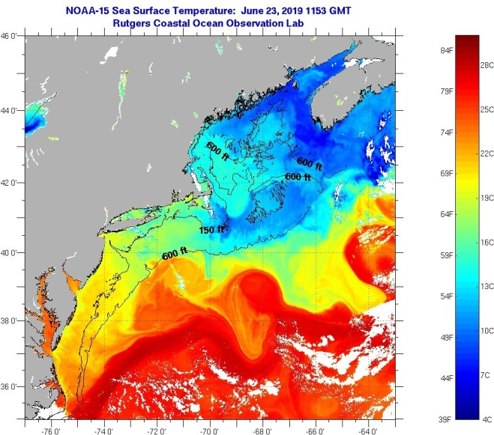 | June 23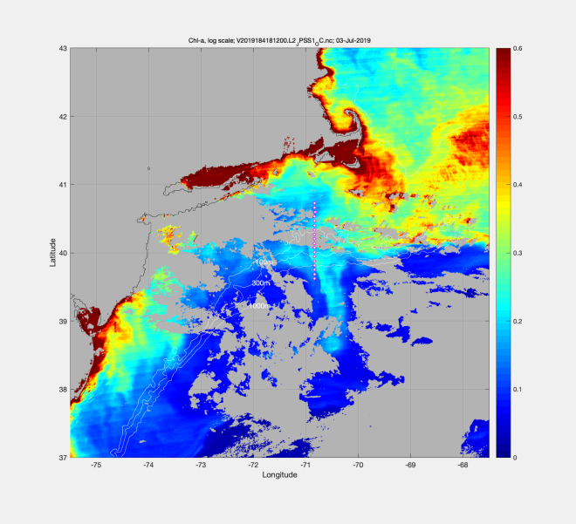
July 3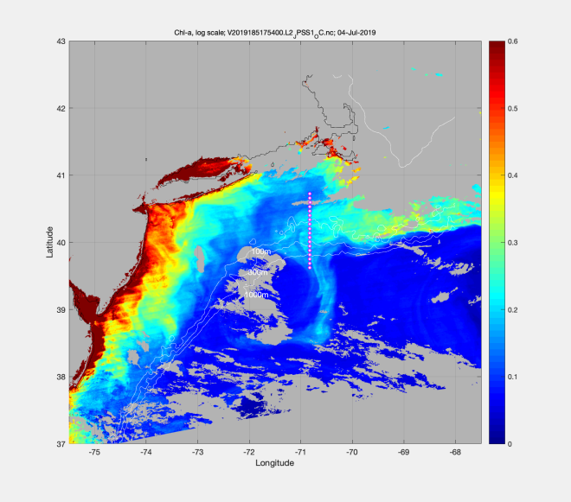 | July 4
Figure 0703.1. Satellite images: (A) SST on June 23, (B) Chl on June 23, (C) Chl on July 3, and (D) Chl on July 4.

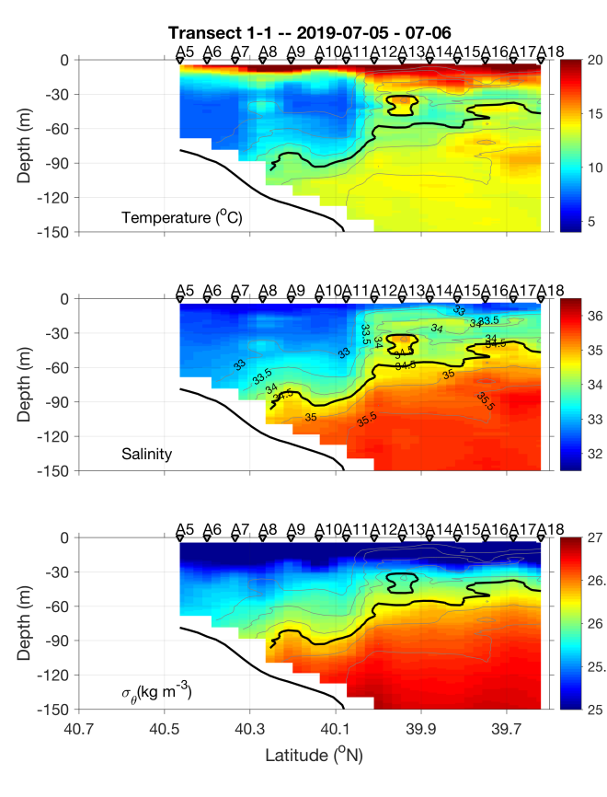 | 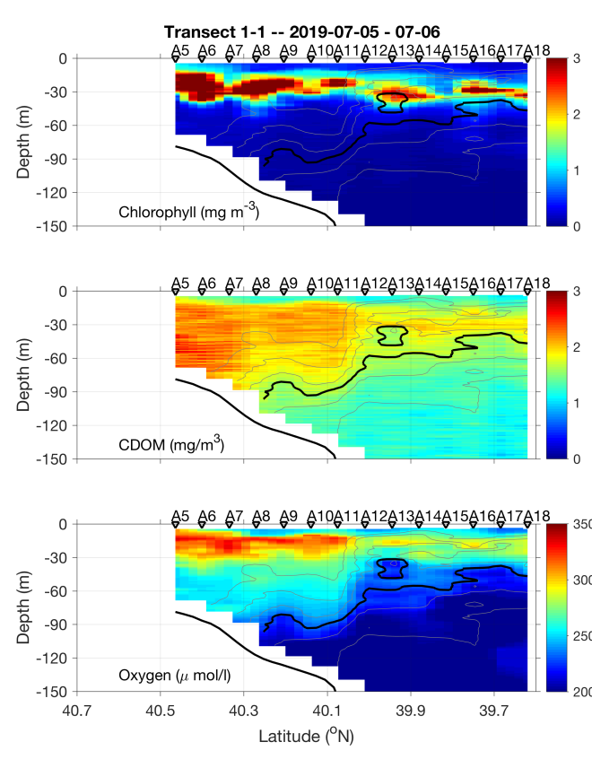
Figure 0706.1. July 5-6 transect.

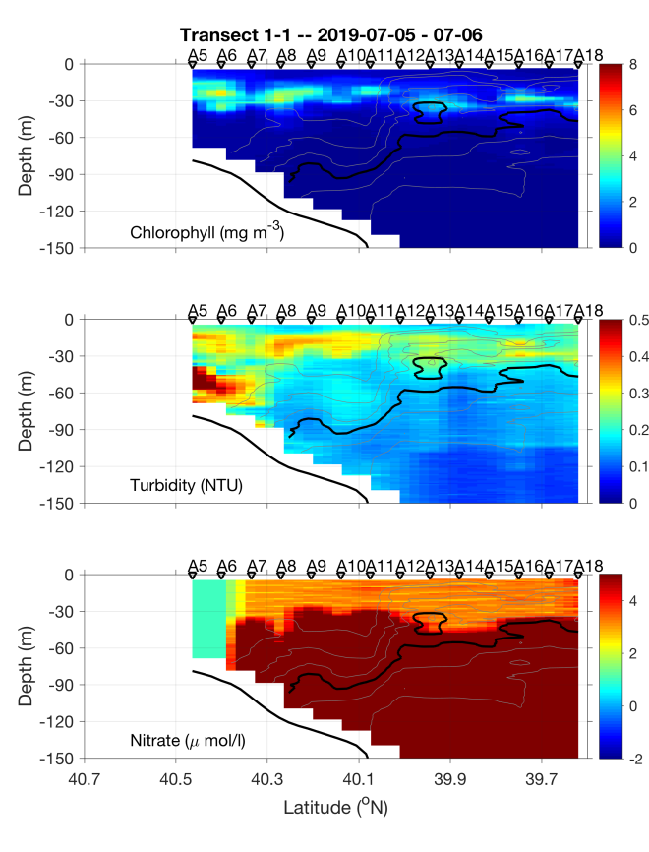 | 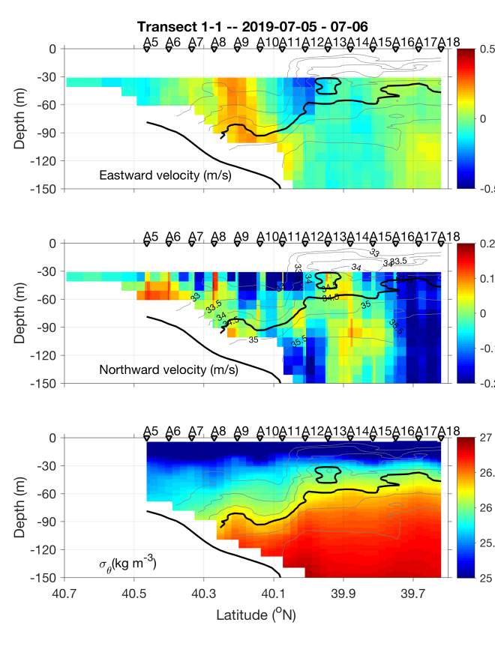
Figure 0706.2. July 5-6 transect.
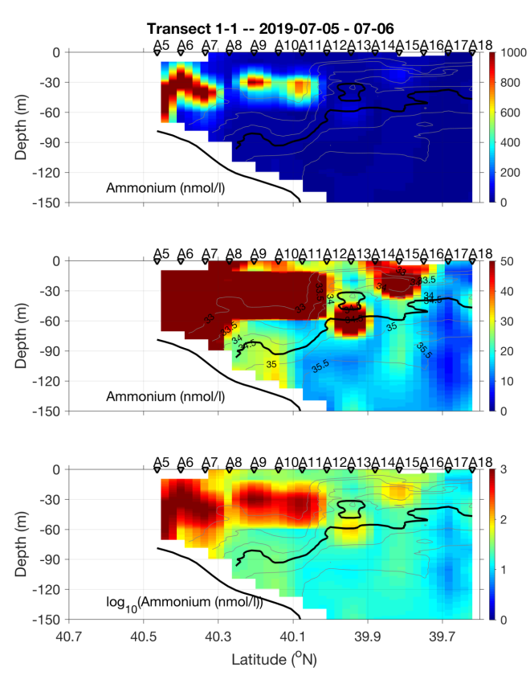
Figure 0706.3. July 5-6 transect.

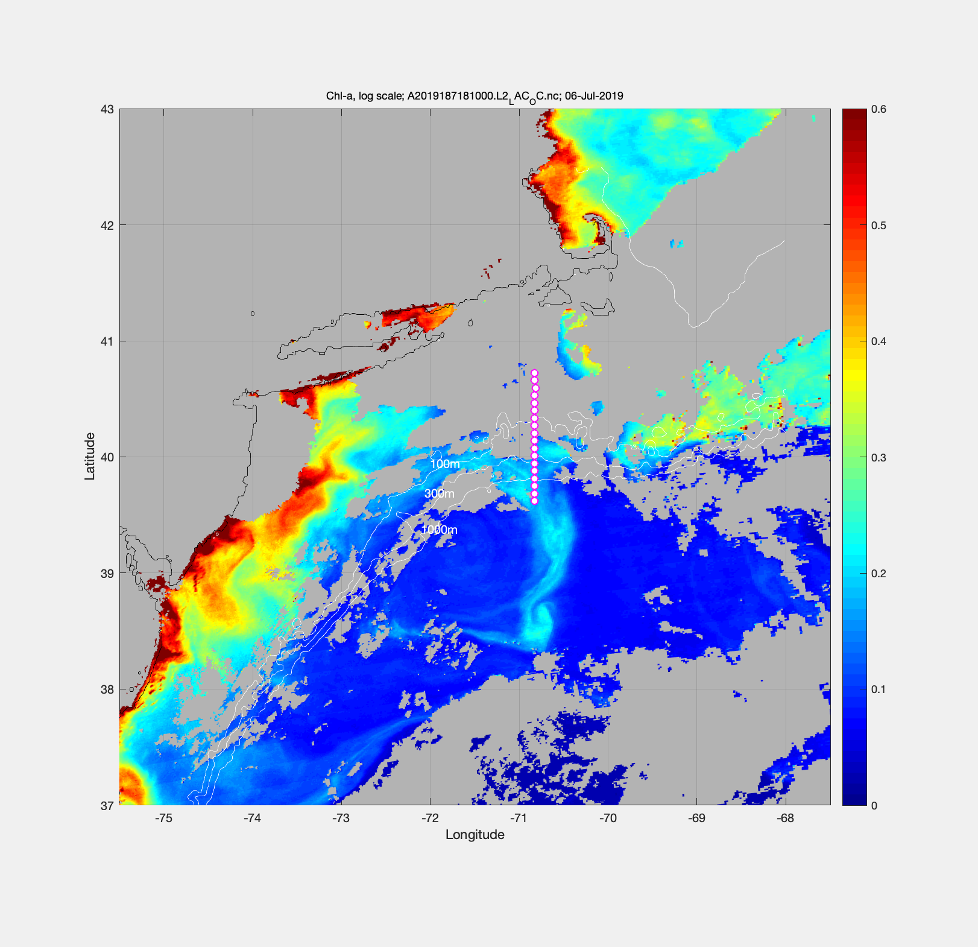
Figure 0706.4. MODIS Chl for July 6.

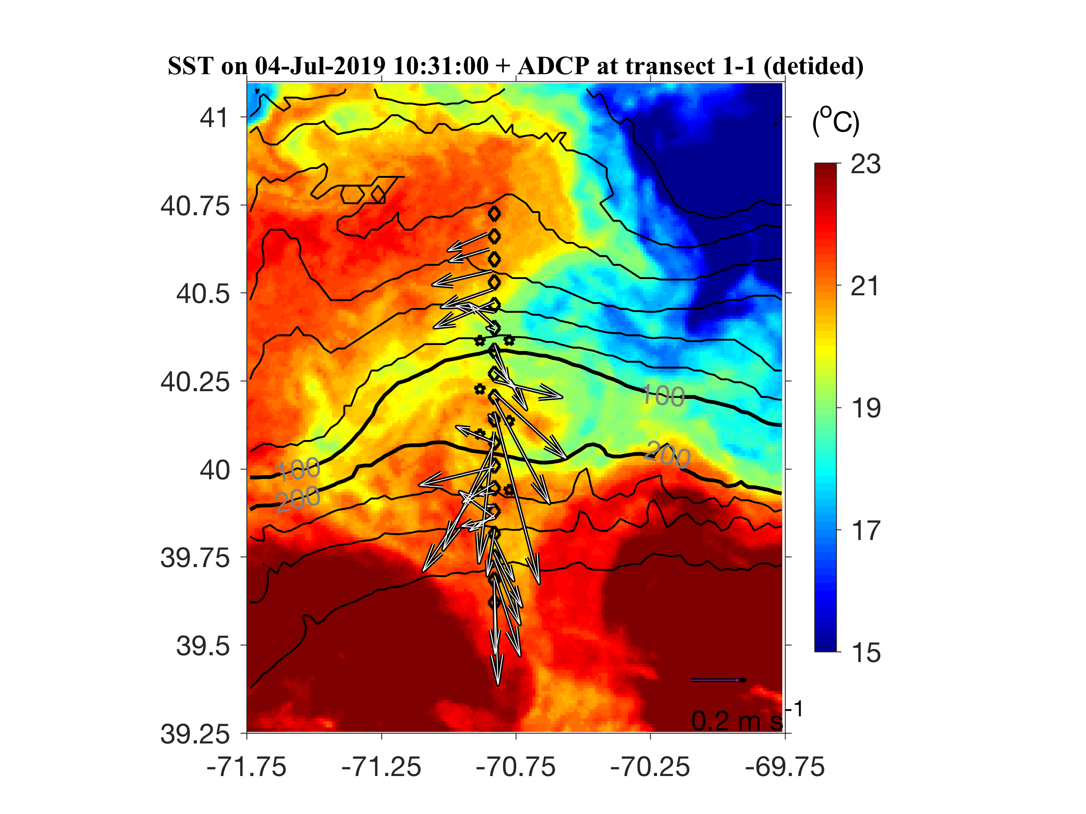
Figure 0706.5. Detided ADCP velocities overlayed on SST from July 4.

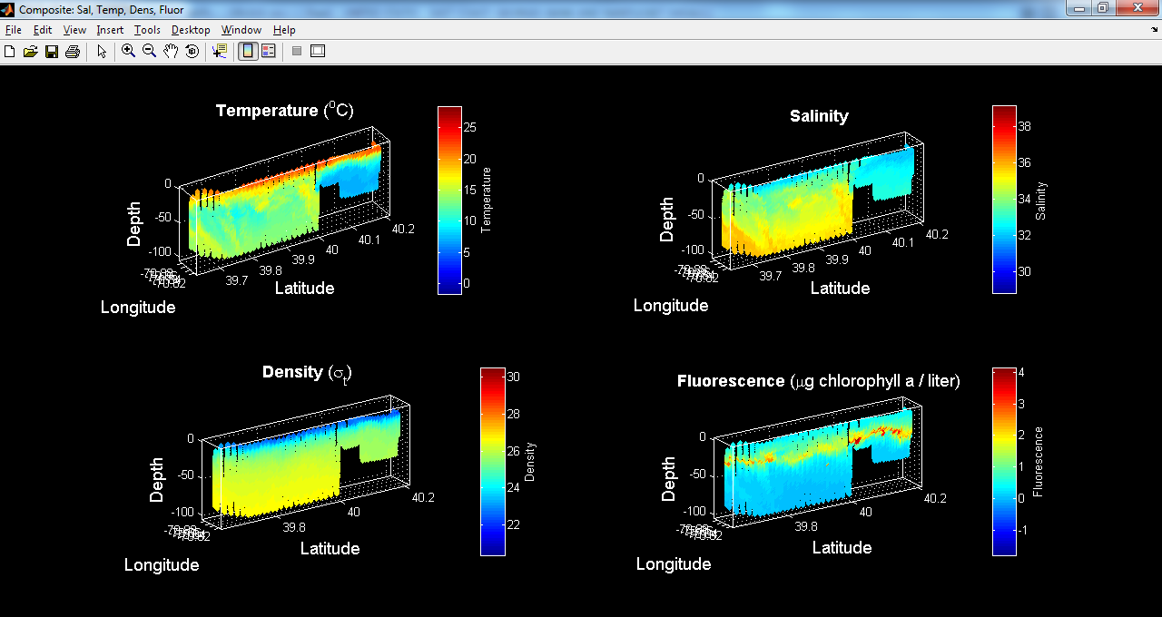
Figure 0706.6. VPR survey 1 from A17 to A9.

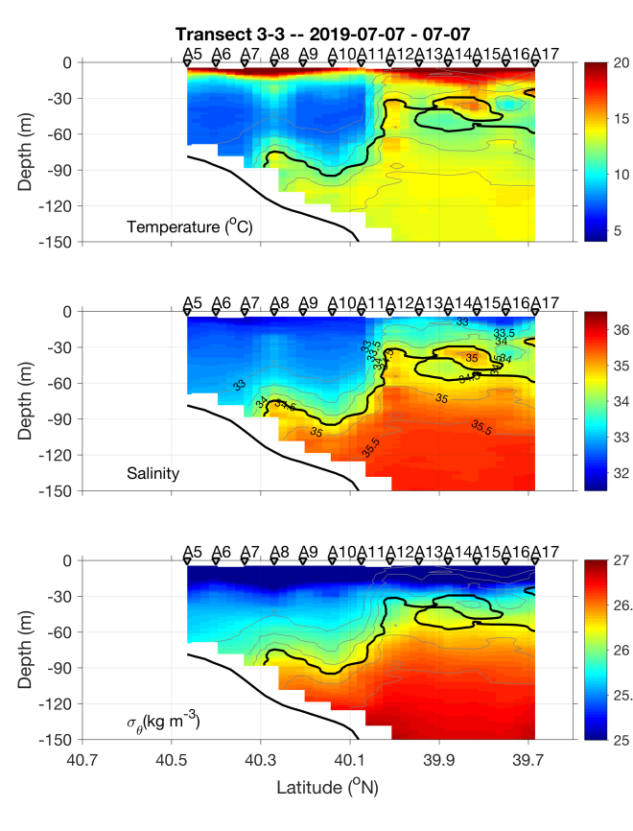 | 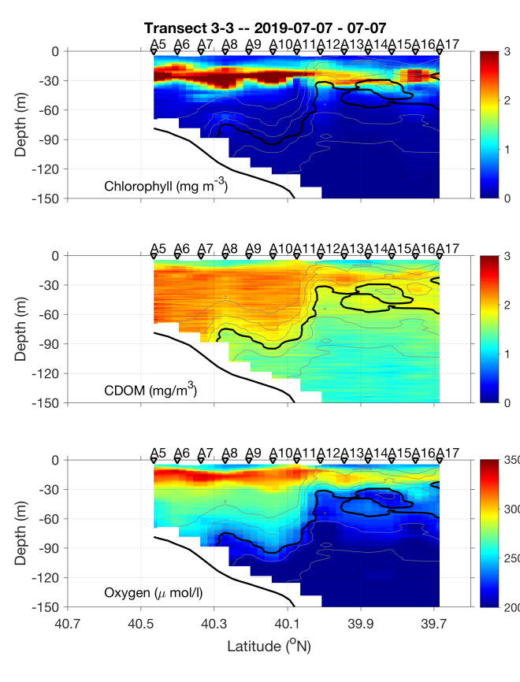
Figure 0707.1. July 6-7 transect.

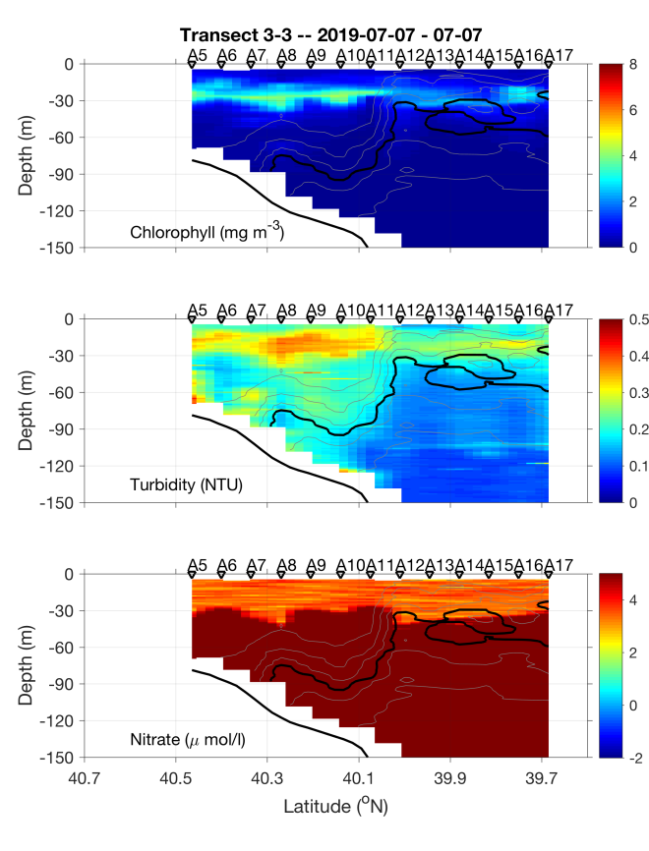 | 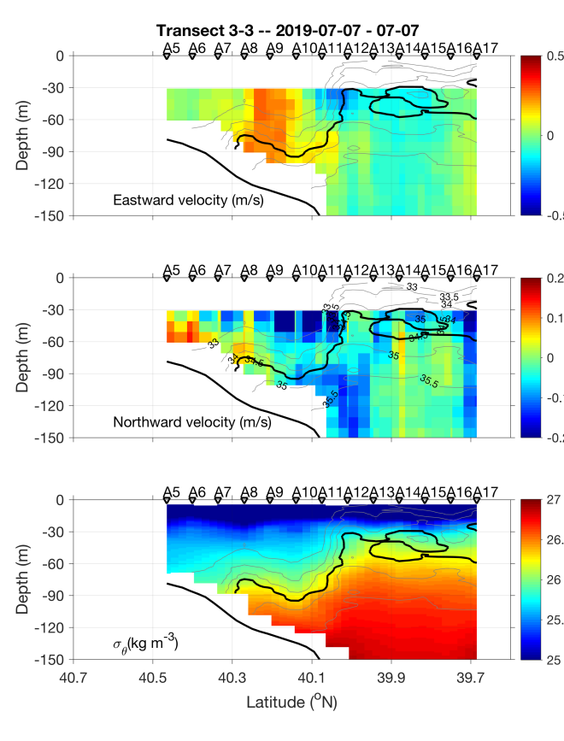
Figure 0707.2. July 6-7 transect.

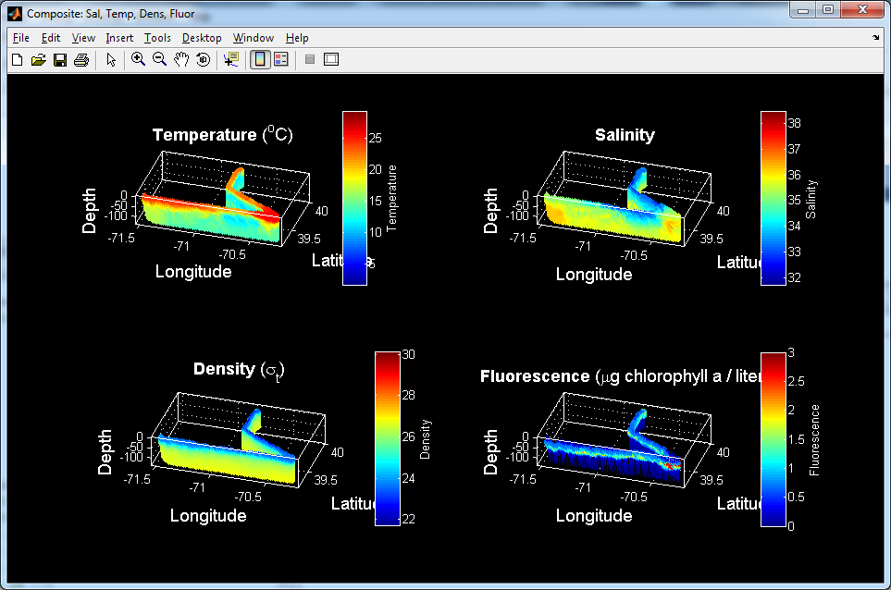
Figure 0708.1. VPR2 survey of ring streamer.

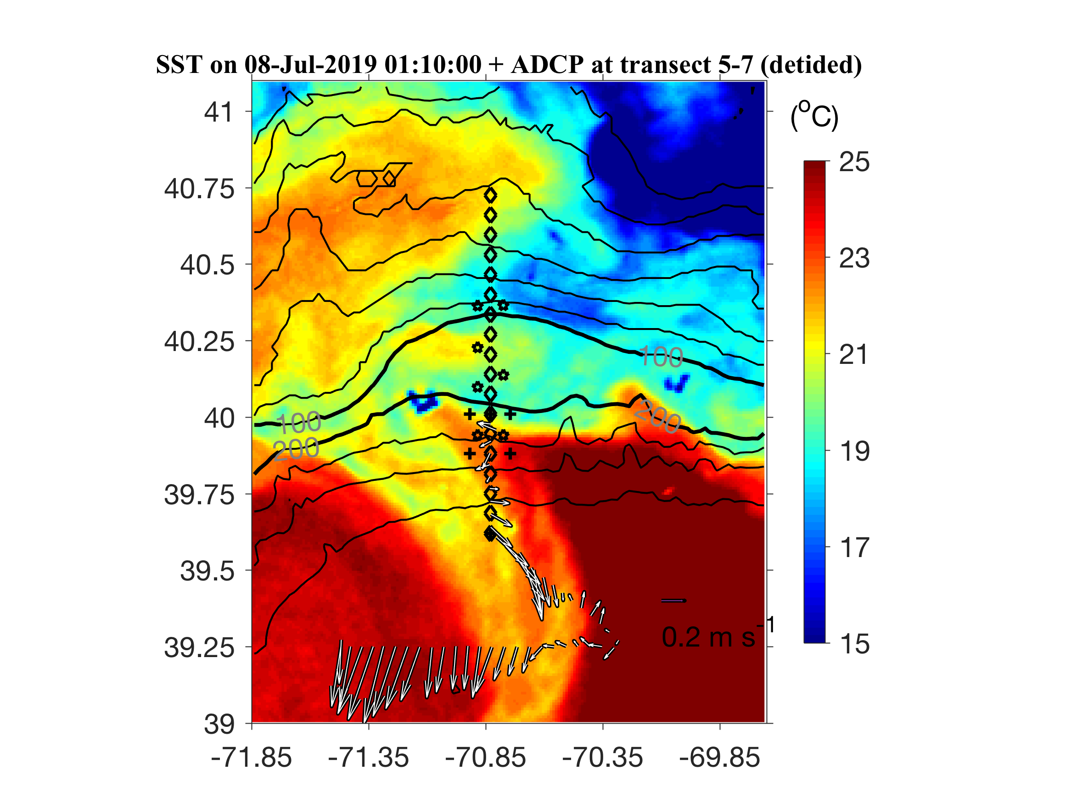
Figure 0708.2. ADCP observation corresponding to the VPR survey shown in Figure 0708.1

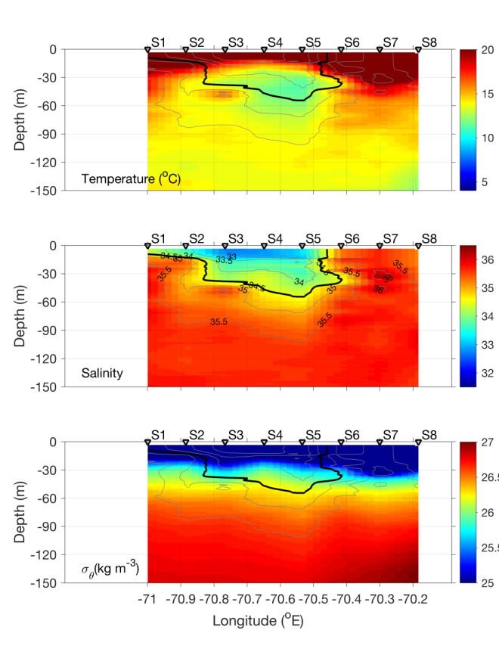 | 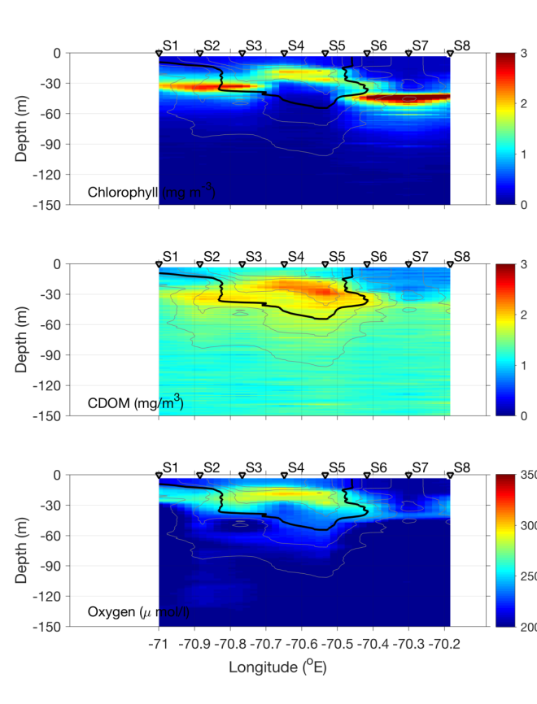
Figure 0708.3. July 8 streamer transect 0-150m.

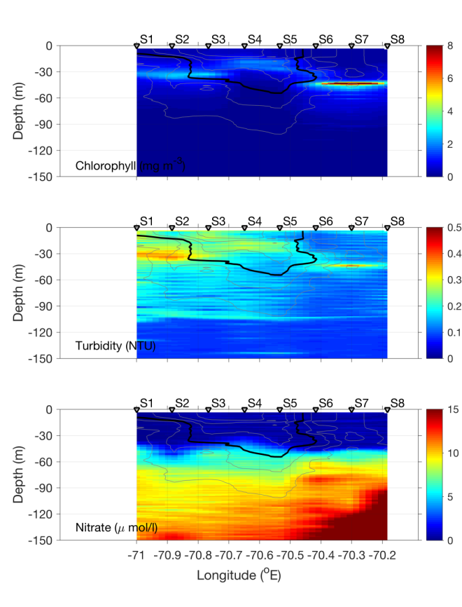 | 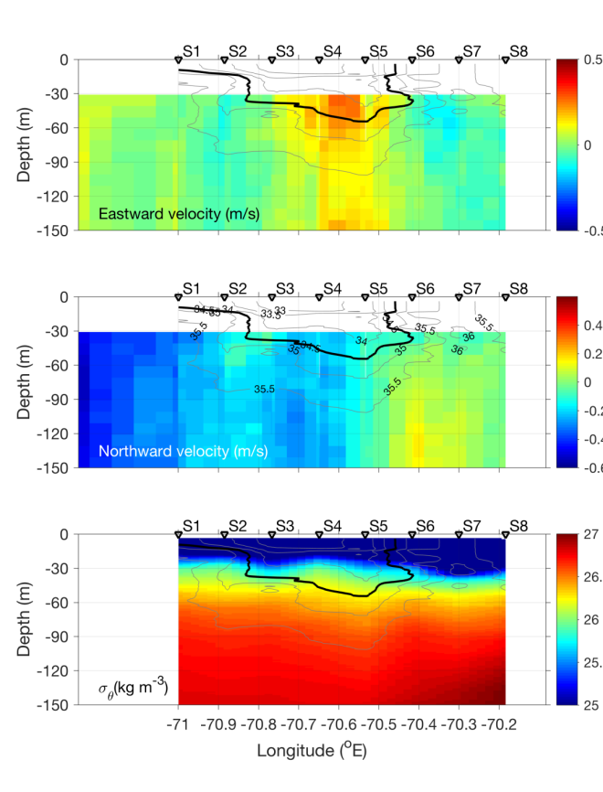
Figure 0708.4. July 8 streamer transect 0-150m.
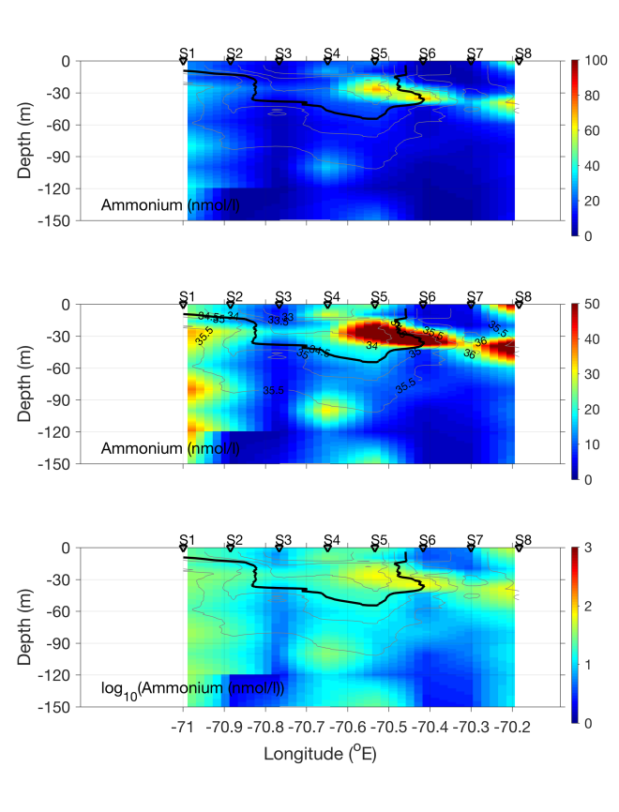
Figure 0708.5. July 8 streamer transect 0-150m.

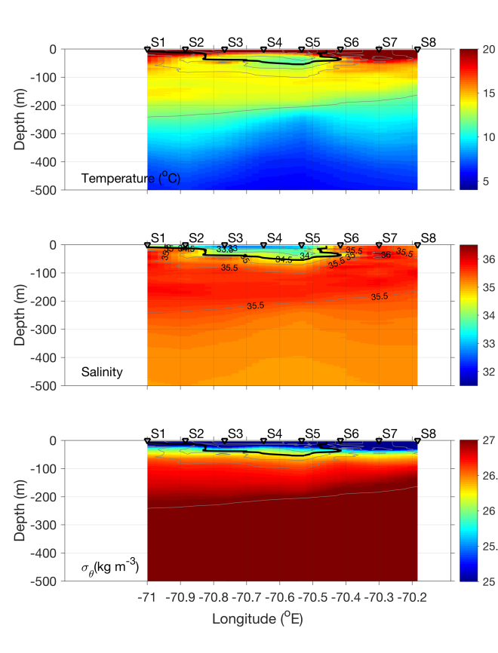 | 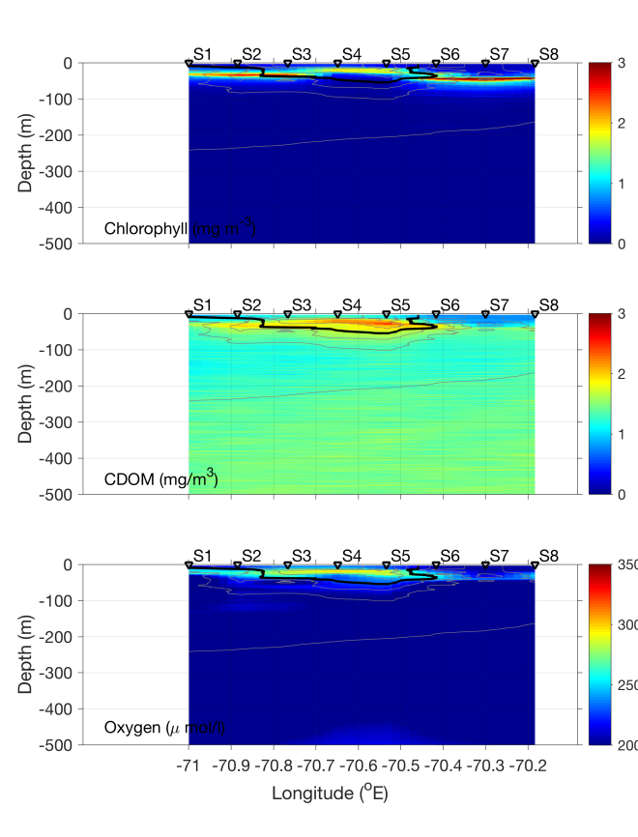
Figure 0708.6. July 8 streamer transect 0-500m.

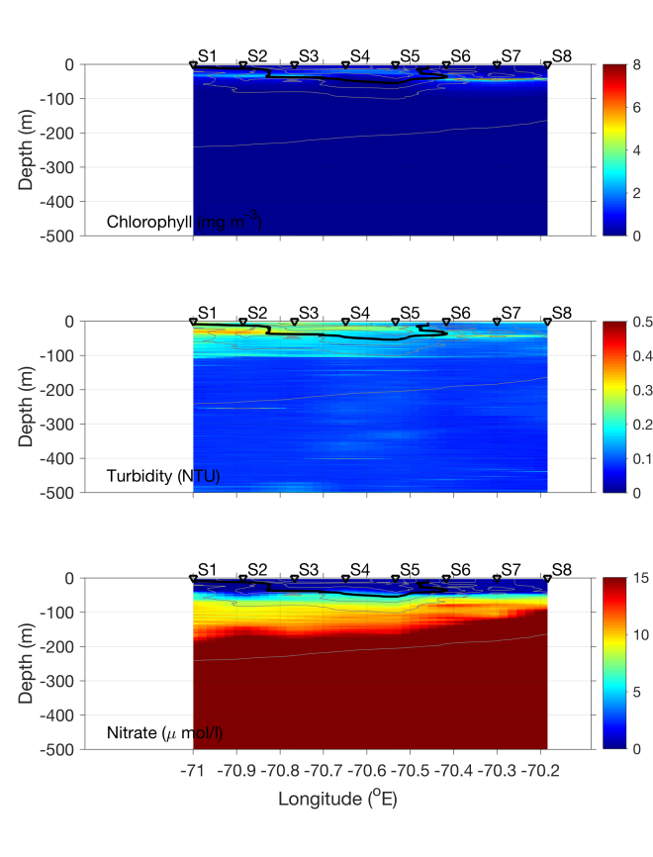 | 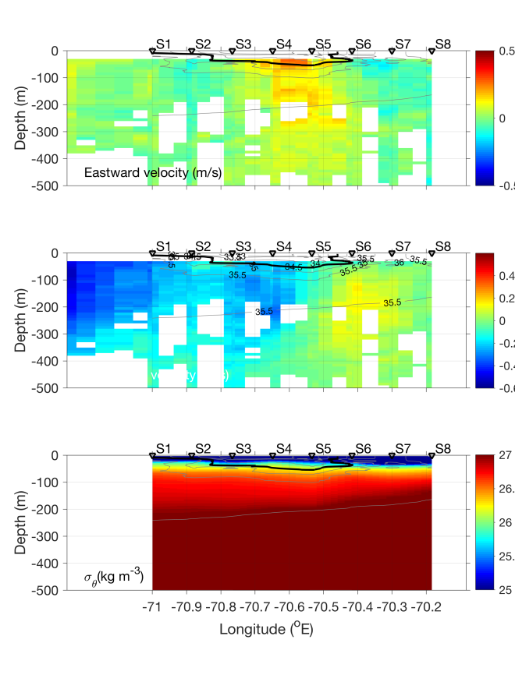
Figure 0708.7. July 8 streamer transect 0-500m.

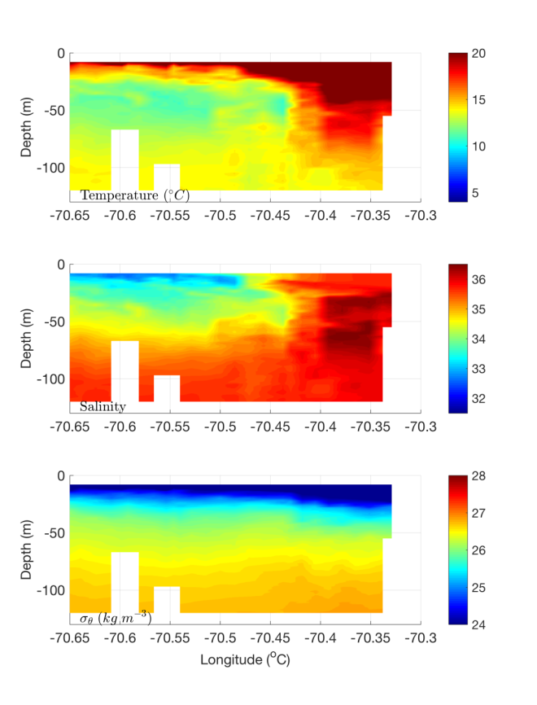 | 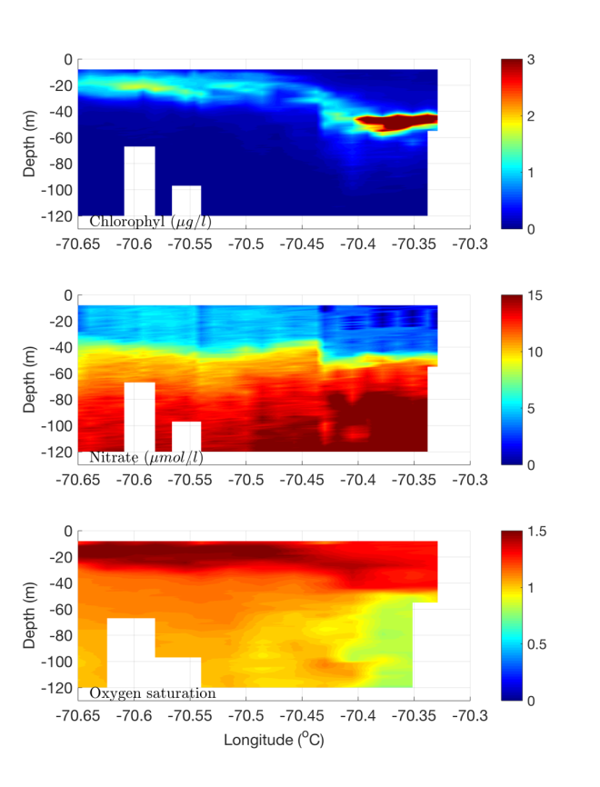
Figure 0708.8. July 8 streamer transect occupied by REMUS.

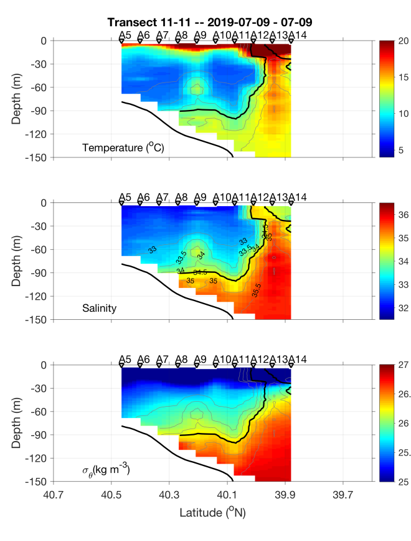 | 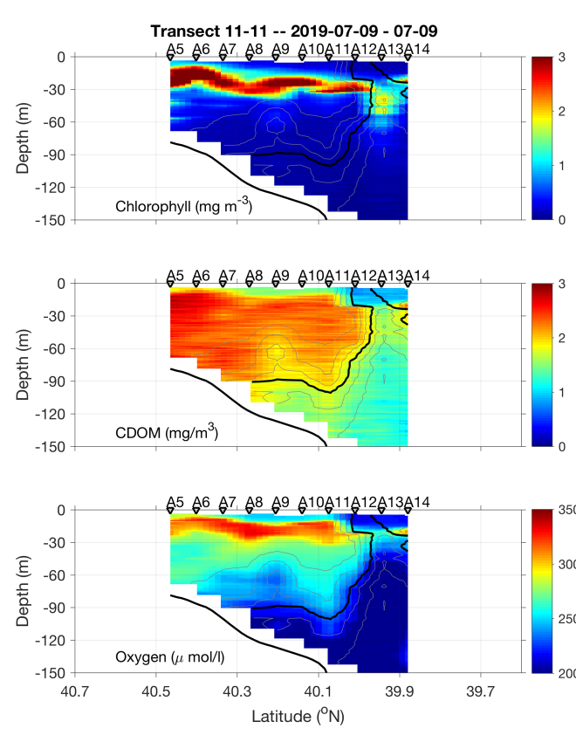
Figure 0709.1. July 9 CTD transect 0-150m.

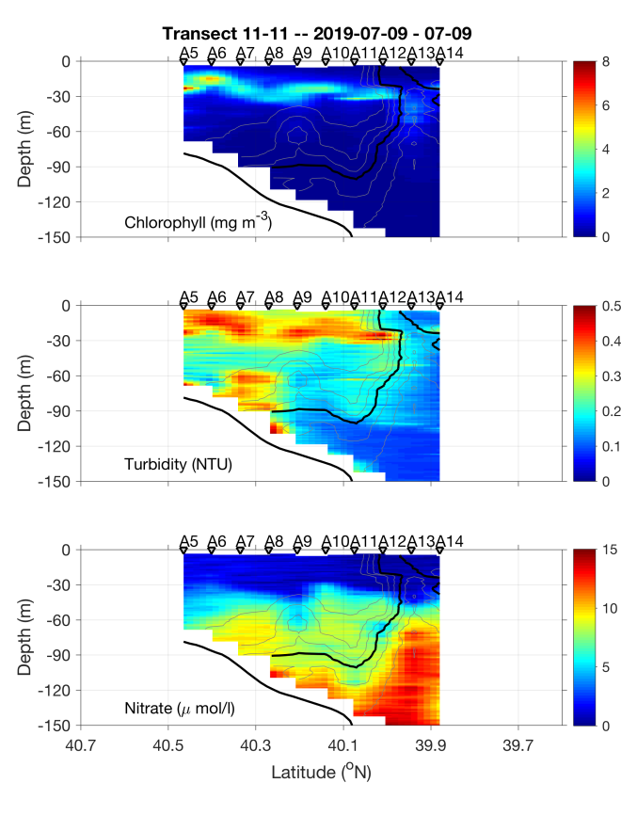 | 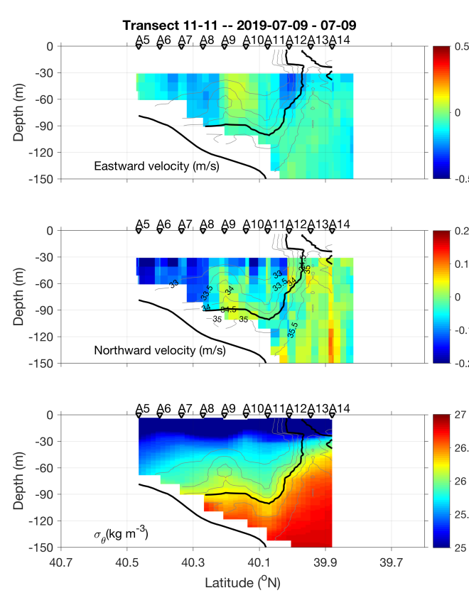
Figure 0709.2. July 9 CTD transect 0-150m.

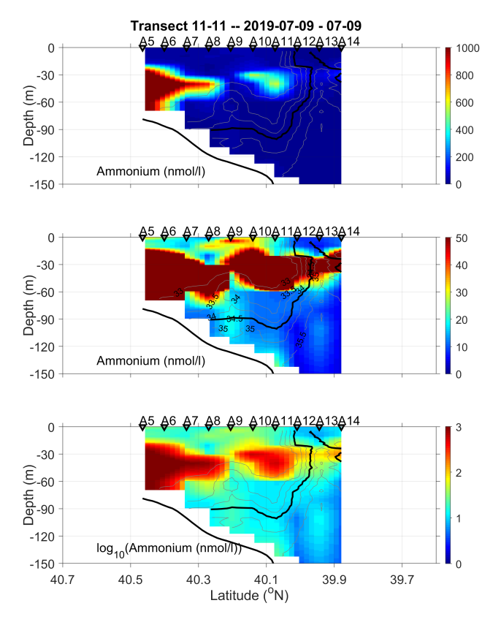
Figure 0709.3. July 9 CTD transect 0-150m.

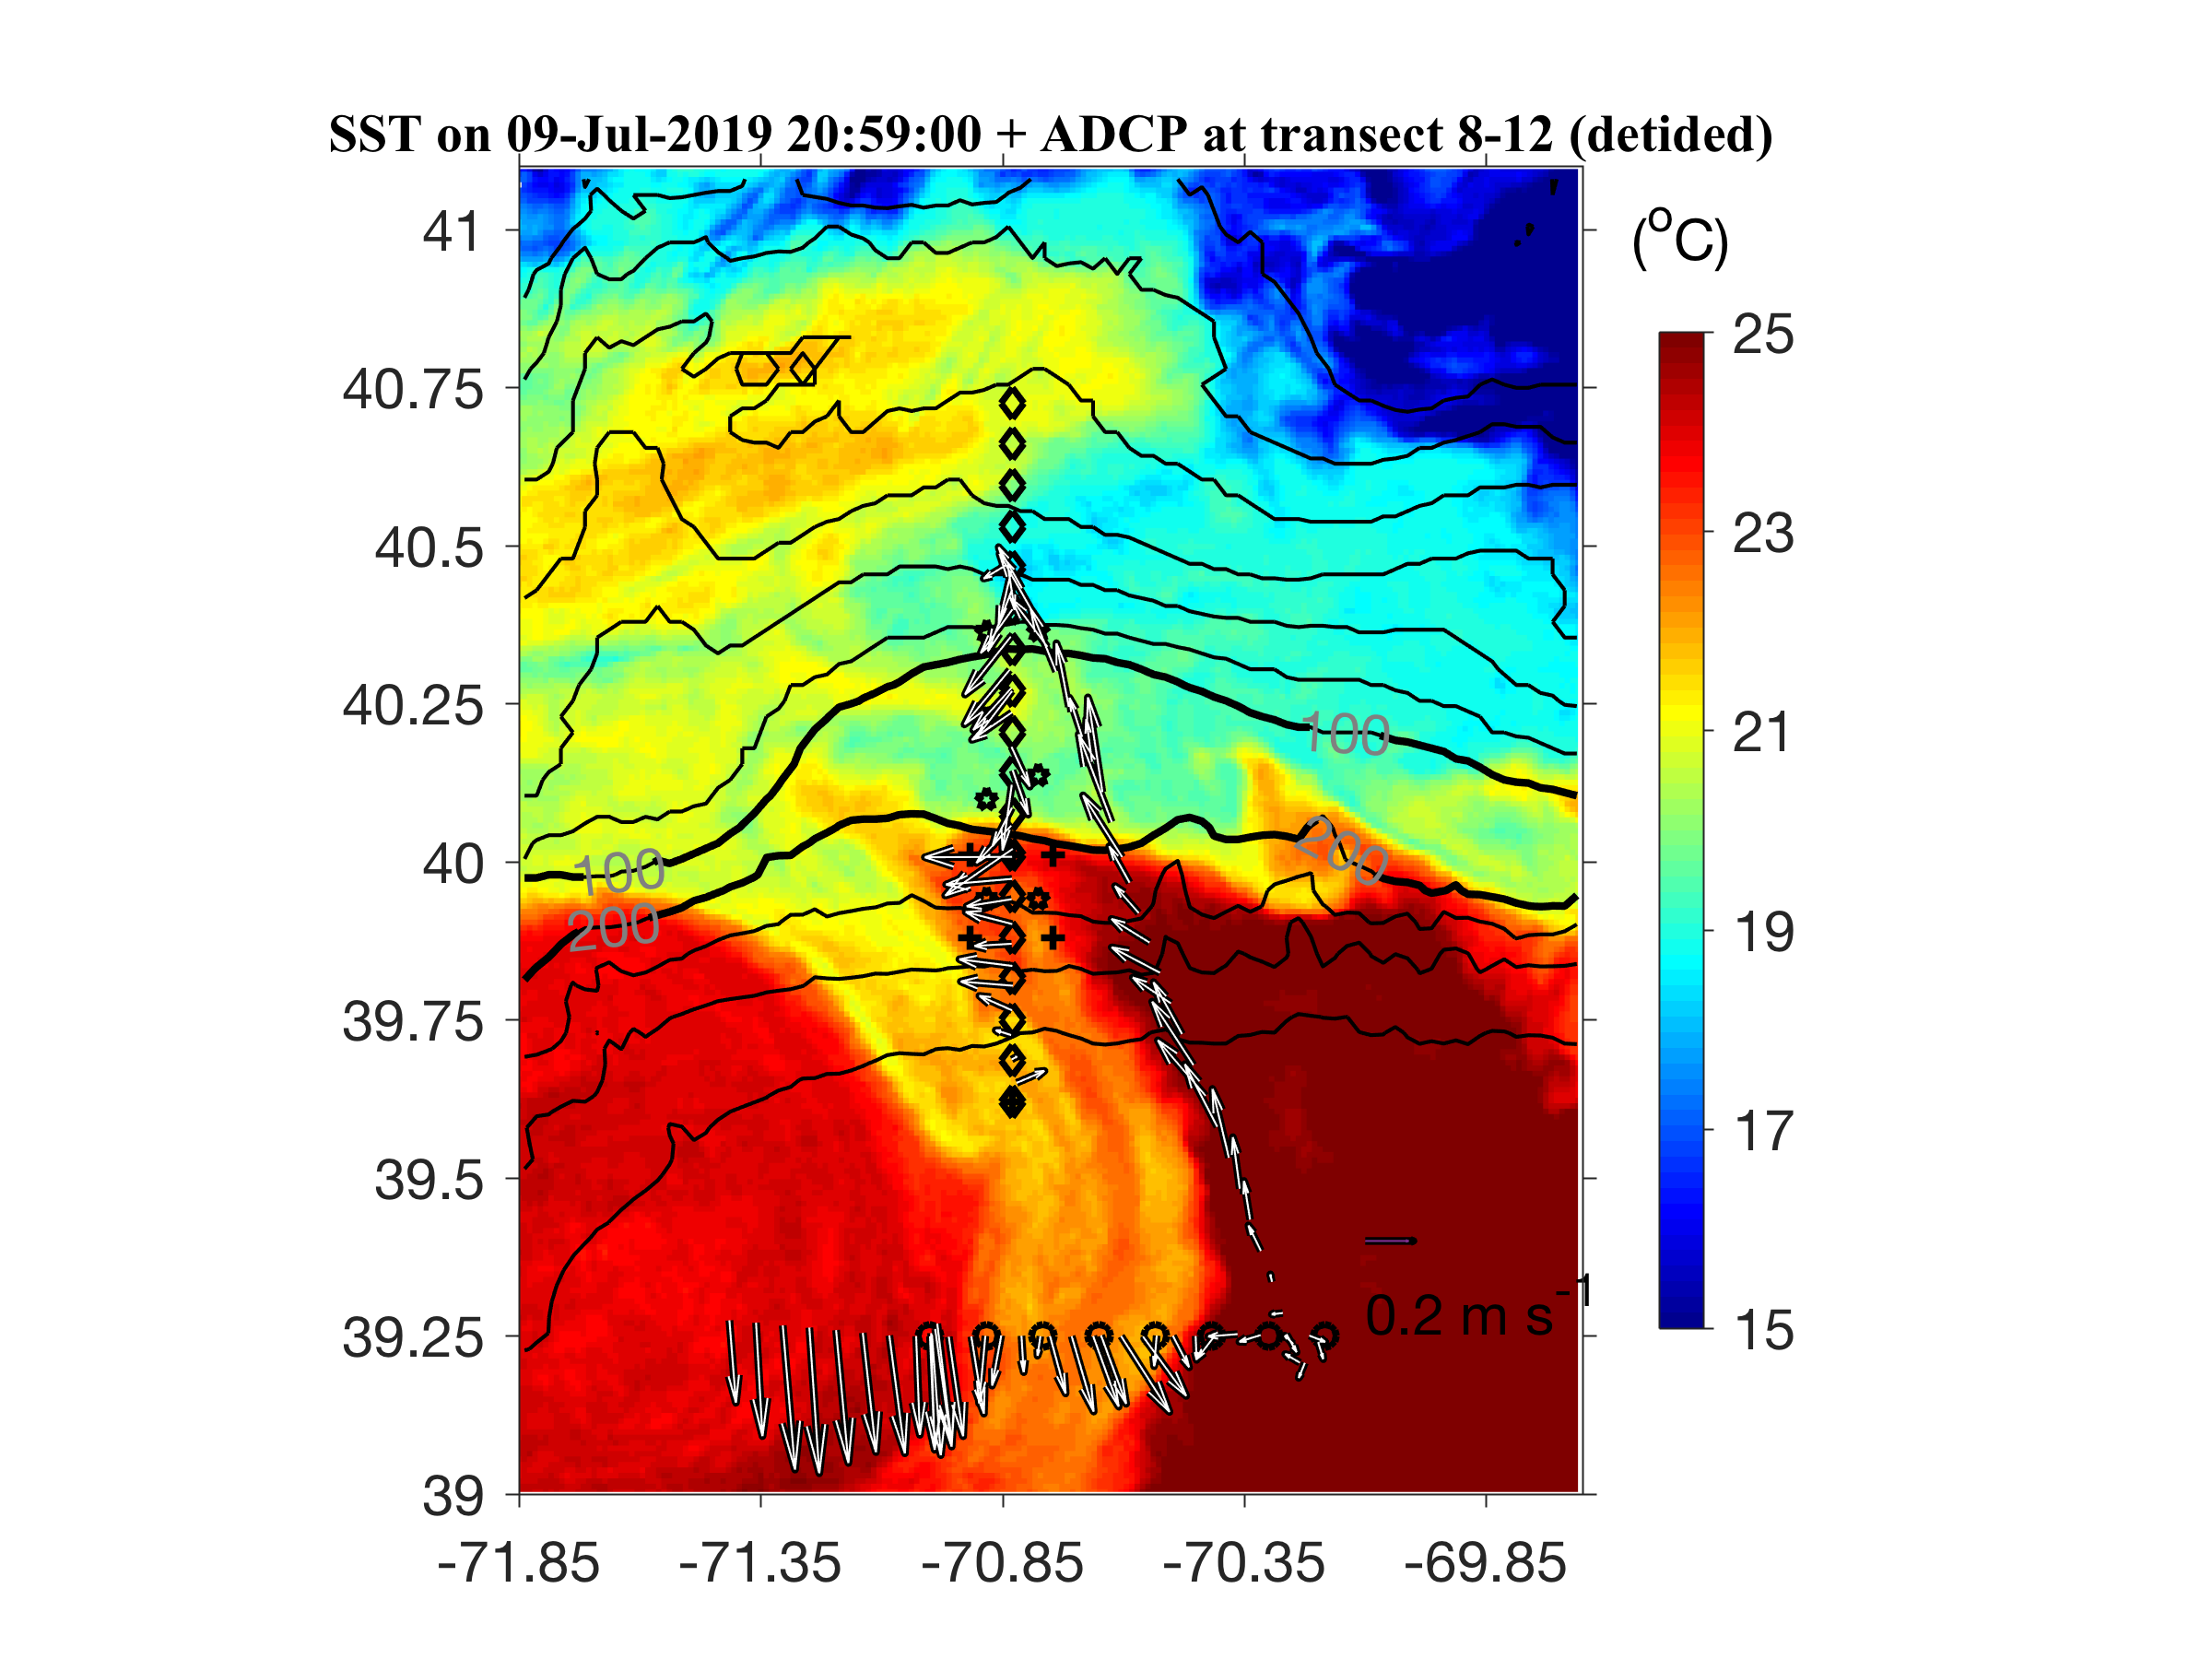
Figure 0709.4. ADCP observation corresponding to the CTD survey shown in Figure 0709.1,2.

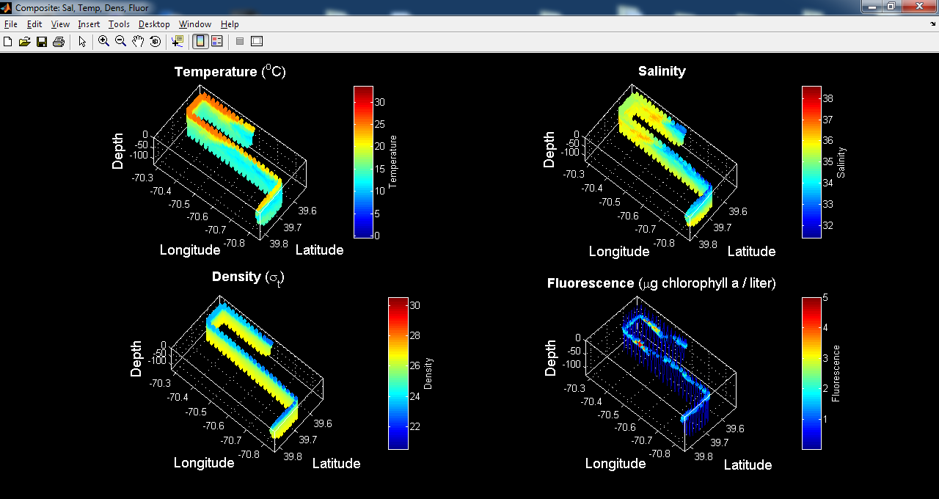
Figure 0709.5. VPR3 July 9, starting from A14 and surveying the diatom population to the east of the streamer.

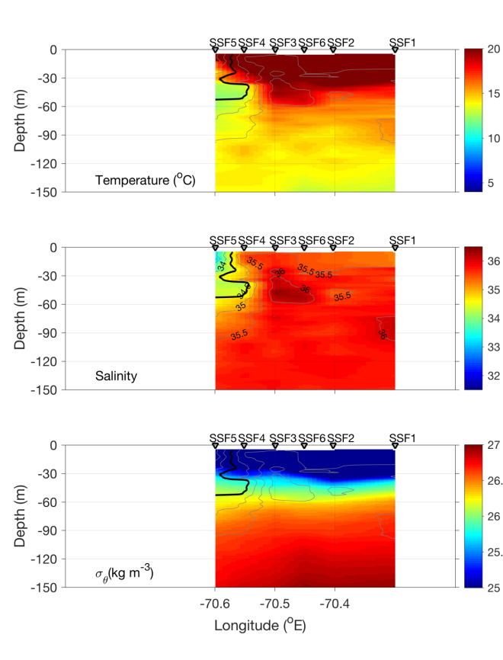 | 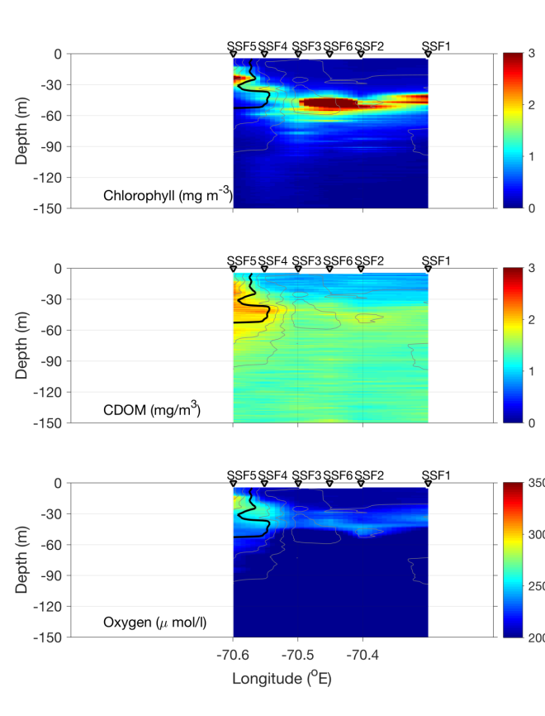
Figure 0710.1. July 10 CTD transect across the streamer/slope front.

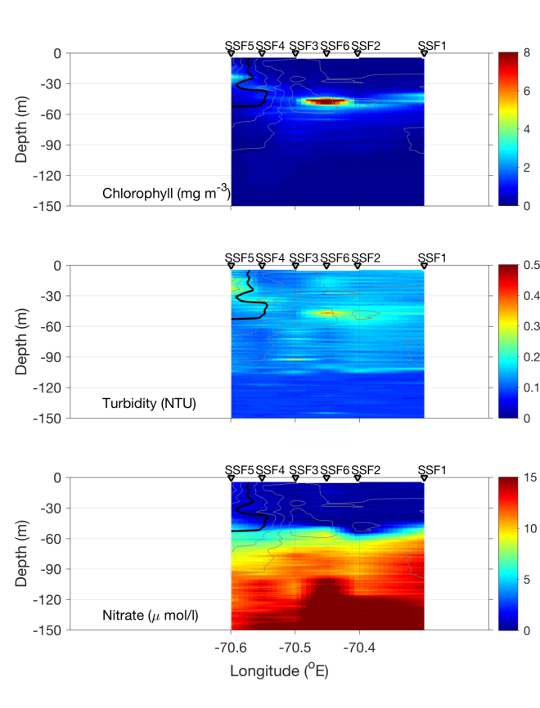 | 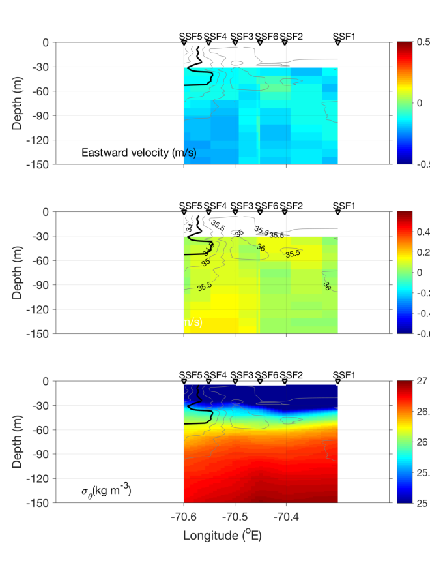
Figure 0710.2. July 10 CTD transect across the streamer/slope front.

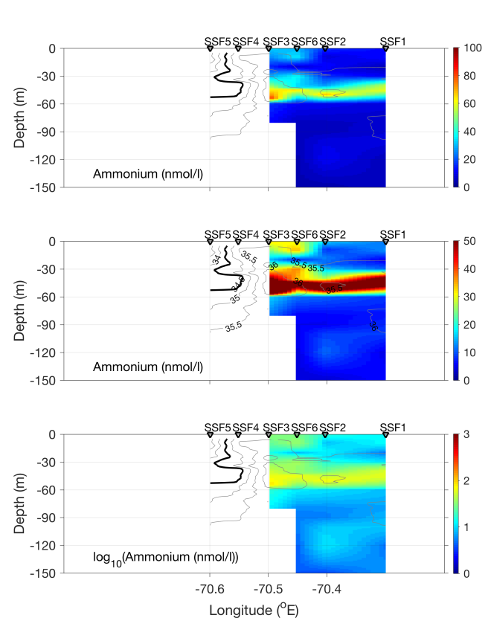
Figure 0710.3. July 10 CTD transect across the streamer/slope front.

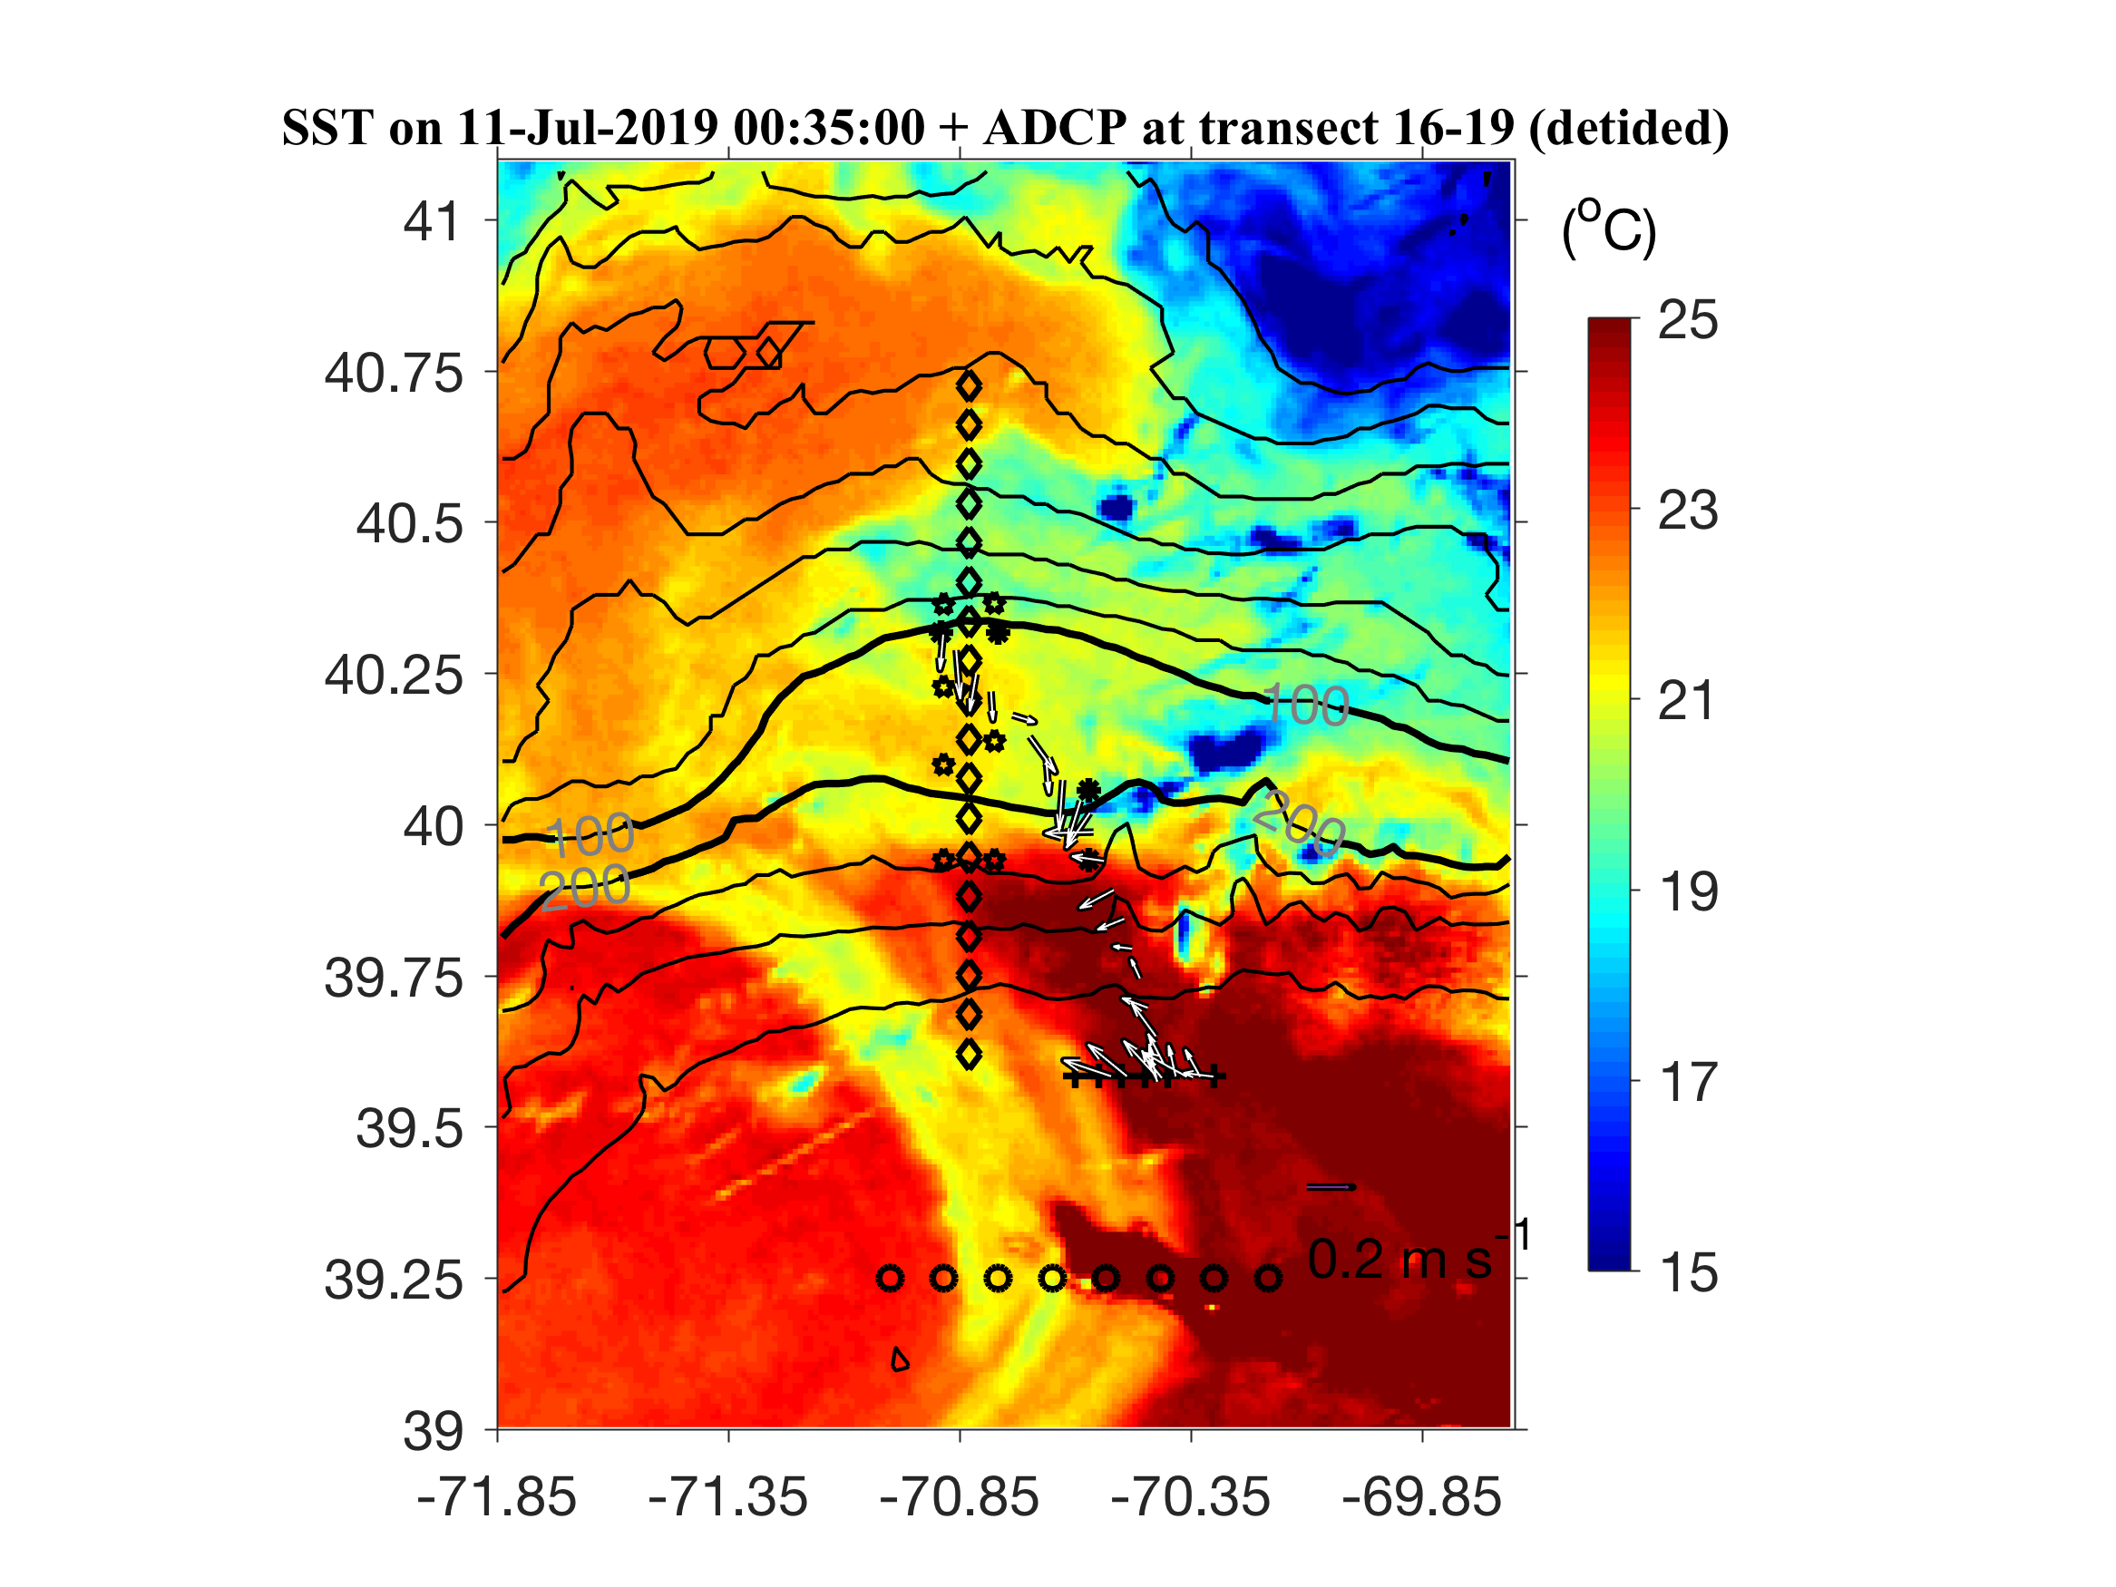
Figure 0710.4. ADCP observation corresponding to the CTD survey (plus signs) shown in Figure 0710.1,2.

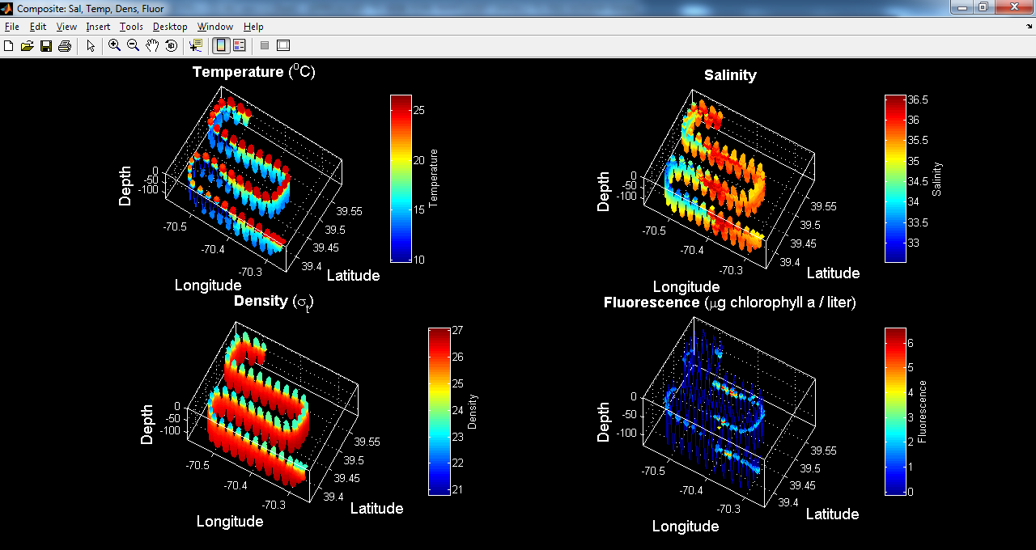
Figure 0710.5. VPR4 July 10-11, starting from station SSF6 in the streamer/slope front section (Figure 0709.1,2).

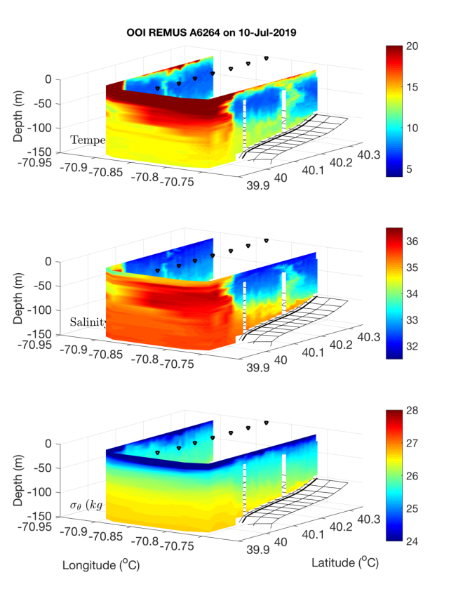 | 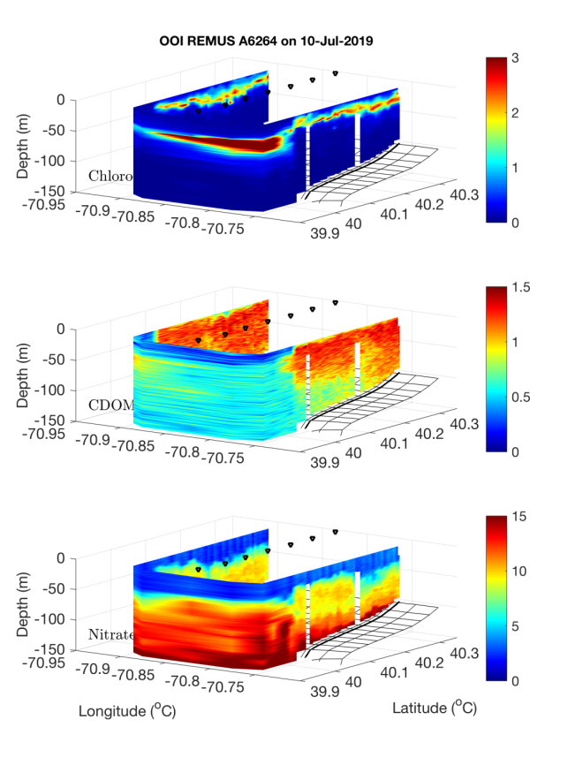
Figure 0711.1. OOI REMUS across-front mission July 10.

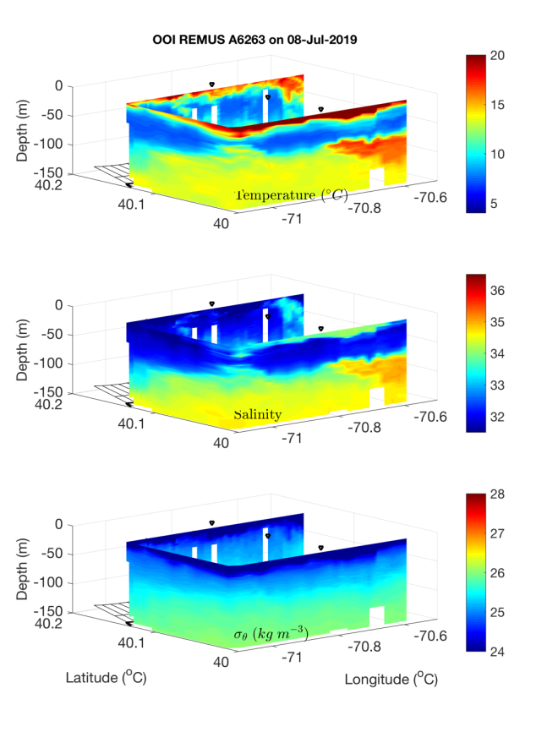 | 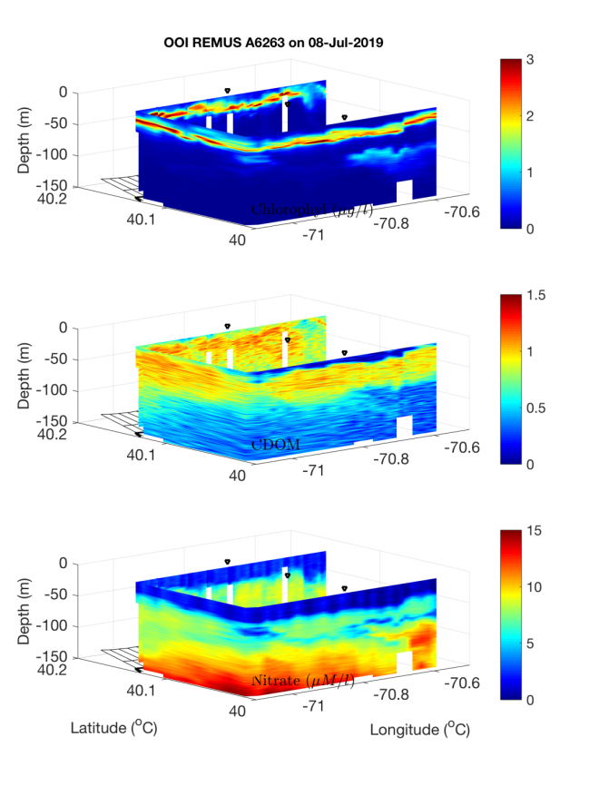
Figure 0711.2. OOI REMUS along-front mission July 10.

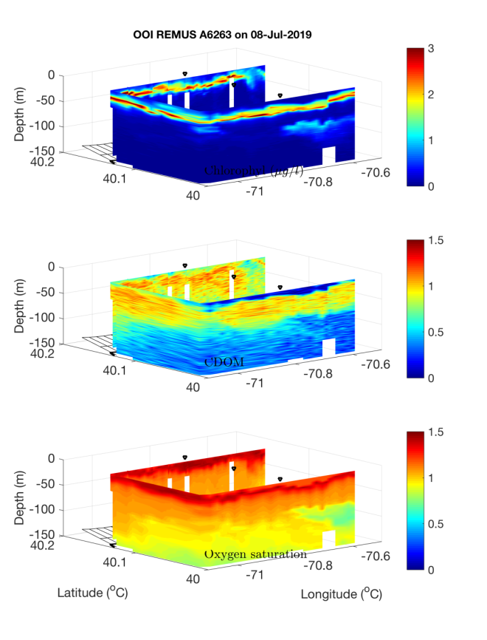
Figure 0711.3. OOI REMUS along-front mission July 10.

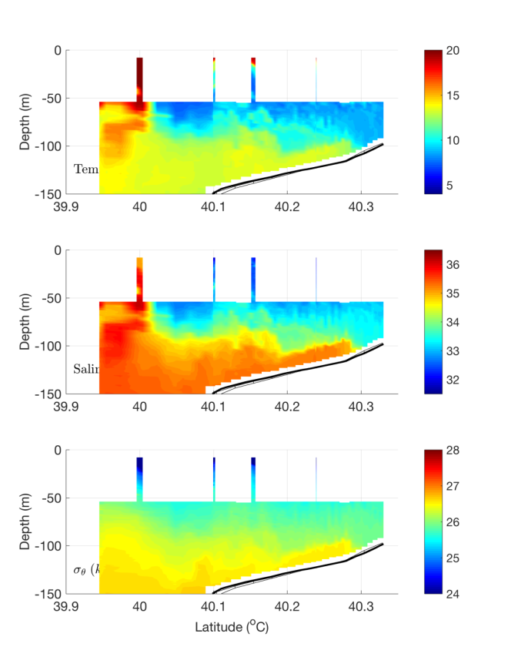 | 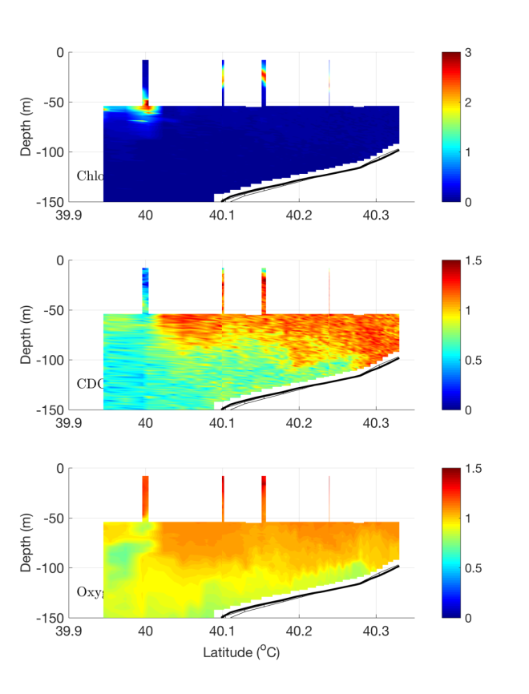
Figure 0711.4. OOI REMUS bottom boundary layer mission July 11.

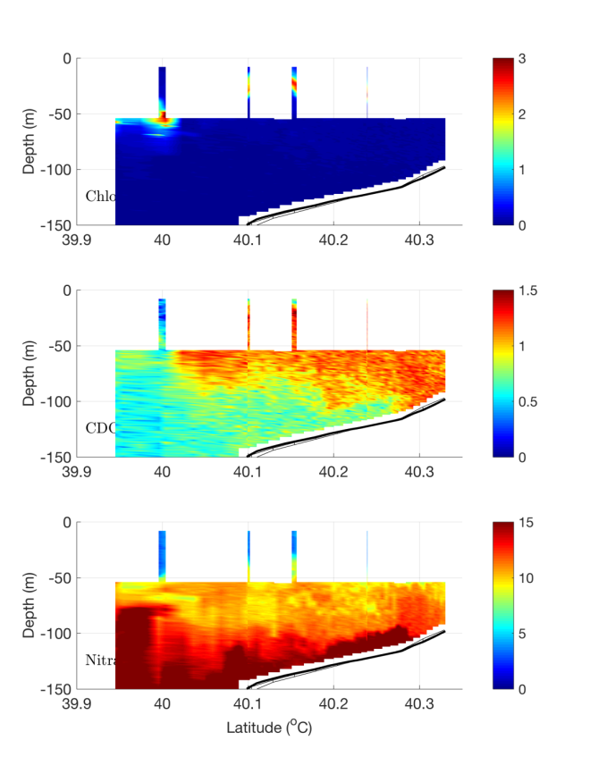
Figure 0711.5. OOI REMUS bottom boundary layer mission July 11.

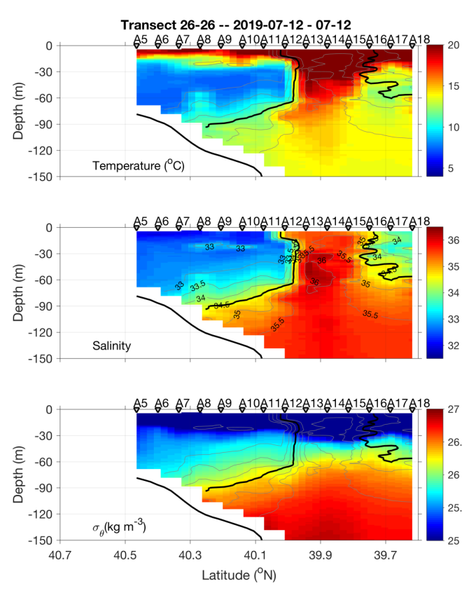 | 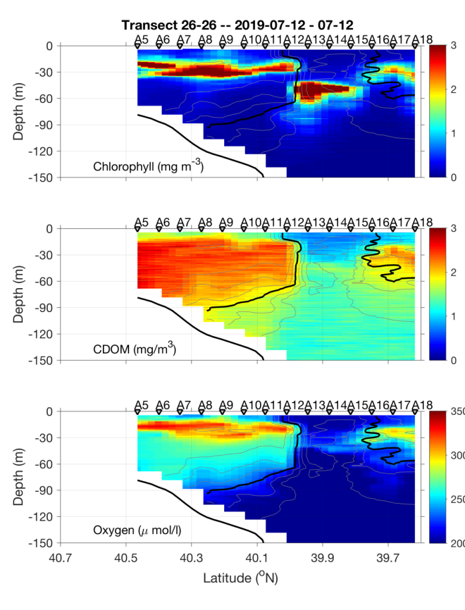
Figure 0712.1. July 11-12 CTD transect.

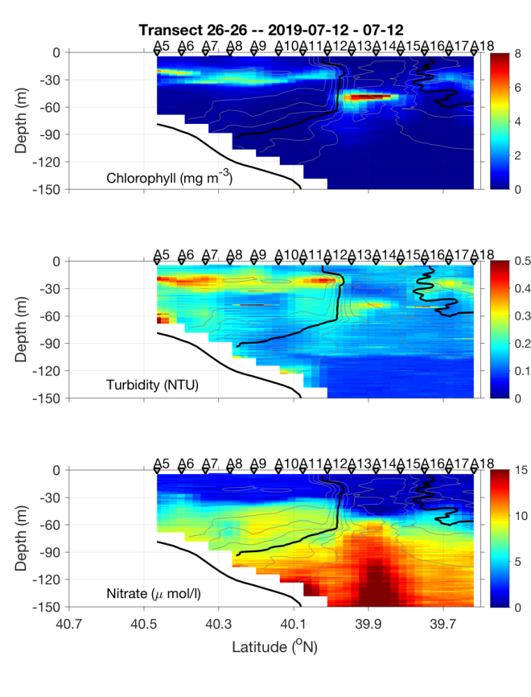 | 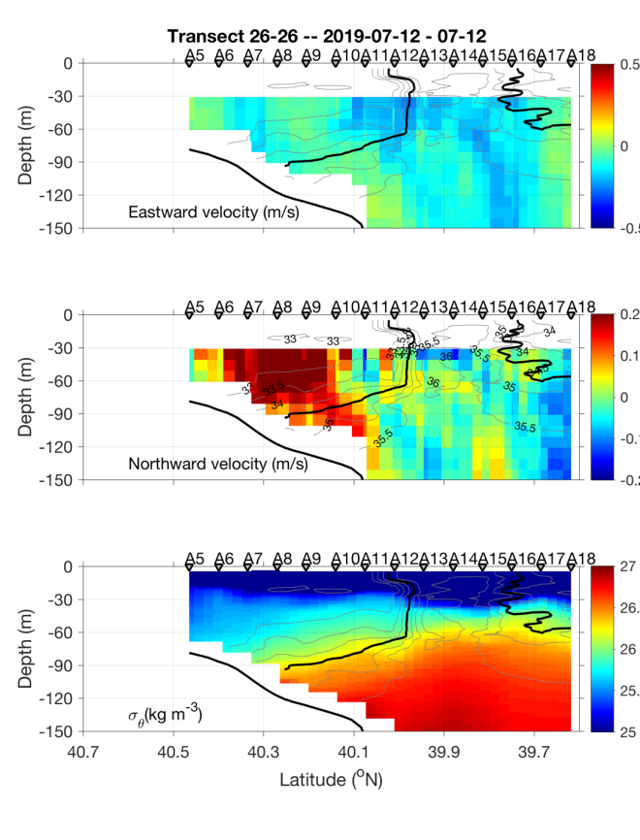
Figure 0712.2. July 11-12 CTD transect.

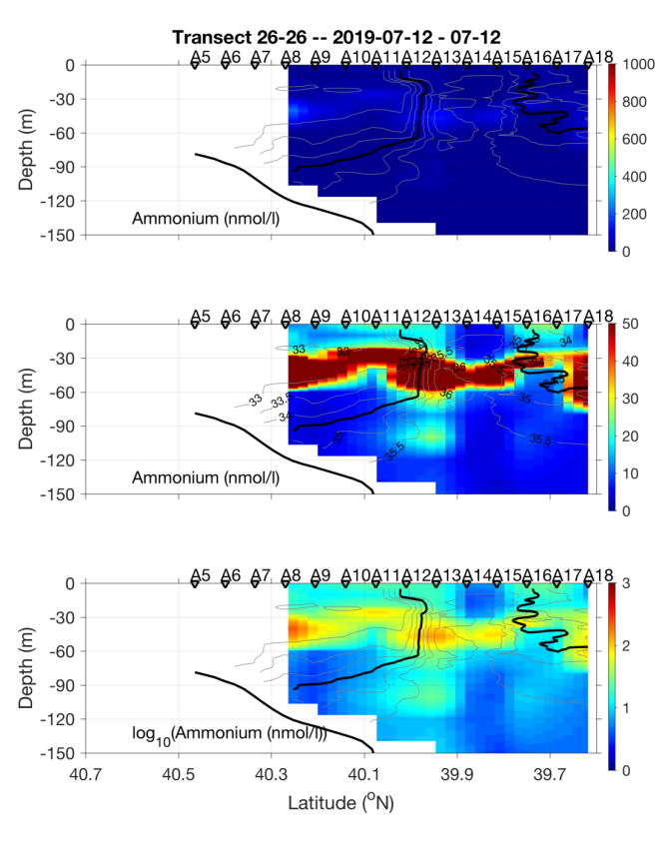
Figure 0712.3. July 11-12 CTD transect.

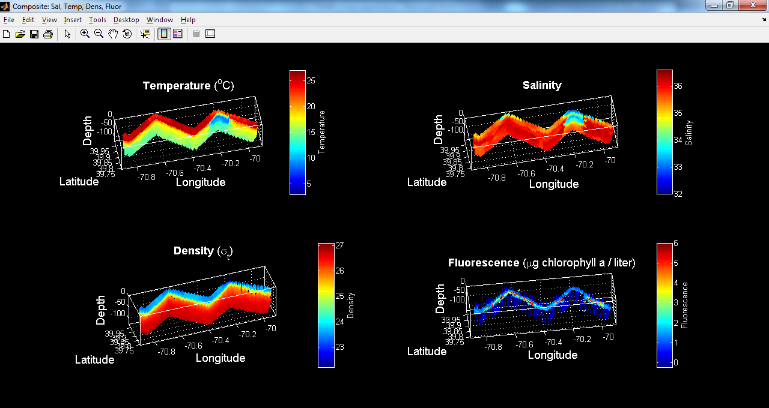
Figure 0712.4. VPR5 July 12, starting from A14 and surveying eastward.

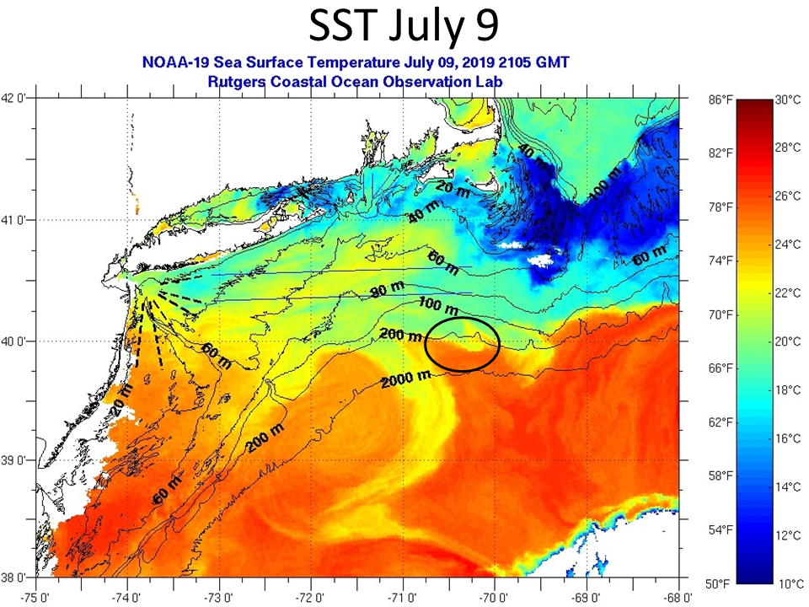
Figure 0712.5. SST on July 9. Black oval indicates the southward meander of the shelf break front observed in the VPR survey shown in Figure 0712.3.

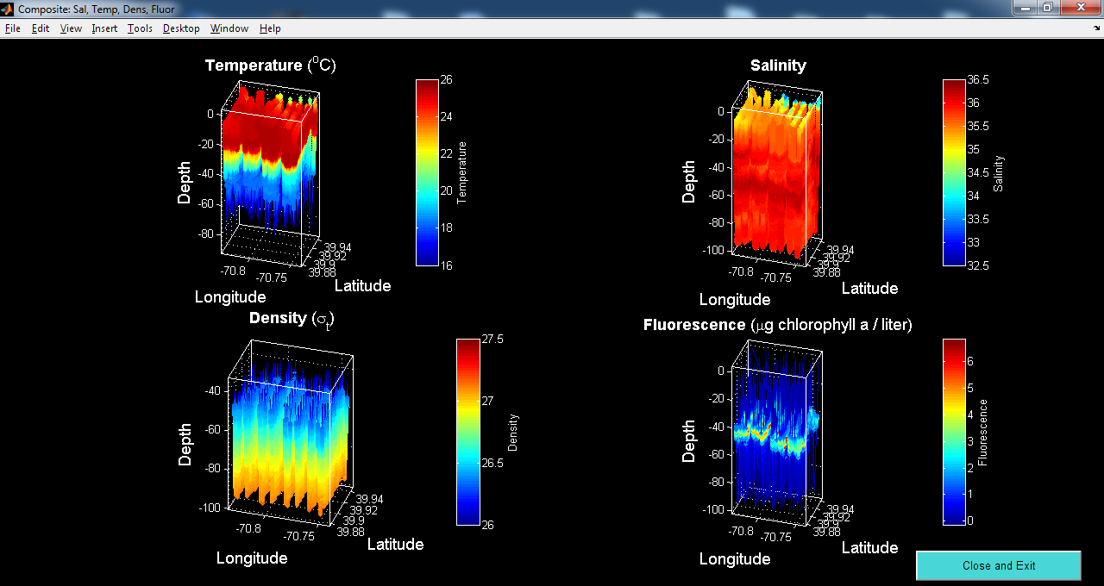
Figure 0713.1. REMUS hotspot survey.

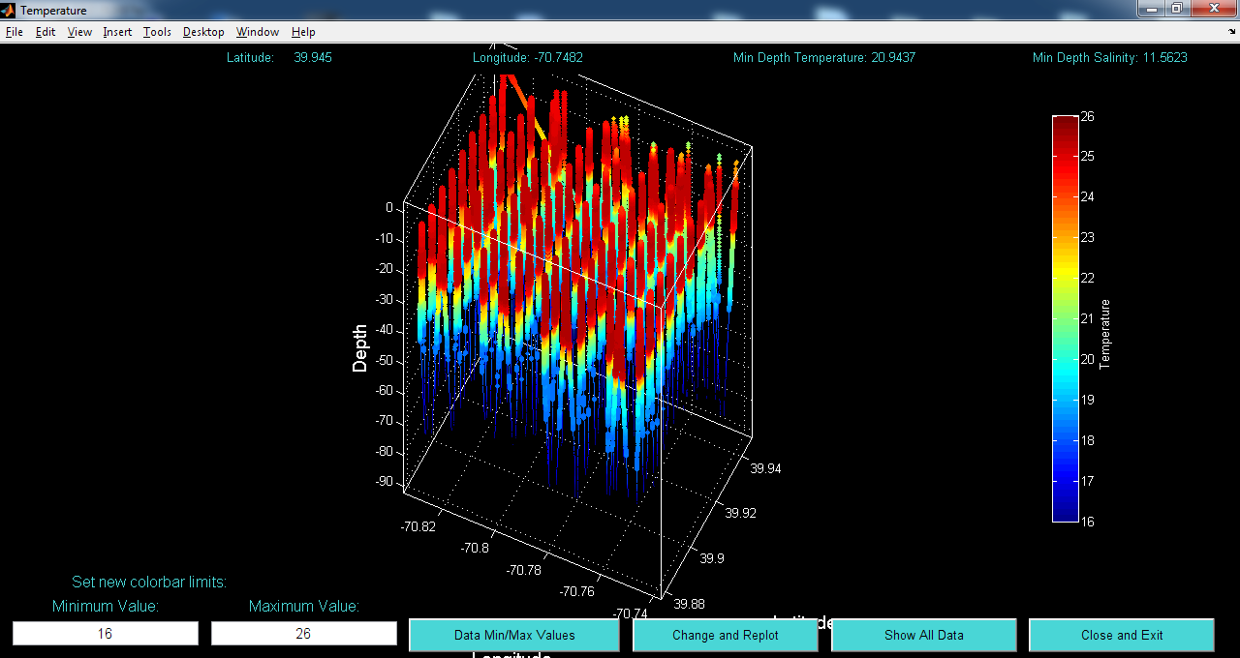 | 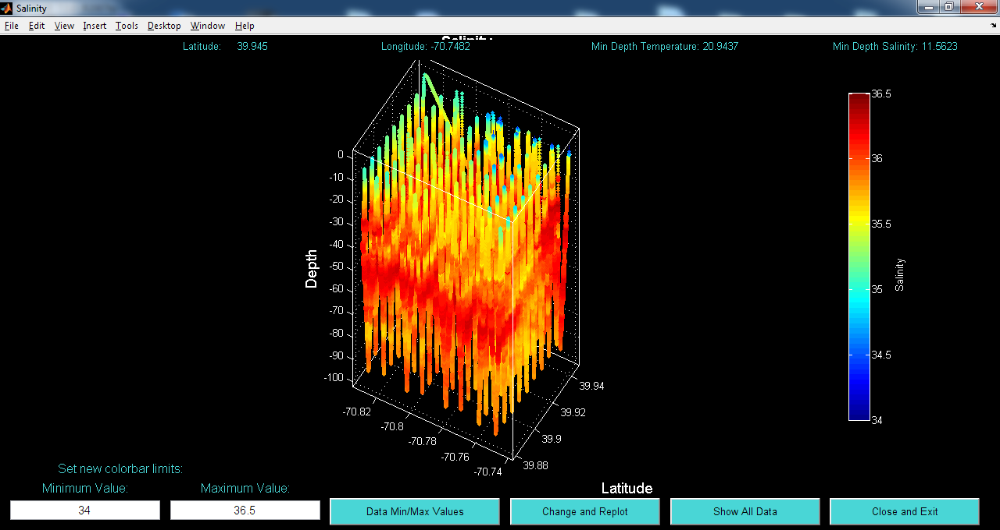
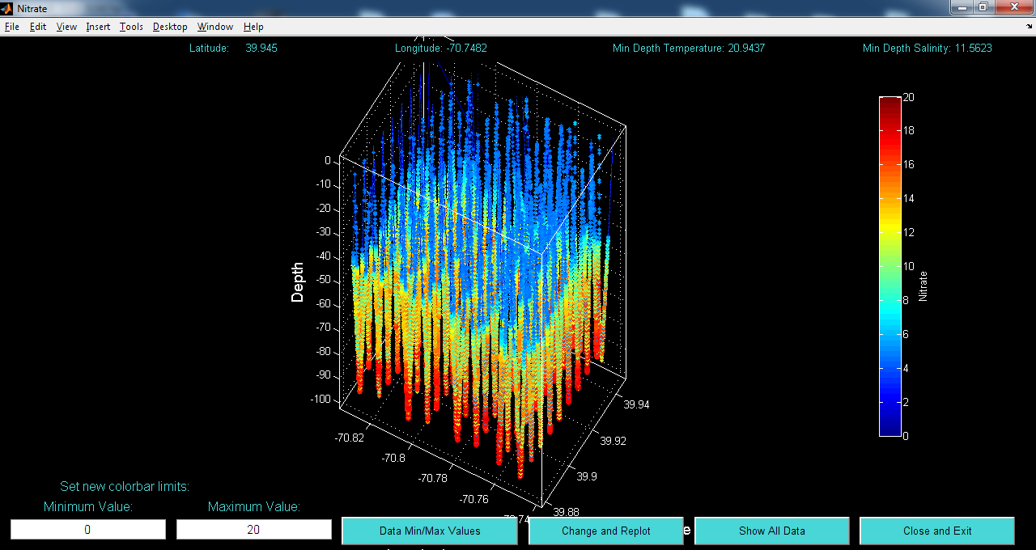 | 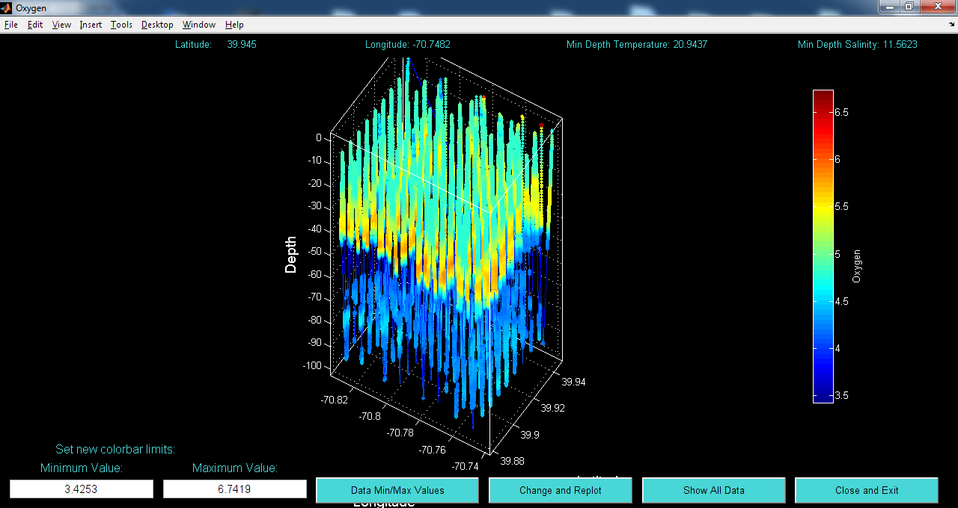
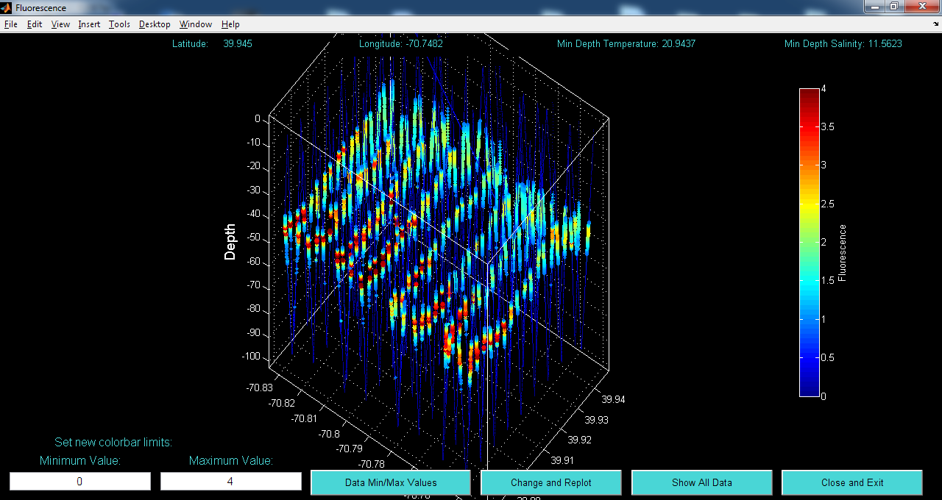 | 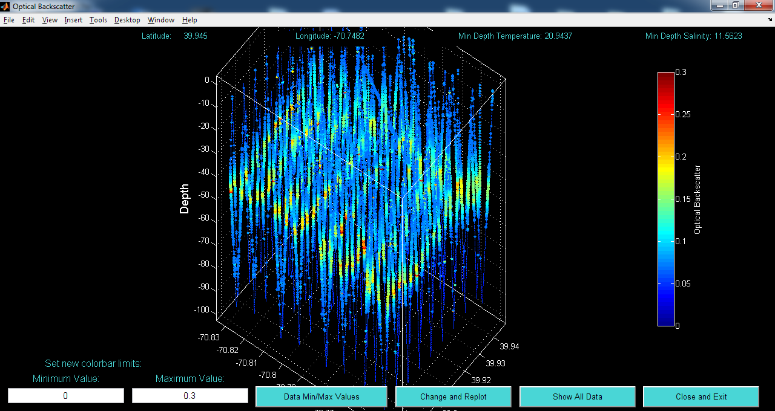
Figure 0713.2. REMUS hotspot survey: (a) temperature, (b) salinity, (c) nitrate, (d) oxygen, (e) fluorescence, and (f) backscatter.

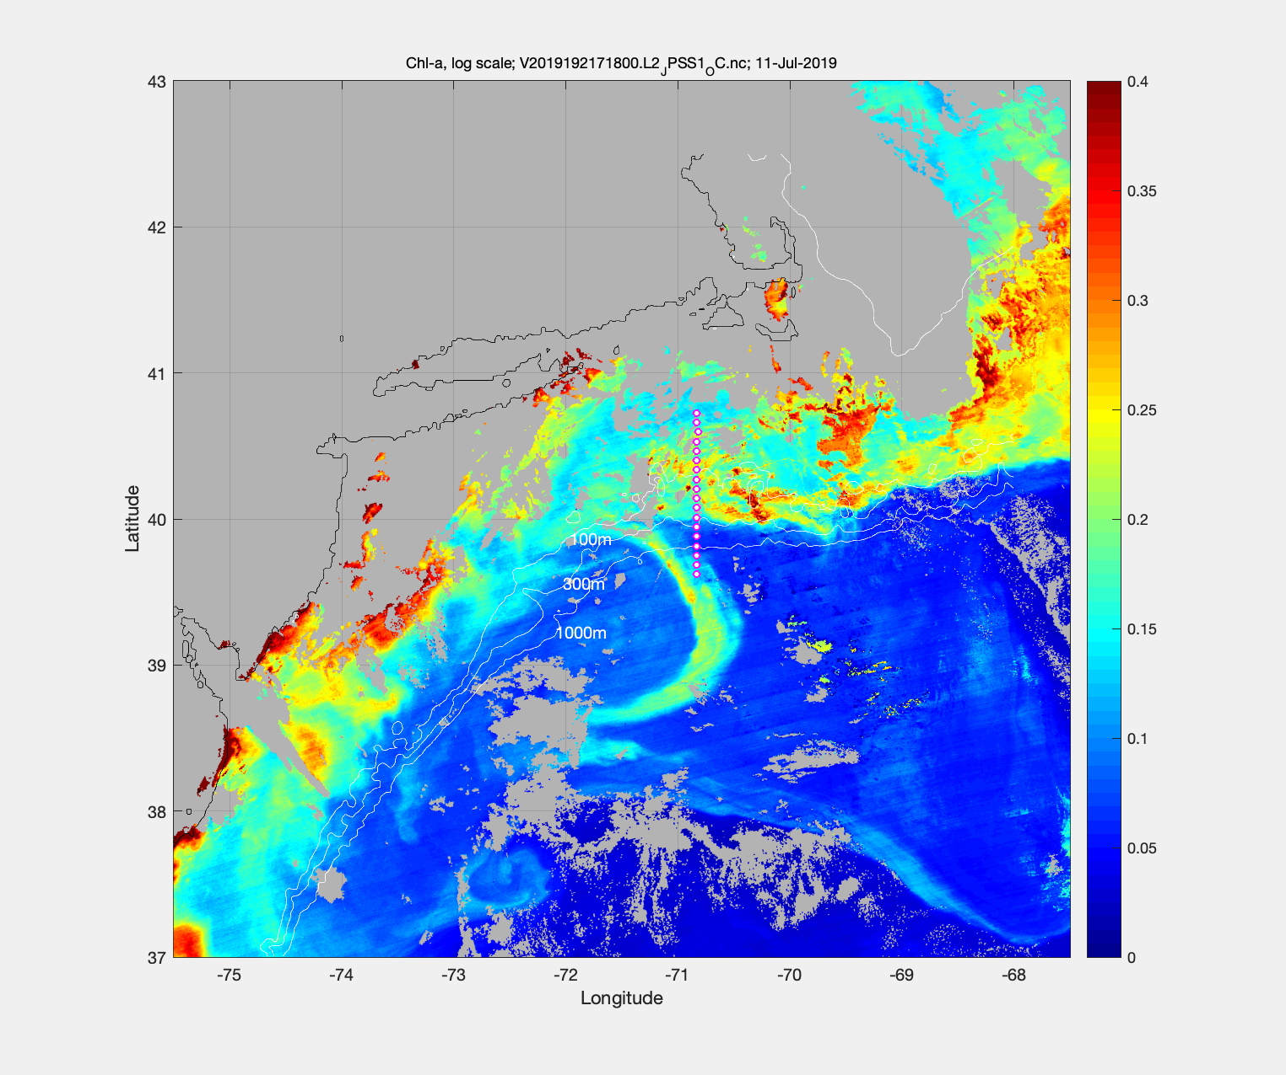
Figure 0712.3. VIIRS chlorophyll on July 11.

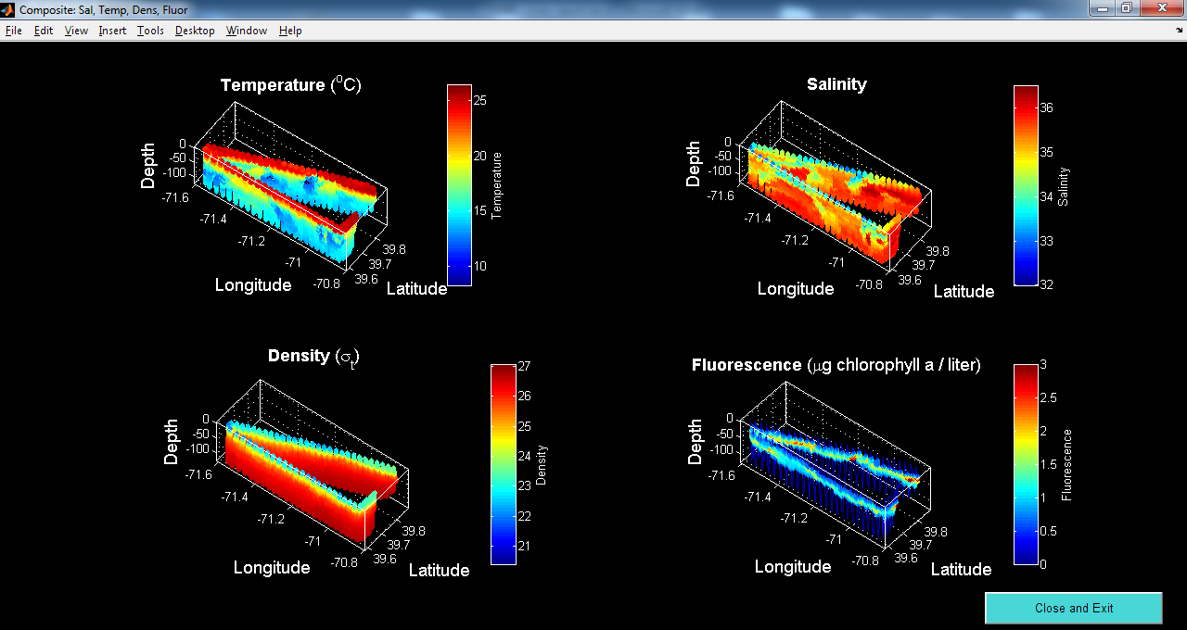
Figure 0713.4. VPR6 July 13, starting from A14 and surveying southwestward then eastward back to A18, turning north to A17.

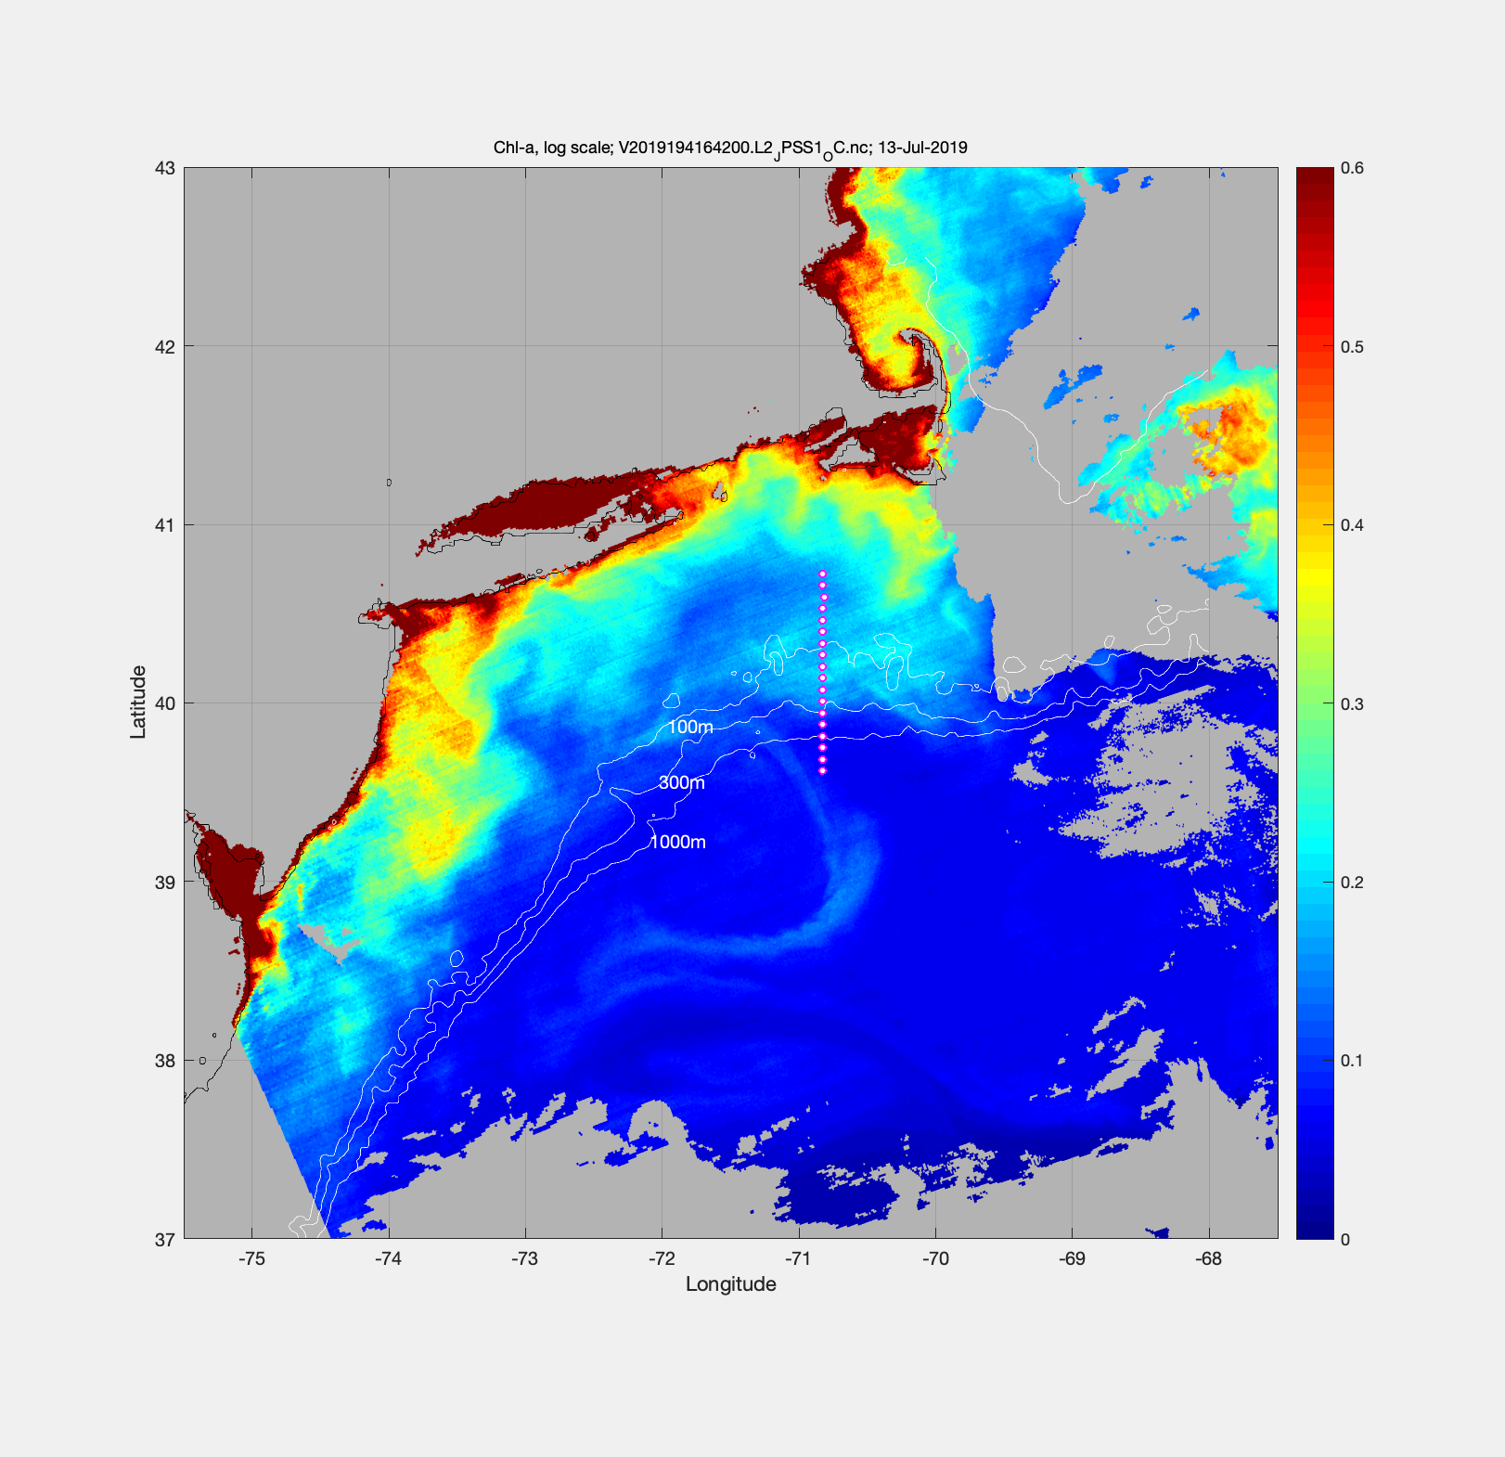
Figure 0713.5. VIIRS chlorophyll on July 13.

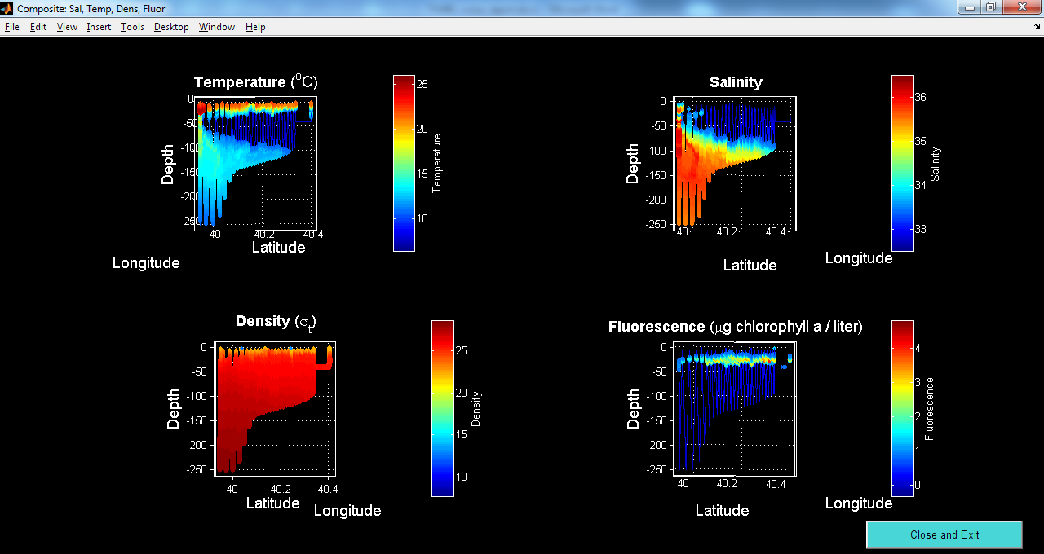
Figure 0714.1. REMUS bottom boundary layer survey.

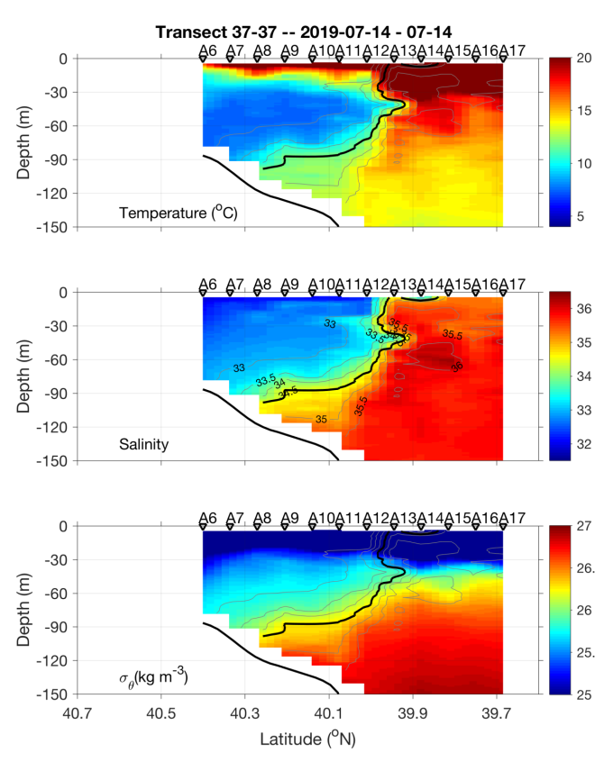 | 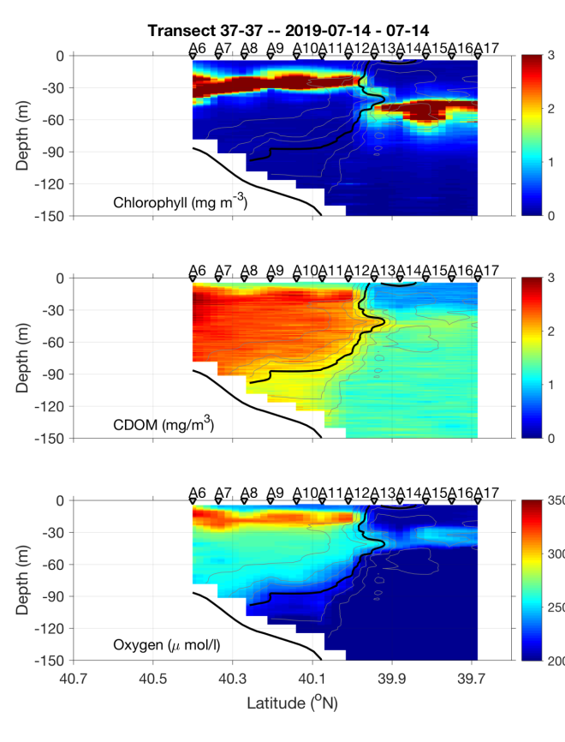
Figure 0714.2. July 14 CTD transect.

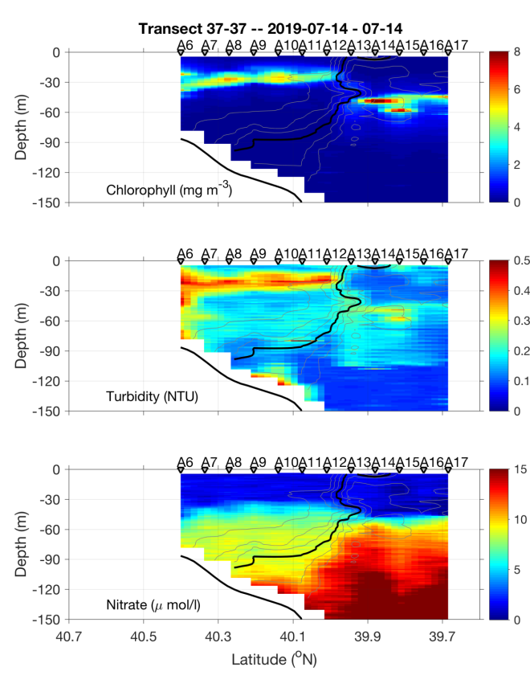 | 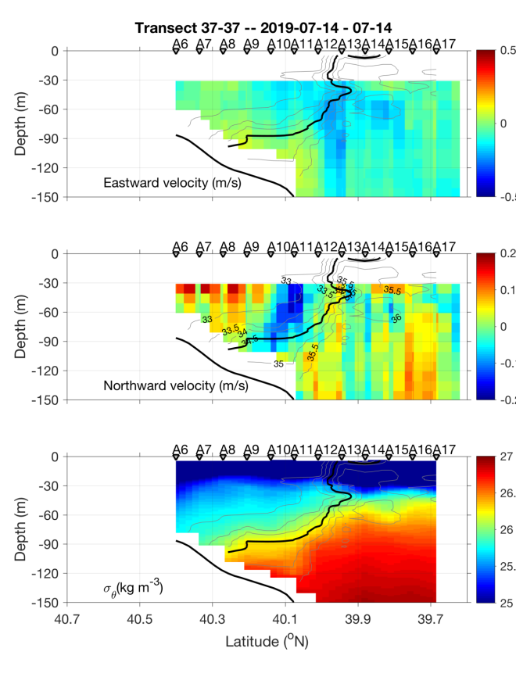
Figure 0714.3. July 14 CTD transect.

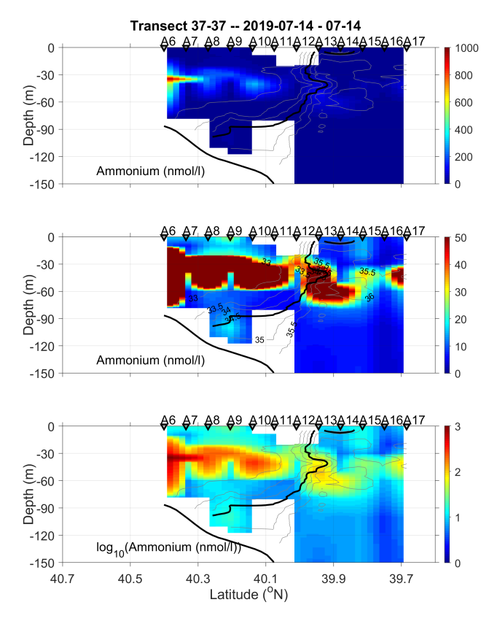
Figure 0714.4. July 14 CTD transect.

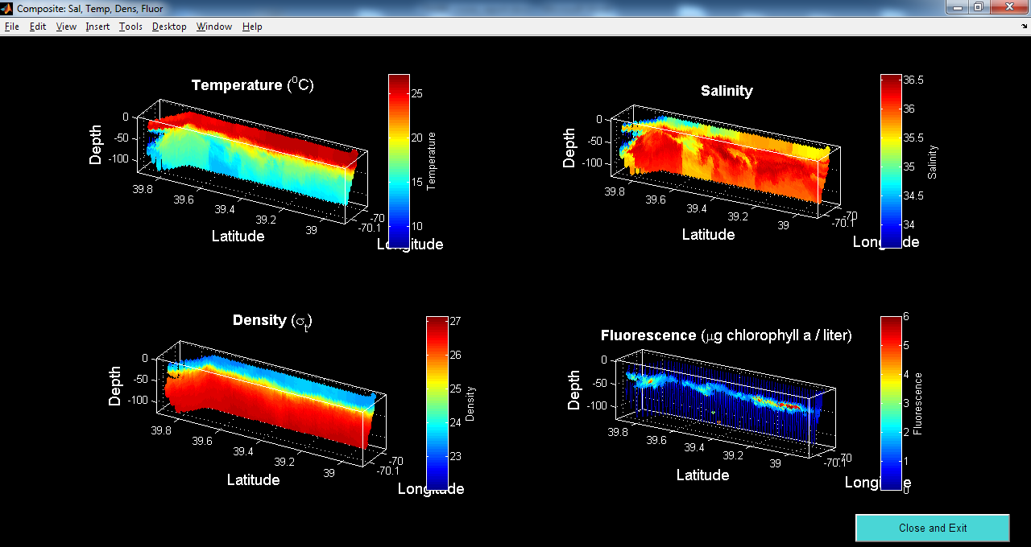
Figure 0715.1. VPR7 survey on July 14-15.

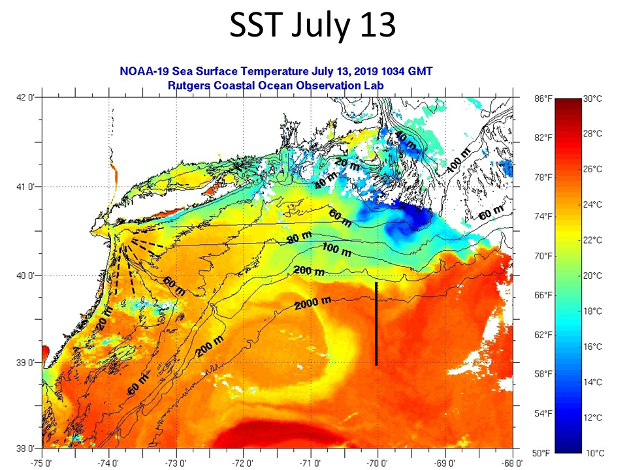
Figure 0715.2. SST on July 13. Approximate location of VPR7 survey shown as a solid line.

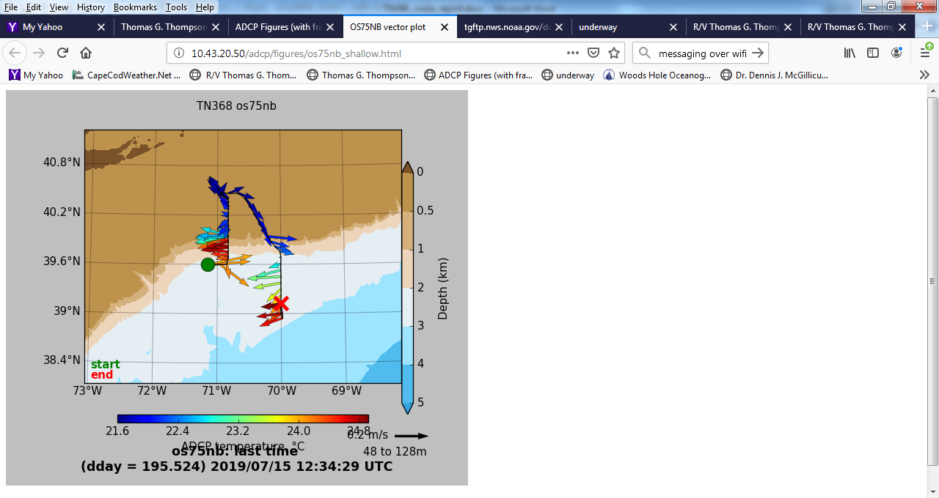
Figure 0715.3. Shipboard ADCP currents on July 15.

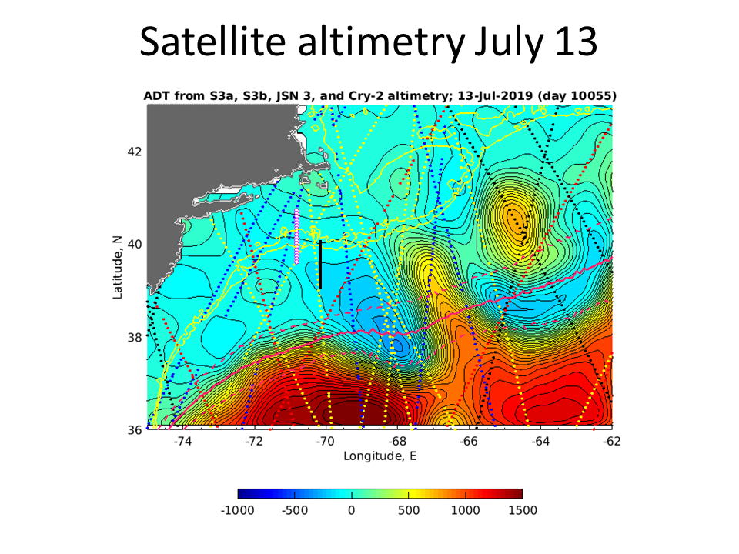
Figure 0715.4. Absolute dynamic topography on July 13. Approximate location of VPR7 survey shown as a solid line.

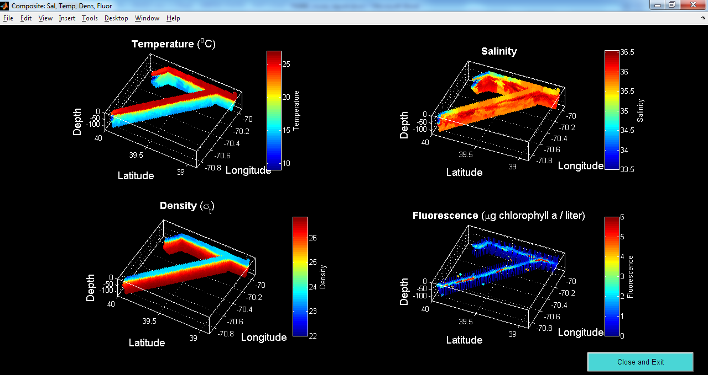
Figure 0715.5. Combined VPR7/8 survey on July 14-15.

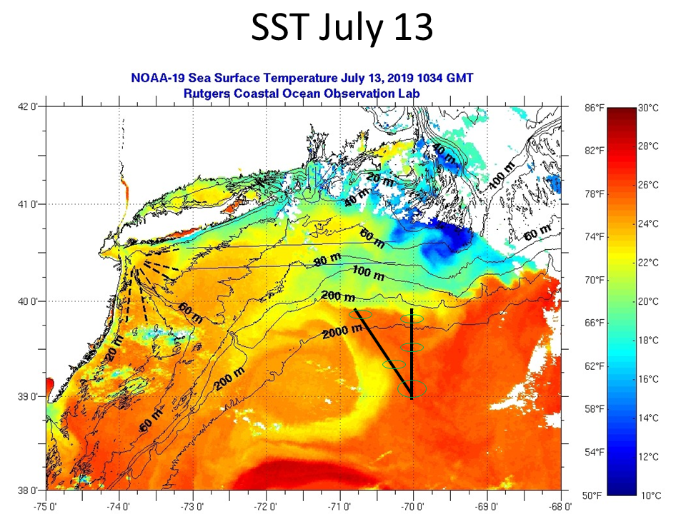
Figure 0715.6. SST on July 13. Approximate location of VPR7/8 surveys shown as a solid line. Green ovals indicate the locations of the five hotspots observed in the fluorescence signal (Figure 0716.5) and VPR imagery.

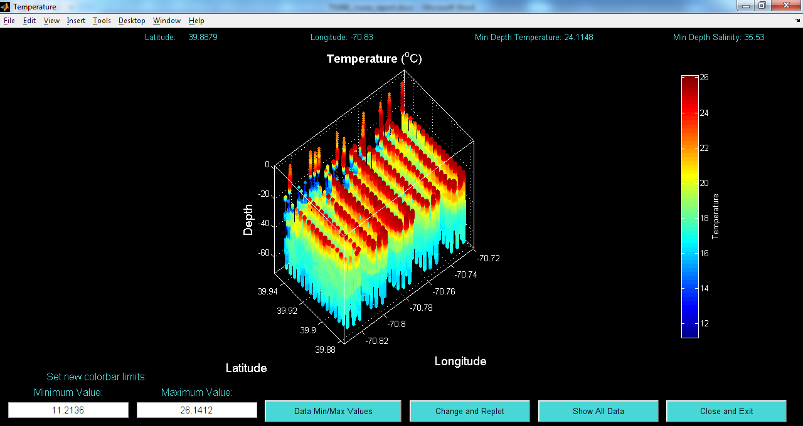 | 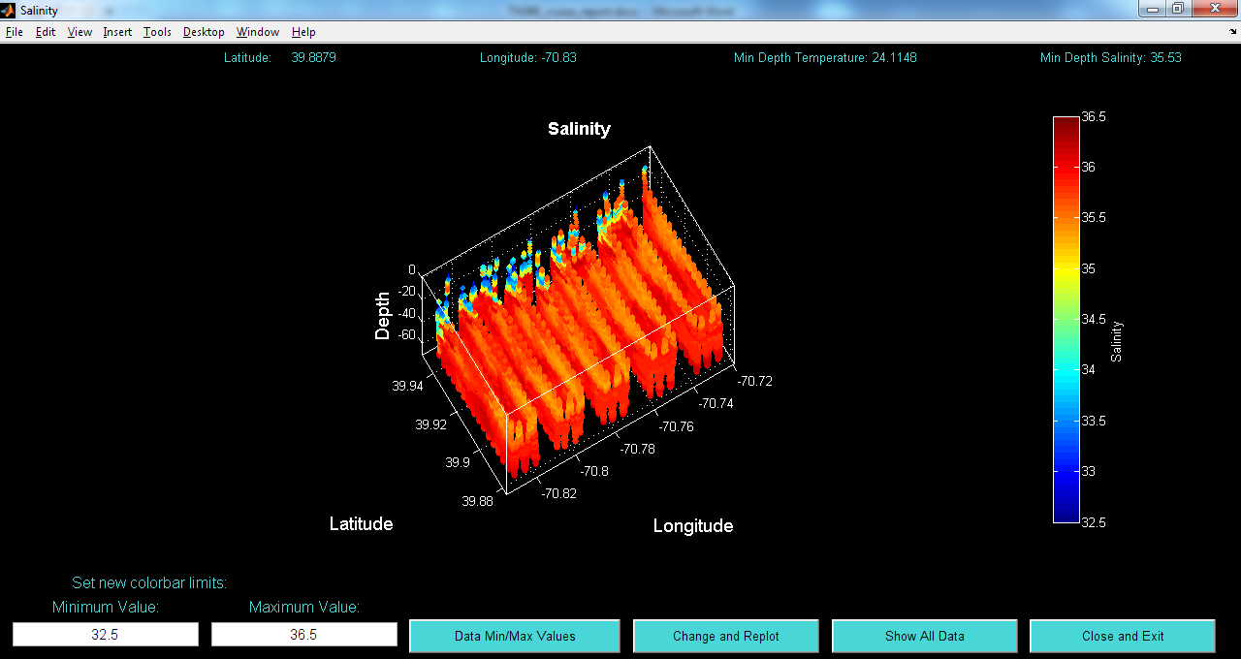
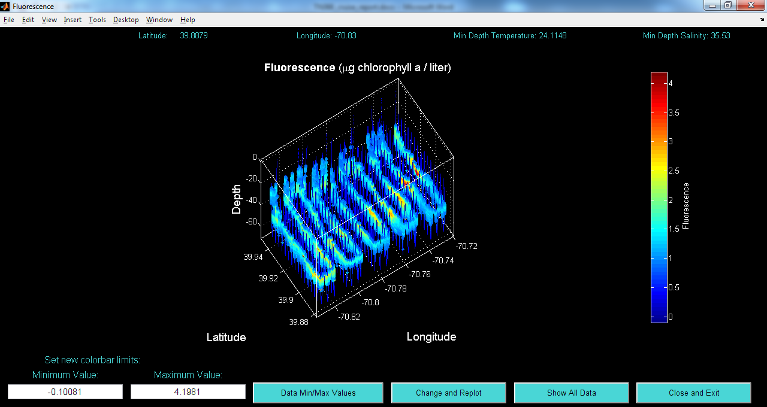 | 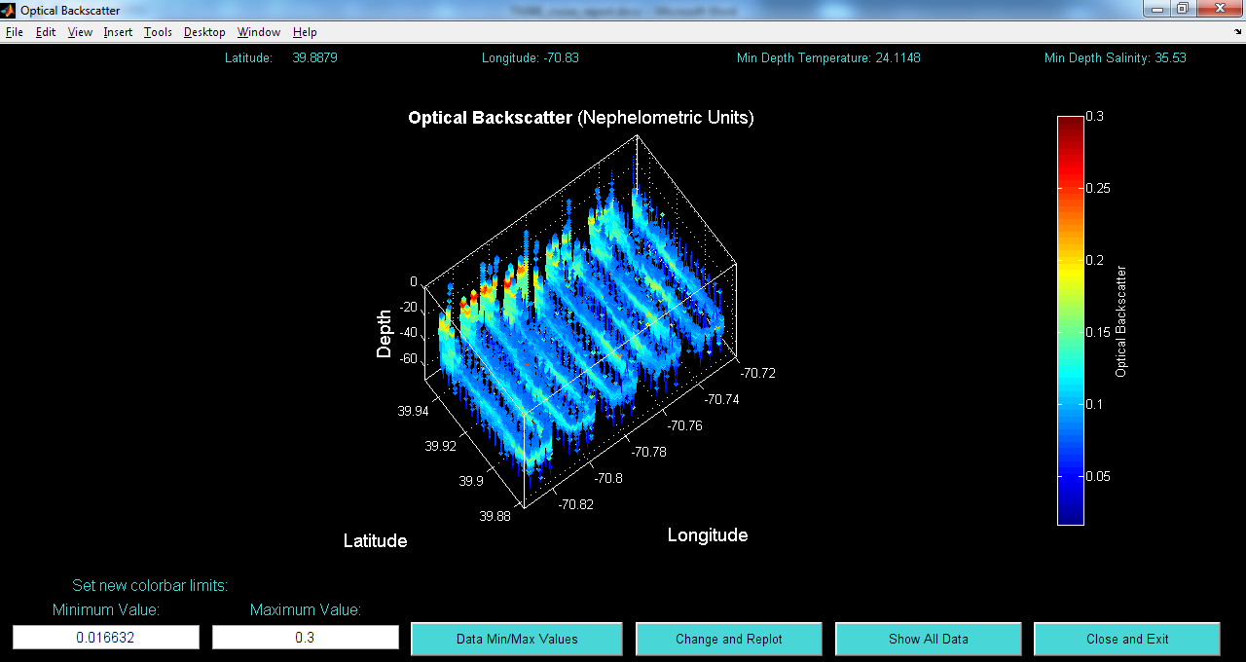
Figure 0716.1. REMUS hotspot survey: (a) temperature, (b) salinity, (c) fluorescence, and (d) backscatter.

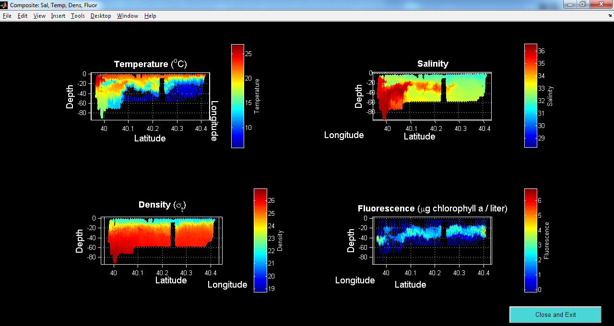
Figure 0716.2. VPR9 July 16.

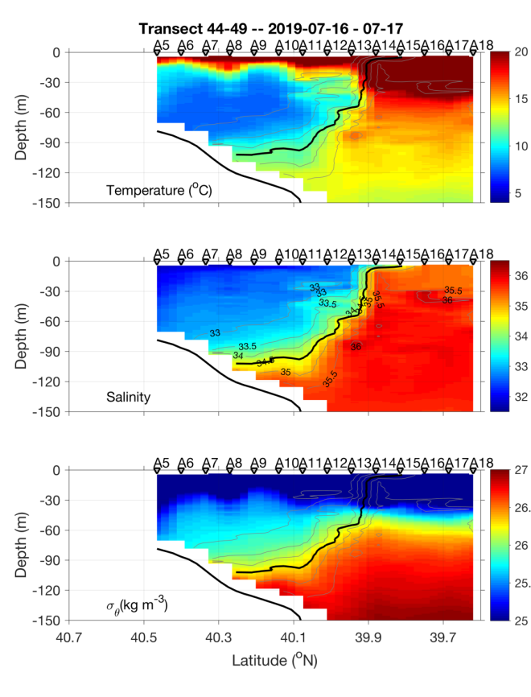 | 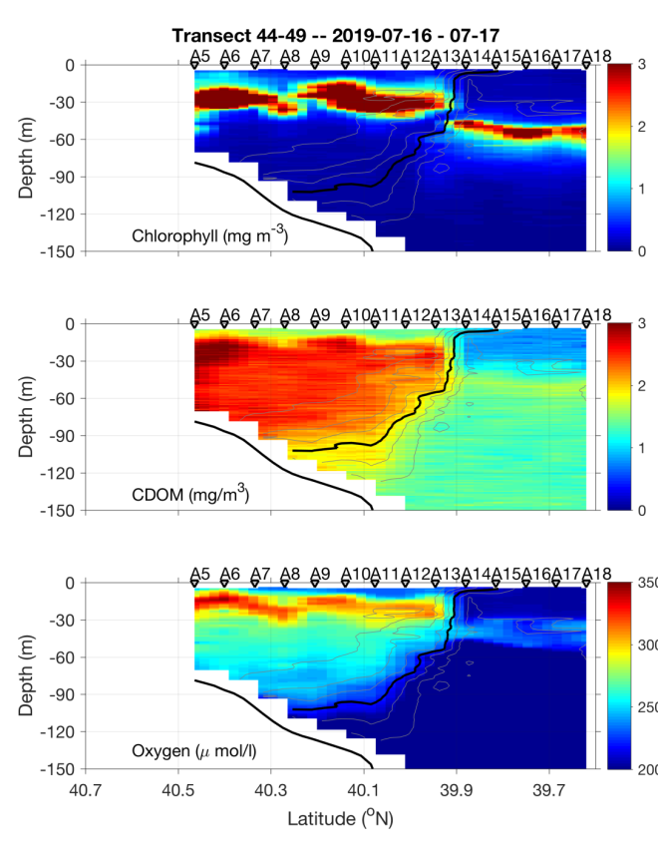
Figure 0717.1. July 16-17 CTD transect.

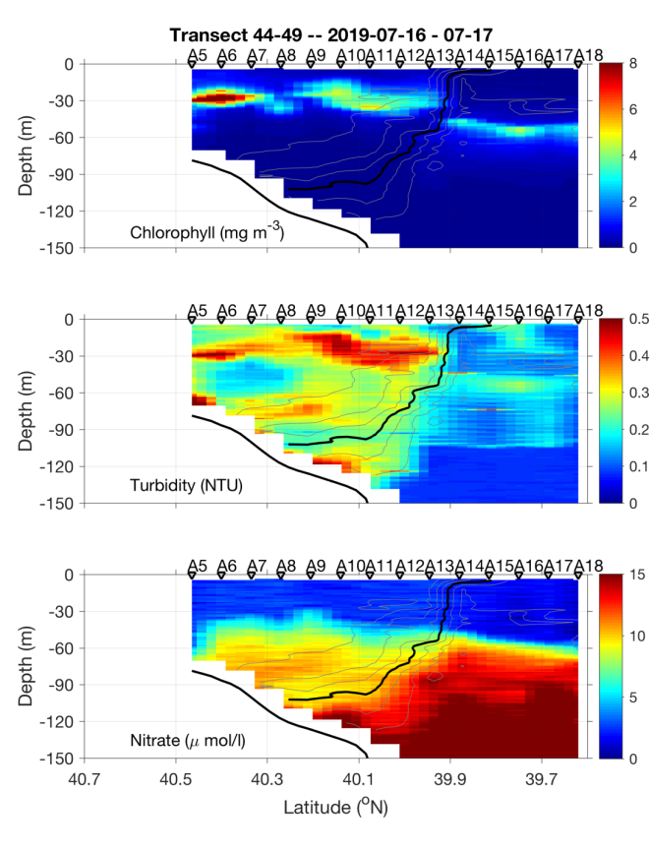 | 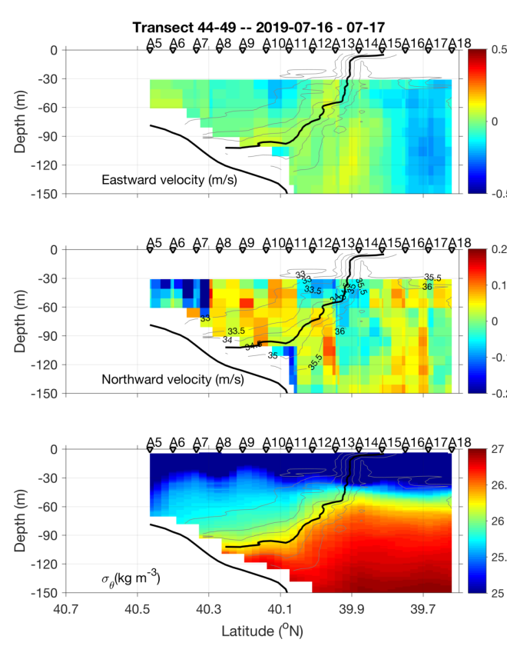
Figure 0717.2. July 16-17 CTD transect.

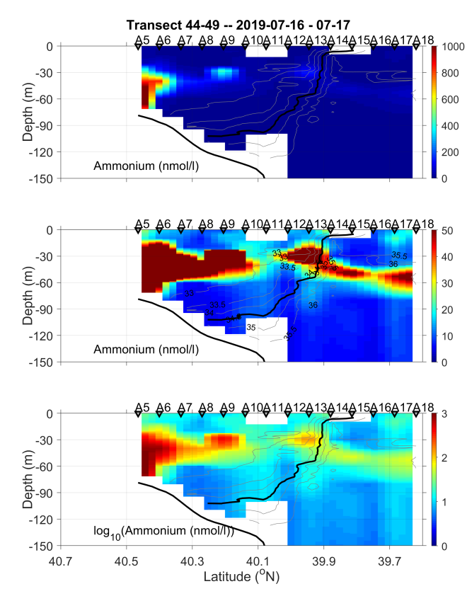
Figure 0717.3. July 16-17 CTD transect.

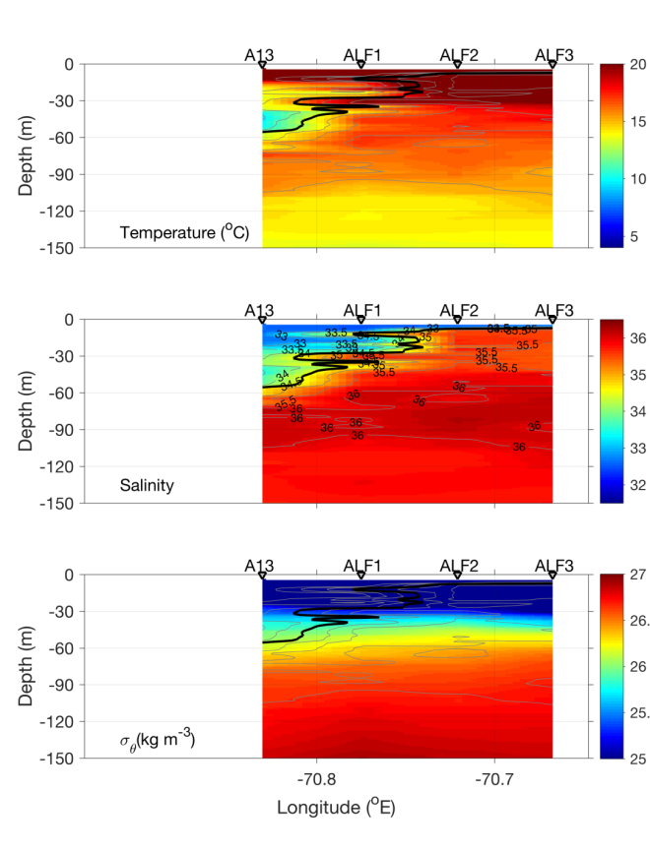 | 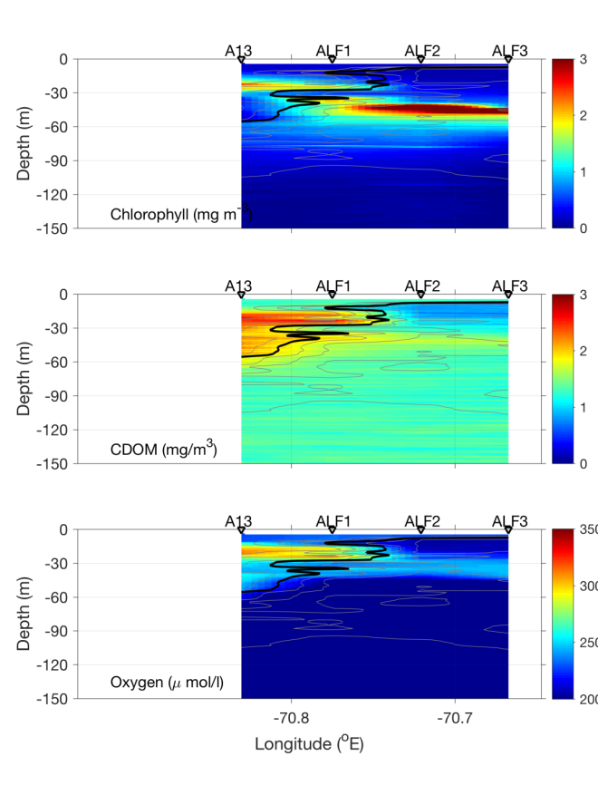
Figure 0717.4. July 16 along-shelf CTD transect.

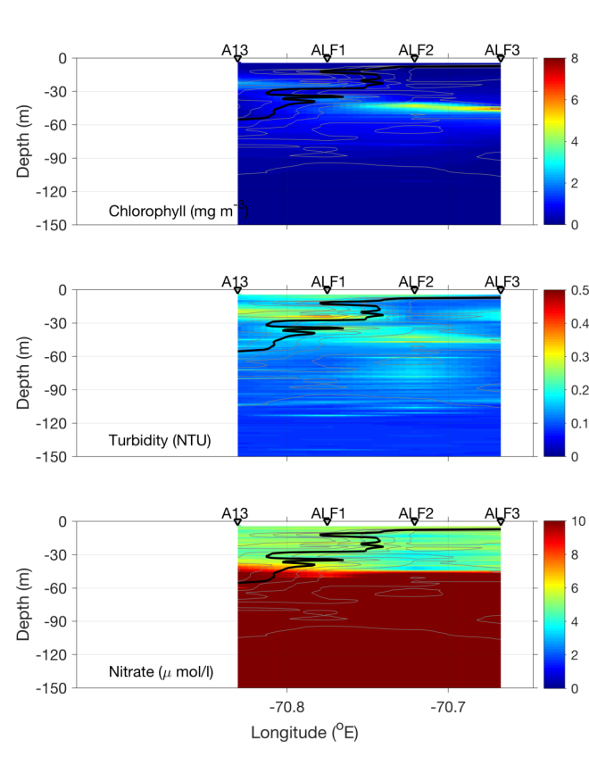 | 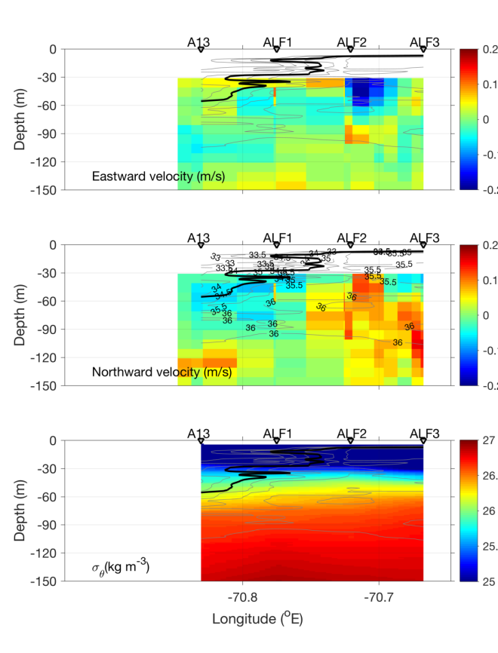
Figure 0717.5. July 16 along-shelf CTD transect.

Ammonium plot
Figure 0717.6. July 16 along-shelf CTD transect.

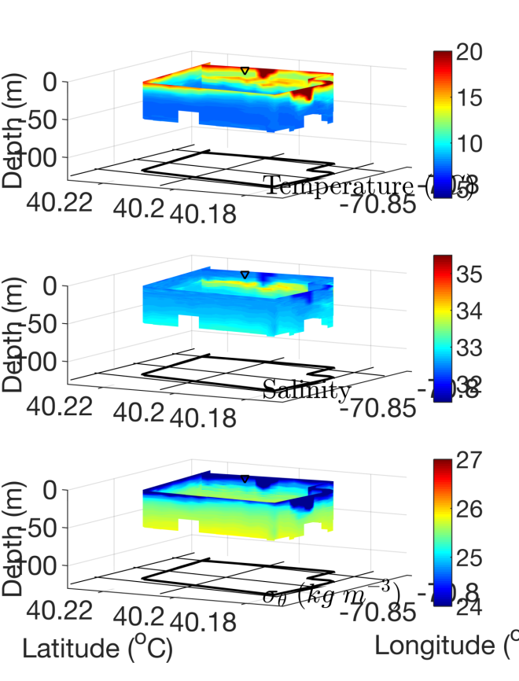 | 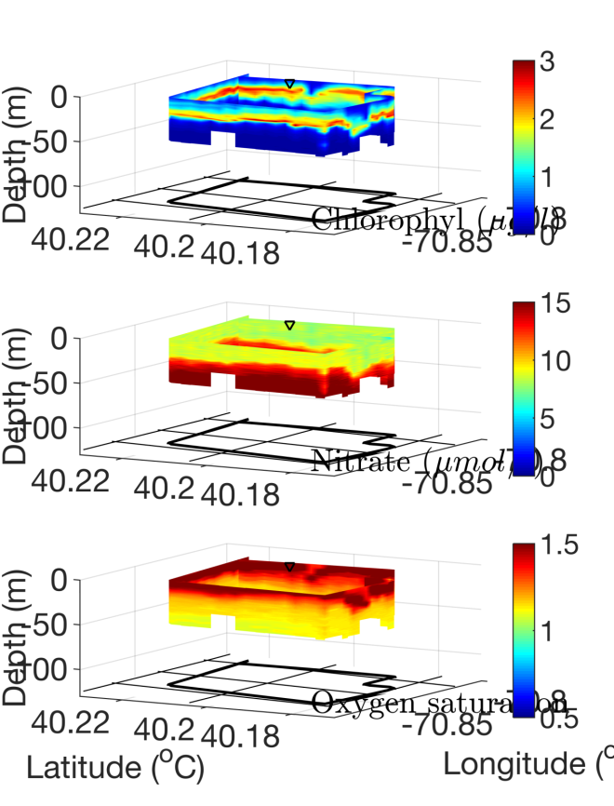
Figure 0717.7. REMUS billow mission box 1.

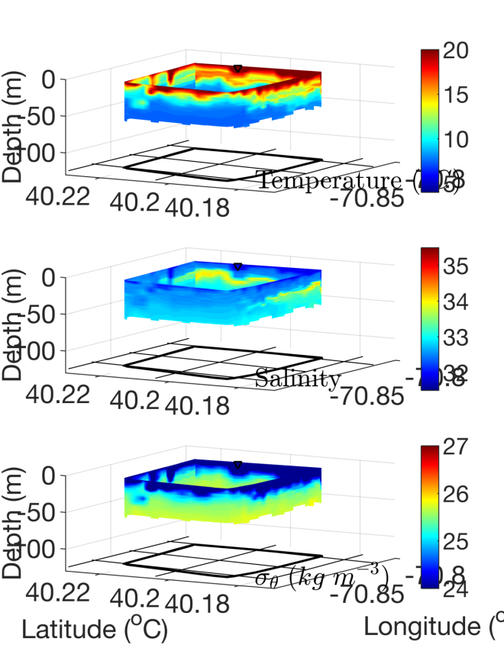 | 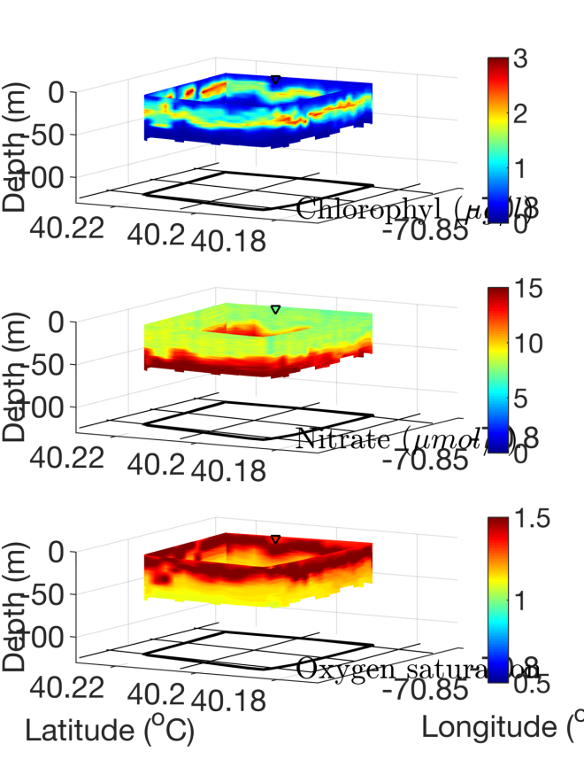
Figure 0717.8. REMUS billow mission box 2.

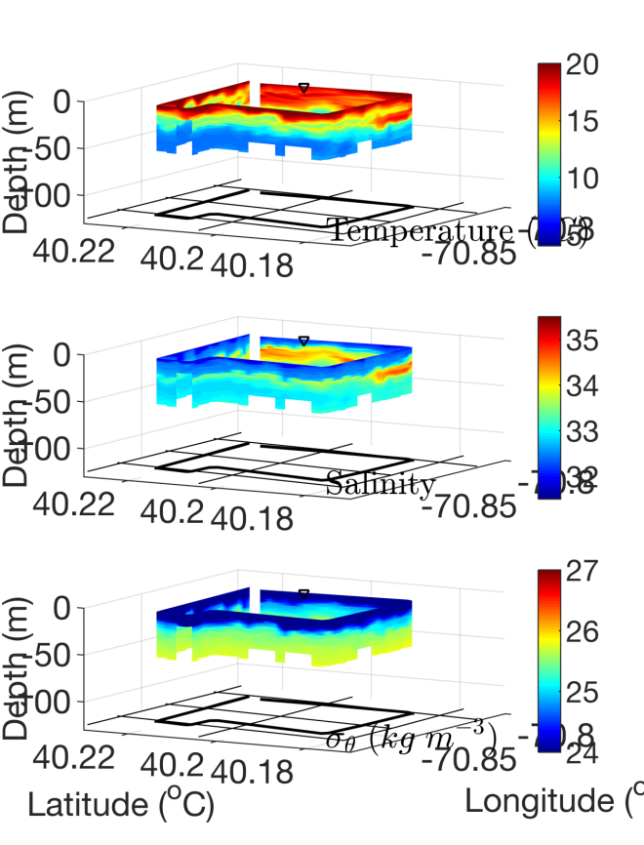 | 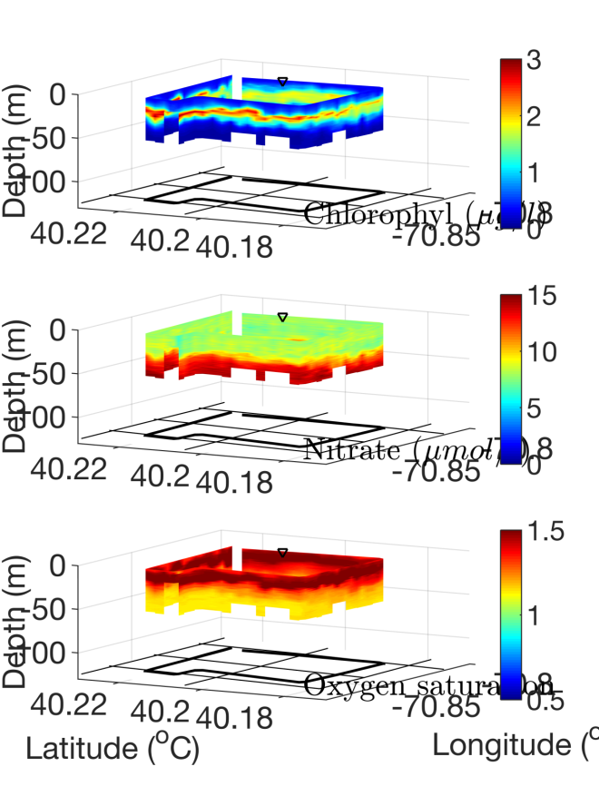
Figure 0717.9. REMUS billow mission box 3.

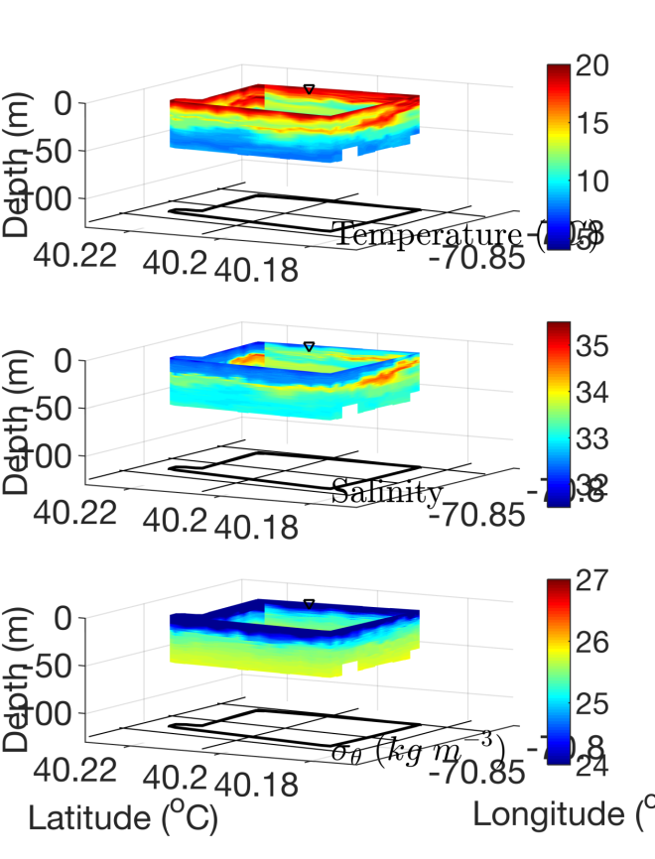 | 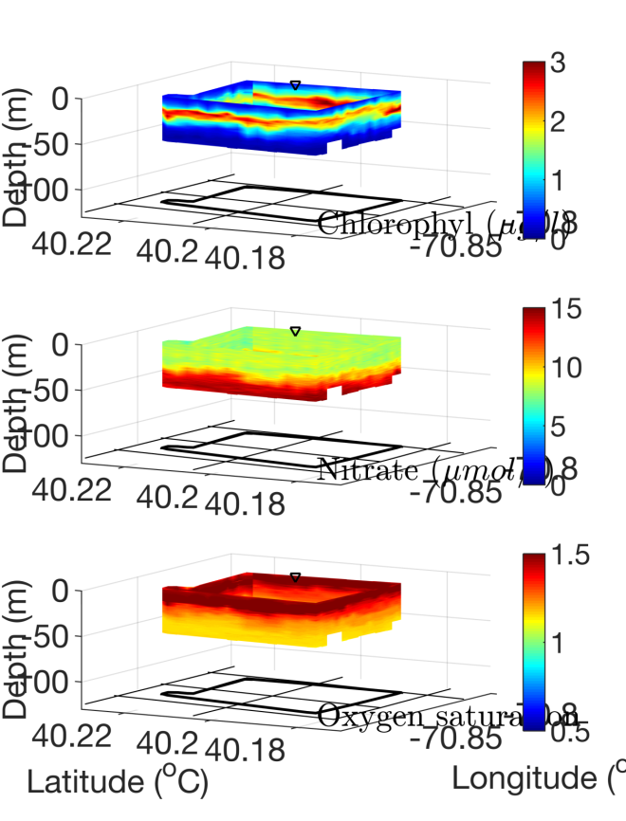
Figure 0717.10. REMUS billow mission box 4.

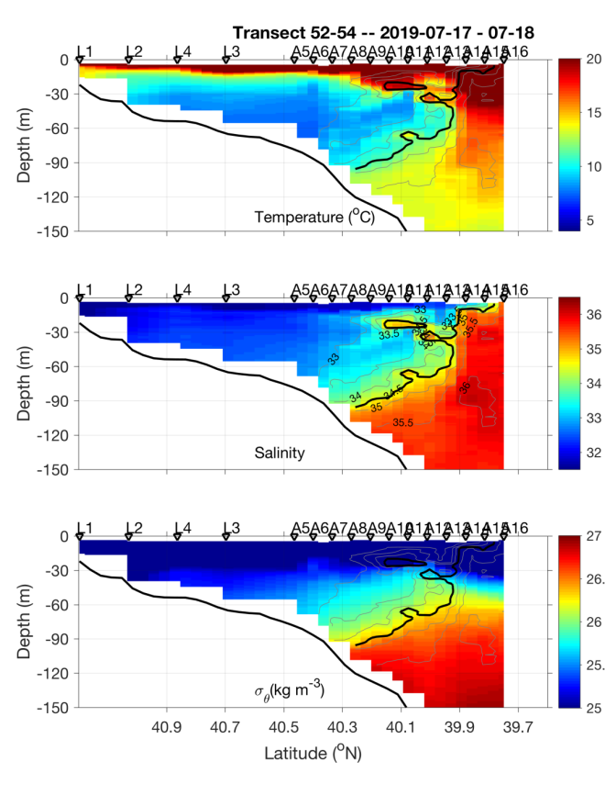 | 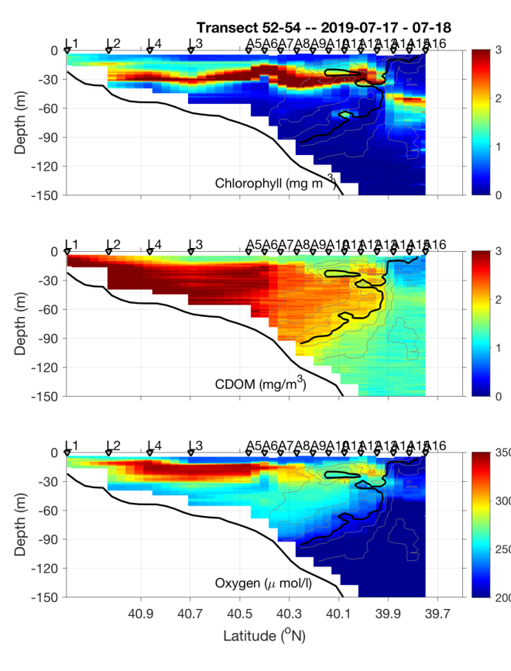
Figure 0718.1. July 17-18 CTD transect.

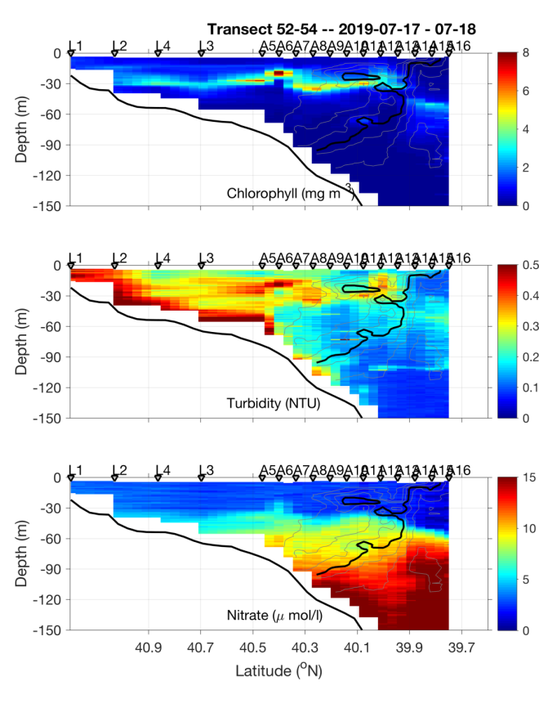 | 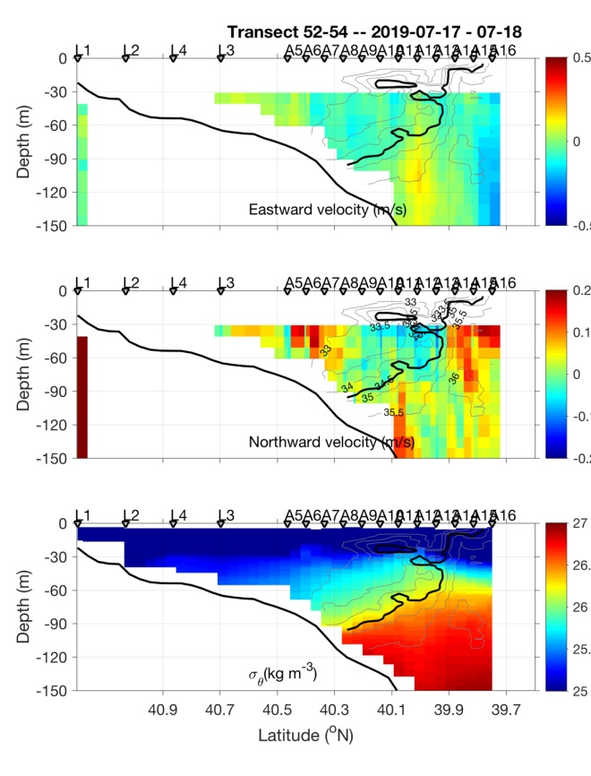
Figure 0718.2. July 17-18 CTD transect.

Ammonium plot
Figure 0718.3. July 17-18 CTD transect.

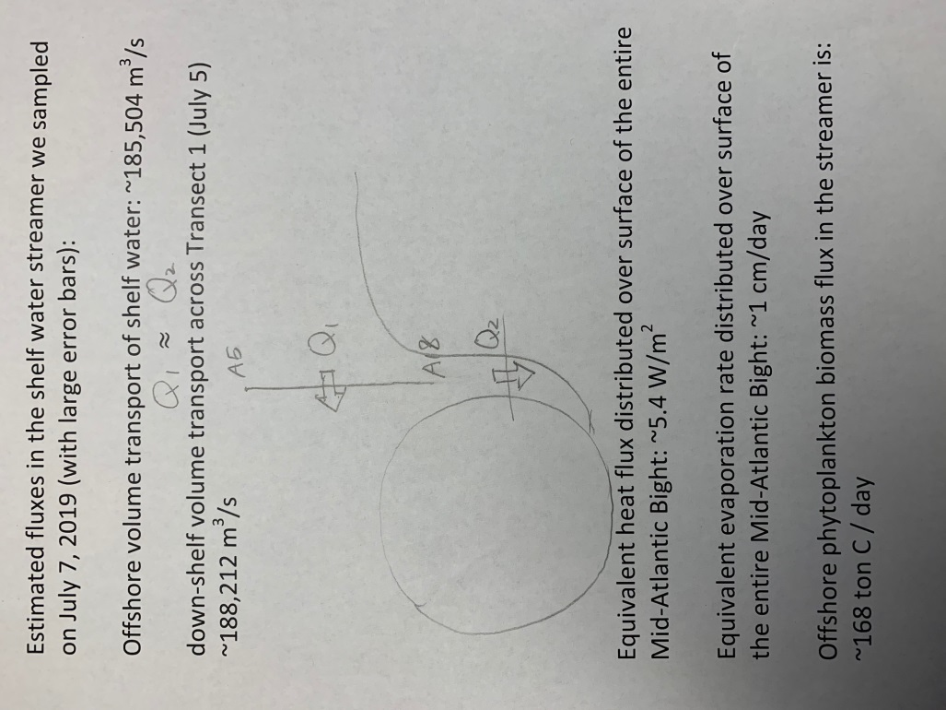
Figure 0718.4. Cross shore fluxes associated with the WCR streamer. Figure from Gordon Zhang.

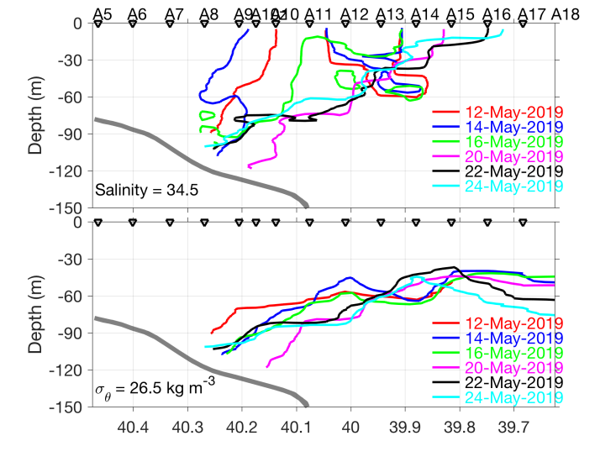
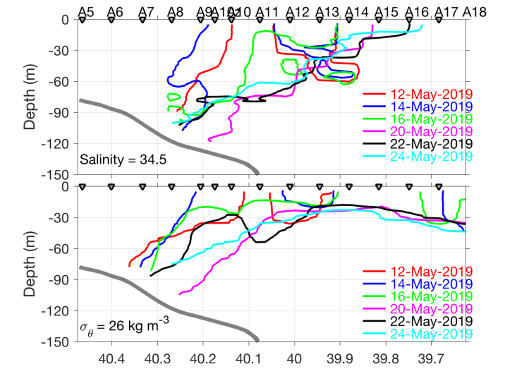
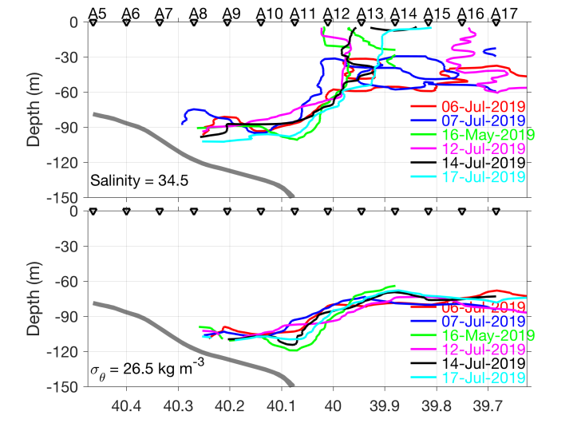
Figure 0718.5: Frontal positions for AR29 (top), RB1904 (middle), and TN368 (bottom).

