Charles Stock
August 28, 2006

A Comparison of Models Used in the ECOHAB Gulf of Maine Project

This document compares the versions of the A. fundyense biological model (germination and growth) used during the ECOHAB-Gulf of Maine program. Familiarity with the basic elements of the model is assumed, and those not familiar with these are directed to the detailed descriptions at:

http://www.whoi.edu/science/cohh/alexbiomodels.htm

Descriptions can also be found within the published literature referenced herein. Each model version represents a different stage of model development. New data was incorporated as it became available, and corrections and adjustments were made as necessary. The model versions are designated as model 1.0 through model 3.1. Model 3.1 is the latest, and this is recommended. Differences between the models are summarized in Table 1. While there are changes, the basic properties of the formulation have remained throughout its development. The pages that follow will discuss the evolution of each of the three basic components of the biological model: 1) the germination response to temperature and light, 2) the endogenous clock, and 3) the growth function.

The Germination Rate as a Function of Temperature and Light

The only change in the germination response to temperature and light came between model versions 2.0 and 3.0. A second set of germination time series experiments carried out during the ECOHAB-Gulf of Maine program replaced data collected in 1985 (Keafer, unpublished). Refinements to experimental techniques suggested that the more recent data replace the older data, rather than being combined with it (Keafer, Anderson, personal communication). There were also small adjustments to the fitting procedure, and the functional form of the temperature dependence was changed from a piece-wise linear representation to a hyperbolic tangent. However, these changes did not alter the
Table 1: Summary of models used during the ECOHAB Gulf of Maine program
Version | Germination Rates | Endogenous Clock | Growth Rate¹ | References
1.0 | Western Gulf of Maine isolate (Anderson et al. 2005).  Unpublished data from Keafer (1985) | Station 38 data (first 14 points) collected by Bronzino, Anderson lab. | Temp: Watras  Salt: Prakash | Franks and Signell (1997)
2.0 | As above | As above | Temp: Watras, Langdon, Keafer  Salt: Prakash, Watras  Light: Langdon | McGillicuddy et al. (2003a,b)  McGillicuddy et al. (2005)  McGillicuddy et al. (In Press)
3.0 | Replaced data from Keafer (1985) with data from eastern Gulf of Maine isolates from ECOHAB-GOM (Anderson et al. 2005) | Added completed Station 38 series, data from Matrai et al. (2005), and earlier data from Anderson and Keafer (1987) | Temp: Watras, Langdon, Keafer, Kulis, Etheridge (MI and BOF strains).  Salt: Prakash, Etheridge (MI and BOF strains)  Light: Cullen | Anderson et al. (2005), (germ. only),  Stock et al. (2005); Stock et al. (Under Review)
3.1 | As above | As above | As above, but with minor correction to temperature and salinity dependence
¹Prakash: Prakash (1967), Watras: Watras et al. (1982), Langdon: Langdon (1987; 1988), Keafer: unpublished (contact bkeafer@whoi.edu), Kulis: unpublished (contact: bkeafer@whoi.edu), Etheridge: Etheridge and Roesler (2005), Cullen: Cullen et al. (in preparation).

basic germination response (Fig. 1). The largest change is in warm (~15^{O}C) and dark conditions (4.24 %/day for the new function versus 1.79 %/day for the old). Such conditions are rare in the Gulf of Maine but may be important in other regions.

The Endogenous Clock

Additional data was added to constrain the endogenous clock function between model 2.0 and model 3.0. These included the data of Matrai et al. (2005), the completed data set from station 38, and older data from Anderson and Keafer (1987). Patterns in this additional data suggested a shift from a piece-wise linear function with 4 segments (Fig. 2, left panel), to a piece-wise linear function constructed from the monthly medians of the data points. However, the essential properties of the endogenous clock were robust to these changes, particularly during the spring/early summer season of primary interest.

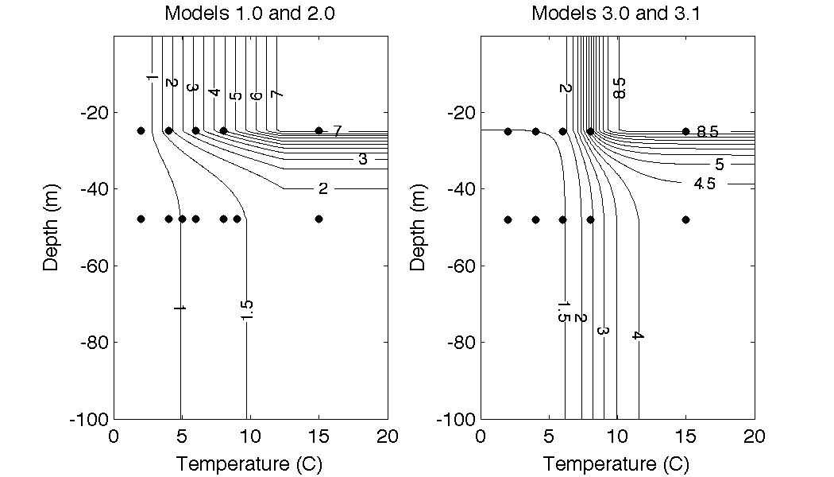
Figure 1: Comparison of the germination rate (%/day) estimated by the model at the sediment surface for the two germination rate parameterizations used during the ECOHAB-Gulf of Maine project. Light conditions have been translated to an equivalent depth using a typical solar radiation (~350 watts/m²) and light attenuation (~0.2 m⁻¹) values for the Gulf of Maine. The contour interval for both plots is 0.5 %/day. Note: the germination rate figure for Model 2.0 in McGillicuddy et al. (2003) and McGillicuddy et al. (In Press) contained an erroneous contour a 2 %/day stretching into dark conditions. The correct figure is shown in the left panel.

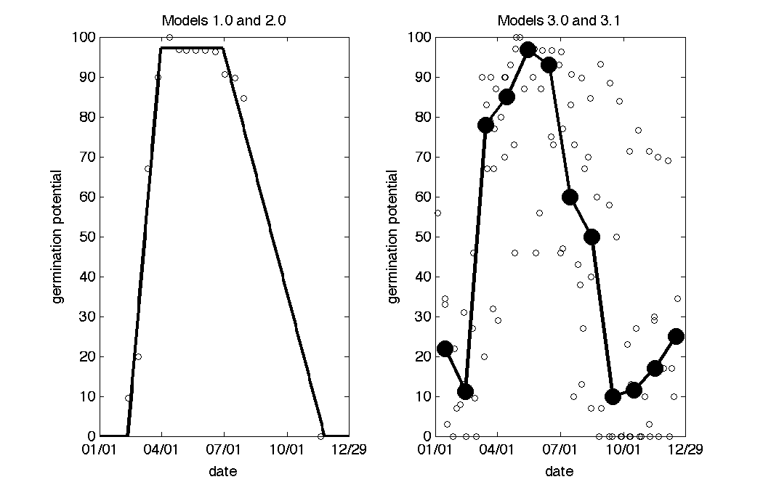

Figure 2: Comparison of the two endogenous clock functions used in the ECOHAB-Gulf of Maine project. The germination potential is the percentage of cysts that are able to germinate. In the germination model, the values above are normalized by the maximum value attained by each fitted curve to produce a factor between 0 and 1 that modifies the germination rates in Fig. 1.

The Growth Function

The growth function has gone through the most changes since the initial model formulation. Model 1.0 was from Franks and Signell (1997). It was based on data from Watras et al. (1982) and Prakash (1967), but details of the function construction were not available. Additional constraints were added to the temperature, salinity, and light dependences in Model 2.0. Model 3.0 added data collected during the ECOHAB-Gulf of Maine program, and model 3.1 implemented some minor corrections to the 3.0 formulations.
The maximum growth rates (as a function of temperature and salinity) for all of the growth functions are shown in Fig. 3. All functions show an optimal growth rate at temperatures between 15-20 Celsius and at fairly low salinities (15-25 ppt). The overall maximum growth rate for the first function is less than the others, but there is considerable uncertainty in this parameter (e.g. Stock et al. (2005), Table 2). Growth functions 3.0 and 3.1 exhibit negative growth at very high temperatures as suggested by the Etheridge and Roesler (2005) data. Model structure 3.1 has a somewhat lower growth rate at very high salinities (> 35 ppt) than model structure 3.0. This is because the 40 ppt growth point from Prakash was assigned a value that was too high during the construction of Model 3.0 (these points were picked manually from the plots of Prakash). The influence of this change is very small for salinities of 35 ppt and below.
The functional form used by Platt and Jassby (1976) for photosynthesis-irradiance relationships and later adopted by Langdon (1987, 1988) for growth was used for models 2.0-3.1:

$$μ(E,T,S)=\left(μ_{\text{max}}(T,S)+μ_{o}^{r}\right)\text{tanh}\left(\frac{α_{g}E}{(μ_{\text{max}}(T,S)+μ_{o}^{r})}\right)−μ_{o}^{r}$$

Parameter definitions and values for each of the models 2.0-3.1 are summarized in Table 2. The primary changes in the model are refinements in the maintenance growth rate and growth efficiency parameters based on the data of Cullen, and a slight upward shift in the estimates of maximum growth. The uncertainty ranges are approximate, and the smallness of the bounds in model 2.0 partly reflects the relative scarcity of data upon which to make estimates.
The uncertainty range for α_{g} was chosen liberally in published versions of model 3.0 (Stock et al. 2005). This was done to include past estimates of the growth efficiency and encompass an entire plausible range. The revised estimate for model 3.1 in Table 2 is simply the standard deviation around the Cullen estimates.
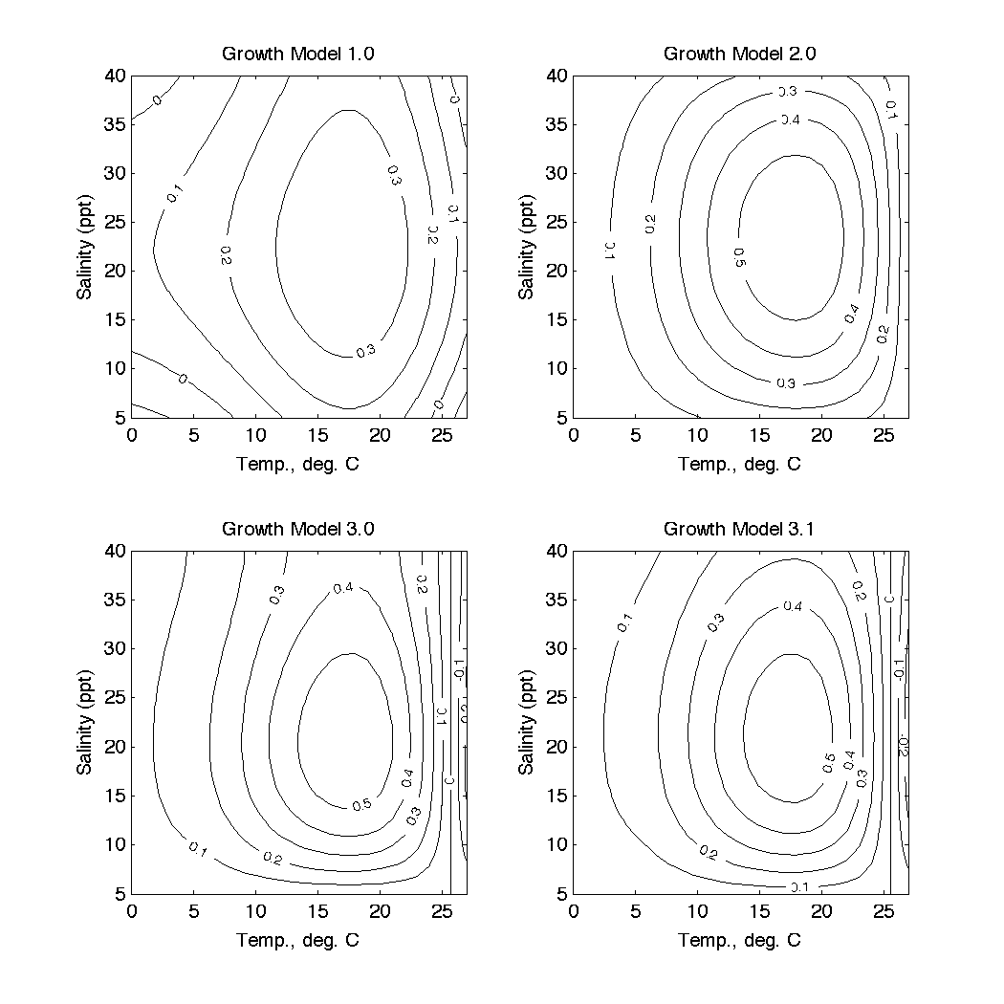
Figure 3: Comparison of the maximum growth rate as a function of temperature and salinity for each model formulation. Plots for model 2.0 and 3.1 are constructed using μ_{max}(T_{opt},S_{opt}) = 0.58 day⁻¹.

Table 1: Growth function Parameters. Central value followed by standard deviation.

Symbol | Description | Model 2.0 | Model 3.0 | Model 3.1
μ_{max}(T_{opt},S_{opt}) | The maximum growth rate (day⁻¹) at optimal temperature and salinity. | 0.46  (0.35-0.65) | 0.58  (0.46-0.70) | 0.59  (0.48-0.69)
α_{g} | The growth efficiency (m² watts⁻¹ day⁻¹) | 0.017  (0.013-0.021) | 0.036  (0.017-0.056) | 0.036  (0.024-0.048)
$$μ_{o}^{r}$$ | The maintenance growth rate (day⁻¹) | 0.05  (0.005-0.1) | 0.20  (0.15-0.25) | 0.20  (0.15-0.25)

Anderson, D. M. and B. A. Keafer (1987). The endogenous annual clock in the toxic dinoflagellate Alexandrium tamarensis. Nature 325(6105): 616-617.
Anderson, D. M., C. A. Stock, B. A. Keafer, A. B. Nelson, B. Thompson, D. J. McGillicuddy, M. Keller, P. A. Matrai and J. Martin (2005). Alexandrium fundyense cyst dynamics in the Gulf of Maine. Deep-Sea Research Part II-Topical Studies in Oceanography 52(19-21): 2522-2542.
Cullen, J. J., Wood, Barnett, Normandeau and Ryan (in preparation). Behavioral and physiological variability among strains of the toxic dinoflagellate Alexandrium fundyense from the Gulf of Maine.
Etheridge, S. M. and C. S. Roesler (2005). Effects of temperature, irradiance, and salinity on photosynthesis, growth rates, total toxicity, and toxin composition for Alexandrium fundyense isolates from the Gulf of Maine and Bay of Fundy. Deep Sea Research Part II 52: 2491-2500.
Franks, P. J. S. and R. P. Signell (1997). Coupled physical and biological models for the study of harmful algal blooms. U.S. Geological Survey, open file report 97:498.
Langdon, C. (1987). On the causes of interspecific differences in the growth-irradiance relationships for phytoplankton. Part I. A comparitive study of the growth irradiance relationships of three marine phytoplankton species: Skelotonema costatum, Olithodiscus luteus and Gonyaulax tamarensis. Journal of Plankton Research 9(3): 459-482.
Langdon, C. (1988). On the causes of interspecific differences in the growth-irradiance relationship for phytoplankton. Part II. A general review. Journal of Plankton Research 10(6): 1291-1312.
Matrai, P., B. Thompson and M. D. Keller (2005). Circuannual excystment of resting cysts of Alexandrium spp. from eastern Gulf of Maine populations. Deep Sea Research Part II 52: 2560-2568.
McGillicuddy, D. J., D. M. Anderson, D. R. Lynch and D. W. Townsend (2005). Mechanisms regulating large-scale seasonal fluctuations in Alexandrium fundyense populations in the Gulf of Maine: Results from a physical-biological model. Deep-Sea Research Part II-Topical Studies in Oceanography 52(19-21): 2698-2714.
McGillicuddy, D. J., D. M. Anderson, C. A. Stock, D. R. Lynch and D. W. Townsend (In Press). Modeling blooms of Alexandrium fundyense in the Gulf of Maine. Monographs on oceanographic methodology. M. Babin and C. S. Roesler, UNESCO: 40 pages.
Mcgillicuddy, D. J., R. P. Signell, C. A. Stock, B. A. Keafer, M. D. Keller, R. D. Hetland and D. M. Anderson (2003a). A mechanism for offshore initiation of harmful algal blooms in the coastal Gulf of Maine. Journal of Plankton Research 25(9): 1131-1138.
McGillicuddy, D. J., C. A. Stock, D. M. Anderson and R. P. Signell (2003b). Hindcasting blooms of the toxic dinoflagellate Alexandrium spp. in the western Gulf of Maine. Ecological Forecasting: New Tools for Coastal and Marine Ecosystem Management, NOAA technical memorandum.
Platt, T. and A. D. Jassby (1976). The relationship between photosynthesis and light for natural assemblages of coastal marine phytoplankton. Journal of Phycology 12(4): 421-430.
Prakash, A. (1967). Growth and toxcity of a marine dinoflagellate, Gonyaulax tamarensis. Journal of the Fisheries Research Board of Canada 24(7): 1589-1606.
Stock, C. A., D. J. McGillicuddy, D. M. Anderson, A. R. Solow and R. P. Signell (Under Review). Blooms of the toxic dinoflagellate Alexandrium fundyense in the western Gulf of Maine in 1993 and 1994: a comparative modeling study. Submitted to Continental Shelf Research: 69 pages.
Stock, C. A., D. J. McGillicuddy, A. R. Solow and D. M. Anderson (2005). Evaluating hypotheses for the initiation and development of Alexandrium fundyense blooms in the western Gulf of Maine using a coupled physical-biological model. Deep-Sea Research Part II-Topical Studies in Oceanography 52(19-21): 2715-2744.
Watras, C. J., S. W. Chisholm and D. M. Anderson (1982). Regulation of growth in an estuarine clone of Gonyaulax tamarensis Lebour: salinity-dependent temperature responses. Journal of Experimental Marine Biology and Ecology 62(1): 25-37.

