Charles Stock
August 20, 2006

Corrections to the Alexandrium fundyense Biological Model

Several corrections were made to the biological model appearing in Fig. 4 of Stock et al. (2005). The most notable of these have a minor influence on the temperature and salinity dependence of the growth function. These corrections are:

- The values of a subset of points use to construct the temperature function were adjusted slightly to account for a conversion error.
- The position of one of the points used for the salinity dependence was corrected.

The effect on the temperature (T) and salinity (S) dependence relative to the fits reported in Stock et al. (2005) is slight. In the case of the temperature dependence (Fig. 1), the R² value of the new fit to the corrected data (before normalization) is 0.802. The old fit yields a value of 0.798. These differences are statistically insignificant, and changes in the estimated growth rate at any given temperature are generally < 0.01 day⁻¹. The corrected fit after normalization is given by:

$$\begin{aligned}f(T)\text{=-}0\text{.}\text{000536}T^{3}+0\text{.}\text{0169}T^{2}−0\text{.}\text{0961}T+0\text{.}\text{379}(T{³5}^{o}C) \\ f(T)=0\text{.}\text{254}−0\text{.}\text{0327}(5−T)(T<5^{o}C)\end{aligned}$$

Where $f(T=5)=0\text{.}\text{254}$. The second correction is to one point in the salinity function (that at 40 ppt). This point was chosen manually from the plots of Prakash (1967) and was simply chosen too high. The effect of this correction on the salinity function is shown in Fig. 2. As with the temperature corrections, differences are minor. The R² value of the new fit is 0.499, while that of the old fit to the corrected data is 0.480. After normalizing, the fit becomes:

$$f(S)=0\text{.}\text{0000577}S^{3}−0\text{.}\text{00622}S^{2}+0\text{.}\text{186}S−0\text{.}\text{693}$$

The biggest differences between the new and old functions occur in waters with salinities > 35 ppt. In regions where surface waters are < 35 ppt (such as the Gulf of Maine), differences in the estimated growth rate translate to < 0.01 day⁻¹. These corrections do not influence light parameters or the maintenance growth rate. The effect on estimates of the overall maximum growth rate is also minimal: a range of 0.48-0.69 is suggested.

There are several other minor corrections and clarifications with Fig. 4 of Stock et al. (2005):

- The point in Fig. 4a (the germination rate function) at 5^{O} C in the “dark” should not be there. This was from a previous formulation.
- The last (December) point of the endogenous clock figure should have a germination potential of 25% rather than 34.5%. This has no influence on simulations.
- The growth contours in Fig. 4D go negative if they are continued beyond 25⁰C (see Fig 3).

The model timeline available at:

http://www.whoi.edu/science/cohh/alexbiomodels.htm

provides a more complete documentation of model development during the ECOHAB-Gulf of Maine project. The model used by Stock et al. (2005) with the corrections detailed herein is referred to as model 3.1. Detailed descriptions of the germination and growth components of this model can also be found at the above website.

Reference:
Stock, C. A., D. J. McGillicuddy, A. R. Solow and D. M. Anderson (2005). Evaluating hypotheses for the initiation and development of Alexandrium fundyense blooms in the western Gulf of Maine using a coupled physical-biological model. Deep-Sea Research Part II-Topical Studies in Oceanography 52(19-21): 2715-2744.

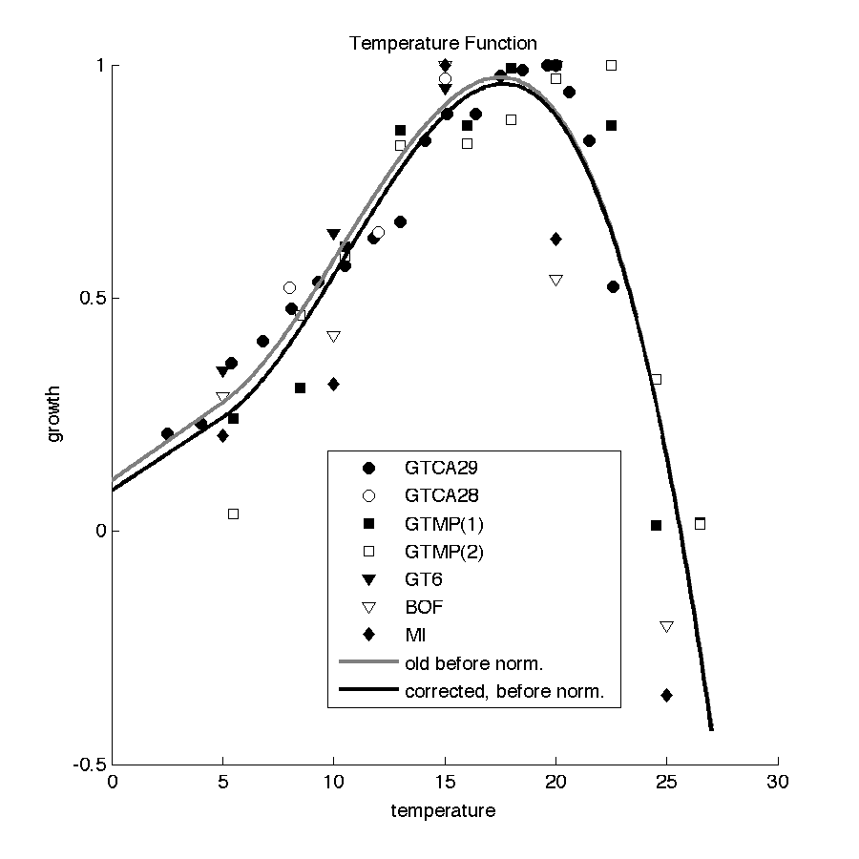
Figure 1: Comparison between the temperature functions (before normalization) used by Stock et al. (2005) (“old”, gray line, R² = 0.798) and the corrected fit (black line, R² = 0.802).
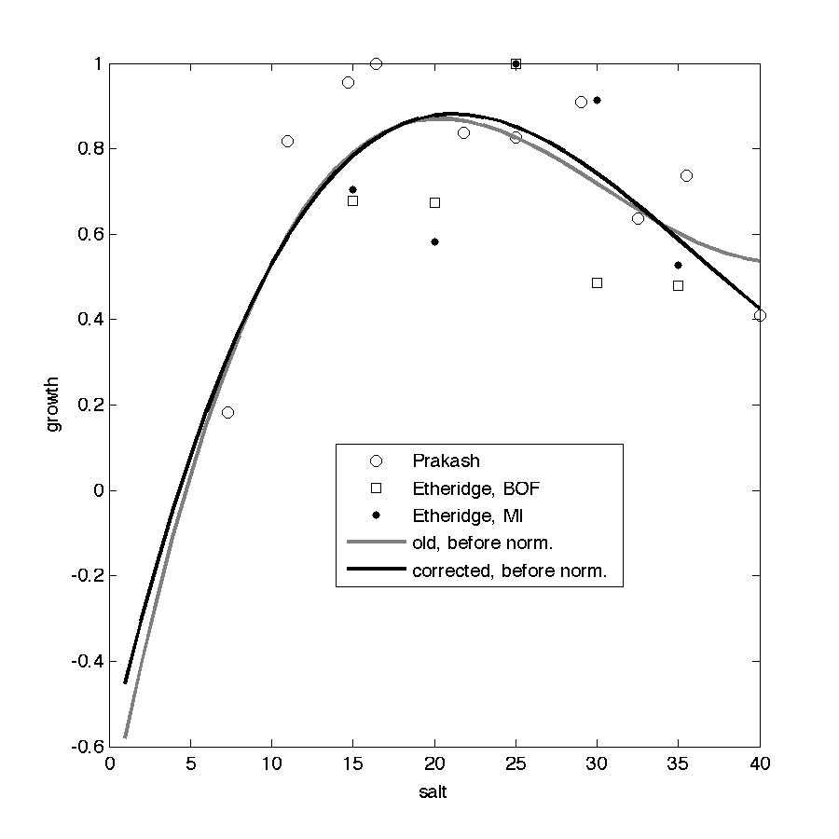

Figure 2: Comparison between the salinity functions (before normalization) used by Stock et al. (2005) (“old”, gray line, R² = 0.480) and the corrected fit (black line, R² = 0.499).

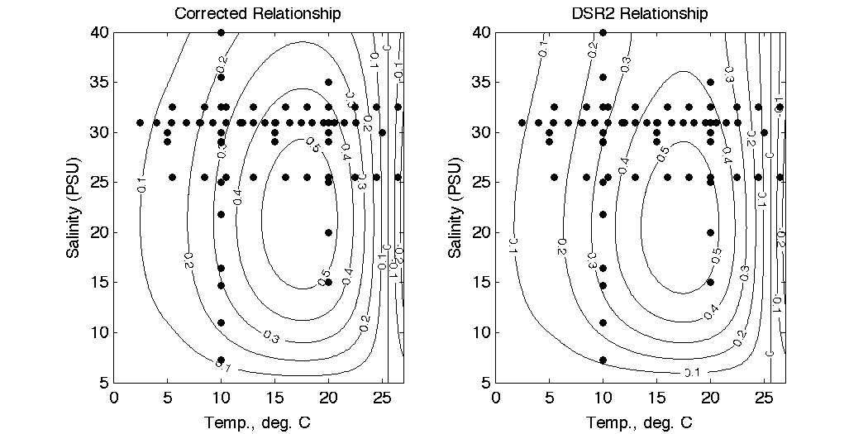

Figure 3: Comparison of estimated growth rates as a function of temperature and salinity for the corrected relationship (left plot), and the relationship used by Stock et al. (2005) (right plot).

