A Growth model for Alexandrium fundyense

Updated August 19, 2006

Charles Stock

This document gives a detailed description of the Alexandrium fundyense growth model that was developed as part of the ECOHAB-Gulf of Maine program. The model described is that used in Stock et al. (2005) with several minor corrections to the temperature and salinity dependence. Detailed descriptions of the corrections, as well as a timeline of model development can be found at:

http://www.whoi.edu/science/cohh/alexbiomodels.htm

The growth parameterization described here is in version 3.1 of the A. fundyense biological model.
The growth parameterization takes the form suggested by Platt and Jassby (1976) for photosynthesis, irradiance relationships and used by Langdon (1987, 1988) in studies of phytoplankton growth:

$$μ(E,T,S)=\left(μ_{\text{max}}(T,S)+μ_{o}^{r}\right)\text{tanh}\left(\frac{α_{g}E}{(μ_{\text{max}}(T,S)+μ_{o}^{r})}\right)−μ_{o}^{r}$$

Where μ_{max} is the maximum growth rate (days⁻¹) for a given temperature (T) and salinity (S), $μ_{o}^{r}$ is the maintenance respiration rate (days⁻¹), E is the daylight-averaged irradiance (6 AM – 8 PM, watts/m²), and α_{g} is the growth efficiency (m² watt⁻¹ day⁻¹). Best estimates, ranges, and references are given in Table 1. Table 2 summarizes the origins of the different A. fundyense isolates used in the studies that contributed to function construction.
The dependence of μ_{max} on temperature and salinity is formulated as follows:

$$μ_{\text{max}}(T,S)=μ(T_{\text{opt}},S_{\text{opt}})×f(T)×f(S)$$

Where T_{opt} and S_{opt} are the optimal temperature and salinity for growth. f(T) and f(S) are scaling factors with a maximum value of 1. The temperature relationship was formulated using data from isolates GTCA29, GTCA28, GT6, GTMP, BOF, and MI that measured growth as a function of temperature. The data points from each isolate are plotted as fractions of the maximum growth rate attained for that isolate. A cubic polynomial was fit to this data. Growth rates below 5ºC were approximated with a linear extrapolation of the slope at 5º C (i.e. the first term in the Taylor expansion of the polynomial about T = 5ºC) to prevent anomalous extrapolation. The resulting relationship achieves an R² of 0.80. Lastly, the fit polynomial is again normalized to ensure that a value of 1 is reached under optimal growth conditions (figure 1). This yields:

$$\begin{aligned}f(T³5)\text{=-}0\text{.}\text{000536}T^{3}+0\text{.}\text{0169}T^{2}−0\text{.}\text{0961}T+0\text{.}\text{379} \\ f(T<5)=f(T=5)−0\text{.}\text{0327}(5−T)\end{aligned}$$

The salinity dependence f(S) was constructed in similar fashion using data from Prakash (1967) and Etheridge and Roesler (isolates MI and BOF, figure 2). The resulting polynomial is:

$$f(S)=0\text{.}\text{0000577}S^{3}−0\text{.}\text{00622}S^{2}+0\text{.}\text{186}S−0\text{.}\text{693}$$

The salinity dependence is secondary to temperature over the normal range of salinities encountered in the western Gulf of Maine (25-33 PSU), and the relationship is rather noisy (R² = 0.50 before normalization). However, retaining the relationship despite this uncertainty allows assessment of the hypothesis that elevated cell concentrations in river plume waters can be explained by increased growth rates in waters of depressed salinity. The final relationship with both the T and S functionality is shown in figure 3.
The range of μ_{max} at optimal temperature and salinity is estimated based on adjustment of measured rates using the polynomial relationships described above. Most experiments used in this study measured the light saturated growth rate at only a limited number of T, S values (often only one). For example, in the case that the growth rate for an isolate was measured only at 15C and ~30 ppt salinity, the relationships above suggest that measured rates here are about 93% optimal with respect to temperature, and 83% optimal with respect to salinity. The adjustment was thus done as follows:

$$m_{\text{max}}(T_{\text{opt}},S_{\text{opt}})=\frac{m(T,S)}{f(T)´f(S)}=\frac{m(T,S)}{0\text{.}\text{93}´0\text{.}\text{83}}$$

Note that there is an assumption here that the two factors act independently, and no attempt to account for variable uncertainty in growth estimates from the various studies.
The estimates of the growth efficiency (α) and the maintenance respiration ($μ_{o}^{r}$) relied solely on the Cullen data, which was exceptionally well resolved at low light conditions. This added resolution greatly improved confidence in the estimates of these two parameters relative to previous iterations of this model.
When nutrient dependence is added, it is assumed that only one factor apart from T and S can limit growth. For example, a dependence on dissolved inorganic nitrogen (DIN) is added as follows:

$$μ(T,S,\text{DIN})=μ_{\text{max}}(T,S)×f(\text{DIN})$$

f(DIN) is specified with a Monod relationship:

$$f(\text{DIN})=\frac{[\text{DIN}]}{[\text{DIN}]+K_{\text{DIN}}}$$
[DIN] is the concentration of dissolved inorganic nitrogen in μM and K_{DIN} is an approximate half saturation constant for DIN (also in μM). μ(T,S,DIN) is then compared to μ(T,S,E) and the minimum of the two is taken:

$$μ(T,S,E,\text{DIN})=\text{min}(μ(T,S,E), μ(T,S,\text{DIN}))$$

Interpretive limitations are imposed by the assumptions used in the model formulation. The model can only be used to test hypotheses concerning systems where temperature, salinity, light, and nutrients are thought to be the primary factors controlling growth. Several other potentially important factors, such as the role of turbulence (Thomas and Gibson 1990; Sullivan et al. 2003) and bacterial abundance (Yentsch et al. 1975) have been neglected. The neglect of these factors must be considered an implicit part of each hypothesis tested with the above model.

Table 1: Growth function Parameters. Central value followed by standard deviation (in parentheses).
Symbol | Description | Value | Sources
μ_{max}(T_{opt},S_{opt}) | The maximum growth rate (day⁻¹) at optimal temperature and salinity. | 0.59 (0.48-0.69) | Cullen et al. (in preparation);  Langdon (1988); Watras et al. (1982); Keafer (unpublished data); Kulis (unpublished data); Etheridge and Roesler (2005)
α_{g} | The growth efficiency (m² watts⁻¹ day⁻¹) | 0.036  (0.024-0.048) | Cullen et al. (in preparation)
$$μ_{o}^{r}$$ | The maintenance growth rate (day⁻¹) | 0.20 (0.15-0.25) | Cullen et al. (in preparation)

Table 2: Summary of different isolates used in growth function construction
Designation | Origin | Source
ccmp1978 | Bay of Fundy | Cullen et al. (in preparation)
ccmp1979 | Bay of Fundy | Cullen et al. (in preparation)
ccmp1980 | Bay of Fundy | Cullen et al. (in preparation)
cb301 | Casco Bay | Cullen et al. (in preparation)
cb307 | Casco Bay | Cullen et al. (in preparation)
cb501 | Casco Bay | Cullen et al. (in preparation)
GTMP | Mill Pond (Cape Cod) | Watras et al. (1982)
GTCA29 | Near Cape Ann | Keafer (unpublished)
GTCA28 | Near Cape Ann | Kulis (unpublished)
BOF | Bay of Fundy | Etheridge and Roesler (2005)
MI | Monhegan Island | Etheridge and Roesler (2005)
gt6 | Near Cape Ann | Langdon (1987; 1988)
none | Head Harbour, Bay of Fundy | Prakash (1967)

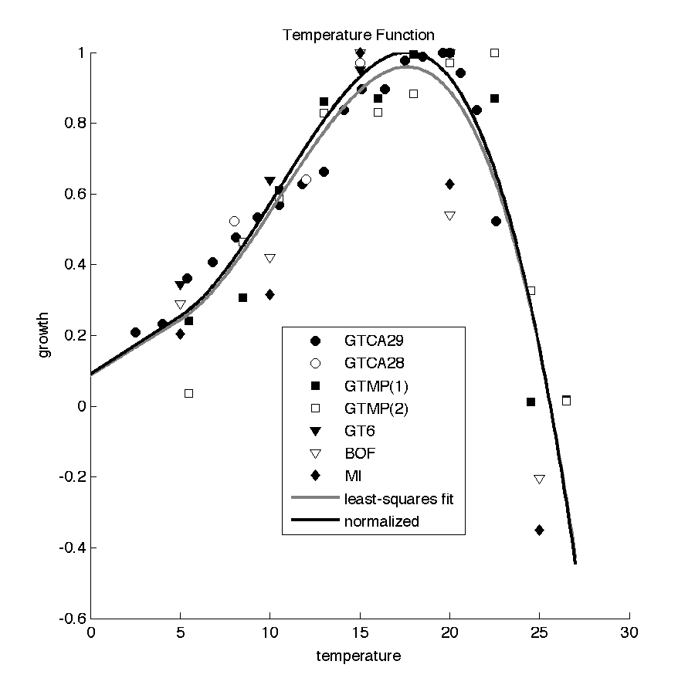
Figure 1: Temperature Scaling factor for application to the growth function. The gray line is the relationship before final normalization to ensure a maximum value of 1 (black line).
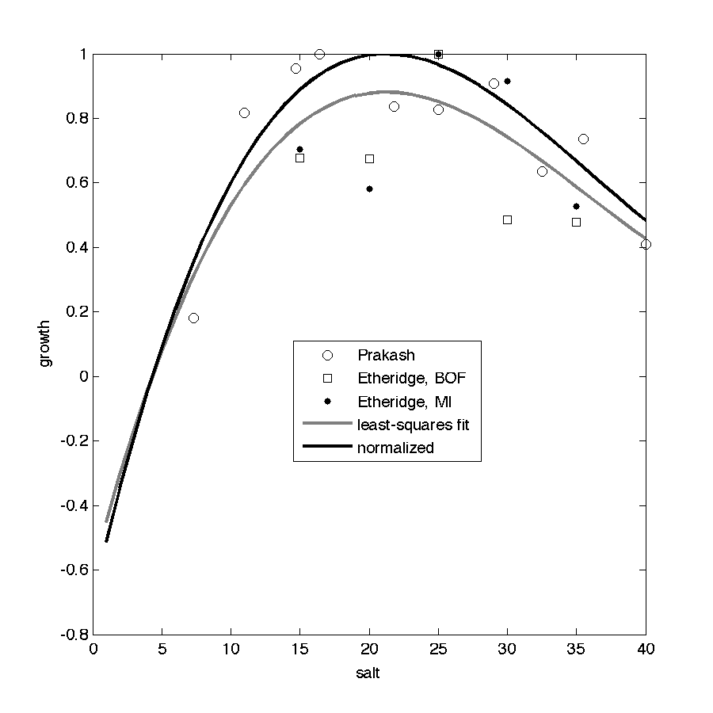
Figure 2: Salinity scaling factor for application to the growth function. The gray line is the relationship before final normalization to ensure a maximum value of 1 (black line).

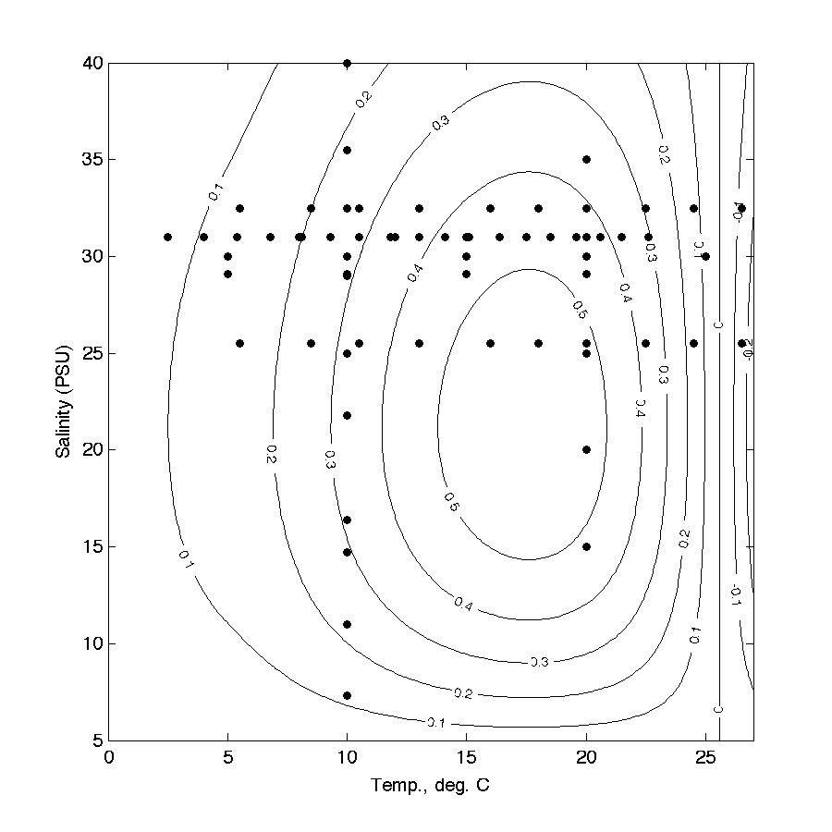
Figure 3: Maximum Growth Rate as a Function of T, S. Points indicate data coverage. This plot is with μ_{max}(T_{opt}, S_{opt}) = 0.58 day⁻¹.

Cullen, J. J., Wood, Barnett, Normandeau and Ryan (in preparation). Behavioral and physiological variability among strains of the toxic dinoflagellate Alexandrium fundyense from the Gulf of Maine.
Etheridge, S. M. and C. S. Roesler (2005). Effects of temperature, irradiance, and salinity on photosynthesis, growth rates, total toxicity, and toxin composition for Alexandrium fundyense isolates from the Gulf of Maine and Bay of Fundy. Deep Sea Research Part II 52: 2491-2500.
Langdon, C. (1987). On the causes of interspecific differences in the growth-irradiance relationships for phytoplankton. Part I. A comparitive study of the growth irradiance relationships of three marine phytoplankton species: Skelotonema costatum, Olithodiscus luteus and Gonyaulax tamarensis. Journal of Plankton Research 9(3): 459-482.
Langdon, C. (1988). On the causes of interspecific differences in the growth-irradiance relationship for phytoplankton. Part II: A general review. Journal of Plankton Research 10(6): 1291-1312.
Prakash, A. (1967). Growth and toxcity of a marine dinoflagellate, Gonyaulax tamarensis. Journal of the Fisheries Research Board of Canada 24(7).
Stock, C. A., D. J. McGillicuddy, A. R. Solow and D. M. Anderson (2005). Evaluating hypotheses for the initiation and development of Alexandrium fundyense blooms in the western Gulf of Maine using a coupled physical-biological model. Deep-Sea Research Part II-Topical Studies in Oceanography 52(19-21): 2715-2744.
Sullivan, J., E. Swift, P. Donaghay and J. Rines (2003). Small-scale turbulence affects the division rate and morphology of two red-tide dinoflagellates. Harmful Algae 2(3): 183-199.
Thomas, W. H. and C. H. Gibson (1990). Quantified small-scale turbulence inhibits a red tide dinofaggellate, Gonyaulax polyedra Stein. Deep Sea Research 37(10): 1583-1593.
Watras, C. J., S. W. Chisholm and D. M. Anderson (1982). Regulation of growth in an estuarine clone of Gonyaulax tamarensis Lebour: salinity-dependent temperature responses. Journal of Experimental Marine Biology and Ecology 62: 25-37.
Yentsch, C. M., E. J. Cole and M. G. Salvaggio (1975). Some of the growth characteristics of Gonyaulax tamarensis isolated from the Gulf of Maine. Proceedings of the first international conference on toxic dinoflagellate blooms, Boston, Massachusetts Science and Technology Foundation.

