Andrew Hirzel

12.823 Homework 1

1) Replicate Figure 21 from Riley, 1946:

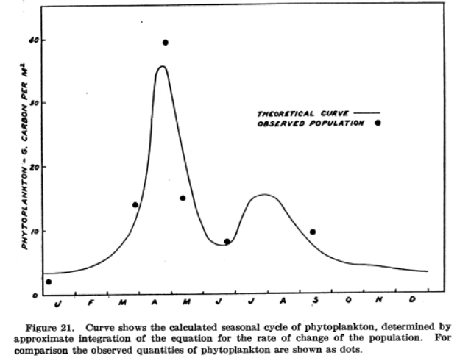

The curves are slightly different as a result of the use of a 15 day time step.

Sensitivity analysis for p, R0, r, g, and 1 – N:

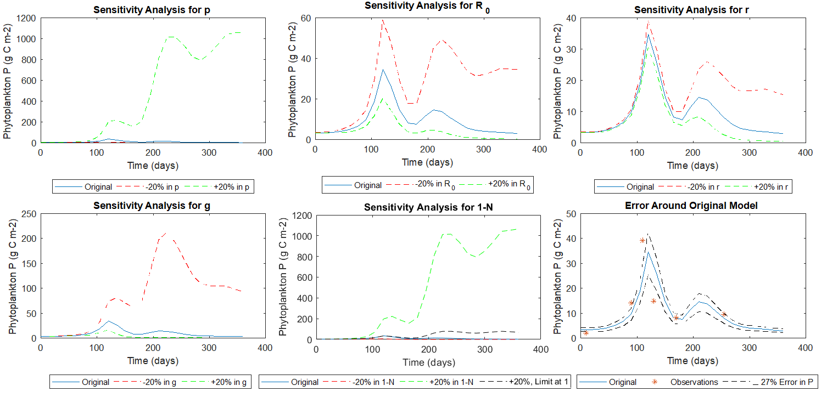

The mean photosynthesis equation (Ph) was the most sensitive to change, with a 20% increase in p and 1-N resulting in an increase of phytoplankton of multiple orders of magnitude. Fall blooms slightly diminished at the end of the bloom, before returning to peak bloom concentrations. A 20% decrease in the same variables resulted in phytoplankton abundance reaching zero. However, 1-N has a limit at 1 because N= (0.55 – mg-atom Phosphate m-3)/0.55 for phosphate concentrations≤0.55. This term is designed to only inhibit phytoplankton growth when the concentration is below 0.55, so 1-N should never be higher than 1 (black line above). When this occurs, phytoplankton growth increases, but levels off around 100 g C m-2. Any changes to Ph quickly left the 27% error measurement reported by Riley (1946).

The grazing equation (G) was also highly sensitive to change, as grazing is one of the primary limits to the phytoplankton blooms (spring and fall). Increasing g by 20% resulted in phytoplankton abundance approaching zero following the spring bloom. Decreasing g resulted in a higher spring and fall bloom. The fall bloom lasted a similar time as the original model before declining, unlike increased Ph fall blooms, which returned to peak bloom phytoplankton abundance by the end of the year. Both changes in g diverged from the 27% error measurement from Riley (1946).

The temperature respiration rate equation (RT) had the lowest sensitivity. Increasing R0 and r resulted in decreased phytoplankton abundance. Decreasing R0 and r resulted in increased phytoplankton abundance. The fall bloom was most affected by changes to R0 and r, due to the higher temperatures at the end of the summer. The 20% increase and decrease of R0 was outside the 27% error estimates but were fairly close to the given values for the spring bloom. Similar changes to r were within the error estimates for the spring bloom and outside the error estimates for the fall bloom. Since RT had little impact on the error, the 27% error given by Riley (1946) was likely due to inaccuracies in Ph or G, not RT.

2) Find the values of g where P is periodic:



P is periodic if and only if the end phytoplankton concentration is the same as the initial concentration. If this occurs, then P will always have the exact same annual cycle, given identical outside forcing (Z,T,I, etc.). P is not perfectly periodic as written and is only completely periodic at g= 0.007434769143793.

The following are how g changes along with changing the other 2 equations:

Ph\*0.8: g=0.0048766; Ph\*1.2: g=0.0097679

RT\*0.8: g=0.008506; RT\*1.2: g=0.0063636

Similar to the sensitivity analysis, changes in Ph result in the largest changes in g.­

3) Periodic model with randomly varying Z:

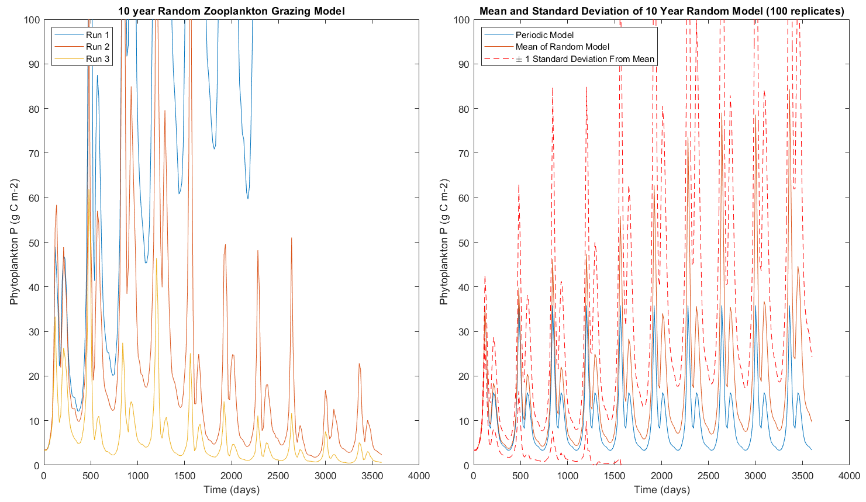

The left plot above shows three runs with randomly varying zooplankton populations, each with a different general trend. Run 1 (blue) has successive years of low zooplankton concentration, so the phytoplankton population quickly rises year after year. Run 2 demonstrates a population that has a similar average zooplankton concentration to the original model. As a result, increases in phytoplankton abundance due to low zooplankton concentration are lowered in later years of high zooplankton abundance. Run 3 shows successive years of high zooplankton concentration, which results in phytoplankton abundance to decrease each year. All three of these runs arose from random chance.

The right plot above shows the result of 100 randomly varying zooplankton models (mean: orange, ± 1 standard deviation from mean: red). The standard deviations represent 68% of 100 models. The lower bound hits zero after 4 years. Since a phytoplankton population has no way of recovering after dying out in this model, successive high zooplankton concentrations cause a significant number of runs to approach zero abundance over time. None of the 100 runs reached zero abundance, as e raised to a large negative power is still nonzero. The 100-model run mean shifts upward with time compared to the periodic model (blue) as lower zooplankton concentrations allow phytoplankton concentrations to rise. Increased time permits higher phytoplankton concentrations, potentially without limit. Zooplankton concentrations randomly vary every 15 days from the original values, however, not all times in the year are equally important. If lower zooplankton populations occur during the bloom, phytoplankton populations can increase much more rapidly than lower zooplankton populations at other times of the year. This leads to a widening gap between runs, permitting individual runs to grow more rapidly. These runs with elevated phytoplankton concentrations are what shifts the mean upwards, much more than the average run. The highest phytoplankton concentration within the 10th year was over 5000, which is much larger than the peak mean of around 80.