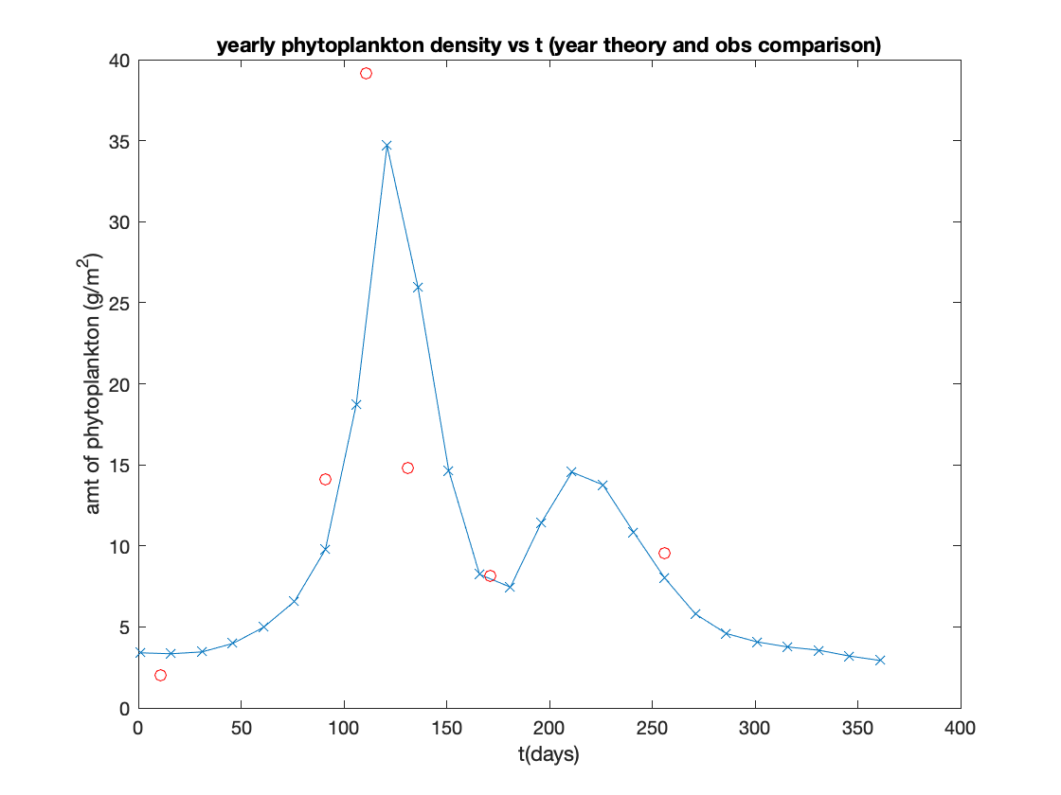Figure 1. Duplication of results from Riley of the theoretical model prediction of P vs the observations. (Further analysis in the comments of the code)

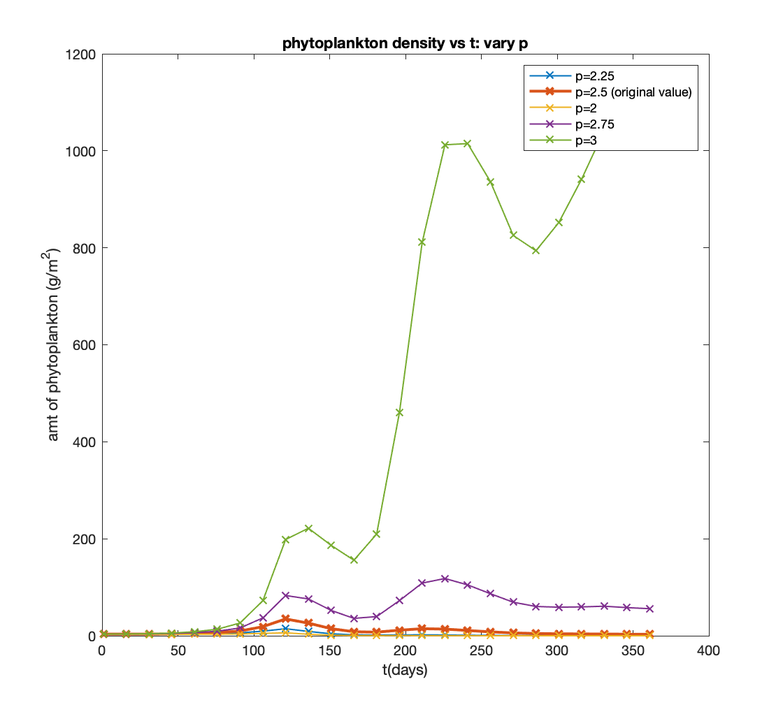

Figure 2. Sensitivity analysis: P over the course of a year, changing the photosynthesis amplifying parameter p 10% and 20%. The Red curve indicates the original parameter choices. (further analysis in comments of code)

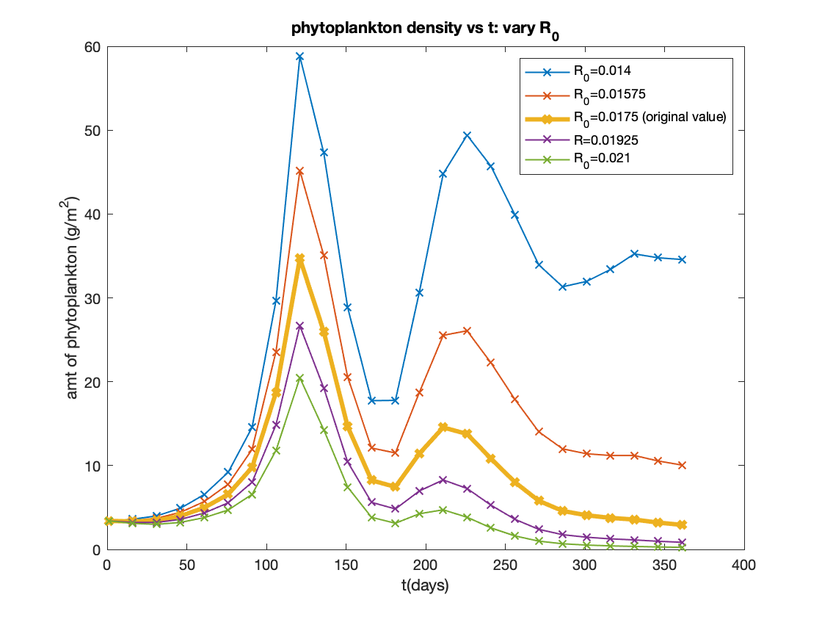

Figure 3. Sensitivity analysis: P over the course of a year, changing the temperature-dependent amplifying parameter R_0 10% and 20%. The yellow curve indicates the original parameter choices. Note that the deviations from the control parameter P in R_0 are relatively small compared to those in p, suggesting that P is very sensitive to choices of p but not as sensitive to R_0. (further analysis in comments of code)

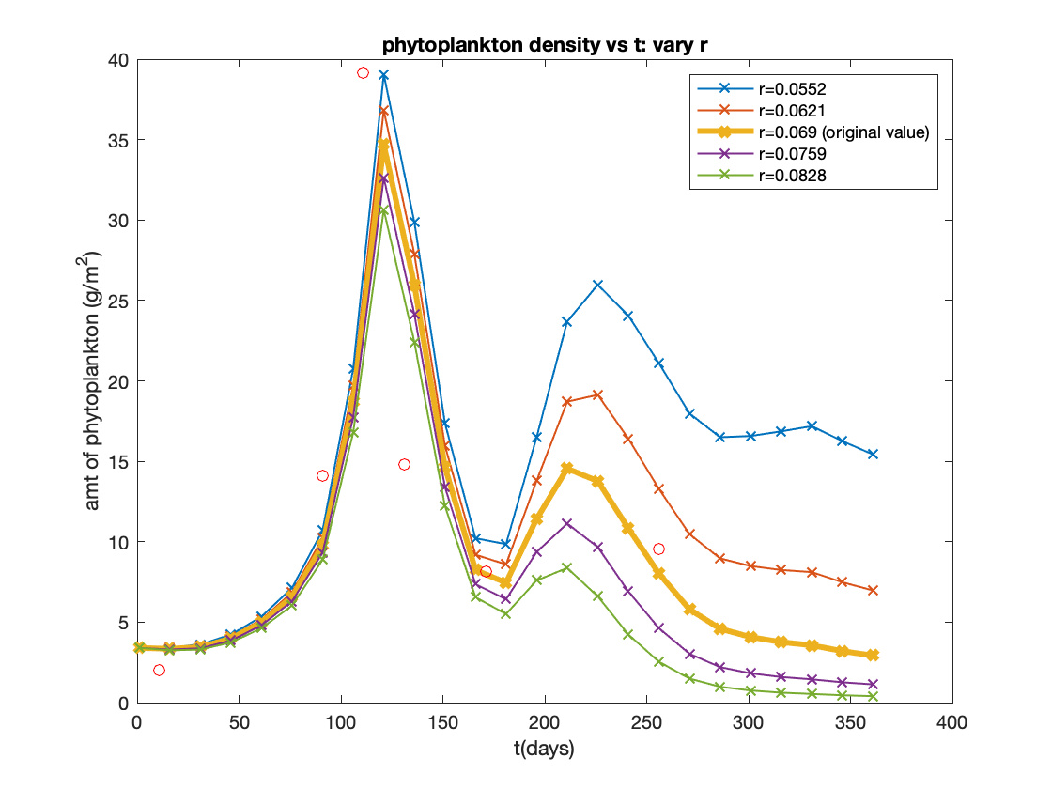

Figure 4. Sensitivity analysis: P over the course of a year, changing the temperature-dependent exponential parameter r_0 10% and 20%. The yellow curve indicates the original parameter choices. Note that the deviations from the control parameter P in R_0 are relatively small compared to those in p (even closer to the control case than deviations in R_0), suggesting that P is very sensitive to choices of p but not as sensitive to r. (further analysis in comments of code)

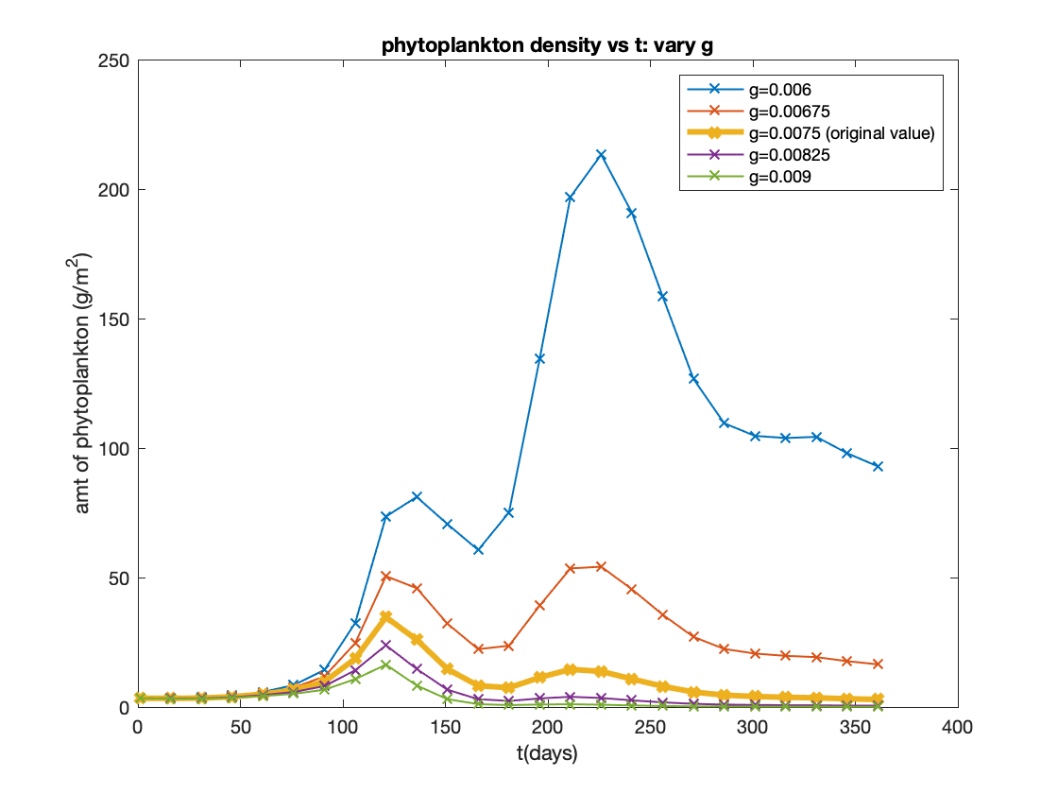

Figure 5. Sensitivity analysis: P over the course of a year, changing the grazing parameter g 10% and 20%. The yellow curve indicates the original parameter choices. Note that the deviations from the control parameter P in g are rather large compared to those in R_0 (though not nearly as sensitive as p, the reason being that there is also a temperature-dependent term which aids in the decay of P), suggesting that P is still quite sensitive to choices of g but not as sensitive to r. (further analysis in comments of code)

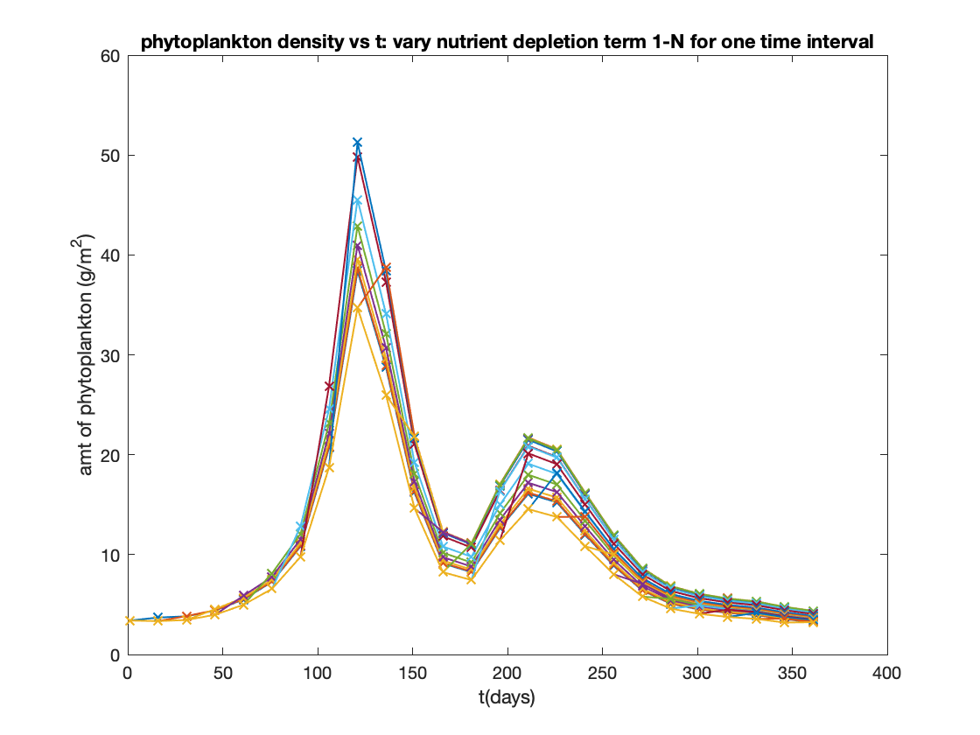

Figure 6 (supplementary figure). Sensitivity analysis: P over the course of a year, increasing the nutrient depletion parameter 1-N by 20% for a given time interval (it is a redundant calculation to uniformly amplify or diminish 1-N by 10% or 20% in the sensitivity analysis). In other words, each curve corresponds to a time interval for which we increase the corresponding 1-N value there by 20%. Although a bit muddled in the steeper gradient sections of this plot, looking near the local peaks of P we can observe that the sensitive P values deviate from their standard values by about 5 (first peak) or 10 (secondary peak) (further analysis in comments of code). This is suggestive of the sensitivity of P on 1-N, though the obvious conclusion is reached upon uniformly enhancing 1-N, which has the same degree of sensitivity of p.

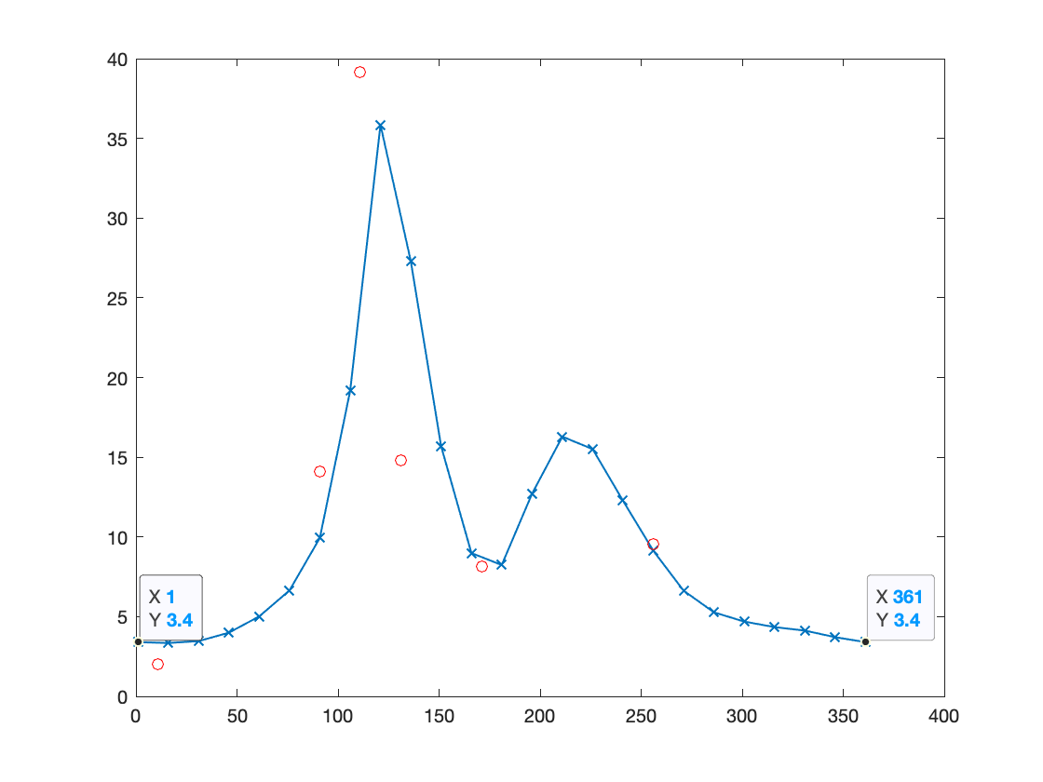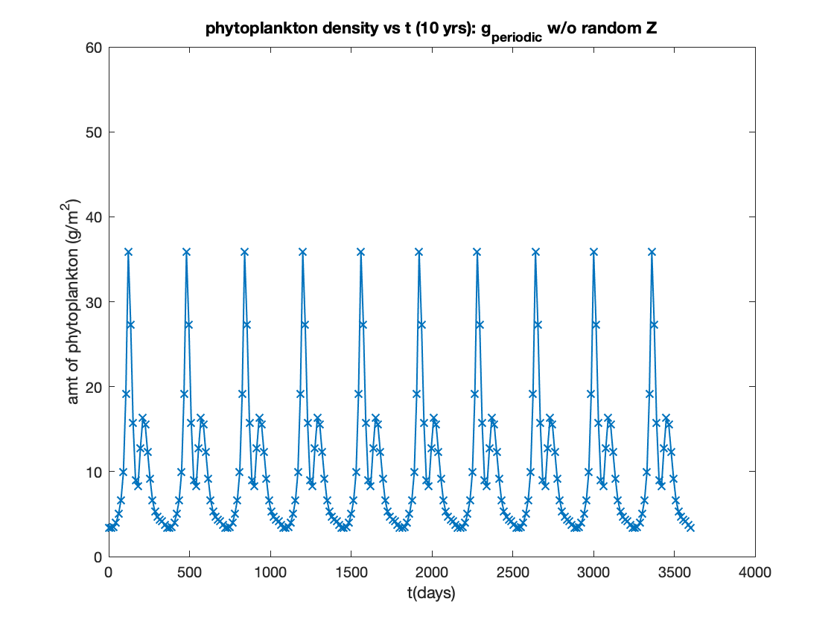

Figure 7. approximate grazing coefficient g= 0.007434768 to generate a periodic solution for P by equating endpoints of distribution.

Figure 8. 10-year plot of P for the standard values used in Riley, except that we now use the approximate grazing coefficient g= 0.007434768 to generate a periodic solution for P. This will be our base case with which we compare some of the P distributions in the presence of randomized predator forcing Z.

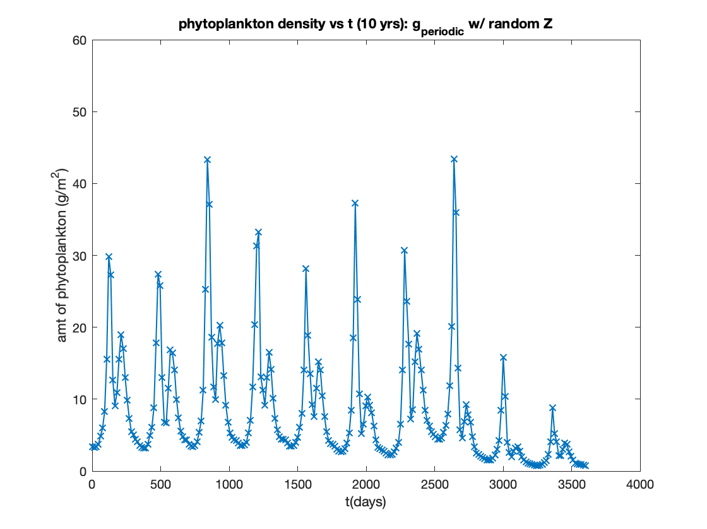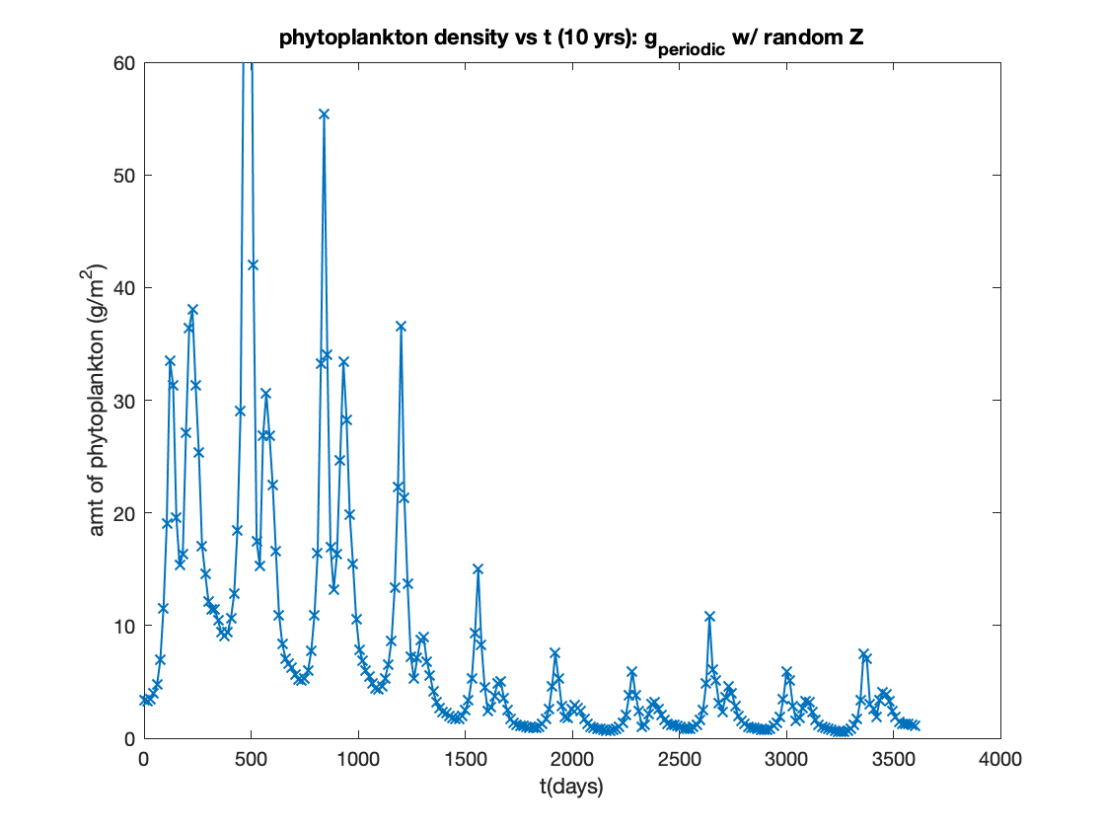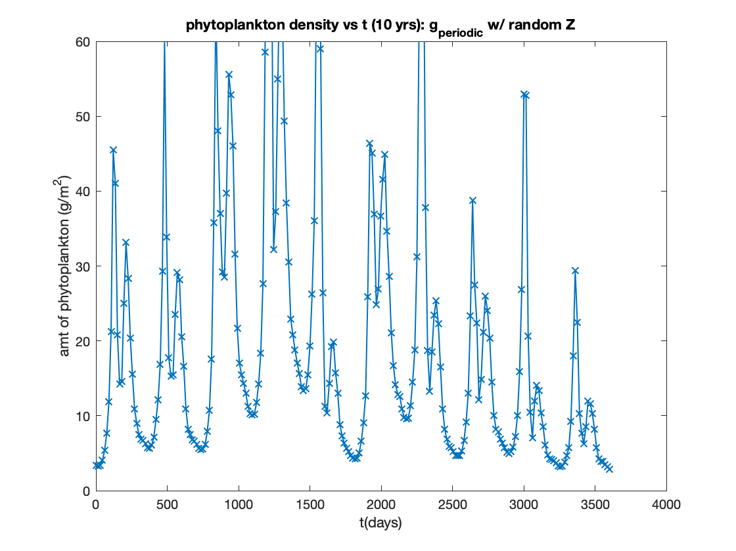

Figure 9. 10-year plot of P for the standard values used in Riley, except that we now use the approximate grazing coefficient g= 0.007434768 and randomized Z forcing. The bottom right diagram is the periodic non-randomized Z with the above grazing parameter to allow for periodic P solutions. The top left diagram shows the case where the random components on the whole act to diminish the zooplankton population enough that the P density is amplified and the signal becomes sharper. The bottom left demonstrates a similar phenomenon in the sense that there becomes an aperiodic intermittent signal averaging the original non-randomized P plot, but diverges from the top left in that P eventually is eaten down and the P population signal diminishes. The top right demonstrates an even steeper zooplankton forcing where it starts weak so P can increase significantly, then Z becomes stronger so that P decays midway through year 4.

Code for generating the above figures/sensitivity analysis: (green paragraphs indicate responses to questions)

clear all; close all; fclose all;

cd('/Users/michaeldotzel/Desktop/12823');

load('Riley_dat.mat');

%In Riley (1946), we consider a simple plankton model P_t=P*(P_h-R-G),

%where P_h denotes the rate of photosynthesis (given as aan exponentially

%decaying function of depth, along with a vertical motion and nutrient

%depletion factors), R the effect of temperature, and G the grazing rate.

%Riley takes the grazing rate to be directly proportional to the predator

%density, and R exponential in temperature. Combining these somewhat empirically

%motivated assumptions gives the final form

%

%dP/dt = P[(p*I_0/(k*z_1))*(1-exp(-k*z_1))*(1-N)*(1-V)-R_0*exp(r*T)-g*Z].

%

%Integrating this equation in time (for a series of relatively shorter, 15 day

%time intervals) yields the expression

%

%ln[P(t+15)/P(t)]=15*[P_h(t)-R(t)-G(t)],

%

%where here we assume that rates of growth on these small time intervals

%are (roughly) constant (hence our multiplication by t_f-t_i = 15).

%

%Out parameter values are

%

p=2.5;

R_0=0.0175;

r=0.069;

g=0.0075;

%

%In addition, we have initial condition that

%

P=NaN(25,1);

P(1)=3.4;

for i=1:length(T)

P(i+1)=P(i)*exp(15*[(p*I(i)/(k(i)*z1(i)))*(1-exp(-k(i)*z1(i)))*OneMinusN(i)*OneMinusV(i)-R_0*exp(r*T(i))-g*Z(i)]);

end

%P=P(1:15:end);

t=1:15:361;

plot(t,P,'-x'); %plots the theoretical P with t

%here we shifted our initial points forward 1 day so that P_initial = P(1)

%instead of P(0) (so that indices jive with matlab).

%overlay with plot of observed P w/ resp to observed t (shift forward one

%day in the same vein as above theoretical estimate)

Obs_time=1+Obs_time; %since we are taking P(initial)=P(1) instead of P(0)

hold on; plot(Obs_time,Obs_P,'o','Color','r');

xlabel('t(days)');ylabel('amt of phytoplankton (g/m^2)');

title('yearly phytoplankton density vs t (year theory and obs comparison)');

%We observe that the distribution obtained from this plot for the most part

%appears to duplicate that of Riley, with some small differences: the

%observational and theoretical primary peaks appear to not quite coincide

%as they seem to in his diagram, and while one might assume this is due to

%some kind of shifting error in the code, applying a shift of 10 days

%(which would position the observational peak point over the theoretical

%peak) is not enough to bring the remaining observations to coincide exactly with

%the theoretical curve in the way depicted in Riley.

%%% Now we perform sensitivity analysis on each parameter

%

%For each parameter as listed above, we are interested in how dependent the

%phytoplankton are to changes to their growth dynamics. First we determine

%the sensitivity of P to the rate of photosynthesis amplifying parameter p:

p_vary=[2 2.25 2.5 2.75 3];

R_0=0.0175;

r=0.069;

g=0.0075;

P=NaN(25,5);

P(1,:)=3.4;

for j=1:length(p_vary)

for i=1:length(T)

P(i+1,j)=P(i,j)*exp(15*[(p_vary(j)*I(i)/(k(i)*z1(i)))*(1-exp(-k(i)*z1(i)))*OneMinusN(i)*OneMinusV(i)-R_0*exp(r*T(i))-g*Z(i)]);

end

%P=P(1:15:end);

t=1:15:361;

figure(1)

if j==3

plot(t,P(:,j),'-x','LineWidth',2); %plots the theoretical P with t

else

plot(t,P(:,j),'-x','LineWidth',1); %plots the theoretical P with t

hold on

end

end

hold on; plot(Obs_time,Obs_P,'o','Color','r');

xlabel('t(days)');ylabel('amt of phytoplankton (g/m^2)');

title('phytoplankton density vs t: vary p');

legend('p=2.25',...

['p=2.5 (original value)'],['p=2'],['p=2.75'],['p=3']);

%

%

%We first observe that at 20% enhancement of p, the solution for P becomes

%very large, with values more than 5x larger at the first local maximum in

%P than the p=2.5 Riley case, and nearly 60x larger at the 2nd local

%maximum than the original. It is also worth noting that the second local

%maximum which was smaller than the first in the original p case, becomes

%more recessive with smaller p while increasing to overtake the value of P

%at the first local maximum for larger p. This could be attributed to the

%enhancement of light intensity in the northern hemisphere (e.g. the Georges Bank region)

%during the summer and the corresponding emphasis on light exposure with

%increasing p. For smaller p, temperature-dependent reduction in growth

%rate becomes more important for the higher temperatures in summer than in

%spring. As I am sure will be important for the second part of the

%assignment, it is as well interesting to see that for p even 10% larger,

%P does not oscillate seasonally - instead, there is an annual net

%increase.

%

%Now we determine the sensitivity of P to the temperature-dependent growth amplifying parameter R_0:

p=2.5;

R_0vary=[0.014 0.01575 0.0175 0.01925 0.021];

r=0.069;

g=0.0075;

P=NaN(25,5);

P(1,:)=3.4;

for j=1:length(R_0vary)

for i=1:length(T)

P(i+1,j)=P(i,j)*exp(15*[(p*I(i)/(k(i)*z1(i)))*(1-exp(-k(i)*z1(i)))*OneMinusN(i)*OneMinusV(i)-R_0vary(j)*exp(r*T(i))-g*Z(i)]);

end

%P=P(1:15:end);

t=1:15:361;

figure(1)

if j==3

plot(t,P(:,j),'-x','LineWidth',3); %plots the theoretical P with t

else

plot(t,P(:,j),'-x','LineWidth',1); %plots the theoretical P with t

hold on

end

end

hold on; plot(Obs_time,Obs_P,'o','Color','r');

xlabel('t(days)');ylabel('amt of phytoplankton (g/m^2)');

title('phytoplankton density vs t: vary R_0');

legend('R_0=0.014',...

['R_0=0.01575'],['R_0=0.0175 (original value)'],['R=0.01925'],['R_0=0.021']);

%

%

%Our phytoplankton model is less sensitive to the effects of changing the

%amplitude of the temperature-dependent term than changing p

%(though indeed still sensitive). I say this for two reasons: the general

%qualitative features of a sharper local maximum followed by a smaller

%secondary local maximum are preserved, and the end-of-year deviation from

%the initial P density is much smaller in magnitude than that observed when

%varying p. The original value of R_0 (in yellow) in fact provides an

%close-to-periodic-oscillation of P, with P(end)=2.925 for

%P(initial)=3.4. When decreasing R_0 10% our P distribution no longer

%promises anything in the vicinity of periodicity, with P(final) being 3

%times larger than P(initial), and decreasing 20% P(final) becomes 10x

%larger than P(initial). However, this suggests that (because computed

%values of P are continuous with respect to a continuous parameter change)

%there is a value of R_0 which is slightly smaller than 0.0175 (original)

%which does provide oscillation of P for fixed other parameters. When R_0

%increases there is further dissipation of P, with P(final) becoming much

%smaller than P(initial). These features are all consistent with the

%temperature-dependent term interpretation of Riley's model: chiefly a

%decay term, for smaller R_0 there is less decay due to temperature, hence

%a relative increase in the amplitude of the second peak. For larger R_0

%however, in the warmer summer months temperature plays a much more

%enhanced role in depressing P growth, hence the much smaller secondary

%peak and in the end a net negative yearly effect on P.

%

%Now we determine the sensitivity of P to the exponential temperature rate of increase r:

p=2.5;

R_0=0.0175;

r_vary=[0.0552 0.0621 0.069 0.0759 0.0828];

g=0.0075;

P=NaN(25,1);

P(1)=3.4;

for j=1:length(r_vary)

for i=1:length(T)

P(i+1)=P(i)*exp(15*[(p*I(i)/(k(i)*z1(i)))*(1-exp(-k(i)*z1(i)))*OneMinusN(i)*OneMinusV(i)-R_0*exp(r_vary(j)*T(i))-g*Z(i)]);

end

%P=P(1:15:end);

t=1:15:361;

figure(1)

if j==3

plot(t,P,'-x','LineWidth',3); %plots the theoretical P with t

else

plot(t,P,'-x','LineWidth',1); %plots the theoretical P with t

hold on

end

end

hold on; plot(Obs_time,Obs_P,'o','Color','r');

xlabel('t(days)');ylabel('amt of phytoplankton (g/m^2)');

title('phytoplankton density vs t: vary r');

legend('r=0.0552',...

['r=0.0621'],['r=0.069 (original value)'],['r=0.0759'],['r=0.0828']);

%

%

%Our phytoplankton model is even less sensitive to the effects of changing the

%exponent of the temperature-dependent term than changing R

%(though indeed still sensitive). I say this again for two reasons: the general

%qualitative features of a sharper local maximum followed by a smaller

%secondary local maximum are preserved (as in the case of varying R), and

%the end-of-year deviation from

%the initial P density is even smaller in magnitude than that observed when

%varying R or P. When decreasing r 10% our P distribution also still fails to

%be periodic, however P(final) is still closer to P(initial) than that found

%for the corresponding value of R_0. Decreasing 20% P(final) becomes ~5x

%larger than P(initial). However, this suggests that (because computed

%values of P are continuous with respect to a continuous parameter change)

%there is a value of r which is slightly smaller than 0.069 (original)

%which does provide oscillation of P for fixed other parameters. When r

%increases there is further dissipation of P, with P(final) becoming much

%smaller than P(initial). These features are all again consistent with the

%temperature-dependent term interpretation of Riley's model: chiefly a

%decay term, for smaller r there is exponential decrease of this term due to temperature, hence

%a relative increase in the amplitude of the second peak. For larger r

%in the warmer summer months temperature plays a much more

%enhanced role in depressing P growth, hence the much smaller secondary

%peak and in the end a net negative yearly effect on P.

%

%Now we determine the sensitivity of P to grazing coefficient g:

p=2.5;

R_0=0.0175;

r=0.069;

g_vary=[0.006 0.00675 0.0075 0.00825 0.009];

P=NaN(25,1);

P(1)=3.4;

for j=1:length(g_vary)

for i=1:length(T)

P(i+1)=P(i)*exp(15*[(p*I(i)/(k(i)*z1(i)))*(1-exp(-k(i)*z1(i)))*OneMinusN(i)*OneMinusV(i)-R_0*exp(r*T(i))-g_vary(j)*Z(i)]);

end

%P=P(1:15:end);

t=1:15:361;

figure(1)

if j==3

plot(t,P,'-x','LineWidth',3); %plots the theoretical P with t

else

plot(t,P,'-x','LineWidth',1); %plots the theoretical P with t

hold on

end

end

hold on; plot(Obs_time,Obs_P,'o','Color','r');

xlabel('t(days)');ylabel('amt of phytoplankton (g/m^2)');

title('phytoplankton density vs t: vary g');

legend('g=0.006',...

['g=0.00675'],['g=0.0075 (original value)'],['g=0.00825'],['g=0.009']);

%

%Our phytoplankton model is quite sensitive to the effects of changing the

%grazing coefficient. The reason is because qualitatively, the secondary

% local maximum in P (just the opposite of the varying p case) becomes even

% larger than the first local maximum when decreasing g more than 10% of the original grazing

%coefficient value, whereas originally the first peak is more pronounced

%than the second (this property still holds when g is increased). However,

%the value of P at the secondary peak when decreasing g by 20% is close to

%20x that of the original P at this peak. This suggests that grazing

%(along with light uptake term governed by p) is a principal factor in the

%model governing the growth of P, in contrast to temperature effects.

%For smaller g value, less grazing of P by Z allows P to multiply faster

%than the predators can regulate them, so a net increase in P over the year

%follows, in addition to a larger spike in the summer months due to

%increased sunlight/larger rate of P growth relative to grazing. For

%g 10% less than the one originally used by Riley, already the peaks seem

%about even with one another in the spring as the summer, though still

%coming out with a net positive annual increase in P despite Z's best efforts.

%Of course if g is too large then P just plummets from overeating, which is

%what can be observed from the smaller g values than the original.

%

%

%Now we determine the sensitivity of P to the nutrient depletion rate

%factor 1-N. It is redundant to consider cases where these values are uniformly increased or uniformly decreased by 10%

%or 20%, since this effect would be equivalent to changing p by that

%amount which was already analyzed. Therefore, in this case P is equally sensitive to 1-N as p. We can instead think about performing sensitivity

%analysis for one 15 day period (i.e. for one time interval in which 1-N is

%constant). It is unlikely that such an analysis will yield anything striking about the sensitivity of the forcing function

%itself - since we are leaving the parameters for all other times

%invariant, the qualitative difference between distributions will not

%differ appreciably. We've confirmed this below, in which we have increased

%1-N at each time interval separately by 20% to see how sensitive P is to

%1-N for one interval parameter change:

%

p=2.5;

R_0=0.0175;

r=0.069;

g=0.0075;

for j=1:24

if j==1

OMN(j,:)=[1.2*OneMinusN(1),OneMinusN(2:24)'];

else

OMN(j,:)=[OneMinusN(1:j-1)',1.2*OneMinusN(j),OneMinusN(j+1:end)'];

end

end

P=NaN(25,1);

P(1)=3.4;

for j=1:size(OMN,1)

for i=1:length(T)

P(i+1)=P(i)*exp(15*[(p*I(i)/(k(i)*z1(i)))*(1-exp(-k(i)*z1(i)))*OMN(j,i)*OneMinusV(i)-R_0*exp(r*T(i))-g*Z(i)]);

end

%P=P(1:15:end);

t=1:15:361;

figure(1)

plot(t,P,'-x','LineWidth',1); %plots the theoretical P with t

hold on

end

hold on; plot(Obs_time,Obs_P,'o','Color','r');

xlabel('t(days)');ylabel('amt of phytoplankton (g/m^2)');

title('phytoplankton density vs t: vary nutrient depletion term 1-N for one time interval');

%

%

%Now we will fit the observed P to the predicted P for each of the

%sensitivity studies performed above. We use a standard deviation method first to

%find the error for each theoretical sensitivity test relative to the observation.

%We will also use an averaged relative error formula to fit the observations and corresponding theoretical

%predictions. The reason I do so is twofold: 1) I did not catch that

%average error referred to standard deviation in the paper until rather

%late, and so then tried to resolve the ambiguity by another way; 2) though slightly

%different, this average error method captures a similar local percent error between theory

%and observation (in a somewhat weighted sense) as captured by the standard

%deviation.

%

%

%p_vary case (repeating part of code above)

p_vary=[2 2.25 2.5 2.75 3];

R_0=0.0175;

r=0.069;

g=0.0075;

P=NaN(25,5);

P(1,:)=3.4;

for j=1:length(p_vary)

for i=1:length(T)

P(i+1,j)=P(i,j)*exp(15*[(p_vary(j)*I(i)/(k(i)*z1(i)))*(1-exp(-k(i)*z1(i)))*OneMinusN(i)*OneMinusV(i)-R_0*exp(r*T(i))-g*Z(i)]);

end

%P=P(1:15:end);

t=1:15:361;

figure(1)

if j==3

plot(t,P(:,j),'-x','LineWidth',2); %plots the theoretical P with t

else

plot(t,P(:,j),'-x','LineWidth',1); %plots the theoretical P with t

hold on

end

end

hold on; plot(Obs_time,Obs_P,'o','Color','r');

xlabel('t(days)');ylabel('amt of phytoplankton (g/m^2)');

title('phytoplankton density vs t: vary p');

legend('p=2',...

['p=2.25'],['p=2.5 (original value)'],['p=2.75'],['p=3']);

%now find corresponding value at observed times

a=1:1:24;

m=NaN(length(Obs_time),length(p_vary));

Pre_P=NaN(length(Obs_time),length(p_vary));

for i=1:length(Obs_time)

F=find(Obs_time(i)>=t(a) & Obs_time(i)<=t(a+1)); %finds 15 day interval in which observation is located

if length(F)>1

Pre_P(i,:)=P(F(2),:);

else

for j=1:size(P,2)

m(i,j)=(P(F+1,j)-P(F,j))./(t(F+1)-t(F));

Pre_P(i,j)=P(F,j)+(Obs_time(i)-t(F)).*m(i,j);

end

end

end

%METHOD 1: standard deviation

ObsP=repmat(Obs_P',1,5);

Err=ObsP-Pre_P; %relative errors

SD=NaN(5,1);

for i=1:5

SD(i)=std(Err(:,i)); %for each sensitivity test, over all time points

end

SS=SD'./mean(Pre_P,1); %yields percent deviation of P from the predicted value (Incorrect - not paper value)

%I do not obtain the right percentage error in this computation compared to

%that of Riley. I would at some point like to clear this up with you

%sometime, if alright - I somehow misinterpret the standard deviation

%method. I use an alternate method below, but cannot be nicely compared to

%that of Riley.

%METHOD 2: find relative error (%error=(obs-exp)/exp)

ObsP=repmat(Obs_P',1,5);

err=ObsP-Pre_P;

N=NaN(5,1);

N(1,1)=norm(err(:,1))/norm(Obs_P);

N(2,1)=norm(err(:,2))/norm(Obs_P);

N(3,1)=norm(err(:,3))/norm(Obs_P);

N(4,1)=norm(err(:,4))/norm(Obs_P);

N(5,1)=norm(err(:,5))/norm(Obs_P);

%N =

% 0.8500

% 0.6829

% 0.4613

% 2.2820

% 21.0114

%Note that of these relative errors for each varied value of p in our

%sensitivity analysis, the smallest in magnitude is that which corresponds

%to the initial choice of parameters, and which gives 46.13% averaged relative error

%between the theoretical prediction and the observations.

%2. R_0 case

p=2.5;

R_0vary=[0.014 0.01575 0.0175 0.01925 0.021];

r=0.069;

g=0.0075;

P=NaN(25,5);

P(1,:)=3.4;

for j=1:length(R_0vary)

for i=1:length(T)

P(i+1,j)=P(i,j)*exp(15*[(p*I(i)/(k(i)*z1(i)))*(1-exp(-k(i)*z1(i)))*OneMinusN(i)*OneMinusV(i)-R_0vary(j)*exp(r*T(i))-g*Z(i)]);

end

%P=P(1:15:end);

t=1:15:361;

figure(1)

if j==3

plot(t,P(:,j),'-x','LineWidth',3); %plots the theoretical P with t

else

plot(t,P(:,j),'-x','LineWidth',1); %plots the theoretical P with t

hold on

end

end

hold on; plot(Obs_time,Obs_P,'o','Color','r');

xlabel('t(days)');ylabel('amt of phytoplankton (g/m^2)');

title('phytoplankton density vs t: vary R_0');

legend('R_0=0.014',...

['R_0=0.01575'],['R_0=0.0175 (original value)'],['R=0.01925'],['R_0=0.021']);

%now find corresponding value at observed times

a=1:1:24;

m=NaN(length(Obs_time),length(R_0vary));

Pre_P=NaN(length(Obs_time),length(R_0vary));

for i=1:length(Obs_time)

F=find(Obs_time(i)>=t(a) & Obs_time(i)<=t(a+1)); %finds 15 day interval in which observation is located

if length(F)>1

Pre_P(i,:)=P(F(2),:);

else

for j=1:size(P,2)

m(i,j)=(P(F+1,j)-P(F,j))./(t(F+1)-t(F));

Pre_P(i,j)=P(F,j)+(Obs_time(i)-t(F)).*m(i,j);

end

end

end

%METHOD 2: take relative error (%error=(obs-exp)/exp)

ObsP=repmat(Obs_P',1,5);

err=ObsP-Pre_P;

N=NaN(5,1);

N(1,1)=norm(err(:,1))/norm(Obs_P);

N(2,1)=norm(err(:,2))/norm(Obs_P);

N(3,1)=norm(err(:,3))/norm(Obs_P);

N(4,1)=norm(err(:,4))/norm(Obs_P);

N(5,1)=norm(err(:,5))/norm(Obs_P);

%N =

% 1.0526

% 0.5837

% 0.4613

% 0.5075

% 0.5927

%Again note that of these relative errors for each varied value of p in our

%sensitivity analysis, the smallest in magnitude is that which corresponds

%to the initial choice of parameters, and which gives 46.13% relative error

%between the theoretical prediction and the observations. An increase to 110% of the

%original R_0 value produces a somewhat closer relative error estimate of 50.75%.

%3. Vary exponential temperature rate of increase r

p=2.5;

R_0=0.0175;

r_vary=[0.0552 0.0621 0.069 0.0759 0.0828];

g=0.0075;

P=NaN(25,5);

P(1,:)=3.4;

for j=1:length(r_vary)

for i=1:length(T)

P(i+1,j)=P(i,j)*exp(15*[(p*I(i)/(k(i)*z1(i)))*(1-exp(-k(i)*z1(i)))*OneMinusN(i)*OneMinusV(i)-R_0*exp(r_vary(j)*T(i))-g*Z(i)]);

end

%P=P(1:15:end);

t=1:15:361;

figure(1)

if j==3

plot(t,P(:,j),'-x','LineWidth',3); %plots the theoretical P with t

else

plot(t,P(:,j),'-x','LineWidth',1); %plots the theoretical P with t

hold on

end

end

hold on; plot(Obs_time,Obs_P,'o','Color','r');

xlabel('t(days)');ylabel('amt of phytoplankton (g/m^2)');

title('phytoplankton density vs t: vary r');

legend('r=0.0552',...

['r=0.0621'],['r=0.069 (original value)'],['r=0.0759'],['r=0.0828']);

%

a=1:1:24;

m=NaN(length(Obs_time),length(R_0vary));

Pre_P=NaN(length(Obs_time),length(R_0vary));

for i=1:length(Obs_time)

F=find(Obs_time(i)>=t(a) & Obs_time(i)<=t(a+1)); %finds 15 day interval in which observation is located

if length(F)>1

Pre_P(i,:)=P(F(2),:);

else

for j=1:size(P,2)

m(i,j)=(P(F+1,j)-P(F,j))./(t(F+1)-t(F));

Pre_P(i,j)=P(F,j)+(Obs_time(i)-t(F)).*m(i,j);

end

end

end

%take relative error (%error=norm(obs-exp)/norm(exp))

ObsP=repmat(Obs_P',1,5);

err=ObsP-Pre_P;

N=NaN(5,1);

N(1,1)=norm(err(:,1))/norm(Obs_P);

N(2,1)=norm(err(:,2))/norm(Obs_P);

N(3,1)=norm(err(:,3))/norm(Obs_P);

N(4,1)=norm(err(:,4))/norm(Obs_P);

N(5,1)=norm(err(:,5))/norm(Obs_P);

%N =

% 0.5469

% 0.4759

% 0.4613

% 0.4711

% 0.4883

%Here we observe that just as in the other sensitivity analyses, of each case the

%original conditions produce the smallest average relative error at 46.13%.

%

%

%4. vary grazing constant g

p=2.5;

R_0=0.0175;

r=0.069;

g_vary=[0.006 0.00675 0.0075 0.00825 0.009];

P=NaN(25,5);

P(1,:)=3.4;

for j=1:length(g_vary)

for i=1:length(T)

P(i+1,j)=P(i,j)*exp(15*[(p*I(i)/(k(i)*z1(i)))*(1-exp(-k(i)*z1(i)))*OneMinusN(i)*OneMinusV(i)-R_0*exp(r*T(i))-g_vary(j)*Z(i)]);

end

%P=P(1:15:end);

t=1:15:361;

figure(1)

if j==3

plot(t,P(:,j),'-x','LineWidth',3); %plots the theoretical P with t

else

plot(t,P(:,j),'-x','LineWidth',1); %plots the theoretical P with t

hold on

end

end

hold on; plot(Obs_time,Obs_P,'o','Color','r');

xlabel('t(days)');ylabel('amt of phytoplankton (g/m^2)');

title('phytoplankton density vs t: vary g');

legend('g=0.006',...

['g=0.00675'],['g=0.0075 (original value)'],['g=0.00825'],['g=0.009']);

%

a=1:1:24;

m=NaN(length(Obs_time),length(g_vary));

Pre_P=NaN(length(Obs_time),length(g_vary));

for i=1:length(Obs_time)

F=find(Obs_time(i)>=t(a) & Obs_time(i)<=t(a+1)); %finds 15 day interval in which observation is located

if length(F)>1

Pre_P(i,:)=P(F(2),:);

else

for j=1:size(P,2)

m(i,j)=(P(F+1,j)-P(F,j))./(t(F+1)-t(F));

Pre_P(i,j)=P(F,j)+(Obs_time(i)-t(F)).*m(i,j);

end

end

end

%take relative error (%error=(obs-exp)/exp)

ObsP=repmat(Obs_P',1,5);

err=ObsP-Pre_P;

N=NaN(5,1);

N(1,1)=norm(err(:,1))/norm(Obs_P);

N(2,1)=norm(err(:,2))/norm(Obs_P);

N(3,1)=norm(err(:,3))/norm(Obs_P);

N(4,1)=norm(err(:,4))/norm(Obs_P);

N(5,1)=norm(err(:,5))/norm(Obs_P);

%N =

% 3.7451

% 0.9746

% 0.4613

% 0.5362

% 0.6558

%Here we observe that just as in the other sensitivity analyses, of each case the

%original conditions produce the smallest relative error at 46.13%.

%Increasing g to 110% of the original value yields P which is relatively close to

%that of the original parameter values, with relative error 53.62%.

%

%In summary, the relative error method gives a relative measure of how

%important parameters are to the P solution by considering how different

%the errors are between the original parameter value-determining P and the

%plus/minus 10% or 20% the value of the respective parameter on P.

%In this way, one can observe that P is extremely sensitive to p,

%moderately sensitive to both g and R_0, and not as sensitive to r.

%

%We now turn our attention to the case where P is periodic, i.e. if there

%is annual cycling of P. In order for this to happen, we must have

%P(end)=P(initial)=3.4. We observed that in all our sensitivity and

%original analyses, we have come close to periodic oscillation in P but not

%quite. We will then change the grazing parameter and keep the other

%parameters constant to see what value of g yields this assumption

%(assuming of course that other parameter values are also the same constant

%values for their corresponding time interval of the year):

p=2.5;

R_0=0.0175;

r=0.069;

g_vary=[0.0074 0.00745 0.0075 0.00755 0.0076];

P=NaN(25,5);

P(1,:)=3.4;

for j=1:length(g_vary)

for i=1:length(T)

P(i+1,j)=P(i,j)*exp(15*[(p*I(i)/(k(i)*z1(i)))*(1-exp(-k(i)*z1(i)))*OneMinusN(i)*OneMinusV(i)-R_0*exp(r*T(i))-g_vary(j)*Z(i)]);

end

%P=P(1:15:end);

t=1:15:361;

figure(1)

if j==3

plot(t,P(:,j),'-x','LineWidth',3); %plots the theoretical P with t

else

plot(t,P(:,j),'-x','LineWidth',1); %plots the theoretical P with t

hold on

end

end

hold on; plot(Obs_time,Obs_P,'o','Color','r');

xlabel('t(days)');ylabel('amt of phytoplankton (g/m^2)');

title('phytoplankton density vs t: vary g');

legend('g=0.0074',...

['g=0.00745'],['g=0.0075 (original)'],['g=0.00755'],['g=0.0076']);

%As we can observe in the corresponding figure, there is periodic P

%behavior for the grazing parameter approximate value g=0.0074348, which is less than 1% from

%the original g=0.0075 value used by Riley. Now of course, if one were to

%increase p or decrease R_0 or r, one would expect the necessary value of g

%would increase to compensate. This is demonstrated below, for increasing p

%to 110% of its original value:

p=2.75;

R_0=0.0175;

r=0.069;

g_vary=[0.008 0.00825 0.0085 0.00875 0.009];

P=NaN(25,5);

P(1,:)=3.4;

for j=1:length(g_vary)

for i=1:length(T)

P(i+1,j)=P(i,j)*exp(15*[(p*I(i)/(k(i)*z1(i)))*(1-exp(-k(i)*z1(i)))*OneMinusN(i)*OneMinusV(i)-R_0*exp(r*T(i))-g_vary(j)*Z(i)]);

end

%P=P(1:15:end);

t=1:15:361;

figure(1)

if j==3

plot(t,P(:,j),'-x','LineWidth',3); %plots the theoretical P with t

else

plot(t,P(:,j),'-x','LineWidth',1); %plots the theoretical P with t

hold on

end

end

hold on; plot(Obs_time,Obs_P,'o','Color','r');

xlabel('t(days)');ylabel('amt of phytoplankton (g/m^2)');

title('phytoplankton density vs t: vary g');

legend('g=0.008',...

['g=0.00825'],['g=0.0085'],['g=0.00875'],['g=0.009']);

%As can be observe in this figure, the g value that would yield a periodic

%solution of P is closer to g=0.0087. This is consistent with what we would expect:

%as we are changing g in response to other parameters, p increasing would

%have the same effect as decreasing either r or R_0 and would boost the P

%density, which must then be depressed by an increase in g for yearly

%oscillation of P to occur.

%

p=2.5;

R_0=0.0175;

r=0.069;

g_vary=0.007434768;

P=NaN(25,5);

P(1,:)=3.4;

for j=1:length(g_vary)

for i=1:length(T)

P(i+1,j)=P(i,j)*exp(15*[(p*I(i)/(k(i)*z1(i)))*(1-exp(-k(i)*z1(i)))*OneMinusN(i)*OneMinusV(i)-R_0*exp(r*T(i))-g_vary(j)*Z(i)]);

end

%P=P(1:15:end);

t=1:15:361;

figure(1)

if j==3

plot(t,P(:,j),'-x','LineWidth',3); %plots the theoretical P with t

else

plot(t,P(:,j),'-x','LineWidth',1); %plots the theoretical P with t

hold on

end

end

hold on; plot(Obs_time,Obs_P,'o','Color','r');

%

%

%Now we vary the predator population by introducing a random component to

%the Z observations. For a 10 year timeseries, we assume that Z without the

%random component is

Zrand=NaN(10*length(Z),1);

for i=1:length(Zrand)

Zrand(i)=rand;

end

ZZ=repmat(Z,10,1);

Zr=ZZ.*(0.8+0.4*Zrand); %defines new Z population

TT=repmat(T,10,1);

OMV1=repmat(OneMinusV,10,1);

OMN1=repmat(OneMinusN,10,1);

II=repmat(I,10,1);

Z1=repmat(z1,10,1);

KK=repmat(k,10,1);

p=2.5;

t1=1:15:1+15*length(ZZ);

R_0=0.0175;

r=0.069;

g_vary=0.007434768;

P=NaN(1+length(ZZ),1);

P(1)=3.4;

for i=1:length(TT)

P(i+1)=P(i)*exp(15*[(p*II(i)/(KK(i)*Z1(i)))*(1-exp(-KK(i)*Z1(i)))*OMN1(i)*OMV1(i)-R_0*exp(r*TT(i))-g_vary*ZZ(i)]);

end

%P=P(1:15:end);

t=1:15:361;

figure(1)

plot(t1,P,'-x','LineWidth',1); %plots the theoretical P with t

ylim([0 60]);

xlabel('t(days)');ylabel('amt of phytoplankton (g/m^2)');

title('phytoplankton density vs t (10 yrs): g_{periodic} w/o random Z'); %plotting non-random Z

%Now for randomized Z:

Zrand=NaN(10*length(Z),1);

for i=1:length(Zrand)

Zrand(i)=rand;

end

ZZ=repmat(Z,10,1);

Zr=ZZ.*(0.8+0.4*Zrand); %define random Z component

for i=1:length(TT)

P(i+1)=P(i)*exp(15*[(p*II(i)/(KK(i)*Z1(i)))*(1-exp(-KK(i)*Z1(i)))*OMN1(i)*OMV1(i)-R_0*exp(r*TT(i))-g_vary*Zr(i)]);

end

%t=1:15:361;

figure(1)

plot(t1,P,'-x','LineWidth',1); %plots the theoretical P with t

ylim([0 60]);

xlabel('t(days)');ylabel('amt of phytoplankton (g/m^2)');

title('phytoplankton density vs t (10 yrs): g_{periodic} w/ random Z'); %plotting non-random Z

hold on;

%It is easy to see that in the attached figures, the random aspect of the zooplankton

%term can induce a lot of variability in P - in one case, the periodic

%signature simply seems to diminish in magnitude and dissipate over the 10

%years, while another displays quasi-periodic, intermittent pulsing of

%phytoplankton before dissipating, while yet the third plot shows an

%on-average weaker grazing component which manifests as a consistently

%larger and steeper P density plot.