Zoe Aarons
12.823
Problem Set #1

- The sensitivity analysis (see figure on next page) reveals that the model is most affected by increases in p and 1-N. Both of these variables cause an increase in the photosynthetic rate, which cases the phytoplankton to grow at rates that are unchecked by respiration and grazing. Raising p and 1-N by 20% caused the December concentration of phytoplankton to rise from about 3.4 to >1000 g C m⁻². In contrast, raising p and 1-N (lowering the rate of photosynthesis) caused the phytoplankton concentration to decrease. Because the original concentration of phytoplankton was always below 40 g C m⁻² and cannot fall below 0, the impact of decreasing p and 1-N was much less than increasing these parameters. As expected, an opposite trend was found for respiratory rate (R₀ and r) and grazing rate (g). As these parameters were increased, higher rates of respiration and grazing caused the phytoplankton stock to decrease. And when these parameters were lowered by 20%, phytoplankton biomass rose as the sources of carbon loss decreased. The impacts on grazing were greater than those on respiration. While a 20% increase in R₀, r, and g caused slight decreases in phytoplankton, the -20% decrease in g caused phytoplankton biomass to reach >200 g C m⁻² while it never exceeded 60 and 40 for R₀ and r respectively. Overall, the sensitivity analysis reveals that the model is most sensitive to changes in the photosynthetic rate (parameters p and 1-N). Photosynthetic rate provides the upper limit of the model and thus changes in these parameters can cause a runaway effect.

When calculating error, I found a value of 41.6% compared to the 26% calculated by Riley. I would expect that this deviation is largely caused by the smoothing done by Riley, while my yearly result was composed of straight lines. The percent errors for the sensitivity tests support the above findings – increasing p and 1-N had by far the greatest impact. Furthermore, the percent error for all parameters when increased or decreased by 20% exceeded 50%. So, while the Riley model provides a shape that seems to agree with the seasonal variation in the Gulf of Maine, it is important to note that the values are significantly different from those found in the observations and are sensitive to small changes in the inputs.

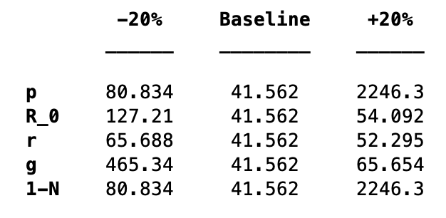
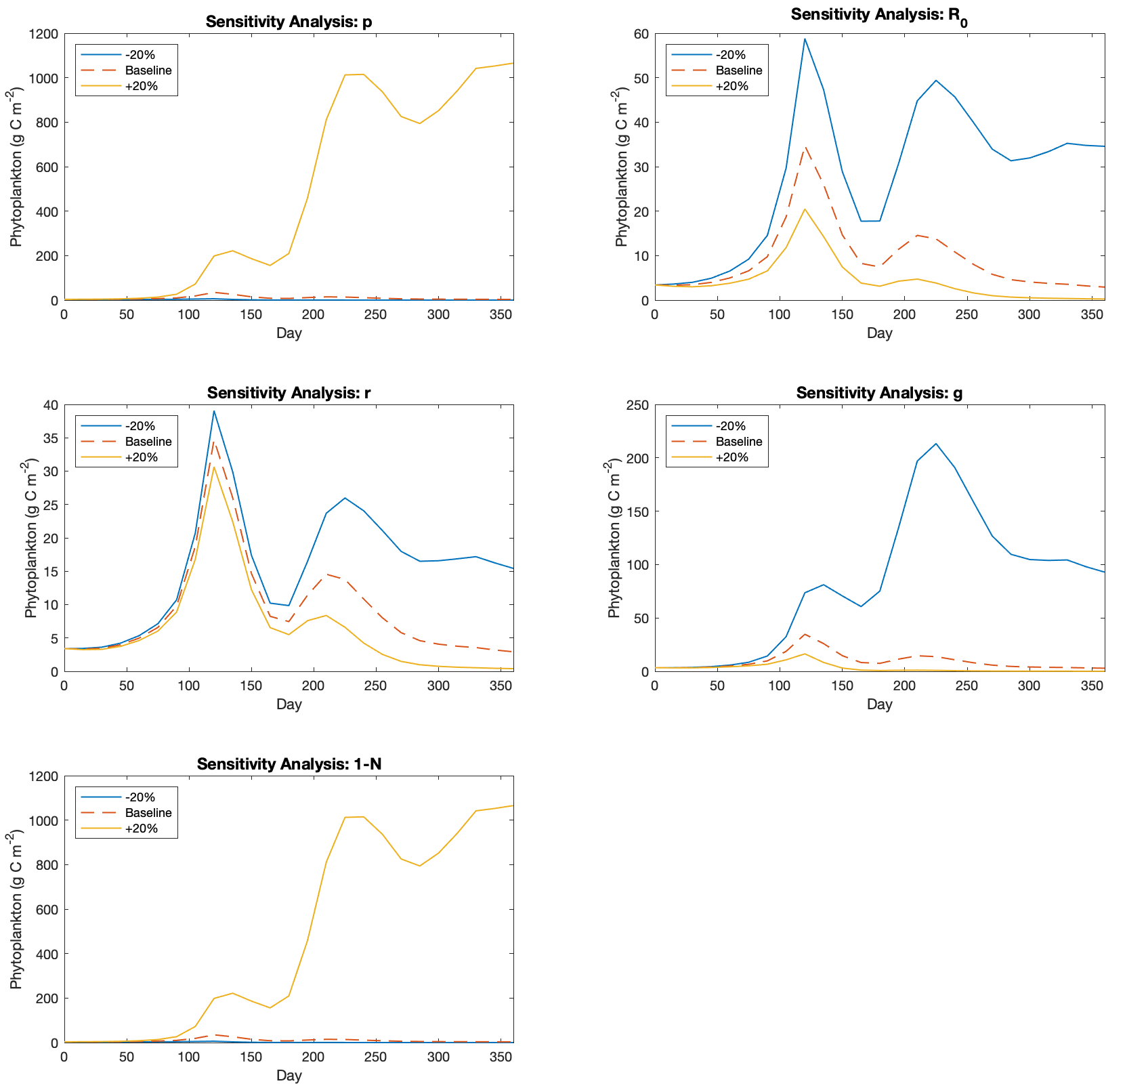

- P is periodic when photosynthesis is balanced by respiration and grazing over the course of a year. If photosynthesis is the additive inverse of respiration + grazing, then the net change in phytoplankton biomass over the course of the year will be 0. P is periodic when g = 0.0074348. When other parameters (p, 1-N, R₀, and r) are altered, the g value required to keep P periodic changes as expected. When p and 1-N are raised, the rate of photosynthesis increases. Therefore, the rate of zooplankton grazing must also increase and so g increases. When p and 1-N are decreased, g also decreases. The opposite occurs for R₀ and r because when the rate of respiration increases, the rate of zooplankton grazing (and therefore g) must decrease for P to remain periodic.

- Using the g value calculated in question 2 and varying the zooplankton grazing rate randomly each time step by 20% results in significant differences in annual phytoplankton biomass. Running the model multiple times produced time series with significant differences in maximum phytoplankton biomass. All runs were characterized by two peaks each year – a stronger spring bloom followed by a weaker late summer bloom. These peaks were visible for all ten years. However, the amplitude of these peaks varied across years and across model runs with peaks that regularly range from >90 g C m⁻² to <5 g C m⁻². In one run, a spring bloom even reached >350 g C m⁻². This reveals the strong impact that zooplankton grazing has on phytoplankton communities. Small differences in the rates of grazing have significant impacts on phytoplankton biomass. Furthermore, changes in this rate of grazing can cause spring blooms in subsequent years to differ by >60 g C m⁻².

Example of one model run: